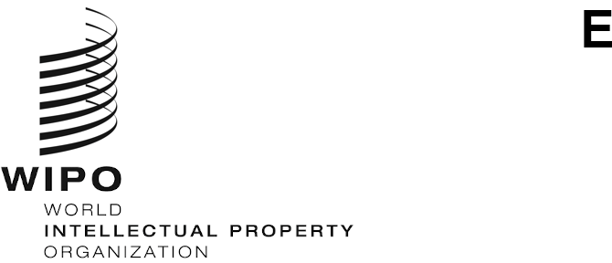
PCT/CTC/33/11
ORIGINAL: ENGLISH / SPANISH
Date: December 19, 2025
Patent Cooperation Treaty (PCT)

Committee for Technical Cooperation

Thirty-Third Session

Geneva, February 2 to 6, 2026
EXTENSION OF APPOINTMENT OF THE SPANISH PATENT AND TRADEMARK OFFICE AS AN INTERNATIONAL SEARCHING AND PRELIMINARY EXAMINING AUTHORITY UNDER THE PCT

Document prepared by the International Bureau
- All the existing International Authorities were appointed by the PCT Assembly for a period ending on December 31, 2027. Before the expiry of this period, the Assembly will need to decide on the extension of the appointment of each existing International Authority that wishes to seek an extension of its appointment, having first sought the advice of this Committee (see PCT Articles 16(3)(e) and 32(3)). Information concerning this process and the role of the Committee is set out in document PCT/CTC/33/INF/1.
- On November 18, 2025, the Spanish Patent and Trademark Office submitted its application for extension of appointment, which is reproduced in the Annex to this document.
- The Committee is invited to give its advice on this matter.
[Annex follows]

Application for extension of appointment as an International Searching and Preliminary Examining Authority under the PCT

1. General
(a) Name of Office or intergovernmental organization:
Spanish Patent and Trademark Office (SPTO)

(b) Name and contact details of official for any queries about this application:
Raquel Sampedro, Deputy Assistant Director of the Patent and Technological Information Department raquel.sampedro@oepm.es

(c) Date on which application for extension of appointment was received by the Director General:
November 18, 2025

2. Minimum Requirements for Appointment
In addition to the annual report on the quality management system by the Office or organization for 2025 (“the QMS Report”, https://www.wipo.int/en/web/pct-system/quality/authorities#ES), produced in accordance with paragraphs 21.31 and 21.32 of the International Search and Preliminary Examination Guidelines (“the Guidelines”), the Authority submits the following information.

Since the SPTO was appointed as an International Searching Authority (ISA) and an International Preliminary Examining Authority (IPEA), it has complied with all the substantive requirements to be an international PCT authority, and continues to do so. This includes, for example, the implementation of a quality management system and the making available for consultation and access to the PCT minimum documentation, in accordance with Rules 34 and 63, as amended.

The SPTO has served as an ISA under the PCT since 1995. In September 2001, the SPTO extended its services as an IPEA, becoming the first competent authority to conduct international searches and preliminary examinations in Spanish. This enabled Spanish-speaking applicants to perform all the processes of an international patent application in their own language, cutting down on costs and processing times.

2.1. Search and Examination Capacity
Rules 36.1(i) and 63.1(i): The national Office or intergovernmental organization must have at least 100 full-time employees with sufficient technical qualifications to carry out searches and examinations.
The QMS Report provides information from the Authority on the infrastructure in place to ensure a sufficient quantity of technically qualified staff under paragraph 21.15(i) of the Guidelines, and on the training and development programs for staff involved in the search and examination process under paragraph 21.15(vi). The Authority also includes the following information on numbers of employees qualified to carry out search and examination.
The technical staff working at the SPTO is comprised of 131 full-time patent examiners, including 5 Heads of Patents and Utility Models Divisions, 7 Heads of Technical Service, and a Patent and Technological Information Department, which includes a patent documentation service and a search service. They are all are civil service officials with the necessary technical qualifications (such as bachelor's degrees or doctorates in areas such as engineering, architecture, science, physics and chemistry) to search and examine in the different technical fields and perform technological information services (see point 4 – OTHER, OTHER SPTO SERVICES). Staff also need to be sufficiently proficient in foreign languages to be able to read and understand technical texts, especially patent documents.

See point 3 of the QMS Report for more detail on the different competencies required of examiners.

Employees qualified to carry out search and examination:

See point 3 of the QMS Report for information on SPTO recruitment and training programs for patent examiners and administrative staff.
Technical field | Number (in full-time equivalent) | Average experience as examiners (years) | Breakdown of qualifications
Mechanical | 58 | 15 | 31 Industrial engineers  2 Doctors in civil engineering  5 Civil engineers  4 Architects  3 Chemists  2 Agronomists  2 Aeronautical engineers  1 Mining engineer  1 Forestry Engineer  1 Mechanical engineer  1 Doctor in mechanical engineering  1 Naval engineer  1 Chemistry graduate  1 Doctor in chemistry  1 Biochemist  1 Industrial technology engineer
Electrical/electronic | 33 | 16 | 12 Industrial engineers  8 Telecommunications engineers  3 Physics graduates  2 Doctors in physics  1 Energy engineer  1 Electronics engineer  1 Aeronautical engineer  1 Mining engineer  1 Optician and optometrist  1 Veterinarian and telecommunications engineer  1 Physics graduate and industrial engineer  1 Doctor in chemistry
Chemistry | 19 | 14 | 10 Chemical engineers  2 Doctors in chemistry  1 Doctor in chemical engineering  1 Pharmacist  1 Doctor in pharmacy  1 Chemist  1 Chemistry graduate  1 Chemistry graduate and Doctor in physics  1 Environmental sciences graduate and Doctor in chemistry
Biotech | 21 | 20.5 | 5 Biology graduates  4 Doctors in biology  3 Chemistry graduates  1 Chemical engineer  1 Biologist  1 Doctor in biotechnology  1 Pharmacist  1 Doctor in pharmacology  1 Forestry Engineer  1 Biochemistry and molecular biology graduate  1 Doctor in molecular biology  1 Biochemistry graduate and Master of neuroscience
Total | 131 | 16.4

Other information beyond the QMS Report and the above table (optional):
Inventions in the applications received cover a wide range of technologies. Taking into account the technical sectors for which the most applications are filed with the SPTO, the number of examiners and the technical fields assigned to them are considered sufficient to meet processing requirements.
Below is a table ranking the 10 technical subsectors with the highest number of applications in 2023 and 2024. This table is can be found in the 2024 “SPTO in figures” brochure, published and available at: La OEPM-en-cifras-2024.
Subsectors of patent applications
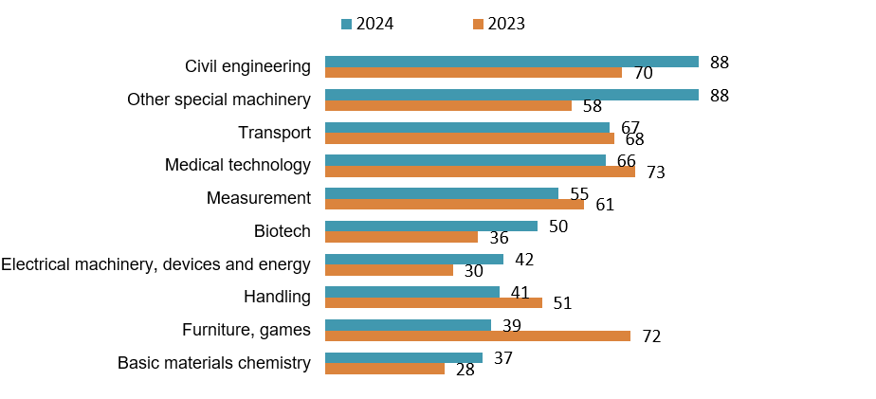
Subsectors of utility model applications
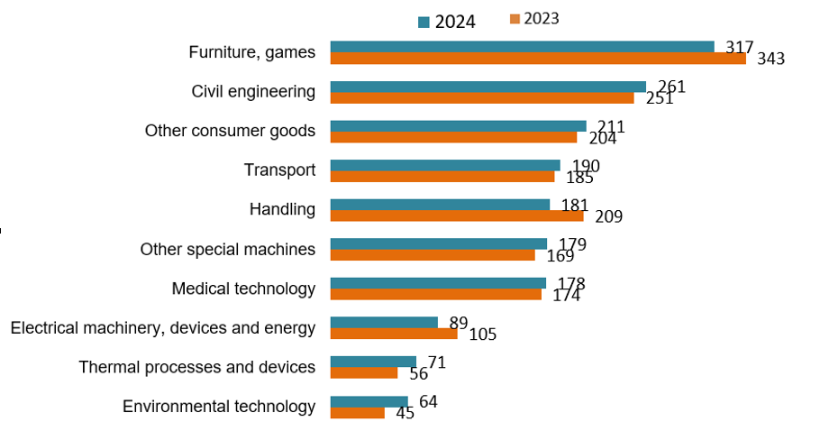

2.2. Minimum Documentation – Making Available for Consultation
Rules 36.1(ii) and 63.1(ii): That Office or organization must make available for consultation as part of the minimum documentation referred to in Rule 34, in accordance with the requirements specified in the Administrative Instructions, any patent issued, and any patent application published, by it, and where applicable by its legal predecessor(s).
The requirements specified in the Administrative Instructions are set out in Circular C. PCT 1672, dated June 19, 2024.
The making available for consultation as part of the minimum documentation referred to in Rule 34 of the patents issued and patent applications published by the Office or, where applicable, the Offices that are members of the intergovernmental organization in accordance with the Understanding adopted by the PCT Assembly in paragraph 8 of document PCT/A/55/2, is reported as follows:
☒ The PCT Minimum Documentation Task Force has tested the availability of the patent documentation collections before November 1, 2025, and certifies that the requirements have been met. The extent and format of the documents that the Authority has made available for consultation were published in the PCT Gazette on October 23, 2025, at: https://www.wipo.int/documents/d/pct-system/docs-en-official-notices-officialnotices.pdf#page=192.

2.3. Minimum Documentation – Access
Rules 36.1(iii) and 63.1(iii): That Office or organization must have in its possession, or maintain access to, at least the minimum documentation referred to in Rule 34, for search purposes in accordance with the Administrative Instructions.
The QMS Report provides information from the Authority on the infrastructure in place to ensure that at least the minimum documentation referred to in Rule 34 is available, accessible, properly arranged and maintained for search and examination purposes under paragraph 21.15(iv) of the Guidelines.
Other information beyond the QMS Report (optional):
As already stated in the QMS Report, all examiners are proficient in English and many of them also speak French and/or German. Moreover, to ease the search for and understanding of prior art in different languages, there is a bilateral cooperation plan between the European Patent Office (EPO) and the member States of the European Patent Organization (including Spain).
That includes the general language training project, which provides financial support to improve the language skills of staff at national patent offices in Europe who do not speak English, French or German as their native language. The courses are taught by the following prestigious language institutes: the British Council, the Goethe Institut and the Institut Français. Language courses are offered to national patent office staff in the form of individual training courses for senior managers and group courses for staff involved in patent-related activities, such as patent examiners.
It should be noted, as stated in the QMS Report, that the SPTO has access to a wide range of patent documentation and patent-related literature that exceeds the minimum documentation required by Rule 34.

2.4. Quality Management
Rules 36.1(iv) and 63.1(iv): That Office or organization must have in place a quality management system and internal review arrangements in accordance with the common rules of international search.
The QMS Report provides information from the Authority on the quality management system in place under Chapter 21 of the Guidelines and includes a report under paragraph 21.09 of the internal review arrangements that are further described in paragraphs 21.27 to 21.30 of the Guidelines.
Other information beyond the QMS Report (optional):
The quality management system at the SPTO is ISO 9001:2015 certified.
The scope of this system includes the PCT procedure, technology watch procedures, industrial designs, national trademarks and trade names, national patents, utility models, supplementary protection certificates, the registration of license agreements and transfer of industrial property rights, decisions on the restoration of rights, appeals, and the validation of European patents.
The last external audit was conducted in June 2025, and its follow-up has been successfully completed.

3. Scope of Operation
(a) Current scope of operation
The receiving Offices for which the Office or intergovernmental organization is competent as an International Searching Authority and an International Preliminary Examining Authority, language(s) in which services are offered and other details of scope of operation are listed in the PCT Applicant’s Guide at the following link: https://pctlegal.wipo.int/eGuide/view-doc.xhtml?doc-code=ES&amp;doc-lang=en#ISA; https://pctlegal.wipo.int/eGuide/view-doc.xhtml?doc-code=ES&amp;doc-lang=en#IPEA.
(b) Planned changes to scope of operation as an Authority, such the receiving Offices for which the Authority is competent and languages offered (if any):
The Office has no plans to alter its scope of operation as an International Authority. Specifically, the SPTO will continue to conduct international searches and draft preliminary examination reports in Spanish and English.
Furthermore, we will continue to conduct international searches and preliminary examinations for PCT international applications filed with the following receiving Offices (ROs):
- ES Spain
- CL Chile
- CO Colombia
- CU Cuba
- CR Costa Rica
- DO Dominican Republic
- EC Ecuador
- GT Guatemala
- HN Honduras
- MX Mexico
- NI Nicaragua
- PA Panama
- PE Peru
- SV El Salvador
- UY Uruguay (international searches)

4. OTHER
Any further information relevant to the extension of appointment as an International Searching and Preliminary Examining Authority:

WORK THROUGHPUT
Number of national applications (patents) received by technical field
Year  Applications | 2022 | 2023 | 2024 | 2025
National patents | 1,318 | 1,455 | 1,296 | 1,156
National utility models | 2,635 | 2,807 | 2,704 | 2,400

Average time taken to process national patents and utility models
Operation | Measured from | Time (months)
To conduct the search and first examination. | From filing of the application | 7.18 months for national patents
To conduct the search and first examination. | From filing of the application | No search is conducted for utility models
To grant | From filing of the application | 14.60 months if the applicant chooses the fast-track procedure (12.5% of applications)  21.90 months for the ordinary procedure
To grant | From filing of the application | 7.62 months for utility models (13.25 months in the event of pre-grant opposition; 1.25% of total applications)

These figures include both the first-time national applications and applications filed under the Paris Convention with the national phase of PCT international applications.
Year  PCT Applications | 2022 | 2023 | 2024 | 2025
Received as receiving Office | 893 | 827 | 832 | 671
International search reports as an ISA | 846 | 695 | 660 | 658
International preliminary examinations as an IPEA | 53 | 33 | 33 | 37

MEASURES TO IMPROVE SPTO INTERNATIONAL SEARCH REPORTS

Since the mid-2020s, the SPTO offers the “PCT Direct” service. This optional service allows applicants to submit informal comments, by letter, on the objections raised in the written opinion of the previous application, for which priority is claimed. These comments contribute to an improved assessment of international applications, adding value to the international search report and the written opinion drafted by the SPTO as the authority responsible for the search. That, in turn, leads to overall higher quality products issued by the Office.

INTERNATIONAL COOPERATION

As a rule, the SPTO benefits from and greatly values the work done by other IP offices and by international authorities and the International Bureau, both through the resources made available to PCT contracting States and through discussions and meetings held to share and disseminate best practices.

Cooperation between the SPTO, other IP offices and international organizations has therefore proven essential for exchanging information and harmonizing IP practices.

In addition to strengthening relationships, these initiatives help to protect and promote IP rights through partnerships based on the exchange of information, best practices and training activities, resulting in shared experiences that are mutually beneficial.

In that context, the SPTO recently adopted its Strategic Plan for the years 2025-2027. Its overall objectives include strengthening leadership and improving cooperation by the SPTO at the national and international levels.

Such cooperation at the international level, however, is nothing new and the SPTO has intensified its cooperation and partnerships over the years.

Cooperation at the European level with the EPO

At the European level, the SPTO participates in activities to harmonize searching in Europe under the PCT, in accordance with the Protocol on Centralisation of the European Patent System under the European Patent Convention, which stipulates cooperation between the EPO and the other European ISAs/IPEAs. A Permanent Committee on Harmonisation of Search Activities (PCHSA) has been set up, together with three specialized working groups focusing on quality, tools and training. Representatives from each Office sit on the groups and hold regular meetings to promote collaboration and standardization in search activities. In particular, cooperation covers search procedures and methods, the qualifications required by candidates for recruitment and training as examiners, guidelines for the exchange of searches, the exchange of harmonization files (to promote the convergence of search practices among European ISAs) and other services between Offices, as well as other measures necessary to establish the required level of control and supervision.

With respect to the harmonization file exercise, examiners from one of the participating European ISAs and examiners from the EPO conduct a comparative analysis between the searches carried out by each of them on the same application file.

Then, at the PCHSA meeting, a comprehensive study is presented examining similarities and differences between the searches performed by the examiners from the European ISA and EPO. Special attention is paid to where there is divergence on key issues such as the assessment of novelty, inventive step, clarity, and unity of invention.

The comparative analysis presented at the PCHSA meeting includes quantitative metrics relating to classification and search strategies, as well as a detailed discussion of the interpretation of claims and citations used during the search.

International cooperation

International cooperation is demonstrated through a number of Patent Prosecution Highway (PPH) agreements that the SPTO has signed with other IP offices (such as those of Brazil, China, Colombia, Finland, Japan, Mexico, Morocco, Peru and Türkiye). The purpose of those PPH agreements is to promote work-sharing and allow patent applicants to request fast-track processing of their applications. This Office has also signed a number of PCT-PPH agreements that include PCT work products. In 2014, the SPTO also joined the Global PPH Project, which allows patent applicants to request fast-track examination at any of the 28 offices involved.

The SPTO has also established bilateral cooperation programs with a number of countries (including Argentina, Brazil, Chile, China, Colombia, Costa Rica, Cuba, Ecuador, El Salvador, Greece, Italy, Republic of Korea, Mexico, Peru, Portugal, the Russian Federation, Singapore and Türkiye). These memorandums of understanding provide a framework within which IP offices share experiences or training programs, cooperate in application searches and examinations, or exchange data in order to improve the international patent system.

Under those bilateral programs, the SPTO has run a Training Program on Patent Searches and Examinations (CIBIT) since 2002. Its chief goal is to teach Ibero-American patent examiners to search in different databases and to use different technological information services.

The SPTO has long prioritized its relationship with Latin America in the field of IP. With that in mind, the Spanish Fund-in-Trust (FIT/ES) was established at the World Intellectual Property Organization (WIPO) in 2004. Since then, the FIT/ES has supported many projects.

- One example is the LATIPAT project to create a free database in Spanish and Portuguese containing patent information from all Latin American countries, which would serve as a global reference tool.

- The Fund-in-Trust has also financed a patent manual for the countries of Central America and the Dominican Republic, in which common guidelines are set for examining patent applications in participating countries.

Furthermore, interregional seminars for Latin American judges have been organized annually. Their purpose is to improve protection of industrial property and promote a uniform interpretation of current industrial property law.

For some years, as part of the Intercoonecta program, the SPTO has joined WIPO and the Spanish Agency for International Development Cooperation (AECID) to organize a Regional Workshop for Training of Trainers on Industrial Property: Drafting of Patent Applications in Latin American Countries, at the Spanish Cooperation Training Center in Montevideo.

In 2020, an agreement was reached between the not-for-profit International and Ibero-American Foundation for Administration and Public Policies and the SPTO on a twinning project with Egypt entitled “Supporting and upgrading the institutional, technical and awareness-raising capacities of the Egyptian Patent Office (EGYPO)”. Its aim was to support and improve the technical and institutional capacity and visibility of the Egyptian Office. With a budget of 1.5 million euros, it was conducted over a period of more than two years. The Danish Patent and Trademark Office (DKPTO) and the German Foundation for International Legal Cooperation (IRZ) supported the project as junior partners.

The project was structured around five components:

- Component 1: Establishment of a strategic IP plan for scientific research in Egypt.
- Component 2: Sustainable cooperation and coordination with rights holders, companies and small and medium-sized enterprises, focusing on institutions.
- Component 3: Review and update of EGYPO systems and procedures in line with European Union standards.
- Component 4: Skills building for EGYPO staff in granting patents and disseminating information.
- Component 5: Training and building the organizational skills of EGYPO staff.

The components corresponded to the expected results of the project, and a series of activities were planned throughout, including workshops, training sessions, expert missions, study visits and consultations. Expert examiners and other SPTO staff were sent to the EGYPO.

One success was the attainment by EGYPO of ISO 9001 quality certification, the fruit of joint efforts and support provided by quality experts from the Spanish and Egyptian Offices under component 3.

The SPTO also signed a memorandum of understanding with WIPO on cooperation in the dissemination of IP-related information. SPTO experts have participated in a range of events in the Republic of Moldova, Uzbekistan, Slovenia and Ukraine in order to meet the region’s academic needs and boost the qualifications of its IP professionals.

The SPTO and WIPO Academy organize annual Summer Schools on IP Law. Taught in Spanish, they give students in their final years and young professionals an opportunity to deepen their knowledge of industrial property and to become acquainted with the role and functions of WIPO in the global administration of IP. The program consists of lectures and round table discussions led by WIPO and SPTO experts and well-known professionals in the field of industrial and intellectual property.

As part of training cooperation with WIPO, the SPTO has been taking part since 2020 in advanced online courses on examining computer-implemented inventions (CIIs) and the issue of artificial intelligence (AI), biotech, and chemical and pharmaceutical products, conducted for Latin American examiners. Cooperation with WIPO and national offices runs along the following lines:

1. Phase 1: Theory, patent law in the selected technological sectors, with emphasis on international aspects and different jurisdictions.

2. Phase 2: How other offices operate: Presentations on theory and practice by international offices and some participating offices, with specific examples of examination, the interpretation of patentability requirements and the use of databases in the sector in question.

3. Phase 3: Training through the examination of specific applications by the participants, supported by regional and international tutors, based on the review of real cases being processed in each of the offices.

Last but not least, the SPTO works closely with the European Union Intellectual Property Office (EUIPO) and EPO, helping our Office to keep abreast of the latest IP-related IT tools and databases, continue harmonizing procedures and increase predictability for users.

OTHER SPTO SERVICES

Patent technology reports

Aware that companies and public research centers need to keep up with technology, the SPTO has expanded and diversified its range of technological information services, adopting new IT tools, designing new services and improving the format and content of those it has provided for more than 30 years.

Patent technology reports (PTRs) reports can be useful for:

- Planning research and development (R&D)
- Analyzing patentability of the results obtained
- Drafting patents
- Solving specific technical problems
- Learning about new products or areas of research
- Valuing license agreements
- Finding technologies in the public domain
- Preventing potential infringements

A PTR contains the following key elements:

- Purpose: detailed description of the technical issue addressed in the report.
- Search strategy: list of search criteria for retrieving information.
  - International Patent Classification
  - Key words
  - Related companies
- Results analysis: Most relevant documents retrieved and a brief description of their content compared with the subject of the report.
- Conclusion: Final comments on the report’s purpose and the documents retrieved.
- Reference list: bibliographic references of the documents retrieved in connection with the search subject, including web links, are attached in an annex.

Technology watch bulletins

The quarterly technology watch bulletins provide information on stand-out published patents and the latest advances in various technological sectors.

With this free technology information service, the SPTO helps to draw the public’s attention to technical information contained in patent documents.

SPTO produces the bulletins, on occasion in tandem with other national institutions such as the ITECAM and INESCOP technology centers, technology platforms such as VET+i, Food For Life Spain PTF4LS, BIOPLAT, PTEPA, ASEBIO and ITEMAS, or international organizations such as the National Industrial Property Institute of Portugal.

The bulletins cover the following sectors:

- Biotech and health:
- Coronavirus: diagnosis and treatment for humans
- Health biotech
- Medical devices
- Animal health
- Food:
- Agri-food sector
- Fisheries and aquafarming
- Energy and sustainability:
  - Biomass
  - Ocean energy
- Mobility:
- Electric vehicles
- Intelligent vehicles
- ICT:
- eDependence
- Advanced mobile services and interfaces
- Wireless sensor networks
- Industry:
- Metalworking
- Plastic processing
- 3D printing
- Footwear

Technology alerts

Technology alerts provide up-to-date information on the latest patents published worldwide in a specific technical area.

The themes of each alert are set jointly with technology platforms and other institutions or organizations and tailored to the specific information needs of companies and public research organizations in different technology sectors.

In this way, SPTO maintains the commitment it made in 2012 to work with the aforementioned platforms to bring patent information to companies, researchers and R&D managers, thereby helping them to generate technology with added value, obtain a financial return, become more competitive and expand abroad.

Once a topic of interest has been decided upon, patent examiners devise a search strategy enabling users to identify the latest patents published anywhere in the world on that topic when they read the alert.

The specific technical areas are:

- Life and food sciences:
  - Hematological neoplasms: leukemias, lymphomas and myelomas
  - Biocides and plant growth regulators of biological origin
  - Nanodrugs
  - Monitoring and control technology for diabetes
  - Viticulture and enology
  - Coronavirus: diagnosis and treatment for humans
  - 3D bioprinting
  - Salmonella
  - Biomarkers for the diagnosis of dementia
  - Microalgae: cultivation and uses
  - Biomarkers for the diagnosis of inflammatory bowel disease.
  - Treatment of Alzheimer’s disease, Parkinson’s disease, Huntington’s disease and amyotrophic lateral sclerosis

- Energy and sustainability:
  - Geothermal energy
  - Concentrated solar power (CSP)
  - Fuel cells
  - Photovoltaic solar energy
  - Electrolytic hydrogen
  - Wind energy
  - Battery storage
  - Ocean energies
  - Low temperature solar energy
  - Floating wind energy
  - Personal mobility vehicles
  - Biofuels, bioenergy and bio-based products

- Materials and their applications:
  - Biodegradable plastic materials and packaging
  - Oxygen scavengers in plastic formulations
  - Security inks
  - Carbon nanomaterials
  - Inks and paints with electrical properties
  - Varnishes and textiles with functional nano-coatings

- AI and Blockchain:
  - Machine learning
  - Neural networks
  - Fuzzy logic
  - Blockchain

- Miscellaneous:
  - Logistics: management systems
  - Road safety

Retrospective searches

This service provides users with bibliographic references relating to patents and utility models published in Spain (national search) and references in English relating to patents published elsewhere (international search), on a given topic.

Each reference includes a link to INVENES (a database of inventions in Spain) and Espacenet to access the complete document.

Tailor-made technology watch reports

Users can receive these reports as regularly as they wish. They provide bibliographic references relating to patents and utility models published in Spain (national search) and references in English relating to patents published elsewhere (international search), on a given topic.

Again, each reference includes a link to INVENES and Espacenet to access the complete document.

On-call examiner

First, the SPTO has an Information Service for general enquiries. Users can contact the SPTO by telephone or email (there is a dedicated email address for information), or visit its headquarters in person.

More specific queries on inventions, which cannot be handled by the general information service, are referred to the On-call Examiner Service.

That service fields enquiries on the following:
- Patentability, novelty, inventive step, and unity of invention
- Scope and content of claims
- Drafting of the patent, PCT or utility model application (in general, however, this does not involve suggesting or correcting specific text)
- Patent search in the free Espacenet and INVENES databases; SPTO technological information services

Enquiries on applications currently being processed, such as with regard to suspension or objections to admission for processing are referred to the examiner handling the application or, where appropriate, to the Head of Service or Head of Area.

PCT information brochures

The SPTO website carries several brochures on the PCT procedure and its potential advantages. Some are general and others explain how to file such an application with the SPTO. The more specific brochures detail the different phases of the PCT procedure.

PCT mailbox

The SPTO has a specific mailbox for email enquiries, whether general or more specific in nature. The mailbox is staffed by SPTO receiving Office personnel. If need be, they will forward enquiries to the examiners conducting the international search or examination in question.

[End of Annex and document]

Updated as of October 31, 2025.
The Spanish national procedure includes a written opinion together with the search results; the first examination is therefore carried out at that time.
Updated as of October 31, 2025.
The Fund has also enabled the creation of a harmonized manual of criteria for registering distinctive signs for the countries of Central America and the Dominican Republic. The manual also serves as a common reference tool for the administrative and technical management of the procedure for granting trademarks.

