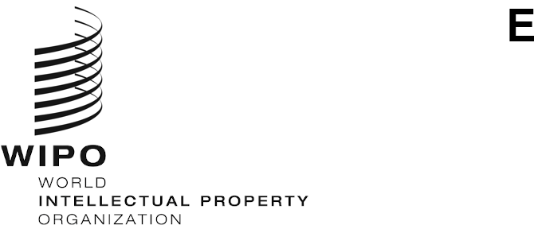
PCT/CTC/32/3
ORIGINAL: English
DATE: October 7, 2022

Patent Cooperation Treaty (PCT)
Committee for Technical Cooperation

Thirty-Second Session

Geneva, October 3 to 7, 2022

Summary by the Chair

Agenda Item 1: Opening of the session
- Ms. Lisa Jorgenson, Deputy Director General, Patents and Technology Sector, opened the session and welcomed the participants on behalf of Mr. Daren Tang, Director General of WIPO. Mr. Michael Richardson (WIPO) acted as Secretary to the Committee.
- The list of participants is set out in document PCT/WG/15/INF/1.

Agenda Item 2: Election of a Chair and two Vice-Chairs
- The Committee unanimously elected Ms. Aleksandra Mihailović (Serbia) as Chair. There were no nominations for Vice-Chairs.

Agenda Item 3: Adoption of the agenda
- The Committee adopted the draft agenda as set out in document PCT/CTC/32/1 Prov.

Agenda Item 4: Advice to the Assembly of the PCT Union on the proposed appointment of the Saudi Authority for Intellectual Property as an International Searching and Preliminary Examining Authority under the PCT
- Discussions were based on document PCT/CTC/32/2 Rev.
- The Committee unanimously agreed to recommend to the Assembly of the PCT Union that the Saudi Authority for Intellectual Property be appointed as an International Searching and Preliminary Examining Authority under the PCT.

Agenda Item 5: Summary by the Chair
- The Committee noted this summary, established under the responsibility of the Chair, and agreed to make it available to the Assembly of the PCT Union as a record of the advice given under agenda item 4.

Agenda Item 6: Closing of the session
- The Chair closed the session on October 7, 2022

[End of document]

