E
PCT/CTC/30/23
ORIGINAL: English
DATE: March 16, 2017

Patent Cooperation Treaty (PCT)
Committee for Technical Cooperation

Thirtieth Session
Geneva, May 8 to 12, 2017

Extension of Appointment of the Nordic Patent Institute as an International Searching and Preliminary Examining Authority Under the PCT

Document prepared by the International Bureau

- All of the existing International Authorities were appointed by the PCT Assembly for a period ending on December 31, 2017. In 2017, the Assembly will therefore need to make a decision on the extension of the appointment of each existing International Authority that wishes to seek an extension of its appointment, having first sought the advice of this Committee (see PCT Articles 16(3)(e) and 32(3)). Information concerning this process and the role of the Committee is set out in document PCT/CTC/30/INF/1.
- On March 7, 2017, the Nordic Patent Institute submitted its application to extend its appointment as an International Searching Authority and International Preliminary Examining Authority under the PCT. This application is reproduced in the Annex to this document.
- The Committee is invited to give its advice on this matter.

[Annex follows]
Application of the Nordic Patent Institute
for Extension of Appointment
as an International Searching and Preliminary Examining Authority Under the PCT

1 – General
Name of Office or intergovernmental organization: Nordic Patent Institute, Intergovernmental Organization established by the governments of Denmark, Iceland and Norway.

Date on which application for reappointment was received by the Director General: March 7, 2017

Session of the Assembly at which reappointment is to be sought: Forty-Ninth Session, October 2 to October 11, 2017 in Geneva, Switzerland.

Expected date at which operation as ISA/IPEA could commence: Nordic Patent Institute is seeking reappointment and is therefore already operating as ISA/IPEA

Existing ISA/IPEA(s) assisting in assessment of extent to which criteria met: N/A

2 – Substantive Criteria: Minimum Requirements for Appointment

2.1 – Searching and Preliminary Examining Capacity
Rules 36.1(i) and 63.1(i): The national Office or intergovernmental organization must have at least 100 full-time employees with sufficient technical qualifications to carry out searches and examination

Employees qualified to carry out Searching and Preliminary Examining:

The operation of the Institute is based on cooperation between the national patent offices of the three contracting states and exploitation of the existing resources and competencies of the national offices. The Icelandic Patent office has chosen not to perform Searching and Preliminary Examining by its own staff so all Searching and Preliminary Examining is carried out by the patent examiners of the Danish Patent and Trademark Office and the Norwegian Industrial Property Office.

Organization of NPI

* Services supplied by the national patent offices

The number of qualified examiners performing Searching and Preliminary Examining for NPI is 150, with 80 examiners in NIPO and 70 in DKPTO. The breakdown into technical fields, experience and qualifications is as follows:

Technical field | Number (in full-time equivalent) | Average experience as examiners (years) | Breakdown of qualifications
Mechanical | 60 | 15.1
Electrical/electronic | 43 | 13.3
Chemistry | 30 | 15.7
Biotech | 17 | 13.8
Total | 150 | 14.5 | 16% PhD, 84% MSc or equivalent.

Training Programs

All new NPI examiners start a 12-18 month training period before they are given the right to decide the outcome of a patent application on their own. During the training period, all new examiners will have at least two different mentors within their technical field, or a closely related technical field. The mentors are experienced examiners, trained to be mentors. The mentor will follow up all work performed by the new examiner, and work closely in every day matters related to case handling and examination. In addition to working close with a mentor, all new examiners attend a comprehensive educational program covering all aspects of the case handling procedures.

The examiners are extensively trained in the laws and legislation related to patents. This includes the PCT Treaty, Regulations and Administrative Instructions and the PCT International Search and Preliminary Examination Guidelines. Furthermore, examiners are trained in the use of tools and databases related to search, internal systems and documentation.

All experienced examiners are encouraged to keep up to date on their technical fields. This is made possible through discussions and practices within their technical groups, by attending external courses and conferences within their technical field, as well as keeping up on information on internet and in different journals. All examiners attend regular meetings where specialists within Searching and Preliminary Examining give an update on changes or new aspects regarding the work performed.

Rules 36.1(ii) and 63.1(ii): That Office or organization must have in its possession, or have access to, at least the minimum documentation referred to in Rule 34, properly arranged for search purposes, on paper, in microform or stored on electronic media.

Access to the minimum documentation for search purposes:
(X) Full access
( ) Partial access (indicate areas currently missing and how you intend to obtain access to the missing areas)

Search systems:

All NPI examiners have full access to PCT-minimum as referred to in Rule 34.

Searches are mainly conducted online by using the same databases and search systems provided to EPO member states. The most important databases are EPODOC, WPI and INSPEC are accessed via the EPOQUENET search tool. Other important document databases are accessed for instance via Dialog and STN. Examiners also use full text databases in various languages and other databases containing articles and other non-patent literature.

NPI also operates as a commercial search services provider and as such has teamed up with various commercial database providers. This means that NPI examiners also have access to various specialized databases both patent and non-patent, both directly or via Dialog and STN including M-CAM, IEEE, GenomeQuest and more.

The collection of patent documents and other publications in paper is gradually being digitalized. This is used whenever appropriate.

Rules 36.1(iii) and 63.1(iii): That Office or organization must have a staff which is capable of searching and examining the required technical fields and which has the language facilities to understand at least those languages in which the minimum documentation referred to in Rule 34 is written or is translated.

Language(s) in which national applications may be filed and processed:

All the NPOs have Danish, English, Norwegian and Swedish as filing languages, in Iceland you can also file in Icelandic.

Other languages in which large numbers of examiners are proficient:

German and French.

Services available to assist search or understanding of prior art in other languages:

The diversity of the examiner group means that we have the possibility to review prior art in over 30 languages, if necessary by pairing examines with the right language skills with a technically competent examiner. Additionally we have access (via STN and Dialog) to numerous full text patent databases including Chinese, Japanese, Korean and more, translated to English.

Online translation tools such as the EPO/Google translator accessible via Espacenet are also used.

2.2 – Quality Management
Rules 36.1(iv) and 63.1(iv): That Office or organization must have in place a quality management system and internal review arrangements in accordance with the common rules of international search.

National quality management system:

Nordic Patent Institute (NPI) has established a Quality Management System in accordance with ISO 9001 standard. The system covers all services offered and consists of three levels. Level 1 describes the policy, goals and organization of the Institute, level 2 contains procedures for handling of the QA system and level 3 contains the procedures for the daily operation of Nordic Patent Institute, including the association.

Searching and Preliminary Examining of PCT applications is carried out by examiners of the Danish Patent Office (DKPTO) and Norwegian Industrial Property Offices (NIPO) on behalf of NPI. Both offices have quality Management System (QMS) certified according to ISO 9001 standards.

The Service Agreements between NPI and DKPTO and between NPI and NIPO specify exact requirements for the quality management system in the national patent offices of Denmark and Norway. The documentation in the national QMS systems relating to PCT Searching and Preliminary Examining has been fully harmonized between the two offices, creating so-called Common National Procedures (CNPs).

The national quality systems in DKPTO and NIPO, as well as the NPI quality system, are described and maintained in electronic form. The Common National Procedures are described and maintained in English on a common server, accessible to all NPI staff and the staff of the national patent offices, which work on NPI matters.

Since Iceland, as a member state of Nordic Patent Institute, does not perform any search or examination work on behalf of NPI, the quality management system of NPI does not contain provisions concerning Searching and Preliminary Examining.

For more in-depth information on our quality management system we refer to our annual PCT International Authority Quality Report issued in accordance with PCT International Search and Preliminary Examination Guidelines, paragraphs 21.26 and 21.27. The report is available on the WIPO website: http://www.wipo.int/pct/en/quality/authorities.html.

If applying as an international organization consisting of a group of national Offices, outline the arrangements to ensure appropriate distribution, and consistent timeliness and quality of reports:

NPI has Service Agreements between NPI and the Danish Patent Office and the Norwegian Industrial Property Offices governing the work carried out on behalf of NPI in accordance with the PCT guidelines.

The Service Agreements, which are negotiated annually, contain the specification of the services that the national patent offices shall provide to NPI. Services Agreements describe in detail specifications of the delivery of PCT services, including, standards, formalities, coordination and reporting. The national offices perform the tasks of the International Secretariat (ISEC). ISEC is responsible for further communication with the international Bureau (IB) of WIPO, with the applicant, all PCT formalities tasks and collection of later fees.

ITS
Demand
ITS
Protest
IB WIPO
Applicant
Applicant
Nordic Patent Institute

ISA / IPEA

ISEC/DK Search and Examination DK
ISEC/NO Search and Examination NO
National office
Application
RO/SE
RO/IB
RO/NO
RO/IS
RO/DK

Communication between the Nordic Patent Institute and the NPOs about PCT tasks is handled by ISEC. This includes all types of formalities as well as reallocation of cases between NIPO and DKPTO in case of mistakes. Reallocation between NIPO and DKPTO in case of temporary under-capacity at one office is handled by departmental heads on an ad hoc basis.

Each NPO updates on a regular basis a list of technical areas for which it on a long term has limited capacity available for work for the Nordic Patent Institute. The Institute makes a consolidated list covering all NPOs and the Board of Nordic Patent Institute takes the necessary steps to ensure that there will always be capacity available for work for the Institute in at least one NPO to ensure appropriate distribution, and consistent timeliness.

3 – Intended Scope of Operation
Language(s) in which services would be offered:

Danish, English, Icelandic, Norwegian and Swedish

State(s) or receiving Office(s) for which Authority would offer to be competent:

Denmark, Iceland, Norway, Sweden (and as RO, the International Bureau of WIPO).

Limitations on scope of operation:

The scope of operation is limited only by the obligations of Denmark, Iceland, and Norway within the framework of the European Patent Organisation.

4 – Statement of Motivation
Nordic Patent Institute (NPI) is an international organization established by the governments of Denmark, Iceland and Norway.

The agreement on NPI’s establishment was signed in July, 2006 and it was appointed as a PCT International Searching and Preliminary Examining Authority by the PCT General Assembly in September same year. NPI started operations as an ISA/IPEA on January 1, 2008.

NPI was established in order to give the users in the contracting states the best possible local framework conditions for operating efficiently in a patent active market as well as contribute to the development of the PCT system. As an International Searching and Preliminary Examining Authority, NPI supplies international patenting and information services in close cooperation with the participating national patent offices in order to stimulate innovation in the contracting states.

Nordic Patent Institute draws upon the resources of the national patent offices of the contracting states, thereby strengthening competencies at national level and at the same time exploiting the advantage of having access to the consolidated resources of the national offices. This model has proved to be incredibly successful and has since been duplicated in other regions.

On a global scale the NPI member states are small countries. Nevertheless they are all knowledge based economies, regularly ranked amongst the world’s most innovative nations. SMEs are the backbone of the economy in the NPI member states, representing a large majority of all enterprises. They are crucial for growth, prosperity and job creation in the region. Providing a local option with close personal contact has opened the international patent system to many of these companies.

Patent protection on a global scale has become increasingly important in the knowledge-based society. Consequently, the need for an efficient patent system offering high quality products and services has also increased. The PCT system offers an excellent platform for such a global system, and we have noted with satisfaction the great success of the PCT system, although we are also concerned about the ensuing consequences on workload and backlogs at the PCT authorities. It is our firm belief that an efficient and successful global patent system must start at the national level, i.e. by offering the best possible national framework conditions for protection of innovations.

Since start of operations, NPI and its member states have been very active in improving the PCT system, with participation in various forums such as the PCT Working Group, Meetings of International Authorities (MIA) and the MIA Quality Sub Group. (In February 2017, the Nordic Patent Institute hosted the MIA and MIA Quality Sub Group meetings in Reykjavík Iceland.).

Furthermore, NPI has from the beginning had excellent cooperation with the International Bureau of WIPO. The most important part of this cooperation at the moment is the PCT Online Services. We will continue to cooperate with WIPO in developing these services for the benefit of the users, other International Authorities and national offices of all the PCT member states.

The NPI member states have hosted numerous Intellectual Property focused activities in cooperation with WIPO, including several within the scope of providing technical assistance to Developing Countries. This includes training courses for patent examiners and courses related to patent quality. Furthermore, The Danish Patent and Trademark Office has for almost two decades provided support and technical assistance to various countries around the globe, including many Eastern European countries through so-called Twinning programs, sponsored by the European Union.

The experience and competences gained from operating as ISA/IPEA under the PCT has contributed to increasing the capabilities of our staff to provide technical assistance to other PCT member states, in particular Developing Countries, which the NPI and its member states are focused on continuing for the coming years.

Nordic Patent Institute is committed as an International Searching and Preliminary Examining Authority under the PCT, to continue to support the global development and usefulness of the PCT system with its highly competent resources.

5 – Applicant State(s)
Regional location

Nordic Patent Institute acts as International Search Authority (ISA) and International Preliminary Examination Authority (IPEA) for nationals and residents of Denmark, Iceland, Norway and Sweden.

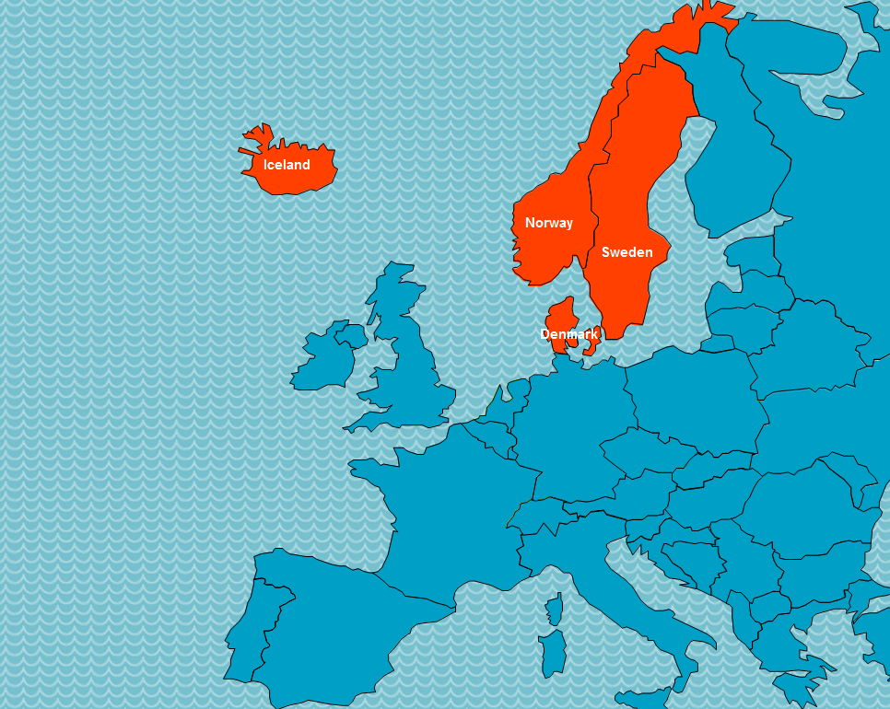

Regional organization memberships:

All the member states of Nordic Patent Institute are members of the European Patent Organization.

Population (2016):
Denmark: 5,7 million
Iceland: 330,000
Norway: 5,2 million

GDP per capita (2016):
Denmark 48,994 United States dollars
Iceland 47,679 United States dollars
Norway 62,025 United States dollars

Estimated national R&D expenditure (% of GDP):
Denmark 3.0%
Iceland 2.2%
Norway 1.9%

Number of research universities:
Denmark 8
Iceland 4
Norway 9

Summary of national patent information network (for example patent libraries, technology and innovation support centers):

All the NPI member states are members of the European Patent Organization. As such they all have set up several so-called PATLIB (PATent LIBrary) centers, in cooperation with the European Patent Office (EPO). Their qualified and experienced staff can offer practical assistance on a variety of intellectual property rights (IPR). Denmark has four PATLIB centers, Iceland has three and Norway one.

The national patent offices of the member states are all responsible for promoting innovation and information on patents and other Intellectual Property Rights in their member states. All offices offer a broad variety of patent information services including written material, online services, information centers, education programs and other activities. International and regional cooperation plays an important role, with organizations such as WIPO, EPO and EUIPO. Many of these activities are coordinated and/or jointly organized by the NPI member states.

Major local industries:

The major Danish industries include a high-tech agricultural sector, advanced industry with world-leading firms in pharmaceuticals, electronics, maritime shipping and renewable energy. Its main exports include processed foods, agricultural and industrial machinery, pharmaceuticals, furniture, electronics and windmills.

Iceland’s main industries include fish processing, aluminum smelting, ferrosilicon production, geothermal power, hydropower, tourism. Iceland has played a leading role in genetic, environmental and renewable energy research. Main exports are aluminum, ferroalloys and fish.

Norway is one of the world’s largest oil exporters, and is among the world leaders in aquaculture, maritime industries, hydropower, energy, technology and telecommunications. Norway’s main exports include petroleum and petroleum products, machinery and equipment, metals, chemicals, ships and fish.

Major trading partner States:

The top five major trading partner states of the NPI member states in 2015 where as follows:

Denmark: Germany, Sweden, Norway, United Kingdom and United States of America.

Iceland: Netherlands, United Kingdom, Spain, Germany, France.

Norway: United Kingdom, Germany, Netherlands, France, Sweden.

Other key information:

See the following links for information on national Intellectual Property Policies of the NPI member states:

Denmark:
http://www.dkpto.org/ip-law--policy/national-ip-policy.aspx

Iceland:
https://www.atvinnuvegaraduneyti.is/media/Acrobat/160610-Hugverkastefna-vefutgafa.pdf (currently only available in Icelandic).

Norway:
https://www.regjeringen.no/no/dokumenter/meld-st-28-20122013/id722822/sec1 (currently only available in Norwegian).

6 – Profile of Patent Applications
Statistical information on International Search Reports and International Preliminary Examination Reports from NPI, including information on timeliness is available at WIPO:

http://www.wipo.int/pct/en/activity/index.html
https://patentscope.wipo.int/search/en/structuredSearch.jsf

Number of national applications received – by technical field

Year  Technical Field | 2013 |  |  | 2014 |  |  | 2015 |  |  | 2016
 | DK | IS | NO | DK | IS | NO | DK | IS | NO | DK | IS | NO
Mechanical | 222 |  | 777 | 417 |  | 776 | 305 |  | 814 | 290 |  | 871
Electrical/electronic | 155 |  | 192 | 300 |  | 171 | 249 |  | 179 | 237 |  | 208
Chemistry | 103 |  | 92 | 155 |  | 105 | 117 |  | 121 | 148 |  | 132
Biotech | 15 |  | 10 | 14 |  | 12 | 11 |  | 9 | 11 |  | 15
Other or not classified by tech. | 1039 | 46 |  | 697 | 49 |  | 1050 | 46 |  | 1162 | 38
Total | 2,651 |  |  | 2,696 |  |  | 2,901 |  |  | 3,112

Number of national applications received – by route
Year  Route | 2013 |  |  | 2014 |  |  | 2015 |  |  | 2016
 | DK | IS | NO | DK | IS | NO | DK | IS | NO | DK | IS | NO
National first filing/internal priority | 1341 | 41 | 1071 | 1381 | 38 | 1064 | 1462 | 43 | 1123 | 1551 | 36 | 1226
Paris priority | 132 |  | 146 | 126 |  | 95 | 187 |  | 129 | 228 |  | 101
PCT national phase entry | 61 | 5 | 538 | 76 | 11 | 417 | 83 | 3 | 556 | 69 | 2 | 741

Number of international applications received as RO

Year  Technical Field | 2013 |  |  | 2014 |  |  | 2015 |  |  | 2016
 | DK | IS | NO | DK | IS | NO | DK | IS | NO | DK | IS | NO
Not classified by tech. | 636 | 14 | 303 | 505 | 15 | 302 | 459 | 17 | 301 | 521 | 21 | 304
Total | 953 |  |  | 822 |  |  | 777 |  |  | 846

Main Offices/States in which priority is claimed from national applications:

Denmark: From 2012-2015 the split was DK 71%, US 17%, EP 9%, GB 2%.

Iceland: N/A

Norway: Fraction of priority countries last five years of the PCT applications to Norway:
US 56%, GB 8%, EP 7%, DE 3%, FR 3%, JP 3%

Average time taken for national patent processing
Denmark
Indicator | Measured from | Time (months)
To search | Date of filing | 7
To first examination | Date of filing | 7
To grant | Date of filing | 23 (90% within 18 months)

Iceland
Indicator | Measured from | Time (months)
To search | Sent to DKPTO | 4
To first examination | Sent to DKPTO | 4
To grant | Date of filing | 81

Norway
Indicator | Measured from | Time (months)
To search | Date of filing | 6.5
To first examination | Date of filing | 6.5
To grant | Date of filing | 24.0

National backlogs
Denmark
Measure 3 March 2017 | Number of applications
All pending applications | 2,546
Applications awaiting search (where relevant fees paid) | 1,012
Applications awaiting first examination (where relevant fees paid) | 1,012

Norway
Measure | Number of applications
All pending applications | 8,728
Applications awaiting search (where relevant fees paid) | 6,271
Applications awaiting first examination (where relevant fees paid) | 6,271 (same, one operation)

[End of Annex and of document]

Global Innovation index rankings 8, 13 and 22 in 2016 http://www.wipo.int/publications/en/details.jsp?id=4064 and ranking as no. 1, 5 and 13 on the Index of Patent Systems Strength 2014/2015 https://www.liverpool.ac.uk/management/research/projects/patent-systems/
Search and examination on Icelandic national patent applications is performed by the DKPTO.
March 3, 2017. Under the terms of the Service Agreement between NPI and NIPO and DKPTO the national backlogs have no effect on the timeliness on ISA/IPEA work performed for NPI.

