E
PCT/CTC/28/3
ORIGINAL: English
DATE: April 1, 2015

Patent Cooperation Treaty (PCT)
Committee for Technical Cooperation

Twenty-Eighth Session
Geneva, May 26 to 29, 2015

Appointment of the visegrad patent institute as an International Searching and Preliminary Examining Authority under the PCT: additional information

Document prepared by the International Bureau

- The Annex to the present document sets out further information on the existing quality management systems (QMS) covering the national patent granting processes of the four industrial property Offices participating in the Visegrad Patent Institute, presented in the form of individual QMS reports in accordance with Chapter 21 of the PCT International Search and Preliminary Examination Guidelines.
- The Committee is invited to note the contents of the present document.
[Annexes follow]
Report on Quality Management Systems
prepared by the Industrial Property Office of the Czech Republic (IPO CZ)
as participating office of the Visegrad Patent Institute (VPI)

The Authority should provide general background information relevant to the quality management system (QMS) as set forth in this template.
The descriptions below each main heading of this template should be considered examples of the type and arrangement of information that should be included under each heading. Each Authority may provide additional information beyond that set forth in this template as desired. INTRODUCTION (PARAGRAPHS 21.01 - 21.03)

If applicable, the Authority may at this point indicate any recognized normative reference or basis for their quality management system besides Chapter 21, such as ISO 9001, under the heading “Normative Reference for QMS”
For example: “Normative reference for QMS: ISO 9001, EQS (European Quality System)”
Each Authority should then provide at least the information indicated in the descriptive boxes, under the following headings

The Industrial Property Office of the Czech Republic (IPO CZ) strives to maintain and further increase the efficiency, trustworthiness and quality of all administrative activities and services it provides. It places emphasis on the protection of information, takes care of workplace safety, and has a responsible approach to environmental protection. The integrated system of the Office management has been systematically improved along with this. At present, this includes the system for quality management according to the requirements of the ISO 90001:2008 standard, the information security management system according to the requirements of the ISO/IEC 27001:2005 standard, the occupational health and safety management system according to the BS OHSAS 18001:2007 standard and the system of environmental protection according to the ISO 14001:2004 standard. In cooperation with the European Patent Office, the European standard of quality management – EQMS – CA 57/07 has been implemented.
The IPO CZ Integrated management system is certified by independent international external auditors. Quality Austria Training, Certification and Evaluation GmbH. and CIS Certification and Information Security Services GmbH.

Figure 1: The IMS certification of the IPO
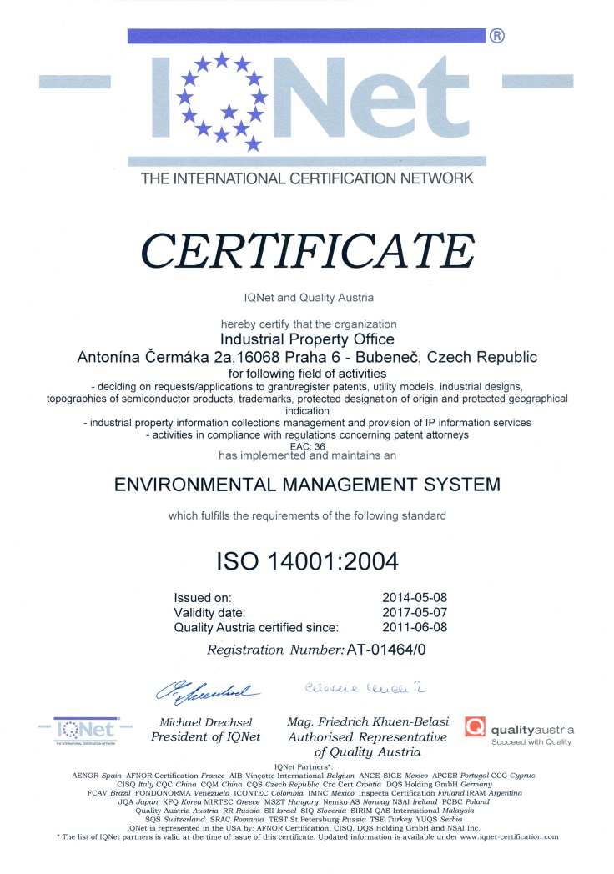
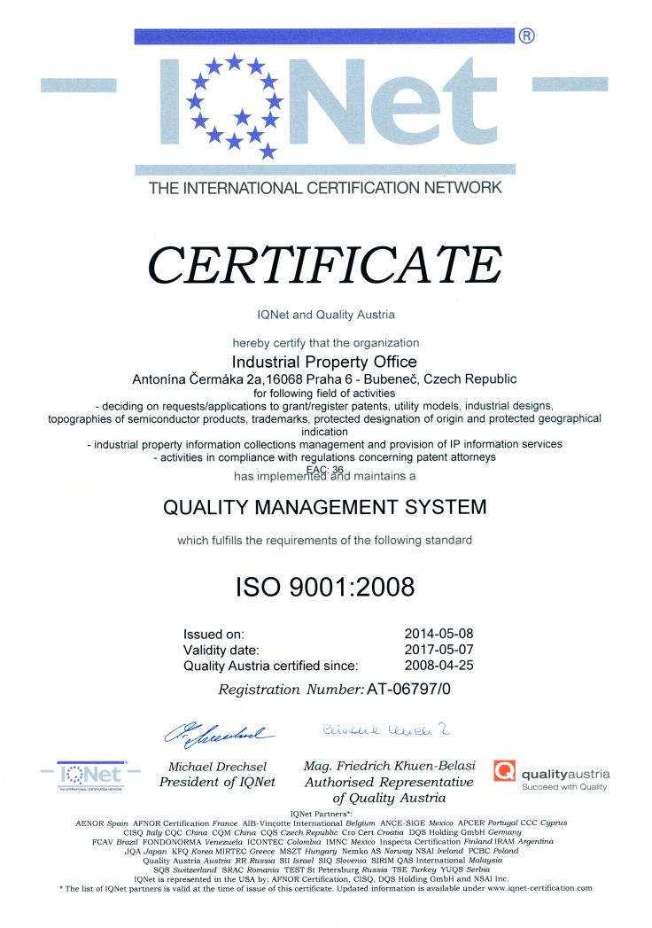
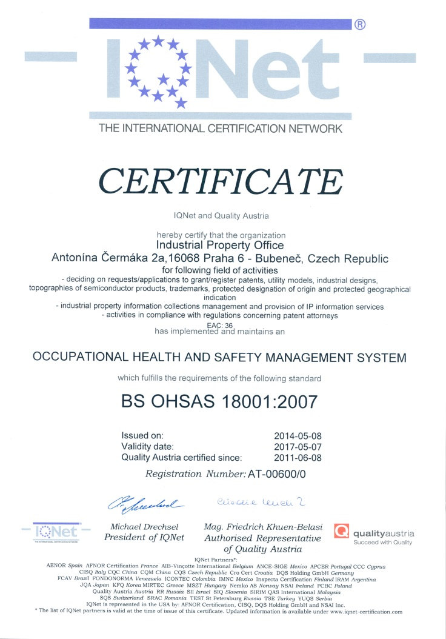

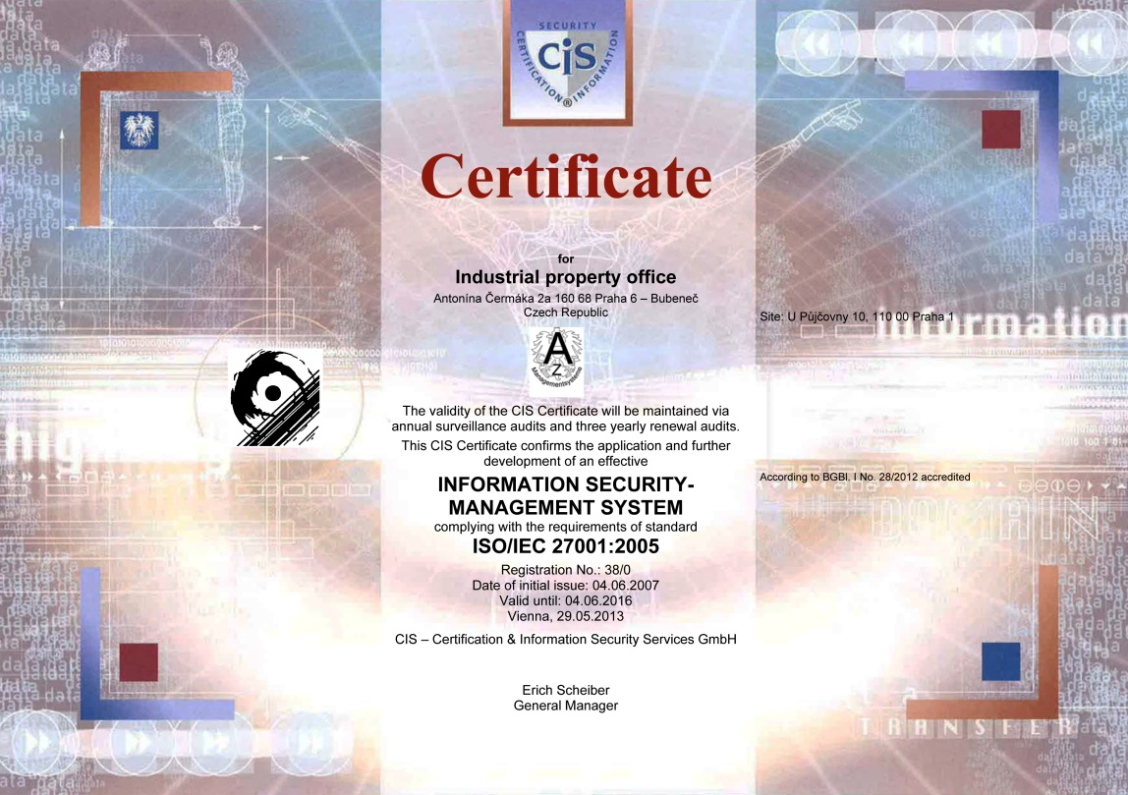

1. LEADERSHIP AND POLICY

21.04 Confirm that the following are clearly documented, and that this documentation is available internally:
(a) The quality policy established by top management.
(b) The roles and names of those bodies and individuals responsible for the QMS, as delegated by top management.
(c) An organizational chart showing all those bodies and individuals responsible for the QMS.
(a) The quality policy established by the top management:

POLICY of the Integrated Management System
- Responsibility to the State
The IPO CZ (hereinafter referred to as Office) takes such actions that promote the rights and interests of the State and all its citizens. It lays great emphasis on information protection when dealing with information related to support of the public service industrial property protection. Information security is promoted at all levels of the Office and the managers of the individual Office departments are responsible for it at all levels. The Office management quality is continually evaluated and improved. The Office promotes systematic approach towards Environment, Health and Safety. The Integrated Management System serves as a foundation which is process-based and aims at improving work efficiency regarding all the responsibilities and powers.
- Openness towards the public
Open attitude towards the public is based on wide and free information exchange, extending the awareness of the need and function of the industrial property protection system, providing accurate picture of the industrial property status and recording legitimate needs and opinions of the citizens. The Office prides itself on improving cooperation with the general and expert public on all occasions, from forming legal regulations to the content of activities concerning education and public education.
- Citizens' satisfaction
Attention is paid to lawfulness, unity, security and objectivity of the administrative procedures and integrity, availability and confidentiality of the Office information. Equal approach to both individuals and legal entities is the basis. The Office strives for procedures that are thorough, clear, predictable. The notion of the Office activities is compared to the clients' responses. Their suggestions are sources of improvements.
- Employees' qualification and motivation
Employees are encouraged to work in compliance with the laws and other legal regulations, the information security policies, the EEC policies and ethics norms of the State administration. High level of expertise and its continual improvement, highest level of politeness, sympathy and helpfulness are considered the basic characteristics of the Office's employees. Suitable working conditions are created for employees who are motivated to improve their work initiative and efficiency.
(b)
Figure 2: the roles of ISO QMS, ISMS, OHSAS, EMS integrated management system in the Industrial Property Office of the Czech Republic

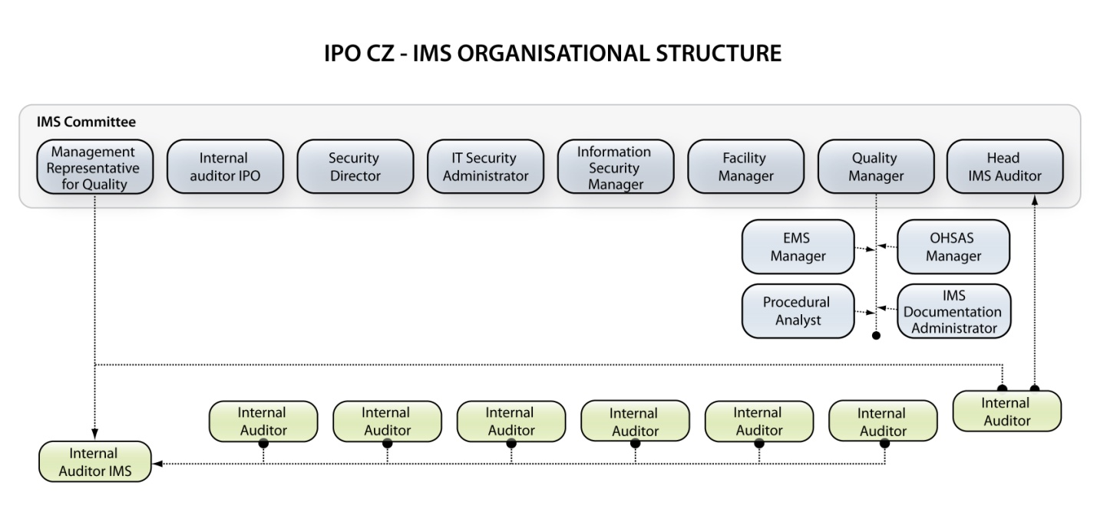

Figure 3: Organization structure of the IPO CZ

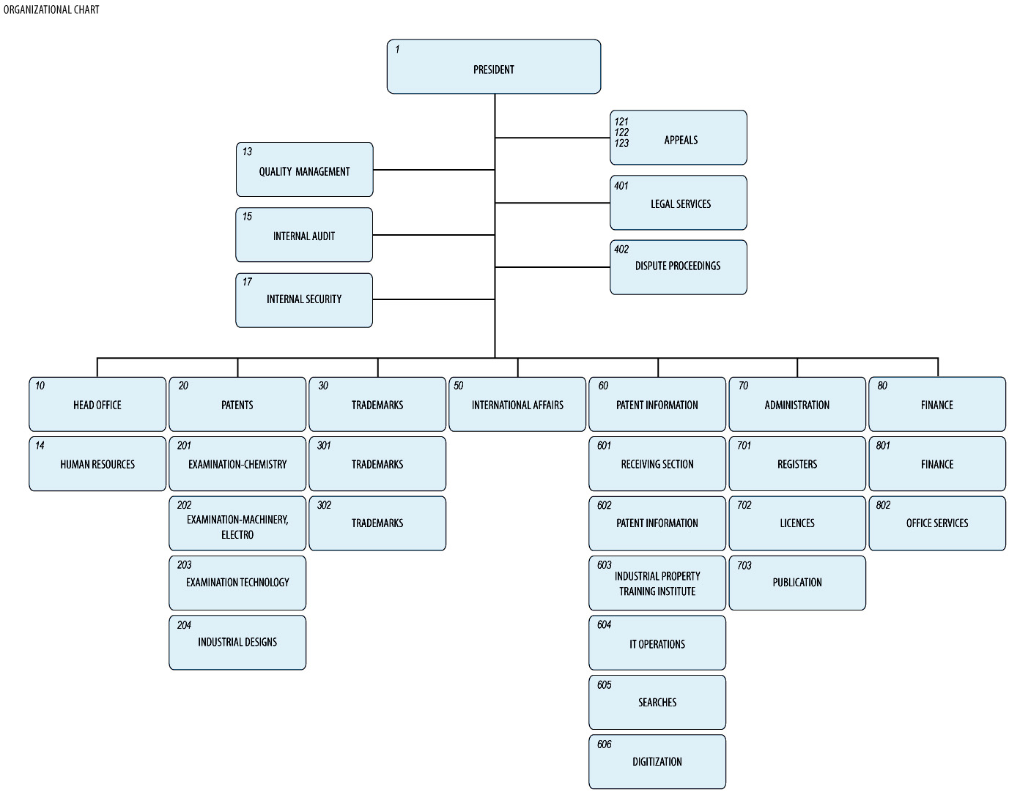

21.05 Indicate (e.g. by means of a table) the extent of compatibility between the Authority's QMS and the requirements of Chapter 21 of these International Search and Preliminary Examination Guidelines. Alternatively, indicate where the Authority is not yet compliant with these requirements.).

Chapter 21 requirement |  |  | Extent of compliance
 |  |  | full | part | no
21.04 | (a) | Quality policy available
 | (b) | Identified roles and names for QMS responsibility
 | (c) | Organizational chart available
21.05 |  | Established compatibility of QMS with Chapter 21
21.06 | (a) | Mechanisms to ensure effectiveness of the QMS
 | (b) | Control of the continual improvement process
21.07 | (a) | Communication of management about this standard to staff
 | (b) | The PCT Guidelines are in line with the Authority's QMS
21.08 | (a) | Management reviews take place
 | (b) | Quality objectives are reviewed
 | (c) | Communication of quality objectives throughout the Authority
21.09 | (a) | Performance of a yearly internal review of the QMS in/to
 | (b) | (i) determine the extent to which the QMS in based on Chapter 21
 |  | (ii) determine the extent to which S&E complies with PCT Guidelines
 | (c) | an objective and transparent way
 | (d) | using input incl. information according paragraph 21.17
 | (e) | recording the results
21.10 |  | Assurance to monitor and adapt to actual workload
21.11 | (a) | Infrastructure in place to ensure that a quantity of staff
 |  | (i) sufficient to deal with the inflow of work
 |  | (ii) which maintains tech. qualifications to S&E in all technical fields
 |  | (iii) which maintains the language facilities to understand languages according to Rule 34
 | (b) | Infrastructure to provide a quantity of skilled administrative staff
 |  | (i) at a level to support the technically qualified staff
 |  | (ii) for the documentation records
21.12 | (a) | (i) Ensuring appropriate equipment to carry out S&E
 |  | (ii) Ensuring documentation accord. to Rule 34
 | (b) | (i) Instructions to help staff understand and act accord. the quality criteria and standards
 |  | (ii) Instructions to follow work procedures accurately and they are kept up-to-date.
21.13 |  | (i) L&D program to ensure and maintain necessary skills in S&E
 |  | (ii) L&D program to ensure awareness of staff to comply with the quality criteria and standards.
21.14 | (a) | System in place for monitoring resources required to deal with demand
 | (b) | System in place for monitoring resources required to comply with the quality standards in S&E
21.15 | (a) | Control mechanisms to ensure timely issue of S&E reports
 | (b) | Control mech. regarding fluctuations in demand and backlog
21.16 | (a) | Internal quality assurance system for self-assessment
 |  | (i) for compliance with S&E Guidelines
 |  | (ii) for channeling feedback to staff
 | (b) | A system for measurement of data and reporting for continuous improvement
 | (c) | System for verifying the effectiveness of actions taken to correct deficient S&E work
21.17 | (a) | Contact person helping identify best practice between Authorities
 | (b) | Contact person fostering continual improvement
 | (c) | Contact person providing for effective comm. with other Authorities for feedback and evaluation
21.18 | (a) | (i) Appropriate system for handling complaints
 |  | (ii) Appropriate system for taking preventive/corrective actions
 |  | (i) Appropriate system for offering feedback to users
 | (b) | (i) A procedure for monitoring user satisfaction & perception
 |  | (ii) A procedure for ensuring their legitimate needs and expectations are met
 | (c) | Clear and concise guidance on the S&E process for the user
 | (d) | Indication where and how the Authority makes its quality objectives publicly available
21.19 |  | Established communication with WIPO and designated and elected Offices | -
21.20 |  | QMS of Authority clearly described (e.g. Quality Manual)
21.21 | (a) | Documents making up the Quality Manual have been prepared and distributed
 | (b) | Media available to support the Quality Manual
 | (c) | Document control measures are taken
21.22 | (a) | Quality policy of the Authority and commitment to QMS
 | (b) | Scope of QMS
 | (c) | Organizational structure and responsibilities
 | (d) | the documented processes are carried out in the Authority
 | (e) | Resources available to carry out processes
 | (f) | a description of the interaction between the processes and the procedures of the QMS.
21.23 | (a) | Records which documents are kept and where they are kept
 | (b) | Records of results of management review
 | (c) | Records about training, skills and experience of staff
 | (d) | Evidence of conformity of processes
 | (e) | Results of reviews of requirements relating to products
 | (f) | Records of the S&E process carried out on each application
 | (g) | Record of data allowing individual work to be tracked
 | (h) | Record of QMS audits
 | (i) | Records on actions taken re. non-conforming products
 | (j) | Records on actions taken re. corrective actions
 | (k) | Records on actions taken re. preventive actions
 | (l) | Records referring to search process documentation
21.24 | (a) | (i) Recording of the databases consulted during search
 |  | (ii) Recording of keywords, combination of words and truncations during search
 |  | (iii) Recording of the languages used during search
 |  | (iv) Recording of classes and combinations thereof consulted during search
 | (b) | Records about other information relevant to the search
 | (c) | (i) Records about limitation of search and its justification
 |  | (ii) Records about lack of clarity of the claims
 |  | (iii) Records about lack of unity
21.25 |  | Report on its own internal review processes
21.26-21.28 |  | Additional information on further inputs to its internal reviews
21.29 |  | Initial report called for by paragraph 21.19 | -

21.06 Indicate with reference to the organizational chart those bodies and mechanisms management uses to ensure:
(a) the effectiveness of the QMS; and
(b) that the process of continual improvement progresses.
(a)
The Improvement of the established processes is at the Office in the phase of the current process model optimization, improvement also comes from recommendations provided by surveillance audits, internal audits, corrective actions, preventive actions etc.
The next phase of improvement of the processes is setting appropriate key performance indicator (KPI) enabling detailed monitoring of the process model functioning. Improvement proposals are part of the management review.
The Office process model comprises a defined process improvement program enabling the way of communicating improvement proposal from all employees to the management.
The quality management unit is responsible for the system of improvement.
(b)
Besides performing audits by internal auditors, the integrated management system is inspected by independent certification bodies (CIS and Quality Austria) through the surveillance audits performed on yearly basis and the recertification audit performed every three years ensuring full conformity.
After a successful recertification audit, new certificate is issued with prolonged Validity.
21.07 Indicate how management of the Authority communicates to its staff the importance of meeting treaty and regulatory requirements including:
(a) those of this standard; and
(b) complying with the Authority's QMS
The management of the IPO CZ communicates to the personnel the importance of fulfillment of the QMS requirements.
The communication is conducted via the regularly held meetings. On these meetings the compliance with the QMS of the IPO is also discussed.
21.08 Indicate how and when top management of the Authority or delegated officers:
(a) conducts management reviews and ensures the availability of appropriate resources;
(b) reviews quality objectives; and
(c) ensures that the quality objectives are communicated and understood throughout the respective Authority.
(a)
The IPO CZ management develops and forms quality goals, directed toward continuous improvement, based on the strategy. Quality objectives are defined during the management review; the process of quality objectives is described and documented in the Office process model.
Objectives are communicated to all employees during periodical trainings and are available on the intranet. Objectives are available to the public/customers on the IPO website.
(b)
The quality management unit prepares an integrated management review report, which includes all inputs and outputs defined by ISO 9001:2008, EQMS – CA 57/07, ISO/IEC 27001:2005, OHSAS 18001:2007 and ISO 14001:2004. The management review report is communicated at the management meeting where the report is evaluated by directors of all departments and by the President of the Office. If the report is found complete and correct, the President of the Office approves the report and after the approval, the report is considered as a top management review.
Quality objectives revision and evaluation is a part of the report.
(c)
The quality objectives are available for the personnel via intranet and are discussed on staff meetings.
21.09 Indicate whether top management or delegated officers of the Authority perform an internal review of the QMS in accordance with paragraphs 21.25-21.28:
(a) at least once per year (cf. paragraph 21.25);
(b) in accordance with the minimum scope of such reviews as set out in Section 8, namely:
(i) to determine the extent to which the QMS is based on Chapter 21 (cf. paragraphs 21.25, 21.27(a));
(ii) to determine the extent to which Search and Examination work complies with PCT Guidelines (cf. paragraphs 21.25, 21.27(a));
(c) in an objective and transparent way (cf. paragraph 21.25);
(d) using input including information according to paragraphs 21.27 (b)-(f);
(e) recording the results (cf. paragraph 21.28).

The management of the IPO CZ carries out the internal review of the QMS once a year.
The objective and transparent review is using the input information according to paragraphs 21.27 (b)-(f).
The results are recorded and reported on the intranet of the IPO CZ.

2. Resources

21.10 Explanatory note: The granting of ISEA status means that the Authority has demonstrated it has the infrastructure and resources to support the search and examination process. Chapter 21 calls for assurance that the Authority can continually support this process while accommodating changes in workload and meeting QMS requirements. The responses to Sections 21.11 to 21.14, below, should provide this assurance.
21.11 Human resources:
(a) Provide information about the infrastructure in place to ensure that a quantity of staff:
(i) sufficient to deal with the inflow of work;
(ii) which maintains the technical qualifications to search and examine in the required technical fields; and
(iii) which maintains the language facilities to understand at least those languages in which the minimum documentation referred to in Rule 34 is written or is translated
is maintained and adapted to changes in workload.
(b) Describe the infrastructure in place to ensure that a quantity of appropriately trained/skilled administrative staff is maintained and adapted to changes in workload:
(i) at a level to support the technically qualified staff and facilitate the search and examination process;
(ii) for the documentation of records.
21.12 Human resources:
(a) Describe the infrastructure in place to ensure that:
(i) appropriate equipment and facilities such as IT hardware and software to support the search and examination process are provided and maintained;
(ii) at least the minimum documentation referred to in Rule 34 is available, accessible, properly arranged and maintained for search and examination purposes. State whether it is on paper, in microform or stored on electronic media, and where.
(b) Describe how instructions
(i) to help staff understand and adhere to the quality criteria and standards; and;
(ii) to follow work procedures accurately and consistently
are documented, provided to staff, kept up-to-date and adapted where necessary

21.13 Training resources:
Describe the training and development infrastructure and program which ensures that all staff involved in the search and examination process:
(i) acquire and maintain the necessary experience and skills; and
(ii) are fully aware of the importance of complying with the quality criteria and standards.

- two-year specialized study program (in the range of 320 hours, 4 semesters) provides students with complex overview of industrial property protection and industrial/legal information
- each semester is concluded by 4 exams, during the second year the students are obliged to complete final thesis which they defend in front of expert committee. At the same time the students pass final exams. Upon succession of the study program the students receive a certificate on completion of the two-year specialized study in the area of IP protection.
Target group: IPO CZ employees, professional IP workers, patent attorney assistants, commercial lawyers, entrepreneurs, R&D staff and students
Beginning of the study: every September
in accordance with the educational plan there are expert seminars and trainings to increase the required knowledge and skills:
performing searches in the Epoque database, in foreign databases, seminars on new legislation, current issues on IP, written communication and text layout, presentation skills or new software tools.
e-learning: The art of efficient searching, Distance learning course, CPC for classifiers, Patent classification based on CPC
21.14 Oversight over resources:
Describe the system in place for continuously monitoring and identifying the resources required:
(a) to deal with demand; and
(b) comply with the quality standards for search and examination
(a)
The management of the Patent Department performs quarterly the analysis of compliance of the level of sufficiency of the resources with current needs.
(b)
- Double monitoring is performed for search and examination on a regular base. The work of each examiner is controlled by the head of section /2nd grade). The controls are also carried out by the director of patent department (like 3nd grade).

3. MANAGEMENT OF ADMINISTRATIVE WORKLOAD

21.15 Indicate how the following practices and procedures for handling search and examination requests and performing related functions such as data-entry and classification are implemented:
(a) Effective control mechanisms regarding timely issue of search and examination reports to a quality standard as set by the respective Authority; and
(b) Appropriate control mechanisms regarding fluctuations in demand and backlog management.
One of the IPO CZ quality objectives is to issue reports in a timely manner. To ensure timely issue of search reports, the Patent Department monitors them based on the performance reports generated from a workflow management system (SyPP). The workflow management system tracks each step of the workflow and provides the latest action and timeliness status of each case, real-time. Performance reports are generated weekly and it is possible to check that all search reports are issued within set time limits. Reports are sent to the examiners, the heads of the patent sections and the Head of the Patent Dept.

4. Quality Assurance

21.16 The following are required quality assurance measures for timely issue of search and examination reports of a quality standard in accordance with the Guidelines. Indicate how the following are implemented:
(a) An internal quality assurance system for self assessment, involving verification, validation and monitoring of searches and examination work:
(i) for compliance with these Search and Examination Guidelines;
(ii) for channeling feedback to staff.
(b) A system of measurement and collection of data and reporting. Show how the Authority uses the system to ensure the continuous improvement of the established processes.
(c) A system for verifying the effectiveness of actions taken to correct deficient S&E work, eliminate the causes, and to prevent issues from recurring.
The Guidelines for examination in the IPO CZ are available via intranet of the IPO CZ for internal users and via the web side of the IPO CZ for external users.
Prepared check list forms are helping the self assessment for monitoring the search work. Two people have to sign the forms for accepting the reports: the examiner and the head of section.
A quarterly statistical report is analyzing the actual quality situation of searches and examination work. For verifying the effectiveness of actions taken to correct deficient work, eliminate the causes, and to prevent issues from recurring, the random-like cross-check is performed by the Head of the Patent Department 2-3 times per year. The annual internal audit is performed.

5. Communication

21.17 Inter-Authority communication:
Provide the name, job title and contact details of the Authorities designated quality contact person who will take responsibility for:
(a) helping identify and disseminate best practice among Authorities;
(b) fostering continual improvement; and
(c) providing for effective communication with other Authorities to allow for prompt feedback from them so that potential systemic issues can be evaluated and addressed.
JUDr. Světlana Kopecká (skopecka@upv.cz), Directress of International Affairs Dpt.
21.18 Communication and guidance to users:
Describe the system in place for monitoring and using customer feedback including at least the following elements:
(a) An appropriate system for
(i) handling complaints and making corrections;
(ii) taking corrective and/or preventative action where appropriate; and
(iii) offering feedback to users.
(b) A procedure for:
(i) monitoring user satisfaction and perception; and
(ii) for ensuring their legitimate needs and expectations are met.
(c) Clear, concise and comprehensive guidance and information to users (particularly unrepresented applicants) on the search and examination process, giving details of where it is to be found e.g. link to Authority’s web site, guidance literature.
(d) An indication of where and how the Authority makes its quality objectives publicly available for the users.
(a, b)
Customer satisfaction survey forms are available both electronically (on the web site of the IPO CZ and physically at the Office. The results of these customer feedback is also input of the annual internal quality review. The e-form enables monitoring and evaluation of customer satisfactions with the Office services; any customer can use this e-form to express his/her opinions, recommendations for improvement, etc. The customer can choose the anonymous input or input with contact details, if contact details are available, the Office shall provide an answer to the customer after the customer input. In case of any negative customer input via the e-form, the customer information is provided to the responsible head of department. The head of department is responsible for evaluation of the negative information and shall provide appropriate reaction leading to preventive/corrective action or rejection when the information does not need to be treated as preventive/corrective action.
The internal auditor is also responsible for processing the other inputs such as e-mails sent to employees or letters received by the Office. All employees are obliged to provide any information related to the customer satisfaction to the internal auditor. According to the President of the Office instruction, the internal auditor is responsible for the process of monitoring and overall evaluation of customer satisfaction. The process of customer satisfaction monitoring is described and documented in the Office process model.
All data about complaints are annually evaluated by the internal auditor in the report for the President of the Office and main data form one of the inputs to the management review report. All complaints are added to the website with approved reaction and are available in electronic version for employees and the public.
(c, d)
The manual of the search and examination and quality objectives are available for the users at the web page of the IPO CZ.
The quality objectives are based on the Policy of the IPO CZ, which is also available at the web page of the Office.
21.19 Communication with WIPO and designated and elected Offices:
Describe how the Authority provides for effective communication with WIPO and designated and elected offices. In particular describe how the Authority ensures that WIPO feedback is promptly evaluated and addressed.

6. Documentation

21.20 Explanatory note: The QMS of the Authority needs to be clearly described and implemented so that all processes in the Authority and the resulting products and services can be monitored, controlled, and checked for conformity. This is done in the documents that make up the Quality Manual of the Authority (see paragraph 21.21).
(Note: This point is informative. No response is required by the template to paragraph 21.20)
21.21 The documents that make up the Quality Manual serve to document the procedures and processes affecting the quality of work, such as classification, search, examination and related administrative work. In particular, the Quality Manual indicates where to find instructions on the procedures to be followed.
For the purposes of this report indicate:
(a) the documents making up a Quality Manual that have been prepared and distributed;
(b) the media on which it is supported (e.g. Internal Publication, Internet, Intranet); and
(c) document control measures taken e.g. version numbering, access to latest version.
(a, b, c,)
The top document describing the IMS in the Office is the quality management manual. The latest version of the quality manual valid from 1th December 2014 is available in the Office. The quality manual is built on ISO 9001:2008, ISO/IEC 27001:2005, OHSAS 18001:2007, ISO 14001:2004 and EQMS - CA/57/07 normative requirements.
The second level of documentation in the Office is the process model in the HTML format available on the Office intranet to which the quality manual refers. The process model includes defined processes, responsibilities, activities within the processes, documentation inputs, outputs and used information systems. The process model and the quality manual include references to guidelines described in the former sections.
The quality manual is managed by the documentation management process and the process model is managed by processes: new process definition and processes change management.
The quality manager is responsible for managing the quality manual and the process model.

21.22 Indicate whether the documents making up the Quality Manual include the following:
(a) the quality policy of the Authority including a clear statement of commitment to the QMS from top management;
(b) the scope of the QMS, including details of and justification for any exclusions;
(c) the organizational structure of the Authority and the responsibilities of each of its departments;
(d) the documented processes carried out in the Authority such as receipt of incoming applications, classification, distribution, search, examination, publication and support processes, and procedures established for the QMS, or references to them;
(e) the resources available for carrying out the processes and implementing the procedures; and
(f) a description of the interaction between the processes and the procedures of the QMS.
The Quality Manual and its attachments includes the following parts:
(a) the quality policy established by the top management of the IPO CZ
(b) the scope of the QMS, with details of and justification for any exclusions
(c) the organizational structure of the IPO CZ
(d) all the documented processes carried out at the IPO CZ
(e) the resources available for carrying out the processes
(f) a description of the interaction between the processes and the procedures of the QMS
21.23 Indicate which types of records the Authority maintains, such as:
(a) a definition of which documents are kept and where they are kept;
(b) results of management review;
(c) training, skills and experience of personnel;
(d) evidence of conformity of processes, resulting products and services in terms of quality standards;
(e) results of reviews of requirements relating to products;
(f) the search and examination processes carried out on each application;
(g) data allowing individual work to be tracked and traced;
(h) records of QMS audits;
(i) actions taken re. non-conforming products, e.g. examples of corrections;
(j) actions taken re. corrective action;
(k) actions taken re. preventative action; and
(l) search process documentation as set out in Section 7.
According to the ISO 9001:2008, ISO/IEC 27001:2005, OHSAS 18001:2007, ISO14001:2004 and EQMS - CA 57/07 standards, the IPO CZ maintains all the needed records such as:
- a definition of which documents are kept and where they are kept;
- results of management review;
- training, skills and experience of personnel;
- evidence of conformity of processes, resulting products and services in terms of quality standards;
- results of reviews of requirements relating to products
- the search and examination processes carried out on each application
- data allowing individual work to be tracked and traced
- records of QMS audits
- actions taken re. non-conforming products, e.g. examples of corrections;
- actions taken re. corrective action;
- actions taken re. preventative action; and
- search process documentation as set out in Section 7

7. Search Process Documentation

21.24 For internal purposes the Authority should document its search process.
The Authority should indicate
(a) which of the following are included in this record:
(i) the databases consulted (patent and non patent literature);
(ii) the keywords, combinations of words and truncations used;
(iii) the language(s) in which the search was carried out;
(iv) the classes and class combinations searched, at least according to the IPC or equivalent;
(v) a listing of all search statements used in the databases consulted.
(b) which other information relevant to the search itself is included in this record e.g. a statement of the subject of search; details of special relevance to internet searching; a record of documents viewed; on-line thesaurus, synonym or concept databases, etc.
(Explanatory note: The IA is requested to list other information it may collect to monitor and improve the search process)
(c) which special cases are documented and whether records are kept denoting any:
(i) limitation of search and its justification
(ii) lack of clarity of the claims; and
(iii) lack of unity.
The examiners make a record of their search process. Some of them are stored in a shared corporate drive for internal review and documentation.
In most cases the search record documents the following:
(i) the databases consulted (patent, non-patent literature or Internet); and
(ii) the keywords and synonyms describing the subject matter to be searched;
(iii) the classes and class combinations searched, at least according to the IPC or equivalent
(iv) the search statements used and results returned (i.e. search history);
(v) a list of the documents considered to be relevant and corresponding comments on their relevance;
(vi) any search limitations resulting from claims that lack clarity or support to the extent that no meaningful search can be carried out;
(vii) any indications regarding unity of invention.

8. Internal Review

21.25 Explanatory note: The Authority should report on its own internal review arrangements. These reviews determine the extent to which it has established a QMS based on the model of Chapter 21 and the extent to which it is complying with the QMS requirements and the Search and Examination Guidelines. The reviews should be objective and transparent to demonstrate whether or not those requirements and guidelines are being applied consistently and effectively and should be undertaken at least once a year. With reference to point 21.08 of this template, the Authority may provide additional information on its internal review arrangements under this section if it so wishes.
21.26-21.28 These arrangements are reported according to this template in Section 1, above, at points 21.04 - 21.09. The Authority may provide additional information on further inputs to its internal reviews under this section, if it so wishes.

Both internal and external QMS audits are carried out yearly.
The audit aim is to confirm the QMS conformity with the ISO 9001:2008, ISO/IEC 27001:2005, OHSAS 18001:2007, ISO 14001:2004 and EQMS – CA 57/07 standards.

9. Arrangements for Authorities to Report to the MIA

21.29 There are two stages in the reporting arrangements outlined in Chapter 21: the initial report called for by paragraph 21.29, and supplementary annual reports in accordance with paragraph 21.30.

[Annex II follows]
Report on Quality Management Systems
prepared by the Hungarian Intellectual Property Office (HIPO)
as participating Office of the Visegrad Patent Institute (VPI)

The Authority should provide general background information relevant to the quality management system (QMS) as set forth in this template.
The descriptions below each main heading of this template should be considered examples of the type and arrangement of information that should be included under each heading. Each Authority may provide additional information beyond that set forth in this template as desired.

INTRODUCTION (PARAGRAPHS 21.01 - 21.03)

If applicable, the Authority may at this point indicate any recognized normative reference or basis for their quality management system besides Chapter 21, such as ISO 9001, under the heading “Normative Reference for QMS”
For example: “Normative reference for QMS: ISO 9001, EQS (European Quality System)”
Each Authority should then provide at least the information indicated in the descriptive boxes, under the following headings

The Hungarian Intellectual Property Office (HIPO) has implemented a quality management system for its patent search and examination functions that conforms to the ISO 9001 standards. The first certification according to the ISO 9001:2008 standards was valid from 2011 until 2014 and the re-certification is valid from 2014 until 2017.
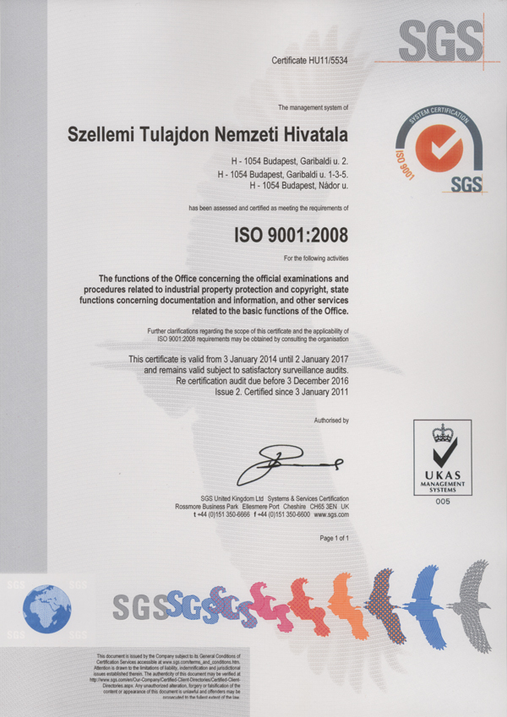 | 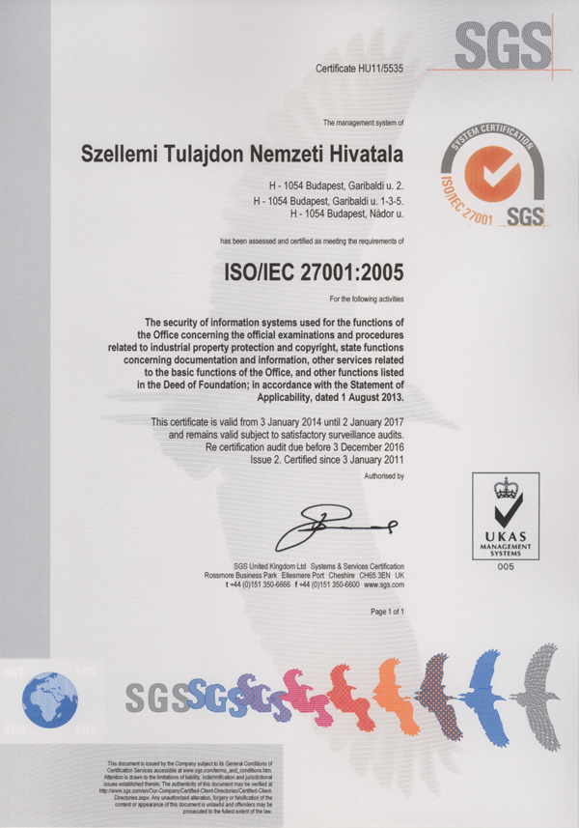
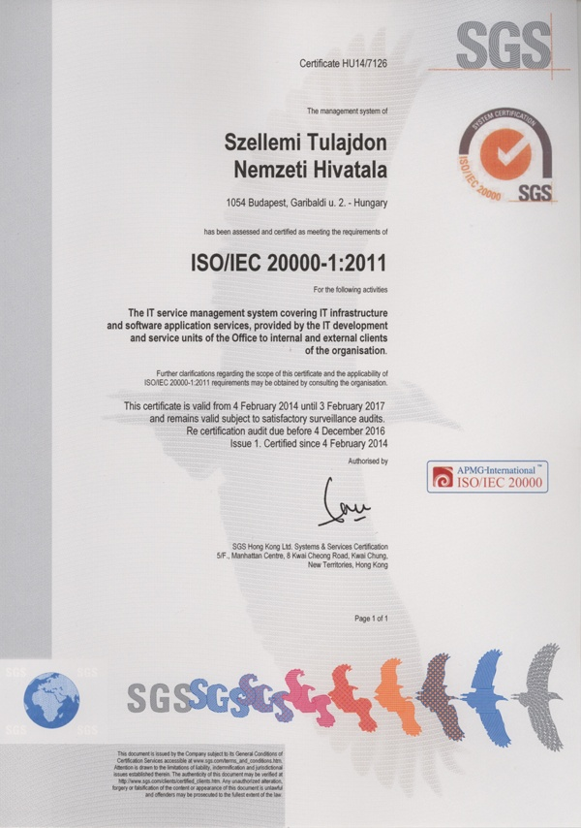
Figure 1: The ISO certificates of HIPO issued by SGS

1. LEADERSHIP AND POLICY

21.04 Confirm that the following are clearly documented, and that this documentation is available internally:
(a) The quality policy established by top management.
(b) The roles and names of those bodies and individuals responsible for the QMS, as delegated by top management.
(c) An organizational chart showing all those bodies and individuals responsible for the QMS.

(a) The quality policy established by the top management:
The mission of the Hungarian Intellectual Property Office, as the governmental centre of intellectual property protection and the authority thereof providing quality services, is to efficiently operate and smoothly develop the industrial property and copyright systems needed for the development of a knowledge-based, innovative and competitive economy.
To achieve the objective defined, the following actions are taken:
- We shall maintain and continually improve the quality management system, which is in accordance with the ISO 9001:2008 standards.
- We shall continually monitor the functioning of our work processes under the quality management system, analyse their quantity, quality and time indexes in order to flexibly harmonise the demands of our customers with the Office’s quantity and quality performance in a changing environment.
- We shall pay special attention to learning the needs of our customers and to manage their complaints in order to strengthen the service character of the official activities and to maintain a partnership with the customers.
- We shall participate in the exchange of knowledge and experience between the national offices and international organisations; we shall operate and possibly improve our own system so that we can apply the best practices – accepted internationally – in our activities.
- We shall ensure the improvement of the professional, language and public administration knowledge and skills of our employees, making them understand the effect of their activities on quality requirements.
- We shall establish a work plan which ensures that the performance be in accordance with legislation in force, be identified and checked, and that the staff effectively attains the performance objectives.
- We shall continually check our human, financial and infrastructural resources so that they are always sufficient to perform our duties and to achieve the quality objectives.
- We shall endeavour, focusing on the changes of the system environment and the improvement of performance, to improve our quality management system in a way to make it suitable for satisfying the changing demands and for continual improvement of the quality of performance.
- We shall maintain our quality management system as certified by the requirements of the ISO 9001:2008 standards, so that, where possible, we can meet or even surpass the government expectations regarding the quality of internal control activity.
- Our aim is to ensure that both the customers and the staff are satisfied with the operation of the Hungarian Intellectual Property Office.
(b) The roles and names of those bodies and individuals responsible for the QMS; as delegated by the top management
Roles of ISO QMS, ISMS, ITIL integrated management system in the Hungarian Intellectual Property Office
QMS: ISO 9001:2008 Quality Management Systems
ISMS: ISO/IEC 27001:2013Information Security Management Systems
ITIL: ISO/IEC 20000-1:2011 Information Technology Infrastructure Library

QMS leadership
Head of the QMS |  |  | Ms Ildikó Babilai
Information Security Manager |  |  | Mr Zoltán Hegedűs
IT Process Development Manager |  |  | Mr Tivadar Bognár
Document Manager |  |  | Ms Orsolya Gilyán
ITIL roles |  |  | Integrated Handbook, Annex 10.
Shared job Roles and Names responsible for the ISO integrated management system.
Departments | Department responsible | Data owners |  | Process owners | Internal auditors
Presidency | The Cabinet members have independent responsibility | Ms Lilla Ignéczi |  |  | Ms Krisztina Hegedüs  (QMS+ISMS)  Ms Erzsébet Kun (QMS)
Patent Department | Ms Dóra Gyetvainé Virág | Mr Jenő Kürtössy  (ENYV, E-PUB,SZF, CPC)  Mr Szabolcs Farkas  (External) |  | Ms Mariann Szulmanné Binet (patents)  Ms Mária Petz-Stifter (services)  Ms Katalin Mikló (plant varieties)  Ms Ildikó Prohászkáné Németh (SPCs)  Mr István Kárpáty (topography protection) | Mr Jenő Kürtössy  (QMS+ISMS)  Ms Ildikó Szepesné Sámson (QMS)  Mr László Végh (QMS+ISMS)  Mr Tamás Parragi (QMS+ISMS)
Trademark, Model and Design Department | Mr Péter Csiky | Ms Viktória Hegedűs (ENYV, E-PUB)  Mr Imre Gonda (ENYV, E-PUB)  Mr Gusztáv Szöllősi  (ENYV, E-PUB) |  | Ms Viktória Hegedűs  Ms Gabriella Kiss  Mr Gusztáv Szöllősi | Ms Erika Szép (QMS)  Ms Lászlóné Takács (QMS+ISMS)  Mr Gusztáv Szöllősi (QMS+ISMS+ITIL)
Office Management Department | Mr Zoltán Zábori | Mr Tamás Dénes  Ms Enikő Huszár  (ENYV, ELO, E-PUB)  Mr Richárd Szabó  (ENYV, ELO, E-PUB)  Ms Gyöngyi Szilvitzky (ENYV, ELO, E-PUB) |  | Ms Enikő Huszár  Mr Richárd Szabó  Ms Gyöngyi Szilvitzky | Ms Melinda Káldi (QMS)  Mr László Lendvay (QMS+ISMS)  Mr Richárd Szabó (QMS+ISMS+ITIL)
Legal and International Department | Ms Johanna Stadler | Ms Viola Veréb  (ENYV, E-PUB) |  | Mr Csaba Baticz  Ms Viola Veréb | Ms Krisztina Kovács (QMS)  Ms Ildikó Zielbauerné Bali (QMS+ISMS)
Copyright Department | Mr Péter Lábody | Mr Péter Lábody (ENYV, E-PUB) |  | Mr Dénes István Legeza
Human Resources Management Section | Ms Ildikó Faragó-Hönig | Ms Ildikó Faragó-Hönig |  | Ms Ildikó Faragó-Hönig

Departments | Department responsible | Data owners | Process owners | Internal auditors
Financial Management Department | Ms Györgyi Kóczánné Pásztor | Ms Tamara Filyó (SAP)  Ms Zsuzsanna Wapokuruua (SAP )  Ms Erzsébet Kolozsváriné Máté (SAP) | Oláh Zoltán (LGO  Kolozsváriné Máté Erzsébet  Wapokuruua Zsuzsanna | Wapokuruua Zsuzsanna (QMS+ISMS)
Information Services Department | Mr Tivadar Bognár | Mr Tamás Dénes  Mr Attila Szendefi | Mr Tamás Dénes  Mr Attila Szendefi | Ms Tünde Gallóné Pethő (QMS+ISMS+ITIL)  Ms Krisztina Szepesházy  (ITIL)
Innovation Department | Mr Gábor Németh | Ms Szilvia Bognár (ENYV) | Ms Zsuzsa Varju  Ms Szilvia Bognár | Ms Hajnalka Bógyik (QMS)  Ms Szilvia Bognár (QMS+ISMS)

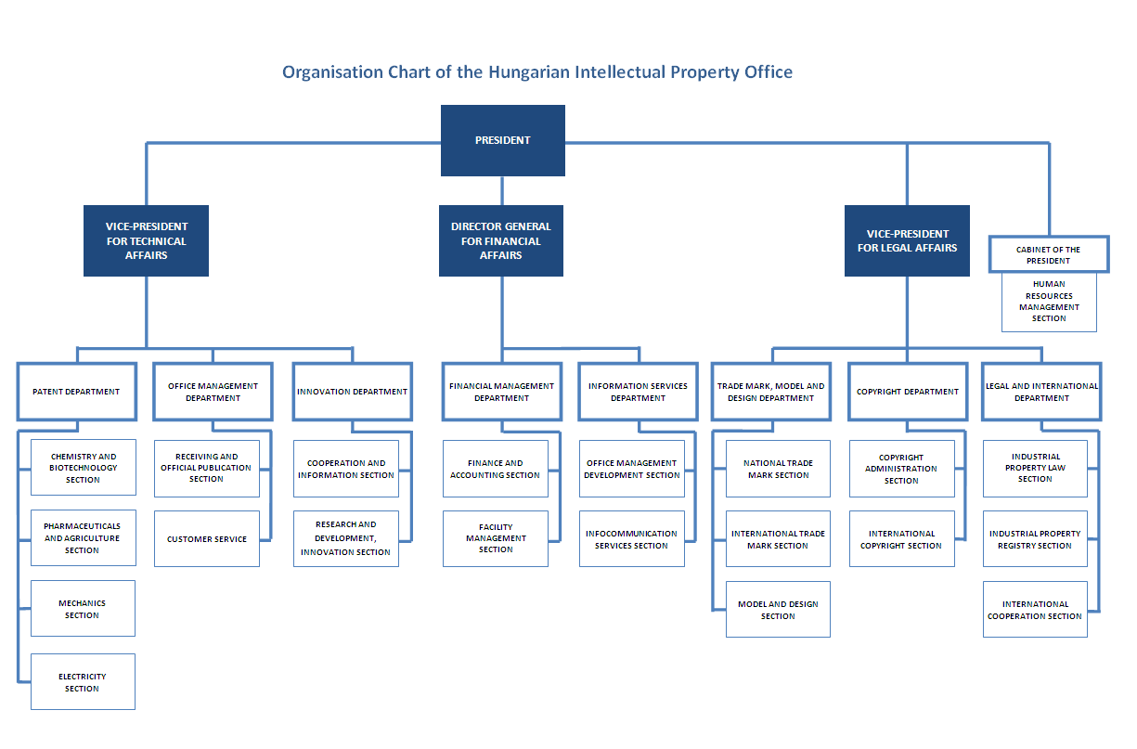
Figure 2: Organisational structure of the HIPO

ISO Integrated Management System organisation chart of the Hungarian Intellectual Property Office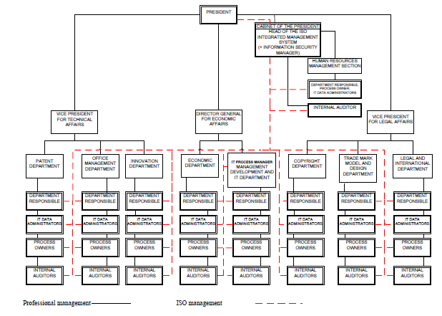
Figure 3: Organisational structure of the QMS at the HIPO

21.05 Indicate (e.g. by means of a table) the extent of compatibility between the Authority's QMS and the requirements of Chapter 21 of these International Search and Preliminary Examination Guidelines. Alternatively, indicate where the Authority is not yet compliant with these requirements.).

Chapter 21 requirement |  |  | Extent of compliance
 |  |  | full | part | no
21.04 | (a) | Quality policy available
 | (b) | Identified roles and names for QMS responsibility
 | (c) | Organizational chart available
21.05 |  | Established compatibility of QMS with Chapter 21
21.06 | (a) | Mechanisms to ensure effectiveness of the QMS
 | (b) | Control of the continual improvement process
21.07 | (a) | Communication of management about this standard to staff
 | (b) | The PCT Guidelines are in line with the Authority's QMS
21.08 | (a) | Management reviews take place
 | (b) | Quality objectives are reviewed
 | (c) | Communication of quality objectives throughout the Authority
21.09 | (a) | Performance of a yearly internal review of the QMS in/to
 | (b) | (i) determine the extent to which the QMS in based on Chapter 21
 |  | (ii) determine the extent to which S&E complies with PCT Guidelines
 | (c) | an objective and transparent way
 | (d) | using input incl. information according paragraph 21.17
 | (e) | recording the results
21.10 |  | Assurance to monitor and adapt to actual workload
21.11 | (a) | Infrastructure in place to ensure that a quantity of staff
 |  | (i) sufficient to deal with the inflow of work
 |  | (ii) which maintains tech. qualifications to S&E in all technical fields
 |  | (iii) which maintains the language facilities to understand languages according to Rule 34
 | (b) | Infrastructure to provide a quantity of skilled administrative staff
 |  | (i) at a level to support the technically qualified staff
 |  | (ii) for the documentation records
21.12 | (a) | (i) Ensuring appropriate equipment to carry out S&E
 |  | (ii) Ensuring documentation accord. to Rule 34
 | (b) | (i) Instructions to help staff understand and act accord. the quality criteria and standards
 |  | (ii) Instructions to follow work procedures accurately and they are kept up-to-date.
21.13 |  | (i) L&D program to ensure and maintain necessary skills in S&E
 |  | (ii) L&D program to ensure awareness of staff to comply with the quality criteria and standards.
21.14 | (a) | System in place for monitoring resources required to deal with demand
 | (b) | System in place for monitoring resources required to comply with the quality standards in S&E
21.15 | (a) | Control mechanisms to ensure timely issue of S&E reports
 | (b) | Control mech. regarding fluctuations in demand and backlog
21.16 | (a) | Internal quality assurance system for self-assessment
 |  | (i) for compliance with S&E Guidelines
 |  | (ii) for channeling feedback to staff
 | (b) | A system for measurement of data and reporting for continuous improvement
 | (c) | System for verifying the effectiveness of actions taken to correct deficient S&E work
21.17 | (a) | Contact person helping identify best practice between Authorities
 | (b) | Contact person fostering continual improvement
 | (c) | Contact person providing for effective comm. with other Authorities for feedback and evaluation
21.18 | (a) | (i) Appropriate system for handling complaints
 |  | (ii) Appropriate system for taking preventive/corrective actions
 |  | (i) Appropriate system for offering feedback to users
 | (b) | (i) A procedure for monitoring user satisfaction & perception
 |  | (ii) A procedure for ensuring their legitimate needs and expectations are met
 | (c) | Clear and concise guidance on the S&E process for the user
 | (d) | Indication where and how the Authority makes its quality objectives publicly available
21.19 |  | Established communication with WIPO and designated and elected Offices
21.20 |  | QMS of Authority clearly described (e.g. Quality Manual)
21.21 | (a) | Documents making up the Quality Manual have been prepared and distributed
 | (b) | Media available to support the Quality Manual
 | (c) | Document control measures are taken
21.22 | (a) | Quality policy of the Authority and commitment to QMS
 | (b) | Scope of QMS
 | (c) | Organizational structure and responsibilities
 | (d) | the documented processes are carried out in the Authority
 | (e) | Resources available to carry out processes
 | (f) | a description of the interaction between the processes and the procedures of the QMS.
21.23 | (a) | Records which documents are kept and where they are kept
 | (b) | Records of results of management review
 | (c) | Records about training, skills and experience of staff
 | (d) | Evidence of conformity of processes
 | (e) | Results of reviews of requirements relating to products
 | (f) | Records of the S&E process carried out on each application
 | (g) | Record of data allowing individual work to be tracked
 | (h) | Record of QMS audits
 | (i) | Records on actions taken re. non-conforming products
 | (j) | Records on actions taken re. corrective actions
 | (k) | Records on actions taken re. preventive actions
 | (l) | Records referring to search process documentation
21.24 | (a) | (i) Recording of the databases consulted during search
 |  | (ii) Recording of keywords, combination of words and truncations during search
 |  | (iii) Recording of the languages used during search
 |  | (iv) Recording of classes and combinations thereof consulted during search
 | (b) | Records about other information relevant to the search
 | (c) | (i) Records about limitation of search and its justification
 |  | (ii) Records about lack of clarity of the claims
 |  | (iii) Records about lack of unity
21.25 |  | Report on its own internal review processes
21.26-21.28 |  | Additional information on further inputs to its internal reviews
21.29 |  | Initial report called for by paragraph 21.19
21.06 Indicate with reference to the organizational chart those bodies and mechanisms management uses to ensure:
(a) the effectiveness of the QMS; and
(b) that the process of continual improvement progresses.
(a)
In order to assess the QMS effectiveness, the HIPO management yearly develops and formulates measuring quality goals and indicates the persons responsible for ensuring their achievement, and approves the QMS internal auditing program.
(b)
The internal auditors conduct random-like cross-check every 3 months, there are internal and external audits once a year. The results of the internal audits are discussed and analyzed at the Presidential Board meeting, where the decisions about necessary actions are made.
21.07 Indicate how management of the Authority communicates to its staff the importance of meeting treaty and regulatory requirements including:
(a) those of this standard; and
(b) complying with the Authority's QMS
The management of the HIPO communicates to the personnel the importance of fulfillment of the QMS requirements, including requirements under the PCT, relating to the international search and international preliminary examination quality provision. Communication is conducted via regularly held meetings. On these meetings the compliance with the QMS of the HIPO is also discussed.
21.08 Indicate how and when top management of the Authority or delegated officers:
(a) conducts management reviews and ensures the availability of appropriate resources;
(b) reviews quality objectives; and
(c) ensures that the quality objectives are communicated and understood throughout the respective Authority.
(a)
The HIPO management develops and forms quality goals, directed toward continuous improvement, based on the strategy.
QMS analysis and goal achievement level are performed every year at Presidential Board meetings, where the necessary decisions are made.
The minutes of the meetings are available for the personnel via the Intranet of the HIPO.
(b)
The reviews are carried out by the QMS management according to the strategy every year.
(c)
The quality objectives are available for the personnel via the Intranet and are discussed at staff meetings.
21.09 Indicate whether top management or delegated officers of the Authority perform an internal review of the QMS in accordance with paragraphs 21.25-21.28:
(a) at least once per year (cf. paragraph 21.25);
(b) in accordance with the minimum scope of such reviews as set out in Section 8, namely:
(i) to determine the extent to which the QMS is based on Chapter 21 (cf. paragraphs 21.25, 21.27(a));
(ii) to determine the extent to which Search and Examination work complies with PCT Guidelines (cf. paragraphs 21.25, 21.27(a));
(c) in an objective and transparent way (cf. paragraph 21.25);
(d) using input including information according to paragraphs 21.27 (b)-(f);
(e) recording the results (cf. paragraph 21.28).
The management of the HIPO carries out the internal review of the QMS once a year. The objective and transparent review is using the input information according to paragraphs 21.27 (b)-(f).
The results are recorded and reported on the Intranet of the HIPO.

2. Resources

21.10 Explanatory note: The granting of ISEA status means that the Authority has demonstrated it has the infrastructure and resources to support the search and examination process. Chapter 21 calls for assurance that the Authority can continually support this process while accommodating changes in workload and meeting QMS requirements. The responses to Sections 21.11 to 21.14, below, should provide this assurance.
21.11 Human resources:
(a) Provide information about the infrastructure in place to ensure that a quantity of staff:
(i) sufficient to deal with the inflow of work;
(ii) which maintains the technical qualifications to search and examine in the required technical fields; and
(iii) which maintains the language facilities to understand at least those languages in which the minimum documentation referred to in Rule 34 is written or is translated
is maintained and adapted to changes in workload.
(b) Describe the infrastructure in place to ensure that a quantity of appropriately trained/skilled administrative staff is maintained and adapted to changes in workload:
(i) at a level to support the technically qualified staff and facilitate the search and examination process;
(ii) for the documentation of records.

21.12 Material resources:
(a) Describe the infrastructure in place to ensure that:
(i) appropriate equipment and facilities such as IT hardware and software to support the search and examination process are provided and maintained;
(ii) at least the minimum documentation referred to in Rule 34 is available, accessible, properly arranged and maintained for search and examination purposes. State whether it is on paper, in microform or stored on electronic media, and where.
(b) Describe how instructions
(i) to help staff understand and adhere to the quality criteria and standards; and;
(ii) to follow work procedures accurately and consistently
are documented, provided to staff, kept up-to-date and adapted where necessary.
21.13 Training resources:
Describe the training and development infrastructure and program which ensures that all staff involved in the search and examination process:
(i) acquire and maintain the necessary experience and skills; and
(ii) are fully aware of the importance of complying with the quality criteria and standards.
Intermediate level IP course:
- 60 hours (in the spring: intensive, in the fall: regular) with written AND oral exams at the end
- target group: all kinds of IP related professionals, PRO employees, TTO employees, and employees of research based companies (especially pharmaceutical sector), plus customs
- Organized twice a year in Budapest, occasionally in the countryside mainly based on contract with other organizations
- Offer: 60 hours training + exam fee + printed training material
Intermediate Certificate in IP
Advanced level IP course:
- 3 semesters professional training, exams during the semesters, closed by a written thesis that has to be defended before a board
- Target group: IP professionals, patent attorneys, patent examiners, employees of PROs and research based companies
- Organized on a bi-annual basis, starts when the previous course has ended, always starting in the fall, only organized in Budapest with one full day of training per week
- Offer: 3 semester training + all exam fees + final exam fee + thesis consultation + training material
Advanced level certificate in IP – the highest IP qualification in Hungary
Distance learning courses:
- 2 different training materials, modular basis,
- 5 higher education institutes, approx. 600 students a year
- + Public e-learning course available for anybody after registration at: http://tavoktatas.sztnh.gov.hu/
21.14 Oversight over resources:
Describe the system in place for continuously monitoring and identifying the resources required:
(a) to deal with demand; and
(b) comply with the quality standards for search and examination
(a)
The management of the Patent Department performs monthly the analysis of compliance of the level of sufficiency of the resources with current needs. Transmission between patent sections is performed if necessary.
(b)
Double monitoring is performed for search and examination on a regular basis: both the deputy and the head of the patent section is checking the quality of the reports which are issued only when they comply with the quality standards.

3. MANAGEMENT OF ADMINISTRATIVE WORKLOAD

21.15 Indicate how the following practices and procedures for handling search and examination requests and performing related functions such as data-entry and classification are implemented:
(a) Effective control mechanisms regarding timely issue of search and examination reports to a quality standard as set by the respective Authority; and
(b) Appropriate control mechanisms regarding fluctuations in demand and backlog management.
Well documented process descriptions have performance (P), time (T) and quality (Q) indicators, showing the standards set by the HIPO. Both the head and the deputy head of the patent section are monitoring the timely issues, and they define priorities if necessary.
The management arranges the transfer of the requests between the sections if the workload of the examiners requires.
A monthly statistical report is generated by an authorized person based on the results of such monitoring of the application processing. The report is forwarded for the consideration of the Head of the Patent Department, and summarized analytical data are sent to the to the heads of the patent sections.
(Find enclosed the process of the search and examination with P,T and Q indicators in Hungarian )

4. Quality Assurance

21.16 The following are required quality assurance measures for timely issue of search and examination reports of a quality standard in accordance with the Guidelines. Indicate how the following are implemented:
(a) An internal quality assurance system for self assessment, involving verification, validation and monitoring of searches and examination work:
(i) for compliance with these Search and Examination Guidelines;
(ii) for channeling feedback to staff.
(b) A system of measurement and collection of data and reporting. Show how the Authority uses the system to ensure the continuous improvement of the established processes.
(c) A system for verifying the effectiveness of actions taken to correct deficient S&E work, eliminate the causes, and to prevent issues from recurring.
(a)
The Search and Examination Guidelines are available via the Intranet of the HIPO for internal users and via the web site of the HIPO for external users.
Prepared check list forms are helping the self assessment for monitoring the search and examination work.
Three people have to sign the forms for accepting the reports: the senior examiner, the deputy head and the head of section. These forms are containing all the feedback to the examiner about every single report.
(b)
The quality of search and examination work is analysed in statistical reports prepared monthly. Knowing the results of this monthly report, the head of the Patent Department can decide on all the necessary actions to ensure the continuous improvement of the processes.
(c)
For verifying the effectiveness of actions taken to correct deficient S&E work, eliminate the causes and to prevent issues from recurring, quarterly random-like cross-checks and an annual internal audit are performed.

5. Communication

21.17 Inter-Authority communication:
Provide the name, job title and contact details of the Authorities designated quality contact person who will take responsibility for:
(a) helping identify and disseminate best practice among Authorities;
(b) fostering continual improvement; and
(c) providing for effective communication with other Authorities to allow for prompt feedback from them so that potential systemic issues can be evaluated and addressed.
Quality contact person: Ms Johanna Stadler (johanna.stadler@hipo.gov.hu), Head of the Legal and International Department.
21.18 Communication and guidance to users:
Describe the system in place for monitoring and using customer feedback including at least the following elements:
(a) An appropriate system for
(i) handling complaints and making corrections;
(ii) taking corrective and/or preventative action where appropriate; and
(iii) offering feedback to users.
(b) A procedure for:
(i) monitoring user satisfaction and perception; and
(ii) for ensuring their legitimate needs and expectations are met.
(c) Clear, concise and comprehensive guidance and information to users (particularly unrepresented applicants) on the search and examination process, giving details of where it is to be found e.g. link to Authority’s web site, guidance literature.
(d) An indication of where and how the Authority makes its quality objectives publicly available for the users.
(a) and (b)
Customer satisfaction survey forms are available both electronically (on the web site of the HIPO) and physically at the office. The results of customer feedback are also contained in the annual internal quality review of the Presidential Board, where the necessary decisions are made.
The users can get feedback both personally during face-to-face discussions and on the web site of the HIPO.
(c) and (d)
The manual of search and examination is available for the users at the web site of the HIPO.
The quality objectives are based on the Strategic Plan of the HIPO, which is also available at the web site of the office.

21.19 Communication with WIPO and designated and elected Offices:
Describe how the Authority provides for effective communication with WIPO and designated and elected offices. In particular describe how the Authority ensures that WIPO feedback is promptly evaluated and addressed.

6. Documentation

21.20 Explanatory note: The QMS of the Authority needs to be clearly described and implemented so that all processes in the Authority and the resulting products and services can be monitored, controlled, and checked for conformity. This is done in the documents that make up the Quality Manual of the Authority (see paragraph 21.21).
(Note: This point is informative. No response is required by the template to paragraph 21.20)
21.21 The documents that make up the Quality Manual serve to document the procedures and processes affecting the quality of work, such as classification, search, examination and related administrative work. In particular, the Quality Manual indicates where to find instructions on the procedures to be followed.
For the purposes of this report indicate:
(a) the documents making up a Quality Manual that have been prepared and distributed;
(b) the media on which it is supported (e.g. Internal Publication, Internet, Intranet); and
(c) document control measures taken e.g. version numbering, access to latest version.
The Quality Manual and its attachments – serving to document the procedures and processes affecting the quality of classification, search, examination and related administrative work – are available both on paper and on the Intranet. The latest version (No. 2/2) is in force from August 1, 2014.
(Find enclosed an abstract of the Quality Manual in English)
21.22 Indicate whether the documents making up the Quality Manual include the following:
(a) the quality policy of the Authority including a clear statement of commitment to the QMS from top management;
(b) the scope of the QMS, including details of and justification for any exclusions;
(c) the organizational structure of the Authority and the responsibilities of each of its departments;
(d) the documented processes carried out in the Authority such as receipt of incoming applications, classification, distribution, search, examination, publication and support processes, and procedures established for the QMS, or references to them;
(e) the resources available for carrying out the processes and implementing the procedures; and
(f) a description of the interaction between the processes and the procedures of the QMS.
The Quality Manual and its attachments include the following parts:
(a) the quality policy established by the top management of the HIPO,
(b) the scope of QMS, with details of and justification for any exclusions,
(c) the organizational structure of the HIPO,
(d) all the documented processes carried out at HIPO,
(e) the resources available for carrying out the processes,
(f) a description of the interaction between the processes and the procedures of the QMS.
21.23 Indicate which types of records the Authority maintains, such as:
(a) a definition of which documents are kept and where they are kept;
(b) results of management review;
(c) training, skills and experience of personnel;
(d) evidence of conformity of processes, resulting products and services in terms of quality standards;
(e) results of reviews of requirements relating to products;
(f) the search and examination processes carried out on each application;
(g) data allowing individual work to be tracked and traced;
(h) records of QMS audits;
(i) actions taken re. non-conforming products, e.g. examples of corrections;
(j) actions taken re. corrective action;
(k) actions taken re. preventative action; and
(l) search process documentation as set out in Section 7.
According to the ISO 9001:2008 standards the HIPO maintains all the needed records such as:
- a definition of which documents are kept and where they are kept;
- results of management review;
- training, skills and experience of personnel;
- evidence of conformity of processes, resulting products and services in terms of quality standards;
- results of reviews of requirements relating to products
- the search and examination processes carried out on each application
- data allowing individual work to be tracked and traced
- records of QMS audits,
- actions taken regarding non-conforming products, e.g. examples of corrections;
- actions taken regarding corrective action;
- actions taken regarding preventative action; and
- search process documentation as set out in Section 7.

7. Search Process Documentation

21.24 For internal purposes the Authority should document its search process.
The Authority should indicate
(a) which of the following are included in this record:
(i) the databases consulted (patent and non patent literature);
(ii) the keywords, combinations of words and truncations used;
(iii) the language(s) in which the search was carried out;
(iv) the classes and class combinations searched, at least according to the IPC or equivalent;
(v) a listing of all search statements used in the databases consulted.
(b) which other information relevant to the search itself is included in this record e.g. a statement of the subject of search; details of special relevance to internet searching; a record of documents viewed; on-line thesaurus, synonym or concept databases, etc.
(Explanatory note: The IA is requested to list other information it may collect to monitor and improve the search process)
(c) which special cases are documented and whether records are kept denoting any:
(i) limitation of search and its justification
(ii) lack of clarity of the claims; and
(iii) lack of unity.

The examiners make a record of their search process and store them in a shared corporate drive for internal review and documentation.
The search record documents are the following:
(i) the databases consulted (patent, non-patent literature or Internet); and
(ii) the keywords and synonyms describing the subject matter to be searched;
(iii) the classes and class combinations searched, at least according to the IPC or equivalent
(iv) the search statements used and results returned (i.e. search history);
(v) a list of the documents considered to be relevant and corresponding comments on their relevance;
(vi) any search limitations resulting from claims that lack clarity or support to the extent that no meaningful search can be carried out;
(vii) any indications regarding unity of invention.

8. Internal Review

21.25 Explanatory note: The Authority should report on its own internal review arrangements. These reviews determine the extent to which it has established a QMS based on the model of Chapter 21 and the extent to which it is complying with the QMS requirements and the Search and Examination Guidelines. The reviews should be objective and transparent to demonstrate whether or not those requirements and guidelines are being applied consistently and effectively and should be undertaken at least once a year. With reference to point 21.08 of this template, the Authority may provide additional information on its internal review arrangements under this section if it so wishes.
21.26-21.28 These arrangements are reported according to this template in Section 1, above, at points 21.04 - 21.09. The Authority may provide additional information on further inputs to its internal reviews under this section, if it so wishes.

Both internal and external QMS audits are carried out yearly.
The aim of the audit is to confirm the QMS conformity with the ISO 9001:2008 standards

9. Arrangements for Authorities to Report to the MIA

21.29 There are two stages in the reporting arrangements outlined in Chapter 21: the initial report called for by paragraph 21.29, and supplementary annual reports in accordance with paragraph 21.30.

[Annex III follows]
Report on Quality Management Systems
prepared by the Patent Office of the Republic of Poland (PPO)
as participating Office of the Visegrad Patent Institute (VPI)

The Authority should provide general background information relevant to the quality management system (QMS) as set forth in this template.
The descriptions below each main heading of this template should be considered examples of the type and arrangement of information that should be included under each heading. Each Authority may provide additional information beyond that set forth in this template as desired.

INTRODUCTION (PARAGRAPHS 21.01 - 21.03)

If applicable, the Authority may at this point indicate any recognized normative reference or basis for their quality management system besides Chapter 21, such as ISO 9001, under the heading “Normative Reference for QMS”
For example: “Normative reference for QMS: ISO 9001, EQS (European Quality System)”
Each Authority should then provide at least the information indicated in the descriptive boxes, under the following headings

The PPO has been audited by the Polish Centre for Testing and Certification and was granted an PN-EN ISO 9001:2009 certificate in July 2011. Pursuant to the changes introduced at the beginning of 2009 by the Polish Standardization Committee (Polski Komitet Normalizacyjny) the PN-EN ISO 9001:2009 standard fully corresponds in Poland with the EN ISO 9001:2008 standard and its requirements.
This PN-EN ISO 9001:2009 certificate was in force in the PPO for three years until July 2014. Due to extensive work being carried out at that time in the Office with intention to introduce the improvements and changes to internal procedures, the PPO has then decided to postpone its application for extension of ISO certification till the full implementation of new solutions.
The introduction of a new electronic document management system was finalized in October 2014 while implementation of a new BackOffice is in the final stage. These improvements were followed by amendments to the internal regulations on the document management in the PPO. The procedure for obtaining an ISO certificate was initiated at the beginning of March 2015.
The internal and external audits were completed by March 20, 2015, and on March 24, 2015 a Technical Committee of Polskie Centrum Badań i Certyfikacji SA made a positive opinion on the grant of the PN-EN ISO 9001 certificate to the PPO.
Information provided in this document presents the quality objectives, documentation, procedures and practice applied in the PPO under the PN-EN ISO 9001:2009 certificate.

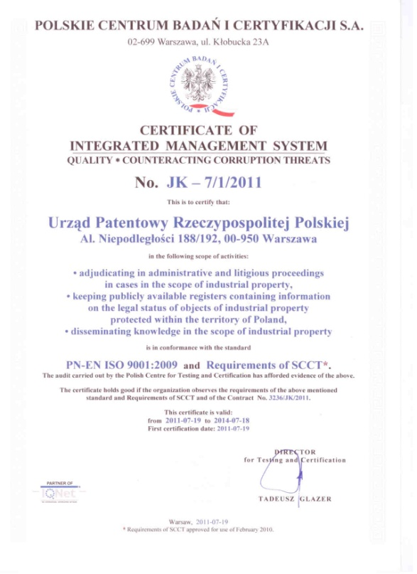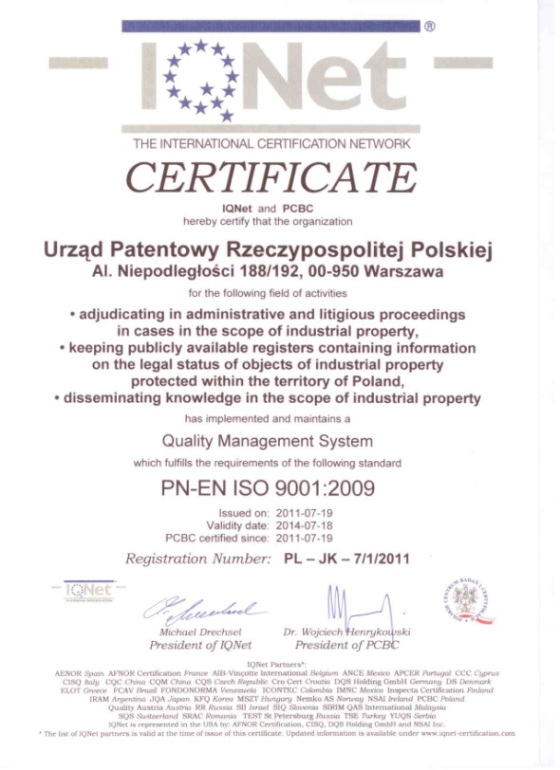

Figure 1: The EN-PL ISO 9001:2009 certification of the PPO

1. LEADERSHIP AND POLICY

21.04 Confirm that the following are clearly documented, and that this documentation is available internally:
(a) The quality policy established by top management.
(b) The roles and names of those bodies and individuals responsible for the QMS, as delegated by top management.
(c) An organizational chart showing all those bodies and individuals responsible for the QMS.
(a) The quality policy established by the top management:
The mission of the Patent Office of the Republic of Poland (PPO) is to receive and examine applications filed in order to obtain protection for industrial property objects, issue decisions on granting exclusive rights, adjudicate in the administrative and litigation proceedings in cases relating to the industrial property matters, keeping publicly available registers containing information on the legal status of the objects of industrial property protected on the territory of Poland and disseminating knowledge in the scope of industrial property.
The PPO performs its tasks under the Act – the Industrial Property Law, mainly by receiving applications concerning the industrial property objects, examining them as well as keeping relevant registers and providing services to clients in this regard ensuring the highest quality of its work products issued within the framework of a corruption-free processes. The intention of the PPO is to ensure:
- orientation of the main process of the Internal Management System on the client;
- maintenance of the achieved level of productivity and effectiveness of processes;
- management of risk in identified processes and areas;
- continuity of services provision;
- optimization of the Office maintenance and service costs;
- supervision over the accurate budgeting of the Office;
- provision of reliable and useful information;
- acquisition and maintenance of the skills and knowledge necessary to proper performance of its processes;
In order to ensure achievement of the above-mentioned goals, the PPO has introduced Integrated Management System satisfying the requirements of PN-EN ISO 9001:2009 standard on external client services, as well as additional requirements of the Anti-corruption System. All employees of the Patent Office of the Republic of Poland are aware that the maintenance of set quality and anti-corruption standards enable development, thus contributing to achievement of assumed goals. All documentation relating to the Integrated Management System Policy is available to all employees online via the Office Intranet and in each department in hard copy.
(b) The roles and names of those bodies and individuals responsible for the QMS; as delegated by the top management
Roles within the Integrated Management System under the ISO QMS in the Patent Office of the Republic of Poland

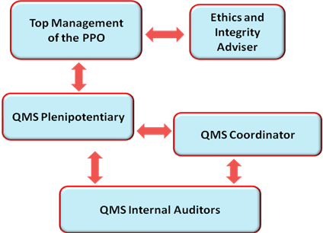

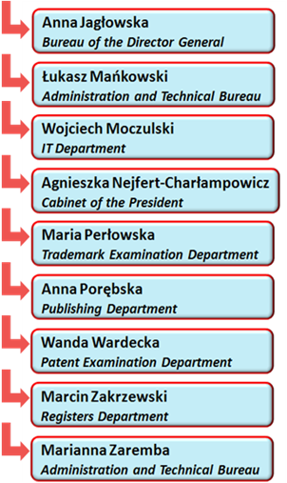
Figure 2: Roles within the IMS in the PPO

Organizational chart of the Patent Office of the Republic of Poland

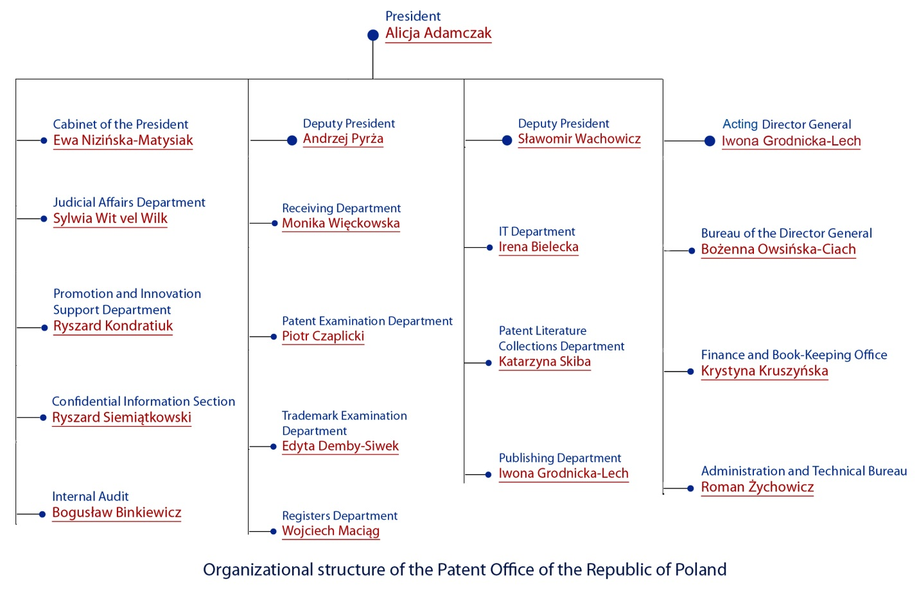

Figure 3: Organizational structure of the PPO

21.05 Indicate (e.g. by means of a table) the extent of compatibility between the Authority's QMS and the requirements of Chapter 21 of these International Search and Preliminary Examination Guidelines. Alternatively, indicate where the Authority is not yet compliant with these requirements.).

Chapter 21 requirement |  |  | Extent of compliance
 |  |  | full | part | no
21.04 | (a) | Quality policy available
 | (b) | Identified roles and names for QMS responsibility
 | (c) | Organizational chart available
21.05 |  | Established compatibility of QMS with Chapter 21
21.06 | (a) | Mechanisms to ensure effectiveness of the QMS
 | (b) | Control of the continual improvement process
21.07 | (a) | Communication of management about this standard to staff
 | (b) | The PCT Guidelines are in line with the Authority's QMS
21.08 | (a) | Management reviews take place
 | (b) | Quality objectives are reviewed
 | (c) | Communication of quality objectives throughout the Authority
21.09 | (a) | Performance of a yearly internal review of the QMS in/to
 | (b) | (i) determine the extent to which the QMS in based on Chapter 21
 |  | (ii) determine the extent to which S&E complies with PCT Guidelines
 | (c) | an objective and transparent way
 | (d) | using input incl. information according paragraph 21.17
 | (e) | recording the results
21.10 |  | Assurance to monitor and adapt to actual workload
21.11 | (a) | Infrastructure in place to ensure that a quantity of staff
 |  | (i) sufficient to deal with the inflow of work
 |  | (ii) which maintains tech. qualifications to S&E in all technical fields
 |  | (iii) which maintains the language facilities to understand languages according to Rule 34
 | (b) | Infrastructure to provide a quantity of skilled administrative staff
 |  | (i) at a level to support the technically qualified staff
 |  | (ii) for the documentation records
21.12 | (a) | (i) Ensuring appropriate equipment to carry out S&E
 |  | (ii) Ensuring documentation accord. to Rule 34
 | (b) | (i) Instructions to help staff understand and act accord. the quality criteria and standards
 |  | (ii) Instructions to follow work procedures accurately and they are kept up-to-date.
21.13 |  | (i) L&D program to ensure and maintain necessary skills in S&E
 |  | (ii) L&D program to ensure awareness of staff to comply with the quality criteria and standards.
21.14 | (a) | System in place for monitoring resources required to deal with demand
 | (b) | System in place for monitoring resources required to comply with the quality standards in S&E
21.15 | (a) | Control mechanisms to ensure timely issue of S&E reports
 | (b) | Control mech. regarding fluctuations in demand and backlog
21.16 | (a) | Internal quality assurance system for self assessment
 |  | (i) for compliance with S&E Guidelines
 |  | (ii) for channeling feedback to staff
 | (b) | A system for measurement of data and reporting for continuous improvement
 | (c) | System for verifying the effectiveness of actions taken to correct deficient S&E work
21.17 | (a) | Contact person helping identify best practice between Authorities
 | (b) | Contact person fostering continual improvement
 | (c) | Contact person providing for effective comm. with other Authorities for feedback and evaluation
21.18 | (a) | (i) Appropriate system for handling complaints
 |  | (ii) Appropriate system for taking preventive/corrective actions
 |  | (i) Appropriate system for offering feedback to users
 | (b) | (i) A procedure for monitoring user satisfaction & perception
 |  | (ii) A procedure for ensuring their legitimate needs and expectations are met
 | (c) | Clear and concise guidance on the S&E process for the user
 | (d) | Indication where and how the Authority makes its quality objectives publicly available
21.19 |  | Established communication with WIPO and designated and elected Offices
21.20 |  | QMS of Authority clearly described (e.g. Quality Manual)
21.21 | (a) | Documents making up the Quality Manual have been prepared and distributed
 | (b) | Media available to support the Quality Manual
 | (c) | Document control measures are taken
21.22 | (a) | Quality policy of the Authority and commitment to QMS
 | (b) | Scope of QMS
 | (c) | Organizational structure and responsibilities
 | (d) | the documented processes are carried out in the Authority
 | (e) | Resources available to carry out processes
 | (f) | a description of the interaction between the processes and the procedures of the QMS.
21.23 | (a) | Records which documents are kept and where they are kept
 | (b) | Records of results of management review
 | (c) | Records about training, skills and experience of staff
 | (d) | Evidence of conformity of processes
 | (e) | Results of reviews of requirements relating to products
 | (f) | Records of the S&E process carried out on each application
 | (g) | Record of data allowing individual work to be tracked
 | (h) | Record of QMS audits
 | (i) | Records on actions taken re. non-conforming products
 | (j) | Records on actions taken re. corrective actions
 | (k) | Records on actions taken re. preventive actions
 | (l) | Records referring to search process documentation
21.24 | (a) | (i) Recording of the databases consulted during search
 |  | (ii) Recording of keywords, combination of words and truncations during search
 |  | (iii) Recording of the languages used during search
 |  | (iv) Recording of classes and combinations thereof consulted during search
 | (b) | Records about other information relevant to the search
 | (c) | (i) Records about limitation of search and its justification
 |  | (ii) Records about lack of clarity of the claims
 |  | (iii) Records about lack of unity
21.25 |  | Report on its own internal review processes
21.26-21.28 |  | Additional information on further inputs to its internal reviews
21.29 |  | Initial report called for by paragraph 21.19 | -

21.06 Indicate with reference to the organizational chart those bodies and mechanisms management uses to ensure:
(a) the effectiveness of the QMS; and
(b) that the process of continual improvement progresses.
(а)
The implementation of goals under the Integrated Management System Policy is supervised by the top management of the PPO that conducts an annual risk analysis for identified processes and areas, provides resources for system maintenance, observes the rules resulting from the introduction of IMS Policy in the PPO and continues the development of system effectiveness. Once a year the management performs a review of applicable quality goals. Internal audits are performed periodically in accordance with the set schedule.
(b)
The QMS Internal Auditors are appointed upon fulfillment of certain conditions and requirements and they are obliged to undergo comprehensive trainings on QMS at least once in two years. Each year the QMS Plenipotentiary performs an overview of the auditors’ qualifications.
An Internal Auditor conducts random-like cross-checks one per year and prepares a Report on each audit performed and supplements it, if applicable, with the Identified Non-compliance Report. All post-audit documentation is submitted with the QMS Coordinator who notifies the results to the head of the audited field or process. The internal audits’ results are also subject to discussions and analyses of the top management that decides on undertaking any potential further actions. The search and examination processes are also subject to self-assessment actions undertaken and carried out by the employees of the two Quality Control Sections established in the Patent Examination Department.
In addition, the PPO undergoes annual controls of compliance with the QMS Policy carried out by the independent external bodies.
21.07 Indicate how management of the Authority communicates to its staff the importance of meeting treaty and regulatory requirements including:
(a) those of this standard; and
(b) complying with the Authority's QMS.
Importance of meeting requirements relating to performance of the international search and international preliminary examination under the Patent Cooperation Treaty as well as requirements specified under the Integrated Management System, including those concerning quality, are communicated to the PPO staff by the top management during regular meetings.

21.08 Indicate how and when top management of the Authority or delegated officers:
(a) conducts management reviews and ensures the availability of appropriate resources;
(b) reviews quality objectives; and
(c) ensures that the quality objectives are communicated and understood throughout the respective Authority.
(a)
The quality goals of the PPO are identified during the specially-dedicated meetings held annually by the top management. The demand for resources necessary for successful performance of the quality goals is regularly communicated by the relevant units and departments of the PPO to the top management, and decisions on ensuring such resources are made as required.
(b)
The review of the quality objectives is performed by the top management during the annual meeting dedicated to the QMS Policy.
(c)
All documentation relating to the Integrated Management System Policy, including the established quality objectives and anti-corruption standards, is available to all employees online via the Office Intranet and in each department in hard copy. Each internal audit is finalized with an Audit Report subsequently submitted to the director of the audited field or process, which is followed by further discussions over the reported results held between the director and the employees of the respective unit.
Quarterly and yearly reports of a detailed quality check as well as indicators of the concluded self-assessment actions are submitted to the top management’s meetings. Moreover, conclusions and recommendations on conducting unified search and examination procedure are periodically presented to all examiners and top management.
21.09 Indicate whether top management or delegated officers of the Authority perform an internal review of the QMS in accordance with paragraphs 21.25-21.28:
(a) at least once per year (cf. paragraph 21.25);
(b) in accordance with the minimum scope of such reviews as set out in Section 8, namely:
(i) to determine the extent to which the QMS is based on Chapter 21 (cf. paragraphs 21.25, 21.27(a));
(ii) to determine the extent to which Search and Examination work complies with PCT Guidelines (cf. paragraphs 21.25, 21.27(a));
(c) in an objective and transparent way (cf. paragraph 21.25);
(d) using input including information according to paragraphs 21.27 (b)-(f);
(e) recording the results (cf. paragraph 21.28).
The management of the PPO carries out the internal review of the QMS once a year. The objective and transparent review is using the input information according to paragraphs 21.27 (b)-(f).
The results are recorded and reported on the Intranet of the PPO.

2. Resources

21.10 Explanatory note: The granting of ISEA status means that the Authority has demonstrated it has the infrastructure and resources to support the search and examination process. Chapter 21 calls for assurance that the Authority can continually support this process while accommodating changes in workload and meeting QMS requirements. The responses to Sections 21.11 to 21.14, below, should provide this assurance.
21.11 Human resources:
(a) Provide information about the infrastructure in place to ensure that a quantity of staff:
(i) sufficient to deal with the inflow of work;
(ii) which maintains the technical qualifications to search and examine in the required technical fields; and
(iii) which maintains the language facilities to understand at least those languages in which the minimum documentation referred to in Rule 34 is written or is translated
is maintained and adapted to changes in workload.
(b) Describe the infrastructure in place to ensure that a quantity of appropriately trained/skilled administrative staff is maintained and adapted to changes in workload:
(i) at a level to support the technically qualified staff and facilitate the search and examination process;
(ii) for the documentation of records.

21.12 Human resources:
(a) Describe the infrastructure in place to ensure that:
(i) appropriate equipment and facilities such as IT hardware and software to support the search and examination process are provided and maintained;
(ii) at least the minimum documentation referred to in Rule 34 is available, accessible, properly arranged and maintained for search and examination purposes. State whether it is on paper, in microform or stored on electronic media, and where.
(b) Describe how instructions
(i) to help staff understand and adhere to the quality criteria and standards; and;
(ii) to follow work procedures accurately and consistently
are documented, provided to staff, kept up-to-date and adapted where necessary.

21.13 Training resources:
Describe the training and development infrastructure and program which ensures that all staff involved in the search and examination process:
(i) acquire and maintain the necessary experience and skills; and
(ii) are fully aware of the importance of complying with the quality criteria and standards.

Internal examiner’s training program:
- 3-years PPO-based training addressed to junior examiners;
- obtaining extensive knowledge on patent law and procedure;
- assisting with dealing with regular applications, drafting letters, i.a. notices, calls, rulings and decisions, under the supervision of a senior examiner;
- completed with examination on advanced IP knowledge and patent grant procedure consisting of 3 modules: a written part and two tests verifying theoretical knowledge and practical skills;
- upon successful completion of the examination – 2 years at the position of a junior expert, acting independently with random cross-checks performed each month by
the supervising senior examiner;

Other internal training programs:
- weekly trainings in the PPO dealing with various legal and practical aspects of national and international IP law and procedure;
- access to the PPO Online Education Platform with knowledge and training sections updated with the most recent resources of national court decisions, IP-related literature, etc.; available on http://ipe.uprp.pl/login/index.php ;
- regular language courses based in the PPO and in external language centers;
External training programs:
- in-house and distant learning courses organized by the European Patent Academy of the EPO and the World Intellectual Property Office;
- participation in workshops, trainings, seminars and conferences organized by national and international relevant industry-specific institutions;
- intensive university post-graduate program authorizing participants to teach IP;
- obligatory courses on IPRs incorporated into curricula of each faculty at the higher education institutions in Poland;
- trainings for patent attorneys organized in the regional branches of the Chamber of Patent Attorneys and during annual conferences in Cedzyna.

21.14 Oversight over resources:
Describe the system in place for continuously monitoring and identifying the resources required:
(a) to deal with demand; and
(b) comply with the quality standards for search and examination
(a)
Analysis of the sufficiency of resources necessary for successful performance of the quality goals is performed by the management of the Patent Examination Department on a regular basis. Current needs are communicated by the relevant units and departments to the top management, and decisions on ensuring such resources are made as required.
(b)
Quality control of the search and examination work products is carried out randomly on
a regular basis. Currently there are two Quality Control Sections (so called “self assessment”) established in the Patent Examination Department, whose tasks relate to detailed control of
the S&E process applied by the examiner, drafting post-control conclusions forwarded later to examiners and heads of the units, and preparing reports on identified errors and discrepancies in interpretation discussed afterwards at the inter-department meetings.

3. MANAGEMENT OF ADMINISTRATIVE WORKLOAD

21.15 Indicate how the following practices and procedures for handling search and examination requests and performing related functions such as data-entry and classification are implemented:
(a) Effective control mechanisms regarding timely issue of search and examination reports to a quality standard as set by the respective Authority; and
(b) Appropriate control mechanisms regarding fluctuations in demand and backlog management.
The search and examination processes are described in detail in a documentation specifying the PPO’s performance, time and quality indicators. The Quality Control Sections in the Patent Examination Department are responsible for monitoring the timely issuance of search and examination reports, and they set the priorities, if necessary. The management of the Patent Examination Department decides on the transfer of the requests between the sections, if it is required due to the workload. The results of such a monitoring are reported on a monthly basis in a statistical report submitted to the Director of the Patent Examination Department with
a summarized analytical data being sent to the heads of the patent sections.

4. Quality Assurance

21.16 The following are required quality assurance measures for timely issue of search and examination reports of a quality standard in accordance with the Guidelines. Indicate how the following are implemented:
(a) An internal quality assurance system for self assessment, involving verification, validation and monitoring of searches and examination work:
(i) for compliance with these Search and Examination Guidelines;
(ii) for channeling feedback to staff.
(b) A system of measurement and collection of data and reporting. Show how the Authority uses the system to ensure the continuous improvement of the established processes.
(c) A system for verifying the effectiveness of actions taken to correct deficient S&E work, eliminate the causes, and to prevent issues from recurring.
(a)
The PPO is using the Search and Examination Guidelines that are available for the employees via Intranet, as well as for external users on the Office website.
For the self assessment of monitoring the search and examination work the examiners are using the checklist forms. There are 24 cases verified every month by the examiners from
the Quality Control Section on the basis of such checklists. Results of such verifications are discussed with experts performing search and examination.
(b)
The respective checklist forms are collected and kept by the coordinators of the Quality Control Section.
(c)
The checklist forms provide a basis for preparation of periodic reports whose conclusions are aiming at harmonization of search and examination procedures.
In addition to the prepared and verified checklists, there are annual QMS audits carried out by the independent experts. Reports and feedback from these audits serve the top management as a basis for introduction of further improvements to the QMS applied in the PPO.

5. Communication

21.17 Inter-Authority communication:
Provide the name, job title and contact details of the Authorities designated quality contact person who will take responsibility for:
(a) helping identify and disseminate best practice among Authorities;
(b) fostering continual improvement; and
(c) providing for effective communication with other Authorities to allow for prompt feedback from them so that potential systemic issues can be evaluated and addressed.
Alicja Tadeusiak (atadeusiak@uprp.pl), Expert Coordinator of the Quality Control Section in the Biotechnology and Pharmacy Department.
21.18 Communication and guidance to users:
Describe the system in place for monitoring and using customer feedback including at least the following elements:
(a) An appropriate system for
(i) handling complaints and making corrections;
(ii) taking corrective and/or preventative action where appropriate; and
(iii) offering feedback to users.
(b) A procedure for:
(i) monitoring user satisfaction and perception; and
(ii) for ensuring their legitimate needs and expectations are met.
(c) Clear, concise and comprehensive guidance and information to users (particularly unrepresented applicants) on the search and examination process, giving details of where it is to be found e.g. link to Authority’s web site, guidance literature.
(d) An indication of where and how the Authority makes its quality objectives publicly available for the users.
(a) (b)
Methods and forms of the PPO’s customer service are constantly improved by the top management on the basis of the users’ feedback provided under the customer satisfaction surveys, complaints addressed to the President of the PPO and remarks concerning functionality of the Office website. Customer satisfaction survey forms, complaints and remarks can be submitted both electronically and in hard copy.
The procedure for taking the corrective or preventive actions is stipulated in detail in the Procedural Charts that comprise the documentation of the QMS policy in the PPO (available on the Intranet of the PPO and in hard copy in each Department). The respective actions are initiated upon request of a head of a division/department after identification of non-compliance. All such requests are collected and processed by the QMS Coordinator who reports on these actions to the top management.
(c) (d)
Detailed information on the application, search and examination procedure used in the PPO is available online on the Office website and is comprehensively described in the PPO publications. Most of these publications are uploaded in the electronic version on the Office website and are available in hard copies distributed free of charge or sold by the PPO on its premises and at various events, conferences and trainings. The PPO’s flagship publications detailing the search and examination procedure and the related quality objectives are entitled “Inventors Guidebook”, one of which is dedicated to “Application procedure in the national, European and international systems” and the second to “Methodology of patentability examination with respect to patents and utility models”. Moreover, comprehensive information on IP related laws and procedures is provided by a highly qualified staff of the IP Info Center available to the users in the PPO and via telephone, e-mail, fax, chat, callback and website enquiries.
The Integrated Management System Policy was publicly available to the users on the Office website between 2011 and 2014, and it is declared to be uploaded to this website also upon grant of a new ISO certificate.
21.19 Communication with WIPO and designated and elected Offices:
Describe how the Authority provides for effective communication with WIPO and designated and elected offices. In particular describe how the Authority ensures that WIPO feedback is promptly evaluated and addressed.

6. Documentation

21.20 Explanatory note: The QMS of the Authority needs to be clearly described and implemented so that all processes in the Authority and the resulting products and services can be monitored, controlled, and checked for conformity. This is done in the documents that make up the Quality Manual of the Authority (see paragraph 21.21).
(Note: This point is informative. No response is required by the template to paragraph 21.20)
21.21 The documents that make up the Quality Manual serve to document the procedures and processes affecting the quality of work, such as classification, search, examination and related administrative work. In particular, the Quality Manual indicates where to find instructions on the procedures to be followed.
For the purposes of this report indicate:
(a) the documents making up a Quality Manual that have been prepared and distributed;
(b) the media on which it is supported (e.g. Internal Publication, Internet, Intranet); and
(c) document control measures taken e.g. version numbering, access to latest version.
The Quality Manual of the PPO comprises of the Quality Manual of the Integrated Management System, the Core Process Procedural Charts of the PPO, the Procedural Charts and the Maps of the Procedures. The latest version of the documentation is numbered 3.0 and is available on the Intranet and in hard copy in each department since mid March 2015. The Quality Manual documentation regulates the procedures and processes affecting the quality of classification, search, examination for the entire Office and related administrative work. Currently, there is work conducted with the aim of preparing an additional Quality Manual dedicated solely to the detailed description of search and examination procedures and processes.
21.22 Indicate whether the documents making up the Quality Manual include the following:
(a) the quality policy of the Authority including a clear statement of commitment to the QMS from top management;
(b) the scope of the QMS, including details of and justification for any exclusions;
(c) the organizational structure of the Authority and the responsibilities of each of its departments;
(d) the documented processes carried out in the Authority such as receipt of incoming applications, classification, distribution, search, examination, publication and support processes, and procedures established for the QMS, or references to them;
(e) the resources available for carrying out the processes and implementing the procedures; and
(f) a description of the interaction between the processes and the procedures of the QMS.
The Quality Manual and it’s attachments include the following parts:
(a) the quality policy established by the top management of the PPO;

(b) the scope of the QMS, with details of and justification for any exclusions;
(c) the organizational structure of the PPO;
(d) all the documented processes carried out at the PPO;
(e) the resources available for carrying out the processes;
(f) a description of the interaction between the processes and the procedures of the QMS.
21.23 Indicate which types of records the Authority maintains, such as:
(a) a definition of which documents are kept and where they are kept;
(b) results of management review;
(c) training, skills and experience of personnel;
(d) evidence of conformity of processes, resulting products and services in terms of quality standards;
(e) results of reviews of requirements relating to products;
(f) the search and examination processes carried out on each application;
(g) data allowing individual work to be tracked and traced;
(h) records of QMS audits;
(i) actions taken re. non-conforming products, e.g. examples of corrections;
(j) actions taken re. corrective action;
(k) actions taken re. preventative action; and
(l) search process documentation as set out in Section 7.

According to the PN-EN ISO 9001:2009 standards the PPO maintains all the needed records such as:
- a definition of which documents are kept and where they are kept;
- results of management review;
- training, skills and experience of personnel;
- evidence of conformity of processes, resulting products and services in terms of quality standards;
- results of reviews of requirements relating to products;
- the search and examination processes carried out on each application – available on Register+;
- data allowing individual work to be tracked and traced;
- records of QMS audits;
- actions taken re. non-conforming products, e.g. examples of corrections;
- actions taken re. corrective action;
- actions taken re. preventative action; and
- search process documentation as set out in Section 7.

7. Search Process Documentation

21.24 For internal purposes the Authority should document its search process.
The Authority should indicate
(a) which of the following are included in this record:
(i) the databases consulted (patent and non patent literature);
(ii) the keywords, combinations of words and truncations used;
(iii) the language(s) in which the search was carried out;
(iv) the classes and class combinations searched, at least according to the IPC or equivalent;
(v) a listing of all search statements used in the databases consulted.
(b) which other information relevant to the search itself is included in this record e.g. a statement of the subject of search; details of special relevance to internet searching; a record of documents viewed; on-line thesaurus, synonym or concept databases, etc.
(Explanatory note: The IA is requested to list other information it may collect to monitor and improve the search process)
(c) which special cases are documented and whether records are kept denoting any:
(i) limitation of search and its justification
(ii) lack of clarity of the claims; and
(iii) lack of unity.
Search process in the PPO is reported in the search report itself and in specifically dedicated files on an internal drive accessible to all examiners.
The search report prepared by the PPO documents the following:
(i) the databases consulted (patent, non-patent literature or Internet);
(ii) the classes and class combinations searched, according to the IPC;
iii) a list of the documents considered to be relevant and corresponding comments on their relevance;
(iv) any search limitations resulting from claims that lack clarity or support to the extent that no meaningful search can be carried out;
v) any indications regarding unity of invention.
Records of the search will be stored on the Office specialty dedicated Office drive document for each file:
(vi) the keywords and synonyms describing the subject matter to be searched;
(vii) the search statements used and results returned (i.e. search history).

8. Internal Review

21.25 Explanatory note: The Authority should report on its own internal review arrangements. These reviews determine the extent to which it has established a QMS based on the model of Chapter 21 and the extent to which it is complying with the QMS requirements and the Search and Examination Guidelines. The reviews should be objective and transparent to demonstrate whether or not those requirements and guidelines are being applied consistently and effectively and should be undertaken at least once a year. With reference to point 21.08 of this template, the Authority may provide additional information on its internal review arrangements under this section if it so wishes.
21.26-21.28 These arrangements are reported according to this template in Section 1, above, at points 21.04 - 21.09. The Authority may provide additional information on further inputs to its internal reviews under this section, if it so wishes.
Both internal and external QMS audits are carried out on a yearly basis.
The audit’s aim is to confirm the QMS conformity with the PN-EN ISO 9001:2009 standards.

9. Arrangements for Authorities to Report to the MIA

21.29 There are two stages in the reporting arrangements outlined in Chapter 21: the initial report called for by paragraph 21.29, and supplementary annual reports in accordance with paragraph 21.30.

[Annex IV follows]
Report on Quality Management Systems
prepared by the Industrial Property Office of the Slovak Republic (IPO SR)
as participating Office of the Visegrad Patent Institute (VPI)

The Authority should provide general background information relevant to the quality management system (QMS) as set forth in this template.
The descriptions below each main heading of this template should be considered examples of the type and arrangement of information that should be included under each heading. Each Authority may provide additional information beyond that set forth in this template as desired.

INTRODUCTION (PARAGRAPHS 21.01 - 21.03)

If applicable, the Authority may at this point indicate any recognized normative reference or basis for their quality management system besides Chapter 21, such as ISO 9001, under the heading “Normative Reference for QMS”
For example: “Normative reference for QMS: ISO 9001, EQS (European Quality System)”
Each Authority should then provide at least the information indicated in the descriptive boxes, under the following headingsThe Industrial Property Office of the Slovak Republic (IPO SR) has implemented
a quality management system for almost all processes including patent search and examination functions that conforms to the ISO 9001 standards. The first certification according to the EN ISO 9001:2008 standards was granted in year 2008; the first re-certification was in 2011 and was valid until June 2014.
In June 2014 the IPO SR successfully passed the second re-certification audit and defended the quality management system in the IPO SR and obtained the certificate verifying the implementation and maintenance of quality management system in accordance with the requirements of the EN ISO 9001:2008 for the execution of the central state administration in the field of inventions, designs, trade marks and designation of origin and geographical indications protection, administration of the central patent literature fund and exchange and provision of information in the field of industrial property rights until June 2017.
The objective of re-certification audit was to examine the overall effectiveness of the quality management system with due regard to any changes, its continued relevance and applicability to the subject of certification demonstrating commitment of the IPO SR to maintain and improve efficiency in all certification standards. An audit was conducted by certification authority ELBACERT, a.s. The re-certification audit did not reveal any issues; the auditors highlighted several strong points of the IPO SR and identified certain opportunities for further improvement. Following these auditors´ recommendations the IPO SR has been proceeding in managing its internal processes with a view of continual quality enhancement.

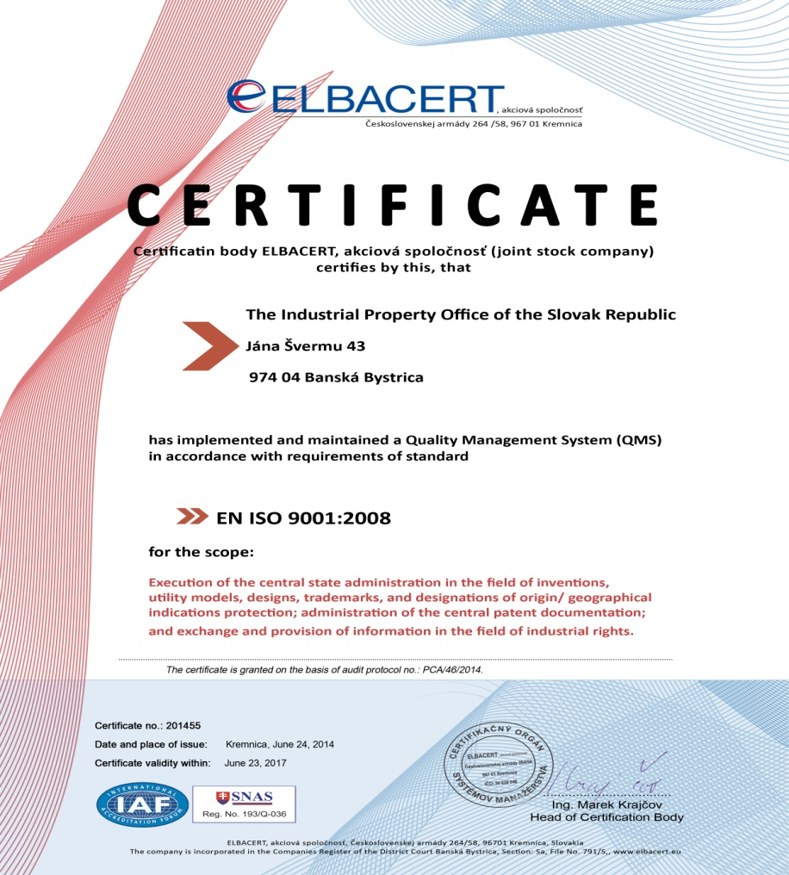

Figure 1: The ISO certificate of the IPO SR

1. LEADERSHIP AND POLICY

21.04 Confirm that the following are clearly documented, and that this documentation is available internally:
(a) The quality policy established by top management.
(b) The roles and names of those bodies and individuals responsible for the QMS, as delegated by top management.
(c) An organizational chart showing all those bodies and individuals responsible for the QMS.
The quality policy the IPO SR applies in its strategic vision and objectives which follows in fulfilling its core mission - the state administration in the protection of inventions, utility models, topographies of semiconductor products, designs, trademarks, designations of origin and geographical indications.
Strategy of the IPO SR
The main task and mission of the IPO SR is to provide fast, efficient and reliable IP protection. This protection is a cornerstone of economic activity that provides significant value to its owner but also throughout the economy.
Main priorities of the IPO SR for the years 2012 – 2016 focused on improving quality of services provided and optimize the operation of the IPO SR are:
- Extension of computerization - extension of electronic services for the public, enabling access to online filing of other IP subjects, scanning paper filings, re-adjusting the web registers of the IPO SR;
- Streamlining of operations - shortening of proceedings, improving quality and effectiveness of search of patent applications; continuation with modernization of information system for patent application administration and proceedings on the subjects of the IP with the view of the development of legislation, international relations and information technology; update performance indicators processes in the framework of ISO;
- Increasing awareness - knowledge dissemination towards importance and strategies of exploitation of intellectual property for research and industrial and business practice; introduction of "IP minimum" to the curriculum of primary, secondary schools and universities.
(a) The quality policy established by top management.
The quality policy of the IPO SR is based on the following principles:
- The IPO SR is in accordance with Art. 32(2) and (3) of the Act no. 575/2001 Coll. the organization of the ministries and other central state administration bodies of the Slovak Republic, as amended, the only central state administrative body for the field of the industrial property. This task it fulfils in a professional, impartial, effective manner in accordance with the requirements of the modern state administration.
- The IPO SR in the performance of the tasks entrusted by the state is committed to improve the quality and efficiency of all its activities and focuses them on the requirements of its clients. To achieve this goal the IPO SR introduced the quality management system.
- The IPO SR takes share in shaping of IPR protection at national, regional and international levels. This role is performed with respect to the requirements and needs of the clients of the IPO SR and with respect of promotion the interests of the Slovak Republic and its citizens.
- The IPO SR for professional, impartial, efficient and modern performance of state administration in the field of industrial property highly needs qualified employees, therefore is particular in continuous training and professional development of its employees.
- Management of the IPO SR takes such decisions and measures which continuously improve activities and outputs of the IPO SR towards internal and external environment.
(b) The roles and names of those bodies and individuals responsible for the QMS; as delegated by the top management
For the Managerial Processes two persons from the top management of the IPO SR are responsible: Mr Ľuboš Knoth, the President of the IPO SR and Mr Andrej Legiň, the Secretary General of the IPO SR.
For the Main Processes two persons from the middle-management of the IPO SR are responsible: Ms Ingrid Maruniaková, the Principal Director of the Business Section and Mr Milan Oravec, the Principal Director of the Business Support Section.

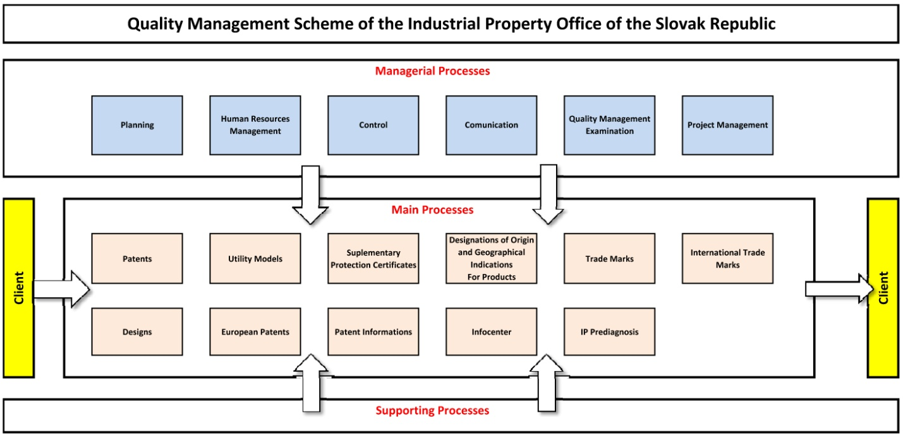
Figure 1: Quality Management Scheme of the IPO SR

Figure 2: Organization structure of the IPO SR

21.05 Indicate (e.g. by means of a table) the extent of compatibility between the Authority's QMS and the requirements of Chapter 21 of these International Search and Preliminary Examination Guidelines. Alternatively, indicate where the Authority is not yet compliant with these requirements.).

Chapter 21 requirement |  |  | Extent of compliance
 |  |  | full | part | no
21.04 | (a) | Quality policy available
 | (b) | Identified roles and names for QMS responsibility
 | (c) | Organizational chart available
21.05 |  | Established compatibility of QMS with Chapter 21
21.06 | (a) | Mechanisms to ensure effectiveness of the QMS
 | (b) | Control of the continual improvement process
21.07 | (a) | Communication of management about this standard to staff
 | (b) | The PCT Guidelines are in line with the Authority's QMS
21.08 | (a) | Management reviews take place
 | (b) | Quality objectives are reviewed
 | (c) | Communication of quality objectives throughout the Authority
21.09 | (a) | Performance of a yearly internal review of the QMS in/to
 | (b) | (i) determine the extent to which the QMS is based on Chapter 21
 |  | (ii) determine the extent to which S&E complies with PCT Guidelines
 | (c) | an objective and transparent way
 | (d) | using input incl. information according paragraph 21.17
 | (e) | recording the results
21.10 |  | Assurance to monitor and adapt to actual workload
21.11 | (a) | Infrastructure in place to ensure that a quantity of staff
 |  | (i) sufficient to deal with the inflow of work
 |  | (ii) which maintains tech. qualifications to S&E in all technical fields
 |  | (iii) which maintains the language facilities to understand languages according to the Rule 34
 | (b) | Infrastructure to provide a quantity of skilled administrative staff
 |  | (i) at a level to support the technically qualified staff
21.12 | (a) | (i) Ensuring appropriate equipment to carry out S&E
 |  | (ii) for the documentation records
 | (b) | (i) Instructions to help staff understand and act accord. the quality criteria and standards
 |  | (ii) Instructions to follow work procedures accurately and they are kept up-to-date.
21.13 |  | (i) L&D program to ensure and maintain necessary skills in S&E
 |  | (ii) L&D program to ensure awareness of staff to comply with the quality criteria and standards.
21.14 | (a) | System in place for monitoring resources required to deal with demand
 | (b) | System in place for monitoring resources required to comply with the quality standards in S&E
21.15 | (a) | Control mechanisms to ensure timely issue of S&E reports
 | (b) | Control mech. regarding fluctuations in demand and backlog
21.16 | (a) | Internal quality assurance system for self assessment
 |  | (i) for compliance with S&E Guidelines
 |  | (ii) for channeling feedback to staff
 | (b) | A system for measurement of data and reporting for continuous improvement
 | (c) | System for verifying the effectiveness of actions taken to correct deficient S&E work
21.17 | (a) | Contact person helping identify best practice between Authorities |  | N/A YET
 | (b) | Contact person fostering continual improvement
 | (c) | Contact person providing for effective comm. with other Authorities for feedback and evaluation
21.18 | (a) | (i) Appropriate system for handling complaints
 |  | (ii) Appropriate system for taking preventive/corrective actions
 |  | (i) Appropriate system for offering feedback to users
 | (b) | (i) A procedure for monitoring user satisfaction & perception
 |  | (ii) A procedure for ensuring their legitimate needs and expectations are met
 | (c) | Clear and concise guidance on the S&E process for the user
 | (d) | Indication where and how the Authority makes its quality objectives publicly available
21.19 |  | Established communication with WIPO and designated and elected Offices
21.20 |  | QMS of Authority clearly described (e.g. Quality Manual)
21.21 | (a) | Documents making up the Quality Manual have been prepared and distributed
 | (b) | Media available to support the Quality Manual
 | (c) | Document control measures are taken
21.22 | (a) | Quality policy of the Authority and commitment to QMS
 | (b) | Scope of QMS
 | (c) | Organizational structure and responsibilities
 | (d) | the documented processes are carried out in the Authority
 | (e) | Resources available to carry out processes
 | (f) | a description of the interaction between the processes and the procedures of the QMS.
21.23 | (a) | Records which documents are kept and where they are kept
 | (b) | Records of results of management review
 | (c) | Records about training, skills and experience of staff
 | (d) | Evidence of conformity of processes
 | (e) | Results of reviews of requirements relating to products
 | (f) | Records of the S&E process carried out on each application
 | (g) | Record of data allowing individual work to be tracked
 | (h) | Record of QMS audits
 | (i) | Records on actions taken re. non-conforming products
 | (j) | Records on actions taken re. corrective actions
 | (k) | Records on actions taken re. preventive actions
 | (l) | Records referring to search process documentation
21.24 | (a) | (i) Recording of the databases consulted during search
 |  | (ii) Recording of keywords, combination of words and truncations during search
 |  | (iii) Recording of the languages used during search
 |  | (iv) Recording of classes and combinations thereof consulted during search
 | (b) | Records about other information relevant to the search |  | N/A
 | (c) | (i) Records about limitation of search and its justification |  | N/A
 |  | (ii) Records about lack of clarity of the claims |  | N/A
 |  | (iii) Records about lack of unity |  | N/A
21.25 |  | Report on its own internal review processes
21.26-21.28 |  | Additional information on further inputs to its internal reviews
21.29 |  | Initial report called for by paragraph 21.19 |  | N/A YET
N/A = not applicable due to differences in the Slovak legislation
N/A YET = not applicable until commencement Authority´s work

21.06 Indicate with reference to the organizational chart those bodies and mechanisms management uses to ensure:
(a) the effectiveness of the QMS; and
(b) that the process of continual improvement progresses.
(а)
The efficiency of the QMS is verified and assessed by the IPO SR management on a yearly basis. Management evaluates mainly fulfillment of the politics and quality goals, evaluation of quality audits and finally develops and formulates adjusted measuring quality goals and indicates the persons responsible for ensuring their achievement.
(b)
The internal auditors conduct internal audits at least once a year. The results of the internal audits are discussed and analyzed at Management meetings and Management takes decisions about necessary actions to be made with control options.
21.07 Indicate how management of the Authority communicates to its staff the importance of meeting treaty and regulatory requirements including:
(a) those of this standard; and
(b) complying with the Authority's QMS.
The management of the IPO SR communicates to its staff the importance of fulfillment of the QMS requirements via regularly held meetings:
- Management meetings
- Meetings of the departments and sections
- Communication via Intranet
On these meetings the compliance with the QMS is also discussed.
21.08 Indicate how and when top management of the Authority or delegated officers:
(a) conducts management reviews and ensures the availability of appropriate resources;
(b) reviews quality objectives; and
(c) ensures that the quality objectives are communicated and understood throughout the respective Authority.
(a)
The IPO SR management develops and forms quality goals, directed towards a continuous improvement based on the strategy of the IPO SR. QMS analysis and goal achievement level are performed once a year at Management meetings, where the necessary decisions are made and also human or material resources can be reallocated in order to assure appropriate conditions for the respective activities and processes.
(b)
The reviews of quality objectives are carried out by the QMS management according to the strategy once a year. Evaluation of the QMS objectives is available for the personnel via Intranet of the IPO SR.
(c)
The quality objectives are available for the personnel via Intranet and are discussed on staff meetings.
21.09 Indicate whether top management or delegated officers of the Authority perform an internal review of the QMS in accordance with paragraphs 21.25-21.28:
(a) at least once per year (cf. paragraph 21.25);
(b) in accordance with the minimum scope of such reviews as set out in Section 8, namely:
(i) to determine the extent to which the QMS is based on Chapter 21 (cf. paragraphs 21.25, 21.27(a));
(ii) to determine the extent to which Search and Examination work complies with PCT Guidelines (cf. paragraphs 21.25, 21.27(a));
(c) in an objective and transparent way (cf. paragraph 21.25);
(d) using input including information according to paragraphs 21.27 (b)-(f);
(e) recording the results (cf. paragraph 21.28).
The management of the IPO SR carries out the internal review of the QMS at least once a year. The input information according to paragraphs 21.27 (b)-(f) is used for the objective and transparent review. The results are reported on the Management meetings and recorded on the Intranet of the IPO SR.
Regarding the establishing Authority’s own internal review arrangements to determine the extent to which it has established a QMS, these are being tailored for Authority´s processes accordingly.

2. Resources

21.10 Explanatory note: The granting of ISEA status means that the Authority has demonstrated it has the infrastructure and resources to support the search and examination process. Chapter 21 calls for assurance that the Authority can continually support this process while accommodating changes in workload and meeting QMS requirements. The responses to Sections 21.11 to 21.14, below, should provide this assurance.
21.11 Human resources:
(a) Provide information about the infrastructure in place to ensure that a quantity of staff:
(i) sufficient to deal with the inflow of work;
(ii) which maintains the technical qualifications to search and examine in the required technical fields; and
(iii) which maintains the language facilities to understand at least those languages in which the minimum documentation referred to in Rule 34 is written or is translated
is maintained and adapted to changes in workload.
(b) Describe the infrastructure in place to ensure that a quantity of appropriately trained/skilled administrative staff is maintained and adapted to changes in workload:
(i) at a level to support the technically qualified staff and facilitate the search and examination process;
(ii) for the documentation of records.
-

21.12 Material resources:
(a) Describe the infrastructure in place to ensure that:
(i) appropriate equipment and facilities such as IT hardware and software to support the search and examination process are provided and maintained;
(ii) at least the minimum documentation referred to in Rule 34 is available, accessible, properly arranged and maintained for search and examination purposes. State whether it is on paper, in microform or stored on electronic media, and where.
(b) Describe how instructions
(i) to help staff understand and adhere to the quality criteria and standards; and;
(ii) to follow work procedures accurately and consistently
are documented, provided to staff, kept up-to-date and adapted where necessary.
(a)
(i)
The IPO SR provides modern IT hardware and software for examiners to carry out their work. Every examiner has high-specification desktop with monitor. Stable and high speed internet connection is also provided to allow efficient access to any web-based search platform. Patent applications documents that are subject of search and examination are accessible to the examiners only from their workstations (internal automated system INVENTIO II used for managing the industrial property subjects in the IPO SR).
The documentation of records is stored in an electronic form in the INVENTIO II system and is governed by the internal Registry Rules. According to IT Security Policy of the IPO SR all important data in the internal information systems shall be backed up following respective back-up plans and archive plans. Several principles shall apply: operational back-up are carried out once a week, for critical information systems (e.g. INVENTIO II) on daily basis. Archive back-up (in two separate datasets) are carried out at least in 2 months periods.
(ii)
The examiners have at their disposal comprehensive search platforms accessible via Internet:
    - EPOQUE Net - FULL TEXT
    - EPODOC, WPI
    - Free non patent literature databases
    - IEEE/IET Electronic Library (IEL)*

EZB Catalogue of Periodicals*

ScienceDirect (Elsevier)*

Engineering Village 2 – Compendex*

Web of Science (Thomson Reuters) - Biosis Citation Index (BCI)*

Scopus (Elsevier)*

SpringerLink (Springer Verlag)*

Wiley Online Library (Wiley-Blackwell)*

EBSCO (Ebsco host)*

STN Global Value Pricing (Thomson Reuters)**

* The IPO SR has access to these databases based on the agreement with the national partner.

The IPO SR plans to conclude an agreement with the database providers and have an independent access by the end of 2015.

** The public procurement procedure draws to a close; it is expected that the contract will be in force from June 1, 2015.
(b)
(i)(ii)
All work processes are documented in a set of guidelines that are maintained and stored on the Intranet. For search and examination practices - the examiners are guided by internal Proceeding Instructions available on the IPO SR’s Intranet. Examiners have also access to other resources as PCT International and Preliminary Examination Guidelines and the PCT Regulations. Besides above mentioned documents the examiners shall follow valid QMS Process cards available via Intranet.

21.13 Training resources:
Describe the training and development infrastructure and program which ensures that all staff involved in the search and examination process:
(i) acquire and maintain the necessary experience and skills; and
(ii) are fully aware of the importance of complying with the quality criteria and standards.
(i) (ii)
Education program for all the staff of the IPO SR involved in patent search and examination is prepared and approved by the IPO SR’s management annually.
Furthermore the IPO SR organizes also education programme “Intellectual Property” accredited by the Ministry of Education, Science, Research and Sport of the SR in four modules:
A – Intellectual Property and Copyright Basis (54 hours)
B – Creativity, its Management, Marketing and Economy (54 hours)
C – Information in the Field of Intellectual Property (54 hours)
D – Industrial Property Rights (154 hours)
Overall scope of training: 316 hours
Beginning of the study: every September
Target group: any kind of IP-related professionals, IPO SR employees, employees of research-based companies, patent practitioners, judges, police and customs officers. The studies are completed by the final thesis plea.
The IPO SR utilizes training activities implemented by the European Patent Academy (EPA) to train its examiners aimed to patent search and examination: expert seminars, searches in EPOQUENET including non-patent literature, search strategies in pharmacy and biotechnology using free databases and EPOQUENET search, drafting search reports and written opinions, examination practice in the fields of computer-implemented inventions, strategies in emerging technologies and other topics as novelty and inventive step, clarity and unity, seminars on new legislation, presentation skills.

E-learning (the following topics): EPOQUENET: the art of efficient searching, CPC for classifiers, Espacenet,http://application.epo.org/ipcal/i_event.php?id=11948 Searching in non-patent literature.
Besides these trainings, the examiners are trained also internally by in-house lecturers and senior experts and some of them (15%) passed the WIPO distance learning courses (e.g. General Course on IP, Advanced Course on Biotechnology and IP, Patent Information Searching).
The IPO SR also organizes courses focused on the QMS - “Internal auditor of quality management system ISO 9001:2008”.

21.14 Oversight over resources:
Describe the system in place for continuously monitoring and identifying the resources required:
(a) to deal with demand; and
(b) comply with the quality standards for search and examination
(a)
The analysis of compliance of the level of sufficiency of the resources with current needs including personal constitution of the department is performed and consulted with the IPO SR’s management every six months. Transmission of human resources is performed if necessary.
(b)
Quality monitoring and control is performed for all outputs (decisions, instructions for granting). Control of observance of prescribed procedures is performed in the framework of ISO audits.

3. MANAGEMENT OF ADMINISTRATIVE WORKLOAD

21.15 Indicate how the following practices and procedures for handling search and examination requests and performing related functions such as data-entry and classification are implemented:
(a) Effective control mechanisms regarding timely issue of search and examination reports to a quality standard as set by the respective Authority; and
(b) Appropriate control mechanisms regarding fluctuations in demand and backlog management.
A monthly statistical report is generated by an authorized person based on the results of such monitoring of the application processing. The report is accessible for the consideration to the Management of the IPO SR.

4. Quality Assurance

21.16 The following are required quality assurance measures for timely issue of search and examination reports of a quality standard in accordance with the Guidelines. Indicate how the following are implemented:
(a) An internal quality assurance system for self assessment, involving verification, validation and monitoring of searches and examination work:
(i) for compliance with these Search and Examination Guidelines;
(ii) for channeling feedback to staff.
(b) A system of measurement and collection of data and reporting. Show how the Authority uses the system to ensure the continuous improvement of the established processes.
(c) A system for verifying the effectiveness of actions taken to correct deficient S&E work, eliminate the causes, and to prevent issues from recurring.
(a)
The Internal quality assurance measures are available via Intranet of the IPO SR.
(b)(c)
A half-year statistical report is analyzing the actual quality situation of searches and examination work on the basis of data acquired from the INVENTIO II system. Knowing the results of this report management decides all the necessary actions to ensure the continuous improvement of the processes.
The IPO SR shall deal with nonconforming product by one or more of the following ways:
- by taking action to eliminate the detected nonconformity;
- by authorizing its use, release or acceptance under concession by a relevant authority and, where applicable, by the customer;
- by taking action to preclude its original intended use or application;
- by taking action appropriate to the effects, or potential effects, or potential effects, the nonconformity when nonconforming product is detected after delivery or use has started. Records of nature of nonconformities and any subsequent actions taken, including concessions obtained, are maintained.
The IPO SR takes actions to eliminate causes of nonconformities in order to prevent recurrence. Corrective actions are appropriate to the effects of nonconformities encountered.
Based on these general principles a system of measurement and data collection together with
a system of verifying the effectiveness of corrective actions are being specifically tailored to the needs of ISA/IPEA activities.

5. Communication

21.17 Inter-Authority communication:
Provide the name, job title and contact details of the Authorities designated quality contact person who will take responsibility for:
(a) helping identify and disseminate best practice among Authorities;
(b) fostering continual improvement; and
(c) providing for effective communication with other Authorities to allow for prompt feedback from them so that potential systemic issues can be evaluated and addressed.
The contact person will be appointed later.
21.18 Communication and guidance to users:
Describe the system in place for monitoring and using customer feedback including at least the following elements:
(a) An appropriate system for
(i) handling complaints and making corrections;
(ii) taking corrective and/or preventative action where appropriate; and
(iii) offering feedback to users.
(b) A procedure for:
(i) monitoring user satisfaction and perception; and
(ii) for ensuring their legitimate needs and expectations are met.
(c) Clear, concise and comprehensive guidance and information to users (particularly unrepresented applicants) on the search and examination process, giving details of where it is to be found e.g. link to Authority’s web site, guidance literature.
(d) An indication of where and how the Authority makes its quality objectives publicly available for the users.
(a)
The IPO SR handles complaints pursuant to the relevant national law (Act No. 9/2010 Coll. on Complaints) and internal rules which are fully in line with legal standards. IPO SR maintains pro-user (pro-claimant) approach and deals with a subject matter of relevant complaint even if the formal legal requirements are not met. Independency of complaint settlement is guaranteed. When the complaint is considered to be justified or partly justified, the IPO SR takes legal, personal, procedural or other appropriate measures in order to correct all negative effects. If systematic error was identified, the internal guidelines and practice is to be changed. The claimant is always informed accordingly.
(b)
Customer satisfaction survey forms are available both electronically (on the web site of the IPO SR) and physically at the front desk of the IPO SR. The results of customer feedback are also input to the annual internal quality review of the Management meeting, where the necessary decisions are made. The users can get the feedback both personally on the face-to-face discussions and on the web site of the IPO SR.
(c)(d)
The search and examination guidelines are available to public at the web page of the IPO SR. The quality objectives are based on the Strategic Plan (2012-2016) of the IPO SR, which is also available at the web page of the IPO SR (in Slovak language only).

21.19 Communication with WIPO and designated and elected Offices:
Describe how the Authority provides for effective communication with WIPO and designated and elected offices. In particular describe how the Authority ensures that WIPO feedback is promptly evaluated and addressed.
-

6. Documentation

21.20 Explanatory note: The QMS of the Authority needs to be clearly described and implemented so that all processes in the Authority and the resulting products and services can be monitored, controlled, and checked for conformity. This is done in the documents that make up the Quality Manual of the Authority (see paragraph 21.21).
(Note: This point is informative. No response is required by the template to paragraph 21.20)
21.21 The documents that make up the Quality Manual serve to document the procedures and processes affecting the quality of work, such as classification, search, examination and related administrative work. In particular, the Quality Manual indicates where to find instructions on the procedures to be followed.
For the purposes of this report indicate:
(a) the documents making up a Quality Manual that have been prepared and distributed;
(b) the media on which it is supported (e.g. Internal Publication, Internet, Intranet); and
(c) document control measures taken e.g. version numbering, access to latest version.
The IPO SR’s Quality manual and its attachments - serving to document the procedures and processes affecting the quality of classification, search, examination and related administrative work - are available both in paper and Intranet.
(a)
The documents making up Quality Manual of the IPO SR are available via Intranet. The Quality manual includes:
- The scope of the quality management system, including details of and justification of any exception;
- The documented procedures established for the quality management system, or reference to them, and
- A description of the interaction between the processes of the quality management system.
(b)
Quality manual is accessible via Intranet. Process cards relevant to the respective processes describe the processes in detail.
(c)
Version numbering is increased after any change of the process card; latest versions are available via Intranet.
21.22 Indicate whether the documents making up the Quality Manual include the following:
(a) the quality policy of the Authority including a clear statement of commitment to the QMS from top management;
(b) the scope of the QMS, including details of and justification for any exclusions;
(c) the organizational structure of the Authority and the responsibilities of each of its departments;
(d) the documented processes carried out in the Authority such as receipt of incoming applications, classification, distribution, search, examination, publication and support processes, and procedures established for the QMS, or references to them;
(e) the resources available for carrying out the processes and implementing the procedures; and
(f) a description of the interaction between the processes and the procedures of the QMS.
The IPO SR’s Quality manual and its attachments include the following parts:
- Quality Policy defined by the Management contains statement on obligation of QMS, Quality manual that is the basic document of the Quality management system. It describes the system in relation to the EN ISO 9001 and its particular application in the IPO SR. It describes defined processes in progress in the IPO SR together with reference to other valid documentation. The IPO SR’s management with this document presents readiness and obligation to secure and constantly improve all processes influencing quality of products and services provided in line with the EN ISO 9001 standard and thus fulfil requirements of its clients, legislative requirements and constantly increase satisfaction of clients. The Management of the IPO SR once a year reviews QMS of the IPO SR.
- QMS covers all main processes in the IPO SR resulting from the Act on the organization of the ministries and other central state administration bodies of the Slovak Republic; only the topographies of the semiconductor products are not covered by QMS.
- Organisation scheme including duties and competencies of individual organization units of the organisation order.
- The documented procedures of the IPO SR’s activities (processes and sub-processes cards), part of documented processes are also processes required by the EN ISO 9001 standard – internal audits, non-conformance management, correction and preventive actions and monitoring of customer satisfaction.
- The Resource management determine and provide the resources needed in general, human resources (competency, awareness and appropriate education, training, skills and experience), infrastructure needed to achieve conformity to product requirements (building, workspace and associated utilities, process equipment - both hardware and software, supporting services (communication, information systems), work environment.
- Description of interaction between processes is described in the process map and in the process and sub-process cards.
21.23 Indicate which types of records the Authority maintains, such as:
(a) a definition of which documents are kept and where they are kept;
(b) results of management review;
(c) training, skills and experience of personnel;
(d) evidence of conformity of processes, resulting products and services in terms of quality standards;
(e) results of reviews of requirements relating to products;
(f) the search and examination processes carried out on each application;
(g) data allowing individual work to be tracked and traced;
(h) records of QMS audits;
(i) actions taken re. non-conforming products, e.g. examples of corrections;
(j) actions taken re. corrective action;
(k) actions taken re. preventative action; and
(l) search process documentation as set out in Section 7
According to the ISO 9001:2008 standards the IPO SR maintains all the needed records such as:
- a definition of which documents are kept and where they are kept – YES;
- results of management review; results of examination of QMS by the Management of the IPO SR – YES - once a year,
- training, skills and experience of personnel; as individual education and training plans, evaluation of their efficiency – YES;
- evidence of conformity of processes, resulting products and services in terms of quality standards – YES;
- results of reviews of requirements relating to products – YES;
- the search and examination processes carried out on each application, documentation concerning searches and examination is stored in paper files and in the INVENTIO II system – YES;
- data allowing individual work to be tracked and traced – YES;
- records of QMS audits (programs of audits and protocols from audits) – YES;
- actions taken re. non-conforming products, e.g. examples of corrections; (discrepancy management) – YES;
- actions taken re. corrective action; – YES;
- actions taken re. preventative action – YES; and
- search process documentation as set out in Section 7 is stored in a paper files and in the INVENTIO II system – YES.

7. Search Process Documentation

21.24 For internal purposes the Authority should document its search process.
The Authority should indicate
(a) which of the following are included in this record:
(i) the databases consulted (patent and non patent literature);
(ii) the keywords, combinations of words and truncations used;
(iii) the language(s) in which the search was carried out;
(iv) the classes and class combinations searched, at least according to the IPC or equivalent;
(v) a listing of all search statements used in the databases consulted.
(b) which other information relevant to the search itself is included in this record e.g. a statement of the subject of search; details of special relevance to internet searching; a record of documents viewed; on-line thesaurus, synonym or concept databases, etc.
(Explanatory note: The IA is requested to list other information it may collect to monitor and improve the search process)
(c) which special cases are documented and whether records are kept denoting any:
(i) limitation of search and its justification
(ii) lack of clarity of the claims; and
(iii) lack of unity.
The examiners make a record of their search process of the national patent applications and store them in an electronic system as well as in the paper files of the applications for internal review and documentation.
(a)(b)
The search record includes:
- the databases consulted (patent, non-patent literature);
- the keywords, combinations of words and truncations used;
- the languages in which the search was carried out;
- the IPC classes and IPC class combinations;
- the search statements;
- a listing of all search statements used in the databases consulted (list of the documents considered to be relevant as well as the indication of their relevance to the subject matter of the application and indication of parts of the cited documents which are considered to be relevant).
(c)
The search reports of the national patent applications do not contain information about search limitations resulting from claims that lack clarity or support to the extent that no meaningful search can be carried out either indications regarding unity of invention because according to the national law these deficiencies must be corrected before the search process starts (otherwise the application is rejected and search is not conducted at all).

8. Internal Review

21.25 Explanatory note: The Authority should report on its own internal review arrangements. These reviews determine the extent to which it has established a QMS based on the model of Chapter 21 and the extent to which it is complying with the QMS requirements and the Search and Examination Guidelines. The reviews should be objective and transparent to demonstrate whether or not those requirements and guidelines are being applied consistently and effectively and should be undertaken at least once a year. With reference to point 21.08 of this template, the Authority may provide additional information on its internal review arrangements under this section if it so wishes.
21.26-21.28 These arrangements are reported according to this template in Section 1, above, at points 21.04 - 21.09. The Authority may provide additional information on further inputs to its internal reviews under this section, if it so wishes.

Internal QMS audits are carried out yearly.
The audit´s aim is to confirm the QMS conformity with the ISO 9001:2008 standards.
The main aim of internal audits is to verify whether the certified QMS in respective processes and sub-processes continues to fulfil requirements of the ISO standard, conformity of procedures with the QMS documentation and whether the documentation is up-to-date.
Internal audits are preformed by random choice, for selection of audited patent applications there is not defined unified procedure.
In the IPO SR there are 22 internal auditors out of which 20 perform audits actively. Auditors are retrained by the extern company having accreditation for education. The last retraining took part in 2013. Audits are performed in line with plan of internal audits for the respective calendar year, which is approved by the quality manager. Audits are always performed by two internal auditors. They do not audit such processes where they are personally involved or those processes owning by their first-line supervisor.

9. Arrangements for Authorities to Report to the MIA

21.29 There are two stages in the reporting arrangements outlined in Chapter 21: the initial report called for by paragraph 21.29, and supplementary annual reports in accordance with paragraph 21.30.

[End of Annex IV and of document]

