E
PCT/CTC/27/2
ORIGINAL: English
DATE: July 21, 2014

Patent Cooperation Treaty (PCT)
Committee for Technical Cooperation

Twenty-Seventh Session
Geneva, September 22 to 30, 2014

Appointment of the Intellectual Property Office of Singapore as an International Searching and Preliminary Examining Authority under the PCT

Document prepared by the International Bureau

INTRODUCTION
- The Committee is invited to give advice to the PCT Assembly on the proposed appointment of the Intellectual Property Office of Singapore as an International Searching and Preliminary Examining Authority under the PCT.

Background
- In a letter received at the International Bureau on July 11, 2014, the Chief Executive of the Intellectual Property Office of Singapore requested that the Intellectual Property Office of Singapore be appointed as an International Searching Authority (ISA) and an International Preliminary Examining Authority (IPEA) under the PCT. The application is set out in the Annex to this document.
- The appointment of ISAs and IPEAs under the PCT is a matter for the Assembly of the PCT Union and is governed by Articles 16 and 32(3) of the PCT.
- Articles 16(3)(e) and 32(3) of the PCT require that, before the Assembly makes a decision on such an appointment, it shall seek the advice of the PCT Committee for Technical Cooperation. The Committee’s advice, which is sought by the present document, will be submitted to the Assembly during its forty-sixth session, which is being held during the same period as the session of the Committee.

Requirements to be Satisfied
- The minimum requirements for an Office to act as an International Searching Authority are set in PCT Rule 36.1 as follows:
“The minimum requirements referred to in Article 16(3)(c) shall be the following:
“(i) the national Office or intergovernmental organization must have at least 100 full-time employees with sufficient technical qualifications to carry out searches;
“(ii) that Office or organization must have in its possession, or have access to, at least the minimum documentation referred to in Rule 34, properly arranged for search purposes, on paper, in microform or stored on electronic media;
“(iii) that Office or organization must have a staff which is capable of searching the required technical fields and which has the language facilities to understand at least those languages in which the minimum documentation referred to in Rule 34 is written or is translated;
“(iv) that Office or organization must have in place a quality management system and internal review arrangements in accordance with the common rules of international search;
“(v) that Office or organization must hold an appointment as an International Preliminary Examining Authority.”
- PCT Rule 63.1 sets out equivalent minimum requirements for acting as an International Preliminary Examining Authority, except that item (v) requires the Office to hold an appointment as an International Searching Authority, so that, in order to meet the requirements, it is essential to be appointed as both types of Authority.
- The Committee is invited to give its advice on this matter.

[Annex follows]

Appointment of the Intellectual Property Office of Singapore
as an International Searching and
Preliminary Examining Authority Under the PCT

BACKGROUND
- Singapore’s first five-year national Science & Technology Plan in 1991 was a key element in its strategy to build a knowledge-based, innovation-driven economy. This focus on science and technology, research and development, and innovation has been sustained over the years and is reflected in the current five-year plan, Research Innovation Enterprise 2015 (RIE2015). To support this, a strong and vibrant intellectual property (IP) eco-system is critical to protect and facilitate the commercialisation of the IP created. Thus, the raison d’être of the Intellectual Property Office of Singapore (IPOS).
- In 2001, the Registry of Trade Marks and Patents, a department in the Singapore Ministry of Law, was restructured to form IPOS, a government statutory board under the Singapore Ministry of Law. IPOS advises and administers the IP regime, promotes its usage and builds expertise to facilitate the development of Singapore’s IP eco-system. Together with other Singapore government agencies, the local IP industry, and overseas partners, IPOS has helped to build up the requisite legal and economic infrastructure, and workforce to support the development and growth of IP in the country. In cooperation with fellow Association of South-East Asian Nations (ASEAN) member states within the framework of the ASEAN Working Group on Intellectual Property Cooperation (AWGIPC) and its partners, IPOS has also been actively involved in the regional development of IP.
- To further build up the IP eco-system, in April 2013, the Singapore government announced its IP Hub Master Plan to develop and position Singapore as a Global IP Hub in Asia and be a key nexus for the flow of IP and IP activities for the region. Since then, many initiatives have been implemented. Among them, an office dedicated to developing the country’s legal and IP sectors was formed by the Singapore Economic Development Board and the Ministry of Law, more funds were invested to build a stronger patent search and examination capability, an IP financing scheme was launched to catalyse monetisation activities, and a flagship IP event called the IP Week@SG is being organised annually to bring together IP thought leaders and key leaders to generate conversations about important current IP issues. One element of the master plan is for IPOS to develop itself to be an International Searching Authority (ISA) and International Preliminary Examining Authority (IPEA) under the Patent Cooperation Treaty (PCT).

IPOS’ ROLE IN THE PCT SYSTEM
- Singapore is well-placed to play a greater role in the international patent system. There is growing demand for IP services in Singapore domestically. With a population of just over 5 million within a compact area of 716 square kilometres, it is home to over 7,000 Multi-National Companies and some 2,000 of these global companies actively stage their innovation activities in Singapore. Singapore’s Gross Expenditure on Research and Development as a percentage of its Gross Domestic Product was 2.1% in 2012 and is set to reach 3.5% by 2015. There are some 38,400 full-time researchers working in Singapore and total annual investment in research and development is estimated at US$8-10 billion. This focus on innovation has underpinned the continuous growth in patenting activity, including PCT activity.
- Singapore has been a contracting state of the PCT since 1995, with IPOS acting as the PCT Receiving Office (RO) in Singapore. IPOS is familiar with PCT work as it handles a significant volume of PCT applications. Based on the World Intellectual Property Organization’s (WIPO) latest PCT statistics, Singapore is ranked 12th (in 2011) in terms of the number of PCT national phase entries and 20th (in 2013) in terms of the number of PCT applications handled as an RO. Combined with IPOS’ current focus on building a strong patent search and examination capability, IPOS is confident of taking on a more active role in the PCT by being an ISA and IPEA.
- In addition to our familiarity with the PCT system, IPOS as ISA and IPEA will be able to help meet the continued strong growth in demand for PCT search and preliminary examination work, particularly in South-East Asia. Over the last decade, total PCT applications grew by over 67%. This was driven largely by a phenomenal, over 194% growth in Asia. Within Asia, PCT applications from ASEAN and Singapore grew aggressively at over 152% and 94% respectively. Taking a more recent view, from 2012 to 2013, while PCT applications worldwide and from Asia grew by 5% and 5.4% respectively, PCT applications from ASEAN and Singapore grew at an even faster pace – at over 14% and 17% respectively. Looking ahead, ASEAN’s goal of regional economic integration to form the ASEAN Economic Community by 2015 will continue to drive regional economic growth and consequently, an increase in patenting activity in the region. And Singapore’s IP Hub Master Plan will also spur patenting activity. Therefore, it is anticipated that the strong growth in PCT applications from ASEAN and Singapore is poised to continue. IPOS as an ISA and IPEA will be able to support Asia, and in particular ASEAN, as PCT activity continues to increase robustly, not only to provide search and examination services, but to also continue to work to increase awareness and use of the PCT system.
- Furthermore, an ISA and IPEA role will also be synergistic with our efforts within the ASEAN region to reduce workload and increase the quality and efficiency in patent search and examination. In particular, such a role will complement our regional responsibilities under the ASEAN Patent Examination Cooperation (ASPEC) programme to increase work-sharing and build a Community of Practice for patent examiners.

ISA and IPEA APPOINTMENT REQUIREMENTS
- The requirements are as follows:
  - at least 100 full-time employees with sufficient technical qualifications to carry out searches and examinations;
  - possession of, or access to, at least the minimum documentation referred to in Rule 34 of the PCT Regulations, properly arranged for search and examination purposes, on paper, in microform or stored on electronic media;
  - a staff which is capable of searching and examining the required technical fields and which has the language facilities to understand at least those languages in which the minimum documentation referred to in Rule 34 of the PCT Regulations is written or is translated; and
  - a quality management system and internal review arrangements in accordance with the common rules of international search and preliminary examination (defined by Chapter 21 of the PCT International Search and Preliminary Examination Guidelines).
- IPOS is well able to perform the role of an ISA and IPEA. The supporting information below sets out our:
  - examiners’ qualifications and capabilities (to meet the requirements in paragraphs 8(a) and 8(c));
  - access to documentation for search and examination purposes (to meet the requirements in paragraph 8(b)); and
  - quality management system and internal review arrangements (to meet the requirements in paragraph 8(d)).
- IPOS presently meets all the criteria for appointment except for the number of examiners. At the time of the PCT Assembly in September 2014, this will stand at 82. We are targeting to grow the team to well over 100 examiners by 2015 and over 150 examiners in the coming two to three years. Appointing IPOS now will allow us to continue the recruitment and training process as planned with confidence and be operational as an ISA and IPEA before the next PCT Assembly in September 2015.
- It is recognised that IPOS has only been conducting its own search and examination for a relatively short period of time and Contracting States may be concerned that we do not have sufficient experience with national search and examination to guarantee the necessary quality of international reports. We do not believe that this should in fact be an issue. As explained below, we have hired high quality staff, put in place a comprehensive and continuing training programme to develop their skills quickly to a high level and thereafter to continually enhance their skills, and implemented a 100 per cent review of office actions prior to issue by highly experienced examiners recruited from other offices.
- The quality of our work is very important to us and with the high level of training, mentoring and quality review processes we have put in place, we have every confidence that we will be able to perform our ISA and IPEA duties to the expected international standards. We are also committed to continuously improving the quality of our work. We have commenced search and examination comparison exercises with other offices. The results have been positive, thus validating the quality of our work.

EXAMINERS
- IPOS believes that the key input to quality search and examination work is highly technically-qualified and trained people. We have a rigorous 3-stage process to recruit the right people. 95% of our examiners hold a PhD degree, and most of them are multi-lingual and have industry experience. They undergo a comprehensive and structured training programme that is co-designed by IPOS and the European Patent Office (EPO), and keep updated on IP and technological developments through a continuing learning programme.

Examiner Profile
- Singapore’s strong university and research sectors provide a continuous stream of quality talent for examiner recruitment. As a consequence, most examiners have an advanced degree as well as significant relevant work experience.
- All examiners have at least a good class honours degree, with 95% having a PhD degree. They come from top global universities like Imperial College London (UK), John Hopkins University (US), National University of Singapore, Nanyang Technological University (Singapore), Peking University (China), Technische Universität München (Germany), Tsinghua University (China), and University of Melbourne (Australia). Most have also authored works published in high impact journals, and many are co-inventors on patent applications.
- The current examiners have an average of 7 years post-graduate work experience prior to joining IPOS. A significant number have experience in a patent office, or in the IP private sector, involved in patent drafting, patent prosecution or IP management.
- The team is guided by experienced examiners who have worked in established patent offices, like those of Australia, Canada, China and the United Kingdom. Their areas of expertise and experience include search and examination (including the work of an ISA and IPEA), training, hearings, quality management, strategic planning, policy and patent informatics.
- In-house experience has been supplemented with external training by experienced examiners from other established offices, including the EPO, Japan Patent Office (JPO), State Intellectual Property Office of China (SIPO), and the United States Patent and Trademark Office (USPTO). IPOS also has a Visiting Examiner Programme where experienced examiners come to IPOS to share their knowledge and practices with our examiners. This is further detailed below under Training and Development.
- At the time of the PCT Assembly in September 2014, the number of full-time in-house examiners is 82, with a support team of 9 officers.

Multi-linguistic Capability
- All examiners are fluent in English as it is the official working language in Singapore.
- More than 25% of our examiners have an excellent command of the Chinese language. IPOS is therefore able to perform searches in Chinese and review Chinese language patent and non-patent literature. As the volume of such literature continues to trend upwards, the ability to do a full text search and examination of Chinese language documents will be a positive contribution to the comprehensiveness and accuracy of PCT search and examination work.
- In addition, many of our examiners are also proficient in the languages of other ASEAN countries such as Bahasa Malaysia, Bahasa Indonesia and Thai, and in other Asian languages such as Hindi and Japanese.

Recruitment
- IPOS employs a rigorous 3-stage recruitment process to hire people who are highly technically-qualified, have relevant industrial experience in their technical field, and have the right aptitude for patent search and examination work.
- At the first stage, applicants will be shortlisted based on the following criteria: qualification in a relevant technical field, academic excellence, and relevant work experience.
- At the second stage, the shortlisted candidates will undergo an interview and a series of tests. As part of the interview, the technical ability of candidates is assessed through close scrutiny of their academic track record, their journal publications and their work experience. Candidates will be required to complete a case study so that we can gauge their aptitude for search and examination work. Candidates will also take a written test, and a set of psychometric and personality tests. The psychometric test assesses the candidates' cognitive skills in the areas of:
  - Critical Thinking (ability to make accurate inferences, and evaluate arguments);
  - General Reasoning (observation skills, thinking ability, and clear and accurate thinking); and
  - Verbal Reasoning (ability to remember, process and utilise a store of largely verbal information and knowledge).
The personality test is used to identify candidates with suitable personal attributes to be examiners. Traits we look for include meticulousness, diligence, prudence and a fit with our office culture.
- The third stage is the final interview before an expanded panel of interviewers, who will conduct an assessment on the candidates’ motivation and suitability for the job.
- A rigorous recruitment process is the foundation of our search and examination work. With this, IPOS is able to recruit highly-qualified persons with the right motivation and orientation to undergo intense and comprehensive training, build up their competencies and swiftly become capable examiners.

Training and Development
- The training and development strategy is built upon the tenets of comprehensiveness and continuity. To ensure comprehensiveness, IPOS partnered the EPO to develop and run a full-time nine-month examiner training programme for its pioneer group of examiners. This initial training was conducted via an innovative blend of face-to-face lectures and group work, remote coaching by means of “live” videolink (virtual classroom), and online e-learning. The programme was deliberately designed to cater for sufficient direct contact time (12 weeks of workshops in Singapore) such that the EPO trainers and our examiners could build up good understanding and rapport with each other, thus enabling the remote coaching to be conducted effectively. This blended training delivery approach maximised the trainers’ time and effort, and enabled examiners to gain knowledge and expertise very quickly. Additional training on the comparative patent laws and practices of Singapore, other jurisdictions (including that of the United States, United Kingdom and Australia) and of the PCT was also conducted. We also employed senior examiners in-house to complete the development of our examiners' competencies and to provide close supervision of their work. With this intensive, comprehensive training programme, IPOS was able to establish and operate its search and examination unit in nine months.
- Having successfully trained the pioneer group of examiners, and to ensure continuity of quality training, IPOS partnered the EPO and the USPTO to develop its in-house training capability. Trainers were identified and developed from the pioneer group of examiners. Examiners who had lecturing and teaching experience in university were given specialised training to be trainers. These examiner-trainers, together with IPOS’ senior examiners and guest lecturers, have since successfully delivered a joint IPOS-EPO training programme to new trainee examiners. Recognising the need for continual improvement, our in-house trainers are now also working on improving the training programme, which will include a module on PCT work.
- The table in Figure 1 below provides the overview of the training programme of an IPOS examiner.
Formal Training |  | Topic | Duration
 | 1 | Introduction to S&E Unit’s Mission, Values, Culture. Orientation to Work Processes, Work Systems | 1 week
 | 2 | Patent Law | 3 weeks
 | 3 | Patent Classification | 1 week
 | 4 | Patentability Criteria | 3 weeks
 | 5 | Search and Examination  - Claims construction  - Search strategy, Search systems  - Drafting opinions | 11 weeks
 | 6 | Search and Examination Practice – PCT and other jurisdictions | 2 weeks
 | Assessment via Written Examination |  | 1 week
 | Preparation for OJT, Team-forming |  | 2 weeks
 | Total |  | 24 weeks  (6 months)
On-the-job Training | Competency-based training by experienced examiners and using practical work |  | Up to 12 months
Overall  Assessment | Assessment that the examiner has demonstrated the required competencies
Continuing training of examiners (see paragraph 31).
Figure 1: Training programme for Associate Patent Examiner

- Continuous learning is also incorporated into our training strategy to ensure that examiners continue to gain experience and keep up-to-date with IP and technological developments. Examiners have numerous opportunities to attend training courses and conferences locally and overseas. A Visiting Examiner Programme provides our examiners with learning opportunities over a sustained period of time with experienced examiners from other offices. These programmes range from one week to six months. To date, we have had the privilege of hosting examiners from the EPO and the JPO. We are also developing an Examiner Exchange Programme, and recently collaborated with JPO on one such programme. Reciprocal visits allow examiners from both offices to share and compare the practices in their respective offices and learn from each other. IPOS also regularly organises Community of Practice Workshops for patent examiners within ASEAN. The most recent one was held in Singapore in May 2014, where some 40 patent examiners from ASEAN participated in a three-day workshop and exchanged practice experiences and discussed issues of common interest in our regional work-sharing platform, ASPEC.

SEARCH AND EXAMINATION RESOURCES
- Our examiners are equipped with the right resources to deliver quality work. We have developed a set of Singapore patent search and examination guidelines which provide our examiners clear and detailed instructions, and an IT system that allows them to manage and undertake their work efficiently. Complementing these, we have a suite of search and examination tools which include patent search systems that provide them access to documentation that meets and exceeds the requirement of Rule 34 of the PCT Regulations on minimum documentation.

Consistent Examination Standards
- An Examination Standards Office (ESO) consisting of a senior examiner and three examiners was formed to carry out this work and to be the "think tank" for other issues relating to examination standards and practices. The ESO identified and analysed important legal decisions in Singapore for their impact on examination practices. Other guidance was taken from legal decisions overseas, especially from the UK due to the historical link between our legal systems, and also from the PCT and the EPC systems where the language of the patent legislation was similar. The resulting work was the publication of the IPOS Patent Examination Guidelines ("Guidelines") in February 2014. The Guidelines have been well received by the patent profession and is regarded as an authoritative resource.

IT System
- IPOS has significant experience running IT systems for patent operations. We introduced electronic online filing as well as paperless processing of patent applications in 2003. In February 2014, we launched IP²SG, a new and advanced replacement system. IP²SG is a paperless patent application and processing system that handles the entire process electronically, in an efficient manner that is responsive to applicants.
- The specific IT system supporting the examiners' work is made up of 4 tools:
  - the workflow management system;
  - the independent document viewer;
  - the report generator; and
  - the external search systems (inclusive of their viewers).
- The workflow management system provides for the routing of the work from the assignment of a case to an examiner, through to the quality check process, and the delivery of the examiner's office action to the applicant. The workflow management system tracks each step of the work process and provides the latest status of each case in real-time.
- The second tool is the independent document viewer which allows the examiner to review retrieved documents in PDF format and save the annotations made on the documents for future reference. It provides a convenient way to make notes on the documents in our paperless environment.
- Another tool is the report generator. It provides templates and suggested texts for the examiners to use or to modify according to the case and prompts the examiners when an inappropriate entry is made or an entry is missed. This helps the examiners to complete their office actions quicker and reduces human errors. The current templates follow the format of the PCT ISA and IPEA reports.

Future IT System
- Continual improvement plans have already been mapped out and a project to integrate all the tools in an examiner's workbench is underway. The new workbench, which promises to improve examiners' productivity, is expected to be completed in September 2015. A further planned enhancement of the new workbench, which features artificial intelligence tools to help our examiners work more effectively, will be rolled out in April 2016.

Search Systems and PCT Minimum Documentation
- A patent search system is a mission critical tool of an office performing patent search. The ability to access a good range of patent information and scientific literature ensures adequacy of the patent search, which in turn impacts directly on the quality of the patent examination. For these reasons, IPOS has implemented a comprehensive suite of search platforms with their respective plugs-in, covering both patent and non-patent literature. Together, they provide the examiners access to the minimum documentation referred to in Rule 34 of the PCT Regulations and more.
- The search platforms available to the examiners include:
  - the EPO’s search platform, EPOQUENet, incorporating access to Derwent World Patent Index (DWPI);
  - a broad coverage commercial search platform, Questel Orbit;
  - a dedicated commercial search platform for chemistry and biotechnology searches, STN; and
  - further specialised commercial databases including American Chemical Society (ACS) database, China Academic Journals database by China National KnowIedge Infrastructure (CNKI), Embase by Elsevier, IEEE Xplore, and Thomson Reuters’ Web of Science.
These platforms are linked to the patent documentation of more than 80 countries and authorities (including WIPO, China, EPO, Germany, Japan, Korea, Russia, the UK, the US, and Singapore) and in many languages (including Chinese, English, French, German, Japanese, Korean, Russian, and Spanish).
- IPOS has an agreement with the EPO for all its examiners to access EPOQUENet. We also subscribe to DWPI which is accessed through EPOQUENet. This provides an additional source of patent information with enhanced abstracts and additional keyword tags to improve search efficiency.
- The broad coverage commercial search platform that is used currently is Questel Orbit. Using Questel Orbit, the examiners are able to search full text documents, including documents from China, Japan and Korea, both in English and in their original languages (currently, Chinese and Japanese). The other commercial search platform is STN for chemistry and biotechnology searches. Through STN, the examiners have access to important and comprehensive non-patent literature databases like Biosis, FSTA, Inspec and Research Disclosures. Other specialised commercial databases as mentioned in paragraph 41(d) are accessed and searched too, as and when necessary.
- The examiners also have access to patent information databases such as our national patent database, SIPO's Chinese patent database, and patent dossier information of other offices through WIPO CASE, SIPO's Cloud Patent Examination Solution (CPES), JPO's Advanced Industrial Property Network (AIPN) and USPTO’s Patent Application Information Retrieval (PAIR) system.
- IPOS regularly reviews its patent search system for its adequacy, relevance and efficiency. New resources are reviewed and, where appropriate, added to the pool of patent resources available to the examiners for wider search coverage. Figure 2 below sets out our patent search system in a block diagram.
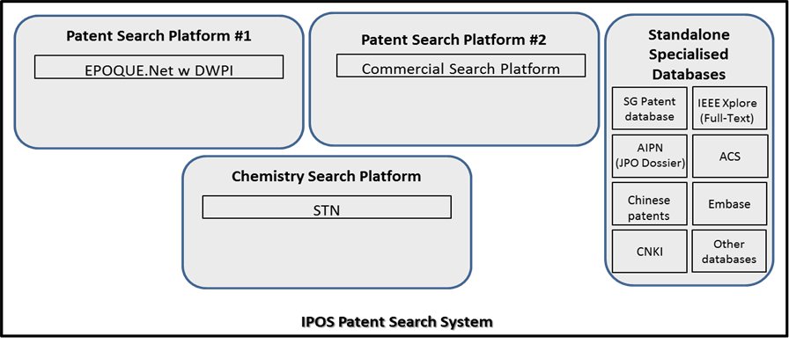
Figure 2: Diagrammatic representation of the IPOS Patent Search System

- Full training to use the search system was provided to the examiners. For using EPOQUENet, all examiners were trained by the EPO as part of their training programme.

QUALITY MANAGEMENT SYSTEM & INTERNAL REVIEW ARRANGEMENTS
- The IPOS Search and Examination Unit (S&E Unit) implemented ISO-compliant quality procedures since 2013. Documentation of processes is being finalised in preparation for external certification according to the ISO 9001:2008 standards in September 2014.
- Our quality policy is to work together with our customers to provide high quality products and services which are delivered in an efficient and consistent manner. We are committed to continually improve our systems, practices and programmes in order to provide robust IP rights that will foster a thriving and vibrant Singapore IP environment.
- Our quality objectives are to provide high quality search and examination products and services that are valid and reliable, delivered in an efficient and pragmatic manner.

Valid and Reliable
- We regard a search to be valid when the search was conducted employing an appropriate search strategy, and using a comprehensive set of authoritative sources of information. A search is considered reliable when it is sufficiently documented to permit a reproducible and consistent search result.
- An examination is valid when the law is correctly interpreted and logically applied to arrive at a sound decision, and where that decision and its basis are clearly communicated to the customer. An examination is reliable when examiners use a consistent approach based on an open and transparent set of guidelines and where considerations for arriving at a decision have been documented to show that guidelines have indeed been followed during the examination.
- All office actions at the S&E Unit go through a triple-check process. At the first instance, the quality check is performed by the examiner himself/herself. The office action is then forwarded to an appointed buddy examiner for the next quality check. The buddy examiner will check the logic of the arguments and the formalities, before sending the file back to the examiner with his/her comments. If required, the examiner will amend the office action before sending it to a senior examiner for the final quality check. Presently, the three levels of checks are conducted for all cases.

Efficient – Commitment to Timely Actions
- Products and services are delivered efficiently when they are delivered in a timely manner. We are committed to delivering first office actions within six months and not allow any backlog to build up. Since turning operational in 2013, this has been the case.
- IPOS has a monitoring system that reports the pendency of all office actions in real-time. Reviews are conducted weekly to ensure that all office actions are issued within set time limits. Two weeks before any case becomes due, individual emails will be sent to the examiners to remind them of the time limits.

Pragmatic
- IPOS expects the examiners to take a pragmatic and common-sense approach to deliver the products and services in the best way to the customers.

QMS Details
- The quality management system of the S&E Unit is described in detail using the template “Report on Quality Management Systems” used by ISAs and IPEAs under Chapter 21 of the PCT International Search and Preliminary Examination Guidelines, set out in the Appendix.

Setting up of an International Authority Implementation Office
- In preparation to become an ISA and IPEA, IPOS set up an International Authority Implementation Office to prepare for a smooth and rapid transition. We have looked into the resource allocation, training of the examiners on PCT procedures, mapping the ISA and IPEA work processes, preparing to apply PCT templates, preparing our IT infrastructure to implement the ePCT system and to identify the Singapore approach to applying the PCT International Search and Preliminary Examination Guidelines. Given our experience in developing processes, work systems and examination guidelines, IPOS is confident and prepared to assume the duties of an ISA and IPEA.

CONCLUSION
- In conclusion, IPOS is ready to meet existing ISA and IPEA requirements:
  - Based on:
    - our rigorous 3-stage recruitment process;
    - which draws upon a talented and multi-lingual pool of researchers, scientists and engineers;
    - the comprehensive and continuing training and development programme that has been co-developed and implemented with the EPO, as well as with the assistance of the JPO and the USPTO; and
    - the appropriate resources made available for their work,
    - our examiners are clearly capable of performing the search and examination work required of an ISA and IPEA.
  - IPOS has met and exceeded the requirement for having access to the required PCT minimum documentation. The tools and databases at the examiners' disposal include the EPO’s EPOQUENet, DWPI, Questel Orbit, STN, ACS database, China Academic Journals database by CNKI, Embase by Elsevier, IEEE Xplore, Thomson Reuters’ Web of Science and more. We also have access to SIPO’s Chinese language database.
  - Our examiners are capable of searching and examining the required technical fields and have the ability to understand the languages in which the PCT minimum documentation is written in or translated into.
  - We have in place a robust quality management system and internal review arrangements. In addition, we have an advanced IT system which provides for the full electronic filing and processing of patent applications.
- Upon appointment as ISA and IPEA, we will adjust our internal processes, set up the necessary linkages and put in place the required IT infrastructure through our International Authority Implementation Office. During this preparatory period, our patent examination team (over 80-strong in September 2014) will also continue to be built up to over 100 trained examiners to do ISA and IPEA work. We will be ready to operate and offer our services as an ISA and IPEA by September 2015.

[Appendix follows]

APPENDIX

Report on Quality Management Systems
prepared by the Intellectual Property Office of Singapore (IPOS)

The Authority should provide general background information relevant to the quality management system (QMS) as set forth in this template.
The descriptions below each main heading of this template should be considered examples of the type and arrangement of information that should be included under each heading. Each Authority may provide additional information beyond that set forth in this template as desired.

INTRODUCTION (PARAGRAPHS 21.01 - 21.03)
If applicable, the Authority may at this point indicate any recognized normative reference or basis for their quality management system besides Chapter 21, such as ISO 9001, under the heading “Normative Reference for QMS”
For example: “Normative reference for QMS: ISO 9001, EQS (European Quality System)”
Each Authority should then provide at least the information indicated in the descriptive boxes, under the following headings

The Intellectual Property Office of Singapore (IPOS) has implemented a quality management system for its patent search and examination functions that conforms to the ISO 9001 standards. The certification according to the ISO 9001:2008 standards is expected to take place in September 2014.

1. LEADERSHIP AND POLICY
21.04 Confirm that the following are clearly documented, and that this documentation is available internally:
(a) The quality policy established by top management.
(b) The roles and names of those bodies and individuals responsible for the QMS, as delegated by top management.
(c) An organizational chart showing all those bodies and individuals responsible for the QMS.
Our quality policy is to work together with our customers to provide high quality products and services which are delivered in an efficient and consistent manner. We are committed to continually improve our systems, practices and programs in order to provide robust intellectual property rights that will foster a thriving and vibrant Singapore intellectual property environment.
Our quality objectives are to provide high quality search and examination products and services that are valid and reliable, delivered in an efficient and pragmatic manner.
Valid and Reliable
We regard a search to be valid when the search was conducted employing an appropriate search strategy, and using a comprehensive set of authoritative sources of information. A search is considered reliable when it sufficiently documented to permit a reproducible and consistent search result.
An examination is valid when the law is correctly interpreted and logically applied to arrive at a sound decision, and where that decision and its basis are clearly communicated to the customer. An examination is reliable when examiners use a consistent approach based on an open and transparent set of guidelines and where considerations for arriving at a decision have been documented to show that guidelines have indeed been followed during the examination.
Efficient – Commitment to Timely Actions
Products and services are delivered efficiently when they are delivered in a timely manner. We are committed to delivering first office actions within 6 months and not allow any backlog to build up. We have been meeting this commitment.
IPOS has a monitoring system that reflects the pendency of all office actions in real-time. Reviews are conducted weekly to ensure that all office actions are issued within set time limits. 2 weeks before any case becomes due, individual emails will be sent to the examiners to alert them of time-limit conformity.
Pragmatic
IPOS expects the examiners to take a pragmatic and common-sense approach to deliver the products and services in the best way to the customers.
The quality policy and objectives are described in the S&E Unit QMS. The QMS document is stored and accessible on the Intranet.
The Quality Management Office (QMO) within the S&E Unit coordinates the works on development, implementation and maintenance of the QMS processes. The QMO is formally trained on ISO 9001 Documentation and Implementation and ISO 9001 Internal Auditor Training. Both courses equipped the QMO with the techniques and know-how to carry out an effective internal QMS audit for the organisation.
The QMO organisational structure is presented below.
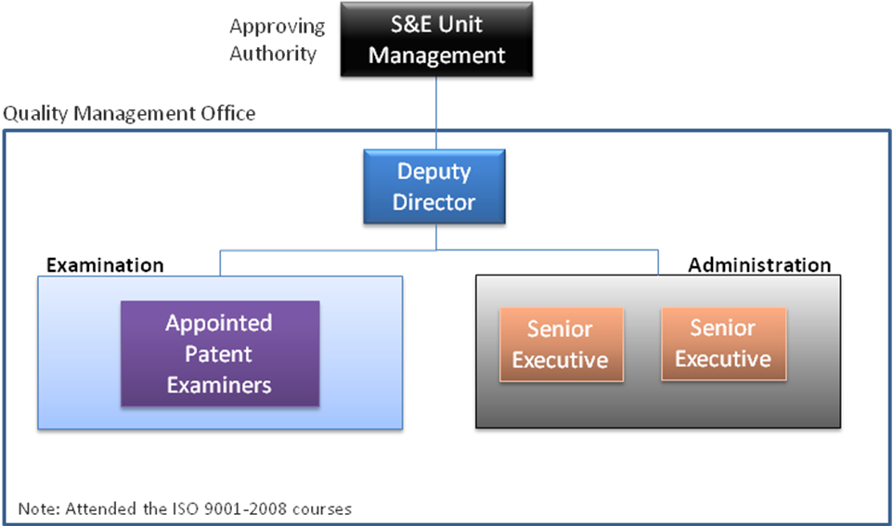
Figure 1: Organisational structure of the S&E Unit Quality Management Office

21.05 Indicate (e.g. by means of a table) the extent of compatibility between the Authority's QMS and the requirements of Chapter 21 of these International Search and Preliminary Examination Guidelines. Alternatively, indicate where the Authority is not yet compliant with these requirements.).

Chapter 21 requirement |  |  | Extent of compliance
 |  |  | full | part | no
21.04 | (a) | Quality policy available
 | (b) | Identified roles and names for QMS responsibility
 | (c) | Organizational chart available
21.05 |  | Established compatibility of QMS with Chapter 21
21.06 | (a) | Mechanisms to ensure effectiveness of the QMS
 | (b) | Control of the continual improvement process
21.07 | (a) | Communication of management about this standard to staff
 | (b) | The PCT Guidelines are in line with the Authority's QMS
21.08 | (a) | Management reviews take place
 | (b) | Quality objectives are reviewed
 | (c) | Communication of quality objectives throughout the Authority
21.09 | (a) | Performance of a yearly internal review of the QMS in/to
 | (b) | (i) determine the extent to which the QMS in based on Chapter 21
 |  | (ii) determine the extent to which S&E complies with PCT Guidelines
 | (c) | an objective and transparent way
 | (d) | using input incl. information according paragraph 21.17
 | (e) | recording the results
21.10 |  | Assurance to monitor and adapt to actual workload
21.11 | (a) | Infrastructure in place to ensure that a quantity of staff
 |  | (i) sufficient to deal with the inflow of work
 |  | (ii) which maintains tech. qualifications to S&E in all technical fields
 |  | (iii) which maintains the language facilities to understand languages according to Rule 34
 | (b) | Infrastructure to provide a quantity of skilled administrative staff
 |  | (i) at a level to support the technically qualified staff
 |  | (ii) for the documentation records
21.12 | (a) | (i) Ensuring appropriate equipment to carry out S&E
 |  | (ii) Ensuring documentation accord. to Rule 34
 | (b) | (i) Instructions to help staff understand and act accord. the quality criteria and standards
 |  | (ii) Instructions to follow work procedures accurately and they are kept up-to-date.
21.13 |  | (i) L&D program to ensure and maintain necessary skills in S&E
 |  | (ii) L&D program to ensure awareness of staff to comply with the quality criteria and standards.
21.14 | (a) | System in place for monitoring resources required to deal with demand
 | (b) | System in place for monitoring resources required to comply with the quality standards in S&E
21.15 | (a) | Control mechanisms to ensure timely issue of S&E reports
 | (b) | Control mech. regarding fluctuations in demand and backlog
21.16 | (a) | Internal quality assurance system for self assessment
 |  | (i) for compliance with S&E Guidelines
 |  | (ii) for channeling feedback to staff
 | (b) | A system for measurement of data and reporting for continuous improvement
 | (c) | System for verifying the effectiveness of actions taken to correct deficient S&E work
21.17 | (a) | Contact person helping identify best practice between Authorities
 | (b) | Contact person fostering continual improvement
 | (c) | Contact person providing for effective comm. with other Authorities for feedback and evaluation
21.18 | (a) | (i) Appropriate system for handling complaints
 |  | (ii) Appropriate system for taking preventive/corrective actions
 |  | (i) Appropriate system for offering feedback to users
 | (b) | (i) A procedure for monitoring user satisfaction & perception
 |  | (ii) A procedure for ensuring their legitimate needs and expectations are met
 | (c) | Clear and concise guidance on the S&E process for the user
 | (d) | Indication where and how the Authority makes its quality objectives publicly available
21.19 |  | Established communication with WIPO and designated and elected Offices
21.20 |  | QMS of Authority clearly described (e.g. Quality Manual) |  |  | *
21.21 | (a) | Documents making up the Quality Manual have been prepared and distributed |  |  | *
 | (b) | Media available to support the Quality Manual
 | (c) | Document control measures are taken
21.22 | (a) | Quality policy of the Authority and commitment to QMS
 | (b) | Scope of QMS
 | (c) | Organizational structure and responsibilities
 | (d) | the documented processes are carried out in the Authority
 | (e) | Resources available to carry out processes
 | (f) | a description of the interaction between the processes and the procedures of the QMS.
21.23 | (a) | Records which documents are kept and where they are kept
 | (b) | Records of results of management review |  |  | *
 | (c) | Records about training, skills and experience of staff
 | (d) | Evidence of conformity of processes
 | (e) | Results of reviews of requirements relating to products
 | (f) | Records of the S&E process carried out on each application
 | (g) | Record of data allowing individual work to be tracked
 | (h) | Record of QMS audits |  |  | *
 | (i) | Records on actions taken re. non-conforming products
 | (j) | Records on actions taken re. corrective actions
 | (k) | Records on actions taken re. preventive actions
 | (l) | Records referring to search process documentation
21.24 | (a) | (i) Recording of the databases consulted during search
 |  | (ii) Recording of keywords, combination of words and truncations during search
 |  | (iii) Recording of the languages used during search
 |  | (iv) Recording of classes and combinations thereof consulted during search
 | (b) | Records about other information relevant to the search
 | (c) | (i) Records about limitation of search and its justification
 |  | (ii) Records about lack of clarity of the claims
 |  | (iii) Records about lack of unity
21.25 |  | Report on its own internal review processes
21.26-21.28 |  | Additional information on further inputs to its internal reviews
21.29 |  | Initial report called for by paragraph 21.19
* Requirement will be complied with by September 2014.

21.06 Indicate with reference to the organizational chart those bodies and mechanisms management uses to ensure:
(a) the effectiveness of the QMS; and
(b) that the process of continual improvement progresses.
The S&E Unit management reviews the internal audit reports of the QMO and the external audit reports. The QMO conducts the internal audit at least once every 6 months and submits its report consisting of its findings on the QMS and recommendations for corrective/preventive actions. The S&E Unit management will consider the report and adopt, modify or reject the recommendations.

21.07 Indicate how management of the Authority communicates to its staff the importance of meeting treaty and regulatory requirements including:
(a) those of this standard; and
(b) complying with the Authority's QMS.
On behalf of the S&E Unit management, the QMO communicates to the staff the importance of QMS. The communication is conducted via the monthly unit sharing sessions and meetings.

21.08 Indicate how and when top management of the Authority or delegated officers:
(a) conducts management reviews and ensures the availability of appropriate resources;
(b) reviews quality objectives; and
(c) ensures that the quality objectives are communicated and understood throughout the respective Authority.
Please see paragraph 21.06 on management reviews.
Every year, the S&E Unit management will review the results of the current workplan and plan for the next workplan. A review of the required resources and quality objectives is undertaken as part of the process. Any new quality objectives are communicated to the staff at the monthly unit sharing sessions or meetings.

21.09 Indicate whether top management or delegated officers of the Authority perform an internal review of the QMS in accordance with paragraphs 21.25-21.28:
(a) at least once per year (cf. paragraph 21.25);
(b) in accordance with the minimum scope of such reviews as set out in Section 8, namely:
(i) to determine the extent to which the QMS is based on Chapter 21 (cf. paragraphs 21.25, 21.27(a));
(ii) to determine the extent to which Search and Examination work complies with PCT Guidelines (cf. paragraphs 21.25, 21.27(a));
(c) in an objective and transparent way (cf. paragraph 21.25);
(d) using input including information according to paragraphs 21.27 (b)-(f);
(e) recording the results (cf. paragraph 21.28).
The QMO carries out the internal review of the QMS at least once a year. The review results are recorded and reported to the S&E Unit management.

2. Resources
21.10 Explanatory note: The granting of ISEA status means that the Authority has demonstrated it has the infrastructure and resources to support the search and examination process. Chapter 21 calls for assurance that the Authority can continually support this process while accommodating changes in workload and meeting QMS requirements. The responses to Sections 21.11 to 21.14, below, should provide this assurance.
21.11 Human resources:
(a) Provide information about the infrastructure in place to ensure that a quantity of staff:
(i) sufficient to deal with the inflow of work;
(ii) which maintains the technical qualifications to search and examine in the required technical fields; and
(iii) which maintains the language facilities to understand at least those languages in which the minimum documentation referred to in Rule 34 is written or is translated
is maintained and adapted to changes in workload.
(b) Describe the infrastructure in place to ensure that a quantity of appropriately trained/skilled administrative staff is maintained and adapted to changes in workload:
(i) at a level to support the technically qualified staff and facilitate the search and examination process;
(ii) for the documentation of records.
As at September 2014, IPOS has 82 full-time patent examiners. All of them have at least a good class honours degree, with 95% having a PhD degree.
The examiners have at their disposal a comprehensive suite of search platforms (EPOQUENet, a commercial patent search platform and a specialised commercial patent search platform for Chemistry and Biotechnology searches), their respective plugs-in and standalone databases. Together, it provides the examiners access to the minimum documentation referred to in Rule 34 of the PCT Regulations and more.
The number of personnel supporting the examination work is 9.
The S&E Unit management monitors and discusses the matching of human resources with workload requirements for both examination staff and administrative staff. The staff is supported by a policy of regular review of workload and re-distribution of workload, where necessary.
In addition, a systematic recruitment process with clear requirements for candidates and a systematic training programme for them are in place. They can be activated should the review by the S&E Unit management determines a need for new hires.

21.12 Human resources:
(a) Describe the infrastructure in place to ensure that:
(i) appropriate equipment and facilities such as IT hardware and software to support the search and examination process are provided and maintained;
(ii) at least the minimum documentation referred to in Rule 34 is available, accessible, properly arranged and maintained for search and examination purposes. State whether it is on paper, in microform or stored on electronic media, and where.
(b) Describe how instructions
(i) to help staff understand and adhere to the quality criteria and standards; and;
(ii) to follow work procedures accurately and consistently
are documented, provided to staff, kept up-to-date and adapted where necessary.
IPOS provides modern IT hardware and up-to-date software for the examiners to carry out their work. Every examiner has a high-specification desktop and two 24-inch monitors. Stable and high-speed internet connection is also provided to allow efficient access to any web-based search platforms. The patent search system described in paragraph 21.11 is an electronic search system accessible in the office of IPOS. Patent application documents that are subject of the search and examination required are stored electronically in IPOS and accessible to the examiners only from their workstations.
All work processes are documented in a set of guidelines that are maintained and stored on the Intranet. For search and examination practices, the examiners are guided by the IPOS Examination Guidelines on Patent Applications that is available on the IPOS corporate website, as well as, the Intranet.
The examiners also have online access to other resources like the PCT International Search and Preliminary Examination Guidelines and the PCT Regulations.

21.13 Training resources:
Describe the training and development infrastructure and program which ensures that all staff involved in the search and examination process:
(i) acquire and maintain the necessary experience and skills; and
(ii) are fully aware of the importance of complying with the quality criteria and standards.
IPOS has a structured and competency-based training programme for its examiners. First, a 6-month formal training and followed by up to 12 months of on-the-job training. On-the-job training is supervised by senior examiners, who can tailor the training according to the assessment of the examiner based on a set of defined competencies.
Continuing development of the examiners is another aspect of our training. There are regular symposiums held in-house for knowledge sharing by internal or external speakers, the examiners attend IP or technical conferences locally or overseas, attend workshops conducted locally or by overseas IP Offices, participate in examiner exchanges, visit other IP Offices, or host Visiting Examiners from other IP Offices.

21.14 Oversight over resources:
Describe the system in place for continuously monitoring and identifying the resources required:
(a) to deal with demand; and
(b) comply with the quality standards for search and examination
Please see paragraph 21.15.

3. Management of Administrative Workload
21.15 Indicate how the following practices and procedures for handling search and examination requests and performing related functions such as data-entry and classification are implemented:
(a) Effective control mechanisms regarding timely issue of search and examination reports to a quality standard as set by the respective Authority; and
(b) Appropriate control mechanisms regarding fluctuations in demand and backlog management.
One of our quality objectives is to issue reports in a timely manner. We have been delivering first office actions within 6 months. In 2014, we began a pilot to issue first office actions within 60 days for first filings and had been achieving good performance results on this pilot.
To ensure timely issue of search and examination reports, the S&E Unit monitors them based on the performance reports generated from a workflow management system. The workflow management system tracks each step of the workflow and provides the latest action and timeliness status of each case, real-time. Performance reports are reviewed weekly by the management to ensure that all search and examination reports are issued within set time limits. 2 weeks before any case becomes due, individual emails will be sent to the examiners to alert them of time-limit conformity.

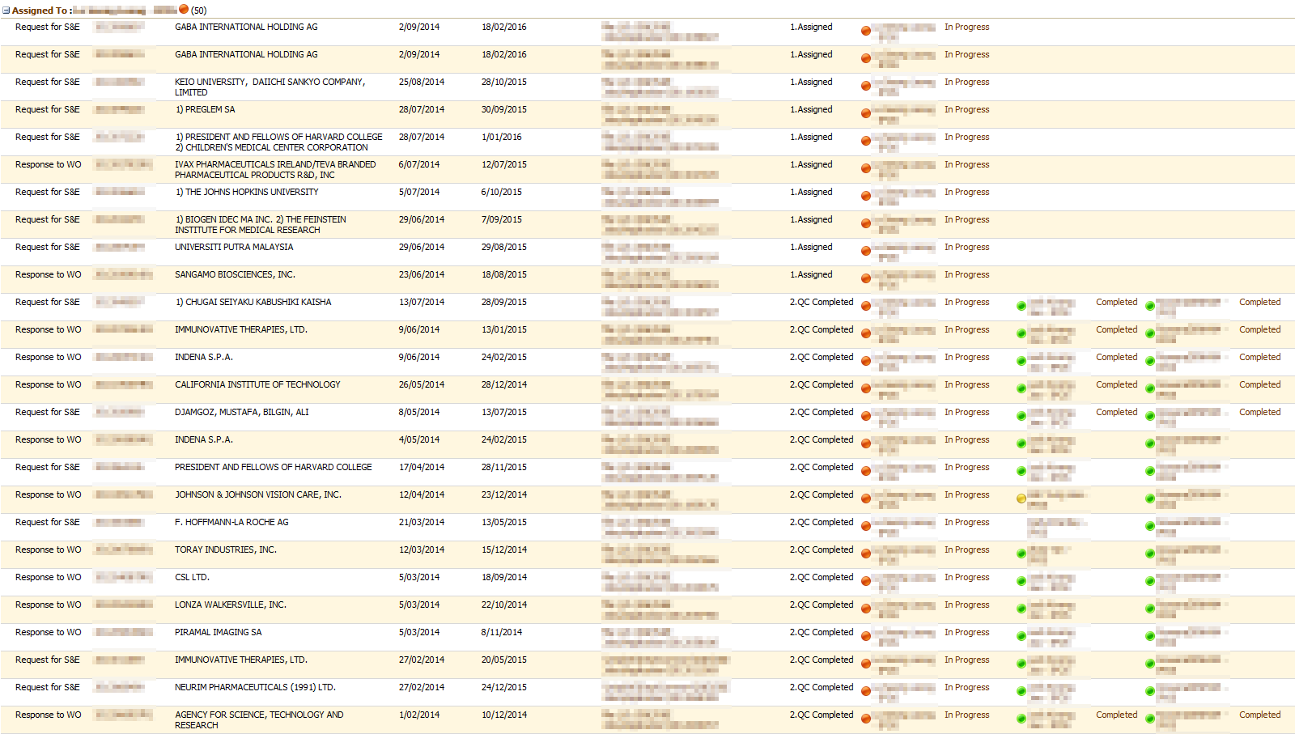
Figure 2: A screenshot of the workflow management system

Every week, the S&E Unit management reviews the workload of the examiners. Preventive and corrective measures would be taken should any deviation be observed or anticipated. Specific measures taken include assigning a complex case to two examiners to work on collaboratively, and more targeted coaching or mentoring by the senior examiners.

4. Quality Assurance
21.16 The following are required quality assurance measures for timely issue of search and examination reports of a quality standard in accordance with the Guidelines. Indicate how the following are implemented:
(a) An internal quality assurance system for self assessment, involving verification, validation and monitoring of searches and examination work:
(i) for compliance with these Search and Examination Guidelines;
(ii) for channeling feedback to staff.
(b) A system of measurement and collection of data and reporting. Show how the Authority uses the system to ensure the continuous improvement of the established processes.
(c) A system for verifying the effectiveness of actions taken to correct deficient S&E work, eliminate the causes, and to prevent issues from recurring.
The S&E Unit QMS system has 2 quality assurance measures: (1) an internal feedback process and (ii) an external feedback process.
In the internal feedback process, there is a triple-check process for corrective actions for each search report ("SR"), written opinion ("WO") or examination report ("ER"). Without the approval of the senior examiners, the products cannot be sent to the applicants. The triple-check process is as follows:
(a) A quality check performed by the examiner himself/herself – 100% of the search strategy and the decisions made by the examiner. The examiner will send his/her SR/WO/ER to the appointed buddy examiner for quality check.
(b) A quality check performed by the buddy examiner (buddy QC) – 100% of the decisions made by the examiner. The buddy examiner will check the logic of the arguments and the formalities, before sending the files back to the examiner with his/her comments. The Examiner amends the SR/WO/ER based on the comments, and sends it to the senior examiner for final quality check.
(c) A quality check performed by the senior examiner – 100% (to be reduced progressively to 5%-10% at steady state). The senior examiner will send the SR/WO/ER back to the examiner if there are queries, and this process is iterative. Otherwise the senior examiner will approve the release of the SR/WO/ER and submit a copy of the Quality Check form to the QMO.
The QMO collates and analyses the Quality Check forms, identifies the issues that need to be addressed in a report to the S&E Unit management. Upon the management's endorsement, the Examination Standards Office, the Training Cadre or the Operations Team will follow-up thereafter. To close the loop, the examiners will be updated on the actions to be carried out.
In the external feedback process, any feedback or complaint from the Applicant/Attorney will be referred to the Quality Management Office. In turn, the QMO will collate and analyse the feedback and complaints, identify the issues that need to be addressed, and recommend appropriate action. Upon the management's endorsement, the Examination Standards Office, the Training Cadre or the Operations Team will follow-up thereafter. The Examiners will be updated on the actions to be done or carried out. The Customer Service or the Registry will be informed on the outcomes. The Applicant/Attorney will be updated on the outcomes so as to close the loop. In the event that there is a need for our Examiner to communicate directly with the Applicant/Attorney, a meeting with an appropriate agenda will be convened. A process diagram to illustrate the internal feedback process and one for the external feedback process are in Figure 3.
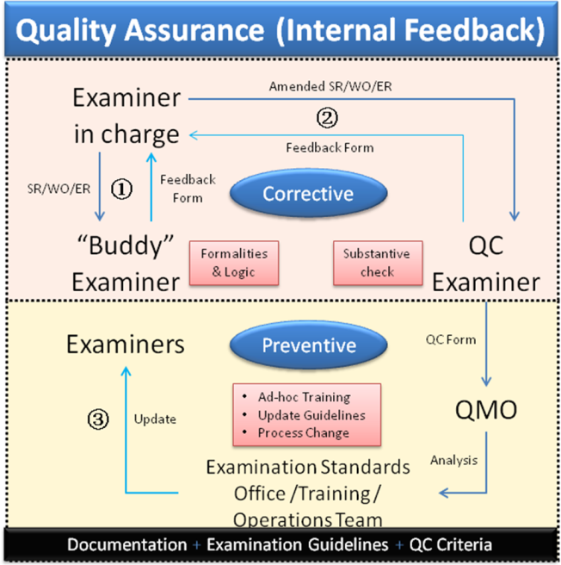 | 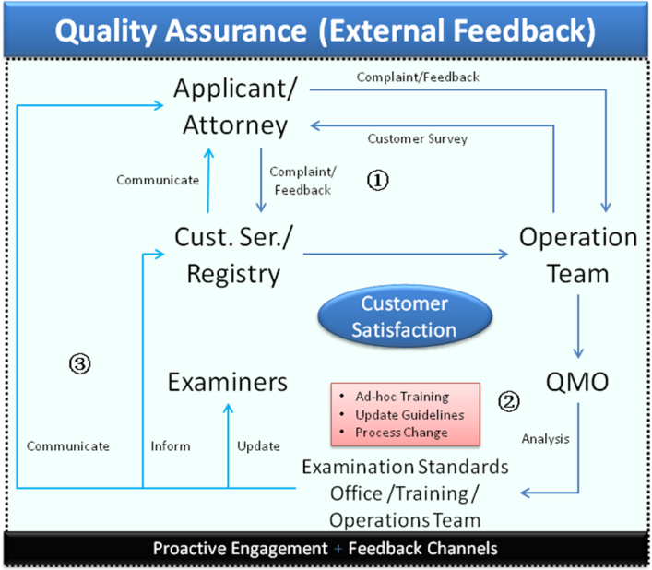
Figure 3: Diagrammatic representation of the quality assurance internal feedback and external feedback processes

5. Communication
21.17 Inter-Authority communication:
Provide the name, job title and contact details of the Authorities designated quality contact person who will take responsibility for:
(a) helping identify and disseminate best practice among Authorities;
(b) fostering continual improvement; and
(c) providing for effective communication with other Authorities to allow for prompt feedback from them so that potential systemic issues can be evaluated and addressed.
Mr. Dexter Teo (dexter_teo@ipos.gov.sg), Deputy Director of the S&E Unit, who is in-charge of the operations of the unit, is the designated contact for this purpose.
21.18 Communication and guidance to users:
Describe the system in place for monitoring and using customer feedback including at least the following elements:
(a) An appropriate system for
(i) handling complaints and making corrections;
(ii) taking corrective and/or preventative action where appropriate; and
(iii) offering feedback to users.
(b) A procedure for:
(i) monitoring user satisfaction and perception; and
(ii) for ensuring their legitimate needs and expectations are met.
(c) Clear, concise and comprehensive guidance and information to users (particularly unrepresented applicants) on the search and examination process, giving details of where it is to be found e.g. link to Authority’s web site, guidance literature.
(d) An indication of where and how the Authority makes its quality objectives publicly available for the users.
Annually, IPOS sends our patent examiners to attend the international conferences and events and also to visit foreign patent offices to improve communication and understand the latest development in IP, especially in the area of patents.
IPOS's corporate website regularly announces its IP courses and programmes available, so that the users/public can register and attend these activities whenever available.
IPOS has established procedures to seek customer feedback and vice versa. Public opinion is sought before any amendment to the patent law and examination guidelines are published.
IPOS conducts annual customer satisfaction surveys with its customers to solicit feedback and improvement to the patent system in Singapore. The surveys also help to determine the demands and satisfaction level of the patent applicants and attorneys.
Each patent applicant/attorney has the possibility to communicate on the written opinion with the patent examiner face-to-face. There is an internal procedure to set-up this meeting which requires less than five working days to arrange. An appropriate agenda is a must for such meeting.
Based on the information analysis received from the applicants, attorneys and public, the management of IPOS and the S&E Unit take action to address any shortcomings and will continue to improve on the procedures and processes wherever applicable.
IPOS has published on its website information on the filing process for a Singapore patent application, the search and examination procedures in the form of Examination Guidelines for Patent Applications at IPOS, and about its quality management system. IPOS has established links in its website to guide and introduce users to the information, regulations and guidelines concerning the process of obtaining the rights to inventions in Singapore and also under PCT with reference to the WIPO website.
21.19 Communication with WIPO and designated and elected Offices:
Describe how the Authority provides for effective communication with WIPO and designated and elected offices. In particular describe how the Authority ensures that WIPO feedback is promptly evaluated and addressed.
The Deputy Director of the S&E Unit, who oversees the operations of the unit, will handle communication with WIPO as well as designated and elected offices. In particular, all quality matters and communication with customers (including WIPO and other Authorities) are managed by him.

6. Documentation
21.20 Explanatory note: The QMS of the Authority needs to be clearly described and implemented so that all processes in the Authority and the resulting products and services can be monitored, controlled, and checked for conformity. This is done in the documents that make up the Quality Manual of the Authority (see paragraph 21.21).
(Note: This point is informative. No response is required by the template to paragraph 21.20)
21.21 The documents that make up the Quality Manual serve to document the procedures and processes affecting the quality of work, such as classification, search, examination and related administrative work. In particular, the Quality Manual indicates where to find instructions on the procedures to be followed.
For the purposes of this report indicate:
(a) the documents making up a Quality Manual that have been prepared and distributed;
(b) the media on which it is supported (e.g. Internal Publication, Internet, Intranet); and
(c) document control measures taken e.g. version numbering, access to latest version.
The process approach was adopted when developing and implementing the S&E QMS, and it is applicable to the following:
(a) receiving requests and carrying out S&E work;
(b) documentating and processing operations which include updating and operability assurance of the patent information file and availability of the reference and search tools;
(c) providing the examiners and the patent information system to process the files;
(d) managing of oppositions and feedback concerning the issuance of the opinions and reports; and
(e) measuring, analysing and improving the overall S&E processes.
The QMS document sets out the requirements to the S&E Unit QMS and contains its description to the following core processes:
(a) the Search Request;
(b) the Examination Request;
(c) the Supplementary Examination Request;
(d) the Response to the Written Opinion Process; and
(e) the Non-Conformity (NC) Process.
The QMS document is available both on paper and Intranet.

21.22 Indicate whether the documents making up the Quality Manual include the following:
(a) the quality policy of the Authority including a clear statement of commitment to the QMS from top management;
(b) the scope of the QMS, including details of and justification for any exclusions;
(c) the organizational structure of the Authority and the responsibilities of each of its departments;
(d) the documented processes carried out in the Authority such as receipt of incoming applications, classification, distribution, search, examination, publication and support processes, and procedures established for the QMS, or references to them;
(e) the resources available for carrying out the processes and implementing the procedures; and
(f) a description of the interaction between the processes and the procedures of the QMS.
The S&E Unit QMS document consists of the following chapters:
(a) quality policy;
(b) quality objectives;
(c) quality manual;
(d) QMS documented processes;
(e) schedules;
(f) organisational chart; and
(g) record.

21.23 Indicate which types of records the Authority maintains, such as:
(a) a definition of which documents are kept and where they are kept;
(b) results of management review;
(c) training, skills and experience of personnel;
(d) evidence of conformity of processes, resulting products and services in terms of quality standards;
(e) results of reviews of requirements relating to products;
(f) the search and examination processes carried out on each application;
(g) data allowing individual work to be tracked and traced;
(h) records of QMS audits;
(i) actions taken re. non-conforming products, e.g. examples of corrections;
(j) actions taken re. corrective action;
(k) actions taken re. preventative action; and
(l) search process documentation as set out in Section 7.
According to the ISO 9001:2008 standards, the S&E Unit creates and maintains the following documents:
(a) quality manual;
(b) records on procedures for quality provision;
(c) records on management review and results;
(d) records on personnel training, conference and seminars attended;
(e) records on staff qualification and experience;
(f) records on quality control of the product;
(g) records on conformity of the S&E processes;
(h) records on the results of S&E for each patent application; and
(i) summary of the S&E quality and follow-up actions.

7. Search Process Documentation
21.24 For internal purposes the Authority should document its search process.
The Authority should indicate
(a) which of the following are included in this record:
(i) the databases consulted (patent and non patent literature);
(ii) the keywords, combinations of words and truncations used;
(iii) the language(s) in which the search was carried out;
(iv) the classes and class combinations searched, at least according to the IPC or equivalent;
(v) a listing of all search statements used in the databases consulted.
(b) which other information relevant to the search itself is included in this record e.g. a statement of the subject of search; details of special relevance to internet searching; a record of documents viewed; on-line thesaurus, synonym or concept databases, etc.
(Explanatory note: The IA is requested to list other information it may collect to monitor and improve the search process)
(c) which special cases are documented and whether records are kept denoting any:
(i) limitation of search and its justification
(ii) lack of clarity of the claims; and
(iii) lack of unity.

The examiners make a record of their search process and store them in a shared corporate drive for internal review and documentation.
The search record documents the following:
(a) a description of the point of invention/technical problem to be solved;
(b) the search strategy adopted by the examiner, comprising:
(i) classification of the subject matter to be searched e.g. IPC (for searches in EPOQUENet and other patent databases);
(ii) the databases consulted (patent, non-patent literature or Internet); and
(iii) the keywords and synonyms describing the subject matter to be searched;
(c) the search statements used and results returned (i.e. search history);
(d) a list of the documents considered to be relevant and corresponding comments on their relevance;
(e) any search limitations resulting from claims that lack clarity or support to the extent that no meaningful search can be carried out;
(f) any indications regarding unity of invention; and
(g) the reasons for ending the search.
The search record documents the search procedure performed by the examiner, so that others can understand how the relevant documents are derived. This will include documents that are directly relevant to the claims, as well as documents which the examiner anticipates might become relevant later in the patent prosecution process.
WIPO Standard ST.14 is followed for identification and categorisation of any document cited.

8. Internal Review
21.25 Explanatory note: The Authority should report on its own internal review arrangements. These reviews determine the extent to which it has established a QMS based on the model of Chapter 21 and the extent to which it is complying with the QMS requirements and the Search and Examination Guidelines. The reviews should be objective and transparent to demonstrate whether or not those requirements and guidelines are being applied consistently and effectively and should be undertaken at least once a year. With reference to point 21.08 of this template, the Authority may provide additional information on its internal review arrangements under this section if it so wishes.
21.26-21.28 These arrangements are reported according to this template in Section 1, above, at points 21.04 - 21.09. The Authority may provide additional information on further inputs to its internal reviews under this section, if it so wishes.

The S&E Unit’s internal QMS audits will be carried out twice a year. External audits are scheduled once every 2-3 years. The audit is to ensure that the QMS conforms to the ISO 9001:2008 standards.

9. Arrangements for Authorities to Report to the MIA
21.29 There are two stages in the reporting arrangements outlined in Chapter 21: the initial report called for by paragraph 21.29, and supplementary annual reports in accordance with paragraph 21.30. At the second informal meeting of the Quality Subgroup in Canberra on February 6 and 7, 2012, the Subgroup recommended that, instead of submitting full reports every five years and cumulative updates in the intervening years, Authorities should submit each report in the form of a full report, making the differences from the previous year’s report clear, for example using “track changes” or other form of highlighting. The template for the supplementary annual reports is therefore no longer used.

IPOS supports the reporting arrangements on the QMS by the ISA/IPEA required under Chapter 21 of the PCT International Search and Preliminary Examination Guidelines.

[End of Annex and of document]

"Intellectual Property (IP) Hub Master Plan: Developing Singapore as a Global IP Hub of Asia" can be viewed at http://www.ipos.gov.sg/Portals/0/Press%20Release/IP%20HUB%20MASTER%20PLAN%20REPORT%202%20APR%202013.pdf.
The IPOS Patent Examination Guidelines are published on our corporate website at http://www.ipos.gov.sg/Portals/0/Patents/Examination%20Guidelines%20for%20Patent%20Applications%20at%20IPOS_Feb%202014.pdf.
IPOS has published information about the quality management system on its website and it can be viewed at http://www.ipos.gov.sg/Portals/0/Patents/QMS%20Slides.pdf.
"IPOS Examination Guidelines for Patent Applications (2014)" can be viewed at http://www.ipos.gov.sg/Portals/0/Patents/Examination%20Guidelines%20for%20Patent%20Applications%20at%20IPOS_Feb%202014.pdf
Information on these can be viewed at www.ipos.gov.sg.

