WIPO |  | E  PCT/CAL/IV/5  ORIGINAL: English  DATE: November 28, 1990
WORLD INTELLECTUAL PROPERTY ORGANIZATION
GENEVA
INTERNATIONAL PATENT COOPERATION UNION
(PCT UNION)
PCT COMMITTEE FOR ADMINISTRATIVE AND LEGAL MATTERS
Fourth Session, First Part∗
Geneva, December 10 to 14, 1990
proposal to amend pct rule 13
Submitted jointly by the European Patent Office,
the Japanese Patent Office and the
United States Patent and Trademark Office

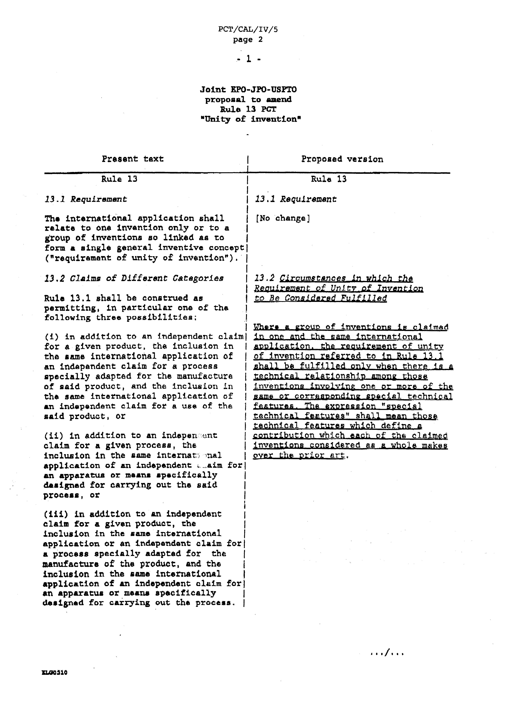
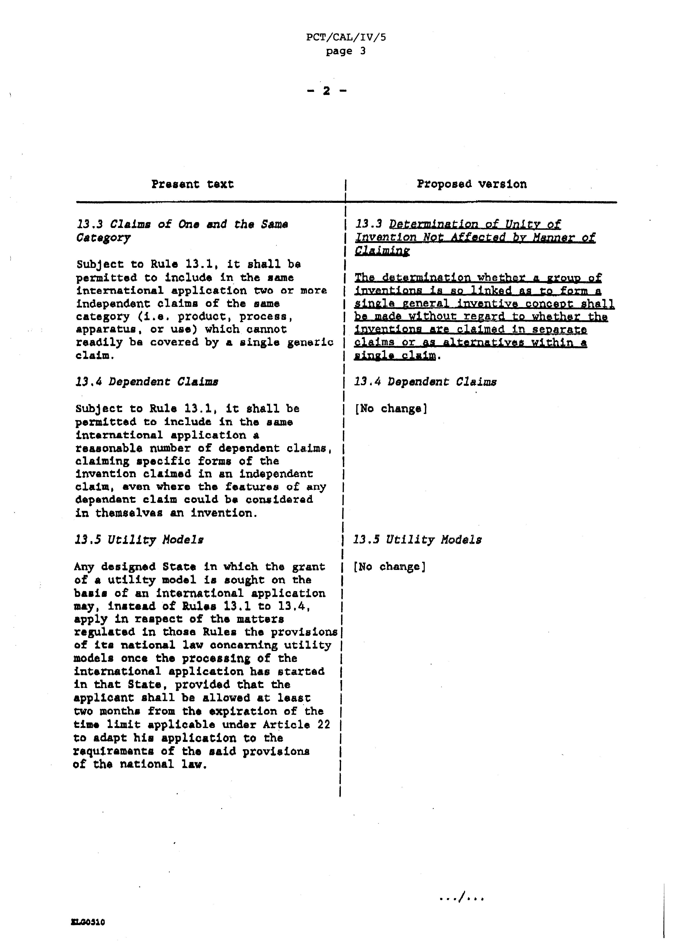
Reasons

1. At the 1998 Trilateral Conference in Tokyo between the EPO, JPO and USPTO, in the 6th Memorandum of Understanding (MOU) dated 1 November 1988 the following was agreed:

“The three Offices finalized and agreed upon a text (annexed to this Memorandum of Understanding) for harmonizing the unity of invention practice. Each Office agreed to promptly initiate the steps necessary to obtain the authorization needed to implement the unity of invention practice sat forth in the annexed text. It was further agreed that the three Offices would work jointly to secure the incorporation of the results of the Trilateral efforts on unity of invention into the Regulations under the Patent Cooperation Treaty.

Each Office may consider putting forward proposals with a view of incorporating the said results into the WIPO Draft Treaty on the Harmonization of Certain Provisions in Laws for the Protection of Inventions, and the Draft Regulations thereunder.”

2. The Trilateral Agreement on unity was thereafter introduced into the Draft Harmonization Treaty currently discussed in· the framework of WIPO.

The basic provisions of the Trilateral agreement now appear, with 80me further refinement, in the latest version of Article 5 and Rule 3 of the draft Treaty (HL/CE/VIII/2). The basic test to be applied in determ1n1nq Whether or not there is unity of invention is set out in draft Rule 3. The details concerning the application of those provisions are contained in the explanatory notes particularly on Rule 3 (see Annex).

3. The proposal concerning Rule 3 was discussed and, subject to a slight modification, unanimously approved by the WIPO Committee of Experts at its meeting in June 1990.

4. A proposal amending Rule 30 EPC with a view to implementing the Trilateral Agreement and harmonizing Rule 30 EPC with Rule 3 of the draft Harmonization Treaty has been submitted to the Administrative Council of the EPO for adoption at its December 1990 meeting. The proposal was unanimously approved by the EPO Administrative council's Ad hoc working Party for the Examination of Amendments to the EPC Implementing Regulations at its recent meeting on 17 and 18 September 1990. Once approved, Rule 30 EPC as amended will come into effect on 1 June 1991.

5. At the 8th Trilateral Conference on 25 October 1990 in Munich, the EPO, the JPO and the USPTO agreed to make a joint proposal for amending Rule 13 PCT in order to bring that Rule into line with Rule 3 of the draft Harmonization Treaty and the proposed wording of Rule 30 EPC. The current revision of the Regulations under the PCT offers an ideal opportunity to amend Rule 13 as proposed in this document. The proposed amendment will be beneficial to all PCT applicants, the International Authority under the PCT as well as the designated or elected Offices, in providing D comprehensive and reliable test for interpreting the concept of unity of invention.

6. The EPO, Japan and United States of America further propose that once Rule 13 PCT has been amended as proposed, the essence of unity of invention practices set out in more detail in the Notes on Rule 3 of the draft Harmonization Treaty, be incorporated into the Guidelines for International Search under the PCT.

[Annex follows]

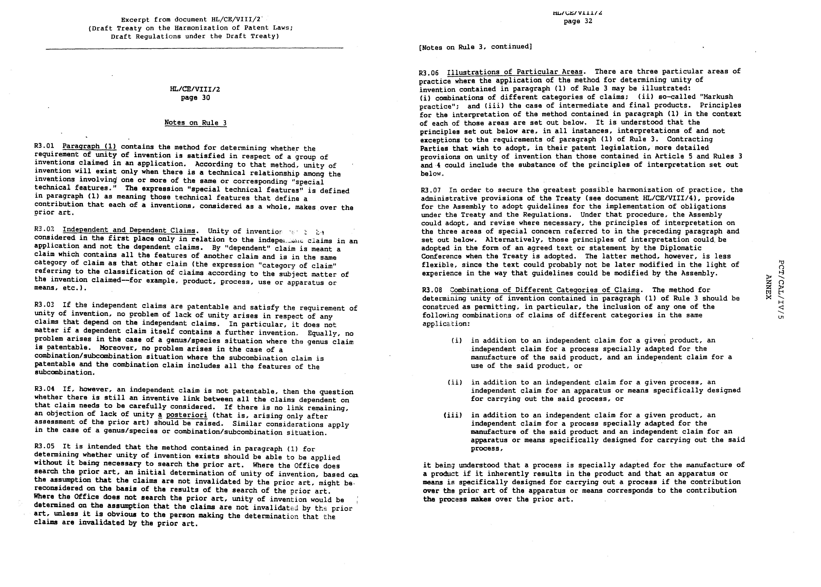
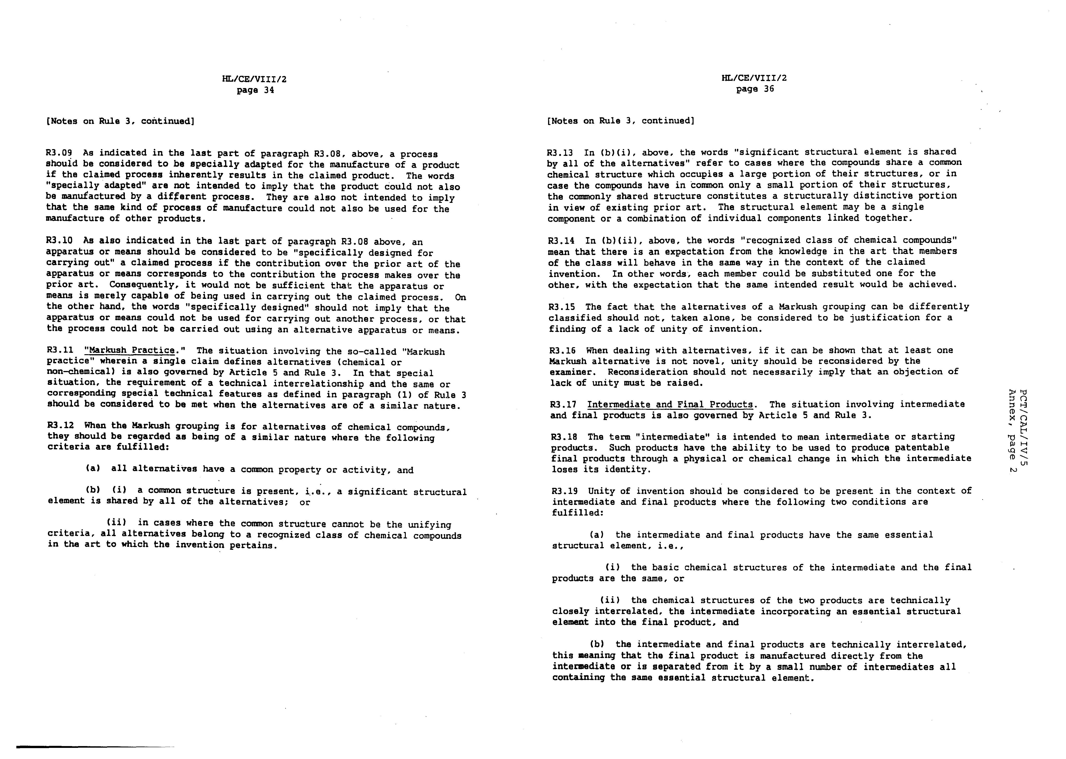
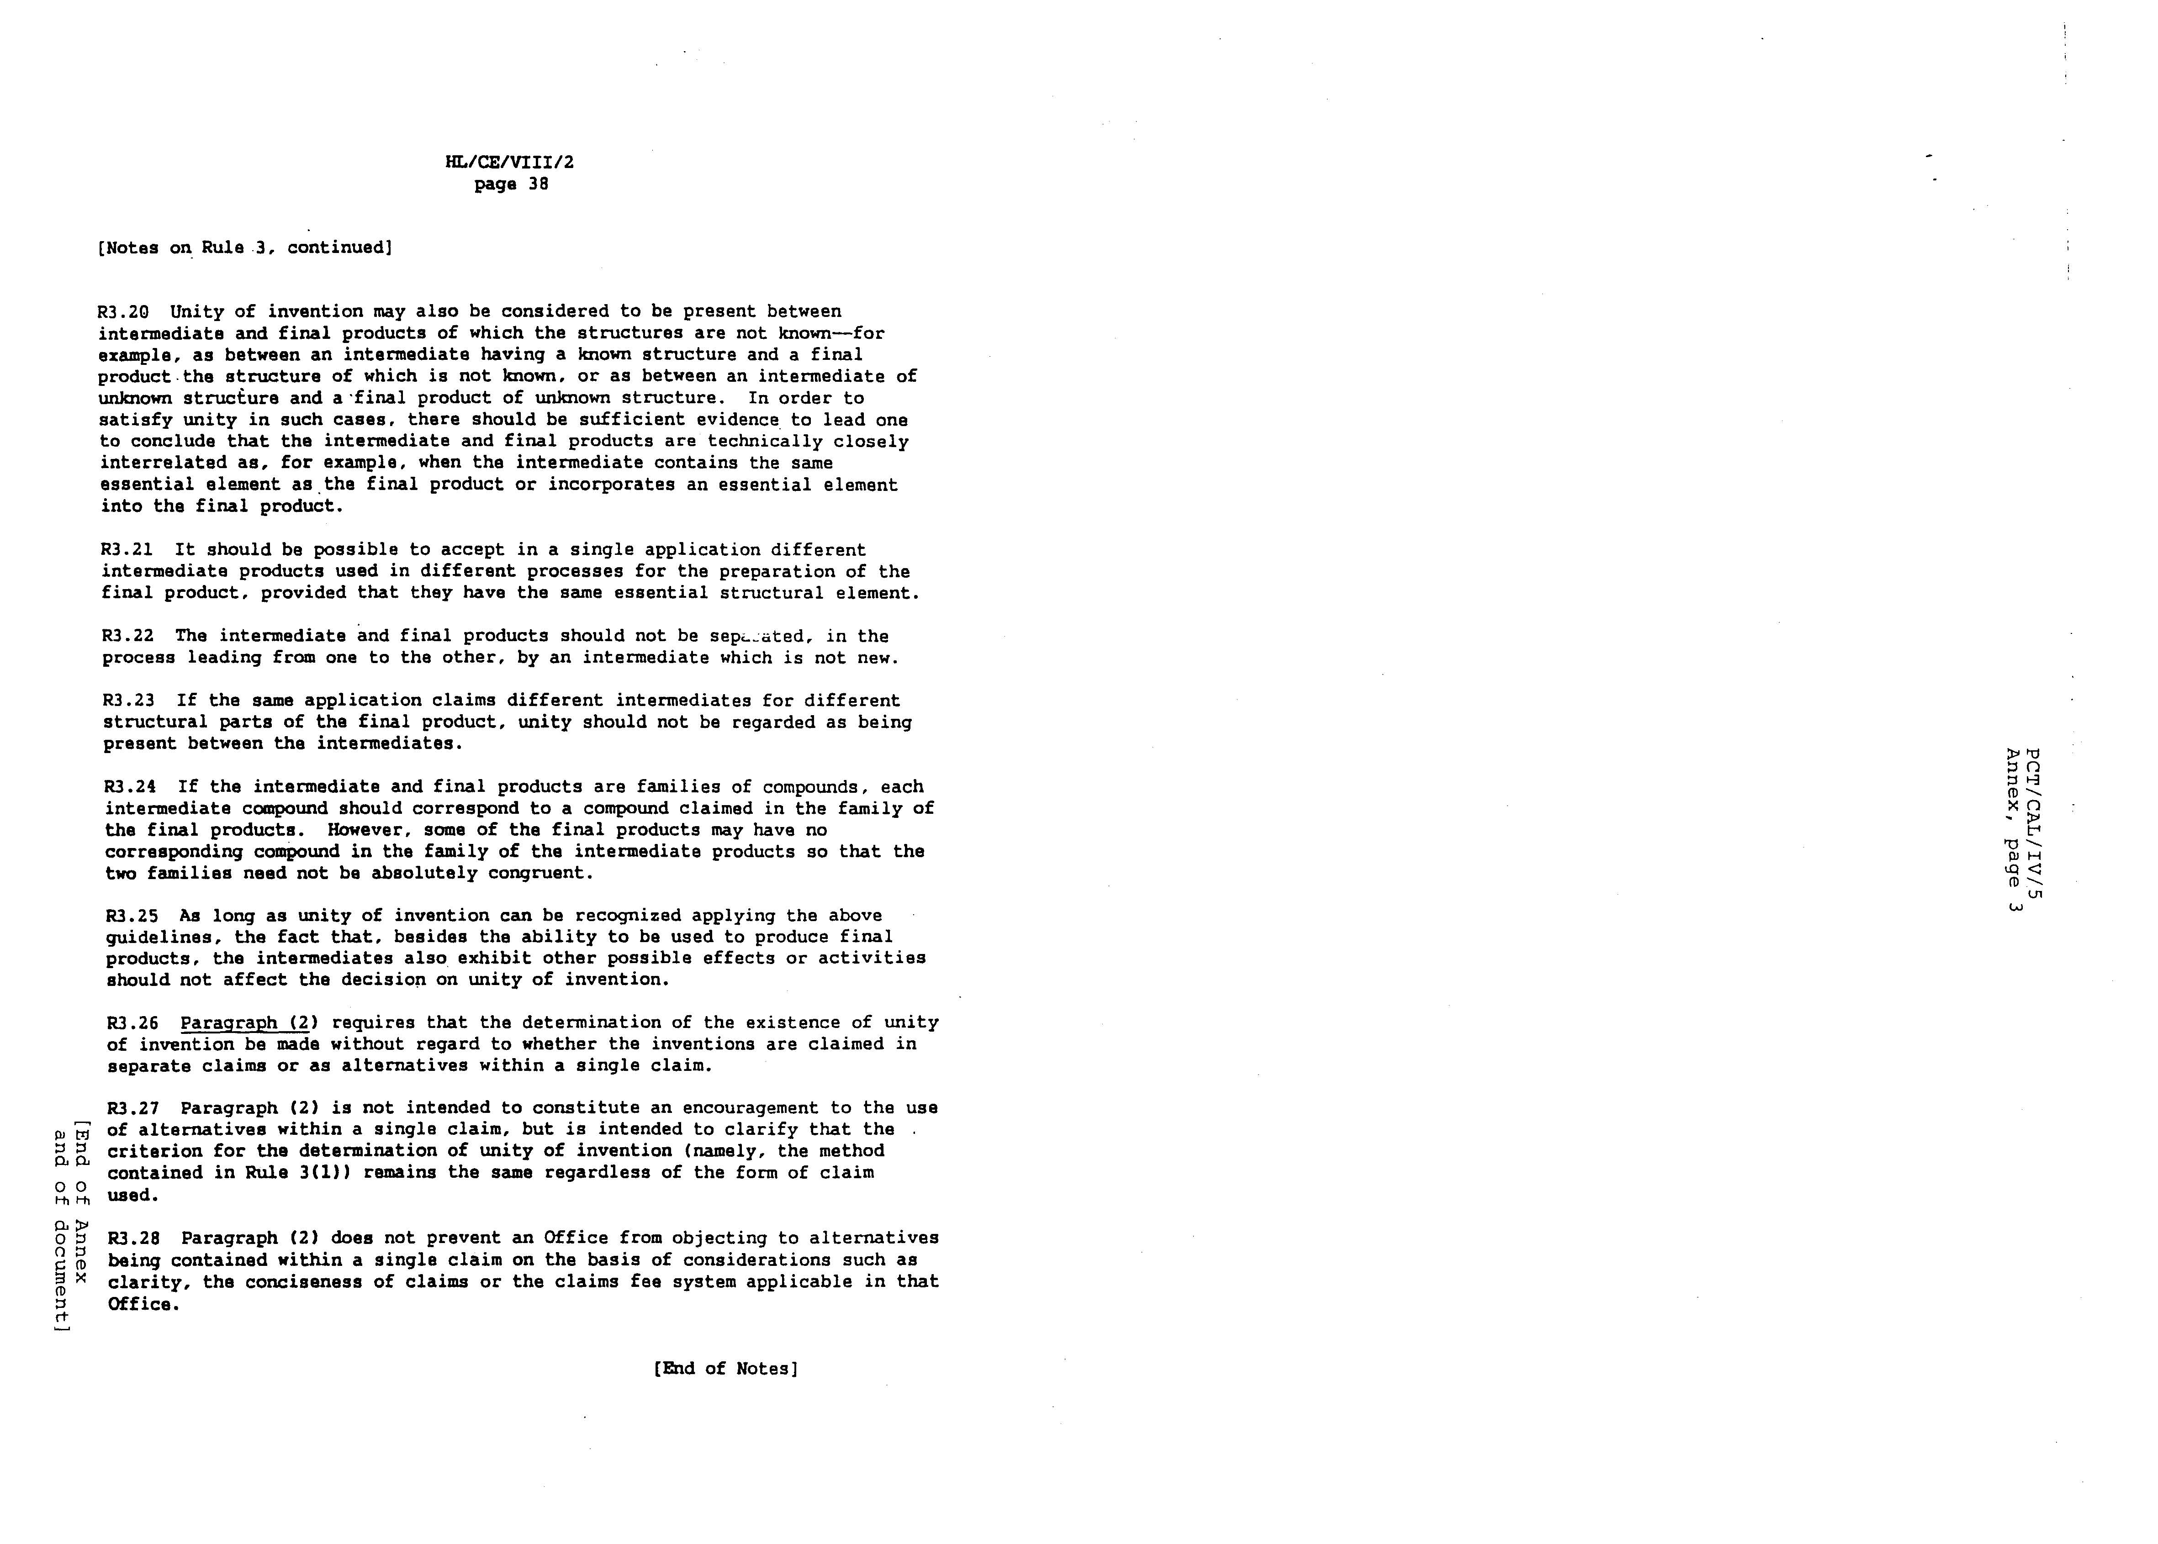

 Editor’s Note: This electronic document has been created from the paper original and may contain errors. Please bring any such errors to the attention of the PCT Legal Division by e-mail at pct.legal@wipo.int

