WIPO |  | E  PCT/CAL/III/8  ORIGINAL: English  DATE: August 30, 1990
WORLD INTELLECTUAL PROPERTY ORGANIZATION
GENEVA
INTERNATIONAL PATENT COOPERATION UNION
(PCT UNION)
pct committee
for administrative and legal matters

Third session, Second Part
Geneva, September 17 to 21, 1990
suggestions concerning RULEs 53.7, 53.7bis, 54.2, 59,
63 AND 67
Received from the Australian Patent Office

The present document contains suggestions received from the Australian Patent Office concerning the proposed amendments of certain Rules.

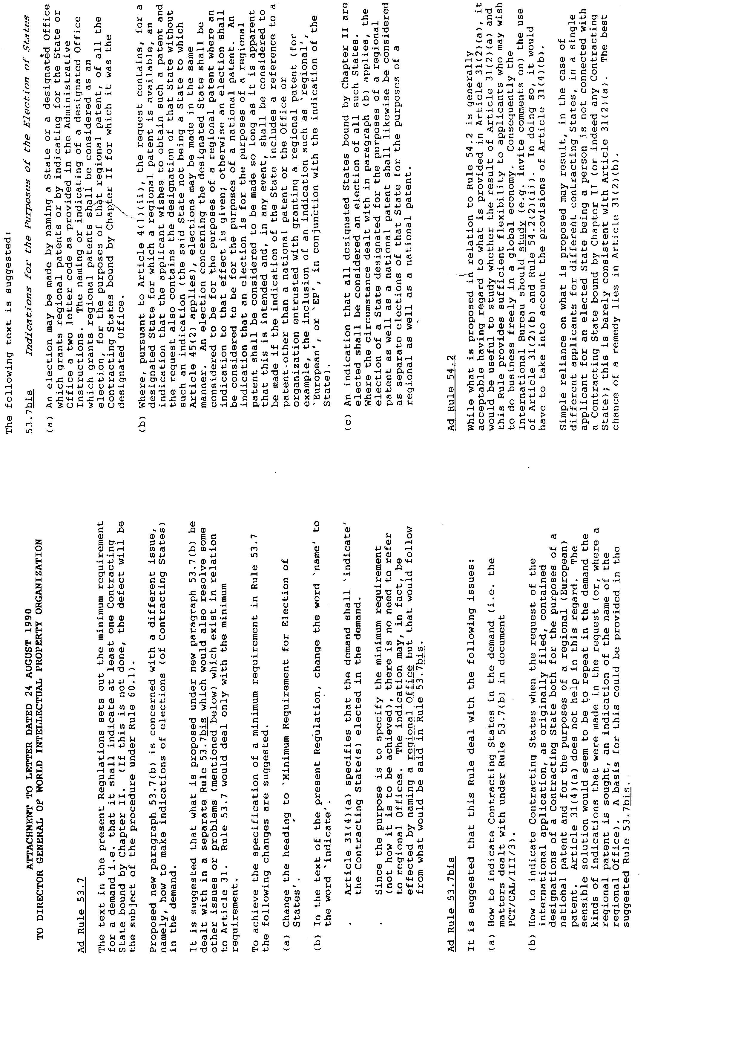
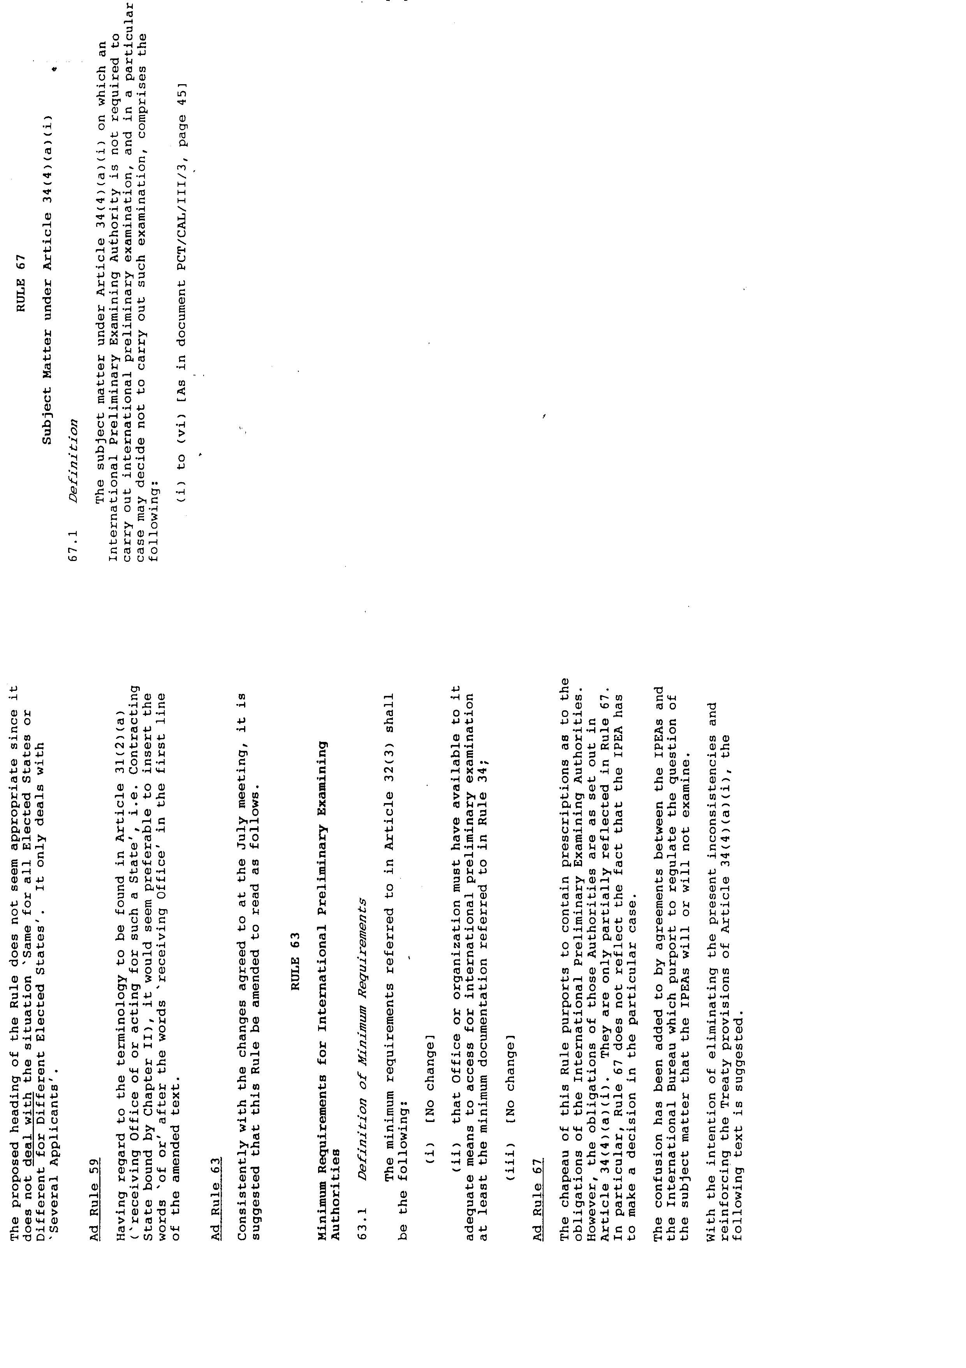

[End of document]

