WIPO |  | E  PCT/CAL/III/7  ORIGINAL: English  DATE: August 24, 1990
WORLD INTELLECTUAL PROPERTY ORGANIZATION
GENEVA
INTERNATIONAL PATENT COOPERATION UNION
(PCT UNION)
pct committee
for administrative and legal matters

Third session, Second Part
Geneva, September 17 to 21, 1990
Draft RULE 90bis
Comments by the European Patent Office

The present document contains comments, received from the European Patent Office, concerning proposed new draft Rules 90bis.4(a) and 90bis.5(a) and (c).

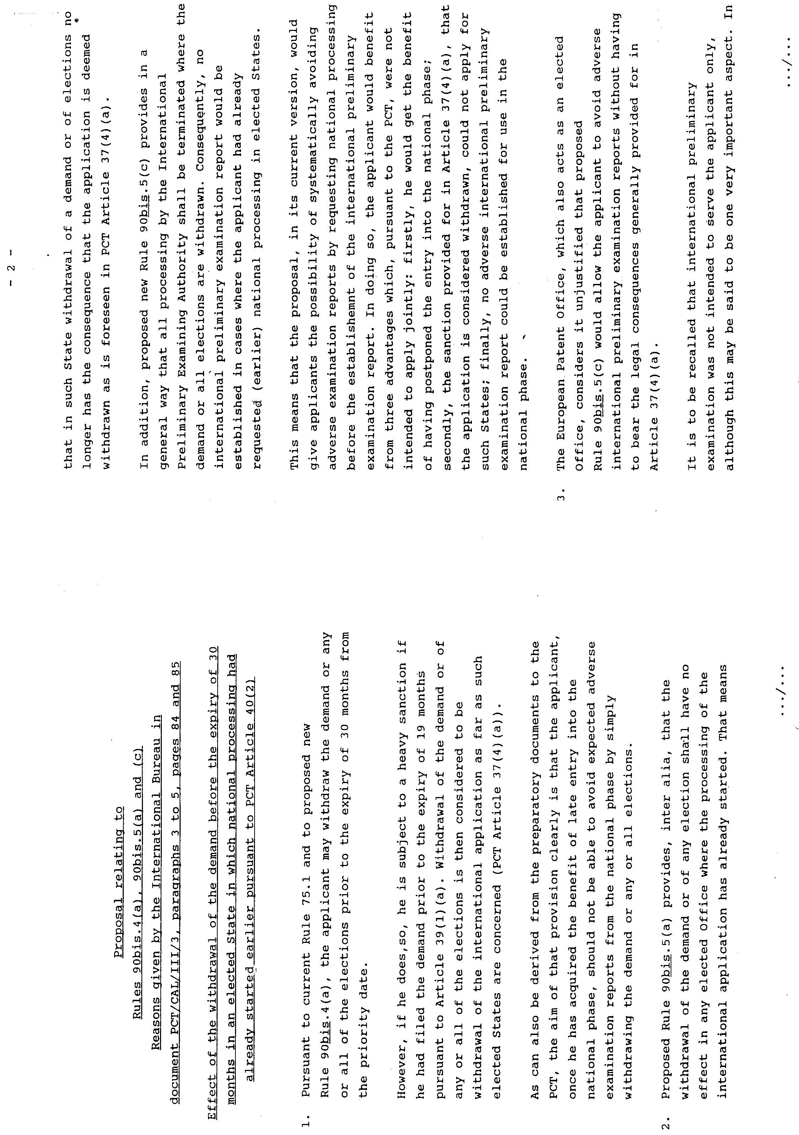

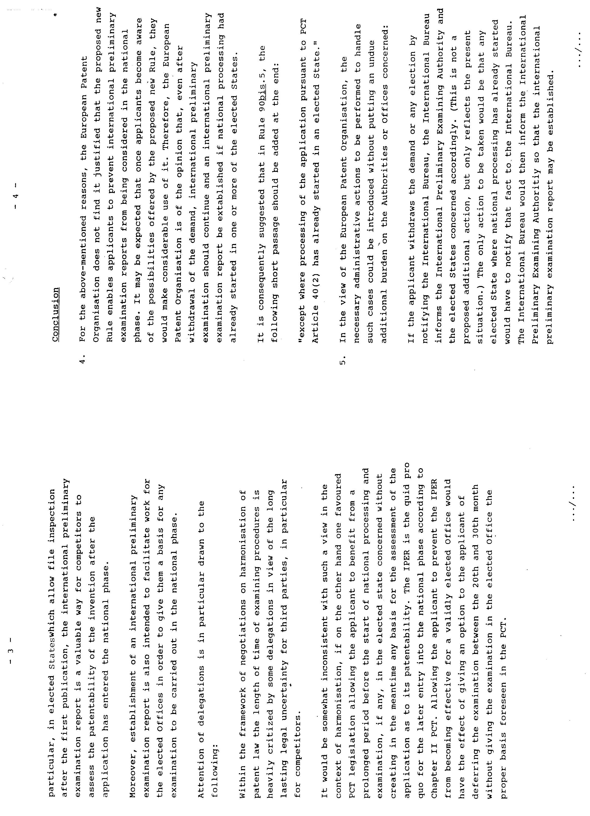

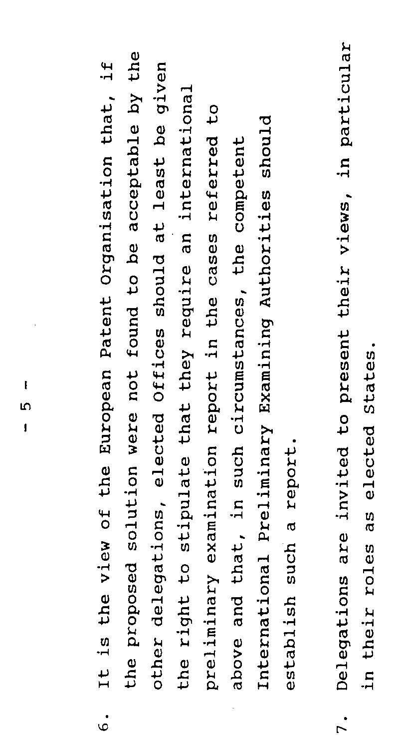
[End of document]

