C
CDIP/14/8 REV.2
原 文：英文
日 期：2014年11月14日

发展与知识产权委员会(CDIP)

第十四届会议
2014年11月10日至14日，日内瓦

知识产权与技术转让：共同挑战–共同解决项目
(建议19、25、26和28)概念文件

秘书处编拟

- “知识产权与技术转让：‘共同挑战–共同解决’项目”已经2010年11月举行的发展与知识产权委员会(CDIP)第六届会议批准，设想撰写关于如何共同解决的概念文件，作为国际技术转让高级别专家论坛的讨论依据，该论坛将于本项目结束时(暂时计划于2015年1月)举行。
- 据此，本文件的附件载有上述概念文件。
- 本文件载有最初载于文件CDIP/14/8中的“概念文件”的修订稿。本修订稿纳入了各成员国常驻代表团的代表在非正式吹风会上就“概念文件”初稿发表的意见，吹风会于2014年9月1日和2014年10月21日举行。还纳入了参加2014年10月28日为非政府组织(NGO)、政府间组织(IGO)、专业协会及被遴选专家举办的会议与会人员的意见，以及区域协调员在2014年10月24日的非正式吹风会上收到的反馈意见。修订后的文件还包括成员国在CDIP第十四届会议上提出的评论意见。
- 请CDIP审议并批准本文件附件中所载的概念文件。

[后接附件]

一、项目背景
- 本概念文件分析了国际技术转让中的挑战，总结了发展与知识产权委员会(CDIP)于2010年11月举行的第六届会议上批准的“知识产权与技术转让：‘共同挑战–共同解决’项目”(“项目”)(建议19、25、26和28)的主要成果，并提议基于公正公平的国际技术转让共同构建解决方案，回应全球面临的共同挑战。
- 此外，本概念文件旨在为高级别国际专家论坛提供讨论依据，该论坛暂时计划于2015年1月项目结束时在日内瓦举行。
“技术转让”的定义
- 本项目首要的成果之一，是为本项目之目的，对“技术转让”这一语词进行了定义。CDIP/9最后议定的定义措辞如下：
(a) “在本文件中，笼统地说，技术转让是指通过一系列程序，让大学和研究机构、国际组织、政府间组织、非政府组织、私营部门的实体和个人等不同利益攸关者的技能、知识、思想、诀窍和技术得以流通，并为此提供便利的行为，以及国家之间的国际技术转让。”
(b) “技术转让常常被视为包括吸收新技术，但有时也被认为涉及生产产品、运用方法或提供服务的一些具体知识的转让，其目的在于提高有关方面在经济市场中的国内和国际竞争力。”
- 根据前述议定的“技术转让”的定义，找到国际技术转让挑战的解决方案与实现知识流的正确动态之间具有内在联系，知识流包含了“具体知识”这一重要概念。
- 已经有很多研究分析了创新和技术传播的挑战，尤其是在环境创新领域。根据这些研究，技术交易以三个主要问题为特征：a)信息不对称：买家事前难以评估信息的价值；b)市场力量：上市时间、知识产权意识、融资渠道；以及c)外部性：无补偿的溢出效应和制度框架的缺失。
- 科罗拉多大学的Keith Maskus教授提出了促进国际技术转让可以采取的三种选择：a)保障国家处理市场失灵的“政策空间”；b)识别来源国鼓励国际技术转让的活动；以及c)处理与技术市场和/或国家政策有关的外部性的多边倡议。
- 应对前述挑战应该从识别国际技术转让的正式渠道开始。主要有三个渠道：a)商品和服务贸易；b)外国直接投资；以及c)知识产权许可，包括商业秘密许可。
- 知识产权捕捉发展的经济价值，并便利知识差距的缩小。
- 在企业界，为开创和保持其在市场中的竞争力，企业越来越依赖无形的或者以知识为基础的资产，而非有形的或者物质的资产，其创新、部署并战略性地管理这种专有资产的能力正在成为商业成功的关键因素。
二、CDIP批准的项目文件
- 2012年5月举行的CDIP第九届会议批准了该项目的项目文件(文件CDIP/9/INF/4)。项目文件提供了该项目的愿景、战略、最终目标，以及该项目的整体、全面图景。
- 此外，项目文件载有相关信息、各阶段详细说明，以及项目拟议开展的各项活动。其还提供了不同实体现有的各种技术转让途径的概述。
三、项目可交付成果总结
- 根据CDIP批准的项目文件，该项目的项目可交付成果有如下方面：
(a) 组织五次技术转让区域磋商会议(见以下14至16段)；
(b) 制作六份经同行评议的分析研究报告(见以下19至20段)；
(c) 撰写关于如何共同解决的概念文件(本文件)，以此作为高级别国际专家论坛的讨论依据，提交给CDIP批准(见以下31至33段)；
(d) 以国际会议的形式组织一次高级别国际专家论坛(见以下21至25段)；
(e) 制作和提供材料、模块、教学工具和由专家会议所通过建议产生的其他工具(见以下28段)；
(f) 创建网络论坛(见以下29段)；以及
(g) 经CDIP的审议以及委员会可能向大会提出的任何建议，将因上述活动而获通过的任何成果纳入到WIPO计划中(见以下30段)。
四、区域磋商会议
- 根据该项目，经与成员国事先磋商，共组织了五次知识产权技术转让的区域磋商会议，成员国在CDIP第八届会议上批准了区域磋商会议和承担各项研究的专家的职责范围(TORS)和构成标准。
(A) 组织五次会议
- 五次区域磋商会议在以下区域组织：
(a) 亚洲地区(“新加坡”)：知识产权与技术转让区域磋商会议，新加坡，新加坡，2012年7月16日-17日，
(b) 非洲和阿拉伯地区(“阿尔及尔”)：知识产权与技术转让区域磋商会议，阿尔及尔，阿尔及尔，2013年1月29日-30日，
(c) 转型区(“伊斯坦布尔”)：知识产权与技术转让区域磋商会议，伊斯坦布尔，土耳其，2013年10月24日-25日，
(d) 发达地区(“日内瓦”)：知识产权与技术转让区域磋商会议，日内瓦，瑞士，2013年11月25日-26日，以及
(e) 拉丁美洲和加勒比地区(“蒙特雷”)：知识产权与技术转让区域磋商会议，蒙特雷，墨西哥，2013年12月5日-6日。
(B) 会议分析
- 附录一提供了一系列信息图，即关于参加国代表总数(图表1)，每次活动参加人的总数(图表2)，每次活动形成的观点的总数(图表3)，能力构建等领域的观点的数量(图表4)，制度框架中的支持(图表5)，创新基础设施中的支持(图表6)，融资机制中的支持(图表7)，评估机制中的支持(图表8)，全球合作(图表9)，每次活动国际专家的地理来源(图表10、11、12、13和14)，以及每次活动国际专家的隶属关系(图表15)。
(C) 会议成果总结
- 每次区域磋商会议结束时，以“观点”的形式征求了该区域所有与会人员关于如何促进国际技术转让的开放式反馈意见。附录二提供了所有五次区域会议的“观点”清单。
五、经同行评议的分析研究报告
(A) 委托开展分析研究
- 根据该项目，在不同领域的工作中，委托了共六项分析研究报告，包括以下问题：(i)国际技术转让的经济学研究；(ii)发达国家与知识产权有关的政策；(iii)研发机构之间的合作；(iv)对商业伙伴的有利刺激；(v)发展中国家视角下的技术转让问题；以及(vi)专利之外的支持创新的研发努力的替‍代。
(B) 研究专家、职责范围与研究报告的完成
- 附录一中的图表16提供了受托开展此项研究的专家的地理来源与隶属关系。这些研究报告的概要载于附录三。这些研究报告已经同行评议。研究报告的最终文本及同行评议将在CDIP网站上提供。研究报告的题目、作者和完成日期如下：
(a) 研究(a)：知识产权与国际技术转让的经济学，印度班加罗尔的A. Damodaran教授(同行评议人意大利博科尼大学Francesco Lissoni教授的评议并入最终文本，2014年7月30日收到)；
(b) 研究(b)：发达国家促进技术转让的知识产权相关政策和倡议，肯尼亚内罗毕的Sisule Musungu先生(同行评议人美国美国大学Walter Park教授的评议并入最终文本，2014年9月5日收到)；
(c) 研究(c)：发达国家与发展中国家研发机构合作与交流的案例研究，瑞典哥登堡Bowman Heiden教授(同行评议人西班牙欧洲委员会联合研究中心Nikolaus Thumm教授的评议并入最终文本，2014年9月11日收到)；
(d) 研究(d)：促进企业参与技术转让的政策，澳大利亚布里斯班的Philip Mendes先生，(同行评议人西班牙欧洲委员会联合研究中心Nikolaus Thumm教授的评议并入最终文本，2014年9月5日收到)；
(e) 研究(e)：国际技术转让：以发展中国家为视角的分析，美国科罗拉多州玻尔得的Keith Maskus教授，及美国田纳西州纳什维尔的Kamal Saggi教授(同行评议人美国美国大学Walter Park教授的评议并入最终文本，2014年7月31日收到)；以及
(f) 研究(f)：包括推拉机制在内的用以支持研发努力的专利制度的替代：特别关注创新引导奖项与开源发展模式，美国华盛顿特区的Packard Love先生(同行评议人瑞士洛桑高等联邦理工学院Dominique Foray教授的评议并入最终文本，2014年9月9日收到)。
六、高级别国际专家论坛
- 根据该项目，设想组织一次高级别国际专家论坛，该论坛暂时计划于2015年1月在位于日内瓦的WIPO总部举行。如CDIP/9/INF/4所载的，将以国际会议的形式举行一次高级别专家论坛，意在启动讨论，即讨论如何在WIPO授权范围内，兼顾建议19、25、26和28(食品、农业和气候变化)，进一步为发展中国家和最不发达国家获取知识和技术提供便利，其中包括在新出现的领域以及发展中国家特别关心的其他领域提供这种便利。特别是吸收五次区域磋商会议、六份经同行评议的研究报告的成果，以及知识产权转让领域学术界和产业界的全球专家的经验，该论坛将为发达国家和发展中国家在公共和私营部门技术转让领域知识丰富的专家进行公开对话，及为讨论发达国家支持技术转让的知识产权相关政策提供一个框架。
- 关于被邀请参加论坛的专家的遴选以及这些专家的职责范围，文件CDIP/9/INF/4(第59段，末尾)声明如下：
“关于高级别专家论坛的组成，WIPO需要根据成员国批准的公正的遴选标准遴选各个不同领域的世界顶尖专家，以确保项目取得进展。对于专家会议，将邀请公共和私营部门的专家。经与成员国磋商后确定专家的职责范围(TOR)。”
- 为了就可能的机制获得指导，以就一套公平的、被邀请参加论坛的专家遴选标准获得成员国批准，并与成员国就这些专家的职责进行磋商，秘书处请各区域集团的协调员参加了2014年10月24日在日内瓦举行的一次非正式会议。
- 会上，各区域协调员同意努力使成员国批准以下拟议的关于被邀请参加论坛的专家遴选标准(以成员国在遴选根据该项目召开的区域磋商会的顾问之背景下批准的标准为基础；见文件CDIP/9/INF/4附录一第12段)：
“请秘书处在遴选被邀请参加高级别专家论坛的专家时，争取在其地域代表性(包括发达国家和发展中国家)、其隶属关系(公共和私营部门)，以及他们就知识产权对技术转让的作用的立场方面实现平衡。”
- 会上，各区域协调员还同意与成员国就被邀请参加高级别专家论坛的专家的职责进行磋商：
“专家应当熟悉项目交付成果。专家在确定观点、纳入有关促进技术转让的建议和可能的措施清单之中，以提交CDIP审议之时，应当首先找出所有观点的根本不同之处，并基于这种想法，找出具有现实意义的、双方都能接受的有利的要素，作为构建联合解决方案的出发点。”
- 最后，如最初设想的那样，高级别专家论坛将是为期三天的活动。
- 因此，将就载于上文第24段的拟议的关于遴选被邀请参加高级别专家论坛的专家的标准寻求成员国的批准。此外，也将寻求成员国对载于上文第25段的关于这些专家的拟议职责的反馈意见。
七、材料、模块、教具
- 采纳CDIP批准的项目文件设想的高级别国际专家论坛的建议，将准备材料、模块、教学工具和其他工具，并将之纳入WIPO全球能力构建框架。
八、网络论坛
- CDIP批准的项目文件设想的网络论坛将被纳入创新与技术转让支撑结构的国家机构门户的框架中，该国家机构是在执行建议10的项目的背景下建立的。
九、将成果纳入WIPO计划
- 采纳高级别国际专家论坛的建议，按照CDIP所批准的“项目文件”的设想，经CDIP审议通过以及委员会向大会提出任何可能的建议之后，上述活动的任何成果将被纳入本组织的工作之中。
十、将概念文件提交给国际专家提出评论意见
- 根据CDIP/6/4 Rev.所载的落实时间表，本概念文件的草案于2014年3月7日提交给了下列国际专家：国际贸易与可持续发展中心(ICTSD)高级项目助理Pedro Roffe先生及高级方案经理Ahmed Abdel Latif先生。他们提供了对信息图表内容、区域磋商会议的观点、分析研究报告及本概念文件中介绍内容的反馈意见。本概念文件纳入了这些评论意见。
十一、向各常驻日内瓦代表团提交概念文件
- 根据CDIP/6/4 Rev.所载的落实时间表，本概念文件于2014年9月1日和2014年10月21日在WIPO总部举行的非正式吹风会上向各常驻日内瓦代表团提交。成员国在这些吹风会上发表的意见已被纳入“概念文件”最终稿之中。
十二、与政府间组织、非政府组织、专业协会及被遴选专家为期一天的会议
- 根据CDIP/6/4 Rev.所载的落实时间表，本概念文件已于2014年10月28日在WIPO总部举行的一次会议上提交给了非政府组织(NGO)、政府间组织(IGO)、专业协会及被遴选专家。发言人列举了发展中国家参与技术转让的好处。产业界和政府间组织及非政府组织的代表就WIPO此项目的时间表和重要性达成了一致，指出该项目可以帮助实现技术转让的潜力，让所有各方受益，尤其是在未来的市场机遇方面更是如此。会议期间提出的问题包括了有关项目程序的问询，意在确保通过该项目“实现”有意义的成果(因为其标题指出：“共同挑战–共同解决”)。发言人以及与会人员提出了旨在通过技术转让支持当地行动倡议的以下观点：
- 建立人力资本；
- 扩展国家创新体系；以及
- 制定一种兼顾各方利益的知识产权制度。
十三、结 论
- “知识产权与技术转让：共同挑战–共同解决”的WIPO发展议程项目(建议19、25、26和28)运用了逐步的、二分法的途径，探索建立知识产权合作的新方式，以加强理解，就可能的促进技术转让的知识产权倡议或政策达成一致意见。该项目分为不同阶段，包括组织五次区域磋商会议，委托六项分析研究报告，举行高级别国际专家论坛以及开发网络论坛。
- 高级别专家论坛暂定于2015年1月19日至20日以国际会议的形式在位于日内瓦的WIPO总部举行。吸收五次区域磋商会议、六份经同行评议的研究报告的成果，以及知识产权转让领域学术界和产业界的全球专家的经验，该论坛将为发达国家和发展中国家在公共和私营部门技术转让领域知识丰富的专家进行公开对话，及为讨论发达国家支持技术转让的知识产权相关政策提供一个框架。
- 该WIPO发展议程技术转让项目探索性的、逐步的方式有前景。其提供了反思、验证设想并思考在之前的工作中很少被关注的新领域的机会。从在CDIP第四届会议上启动起，该项目一直被认为是项目阶段一，还有试点国家参与的包括更实用的项目的可能的第二阶段。
- 在高级别国际专家论坛结束时，该项目的目标是，经CDIP的审议以及委员会可能向大会提出的任何建议，将所有成果纳入到WIPO计划中。

[后接英文附录]
APPENDIX I

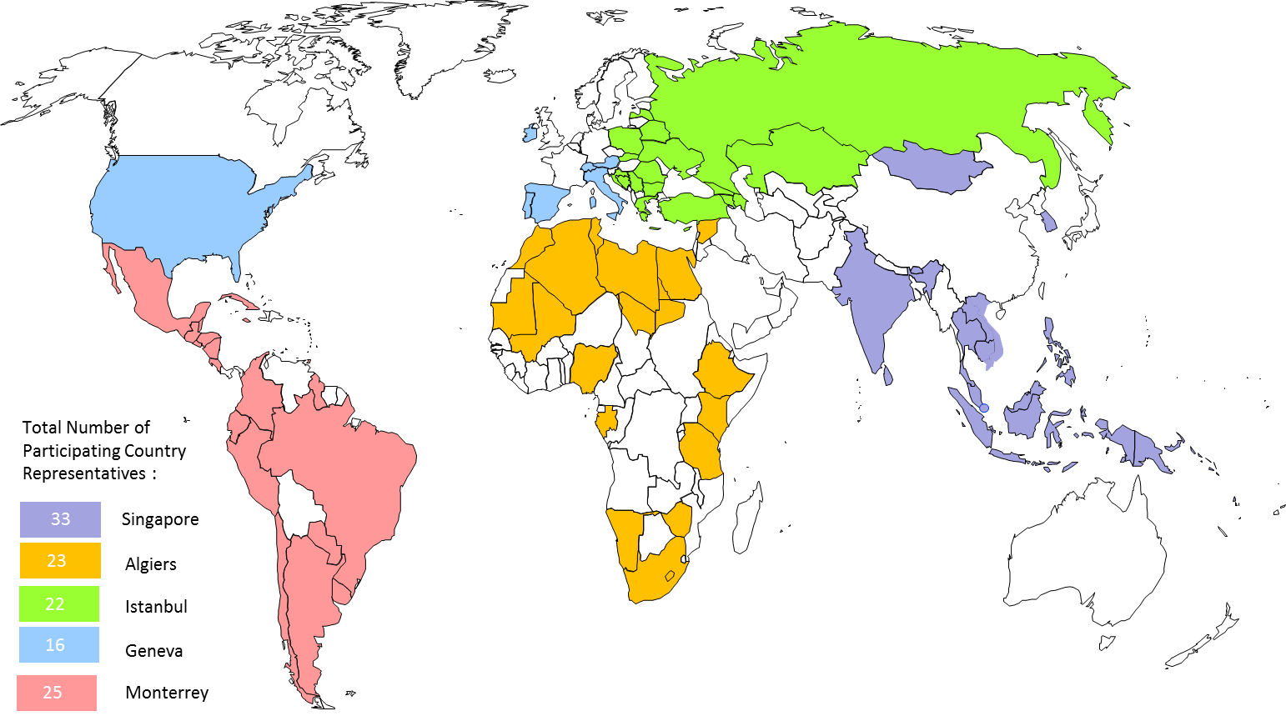

Figure 1. Participating Country Representatives to Regional Consultation Meetings.

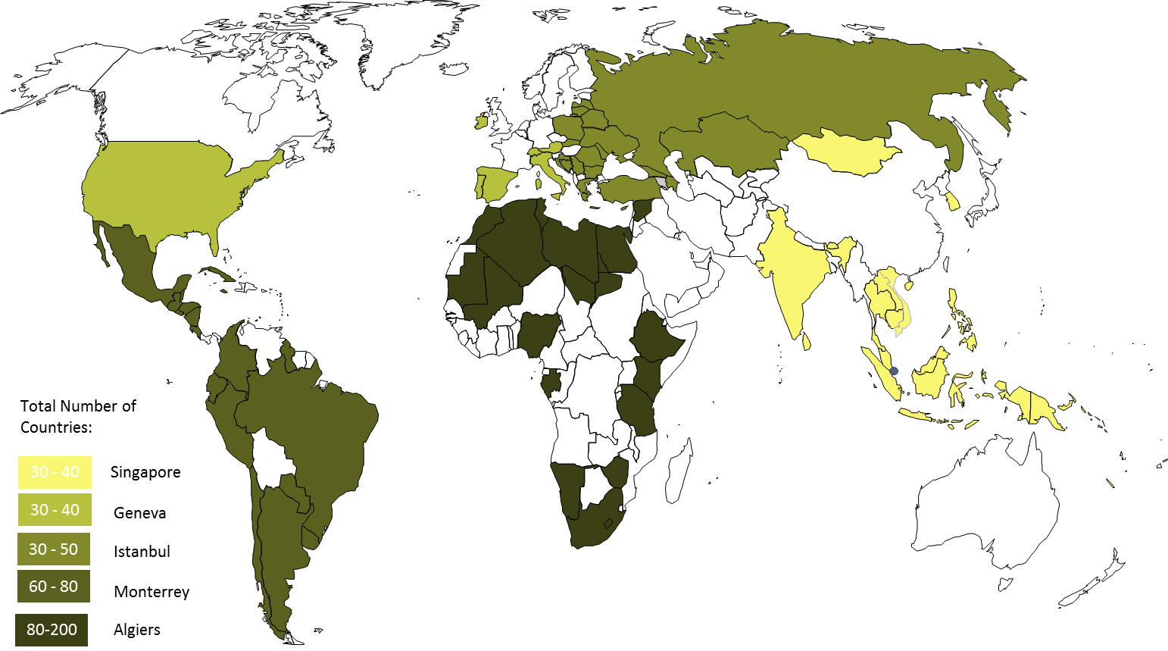

Figure 2. Number of Participants to Regional Consultation Meetings.

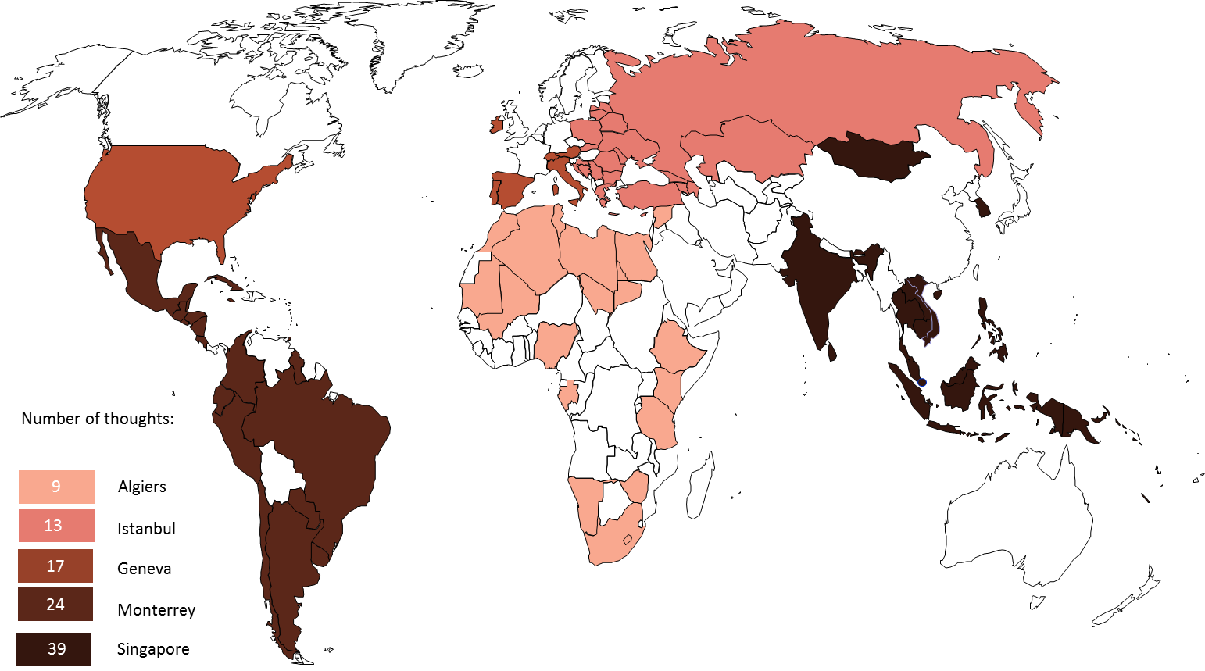

Figure 3. Total Number of Thoughts at Regional Consultation Meetings.

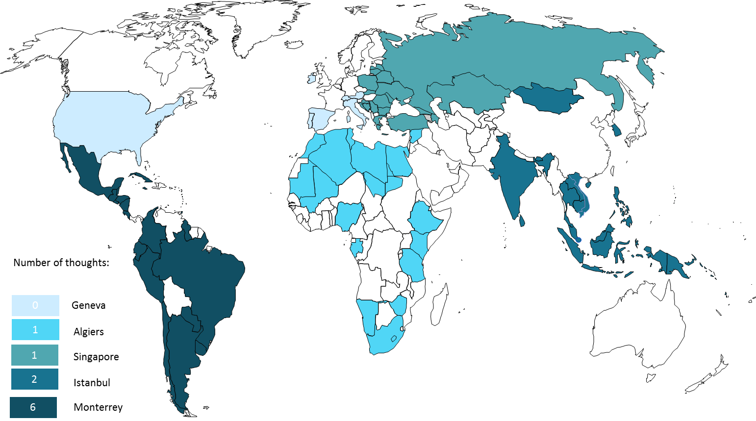

Figure 4. Number of Thoughts in Capacity Building at Regional Consultation Meetings.

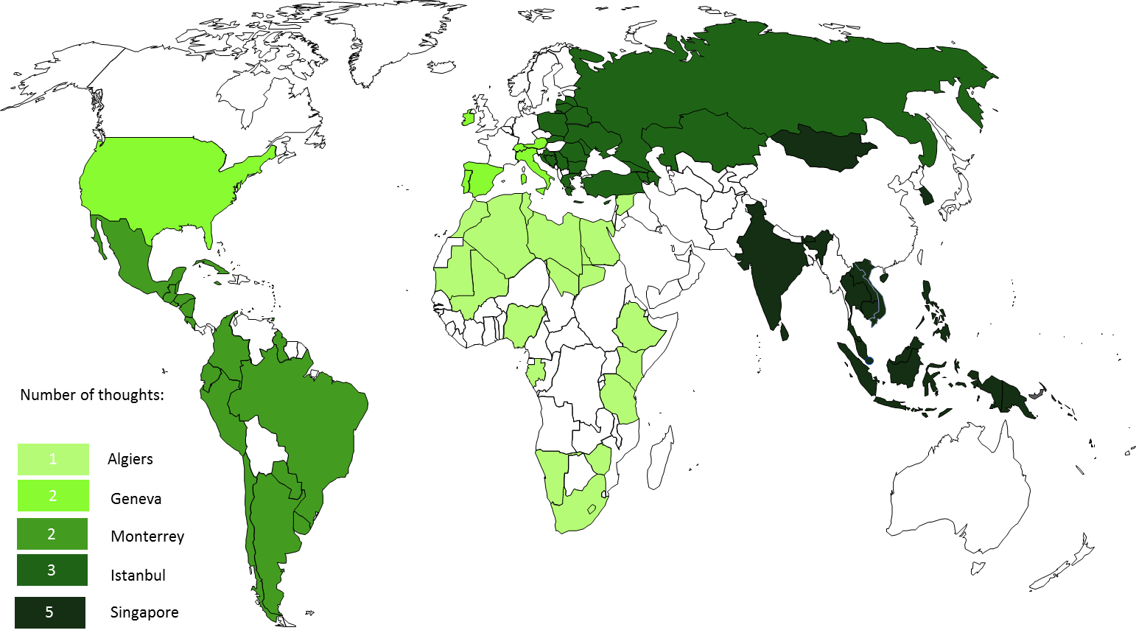

Figure 5. Number of Thoughts for Support in Institutional Framework at Regional Consultation Meetings.

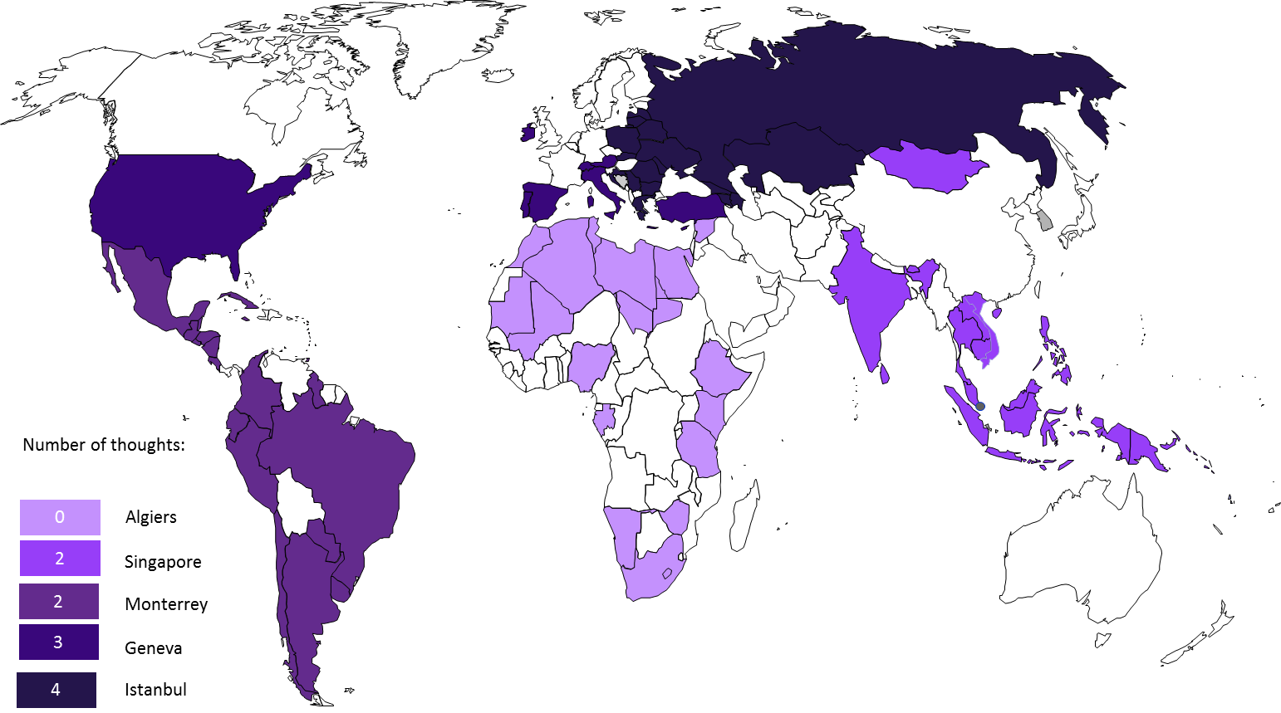

Figure 6. Number of Thoughts for Support in Innovation Infrastructure at Regional Consultation Meetings.

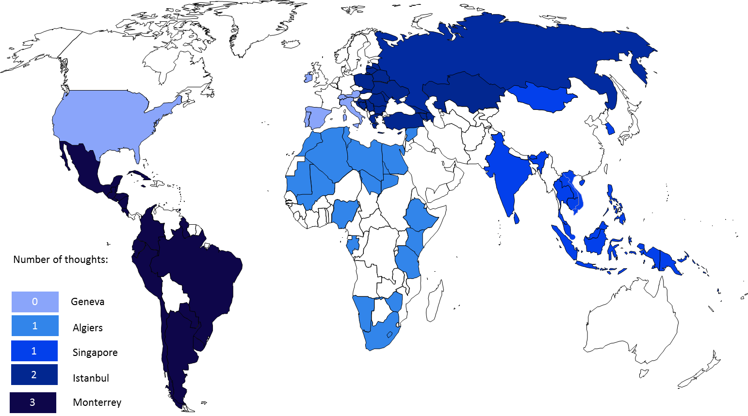

Figure 7. Number of Thoughts for Support in Funding Mechanisms at Regional Consultation Meetings.

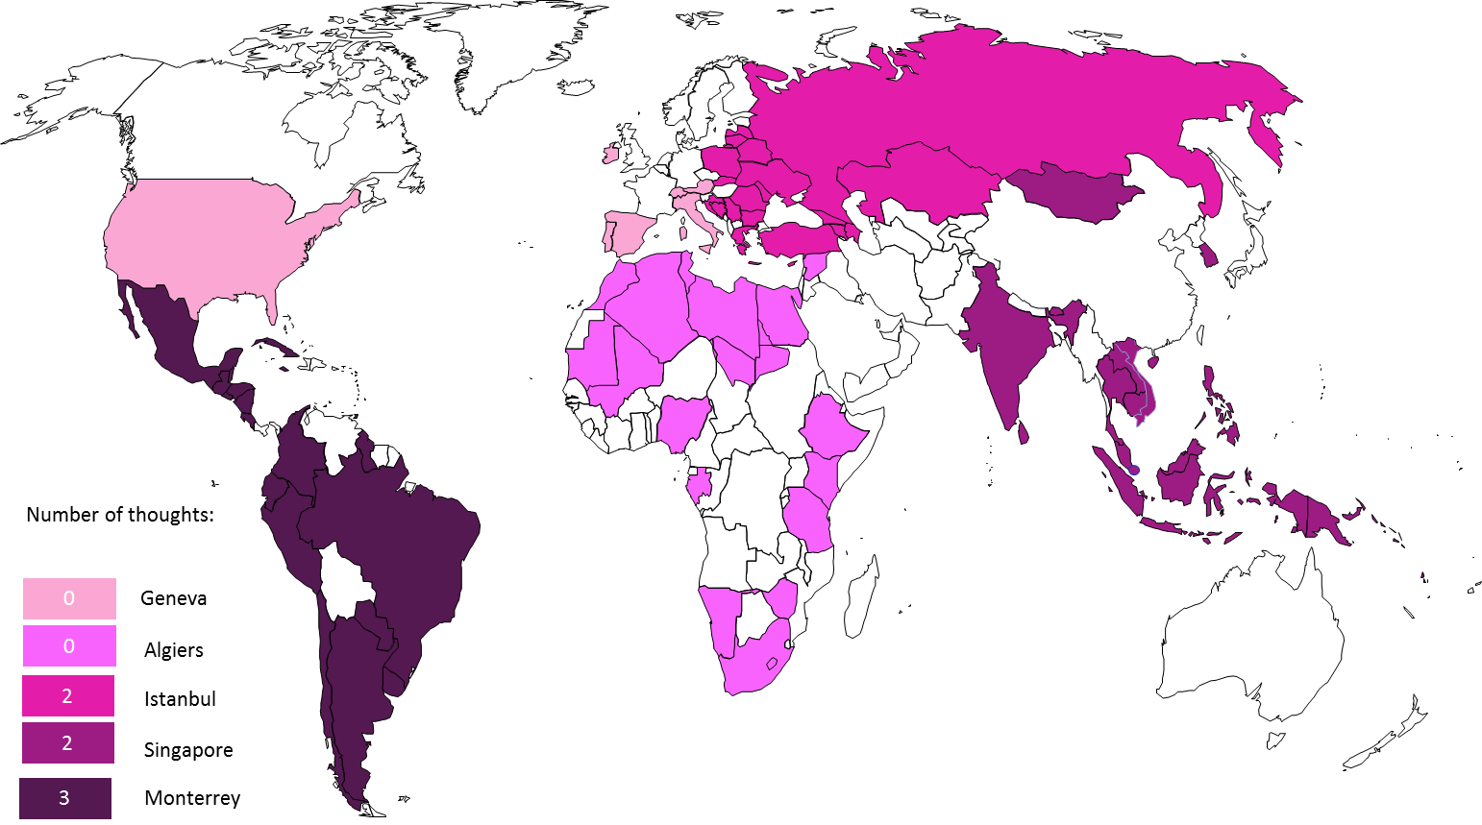

Figure 8. Number of Thoughts for Support in Evaluation Mechanisms at Regional Consultation Meetings.

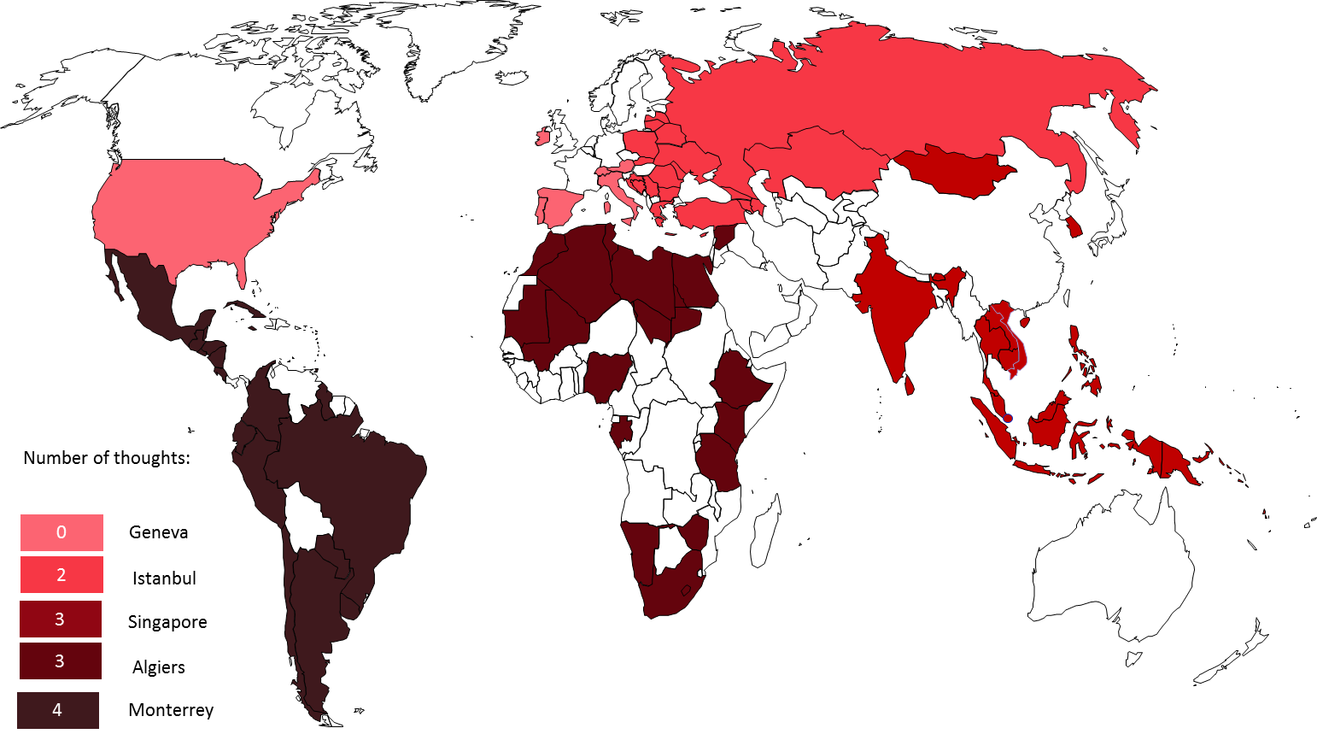

Figure 9. Number of Thoughts for Global Collaboration Incentives at Regional Consultation Meetings.

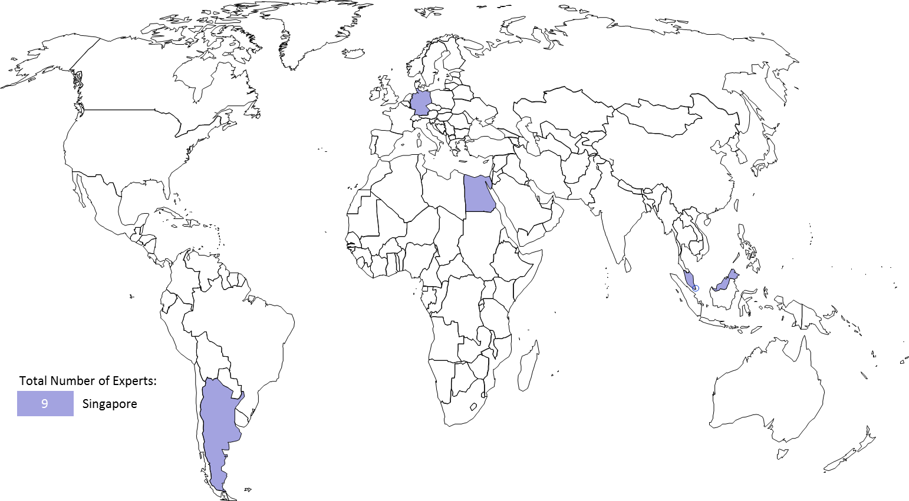

Figure 10. Geographical Origin for International Experts at the Regional Consultation Meeting in Singapore.
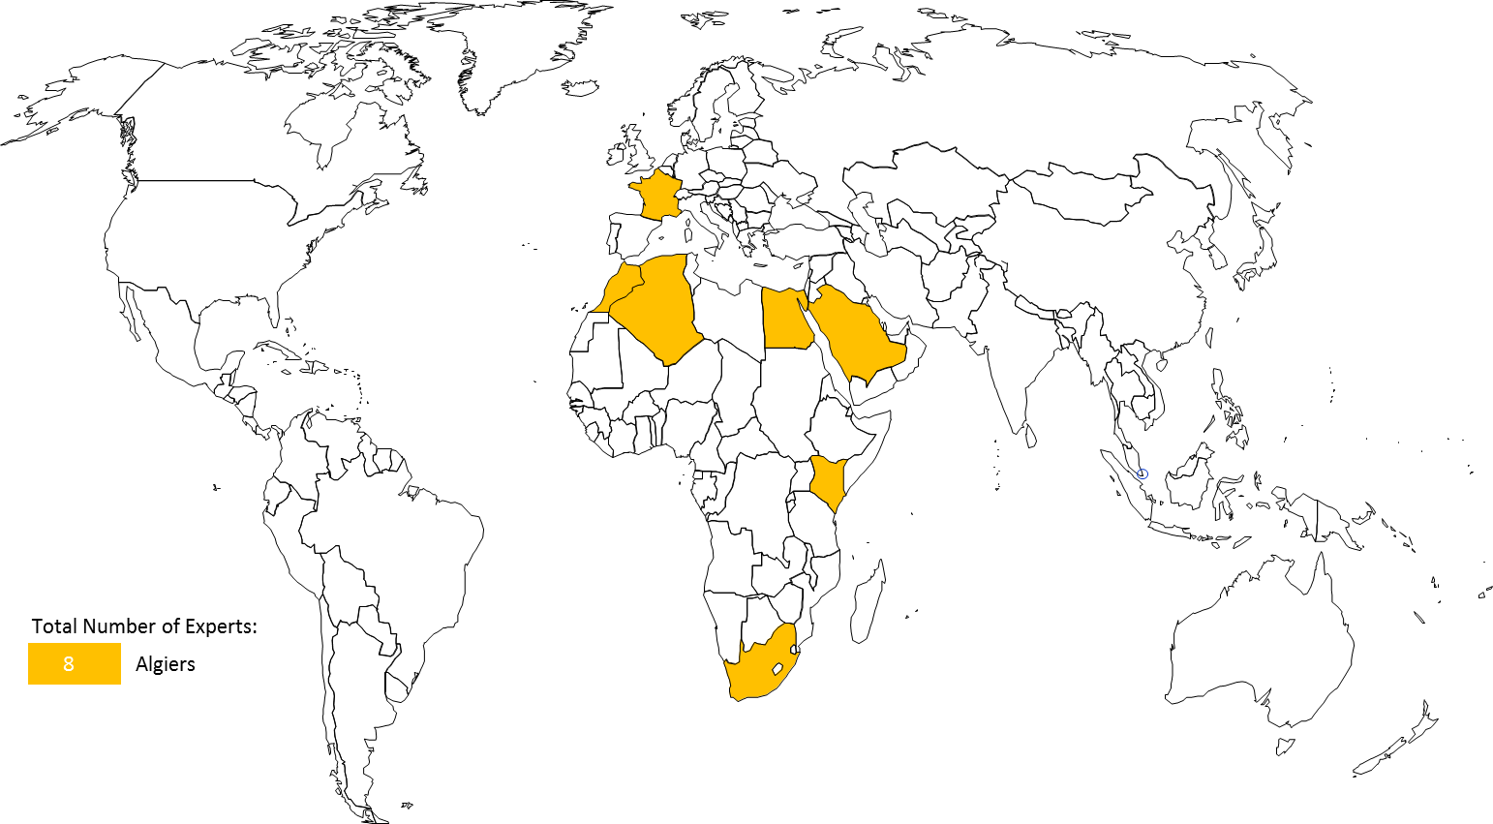

Figure 11. Geographical Origin for International Experts at the Regional Consultation Meeting in Algiers.

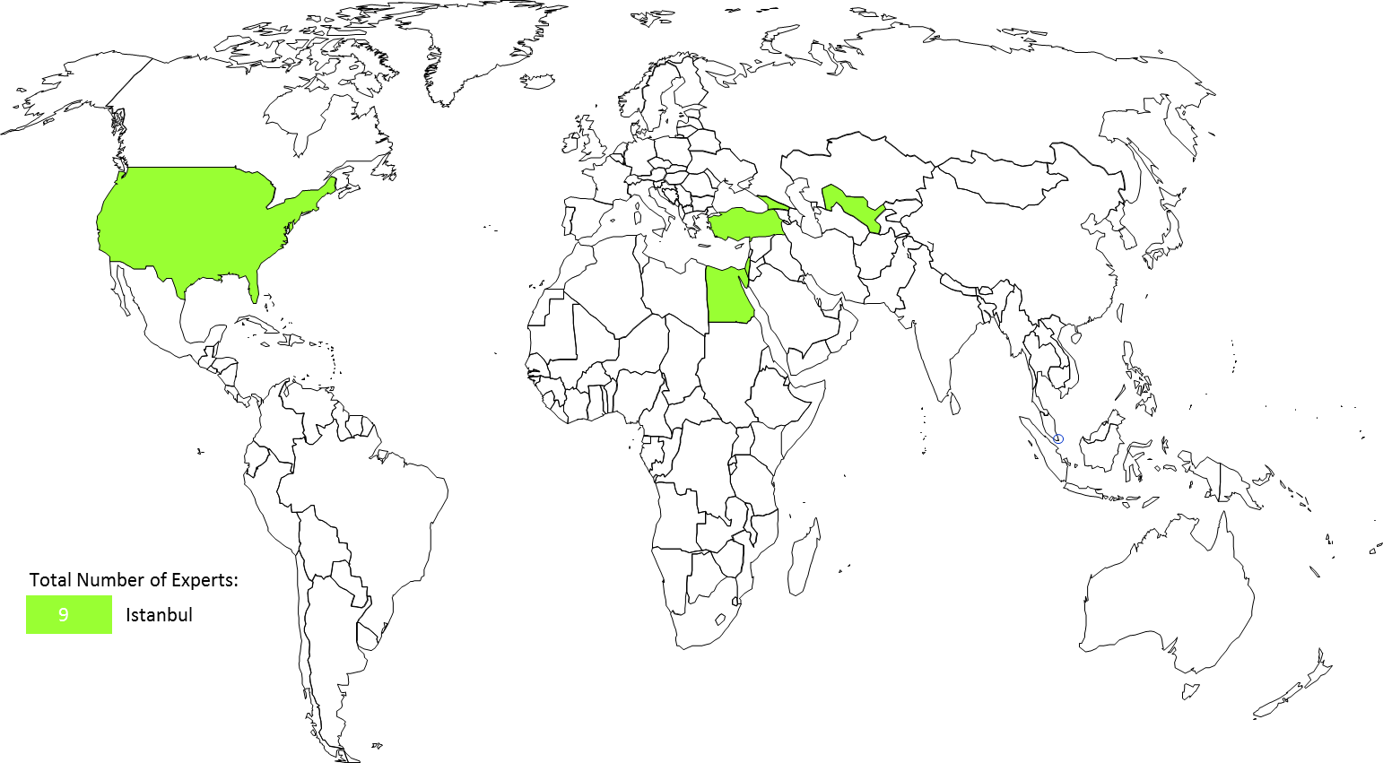

Figure 12. Geographical Origin for International Experts at the Regional Consultation Meeting in Istanbul.
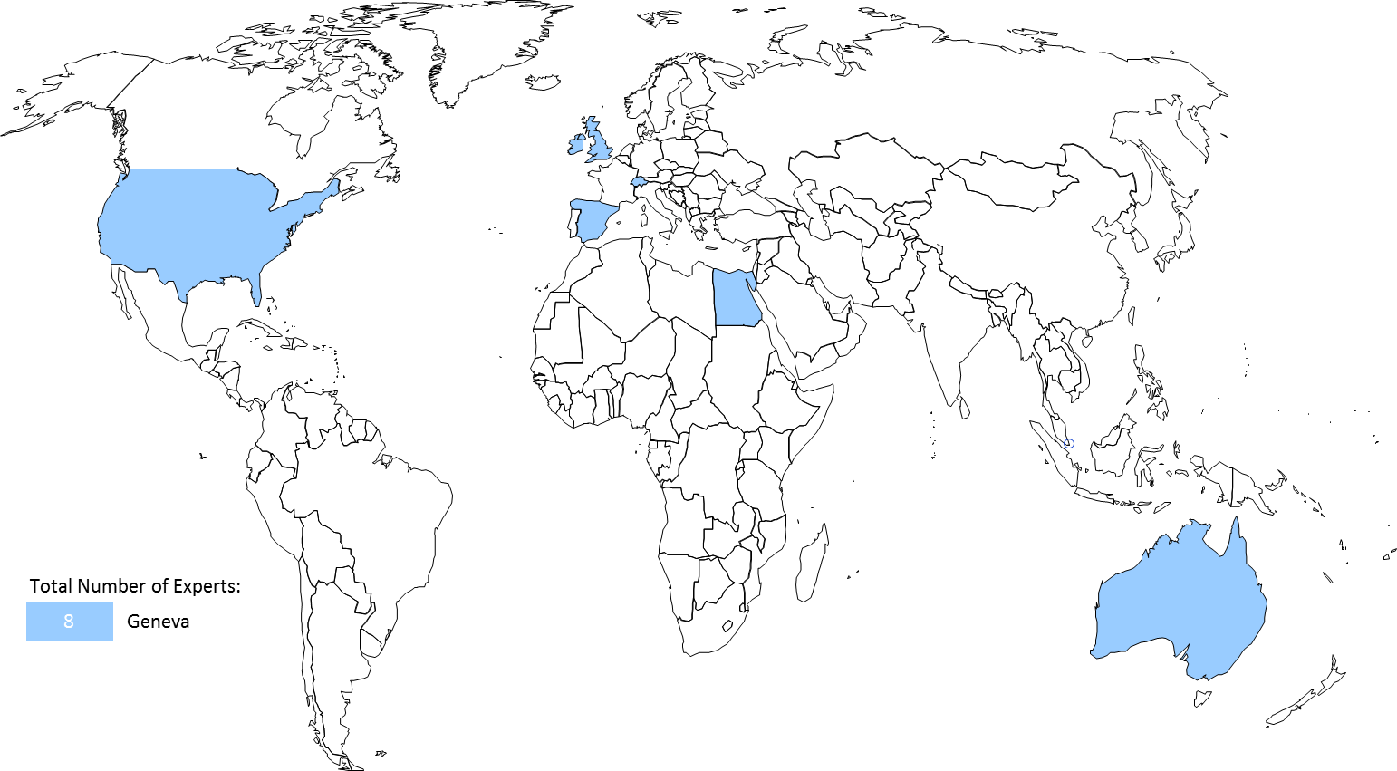

Figure 13. Geographical Origin for International Experts at the Regional Consultation Meeting in Geneva.

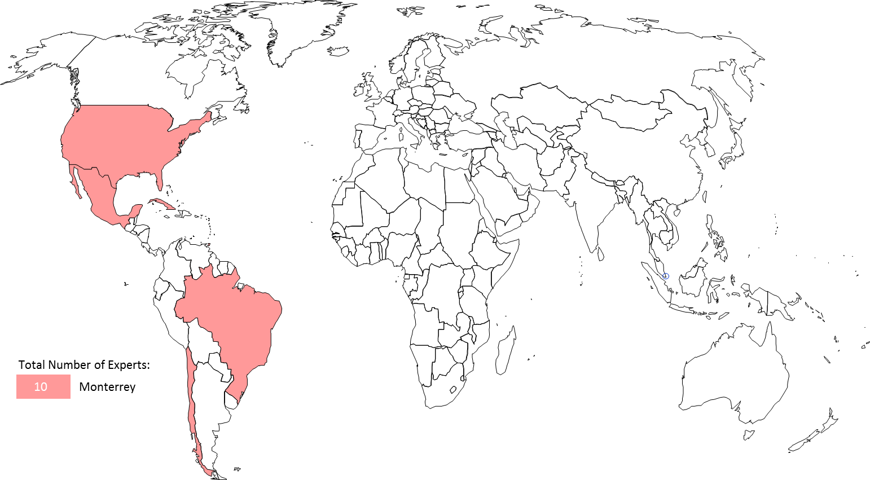

Figure 14. Geographical Origin for International Experts at the Regional Consultation Meeting in Monterrey.

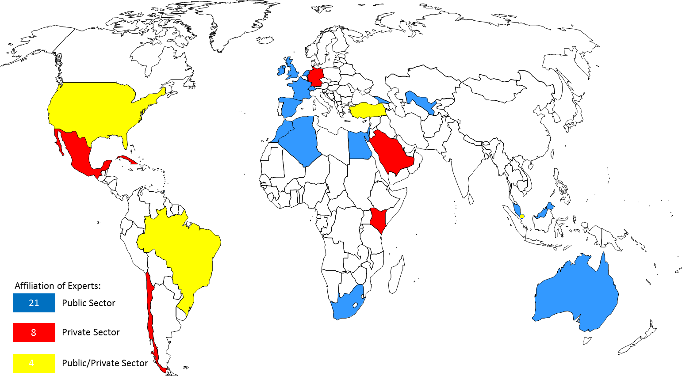

Figure 15. Affiliation for International Experts at the 5 Regional Consultation Meetings.

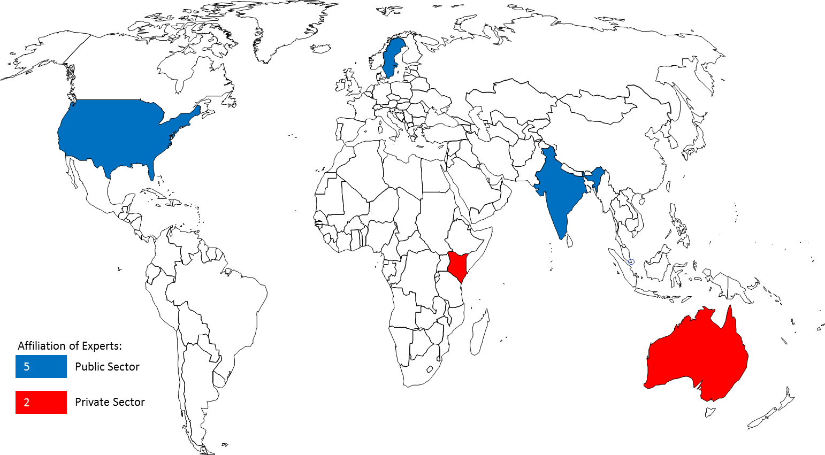

Figure 16. Affiliation of Experts for 6 Technology Transfer Studies.

[Appendix II follows]
APPENDIX II

(A) THE FIRST REGIONAL CONSULTATION
- The first Regional Consultation Meeting on Intellectual Property and Technology Transfer which took place in Singapore, Singapore, July 16-17, 2012, achieved some important milestones for the project. It obtained important information about the current status of technology transfer in this rapidly emerging Asian region and shared valuable experts’ opinions. The outcome of this Regional Consultation helped shape the next regional consultation in the African and Arab regions. 33 representatives attended from the following 19 Asian countries (2 from each country except Maldives, which was represented by only one representative): Bhutan, Brunei Darussalam, Cambodia, China, Fiji, Indonesia, Lao People’s Democratic Republic, Malaysia, Maldives, Mongolia, Myanmar, Papua New Guinea, Philippines, Republic of Korea, Singapore, Sri Lanka, Thailand and Vietnam.
Some of the main actionable thoughts from this first Regional Consultation in the Asian region, which focused mainly on capacity building, included the following:
- provide IP awareness building and especially on economic benefits of IP;
- encourage governments for national innovation and in updating IP protection laws;
- provide more training on IP and technology evaluation through patent information search, as well as, more assistance in capacity building on technology transfer and innovation;
- assist in the establishment of national technology transfer mechanisms;
- assist in developing a national IP policy and innovation infrastructure, technology transfer infrastructure in universities and R&D institutions, and innovation-based human resources development;
- assist in the creation of collective technology transfer offices and in the creation of links between developing countries and centers of excellence in developed countries;
- provide institutions with capacity building including in R&D planning, technology evaluation, industrial design, patents, valuation, and patent information search, encouragement of know-how and trade secret;
- assist governments to provide concrete encouragement and incentive programs to commercialize IP;
- create regional IP open forums for the exploitation of IP valuation models in different industry sectors;
- foster university-industry collaboration, through government partial financing (50%) of research projects when industry collaborates with universities and IP donation/low royalty licensing of IP in developed countries to developing countries; and
- encourage increased membership to the PCT system.

(B) THE SECOND REGIONAL CONSULTATION
The second Regional Consultation Meeting on Intellectual Property and Technology Transfer, Algiers, Algeria, January 29-30, 2013, built on the achievements of the first regional consultation and discussed a list of thoughts for the African and Arab regions, which focused on capacity building, innovation infrastructure, institutional infrastructure, university-industry collaboration, funding, regional and South-South cooperation, recognition for young inventors, and the markets. 23 representatives attended from the following 23 African and Arab countries (1 representative from each country): Algeria, South Africa, Saudi Arabia, Djibouti, Egypt, Ethiopia, Gabon, Ghana, Jordan, Kenya, Lebanon, Mali, Mauritania, Morocco, Namibia, Nigeria, Palestine, Sudan, Syria, Tanzania, Tunisia, Zambia and Zimbabwe.
Some of the main actionable thoughts from this second Regional Consultation in the African and Arab region included the following:
- provide additional capacity building for the development of human resources and skills in innovation commercialization with tailored workshops (particularly in the areas of patent search, examination, IP and entrepreneurship, and IP awareness), Academy trainings, training of trainers programs, as well as to participate in the elaboration of IP curricula at school, undergraduate and graduate-level programs (while taking into account the local language requirements and promoting a mixture of North-South participation);
- organize regional workshops to share best practices for the development of efficient innovation infrastructures and the promotion of regional-based networking of TISCs;
- assist universities and R&D institutions in elaborating their institutional infrastructures and help them to adopt intellectual property policies that encourage, through a system of recognition, the filing of patents and other intellectual property rights, as well as to launch a regional training center for the commercialization of intellectual property and the transfer of technology;
- design and develop workshops for improving the communication between universities and enterprises, including adopting the cluster models that have gained widespread success in some countries, as well as to develop regional competitions and awards for best collaborations among universities, enterprises and individual inventors;
- develop mechanisms for providing funding to innovation projects, through the potential creation of a Global Fund or an Angel Investor Program for intellectual property commercialization and technology transfer, which could be used by SMEs as well as individuals;
- promote regional and South-South cooperation for the promotion of intellectual property commercialization and technology transfer;
- design programs for the encouragement of publications and recognition to young inventors; and
- provide a better understanding of the market for technology, such as identifying needs in particular technology areas and conducting patent landscapes in emerging areas of technology;
- call for the launch of a “United Nations Decade for Innovation and Youth Employment” from 2014-2023, similar to other international decades such as the United Nations Decade for the Eradication of Poverty.

(C) THE THIRD REGIONAL CONSULTATION
The Third WIPO Regional Consultation Meeting on Intellectual Property and Technology Transfer, Istanbul, Turkey, October 24-25, 2013. 22 representatives attended from the following 22 countries in transition: Azerbaijan, Belarus, Bosnia and Herzegovina, Bulgaria, Croatia, Georgia, Greece, Israel, Kazakhstan, Kyrgyzstan, Republic of Latvia, Republic of Macedonia, Malta, Moldova, Montenegro, Poland, Romania, Republic of Tajikistan, Turkey, Ukraine and Republic of Uzbekistan.
Some of the main actionable thoughts from this third Regional Consultation in the Transition region included the following:

In the area of institutional framework:
  - provide IP Offices with guidelines on data mining and the visualization of statistical intellectual property data and evidence;
  - assist Member States in the development, monitoring and evaluation of national intellectual property, innovation and technology transfer strategies; and
  - revitalize the WIPO University Initiative.

In the area of Innovation infrastructure:
- assist in the setup of benchmarking platforms for best practices in technology transfer;
- develop a Guide on success stories for successful business environments to promote technology transfer;
- develop a platform for enhancing the regional collaboration and the sharing of experiences of TTOs; and
- identify the role and lessons learned from national innovation funds.

In the area of capacity building and the development of human resources with innovation commercialization skills:
  - develop and fund a Mentors Program to connect leaders in a particular field to TTOs around the world; and
  - design and develop a practical Workshop and Guide for the licensing of trade secrets.

In the area of private funding facilitation and evaluation mechanisms:
  - commission a Survey of available Venture Capitalists, angel investors and philanthropist donors, for funding technology transfer; and
  - provide a matchmaking platform.

In the area of repatriation incentives and global collaboration:
  - commission a Study on the incentives for the repatriation of international professionals; and
  - promote the exchange of expertise in the area of TTOs.

(D) THE FOURTH REGIONAL CONSULTATION
The Fourth WIPO Regional Consultation Meeting on Intellectual Property and Technology Transfer, Geneva, Switzerland, November 25-26, 2013. 16 representatives attended from the following 8 Permanent Missions: Ireland, Austria, Holy See, Italy, Portugal, Spain, Switzerland, and the United States of America.
Some of the main actionable thoughts from this fourth Regional Consultation in the Developed Country region included the following:

The first area of work concerned the people exchange:
  - create a program for people exchange to share experience and knowledge for long-term sustainability;
  - analyze existing programs such as those of the Licensing Executives Society International (LESI) and the Association of University Technology Managers (AUTM) for the networking of technology transfer officials;
  - scope out what an effective Technology Transfer Office looks like;
  - create a subgroup of technology transfer officials from developed countries;
  - enable a network of technology centers around the world;
  - create a database of technology transfer opportunities;
  - increase awareness for the potential of technology transfer;
  - identify effective technology transfer activities and apply lessons from those to future WIPO programs;
  - advertise effective technology transfer activities through the media so they become models to follow;
  - map of incentives for technology transfer and landscape certain initiatives such as the EU twinning practices between different institutions for the exchange of know-how;
  - expand on the EU twinning scheme and apply it between developed and developing countries; and
  - benchmark experiences and best practice relevant to the transfer of technology to inform the future and ensure that experience permeates everything;

Regarding the enabling infrastructure:
  - build networks of innovation infrastructures and encourage the twinning of technology transfer agents; and
  - create a Global Observatory providing technical assistance in technology transfer to ensure a regional strategy rather than a piecemeal approach;

Finally, with reference to the innovation policy:
- evaluate the impact of investment in technology transfer on economic and social development;
- commission a Study on incentives for technology transfer; and
- commission a landscaping Report on successful technology transfer between developed and developing countries.

(E) THE FIFTH REGIONAL CONSULTATION
The Fifth WIPO Regional Consultation Meeting on Intellectual Property and Technology Transfer, Monterrey, Mexico, December 5-6, 2013. 25 representatives attended from the following 21 Latin American and Caribbean countries: Argentina, Bahamas, Barbados, Brazil, Chile, Colombia, Costa Rica, Cuba, Ecuador, El Salvador, Guatemala, Guyana, Honduras, Jamaica, Mexico, Nicaragua, Paraguay, Peru, Saint Kitts and Nevis, Saint Vincent and the Grenadines, Uruguay, and Trinidad and Tobago.
Some of the main actionable thoughts from this fifth Regional Consultation in the Latin American and Caribbean region included the following:

In the area of capacity-building and the development of human resources with innovation commercialization skills:
  - develop a workshop for the training of TTO staff and the exchange of experiences between TTOs at a regional level;
  - conduct workshops on IP awareness for SMEs in the LAC region;
  - incorporate IP awareness and initiatives for schoolchildren/teachers and IP curricula at all education levels;
  - design and develop a workshop on the licensing of trade secrets and knowhow;
  - enable the dissemination of existing capacity-building tools through one-stop shops; and
  - provide patent examiners with access to proprietary databases.

Concerning institutional framework:
  - promote among the Member States of the PCT system its better use in the LAC region; and
  - support the development of university and research institute’s appropriate IP policies.

As to innovation infrastructure:
  - assist in the development of innovation networks; and
  - share best practices and business models from innovation infrastructures in the LAC region.

Regarding the regulatory framework:
  - assist in the development of guidelines and rules for institutions to promote technology transfer;
  - establish a forum to debate on trade and innovation and use the expertise of the WTO;
  - explore multilateral frameworks to improve access to technology that meets public needs including the promotion of WIPO platforms such as WIPO Re: Search and WIPO Green; and
  - promote the use of flexibilities of the TRIPs Agreement in order to increase access to technology.

On the subject of funding mechanisms:
  - commission a Study on the impact of funding mechanisms and best practices for innovation and technology transfer;
  - assist in the design of cost-effective projects on technology transfer; and
  - commission a Study on the impact of funding mechanisms such as proof-of-concept centers which provide seed funding and the tailoring of this model to countries in the LAC region;

As regards to the evaluation mechanisms:
  - assist in the development of national score cards with respect to the performance in IP management and technology transfer;
  - evaluate the extension of the Global Innovation Index parameters to include the patent applications in offices such as USPTO and EPO and look at the impact of specifying the multiple citizenships for inventors; and
  - improve awareness of the use of the WIPO databases and on the feedback from the users;

Finally, in the area of global collaboration:
  - develop and strengthen networks of TISCs at the regional level;
  - examine mechanisms for the repatriation of international talents and exchange experiences in this area;
  - design and launch a Web Forum to exchange experiences and best practices in international technology transfer; and
  - develop a global compendium of incentives for international technology transfer.

[Appendix III follows]
APPENDIX III

(A) THE FIRST STUDY

- The first of the six peer-reviewed analytical studies to be carried out under the project was to be (see document CDIP/9/INF/4, Annex, page 12): “(a) a series of economic studies on IP and international technology transfer. These studies would focus on areas that have received less attention in the available economic literature and on identifying possible obstacles and suggesting possible ways in which technology transfer could be enhanced. These studies should not be redundant with existing internal (in other WIPO committees such as the Standing Committee on the Law of Patents) or external (from other organizations) studies on technology transfer”.
This first study entitled “Economics of IP and International Technology Transfer” was conducted by Prof. A. Damodaran, Indian Institute of Management, Bangalore, India. The study focuses on key compartments of international macroeconomic policy. It was peer-reviewed by Prof. Francesco Lissoni, Bocconi University, Italy.

(B) THE SECOND STUDY
The second of the six peer-reviewed analytical studies to be carried out under the project was to be (see document CDIP/9/INF/4, Annex, page 12): “(b): a study that will provide information on existing intellectual property right (IPR) related policies and initiatives found in the public and private sector of developed countries to promote technology transfer and R&D capacity in developing countries, including international IP standards pertaining to technology transfer, such as the use of flexibilities in international IP agreements. This new study should avoid duplication of work and constitute an addition to work already undertaken in WIPO”.
This second study, entitled “Intellectual Property-Related Policies and Initiatives in Developed Countries to Promote Technology Transfer”, was conducted by Mr. Sisule Musungu, Partner, Sisule Munyi Kilonzo & Associates, Nairobi, Kenya. This study analyses and reviews the potential and performance of identified policies and initiatives in developed countries to determine which are most favorable to promoting technology transfer. It was peer-reviewed by Prof. Walter Park, American University, USA.

(C) THE THIRD STUDY
The third of the six peer-reviewed analytical studies to be carried out under the project was to be (see document CDIP/9/INF/4, Annex, page 12): “(c): a series of case studies of cooperation and exchange between R&D institutions in developed countries and R&D institutions in developing countries as well as a database of links to national institutions that already offer technology transfer opportunities or may offer such possibilities”.
This third study, entitled “Case Studies on Cooperation and Exchange between R&D Institutions in Developed and Developing Countries”, was conducted by Mr. Bowman Heiden, Professor, University of Gothenburg, Gothenburg, Sweden. This work generates eight case studies gathering different insights on international cooperation from the viewpoint of the different investigators on the nature of technology transfer in the different developing country contexts. It was peer-reviewed by Dr. Nikolaus Thumm, European Commission Joint Research Centre, Spain.

(D) THE FOURTH STUDY
The fourth of the six peer-reviewed analytical studies to be carried out under the project was to be (see document CDIP/9/INF/4, Annex, page 12): “(d): a study on Favorable Incentive Policies for businesses to become partners in technology transfer processes at the national and international level”.
This fourth study, entitled “Policies Fostering the Participation of Businesses in Technology Transfer”, was conducted by Mr. Philip Mendes, Principal, Opteon, Inc., Brisbane, Australia. The study focuses on the many factors influencing the underutilization of technology transfer processes. It was peer-reviewed by Dr. Nikolaus Thumm, European Commission Joint Research Centre, Spain.

(E) THE FIFTH STUDY
The fifth of the six peer-reviewed analytical studies to be carried out under the project was to be (see document CDIP/9/INF/4, Annex, page 12): “(e): an analysis of transfer of technologies issues relating to existing and emerging issues of concern to DCs and LDCs in order to identify their needs in certain specific regions or sub-regions”.
This fifth study, entitled “International Technology Transfer: An Analysis from the Perspective of Developing Countries”, was conducted by Mr. Keith Maskus, Professor, University of Colorado, Boulder, Colorado, USA and Mr. Kamal Saggi, Professor, Vanderbilt University, Nashville, Tennessee, USA. The study focuses on international technology transfer, with a particular emphasis on the concerns of developing countries in gaining greater access to global technology. It was peer-reviewed by Prof. Walter Park, American University, USA.

(F) THE SIXTH STUDY
The sixth of the six peer-reviewed analytical studies to be carried out under the project was to be (see document CDIP/9/INF/4, Annex, page 12): “(f): a series of studies looking at alternatives for R&D efforts and support to innovation aside from the currently existing patent system”.
This sixth study, entitled “Alternatives to the Patent System that are Used to Support R&D Efforts, including both Push and Pull Mechanisms, with a Special Focus on Innovation Inducement Prizes and Open Source Development Models”, was conducted by Mr. James Packard Love, Director, KEI, Washington, DC, USA. The study focuses on several alternatives to the patent system including direct government funding of research, tax policy, mandates to fund research-based upon a percentage of product sales, and innovation inducement prizes. It was peer-reviewed by Prof. Dominique Foray, EPFL, Switzerland.

[附件和文件完]

建议19(建议集B)：“开展讨论，探讨如何在WIPO的职责范围内，进一步提供便利，帮助发展中国家和最不发达国家获取知识和技术，以鼓励创造与创新，并加强WIPO在这方面的现有活动。” 建议25(建议集C)：“探讨为促进有利于向发展中国家转让和推广技术，必须采取哪些与知识产权有关的政策和倡议，并采取适当措施，让发展中国家能全面了解各项不同规定中涉及有关国际协定中提供的灵活性方面的利益。” 建议26(建议集C)：“鼓励成员国尤其是发达国家，敦促其科研机构加强与发展中国家尤其是最不发达国家的研发机构之间的合作与交流。” 建议28(建议集C)：“探讨成员国尤其是发达国家为促进向发展中国家转让和推广技术可以采取哪些与知识产权有关的扶持性政策和措施。”
见CDIP/9/INF/4，第9段和第10段。
根据建议36，“全球知识流图册”为位于纽约的社区系统基金会(CSF)所研发，最终形式发布于2014年7月22‍日。
Kamal Saggi、Keith E. Maskus及Bernard Hoekman，《向发展中国家的技术转移：单边和多边的政策选择》，世界银行政策研究工作文件3332，2004年6月。
文献建议了很多非正式渠道，比如获取专利信息和参加国际博览会。
见CDIP/9/INF/4，http://www.wipo.int/meetings/en/doc_details.jsp?doc_id=202624
见CDIP/8/7，http://www.wipo.int/meetings/en/doc_details.jsp?doc_id=188786
http://www.wipo.int/meetings/en/details.jsp?meeting_id=28643
http://www.wipo.int/meetings/en/details.jsp?meeting_id=31263
http://www.wipo.int/meetings/en/details.jsp?meeting_id=30703
http://www.wipo.int/meetings/en/details.jsp?meeting_id=31242
http://www.wipo.int/meetings/en/details.jsp?meeting_id=31243
分析研究的最后版本将上传至CDIP知识产权与技术转移项目下的“项目状态”页面(http://www.wipo.int/ip-development/en/agenda/projects.html)。
http://www-ocmstest.wipo.int/innovation
http://www.wipo.int/meetings/en/details.jsp?meeting_id=34205

