E
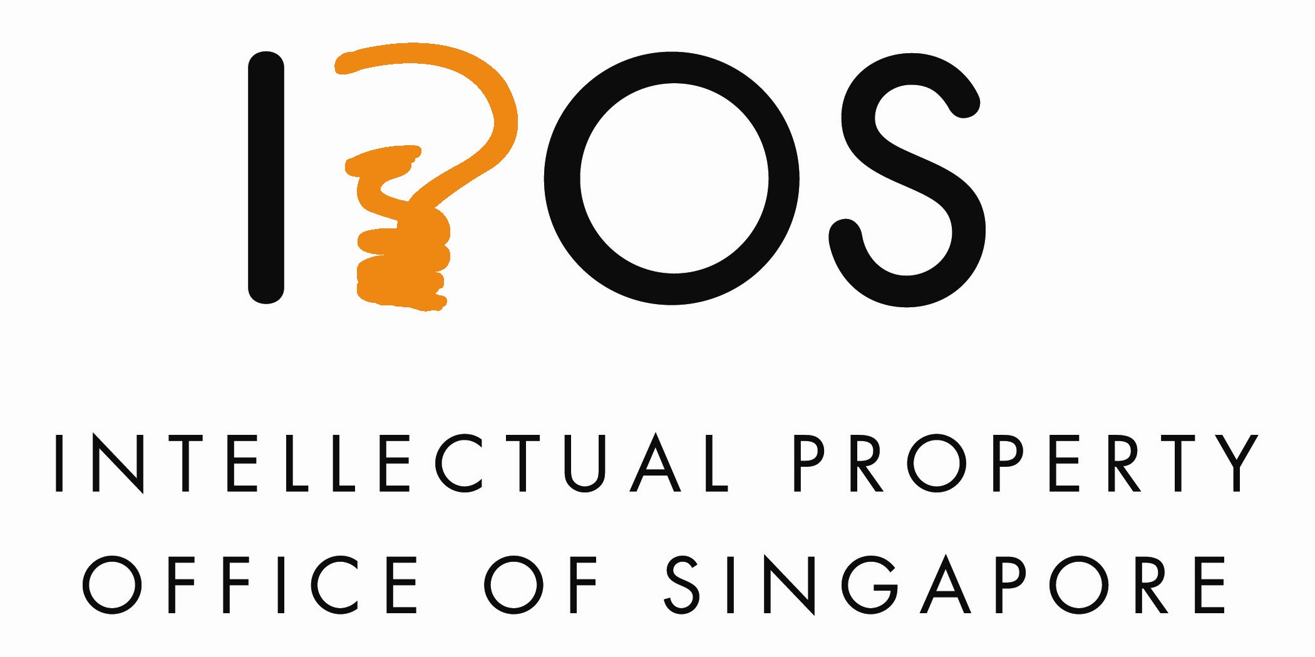 | 
policy dialogue
WIPO/pol/IP/sin/12/INF/2
ORIGINAL: English
DATE: 5 june 2012

Policy Dialogue on Patents Work-Sharing Initiatives

organized by
the World Intellectual Property Organization (WIPO)

in cooperation with
the Intellectual Property Office of Singapore (IPOS)

Singapore, June 5 and 6, 2012

list of SPEAKERS

prepared by the Secretariat

DANIEL CHENG

Mr. Cheng is the Head of Section in WIPO’s Global Infrastructure Sector, Infrastructure Modernization Division. He joined WIPO in 2003, after having worked thirteen years at a French IT Services Company specified in document processes and document management systems.
He has over twenty years experience in the field of systems development, operations and project management and he holds degrees in IT Software Engineering from Paris VI University and “Conservatoire National des arts et métiers”, France.

In his current role as the Head of Product Development Section in WIPO’s Infrastructure Modernization Division, he is in charge of a small team tasked with system development, operations and supports of several software systems and products WIPO Digital Access Service (DAS), WIPO Centralized Access to Search and Examination system (CASE), WIPOSCAN and Industrial Property Automation System (IPAS).

TAIZO HARA

Taizo Hara joined the Japan Patent Office (JPO) in 1997, examining applications in automatic transmission of automobile and later in hybrid vehicle. From 2003 – 2004, he studied IP laws in the University of Washington in Seattle, U.S.A.. From 2005 – 2009, he worked in the International Affairs Division of JPO, in charge of international related issue.

Now, he belongs to the Patent Examination Policy Planning Office of JPO, covering PPH, examiners exchange program, and other work-sharing matters.

Mr. Hara holds a Master Degree in the field of Engineering from Tokyo University in 1997.

CLAUS MATTHES

Mr. Matthes is a Director in WIPO’s Innovation and Technology Sector, PCT Business Development Division. He joined WIPO in 1994, after having worked at the German Patent and Trademark Office in Munich, the Federal Ministry of Justice of Germany in Bonn and Berlin, and the Ministry of Justice of the State of Brandenburg in Potsdam, Germany.

He holds a law degree from Bonn University, Germany, and a master in public administration from Harvard University, USA. In his current role as the Director of WIPO’s PCT Business Development Division, he is in charge of a small team tasked with developing proposals for the further improvement of the PCT system, including proposals for improvements to the PCT legal framework, PCT procedures and processes, and to related standards and specifications of IT systems.

JÚLIO CÉSAR MOREIRA
Mr. Moreira is Director of Patents of the Brazilian Industrial Property Office (INPI) since June 2011. He joined INPI in 1998 as a patent examiner in charge of examination in petroleum, catalysts, chemical processes and related areas. From 2008 to 2011 he worked as Adviser of Directorate of Patents.

He is a Chemical Engineer graduated by Federal University of Bahia ‐ Brazil, with a Master degree in Petroleum Engineering from University of Campinas ‐ Brazil. His PhD was obtained at Federal University of Rio de Janeiro in Chemical Engineering. From 1993 to 1998 worked as a researcher at Petrobras Research Center, Rio de Janeiro, Brazil.
NG SU LIN

Ms. Ng is a Senior Executive of the Registry of Patents in the Intellectual Property Office of Singapore. She is currently involved in the administration of the Patent Prosecution Highway programme, and she manages some of the common patent processes in the Registry. She is also involved in the resource planning of the Registry.

Since 2012, Ms. Ng has taken on the responsibility of overseeing the Registry's function as a receiving Office for international applications filed under the Patent Co-operation Treaty.

Ms. Ng has a degree in Business Management. Prior to joining the Intellectual Property Office of Singapore, Ms. Ng was involved in research and policy work in the arts and heritage industry.

PHILIP NOONAN

Philip Noonan is Director General of IP Australia, the Australian Government agency responsible for the administration of the Australian patent, trade marks, designs and plant breeder’s rights systems.
Since joining IP Australia, Philip has taken a particular interest in reducing patent application backlogs, which affect Australia as well as many other countries. He has been working within the Vancouver Group, which comprises the national IP offices of Canada, the United Kingdom and Australia, on ways in which those offices can reduce re-work and duplication in the processing of related applications before the various offices.
Prior to taking up this position in January 2008, Philip worked in the Australian Government’s Department of Innovation, Industry, Science and Research in a variety of management and policy roles He also has experience advising on company law, international trade law, copyright law reform and consumer affairs issues.
Philip has a Bachelor of Science and a Bachelor of Laws and is admitted to practice as a solicitor and barrister in Victoria, Australia.
KITISRI SUKHAPINDA
Ms. Kitisri Sukhapinda is an Attorney Advisor in the Office of Policy and External Affairs, United States Patent & Trademark Office (USPTO). Her responsibilities at the USPTO include formulating and promoting intellectual property policy in the Southeast Asia region. She leads the USPTO-ASEAN Regional Team in providing legal assistance and technical training to foreign government officials to assist them in complying with their international intellectual property law obligations. Her areas of expertise include patent, technology transfer, and plant-related intellectual property. She represents the United States to the Council of the International Union for the Protection of New Varieties of Plants (UPOV), and has been elected the Vice President of the UPOV Council.
Prior to joining the USPTO, Kitisri practiced patent law in the private sector. Prior to entering into the legal field, Kitisri was a research scientist at a Fortune 500 company. She was named a co-inventor of five U.S. patents.
Kitisri received a bachelor’s degree in crop science from North Carolina State University, master’s and doctorate degrees in plant breeding and genetics from Iowa State University, and a law degree from Indiana University, Indianapolis.

ERIC TOH

Mr. Toh is a Senior Executive of the Registry of Patents in the Intellectual Property Office of Singapore. He currently oversees the search and examination team in the Patents Registry and is involved in the ASEAN Patent Examination Co-operation Programme which is the first co-operation programme in the ASEAN region. He is also responsible for internal and external quality management in relation to search and examination.

Mr. Toh has a degree in Economics and Management. Prior to joining the Intellectual Property Office of Singapore, Mr. Toh was a financial auditor at a mid-tier accounting firm and has experience working across different industries.

[End of Document]

