E
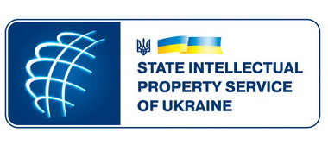 | 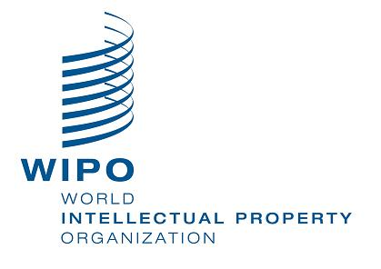
Workshop
WIPO/IPR/JU/KYI/14/inf/1 Prov.
ORIGINAL: English
DATE: august 2014

ENFORCEMENT OF INTELLECTUAL PROPERTY RIGHTS FOR JUDGES AND PROSECUTORS

organized by
the World Intellectual Property Organization (WIPO)

in cooperation with the State Intellectual Property Service of Ukraine (SIPSU)

Kyiv, September 9, 2014

Provisional Program

prepared by the International Bureau of WIPO

9.15 – 9.30 Opening Ceremony

Welcome addresses by:

The representative of SIPSU

Mr. Xavier Vermandele, Senior legal Counsellor, Building Respect for IP Division, World Intellectual Property Organization (WIPO)

9.30 – 9.50 Topic 1: Counterfeiting and Piracy in the Framework of Strategic
Goal VI of WIPO

Speaker: Mr. Xavier Vermandele

9.50 – 10.20 Topic 2: Infringement of IPRs in Ukraine: the Scope of the Problem

Speaker: Local speaker (tbc.)

10.20 – 10.50 Topic 3: International and National Standards for the Enforcement of IP Rights

Speakers: Local speaker (tbc)
Xavier Vermandele

10:50 – 11:20 Topic 4: The Role of Judges and Prosecutors in IP Enforcement

Speaker: Local judge (tbc)

11.20 – 12.20 Topic 5: Gathering of Evidence in Judicial (Civil and Criminal) Proceedings

Speakers: Dr. Oliver Schön, Judge, Munich District Court

Local judge

12.20 – 13.50 Lunch

13.50 – 14.40 Topic 6: Civil Remedies in IPR Litigation: Injunctions and Damages

Speakers: Dr. Oliver Schön

Local Judge (tbc)

14.40 – 15.00 Topic 7: The Equitable Disposal of Infringing Goods

Speaker: Mr. Xavier Vermandele

15.00 – 15.40 Topic 8: The Role of the Right Holders in IP Enforcement

Speakers: Representative of Ukrainian right holders (association
of right holders)

15:40 – 16:40 Topic 9: Case-Law Developments in the Enforcement of IP Rights: Trademarks and Copyright

Speakers: Dr. Oliver Schön

Local Judge (tbc)

16:40 – 17:20 Topic 10: Online IP Infringements

Speaker: Mr. Xavier Vermandele

17.20 – 17.30 Conclusions and Closing of the Workshop

[End of document]

