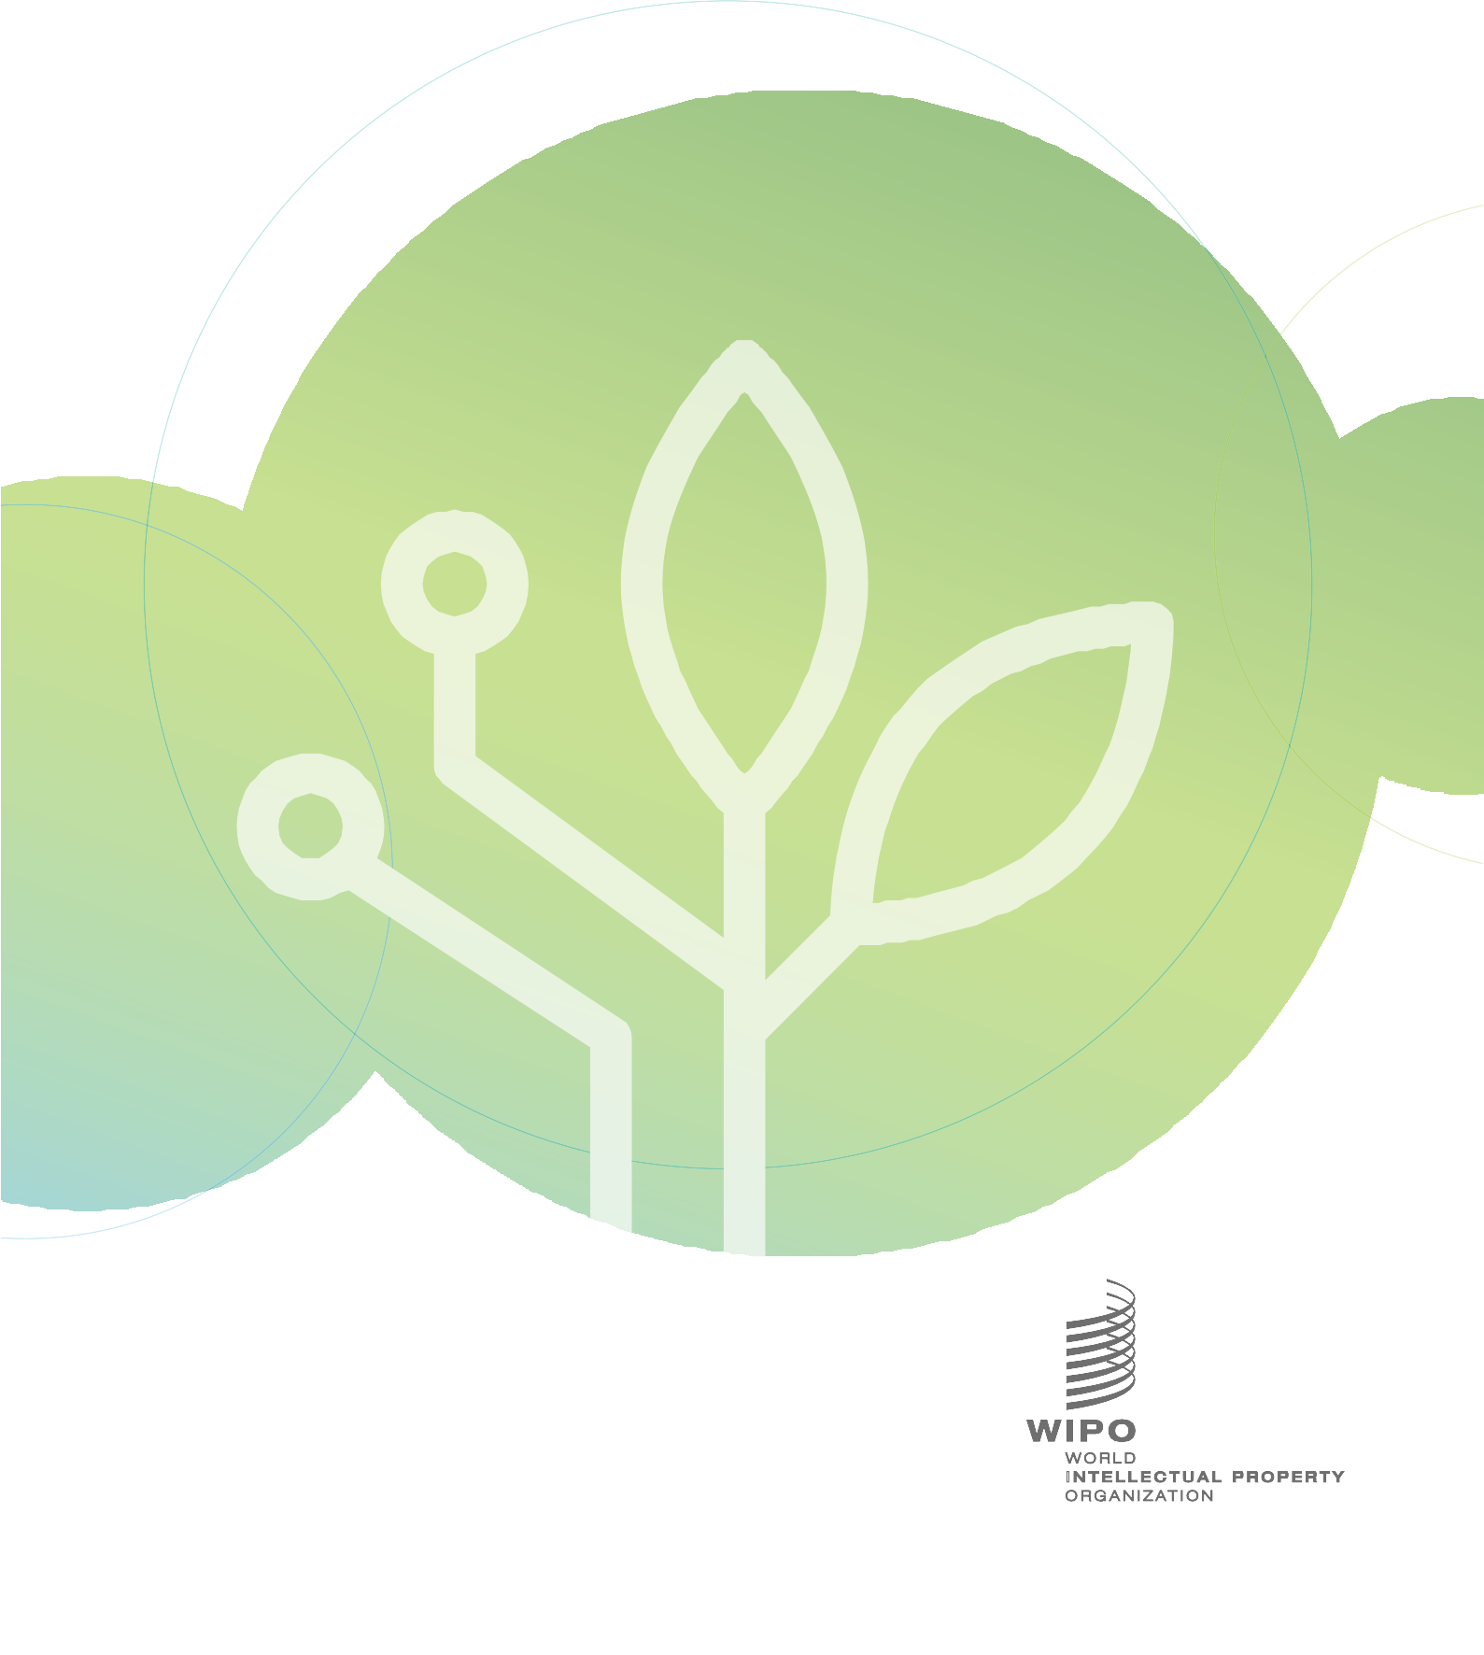

International Conference on Intellectual Property (IP) and Development – **Innovation in Green Technologies for Sustainable Development**

November 22 and 23, 2021

|  |  |
| --- | --- |
| **E** | |
|  | WIPO-E |
| **INTERNATIONAL conference** | |
| code: WIPO/IPDA/GE/21/1 | |
| ORIGINAL:  English | |
| date: OCTOBER 18, 2021 | |
|  | |

**WIPO International Conference on Intellectual Property (IP) and Development – Innovation in Green Technologies for Sustainable Development**

organizedby

the World Intellectual Property Organization (WIPO)

**Geneva, November 22 and 23, 2021**

PROGRAM

*prepared by the International Bureau of WIPO*

Monday, November 22, 2021

12.00 – 12.10 **Welcome Address**

Mr. Daren Tang, Director General, World Intellectual Property Organization (WIPO), Geneva

12.10 – 13.20 **Panel 1 How can Green Innovation Contribute to Achieving Sustainable Development?**

Moderator: H. E., Ms. Tatiana Molcean, Ambassador, Permanent Representative, Permanent Mission of the Republic of Moldova to the United Nations Office and other international organizations in Geneva

Speaker: Ms. Joyce Msuya, Deputy Executive Director, United Nations Environment Programme (UNEP), Kenya

Discussants: Mr. Paul Ekins, Professor, Resources and Environmental Policy, Director of the Institute for Sustainable Resources, University College of London (UCL), United Kingdom

Mr. Alejandro Ortega, Co-founder and Chief Executive Officer, Sibö, The Netherlands

Discussion: Questions and Answers (Q&A)

13.20 – 14.30 **Panel 2** **The Role of IP in the Field of Green Technology**

Moderator: H. E., Ms. Tatiana Molcean

Speaker: Mr. Mikael Rüdlinger, Inventor and President of the Board, BNL Clean Energy, Switzerland

Discussants: Ms. Elisabeth Eppinger, Professor, Berlin University of Technology and Economics, Lead, Project on “IP Models to Accelerate Sustainability Transitions”, Germany

Mr. Rafael Carmona Dávila, Chief Technology Officer, GreenMomentum, Mexico

Discussion: Q&A

Tuesday, November 23, 2021

12.00 – 12.10 **Keynote Address**

H.E., Ms. Yasmine Fouad, Minister of Environment, Ministry of Environment of the Arab Republic of Egypt, Cairo

12.10 – 13.20 **Panel 3 Green Innovation in Developing Countries: How to Address the Challenges**

Moderator: H. E., Mr. Salim Baddoura, Ambassador, Permanent Representative, Permanent Mission of the Lebanese Republic to the United Nations Office and other international organizations in Geneva

Speaker: Mr. R. Raghunathan, Chief Executive Officer, World Wide Fund for Nature (WWF) - Singapore Office, Singapore

Discussants: Ms. Rose Mwebaza, Director and Advisory Board Secretary, UNFCC Climate Technology Centre and Network (CTCN), Denmark

Ms. Leena Pishe Thomas, Director, Global Business Inroads

(GBI), India

Discussion: Q&A

13.20 – 14.20 **Concluding Dialogue**

Moderator: H. E., Mr. Salim Baddoura

Speakers: Mr. Alejandro Ortega

Ms. Elisabeth Eppinger

Ms. Leena Pishe Thomas

Discussion: Q&A

14.20 – 14.30 **Closing**

Mr. Hasan Kleib, Deputy Director General, Regional and National Development Sector, WIPO

[End of document]



World Intellectual Property Organization 34, chemin des Colombettes

P.O. Box 18

CH-1211 Geneva 20 Switzerland

© WIPO, 2021

Attribution 4.0 International

(4.0 CC BY)

Tel: + 41 22 338 91 11

Fax: + 41 22 733 54 28

The CC license does not apply to non-WIPO content in this publication.

For contact details of WIPO’s External Offices visit: [www.wipo.int/about-wipo/en/offices](https://www.wipo.int/about-wipo/en/offices)

Cover: Getty Images