E
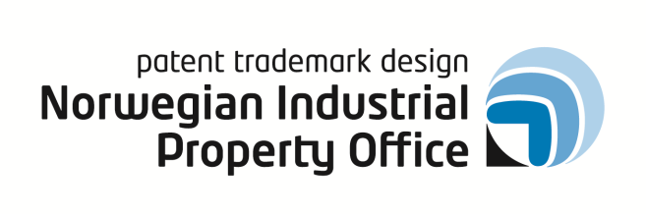
SEMIMAR
Wipo/IP/osl/13/INF1
ORIGINAL: ENGLISH
DATE: October 2, 2013

SEMINAR ON WIPO SERVICES AND INITIATIVES

organized by
the World Intellectual Property Organization (WIPO)

in cooperation with
the Norwegian Industrial Property Office (Patentstyret)

Oslo, Norway, October 16, 2013

program

prepared by the Secretariat

Wednesday, October 16, 2013

10.00 – 10.20 Opening Session, Welcome addresses by:

Mr. Otto Scharff, Director, Market and Information Department, Norwegian Industrial Property Office

Mr. Yo Takagi. Assistant Director General, Global Infrastructure Sector, WIPO, Geneva

10.20 – 10.50 Session I

Topic 1 Introduction to WIPO
Development of the International Legal Framework
Major Intellectual Property Economic Studies

Speaker: Mr. Víctor Vázquez Lopez, Head, Section for Coordination of Developed Countries, Department for Transition and Developed Countries (TDC), WIPO, Geneva

10.50 – 11.30 Topic 2 The Patent Cooperation Treaty (PCT) – Introduction and Future Developments

Speaker: Mr. Claus Matthes, Director, PCT Business Development Division, Innovation and Technology Sector, WIPO Geneva

11.30 – 12.30 Lunch Break

12.30 – 12.45 Special Address by a local innovator on the importance of Intellectual Property for Norwegian creators and performers

Speaker: Mr. Bendik Hofseth, musician and composer

12.45 – 13.20 Session II

Topic 3 Global Intellectual Property systems:
The Madrid System for the International Registration of Marks
The Hague System for the International Registration of Industrial Designs

Speaker: Ms. Debbie Rønning, Director, Legal Division, Madrid Registry, WIPO Brands and Designs Sector (BDS), WIPO, Geneva

13.20 – 13.50 Topic 4 WIPO Arbitration and Mediation: Alternative Dispute Resolution

Speaker: Mr. Víctor Vázquez Lopez, Head, Section for Coordination of Developed Countries, Department for Transition and Developed Countries (TDC), WIPO, Geneva

13.50 – 14.10 Break

14.10 – 14.50 Session III

Topic 5 Global Databases for Intellectual Property
Platforms and Tools for the Connected Knowledge Economy

Speaker: Mr. Yo Takagi, Assistant Director General, Global Infrastructure Sector
WIPO, Geneva

14.50 – 15.20 Topic 6 Relations between the Norwegian Patent and the Industrial Property Office and the World Intellectual Property Organization

Speaker: Mr. Bernt Bolvik, Director, Design and Trademark Department, NIPO

15.20 – 15.35 Questions and Answers, Closing Session

15.35 – 16.20 One-on-One Sessions – Patents, Trademarks and Databases

[End of document]

