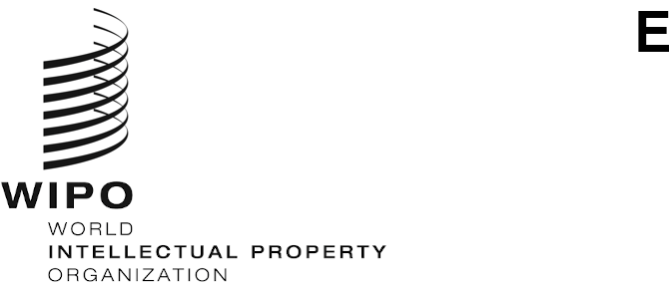
WIPO/IP/CONV/GE/21/INF/2
ORIGINAL: English
DATE: September 13, 2021

WIPO CONVERSATION ON INTELLECTUAL PROPERTY (IP) AND Frontier Technologies

Fourth Session
Geneva, 22 to 23 September 2021, 12.00 to 14.30 CET

Speaker Profiles
prepared by the WIPO Secretariat

Panel 1: Data, beyond AI in a fully interconnected world

Moderator
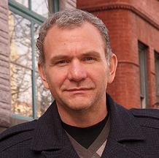
Mr. Dean Jolliffe
Dean Jolliffe is a Lead Economist in the Development Data Group of the World Bank and member of the LSMS-ISA team. He has extensive experience in the design and implementation of household surveys and is currently managing ongoing LSMS-ISA work in Ethiopia. He has also worked in the South Asia region at the Bank on poverty assessments for Afghanistan, Bangladesh and Nepal.
Previously, he was a Research Economist at the Economic Research Service of USDA, an Adjunct Professor at the Johns Hopkins University School of Advanced International Studies, an Assistant Professor at the Center for Economic Research and Graduate Education in Prague, and a Post-doctoral Fellow at the International Food Policy Research Institute. Dean holds appointments as a Research Fellow with the Institute for the Study of Labor in Bonn, and as a Research Affiliate with the National Poverty Center at the University of Michigan. He received his Ph.D. in economics from Princeton University.

Panelists
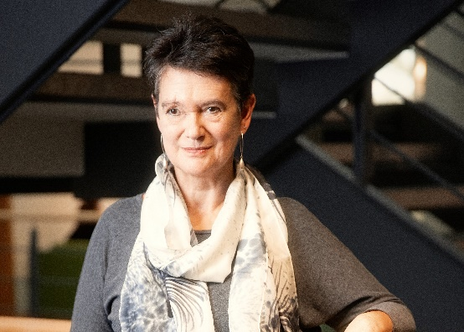
Ms. Diane Coyle
Professor Diane Coyle is the Bennett Professor of Public Policy at the University of Cambridge. Diane co-directs the Bennett Institute where she heads research under the themes of progress and productivity. Her new book ‘Cogs and Monsters’ looks at how economics needs to change, while her previous book, ‘Markets, State and People – Economics for Public Policy’ examines how societies reach decisions about the use and allocation of economic resources.
Diane is also a Director of the Productivity Institute, a Fellow of the Office for National Statistics, an expert adviser to the National Infrastructure Commission, and Senior Independent Member of the ESRC Council. She has served in public service roles including as Vice Chair of the BBC Trust, member of the Competition Commission, of the Migration Advisory Committee and of the Natural Capital Committee. Diane was Professor of Economics at the University of Manchester until March 2018 and was awarded a CBE for her contribution to the public understanding of economics in the 2018 New Year Honours.
Diane’s research interests include economic statistics and the digital economy, competition policy and digital markets, economics of new technologies, natural capital, and infrastructure.
Ms. Aruba Khalid
Aruba Khalid is an economic researcher and analyst at the Dubai Future Foundation in the UAE and has worked for over 10 years in private and public sector entities in the UAE.
Aruba’s primary research interests include the growth and competitiveness of science, technology and innovation hubs in emerging economies. At the Dubai Future Foundation, Aruba has led research on the data economy as a critical sector for the future GDP and its key role in enabling technologies driving Industry 4.0.

Panel 2: The Regulatory Matrix of Data

Moderator
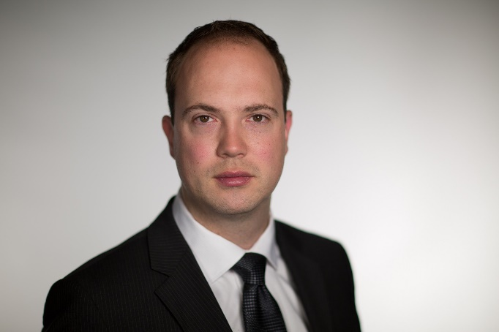
Mr. Aaron Shull
As CIGI’s managing director and general counsel, Aaron Shull acts as a strategic liaison between CIGI’s research initiatives and other departments while managing CIGI’s legal affairs and advising senior management on a range of legal, operational and policy matters.
Aaron is an expert on cyber security issues. He coordinated the CIGI essay series Governing Cyberspace during a Crisis in Trust. In his introduction, he argues that more robust international norms for cyber security are a national imperative for Canada.
Prior to joining CIGI, Aaron practised law for a number of organizations, focusing on international, regulatory and environmental law. He has taught courses at the University of Ottawa, Faculty of Law, and the Norman Paterson School of International Affairs and was previously a staff editor for the Columbia Journal of Transnational Law.
Aaron graduated from the University of Waterloo, placing first in his class as a departmental scholar, with a B.A. (honours) in history and political science. His keen interest in international affairs and political history led him to pursue an M.A. in international affairs at Carleton University’s Norman Paterson School of International Affairs, where he graduated with distinction. He concurrently pursued his LL.B. from the University of Ottawa, where he graduated cum laude with first class honours. Aaron received his LL.M. from Columbia Law School, where he graduated as a Harlan Fiske Stone scholar.

Panelists
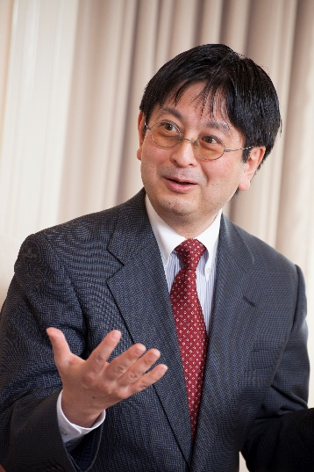
Mr. Jiro Kokuryo
Professor Jiro Kokuryo is a Professor at the Faculty of Policy Management of Keio University, where he served as Dean from 2009 to 2013. He also served as a Vice President from 2013 to 2021 and played a key role in the execution of the digital transformation of the university. Professor Kokuryo's research and teaching interests are focused on developing business and social models that maximize the benefits of information technologies to society.
Professor Kokuryo graduated from the University of Tokyo in 1982. While an employee of Nippon Telegraph and Telephone Corporation between 1982 and 1993, he obtained a Master of Business Administration (MBA) in 1988 and Doctor of Business Administration (DBA) in 1992, both from Harvard Business School.

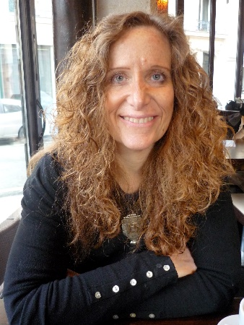
Ms. Dafna Feinholz
Dafna Feinholz has a PhD in Research Psychology (UIA Mexico) and a Master in Bioethics (Universidad Complutense, Madrid, Spain). She was the Head of the Reproductive Epidemiology Department at the Mexican National Institute of Perinatology, and the Director for Research and Planning of the Women and Health Programme, at the Ministry of Health (Mexico). She successively occupied the posts of Academic Coordinator of the National Commission of Human Genome at the Ministry of Health and Executive Director of the National Commission of Bioethics.
Among her achievements, she ensured a more independent legal status for the National Bioethics Committees (NBC); contributed to define their mission as promoters of a bioethics culture; encouraged them to provide society and decision makers with the necessary elements to understand and tackle ethical issues. She drafted the first national guidelines for Research Ethics Committees and Clinical Bioethics Committees; and promoted the law that established and differentiated both types of committees (law approved and currently in vigour).
She was Mexico’s representative at the Intergovernmental Committee of Experts in charge of drafting and negotiating the UNESCO’s Universal Declaration on Bioethics and Human Rights.
Since September 2009, Dafna Feinholz is the Chief of the Bioethics and Ethics of Science Section, within UNESCO’s Social and Human Science Sector.
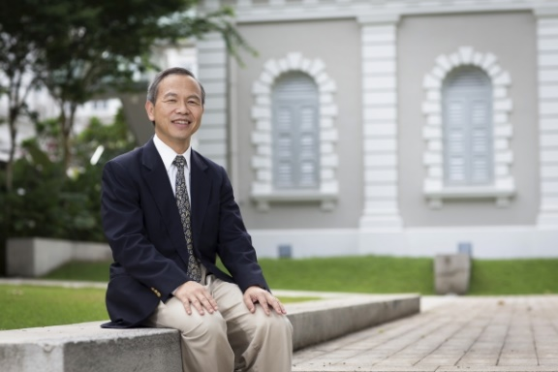
Mr. Kung-Chung Liu
Dr. Kung-Chung Liu is currently Professor of Law (Practice), Lead, Intellectual Property Initiative, Center for AI and Digital Governance, School of Law, Singapore Management University/Renmin University of China/Visiting Professor, National Law University Delhi, India and Adjunct Chair Professor, Shandong University, China.
His research interests focus on intellectual property law, its intersection with antitrust and unfair competition law, with a geographic focus on Asia and Greater China. Prof Liu has edited and co-edited 15 books, two latest of which are Jyh-An Lee/Reto Hilty/Kung-Chung Liu/ (eds.), Artificial Intelligence & Intellectual Property, Oxford University Press (2021) and Kung-Chung Liu/Reto Hilty (eds.), Trade Secret Protection—Asia at a Crossroads, Kluwer (2021). Prof. Liu got his LLB and LLM from National Taiwan University and his LLD from University of Munich, Germany.
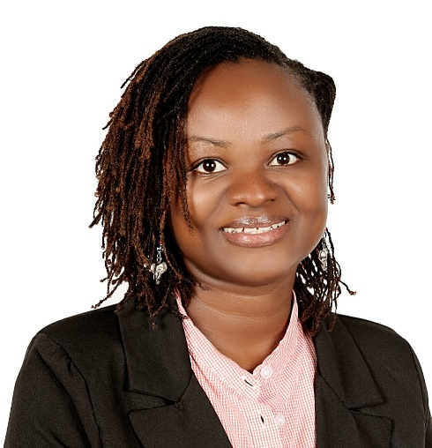
Ms. Caroline Wanjiru Muchiri
Caroline is an intellectual property expert currently working as a Research Fellow at Centre for Intellectual Property and Information Technology (CIPIT)-Strathmore University in charge of IP and innovation research;
She is also the Manager CIPIT IP Legal Aid Clinic; Member, Intellectual Property & Commercialisation Board Committee, Young Scientists Kenya (YSK); and Judge, Trainer, Coach and Mentor for entrepreneurs at @iBizAfrica, Kenya. Caroline’s research interests in Law include Innovation and Intellectual Property; Agriculture and the Law; African Feminism; Gender, Women and the Law.
Caroline is a Mentor. Mentee. A Rotarian. Amateur Farmer.

Panel 3: Data and business models – a business view

Moderator
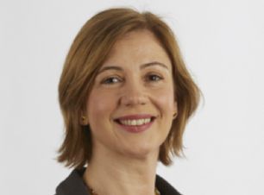
Ms. Clara Neppel
Dr. Clara Neppel is the Senior Director of the IEEE European office in Vienna, where she is responsible for the growth of IEEE’s operations and presence in Europe, focusing on the needs of industry, academia, and government. Clara serves as a point of contact for initiatives with regard to technology, engineering and related public policy issues that help implementing IEEE’s continued global commitment to fostering technological innovation for the benefit of humanity.
Clara joined IEEE after many years with the European Patent Office where she was involved in various aspects relating to innovation, intellectual property and public policy in the field of information and communication technologies. She co-authored publications both in the field of patentability of computer implemented inventions as well as possible future scenarios of the patent system. Before joining the Office she worked in research, in the area of parallel database optimization, and in industry, as program manager for archiving solutions.
She holds a Ph.D. in Computer Science from the Technical University of Munich and a Master in Intellectual Property Law and Management from the University of Strasbourg.

Panelists
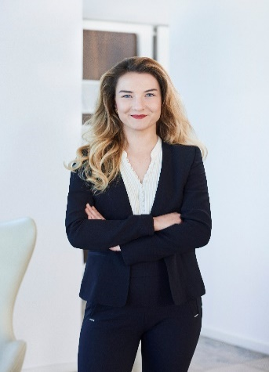
Ms. Lucie Arntz
Lucie Arntz is a fully qualified lawyer with extensive experience around IP and data protection in enterprises.
She worked at international law firms Noerr and Freshfields as well as Rocket Internet, HelloFresh and helped other innovative organizations to ensure the privacy, security, fairness and transparency of their AI and analytics.
At Apheris, she is responsible for legal and operations and helps Apheris’ customers to tap the full potential of the product in line with the latest legal developments.

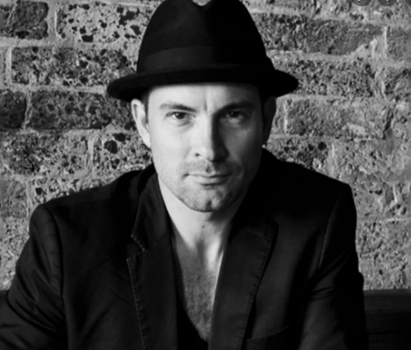
Mr. Charlton Hill
Charlton Hill has over 20 years’ experience in the music and media industries in an array of roles ranging from major recording artist, studio manager, music and post-production audio supervisor, copyright consultant and actor. In 2010, Hill partnered with international music producer/composer Justin Shave to co-found Uncanny Valley – a high end, music branding company that has quickly risen to prominence in both Australia and Asia.
With a foot firmly planted in both art and commerce, Charlton is now Head of Music and Innovation at Uncanny Valley. Turning their focus to tech, Uncanny Valley are harnessing the power of AI to provide innovative solutions for the music industry and artists.
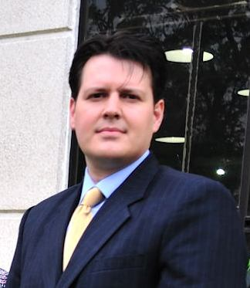
Mr. Javier Fernández
Javier Fernández serves as Legal Counsel and Director of Regulatory Affairs for CropLife Latin America. Stationed in Costa Rica, he has responsibility for 18 Latin American countries.
Before working in Latin America, Javier Fernández was responsible for global intellectual property and international trade matters for CropLife International, based in Washington, D.C. and Brussels. During his time with CropLife International, Javier Fernández represented the crop science industry before the World Intellectual Property Organization, Working Groups related to the Biodiversity Convention, World Trade Organization matters, and actively participated during negotiations of free trade agreements between different trading blocs. He often speaks in fora related to international trade, pesticide regulation and intellectual property. He holds a Master's degree in Intellectual Property from George Washington University, as well as a J.D. equivalent and B.A. in and political science from the University of Costa Rica.
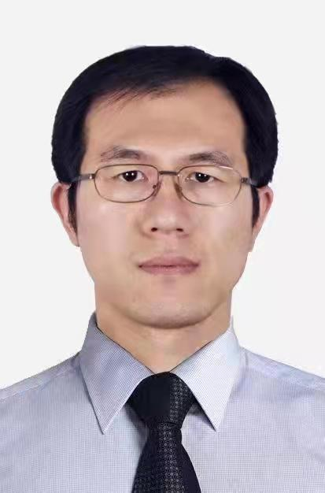
Mr. Shuo Wang
Mr. Wang is the Vice President of Bryea Co., ltd, a leading industrial internet and big data solution provider in China. With the accomplishments of managing big data and edge computing technologies projects in the Bryea, Mr. Wang has various and extensive professional experience. For instance, he served in Tencent Group as senior public relations manager in 2018, and before that, he served as the Editor-in-chief for a news application program and a deputy chief editor at the China News Service for almost a decade.
Mr. Wang has also achieved a media EMBA in Tsinghua University in 2016, and a master degree at the School of Journalism of Renmin University of China in 2014.

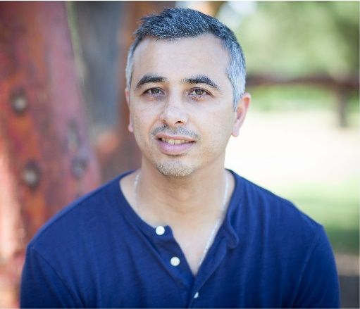
Mr. Saar Safra
Saar Safra, CEO & Co-Founder of Beewise, is a seasoned entrepreneur. He started his career as a software developer; in 2001 he became CTO of Ad4Ever which was acquired by aQuantive where he served as GM & VP of Rich Media. In 2007 aQuantive was acquired by Microsoft, where Saar served as Director of Rich Media solutions until 2008, when he left and founded ActiveBuilding; the company was then acquired by RealPage in 2013.
Saar has had three successful exits from the five companies he founded prior to Beewise. Saar received his MBA from the Foster School of Business at the University of Washington.

Panel 4: Data in the current IP system

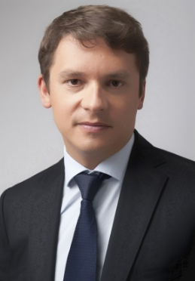
Moderator
Mr. Igor Drozdov
Mr. Igor Drozdov was born in St. Petersburg in 1977. In 1999 graduated cum laude from the law faculty of St. Petersburg State University. Has PhD in law. Between 2004 and 2005 he worked as an advisor to the Minister of Economic Development and Trade of the Russian Federation.
From 2005 headed the secretariat of the Chairman of the Supreme Arbitration Court of the Russian Federation. 2006-2010 - chief of staff/administrator of the Supreme Arbitration Court of the Russian Federation. In December 2010 he was appointed director of legal issues of the Skolkovo Foundation, and in November 2011, he was in addition appointed a vice president of the foundation. In September 2012, he became senior vice president for legal and administrative issues.
Chairman of the Board of the Skolkovo Foundation since June 14, 2016.

Panelists
Mr. Bret Hrivnak
Since 2013 Bret Hrivnak is a partner at Hahn Loeser & Parks LLP. As a patent and trademark attorney, Bret A. Hrivnak counsels clients on the protection of U.S. and international intellectual property, including patents, trademarks, copyrights, trade secrets and domain names. Bret manages worldwide IP portfolios and develops global strategies for IP protection.
Bret’s IP experience includes prosecuting and defending disputes arising under state, federal and international laws, including proceedings before the Board of Patent Appeals and Interferences, the Trademark Trial and Appeal Board and the World Intellectual Property Organization.

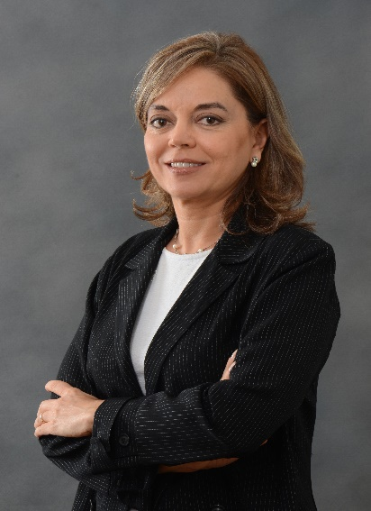
Ms. Elisabeth Kasznar Fekete
Mrs. Kasznar is a co-founding partner of the Kasznar Leonardos IP firm, Brazil (as attorney for over 40 years). She is Adjunct Professor at the São Paulo Bar’s Faculty of Specialists, where she serves as academic coordinator of IP Law (since 2010).
She served as President of the Brazilian Intellectual Property Association (2014-2015) and as member of INTA’s Board of Directors (2017-2020).
Mrs Kasznar was a Guest Research Fellow at the Max Planck Institute, Munich (1984) and obtained a Doctorate in Commercial Law (in 1999) from the University of São Paulo. [Known in Brazil as “the woman of the secret”], her litigation and arbitration, as well as publishing and teaching activities took a particular focus on trade secrets and unfair competition, since she published a treatise on trade secret law in Brazil (in 2003).
She speaks seven languages.
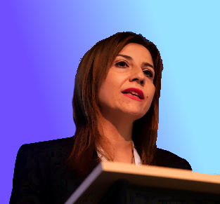
Ms. Tatiana Eleni Synodinou
Tatiana Eleni Synodinou is a Professor of Private and Commercial law at the Law Department of the University of Cyprus. Prior to her appointment at the University of Cyprus, Tatiana Synodinou worked as scientific collaborator with teaching duties at the Faculty of Law of Aristotle University of Thessaloniki (2001-2004) and as a full time Visiting lecturer of the Interdisciplinary postgraduate program of “Informatics and Management” of the Aristotle University of Thessaloniki. She also worked as a full-time Visiting Lecturer at the Department of Mass Media of Aristotle University of Thessaloniki and the Department of Accounting and Finance of the University of Macedonia.
She has also been a National expert for many projects and EU studies. She is a case law reporter for “Kluwer Law International” to the legal database «Kluwer EU IP Cases» and a contributor to Kluwer Copyright Blog. She is member of the Patent and Innovation Committee of the University of Cyprus (since 2012). She is founding member and President of the Union of Copyright Law of Cyprus (EDPI) that is the Cypriot affiliate of International Literary and Artistic Association (ALAI). She is member of the European Copyright Society (ECS). She is the author of numerous books, journal articles and chapters in edited books in copyright law, Internet law, media law, property law. She is the Founder and Chair of the Cypriot branch of ALAI and Member of the European Copyright Society (ECS). She teaches Copyright law, EU Intellectual property law, Company law and Property law.
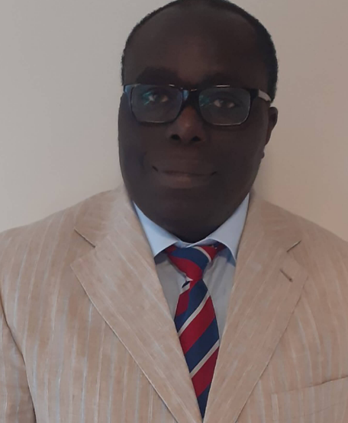
Mr. Taiwo Oriola
Taiwo Oriola is a Senior Lecturer in Law at the University of Derby Law School; Programme Leader for LLM Degree Pathways; and Programme Leader for LLM Intellectual Property and Information Technology Law.
He has previously taught Intellectual Property Law on the LLB and LLM Programmes at the University of Cardiff Law School. Also, he was the Course Director for LLM Commercial Law Programme at Ulster University Law School, and taught Computer & Internet Law; Intellectual Property Law; Internet Law & Policy; Copyright & Information Law; and International Intellectual Property Law.
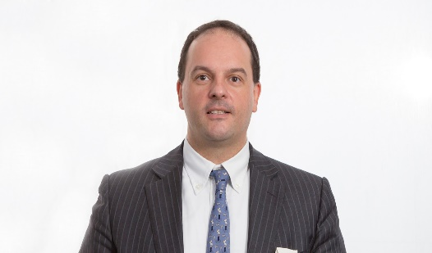
Mr. Oriola’s qualifications: PhD in Law, University of Cardiff, Postgraduate Certificate in University Teaching and Learning, University of Cardiff, Fellow, UK Higher Education Academy.
Mr. Carlo Scollo Lavizzari
Carlo Scollo Lavizzari, a lawyer qualified in South Africa, England & Wales, and Switzerland. Carlo specializes in intellectual property protection and by now has more than 21 years of work experience with law firms in Africa, Europe, Switzerland and the United States of America.
He is a strategist and problem solver in negotiations, conflict resolution and policy, participating actively in global advocacy for norm setting and in litigation. Carlo is fluent in four languages: German, English, French and Italian, and has a very basic proficiency in Chinese. Born 1970 in Zurich. Studied law at University of Basel, Switzerland, and Cape Town, South Africa. Licentiate 1993 (University of Basel), Master of Laws, Cape Town, 1996. Admitted to the bar in Basel, Switzerland, in 1997, Partner at Lenz Caemmerer since 2009. Admitted as an attorney of the High Court of South Africa, working with Spoor and Fisher Attorneys, Pretoria, South Africa, specializing in intellectual property law (1998-2000), and then on own account in Johannesburg, between 2004-2007 (currently again on non-practicing roll). Associate Foreign Attorney at Brown Raysman Millstein Felder & Steiner LLP, New York, USA, with Jim Kendrick, Head Entertainment Law Department (2000-2001). Admitted as solicitor of England and Wales since 2013. With Lenz Caemmerer since 2009. Frequent speaker and presenter at conferences, author of numerous publications in the fields of copyright and intellectual property law.
[End of Document]

