WIPO/IP/AI/2/GE/20/INF/3
ORIGINAL: English
DATE: June 30, 2020

WIPO Conversation on Intellectual Property (IP) and Artificial Intelligence (AI)

Second Session
Virtual meeting, July 7 to 9, 2020

Speaker Profiles
prepared by the WIPO Secretariat

Session 1: IP protection for AI-generated and AI-assisted works and inventions and related topics
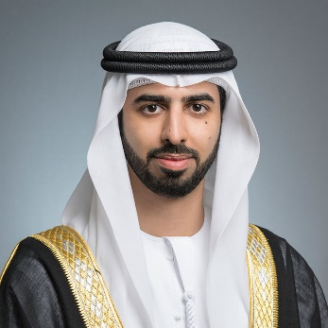
H.E. Mr. Omar Sultan Al Olama
Minister of State for Artificial Intelligence, United Arab Emirates
His Excellency Omar Sultan Al Olama was appointed as Minister of State for Artificial Intelligence following the Cabinet reshuffle in October 2017. His responsibilities include enhancing the government performance by investing in the latest technologies and tools of artificial intelligence and applying them in various sectors.
His Excellency Omar Sultan Al Olama is currently the Managing Director of the World Government Summit. He is also a member of the Board of Trustees of Dubai Future Foundation and Deputy Managing Director of the Foundation. In November 2017, the UAE government announced selecting HE. Omar Al Olama as a member of the Future of Digital Economy and Society Council at the World Economic Forum.
During his work in the Future Department at the Ministry of Cabinet Affairs and the Future, His Excellency participated in developing the UAE Centennial 2071 strategy that aims to position the UAE as the best country in the world. He also participated in developing the UAE 4th Industrial Revolution Strategy that aims to promote the UAE’s status as a global hub for the 4th Industrial Revolution and develop a national economy based on knowledge, innovation and future technologies. Prior to his appointment, His Excellency worked on developing the UAE’s Artificial Intelligence Strategy, making it the first such strategy of its kind globally.
His Excellency Omar Sultan Al Olama worked in several sectors including the banking sector, telecommunications, private enterprises and government. H.E. also worked on developing and executing strategies, risk analysis, change management and scenario planning.
His Excellency Omar Sultan Al Olama holds a Diploma in Project Management and Excellence from the American University of Sharjah and a Bachelor of Business Administration from the American University of Dubai.

Professor Ahmed Elgammal
Department of Computer Science, Rutgers University, United States of America
Dr. Ahmed Elgammal is a professor at the Department of Computer Science, Rutgers, the State University of New Jersey. Dr Elgammal is a member of the Center for Computational Biomedicine Imaging and Modeling (CBIM) at Rutgers and an Executive Council Faculty at Rutgers University Center for Cognitive Science (RUCCS). Dr. Elgammal is the director of the Art and Artificial Intelligence at Rutgers and the Human Motion Analysis Lab (HuMAn Lab). His primary research interest is computer vision and machine learning. His research focus includes human activity recognition, human motion analysis, tracking, human identification, and statistical methods for computer vision. Dr Elgammal recent research activities also include data science in the domain of digital humanities. He received the National Science Foundation CAREER Award in 2006. Dr. Elgammal received his B.Sc. and M.Sc. degrees in computer science and automatic control from University of Alexandria, Egypt, in 1993 and 1996, respectively. He received another M.Sc. and his Ph.D. degree in computer science from the University of Maryland, College Park, in 2000 and 2002, respectively.

Session 2: AI inventions: Patentability, disclosure and guidelines
Judge Klaus Grabinski
Federal Court of Justice, Germany
Judge Grabinski has served as a judge of the German Federal Court of Justice (Bundesgerichtshof) since 2009. He is a member of the 10th Civil Division (X. Zivilsenat), which has, inter alia, jurisdiction on patent dispute matters. Prior to this appointment, he was Presiding Judge at the District Court in Duesseldorf from 2001 to 2009, where he chaired a Civil Division that dealt mainly with patent disputes. Judge Grabinski served as a judge at the Court of Appeal in Duesseldorf from 2000 to 2001 and as a legal researcher at the Federal Court of Justice in Bundesgerichtshof from 1997 to 2000. From 1992 to 1997, he was a judge at the District Court in Duesseldorf.
Judge Grabinski studied law at the Universities of Trier, Geneva and Cologne and was university assistant at the University of Trier. He is coauthor of a commentary on the European Patent Convention (Benkard, Europäisches Patentübereinkommen) and a commentary on the German Patent Law (Benkard, Patentgesetz, 10th ed.). He is author of a multitude of articles concerning patent law, civil procedure and international private law and is a frequent speaker at national and international conferences on intellectual property law.

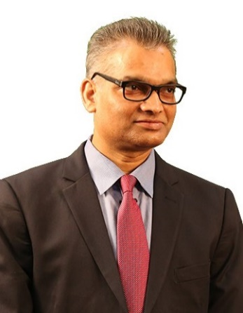
Dr. Santosh Mohanty
Vice President, Tata Consultancy Services, India
Dr. Santosh Kumar Mohanty is a Vice President at Tata Consultancy Services Ltd. He has PhD in Mathematical Sciences and MS in Computational Mathematics from Northern Illinois University, IL, USA. The Open Group has certified him with the title of Distinguished IT Architect (Profession Leader). He is in the IAM (Intellectual Asset Management) Strategy 300 List (2015-2020) as world’s leading IP strategist. He has received the LESI President’s 2018 Service Recognition Award and GIPC 2019 Award of Excellence in recognition of his services in the field of innovation and IP.
His prime contribution is in terms of strategizing and building intellectual property (IP) leading to solution, service and business model that strengthens organizational performance. His research interest includes AI and Digital Adoption Strategy, IP Portfolio Management, Enterprise Architecture, Analytical Modeling, and Data Management. Prior to TCS, he was in academics and research for 10 years. He has five granted patents and has published many articles in international journals. He regularly speaks in national and international conferences.
Santosh is associated with many professional institutions that includes senior member of IEEE, senior member of CSI, and member of LES India. Currently, he is a member of Industry Strategy team and Global Technology Governance team at World Economic Forum (WEF). He has served as chairperson for LESI IT & SW committee and member of IEEE CS Industry Advisory Board, Open CA Certification Board, CII-National committee on IP and CSI academic committee. He is fond of light workout, brisk walking and regular running.

Session 3: Data: Copyright in Training Data, Further Rights in Data and Trade Secrets
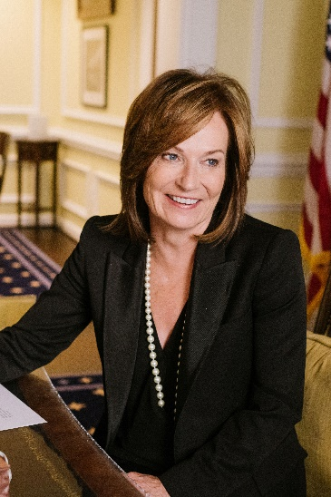
Judge Kathleen O’Malley
Circuit Judge, United States Court of Appeals for the Federal Circuit, United States of America
Judge O’Malley was appointed to the U.S. Court of Appeals for the Federal Circuit by President Obama in 2010. Prior to her elevation to the Federal Circuit, Judge O’Malley was appointed to the U.S. District Court for the Northern District of Ohio by President Clinton in 1994. Prior to her appointment to the bench, Judge O’Malley served as First Assistant Attorney General, Chief of Staff, and Chief Counsel to the Attorney General for the State of Ohio. Judge O’Malley was also in private practice with Jones Day and Porter, Wright, Morris & Arthur. Judge O’Malley began her legal career as a law clerk to the Hon. Nathaniel R. Jones, U.S. Court of Appeals for the Sixth Circuit.
She received her J.D. from Case Western Reserve University School of Law in 1982, summa cum laude and Order of the Coif, she received her A.B. from Kenyon College in 1979, magna cum laude and Phi Beta Kappa, and she also received an honorary LL.D. from Kenyon in 1995. Judge O’Malley has been an active speaker and educator, having delivered over 50 speeches and lectures, taught a number of law school courses, published articles, and been active in Inns of Court and bar functions. For her contributions to intellectual property law during her 25 years on the bench, Judge O’Malley has been awarded the Sedona Conference Lifetime Achievement Award, the New Jersey Intellectual Property Law Association Jefferson Medal, the New York Intellectual Property Law Association Outstanding Public Service Award, and named to Globe Business Media Group’s IP Hall of Fame.

