E
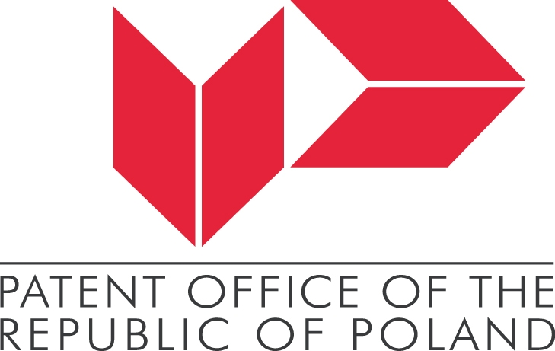 |   WARSAW STOCK EXCHANGE

INTERNATIONAL CONFERENCE
WIPO/INN/WAW/11/INF/1 Prov.
OriGINAL: English
DATE: January 2011
Innovation and Creativity of Women
for Economic Development – Design in Innovative Economy
Organized by
the World Intellectual Property Organization (WIPO)
in cooperation with
the Patent Office of the Republic of Poland (PPO)
the Warsaw Stock Exchange
and
the Office of Harmonization for the Internal Market (OHIM)

Warsaw, March 17 and 18, 2011
PROVISIONAL PROGRAM
prepared by the International Bureau
Thursday, March 17, 2011

09:00 – 9:30 Registration

09:30 – 10:00 Opening Ceremony

• Alicja Adamczak, President, Polish Patent Office, Warsaw, Poland

• Lidia Adamska, Member of the Management Board, Warsaw Stock Exchange, Warsaw

- Binying Wang, Deputy Director General, World Intellectual Property Organization (WIPO), Geneva, Switzerland

10:00 – 10:30 Welcome address by:

• Waldemar Pawlak, Vice Prime Minister, Minister for Economy, Ministry of Economy, Warsaw, Poland
• Christian Archambeau, Vice-President, Office of Harmonization for the Internal Market, Alicante, Spain

10.30 – 11.00 WIPO Award for Innovative Enterprises Ceremony

11:00 – 11:30 Coffee break

11:30 – 13:00 Topic 1: The Importance of Design in an Innovative Economy

Moderator: Ewa Okoń-Horodyńska, Professor, Jagiellonian University (UJ), Cracow, Poland

Speakers:

• Mi-Young Han, President, World Women Inventors and Entrepreneurs Association, Seoul, Korea

• Susanne Äs Sivborg, President, Swedish Patent Office, Stockholm, Sweden

• Li Yuguang, Vice Commissioner, State Intellectual Property Office of the Peoples' Republic of China (SIPO), Beijing, China

• Zuzanna Skalska, Senior Consultant, Trend Research Expert, VanBerlo Design Strategy, Eindhoven, Netherlands

• Paulina Tumiel, University of Bialystok, Bialystok, Poland

• Lena Ekelund, Chalmers Technological University, Volvo Cars, BWAB, Göteborg, Sweden

• Zdzislaw Sobierajski, Managing Director, PERFEKT, Nowy Sękocin, Poland

• Paulina Kordos, Designer, PERFEKT , Nowy Sękocin, Poland

13:00 – 14:00 Lunch break
14:00 – 15:30 Topic 2: National, Regional and International Strategies of Using Design

Moderator: Ewa Gołębiowska, Director, Silesian Castle of Art and Enterprise, Cieszyn, Poland

Speakers:

• Patrycja Zielińska, Deputy Chief to the Executive Officer, Polish Agency for Entreprise Development, Warsaw, Poland

• Beata Bochińska, President, Institute of Industrial Design, Warsaw, Poland
• Wojciech Lubawski, President of Kielce, Poland

• Ludmila Celisova, Head, Industrial Design Section, Industrial Property Office, Prague, Czech Republic

• Sandrine Pitaccolo Bartolomei, Senior IP Counsel, Head, Rights Acquisition Department, Richemont International SA, Geneva, Switzerland

15:30 – 16:00 Coffee break

16:00 – 17:45 Topic 3: From Design to Business Success

Moderator: Józef Mrozek, Academy of Fine Arts, Warsaw, Poland

Speakers:

• Ewa Mańkiewicz-Cudny, President, Polish Federation of Engineering Associations (NOT), Warsaw, Poland

• Katarzyna Laskowska, University of Arts in Poznań, Poland

• David Korzekwa, President, Association of Applied Graphic Designers, Warsaw, Poland

• Marek Jankowski, Expert, Wronki, Poland

• Andrzej Tomasz Rudkiewicz, designer, Finnish Association of Designers ORNAMO, Warsaw, Poland and Turku, Finland

• Jakub Rudkiewicz, President, Design Office, NC.ART Sp., Foundation Pro-Design, Warsaw, Poland

• Bartosz Piotrkowski, PESA Bydgoszcz SA, Bydgoszcz, Poland

• Marcin Buszewski, Manager, Planika Sp. z o.o., Brzoza, Poland

- Andrzej Śmiałek, Ergo Design Sp. z o.o., Cracow, Poland

18:00 WIPO Reception
Friday, March 18 2011

08:30 – 09:00 Reception

09:00 – 10:30 Topic 4: The Importance of Design in Company Activity

Moderator: Lidia Adamska

Speakers:

• Ewa Czekała, 4fun Media, Warsaw, Poland

• Mariola Belina-Prażmowska, Polish Pharmaceutical Group PGF, Łódź, Poland

• Iwona Wtorkowska, LUG SA, Zielona Góra, Poland

- Joanna Szymańska – Bulska, BIOTON S.A., Warsaw, Poland

10:30 – 11:00 Coffee break

11:00 – 12:30 Topic 5: Women Designers and Their role in an Innovative Economy

Moderator: Wiktor Jędrzejec, Director, Department of Art and Culture Education, Ministry of Culture and National Heritage, Warsaw, Poland

Speakers:

• Justyna Lauer, Academy of Fine Arts in Katowice, Katowice, Poland

• Bogumiła Jung, University of Arts in Poznań, Poland

• Alina Adamczak, Deputy Director in Education, Koszalin University of Technology, Koszalin, Poland

• Leszek Mellibruda, Business Psychologist, Warsaw, Poland

• Irmina Aksamitowska - Szadkowska, Radom University of Technology, Radom, Poland

12:30 – 13:45 Lunch break

13:45 – 15:15 Topic 6: How to Promote and Implement Design

Moderator: Weronika Rochacka, Design Council, London, Great Britain

Topic 6 (Continued):

How to Promote and Implement Design

Speakers:

• Katarzyna Rzehak, Director, Design Center, Institute of Industrial Design, Warsaw, Poland

• Anna Pietrzyk-Simone, Head of Communications, Lovegrove Studio, co-founder of Young Creative Poland, London, Great Britain

• Marlena Misiurska-Marczak, Head, Package Development Division, Dr Irena Eris SA, Piaseczno, Poland

• Justyna Smolec, Stylist Manager, “Dobre Wnętrze” Magazine, Warsaw, Poland

15:15 – 15:45 Coffee break

15:45 – 17:15 Topic 7: Legal Protection of Design

Moderator: Alicja Adamczak

Speakers:

• Marie-Paule Rizo, Head, Design and Geographical Indication Law Section, WIPO

• Krystyna Szczepanowska-Kozłowska, Profesor, Warsaw University,
Warsaw, Poland

• Joanna Sieńczyło- Chlabicz, Lecturer, University of Bialystok, Poland

• Edyta Demby-Siwek, Trademark Department, PPO

17.15 – 18.00 Summary and closing ceremony

Speakers:

• Alicja Adamczak

• Lidia Adamska

18.00 – 19.00 Cocktail

[End of document]

