 | E
 | 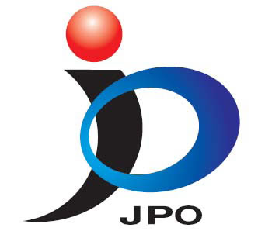 | 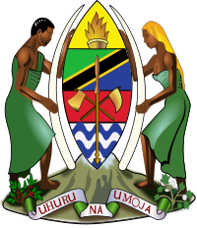 | 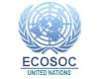 | 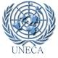 | 
 | japan patent  office | uNITED rEPUBLIC OF TANZANIA | United Nations Economic and Social Council | uNITED nATIONs eCONOMIC cOMMISSION FOR aFRICA
 | meeting
 | WIPO/IP/DAR/13/inf 1/Prov.
 | ORIGINAL :ENGLISH
 | DATE: March 8, 2013

2013 Annual Ministerial Review

Regional Preparatory Meeting for Africa

on

“Innovation as Enabler for the Achievement of the Millennium Development Goals and Sustainable Development”

PROGRAMME

Hyatt Regency Dar es Salaam, The Kilimanjaro

United Republic of Tanzania

March 14, 2013

organized by

the World Intellectual Property Organization (WIPO) and the

United Nations Department for Economic and Social Affairs (UN-DESA)

in cooperation with

the Japan Patent Office

and

the Government of the United Republic of Tanzania

Thursday, March 14, 2013

09.00 – 09.30 Welcoming Remarks

Mr. Francis Gurry, Director General, World Intellectual Property Organization (WIPO), Geneva, Switzerland

Representative of the Government of Japan (to be nominated by the Govt.)

Representative of the Government of the United Republic of Tanzania (to be nominated by the Govt.)

09.30 – 10.00 Opening Session: Science, Technology and Innovation, and the Potential of Culture, for Promoting Sustainable Development and Achieving the Millennium Development Goals (MDGs)

H.E. Mr. Néstor Osorio, President of the United Nations Economic and Social Council (ECOSOC), Permanent Representative of Colombia to the United Nations, New York

Mr. Wu Hongbo, Under Secretary General for Economic and Social Affairs, United Nations, Secretary-General for the International Conference on Small Island Developing States

10.00 – 10.15 Coffee Break

10.15 – 12.30 Roundtable Discussion 1 – Innovation as Enabler for the Achievement of the Millennium Development Goals and Sustainable Development

This discussion will focus on national and regional frameworks for innovation and how these can become enablers for the achievement of the MDGs, the post-2015 development agenda and sustainable development

Moderator: Prof. Mr. Makame Mbarawa, Minister for Communication, Science and Technology, Dar es Salaam, United Republic of Tanzania

Panelists: Mrs. Margaret Kamar, Minister for Higher Education, Science and Technology, Nairobi, Kenya

Prof. Barthelemy Nyasse, Laboratory of Medicinal Chemistry, Faculty of Science, University of Yaoundé, Yaoundé, Cameroon

Ms. Padma Gehl Sampath, Chief of the Science and Technology Section, Division on Technology and Logistics Division, UNCTAD

Jon Gosier, Founder, Appfrica

12.30 – 14.00 Lunch Break

/...

14.00 – 15.30 Roundtable Discussion 2 – Local Knowledge, Innovation and Sustainable Development: Country Case Studies

This discussion will focus on how both tacit and codified knowledge can be used as engines of growth and sustainable development, highlighted by country case-studies presentations. These could include presentations by African countries, development partners, United Nations system organizations, private sector representatives, etc.

Moderator: Mr. McLean Sibanda, CEO, The Innovation Hub, Pretoria, South Africa

Panelists: Mr. Ita-Okon Bassey Ewa, Minister for Science and Technology, Abuja, Nigeria

Hon. Minister Prof. Nadia Zakhary, Minister of Scientific Research, Cairo, Egypt (to be confirmed)

Prof. Mr. Drissa Diallo, National Institute of Public Research Department of Traditional Medicine, Bamako, Mali

Dr. George Owusu Essegby, Director, Science and Technology Policy Research Institute, Council for Scientific and Industrial Research (CSIR), Accra, Ghana

First Discussant: Mr. Alberic Kacou, UNDP Resident Coordinator

15.30 – 16.00 Coffee Break

16.00 – 17.00 Roundtable Discussion 3 – Key Policy Messages for the 2013 ECOSOC Annual Ministerial Review

This session will aim to convey key messages on the next steps required for an improved regional approach to fostering innovation in Africa, with the involvement of Governments, regional and multilateral institutions, as well as the private sector and civil society

Moderator: Mr. Wu Hongbo, Under Secretary General for Economic and Social Affairs, United Nations, Secretary-General for the International Conference on Small Island Developing States

Panelists: Mr. Ita-Okon Bassey Ewa, Minister for Science and Technology, Abuja, Nigeria

Mrs. Margaret Kamar, Minister for Higher Education, Science and Technology, Nairobi, Kenya (to be confirmed)

Bruno Jean Richard ITOUA, Minister, Ministry of Scientific Research and President of AMCOST, Brazzaville, Republic of the Congo (to be confirmed)

/...

17.00 – 17.30 Closing Session

H.E. Mr. Néstor Osorio, President of the United Nations Economic and Social Council (ECOSOC), Permanent Representative of Colombia to the United Nations, New York

Mr. Geoffrey Onyeama, Deputy Director General, Cooperation for Development, World Intellectual Property Organization (WIPO), Geneva, Switzerland

Representative of Government of Japan

Representative of Government of the United Republic of Tanzania

[End of document]

