E
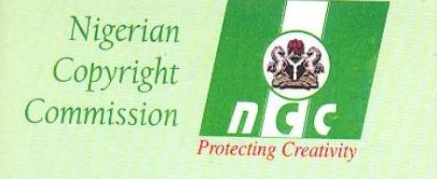
nigeriAN COPYRIGHT COMMISSION (NCC)
Federal Ministry of justice
GOVERNMENT OF NIGERIA

regional seminar
wipo/cr/abu/10/1 Prov
OriGINAL: English
DATE: July 29, 2010
WIPO Regional Seminar for African Countries
on the Protection of Broadcasting Organizations
organized by
the World Intellectual Property Organization (WIPO) and
the Nigerian Copyright Commission (NCC),
Federal Ministry of Justice,
Government of Nigeria
Abuja, October 18 and 19, 2010
Provisional Program
Document prepared by the International Bureau of WIPO

Monday, October 18, 2010

9.00 – 9.30 Opening Ceremony
Welcome addresses by:
Director General, Nigerian Copyright Commission (NCC), Abuja

Assistant Director General, Culture and Creative Industries Sector,
World Intellectual Property Organization (WIPO), Geneva

9.30 – 10.00 Topic 1: Broadcasting for Development
Speaker:

10.00 – 10.30 Topic 2: Digital Sports in Africa
Speaker:

10.30 – 11.00 Topic 3: The Need for an International Instrument for the Protection
of Broadcasting Organizations and the Consequences of Its Lack of Adoption
Speakers:
11.00 – 11.15 Coffee Break

11.15 – 12.00 Topic 4: Broadcast Infringements in Africa: Case Studies
Speaker:

12.00 – 13.00 Roundtable: The Draft WIPO Treaty on the Protection of
Broadcasting Organizations: Protecting the
Public Interest
Moderator:
Speakers:

13.00 Lunch Break

October 18, afternoon Informal discussions on the proposed WIPO
and Draft Treaty and on the Protection of
October 19, 2010 morning Broadcasting Organizations

[End of document]

