WIPO |  | E  PCDA/4/2  ORIGINAL: English  DATE: May 24, 2007
WORLD INTELLECTUAL PROPERTY ORGANIZATION
GENEVA

PROVISIONAL COMMITTEE ON PROPOSALS RELATED
TO A WIPO development agenda
Fourth Session
Geneva, June 11 to 15, 2007
PROPOSAL BY COLOMBIA
Document prepared by the Secretariat
1 In a communication dated May 18, 2007, the International Bureau received a proposal from Colombia for consideration by Member States at the Provisional Committee on Proposals Related to a WIPO Development Agenda, to be held in Geneva from June 11
to 15, 2007.

2 The said proposal is annexed to this document.

3 The PCDA is invited to note the contents of the attached proposal from Colombia.

[Annex follows]
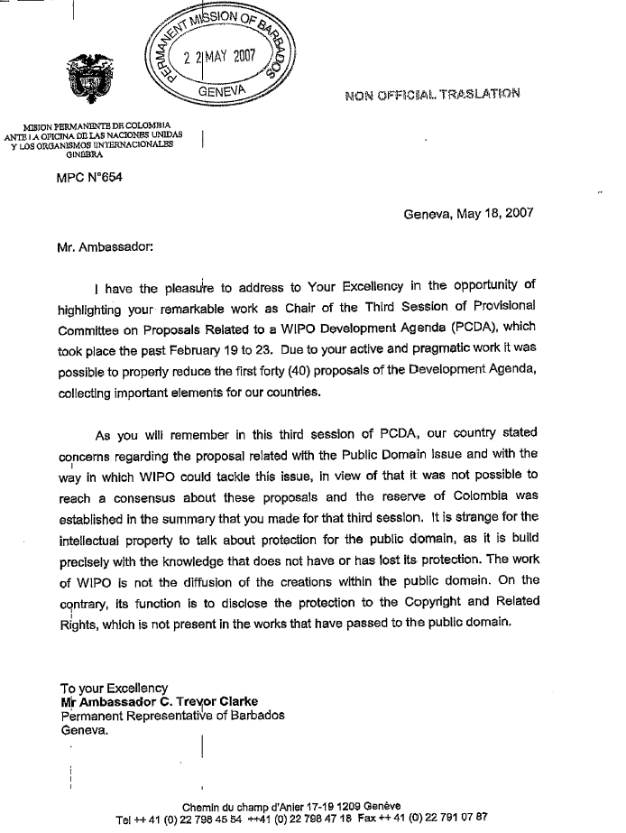

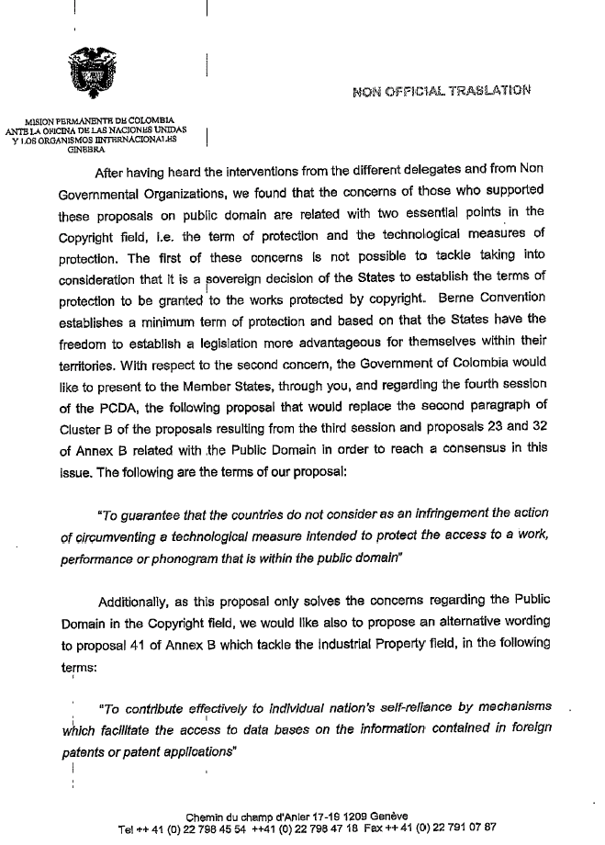

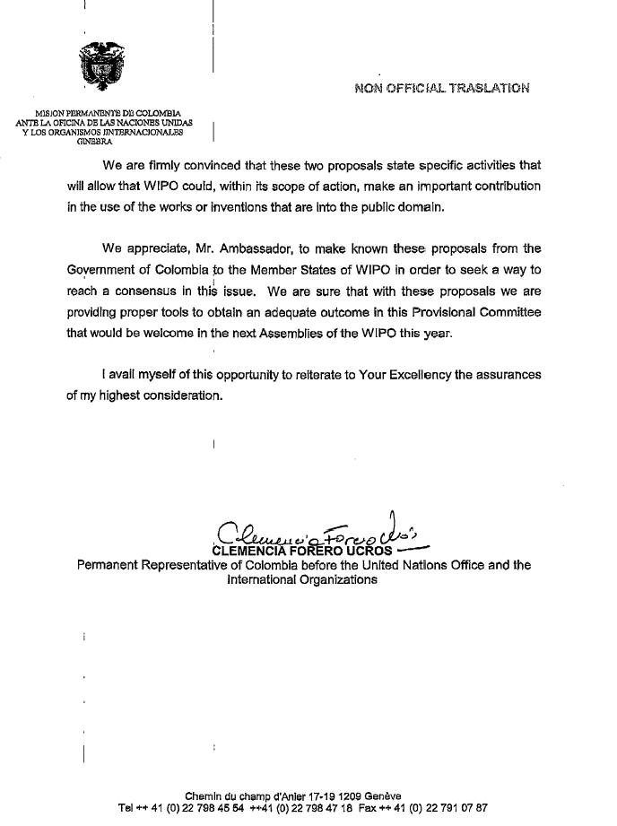

[End of Annex and of document]

