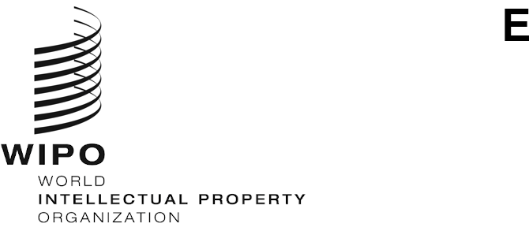
LI/WG/DEV-SYS/4/4
ORIGINAL: English
DATE: April 4, 2023

Working Group on the Development of the Lisbon System

Fourth Session

Geneva, June 14 to 16, 2022

RECORDS OF THE SESSION
Document prepared by the Secretariat
1. In accordance with the decision taken at the Sixty-Second Series of Meetings of the Assemblies of the Member States of the World Intellectual Property Organization (WIPO), as of October 2021, automated speech-to-text transcripts and translations replace the verbatim reports of WIPO meetings, except for those meetings taking place in the framework of the Assemblies, meetings of WIPO Governing Bodies, the Program and Budget Committee (PBC) and of Diplomatic Conferences∗.
2. The videos on demand of the fourth session of the Working Group on the Development of the Lisbon System are available, with automatically generated transcripts, in the six official languages of the United Nations, at the following address: https://webcast.wipo.int/home.
[End of document]

∗ Please see document A/62/13 “General Report”, paragraph 102 (https://www.wipo.int/edocs/mdocs/govbody/en/a_62/a_62_13.pdf).

