
E
CDIP/4/3 REV./STUDY/INF/3
OriGINAL: English
DATE: April 28, 2011

FEASIBILITY STUDY ON THE ESTABLISHMENT OF NATIONAL PATENT REGISTER DATABASES AND LINKAGE TO PATENTSCOPE
Prepared by the Secretariat
Table of Contents

I. Executive Summary 3
(i) Introduction 3
(ii) Analysis of WIPO Survey and of Existing Databases 3
(iii) Conclusions 4

II. Study 6
- Introduction 6
- Types and Categories of Legal Status Elements
and Their Comparability 7
- Sources of Legal Status Information 12
- INPADOC – A Major Secondary Source 15
- Recommendations 22

Annex I Evaluation of WIPO Survey on Availability of Patent Legal Status Data

Annex II Results of WIPO Survey

Annex III List of two-letter country codes

Annex IV Detailed Evaluation of Responses Received from 87 Member States and
Regional Patent Offices
End Notes to Evaluation of Responses

- EXECUTIVE SUMMARY

(i) INTRODUCTION

- The study (hereinafter referred to as “the Study”) focuses on the technical aspects related to patent legal status information. These aspects mostly fall into the three categories of availability, reliability and comparability of such data.

- Patent legal status information comprises all data related to legal events or actions as defined by the respective patent law and regulations of a particular jurisdiction. The authority in charge of executing these actions is also usually in charge of informing the public about relevant legal events, such as the grant of a patent, and thereby serves as the authoritative or primary source of such information.

- Traditionally two major primary sources of legal status data can be distinguished: Patent Gazettes and Patent Registers. Gazettes were and are sometimes still published at regular intervals in paper form, i.e. in individual editions which inform about the latest events changing the legal status of a patent application or a granted patent, e.g. a change in ownership. On the other hand, such status can change from day to day. Registers are, therefore, a kind of facility or service that records such changes and makes available up-to-date and authoritative information in a more frequent manner, ideally on a daily basis.

- Users of patent information however often refer to secondary sources of legal status information which collect such data from primary sources, process the data and make it searchable. The important advantages of these secondary sources reside in the availability of such data in combination with patent family information allowing an effective investigation of the status of several related patent rights filed in different jurisdictions by searching through a unified interface. Disadvantages of such use of secondary sources are mainly the delay in publication and the lack of some data from primary sources.

(ii) ANALYSIS OF WIPO SURVEY AND OF EXISTING DATABASES

- For the purpose of this study, WIPO has conducted a survey on the availability of legal status data from primary sources by sending a questionnaire to Member States and Regional Patent Offices. 87 replies have been received. The detailed evaluation results are available on the website at: http://www.wipo.int/patentscope/en/programs/legal_status/index.html.

- In summary, in jurisdictions where the patent system is already operational for a considerable time (some 40 countries), the access to legal status information is mostly sufficient and, in particular, patent registers are operational, often searchable through the internet, updated daily and the data are shared with secondary databases.

- In many emerging economies and developing countries the situation is less favorable. In several jurisdictions registers are not operational, or operational only in the sense that only (e.g. written) requests for information and legal status data can be submitted to the Office. Registers are frequently not searchable through the internet. The range of searchable data is limited, and data are rarely shared with secondary sources. Roughly one third of the registers provide information against a fee.

- The study has also investigated secondary sources of legal status information with a special focus on the International Patent Documentation Center (INPADOC), which is widely recognized as the leading secondary source of legal status data from which many other providers of patent information obtain or purchase legal status data. INPADOC was initiated in 1972 by WIPO and was later taken over by the European Patent Office (EPO). It currently collects legal status data from 57 jurisdictions. Input data from up to 10 different input channels per country are retrieved and processed for standardizing the data and for complementing them with respective INPADOC family information for each patent application. The number of items and diversity of data reported from each IPO also vary. This laborious processing incurs delays of availability of the data that varies from 2 days to 3 months depending on the primary source. The processed data are up-dated weekly and available for search through various EPO patent information services, e.g. free of charge through Espacenet, or as raw data products to other IPOs or private information providers. The reliability of such data is greatly influenced by the correctness of the raw data obtained from the primary sources, their completeness and their publication frequency.

- Other secondary sources of legal status information are WIPO’s PATENTSCOPE database to the extent that it includes data of legal events of the PCT international phase and the entry into the national phase. The latter information is provided only on a voluntary basis from selected PCT Member States and with varying regularity since there is no obligation to provide such information to WIPO. The data for identifying international applications which have not entered into the national/regional phase are important to identify technologies included in the applications that are considered to have entered into the public domain.

- Other important secondary sources of legal status information for professional use are commercial databases which obtain a lot of their raw data from INPADOC due to the cost savings with respect to collecting and pre-processing such data. However, these providers also derive some data from selected primary sources.

- Because legal status data are in principle related to the different actions and events defined by each jurisdiction there is a large variety of such data: certain events that may occur in one jurisdiction may not have been foreseen in another; and certain events or actions that occur in the lifetime of a patent application may not even be defined explicitly, but are necessary for automated monitoring of internal procedures. The different legal definitions inevitably also limit the comparability of such data. Even rather similar events could be defined slightly differently or depend on different conditions. In view of these limitations, INPADOC, therefore, records each legal event reported from a particular country with a different code, i.e. a particular code describing a particular legal event is applied only for the patent application data of that country. INPADOC data, thus, comprises several thousand different types of legal status data. Standardization or use of unified codes that are applicable to describe events in a global manner is highly desirable, but it would require a careful comparison of the individual definitions and has not yet been undertaken.

(iii) CONCLUSIONS

Based on the evaluation of WIPO survey and inputs received for the preparation of the Study, the Secretariat of WIPO suggests the following conclusions:

- Most jurisdictions/countries that responded to WIPO’s Questionnaire (some 80 countries) keep records of legal status data of patents and many IP offices make databases accessible to the public on the Internet. In this regard, public access to the information necessary for identifying inventions in the public domain appears to be met. However, many issues remain to be resolved to enhance public access to the legal status data.

- The availability of legal status data of some 50 countries/jurisdictions (most of them are developing countries and LDCs) is limited, since many of them do not have the legal status data in digital form and national on-line registers (accordingly secondary sources do not include such data). The diversity of legal events and their changing character over time pose specific challenges to maintaining and disseminating the legal status data.

- The availability of legal status data is better in other countries/jurisdictions (some 40 countries/jurisdictions) which provide the data in on-line patent registers on the Internet. However, there is still much room for improvement in the content and reliability of such data.

- The availability of the data does not necessarily mean that there is an easy access to data for the identification of inventions available in the public domain. Difficulties arise from a need for visiting a number of different on-line databases to perform a global search, a need for understanding different definitions of legal events in different jurisdictions, a need for a fee payment to access legal status data in some countries, and different interfaces and languages of the existing national on-line registries when performing a global search.

- As regards a policy of sharing and disseminating data for the public availability, the majority of countries have already adopted a policy of free of charge access to the legal status data of patents, whereas some others have not.

- The availability of licensing information is limited in most countries.

- The availability of information with regard to entry and/or non-entry of international applications into national/regional phase is still limited in PATENTSCOPE, since efforts to collect such data depend on voluntary participation by IP offices. Non-entry data, if used and analyzed properly, would be useful to indentify inventions in the public domain.

- The reliability of data needs to be improved, e.g. by increasing the frequency of updates and synchronizing their publication, and by implementing standardized mechanisms for error correction notifications that facilitate the updating of secondary sources of legal status data information.

- In view of the fact that the majority of countries have national on-line registers, it is possible and feasible to create a global portal in PATENTSCOPE with links to national patent online registers.

- Effective public knowledge of the existence and status of patent rights is essential for assisting technology transfer, either by encouraging licensing of rights which already exist, or by identifying opportunities to freely use and develop technology which is in the public domain in some or all Member States. With globalization, activities for identifying inventions in the public domain and possible licensing opportunities will continue to grow geographically and seek potential partners worldwide. If Member States see further needs for improving public access to the legal status data information of patents in this context, any WIPO project in response to those needs will require an active participation by a large majority of the Member States, mainly because primary sources must be generated and shared by each Member State.

- The WIPO Secretariat will seek strong support from policy makers in each Member State to enhance public access to the legal status data of patents and will continue to provide technical assistance to countries where resources and capacities are too limited to create on-line patent registers in accordance with WIPO Standards.

- The WIPO Secretariat will also create a prototype of a global portal on the WIPO website which will contain links to URLs of the existing national patent registries and will continue to enhance PATENTSCOPE in terms of its content and functions to facilitate patent information search regarding inventions in the public domain.

II. STUDY

(i) INTRODUCTION

- The present study is requested by the WIPO Development Agenda Project “Intellectual Property and the Public Domain” (DA_16_20_01):

“The Study would analyze the feasibility of WIPO supporting IP Offices that wish to establish a national database containing the legal status of national patents so that the register may enhance public access to the information necessary for identifying inventions in the public domain. The study also includes the possibility of creating a global portal in PATENTSCOPE, which would link to those patent registers.”

- The said DA project comprises two studies related to patents, the present one and another one on “Patents and the Public Domain” focusing primarily on policy and legal aspects of public domain issues. There is some common ground shared by both studies since public domain is defined by certain legal status data, e.g. data determining the validity or lapse of patent protection. The need for such data and their utility is evident and not discussed further here. The present study focuses mainly on technical aspects of such legal status data, i.e. it will attempt to describe their nature, and the types or categories of legal status data, their availability, reliability, and comparability. The study intends to facilitate a better understanding of the specific difficulties and challenges that national and regional IP offices are facing in making such data available through their patent register databases, and the respective challenges in aggregating such data in a central database, i.e. a one-stop-shop for checking the validity of patents.

- These specific challenges arise because legal status of a patent application or a granted patent is determined by events and actions that are associated with dates. The legal status can therefore change from day to day, unlike the technical disclosure of an invention which is fixed with the first filing. Furthermore, the events or actions are defined by the respective jurisdictions which in turn limits the comparability of legal status, e.g. certain jurisdictions may foresee legal remedies for the lapse of a patent that are not foreseen by others.

- The study starts with a first chapter explaining the nature and categories of legal status data, addressing the comparability of legal status data and considering the approach which has been taken by INPADOC, the largest existing provider of global patent legal status information, as a secondary source, hosted by the EPO. Thereafter primary and secondary sources of legal status information are discussed. The findings and analysis of a survey conducted by WIPO (see Annex I; Evaluation of WIPO Survey on Availability of Patent Legal Status Data) are presented with a view to identifying challenges facing Member States in establishing and enhancing their national databases for greater availability of legal status data from patent registers. A subsequent chapter explains in more detail the INPADOC database since information about challenges and solutions adopted by the INPADOC provide useful information for the feasibility of WIPO’s support for a national database containing the legal status of national patents. A summary of selected recommendations completes the study.

Acknowledgement

- The WIPO Secretariat wishes to express special thanks to the EPO and Mr. Peter Paris, former staff member of the EPO, for their valuable inputs with regard to INPADOC. The WIPO Secretariat is responsible for the entire study including recommendations.

(ii) TYPES AND CATEGORIES OF LEGAL STATUS ELEMENTS AND THEIR COMPARABILITY

Definitions of Legal Status

- There is a divergence of opinions as to the definition of legal status of IPR (Intellectual Property Rights) and which elements should be included in that definition especially in the case of patents.

- The narrowest definition is certainly the one that is only interested in whether a patent is valid or not. Historically, this was the initial requirement of those circles interested in freedom to operate, on the one hand, and in competition concerning the domination of certain markets, on the other hand. Interestingly, this requirement has come to the forefront during the last few years with the request to patent offices and patent information providers to introduce traffic light indicators for patents: green light for patents in force, amber light for contended cases and red light for extinct rights. At least, the traffic light concept is seen as a desirable complement to the set of individual legal status event notifications.

- A comprehensive data set of legally relevant details and all legal events in the lifetime of an IPR would be a more wider definition. This would include all intermediary steps and actions during the application, search, examination, granting, opposition/appeal and renewal phases, such as all communications between the applicant and the Office. If applied, legal status information would involve all details of the contents (description, claims) of a patent application which are subject to the argumentation used e.g. during infringement cases or opposition cases. In fact, this concept of legal status is best served by a full collection of all documents and exchange of communications, access to which is given e.g. by the “file or dossier inspection”, offered by some of the intellectual property authorities.

- The INPADOC (see section below on INPADOC) legal status system seeks a pragmatic approach to this issue. Legal status data for a patent is the collectivity of events in the lifetime of a patent, and does not include parts of the patent specification, e.g. the claims, and the contents of the communications exchanged. The minimum set of data elements for one legal event is:

  - The identification of the kind of the event, e.g. through the use of specific codes;
  - At least one calendar date linked to this event, preferably the date of its legal
effect;
  - And in addition, depending on the case, one attribute or set of attributes.

- The INPADOC approach also avoids the duplication of data. Events already included in the bibliographic data collections, even if they are legally relevant as is the case for filing, the priority and the publication details, are excluded from the legal status collection.

Basic Events Versus Status of a Patent (Application)

- A suitable legal status system has to contain both events and status. While basic events, such as fee payments, assignments, the availability of examination reports etc. can easily be determined and reported, the status of a patent or the change in the status of a patent often depends on a variety of conditions defined by the respective regulations of each jurisdiction and the related basic events. Whether a certain status is given, i.e. whether it is true or not, can therefore be described by a logical expression consisting of various variables representing legal events or actions and Boolean operators linking these variables.

- A good example for a complex change in the legal status of a patent application is the entry into the national/regional phase of an international patent application. The target office has to be among the designated ones, the national fees for entry have to be paid, the prescribed time limits have to be met, and if applicable, a translation has to be supplied. Normally, such a status change is reported as a cumulated or aggregated event, the event date being the date when “all requirements for the entry into the national/regional phase have been met”.

- Information on the status of a granted patent or a patent application is certainly the most interesting aspect of each legal status inquiry. In fact, it centers on their validity: for patent applications, whether they are pending or abandoned/refusded/rejected, for patents whether they are in force or lapsed or invalidated or revoked. This is a status and not always the consequence of an event. It is not always possible to easily transform it into an “event” for reporting purposes. Nevertheless, it should be made available to the public by a traffic light system mentioned above.

Access to Data

- Regarding the availability of or access to legal data from the primary sources, i.e. the patent offices, we have to distinguish between at least three categories:

  - Data that is collected and used only internally, e.g. for work flow administration, monitoring of time limits, etc. (“internal data”);
  - Data that is reported/disseminated to interested circles to which a privileged access has been conceded, such as co-operating patent offices and commercial providers, e.g. INPADOC ("reported data");
  - Data that is published via, e.g., the register or gazette ("visible data").

- The first category, being strictly reserved for internal operations is outside the scope of this study. Nevertheless, patent offices should consider whether some items among the “internal data” merit publication or dissemination, for example validity indicators. Currently they are reported to the public only by a minority of patent offices, although information e.g. about abandoned patent applications or “dead” patents are of major interest.

- The second category is the most relevant one to the goals of this study. In general, the scope of the events reported are similar or identical to those of category three. The main difference is the way in which the data is shared. The prevailing concept is mutual data exchange under a data exchange agreement. In some cases the same data package is also made available to the general public through the public website of the office, while the privileged access is secured by specific file transfer protocols, often before the date of the public notification. In most cases the data exchange procedures have been specifically designed for data exchange between offices and commercial providers. Legal status can change from day to day but these data are usually reported or shared much later on and are therefore not necessarily up-to-date.

- The third category is intended for individual online searches, monitoring the status of a patent and browsing through the reports of recent events rather than for bulk data exchange. These sets of visible data give the most up-to-date legal information since they are available through national patent registers which should in theory be updated daily since legal status can change from one day to the next.

- It should also be noted that these sets of visible data and in particular the publication event could constitute a legal event in itself. For example, in some jurisdictions the grant of a patent becomes effective with the publication of the grant, i.e. with the granting event becoming visible to the public.

- It should also be noted that the third category is still an important source for gathering legal status data for secondary sources, given that a dedicated exchange product, as described in the paragraphs above, is not yet available.

The Structuring and Presentation of Legal Status Events

- There are several ways to structure legal status events of an IPR for storage, and at least as many again for dissemination and presentation. The three issues are related but not necessarily dependant on each other. The first one describes how events are stored into records, i.e. how they are mapped into a database; the latter ones describes how they are disseminated to commercial providers and co-operating offices and made visible to the user. However, to maintain a legal status system, it is highly recommended to synchronize the internal structure, the dissemination structure and the presentation.

- Generally, the life span of a patent can be divided into several phases and the associated procedures, although there can be some overlap between them:

  - The filing
  - The search and examination
  - The granting
  - The opposition and appeal (before and / or after grant)
  - The maintenance (before and after grant)
  - The lapse or expiration

- The basic events could be grouped accordingly. As an alternative to creating new records for each single event, it could, in principle, be possible to handle each of these phases as one complex legal status event with many sub-events, and build a structured record, which would allow the adding of details. For practical reasons (there are several events which cannot clearly be allocated to one of the phases, e.g. the maintenance fee payments), this grouping is not applied for the internal database structure, but can frequently be seen in the on-line representations of patent registers.

Dependency of the Categories of Legal Status on the Patent System in Place

- The range of legal status categories and the diversity of events largely depend on the specific intellectual property law and the procedural framework of the issuing intellectual property authority. Only the most important events or actions are explicitly defined by the patent law or applicable regulations. Other events or actions may be part of the regularly applied procedures but need not necessarily be defined in writing unless an IP office disposes of a comprehensive description of workflow and respective guidelines or manuals.

- In the first instance we have to take into account the variety of IPRs implemented by a certain office. For the protection of inventions there are two types of IPRs:

  - Patent for inventions;
  - Other types of patent which can be referred to as either utility model, petty patent or short term patent etc.

- Secondly, patent procedures vary from jurisdiction to jurisdiction, and, in the case of amendments to the patent legislation, also for the same jurisdiction. The major concepts for treating patent applications currently in place are:

  - Simple registration of patents;
  - Examination as to formalities only, or in depth examination as to substance (substantive examination);
  - Opposition proceedings (the opponent is party in the proceedings) or third party observations (the “opponent” is not party in the proceedings), or both procedures in parallel;
  - Pre-grant or post-grant opposition or a combination of both;
  - Limitation proceedings (i.e. the applicant himself requests the deletion or amendment of claims in his patent)
  - Renewal fee treatment (annual, increasing, grace period, deductions, etc.)

Comparability of Similar Legal Status Data of Different National Origin

- As already stated, the diversity of legal events and legal status depend on the individual patent legislation of each jurisdiction which, for historical reasons, can be quite diverse. There can be events that are provided in one legislation, but not in another. On the other hand, there appear to be quite similar legal events or status, e.g. the legal status “in force” or “not in force” is common to all IPR systems.

- For legal status which depends on a variety of basic events, the apparent similarity may be complicated by different definitions of the status, i.e. by the different conditions that have to be met for a status to be given. This limits the comparability of legal status in different jurisdictions and poses particular problems for a global legal status database collecting legal status information from different IP offices.

- With respect to operating a global legal status patent database such as INPADOC these differences have severe implications. The interpretation, the allocation of appropriate legal status codes, the formatting and the standardization of this data constitutes an enormous challenge. The allocation of the correct legal status code requires a lot of intellectual effort. Very often it has to be derived from the heading line in a patent bulletin, which describes the kind of event the patents and patent applications listed below it are subject to, e.g. a withdrawal after publication. If there is a doubt that one of the existing codes does fit, a new code is introduced. This explains the high number of legal status codes from some countries, e.g. the United Kingdom.

- It is evident that further efforts to adopt coherent approaches to patent prosecution procedures and legal events in various jurisdictions and the terms used by them will facilitate the objectives aimed at in the support for national databases including patent legal status data and international search and exchange of such data.

Standardization of Legal Status Codes

- The codification of legal status events, as was done with the INPADOC legal status from the outset, has proved to be an intelligent approach. A concept for the allocation of legal status codes to the different types of events and an appropriate classification or categorization of codes should be one of the initial preparatory tasks. One of the possible designs could emanate from a revised and extended WIPO standard ST. 17 for headings of announcements in official gazettes, which in its current form dates from 1990.

- An additional advantage of this standard is the fact that most of the IP offices are experienced in its usage since they apply it in the headings of their official gazettes fully in line with the intention of the standard. IP offices should consistently apply such a new codification system not only in the patent gazettes but also in the register and the legal status data exchanges.

- In order to facilitate the comparability of the nationally coded legal status information IP offices would have to complement the inventory of used codes by exact definitions of the respective events and status. Comprehensive descriptions of the codes applied on a national level would, e.g., facilitate the development of secondary legal status codes which are discussed in the following sub-chapter.

An Attempt of a Simplified Global Model

- INPADOC has preserved the diversity of national legal events in the coding of the recorded events, due to a lack of comparability. On the other hand there is an apparent similarity between events and status occurring in different jurisdictions which calls for some sort of standardization of the presentation of such comparable events or status in a global database.

- This could be possible through the development of an inventory of secondary legal status codes that describe events or status that are defined in a similar way in different jurisdictions and where differences are negligible.

- Another way of creating codes applicable to a variety of jurisdictions could be deliberate simplification, i.e. for events or status where the respective national definitions or conditions are similar in some respects but distinct in others, the respective differences would be ignored. For example, for the status “lapsed” it could be ignored that in some jurisdictions there are legal remedies for reverting the lapse of an application or patent. Secondary codes could also be used for such simplified events or status. Such an approach may be found at EPO’s attempt “Classification of recently used PRS codes“.

- Secondary codes would therefore also facilitate the development of traffic light systems for the validity of patents since such systems will certainly require some simplifications of the conditions that have to be met for the status “valid” or “invalid”, e.g. the already mentioned legal remedies.

(iii) SOURCES OF LEGAL STATUS INFORMATION

- Information on the legal status of a particular patent or patent application can be retrieved from two different categories of sources:

  - Primary sources are the official publications of the jurisdiction with which a particular patent or patent application was filed. They are usually defined by the respective legislation of each jurisdiction and are thereby the authoritative source. Some of these publication events through such a primary source can already constitute an event with legal effect in itself.

  - Secondary sources collect the published patent information from the primary sources of various jurisdictions, process them and make them available to users of patent information.

Primary Sources

- The primary sources of legal status data are patent gazettes or patent bulletins and patent registers:

- Patent Gazettes or Bulletins are individual publications which are published as separate issues on specific dates for the purpose of informing the public about patent applications that have been filed and/or patents that have been granted. Once published the content of a particular issue of the gazette or bulletin is not updated. In some jurisdictions there are no separate Gazettes or Bulletins for IP rights but only a general government gazette or bulletin.

- Patent Registers serve the purpose of informing the public about the most recent legal or administrative status of a pending application or a granted patent, i.e. they reflect the recent legal events or actions that changed or maintained the legal status. For the purpose of this study, a register is meant to be any electronic or non-electronic facility or service that allows the public to retrieve either directly (e.g. via the internet) or indirectly (e.g. via written request or a physical visit to the premises of the IPO) up-to-date information on the legal status related to individual national patent applications or patents. A patent register is considered operational if a request regarding the legal status of national patent applications and/or granted patents can be submitted and processed.

- Further sources of legal status information are the publications of patent applications or granted patents which usually include a front page with bibliographic information, the description including drawings, the claims and sometimes a search report. The predominant purpose of these publications is however the disclosure of the technical teachings of the invention to the public and the definition of the scope of protection whether granted or provisional. The claims define this scope of protection and therefore have a legal impact but they are not usually considered as legal status data in the proper sense since they have no impact on the status as such, e.g. whether the patent is in force. The bibliographic data components presented on the front page of these documents however contain several elements considered as legal status data, e.g. the filing or priority date.

- Depending on the provisions of each jurisdiction there can be a variety of such publications related to an individual application, e.g. a first publication 18 months after the filing or priority date, the subsequent separate publication of a search report, the publication after the grant of a patent, or other publications such as corrections, or amended specifications after opposition or revocation proceedings.

- In several jurisdictions only granted patents are published, i.e. the intellectual property right becomes only visible to the public after the grant of a patent which may take place several or in some cases many years after the filing. This delayed access to legal status information related to potential property rights may have detrimental effects for investment decisions in such jurisdictions.

- In a wider sense and depending on the proper definition of legal status, the file or dossier of a patent application as maintained by the respective IP office may also constitute a primary source of legal status information if accessible to the public by file inspection.

- The distinction of these three types of official publications has historical reasons and is mostly due to the traditional paper form of printed publications. Paper publications of Gazettes or specifications of granted patents were the straightforward way of broad dissemination of the technical disclosure and legal notifications though they were not easy to update. On the other hand, a register that was usually maintained manually and accessible at the premises of the IP authority is easy to keep up-to-date on a daily basis but did not permit easy and broad dissemination of information. This situation is changing because publications are now done electronically, and can therefore be easily modified, updated and disseminated. In modern IT environments, these three different sources of patent information have often been merged into a single electronic publication platform.

Survey

- For the purpose of this study, WIPO conducted a survey to investigate the availability and reliability of patent legal status data from primary sources; the survey focused only on national patent registers and patent gazettes or bulletins according the above definitions. A questionnaire was sent to all WIPO member countries and regional organizations in charge of granting patent rights. 87 replies were received and evaluated.

- The evaluation consists of two parts, a simple “Statistical Summary of WIPO Questionnaire” including a simple statistical analysis of the replies, i.e. the Yes/No counts for each question that was to be answered by “Yes” or “No” (Annex II), and an “Evaluation of WIPO Survey” which includes several conclusions that can be derived from the statistical analysis (Annex I). Spread sheets include the individual replies of the Offices.

Secondary Sources

- There is a variety of secondary sources of legal status information, i.e. databases that present information collected from a variety of primary sources. A very important secondary source is the INPADOC legal status services provided by the EPO. Other secondary sources are services offered by commercial providers of patent information. However, these providers also buy the INPADOC data collected, processed and published by the EPO and combine these data to various extents with data from other sources.

- The major advantage of secondary sources is the ready availability and searchability of data from several jurisdictions in a standardized way. These sources usually also include patent family information and therefore enable the checking of the status of family members in the various jurisdictions where such family members have been filed. However, secondary sources may also lack any data from certain jurisdictions because they do not share their data, or because the retrieval and processing is too costly in view of their utility for the objectives of such secondary sources.

- The disadvantages from a user’s viewpoint are mostly related to the inherent delay of the availability of up-to-date information. The data from primary sources are usually only available after their publication in the primary source and usually require additional processing (e.g., standardization, quality checking) before they can be made available through the secondary source.

- The reliability of such data can further be compromised by incorrectness, i.e. wrong data, which can only be checked to a limited extent by quality monitoring procedures of the secondary sources data, or incompleteness, e.g. when only a new status is reported but not its date of becoming effective.

- Since the data from secondary sources are not fully reliable in terms of timeliness, correctness and completeness, a user of patent information may have to refer to the primary sources, i.e. the national registers, in order to get the most up-to-date and correct information. Ideally this could be done by querying the national registers directly from the secondary source, e.g. directly from the table of family members, by sending respective electronic requests to the national online registers. This approach to retrieve the most up-to-date data on the fly is currently under consideration by the EPO for data from its member offices as so-called “federated register”.

- In order to illustrate the challenges with operating and maintaining a secondary source the following chapter describes various aspects of the INPADOC database hosted by the EPO. Experience gained in this context has led to some of the recommendations given in the last part of the study.

(iv) INPADOC – A MAJOR SECONDARY SOURCE

Brief Summary of the INPADOC History

- In the late 1960s an urgent demand was felt by the patent information community to establish a central organization for the collection and dissemination of worldwide bibliographic patent information in a central place. There had already been some commercial activities in this direction before, e.g. by IIB (Institut International de Brevets), Derwent, Chemical Abstracts etc., but all these institutions lacked at least one important aspect, either the worldwide geographical or universal coverage of technical fields.

- WIPO took the initiative to establish an International Patent Documentation Center (INPADOC). At that time the Austrian government was very keen to host international organizations, or parts of them and proposed a legal and financial framework of such a Center on the Republic of Austria territory. For WIPO the proposal was attractive due to the fact that the Center would be self-supporting and also because of the Austria’s neutrality. Hence in 1972, the International Patent Documentation Center was founded in Vienna as limited liability corporation under Austrian law (GmbH), owned by the Republic of Austria but with the composition of a board of directors from WIPO.

- The first task of the new organization was the computerization and provision of sorted collections of bibliographic data of all available national patent collections, primarily for patent families and for international classifications. The first online service became operational in 1977. After a quick start with data from only a few countries, both country coverage and completeness of bibliographic elements increased rapidly. In 1978 a new service was launched, namely a worldwide legal status service, aiming to complement the patent family system with the legal status.

- In the late 1980s the competitive position of INPADOC became critical since more and more patent offices started to offer online services to the public, free of charge, including national patent register data and full texts of patent specifications to the public free of charge. At the same time the EPO showed interest in getting hold of the data collections of INPADOC. As a consequence, the Republic of Austria and WIPO started consultations to sell INPADOC to the EPO. In the beginning of 1991 INPADOC was finally integrated into the EPO. The main condition, besides a commercial one, was that the EPO had to commit itself to continue the services of INPADOC for the national offices and for the general public.

- Concerning the terminology, the term INPADOC ceased to denominate a GmbH, but remained as a registered trade mark describing all the services provided by the former INPADOC GmbH. This included the family and legal status database as well as all further services derived from them. The term, up to our days, is still used in this broader sense by most of the commercial providers of patent information, while internally within the EPO INPADOC is currently used as a synonym for the whole range of raw data products. In this study, the term INPADOC is however limited to the worldwide legal status database, or the respective data collection behind these parts of the services.

The Role of INPADOC

- INPADOC plays an essential role for EPO’s internal information systems and operations, and for EPO’s external services. INPADOC preserves the principle of having the legal status closely linked to the patent family data.

- INPADOC as contributing source to the other EPO databases since INPADOC database, in the narrower definition used in this report, feeds the legal status part of the patent family extension of the European Patent Register (formerly “Register Plus”) and the legal status part of EPODOC (internal version of the worldwide patent family system), visible to the outside world as Espacenet; and INPADOC as a recipient of EPO procedural data information since the EPO as a patent issuing authority is a major provider of its own procedural data applications filed with the EPO. This refers to the European Patent Register and to the EPO's post grant fee administration system, the latter one being kept as a separate system because it relates to fee payment information provided independently by the Member States.

- For the external services, the legal status data collected and processed by the INPADOC section within the EPO is used in a twofold manner by the EPO:

  - It is distributed via the EPO website "Raw data products and test data" as a weekly raw data product to commercial database providers, end-users in industry and national offices;
  - It is used within the EPO’s web services which are offered to external users.

- The weekly legal status raw data product is just one within a wide range of raw data products offered on a subscription basis. Besides the legal status they comprise the worldwide bibliographic data, several full text collections from different patent offices, and the clipped image collection from the first page database.

- Within the EPO’s web services, offered free of charge to the public, the INPADOC legal status forms a separate section that can be viewed by the public by selecting specific display formats. The services that offer INPADOC legal status as an add-on information are the European Patent Register, the Espacenet and the Open Patent Services (OPS).

The Input Data Sources for the INPADOC Legal Status

- Traditionally, the data input from national offices is governed by bilateral data exchange agreements. Up until the integration of INPADOC into the EPO in 1991 the data input was coordinated under the auspices of WIPO. The current geographical coverage of the legal status service is displayed in the “Useful tables and statistics” section of the “Raw data resources” website of the EPO. The agreements comprise a “Memorandum of Understanding” and a subsequent “Cooperation Agreement” and always contain a chapter dealing with legal status. With regard to the Member States of the EPC, there is an additional facilitating body, the Technical Cooperation with National Offices (TECNO).

- Physically the input data is alternatively organized via the following supply lines:

  - Periodical delivery by the national office to the EPO´s upload area;
  - Sending of periodical updates via electronic mail;
  - Provision of formatted data on a specific download site at the national office;
  - Provision of an official gazette at the site of the national office;
  - For large back files, delivery on DVDs.

- The delivery periods vary depending on the publication frequency of the national office. Typically it is weekly, but some offices publish only fortnightly or monthly. A few offices have recently switched to daily publication. In none of the cases has the legal status information been extracted from the on-line register of a national office since active crawling is not a technique foreseen at the EPO.

Recurring Issues in Processing the Input Data for the INPADOC Legal Status

- The issues with input data can be grouped under three main aspects:

  - Availability and diversity of input sources
  - Timeliness of delivery
  - Completeness of data records

- Apart from the situation where an office does not publish any legal status events, there are several other situations that can prevent the regular retrieval and processing of legal status information. The most frequent interruption of data delivery happens due to changes in the office’s computer system or data management system, e.g. the migration from pure text formats to XML compatible formats. In principle this constitutes an improvement, however, it often leads to long term interruption of data delivery. Quite frequently such changes in the computer systems are triggered by or coincide with changes in the patent procedure, e.g. the introduction of new publication steps and/or kind-codes.

- Another situation that sometimes leads to the interruption of data delivery is where certain patent offices having outsourced their production of patent information have also transferred the ownership on the patent information to their contractors. In such cases, even if the office is willing to cooperate, it becomes cumbersome to reestablish the data transfer channels.

- In the regular production, i.e. if there are no exceptional obstacles as mentioned above, the timeliness depends on the dates of delivery of legal status by the cooperating offices and their official publication dates. The EPO processes the weekly legal status updates in the night of Wednesday to Thursday morning, updates its internal legal status database at the same time and distributes the updates to the subscribers on Thursday morning. This means that in the best case, that is when the official publication day of the delivering office is Thursday, and the office sends data before publication, the legal status is ready on publication day. If, for example, the official publication day is Friday, the minimum delay is 6 days.

- For countries delivering their legal status in batches, the regular delay can vary between one week and three months. This description of the timeliness scenario can be overruled by particular incidents, as described above, and interruptions of up to one year have been experienced.

- Taking into account the time required for pre-processing (e.g., decompressing, file type, and code table conversions) and standardization (e.g., putting data in standard format, applying the appropriate legal status codes), an additional delay of two to four days is inevitable.

- In order to reach significant improvements in the timeliness of legal status information in this service the only feasible measure could be to convince all patent offices to provide their updates well in advance, i.e. several days before the official notification date.

- Deficiencies in the completeness of the legal status collections are mainly related to the absence of certain relevant data elements in the incoming raw data, e.g. the effective date in many of the collections. Many events are notified as having taken place but without the date of legal effect. In principle the dates can be calculated from the filing date, but this requires additional effort on the side of the user. For change of ownership not even this is possible.

- Not so frequent but nevertheless serious is the fact that in some instances corrections for erroneous legal status notifications are carried out in the patent registers of the national patent office but are not reported to the public (including the EPO).

- The diversity of input sources as such constitute a serious obstacle, unless the provider of a secondary source of information has sufficient experience such as EPO’s. In fact, the processing of the input data is effected by individual pre-processing steps. There are pre-processing jobs for each separate input stream. The number of input streams can vary between one in most of the cases and ten per country. Some of the input streams need manual treatment; in particular this is true for official gazettes in PDF format, which have first to be converted into text format by specific conversion procedures.

- Some of the problems described above could be solved by organizational measures within the production chains. Among them, for example a change of the distribution schedule from weekly to daily. But this would bring about additional risks because it would reduce the contingency time span between the pre-processing of data and the distribution which is currently used for quality control.

- The majority of obstacles however are due to circumstances outside the influence of the EPO. Their remedy could only be an international standardization of patent register structures, e.g. by means of a WIPO recommendation about the minimum information to be provided for each legal status event, and a worldwide standardized method of legal status data exchange, a scenario that could only be achieved by a long-term internationally monitored process.

Content of the Legal Status Secured by INPADOC

- The variety of legal status available from different offices varies widely from country to country. While some countries report each minor step during the patenting process, some others report only the most significant events like grant and lapse. In the first group we find in particular countries that have oriented their notification practice according to the UK model which reports each single procedural step in its Official Journal of Patents. This discrepancy in elaborateness is clearly reflected by the varying number of legal status codes by country as can be seen in the legal status code table in the “Useful tables and statistics” section of the “Raw data resources” website of the EPO.

- The added value of the INPADOC legal status is already constituted by the primary mission of INPADOC, namely the combination of heterogeneous patent information sources into one single service. For the legal status this means that all documents within a patent family are linked together, that the bibliographic data is available for all family members and is completed by the legal status of each family member. For some countries there are even different sources for different procedural steps, e.g. for the US fee payments and assignments are available via separate databases. All this information is gathered in one place by the legal status service of INPADOC. For regional patent offices the post grant phase constitutes a problematic area, because information on the national phase is no longer controlled by the regional office.

Availability and Delivery of the INPADOC Legal Status Data

- The INPADOC legal status is used as an additional feature of Espacenet and the European Patent Register. In this case, individual copies of the relational database are produced for the respective search environments. In order to link the legal status to documents for which legal status is requested, a specific link table is created from the DOCDB database each time the legal status database has been updated. Espacenet also displays the “country” family (i.e. the publication numbers and the publication dates of the different publication steps within the country) of the selected document in the legal status screen. The “country” family is retrieved from DOCDB on the fly. For the European Patent Register only the European part of the legal status database is used (including the post grant information).

- The production of the exchange files for the weekly updates of the raw data product “legal status” is done by a specific extraction process. The result is a SGML coded sequential file, one record for each legal event. In order to meet a request of several commercial providers, a second file in the same SGML structure is produced which contains the publication and the priority information for each document having been entered into DOCDB during the respective production week. Both files are posted in a download area which is used for all of the EPO’s raw data products and keeps up to 52 weeks of production.

- The download service is a subscription service. Subscribers have to conclude a contract with the EPO and they have to identify themselves by user-id and password when downloading weekly updates. There are about 25 subscribers to the legal status download service, approximately 60% of them commercial providers who use the information within their online services.

- Back files for the legal status are produced on an annual schedule, usually at the end of January. This date is chosen in order to have, at least for the most important countries, a complete set of data up to the end of the previous year and to synchronize it with the back file production schedule of DOCDB. For reasons of storage requirements and line capacity, the back files are not offered via the download site, but are burnt on DVD.

- The users of legal status via commercial services are mainly staff of patent departments of large industrial enterprises. The second largest group is formed by patent attorneys and legal representatives of large patent applicants. Academic circles and private users prefer to use the Espacenet option.

- As mentioned above, the download of EPO raw data, including the legal status data is restricted to subscription holders. The only exception is the download via the Open Patent Services (OPS). OPS is a web service that allows the download of patent families, bibliographic data, legal status and, for a few countries, also the text part of full specifications in XML format. It also allows download of facsimile documents from the EPO´s BNS collection. The download of full text and facsimile documents has to be carried out document by document. This also applies to lists of document numbers retrieved by using the OPS search functionality.

- The usage of OPS is regulated by a “fair use” policy which essentially means a limitation of the volume of downloaded data to 2 Gigabytes per week. Legal status constitutes only a marginal share of the downloaded volumes, in average less than 2%.

- Certain data elements from the legal status have recently been integrated into the PATSTATS (Patent Statistics) database, a statistical instrument that has been developed by the EPO on the initiative of the OECD. Initially restricted to the members of the original consortium, it has now become a standard raw data product. In essence, PATSTATS constitutes an extract from DOCDB enhanced by some added value features, for example an indicator for granted patents and additional applicant name information for applicants with residence in the United States of America.

Quality Management

- Since the correctness of legal status can be a very critical issue the EPO has established a set of quality control mechanisms, the most important being the four eyes principle, i.e. at least two persons have to check the results of each production step.

- In the preprocessing step the incoming data streams undergo manual plausibility checks, as to:
  - size of the files;
  - publication date; and
  - occurrence of the usual event codes based on statistical reports and manual checks.

- The preprocessing programs convert the incoming data into standard formats. By doing so, erroneous data, e.g. wrong dates or unknown legal status event codes, are counted and reported. The programs have a dynamic tolerance ceiling. By default it is set to 2.5%, but it can be adapted to the particular data collection. If there is an error rate above the tolerated ceiling the complete data collection is rejected. In this case the following measures are taken:

  - If the reason is a marginal change in the layout of the input data the respective program is adapted.
  - If the reason is an obvious inconsistency, the deficient records are edited manually, the run is repeated and the sending office is informed.
  - If the reason is the fact that new types of events are reported, these events are included in the list of legal status codes, the run is repeated and a newsflash is issued in order to inform the users.

- If the error rate is below the tolerance ceiling, the erroneous records are entered into the to-be-corrected-queue for further treatment.

- After completion of the preprocessing, records which have passed through it are checked against the DOCDB database. Records relating to documents which are not found in DOCDB are entered into two different wait-to-be-processed queues, depending on the condition whether they can be expected to appear in DOCDB within a couple of months or not. The wait-to-be-processed queue of the first case is reprocessed every week until the match with DOCDB is found. The wait-to- be-processed queue of the second case is kept in store and only reprocessed when DOCDB gets the missing information.

- Currently there are no checks as to consistency between the new records and previously stored records, i.e. conflicting events are accepted. Typical conflict cases are for example grant after withdrawal or fee payments after a lapse notification. In fact, the current policy is to reflect as precisely as possible the contents of the different national registers and/or patent gazettes, and not to do consistency checks for the supplying offices. Nevertheless, random consistency of legal status database entries with the contents of the national registers, random samples are taken and the respective entries are compared against the respective national online register.

- User feedback on particular errors in the database is received occasionally (below 100 cases a year). In such cases the information is rechecked by the legal status team in the respective national register if available. If confirmed, the error is corrected in the INPADOC legal status database, otherwise the national office is requested to recheck in its own database.

- The EPO also collects general user feedback through different user conferences (EPO Annual Conference, SACEPO/PDI, IMPACT). The feedback mainly refers to the geographical coverage of economic regions of the Pacific Rim, Latin America and increasingly the Middle East. Recently, the inclusion of licensing related information and the recording of litigation cases has attracted interest.

(v) RECOMMENDATIONS

Legal Status Data and their Comparability

- It is highly desirable to develop a globally accepted and applied classification or taxonomy for both basic legal events and legal status which includes standardized codes for each component. The work could build on the existing WIPO Standard ST. 17.

- IP offices using these codes should provide comprehensive descriptions of the codes similar to the PRS code sheet descriptions of the EPO at least for the codes associated with the legal status data visible through the register and the data exchanged with other IP offices. Such descriptions should be available in English language and in a standardized format.

- Secondary (or generalized) codes that can be used for describing events or status that are almost identical in different jurisdictions or the result of a simplification that ignores certain differences in the respective national definitions should be developed further. This would be facilitated by the comprehensive descriptions of codes described above.

- It is highly desirable to define a minimum set of legal status data that need to be accessible through a register (visible data), and should be shared with secondary sources (reported data). Consultations with user groups could provide indications which data components have highest priority in professional use.

- Work sharing between IP offices and the use of examination results obtained by other IP offices will become more important. In this context, it is important to note that the survey result indicates that a large majority of countries replied to WIPO’s questionnaire (see question 9) include in the patent register certain data useful to understand the examination results. Thus, consideration should be given to the value of information on examination status and its inclusion in the legal status data which should be visible to other IP offices and/or the public.

- The availability of information with regard to entry and/or non-entry of international applications into the national/regional phase is still limited since efforts to collect such data depend on voluntary participation of the designated IP offices. Non-entry data, although being highly desired by commercial users of patent information and important to supporting services requested by developing countries to help identify public domain technology, are particularly scarce since it requires that, with no formal notification of designation, specific efforts of designated offices need to determine that certain actions have not been taken by a potential applicant that has filed an international application. In order to improve availability of such data, the PCT community may therefore wish to consider whether participation by designated offices should become mandatory or whether the International Bureau could facilitate such verification with more specific notification of designation.

- In view of its importance for technology transfer and the survey results on the availability of licensing data in the patent register (question 9.16) it is highly desirable to include in registers also licensing related information, if countries have not done so.

- In order to enhance the availability, reliability and comparability of legal status information, WIPO should seek synergies with other IP Offices and stakeholders, in particular, EPO, to coordinate and develop standards and other components necessary for sharing legal status data.

Availability and accessibility through primary sources

- National registers and gazettes as defined by national patent legislation will always remain to be the authoritative sources of up-to-date legal status. They may have to be consulted if legal status is to be verified and if the delay of the availability of such data in secondary sources is not acceptable, or if such data are not included in secondary sources.

- The diversity of events and their character of changing over time poses specific challenges to maintaining and disseminating such data, in particular for IP offices with limited resources that are in the process of implementing an effective patent system. This requires therefore, on the one hand, considerable commitment by responsible IP offices and attention by policy makers, and, on the other hand, special support where resources and capacities of these authorities are limited. In particular, WIPO’s support to developing countries for modernizing technical infrastructure of IP office should facilitate and improve maintenance, dissemination, and on-line accessibility of data from primary sources. WIPO should continue to implement program activities for assisting IP offices in strengthening their infrastructure and capacity with resources made available.

- The awareness of the need for improvement in the availability of relevant legal status data of patents could be enhanced by organizing specific regional workshops or including the issue in other related events, preferably in a relevant thematic context, like access to medicines or technology transfer.

- The International Bureau of WIPO will provide interested IP Offices with facilities in PATENTSCOPE which would allow them to make their legal status data of patents accessible to the public.

- In view of their role as authoritative source a global portal at WIPO web site is useful for accessing the national and regional registers. Such a portal should contain, for each IP office, information on how the legal status of an individual patent application could be researched, in particular the URLs of the respective online registers where available. A prototype for such a portal could be developed based on the information collected in the WIPO survey. In order to make the portal as comprehensive and reliable as possible, Member States should be encouraged to participate in the collaboration and to make contributions in this project.

- An architectural design of such a portal will be studied in view of the variety of data formats and the desire of the participating IP offices.

- In view of its fundamental function in defining the validity of patent rights and in avoiding potential infringements in business planning, access to legal status information via registers should be free of charge and made available already at an early stage prior to granting. It may, therefore, be necessary to review national publication policies of patent applications.

- Ideally, national registers should be available online and updated daily because the legal status can change from one day to another.

- There are several recommendations for patent offices in place on how to present their home pages, e.g. in SCIT/SDWG/8/8 ANNEX II. However, in reality the access to the register information, if there is any, is often hidden in a site difficult to find. Standards or guidelines for the online presentation of registers could assist in improving their user-friendliness. E.g., each online register should also be accessible through an interface in common language (e.g. English), and a manual or other help file for searching the registers should be provided. A unique identification of the register pages for all offices would improve the accessibility.

Data Exchange and Secondary Sources

- The exchange of legal status data would benefit from a globally applied XML standard for legal status data. The development of such a standard could be included in Task 38 of the Committee on WIPO Standards (CWS). A model for a unified format has been designed by the EPO in the framework of the development of the Open Patent Services (OPS). This XML schema was designed for the exchange of the European Register Data, and therefore quite suitable for legal status in general.

- The reliability of secondary sources can be improved by synchronizing the publication of data by primary sources and the associated batch delivery to secondary sources with the update frequency of secondary sources.

- The reliability of secondary sources could be even further improved if the data were published in both sources at the same time. Given the necessary processing required prior to publication, the data would therefore have to be made available to the secondary source already prior to their publication, as is currently practiced between the EPO and several of its member offices.

- The maintenance and updating of legal status data in secondary sources would greatly be facilitated by:

  - implementing standardized mechanisms for error correction notifications;
  - early notification of any changes/interruptions of electronic document publications (EDP) systems;
  - assuring completeness of the data reported, e.g. including in the data reported an effective date and not just an event or new status.

- In view of the complex processing necessary for data retrieved from different primary resources, the necessary efforts for maintaining a reliable secondary source should be bundled and synergies created by enhanced international cooperation.

- In cases where IP offices outsource EDP, the contracts with the service providers should include clear provisions for data sharing with other IPOs which facilitate the exchange with secondary sources.

- In cases where legal information to be included in secondary sources can only be extracted from gazettes, a structure of the gazettes that allows easier and automated extraction of text would be highly desirable.

[Annexes follow]

I. EVALUATION OF WIPO SURVEY ON AVAILABILITY OF PATENT LEGAL STATUS DATA

1. Introduction

This survey is related to the following ‘feasibility study’ requested by WIPO’s Development Agenda Project DA_16_20_01 (see paragraph 3.2 of document
CDIP/4/3 Rev):

“The Study would analyze the feasibility of WIPO supporting IP Offices that wish to establish a national database containing the legal status of national patents so that the register may enhance public access to the information necessary for identifying inventions in the public domain. The study also includes the possibility of creating a global portal in PATENTSCOPE, which would link to those patent registers.”

- For the purpose of this study, the survey intended to investigate the availability and reliability of patent legal status data from primary sources of legal status data, i.e. national patent registers and patent gazettes or bulletins (see the executive summary for a brief explanation about primary and secondary sources). A questionnaire was sent to all WIPO Member States and regional organizations in charge of granting patent rights.

- A total of 87 replies were received by the International Bureau of WIPO before February 2011 from following countries or organizations (The term “country” also includes regional organizations, unless otherwise specified): AM, AP, AR, AT, AU, AZ, BA, BE, BG, BH, BI, BO, BR, BT, BY, CA, CH, CL, CN, CO, CR, CU, CZ, DE, DJ, DK, DZ, EA, EC, EE, EG, EP, ES, FI, FR, GB, GE, GR, HK, HR, HU, ID, IE, IL, IS, IT, JO, JP, KE, KG, KZ, LI, LK, LT, LV, MA, MD, ME, MG, MX, MY, MZ, NL, NO, OM, PE, PG, PH, PK, PT, RO, RU, SA, SE, SG, SI, SK, SL, SR, SV, SY, TR, TT, UA, US, UY, UZ, ZA. (See a concordance list of names of countries and two-letter country codes in Annex III.)

- This evaluation is complemented by the separate document “Numerical Analysis of WIPO Survey” including a simple statistical analysis of the replies, i.e. the Yes/No counts for each question that were to be answered by “Yes” or “No”.

II. AVAILABILITY OF PRIMARY LEGAL STATUS SOURCES

- The primary sources of legal status data are patent gazettes/bulletins and patent registers. The survey was based on the following definition of these sources:

- Patent Gazettes or Bulletins are individual publications published as separate issues on specific dates for the purpose of informing the public about patent applications that have been filed and/or patents that have been granted (see, e.g. WIPO Standard ST.18). Once published the content of a particular issue of the gazette or bulletin is not updated.

- Patent Registers serve the purpose of informing the public about the most recent legal or administrative status of a pending application or a granted patent, i.e. they reflect the recent legal events or actions that changed or maintained the legal status. For the purpose of the study, a register is meant to be any electronic or non-electronic facility or service that allows the public to retrieve either directly (e.g. via the internet) or indirectly (e.g. via written request or a physical visit to the premises of the IPO) up-to-date information on the legal status related to individual national patent applications or patents. A patent register is considered operational if a request regarding the legal status of national patent applications and/or granted patents can be submitted and processed.

- Registers or gazettes are often defined by respective laws or regulations: 74 countries have replied that their patent legislation explicitly provides for a national patent register. For 12 countries this is not the case. In the vast majority of countries the register is also operational: only 5 of the 74 countries replied that the register is not yet operational. 78 countries have replied that their patent legislation explicitly provides for a gazette; only one of these countries is not yet publishing such a gazette because it is in the process of implementing the patent system.

- A register is already operational in 76 of the countries that have replied. 7 of these countries operate a register although it is not specified in the respective legislation. It can be assumed that a register is operational in a few other countries because no replies were received from several countries which are known to have an efficient operational patent system.

- Countries replied that they have no register operational; and all of these 10 countries except for one publish legal status in a gazette.

- In summary, for a total of 85 countries some legal status information is available either through a register or a gazette.

- With the exception of two countries (SV, TT), all countries with an operational register also publish a gazette even though the data obtained from registers are usually more up-to-date. This can most likely be explained by the fact that gazettes also serve the purpose of publishing other notifications not related to the status of individual patent rights.

III. ACCESS TO REGISTERS OR GAZETTES

- Internet access is possible for 47 of the 76 operational registers which is not the case for 29 registers. For two registers (PT, ZA) access through the internet is the only way of obtaining legal status information.

- For 74 of the 76 operational registers, information on the legal status of an individual patent application or a granted patent can also be retrieved by submitting a (e.g. written) request to the Office. For 21 registers this is the only way of obtaining legal status information.

- For all of the 29 registers that do not allow access through the internet, legal status can be obtained by submission of a request, and for 7 of the 29 registers, such information can also be obtained by searching the register electronically other than through the internet (e.g. through terminals in the premises of the Office).

- 71 countries have replied that the gazette or bulletin is published electronically, e.g. in PDF format; however this electronic publication is accessible through the internet in only 66 countries. The respective URLs have been collected, will be verified and made available on a new WIPO website serving as a portal to gazettes and registers.

- In summary, for a total of 65 countries some legal status information is available online through the internet, either through a register or a gazette.

- Only 2 online registers require registration of the user.

- The fee policy appears to be rather diverse, and the questionnaire did not intend to investigate comprehensively the details of the different fees that apply for the different types of inquiries. However, for 50 registers at least some information can be obtained freely. More details can be obtained by referring to the individual replies to questions 7.1 to 7.4 of the questionnaire. The fee policy regarding gazettes was not investigated.

IV. UPDATE FREQUENCY

- The update frequency of registers and gazettes reveals the different nature of the two sources.

- Of the 47 online registers, a majority of 33 is updated daily, 7 are updated weekly, 2 are updated every second week, and 5 are updated monthly. 2 are updated at non-periodical intervals.

- A majority of 33 gazettes is published regularly every month. 22 gazettes are published weekly, and others bi-weekly (6), bi-monthly (6) or quarterly (6).

V. DATA CONTENT OF REGISTERS AND GAZETTES

- The content of registers, i.e. the different types of patent status or legal events reflected in the register, varies strongly. The information details provided can be broadly separated into pre and post-grant legal status.

- As expected, the minimum information offered by a register relates to the grant of a patent right: 73 of the 75 IPOs with an operational register have replied that this information is indeed retrievable (2 IPOs with an operational register have not answered respective questions).

- Explicit information on the invalidation, revocation, nullification, expiry or lapse of a patent is available from 70 of these 73 registers with grant information, and thereby permits verification of the validity of a granted patent; two additional registers allow for an indirect conclusion because they include at least information on fee payments (AR, SY), and only one register appears not to include any information on the validity of a granted patent (MA).

- Only 62 registers also provide information on patent applications prior to their grant. This can largely be explained by the fact that in these legislations patent applications are not published prior to grant (10 countries) and thereby do not make any information on such applications available in the register either.

- Only 50 registers include information on the entry into the national phase of PCT applications. Several Member States of the European Patent Organization have replied “No” to the respective question because the national phase entry for their country is via the EPO. The registers of 7 further PCT Member States do not include such information. Information regarding the non-entry into the national PCT phase is scarcely available in registers: only 12 registers make such information available.

- Changes in ownership of the registered patent rights are recorded by 69 registers and thereby ranks second in the list of legal events recorded by registers. Surprisingly, 57 registers also disclose information related to licenses. The range of license information is quite diverse and appears to include compulsory, exclusive and non-exclusive licenses. For more details, reference is made to the compilation of replies to question 9.17 of the questionnaire.

- It should be noted that the questionnaire only researched the publicly available legal status data. The internal office administrative systems most likely record many more legal events or actions.

- The content of gazettes has not been researched by the questionnaire.

VI. SHARING OF REGISTER DATA

- In view of the authoritative nature of the legal status data available in a national register as primary sources, it is interesting to know to what extent the owner of such data would be able to share them with other database providers compiling and processing such information in order to make the whole data searchable through a single interface.

- From a purely legal (and not technical) perspective, 73 IPOs would be able to share published legal status information with WIPO, i.e. there would be no legal impediments; 3 of these IPOs (KE, MY, PK) have indicated that the legal constraints would require the payment of a fee. 61 IPOs would also be in the position to share the data with other IPOs. However, only 43 IPOs would be able to also share the data with commercial providers of patent information. 5 IPOs appear to be able to share such data only with WIPO.

- Only 26 of the 73 IPOs that would be able to share data with WIPO already exchange such data with WIPO while 43 IPOs exchange data with other IPOs, e.g. EPO’s INPADOC database. Only 14 of the 43 IPOs that would be able to share data with commercial providers do indeed exchange data with them. The latter could perhaps be explained by the fact that many commercial providers obtain legal status data from INPADOC or that there is a mismatch between the prices offered and the prices asked.

- 38 IPOs without any legal impediments for sharing data with WIPO would technically be in a position to share such data. However, only 12 of these IPOs do not yet share the data with other IPOs, e.g. EPO’s INPADOC database and only 2 of these IPOs (AM, IS) appear to be able to share such data with WIPO.

- 13 IPOs without any legal impediments for sharing data with WIPO are technically not in a position to share such data. However, 5 IPOs (JO, KE, SA, UY, ZA) have indicated possibilities for technical support by WIPO, i.e. the adaption of WIPO’s IPAS software.

[Annex II follows]
I. RESULTS OF WIPO SURVEY

Introduction

A questionnaire on the Availability of Patent Legal Status Data was sent to Member States (see Circular and Questionnaire at http://www.wipo.int/patentscope/en/programs/legal_status/). A total of 87 replies were received. The first part of this Annex II summarizes only the Yes/No counts of questions that were to be answered by only “Yes” or “No” and the second part of the Annex contains spreadsheets for the remainder of the questions. The full version of the results of the survey is posted on the WIPO website at http://www.wipo.int/patentscope/en/programs/legal_status/.

Register – General

1. Does your national patent legislation explicitly provide for a national patent register?

74 Yes 12 No

2. Is a national patent register already operational? 75 Yes 11 No

If your answer to question 2 is “No”, please go to question 17. However, if the planning or the status of implementation of your national register is already advanced enough to answer the questions 3 to 16, then please also answer these questions as far as possible.

3. Has a description or guideline for the national patent register (e.g. its content, conditions of use, etc.) been published?

3.1 In paper 35 Yes 35 No

3.2 Electronically 47 Yes 26 No

3.3 If your answer to question 3.1 or 3.2 is “Yes”, please indicate the publication language(s):
(for the answers, please refer to the Excel sheet “Question-3-3”)

3.4 If available, please indicate the web site address (URL) for downloading or accessing the publication:
(for the answers, please refer to the Excel sheet “Question-3-4”)

If the publication is not available via the internet, you are kindly asked to send a copy to WIPO to Mr. Lutz Mailänder, Head, Patent Information Section (see above contact details).
(None received)

Register - Access Policy

4. Is the register accessible through the internet? 47 Yes 29 No

4.1 If “Yes”, please indicate the URL:
(for the answers, please refer to the Excel sheet “Question-4-1”
4.2 If your answer to question 4 is “Yes”, please indicate whether the register is updated at periodical or non periodical time intervals:

Daily updates 32 Yes
Weekly updates 7 Yes
Bi-weekly 2 Yes
Monthly updates 5 Yes Updates at non periodical time intervals 2 Yes

4.3 If your answer to question 4 is “Yes”, does the access require registration of the user?

2 Yes 46 No

5. Is the register accessible or searchable electronically by the public other than through the internet (e.g. through terminals in the premises of the Office)?
24 Yes 52 No

5.1 If your answer to question 5 is “Yes”, please explain how:
(for the answers, please refer to the Excel sheet “Question-5-1”)

6. Can information on the legal status of an individual patent application or granted patent be retrieved by submitting a (e.g. written) request to your Office?
74 Yes 2 No

6.1 If your answer to question 6 is “Yes”, please indicate to whom such a request should be addressed (e.g. the registrar or any other Official of the Office):
(for the answers, please refer to the Excel sheet “Question-6-1”)

Register - Fee Policy

7. Please indicate in the table below the different fee options for accessing the register:

Current amount of fee
if applicable
7.1 Totally free of  charge | 50 Yes  13 No | N/A
7.2 Fee for  individual queries | 32 Yes  21 No
7.3 Lump sum for  subscription | 6 Yes  32 No

7.4 If you have ticked more than one “Yes” in this question, please briefly explain the mix of fee options (i.e. when or where they are applicable; e.g. different types of inquiries):
(for the answers, please refer to the Excel sheet “Question-7”)

Register - Publicly Available Content

8. Does the publicly available content of the register include legal status data related to:

8.1 Granted patents 71 Yes 4 No
8.2 Published applications 62 Yes 13 No
8.3 Applications before publication 14 Yes 61 No

If your answer to 8.2 is “No”, please also answer the following question.

8.4 Are patent applications published prior to grant? 21 Yes 14 No

(There have also been answers from IPOs that have answered “Yes” to question 8.2; the answers of those that have answered 8.2 with “No” are the following:

1 Yes 10 No

9. Can data (e.g. dates) for the following legal events be recorded in the patent register and retrieved by the public if available for a particular patent application or granted patent?

9.1 Request for examination 33 Yes 35 No
9.2 Entry into national phase of PCT applications* 50 Yes 19 No
9.3 Non-entry into national phase of PCT applications* 12 Yes 56 No
9.4 Withdrawal of application 54 Yes 17 No
9.5 Rejection of application 56 Yes 14 No
9.6 Appeal to rejection 40 Yes 29 No
9.7 Grant of patent 73 Yes 0 No
9.8 Opposition to grant 38 Yes 32 No
9.9 Request for invalidation/revocation/nullification 45 Yes 25 No
9.10 Granted patent has been invalidated/revoked/nullified 65 Yes 7 No
9.11 Granted patent has expired, i.e. no further extension possible 59 Yes 14 No
9.12 Granted patent has lapsed, i.e. renewal fee not paid 64 Yes 9 No
9.13 Payment of fees (e.g. renewal) 57 Yes 14 No
9.14 Any events related to examination other than final decisions,
e.g. a search report or examination report has been issued 36 Yes 34 No
9.15 Change of ownership 69 Yes 3 No
9.16 Data related to licenses 57 Yes 15 No
9.17 If your answer to question 9.16 is “Yes”, please briefly explain the
data (e.g. data related to compulsory licenses, license of right, etc.):

(for the answers, please refer to the Excel sheet “Question-9-17”)

Register - Sharing of Data with other Intellectual Property Offices or Database Providers

10. From a purely legal (and not technical) perspective, would your Office be able to share legal status information (including those of PCT national phase entries where applicable), for the purpose of including it in databases and making it available to users of patent information with:

10.1 WIPO 67 Yes 6 No
10.2 Other interested IPO 61 Yes 10 No
10.3 Commercial patent information providers 43 Yes 25 No

11. If your answer to question 10.1 is “No”, please indicate the legal issues that currently prevent such sharing, and/or conditions that would allow such sharing with WIPO:
(for the answers, please refer to the Excel sheet “Question-11”)

12. Does your Office already share legal status data on a regular basis with:

12.1 WIPO 26 Yes 49 No
12.2 Other IPOs, e.g. EPO’s INPADOC database 43 Yes 31 No
12.3 Commercial patent information providers 14 Yes 56 No

13. If your answer to question 11.1 is “Yes”, are there any restrictions or conditions for the inclusion of such data in WIPO’s PATENTSCOPE database?
8 Yes 41 No
13.1 If your answer to question 13 is “Yes”, please indicate a contact person for further clarification of any such restrictions or conditions:
(addresses are relevant only for WIPO)

14. If your answer to question to 10.1 is “Yes” and 12.1 is “No”, from a purely technical perspective, would your Office be able to share legal status information with WIPO?
39 Yes 13 No

14.1 If your answer to question 14 is “Yes” please indicate the respective contact person:
(addresses are relevant only for WIPO)

14.2 If your answer to question 14 is “No”, please indicate the technical problems or necessary technical developments or any potential support that can be given by WIPO:
(for the answers, please refer to the Excel sheet “Question-14-2”)

Register - Error Correction

The following question applies only to electronic patent registers that are directly accessible by the public, and target only corrections of incidental errors that occurred during data capturing, i.e. errors that had to be corrected with a subsequent update of the register after their detection:

15. Are corrections of erroneous legal status data notified or indicated as such in the electronic register?
19 Yes 34 No

The following question applies only to Offices that exchange the data with other Offices:

16. Do corrections trigger a separate notification in the exchange data?
10 Yes 29 No

Gazettes or Bulletins

The following questions refer explicitly to patent gazettes or bulletins because they may represent alternative or complementary sources of patent legal status information, or the only sources if a patent register is not operational.

17. Does your patent legislation explicitly provide for a gazette or bulletin?
78 Yes 7 No

17.1 If “Yes”, please indicate the name of the gazette or bulletin:
(for the answers, please refer to the Excel sheet “Question-17-1”)

17.2 Is the patent related gazette or bulletin part of a general government gazette or bulletin, i.e. a publication that covers also official notifications other than notifications related to intellectual property rights?
15 Yes 69 No

18. Is the gazette or bulletin published electronically, e.g. in PDF format? 71 Yes 12 No

18.1 If “Yes”, since when has it been published electronically?
(for the answers, please refer to the Excel sheet “Question-18-1”)

18.2. Is the electronic publication accessible and/or available for download via the internet?

66 Yes 14 No
18.3 If “Yes”, please indicate the URL:
(for the answers, please refer to the Excel sheet “Question-18-3”)

19. Is the gazette or bulletin published on paper? 45 Yes 38 No

19.1 If “No”, up to what date was the gazette or bulletin published on paper?
(for the answers, please refer to the Excel sheet “Question-19-1”)

20. If your answer to question 18 or 19 is “Yes”, please indicate whether the gazette or bulletin is published at periodical or non periodical time intervals:

Weekly publications 22 Yes
Bi-weekly 6 Yes
Monthly publications 33 Yes
Bi-monthly 6 Yes
Quarterly 6 Yes
Publication at non periodical time intervals 6 Yes

If non periodical, please indicate the average number of publications per year:

(for the answers, please refer to the Excel sheet “Question-20”)

Further explanations:

Please add on a separate sheet any explanations that you may consider necessary with respect to each of the above questions. Please indicate for each explanation to which question it relates.

21. Are further explanations attached to this questionnaire? 20 Yes

[Annex III follows]

I. LIST OF TWO-LETTER COUNTRY CODES
AM | Armenia |  | LV | Latvia
AP | African Regional Intellectual Property Organization |  | MA | Morocco
AR | Argentina |  | MD | Moldova
AT | Austria |  | ME | Montenegro
AU | Australia |  | MG | Madagascar
AZ | Azerbaijan |  | MX | Mexico
BA | Bosnia and Herzegovina |  | MY | Malaysia
BE | Belgium |  | MZ | Mozambique
BG | Bulgaria |  | NL | Netherlands
BH | Bahrain |  | NO | Norway
BI | Burundi |  | OM | Oman
BO | Bolivia |  | PA | Panama
BR | Brazil |  | PE | Peru
BS | Bahamas |  | PG | Papua New Guinea
BT | Bhutan |  | PH | Philippines
BY | Belarus |  | PK | Pakistan
CA | Canada |  | PT | Poland
CH | Switzerland |  | RO | Romania
CL | Chile |  | RU | Russian Federation
CN | China |  | SA | Saudi Arabia
CO | Colombia |  | SE | Sweden
CR | Costa Rica |  | SG | Singapore
CU | Cuba |  | SI | Slovenia
CZ | Czech Republic |  | SK | Slovak Republic
DE | Germany |  | SL | Sierra Leone
DJ | Djibouti |  | SR | Suriname
DK | Denmark |  | ST | Sao Tome and Principe
DZ | Algeria |  | SV | El Salvador
EA | Eurasian Patent Organization |  | SY | Syria
EC | Ecuador |  | TR | Turkey
EE | Estonia |  | TT | Trinidad and Tobago
EG | Egypt |  | UA | Ukraine
EP | European Patent Organization |  | UG | Uganda
ES | Spain |  | US | United States of America
FI | Finland |  | UY | Uruguay
FR | France |  | UZ | Uzbekistan
GB | Great Britain (UK) |  | ZA | South Africa
GE | Georgia
GR | Greece
HK | Hong Kong
HR | Croatia
HU | Hungary
ID | Indonesia
IE | Ireland
IL | Israel
IS | Iceland
IT | Italy
JO | Jordan
JP | Japan
KE | Kenya
KG | Kyrgyzstan
KZ | Kazakhstan
LK | Sri Lanka
LT | Lithuania |  | [Annex IV follows]

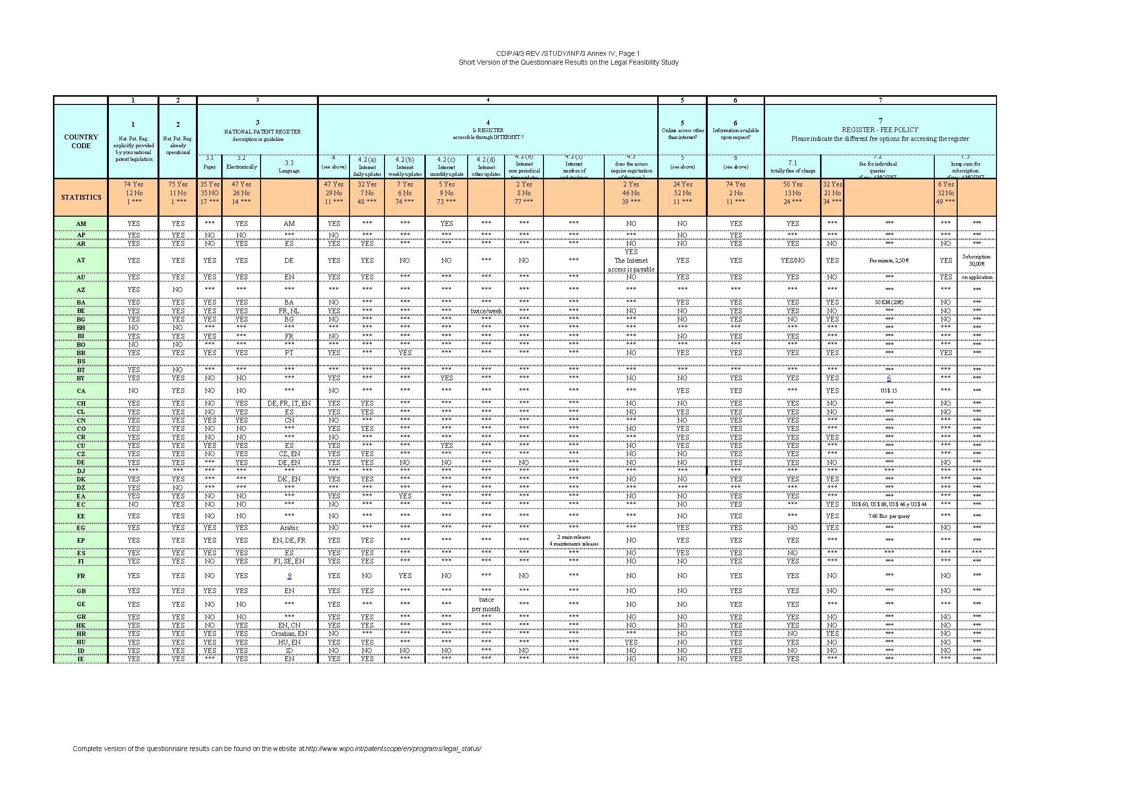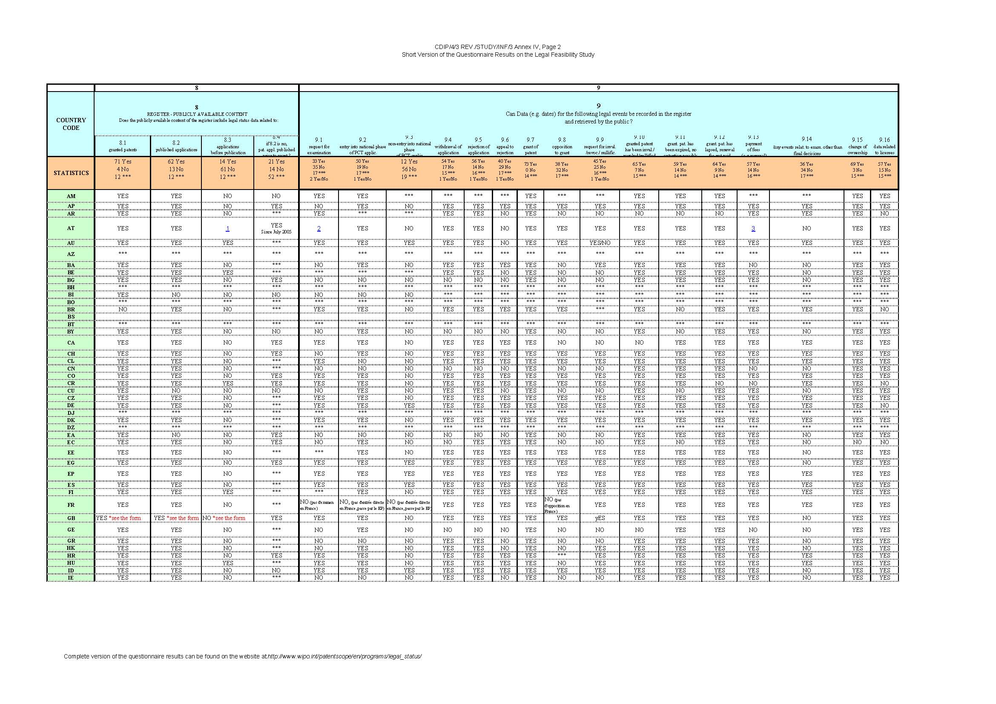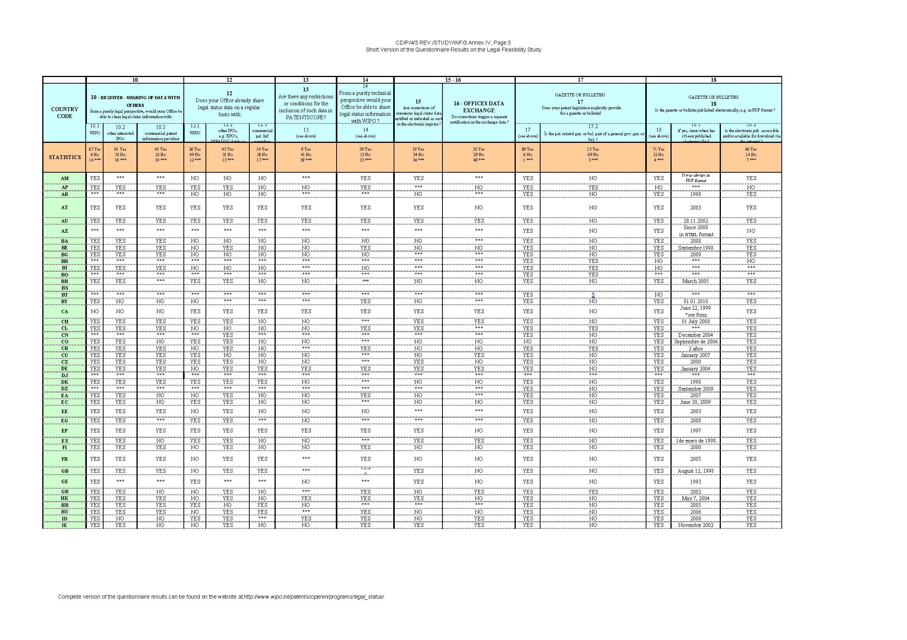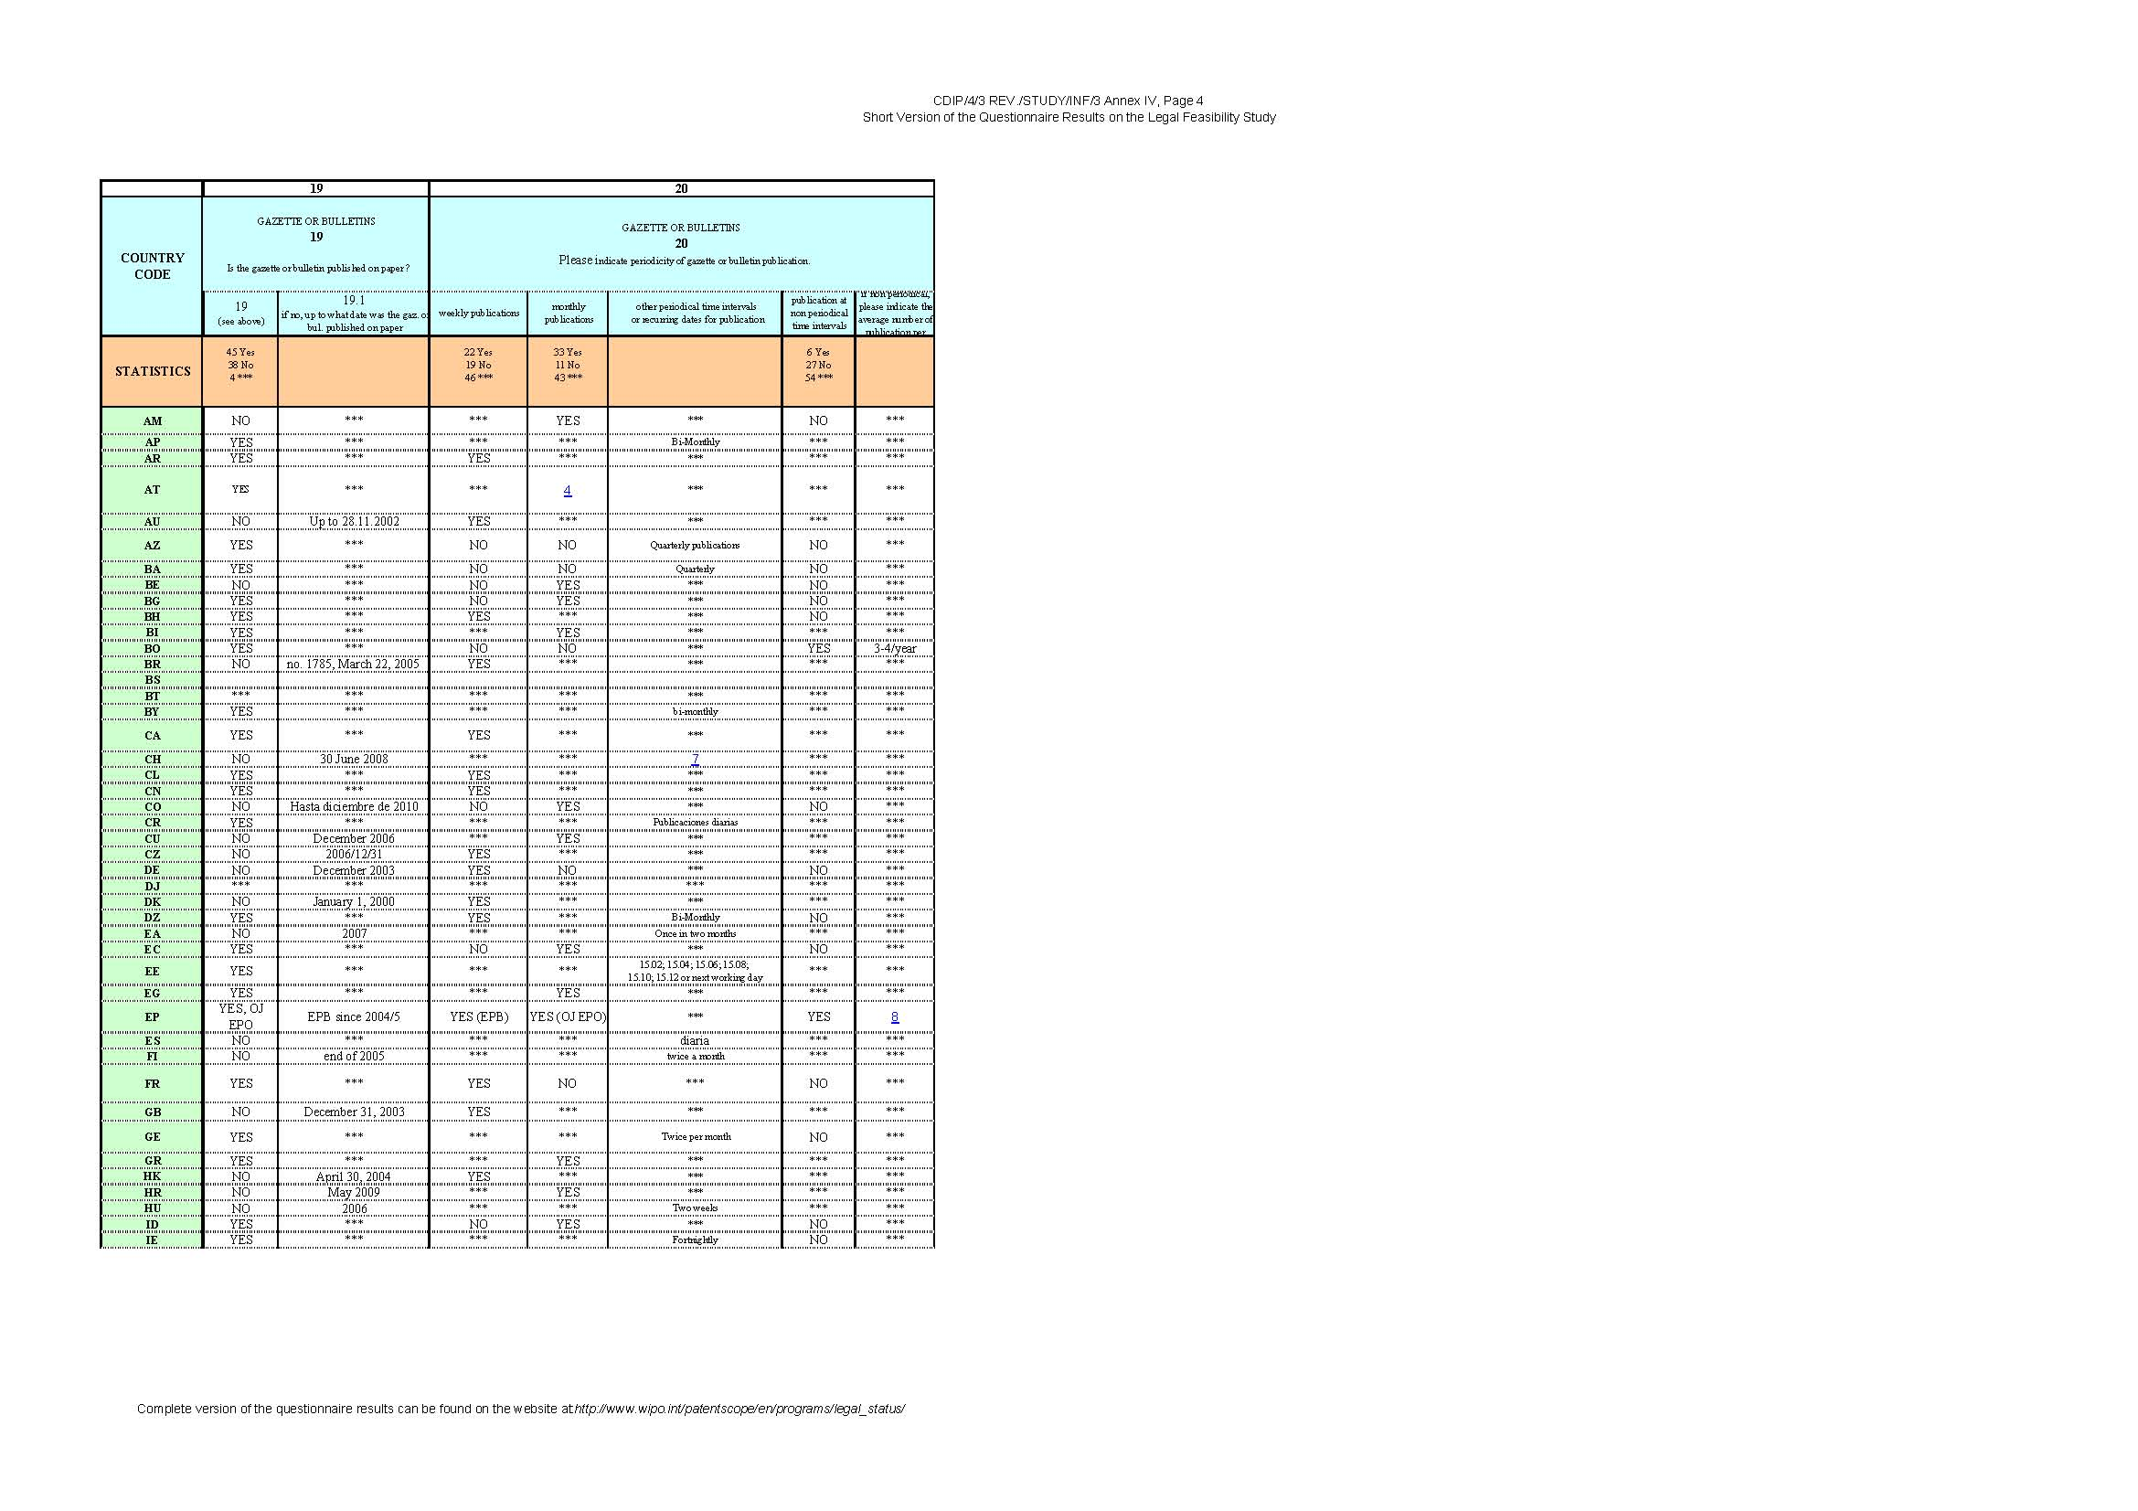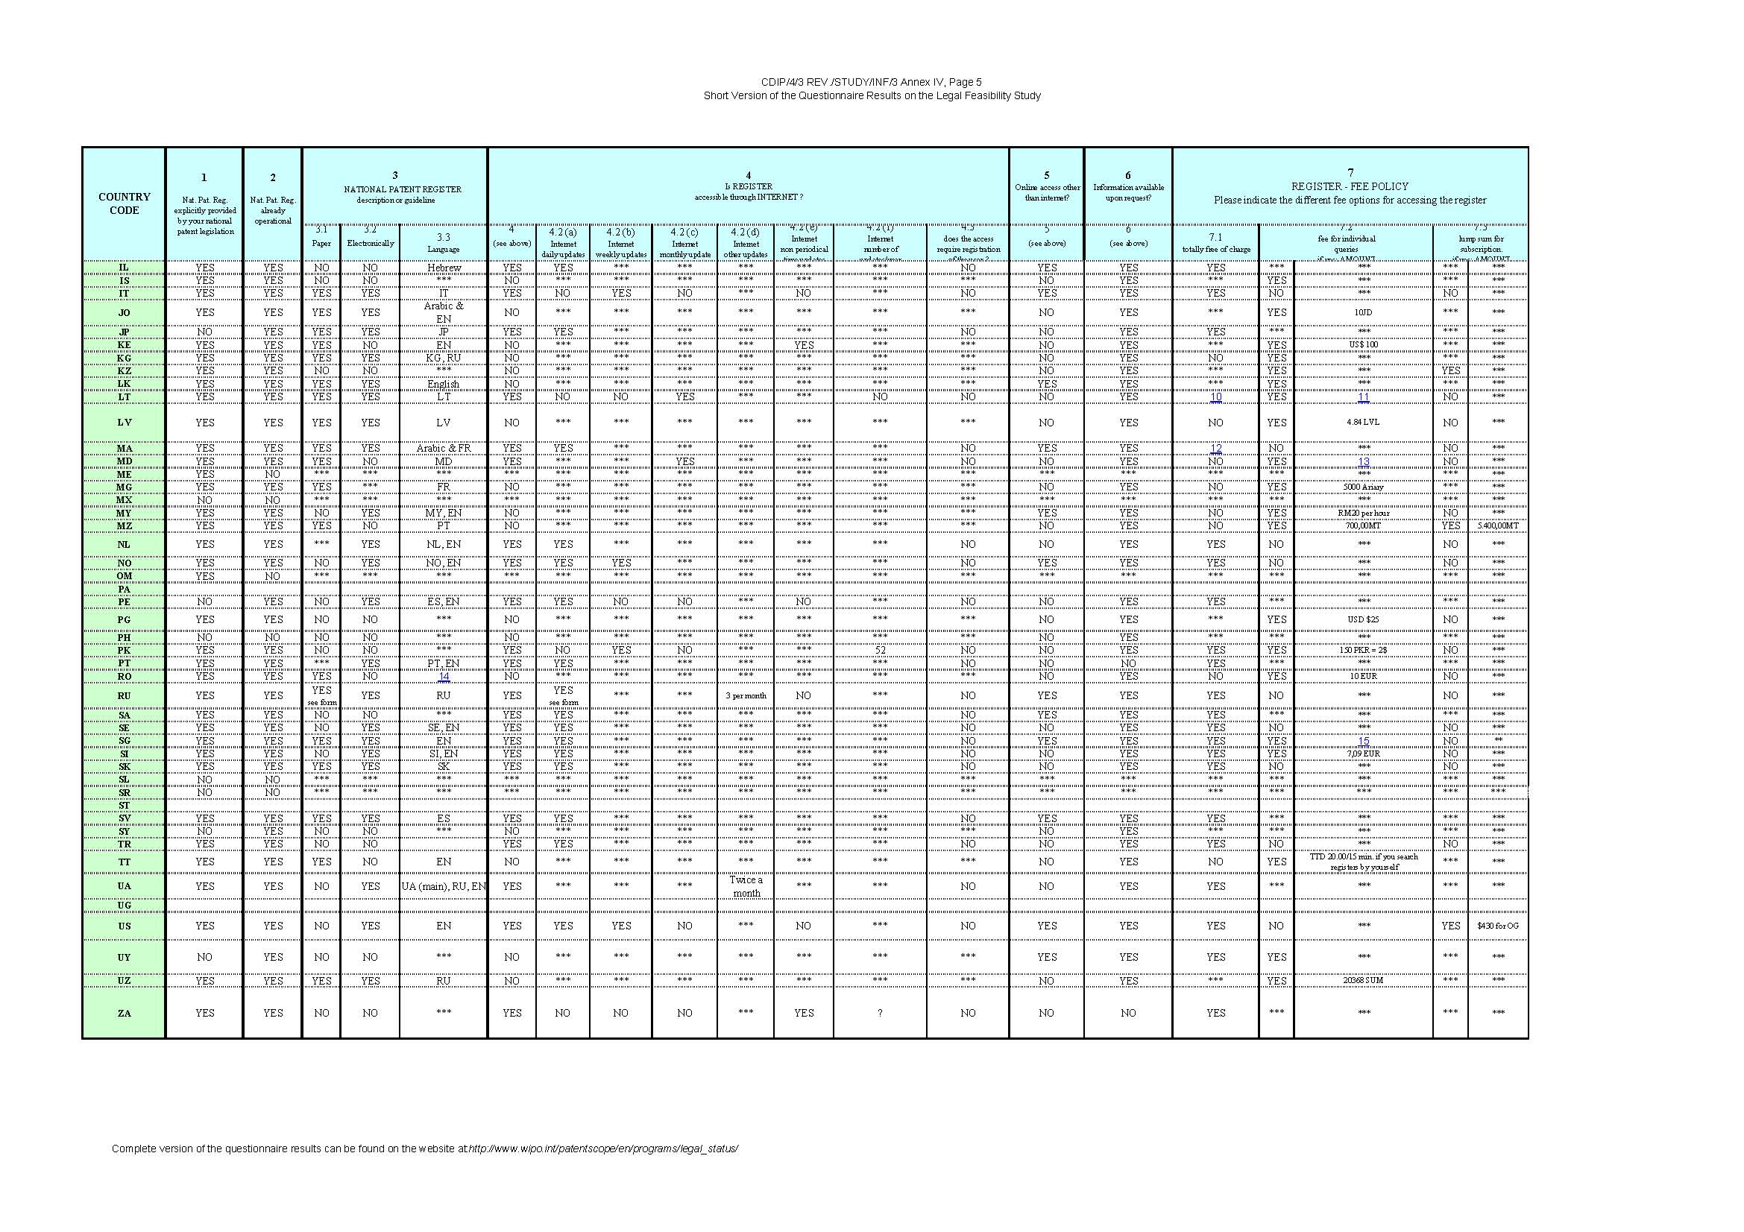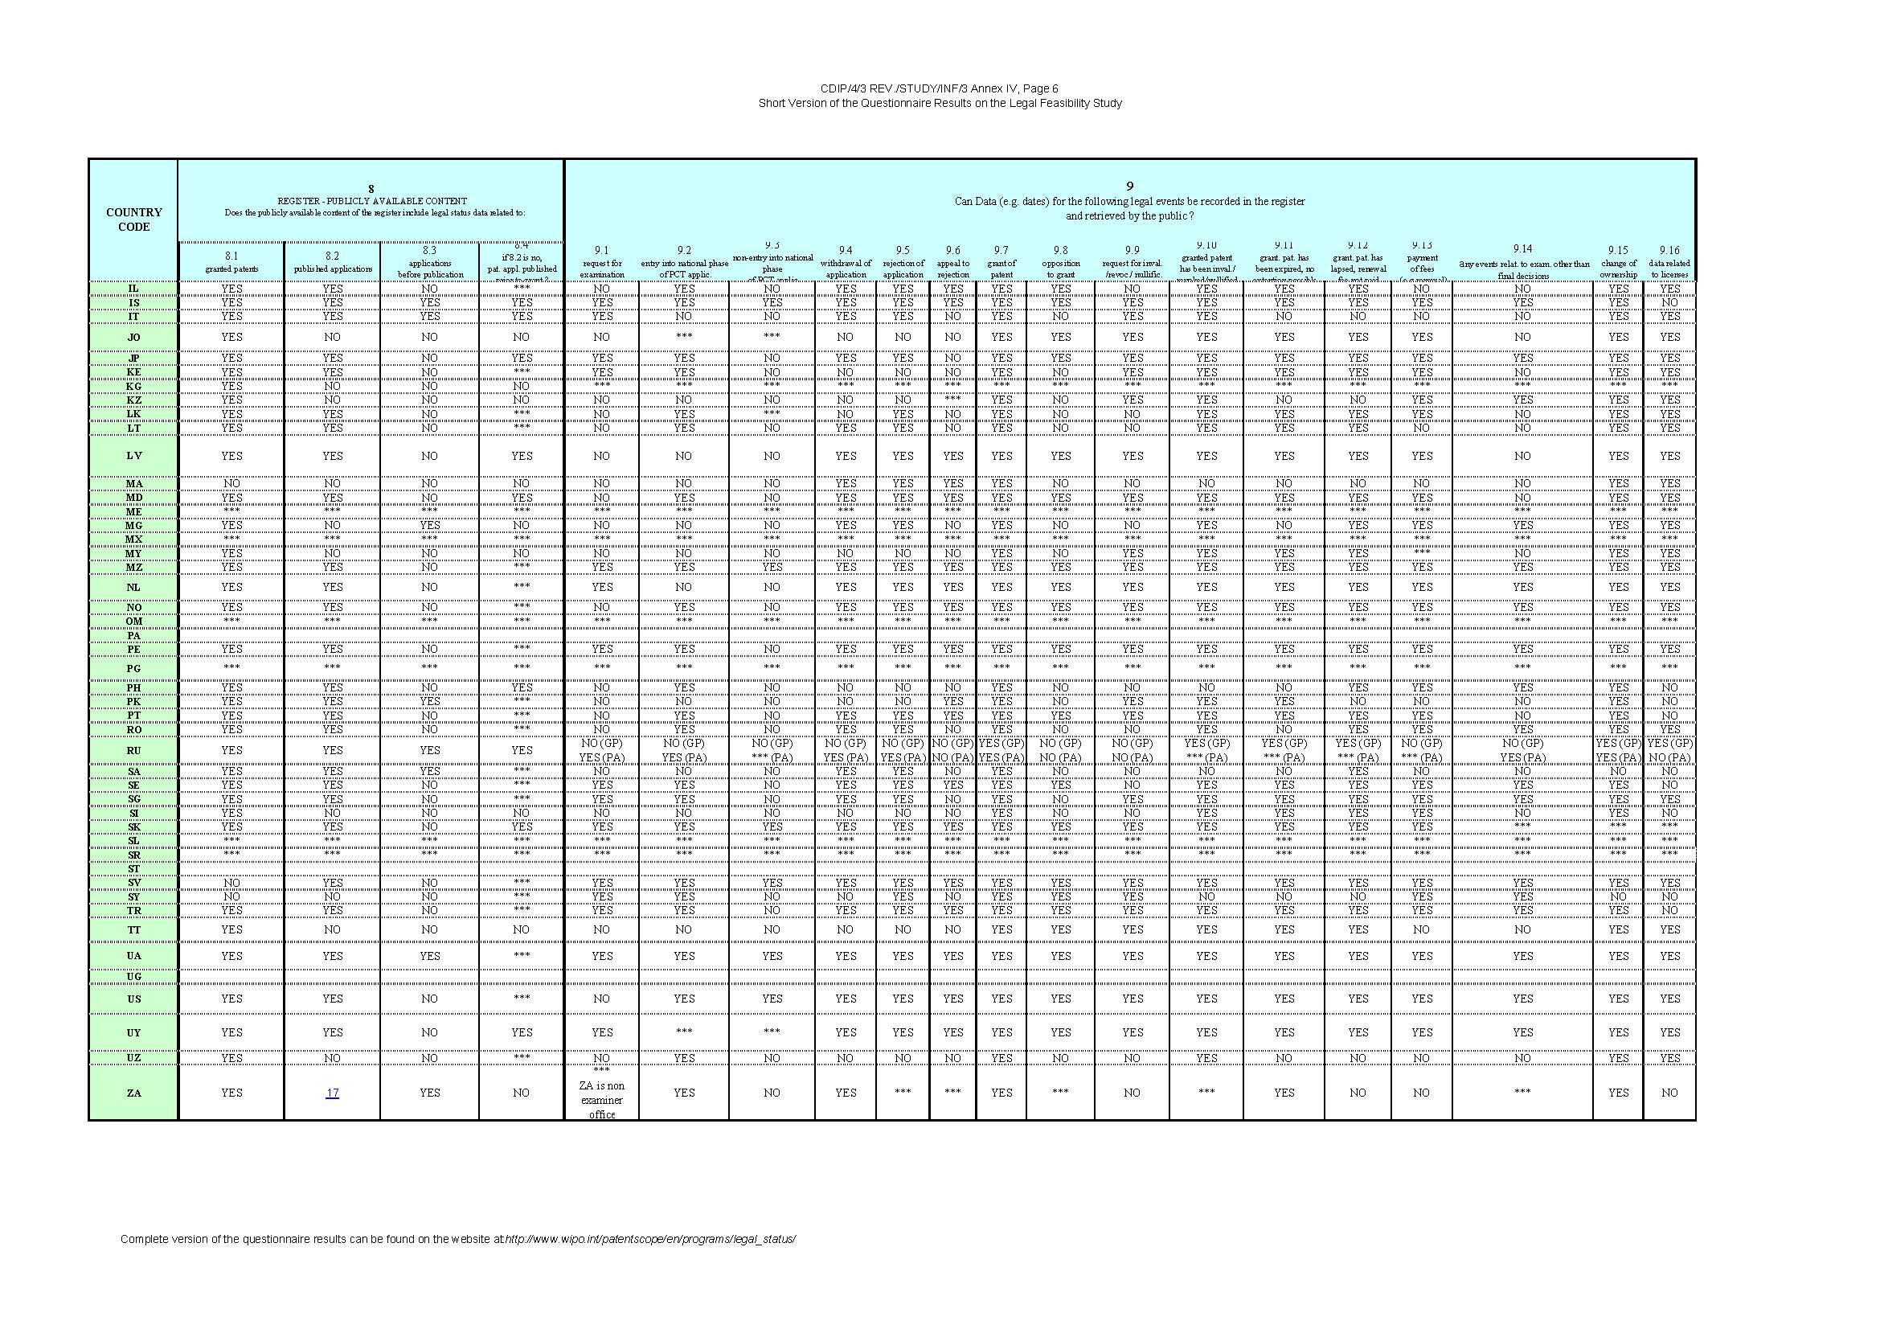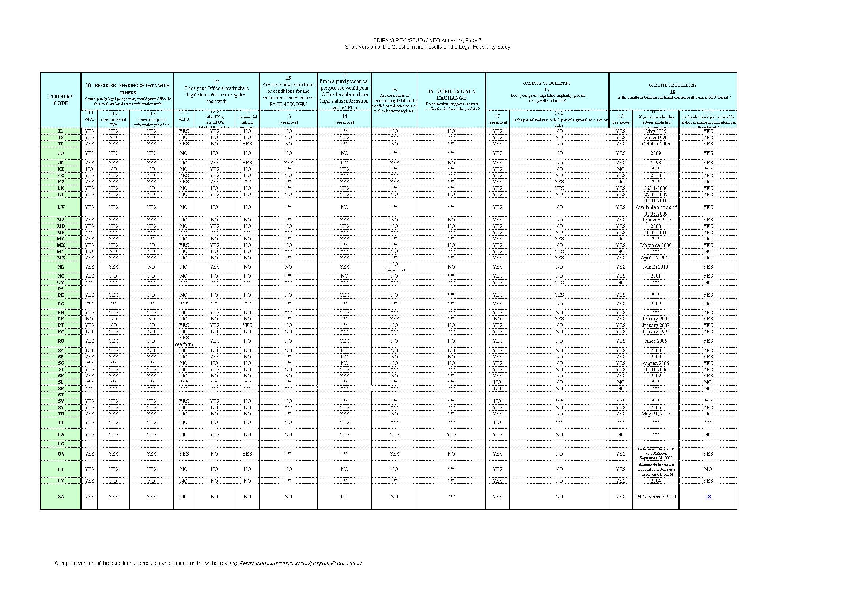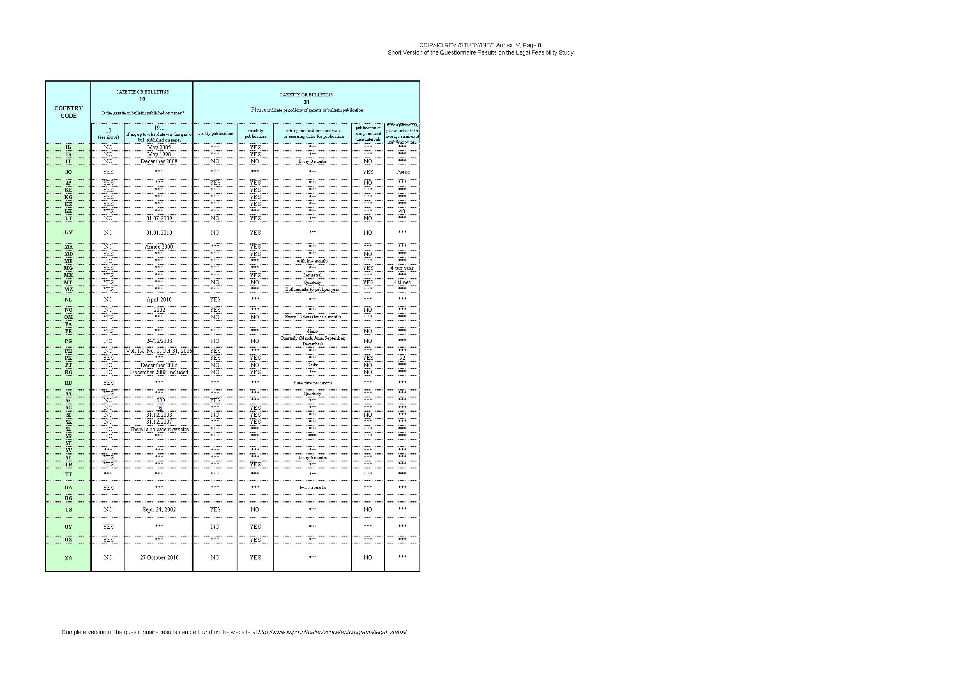

I NOTES TO EVALUATION OF RESPONSES

1 | YES. Before granting only bibliographic data are published; PatG §81(6)
2 | YES/NO. No extra request for examination is necessary in AT
3 | YES. The information which renewal fee (amount) has to be paid and when it has to be paid, is available via the free online-service.
4 | YES. Each 15 of a month
5 | The patent related gazette or bulletin is not a general government gazette or bulletin. The publications will cover notifications only related to Intellectual Property rights
6 | 35000 BYR for nationals 200 USD for foreigners
7 | Daily for legal status data of published applications and patents; Weekly for EP/CH grant; Fortnightly for all national specifications (e.g. grant and application publication)
8 | OJ EPO Special Editions 2-3 in average per year
9 | Les conditions d'utilisation ainsi que la rubrique "aide" sont disponibles en français et en anglais. Les champs d'entrée du registre (ex: no. de publication, demandeur, CIB…) sont également disponibles en français et en anglais. En revanche, le contenu de ces champs d'entrées (c'est-à-dire les informations relatives au brevet) n'est disponible qu'en français.
10 | YES. Only for electronic online register. In case for an individual request to issue of an extract from the register (in written form) - 120 LTL (35 EUR)
11 | For issue of an extract from the Register of Patents of the Republic of Lithuania (in written form) - 120LTL (35EUR)
12 | L'accès internet est gratuit mais les demandes d'extrait de registre sont payantes: 180 Dirhams
13 | Without legal extract: free With legal extract: 30 EUR
14 | There is no guideline for the National Patent Register, but the implementing Regulation (HGnr. 456/18.06.2008) of the Romanian Patent Law provides in art.67 the content and conditions of use of the National Registers.
15 | S$ 24 per request on Patents form 44 and S$ 6.50 per request for file inspection on Patents form 25
16 | Pre-August 2006 Note: All pre-August 2006 copies of The Patents Journals A and B have since been scanned and are presently in PDF format
17 | YES Only abstracts, not publications, take place on the date of grant
18 | We can e-mail the Patent journal if subscribed. Write to patentjournal@cipro.gov.za

[End of Annex IV and of document]

paragraph 3.2 of CDIP/4/3 Rev
They are available as a separate extended legal events file (XLEV)
see the “Legal status codes in original language” on the website http://www.epo.org/searching/essentials/data/tables.html
http://www.wipo.int/export/sites/www/standards/en/pdf/03-17-01.pdf
http://www.epo.org/searching/essentials/data/tables.html
see, e.g. WIPO Standard ST.18
WIPO Circular C.N 3159
The framework for the mission and for the functioning of the Center is laid down in the Bundesgesetzblatt 414/1973, http://www.ris.bka.gv.at/Dokumente/BgblPdf/1973_414_0/1973_414_0.pdf
The conditions and the procedure of the integration are laid down in Bundesgesetzblatt 672/1990 and 673/1990, http://www.ris.bka.gv.at/Dokumente/BgblPdf/1990_672_0/1990_672_0.pdf.
http://www.epo.org/searching/subscription/raw.html
http://www.epo.org/searching/free.html
http://www.epo.org/searching/essentials/data/tables.html
http://www.epo.org/searching/essentials/data/tables.html
http://www.epo.org/searching/subscription/raw.html
http://www.epo.org/searching/free/ops.html
http://www.wipo.int/export/sites/www/standards/en/pdf/03-17-01.pdf
http://archive.epo.org/inpadoc/index_epcodes.htm
http://ops.epo.org/2.6.2/schema/rplus.xsd

