APPENDIXES
Appendix | Title
Appendix I | Summary of Project Deliverables
Appendix II | Reconstructed Theory of Change
Appendix III | Key Findings from Previous Evaluations
Appendix IV | Evaluation Matrix
Appendix V | Survey Respondents
Appendix VI | External Document References

Appendix I: Summary of Project Deliverables
- In Phase I, the project delivered the following:
(a) Brazil: a study on IP use based on firm-level survey data; an IP unit-record database at Brazilian IP Office; a study on IP use in Brazil; a study on IP use and export performance.
(b) Chile: an IP unit-record database at the Chilean IP Office; a study on IP use in Chile; a study on trademark squatting in Chile; and a study on foreign pharmaceutical patenting in Chile.
(c) Uruguay: a study on IP in the forestry sector; and a study on patenting and market structure in the pharmaceutical industry, including a micro database on pharmaceutical IP filings and products.
(d) Egypt: a study on the role of IP in information and communications technology.
(e) China: a study on foreign patenting behavior by Chinese applicants and a study on patenting strategies of Chinese firms.
(f) Thailand: a unit-record data of utility model filings in Thailand; a study on utility model use in Thailand; and a study on the relationship between utility model use and performance of Thai firms.

- In Phase II, the project delivered the following:
(a) Colombia: study entailing the creation of a unit-record IP database for economic analysis, an analysis of IP use in Colombia and an empirical evaluation of recent IP policy initiatives.
(b) Poland: a study exploring the role of the IP system on innovation in the health sector.
(c) ASEAN: a study focusing on understanding the use of industrial designs through a survey of industrial design owners in three Southeast Asian countries, namely, Indonesia, the Philippines and Thailand.
(d) Central America and the Dominican Republic: study analyzing the relationship between IP use and trade flows in the regional economic area.
(e) Uganda: a study focusing on the agro-based industry in Uganda.
(f) The role of IP in the mining sector: study gathering empirical evidence on the main global patterns of the mining sector in terms of innovation and use of IP, focusing on Chile and Brazil.

Appendix II: Reconstructed Theory of Change
The Reconstructed ToC identifies the following expected Primary and Secondary Impacts:
- Capacity-building impacts at country level: i) analytical capacities developed within the scope of the project were sustained, transferred and expanded by the project’s main counterparts; and/or ii) IP Offices were empowered with knowledge and technical skills to generate and use empirical data to promote evidence-based policymaking in IP and socio-economic development; and/or iii) direct or indirect beneficiaries produced similar studies.
- Enduring connectivity impact at country level: i) national databases on IP were maintained/regularly updated and included in the countries’ databases to promote better-informed policymaking on socio-economic development; and/or ii) IP Offices set up teams/units/functions to deal with statistical and economic analysis involving IP datasets; and/or iii) Economists of IP Offices became members of the global network.
- Conceptual impact at country level: policymakers and other decision-makers acquired and sustained knowledge on the importance of IP for socio-economic development concerning their countries’ priorities.
- Instrumental impact at country level: socio-economic studies produced within the scope of the project were used to influence and/or inform policy process and/or decisions.
- Conceptual impact at global level (knowledge, understanding and attitudes): WIPO and Member States at CDIP increased supply of and/or demand for evidence generation on IP for socio-economic development.
- Enduring connectivity impact at global level (strength of networks who understand and can make use of the evidence): stakeholders within WIPO started to gradually mainstream evidence into its programs, project and activities targeting socio-economic development.
- Capacity-building impact at global level (ability to conduct similar work in future): WIPO developed, retained and strengthened its internal capacities to work/collaborate with Member States, including IP Offices, on IP and socio-economic studies.
- Instrumental impact at global level (changes in policies and practices): Initiatives to promote the implementation of DA Recommendations 35 and 37 increased in number and changed their approach; i.e., from activity-based to project-based.
SECONDARY IMPACTS:
- Countries designed and implemented evidence-based policies to promote socio-economic development that integrate IP.
- Knowledge gaps between developed and developing countries were narrowed.
- An evidence-based decision-making development culture was developed and/or strengthened within WIPO and transmitted to Member States

Appendix III: Key Findings from Previous Evaluations
An end-of-project evaluation was conducted for each Phase of the project. Key findings are summarized below:
Phase I:
- The project was highly relevant to Member States as an input to policy making and for linking the use of IP to economic and social performance.
- Studies produced under the project were of good quality and the project successfully strengthened capacities within national IP Offices and among local experts in better understanding the factors determining the use of IP.
- The approach that was successfully piloted in a limited number of countries has the potential to be replicated in other countries.
Phase II
- The project was well-planned and properly managed.
- Beneficiaries received timely and high-quality support, and results were replicable.
- Studies were of good quality, and the project successfully strengthened capacities within national IP Offices and among local experts on the factors determining the use of IP.
- The project was highly relevant to Member States as an input to policy making and for linking the use of IP to economic and social performance.
- The project's approach has the potential to be replicated in other countries

Appendix IV: Evaluation Matrix
EQ # | Evaluation Questions | Criteria | Lines of inquiry | Data sources | Data collection techniques
Relevance
1 | Are the project’s approach and deliverables still relevant? | Relevance | Continued relevance of research and capacity development outputs | Survey data, Case study, KIs | Survey  KIIs, FDGs
Sustainability
2 | Are the project’s results sustainable? | Sustainability | Continued use of research and capacity development outputs | Survey data, Case study, KIs | Survey  KIIs, FDGs
Impact
3 | What are the intended and unintended impacts of the project in beneficiary countries? | Impact | Changes in policy and other unintended impact changes at the country level | Survey data, Case study, KIs | Survey  KIIs, FDGs
4 | What are the intended and unintended impacts of the project within WIPO? | Impact | Changes in policy and other unintended impact changes within WIPO | Survey data, Case study, KIs | Survey  KIIs, FDGs
5 | What are the conditions that have enabled or hindered the achievement of intended impacts? | Impact | Success and failure conditions | Survey data, Case study, KIs | Survey  KIIs, FDGs
6 | What lessons can be learned to inform future projects within WIPO on how to make progress toward desired impact? | Impact | Open-ended | Survey data, Case study, KIs | Survey  KIIs, FDGs

Appendix V: Survey Respondents
Respondents: 23 out of 52 known stakeholders completed the survey.

Figure 1: Stakeholder Relationship with the Project
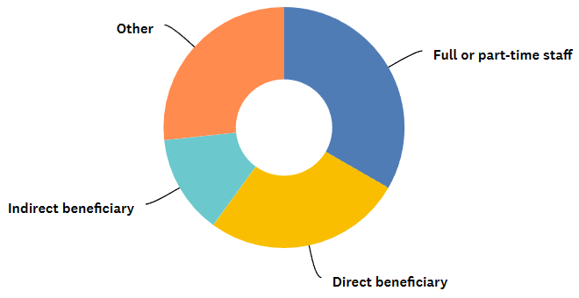
Most respondents worked for the project; respondents indicating “other” were all employed by the project in some capacity.

Figure 2: Phase of Stakeholder Involvement with the Project
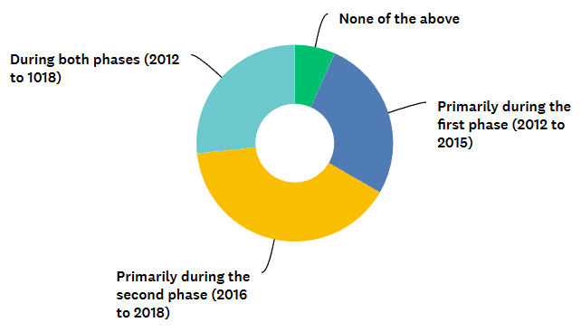

The distribution of respondents between Phase I and Phase II was roughly equal; 27 per cent of respondents were involved in both Phases.

Figure 3: Stakeholder Function in Relation to the Project

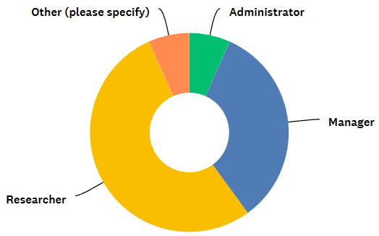

Fifty-three percent of respondents were researchers.

Figure 4: Stakeholder Knowledge of the Project
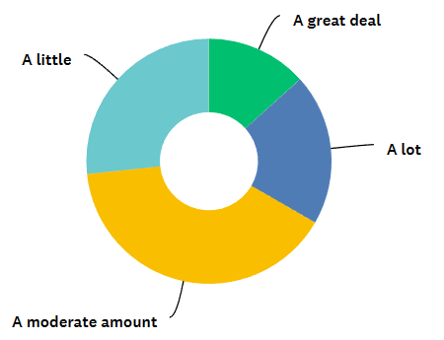

Respondents were knowledgeable about the project; only 27 per cent indicated that they had a little knowledge of the project.

Appendix VI: External References
Child K, Desta G, Douthwaite B, Haileslassie A, van Rooyen A, Tamene L, Uhlenbrook S. 2021. Impact tracking: a practitioner-developed approach to scaling agricultural innovation in Ethiopia. International Water Management Institute (IWMI). CGIAR Research Program on Water, Land and Ecosystems (WLE).
Douthwaite B, Proietti C, Polar V, Thiele G. 2023 January 31. Outcome Trajectory Evaluation (OTE): An Approach to Tackle Research-for-Development’s Long-Causal-Chain Problem. American Journal of Evaluation: 10982140221122771.
European Commission, 2021. Intellectual property (IP) in Indonesia: What should EU businesses know? IP Helpdesk: https://intellectual-property-helpdesk.ec.europa.eu/news-events/news/intellectual-property-ip-indonesia-what-should-eu-businesses-know-2021-12-15_en.
Kingdon JW, Stano E. 1984. Agendas, Alternatives, and Public Policies. Little, Brown Boston.
Mayne J. 2012. Contribution analysis: Coming of age? Evaluation. 18(3):270–280.
Patton M. February 2014. Evaluation Flash Cards: Embedding Evaluative Thinking in Organizational Culture.
Renkow M. 2018. A Reflection on Impact and Influence of CGIAR Policy-Oriented Research. Standing Panel on Impact Assessment (SPIA), CGIAR Independent Science and Partnership Council (ISPC).
Vasconcelos, C.R.d. and Silva, D.P.d. 2019, “Intellectual property challenges for the roads of innovation in Brazil”, Innovation & Management Review, Vol. 16 No. 2, pp. 185-192. https://doi.org/10.1108/INMR-02-2019-0010.

[End of Appendix VI and end of document]

Evaluation criteria are in accordance with those defined by the OECD/DAC (2019).

