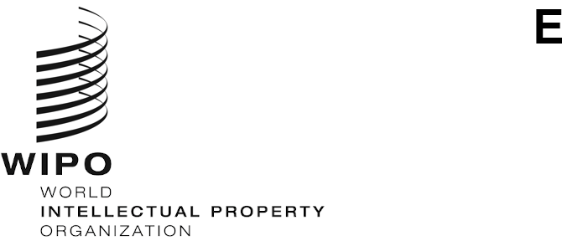
CDIP/31/12 REV.
ORIGINAL: ENGLISH
DATE: OCTOBER 9, 2023

Committee on Development and Intellectual Property (CDIP)

Thirty-First Session
Geneva, November 27 to December 1, 2023
COMPILATION OF SUB-TOPICS PROPOSED BY MEMBER STATES FOR THE INTERNATIONAL CONFERENCE ON INTELLECTUAL PROPERTY AND DEVELOPMENT
prepared by the Secretariat
- The CDIP, at its twenty-ninth session held in October 2022, decided to “convene three consecutive one-day biennial International Conferences on IP and Development on the first day within the CDIP week, starting from the 34th session of the CDIP”.

- At its thirtieth session, while discussing the Future Work, the Committee decided that “proposals for a sub-topic for the International Conference on IP and Development to be held in 2025 should be sent to the Secretariat”.

- The Annex to this document contains a compilation of all proposals submitted by Member States in the order of the receipt by the Secretariat.

- The Committee is invited to consider the Annex hereto.

[Annex follows]

PROPOSAL BY THE DELEGATION OF BRAZIL

- Creative economy in the new digital age – IP as a tool for development
PROPOSALS BY THE GROUP B
- Proposal 1: Vertical tech transfers: Higher Education-Industry collaboration and the facilitative role of IP frameworks
Comment by the Group B:
Given the proposed topics for the Agenda Item IP and Development, there seems to be interest in the area of IP and youth, IP and education, and IP and small businesses. An international conference that invites presentations about vertical tech transfers between universities and the private sector would have the potential to combine the issues related to IP and education, youth, and small businesses. It would be beneficial for MS to hear about how different countries govern vertical tech transfer with varying levels of intervention. The format of the conference would also allow other stakeholders in such tech transfer regimes (tech transfer offices of universities, researchers, and the private sector) to share their experiences and convey what they see as areas of improvement.

- Proposal 2: How to make the young generation engage with IP – IP education and training at schools and universities, IPR awareness among kids and youngsters

Comment by the Group B:

Past topic that can be supported. Maintaining an ethos for IP is vital to mainstream it in day to day use and to recognise the need to protect IPRs. A discussion about how IP is integrated into educational curricula of schools and universities and how topics are introduced based on the educational level would be useful. University students and researchers periodically churn out not only patentable innovations but also literary and artistic works or start enterprises of their own. Considering this, a robust approach to IP education can help ensure that students are not caught unaware by the IP framework.

- Proposal 3: IP and financing for MSMEs

Comment by the Group B:

Building on Group B’s submission in 2022 “IP and Finance”. Group B believes that this sub-topic could provide a means to explore a variety of issues of interest to both developed and developing Member States. Group B would propose that this sub-topic define “IP assets” and/or “innovation” broadly for the purposes of the Conference (e.g., including not only patenting activity but also brands/trademarks). Similarly, that “finance” can also be defined broadly such that the sub-topic could have a wide, cross-regional appeal, and be relatable to developing/least-developed Member States, though potentially with a focus on MSMEs. Group B notes that the Secretariat has a small/emerging program on IP-backed financing (see e.g. www.wipo.int/sme/en/news/2021/news_0006.html) such that this sub-topic could leverage the existing interest/expertise in the Secretariat and the Secretariat’s associated network of contacts.

PROPOSAL BY THE DELEGATION OF POLAND

- IP and creative minds – grasping the future of creativity through IP

Comment by the Delegation of Poland:

Learning from each other (exchange of practices and national experiences) about how to build and increase IP awarness among fine arts academies and artistic school students, as a recognition of their role in growth and deveopment of creative industries accross the world.

PROPOSALS BY THE DELEGATION OF SLOVENIA

- Proposal 1: Intellectual property and innovation in the event of natural disasters

- Proposal 2: Intellectual property and education

- Proposal 3: Intellectual property in the digital world

PROPOSAL BY THE DELEGATION OF THE UNITED KINGDOM

- The role of IP in incentivising AI-enabled innovation for sustainable development

Comment by the Delegation of the United Kingdom

Innovation will be critical to putting the Sustainable Development Goals back on track and solving the most pressing global challenges. AI is increasingly used as a tool in the inventive process, with use cases being demonstrated in diverse fields such as diagnostics and drug discovery, manufacturing, and earth observation for agriculture and combatting climate change.

There would be value in discussing the role of IP in supporting innovators to leverage the potential of AI for sustainable development, through a discussion sharing experiences and challenges of member states, considering the role of different stakeholders in supporting the innovation ecosystem and the unique challenges and considerations relevant for AI-enabled innovation.

PROPOSAL BY THE AFRICAN GROUP

- The role of IP and innovation in addressing global public health challenges: fostering technological transfer and collaborations

Comment by the African Group

Given the relationship between public health and innovation and intellectual property, the aim of this topic is to discuss the contribution of IP and innovation in supporting global public health needs through the promotion of technological transfer and partnerships. Some of the areas to be covered by this topic have to do with strategies to foster and build innovation capacity, encourage technology transfer and local production of medical products, as well as promote information sharing on intellectual property rights to improve access to medicines and other health products for public health purposes.

[End of Annex and of document]

Description taken from previous Group B submission and can be found here.

