**E**



**CDIP/25/****9**

**ORIGINAL:** **ENGLISH**

**DATE:** **MARCH 30, 2020**

**Committee on Development and Intellectual Property (CDIP)**

**Twenty-Fifth Session**

**Geneva, May 18 to 22, 2020**

# STOCKTAKING AND LIST OF SUGGESTED ACTIVITies ON ip and development in the digital environment

*prepared by the Secretariat*

1. The Committee on Development and Intellectual Property (CDIP) at its twenty-third session, held from May 20 to 24, 2019, while discussing the Proposal submitted by the Russian Federation on “IP and Development in the Digital Environment” (document [CDIP/23/16](https://www.wipo.int/meetings/en/doc_details.jsp?doc_id=434323)), requested the Secretariat to:

*“a) conduct a stocktaking in the context of IP office digitalization to identify the respective infrastructure needs of developing countries and LDCs, i.e. raising awareness, improving IP Offices’/institutions’ capacities, and their use of digital technologies to automate and optimize IP registration and administration processes;*

*b) based upon the result of the stocktaking, provide for the CDIP’s consideration a list of suggested activities aimed at enabling implementation of the WIPO Development Agenda Recommendations from Clusters A and C, specifically aimed at bridging the digital divide (Recommendation 24), improving national IP institutional capacity through further development of infrastructure (Recommendation 10), and facilitating IP-related aspects of ICT for growth and development (Recommendation 27).*

*10.3 The Committee will consider the result of the stocktaking and the list of suggested activities at its 25th session, with the view of identifying possible future CDIP needs focused projects. Those Member States interested in participating in such projects and activities may inform the WIPO CDIP Secretariat and/or present their possible proposals to the Committee. If there is a need for additional time or financial resources for conducting the activities contained in para. 10. 2 (a) and 10. 2 (b), the Secretariat should report to the Committee at its 24th session.”*

1. This document presents the result of the stocktaking and the list of suggested activities referred to in the above decision, for the consideration of the CDIP.

## STOCKTAKING IN THE CONTEXT OF ip OFFICE DIGITALIZATION

1. As shown in the WIPO Secretariat’s presentation at the twenty-third session of the CDIP[1], a number of WIPO Programs undertake a wide range of activities in response to the needs for enhancing IP institutions, IP laws and capacity in digital environment, which requires cross-cutting approaches and a wide range of activities.
2. Reflecting on the result of discussions at that session, the Secretariat has reviewed, updated, and further elaborated the information of relevant activities and also provided additional explanation to produce the requested stocktaking below.

### Legal Infrastructure

#### Patent Law

1. There is a close link between the legal procedural requirements for processing industrial property applications on the one hand and the technical design of digitized filing and application processing systems in IP Offices (IPOs) on the other.
2. WIPO administers the Patent Law Treaty in the field of Patent Law, which similar to the Trademark Law Treaty and Singapore Treaty in the area of Trademark Law, addresses formality requirements relating to procedures before IP offices. Obligations under these treaties may well have impacts on the architecture of the digitized systems of the IP Offices. Consequently, should countries have intention to join these treaties, they may consider legal and technical issues in a holistic and synergistic manner. WIPO Secretariat provides targeted legal and practical information to interested Member States and also legislative and policy advice taking duly into account the priorities and special needs of beneficiary countries, the balanced rights and obligations that are inherent to the IP system, and the differing levels of Member States’ development. The Patent Law Division provided legislative advice to 25 countries and regional bodies during the last biennium, with the following distribution by region: Africa (4), Arab (4), Asia and the Pacific (6), Latin America and the Caribbean (8), and Transition and Developed Countries (3).
3. By the end of 2019, ePCT-Filing was being offered by 63 Receiving Offices (ROs) and subsequently filed documents can be uploaded through ePCT to 74 Offices in their role as either RO or International Searching and Preliminary Examining Authority (ISA and IPEA). 90 Offices now have access to ePCT Office services in their role as RO, ISA or designated or elected Office, with 69 of these Offices using the browser based ePCT Office services as their main tool for processing international applications as RO. The eSearchCopy service is now in use in 258 out of the 339 total possible pairs of RO and ISA where those roles are not played by the same Office. These routes represent over 93% of the total volume of transmissions of search copies between different Offices.

#### Trademark Law and Industrial Design Law

1. The Madrid Registry in order to enhance the digital capability of member offices in respect of the operation of the Madrid System, has established in 2019 XML data communication for five offices (Brazil, Canada, China, Japan, and Malaysia) and e-filing services for two offices (Estonia, Lithuania). Discussions about cooperation in this field are under way with more offices.
2. In 2019 for the Hague System, data exchange using WIPO data standards and web services and the sharing of standardized source data with Offices for reporting / analysis took place, particularly, with the Offices of new Contracting Parties (Canada, Israel, Russia, Vietnam) as well the Offices of existing Contracting Parties (most especially Japan and Republic of Korea).
3. During the 2018/19 biennium, the Secretariat also provided targeted legislative and policy advice in the area of trademark and design law in consideration of the needs of beneficiary countries in up to 26 instances.

#### Copyright and Related Rights Law

1. Taking into account the principle of formality-free protection established in the Berne Convention, some Member States are relying on copyright infrastructure to facilitate access to information about copyrighted works.  WIPO offers technical assistance in this field, *inter alia* by sharing sources of information on existing voluntary copyright registration systems, and by organizing capacity-building activities. During the 2018/2018 biennium, a total of 15 Member States, either developing or least-developed countries, benefited from capacity building activities that included the issue of voluntary registration systems.

#### WIPO Judicial Institute

1. In addition to providing legal advice, the Secretariat has been enhancing legal resources of IP laws through the provision of free public access to the full text of IP legislations in multiple languages in WIPO Lex database, which allows legislators in developing countries and LDCs to closely follow and study the development of IP laws in the world, including recent developments in response to needs for IP protection in digital environment. During the last biennium, WIPO Lex added some 30 extensively revised IP laws of 22 countries, out of which 11 were developing countries or LDCs.
2. WIPO is expanding WIPO Lex, to include IP judgments in the free of charge, global database providing access to legal information on IP throughout the world. The purpose of WIPO Lex – Judgments is to contribute to the availability of information and data on judicial systems and decisions on IP, by disseminating leading IP judgments that establish precedent or persuasive interpretations. As part of WIPO Lex’s interface, available in English, Arabic, Chinese, French, Russian and Spanish, the WIPO Lex – Judgments database will capture searchable, bibliographic details for all indexed judgments and provide cross-reference to international treaties and national laws in WIPO Lex. The WIPO Lex – Judgments database was successfully piloted with a selected number of countries (Brazil, Chile, Colombia, Costa Rica, Mexico, Peru, Spain) in 2019, and presented at the twenty-fourth session of the Committee on Development and Intellectual Property (CDIP), as well as the 2019 WIPO Intellectual Property Judges Forum. WIPO Lex – Judgments is expected to be released to the public by end of 2020.

### Technical Infrastructure

#### IPO Administration

1. Most countries now benefit from modern communication technologies, such as the Internet and mobile phones. However, opportunities to use more advanced ICT systems and tools are still not available to administration of IPOs in all developing countries and LDCs. The lack of high-quality digital IP data of national IP rights remains the first obstacle to overcome, since the availability of foreign IP data in digital form do not provide the full benefit and interest to the local stakeholders of innovation and creative industry.
2. IPOs share a common set of business processes and automate workflows of such processes by introducing digital document management consisting of digital procedural steps for reception of IP filings in digital form, workflow and case management in digital environment such as search and examination, and publication and dissemination of digital IP data for public access. All these steps require the support from ICT systems which process digital IP data in accordance with a standardized data format and structure, for which Member States have made efforts to establish and update technical standards for digitization as WIPO Standards. Assistance in this area has been made through the Committee of WIPO Standards.

#### IP Data Digitization and Creation of technically standardized Data of IP Files

1. WIPO Standards is a common framework for IP data, information and documentation in order to enable IP offices and other stakeholders around the globe to work in a more efficient, harmonious, and timely fashion. It contributes to more efficient intellectual property information dissemination. In other words, WIPO Standards helps users of IP systems obtain better access and make more effective use of IP data and information in the digital environment.
2. All WIPO Standards are developed through the discussion by experts from IPOs and IP industry based on the best practices available in the IP community. Around 15 Task Forces under the Committee on WIPO Standards (CWS) are active and participation in CWS and the Task Forces provides deeper knowledge about WIPO Standards, learning opportunities on how Standards are used by different IP offices and opportunities to reflect the situation of the offices to the Standards. Financing the participation of several delegates from developing countries and LDCs in CWS meetings continued during the two biennia to narrow the knowledge gap among countries in technical standards in digital environment. Taking into account the current evaluation of emerging technologies, the CWS recently established the Blockchain Task Force and the Digital Transformation Task Force. All these Task Forces are open to all Member States.
3. WIPO Standards are published in WIPO website as WIPO Handbook so that any interested party can use them freely to enhance their business practices and data operation following the best practices guided by WIPO Standards. To narrow the gap of understanding of the role of WIPO Standards, WIPO Secretariat enhanced its dedicated web site and resources including the WIPO Standards Brochure in 2017.
4. The assistance of the implementation of WIPO Standards is conducted through free distribution and provision of WIPO tools and services that function in compliance with relevant WIPO Standards. They are, for instance, WIPO IPAS Office Suite software (see below), which incorporates WIPO Standards in structuring and formatting IP data; and WIPO Sequence software for digitizing data of the nucleotide and amino acid sequence listing in XML format in accordance with WIPO Standard ST.26 for the purpose of filing and processing patent applications containing such listing.

#### Assistance in Creating Digital IP Data

1. For IPOs in developing countries and LDCs which may not have enough resources and expertise to generate their national IP data in digital form, it is necessary for WIPO Secretariat to respond to their request for technical assistance in digitizing their national IP data. There are two approaches in this regard; one is to provide IPOs with WIPO Optical Character Recognition (OCR) software and training IPO officials to develop skills and acquire knowledge for their own digitization of IP data. The other approach is that WIPO Secretariat provides IPOs which have limited ICT expertise with comprehensive services to manage a national digitization project for national IP data. This approach often requires a significant investment of time and resources of WIPO Secretariat and, if national resources are insufficient, it is necessary to seek contributions from other Member States who wish to provide extra-budgetary resources to the projects.

First approach

1. WIPO uses its internally developed OCR software that was initially developed in 2006 for creating digital data of international applications initially filed in paper or in facsimile image of data under PCT. This system has been built by adapting the market leader OCR solution to the particularities of the patent documents and to the WIPO standards and has allowed WIPO to make the PCT applications descriptions and claims searchable in all publication languages but Arabic in PATENTSCOPE.
2. In 2017, building on this in-house developed technologies and know-how, WIPO started to use it for assisting IPOs in their IP data digitization. To this end, WIPO entered in a partnership with the European Patent Office (EPO) to help national IPOs produce high quality full text for their front file patent publications and offered a customization of its internal OCR system, training and support services, and OCR licenses to participating offices. OCR results are digital and well-structured IP data in accordance with WIPO Standards. From April 2017 to November 2019, six training sessions were organized and 34 offices received the software and were trained.
3. The successful partnership with EPO for European IP data digitization led to an exploratory project for developing countries in Latin America in the framework of the LATIPAT project. WIPO and EPO organized a training session in Latin America in November 2018 during which 12 IPOs in Latin America were trained and received WIPO OCR software.
4. At the end of 2019, the offices that received the assistance were: Albania, Argentina, Bosnia and Herzegovina, Bulgaria, Brazil, Colombia, Costa Rica, Cuba, Cyprus, Dominican Republic, Denmark, EAPO, Ecuador, Estonia, Finland, Guatemala, Greece, Honduras, Ireland, Italy, Latvia, Lithuania, Malta, Mexico, Norway, Peru, Romania, Serbia, Slovak Republic, Spain, Sweden, Switzerland, Tunisia, and Uruguay.
5. Discussions have started with the EPO to extend this successful partnership to the ASEAN region in 2020 and the Israeli patent office has also expressed its interest in participating.
6. In 2012, the Executive Chiefs of the EPO, the Spanish Patent and Trademark Office and WIPO signed an MoU on the project to promote the exchange of patent information in the framework of LATIPAT amongst IPOs of Latin American countries.
7. Since then, the three Organizations together with the IP Offices in Latin America have been working together to maintain and update a regional database containing the information of patent applications published and patents granted in Latin American countries. This database is providing access to the regions patent technology information in digital form and is serving as a common reference platform for the publication of patent information in Latin America. Under this project, 16 Latin American IP Offices have been actively participating in it and sending regularly their information in international standards in WIPO Standards and internationally recognized formats. Since the establishment of the PATENTSCOPE platform, this information is also being included in PATENTSCOPE.
8. One of the main objectives of WIPO’s assistance to IPOs participating in the LATIPAT project over the last three years has been to increase searchable full text data in digital form on patents published by these Offices. In November 2018, a LATIPAT training seminar was organized by WIPO and the EPO in San José, Costa Rica, during which staff from 12 Latin American IP Offices were trained and received the license to use a WIPO developed OCR system for the creation of full text for patent applications and published patents. The seminar aimed at training the staff of those Offices in the production of high quality full text searchable data for inclusion in PATENTSCOPE and ESPACENET. Officials from Argentina, Brazil, Costa Rica, Cuba, Dominican Republic, Ecuador, Guatemala, Honduras, Mexico, Peru and Uruguay participated in the training.
9. As a result, the IPOs of Argentina, Brazil, Chile, Colombia, Costa Rica, Cuba, Dominican Republic, El Salvador, Guatemala, Mexico, Nicaragua, Peru and Uruguay, periodically send data to WIPO and the EPO for inclusion in the database. The full text data produced under the OCR software from the IP offices of Argentina, Costa Rica, Dominican Republic, Ecuador, Honduras, Mexico and Uruguay are in the process of being validated and the data from Cuba and Peru is in the process of being uploaded and put into production.
10. In 2019, there were 16 countries participating in the project and sending bibliographic data and pdf files on patent applications and patents published by IP offices of these countries. In August 2019, the LATIPAT database registered over 2,900,000 bibliographic data and over 2,270,000 image data of full patent documents in digital and pdf format.

Second approach

1. In addition to WIPO’s assistance through the use of WIPO’s own OCR software, WIPO also facilitated IP data digitization by working with certain IPOs to use local ICT services to digitize their national IP data. In many cases, WIPO’s assistance had to rely on the availability of extra-budgetary resources which WIPO established with donor countries for technical assistance in the area of technical infrastructure development. The following list of countries benefited from resources made available by FIT Japan for the digitization of IP data.

| Year | Countries | Content of IP data digitized | Expense in USD |
| --- | --- | --- | --- |
| 2017 | Brunei | Paper volume as 40,000 – 50,000 pages (Patents 15%, Designs 5%, Trademarks 80%); Patents 300,000 pages, Trademarks 7,000,000 pages, Designs 10,000 pages | 75,344 |
| Laos | Patents 110,000 pages ; Trademarks 1,000,000 pages;  Designs 17,5000 pages | 98,445 |
| Botswana | 37,095 files for patents, trademarks and designs | 67,000 |
| Kenya | 820,000 pages of trademarks, patents & designer | 82,000 |
| ARIPO | 8,231 pages of patent files | 100,000 |
| 2018 | Namibia | 83,000 pages of IP Files for data cleaning and validation | 97,000 |
| Mozambique | 800,000 pages of patent documents digitization | 95,000 |
| 2019 | Philippines | 1,2 million pages for patent documents digitization and 93,512 patent applications for data cleaning | 153,207 |
| Vietnam (In progress) | 3 million patent documents digitization | 200,000 |

#### Assistance in development of technical infrastructure and ICT systems at IP Institutions

1. The availability of digital IP data is not enough to enable IPO administrations to work in the digital environment. It requires ICT system effectively working and supporting workflow for IP files in digital form. WIPO Secretariat started to provide its internally developed software for digital IP data and files processing in 1999. Over the years, the WIPO Secretariat has developed, expanded, and upgraded WIPO software for IPO administration. The latest edition of several software applications are bundled and called WIPO IPAS Office Suite. They support the processing of applications for IP rights by establishing an e-registry, controlling workflow processes and business rules, and providing online services to local and international users. The overall objective is to deliver operational efficiencies and improve quality of service. The WIPO IP Office Suite, or parts of it, is currently in operation in more than 80 IP offices in all regions of the world. WIPO has been offering this service to IP offices of developing countries for more than 15 years. The figure below indicates the usage of the WIPO IPAS Office Suite by the user countries.

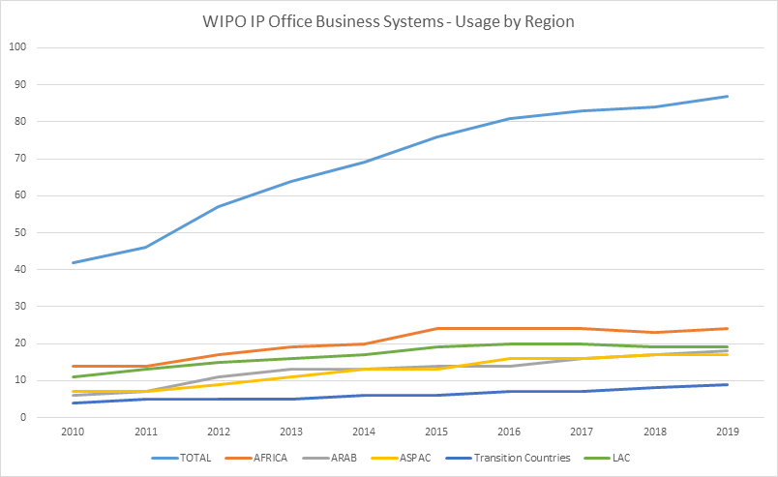

1. Furthermore, workflow optimization project was implemented for several countries in ASEAN since 2017 funded by FIT Japan, including Cambodia, Thailand, Philippines and Vietnam. The project requires thorough review of relevant administration procedures and modification of the business processes to take advantage of automation to improve performance and the delivery of service.
2. During the implementation of the project, actions were agreed and officers were nominated to undertake implementation tasks within the agreed deadlines. Arrangements were also put in place to monitor implementation to ensure continuity. Implementation tables were prepared and updated.
3. Workflow optimization project succeeded in optimizing business processes for administration of the applications within the requirements of the office. Prior to the review, it could take several months for many offices to capture data, scan application documents, record payment details and issue acknowledgement letters. Several IP offices have gained the efficiencies from the streamlined workflows. In addition, the workflow optimization project introduced further improvements which are not related to the optimization of workflows. These enhancements make matters easier for applicants and are consistent with the legal framework. The main improvements include the issuing of acknowledgement receipts, simplification of application requirements, multi-class applications, regular publication of the Gazette on a weekly basis, and notifications through the Global Brand Database when an office action or certificate is ready for collection. Other changes were also introduced to ensure compliance with legal requirements.

#### Assistance in IP Data Exchange on Global IP Platforms; CASE and DAS

1. WIPO CASE provides a platform to share information with regards to search and examination reports among participating local IPOs. The objective of WIPO CASE is to improve the quality and efficiency of the patent search and examination process done at local and regional patent offices. Time taken for examination work at the IP offices of developing countries can be reduced and quality of search results can be improved by sharing information.
2. The WIPO Digital Access Service (DAS) is an electronic system allowing priority documents and similar documents to be securely exchanged between participating intellectual property (IP) offices. The system enables applicants and offices to meet the requirements of the Paris Convention for certification in an electronic environment. If an applicant files applications in many countries, he does not have to request and pay for multiple copies of paper priority documents, wait for them to arrive and send them to his agents in each country to pass on to the relevant Offices. Instead, the applicant can request the Office of first filing to deposit or register the priority application with the service (this might happen automatically in some cases), and can then decide to make it available via the service to any participating Office of second filing.

#### Capacity Building for Digitalization

1. WIPO Secretariat continues to provide IP institutions with opportunities of technical assistance and capacity-building activities in an integrated manner, since training of users of ICT systems, global platforms, databases, and other technical infrastructure require good knowledge of both business workflows and ICT systems in digital environment. The following list of activities shows a wide range of capacity-building activities closely related to technical infrastructure of IP institutions, which WIPO budget and FIT Japan financed to undertake.

| Year | Training | Results |
| --- | --- | --- |
| 2017 | IPAS training for PH, ID, KH | Deepened IPAS knowledge and experience through intensive hand-on training |
| ASEAN IT Workshop at PH | Presented the WIPO solutions to support the ASEAN to move towards online business services and to build up the capacities of ASEAN countries for the utilization of IPAS, WIPO File and WIPO Publish |
| ASEAN business-focused workshop | Promoted patent worksharing and enhanced membership to join WIPO CASE system to reduce the duplication of the examination and increase the productivity |
| IPAS training at WSO for ID NP PNG LK | Provided Information Technology (IT) training on the deployment, customization and administration of the WIPO IPAS, its supporting modules and WIPO Publish |
| IPAS training Workshop Antigua | Improved technical expertise of Information Technology (IT) on the customization, deployment and administration of WIPO IPAS and its related automation modules |
| IPAS Limited Regional Training in Geneva | Greater understanding on the deployment, customization and administration of WIPO IPAS and its supporting modules |
| IPAS Regional Training Botswana | Enhanced capacity of trademark examiners on the use of the IPAS for search and examination |
| Pacific Islands IPAS training in Canberra | Improved capacity of technical staff from IP offices in the installation, configuration and support of WIPO’s IP Office solutions for IP administration and for online services |
| Regional IT Workshop for Arab countries | Demonstrated online systems and tools for office eservices to stakeholders |
| WIPO File Workshop Geneva | Improved technical expertise of on the customization, deployment and administration of WIPO File System |
| 2018 | Regional IT training workshop for ASEAN plus neighboring countries | Greater understanding on the online business services through the utilization of WIPO IP Office Business Solutions |
| ASEAN IT Workshop Malaysia | Presented the WIPO solutions to support the ASEAN to move towards online business services and to build up the capacities of ASEAN countries for the utilization of IPAS, WIPO File and WIPO Publish |
| IPAS Training Workshop ASPAC | Improved technical expertise of Information Technology (IT) on the customization, deployment and administration of WIPO IPAS and its related automation modules |
| IPAS Limited Regional Training in Jordan | Greater understanding on the deployment, customization and administration of WIPO IPAS and its supporting modules |
| IPAS Workshop for Caribbean | Provided Information Technology (IT) training on the deployment, customization and administration of the WIPO IPAS, its supporting modules and WIPO Publish |
| WIPO Regional Workshop Zimbabwe | Enhanced capacity of trademark examiners on the use of the IPAS for search and examination |
| Regional IT Workshop for Arab Countries | Demonstrated online systems and tools for office eservices to stakeholders |
| 2019 | WIPO Subregional IT Workshop and Business focused training | Greater understanding on the online business services through the utilization of WIPO IP Office Business Solutions |
| ASEAN IT Workshop at Vietnam | Enhanced knowledge and technical expertise on the use of WIPO IPAS suited for the online customer services |
| Pacific Island Countries Workshop, Canberra | Improved capacity of technical staff from IP offices in the installation, configuration and support of WIPO’s IP Office solutions for IP administration and for online services |
| IPAS Limited Regional Training in Jordan | Greater understanding on the deployment, customization and administration of WIPO IPAS and its supporting modules |
| Regional Workshop Caribbean Jamaica | Deepened IPAS knowledge and experience through intensive hand-on training |
| Regional Workshop Tanzania | Enhanced capacity of trademark examiners on the use of the IPAS for search and examination |
| WIPO Regional IT Workshop for Arab Countries - Oman | Demonstrated online systems and tools for office eservices to stakeholders |

#### Access to digital data of science and technology and IP available in commercial databases

1. As a result of discussions and recommendations of the WIPO Development Agenda, WIPO created several partnership projects in this area. WIPO’s Access to Research for Development and Innovation (ARDI) program is part of a public-private partnership with some of the world’s leading scientific and technical publishers providing free or low-cost access to over 8,000 subscription-based scientific and technical journals and over 34,000 e-books and reference works in 125 developing countries and LDCs. It is also a member of the Research4Life partnership together with programs administered by the World Health Organization (WHO), the Food and Agriculture Organization (FAO) the United National Environment Programme (UNEP), and the International Labour Organization (ILO), all of which offer content in their respective specialized fields. The number of institutions subscribed to ARDI has increased to over 2,300 last year (see figure below). In total, over 10,000 institutions are registered with Research4Life providing a total access to over 23,000 journals and over 86,000 books and reference works.
2. Another public-private partnership program with nine of the world’s leading patent database providers, WIPO’s Access to Specialized Patent Information (ASPI), offers free or low-cost access to commercial patent search and analytical services to over 140 registered institutions in 51 developing countries and LDCs. Commercial patent databases provide more sophisticated search and analysis tools compared to free of charge patent databases.
3. Yet another program that WIPO Development Agenda Recommendations guided the Secretariat to start is Technology and Innovation Support Centers (TISCs). This program aims to strengthen an institutional aspect of each country to make the best use and perform the optimal search and retrieval of digital data regarding science, technology and IP.
4. TISCs promote and support access to technology information and provide related innovation support services, which range from basic technology searches to value-added analytical services to help inventors, researchers and entrepreneurs unlock their innovative potential. Since the WIPO TISC program was launched in 2009, national projects are formally ongoing in 80 Member States with nearly 900 TISCs hosted in institutions such as universities and research centers and where over 1.2 million inquiries were received last year.
5. The number of different types of services is also expanding in recent years from simple access to databases, through assistance in searching and analysis of data found, to assistance and advice on IP management in licensing, technology transfer, commercialization, patent drafting and patent prosecution. The figure below shows the growth of these different services over the last four years.

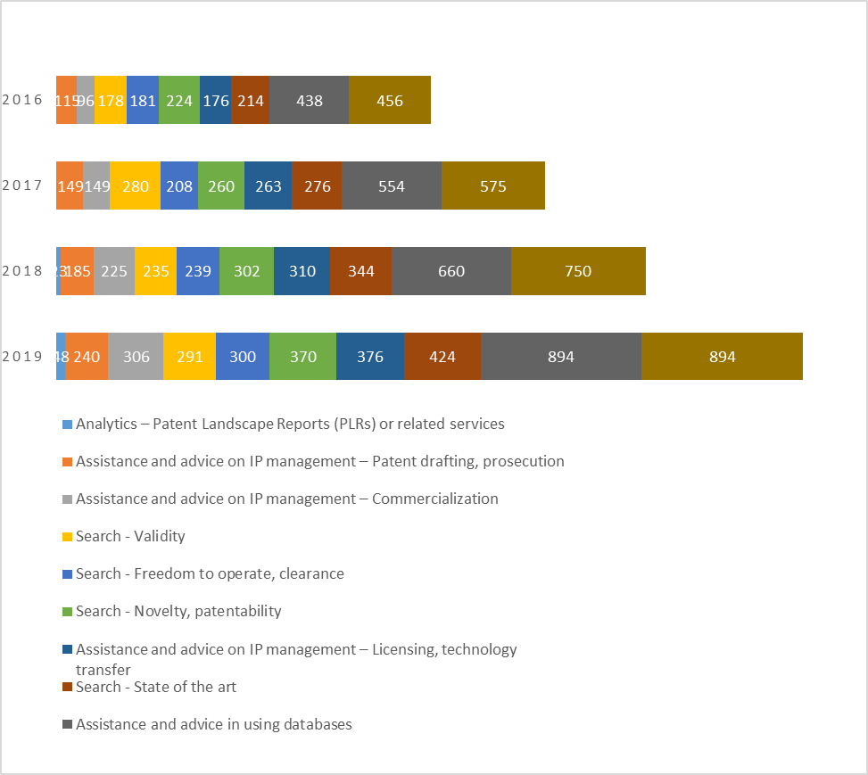

1. Training provided by WIPO supports the development of knowledge and skills among TISC staff building their capacity to provide a range of high-quality services. Training includes on-site workshops and seminars with a focus on training of trainers, distance learning carried out in cooperation with the WIPO Academy. Topics covered include: basic concepts and skills in patent searching; different types of patent searches, including state-of-the-art, novelty and freedom to operate; as well as patent analytics. The figure below illustrates the number of national and regional conferences held in recent years.

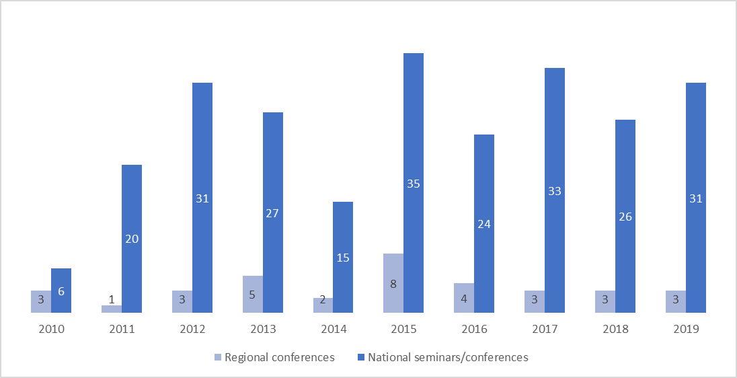

1. A number of publications and learning resources have been developed for patent information users in general and TISC staff specifically to access technology found in databases and use it in developing products and services to take to market. These resources also include an interactive e-tutorial to help innovators to use the wealth of technology information found in patent documents, as well as guides on identifying and using inventions in the public domain by respectively carrying out freedom to operate searches and new product development processes.
2. Moreover, patent landscape reports (PLRs) provide technical and business-relevant information for a specific technology within a given country or region to contribute to informed policy discussions, strategic research planning or technology transfer. A searchable database provides over 215 PLRs from WIPO and other organizations. The patent landscape reports developed in the period 2011 to 2018 attract the interest of patent information users with 40,096 PDF downloads in 2019. In order to develop the capacities of TISCs in the provision of patent analytical services, Guidelines on Drafting Patent Landscape Reports, a Manual on Open Source Tools for Patent Analytics, as well as a Handbook of Patent Analytics have been developed as further training material on patent analytics.
3. The first issue of the new patent analytics-based flagship publication WIPO Technology Trends (WITT) on Artificial Intelligence was published on January 31, 2019. This new publication is based on a patent landscape report and is enriched by non-patent data and inputs from world leading experts in the featured subject matter. It provides innovation and policy decision-makers a thorough overview of the technology, contextualizing it with related policy discussions and other related issues, providing in this way a support tool with a more holistic approach for decision-making. Moreover, it presents the technology in a way which is understandable for non-technical audience which needs to grasp some technical matters, while it provides a state-of-the-art methodology to search patents in the topic concerned. The first issue of the WITT had 96,907 downloads in 2019 and was one of the most referenced WIPO publications, while work started in 2019 for the second edition of the WITT on Assistive Technology which will be published in 2020.

#### New Technologies such as AI and WIPO’s Inclusive Approach

1. WIPO is committed to helping narrow the global digital divide, which is widening due to accelerated use of emerging technologies such as Artificial Intelligence (AI). Through investment in innovative AI to improve IP administration, WIPO has developed a series of AI tools that meet the highest level of standards. WIPO will continue to provide such tools to Member States including developing countries and LDCs free of charge, as those tools are used to enhance IPO administration and improve access to IP information in digital environment.
2. Through the Global Databases Division’s Advance Technology Application Centre (ATAC) and its Global Brands and Designs database team, internally developed world-class AI Tools are currently used by WIPO, other IP Offices and other international organizations such as the UN network. These include:
3. WIPO Translate (Neural Machine Translation);
4. WIPO Brand Image Search (image similarity, based-on shape, color, composition, and concept);
5. WIPO Speech-to-Text (natural language transcription from audio and video).
6. Most of the WIPO AI tools are available to the public online or through APIs, increasing accessibility. WIPO is actively providing these tools to the wider international community through licensing and partnership agreements. These agreements are established on generous terms and conditions in order to share innovation widely whilst recovering some of the organization’s initial investment and operational costs. WIPO will continue to be committed to the enhancement of access to new digital technologies and tools empowered by them such as AI tools by developing countries and LDCs.

## LIST OF SUGGESTED ACTIVITIES

1. Based on the stocktaking and the evaluation of those activities presented to Member States in the course of consideration of WIPO Program and Budget for this biennium, the WIPO Secretariat suggests the following list of activities enabling implementation of the WIPO Development Agenda Recommendations from Clusters A and C, specifically aimed at bridging the digital divide (Recommendation 24), improving national IP institutional capacity through further development of infrastructure (Recommendation 10), and facilitating IP-related aspects of ICT for growth and development (Recommendation 27):
2. Provision of legal advice and relevant information to developing countries and LDCs for their IP legislation in digital environment;
3. Enhancement of information resources for, and international cooperation among IP judiciary institutions;
4. Provision of assistance for IPOs in developing countries and LDCs for digital data exchange for PCT, Madrid and the Hague operation;
5. Provision of assistance to IPOs in digitizing IP data to narrow the digital divide in the IP area;
6. Technical assistance and capacity building for IPOs by offering WIPO in-house developed software, ICT tools, AI-assisted tools, ICT platforms, workflow reengineering suitable for digital data processing, and training for knowledge transfer;
7. Assistance in enhancing institutions for bridging the digital and technology gap through TISCs and its associated services.
8. *The CDIP is invited to consider the information contained in this document.*

1. <https://www.wipo.int/edocs/mdocs/mdocs/en/cdip_23/cdip_23_presentation.pdf>