E
CDIP/23/9
ORIGINAL: English
DATE: march 20, 2019

Committee on Development and Intellectual Property (CDIP)

Twenty-Third Session
Geneva, May 20 to 24, 2019

PROTOTYPE OF A WEB-FORUM ON TECHNICAL ASSISTANCE

prepared by the Secretariat

- The Committee on Development and Intellectual Property (CDIP) at its twenty-second session, while discussing the Feasibility of Establishing a Web-forum on Technical Assistance (document CDIP/22/3), requested the Secretariat to:

“develop a prototype on Wiki or a similar platform, linked to the DA main webpage, containing functionalities that respond to the needs of Member States on technical assistance. The prototype should provide an option for moderated discussions. The prototype should be presented to the next session of the Committee.”

- This document responds to the above-mentioned request. In the following, two possible options are proposed, for consideration of the Committee. These options are based upon the ideas discussed by the Committee in the context of document CDIP/22/3. A live demonstration showing the functioning of each of these options will be provided to the Committee during the consideration of this document. The Annex to this document contains screenshots of the prototypes developed for each of the proposed options.

OPTION A: DISCUSSION FORUM

- The Secretariat would develop a chat room to provide Member States with a discussion forum to share ideas, practices and experiences on technical assistance. In order to benefit from the improvements made to WIPO’s Technical Assistance webpage following the request of the Committee and on the basis of document CDIP/19/10, the Secretariat would make its best efforts to embed into the chat room the information available on that webpage. This would enable participants in the discussion forum to access all relevant information (e.g., technical assistance activities undertaken by WIPO for governments and for IP users, the IP Technical Assistance Database (IP-TAD), Development Agenda projects, etc) in an easier and faster manner.

- The Development Agenda Coordination Division (DACD) of WIPO would administer and moderate the forum. In order to ensure a meaningful and productive exchange, a staff at an appropriate level with the knowledge of intellectual property, technical assistance and WIPO’s work, as well as the required professional experience in facilitating discussions on such a platform, would be employed for this task. The moderator would open a weekly discussion on a specific topic related to technical assistance to be addressed by the participants. Topics for discussion could be also proposed by Member States through the web-forum.

- With a view to encourage participation and effective engagement from different regions, the content of the web-forum would be offered in English, French and Spanish. However, in order to minimize the costs of the maintenance of the web-forum, no external provider would be hired to provide simultaneous translation of the discussions among participants.

- To guarantee the confidentiality of the content and the information shared, as well as the participants’ privacy, the forum would be restricted to Member States and its access would be password-protected. A procedure would be established for providing access to the system to the individuals designated by Member States.

- The web-forum would be active for an initial trial period of six months. After the end of that period, the Committee would discuss its usefulness, with a view to assessing whether the forum should be continued in its form, modified, or closed. The Secretariat would present an independent evaluation to facilitate the assessment by the Committee. The independent evaluation would analyse, inter alia, the number of participants of the web-forum, the frequency of access, the number of topics suggested by Member States, the contributions of participants to each topic, etc.

OPTION B: WEBINAR PLATFORM

- The Secretariat would develop a platform to hold webinars on a monthly basis. Each webinar would be structured as follows, provided that the technical requirements allow it: (i) first, an expert would make a live presentation on a topic related to technical assistance through videoconference; (ii) second, participants would be able to ask questions and make comments to the presenter, in writing through a chat room available to all, during a limited period of time; (iii) third, the presenter would answer the questions and comments live through videoconference.

- Alternatively, where the technical requirements do not allow for live videoconferencing, the webinar would be structured as follows: (i) first, a recording of the expert’s presentation would be shared with participants through the webinar platform; (ii) second, participants would be able to ask questions and make comments to the presenter, in writing through a chat room available to all, during a limited period of time; (iii) third, the presenter would answer the questions and comments, in writing through the chat room.

- In light of the differences in languages and time zones, each webinar would be held for a specific region. However, the videorecording of the experts’ presentations of all webinars would be made available for all Member States on the DA webpage after their conclusion.

- The webinar platform would be administered by a staff of WIPO in order to ensure the efficient organization of the webinars, including the selection of experts and topics, as well as the registration of participants. The expert, topic and language of each of the webinars could be also proposed by Member States through the webinar platform. Member States proposing an expert could be requested to facilitate the logistical arrangements of the webinar, if needed.

- The webinars would be held during an initial period of six months. After the end of that period, the Committee would discuss its usefulness, with a view to assessing whether the webinar platform should be continued in its form, modified, or closed. The Secretariat would present an independent evaluation to facilitate the assessment by the Committee. The independent evaluation would analyse, inter alia, the number of participants to the webinars, the contributions during the follow-up discussions, the number of proposals of topics and experts, etc.

FINANCIAL IMPLICATIONS

- The following is an indicative budget for the establishment and running of each of the possible options of web-forum during the initial trial period of six months:

OPTION | Costs | Total
A. Discussion forum | -Moderation and administration: CHF 59,050  -Technical development: CHF 6,000  -Independent evaluation: CHF 15,000 | CHF 80,050
B. Webinar platform | -Administration: CHF 59,050  -Technical development: CHF 1,695.04  -Independent evaluation: CHF 15,000 | CHF 75,745.04

- Any additional technical feature or administration requirement requested by Member States might entail additional personnel and/or non-personnel resources.

- Should the CDIP decide to continue the web-forum after the initial trial period of six months, the Secretariat would present a project proposal.

- The CDIP is invited to consider the information contained in this document.

[Annex follows]

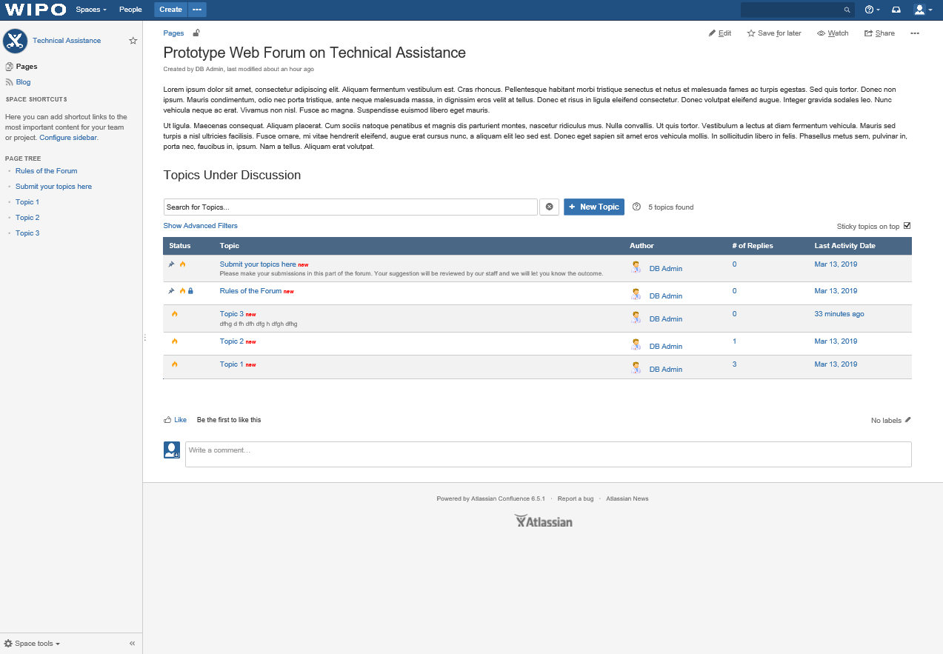
OPTION A

OPTION B
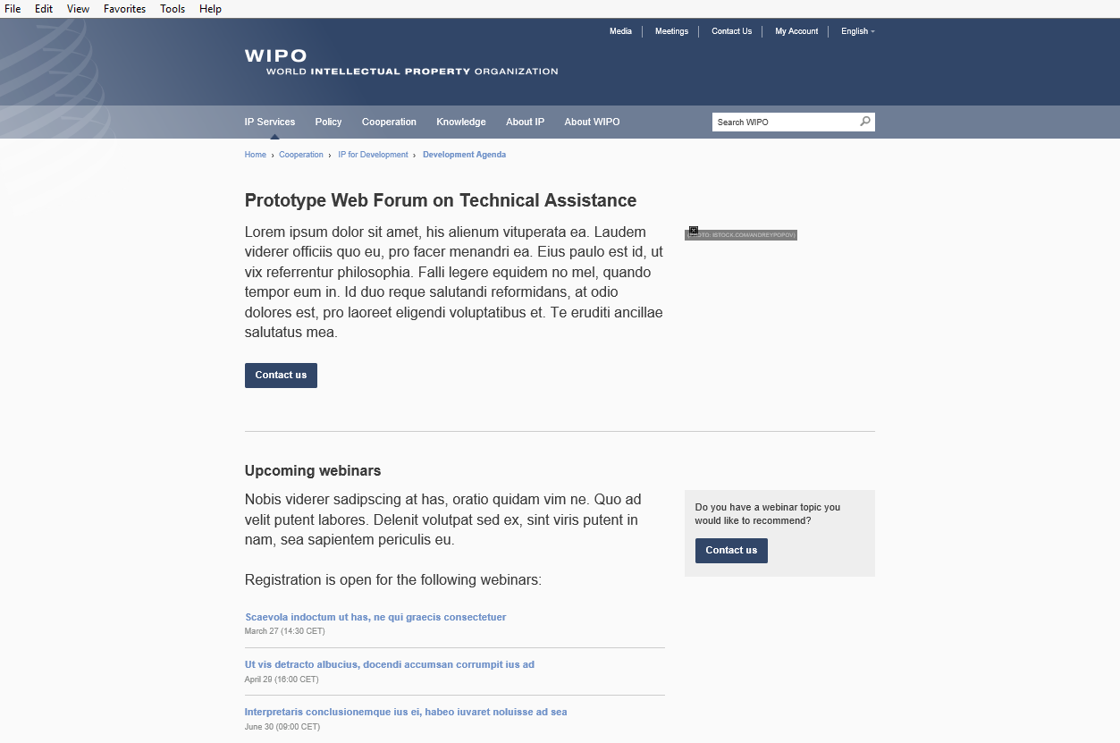

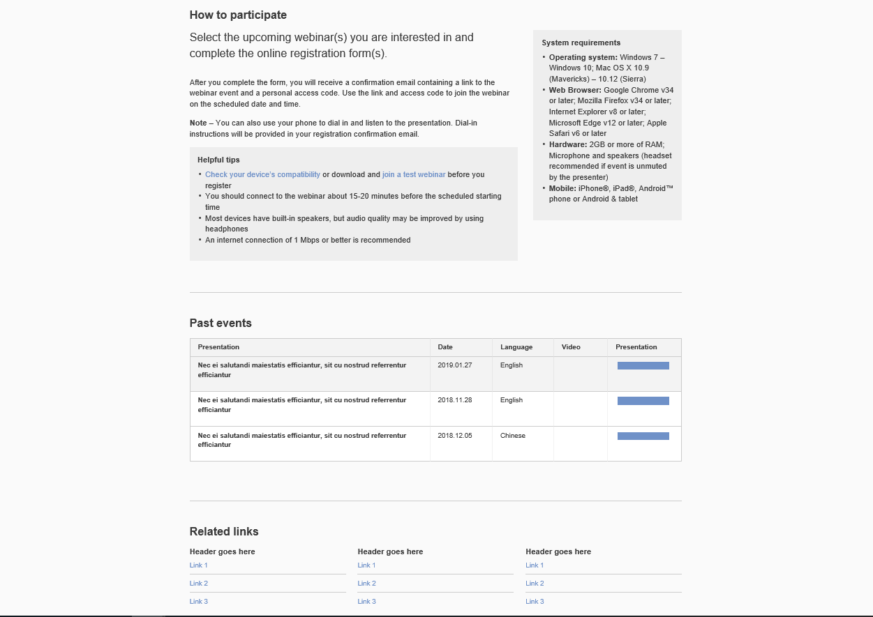

[End of Annex and of document]

The costs will be absorbed from the existing budget of the DACD (Program 8).
The cost reflected in this table covers the price of a license to hold webinars during six months for a maximum of 500 participants.

