E
CDIP/23/16
ORIGINAL: ENGLISH
DATE: APRIL 24, 2019

Committee on Development and Intellectual Property (CDIP)

Twenty-Third Session
Geneva, May 20 to 24, 2019

PROPOSAL SUBMITTED BY THE RUSSIAN FEDERATION ON “IP AND DEVELOPMENT IN THE DIGITAL ENVIRONMENT”

prepared by the Secretariat

- In a communication dated April 19, 2019, the Permanent Mission of the Russian Federation to the United Nations Office and other International Organizations in Geneva has submitted a proposal on “IP and Development in the Digital Environment”, for the consideration of the twenty-third session of the CDIP under the agenda item “IP and Development”.

- The Annex to this document contains the above-mentioned proposal.

- The CDIP is invited to consider the information contained in this document.

[Annex follows]

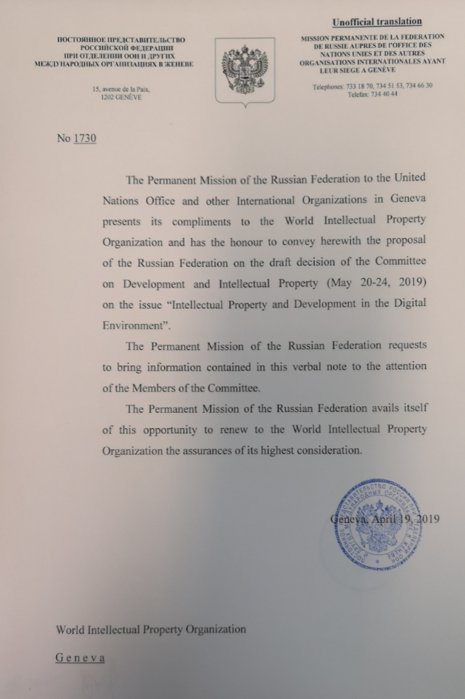
Original text submitted in English and Russian
Draft proposed by the Russian Federation
The Committee addressed the issue of “Intellectual Property and Development in the Digital Environment” under Agenda item “Intellectual Property and Development” and decided as follows:
The WIPO Committee on Development and Intellectual Property,
taking into account IP transformation trends in the context of digital economy and the need to adapt development strategy of IP Offices,
encourages the WIPO Secretariat and the Member States:
- to support international thematic events, dedicated to Information and Communications Technologies strategies and aimed at exchange of experience and best practices of IP Offices, including those concerning development of legislative regulation,
- to encourage experience sharing in implementing digital technologies, including Artificial Intelligence technology, BigData, blockchain technology, 3D modeling,
- to promote projects aimed at improving human resource capacity in the context of IP digital development,
- to continue the work of the Committee on WIPO Standards dedicated to updating the WIPO standards, taking into account the digital e-filing trend,
- to continue implementation of the activities by WIPO Emerging Technology Center in order to conduct research and development in the field of innovative technology such as machine learning, Artificial Intelligence-Based search tools, development of automatic classification tools,
- to continue the development of WIPO’s software products using AI (including Neural Networks in machine translation) and other digital technologies like blockchain to automate and optimize IP registration and management processes.
The Committee approves implementation of the following activities by the Secretariat:
- conducting gap analysis;
- developing a “road map” of further WIPO’s activities, including regular review of digital tools implementation process in IP;
- compiling a list of thematic events, organized by the Secretariat on development and digitalization of the IP field.

The Committee also decides to revisit the issue “Intellectual Property and Development in the Digital Environment” at its 27th session for the way forward to facilitate discussions on this topic.

[End of Annex and of document]

