 | 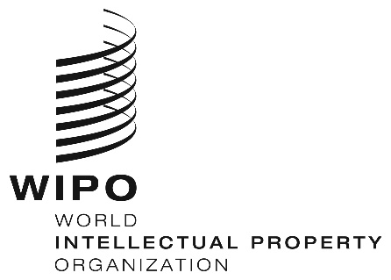 | E
CDIP/22/17
ORIGINAL: English
DATE: november 15, 2018

Committee on Development and Intellectual Property (CDIP)

Twenty-Second Session
Geneva, November 19 to 23, 2018

COMPILATION OF MEMBER STATES INPUTS ON ISSUES TO BE ADDRESSED UNDER AGENDA ITEM “INTELLECTUAL PROPERTY AND DEVELOPMENT” – INPUT FROM INDONESIA AND THE UNITED ARAB EMIRATES

prepared by the Secretariat

The CDIP at its 21st session considered document CDIP/21/8 Rev. entitled “Compilation of Member State Inputs on Issues to be addressed under the Agenda Item “Intellectual Property and Development”. The Committee, inter alia, decided that “other future topics should be based on those proposed in document CDIP/21/8 Rev., or on any proposal from Member States on the basis of the timing of submissions”.

The Annex to this document contains a joint proposal by the Republic of Indonesia and the United Arab Emirates, received by the Secretariat through a communication dated November 15, 2018, from the Permanent Mission of Indonesia.

3. The CDIP is invited to consider the information contained in this document.

[Annex follows]

PROPOSAL OF THE REPUBLIC OF INDONESIA AND THE UNITED ARAB EMIRATES REGARDING ISSUES TO BE ADDRESSED UNDER AGENDA ITEM “INTELLECTUAL PROPERTY AND DEVELOPMENT”

TOPIC: Intellectual Property and Creative Economy

Recalling the decision of the 21st session of the WIPO Committee on Development and Intellectual Property (CDIP) under Agenda Item 9 “Intellectual Property and Development”, that other future topics to be discussed should be based on those proposed in document CDIP/21/8 Rev., or on any proposal from Member States on the basis of the timing of submissions; and recognizing that intellectual property (IP) plays an important role in promoting innovation and creativity and contributes to long-term economic growth and sustainable development:

The Republic of Indonesia and the United Arab Emirates propose the topic of “Intellectual Property and Creative Economy” to be discussed under the Agenda “IP and Development” at WIPO CDIP session.

Sectors and industries in the creative economy are among the most dynamic sectors in the world economy regarded as an emerging high-growth area. Creative economy as a whole creates jobs, economic contribution, value addition, and helps countries establish a stronger national identity. Furthermore creative economy sectors leverage knowledge and information, which in turn triggers innovation, creating social and economic wealth for society and contributing to the achievement of the Sustainable Development Goals.

Creative economy grows and thrives as a liaison among culture, economy, and technology. Its ecosystem consists of many different industries, sectors, and stakeholders, covering a wide spectrum of economic sectors, from traditional cultural and craft industries that are dominated by Micro, Small & Medium Enterprises – (MSMEs) to new businesses in the digital era.

Innovation in creative economy is often a collective process that involves many different actors and stakeholders with specific IP needs. Those actors often combine different types of IP rights, including copyright, patents, designs and trademarks.

In contrast to other economic sectors, which are often faced with entry barriers, creative economy can provide equal opportunities, a level playing field for all peoples of all nations. The digital age has made that more promising with the internet and other technologies enabling talents from all around the world to work together. Certainly, one of the most pressing challenges is how to promote the role of intellectual property in the development of creative economy sectors for sustained socio-economic development.

Discussion and exchange of perspectives under the topic of “Intellectual Property and Creative Economy” are expected to give a better understanding on the role and relevance of the IP system as a means of harnessing the sector’s economic potential and its sustained growth. The discussion and exchange of perspectives could address a wide variety of questions, inter alia:

- How innovation is developed in creative economy?
- What IP policy issues are relevant to support the creative economy sectors?
- What are the opportunities and challenges of the creative economy sectors in the digital era?
- How can IP help finance, commercialise, and sustain the creative economy sectors?
- How can IP policy ensure and protect equal share and opportunities of the various actors and stakeholders involved?

[End of Annex and of document]

