 |  | E
CDIP/17/INF/3
ORIGINAL: English
DATE: march 2, 2016

Committee on Development and Intellectual Property (CDIP)

Seventeenth Session
Geneva, April 11 to 15, 2016

MODELS OF INTELLECTUAL PROPERTY (ip) related contracts for universities and Publically-funded research institutions

prepared by Thomas L. Bereuter, Corresponding Author, CEO of val»IP e.U., Former Director of Technology Exploitation Office, Graz University of Technology, Vienna, Austria, David Jerolitsch, CEST, Researcher, Wiener Neustadt, Austria, and Peter G. Heimerl, Vienna University of Technology, Former Head of Technology Transfer Office, Vienna, Austria

1. This document contains the Models of Intellectual Property (IP) Related Contracts for Universities and Publically-Funded Research Institutions, prepared in the context of the Project on Innovation and Technology Transfer Support Structure for National Institutions (CDIP/3/INF/2). The guide has been prepared by Thomas L. Bereuter, Corresponding Author, CEO of val»IP e.U., Former Director of Technology Exploitation Office, Graz University of Technology, Vienna, Austria, David Jerolitsch, CEST, Researcher, Wiener Neustadt, Austria, and Peter G. Heimerl, Vienna University of Technology, Former Head of Technology Transfer Office, Vienna, Austria

2. The CDIP is invited to take note of the information contained in this document.

Collaboration of Publicly Funded Research Organizations (PROs) with Businesses

Part I

IPR-Codes and Guidelines

■ Thomas L. Bereuter, corresponding author, CEO of val»IP e.U., Former director of Technology Exploitation Office, Graz University of Technology, Vienna, Austria, E-mail: bereuter@valip.eu
■ David Jerolitsch, CEST, Researcher, Wiener Neustadt, Austria, E-Mail: david.jerolitsch@hotmail.com
■ Peter G. Heimerl, Vienna University of Technology, Former Head of Technology Transfer Office, Vienna, Austria, E-mail: peter.heimerl@gmx.at

ABSTRACT
Effective and efficient technology transfer by collaborative R&D between universities or other publicly-funded organizations and businesses is rewarding and necessary, but a challenge. Negotiation of the terms for the collaboration often proves to be hampered by different cultures and missions, conflicts-of-interest, legal requirements and the divergent perception of value of IP. Voluntary codes of practice as well as guidelines on IPR ownership and exploitation on supranational and national basis play an important role in overcoming the aforementioned challenges by providing common ground for the stakeholders of collaborative R&D. Furthermore, nearly all codes define recommendations for measures like awareness creation, education and training, share of good practices, development of policies, procedures, model agreements, and services for IPR and professional collaboration management at PROs.
- INTRODUCTION
  - Relevance of collaborative R&D
As a consequence of financial and economic crises, economic realities of increased competition due to globalization become more obvious. Mostly, it is not size that matters but the ability for agile adoption to change. By creating new business models and developing new markets, change can be initiated even proactively. Before new rules are enforced onto best of class companies, they tend to influence the establishment of new rules by themselves. Therefore, these companies are also called game changers.
A prerequisite for an active or proactive attitude is that companies are excellent in attracting and motivating those rare talents that make the difference during idea creation, R&D and translation of results into viable products. In the high-tech arena even supranational companies nowadays fail to hire and to motivate the best and brightest. The answer to that challenge is open innovation. By accessing the best available expertise worldwide, synergies with one’s own resources are yielded. Mutual collaboration with universities or in general with publicly-funded research organizations (PROs) enables companies to scout for talents as well as for new ideas, technologies and IPRs. If these are combined with suitable business cases, a sound source of innovation is created. Consequent sustainable business development goes along with innovation creating new jobs, dynamic growth and international competiveness.
Companies like Procter & Gamble, General Electrics, 3M, IBM, Google, Microsoft, DuPont, Honeywell, Whirlpool, etc., are frequently presented as role models. In the corresponding case studies it is demonstrated how open innovation is able to rejuvenate the product portfolio and, consequently, to contribute significantly to the revenue streams. The collaborative thinking that goes along with open innovation has improved over the years but is not understood and implemented throughout all industries and regions.
The not-invented here syndrome is still a challenge. Endorsed by the hope that research done in-house by one’s own means could result in innovations required for staying competitive, companies still try to innovate alone. This is limiting the innovation potential, especially in Europe.
If the publication output is applied as a metric for generation of new insights, ideas and knowledge, Europe holds the first position since many years compared to the USA and Asia–Pacific, although the latter region is catching up quickly.
For a more thorough comparison of the EU27 with its main global competitors including Australia, the BRICS countries (Brazil, China, India, Russia and South Africa), Canada, Japan and the U.S. a set of 12 indicators for the innovation performance is applied in the Innovation Union Scoreboard (IUS). This kind of comparison draws a quite differentiated picture: Innovation performance in the U.S., Japan and South Korea is above that of the EU27. The performance of Canada is close to that of the EU27. The EU27 is outperforming the other countries, in particular the BRICS countries.
The dynamic performance analyzing a 5 years period is shown in Figure 1. The lead of the EU27 over Australia, India, Russia and South Africa has been stable. The lead over Canada and Brazil is increasing. The EU27 is slowly closing its performance gap to Japan and the US. Nevertheless South Korea is increasing its lead over the EU27 and China is catching-up to the EU27.
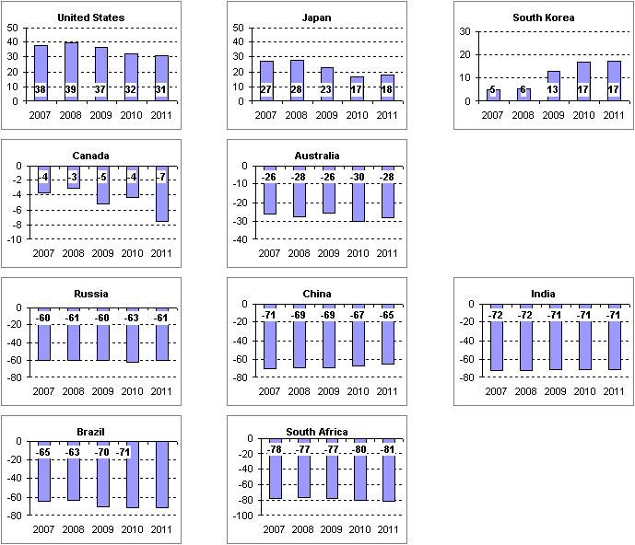

Figure 1. EU27 Innovation performance compared to main competitors over a 5 years period. Source: Innovation Union Scoreboard (IUS) 2011

EU27 is quite divers in its achievements. The Innovation Union Scoreboard (IUS) provides a comparative assessment of the innovation performance of EU Member States based on 24 indicators (Figure 2) resulting in four performance groups. There are the so-called innovation leaders (green) with innovation performance well above that of the EU 27: Denmark, Finland, Germany and Sweden. Then there are the innovation followers (blue) with a performance close to that of the EU27 average: Austria, Belgium, Cyprus, Estonia, France, Ireland, Luxembourg, Netherlands, Slovenia and the UK. The moderate innovators (yellow) are below the EU27 average: Czech Republic, Greece, Hungary, Italy, Malta, Poland, Portugal, Slovakia and Spain. The modest innovators (orange) are well below the EU27 average: Bulgaria, Latvia, Lithuania and Romania.
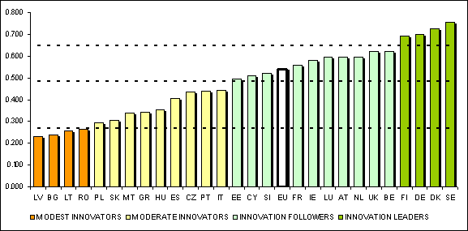

Figure 2. European Countries’ innovation performance. Source: Innovation Union Scoreboard (IUS) 2011.
Compared on a national level there is a broad performance range and, therefore, a lot of room for improvement for most of the nations. The European Commission's "Innovation Union" sets out ambitious goals and a strategic approach to innovation in order to address this challenge.
Particularly promising is the potential collaboration of companies with PROs. Based on the experience of Anglo-American nations and in the U.S. in particular, it is widely understood that universities are able to contribute significantly to the innovation performance and, therefore, to the prosperity of a society. The boom of innovation enabled by patents of U.S. universities is attributed to the Bayh-Dole Act from 1980. It gave U.S. universities, small businesses and non-profits control of the intellectual property that resulted from government funding of their research. Therefore, over the years the contribution of university research to the innovation record has increased steadily.
The economic impact and success stories have created worldwide awareness for the impacts of technology transfer and their underlying mechanisms. Consequently governments started the transformation process by setting up the basis for suitable legal and funding frameworks. In the EU legal regulations have been adopted and the commission developed several programs, tools and recommendations.
  - General regulations with impact on the relationship between PROs and businesses
In Europe, changes of national and EU legislation during the last decade introduced basic rules with a great impact on the way companies and universities collaborate.
    - Ownership of IP created
At the European level there is no consistent system of IP ownership applied to the results of publicly funded research like the Bayh-Dole Act in the U.S. At least on a national level in nearly all EU 27 nations law reforms were implemented abolishing the professor’s privilege or similar models of fragmented IP-ownership prevalent in most nations of continental Europe in favor of institutional ownership. Consequently, inventions created by researchers are owned or ownership may be claimed by the university where the researchers work. For the first time universities were legally enabled to manage centrally IP which their employees created. Although this contributes to the required simplification on a national level, the national differences are still a burden to international collaboration.
    - Public funding
European commission, national governments and their funding programs for collaborative research placed university-industry collaboration higher on the priority list in the last years. Nations such as Germany, Austria and the UK have initiated long term governmental programs to support university-industry collaboration financially as well as administratively in order to promote technology transfer.
Public co-funding of collaborative R&D has to avoid distortion of competition. Therefore, the deminimis regulation limits the cash equivalent a company may obtain by subsidies in a three years period to 200.000 Euro.
Nevertheless, collaboration with universities could result in indirect subsidies for companies. As an interpretation of competition law, the European Commission has published 2006 the Community Framework for State Aid for Research and Development and Innovation, which entered into force on 1 January 2007. The Commission will consider automatically, i.e. without any notification requirement, that no indirect State aid is granted to the private partner by a PRO if the conditions set out in the Community Framework for State Aid for R&D&I are fulfilled.
In case of contract research or research services, market price or full costs plus a reasonable margin need to be paid if the company is going to obtain the results. In case of R&D collaborations, the full cost approach or a compensation equivalent to the market price for the intellectual property rights transferred to the company is required.
    - Challenges for Collaborative R&D
While technology transfer between PROs and companies offers high potential of benefits to all parties as well as to society and economy in general, the handling of the technology transfer process is not an easy task. Collaboration between curiosity-driven research in PROs and business-oriented development in companies has to cross cultures and to yield synergies for all parties involved. Blocked publications on the one side and patent filings impeded by prior-art publications of the inventors on the other side are examples of bad practice. There is also the issue of conflict of interest and commitment in cases where actors are having different roles with different goals. Misinterpreted missions, regulations and legal requirements are also resulting in additional barriers. Companies tend to assume that like hiring of talents educated and trained by universities also their IPRs have to be for free. Universities tend to oversee that companies’ major interest within the collaborations has to be to gain competitive advantage facilitating the generation of revenues.
The discussion about the value of IP already created is a hot topic as the perception of value of early stage technology in a negotiation is nearly always highly asymmetric. Even more difficult is the discussion about the value of unknown IP that might be created in a project not yet started. Especially in case of inventions based on fundamental research, it is impossible to predict which IP might be generated and which market potential might be connected to this IP. Negotiation of valuation methods instead is, therefore, a critical success factor for achieving win-win relationships. The values derived by applying different valuation methods are highly dependent on the application, the business case and the industry. As the topic is rather complex there is no one-size-fits all solution. Partners need to have corresponding education, training and experience in order to understand the relevant parameters, to make use of the options for setting up a suitable business case, to define the corresponding IP use, to apply and adopt established valuation methods and, finally, to define the financial terms as well as to integrate them into executable contracts.
As a prerequisite, a mind change is necessary so that negotiation and implementation strategies support win-win oriented collaborations. On the short run it is easier to go for win-lose or lose-win, but only win-win collaborations are a sound basis for sustainable long-term relationships!
Furthermore, the clearance of ownership questions regarding potential IP contamination between the partners as well as regarding background and sideground technology, as well as the negotiation and implementation of contracts are often time-consuming and the required competences and resources need to be made available.
Last but not least, tech transfer professionals and business executives negotiating the deal require the support of legal counsels. Sometimes legal counsels are more experienced at being fighting opponents than acting as facilitators making contracts legally valid, unambiguous and risk adjusted. In-house legal reviews in companies and PROs as well, often have been described as slowing down negotiations and alienating partners. Instead of showing a deal minded attitude, partners are often frustrated by a bureaucratic approach of legal departments as they are focusing on risk reduction instead of following a business-minded approach looking for a fair sharing of associated recognition, rewards and risks.
  - IPR-Codes and Guidelines
Voluntary codes of practice as well as guidelines on IPR ownership and exploitation play an important role in order to overcome the aforementioned challenges. In an EU consultation a majority of respondents asked for guidelines in order to address issues such as the balance between patenting and publishing and for policies of PROs regulating links with industry in general. The OECD has noted that legislation might be necessary to create “the incentive for PROs to protect and commercialize IP”, but new laws were not the only measure. In general, guidelines and codes of practice on IPR ownership and management have the potential to foster greater transparency and coherence.
Currently the different codes work in parallel with one another, with the pre-existing legal regime in each nation, and with IP policies at the institutional level. They provide a useful source of potential common ground between contracting parties in collaborative research. Usually parties are free to decide about their implementation, but there are exemptions as well.
The following description of codes distinguishes supranational codes, including EU initiatives, from national codes.

2.1 Supranational Codes

OECD and WIPO studies
International organizations like the OECD and WIPO have evaluated the perspective of technology transfer and university-industry relations intercontinentally. Analyzing the status quo, goals and strategies, both organizations have published corresponding recommendations. Part of those recommendations is awareness creation, education, training and in general sharing of good practices. Furthermore, coherent national IP policies and implementation of IP policies at the institutional level are strongly encouraged.

AUTM Guidelines for University Licensing
AUTM (Association of University Technology Managers) published Nine Points to Consider in Licensing University Technology in 2007. The intention is to support the universities’ mission and by doing so to address the dual goals of fostering future research and using the innovations of university research to provide the broadest possible benefit to the public.
If PROs have been creating IPR that is free for licensing to any third party, it is recommended to have basic principles in place. Licensing approaches might vary considerably from case to case and from university to university based on the circumstances. In spite of this uniqueness, universities share certain core values that should be respected in all licensing agreements. The guideline includes examples of clauses for corresponding implementation into contracts

EU Recommendations
The EU has developed a series of activities. In 2004 Directorate-General for Research published twelve recommendations which could be used as a basis for the development of guidelines for the EU in order to promote innovation at European level. This report includes a review of the background, problem areas and examines options for action by PROs, industry and public authorities. It highlights the need for harmonization and convergence of ownership regimes at an EU level. It includes some useful starting points for research collaborators to consider as minimum principles.
The CREST Report affirmed the need for guidelines on EU level. Those guidelines should assist PROs and companies to “work out dispassionately what contractual arrangements for IPR ownership will be appropriate for their needs”. The CREST group was later called ERA expert group which recommended in a later study a code of practice for knowledge sharing at pan-European level from which the principles of codes of practice at Member State level or national knowledge sharing strategies might be drawn for which Member States should be encouraged. The CREST Report also includes the CREST decision guide which is a toolkit for potential R&D collaborators. The guide is a further development of that published as part of the Lambert Tool Kit and is not dependent on any particular IP system. Therefore, it is a tool that compliments the code of practice. By a series of questions the guide proposes the best way to arrange matters in the collaboration agreement. This toolkit also exists as a web tool, which is a quite effective and accessible way for practitioners.
The Recommendation on the Management of Intellectual Property in Knowledge Transfer Activities and Code of Practice for Universities and Other Public Research Organizations of the European Commission, was published in 2008 and reached great attention and visibility. These recommendations to the member states of the European Union are the first voluntary guideline for the management of IP by PROs on a European level and include, for example:
(i) Encouragement of PROs to establish policies and procedures for the management of IP;
(ii) Support for the development of knowledge transfer capacity and skills in PROs, as well as to raise the awareness regarding IP, knowledge transfer and entrepreneurship;
(iii) Improvement of the coherence of IP ownership;
(iv) Implementation of the Code of Practice (see below), whether directly or through the rules laid down by national and regional research funding bodies;
(v) Designation of a national contact point for the coordination of measures regarding knowledge transfer between PROs and business.
In the Code of Practice for PROs, principles are defined for internal policies regarding (i) IP, (ii) knowledge transfer and (iii) collaborative and contract research.
The Internal IP policy of PROs should provide clear rules for staff and students regarding e.g. the disclosure of new ideas with potential commercial interest, the ownership of research results, record keeping, the management of conflicts of interest and engagement with third parties. Furthermore, it should promote the identification, exploitation and protection of IPs in order to maximize socio-economic benefits including incentives, awareness creation and training of basic skills regarding IP and knowledge transfer.
The Knowledge Transfer Policy is intended to ensure that the PRO has professional knowledge transfer services in place including legal, financial, commercial know-how as well as access to protection and enforcement advisors, in addition to staff with technical background. Furthermore, a licensing policy for exploitation purposes should result in adequate compensation for IP transfer.
A policy defining Rules for Collaborative and Contract Research should be compatible with the mission of each party, consider the level of private funding and be in accordance with the objectives of the research activities, in particular to maximize the commercial and socio-economic impact of the research, to support the PROs objective to attract private research funding, to maintain an IP position that allows further academic and collaborative research and avoid impeding the dissemination of the R&D results. IP-related issues should be clarified at management level and as early as possible in the research project, ideally before it starts. IP-related issues include allocation of the ownership of intellectual property, which is generated in the framework of the project (“foreground”), identification of the intellectual property which is possessed by the parties before starting the project (“background”) and which is necessary for project execution and/or exploitation purposes, access rights to foreground and background for these purposes and the sharing of revenues. In a collaborative research project, ownership of the foreground should stay with the party that has generated it, but can be allocated to different parties on the basis of a contractual agreement concluded in advance, adequately reflecting the parties' respective interests, tasks and financial or other contributions to the project.
Within the recommendation, a list of suggested practices of public authorities facilitating the IP management of intellectual property of PROs has been published. Among these are the following measures: (i) sufficient resources and incentives are available to PROs and their staff to engage in knowledge transfer activities; (ii) measures are taken to ensure the availability and to facilitate the recruitment of trained staff (such as technology transfer officers); (iii) pooling of resources between PROs at local or regional level is promoted where these do not have the critical mass of research spending to justify having their own knowledge transfer office or IP-manager; (iv) government funding is made available to support knowledge transfer and business engagement at PROs; (v) in order to promote transnational knowledge transfer and facilitate co-operation with parties from other countries, the owner of IP from publicly-funded research is defined by clear rules (institutional ownership) and this information, together with any funding conditions which may affect the transfer of knowledge, is made easily available; (vi) last but not least: a set of model agreements is made available, as well as a decision-making tool helping the most appropriate model contract to be selected, depending on a number of parameters.
The implementation of those recommendations are supported and tracked by the European commission.

Responsible Partnering
The Responsible Partnering handbook is the result of a joint initiative of the EC European Commission, EIRMA European Industrial Research Management Association, EUA European University Association, EARTO European Association of Research and Technology Organizations, and ProTon Europe. The handbook provides guidance on how to identify suitable partnerships, build consortia and tackle intellectual property. The guide was first published in 2005 and a revised edition was released in 2009.
Society benefits when the fruits of research are exploited for social and economic purposes. Responsible partnering is intended to assist both PROs and companies to improve the effectiveness and efficiency of their collaborative research. The code highlights the need for a sustainable approach. It acknowledges that relationships, in which the fruits of research are equitably allocated between the parties and where there is clarity of IPR ownership, are likely to be durable.
Based on the two main principles (1) maximum beneficial use of public research, and (2) responsible use of that research, ten “self help” guidelines are derived. Checklists for implementation of the guidelines and for drafting of contracts as well as sections on State aid are included.

2.2 National Codes
As a large number of issues need to be addressed by PROs and companies in dealing with the transfer of IP in R&D collaborations, particular conditions at the national level need to be considered as well. Some member states like Ireland, the UK and Denmark have issued guidance on these issues by introducing non-binding national codes.

Ireland
ACSTI Advisory Council for Science, Technology and Innovation has developed two complimentary codes:
- National Code of Practice for Managing Intellectual Property from Publicly Funded Research was published in 2004 and is focused on IP Management, is non-binding, and may be adapted for local use by PROs. One of its key principles is that ownership of research has to be vested to the PRO, backed by published ownership policies and written agreements entered into by all scientists involved. It suggests that conflicts of interests should be managed and resolved, and good practice guidelines (e.g. keeping adequate laboratory notebooks to assist in IP protection) should be put in place as well. It encourages PROs to develop a policy on incentives to research (equity and royalty sharing are examples, but it encourages a broad approach to the issue not restricted to those two options). It also includes a sample invention disclosure form and a user friendly guide to IPRs.
- National Code of Practice for Managing and Commercializing Intellectual Property from Public-Private Collaborative Research was published in 2005, is non-binding and covers the whole process from the initial co-operation to commercialization. It provides a framework for opening negotiations between parties based on best practices. It states that ownership and access to results of public-private collaborative research should be negotiated on a project by project basis based on three key factors: (i) financial input; (ii) intellectual input; and (iii) capacity to exploit. The last aspect, capacity to exploit, is hardly mentioned in any other comparable initiative. It also addresses the need to discuss how disputes between the parties are to be dealt with. It is explicitly aimed at maximizing Ireland’s attractiveness for foreign direct investment in research and development by promoting a common IP management approach and gives preference to commercialization in Ireland. Negotiation of contracts and correlating challenges are not discussed. Furthermore, other forms of co-operation besides the research collaboration are not examined. Both codes have been well received in Ireland.
Whilst both codes are non-binding, it is important to note that compliance with their main terms is a pre-condition for obtaining a grant from one of the major sources of funding for scientific research, the Science Foundation Ireland. Therefore, it is a strong financial incentive to follow the codes under the grant conditions. Another core element of Science Foundation Ireland’s terms and conditions is that there is an attractive incentive and financial return for the research project’s principal investigator and the research team in case of success.

United Kingdom
In the UK several organizations have published non-binding codes relevant to IP ownership and management:
- The so-called Baker Report Creating knowledge creating wealth - Realizing the economic potential of public sector research establishments is a report to the Minister for Science and the Financial Secretary to the Treasury by John Baker, in 1999. It is focused in particular on issues of good practice, barriers to successful commercialization, culture, management and the relationship of PROs and business.
- A Guide to Intellectual Property Management: Strategic Decision-Making in Universities was developed by the UK IPO (Intellectual Property Office, formerly known as the Patent Office) in partnership with AURIL (Association of University Research & Industry Links) and UK Universities, published in 2002. It is designed to inform and support activities of university senior managers in the development of their IP strategies and policies.
- The Lambert Review of Business-University Collaborations by Richard Lambert was published in 2004. Lambert came up with a number of key recommendations on ways to improve links between PROs and business. One of those was that a number of interested parties, including the UK’s Department of Trade and Industry, AURIL and industry stakeholders, developed a set of model agreements to be used in collaborative research projects on a voluntary basis by universities and industry. A decision guide with guidance notes was also developed to help parties decide which of the five main Lambert agreements (or a combination of them) best suits the particular scenario that PRO or company sponsor is dealing with, and to navigate through the agreements by themselves.

Denmark
A working group of DI (Confederation of Danish Industries, Danks Industri) and the Danish Rectors Conference (Rektorkollegiet) developed a non-binding code called Contacts, contracts and codices - research co-operation between universities and companies. The assignment was to study many good experiences from collaboration projects between universities and companies and to demonstrate how hurdles and problems could be handled. Recommendations are intended to help PROs and businesses to become partners and not just parties in collaboration projects.
The code provides useful information and guidance to the smooth transfer of knowledge by nearly all forms of collaboration between universities and companies. It addresses in a user-friendly manner how to decide on payment models, valuations, distribution of rights and the management of the parties’ expectations of what the results will be in any given project. Although it is not meant to be a step-by-step guide for setting up a contract, a chapter covers all important aspects of a corresponding contract. It is well suited for beginners but also provides useful ideas for advanced readers. Although the Danish legal situation is discussed, it is applicable for international use.

Austria
Graz University of Technology has developed a binding guideline not only for the handling of IPRs in general, but also one for IP generated within any form of collaboration with businesses. The guideline defines IP related mandatory rules for all employees with the authority to act and sign on behalf of the university. The first version was enforced in 2007 and was already aligned with the Community Framework for State Aid for Research and Development and Innovation. The guideline has taken into account the feedback of various business partners as well as the Federation of Styrian Industries. The second version released in March 2008 was formally negotiated with the Federation of Styrian Industries with strong involvement of their national umbrella organization. The approval of the document has been unanimous within the participating members of the Federation of Styrian Industries.
For facilitating the use of the guideline, a check list was developed as well. Furthermore, divers corresponding model agreements were designed as a service for the institutes of the university and so assisting the implementation of the guideline.
The guideline has been provided to other Austrian universities for their use and was applied for definition of the initial starting point for the IPAG Intellectual Property Agreement Guide.

Sweden
In Sweden, the professor’s privilege is still in force. Therefore, an example of IP code is included in the overview.
In the guidelines of KTH Stockholm, the university declares to avoid any financial risks by not filing any patents. Inventions generated by public funding are seen as a contribution to society and, therefore, the university supports the scientists by linking to an external company providing specialized services. For case of collaborations, it is stressed that all employees should have contractual agreements in place with the research sponsor so that the precondition for commercialization of results is fulfilled.
  - Conclusions
In nearly all codes, awareness creation, education, training, and in general share of good practices is recommended. Furthermore, PROs are encouraged to establish policies, procedures and services for IPR and collaboration management in order to maximize the commercial and socio-economic impact of research.
In addition, most of the codes strongly recommend providing of a set of model agreements as well as decision-making tools for selection of appropriate model agreements as best practice of public authorities.
As discussed above, these recommendations were supported also by the European Commission (EC) and the support was renewed by the European Parliament. The EC has made available the CREST cross-border collaboration decision guide to help businesses and PROs decide the best way to arrange matters in their collaboration agreement. In a first step, the major issues and their relative importance to the contract are identified by a series of interactive questions. In a second step, the cross border aspects are identified. In this regard, the CREST Group notes that achieving model agreements which could have a Pan-European application might not be possible as the agreements could become too complicated to be of practical use. Instead, it prefers the use of such model agreements at a national level.
Only for standardized and simpler kinds of contracts, a broader transnational use can be achieved. Organizations such as AUTM and DESCA have developed model agreements for material transfer agreements. But most of the contracts regarding collaboration need to cover aspects where a lot of subtle national differences become a challenge. Even for legal regimes that are quite similar, like that of Germany and Austria, those subtle differences are significant. In Germany e.g. the inventors have the right to obtain a remuneration, which is related to what the PRO has earned with the corresponding invention. The elaborated mechanism is part of the German Employees’ Inventions Act and its accompanying guidelines. In Austria, the inventor remuneration has to be appropriate in relation to the value of the invention. In Germany, scientists at universities also have the so-called negative publication right. Therefore, they are allowed to publish instead of disclosing the invention for patenting prior to publication. Furthermore, they have the right to file patents in their own name in nations where the employer does not file. These examples of differences in the legal systems require corresponding regulations in the contracts.
Following this need, model agreements have to be designed reflecting the national legal situation. Table 1 provides a survey of European and national initiatives providing model agreements to help potential contracting parties reach agreements on IPR and reduce that agreement to writing.
Table 1. Overview of European and National Initiatives Providing Model Agreements
No | Initiatives | Links
EU.1 | EC-FP7 Grant Agreement (+Annex II) | cordis.europa.eu/fp7/calls-grant-agreement_en.html#ideas_ga
EU.2 | DESCA Group FP7 Consortium Agreement | www.desca-fp7.eu
EU.3 | EICTA FP7 Consortium Agreement | www.digitaleurope.org/index.php?id=32&id_article=93
US.1 | U.S. Department of Energy (DOE) - Cooperative Research and Development Agreement | technologytransfer.energy.gov/TemplateCRADAagreement.pdf  www.directives.doe.gov/directives/0483.1-DManual-1/at_download/file"
US.2 | U.S. DOE - Small Business Cooperative Research and Development Agreement | www.gpo.gov/fdsys/pkg/FR-1994-03-21/html/94-6522.htm
US.3 | U.S. Public Health Service - Cooperative Research and Development Agreement | www.ott.nih.gov/forms_model_agreements/forms_model_agreements.aspx#MCRDA
CA.1 | University of British Columbia  Collaborative Research Agreement | www.uilo.ubc.ca/pages/industry-engagement/partnering/types/cra
AU.1 | University of New South Wales  Research Agreement | www.legal.unsw.edu.au/research/template_unsw_research_agreement%5B1%5D.pdf
UK.1-5 | Lambert Tool Kit | www.innovation.gov.uk/lambertagreements
DE.1-4 | BMWi Federal Ministry of Economics and Technology | www.bmwi.de/BMWi/Navigation/Service/publikationen,did=342954.html
DE.5-6 | Berlin Contracts | www.fu-berlin.de/forschung/service/vmanagement/berlinervertrag.html
DE.7 | Düsseldorf Contract Workshop | www.gewrs.de/kooperation-und-arbeitskreise/duesseldorfer-vertragswerkstatt.html
AT.1 | Graz University of Technology & Federation of Styrian Industries | mibla.tugraz.at/07_08/Stk_12/080319_Richtlinie_IPR_Wirtschaftskooperationen.pdf
AT.2-4 | Vienna University of Technology:  (1) Introduction/overview (free access);  (2) Model agreements (for employees only) | www.tuwien.ac.at/dle/transfer/services_fuer_tu_angehoerige/fe_vertragsservice
AT.5 | FFG Austrian Research Promotion Agency | www.ffg.at/content.php?cid=1046
AT.6 | IPAG Intellectual Property Agreement Guide | www.ipag.at
AT.7-8 | WKO Austrian Federal Economic Chamber:  (1) Model agreements (for members only);  (2) Handbook (free access) | (1) wko.at/wknoe/rp/gesamtangebot_wirtschaftsrecht.htm  (2) portal.wko.at/wk/dok_detail_file.wk?AngID=1&DocID=813485&ConID=305408
FR.1 | Ministry of Economy, Industry and Employment | www.industrie.gouv.fr/guidepropintel/outils_contractuels/consortium.htm
FR.2-3 | CNRS National Center of Scientific Research | www.dgdr.cnrs.fr/daj/modele/contrat/textes.htm
DK.1-4 | Johan Schlueter Committee | en.fi.dk/innovation/model-agreements
SE.1 | VINNOVA Swedish Governmental Agency for Innovation Systems | www.vinnova.se/upload/dokument/Verksamhet/Starka_FoI-miljoer/VINN_Excellence/Avtal/Avtalsmanual_eng.pdf
IT.1 | Confindustria Confederation of Italian Industries | www.confindustria.it/univimp/index.html

Definitions
Collaborative Research⁴⁶: Several parties are engaged in research towards shared objectives, collectively building on their individual background and sideground in the creation of new foreground knowledge.
Corresponding contracts are called consortium agreements for R&D or Cooperative Research and Development Agreements (CRADAs).
Contract Research⁴⁶: One or more parties perform a task for another at an agreed price and on request. Contract Research tends to be shorter-term in nature, and is driven by different dynamics than collaborative research, and requires specific types of agreement that reflect the straightforward nature of the business deal. The term “Contract Research” is formally defined in the European state aid rules.
Corresponding contracts are called contract research agreements or commissioned research or work for others (WFOs).
Background: Information which is held by beneficiaries prior to their accession to this agreement, as well as copyrights or other intellectual property rights pertaining to such information, the application for which has been filed before their accession to this agreement, and which is needed for carrying out the project or for using foreground.
Foreground⁴⁶: Results, including information, whether or not they can be protected, which are generated under the project. Such results include rights related to copyright, design rights, patent rights, plant variety rights, or similar forms of protection.
Sideground: Results, including information, whether or not they can be protected, which are generated in parallel to the project. In RP 6 Sideground was included whereas in RP 7 it was excluded from Background.

Collaboration of Publicly Funded Research Organizations (PROs) with Businesses

Part II

Model Agreements and Supporting Initiatives

ABSTRACT
Model agreements for collaborative R&D between universities or other publicly-funded research organizations and businesses mostly including model agreements for commissioned research have been developed nationally by platform- as well as by single-initiatives. The initiatives usually intend to facilitate negotiation of terms so that partners can enter into relationships enabling effective and efficient technology transfer. As these initiatives are on a national basis corresponding national legal regimes are reflected in the phrasing of the contracts.
Focusing on model contracts selected, different aspects of the relationship between for-profit companies und knowledge oriented publicly-funded research organizations are analyzed systematically. Summarized in a matrix, model agreements can be compared to each other and similarities as well as differences in the specific approaches become more obvious.
Based on this analysis and experience, conclusions are drawn in order to assist the development of future initiatives as well as to assist the negotiation of co-operations for mutual benefit. It is recommended to stakeholders involved to follow a seven step procedure in order to optimize the positive effects of activities around such initiatives for all parties involved.

INTRODUCTION
Several studies about IPR ownership and exploitation as well as voluntary codes of practice on a supranational or national level do recommend the development of model agreements for cooperation between universities or other publicly-funded research organizations and businesses. The ERA group of experts, (former CREST Group), which is mandated by the European commission, concluded that achieving model agreements, which could have a Pan-European application, might not be possible as the agreements could become too complicated to be of practical use. Instead, the ERA expert group recommended the development of model agreements at a national level. As a starting point the experts developed the CREST cross-border collaboration decision guide to help businesses and PROs with less experience to decide the best way to arrange matters in their collaboration agreements.
Several sets of model agreements have been developed by national platforms as well as by single-institution’s initiatives. Model agreements intend to facilitate negotiation of terms and conditions so that partners can enter into relationships enabling effective and efficient technology transfer.
Even for legal regimes that are quite similar the number of subtle national differences might become a challenge. Therefore, several model agreements have been developed on a national level, which do reflect a.) Interest of business- and of research oriented partners to clarify essential aspects of co-operation and IPR-exploitation, as well as b.) National characteristics of the underlying patent- and IPR-related laws. The latter is crucial for final phrasing of an individual contract, but the former is essential in order to negotiate agreements efficiently. Although intended for national use the model agreements might also facilitate cross border collaborations as it becomes easier to understand the consequences of the applicable national law.
Furthermore, the analysis of initiatives and their model agreements might inspire upcoming initiatives in those nations where there is still a demand perceived for a national set of contracts. It might also encourage stakeholders, who want to complement their national or institutional set of contract models in order to achieve a better support for IPR-management in collaborations.
With any given set of model agreements one can’t expect to apply those contracts to a larger number of projects without any adjustments. Either the special circumstances of the project or one of the co-operation partners will demand changes. Each co-operation needs specific assessment to find out if and which model contract to choose and which qualified adjustments to be made.

INITIATIVES
The various initiatives screened are classified in the following section as “platform initiatives” and “single initiatives”, respectively. In platform initiatives several PROs and businesses were engaged, whereas in case of single initiatives only institutions from either PROs or businesses had the lead. Initiatives of third parties, like a research fund may be viewed either as platform initiative (e.g. EU.1 to EU.3) or as a single initiative (e.g. AT.5).

Platform initiatives
In case of “platform initiatives” the engagement of both, PROs and businesses, usually goes along with a broader discussion and exchange of different viewpoints over a longer period with the intention to achieve improved awareness and involvement of stakeholders, better education of the interested public, more balanced model agreements dedicated to win-win relations as outcome of the discussions and, eventually a wider application of the final outcome in every day work.

EU European commission
Since FP6, Consortium Agreements (CA) are mandatory for most FP-funded research projects. The purpose of a CA is to regulate critical aspects of project governance not covered by the grant agreement between the European Commission (EC) and the project consortium. Key aspects covered in CA are typically: (i) the internal organization of the consortium; (ii) the distribution of the EC financial contribution; (iii) liability and confidentiality arrangements between partners; (iv) management of intellectual property and access rights to results (e.g. when, and on what terms, should access to results be provided to other partners and their affiliates).
From a variety of different model agreements available, only three were selected as those are used most frequently in practice. Furthermore, due to their wide European publicity, those contracts have a great normative impact on how collaboration contracts are set up, even outside the related programs.

EU.1 Seventh Framework Programme: Model grant agreement
The European Commission adopted in 2007 the general model grant agreement to be used in research projects funded under the 7th Framework Program (FP7). This model grant agreement is applicable to the indirect actions under the specific programs 'Cooperation' and 'Capacities' of FP7. It consists of a core text and several annexes. In annex II all relevant IPR provisions are described. In particular rules concerning foreground-IP and assignments are specified in detail. The provision that assignment of IP to a recipient outside of the EU requires approval by the EC seems worth mentioning. Also very particular is the provision, that access rights to foreground have to be granted to partners if they need it for use of their own foreground. In DESCA (cf. below) there are options to specify if those are granted on fair and reasonable conditions or on a royalty-free basis. There is also a list of special clauses to be introduced in the grant agreement whenever appropriate.
The original language of the grant agreement and its annexes is English. The translations into the other community languages are provided to facilitate the understanding of the grant agreement and its annexes. Those translations are not legally binding and are not officially approved.
Both, the DESCA Group FP7 Consortium Agreement and EICTA FP7 Consortium Agreement, which are discussed below, refer to annex II of the model grant agreement.

EU.2 DESCA Group FP7 Consortium Agreement
DESCA, DEvelopment of a Simplified Consortium Agreement, is a rather comprehensive, modular consortium agreement for FP7. It has been initiated by key FP7 stakeholder groups, and was co-developed with the FP community. DESCA intends to balance the interests of the major participant groups in FP7 research projects like large and small firms, universities, public research institutes, etc., in the spirit of Responsible Partnering. Moreover DESCA is also a simplified consortium agreement compared to many of the FP6 models in both content and language. Therefore, it is enjoying a broad support within the FP community. It is estimated that three out of four companies, PROs and individuals involved in cross-border research projects funded under FP7 are making use of the DESCA consortium agreement.
DESCA is supplementary to the rules for participation and the grant agreement of the European Commission (EC) including its annex II (cf. above EU.1). Therefore, many items regulated there are not repeated in the DESCA consortium agreement, but have to be taken into account. It is recommended to have the DESCA consortium agreement signed before the EC grant agreement.
DESCA offers options for clauses around its core text enabling adoption to quite different project types (e.g. large long-term multi-partner consortia versus close-to-market SME-centered projects) or different actor categories (e.g. research-oriented universities versus application-focused enterprises). Furthermore, there are options to include or exclude access rights to background. There is also a module with specific software provisions. DESCA contains guidance notes to help research managers without legal training to recognize key issues and to make informed choices about the best options to approach win-win agreements. In the light of Horizon 2020 an update to the DESCA agreements is announced.⁶

U.S. United States National Science and Technology Council
The National Science and Technology Council (NSTC) published the Final Notice of Standard Terms and Conditions for Research Grants for PROs. Also involved was the Federal Demonstration Partnership (FDP), a cooperative initiative among ten Federal agencies and over one hundred institutional recipients of research funds. With the published final notice, research agencies and awarding offices that participate in the FDP, must use the core set of administrative requirements, to the maximum practicable extent, in research and research-related grant awards. Likewise, agencies may elect to use these terms on selective awards to their research recipients. The Government-wide core set of administrative requirements are posted on the NSF Web site. This includes a link list to the Agency Specific Research Terms and Conditions of DOD/AFOSR, DOD/AMRMC, DOD/ARO, DOD/ONR, DOE, EPA, HHS/NIH, NASA, NSF, and USDA/CSREES. In all cases special rights are granted to the U.S. government and ownership is attributed to the creator of IP.
In this article the collaboration agreements of the U.S. Department of Energy (DOE) and the U.S. Public Health Services (NIH) are analysed in more detail.

U.S.1-2 DOE – U.S. Department of Energy
DOE is responsible for 17 National Laboratories and 5 facilities. The model agreements provide a sound and comprehensive contract structure, including special provisions in case of software code, trademarks, copy rights and mask works, as well as general guidance for its use. In contrast to European model agreements provisions are provided concerning the ownership of instruments bought, yearly reporting duties and listed force majeure events. Unique are the statements regarding duty to file patents in the U.S. and production in the U.S. for the U.S. market. Furthermore special step-in rights are reserved for the government. Although this might not to be executed in practice it is an administrative and legal barrier for business partners involved.
For collaboration with small businesses there is a separate model agreement drafted which is also analysed in table 1. Not covered are the other model contracts that are provided: In case of sponsored research (also called “work for others”, WFO) the funding partner obtains intellectual property and data rights. There are also model agreements provided for use of facilities and development facilities at full cost, again with the option for the partners to obtain intellectual property and data rights.

US.3 NIH – U.S. Public Health Service
As part of the National Institutes of Health’s (NIH) mission to support biomedical research and reduce the burden of illness worldwide, the NIH Office of Technology Transfer (OTT) is facilitating the transfer of technologies to people around the world. Out of the thousands of licenses OTT has executed, more than several hundreds have been licensed to foreign companies. The OTT manages the wide range of NIH and Food and Drug Administration (FDA) intellectual properties. With that goes along the development of technology transfer policies for NIH and for FDA (including the Centers for Disease Control and Prevention [CDC]). Furthermore, the OTT provides model contracts: Inter-institutional Agreements, model cooperative research and development agreements (CRADAs), model license agreements, start-up model license agreements, material transfer agreements (MTA), confidential disclosure agreement (CDA).
As the OTT retains ownership in case of collaborative research and ensures use, commercialization, and public availability by licensing inventions to businesses it is of relevance, that model license agreements are also offered. Typical questions, that come up when model contracts are discussed and assignment of inventions are no option, are responded in two articles.

UK.1-5 Lambert Tool Kit
In the Lambert review it was proposed that key stakeholders representing universities and business should work together to develop a range of model collaborative research agreements. Consequently, the Lambert Tool kit was developed by a working group including key stakeholders such as AURIL, CBI Confederation of British Industry, RDAs Regional Development Agencies, SBS Small Business Service, UNICO, a number of UK companies, universities, and several government departments chaired by Richard Lambert. The group was facilitated by the IPO and the DIUS Innovation Group.
The resulting Lambert-Agreements are representing various approaches to IP ownership, management and exploitation rights, including e.g. ownership of the IP by the university with non-exclusive licensing or exclusive licensing to compny sponsor for voluntary use by both, the company and the universities, up to e.g. nearly unrestricted ownership of the business partner.
UK.1–the University owns the IP in the research results and grants a non-exclusive license to the company allowing the use of the results in a specified field and/or territory.
UK.2–the University owns the IP in the research results and licenses to the company the use of the results in a specified field and/or territory, but the company has a right to negotiate an exclusive license regarding certain results.
UK.3–the University owns the IP in the research results and licenses to the company the use of the results in a specified field and/or territory and the company has a right to negotiate the assignment of the IPRs in some of the results.
UK.4–the company owns the IP in the research results, but some rights are reserved to allow the University to use the results for academic purposes (including academic publication) on certain conditions (protecting the confidentiality of the company’s data; avoiding jeopardizing the option for the company obtaining patent protection).
UK.5–the company owns the IP in the research results, and the University has no right to publish the results.
The model agreements typically have between 11 and 14 pages. They are commented and, based on a questionnaire-based guide, selection of the most suitable type is supported.
The content of the suggested contracts is quite complete - however regulations about background-IP required for commercialization of foreground-IP and regulations about inventor’s remuneration are missing.
In the UK there are two more interesting initiatives but as those are focused on clinical trials and research those are not covered in the survey:
For industry-sponsored trials with patients in hospitals throughout the UK health service model Clinical Trial Agreements (mCTA) have been developed. Four versions of the mCTA have been developed to ensure compliance with the law and to reflect regional institutional arrangements across the UK. In 2011 the revised series was published which is designed to be used without modification.
A model Industry Collaborative Research Agreement (mICRA) was developed by a working group led by the NIHR Office for Clinical Research Infrastructure (NOCRI) and the Medical Research Council. Representatives from industry, universities and the NHS, and the Intellectual Property Office, were brought together with expert legal opinion to develop a model agreement that can be used to support all collaborative clinical research scenarios. Organizations involved in the working group have agreed a statement of endorsement encouraging widespread use of the model agreement to streamline the contracting process for collaborative research. The mICRA is designed to support clinical research collaborations involving the pharmaceutical and biotechnology industries, academia and NHS organizations across the UK. The model agreement is supported by a comprehensive guidance document. There is also a choice of options for clauses covering intellectual property. A decision tree is guiding the less experienced users.

DE.1-4 Model agreements by the Federal Ministry of Economics and Technology
The Federal Ministry of Economics and Technology (BMWI) in Germany initiated a working group in order to summarize existing model agreements. On that basis four bilateral model agreements with 10 to 15 pages each were elaborated: two for contract research (options: IP-licensing or -assignment), one each for research collaboration and service contract. In addition these model agreements are compared to other initiatives in Germany. The final outcome was published in a booklet of 80 pages in 2007. It was updated in 2010 to consider the lessons learned as well as the Community Framework for State Aid for Research and Development and Innovation and new legislation relating to the inventor’s remuneration. The BMWI contracts are the youngest German model agreement initiative.
Several regulations are in clear favor of companies (e.g. publications require a twofold request till they can be published; compensation for IP needs to be calculated within the project costs; background IP required for commercialization has to be for free).

DE.5-6 Berlin Contracts–“Berliner Verträge”
Universities in Berlin and their patent commercialization agency ipal GmbH in cooperation with industry (represented by companies like BASF, Bayer AG, Robert Bosch, DaimlerChrysler, Deutsche Telekom, Rolls-Royce, Schering) elaborated model agreements for contract research and research collaboration. The first edition was published in 2002, updated with the lessons learned in 2007. The Berlin Contracts have formed the initial starting point for the model agreements by the Federal Ministry of Economics and Technology (DE.1-4; cf. above).
In order to differentiate contract research and research collaboration, a list of evidences is provided that facilitates the classification. Furthermore, a comparison shows the differences between the modules of the contracts. For certain issues alternative options are provided (e.g. compensation, invention disclosure). A guideline for calculation of the compensation is added as well.
The clear focus on IP topics results in the lack of issues that are usually part of a contract like warranty, confidentiality, rescission, etc., but those issues hardly become show stoppers. The spirit of the model contract is that PROs and business are treated as equal partners and, therefore, wording is balanced.

DE.7 Contract Workshop Düsseldorf–“Düsseldorfer Vertragswerkstatt”
The Contract Workshop Düsseldorf is a cooperation of the Centre of Intellectual property and the technology transfer unit at the Heinrich Heine University Düsseldorf, which is supported by the patent commercialization agency PROvendis. Other higher education institutions and businesses of different branches are integrated by interviews and questionnaires, but also by involving the lobbyists of businesses.
The initiative started 2004 and published in 2006 the third edition of it’s revised version of an R&D collaboration contract.
The Düsseldorf contract is comprehensive, balanced and due to the various options broadly applicable. Nevertheless the contract with eight pages stayed rather short. In addition the apud-modell was developed for the valuation of patents which might be helpful when discussing payments for inventions assigned.

AT.1 Graz University of Technology & Federation of Styrian Industries
Model agreements were developed based on the guidelines developed together with industry and coordinated by the Federation of Styrian Industries. Covered in table 1 is a corresponding model contract for research collaboration which includes the option which is chosen most frequently: In case of contract research IPR is assigned to the business partner and the IP is prepaid by a lump sum to the PRO, independent of the question if IP is generated and what its potential effectively will be. In order to facilitate the negotiation of the lump sum an extension to the guideline was published later. The inventor’s remuneration, in Austria depending on the value of an invention, is usually financed without any cap by the business partners in addition to the lump sum.

AT.6 IPAG Intellectual Property Agreement Guide
IPAG Intellectual Property Agreement Guide is an initiative of several Austrian universities facilitated by the patent- and licensing management division of austria wirtschaftsservice (aws, a business funding branch of Austria´s national promotional bank) and financed by the ministry of economy. A combination of manual, model agreements and check lists for different kinds of contracts are being developed. Starting point was a model contract for a consortium agreement, which is included in the table 1. Furthermore model agreements for MTA and licensing are added as well. Till end of 2012 model agreements for a NDA and IP sale will follow.
Broad support for the model agreements and tutorials in development is planned to be obtained by applying the guidelines described in AT.1 and by further involvement of businesses and their lobbying institutions. The model agreements for commissioned research and service agreements are still work in progress.

DK.1-4 Johan Schlueter Committee
The Johan Schlueter Committee, supported by the Danish Agency for Science, Technology and Innovation, has outlined five model agreements with 9 to 16 pages. These are tailored for various types of research collaboration: co-financed research collaboration between two or multiple partners, co-financed PhD Study and industrial PhD project.
The model agreements are in English and comprehensive, balanced and flexible as several options for certain modules are offered. The outcome shows some similarity to the Lambert Tool Kit (cf. above UK.1-5).
Lacking is a regulation for cases where background-IP is required for exploitation of foreground-IP. Joint ownership requests unanimous decisions.

Single initiatives

EU.3 EICTA FP7 Consortium Agreement
EICTA, the industry body representing the European digital technology industry, published a consortium agreement for integrated projects (IPCA) funded under FP7 in 2007. The model contract was developed by small and large company members like British Telecom and Orange. The EICTA IPCA template was also endorsed by the European digital technology industry. It is an adoption of the model grant agreement by the European Commission and is based on the experience acquired within earlier Framework Programs.
The information specific to the project is covered in the short first part of the agreement. The more generally applicable conditions, defining the roles and duties of each party, the intellectual property rights, liability regimes, and conditions to leave the project or to exploit its outputs are defined in the comprehensive second part. The IPCA template is intended to become the reference contractual model for the European telecommunications, information and consumer electronics industries. Therefore, rules for generated software, dealing with open source software, etc., is an important part of the model contract. The utilization of Open Source software e.g. needs to be approved unanimously by the partners. Background-IP is listed in the annex only when it’s excluded.

CA.1 University of British Columbia (UBC)
The Collaborative Research Agreement is well structured and has several options for the ownership of inventions and other intellectual property included but in all three the creator owns the corresponding IP: (i) Business partner if solely developed by that partner; (ii) UBC if solely developed by UBC; and (iii) UBC and business partner if jointly developed.
Rights of the business partner to use and/or own UBC IP and Joint IP are included as alternatives: (a) Business partner obtains a non-exclusive, royalty-free license to use the IP. (b) Business partner is granted an option to negotiate a royalty-bearing license for UBC's rights to the IP. (c) Business partner is assigned the rights to the IP if all direct and indirect costs of research are paid by the sponsor, and salaries for researchers are charged at industry rates.
Some collaborative research arrangements might result in Conflict-of-Commitment or Conflict-of-Interest situations. For those approval and management prior to the commencement of the consulting project is required.

AU.1 University of New South Wales
The legal office provides a number of standard agreements including a NDA, MTA, assignment of student IP, clinical trial agreement and a template for research agreements. The agreements reflect the University's preferred position when contracting. Any variations to the standard agreement must be approved by the Legal Office.

AT.2-4 Vienna University of Technology
Vienna University of Technology was the first university in Austria to develop a set of model agreements for collaboration with businesses and to make them available to its researchers in 2003. Those contracts were designed and tested in a two-year period on the basis of a vast variety of existing contracts and on-going negotiations between university-institutes and business-partners. It was a bottom up approach along the line: learning from the experience within university, taking the best-practice modules, complementing missing elements and combining that to slim and flexible model agreements, and finally testing them in negotiations. Care was taken to use plain language and to keep those contracts easy to understand. Furthermore, the model agreements are commented for a clear understanding of all the essential parts to support the researchers’ negotiations with companies. The model agreements were revised due to practical experience during negotiations and feedback by business partners of the university. In this respect, those model agreements are to a certain extent accredited by the business partners of the university as several hundreds of business partners–representing a large variety of companies in terms of size, legal structure, origin and industrial sector–have been accepting those non-binding models with only minor modifications as their own project agreements.
The set of model agreements consists of: a) short contract for a pragmatic approach and rather small project volumes; b) longer version for bi-lateral co-operation with more detailed IP-regulations; c) consortium agreement for multi-partner agreements and involvement of public funding; and d) a contract on measuring and appraisal with no research and development component (this type of contract is not covered in Table 1). A model for an offer to business partners and for a NDA is added as well.

AT.5 Austrian Research Promotion Agency
The Austrian Research Promotion Agency (FFG) is the national funding institution for applied industrial research in Austria. In several funding programs FFG subsidizes collaborative research. Consortium agreements defining the IP rules are mandatory for obtaining the subsidies. FFG provides a consortium agreement designed for multiple partners. Several comments are included explaining the contract. The model contract is comprehensive. Besides usual components of a collaboration contract, particular consortium aspects are detailed as well, so that the contract–including the comments–ends up having 29 pages.
Not only industry, but also PROs views, is considered. For the FFG special rights are secured which have the potential to delay the commercialization of IPs generated. Gendering of the contract does not simplify its reading. A non-solicitation clause is included which was not found in other contracts reviewed.

AT.7-8 Austrian Federal Economic Chamber of Commerce
As a service and support for its members, the Austrian Federal Chamber of Commerce published in 2009 model agreements for contract research and research collaboration. In 2010 these were updated and extended by a model for a letter of intent, as well as by a model for a non-disclosure agreement for a research collaboration of any kind. The model agreements are commented and accessible to all members of the chamber. Until recently the model agreements have been made available to the public by Lower Austrian Chamber of Commerce.
As PROs have not been involved in the discussion and the drafting, important regulations like those for publications are missing. Other issues like confidentiality, liability and termination are just touched. Regulations are in clear favor of businesses. The contracts are in the range of five pages and easy to read.
A Handbook with 53 pages was published by WIFI, the education and training branch of the Austrian Federal Chamber of Commerce in 2008 and updated in 2010. Chapter by chapter essential topics and components of a contract are discussed and summarized by corresponding check lists. In addition to the information about the basics, options and advantages of collaboration, it also contains a basic introduction to IPRs, information retrieval, tax issues for inventors, license agreements, etc. The handbook is available to the public.
The book is comprehensive, also including handling of personalized data and privacy issues. The IPR part is not very extensive and mostly balanced. Only a few recommendations are dominated by the interests of businesses–which are the paying members of the chamber. In addition the study was supported by the Federal Ministry of Economy, Family and Youth.

FR.1 Federal Ministry of Economy, Industry and Employment
The Federal Ministry of Economy of France and lobbyists of French industry are providing a wealth of information on an Internet platform serving as a guide to intellectual property in centers of excellence. Thorough information is provided via checklists, step-by-step guides, etc., giving also reference to other supporting organizations. The platform offers a series of model agreements for R&D collaboration.
The one selected for review is the model contract for R&D consortia which is comprehensive and well explained. As required for “centers of excellence”, rules for running the consortium are defined including standards for employed scientists and prohibition of headhunting the partner’s employees. For IPs, several options are offered enabling a flexible approach; e.g. joint foreground-IP could be owned by the partner dominant in the field of application of the invention, or by equal shares, or corresponding to the percentage of the work packages agreed upon upfront. Improvement of foreground-IP and corresponding ownership, commercialization of joint foreground-IP by the not generating party, etc., are dealt with.

FR.2-3 CNRS (National Center of Scientific Research) –Consortium Agreement
The National Center for Scientific Research (Centre National de la Recherche Scientifique) is Europe’s largest organization for fundamental research. CNRS' annual budget represents a quarter of French public spending on civilian research. As a government-funded research organization, it is under the administrative authority of France's Ministry of Research. In addition to a French version, there is also an English translation of the model agreements provided!
FR.2 is a comprehensive consortium agreement between CNRS and at least one business partner. Rules for running the consortium are defined including standards for employed scientists. For IPs only a few options are offered. The “ownership principle” (Principe de propriete) defines that the creator of IP owns it, and, in case of joint creation, it is joint ownership proportionally to each parties intellectual, human, material and financial contributions, and regulated in a separate contract. Use and exploitation is defined in more detail. Software creation is covered as well.
FR.3 is a contract between several PROs exclusively. Thus the contract is rather short and complete. Again rules for running the consortium are defined (simplified compared to FR.2) and standards for employed scientists are included. The “ownership principle” for IPRs is included in the same way as in FR.2. Protection, use and exploitation of IPRs are defined, nevertheless it is explicitly stated that the optimization of the publication output has to be favored.

SE.1 Lund University
Lund University is the largest PRO in Scandinavia. The model contract reflects the fact that in Sweden the so called professor’s privilege still is in place. Only for contract research a template with three pages is published. The ”General Terms for Contract Research at Lund University” are integrated into the contract as an appendix with further 6 pages. Explicitly mentioned is the fact that an additional agreement with the employees involved in the project is required.

SE.2 VINNOVA–Swedish Governmental Agency for Innovation Systems
The VINNOVA Model Agreement for VINN Excellence Centers is designed for collaborative research of a consortium in research centers. IP rules like other common components of R&D collaboration contracts and comments for a better understanding are included extending the contract to 23 pages. In contrast to Swedish universities, service inventions of employees can be claimed by the research center. Therefore, all IP issues including ownership and transfer of background-IP and foreground-IP as well as joint ownership of joint inventions are specified. Also less common approaches are anticipated like the auction of IP if a preferred partner is not interested in a particular IP.

IT.4 Confederation of Italian Industries
Like in Sweden the professor’s privilege has consequences for the IP management at universities. The model contract for contract research is focused on management of the project, including financial terms but lacks detailed IP rules, e.g. background-IP is not even mentioned, remuneration for assignment of foreground to the business partner or inventor’s remuneration are not dealt with either.
The University of Milano has adopted the model contract for contract research from the Confederation of Italian Industries and created three variations, (i) for contract research, (ii) contract consulting and (iii) R&D collaboration with four to six pages each. IPR topics are hardly covered whereas handling of personalized data and privacy issues are dealt with.

MODEL AGREEMENTS
Various important aspects of the relationship between PROs and businesses are analyzed in detail. How different model contracts suggest to handle these aspects is summarized in table 1. Relevant differences as well as similarities may be spotted easily by comparison.
Table 1 covers regulations that are based on explicit statements in the contract. Implicit regulations that are based on underlying law and legal practice but which are not reflected in the contract’s language are usually not covered by the table.

Table 1. Cf. excel sheet

For simplification certain integral contract components, that tend to be standard provisions, are not covered in detail (e.g. non-disclosure and termination clauses, definitions and assignment of liabilities and warranties). If these provisions are negotiated in good faith they usually do not become show stoppers.
The survey demonstrates that there is already a wealth of information and assistance on these issues available to PROs and businesses. Encouraging the regular updating of existing material and its wider dissemination among research communities and businesses will be the key to maximizing the use of the resources which already exist.
Based on the survey, lessons learned and recommendations can be drawn in order to assist the development of existing and future initiatives as well as to assist in individual negotiations or phrasing of contracts. The latter may hold true especially in cross-border collaborations, if well accepted model agreements of the respective countries are selected to assist in negotiating and drafting of the contract.
Those initiatives are important for national use but also helpful for cross border collaboration as well. Conclusions about best practices and lessons learned for upcoming initiatives can be drawn by studying those initiatives and their model agreements.

Seven steps for facilitation of collaborationS
Mid- and long-term collaboration is best based on win-win relationships. Achieving a win-win situation is the challenge that can be overcome. In the following seven steps are proposed in order to obtain an ideal combination of support measures that facilitate negotiations. All of the mentioned steps require a corresponding kick-off and also an ongoing support for sustainable implementation as continuously new people enter the scene and general conditions change over time. Each of the mentioned elements is intended to improve the efficiency and impact of negotiations between potential partners in general. In an adopted way, the seven steps might also be applied for direct negotiations of collaborations.

Clarifying the positions
PROs and businesses do have different cultures, goals, motivations and incentives. Both are working in quite different environments and even the legal obligations are in part different. For the sake of win-win oriented negotiations it is a necessity to clarify and exchange one’s views, objectives and “dos and dont’s” so that the legitimate interest and motivation of the other party is well understood.

Principles and basic rules for IPs
Principles and basic rules of background- and foreground-IP management in different forms of collaborations need to be developed and implemented. Usually this involves a clear definition of different forms of collaboration and of corresponding rules for IP generated. Typically, all contributions to the IP generated will be considered including the financial contributions, but also reflecting that for calculating full costs at PROs real overhead/indirect costs need to be added to the additional/direct costs.
If these principles and rules are based on a broader agreement or at least on a thorough discussion between PROs and businesses, this can evolve to a kind of general term sheet for the set up of contracts. Even if there would be no resources available for a follow up to create other tools like model agreements, those principles and rules would be of great help on its own.
Best practice on this level would be to include as well rules for avoiding conflict of interests (CoI) of involved players. In informal discussions most of the experts confess that the CoI topic is the root cause for most of the unwanted side effects of collaborative research. Nevertheless there is hardly any public discussion devoted to that topic and a lack of applicable rules.

Checklists
The definition of a list of major issues that usually arise during the arrangement of collaborations is also best practice. The issues might be highlighted as bullet points or presented as questions. Although the answers to those questions might differ quite significantly on a case by case basis, a checklist is usually a good practice for moderating the process of collaboration from its very first beginning to the end of the use of IP generated in a project.

Model Agreements
In practice hardly any expert starts from scratch if a contract needs to be set up. Frequently, former contracts already closed with a good fit to the actual term sheet negotiated are adapted to that particular case. Therefore, model agreements are of particular help for all those that do not have well drafted contracts available. This is particularly the case for small and medium sized companies as well as PROs without dedicated support units or without a lot of expertise within those units. However, larger and experienced organizations also may find model agreements helpful as they can be used to provide referential points for new employees and less experienced contract partners. In particular, model agreements might be a good starting point for collaborations in not that well understood jurisdictions.
For the experts involved in either setting up model agreements or in negotiating single contracts, it is particularly rewarding to discuss issues between PROs and businesses in a wider scope. The discussion generates a deeper understanding of the other party and, therefore, has an end in itself – even if model agreements finally might not be used that frequently or require major adaptions. Some experts are favoring model agreements for setting up of master agreements with strategic partners which are also called umbrella agreements. Master agreements document the common ground about the general conditions and terms that are negotiated once. The specific scopes of work like objectives, obligations, milestones, deliverables, and costs are developed later as addenda on a project basis. By doing so the overhead and the time required per each single project should be reduced.
Including elucidation notes and comments for exchangeable options or whole modules will increase the flexibility and, therefore, broaden the range of applicability of model agreements significantly. Of course this has to be done with care in order to avoid confusion by adding too much complexity as there is the strong desire for simplicity even in complex environments.
Furthermore, in annexes to model agreements proposals might be made e.g. for valuation methods, detailed procedures facilitating the settlement of disputes by mediation and/or arbitration, field specific extensions like for biotech if materials as gen banks, cell cultures, strains, vectors, antibodies, sequences are involved etc. If all these aspects would be included in a model contract a priori, the length of the model contract would become a challenge. In practice there are a lot of collaborations which are neither long term (or of high volume), nor is there any realistic expectation of new IP to be generated. In these cases, practice requires also a pragmatic short cut for achieving slim but smart contracts, which are easily tailored to the project and understood by all involved players.

Decision guide
The selection of the right model contract and also the identification of suitable options or modules can be simplified for the less experienced users by a decision guide or tree.

Training and education
The better the negotiating partners are informed about the use of the provided material and the options to tailor what each party obtains as a reward for its contributions and payments, the easier it becomes to accomplish win-win agreements. Furthermore, case study based trainings for negotiation strategies to establish win-win relationships, like they are offered by LES and WIPO, are a very useful complement.

Active exchange of experiences
For professionalization of the interface between PROs and businesses, it is important to obtain access to case studies representing best practice but also to lessons learned from failures. Organizations like AUTM and LES provide international platforms for an active exchange of experience between PROs and businesses. European organizations like ASTP-Proton are focusing on exchange between technology transfer managers. National chapters of LES or local organizations are suitable for discussion of the national characteristics. Working groups and events with representatives coming from PROs and businesses for discussing particular challenges are special occasions for improvement of the relationships.
Cross border collaboration is intensifying significantly and, therefore, awareness about national differences, associated challenges and suitable remedies will be increasingly required. EC and WIPO are running several programs improving the exchange of experience as well as harmonizing approaches in legislation and IP-management. In recent years the set-up of national contact points (NCP) in each EU member state according to the recommendations of the EC was initiated. As each NCP will report all two years about the national situation, the developments and future initiatives this could result in a further harmonization.
A more up-to date approach could also be to integrate social media applications in order to encourage discussion between the users of model agreements and to obtain feedback as well as improvements to services provided for facilitating PRO-business collaboration.

Disclaimer
The positions and opinions expressed herein are personal to the authors and not necessarily those of Graz University of Technology, Vienna University of Technology, CEST, BMVIT or WIPO and any of their employees, agents or partners.

EU.1 EU.2 US.1 US.2 US.3 CA.1 AU.1 UK.1 UK.2 UK.3 UK.4 UK.5 DE.1 DE.2 DE.3 DE.4

EC-FP7 U.S. De partme nt of U.S. U.S. Public Univ e rsity of Univ e rsity of BM Wi Fe de ral M inistry of Economics & BM Wi Fe de ral M inistry of Economics & (+Anne x II) DESCA Group FP7 Ene rgy De partme nt He alth Se rv ice British Ne w South Lambe rt Tool Kit Lambe rt Tool Kit Te chnology Te chnology
of Ene rgy Columbia Wale s

Small
Cooperative Research Business Cooperativ Collaborative Collaborative Research Research Comissioned Comissioned
Grant Agreement Consortium Agreement and Development Cooperative Research and Research Research Collaborative Research Agreement - Agreement - Research Research Commissioned Research Commissioned Collaborative Research Commissioned
Agreement Research and Development Agreement Agreement Agreement Option: Excl. Option: Assignment, Assignment, - Assignment Research - Licence Agreement Research
Development Agreement Licence Assignment R&D for PRO no R&D
Agreement
BACKGROUND | Use of BG for proje ct e xe cution  Use of BG for comme rcial  e xploitation of FG |  | FoC, non-exclusive, no  FoC, no right to sub-license, right to sub-license, acc. pos. & neg. (1) to annex (pos. & neg.)  (1)  no right to sub-license, pos. & non-exclusive, no right neg. (1) to sub-license, acc. to annex (pos. & neg.) (1) |  | FoC, non- exclusive,  Y (pos) N/S Y N/S irrevocable, no right to sub  license  subject to separate  licensing agreement N/S N/S N/S N/S |  |  |  |  | FoC, non- FoC, non- FoC, non- FoC, non-  FoC, non-exclusive, no exclusive, no right exclusive, no exclusive, no exclusive, no  right to sub-license to sub-license right to sub- right to sub- right to sub-  license license license  N/S N/S N/S N/S N/S |  | FoC, non-exclusive FoC, non-exclusive FoC, non-exclusive N/S  non-exclusive, right to non-exclusive, right to  sub-license, irrevocable, sub-license, non-exclusive N/S  in the FoA irrevocable, in the FoA
MISCELLANEOUS IPR COSTS IPR PROTECTION IPR COMPENSATION FOREGROUND | Prov isions  conce rning joint FG  Pre de finition of the FoA for the FG use & assignme nt  Contractual owne rship/ assignme nt  Comme rcial use by  BIZ  Use by PRO  Use of FG for improv e me nts  Option to assignme nt  Extraordinary assignme nt  Exploitation with third partie s  Use of copyrights  Lice nce fe e for BG  use  Lice nce /royalty for  FG use  FG assignme nt fe e  Compe nsation for e xploitation with third partie s  Compe nsation for inv e ntors  Spe cification of IPR- phrasing  Applicant  Applicant/Joint FG  Filing of IPRs  De fe nce of IPRs  Publication (time limit for approv al)  Dispute re solution /  arbitration  Confide ntiality  Limitation of liability  & warranty  Te rmination  Anne xe s (italic =  model included)  Page s (w/o anne xe s) Numbe r of partne rs |  | Y Y  N/S N/S  GEN or joint ownership by  several GEN N/S  Y (explicity requested) non-exclusive  Y (explicity requested) non-exclusive  Y Y  N/S N/S  if no protection is followed up,  the Commission may require N/S  a transfer  Joint FG, non-exclusive, non-exclusive, no right to sub- no right to sub-license, license, partial assignment after consultation of  possible (19) GEN; (19) (20)  equal to use of FG equal to use of FG (22)  FoC;  V: FRAND FRAND  payment of a compensation  to co-owners FoC  N/S N/A  FRAND compensation to co- FRAND compensation to owners co-owners; V: no  compensation  N/S N/S  by owner N/S  N/S N/S  N/S N/S  N/S N/S  N/S N/S Y Y  (45 days) (45 days)  Y (36)  N (WIPO mediation > WIPO arbitration)  Y Y Y (33) Y  Y Y  - Back ground included  - Back ground excluded  - Description of Work - Accession Document  - General Conditions - Listed Affiliated  - Specific Provisions Entities  - List of third Parties  5 + 37 26  >2 >2 |  | Y N Y Y N/S  O: Y N N/S N/S N/S  GEN or joint PRO/  GEN GEN ownership GEN/ Assignment of by joint GEN all IPR to PRO  excl. or non excl.  Y if BIZ is GEN licence licence in PRO  Y if BIZ is joint GEN N/S (according to or joint FG N  O: excl. licence separate  contract) (39)  Y if PRO is GEN non-exclusive, Y (if BIZ agrees  Y if PRO is joint GEN no right to sub on non excl. Y N/S O: excl. licence license licence) (39)  irrevocable  N/S N/S N/S N/S N/S  N/S N/S N/S N N/S  … if no protection is if no title in  asserted IPRs is N/S N/S N/S  retained  Y (if no licence to  N/S N/S BIZ, unlimited N/S N/S  right to use)  special provisions N/S N/S N/S N/S  N/S N/S N/S N/S N/S  reasonable  FRAND FoC FRAND conditions N/S  N/S N/A N/A N/S N/S  N/S N/S N/S N/S N/S  N/S N/S N/S N/S N/S  agreed jointly N/S GEN PRO N/S  agreed jointly N/S GEN PRO N/S  agreed jointly N/S GEN PRO, both N/S GEN  applicant (38) N/S Applicant / BIZ if BIZ, PRO N/S  licence obtained  applicant (38) N/S Applicant / BIZ if BIZ, PRO N/S  licence obtained  Y Y Y Y  (… days) N/S (30 days) (60 days) (30 days)  Y Y Y Y Y (agreed dispute (court) (resolution (court) (arbitration >  resolution process) proposal > court) mediation)  Y Y Y Y Y Y Y Y Y  Y Y Y Y Y  - Research Plan  -FOCI Questionnaire - Staffing,  Funding and -Schedule A:  - US Competitiveness Material Research -Schedule 1 - Work Sheet none - Modifications to Proposal and Project Plan  - Abstract format the model Budget  description CRADA  59 4 20 10 13  2 2 2 2 2 |  |  |  |  | N N N N N  Y for licence  Y Y for licence N for N N  no for excl. Licence assignment  PRO PRO PRO BIZ BIZ  implicit:  non-exclusive, no non-exclusive, implicit: unlimited  non-exclusive right to sub-license no right to sub unlimited (FG (FG owned  O: excl.Lic. (13) license owned by BIZ) by BIZ)  R&T: non- R&T: non- R&T: non- exclusive,  implicit: unlimited (FG exclusive, exclusive, irrevocable N  owned by PRO) irrevocable (17) irrevocable V: research  (17) with third  parties  N/S N/S N/S N/S N/S  Y (if no Y (if no assignment assignment  N/S N/S Y (13) beforehand is beforehand  possible) is possible)  if no exploitation by BIZ: transfer to  N/S N/S N/S PRO (when N/S  requested by  Y (licence & Y (Lic. &  N/S assignment) assignment) N/S N/S  N/S N/S N/S N/S N/S  N/S N/S N/S N/S N/S FoC;  FoC V: excl. licence PRO: FoC PRO: FoC N/S  chargeable  N/A N/A chargeable FoC N/A  acc. to annex  PRO refunds costs PRO refunds  N/A of IPR filing cost of IPR N/A N/A  filing  N/S N/S N/S N/S N/S  PRO PRO PRO BIZ BIZ  PRO PRO PRO BIZ BIZ  N/A N/A N/A N/A N/A PRO; BIZ during PRO; BIZ  PRO negotiation period during BIZ BIZ  (29) negotiation  period (29)  N/S N/S N/S N/S N/S Y Y Y Y  (30 or 60 days) (30 or 60 days) (30 or 60 (30 or 60 N  days) days)  Y Y Y Y Y (arbitration > court) (arbitration > court) (arbitration > (arbitration > (arbitration >  court) court) court)  Y Y Y Y Y Y Y Y Y Y  Y Y Y Y Y  - Financial  - Financial Contribution - Financial  Contribution - The Project - Financial Contribution  - Financial Contribution Contribution  - The Project - The Project - Agreed - The Project - The  - Good Data - Agreed lic. Terms Assignment - Good Data Project  Management Practices - Good Data Terms Management - Good Data Management - Good Data Practices Managemen Practices Management t Practices  Practices  12 13 13 12 11  2 2 2 2 2 |  | N N Y N  Y (outside FoA: Y (outside: ownership  V1: ownership BIZ PRO, non-exclusive  V2: ownership PRO licence at FRAND to N/S N/S  (each case: granting a BIZ)  back licence)  acc. to share of  BIZ (5) (6) contribution : PRO;  V: PRO outside FoA PRO BIZ if ≥50% (no creation of  PRO if >50% (6) FG expected)  implicit: unlimited (FG excl. licence (5) O: excl. licence for PRO  owned by BIZ) if invention is not taken FG (5)  if invention is not taken up: non-exclusive, right if invention is not taken  up: non-exclusive, right to sub-license, non- up: non-exclusive, right to N/S  to sub-license, non- assignable, worldwide, sub-license, non-  assignable, worldwide, irrevocable assignable, worldwide,  irrevocable irrevocable  implicit: unlimited  R&T: non-exclusive, non- R&T: non-exclusive, R&T: non-exclusive, non- (ownership at  assignable (18) non-assignable (18) assignable (18) PRO)  N/S N/S N/S N/S  on joint inventions N/S on joint inventions N/S  if no protection is renunciation of IPR by if no protection is  effectuated PRO: BIZ has first right effectuated or N/S  V: inventions outside of of refusal renunciation of IPR: from  the FoA BIZ to PRO  N/S N/S N/S N/S  N/S (23) N/S (23) N/S (23) N/S (23)  acc. to financial plan acc. to financial plan acc. to financial plan  (annex 5) (annex 4) (annex 6) N/S  lump sum acc. to excl. Lic.: acc. to financial  N/A(24) financial plan (24) plan (annex 6); N/A PRO: FoC PRO: FoC chargeable if no  protection is achieved by  acc. to financial plan assignment after acc. to fin. plan; FoC  (annex 5) renunciation of IPR on (after renunciation of IPR) N/A BIZ's account  N/A N/A N/A N/A  N/S N/S following legal regulations N/S BIZ (N/S for renunciation BIZ & PRO in BIZ or BIZ & PRO in  by BIZ) accordance (N/S for accordance when PRO- N/S  renunciation by BIZ) results are concerned  PRO & BIZ jointly (PRO  temporary custodian) PRO (28) owner (28) N/S (28)  N/A N/A PRO & BIZ jointly (PRO N/A  temporary custodian) (28)  BIZ (except for PRO (except for BIZ (except for N/S  renunciation by BIZ) renunciation by BIZ) renunciation by BIZ)  BIZ (except for PRO (except for BIZ (except for N/S  renunciation by BIZ) renunciation by BIZ) renunciation by BIZ)  Y Y Y  (6 weeks) (6 weeks) (6 weeks) N/S  Y Y Y Y (WIPO arbitration) (WIPO arbitration) (WIPO arbitration) (WIPO  arbitration)  Y Y Y Y Y Y Y Y  Y Y Y N  ´- Research Plan  - Research Plan - Research Plan - Time Schedule  - Time Schedule - Time Schedule - Sample Declaration of  - Sample Declaration of - Countries to be Accession for PRO staff - Task  Accession for PRO staff considered for foreign - List of PRO staff - Time Schedule  - List of PRO Staff IPR applications - Countries to be - Financial  - Financial - Financial considered for foreign IPR Compensations  Compensations Compensations Applications  - Financial  Compensations  12 11 16 4  2 (35) 2 (35) 2 (35) 2
EU.1 EU.2 US.1 US.2 US.3 CA.1 AU.1 UK.1 UK.2 UK.3 UK.4 UK.5 DE.1 DE.2 DE.3 DE.4

EC-FP7 U.S. De partme nt of U.S. U.S. Public Univ e rsity of Univ e rsity of BM Wi Fe de ral M inistry of Economics & BM Wi Fe de ral M inistry of Economics & (+Anne x II) DESCA Group FP7 Ene rgy De partme nt He alth Se rv ice British Ne w South Lambe rt Tool Kit Lambe rt Tool Kit Te chnology Te chnology
of Ene rgy Columbia Wale s

Small
Cooperative Research Business Cooperativ Collaborative Collaborative Research Research Comissioned Comissioned
Grant Agreement Consortium Agreement and Development Cooperative Research and Research Research Collaborative Research Agreement - Agreement - Research Research Commissioned Research Commissioned Collaborative Research Commissioned
Agreement Research and Development Agreement Agreement Agreement Option: Excl. Option: Assignment, Assignment, - Assignment Research - Licence Agreement Research
Development Agreement Licence Assignment R&D for PRO no R&D
Agreement
BACKGROUND | Use of BG for proje ct e xe cution  Use of BG for comme rcial  e xploitation of FG |  | FoC, non-exclusive, no  FoC, no right to sub-license, right to sub-license, acc. pos. & neg. (1) to annex (pos. & neg.)  (1)  no right to sub-license, pos. & non-exclusive, no right neg. (1) to sub-license, acc. to annex (pos. & neg.) (1) |  | FoC, non- exclusive,  Y (pos) N/S Y N/S irrevocable, no right to sub  license  subject to separate  licensing agreement N/S N/S N/S N/S |  |  |  |  | FoC, non- FoC, non- FoC, non- FoC, non-  FoC, non-exclusive, no exclusive, no right exclusive, no exclusive, no exclusive, no  right to sub-license to sub-license right to sub- right to sub- right to sub-  license license license  N/S N/S N/S N/S N/S |  | FoC, non-exclusive FoC, non-exclusive FoC, non-exclusive N/S  non-exclusive, right to non-exclusive, right to  sub-license, irrevocable, sub-license, non-exclusive N/S  in the FoA irrevocable, in the FoA
MISCELLANEOUS IPR COSTS IPR PROTECTION IPR COMPENSATION FOREGROUND | Prov isions  conce rning joint FG  Pre de finition of the FoA for the FG use & assignme nt  Contractual owne rship/ assignme nt  Comme rcial use by  BIZ  Use by PRO  Use of FG for improv e me nts  Option to assignme nt  Extraordinary assignme nt  Exploitation with third partie s  Use of copyrights  Lice nce fe e for BG  use  Lice nce /royalty for  FG use  FG assignme nt fe e  Compe nsation for e xploitation with third partie s  Compe nsation for inv e ntors  Spe cification of IPR- phrasing  Applicant  Applicant/Joint FG  Filing of IPRs  De fe nce of IPRs  Publication (time limit for approv al)  Dispute re solution /  arbitration  Confide ntiality  Limitation of liability  & warranty  Te rmination  Anne xe s (italic =  model included)  Page s (w/o anne xe s) Numbe r of partne rs |  | Y Y  N/S N/S  GEN or joint ownership by  several GEN N/S  Y (explicity requested) non-exclusive  Y (explicity requested) non-exclusive  Y Y  N/S N/S  if no protection is followed up,  the Commission may require N/S  a transfer  Joint FG, non-exclusive, non-exclusive, no right to sub- no right to sub-license, license, partial assignment after consultation of  possible (19) GEN; (19) (20)  equal to use of FG equal to use of FG (22)  FoC;  V: FRAND FRAND  payment of a compensation  to co-owners FoC  N/S N/A  FRAND compensation to co- FRAND compensation to owners co-owners; V: no  compensation  N/S N/S  by owner N/S  N/S N/S  N/S N/S  N/S N/S  N/S N/S Y Y  (45 days) (45 days)  Y (36)  N (WIPO mediation > WIPO arbitration)  Y Y Y (33) Y  Y Y  - Back ground included  - Back ground excluded  - Description of Work - Accession Document  - General Conditions - Listed Affiliated  - Specific Provisions Entities  - List of third Parties  5 + 37 26  >2 >2 |  | Y N Y Y N/S  O: Y N N/S N/S N/S  GEN or joint PRO/  GEN GEN ownership GEN/ Assignment of by joint GEN all IPR to PRO  excl. or non excl.  Y if BIZ is GEN licence licence in PRO  Y if BIZ is joint GEN N/S (according to or joint FG N  O: excl. licence separate  contract) (39)  Y if PRO is GEN non-exclusive, Y (if BIZ agrees  Y if PRO is joint GEN no right to sub on non excl. Y N/S O: excl. licence license licence) (39)  irrevocable  N/S N/S N/S N/S N/S  N/S N/S N/S N N/S  … if no protection is if no title in  asserted IPRs is N/S N/S N/S  retained  Y (if no licence to  N/S N/S BIZ, unlimited N/S N/S  right to use)  special provisions N/S N/S N/S N/S  N/S N/S N/S N/S N/S  reasonable  FRAND FoC FRAND conditions N/S  N/S N/A N/A N/S N/S  N/S N/S N/S N/S N/S  N/S N/S N/S N/S N/S  agreed jointly N/S GEN PRO N/S  agreed jointly N/S GEN PRO N/S  agreed jointly N/S GEN PRO, both N/S GEN  applicant (38) N/S Applicant / BIZ if BIZ, PRO N/S  licence obtained  applicant (38) N/S Applicant / BIZ if BIZ, PRO N/S  licence obtained  Y Y Y Y  (… days) N/S (30 days) (60 days) (30 days)  Y Y Y Y Y (agreed dispute (court) (resolution (court) (arbitration >  resolution process) proposal > court) mediation)  Y Y Y Y Y Y Y Y Y  Y Y Y Y Y  - Research Plan  -FOCI Questionnaire - Staffing,  Funding and -Schedule A:  - US Competitiveness Material Research -Schedule 1 - Work Sheet none - Modifications to Proposal and Project Plan  - Abstract format the model Budget  description CRADA  59 4 20 10 13  2 2 2 2 2 |  |  |  |  | N N N N N  Y for licence  Y Y for licence N for N N  no for excl. Licence assignment  PRO PRO PRO BIZ BIZ  implicit:  non-exclusive, no non-exclusive, implicit: unlimited  non-exclusive right to sub-license no right to sub unlimited (FG (FG owned  O: excl.Lic. (13) license owned by BIZ) by BIZ)  R&T: non- R&T: non- R&T: non- exclusive,  implicit: unlimited (FG exclusive, exclusive, irrevocable N  owned by PRO) irrevocable (17) irrevocable V: research  (17) with third  parties  N/S N/S N/S N/S N/S  Y (if no Y (if no assignment assignment  N/S N/S Y (13) beforehand is beforehand  possible) is possible)  if no exploitation by BIZ: transfer to  N/S N/S N/S PRO (when N/S  requested by  Y (licence & Y (Lic. &  N/S assignment) assignment) N/S N/S  N/S N/S N/S N/S N/S  N/S N/S N/S N/S N/S FoC;  FoC V: excl. licence PRO: FoC PRO: FoC N/S  chargeable  N/A N/A chargeable FoC N/A  acc. to annex  PRO refunds costs PRO refunds  N/A of IPR filing cost of IPR N/A N/A  filing  N/S N/S N/S N/S N/S  PRO PRO PRO BIZ BIZ  PRO PRO PRO BIZ BIZ  N/A N/A N/A N/A N/A PRO; BIZ during PRO; BIZ  PRO negotiation period during BIZ BIZ  (29) negotiation  period (29)  N/S N/S N/S N/S N/S Y Y Y Y  (30 or 60 days) (30 or 60 days) (30 or 60 (30 or 60 N  days) days)  Y Y Y Y Y (arbitration > court) (arbitration > court) (arbitration > (arbitration > (arbitration >  court) court) court)  Y Y Y Y Y Y Y Y Y Y  Y Y Y Y Y  - Financial  - Financial Contribution - Financial  Contribution - The Project - Financial Contribution  - Financial Contribution Contribution  - The Project - The Project - Agreed - The Project - The  - Good Data - Agreed lic. Terms Assignment - Good Data Project  Management Practices - Good Data Terms Management - Good Data Management - Good Data Practices Managemen Practices Management t Practices  Practices  12 13 13 12 11  2 2 2 2 2 |  | N N Y N  Y (outside FoA: Y (outside: ownership  V1: ownership BIZ PRO, non-exclusive  V2: ownership PRO licence at FRAND to N/S N/S  (each case: granting a BIZ)  back licence)  acc. to share of  BIZ (5) (6) contribution : PRO;  V: PRO outside FoA PRO BIZ if ≥50% (no creation of  PRO if >50% (6) FG expected)  implicit: unlimited (FG excl. licence (5) O: excl. licence for PRO  owned by BIZ) if invention is not taken FG (5)  if invention is not taken up: non-exclusive, right if invention is not taken  up: non-exclusive, right to sub-license, non- up: non-exclusive, right to N/S  to sub-license, non- assignable, worldwide, sub-license, non-  assignable, worldwide, irrevocable assignable, worldwide,  irrevocable irrevocable  implicit: unlimited  R&T: non-exclusive, non- R&T: non-exclusive, R&T: non-exclusive, non- (ownership at  assignable (18) non-assignable (18) assignable (18) PRO)  N/S N/S N/S N/S  on joint inventions N/S on joint inventions N/S  if no protection is renunciation of IPR by if no protection is  effectuated PRO: BIZ has first right effectuated or N/S  V: inventions outside of of refusal renunciation of IPR: from  the FoA BIZ to PRO  N/S N/S N/S N/S  N/S (23) N/S (23) N/S (23) N/S (23)  acc. to financial plan acc. to financial plan acc. to financial plan  (annex 5) (annex 4) (annex 6) N/S  lump sum acc. to excl. Lic.: acc. to financial  N/A(24) financial plan (24) plan (annex 6); N/A PRO: FoC PRO: FoC chargeable if no  protection is achieved by  acc. to financial plan assignment after acc. to fin. plan; FoC  (annex 5) renunciation of IPR on (after renunciation of IPR) N/A BIZ's account  N/A N/A N/A N/A  N/S N/S following legal regulations N/S BIZ (N/S for renunciation BIZ & PRO in BIZ or BIZ & PRO in  by BIZ) accordance (N/S for accordance when PRO- N/S  renunciation by BIZ) results are concerned  PRO & BIZ jointly (PRO  temporary custodian) PRO (28) owner (28) N/S (28)  N/A N/A PRO & BIZ jointly (PRO N/A  temporary custodian) (28)  BIZ (except for PRO (except for BIZ (except for N/S  renunciation by BIZ) renunciation by BIZ) renunciation by BIZ)  BIZ (except for PRO (except for BIZ (except for N/S  renunciation by BIZ) renunciation by BIZ) renunciation by BIZ)  Y Y Y  (6 weeks) (6 weeks) (6 weeks) N/S  Y Y Y Y (WIPO arbitration) (WIPO arbitration) (WIPO arbitration) (WIPO  arbitration)  Y Y Y Y Y Y Y Y  Y Y Y N  ´- Research Plan  - Research Plan - Research Plan - Time Schedule  - Time Schedule - Time Schedule - Sample Declaration of  - Sample Declaration of - Countries to be Accession for PRO staff - Task  Accession for PRO staff considered for foreign - List of PRO staff - Time Schedule  - List of PRO Staff IPR applications - Countries to be - Financial  - Financial - Financial considered for foreign IPR Compensations  Compensations Compensations Applications  - Financial  Compensations  12 11 16 4  2 (35) 2 (35) 2 (35) 2
DK. 4

Research Agreement - multilateral
 |  |  |  |  |  | BACKGROUND | Use of BG for proje ct e xe cution  Use of BG for comme rcial  e xploitation of FG | FoC, non-assignable  N/S
 |  |  |  |  |  | MISCELLANEOUS IPR COSTS IPR PROTECTION IPR COMPENSATION FOREGROUND | Prov isions  conce rning joint FG  Pre de finition of the FoA for the FG use & assignme nt  Contractual owne rship/ assignme nt  Comme rcial use by  BIZ  Use by PRO  Use of FG for improv e me nts  Option to assignme nt  Extraordinary assignme nt  Exploitation with third partie s  Use of copyrights  Lice nce fe e for BG  use  Lice nce /royalty for  FG use  FG assignme nt fe e  Compe nsation for e xploitation with third partie s  Compe nsation for inv e ntors  Spe cification of IPR- phrasing  Applicant  Applicant/Joint FG  Filing of IPRs  De fe nce of IPRs  Publication (time limit for approv al)  Dispute re solution /  arbitration  Confide ntiality  Limitation of liability  & warranty  Te rmination  Anne xe s (italic =  model included)  Page s (w/o anne xe s) Numbe r of partne rs | Y  Y  (acc. to annex)  GEN; if several GEN: in equal shares or pro rata (12)  PRO FG: non- exclusive or excl. licence  V: first right of refusal joint FG: in accordance with PRO  Y, at non discriminatory cond. joint FG: approval by BIZ  R&T: Y N/S  PRO FG: Y;  V: first right of refusal  (16)  V: if no application for IPR is achieved after assignment  PRO with PRO FG: Y, if BIZ not interested  copyright: FoC, non- exclusive; software: non-exclusive, chargeable  N/S  BIZ: chargeable acc. to financial plan  BIZ: chargeable acc. to financial plan  N/A  N/S  BIZ (after acquisition of rights)  N/S  N/S  N/S (30)  N/S Y  (30 days)  Y (arbitration > court)  Y Y  Y  - Project Description  - Field of Application  - Budget  16  >2
 |  | acc BG BIZ F&R FG FoA FoC GEN IPR Lic N/A N/S O PRO R&T V |  | Abbreviations:  According  Background Technology  Business Partner Fair and reasonable Foreground Technology Field of Application  Free of Charge  FG generating Party Intellectual Property Right Licence  Not Applicable Not Specified Option  Publicly Funded Research Organisation  Research and Teaching  Variant
 |  | (1) (2) (3) (4) (5) (6) (7) (8) (9) (10) (11) (12) (13) (14) (15) (16) (17) (18) (19) (20) (21) (22) (23) (24) (25) (26) (27) (28) (29) (30) (31) (32) (33) (34) (35) (36) (37) (38) (39) |  | Footnotes:  Granting of access rights to BG is subject to written request.  BG may be used outside the scope of the project; certain BG (IPRs etc.) may be excluded. Termination of contract possible, if BG is not available for commercialization.  Except scientific methodology  Variation, if filing of IPR is not requested by BIZ.  Assignment of ownership when signing the research contract.  No assignment of rights if BIZ does not fulfil his financial obligations.  Variant: allocation of FG depending on the field of application (FoA); in this case financial compensation to the other generating party is due to be paid. Joint FG is subject to a seperate contract.  Special provisions for the use of further developed FG.  Pro rata shall include intellectual, material, financial and personnel contributions. Pro rata shall include intellectual contributions.  Exclusive licence or assignment at non discriminatory conditions.  PRO may use FG for reseach and teaching (free of charge, non-excl., non assignable) Prohibition of parallel research  The partner, who's field of application is closest to FG may obtain exclusive rights.  After the end of the negotion period for an exclusive licence, the PRO may use FG in research with third parties. Research with third parties within the field of application of the BIZ only after written approval by BIZ.  Use and assignment of rights subject to keeping all obligations.  Variant: use of joint FG without consent of all generating parties (GEN)  Variant: special provisions if a generating party (GEN) does not wish to participate. Additional module for software  The contract has to be extended with provisions concerning copyrights for application to projects for software development. Special provisions for financial contributions if FG becomes a "bestseller".  Compensation for inventions: 2500,- EUR per invention (including special provisions for "bestsellers") Reasonable compensation for inventions, related to the commercial value of the invention.  Compensation for inventions: 5% or 10% of the project budget; percentile if the invention becomes commercially sucessful. Special provisions for IPR-filing in a foreign country.  BIZ may demand application for IPR during a negotion period of 3 or 6 month, even after the termination of the project. PRO has to provide BIZ with support for IPR-filing. Work chargabel at an hourly rate.  Financial compensation for the publication of the PRO's final report. Special provisions for handling of personal data.  Limitation of liability towards the European Commission. Prohibition of poaching  Project manager is a contractual partner, who has to sign the reseach agreement. All co-workers have to sign a declaration of accession.  Opt1: WIPO Mediation followed by WIPO expedited arbitration O2: Mediation followed by CEPANI Mediation or decision ruled by court of Bruxelles. Government has a non-excl. non-sublic., irrevocable, FoC licence for copyrights.  No use of government funding for securing and defending IPRs. Government has a non-excl. non-sublic., irrevocable, FoC licence.

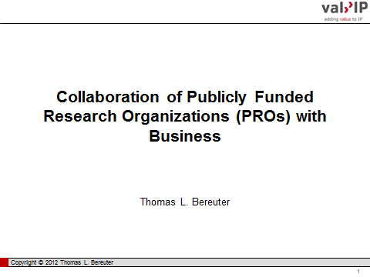 | 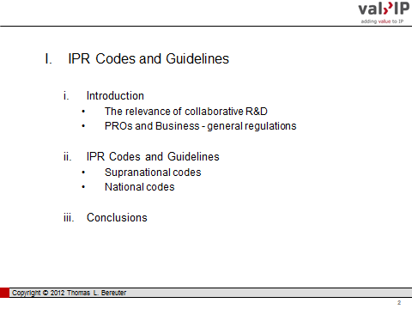
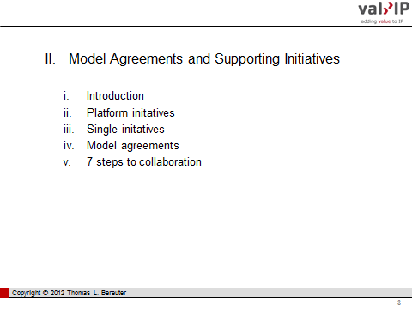 | 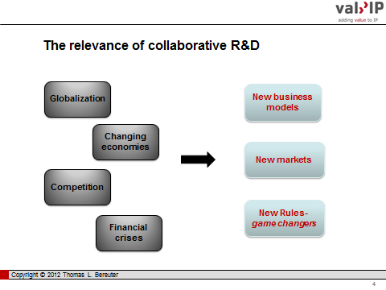
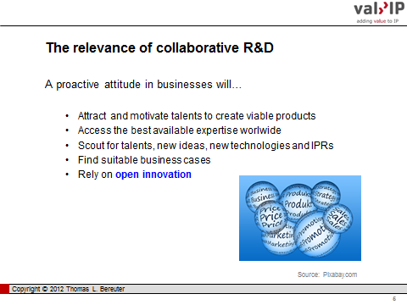 |  |  |  | 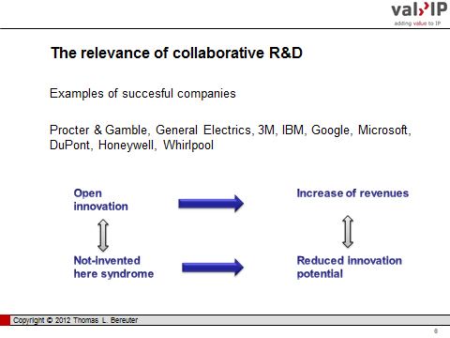
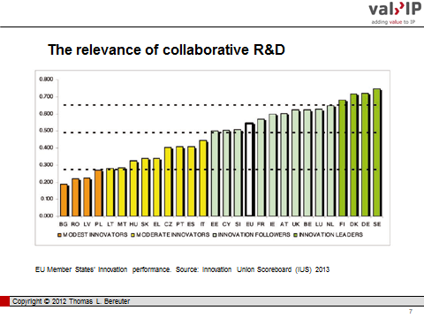 |  |  |  |  |  |  | 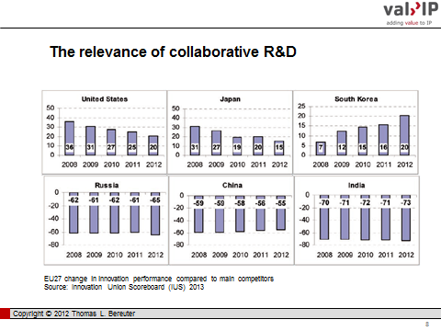
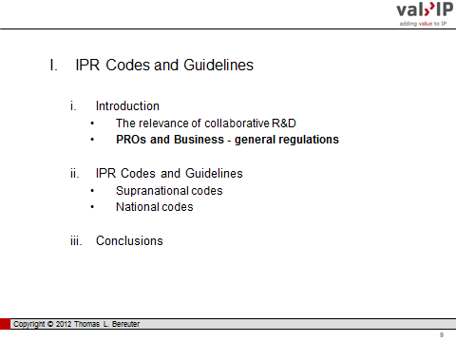 |  |  |  |  |  |  | 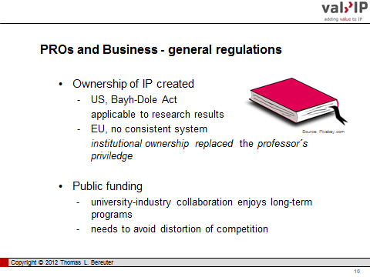
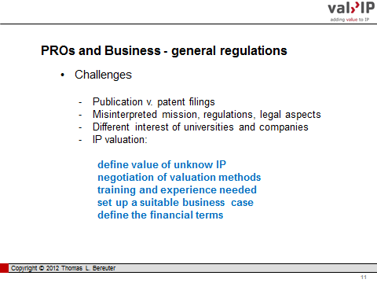 |  |  |  |  |  |  | 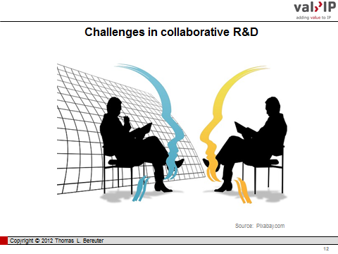
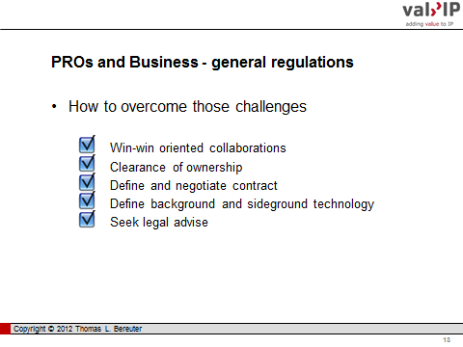 |  | 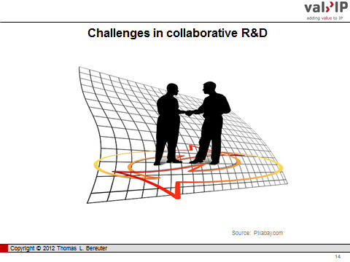
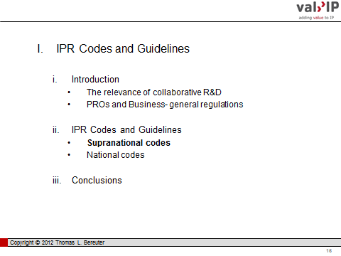 |  | 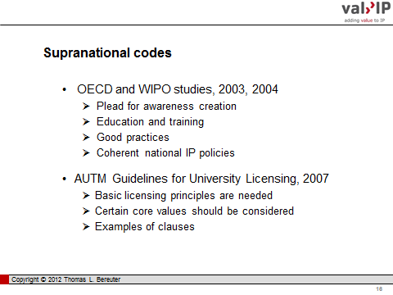
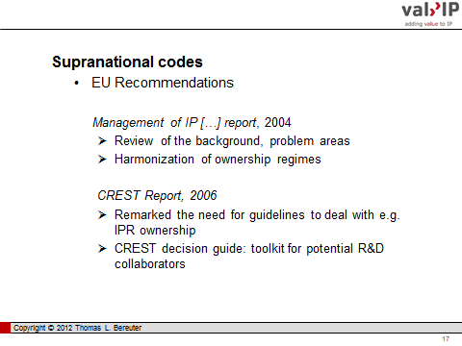 |  |  |  |  | 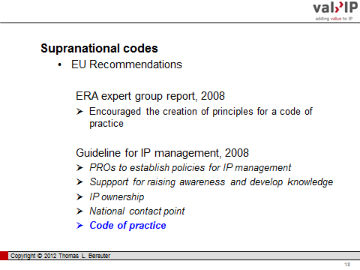
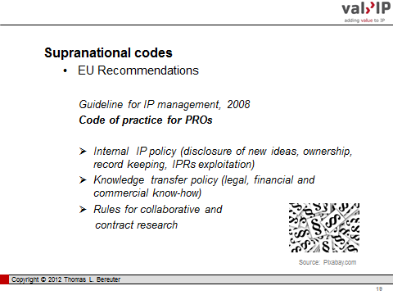 |  |  |  |  | 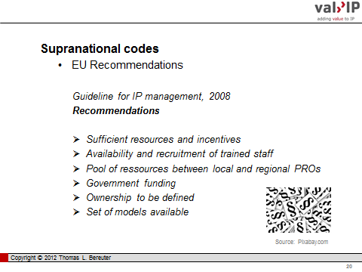
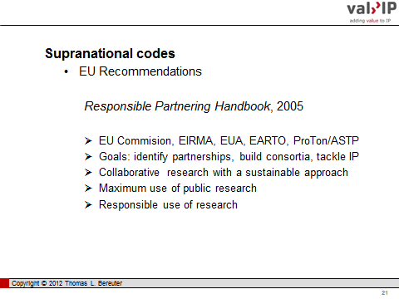 |  |  |  |  |  | 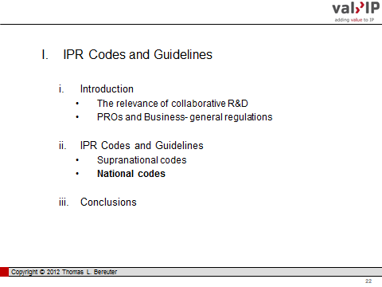
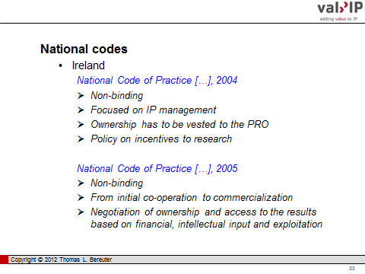 |  |  |  |  |  | 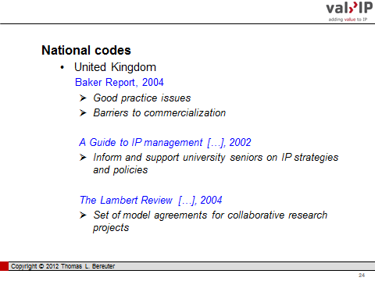
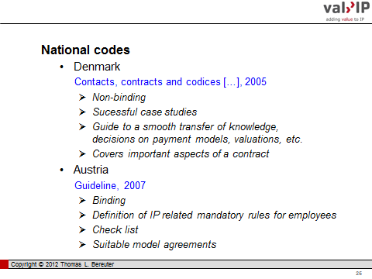 |  |  | 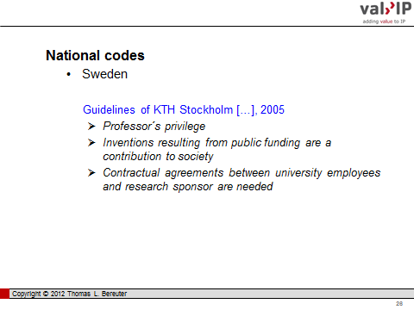
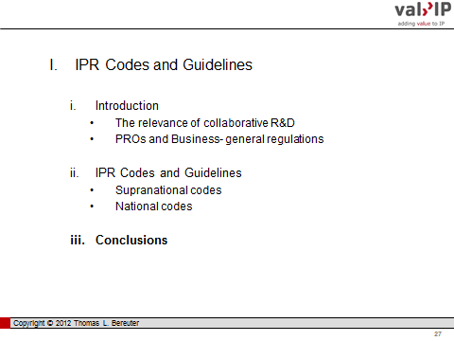 |  |  | 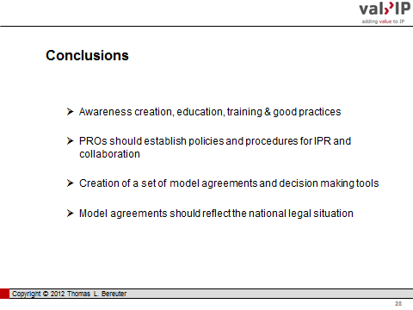
 | 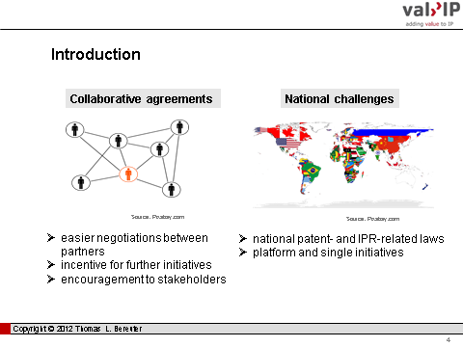
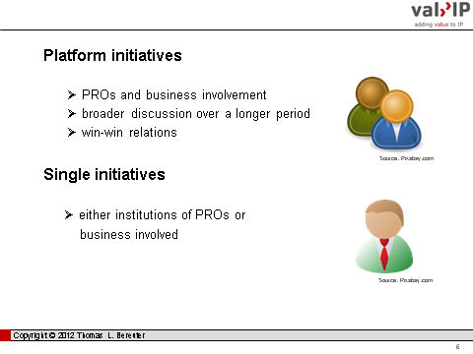 | 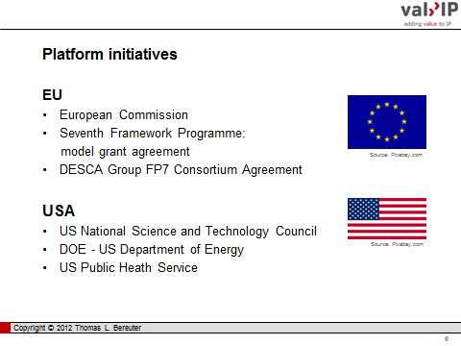
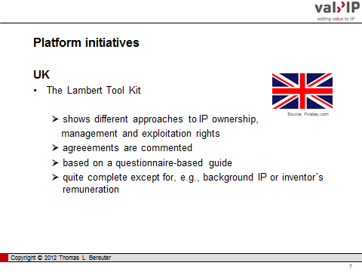 | 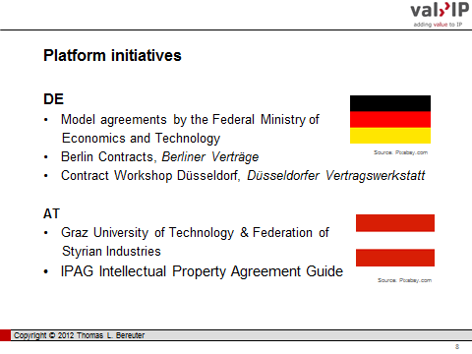
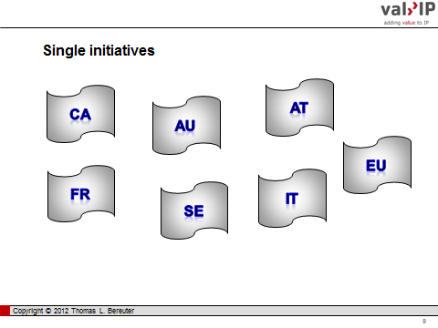 | 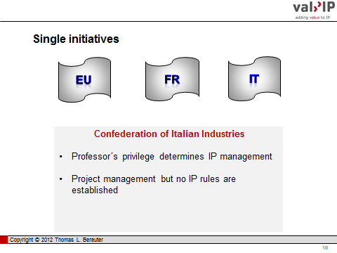
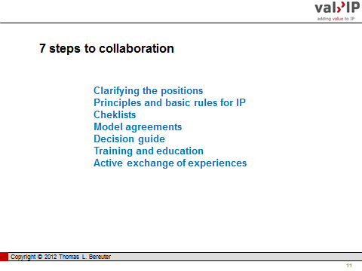 | 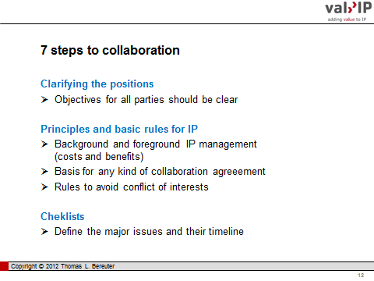
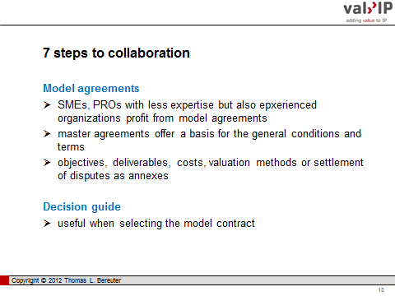 | 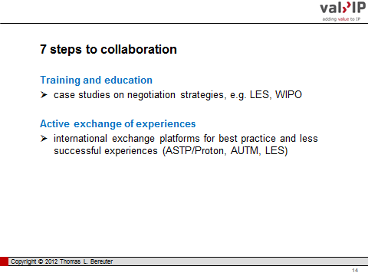
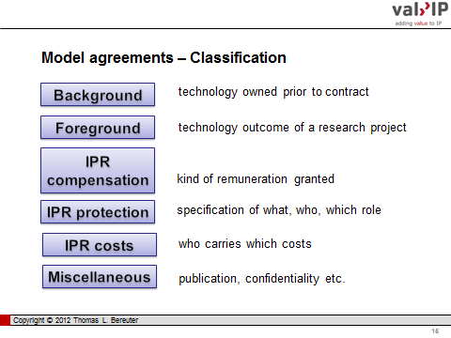 | 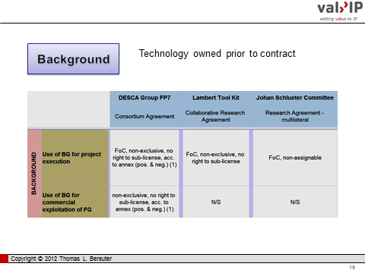
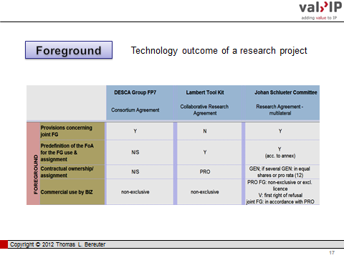
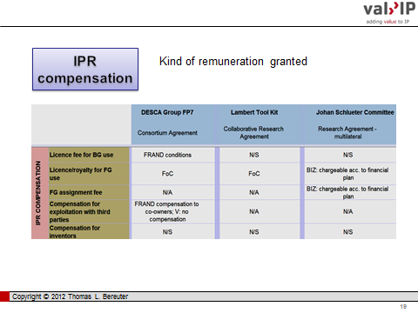 | 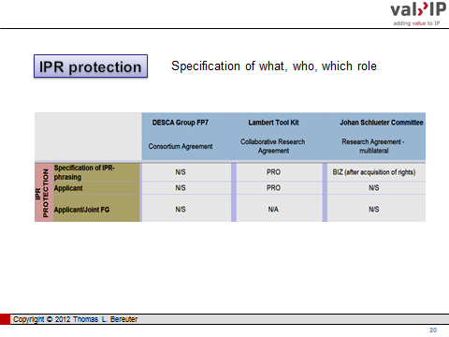
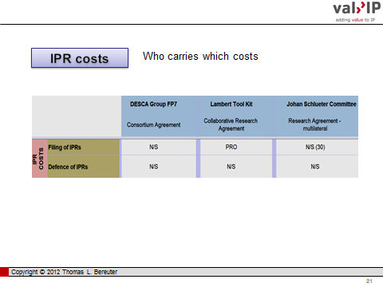 | 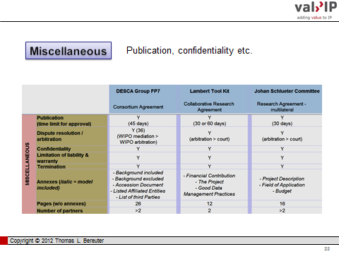
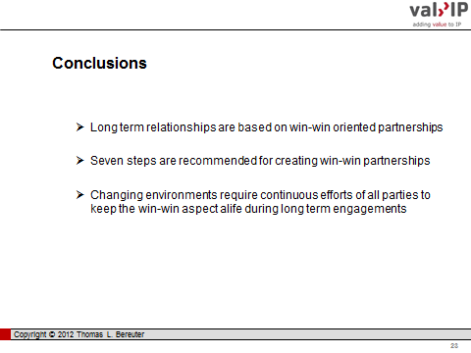 | 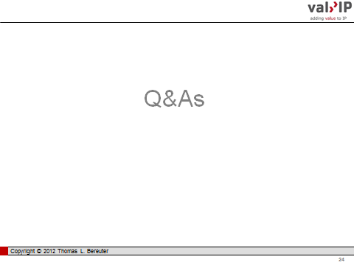
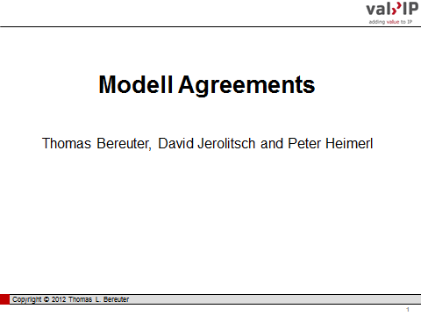 | 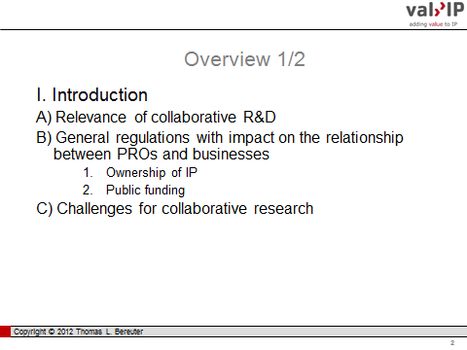
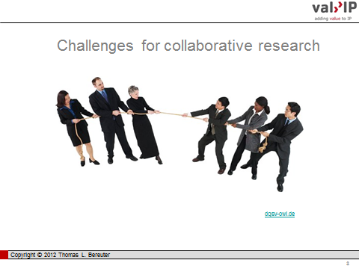 | 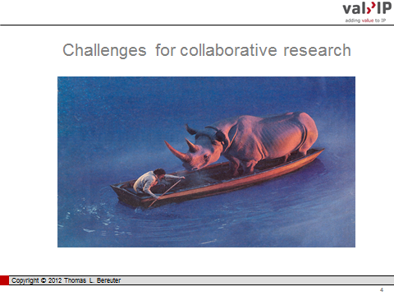
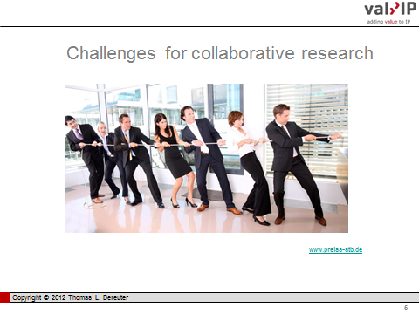 | 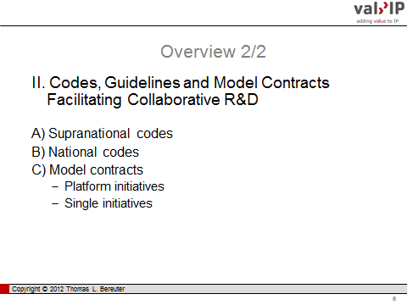
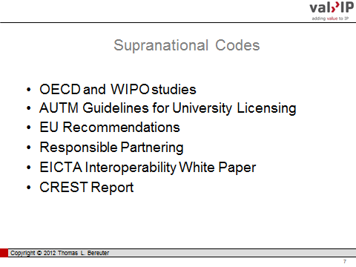 | 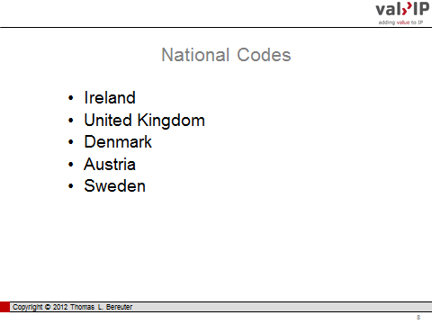
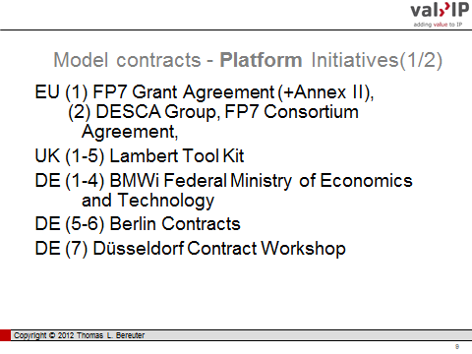 | 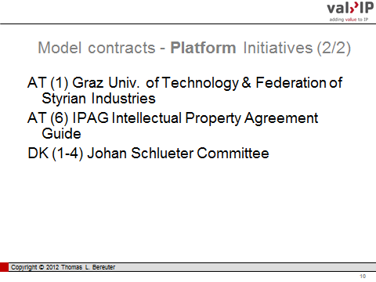
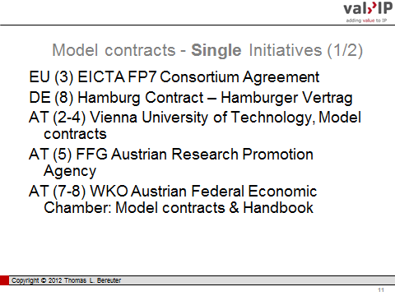 | 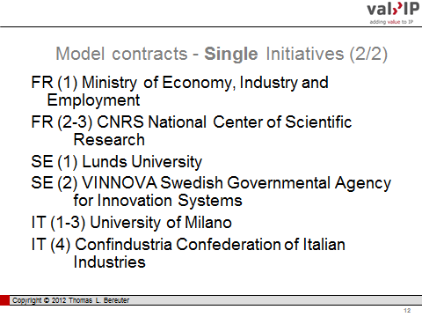
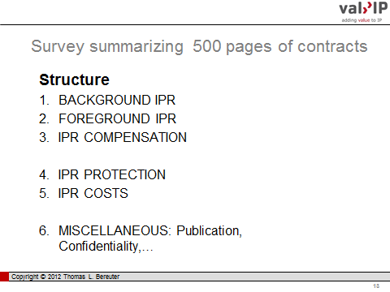 | 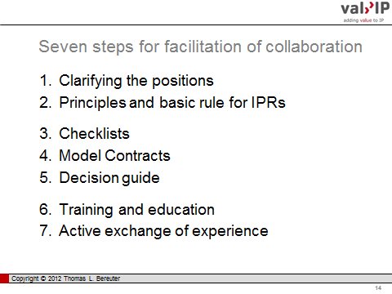
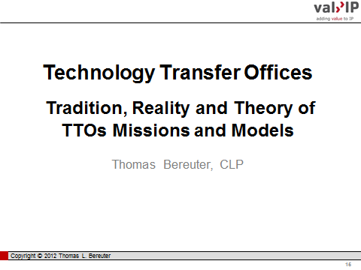 | 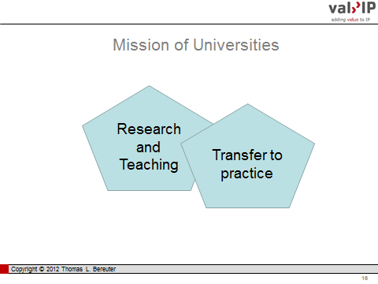
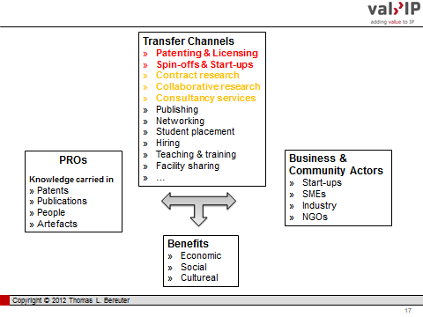 | 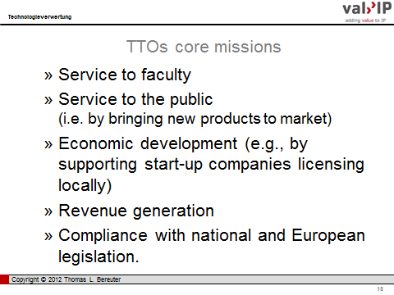
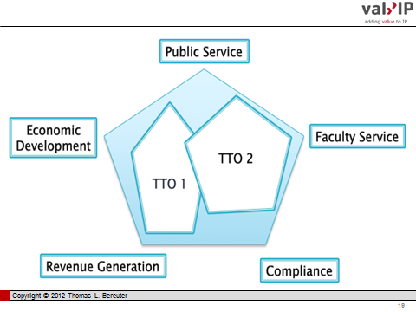 | 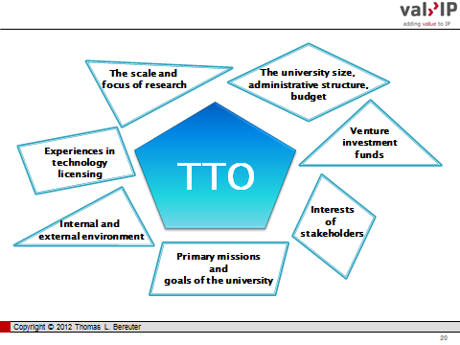
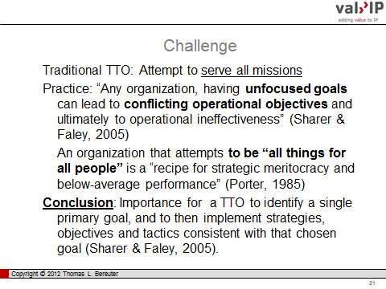 | 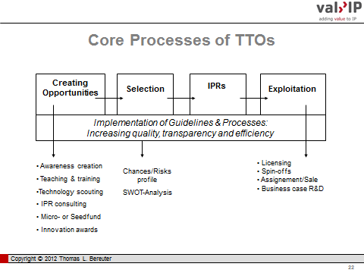
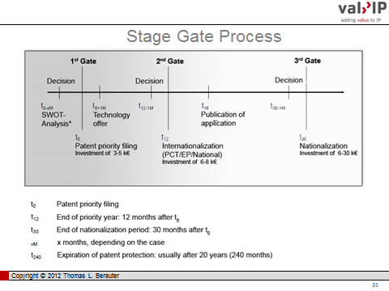 | 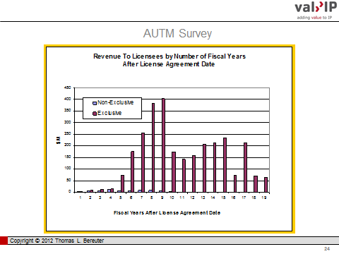
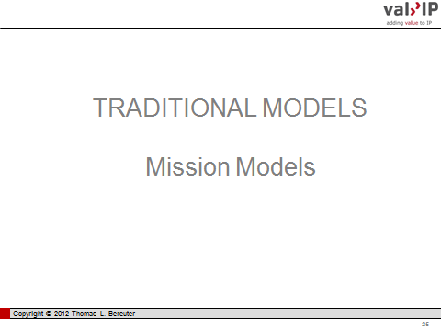 | 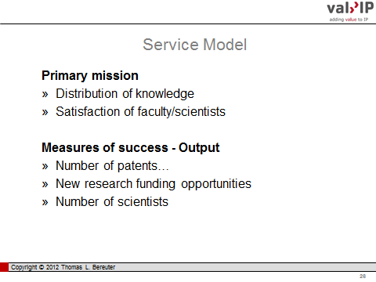
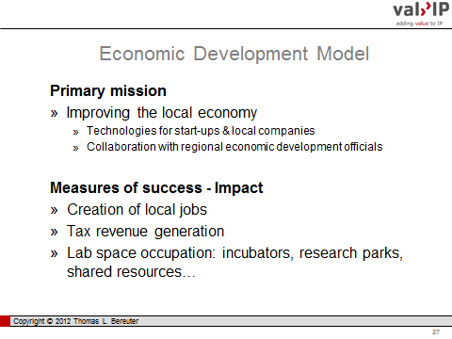 | 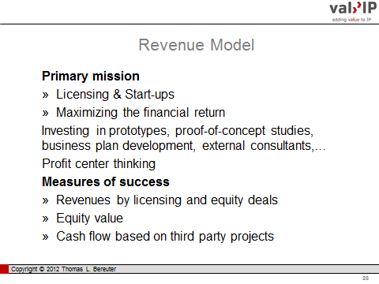
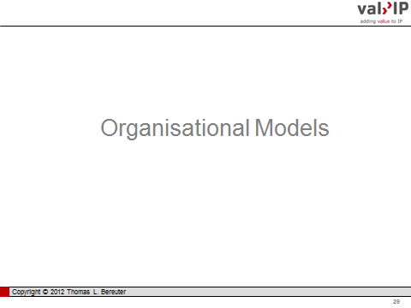 | 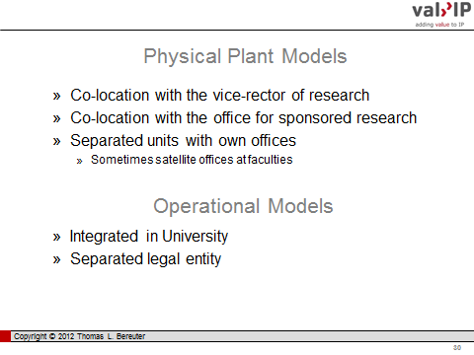
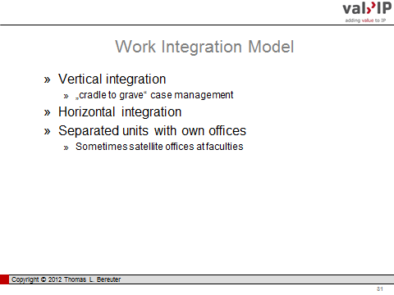 | 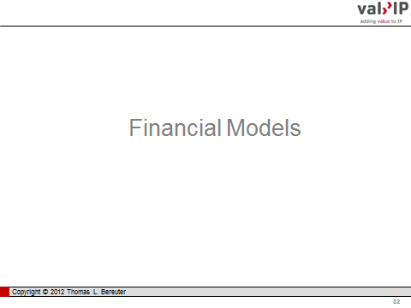
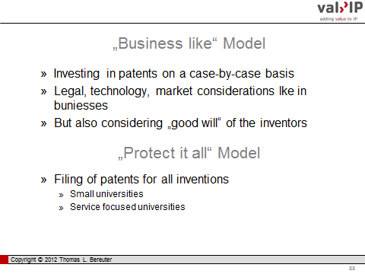 | 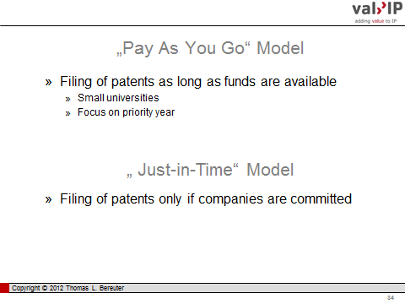
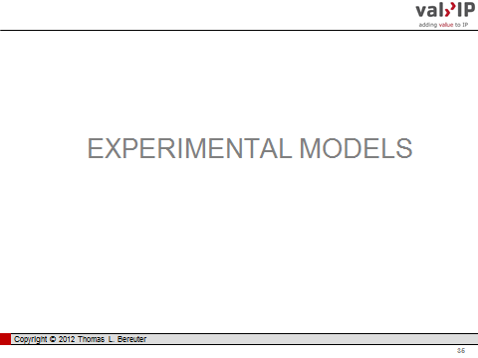 | 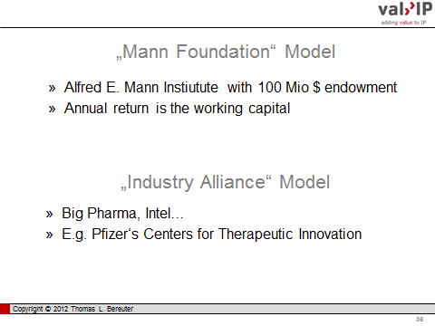
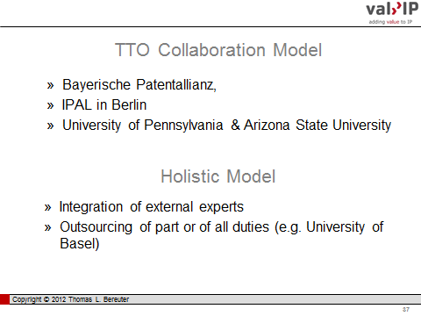 | 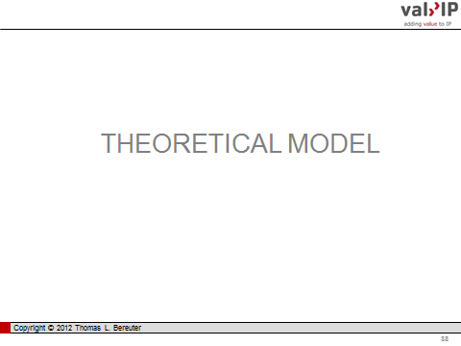
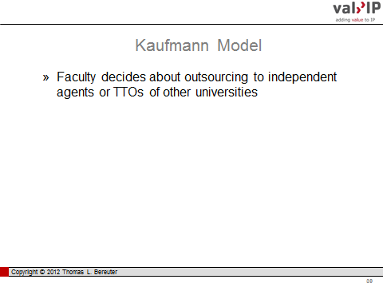 | 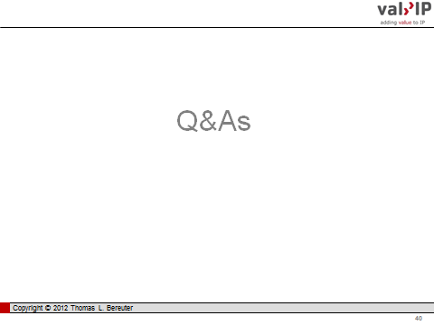

  - Use of Background Technology for Execution of the Project
Definition:
Background technology (BG) is owned by one contracting partner prior to entering into an agreement. In most cases Background (technology) does not refer to a particular kind of IPR and does not necessarily need to be protected or protectable intellectual property. It includes all kinds of IPRs such as copyrights, patented inventions, source code or other not further specified kind of know how.
Background technology usually is clearly differentiated from Sideground technology, which is generated by one contracting partner in parallel and independent to the collaboration project.
In contrast to Background, Foreground is technology generated within the scope of the project defined in the contract.
What BG is needed for?
Background usually needs to be defined and discussed because it is the basis on which the joint research project builds on. Partners with significant Background in a certain field are more attractive to be involved in collaborative research.
It is in the interest of each partner that Background technology is available in the required extent to perform the project. In addition Background technology might also be required for commercialisation of the Foreground technology. Each partner has the opportunity to declare in the contract under which conditions his Background technology is provided to whom, for how long, for which purpose and under which conditions.
Motivation:
The availability of Background technology for the execution of the project in the required extent, to the partners which need it and under defined conditions is standard practice. In order to avoid misunderstanding between the partners, sometimes particular Background technology is also listed for exclusion as it is outside the scope of a project. In the first hand this does not seem to be necessary as the Background could just be not disclosed to the other partners. Bearing in mind, that most projects, at least from the industrial partner’s point of view, are meant to generate directly or indirectly exploitable IPR, the importance of defining background technology becomes more clear. At the end of the project it always should be clear who can use and exploit which technology under what conditions. Therefore, Background needs to be separated as clearly as possible from Foreground and Sideground technology.
Further details defining the use of Background like time, scope, etc. might be added to avoid any misunderstandings. The critical point in most cases is the availability of required Background technology for the use of newly developed Foreground technology which will be discussed in 2.1.

Points to consider:
- Use of Background technology has to be granted in the required extent at predefined conditions for the execution of the project.
- Use of Background might also be granted in the required extent at predefined conditions for the use of Foreground technology.
- Background technology should be defined clearly (usually in the annex of the agreement).
Options for wording
Balanced: Lambert/UK..: This Agreement does not affect the ownership of any Intellectual Property in any Background or in any other technology, design, work, invention, software, data, technique, Know-how, or materials that are not Results. The Intellectual Property in them will remain the property of the party that contributes them to the Project (or its licensors). No licence to use any Intellectual Property is granted or implied by this Agreement except the rights expressly granted in this Agreement. Each Party grants the other a royalty-free, non-exclusive licence to use its Background for the purpose of carrying out the Project, but for no other purpose. Neither party may grant any sub-licence to use the other's Background except that the Sponsor may allow its Group Companies, and any person working for or on behalf of the Sponsor or any Group Company, to use the University's Background for the purpose of carrying out the Project, but for no other purpose.
Complete: Germany/DE..: Die Altrechte verbleiben grundsätzlich beim jeweiligen Inhaber. 5.2 Alle Vertragspartner informieren sich gegenseitig und fortlaufend über derartige Altrechte einschließlich solcher, die trotz fehlender Inhaberstellung in ihrer Verfügungsmacht sind (z. B., weil sie einer Patentverwertungsagentur der Hochschule übertragen sind), nach bestem Wissen, unter Anwendung der erforderlichen Sorgfalt und vollständig, soweit diese Altrechte voraussichtlich für die Nutzung der Ergebnisse erforderlich sind. Die Informationspflicht umfasst auch die Information darüber, ob und inwieweit der jeweilige Inhaber bei der Nutzung dieser Altrechte, etwa durch Nutzungsberechtigungen Dritter, beschränkt ist. Hinsichtlich des Industriepartners gilt die vorgenannte Verpflichtung nur nach entsprechender Anforderung der Hochschule/Forschungseinrichtung und soweit die Altrechte bereits der Öffentlichkeit zugänglich sind. 5.3 Für diejenigen Altrechte, die für die Durchführung dieses Vertrages oder für die kommerzielle Nutzung der Ergebnisse durch den Industriepartner erforderlich sind, gilt Folgendes: 5.3.1 Der jeweils berechtigte Vertragspartner räumt dem jeweils anderen Vertragspartner ein auf die Dauer und die Zwecke dieses Vertrages begrenztes, unentgeltliches und nicht-ausschließliches Nutzungsrecht für die Durchführung dieses Vertrages ein, wenn und soweit er in der Nutzung des betreffenden Altrechts nicht beschränkt ist.
Short: Schlueter/DK..: During the term of the Project, the Parties shall grant each other free access to use their respective Background and Foreground Knowledge for the purpose of completing the Project. This access right shall only apply to work in connection with the Project and shall not be used for commercial purposes or transferred to a third party.

1.2 Use of Background Technology for Commercial Exploitation of Foreground Technology
What it is needed for?
As mentioned in 1.1., Background usually establishes the basis for entering into a joint research project. Starting from the offset point of Background, the outcome of a research project is the development of new Foreground technology. The business partner usually requires technology enabling a competitive advantage, e.g. by the development of new products, processes or services which can be commercialised. This requires freedom-to-operate! If the commercialisation of the Foreground is dependent on the availability of Background, the business partner needs to make sure that he finally can obtain all required rights available from the PRO at defined conditions. The PRO on the other hand usually wants to be rewarded for Background provided by him, in particular if Background is used commercially. Furthermore, the PRO intends to secure best use of the potential of the Background and, therefore, usually wants to keep rights required for future internal but also collaborative R&D. Therefore, the need for definition of the rules regarding Background technology is important to all parties.
Motivation
The availability of Background for the exploitation of project results is not mentioned in all model contracts. As long as it is not clear what precisely is the outcome of the project it often is not clear if the Background would be required to commercialise the results. In addition it can become a tricky point to regulate potentially leading to time consuming negations. Business partners which have encountered the problem of finding out, after the project ended, that they are not free to commercialise the Foreground due to lack of rights for the Background for which they need to pay in addition, are well motivated to negotiate this issue before the project starts. Finally, this is of utmost importance for creating a sound basis for a longterm win win relationship. Therefore, the mentioned (1.1) definition of background (either positive or negative) is the most successful prerequisite to ensure security for both sides. Some companies even demand that Background that is not listed but proves to be required, is provided for free in order to safeguard the upfront negotiation.
When it comes to the details of the conditions for the use of Background for commercialisation of the Foreground technology there are different options. In those cases where it is questionable that the Background might be required for this purpose the minimum requirement might be met by stating, that the use of BG is subject to fair and reasonable or market conditions which needs to be defined in another contract. Of course it is best practice to define “fair and reasonable” or “market” conditions. Furthermore, it might be important to define a certain period after the end of the contract, in which Background technology is made available on a request basis.
The definition of further details might focus on the mechanisms required to prevent or settle a potential escalation by mediation and/or arbitration. Anyway, some research contracts define further details, such as the minimum terms of a granted licence, which often are, that a licence is granted in a defined field of application, with no right to sublicense, non-exclusive, irrevocable, for specific countries only. The more one can define upfront the lesser the risk for a later escalation or for a blocked commercialisation .

Points to consider
- Minimum requirements:
  - List of Background included and/or excluded
  - Define - if required – that Background can be used for exploitation of Foreground technology.
  - Clarify at least the basics of the financial terms of the corresponding use (in most cases “fair and reasonable” or “market” conditions).
  - Clarify the time frame for the availability of Background for being claimed for use after the completion of the project.

- Further terms to be considered:
  - Terms of a licence granted: e.g. non-exclusive, non-assignable, no right to sublicense, in a certain field of application, nevertheless irrevocable and with no limeted time frame for the use of Background.
  - Clear limitation of the use of Background for the exploitation of Foreground technology.

Options for wording
Balanced: FP-7/EU...: […] Beneficiaries shall enjoy access rights to background, if it is needed to use their own foreground provided that the beneficiary concerned is entitled to grant them. Subject to agreement, such access rights shall be granted either under fair and reasonable conditions or be royalty-free. […] . A request for access rights under paragraphs 1, 2 or 3 may be made up to one year after either of the following events: a) the end of the project; or b) termination of participation by the owner of the background or foreground concerned. However, the beneficiaries concerned may agree on a different time-limit.
Complete: Desca/EU…: For the avoidance of doubt, a Party shall not publish Foreground or Background of another Party, even if such Foreground or Background is amalgamated with the Party’s Foreground, without the other Party’s prior written approval. For the avoidance of doubt, the mere absence of an objection according to 8.3.1 is not considered as an approval. […]The Parties shall identify in the Attachment 1 the Background to which they are ready to grant Access Rights, subject to the provisions of this Consortium Agreement and the EC-GA. Such identification may be done by e.g. - subject matter and possibly in addition by - naming a specific department of a Party 9.1.2 The owning Party may add further Background to Attachment 1 during the Project by written notice. However, only the General Assembly can permit a Party to withdraw any of its Background from Attachment 1. 9.1.3 The Parties agree that all Background not listed in Attachment 1 shall be explicitly excluded from Access Rights. The Parties agree, however, to negotiate in good faith additions to Attachment 1 if a Party asks them to do so and those are needed. For the avoidance of doubt, the owner is under no obligation to agree to additions of his Background to Attachment 1. 9.1.4 In addition, if a Party wishes to list specific Background as excluded, it shall identify such Background in the Attachment 2. The owning Party may withdraw any of its Background from Attachment 2 during the Project by written notice. However, only the General Assembly can permit a Party to add Background to Attachment 2. […]
Short: Crada/US…: […] Licensing of Background Intellectual Property, if agreed to by the Parties, shall be the subject of separate licensing agreements between the Parties. Background Intellectual Properties are not Subject Inventions.

[End of document]

The views expressed in the document are those of the authors, and not necessarily those of the WIPO Secretariat or its Member States
Alan G. Lafley and Ram Charan, “The Game Changer: How You Can Drive Revenue and Profit Growth with Innovation”, Crown Business, New York, 2008, ISBN 0307381730.
Henry Chesbrough, “Open Innovation: The New Imperative for Creating and Profiting from Technologies”, Harvard Business School Press, Boston, 2003, ISBN 1578518377.
Definition according to www.responsible-partnering.org: Publicly-Funded Research Organizations are any institutions - universities or in general all higher education institutions, Research and Technology Organizations and others - that carry out R&D for broader application and benefit, to a significant extent using public funding.
Innovation is a successful economic transformation of an idea resulting in to a new product, process, marketing or organization. Cf. OECD’s Oslo manual: www.oecd.org/document/33/0,3746,en_2649_34451_35595607_1_1_1_1,00.html.
Rolf-Christian Wentz, “Die Innovationsmaschine: Wie die weltbesten Unternehmen Innovationen managen”, Springer, Berlin, 2007, ISBN: 3540736263.
Andreas von Bubnoff, “Asia squeezes Europe's lead in science: Global share of scientific output rises in the East“, Nature 436 (21st July 2005) 314, doi:10.1038/436314a, www.nature.com/nature/journal/v436/n7049/full/436314a.html
www.proinno-europe.eu/inno-metrics/page/innovation-union-scoreboard-2011
ec.europa.eu/research/innovation-union/index_en.cfm
Bayh-Dole Act was enacted by the congress of the U.S. Congress in December 1980 as University and Small Business Patent Procedures Act; 2010 marks the 30th anniversary of the Act – cf. www.b-d30.org.
Thomas L. Bereuter, Peter Heimerl, “Lost in Translation: A European Perspective of Bayh-Dole”, les Nouvelles 45 (4) (2010) 248-251.
www.ffg.at, www.cdg.ac.at
europa.eu/legislation_summaries/competition/state_aid/l26121_en.htm
ec.europa.eu/competition/state_aid/reform/archive_docs/rdi_frame_en.pdf
Ibid: OJ No C323 of 30.12.2006 – in particular 3.2.1 and 3.2.2 thereof.
For elucidation of a market price benchmarks can found at private R&D companies which are working for profit.
Full costs are not just additional costs plus an overhead of e.g. 20%. The EU accepts within its funding programs 60% as an flat rate for overhead. For coming closer to reality, an even significantly higher percentage needs to be added. At Graz University of Technology e.g. the real overhead for personnel expenditures calculated for 2009 was 81,88%.
Joe Sandelin, “University-industry relationships: benefits and risks”, Industry & Higher Education, 24 (2010) 55-62.
Draft report on the outcomes of the “Public consultation on transnational research co-operation and knowledge transfer between public research organizations and industry”, M1-FM/DD (D 2006), ec.europa.eu/invest-in-research/pdf/download_en/consult_report.pdf
Organization for Economic Co-operation and Development (OECD), Turning Science into Business; Patenting and Licensing at Public Research Institutions, 2003/4, www.oecd.org/document/61/0,3746,en_21571361_21590465_2513917_1_1_1_1,00.html
In Austria the implementation of the recommendations of the EC is part of the service level agreement for the years 2010-2012 of nearly all universities closed with the Federal Ministry for Science and Research. Consequently, best efforts to its implementation have to be undertaken by the universities otherwise governmental funding might be reduced.
Organization for Economic Co-operation and Development (OECD), Turning Science into Business: Patenting and Licensing at Public Research Organizations, 2003.
World Intellectual Property Organization (WIPO), SMEs Division, Research and Innovation Issues in University–Industry Relations, 06.12.2004.
AUTM was founded in the U.S. but has turned to global focus linking and strengthening a network of global communities of technology transfer professionals. The Nine Points to Consider are endorsed on behalf of more and more institutions worldwide. www.autm.net/Nine_Points_to_Consider.htm
“Investing in Europe”, ec.europa.eu/invest-in-research/index_en.htm, “Innovation union”, ec.europa.eu/research/innovation-union/index_en.cfm.
“Management of intellectual property in publicly-funded research organisations: Towards European Guidelines”, 2004, Expert Group Report, WP EUR 20915 EN, ISBN 92-894-6422-4, ec.europa.eu/research/era/pdf/iprmanagementguidelines-report.pdf
“Intellectual property Cross-border collaboration between publicly funded research organisations and industry and technology transfer training”, Crest Report, 2006 - 2nd cycle, September 2006, ec.europa.eu/invest-in-research/pdf/download_en/kina20796enc.pdf
European Commission, Directorate-General for Research, Report of the ERA Expert Group,“Knowledge sharing in the European Research Area (ERA)”, 2008, DOI 10.2777/34138 http://ec.europa.eu/research/era/pdf/era-gp-eg4_en.pdf
ec.europa.eu/invest-in-research/policy/crest_cross_en.htm
“The management of intellectual property by public research organizations”, europa.eu/legislation_summaries/research_innovation/general_framework/ri0007_en.htm
Commission recommendation on the management of intellectual property in knowledge transfer activities and Code of Practice for universities and other public research organisations. Brussels, 10.04.2008, C(2008)1329, ec.europa.eu/invest-in-research/pdf/ip_recommendation_en.pdf
In Austria e.g. a national contact point (NCP) has been designated at the Federal Ministry of Science and Research, which is assisted by the Federal Ministry of Economy, Family and Youth, and the Federal Ministry of Transport, Innovation and Technology. www.ncp-ip.at
“Joining forces in a world of open innovation, a guide to better practices in collaborative research between science and industry”, 2009, www.responsible-partnering.org or 2005, www.chem.hit.bg/data.htm
www.forfas.ie/publications/2004/title,827,en.php
www.forfas.ie/publication/search.jsp?ft=/publications/2005/Title,785,en.php
SFI Terms and Conditions of Research Grants, August 2006 Edition, at www.sfi.ie
www.hm-treasury.gov.uk/ent_sme_baker.htm
www.ipo.gov.uk/managingipoverview.pdf
Richard Lambert: former editor of the Financial Times and formerly a member of the Monetary Policy Committee at the Bank of England and then Director General of the CBI Confederation of British Industry.
di.dk/English/Shop/Productpage/Pages/isdefault.aspx?productid=2684
mibla.tugraz.at/07_08/Stk_12/080319_Richtlinie_IPR_Wirtschaftskooperationen.pdf
A working group organized by the Austrian universities in co-operation with aws, a public funding agency for businesses, is working on a guideline in the form of a manual with modular units for agreements to cover collaborations between universities and businesses. www.era.gv.at/space/11442/directory/20288.html
Patent-och exploateringspolicy vid KTH, intra.kth.se/regelverk/overgripande-styrning/upphovsratt/patent-och-exploateringspolicy-vid-kth-1.27147
“University Business Dialogue: a new partnership for the modernisation of Europe's universities”, May 20th 2010, Strasbourg P7_TA-PROV(2010)0187, A7-0108/2010, www.europarl.europa.eu/sides/getDoc.do?pubRef=-//EP//TEXT+TA+P7-TA-2010-0187+0+DOC+XML+V0//EN#def_1_5
ec.europa.eu/invest-in-research/policy/crest_cross_en.htm
www.autm.net, restricted member’s area but membership is open to all interested worldwide.
www.desca-fp7.eu/fileadmin/content/Documents/Model_for_Material_Transfer_Agreement_2008_09_18.doc
Two examples of other jurisdictions which are not covered in the survey: (i) The research promotion agency of the Republic of Cyprus has published a consortium agreement in Greek and in English www.research.org.cy/EN/national_programmes/info_received_funds/consortium_agreement.html (ii) The SAIT Global Research Outreach (GRO) Program is Samsung Advanced Institute of Technology’s annual call for proposal, open to world's leading universities. SAIT invites novel research ideas in SAIT's research fields. The submitted ideas are reviewed and selected by annually appointed SAIT technology board members for its novelty and alignment with SAIT's research direction. (www.sait.samsung.com/upload/join/2011_GRO_Research%20Subject%20description_1st.pdf)]. Selected proposals will be financially supported for one year, contract based, in a range of US $50,000 to US $100,000, including any overhead. Based on research outcomes and internal request for research continuance the contract may be renewed up to three years. The contract is focused on the interest of Samsung and might cause problems in several jurisdictions outside of Korea.
cordis.europa.eu/fp7/calls-grant-agreement_en.html#ideas_ga - Annex II
ec.europa.eu/research/fp7/pdf/ipr_prov_expl_en.pdf
European Commission, Directorate-General for Research, Report of the ERA Expert Group,“Knowledge sharing in the European Research Area (ERA)”, 2008, DOI 10.2777/34138 ec.europa.eu/research/era/pdf/era-gp-eg4_en.pdf
ec.europa.eu/invest-in-research/policy/crest_cross_en.htm
www.earto.eu/uploads/media/Comparison_of_FP7_consortium_agreement_models.pdf
DESCA was initiated by ANRT (www.anrt.asso.fr), the German CA-Team (represented by Helmholtz - www.helmholtz.de and KoWi - www.kowi.de), EARTO (www.earto.eu), Eurochambres (www.eurochambres.be), and UNITE (www.unite.be).
www.responsible-partnering.org
Kathrin Werner, DESCA coordinator, “IP Provisions in FP7 Consortium Agreements”, Conference on Licensing, Transfer of Ownership and Dispute Resolution - Commercialization of Intellectual Property Generated in International R&D Projects, WIPO-FFG-LES, Vienna, 01.06.2012, www.wipo.int/amc/en/events/workshops/2012/vienna/index.html.
www.gpo.gov/fdsys/pkg/FR-2008-01-25/pdf/E8-1262.pdf The Standard Terms and Conditions resulted from an initiative of the Research Business Models (RBM) Subcommittee of the Committee on Science of the NSTC.
www.nsf.gov/bfa/dias/policy/rtc/index.jsp
During 2008 DOE was engaged in more than 12,000 technology transfer transactions including 700 contract research agreements, 2500 sponsored research agreements, more than 2800 user facility agreements, and more than 6,000 licenses. DOE reported more than 1400 inventions and was filing more than 900 patent applications with nearly 400 patents issued.
Two or three-dimensional layout or topography of an integrated circuit, i.e. the arrangement on a chip of semiconductor devices.
www.ott.nih.gov/about_nih/statistics.aspx In 2011, OTT has processed for NIH and FDA 351 invention disclosures and 75 priority filings in the U.S. For NIH the OTT executed 68 cooperation agreements.
In analogy, extramural recipients of NIH funds like universities, are allowed to claim ownership for inventions arising from their NIH-funded research and license those rights to private entities to promote commercialization.
Matthew W. Sagal, Gene Slowinski, Kenneth Freese and Steven Ferguson, “Intellectual Property And Other Contractual Issues In Cooperative Research And Development Agreements (CRADAs): Part I”, les Nouvelles, XLIV_(1) (2009)_ 41-48. Matthew W. Sagal, Gene Slowinski, Kenneth Freese and Steven Ferguson, “Intellectual Property And Other Contractual Issues In Cooperative Research And Development Agreements (CRADAs): Part II”, les Nouvelles, XLIV_(2) (2009)_ 79-86.
Lambert Review of Business-University Collaboration: www.hm-treasury.gov.uk/d/lambert_review_final_450.pdf
?www.innovation.gov.uk/lambertagreements
PraxisUnico is an educational not-for-profit organization set up to support innovation and commercialization of public sector and charity research for social and economic impact. www.praxisunico.org.uk
Department for Innovation, Universities and Skills was merged 2009 with the Department for Business, Enterprise and Regulatory Reform creating BIS The Department for Business, Innovation and Skills. www.bis.gov.uk
www.ukcrc.org/regulationgovernance/modelagreements/mctaanddownloads/
www.nihr.ac.uk/infrastructure/Pages/micra.aspx
Marburg Contract, Max Planck Contract, Munich Contract, NRW Contract, Hamburg Contract
ipal GmbH assesses and exclusively markets the inventions of Berlin`s PROs. www.ipal.de
www.gewrs.de/kooperation-und-arbeitskreise/apud.html
www.ipag.at
www.digitaleurope.org
For FP6 there was a much broader platform initiative engaged than for FP7 including EICTA, EARTO (European Association of Research and Technology Organisations), TNOCG (Telecommunications Network Operators' Contracts Group) and UNITE (Group of European Universities). The groups involved have been able to reach a consensus on all sections of the IPCA, except the section IV related to IPR and Access Rights. Finally there was an IPCA EICTA-TNO and an IPCA EARTO-UNITE version of section IV published. www.eurovolvox.org/Private/Administration/PDF/CA08Dec04.pdf
At that time a regulation called “limited legal capacity” of the University was still in place in Austria. Institutes of a university had several rights (e.g. signing of contracts with third parties of their own behalf; employment of additional, project-financed researchers; control of IPR if generated by university’s researchers within an externally funded project and not promised beforehand to the business-partner). The management of the university in general and of IPR in particular –changed with the enactment of new university legislation in 2004 and rests now with the university.
wko.at/wknoe/rp/gesamtangebot_wirtschaftsrecht.htm
“Kooperationen in Forschung und Entwicklung – Erfolgsfaktoren, Chancen, Tipps & Tricks“, Innovation–Schriftenreihe des Wirtschaftsförderungsinstitutes, Nr. 335, portal.wko.at/wk/dok_detail_file.wk?AngID=1&DocID=813485&ConID=305408
Wirtschaftsförderungsinstitut, www.wifi.at
www5.lu.se/upload/Juridiskaenheten/GeneralTermsforContractResearch-2009-04-27.doc
An example for how this can be summarized in the form of a simplified communication can be found in the manual with model contracts of the BMWi Federal Ministry of Economics and Technology on page 8-9, www.bmwi.de/BMWi/Navigation/Service/publikationen,did=342954.html
Joe Sandelin, “University-industry relationships: benefits and risks”, Industry & Higher Education, 24 (2010) 55-62.
The Berlin Contracts include a proposal for valuation principles whereas the Düsseldorf Contract Workshop has developed their own valuation model.
Delayed decisions due to a lack of agreement might cause severe problem for IPR exploitation. In case of defining a fair royalty e.g. the decision might be outsourced to independent experts if negotiations failed within in a defined time period.

