 |  | E
CDIP/14/INF/4
ORIGINAL: english
DATE: SEPTEMBER 9, 2014

Committee on Development and Intellectual Property (CDIP)

Fourteenth Session
Geneva, November 10 to 14, 2014

study on The impact of Utility Models in Thailand

prepared by the Secretariat in cooperation with Ms. Deunden Nikomborirak, Research Director, Economic Governance, and Ms. Weerawan Paibunkott-aree, Senior Researcher, Sectoral Economic Program, Thailand Development Research Institute, Thailand

1. The Annex to this document contains a Study on the Impact of Utility Models in Thailand prepared under the Project on Intellectual Property and Socio-Economic Development (CDIP/5/7 Rev.), approved by the Committee on Development and Intellectual Property (CDIP) at its Fifth Session held in April 2010. This study complements an earlier document on the descriptive analysis of the implementation and use of utility models (UMs) in Thailand, which was presented at the Twelfth Session of the CDIP in November 18 to 21, 2013. Building on a detailed and novel unit record data on UM registration, the present document examines how utility model affects local firm performance in Thailand.

2. The CDIP is invited to take note of the information contained in the Annex to this document.

[Annex follows]

How Utility Models Affect Local Firm Performance in Thailand

EXECUTIVE SUMMARY

The present document is an output of the Project on Intellectual Property and Socio-Economic Development of the Committee on Development and Intellectual Property (CDIP), which consists of a series of economic studies that seeks to provide evidence on the effects of intellectual property (IP) protection in less developed countries. In particular, this study investigates the impact of utility model (UM) protection in Thailand, an upper-middle income country. The results of this country study are divided in two parts: the first document provided a descriptive analysis on the use of UM protection in Thailand and was presented at the Twelfth Session of the CDIP in November, 2013. This second paper investigates how UM protection affects the economic performance of Thai companies.

To carry out this investigation, we relied on a novel and comprehensive database on UMs in Thailand built through a joint effort by the Thailand Development Research Institute (TDRI) and the World Intellectual Property Organization (WIPO), with close cooperation of the Thai Department of Intellectual Property (DIP) under the Ministry of Commerce. It contains all registered UM in Thailand from October 1996 to September 2012, as well as other related information. From this dataset, we singled out applications that were filed by, or attributable to, local firms for the years 1999 to 2012 and extended it to include firm-specific information.

Our research work is carried out in four parts. First, we assess if there is a link between filing for UM protection and the performance of the firms by observing if there has been an effect on the firms’ performances before and after filing for UM protection. Secondly, we try to determine if there are specific traits of firms that apply for UM protection. For example, it could be the case that firms in certain industrial sectors have higher propensity to file for UM protection than others. We then run econometric regressions to ascertain if there is an effect, and to determine the size of the effect of UM protection on the firms.

One way to observe the relationship between UM protection and the firms’ performance indicators is to graph these variables against one another. The subfigures in Figure E-1 are the timing of the firms’ UM application plotted against the three indicators of the firms’ financial performances: net sales, net profit and sales-to-cost ratio.

On average, firms that use UM seem to perform better after filing for UM across all three performance indicators, with several notable variations. Five years after filing for UM protection, the average Thai firm has six times more sales than it did five years preceding the application (a jump from one to six billion baht, roughly equivalent to USD 32.2 million and USD to 96 million, respectively). In a similar trend, once the average firm files for UM protection, its net profit increased from 20 million baht to 350 million baht (approx. USD 643,500 and USD 11.3 million respectively). And lastly, the sales-to-cost ratio trend for the average firm also increases after filing for UMs, however the jump is smaller given the more volatile trend over the time period of investigation. To help contextualize the business trend that the firms in Thailand faced during the same time period, we include a graph which plots the average firm’s operating costs over time to UM application (see Figure E-1(d)).

Figure E-1: Trends in Firms’ Performance Indicators over Time, based on their UM Application Date
- Net Sales (in million baht) | - Net Profit (in million baht)
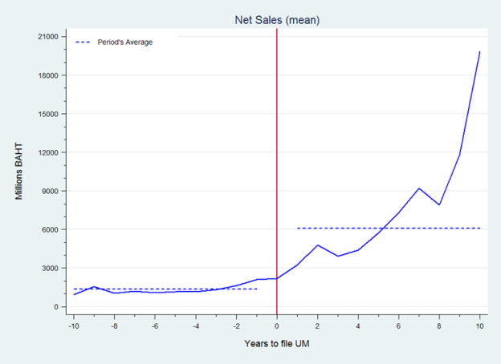 | 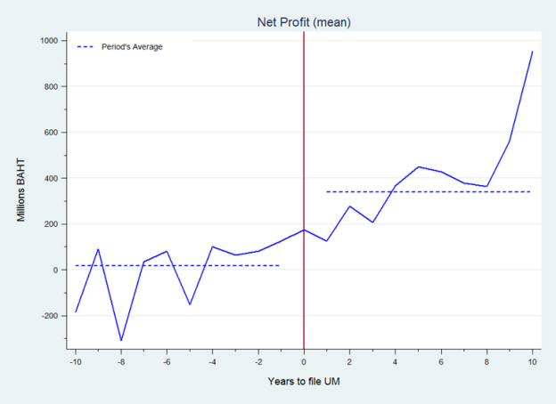
- Sales-to-Cost Ratio | - Operating Costs (in million baht)
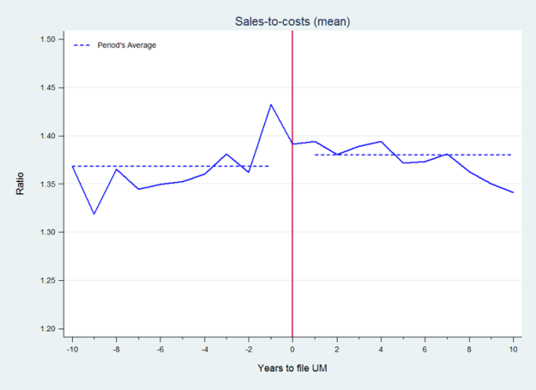 | 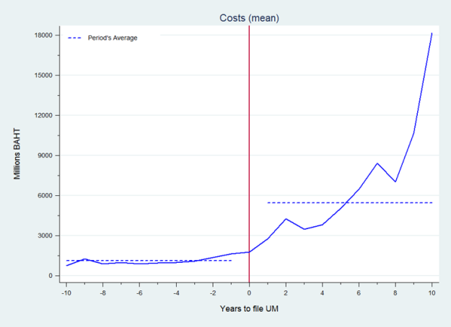
Source: TDRI-WIPO Extended Database (2013).

What are the Traits of the Firms Applying for UMs?

We try to identify if there are specific traits of the firms that apply for this IP instrument to ascertain if there are instances where firms are more likely to use UM protection, for example in a specific industrial sector. If this is the case, then these particular subgroups of firms should observe a stronger effect of UM protection on their performance indicators in comparison to others. We considered the firms’ age group, geographical location, size, industrial sectors, and technological fields, and record the observations below.

First, we observe that there is no particular tendency of using UM protection based on the firms’ age group. Roughly half of the Thai firms that have applied for UM protection are well established businesses with over 20 years of existence.

Second, the size of the firms seems to affect the relationship between UM filings and the firms’ performance indicators. In other words, the magnitude of the effect of UM filings on the firms’ performances differ according to the firms’ sizes. Table E-2 summarizes how the firms’ performance indicators change before and after filing for UM protection. Firms’ net sales jump after they file for UM protection, and the height of this jump increases according to their sizes: bigger sized firms observe a higher increase in their net sales after UM application than their smaller counterparts. However, when we use the sales-to-cost ratio as a proxy for firm performance, the only firm size group that seems to have a slightly better performance is the large firms in the last quartile. The other firms actually see a slight decrease in their sales-to-costs ratio. This observation indicates that there may be a size effect on how UM protection affects the firms’ performance indicators, which we will control for in the econometrics modelling.

Table E-2: Change in Net Sales, Net Profits and Sales-to-Cost Ratio by Firm Size
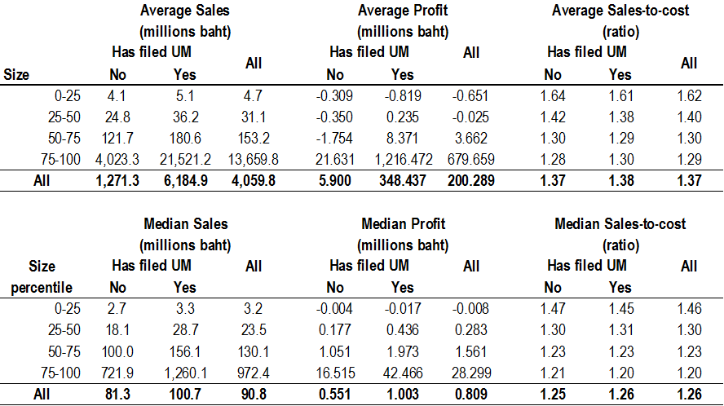
Source: TDRI-WIPO Extended Database (2013).

Third, firms from all industrial sectors have applied for UM protection. But the four industrial sectors that have a sizeable concentration of firms with UM protection are: wholesale, food and beverages, machinery and retail. In contrast, the top three technological fields with the highest number of UM firm applicants are in civil engineering, food chemistry and handling.

Fourth, most of the UM applications come from firms that are located in the capital of Thailand, Bangkok.

And finally, we examine the patterns of UM application by firms in specific industrial sectors according to the technological field of their applications to examine if there are any identifiable trends. As expected, firms in specific industrial clusters file for UM protection on inventions in their traditional technological fields, as is the case for the food and beverages industrial sector in food chemistry technological field. For example, firms from the food and beverages industry file for UM in food chemistry technologies and firms from the chemical industry file for UM in the pharmaceutical and basic materials chemistry fields. But surprisingly, we find that there are a few notable industrial sectors – like wholesale – where the firms file for protection on inventions that are applicable across many different technological fields.

How does UM Protection Affect Firms?

We carry out a more thorough investigation of the link between UM protection and firms’ performance by using an econometric approach. This method allows us to single out if and determine the extent to which firms’ performance can be attributed to UM protection.

The general equation for estimation is:

$${Performance}_{it}=β_{0}+β_{1}{Cost}_{it}+β_{2}{UM}_{it}+α_{i}+ϵ_{it}$$

Where a firm’s financial performance indicator at time $t$ is a function of whether it has a UM application, ${UM}_{it}$, its operating costs, ${Cost}_{it}$, and firm-specific time-invariant factors, $α_{i}$. This time-invariant firm specific factor, $α_{i}$, is obtained by using the fixed effect (FE) regression estimation.

The results of our estimations largely confirm the trends we have plotted earlier in Figure E-1. On average, we find a positive and statistically significant correlation between firms’ financial performance indicators and UM protection.

We suspect that there may be a size effect which influences the link between UM protection and the firms’ performance indicators, and test this theory out. We find two interesting results. First, the size associated with the UM coefficients are higher than the regressions without the size variable. And secondly, the increase in net sales for the average firm decreases as the size of the firm increases. Simply put, the increase in net sales with UM protection is higher than before, and this effect is stronger for smaller firms. This result can be better observed when we graph the influence of UM protection on net sales according to the firm size as in Figure E-2. The figure (below) shows that as the firm size increases – measured by their operating costs – the effect of the UM application on net sales decreases.

Figure E-2: The Interaction of UM Application on Net Sales
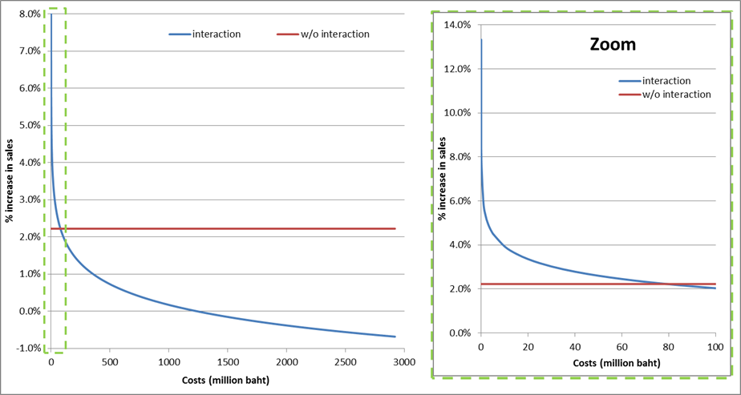

Conclusion

This study takes a first step in trying to establish if UM protection is useful in a less developed economy such as Thailand. In particular, it investigates the relationship of UM protection and performances of local firms in the country.

The results presented here on UM protection are promising. We observe that there is a positive and significant link between UM protection and firm performance indicators. However, we refrain from attributing the increase in the firm’ performance indicators to UM protection. Simply put, we are not able to show causality between the introduction and implementation of UM protection and the gains in the firms’ performances. This is partly due to data limitations. We may be omitting some important factors that can well explain the economic gains that these firms observe which may also be related to the firms’ decision to file for UM. In other words, do more successful innovators that take out more UM protection perform better? As a counter argument, do firms that produce successful innovation but do not take UM protection also perform equally well?

Further investigation is needed before we can conclude how UM affects firms economic performance. For one, what are the channels through which UM protection may affect the firms’ performance? Does UM protection give time to the firms to commercialize their inventions, without fear that rivals may infringe on their intellectual property? Does it facilitate the firms’ access to capital? Also, what are the reasons behind the firms’ decision to file for UM protection, in comparison to patent protection for example? We plan to investigate these avenues for future research work.

How Utility Models Affect Local Firm Performance in Thailand

Introduction

The present document is an output of the Project on Intellectual Property and Socio-Economic Development of the Committee on Development and Intellectual Property (CDIP), which consists of a series of economic studies that seeks to provide evidence on the effects of intellectual property (IP) protection in less developed countries. In particular, this study investigates the impact of utility model (UM) protection in Thailand, an upper-middle income country. The results of this country study are divided in two parts: the first document provided a descriptive analysis on the use of UM protection in Thailand and was presented at the Twelfth Session of the CDIP in November, 2013. This second paper investigates how UM protection affects the economic performance of Thai companies.

UM protection is arguably a development friendly IP instrument that helps less developed economies transition to fully using the system as a whole. For one, many less developed economies are adjusting to the relatively recent implementation of an IP system that is equivalent to their developed counterparts, in particular the World Trade Organization’s Trade-related Aspects of Intellectual Property Rights (TRIPS) agreement. This suggests that many inventors in these countries may not be familiar with using the IP system. Secondly, they tend to be technology importers. In other words, less developed economies are more likely to rely on the rest of the world for new technologies rather than producing them locally. This may imply that their inventors may not have sufficient capacity, or capability, to produce new-to-the-world type of invention.

Studies have shown that even if the countries may not have the capacities to produce the inventions themselves at the initial stages, they may develop the capacity to do so under the right conditions. This has been shown in the cases of South Korea, Japan and even the United States of America, to name a few. In the South Korea case, Kim (1997) argued that the availability of UM protection helped his country transition from a technology importing country to an exporter.

How can UM help inventors in less developed economies? Firstly, UM protection provides an exclusive right over inventions that do not necessarily meet the patentability criteria, in particular the inventive step test. This allows inventors to file for protection on their inventions that may not meet the patentability criteria. The protection is akin to patent protection in that the inventor has exclusive rights to market the invention but for a shorter time period. Secondly, the more the inventors apply for UM protection on their inventions, the more familiar they may become in using the IP system as a whole. In fact, a cross-country study conducted by Kim et al. (2012) found that UM protection was more useful for less developed economies while patent protection was more relevant when the countries had attained a specific level of technological capability.

With the rationale of having an IP system that encourages local innovation in mind, Thai legislators introduced UM protection as part of the reforms undertaken to harmonize its IP system in line with its obligations under the TRIPS agreement. Specifically, they wanted to introduce an IP instrument that was conducive and suitable for their inventors’ stage of technological development. Under the Thai IP legislation, the two main criteria for UM protection are that the invention is new and that it is capable of industrial application. Moreover, there is no substantive examination at time of the application. If the applicant or any interested third party wanted substantive examination to take place, they can request for it within one year after the registration of the UM has been published.

This relative ease of filing for UM protection may have contributed to the overwhelming local use of this IP instrument in comparison to others: Thai residents accounted for 96% of UM applications, which is considerably higher than the cases of industrial designs (74%), trademark (66%0 and patents (14%). In addition, Thai applicants were quick to use this IP instrument even if many of them were first time IP users, having never applied for neither industrial design nor patent protection.

But the main questions are: how and to what extent does UM protection affects local economic activities? We attempt to address this question by examining if there is a relationship between filing for UM protection and the firms’ financial performances. If UM is beneficial for firms then having UM protection over the firms’ inventions should generate higher incomes for them.

Using detailed and novel unit record data on UM application and registration, we carry out our investigation to examine the link between UM and firm performance in four parts. First, we assess if there is a link between filing for UM protection and the performance of the firms by observing if there has been an effect on the firms’ performances before and after filing for UM protection. Second, we try to determine if there are specific traits of firms that apply for UM protection. For example, it could be the case that firms in certain industrial sectors have higher propensity to file for UM protection than others. We then run econometric regressions to ascertain if there is an effect and the size of the effect of UM protection on the firms.

Finally, we conclude the paper by summarizing the main findings of this exercise and point to avenues for future research.

What are the Traits of the Firms Applying for UMs?

To carry out our investigation we relied on the unit record data of UM applications, and registrations, provided by the Thai Department of Intellectual Property (DIP), and singled out applications that were filed by, or attributable to, local firms for the years 1999-2012. From the 7,498 UM applications filed, we identified 751 registered firms and collected financial performances indicators for each of them for the years 1997-2012 from the Thai Business Online (BOL) registry. We were then left with 719 unique firms as some of the firms-level observations were missing in the BOL database, a few due to business closure.

Table 1 below summarizes the descriptive statistics for our sample. The average firm in our dataset has applied for one UM protection, and has annual sales of over 4 billion baht (approx. USD 129 million), and a net profit of 202 million baht (approx. USD 6.5 million)., When we compare the firms’ performance indicators – here depicted by three variables: sales, profits and sales to costs ratio – most of the firms seem to do better after filing for UM protection, although the improvement in the sales to costs ratio is small. On average, firms that file for UM see their sales increase from 1.3 billion baht to 6.2 billion baht (USD 41.8 million to USD 199.8 million).

Table 1: Descriptive Statistics of Firms’ Performance Indicators
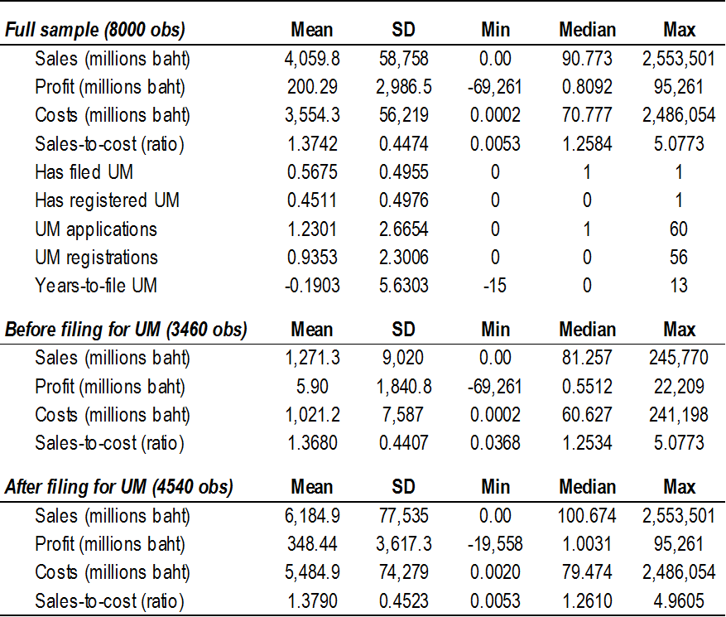
Source: TDRI-WIPO Extended Database (2013).

Another way to observe the relationship between UM protection and the firms’ performance indicators is to plot these variables against one another. The subfigures in Figure 1 are the timing of the firms’ UM application plotted against the three indicators of the firms’ financial performances.

Figure 1: Trends in Firms’ Performance Indicators over Time, based on their UM Application Date
- Net Sales (in million baht) | - Net Profit (in million baht)
- Sales-to-Cost Ratio | - Operating Costs (in million baht)
Source: TDRI-WIPO Extended Database (2013).

On average, firms that use UM perform better after filing for UM across all three performance indicators, with several notable variations. Five years after filing for UM protection, the average Thai firm has six times more sales than it did five years preceding the application (a jump from one to six billion baht, roughly equivalent to USD 32.2 million and USD to 96 million, respectively). In a similar trend, once the average firm files for UM protection, its net profit increased from 20 million baht to 350 million baht (approx. USD 643,500 and USD 11.3 million respectively). And lastly, the sales-to-cost ratio trend for the average firm also increases after filing for UM protection, however the jump is smaller given the more volatile trend over the time period under investigation. To help contextualize the business trend that the firms in Thailand faced during the same time period of investigation, we have included a graph which plots the average firm’s operating costs over time to UM application (see Figure 1(d)).

We then try to identify if there are specific traits of the firms that apply for this IP instrument to ascertain if there are instances where firms are more likely to use UM protection, for example in a specific industrial sector. If this is the case, then these particular subgroups of firms should observe a stronger effect of UM protection on their performance indicators in comparison to others. We considered the firms’ age group, geographical location, size, industrial sectors, and technological fields.

First, we observe that there is no tendency of using UM protection based on the firms’ age group. Roughly half of the Thai firms that have applied for UM protection are well established businesses with over 20 years of existence. Figure 2 plots the distribution of the firms that have applied for UM according to the firm registration year.

Figure 2: Distribution of Firms by Year Established
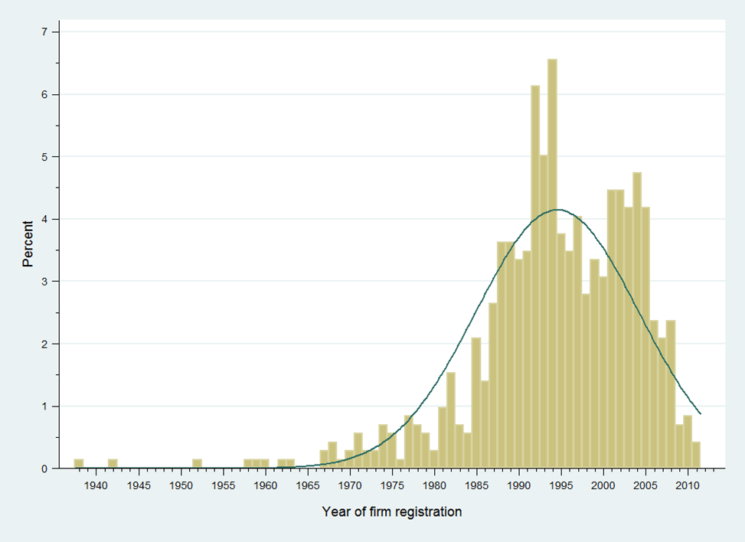
Source: DIP (2012) and TDRI-WIPO Extended Database (2013).

Second, we are able to observe how the net sales, net profits and the sales-to-costs ratio change after the firms file for UM according to their sizes. Table 2 summarizes how the firms’ performance indicators change before and after filing for UM protection. Firms’ net sales jump after they file for UM protection, and the height of this jump increases according to their sizes: bigger sized firms observe a higher increase in their net sales after UM application than their smaller counterparts. However, when we use the sales-to-cost ratio as a proxy for firm performance, the only firm size group that seems to have a slightly better performance is the large firms in the last quartile. The other firms actually see a slight decrease in their sales-to-costs ratio. This observation indicates that there may be a size effect on how UM protection affects the firms’ performance indicators, which we will check in the following section.

Table 2: Change in Net Sales, Net Profits and Sales-to-Cost Ratio by Firm Size
Source: TDRI-WIPO Extended Database (2013).

Third, firms from all industrial sectors have applied for UM protection. But the four industrial sectors that have a sizeable concentration of firms with UM protection are: wholesale, food and beverages, machinery and retail (see Table 3). In contrast, the top three technological fields with the highest number of UM firm applicants are in civil engineering, food chemistry and handling (see Table 4).

Table 3: Top Ten Industrial Sectors of Firms that Apply for UM
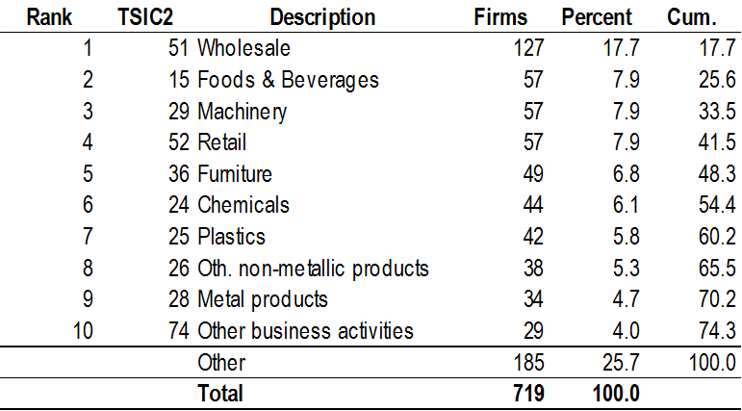
Source: TDRI-WIPO Extended Database (2013).

Table 4: Top Ten Technological Fields of Firms that Apply for UM
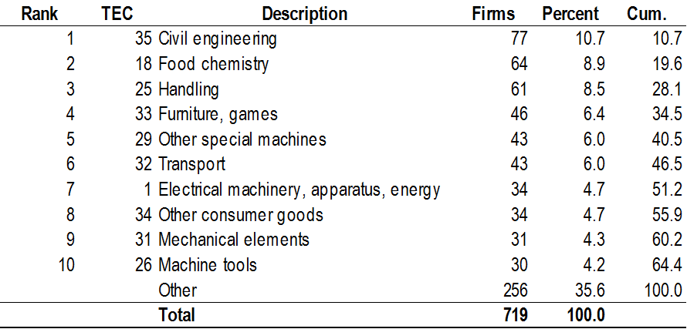
Source: TDRI-WIPO Extended Database (2013).

Fourth, most of the UM applications come from firms that are located in the capital of Thailand, Bangkok.
Figure 3 below shows the location of 719 firms that have applied for UM applications according to their provinces. Each bubble reflects the location and number of firms in the province. The second largest province with firms that have applied for UM protection is Nonthaburi.

The concentration of firms filing for UM protection in the capital city of Thailand rather than the rest of the country raises interesting follow-on questions. For example, does this cluster of firms in Bangkok indicate that Bangkok is the innovation hub of Thailand?

Or perhaps the competition is more intense in Bangkok than the rest of the country that it prompts the firms to file for IP protection on their inventions, more than their counterparts residing outside of capital city. In the same line of reasoning but from a different view, why would firms outside of Bangkok file for IP protection? Could it indicate that these inventions are valuable and would be commercialized throughout the country?

Or maybe there are specific technological field clusters in the different Thai provinces? We examined the top five technological fields for the different provinces in Thailand in Table 5. Bangkok, as expected, had the highest concentration of inventions across the top five technological fields throughout the provinces. And when we broke down the intensity of these technological fields by the provinces we observe that civil engineering field is one of the leading technological fields for inventions in Thailand, followed by food chemistry. We cannot make any reasonable deduction based on this limited observation, but the fact that there are relatively more inventions in the civil engineering field suggests that there may be more construction-based inventions in Thailand.

Figure 3: Location of Firms using UM by Province (with two near-Bangkok zooms)
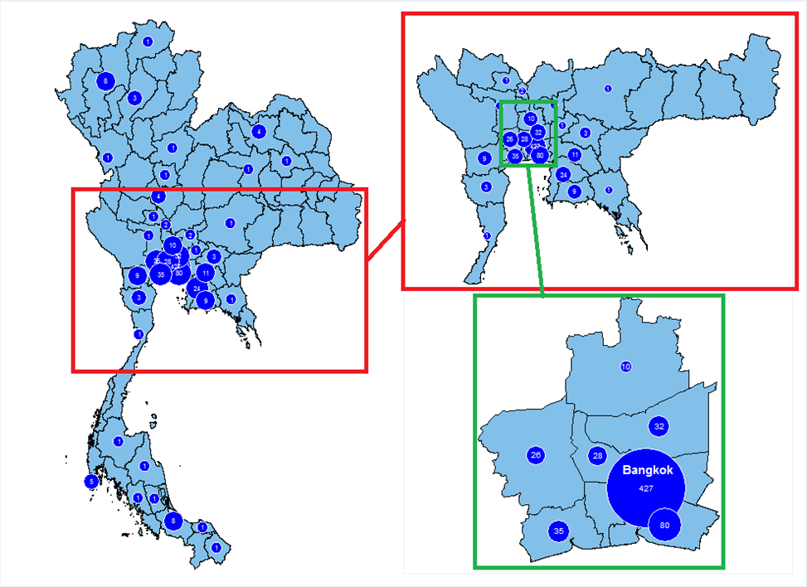
Source: TDRI-WIPO Extended Database (2013).

Finally, we examine the patterns of UM application by firms in specific industrial sectors according to the technological field of their applications to examine if there are any identifiable trends (see Figure 4). As expected, firms in specific industrial clusters file for UM protection on inventions in their traditional technological fields, as is the case for the food and beverages industrial sector in food chemistry technological field. For example, firms from the food and beverages industry file for UM in food chemistry technologies and firms from the chemical industry file for UM in the pharmaceutical and basic materials chemistry fields. But surprisingly, we find that there are a few notable industrial sectors – like wholesale – where the firms file for protection on inventions that are applicable across many different technological fields. This particular observation begs the question of why are these firms able to produce inventions that fall across many technological fields. Could it indicate that these firms’ daily activities also include operations across different technological fields?

Figure 4: Concentration of Firms according to their Industrial Sector (TSIC 2) and Technological Fields (IPC)
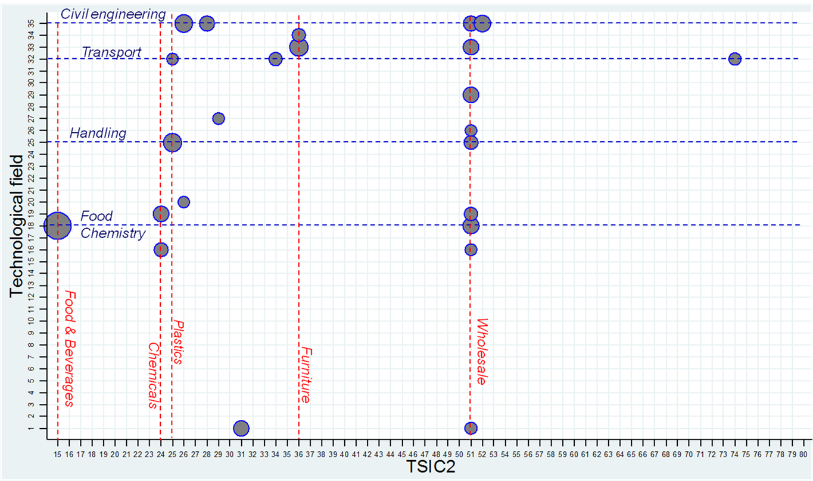

Source: DIP (2012), TDRI-WIPO Extended database (2013) and WIPO concordance table.

Note: Selected technological fields and industries in blue and red, respectively. Only pairs with more than 5 firms reported. Sizes of bubbles reflect number of firms.

Table 5: Distribution of Firms by the Top Five Technological Fields and Province (total and percentage)
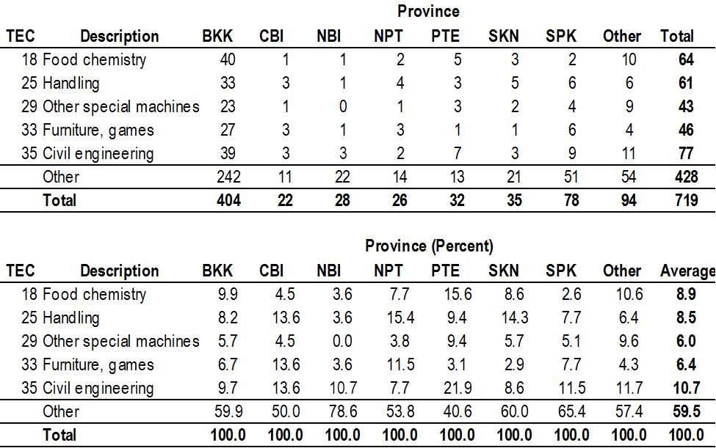

Similarly, there are a few technological fields – like civil engineering and transport – where we can find firms filing for these technologies come from several industrial sectors.

These patterns of industrial sector and technological field clusters tell us that there are a few industrial sectors in Thailand that have inventions that can be applied to many technological fields, while there are a few technological fields with inventions that can be applied across many industrial sectors. However, this observation does not allow us to induce any specific trend regarding the firms, their inventions or how they use the UM protection unless we can observe the application of these inventions and the enforcement of this IP instrument.

How does UM Protection Affect Firms?

We carry out a more thorough investigation of the link between UM protection and firms’ performance by using an econometric approach. This method allows us to single out if and the extent to which firms’ performance can be attributed to UM protection. It also allows us to estimate the size of this link, which is an additional advantage.

Estimation Strategy

The general equation for estimation is:

$${Performance}_{it}=β_{0}+β_{1}{Cost}_{it}+β_{2}{UM}_{it}+α_{i}+ϵ_{it}$$

Where a firm’s financial performance indicator at time $t$ is a function of whether it has a UM application, ${UM}_{it}$, its operating costs, ${Cost}_{it}$, and some firm-specific time-invariant factors, $α_{i}$. This time-invariant firm specific factor, $α_{i}$, is obtained by using the fixed effect regression estimation. As in the preceding section, we measure the firms’ financial performance using three indicators: (i) net sales, (ii) net profits and (iii) net sales to costs ratio. Net sales are expressed in natural logarithm, net profits are in million baht and sales-to-costs ratio is left as it is. To correct for firm size effect as well as to isolate any probable effect of the normal business cycle fluctuations on the performance indicator, we have included the operating cost variable expressed in natural logarithm, $ln⁡({Costs}_{it})$ .

In order to ensure that we have captured the effect of having UM protection on the firms, we used three different measures of UM protection. The first measure we use is a dummy binary variable which differentiates the period before and after each firm filed for UM. For this first proxy, ${UM}_{it}$, the variable would take on the number 1 if the firm $i$ did apply for a UM at time $t$ onwards, and 0 otherwise. The second proxy used is a time-variant variable that measures the number of years firm $i$ has applied or registered for UM. In this particular case, ${Year(UM)}_{it}$, would take on positive values after the year of UM application, or registration, and negative values in the years preceding the UM. For example, the variable would take on the values of -1, 0, and 1 for the years $t$ before, during and after the firm $i$ applies for UM application. And the last proxy for UM, ${Total(UM)}_{it}$, is the cumulative number of UM filed by firm $i$ at year $t$.

We suspect that there may be differences in how UM protection may affect firms according to their size and their geographical location, as mentioned in the previous section. To account for the possibility that the effect of UM protection on firm performance may vary according to their sizes, we included a variable which interacts the three different UM proxies with the operating costs. These variables are denoted as: ${UM}_{it}*ln⁡({Costs}_{it})$, ${Year(UM)}_{it}*ln⁡({Costs}_{it})$and ${Total(UM)}_{it}*ln⁡({Costs}_{it})$for the three different proxies of UM. As for geographical location, we include a dummy binary variable $d(not Bangkok)$ - for whether the firm $i$ is located in Bangkok (takes the value of 0) or not (takes the value of 1) - which is then interacted with the different measures of UM protection.

We also checked to see if there would be a diminishing effect of UM protection over time. For example, successful UM applicants in Thailand are entitled to a maximum of ten years of protection over their invention. After the expiry of the term of protection, either because of the end of the ten years or because of failure to pay the renewal fee, the effect of the UM protection should disappear. One way to account for this is to compute the square of the ${UM}_{it}$ variable to capture any diminishing effect of UM protection over time.

Econometric Regression

We estimated the general model expressed above using the fixed effect (FE) panel estimation. This panel estimator is useful in our case as we have 15 years of observations for 719 firms. In addition, using FE estimation takes into consideration any unobservable firm-specific but time invariant influence in the regression. For example, there may be a particular manner of a firm $i$’s organization that has an influence on its financial performance.

We ran several different specifications of the general equation for net sales, net profit and sales-to-costs ratio in Table 6, Table 7, and Table 8 respectively. Columns (1) and (2) are the estimations using the binary proxy of UM application, ${UM}_{it}$, column (3) is the estimation using the time to-, during- and after filing for UM application, ${Year(UM)}_{it}$, and columns (4) and (5) uses the total number of UM filed by the firm, ${Total(UM)}_{it}$. We also controlled for firm size by including the operating costs variable, $ln⁡({Costs}_{it})$in columns (2), (3) and (5).

The results of our estimations largely confirm the trends we have plotted earlier in Figure 1. On average, we find a positive and statistically significant correlation between firms’ financial performance indicators and UM protection. We report the estimations using two performance indicators net sales and sales-to-cost ratio here, and include the estimation for net profits in the appendix.

Table 6 summarizes the results for the estimation using net sales as dependent variable. In column (1) the average firm with UM application observes a 104% increase in net sales. When we correct for firm size, the increase in net sales is a more modest 2.3% in column (2). This difference in the net sales increase when we control for firm size could indicate that UM filing may be correlated with the size of the firm. For example, it could be that firms of a specific size are more likely to file for UM protection. Using the other two proxies of UM tells the same story: that net sales and UM protection are positively correlated (columns 3, 4 and 5). Five years after filing for UM application, the average firm will observe a 2.5% increase in net sales in comparison to five years before filing for the protection.

We examined in further detail the effect of firm size on net sales in columns (6), (7), and (8) by interacting the three UM proxies with the operating costs variable. We find two interesting results. First, the size associated with the UM coefficients are higher than the previous estimations without the interaction variable. And secondly, the increase in net sales for the average firm decreases as the size of the firm increases. Simply put, the increase in net sales with UM protection is higher than before, and this effect is stronger for smaller firms. Using the results in column (6) as an example, a small firm observes a 6% boost in its net sales while it’s bigger counterparts sees a slightly lower increase in its net sales (2.3%) in column (6). The results of these model specifications are better observed when we plot the influence of UM protection on net sales according to the firm size as in Figure 5. The figure (below) shows that as the firm size increases – measured by their operating costs – the effect of the UM application on net sales decreases.

Figure 5: The Interaction of UM Application on Net Sales

The second performance indicator is the firms’ net profits. We find similar results to the estimation generated for net sales in the signs and significance of the explanatory variables are the same; however the coefficients of these variables are different from those found for net sales.

Our third performance indicator is the sales-to-cost ratio, which can be roughly interpreted as a measurement of the firms’ return to investment. A ratio above 1 implies positive return and below 1 is negative return. Table 8 summarizes the estimation results for our sales-to-cost ratio.

In general, we find that there is a positive correlation between UM protection and the average firms’ return to investment. Moreover, when we control for firm size effect using the interaction variable, the signs and size of the coefficients are similar to the estimation results using net sales although they are not always statistically significant.

In addition to our estimations reported here, we also ran further regressions to capture if there are any geographical location effect and if there is a diminishing effect of UM protection. However, we did not find any significant result for these model specifications and refrained from reporting them here.

Table 6: FE Estimation Results for Net Sales (natural logarithm)
${ln⁡(Net Sales)}_{it}$ | (1) | (2) | (3) | (4) | (5) |  | (6) | (7) | (8)
$$ln⁡({Costs}_{it})$$ |  | 0.964*** | 0.962*** |  | 0.967*** |  | 0.968*** | 0.961*** | 0.968***
 |  | (0.008) | (0.009) |  | (0.008) |  | (0.009) | (0.009) | (0.008)
$${UM}_{it}$$ | 0.713*** | 0.022** |  |  |  |  | 0.057**
 | (0.040) | (0.010) |  |  |  |  | (0.022)
$${Year(UM)}_{it}$$ |  |  | 0.002** |  |  |  |  | 0.006***
 |  |  | (0.001) |  |  |  |  | (0.002)
$${Total(UM)}_{it}$$ |  |  |  | 0.095*** | 0.002 |  |  |  | 0.020***
 |  |  |  | (0.027) | (0.002) |  |  |  | (0.007)
$${UM}_{it}*ln⁡({Costs}_{it})$$ |  |  |  |  |  |  | -0.008**
 |  |  |  |  |  |  | (0.004)
$${Year(UM)}_{it}*ln⁡({Costs}_{it})$$ |  |  |  |  |  |  |  | -0.001**
 |  |  |  |  |  |  |  | (0.000)
$${Total(UM)}_{it}*ln⁡({Costs}_{it})$$ |  |  |  |  |  |  |  |  | -0.003***
 |  |  |  |  |  |  |  |  | (0.001)
Constant | 3.945*** | 0.410*** | 0.430*** | 4.233*** | 0.408*** |  | 0.393*** | 0.437*** | 0.400***
 | (0.023) | (0.032) | (0.037) | (0.033) | (0.032) |  | (0.035) | (0.037) | (0.032)
No. of firms | 719 | 719 | 719 | 719 | 719 |  | 719 | 719 | 719
Observations | 8,000 | 8,000 | 8,000 | 8,000 | 8,000 |  | 8,000 | 8,000 | 8,000
$$F-statistics$$ | 320.4 | 9,189.7 | 10,455.8 | 12.1 | 8,236.8 |  | 7,367.5 | 8,553.1 | 5,808.9
$$R^{2}$$ | 0.123 | 0.948 | 0.948 | 0.041 | 0.948 |  | 0.948 | 0.948 | 0.948
ρ | 0.914 | 0.645 | 0.646 | 0.903 | 0.643 |  | 0.648 | 0.649 | 0.648
Note: ***, ** and * indicate statistical significance at 1, 5 and 10 percent respectively. Standard errors are reported in parentheses.

Table 7: FE Estimation for Net Profit (in million baht)
${Profit}_{it}$ | (1) | (2) | (3) | (4) | (5) |  | (6) | (7) | (8)
$$ln⁡({Costs}_{it})$$ |  | 116.437*** | 80.499* |  | 133.458* |  | 22.944 | 121.071** | 124.951***
 |  | (50.425) | (41.284) |  | (52.305) |  | (38.679) | (50.616) | (49.291)
$${UM}_{it}$$ | 202.595*** | 119.124* |  |  |  |  | -717.297***
 | (75.092) | (64.412) |  |  |  |  | (268.815)
$${Year(UM)}_{it}$$ |  |  | 28.342*** |  |  |  |  | -121.427***
 |  |  | (8.070) |  |  |  |  | (39.928)
$${Total(UM)}_{it}$$ |  |  |  | 20.404* | 7.652 |  |  |  | -203.895**
 |  |  |  | (9.398) | (5.634) |  |  |  | (83.640)
$${UM}_{it}*ln⁡({Costs}_{it})$$ |  |  |  |  |  |  | 194.682***
 |  |  |  |  |  |  | (71.995)
$${Year(UM)}_{it}*ln⁡({Costs}_{it})$$ |  |  |  |  |  |  |  | 33.579***
 |  |  |  |  |  |  |  | (10.148)
$${Total(UM)}_{it}*ln⁡({Costs}_{it})$$ |  |  |  |  |  |  |  |  | 34.721**
 |  |  |  |  |  |  |  |  | (14.213)
Constant | 85.317** | -341.644 | -134.349 | 175.190*** | -352.792* |  | 54.318 | -328.101 | -258.288
 | (42.615) | (209.755) | (169.170) | (11.560) | (212.802) |  | (135.499) | (214.803) | (179.771)
No. of firms | 719 | 719 | 719 | 719 | 719 |  | 719 | 719 | 719
Observations | 8,000 | 8,000 | 8,000 | 8,000 | 8,000 |  | 8,000 | 8,000 | 8,000
$$F-statistics$$ | 7.279 | 4.248 | 6.181 | 4.714 | 4.384 |  | 3.556 | 4.874 | 2.429
$$R^{2}$$ | 0.002 | 0.005 | 0.007 | 0.000 | 0.004 |  | 0.018 | 0.041 | 0.008
ρ | 0.582 | 0.571 | 0.574 | 0.583 | 0.570 |  | 0.568 | 0.569 | 0.570

Note: ***, ** and * indicate statistical significance at 1, 5 and 10 percent respectively. Standard errors are reported in parentheses.

Table 8: FE Estimation for Sales-to-Costs Ratio
${Sales-to-Cost Ratio}_{it}$ | (1) | (2) | (3) | (4) | (5) |  | (6) | (7) | (8)
$$ln⁡({Costs}_{it})$$ |  | -0.088*** | -0.093*** |  | -0.081*** |  | -0.084*** | -0.094*** | -0.080***
 |  | (0.014) | (0.015) |  | (0.014) |  | (0.015) | (0.015) | (0.014)
$${UM}_{it}$$ | -0.012 | 0.051*** |  |  |  |  | 0.085**
 | (0.012) | (0.014) |  |  |  |  | (0.036)
$${Year(UM)}_{it}$$ |  |  | 0.006*** |  |  |  |  | 0.010***
 |  |  | (0.002) |  |  |  |  | (0.004)
$${Total(UM)}_{it}$$ |  |  |  | -0.003* | 0.005 |  |  |  | 0.023**
 |  |  |  | (0.002) | (0.003) |  |  |  | (0.011)
$${UM}_{it}*ln⁡({Costs}_{it})$$ |  |  |  |  |  |  | -0.008
 |  |  |  |  |  |  | (0.007)
$${Year(UM)}_{it}*ln⁡({Costs}_{it})$$ |  |  |  |  |  |  |  | -0.001
 |  |  |  |  |  |  |  | (0.001)
$${Total(UM)}_{it}*ln⁡({Costs}_{it})$$ |  |  |  |  |  |  |  |  | -0.003*
 |  |  |  |  |  |  |  |  | (0.002)
Constant | 1.381*** | 1.702*** | 1.753*** | 1.378*** | 1.698*** |  | 1.686*** | 1.761*** | 1.691***
 | (0.007) | (0.054) | (0.061) | (0.002) | (0.054) |  | (0.058) | (0.061) | (0.055)
No. of firms | 719 | 719 | 719 | 719 | 719 |  | 719 | 719 | 719
Observations | 8,000 | 8,000 | 8,000 | 8,000 | 8,000 |  | 8,000 | 8,000 | 8,000
$$F-statistics$$ | 1.0 | 18.7 | 19.4 | 3.2 | 17.9 |  | 14.2 | 15.8 | 13.4
$$R^{2}$$ | 0.000 | 0.062 | 0.064 | 0.000 | 0.058 |  | 0.063 | 0.066 | 0.059
ρ | 0.655 | 0.658 | 0.662 | 0.655 | 0.651 |  | 0.660 | 0.666 | 0.655
Note: ***, ** and * indicate statistical significance at 1, 5 and 10 percent respectively. Standard errors are reported in parentheses.

Conclusion

This paper takes a first step in trying to establish if UM protection is useful in a less developed economy such as Thailand. In particular, it investigates the relationship of UM protection and firm economic performance in the country. This paper builds an earlier database, which collected information on Thai UM applications and registrations, and extended it to firm performance indicators. Having information on the firms’ financial performance before and after they have applied for UM protection allows us conduct an event study to observe if UM protection does affect the firms’ performances.

The results presented here on UM protection are promising. However, what we have shown is that there is a relationship between firms that apply for UM and their economic performances; but we are not able to show that the gains are because of the market exclusivity of UM protection. Simply put, we were not able to show causality between the introduction and implementation of UM protection and gains in firm economic performance. This is partly due to data limitations. We may be omitting some important factors that can well explain the economic gains that these firms observe which may also be related to the firms’ decision to file for UM. In other words, do more successful innovators that take out more UM protection perform better? As a counter argument, do firms that produce successful innovation but do not take UM protection also perform equally well?

Further investigation is needed before we can conclude how UM affects firms economic performance. For one, what are the channels through which UM protection may affect the firms’ performance? Does UM protection give time to the firms to commercialize their inventions, without fear that rivals may infringe on their intellectual property? Does it facilitate the firms’ access to capital? Also, what are the reasons behind the firms’ decision to file for UM protection, in comparison to patent protection for example? We plan to investigate these avenues for future research work.

Acknowledgements

This work would not have been possible without the close cooperation from the Thai
Department of Intellectual Property (DIP), under the Ministry of Commerce. We also thank Professor Keun Lee and the DIP for reviewing this document.

References

Commission on Intellectual Property Rights. (2002). Integrating Intellectual Property Rights and Development Policy: Report of the Commission on Intellectual Property Rights. London: Commission on Intellectual Property Rights.

Granstrand, O. (1999). The Economics and Management of Intellectual Property. Cheltenham: Edward Elgar Publishing Limited.

Kim, L. (1997). Imitation to Innovation: The Dynamics of Korea's Technological Learning. Boston: Harvard Business Press.

Kim, Y. K., Lee, K., Park, W. G., & Choo, K. (2012). Appropriate Intellectual Property Protection and Economic Growth in Countries at Different Levels of Development. Research Policy, 41(2), 358-375.

Lall, S. (2001). Competitiveness Indices and Developing Countries: An Economic Evaluation of the Global Competitiveness Report. World Development, 29(9), 1501-1525.

Lall, S. (2003). Indicators of the Relative Importance of IPRs in Developing Countries. Research Policy, 32(9), 1657-1680.

Suthersanen, U. (2006). Utility Models and Innovation in Developing Countries, UNCTAD-ICTSD Project on IPRs and Sustainable Development. Geneva: ICTSD-UNCTAD.

World Bank. (2008). Global Economic Prospects 2008 Washington D.C.: World Bank.

Appendix: Construction of the TDRI-WIPO Database

For the purposes of Country Study Thailand, the DIP provided the UM application and registration raw data. This data contained all 7,498 UM filed between October 1996 and September 2012. Using this data, we identified UM applications filed by firms and then linked each of the observation with firm-level data.

Before we could link the raw data with the firms, we had to carry out three cleaning processes to identify the applications made by firms. First, we harmonized the applicants name as well as identified complementary information within the applicant’s field. Figure 6 shows the breakdown of UM application by type of applicant. For instance, many UM applications show the names of more than one applicant in the same field, where sometimes the second one is a registered company or university. In addition, feedback from our interviews suggested that there might be an underrepresentation of firms in our dataset - in some instances, UM applications tend to be filed under the name of the inventor rather than the firm even if the firm would later be responsible for the sale of the invention - and manually corrected for it. For example, many companies provide information on their legal registration or in other cases the name includes members of the company’s board of Directors.

Second, we performed an internal cross-check of individual applicant names. We checked each applicant name from a natural person with the inventor names appearing in non-individual applications. As a result, 206 out of 2,436 unique individual applicants are not listed as an inventor. Among the 2,230 who are listed as inventors, 2,143 (92%) are actually inventors of their own applications, 21 are inventors of an application belonging to another individual, 36 to a corporation, 22 to a university and 8 to a government agency.

Third, we performed Web searches for each of the 2,436 unique natural person names in order to establish a link with companies, universities or government agencies (see Figure 7). We found that no less than 300 individual applicants are foreigners whose institutional association cannot be traced. For Thai individual applicants, most are engaged in small businesses which are not registered. Around 37 individuals are involved in the Thai government initiative known as the One Tambon One Product (OTOP). About 93 individuals are professors and researchers from Thai Universities. In this step, we successfully identified 208 individual applicants which can be linked to registered firms in BOL dataset. These applicants appear tend to hold positions such as managing directors, chief executive officers or executive directors (see Table 9 below).

For each of the UM applications filed for firms, we collected information on their financial performances from the Thai company register database, BOL.

Table 9: Individual Applicants in UM Application Identified in BOL Firm Registry
Positions of individual applicants in registered firms | Individual applicants | Percent
Executive director | 40 | 19.2%
Managing director | 80 | 38.5%
Consultant | 1 | 0.5%
Chief Executive Officer | 48 | 23.1%
Manager | 8 | 3.9%
Share holder | 5 | 2.4%
Director | 5 | 2.4%
Deputy managing director | 4 | 1.9%
Executive officer | 4 | 1.9%
N/A | 13 | 6.3%
Total | 208 | 100%
Source: BOL (2013).
Our resulting extended database, which we refer to as the TDRI-WIPO extended database, contains a total of 754 unique companies with UM and economic performance information from the DIP and BOL, respectively. Table 10 below summarizes the results of our data cleaning effort.

Table 10: Summary of Data Cleaning Effort
Step | UM applicant
Step | Natural person | Corporation
Total UM registrations | 3,950 | 1,895
Identification of unique applicants | 2,436 | 855
Linking to legal entities | 262 | 855
Matching with BOL record | 208 | 561
Companies in extended database (DIP+BOL) | 754
Source: TDRI-WIPO Extended Database (2013) and BOL (2013).

For these 754 unique companies whose financial performance data appear in the BOL database, we compiled the revenue and net profit data for ten years back from 2002 to 2011. In this process, we found that some companies are in the BOL registry with incomplete or inconsistent economic performance data. Therefore, we have a total of 750 companies to conduct the statistical analysis and 719 for the econometric one.

Figure 6: UM Applications by Type of Applicant

Source: DIP (2012) and TDRI-WIPO Extended Database (2013).

Figure 7: Firm Identification Procedure for UM Applicants

Source: DIP (2012) and TDRI-WIPO Extended Database (2013).
[End of Annex and of document]

See WIPO Document CDIP/5/7 Rev.
See WIPO document CDIP/12/INF/6 presented at the Twelfth Session of the Committee on Development and Intellectual Property (CDIP) in November 18 – 21, 2013.
More information on the construction of this dataset is described in the WIPO Document CDIP/12/INF/6.
Official exchange rate of 31.08 baht per 1 USD calculated as an annual average based on monthly averages for the year 2012, International Monetary Fund, International Financial Statistics (data available at: http://data.worldbank.org/indicator/PA.NUS.FCRF).
Ibid.
See WIPO Document CDIP/5/7 Rev.
See WIPO document CDIP/12/INF/6 presented at the Twelfth Session of the Committee on Development and Intellectual Property (CDIP) in November 18 – 21, 2013.
See World Bank (2008).
See Lall (2001, 2003).
See Granstrand (1999); as well as the report of the Commission on Intellectual Property Rights (2002).
See Kim (1997) for the case of South Korea; and Suthersanen (2006) for a relatively comprehensive overview of UM systems in several less developed economies. In addition, the WIPO Document CDIP/12/INF/6 provides a more thorough literature review on this subject area.
In June 2012, WIPO and TDRI staff conducted a series of interviews in Bangkok with a number of stakeholders to seek their views on the contribution and functioning of the Thai UM system. See Appendix C of WIPO document CDIP/12/INF/6 for details.
Ibid.
See Figure 6 on the breakdown of UM applications by four types of applicant: natural persons, corporations, universities and government agencies.
See the appendix for details on the construction of the TDRI-WIPO Extended Database.
See Table 10 in the appendix for a summary of the data cleaning effort.
Official exchange rate of 31.08 baht per 1 USD calculated as an annual average based on monthly averages for the year 2012, International Monetary Fund, International Financial Statistics (data available at: http://data.worldbank.org/indicator/PA.NUS.FCRF).
However for a more accurate picture of the sales and net profit of the firms in the sample we should look at the median firm; the median sales is 87.3 million baht (approx. USD 28.1 million) while the median net profit is 575 thousand baht (approx. USD 185 thousand). The median number is more representative than the average because there are several large firms in the sample that skewed the average up.
See footnote 17 for conversion rate.
Ibid.
Thai provinces have been abbreviated to their 3-digit code: Bangkok (BKK), Chon Buri (CBI), Nonthaburi (NBI), Nakhon Pathom (NPT), Pathum Thani (PTE), Samut Sakhon (SKN) and Samut Prakan (SPK).
We have also computed the proxy for UM protection using the UM registration date. The results have been similar in both sign and size as for UM application date.
We also estimated all the specifications using UM registration data, instead of UM application, and obtained qualitatively similar results with regards to the coefficient signs and levels of statistical significance.
In addition, the results for both net sales and sales-to-cost ratio estimation seem to converge.
We had to transform the coefficient value in column (1) of Table 6 to get the correct marginal estimate: $\left(e^{0.713}-1\right)*100=104\%$. This is the case when our dependent variable is in natural logarithms and our explanatory variable of interest takes on a dummy (0, 1) value.
Again, we need to transform the coefficient value in column (2) of Table 6 as noted above: $\left(e^{0.022}-1\right)*100=2.26\%$.
To make things simple, we assume that the larger firm has operating costs equals to 70.8 million baht (this is the median value of the operating costs in our sample). The observable change in this firm’s net sales with UM application is $\left(e^{0.06-0.008*\ln\left(70.8\right)}-1\right)*100\%=2.3\%$.
As there was incomplete information for certain variables, our local counterpart, TDRI, manually collected the missing data for all 7,498 applications. This is documented in further detail in Appendix B of WIPO Meeting Document CDIP/12/INF/6.
This particularity may be explained by the issue of IP ownership in the case of an infringement – IP infringement is a criminal offense – and in the case of business closure, where the right to exercise the UM protected invention is associated with the firm’s survival.
OTOP is a local entrepreneurship stimulus program. The program aimed to support the locally made and marketed products of each Thai Tambon (i.e. sub-district).
BOL is a Thai limited public company, which provides the service of maintaining the database of the Thai registry of companies. This database contains financial and economic information of registered companies, such as the financial statement, general information of company, financial ratio, etc.
There is an overlap of 15 companies.
Due to business structure one firm from the DIP data appears twice in the BOL data. We have kept only one for the analysis.

