|  |  |  |
| --- | --- | --- |
|  | WIPO-E | **E** |
| CDIP/12/inf/6 | | |
| ORIGINAL: English | | |
| DATE: OCTOBER 24, 2013 | | |

**Committee on Development and Intellectual Property (CDIP)**

**Twelfth Session**

**Geneva, November 18 to 21, 2013**

STUDY ON THE USE OF UTILITY MODELS IN THAILAND

*prepared by Mmes. Deunden Nikomborirak, Economic Governance, Research Director, Thailand Development Research Institute (Thailand), and Weerawan Paibunkott-aree, Senior Researcher, Sectoral Economic Program, Thailand Development Research Institute* *(Thailand)[1]*

1. The Annex to this document contains a Study on The Use of Utility Models (UMs) in Thailand, undertaken in the context of the Project on Intellectual Property and Socio-Economic Development (CDIP/5/7), approved by the Committee on Development and Intellectual Property (CDIP) at its Fifth Session held in April 2010. This study provides a descriptive analysis of the implementation and use of UMs in Thailand and explores the potential challenges faced by the Thai IP system in relation to this new policy instrument.

*2. The CDIP is invited to take note of the information contained in the Annex to this document.*

[Annex follows]

THE USE OF UTILITY MODELS IN THAILAND

EXECUTIVE SUMMARY

There is great interest in better understanding the effects of intellectual property (IP) protection in less developed countries, both on specific measures of social and economic performance and on the economic development process more broadly. Many economists have argued against a “one-size-fits-all” approach in designing and implementing an IP regime. At the same time, national policymakers in developing countries lack credible empirical guidance in tailoring their IP systems to national capacities and needs.

In this context, many economists and lawyers have argued that utility models (UMs) may be a more appropriate form of IP protection than regular invention patents at initial stages of economic development. In addition, use of this IP instrument may familiarize local inventors with the IP system in general and encourage the use of other IP forms in the near future. However, there is little evidence on the uptake and usefulness of UMs in countries at different stages of development.

In 1999, as part of its obligations as signatory member of the World Trade Organization, Thailand reformed its IP laws in line with the Trade Related Aspects of Intellectual Property (TRIPS) agreement by passing the revised Intellectual Property Act (3rd Amendment). One element of this reform – though not required by TRIPS, was the introduction of UM protection, aimed specifically at encouraging local innovation. The Thai UM legislation requires inventions to be new and capable of industrial application. It does not require UM applications to be substantively examined. Either the applicant or any interested third party can request for substantive examination within one year after the registration has been published.

As part of the CDIP/5/7 Country Study for Thailand, this report provides a descriptive analysis of the implementation of UMs in Thailand. Using detailed and novel unit record data on UM registrations, it explores how this IP instrument is being used, by whom and in which sectors. It also points to the potential challenges that the Thai IP system may face in the future in relation to this new policy instrument.

The report draws on a joint effort by the Thailand Development Research Institute (TDRI) and the World Intellectual Property Organization (WIPO). In particular, with the close cooperation of the Thai Department of Intellectual Property (DIP) under the Ministry of Commerce, TDRI and WIPO put together a comprehensive database on the use of UMs in Thailand. This database contains all registered UM in Thailand from October 1996 to September 2012, as well as other related information.

*1. How have users received the new UM* regime?

In answering this question, it is useful to explore two aspects of UM use. First, to what extent have Thai entities taken up the UM system in absolute terms? Second, has UM use complemented or simply substituted the existing IP instruments in Thailand?

***Figure E - 1: UM applications (direct and PCT)***

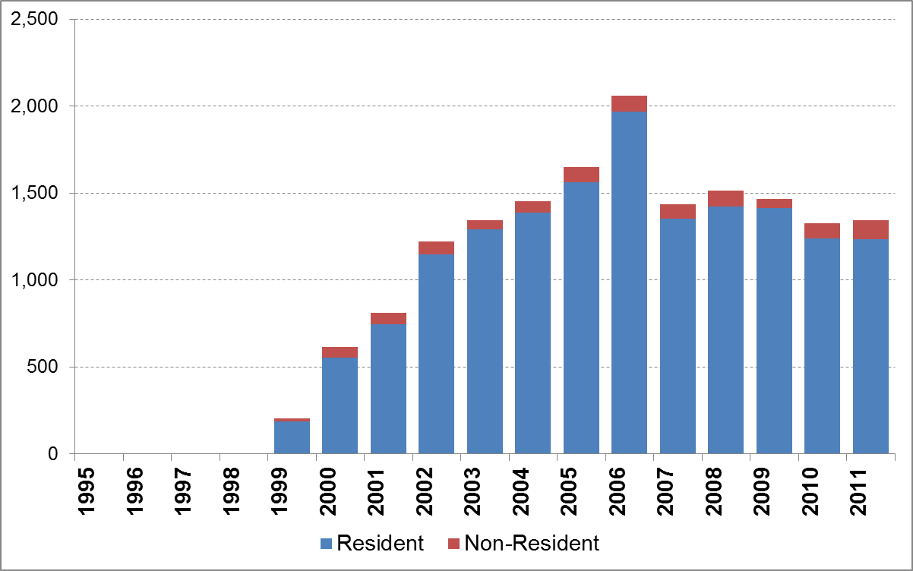

*Source: WIPO Statistics Database, 2013.*

Since Thailand introduced UM protection in 1999, the number of UM filings has grown rapidly from 202 applications to a peak of 2,062 applications in 2006 (***Figure E - 1***). This implies average growth of 27.4% per year, which tops the equivalent growth rates for industrial designs (10.3%), trademarks (6.6%) and patents (3.1%) for the same

8-year period.

However, this positive trend reversed in 2007, with applications in that year falling by about one-third. Thereafter, the trend has remained relatively flat – with around 1,400 applications per year on average. However, the observed decline is not exclusive to UMs, as residents filings for patents, trademarks and industrial designs have also dropped around the same period.

***Figure E - 2*** depicts the evolution of resident IP applications for the 1995-2011 period; in addition to UMs, patents, and industrial designs, it also shows the sum of patent and UM filings. It suggests that UM and patent filings by residents have increased in overall magnitude and at a faster rate than that observed for just resident patent filings prior to 1999. While some UM applications may well have substituted for patent applications, there thus seems to be an overall complementary relationship.

***Figure E - 2: Evolution of resident IP applications***

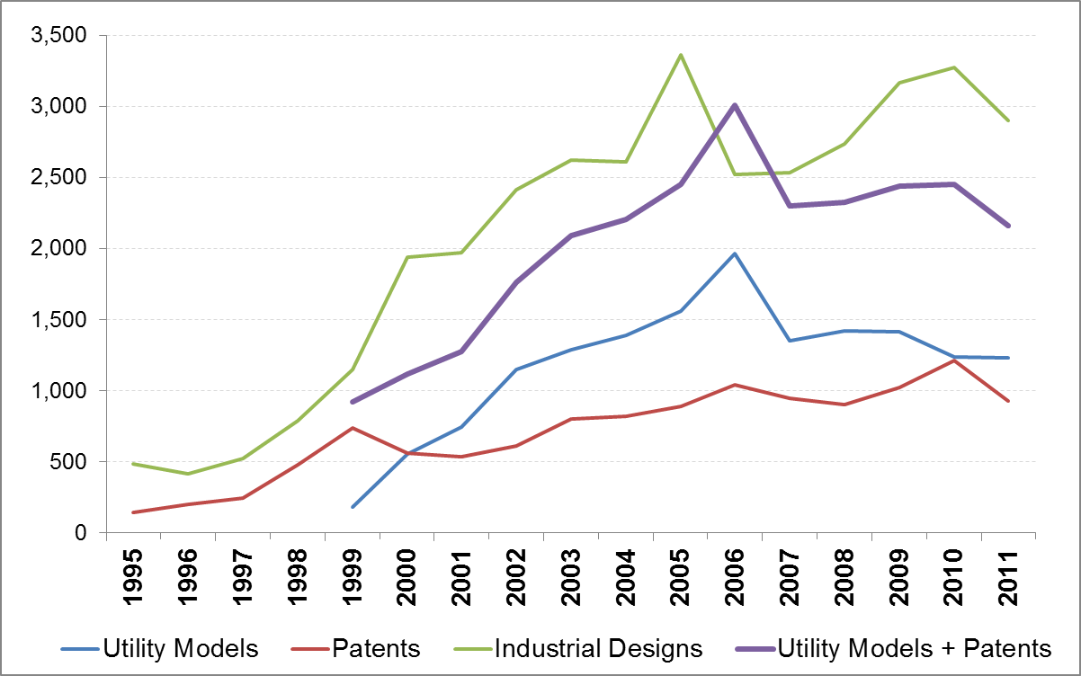

*Source: WIPO Statistics Database, 2013.*

*2. Are UMs the best fit for Thai* innovators?

***Figure E - 1*** also offers a breakdown of UM filings by residents and non-residents. Similar to trademarks and industrial designs but in contrast to patents, Thai residents are behind the vast majority of UM applications. As such, it can be argued that the UM protection has been successful in appealing to local innovators. The 95% resident share for UMs is considerably higher than the equivalent shares for industrial designs (74%) and trademarks (66%); in the case of patents, residents only account for 14% of filings – similar to many other middle-income economies (WIPO, 2012).

As shown in ***Table E - 1***, companies account for a quarter of the registered UMs (25%) and public institutions add up to somewhat less than a quarter of registrations (22%). This means that more than half of granted UM belong to individuals. However, anecdotal evidence suggests that some young and small businesses – particularly when applying for the first time – prefer having their UM rights registered under the name of the company owner rather than the company itself. One explanation could be the higher risk faced by new entrepreneurial businesses. In such cases, the prospect of retaining IP rights after business failure may act as an incentive to register the UM under the name of an individual. Another one could be related to the fact that UM owners are accountable for IP infringements under criminal law, possibly implicating company executives.

Among public institutions applicants, there are found the Office of Vocational Education Commission (OVEC), the National Science and Technology Development Agency (NSTDA), the Government Pharmaceutical Organization and several Universities (see also ***Table E - 1***). Observing these public institutions as UM applicants reflects their roles in promoting innovative activities, as well as in financially supporting research work and other innovation related activities. Some of the UMs registered by these institutions may well result in subsequent entrepreneurial activities, including start-ups.

***Table E - 1: Number of registrations by applicant type***

|  |  |  |
| --- | --- | --- |
| **Applicant type** | **Total** | **%** |
| Natural person | 3,950 | 52.7 |
| Corporation | 1,895 | 25.3 |
| University | 696 | 9.3 |
| OVEC | 528 | 7.0 |
| Government agency | 238 | 3.2 |
| NSTDA | 191 | 2.6 |
| **Total** | **7,498** | **100%** |

*Source: Own elaboration, based on DIP data.   
Note: Only the first applicant is taken into consideration.*

***Figure E - 3*** depicts the top-10 technology fields, which roughly account for two thirds of the registered UM. The top technology field relates to *Food chemistry* technologies, which account for more than 10% of all registered UMs. Registrations in this field have seen considerable growth from the adoption of UM protection in 1999 until 2005, coinciding with the boom in UM applications in Thailand. However, since then, this field has seen a sharp decline in registrations. The reverse pattern holds for *Civil engineering*, *Other special machines*, *Furniture & games* and *Handling* technologies, which have seen most registration activity after 2005.

***Figure E - 3: Top-10 technology fields***

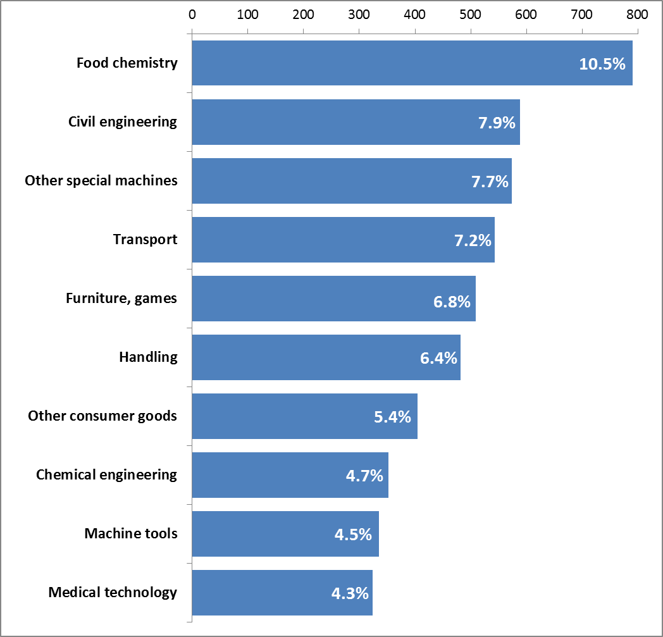

*Source: Own elaboration, based on DIP data and WIPO’s IPC-Technology concordance.   
Note: Percentages may exceed 100% due to 504 UMs registrations which are assigned to more than one technological field.*

*3. To what degree have UMs complemented other IP* forms?

Building on the above finding of complementary between UM and patent use, one can explore in greater detail to what extent UMs have filled a gap in Thailand’s IP system. In particular, one can analyze whether UM holders introduced technologies for the first time to Thailand’s IP system, as opposed to simply claiming priority on existing IP filings elsewhere. ***Figure E - 4*** shows that the vast majority of registered UMs in Thailand are first filings; only 4% of registrations claim a foreign priority. This implies that the underlying inventions are presumed to be new in Thailand, confirming the local appeal of Thailand’s UM system.

***Figure E - 4: Share of registrations by priority office***



*Source: Own elaboration, based on DIP data.*

In addition, the unit record database allows assessing whether UM holders are first-time users of the IP system or experienced users shifting from other IP rights to UMs. [2] The data suggest that only around one-fifth of UM holders have also applied for other IP types, notably patents and industrial designs. This suggests that, indeed, many of the UM holders are using the IP system for the first time. This is especially the case for many Thai companies, where three-quarters of those holding a UM have not applied for other IP forms. This is also true for individual applicants, where as much as 81% of them have only filed for this kind of IP since 1999.

*4. What are important challenges for the development of Thailand's UM* system?

Notwithstanding the successful implementation of UM protection in Thailand, there are potential concerns about the future of this particular instrument, as well as for the IP system more broadly.

Given that the Thai IP law has a novelty requirement for UMs but does not impose substantive examination, one concern – common to pure registration systems – is to what extent UM registrations truly meet the novelty standard. ***Figure E - 5*** shows that only 40 registered UMs have seen requests for examination – for example because of third party oppositions. In addition, Thailand’s specialized IP court has only revoked a few registered UMs. These may be encouraging signs about the quality of UM registrations. However, one should be careful in drawing this conclusion. The lack of oppositions might also reflect that many UM applications and eventual registrations have not found real industrial application and may, therefore, have little economic value.

***Figure E - 5: Examination requests for utility models, by examination year***

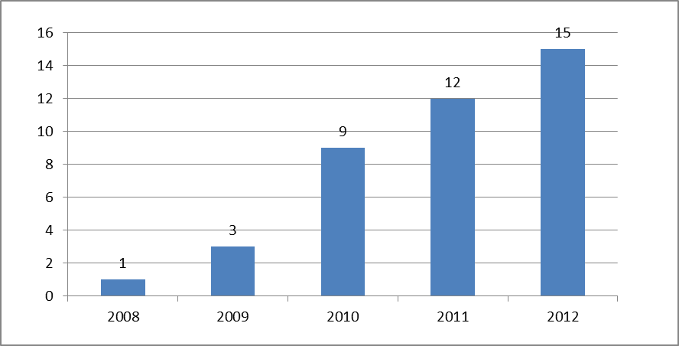

*Source: Own elaboration, based on DIP data.*

An indirect sign of lack of UM quality is the fact that less than half of all UM applications filed between 1999 and 2011 have actually been registered. For the most recent years, a certain share of unregistered applications corresponds to still on-going application procedures. But even if one only takes into account the first half of the 2000s, the share of unregistered UM applications is high – standing at between 40% and 60% (see ***Figure E - 6***). This illustrates the application quality challenge that the Thai IP office may face.

***Figure E - 6: Unregistered and registered utility models***

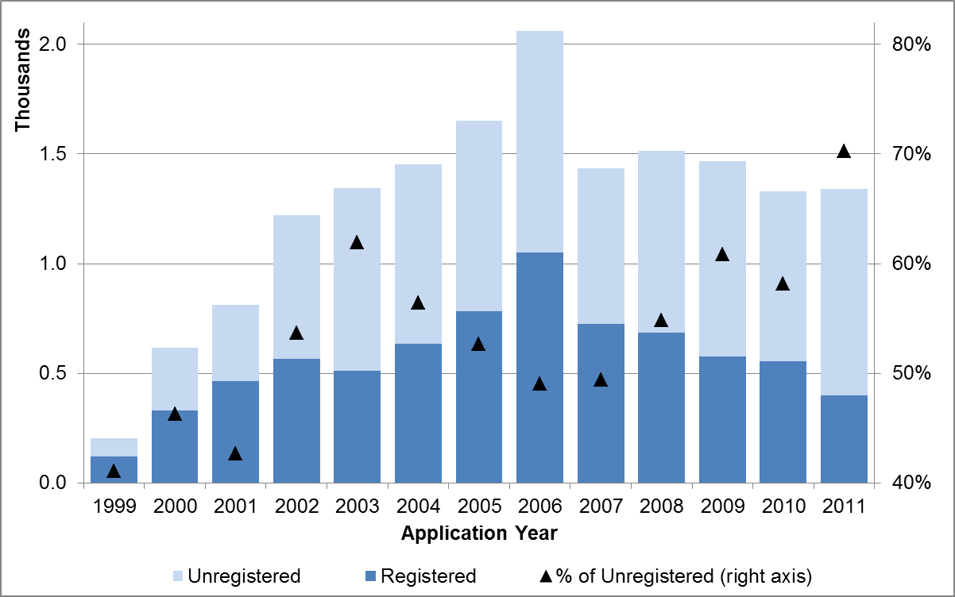

*Source: Own elaboration, based on DIP data and WIPO Statistics Database, 2013.*

Admittedly, the difference in the number of applications and the number of registrations may simply reflect the accumulated backlog in the registration process, reflecting the DPI’s processing capacity. Indeed, interviews have confirmed that resource limitations account for a good part of the application backlog. One direct consequence of this backlog problem is long UM pendency times.

In principle, the Thai law foresees that UM applications be processed within six months. However, in practice, most applications only see registration after six months

(***Figure E - 7***). In particular, around 60% of all registered UM were processed within a year and 83% were processed within two years; for 17% of all registered UMs, the process took more than three years. Anecdotal evidence suggests that even longer pendency times prevail nowadays, although shorter than during the busy 2002-2004 period.

***Figure E - 7: Registration lag***

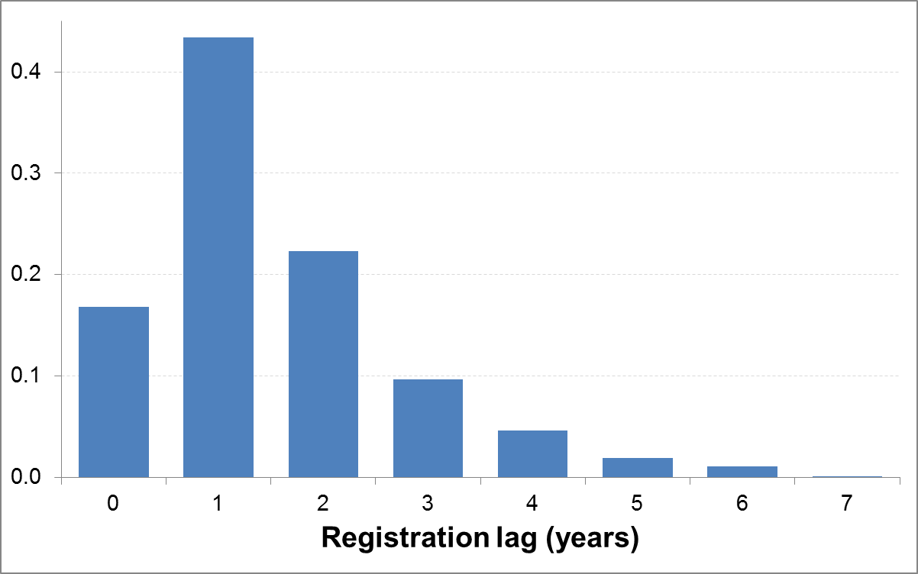

*Source: Own elaboration, based on DIP data.*

Conclusion

This report describes the main trends in the use of UMs in Thailand following its implementation in 1999, drawing on a new unit record dataset.

Evaluating the success of implementing UM protection – or any IP policy change – is not an easy exercise. While not providing a definite answer, the descriptive evidence outlined here offers an encouraging perspective on the uptake of the UM system in Thailand – especially in light of its original objective. It also points to several concerns confronting policymakers.

The data and analysis presented in this report focus entirely on the IP system. In order to assess the impact of UM protection on innovation and economic performance more broadly, it is necessary to combine UM data with information on the performance of Thai innovators, notably Thai companies. This is being done in a complementary investigation under the same CDIP project, the results of which will be reported separately.

THE USE OF UTILITY MODELS IN THAILAND

**TABLE OF CONTENTS**

Introduction 11

1. How have users received the new UM regime? 14

A rapid adoption of UMs applications……………………………………………… ……….14

UMs have increased the registration of overall Thai technological activity…… ………..16

2. Are UMs the best fit for Thai innovators? ….18

Attractive IP for Thai applicants...................................................................................... 18

Better fit for Entrepreneurs and SMEs………………………………………………………… 19

A diverse adoption by industry…………………………………………………………………. 20

3 To what degree have UMs complemented other IP forms?.............................. 23

Locally-New Technologies……………………………………………………………………… 23

New Users of the IP System……………………………………………………………………. 25

4 What are important challenges for the development of Thailand's UM system? 27

Substantive conditions in the Thai Utility Models…………………………………………….. 27

Quality of UM applications……………………………………………………………………… 28

Backlog……………………………………………………………………………………………. 30

Pendency…………………………………………………………………………………………. 30

Conclusion 32

Acknowledgements 34

References 34

Appendix A: Complementary information 35

Appendix B: Construction of the Database 1

Characteristics of the Raw Data……………………………………………………………… 1

Process of Collecting Missing Variables…………………………………………………….. 2

Preparing Applicant Names…………………………………………………………………….. 2

Appendix C: List of interviewed UM stakeholders in Thailand 1

# Introduction

There is great interest in better understanding the effects of intellectual property (IP) protection in less developed countries, both on specific measures of social and economic performance and on the economic development process more broadly. Many economists have argued against a “one-size-fits-all” approach in designing and implementing an IP regime. At the same time, national policymakers in developing countries lack credible empirical guidance in tailoring their IP systems to national capacities and needs. This is in considerable contrast to developed countries, where national IP offices, other branches of government, and academic economists have produced insightful evidence on the economic implications of different dimensions of IP protection.

The resulting changes in the IP landscapes have prompted numerous new questions on the role that the IP system plays in the innovation process. So far the economics literature has heavily focused on high income countries and does not provide much evidence on the role of IP in middle income economies, like Thailand. There appear to be two underlying reasons. First, in absolute terms, these countries have seen the largest increases in IP use and questions of IP protection have gathered considerable public interest. Second, efforts by IP offices in high income countries and academic researchers have led to the creation of micro-level IP databases – mostly on patent data – that have enabled a wide range of empirical investigations. To date, no comparable data infrastructure exists for middle income economies.

The present study is part of the Project on Intellectual Property and Socio-Economic Development under the Committee on Development and Intellectual Property (CDIP) of the World Intellectual Property Organization (WIPO), which consists of a series of economic studies seeking to narrow the knowledge gap facing policymakers in developing countries.[3]

Particularly in the case for less developed countries, many economists and lawyers have argued that patents may be not the most appropriate form of IP protection at initial stages of economic development (Kim, 1997; Lall and Albaladejo, 2001; Suthersanen, 2006). The underlying argument is that patent protection matters to industrial activities only after a certain innovative capacity has been attained. Arguably most of the inventions may not pass the inventive step requirement, if incremental innovation is what characterizes such markets.

There are few studies analyzing empirically this issue. Interestingly, most of them relate to other Asian countries and suggest a general positive impact of the adoption of UM protection. In detail, Maskus and McDaniel (1999) have found an impact of UMs on the total factor productivity of Japanese firms. Similarly, Lee and Kim (2010) have found that UMs have had a positive impact on patent generation in the Republic of Korea, although this impact decreases with the eventual enhancement of the domestic technological capabilities. Lee et al (2012) go even further by stating that patent protection enhances innovation and economic growth in developed economies, but UM protection provides better incentives for incremental inventions which are more conducive of growth in developing ones. Suthersanen (2006) reviews several national experiences – including European ones – to conclude that the UM adoption usually reflects positively in IP statistics. But the author also prevents against hasty conclusions on this matter, as the underlying usefulness may vary considerably for each country.

Even if Thailand began providing IP protection since 1914 – after the promulgation of the *Trademark and Trade Names Act* – and acceded to the Berne Convention in 1931, most of the IP related Thai legislation took place only in the third quarter of the twentieth century. In 1978 and 1979, copyrights and patent protection were established, respectively. A decade later, in 1989, Thailand joined the World Intellectual Property Organization (WIPO). At the end of the past century, and as part of its obligations as signatory member of the World Trade Organization, Thailand reformed its IP laws in line with the *Trade Related Aspects of Intellectual Property* (TRIPS)agreement by passing the revised *Intellectual Property Act (3rd Amendment)* in 1999. More recently, Thailand acceded to the Paris Convention and patent Cooperation Treaty in 2008 and 2009 respectively.

One element of this reform – though not required by TRIPS – was the introduction of UM protection, aimed specifically at encouraging local innovation. The Thai UM legislation requires inventions to be new and capable of industrial application. It does not require UM applications to be substantively examined. Either the applicant or any interested third party can request for substantive examination within one year after the registration has been published.

According to interviews conducted locally, Thai policy-makers have conceived the inclusion of such IP instrument to encourage innovation activities suitable to Thai inventors’ stage of technological development.[4] Roughly put, it was intended that the Thai IP regime would support also local innovation. Indeed, UM protection was seen as filling the gap between industrial design and patent protections.

As part of the CDIP/5/7 Country Study for Thailand, this report provides a descriptive analysis of the implementation of UMs in Thailand. Using detailed and novel unit record data on UM registrations, it explores how this IP instrument is being used, by whom and in which sectors. It also points to the potential challenges that the Thai IP system may face in the future in relation to this new policy instrument.

The report draws on a joint effort by the Thailand Development Research Institute (TDRI) and the World Intellectual Property Organization (WIPO). In particular, with the close cooperation of the Thai Department of Intellectual Property (DIP) under the Ministry of Commerce, TDRI and WIPO put together a comprehensive database on the use of UMs in Thailand. This database contains all registered UM in Thailand from October 1996 to September 2012, as well as other related information.

This database has enriched the existing unit record data from the DIP by cleaning and preparing the bibliographic records for their statistical use. One key contribution of this process was to harmonize applicants into business type categories, as well as uniquely identify private companies with business register information. As such, this new database enables new investigations that can deepen our understanding of the role that UM has played in Thailand’s innovation system since its implementation back in 1999. More details on the construction of this new database are given in the Appendix B (p.1).

As a first step, this study provides a descriptive overview of UMs use in Thailand. It does not include an analysis of the matched data but focuses on an analysis of UMs filings and registrations more generally, which is the subject of a complementary study still under preparation. In other terms, it does not address the implications of the introduction of Ums in the economic performance of applicants, notably private Thai companies, but discusses if they have used and in what extent the UM protection.

The document is organized in four broad questions, which are analyzed with the descriptive analysis of the new UMs data:

1. 1. How have users received the new UM regime?
2. 2. Are UMs the best fit for Thai innovators?
3. 3. To what degree have UMs complemented other IP forms?
4. 4. What are important challenges for the development of Thailand's UM system?

A last section concludes with the summary of the main findings and open questions to be addressed by future research.

# 1. How have users received the new UM regime?

The evaluation of the success of implementing an IP policy instrument such as UMs is not a straightforward task. It is the overall intention of this report to bring a first empirical assessment of this matter. In answering this question, it is useful to explore two aspects of UM use. First, to what extent have Thai entities taken up the UM system in absolute terms? Second, has UM use complemented or simply substituted the existing IP instruments in Thailand?

These questions are addressed at a general level, leaving a more detailed discussion for section 0.

## A rapid adoption of UMs applications

Generally speaking, Thailand seems to be using their IP system relatively well. In 2011 and according to the information reported by the Thai Department of Intellectual Property (DIP) to WIPO, Thai IP applications ranked within the Top 20 economies, with the only exception of patents.[5] This was also the case before the implementation of UMs, as depicted in ***Figure 1*** where the evolutions of applications in Thailand for each IP are shown in detail from 1995 to 2011.

In particular, it is worth mentioning that Thailand ranked 11th and 12th in domestic applications for Industrial designs and UM, which is higher than how it performs in terms of Population (rank 19th) and Gross Domestic Product (22nd). This is even more impressive if compared with domestic patent applications, for which it ranked 36th.

Since Thailand introduced UM protection in 1999, the number of UM filings has grown rapidly from 202 applications to a peak of 2,062 applications in 2006 (see ***Figure 1***, panel b). This implies average growth of 27.4% per year, which tops the equivalent growth rates for industrial designs (10.3%), trademarks (6.6%) and patents (3.1%) for the same 8-year period.

A significant portion of this boom can be attributed to an intensive promotion campaign conducted by the DIP as well as the signing of a Memorandum of Understanding between the DIP and the Department of Vocational Education to promote the use of UM. Another complementary explanation is that UM application process does not require substantive examination, which eases it considerably for the inexperienced applicant. ***Box 1*** gives more detail about the UM application process.

However, this positive trend reversed in 2007, with applications in that year falling by about one-third (-30%). Thereafter, the trend has remained relatively flat – with around 1,400 applications per year on average. However, the observed decline is not exclusive to UMs, as residents filings for patents, trademarks and industrial designs have also dropped around the same period. This fall seems related at least partially with the Thai investments in R&D, which have decreased 7% in 2007.[6]

***Figure 1: IP Applications in Thailand, 1995-2011***

|  |  |
| --- | --- |
| (a) patent applications (direct and PCT) | (b) Utility Model applications (direct and PCT) |
|  |  |
| (c) Total trademark applications (direct and Madrid) | (d) Total industrial design applications (direct and Hague) |
|  |  |

*Data source: WIPO Statistical Database, 2013.*

***Figure 1*** also displays information broken by residents and non-residents. As for Trademarks and Industrial designs and opposed to patents, Thai residents are behind the vast majority of UM applications. This domestic impact of the implementation of UM will be discussed in further detail in section 0.

## UMs have increased the registration of overall Thai technological activity

In 1999, the same year UMs were introduced, total patent filings increased 2% with respect to those observed in 1998. More importantly, domestic patent applications did it by more than half (54%). It is also true that both total and domestic patent filings decreased in 2000. patent resident filings started to grow again in 2002 and it took them an extra year to reach the level before the fall, although it was always above the level observed before the implementation of UM protection.

These trends have to be related with caution, as always some substitution between UMs and patents has to be taken into account. This was part of the UM protection design, where UM applications are allowed to switch to patent and *vice versa* (see ***Box 1***).

However, if patents and UM are took into account together, evidence suggests that there is more domestic technological activity which is seeking for IP protection than before the introduction of UM protection. ***Figure 2*** depicts the evolution of resident IP applications for the 1995-2011 period; in addition to UMs, patents, and industrial designs, it also shows the sum of patent and UM filings. It suggests that UM and patent filings by residents have increased in overall magnitude and at a faster rate than that observed for just resident patent filings prior to 1999. While some UM applications may well have substituted for patent applications, there thus seems to be an overall complementary relationship.

***Figure 2: Evolution of Resident IP applications***



*Data source: WIPO Statistical Database, 2013.*

|  |  |
| --- | --- |
| ***Box 1: Utility Model Application Procedure***  The procedure to apply for Utility Models (UM) is relatively straightforward. According to the Thai patent Act (B.E. 2522, 1999, Article 65*bis*), to qualify for UM protection, the invention has to be new and capable of industrial application.  In practice, any applicant willing to obtain a UM has to submit an application and pay the appropriate application fee (see Appendix Table A. 1 for a list of maximum imposable fees). If there is no identified issue with the application, it will be registered and published, which means that the applicant is granted with the UM protection, known locally as “Thai Petty patent”. The maximum term of protection for UM inventions is eight years from the filing date.  It is worth noting that there is no substantive examination involved in the registration of a Thai UM, but only a formalities one. Either the applicant or any interested third party can request for substantive examination within one year after the registration has been published. This examination costs only 250 baht as submission fee, which means that DIP bears the cost of examination.  Despite the lack of prior substantive examination, there have been very few requests for examinations and very few granted UM which have been revoked by the IP and foreign trade court, which is the specialized IP court.  Under the Thai law, applicants may convert their patent application into UM ones – and *vice versa* – as long as a judgment has not been issued. Based on interviews with selected users of the UM system (see Appendix C), UMs are perceived to have lesser protection than patents. If inventions meet patentability criteria, the inventors are encouraged to apply for patents rather than UMs.  The figure at the right outlines the procedure for an UM application and the examination process. | ***Flow Chart for Utility Model Application and Examination Process***    *Source: Department of Intellectual Property (Thailand)* |

Another way of seeing this is by benchmarking it with domestic filings of Industrial designs. From 1995 to 1998, there were more than two resident Industrial designs applications for each patent one. After the introduction of UM protection this ratio decreased to little more than one resident Industrial design filing for each resident UM or patent application.

# 2. Are UMs the best fit for Thai innovators?

## Attractive IP for Thai applicants

As briefly mentioned in the previous section, ***Figure 1*** also offers a breakdown of UM filings by residents and non-residents. Similar to trademarks and industrial designs but in contrast to patents, Thai residents are behind the vast majority of UM applications. As such, it can be argued that the UM protection has been successful in appealing to local innovators. The 95% resident share for UMs is considerably higher than the equivalent shares for industrial designs (74%) and trademarks (66%); in the case of patents, residents only account for 14% of filings – similar to many other middle-income economies (WIPO, 2012).

As displayed in ***Table 1***, the vast majority of applicants of the registered Utility Models are Thai.[7] With the only exception of the Chinese nationals, who account for 6% of the granted UM, foreign applicants account for a negligible amount of UM. While few, these are more frequently neighboring countries such as Japan, Malaysia, Republic of Korea, Indonesia and Vietnam. Interestingly, there are few applicants from the United States where UM protection is not available.

***Table 1: Registered Utility Models by Applicants’ Nationality***

| **Country** | **Total** | **%** |
| --- | --- | --- |
| Thailand | 6,788 | 90.5% |
| China | 430 | 5.7% |
| Japan | 27 | 0.4% |
| United States | 21 | 0.3% |
| Malaysia | 12 | 0.2% |
| *Other* | 95 | 1.3% |
| *Unknown* | 145 | 1.9% |
| **Total** | **7,498** | **100%** |

*Source: Own elaboration, based on DIP data.   
Note: percentages may exceed 100% due to multiple applicants.*

The overwhelmingly local use of the UM protection seems to fit the objective targeted by the Thai government, which was to introduce an IP instrument that is likely to be more useful for its residents. This is of course not unusual as the same trend has been evidenced in many other Asian economies with UM protection, such as Korea, Malaysia or China (Kim et al, 2012; Suthersanen, 2006; Yang and Clarke, 2005).

## Better fit for Entrepreneurs and SMEs

As shown in ***Table 2***, companies account for a quarter of the registered UMs (25%) and public institutions add up to somewhat less than a quarter of registrations (22%). This means that more than half of granted UM belong to individuals. This high proportion of individual filing has also been noted in other countries. For instance, two thirds of the UM filings from 1999-2003 in Malaysia were done by individuals (Suthersanen, 2006).

However, anecdotal evidence suggests that some young and small businesses – particularly when applying for the first time – prefer having their UM rights registered under the name of the company owner rather than the company itself. One explanation could be the higher risk faced by new entrepreneurial businesses. In such cases, the prospect of retaining IP rights after business failure may act as an incentive to register the UM under the name of an individual. Another one could be related to the fact that UM owners are accountable for IP infringements under criminal law, possibly implicating company executives. In any case, at this stage, it seems this matter deserves further analysis.

***Table 2: Number of Applications by Applicant Type***

|  |  |  |
| --- | --- | --- |
| **Applicant type** | **Total** | **%** |
| Natural person | 3,950 | 52.7 |
| Corporation | 1,895 | 25.3 |
| University | 696 | 9.3 |
| OVEC | 528 | 7.0 |
| Government agency | 238 | 3.2 |
| NSTDA | 191 | 2.6 |
| **Total** | **7,498** | **100%** |

*Source: Own elaboration, based on DIP data.   
Note: Only the first applicant is taken into consideration.*

Among public institutions applicants, there are found the Office of Vocational Education Commission (OVEC), the National Science and Technology Development Agency (NSTDA), the Government Pharmaceutical Organization and several Universities (see ***Table 2***).[8] Observing these public institutions as UM applicants reflects their roles in promoting innovative activities, as well as in financially supporting research work and other innovation related activities. Some of the UMs registered by these institutions may well result in subsequent entrepreneurial activities, including start-ups. For instance, OVEC’s applications are inventions related with an annual competition from the students’ course work, where the winning prize is the application for an UM.

It is worth mentioning that the registration of UM – or any other IP right – under the company owners’ name is not only problematic for the correct assessment of the use of IP in Thailand. Indeed, this can also become problematic when the invention should be counted as part of the companies’ assets. Young firms – notably start-ups – may encounter constraints by financial institutions to access credit under such setup. In any case, the owner of the UM right would have to arrange a licensing contract between himself and his company, which will add transaction costs to the company activities.

## A diverse adoption by industry

As in the case of patents, the technologies described in UM applications are classified using the International patent Classification (IPC) system, which can in turn be re-classified into 35 broad technological fields.[9] Applying this technological field classification to the totality of registered UMs in Thailand gives us a broad representation of the main industries using the UM protection.

***Figure 3*** depicts the top-10 technology fields, which roughly account for two thirds of the registered UM. Besides this apparent concentration with respect to the other 25 technological fields, there is no clear industrial specialization pattern arising. Ranging from 10.5% to 4.3%, there is no clear-cut concentration between the first and tenth technological field.

The top technology field relates to *Food chemistry* technologies, which account for more than 10% of all registered UMs. Registrations in this field have seen considerable growth from the adoption of UM protection in 1999 until 2005, coinciding with the boom in UM applications in Thailand (see ***Figure 4***). As consequence, it has almost doubled its share in only six years. However, since then, from 2006 to 2011, this industry has been decreasing almost as sharply as its previous boom. This has relegated it to the third position by 2011, reaching a share equivalent to the one observed one decade before.

The reverse pattern holds for *Civil engineering*, *Other special machines*, *Furniture & games* and *Handling* technologies, which have seen most registration activity after 2005 during the *Food Chemistry* field decline.

***Figure 5*** display the share of registered UMs by *Mechanical Engineering* and *Chemical Engineering*, which is the broad distinction employed by DIP. There is an increase of technologies related to *Chemical Engineering*, which follows the same pattern mentioned above for *Food Chemistry* (see Appendix ***Table A. 5***, for a double breakdown). As these evolutions reflect only registered UMs, these are not unrelated with DIP availability of examiners for each type.[10]

Besides this apparent heterogeneous adoption pattern – particularly over time – it seems difficult to extract further conclusions without engaging in further analysis. Nevertheless, this is an interesting aspect which deserves further attention not only from an IP policy perspective, but also from an innovation and industrial ones.

***Figure 3: Top10 Technological fields***



*Source: Own elaboration, based on DIP data and WIPO’s IPC-Technology concordance.   
Note: Percentages may exceed 100% due to 504 UMs registrations which are assigned to more than one technological field.*

***Figure 4: Evolution of Top10 Technological Fields (3 years moving average)***

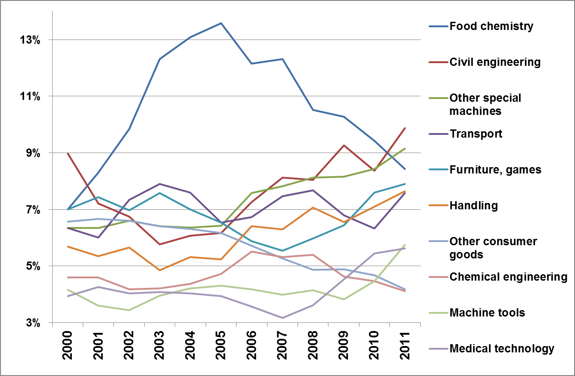

*Source: Own elaboration, based on DIP data and WIPO’s IPC-Technology concordance.*

***Figure 5: Registered Utility Model Applications by Type***

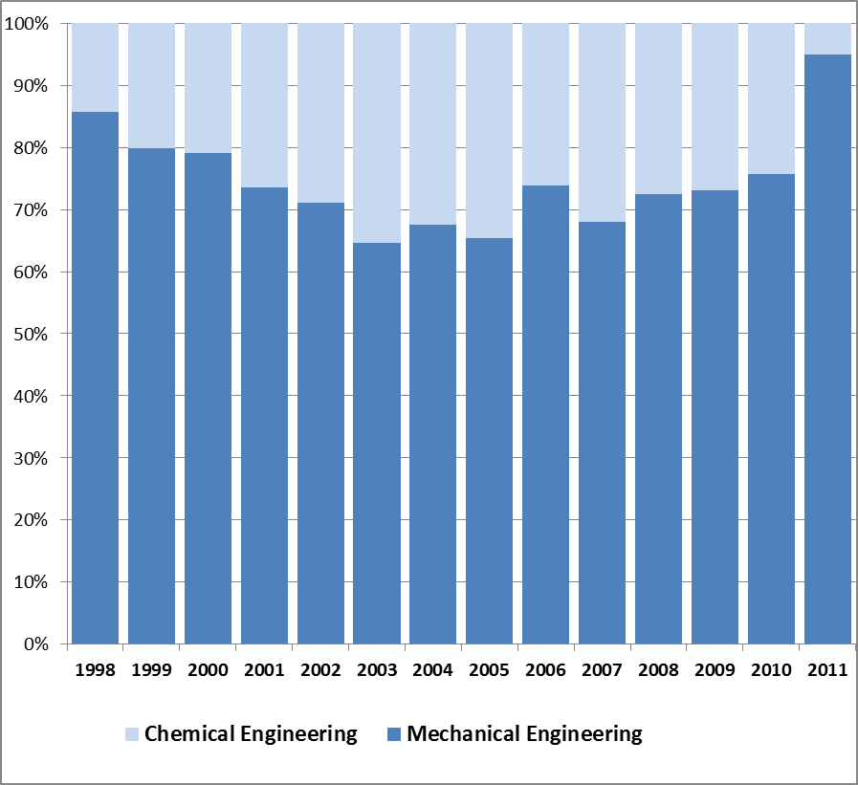

*Source: Own elaboration, based on DIP data.*

# 3. To what degree have UMs complemented other IP forms?

Building on the finding in section 0 of complementary between UM and patent use, this section explores in greater detail to what extent UMs have filled a gap in Thailand’s IP system. In particular, one can analyze whether UM holders introduced technologies for the first time to Thailand’s IP system, as opposed to simply claiming priority on existing IP filings elsewhere.

With this purpose, this section addresses two complementary topics. First, it analyzes if the UM users were bringing technologies for the first time to the IP System, as opposed to simply claiming priority on existing IP filings elsewhere. Second, it analyses in which extent UM applicants were using the IP system for the first time, as opposed to already experienced users which were shifting other IP filings to UM ones.

## Locally-New Technologies

***Table 3*** shows that the vast majority of registered UMs in Thailand are first filings; only 4% of registrations claim a foreign priority. This implies that the underlying inventions are presumed to be new in Thailand, confirming the local appeal of Thailand’s UM system.

It is relevant to note that the UM registration process has no substantive examination involved (see ***Box 1***). As such, it is difficult to determine if the invention is new to the world as well. Different is the case for patent examination, where the Thai DIP conducts an international examination for novelty. As a consequence, the fact that there are very few priorities claimed in the UM applications cannot be directly related to the inventions being internationally novel.

Despite this limitation, the results can be seen as an indication that UM protection has been attractive to, at least, locally-new technologies. It will be shown in the following subsection that these inventions were in a great extent not covered by previous existing IP instruments.

***Figure 6*** shows the few registered UM that have had claimed priority broken-down by priority office. As it can be seen, most of the first filings were done in China, followed by the United States and Japan. As United States does not provide for UM protection, these priority claims are related to US patent applications.

***Table 3: Registered UM by First and Subsequent filings***

|  |  |  |  |  |  |  |
| --- | --- | --- | --- | --- | --- | --- |
|  | **by Application year** | |  | **by Priority year** | |  |
|  | **Subsequent filings** | **First filings** | **Total filings** | **Subsequent filings** | **First filings** | **Total filings** |
| 1996 | 1 | 0 | 1 | 1 | 0 | 1 |
| 1997 | 0 | 0 | 0 | 0 | 0 | 0 |
| 1998 | 2 | 5 | 7 | 4 | 5 | 9 |
| 1999 | 7 | 112 | 119 | 34 | 112 | 146 |
| 2000 | 40 | 291 | 331 | 25 | 291 | 316 |
| 2001 | 24 | 441 | 465 | 26 | 441 | 467 |
| 2002 | 22 | 544 | 566 | 17 | 544 | 561 |
| 2003 | 21 | 491 | 512 | 22 | 491 | 513 |
| 2004 | 24 | 610 | 634 | 25 | 610 | 635 |
| 2005 | 30 | 752 | 782 | 36 | 752 | 788 |
| 2006 | 27 | 1,024 | 1,051 | 19 | 1,024 | 1,043 |
| 2007 | 16 | 710 | 726 | 28 | 710 | 738 |
| 2008 | 34 | 650 | 684 | 20 | 650 | 670 |
| 2009 | 16 | 559 | 575 | 24 | 559 | 583 |
| 2010 | 26 | 530 | 556 | 19 | 530 | 549 |
| 2011 | 13 | 386 | 399 | 3 | 386 | 389 |
| 2012 | 1 | 89 | 90 | 0 | 89 | 89 |
| **1996-2012** | **304** | **7194** | **7498** | **303\*** | **7194** | **7497** |

*Source: Own elaboration, based on DIP data. Note: (*) one priority date is missing.*

***Figure 6: Share of Applications by Priority Office***



*Source: Own elaboration, based on DIP data.*

## New Users of the IP System

Thai authorities conceived UM protection as a bridge between Industrial design and patent protections. As mentioned above (see ***Figure 2*** in p. 16), at least up to certain extent, UM protection seems to fulfill an IP rights need from resident inventors.

Upon a closer inspection of those resident applicants, it is observed that little more than a fifth of them have also applied for other types of IP protection, notably patents and Industrial designs (***Figure 7***). This is a strong indication that there are a few users of UM that were relatively sophisticated IP users. Indeed, for many of the UM applicants this is the first attempt to register a technology under any IP form.[11]

The introduction of this new form of IP has certainly promoted many of private companies to register a technology for the first time. In detail, three quarters of private companies having filed for UM during the analyzed period did only apply for this kind of IP. These represent almost 650 private firms.

Following the same reasoning about individual applicants from Section 0, it is likely that approximately 2,400 potential Entrepreneurs or Small businesses have made use of UM protection. As much as 81% of these – little less of 2,000 individual applicants – have filed only for this kind of IP since their implementation back in 1999.

Most Universities (75%) and many Government agencies (47%) were already using other forms of IP. Nevertheless, it is not negligible that a considerable portion of these public institutions – 8 universities and 20 government agencies – were able to start using the IP system thanks to the implementation of UM protection.

***Figure 7: Utility Model Applicants and Relation to Other IP Instruments***

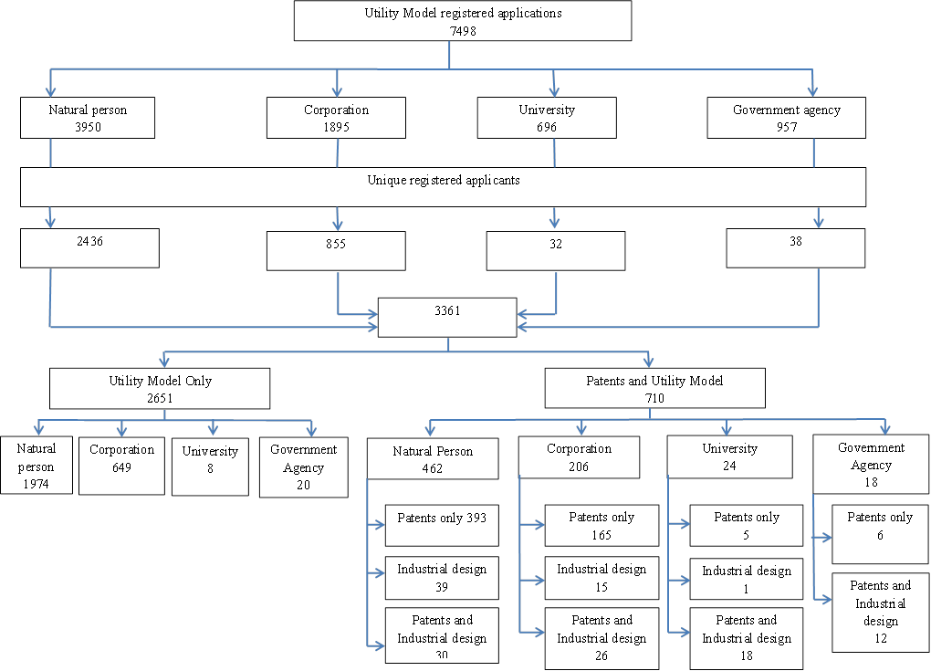

*Source: Own elaboration, based on DIP data.*

# 4. What are important challenges for the development of Thailand's UM system?

Notwithstanding the successful implementation of UM protection in Thailand, there are potential concerns about the future of this particular instrument, as well as for the IP system more broadly.

An important point in assessing the use of IP protection in a country is to consider if the institutional framework involving the IP in question is able to meet the expectations of its users.[12] Some of these expectations include the certainty in the scope, the timeline when waiting for the registration, the payment of the annual fees, and even having recourse to relevant bodies to enforce or oppose registered UMs.

## Substantive conditions in the Thai Utility Models

The scope of a given IP right refers to what is contained and, sometimes even more important, what is not contained in the granted IP right. Given that the Thai IP law has a novelty requirement for UMs but does not impose substantive examination, one concern, common to pure registration systems – is to what extent UM registrations truly meet the novelty standard. According to Suthersanen (2006), the legal uncertainty caused by the “no examination” in the UM reform introduced in Japan in 1993, was undoubtedly one of the key reasons for its failure. Similarly, based on interviews, the same author suggests that such absence of examination in China is generating abusive behavior of local applicants of Ums.

As mentioned in ***Box 1***, interviewees have signaled that there have been very few requests for examinations and very few granted UMs which have been revoked by the specialized IP court. Moreover, ***Figure 8*** shows that only 40 registered UMs have seen requests for examination – for example because of third party oppositions. Most of the requests for substantive examination were filed by competitors in the market of products that were successfully commercialized or by parties already involved in litigation. Very few examination requests were motivated by the contents in the UM application *per se*.[13]

These may be encouraging signs about the quality of UM registrations. However, one should be careful in drawing this conclusion. The lack of oppositions might also reflect that many UM applications and eventual registrations have not found real industrial application and may, therefore, have little economic value.

***Figure 8 Examination Requests Utility Models by Examination year***



*Source: Own elaboration, based on DIP data.*

## Quality of UM applications

An indirect sign of lack of UM application quality is the fact that less than half of all UM filings between 1999 and 2011 have actually been registered. More specifically, only 7,408 applications have been granted UM protection out of the 16,460 total applications filed in the same period. Given that our unit record dataset only contains information for UM applications that have been registered, it is not possible to disambiguate those filings which are still pending from those which have failed the formalities examination. Arguably, for the most recent years, a certain share of unregistered applications corresponds to still on-going application procedures. But even if one only takes into account the first half of the 2000s, the share of unregistered UM applications is high – standing at between 40% and 60% (see ***Figure 9***).

On the positive side, the decline of the unregistered rate apparent from 2003 to 2006 could be an encouraging symptom of learning by new users of the UM system. However, this trend overlaps slightly with a registration fee reduction of 50% since 2006 (see Appendix Table A. 1 for complete a list of fees).

In any case, only time will let us know how much of the increase of this rate after 2007 is due to lack of quality in applications and how much is it related to backlog matters and applicant strategies. But these figures shed some light to the challenges in terms of application quality that the Thai IP office faces.

|  |  |
| --- | --- |
| ***Figure 9: Unregistered and Registered Utility Models***    *Source: Own elaboration, based on DIP data and WIPO Statistical Database, 2013.*  ***Figure 10: Utility Models by Registration Year***    *Source: Own elaboration, based on DIP data.* | ***Figure 11: Registration Lag***    *Source: Own elaboration, based on DIP data.*  ***Figure 12: Registration Lag by Application period***    *Source: Own elaboration, based on DIP data.* |

## Backlog

As just mentioned, the difference in the number of applications and the number of registrations can be attributed to a backlog in the registration process. Interviewees have suggested that a backlog problem is a current challenge in the Thai DPI (see Appendix C).

When UMs are grouped by their registration year in ***Figure 10*** – as opposed to application one in ***Figure 9*** – no declining trend is seen for the second half of the 2000s. This is partially because it also reflects the output flow of the DIP registration process. In other terms it reflects the pace at which DIP manages to process the UM applications.

The erratic flow of registration until 2005 has been attributed to the fact that back then officers that handled also patents applications – whose workload was already considerable, were conducting the formalities examination of UM applications. Thereafter, additional examiners were hired specifically to handle UM applications, which is reflected in the increase in the number of UM registrations.

However, DIP officials reported that given the increase in the time required for patent examination during the last few years, it is likely that a few examiners may be transferred from the UM section to the patent one. If such an event occurs, the number of processed UM applications may drop again.

Another mentioned challenge is that the number of examiners available for both patents and UM fluctuates considerably from year to year. This was related to the tightening conditions in this very specific labor market. The DIP faces constant difficulties to hire examiners as civil servants’ salary scale is extremely low compared with that of the private sector. This also gives incentives to current examiners to leave for private law firms. As there are very few examiners – currently, DIP employs 9 examiners, 5 in engineering and 4 in chemistry, any resignation has a direct impact on the number of UM applications processed. Even in the case that a replacement is found relatively quickly, the training takes time and thus adds to the backlog at the office. .

## Pendency

Admittedly, the difference in the number of applications and the number of registrations may simply reflect the accumulated backlog in the registration process, reflecting the DPI’s processing capacity. Indeed, interviews have confirmed that resource limitations account for a good part of the application backlog. One direct consequence of this backlog problem is long UM pendency times.

Pendency can be roughly defined as the number of years since application required for registration. It is worth noting that not all the pendency is to be attributed to the IP office, in this case the DIP. In many cases, pendency falls under the applicant responsibility as they may take time to take actions after the IP office issues a communication.

In principle, the Thai law foresees that UM applications be processed within six months. Interviewees suggested that, in practice, the process of preparing the documents for registration may take as long as 2 years, depending on the quality of the document at initial submission. Taking into account all registered UMs, the most frequent pendency is about one year (***Figure 11***). In other terms, little more than 60% of all registered UM have been processed within a year and 83% are done within two years. This is slightly better than the general perception. Nevertheless, there are still 17% of all registrations for which it took not less than three years to be granted.

***Figure 12*** extends this analysis by breaking down the pendency rates in four 3-year periods: 1999-2001, 2002-2004, 2005-2007 and 2008-2010. The pendency rates were substantially shorter than the average for those registered UM filed during the first three years after implementation of this IP protection. Three quarters were registered within one year and more than 90% were done within two years. Roughly speaking, the worse situation in terms of pendency seemed to have been for those UM filed between 2002 and 2004. Less than half of them were registered within a year, although almost 90% were done within three years. As mentioned above, this has partially motivated the Thai DIP to incorporate more examiners. This seems to have led to a shorter pendency rates for those registered UM filed between 2005 and 2007. This improvement seems not to be stable over time, as the last 3-year period analyzed show longer pendency rates than those observed for 1999-2001 and 2005-2007, although still shorter than the one seen for 2002-2004.

It is hard to assess how much this is economically meaningful for the UM applicants. On the other hand, the Thai IP law allows applicants to convert their patent applications into UM ones – and vice versa – as long as a judgment has not been issued. It was reported that, given that it takes at least six years between a patent is filed and a decision is issued, there has been a significant increase in the number of patent applications converted into UM ones. This is an indication that, at least in certain extent, pendency matters for applicants. This shift from patents to UM applications may also have an incidence in the UM pendency, which we are not controlling for.

# Conclusion

This report describes the main trends in the use of UMs in Thailand following its implementation in 1999, drawing on a new unit record dataset on UM registrations. Additionally, this study details the construction of this new dataset jointly developed by TDRI and WIPO, with the close cooperation of the Thai DIP.

Evaluating the success of implementing UM protection – or any IP policy change – is not an easy exercise. While not providing a definite answer, the descriptive evidence outlined here offers an encouraging perspective on the uptake of the UM system in Thailand – especially in light of its original objective. It also points to several concerns confronting policymakers.

It has been shown that Thai applicants have, relatively speaking, rapidly adopted the use of UM protection. During the first eight years since Thailand introduced UM protection, the number of filings has grown in average 27.4% per year, which tops the equivalent rates of the other IP instruments for the same period. Despite the fall in 2007, it seems that UM applications have stabilized thereafter around 1,400 applications per year.

More importantly, the main trends suggest that, if anything, UM protection has increased the filings of overall Thai technological activity. When resident filings for patents and UM are took into account together, these filings have increased in volume and at a faster pace than resident patent filings before 1999.

In the same vein, the trends about UM protection use suggest that it has been particularly attractive for local innovators. Thai applicants represent 95% of the UM filings during the 2000s, which is a considerably higher proportion than those observed for the other IP filings. In further detail, UM protection seemed to have been successful also in integrating local Entrepreneurs and SMEs into the IP system, as evidenced by the high proportion of individual filings. However, it is an open question for the overall Thai innovation system – including the IP policies – to which extent the excess of registrations under individual names affects these small business innovative activity.

UM protection was also shown to be used for locally-new inventions as well as by new users of the Thai IP system. More than 95% of all registered UM in Thailand are first filings, which is to say they are presumed to be new inventions in Thailand. Even more relevant, most UM applicants are filing for an IP protection – trademarks excluded – for their first time. Little less than 80% of them have obtained UM protection without having sought for patents or Industrial designs before. This is particularly true for private companies and entrepreneurs, as rough estimates indicate that almost 650 private firms and 2,400 potential entrepreneurs have protected their technologies for their first time by registering UM. This is a strong indication that UM protection has complemented the existing use of other IP.

This study also provides empirical evidence on industries using UM protection at different paces. While not completely surprising, the fact that the adoption rate is not horizontal across the Thai economy can feed the policy discussion on industrial specialization and the role of IP.

This report also brings attention to the potential challenges the Thai IP system may face in the future of this new policy instrument. The institutional framework involving the UM protection need to be able to meet the expectations of its users, which relate to the certainty in the scope and timeline, among others. There is mixed evidence about the substantive matter within Thai UM filings. In the one hand, very few substantive examinations were requested. On the other hand, the lack of oppositions might also mean that these have no actual economic value.

Additionally, there is indirect evidence of a lack of quality of the UM applications, as less than half of all UM applications filed between 1999 and 2011 have been registered. This is a surprising result for an IP instrument that just requires a formalities examination. Besides the lack of quality in the UM filings, this is also a symptom of backlog problems in the DIP. A direct consequence of both lack of quality and backlog is UM pendency. Even if the Thai law requires that the UM applications have to be processed within 6 months, it has been observed that little less of 40% of all registered UM have taken two years or more. Evidence also suggests that this pendency has been increasing lately.

To conclude, while this study provided a thorough description of UM use in Thailand, it runs short of an analytical research on the economic implications of the introduction of UMs. This is particularly true for what it respects to the economic performance of applicants, notably private Thai companies. This issue is being addressed in parallel in complementary research of the Country Study Thailand under the project on Intellectual Property and Socio-Economic Development under the CDIP. For this specific study, the registered UM unit records of Thai companies has been enriched with business register information, notably financial and economic performance information.

There are, of course, other potential avenues to be pursued in order to improve our understanding of the role that UM protection has played in Thailand’s innovation system since its implementation back in 1999. For instance, the statistical analysis in the current report has indicated that there is more to be investigated about the IP activity of individual applicants. Similarly, the analysis by technological fields has suggested that there is plenty of heterogeneity in how industries use this new IP instrument, which also deserves further attention.

In any case, it is the intention of the current report that all its main findings, as well as the efforts conducted to put this new database in place, will enable and foster new investigations in this field which will feed into the IP policy design of developing countries.

# Acknowledgements

This work would not have been possible without the close cooperation from the Thai Department of Intellectual Property (DIP), under the Ministry of Commerce. We also acknowledge all interviewees, who are listed in Appendix C. We also thank Prof. Keun Lee for reviewing this document.

# References

Kim, L. (1997). *Imitation to Innovation: The Dynamics of Korea's Technological Learning*. Boston: Harvard Business Press.

Kim, Y. K., Lee K., Park W. G. and Choo K. (2012). *Appropriate Intellectual Property Protection and Economic Growth in Countries at Different Levels of Development*. Research Policy 41(2): 358–75.

Lee, K. and Kim, Y. K. (2010). *Intellectual Property Rights and Innovation in Economic Development in Korea*. Paper presented at the KDI International Conference on Intellectual Property for Economic Development: Issues and Policy Implications. Seoul, Republic of Korea, Februrary.

Lee, K, Park W.G. and Lim C.(2003). *Industrial Property Rights and Technological Development in the Republic of Korea*. in *The Economics of Intellectual Property in the Republic of Korea*, WIPO Publication No. 1031(E), Geneva, Switzerland.

Maskus, K. E. and McDaniel C. (1999). *Impacts of the Japanese Patent System on Productivity Growth*. Japan and the World Economy 11(4): 557–74.

Odagiri, H., Goto A., Sunami A. and Nelson R.R. (2010). *Intellectual Property Rights, Development, and Catch up: An International Comparative Study*.

Schmoch U. (2008). Concept of a Technology Classification for Country Comparisons, WIPO.

Suthersanen, U. (2006). Utility Modles and Innovation in Developing Countries, *UNCTAD-ICTSD Project on IPRs and Sustainable Development*. Geneva: ICTSD-UNCTAD.

WIPO. (2011). *World Intellectual Property Report 2011: The Changing Face of Innovation*. Geneva: World Intellectual Property Organization.

Yang D. (2003) *The Development of Intellectual Property in China.* World Patent Information 25(2): 131–42.

Yang, D., and Clarke P. (2005). *Globalisation and Intellectual Property in China*. Technovation 25(5): 545–55.

[Appendixes follow]

# Appendix A: Complementary information

***Table A. 1: Comparison of Maximum Fees for patent and Utility Model Protection***

|  |  |  |
| --- | --- | --- |
| ***patents*** | **1999-2005** | **2005-** |
| patent application | 1,000 | 500 |
| Publication of application | 500 | 250 |
| Request for examination | 500 | 250 |
| Opposition of application | 500 | 250 |
| Grant | 1,000 | 500 |
| Annual fees: |  |  |
| Fifth year | 2,000 | 1,000 |
| Sixth year | 2,400 | 1,200 |
| Seventh year | 3,200 | 1,600 |
| Eighth year | 4,400 | 2,200 |
| Ninth year | 6,000 | 3,000 |
| Tenth year | 8,000 | 4,000 |
| Eleventh year | 10,400 | 5,200 |
| Twelfth year | 13,200 | 6,600 |
| Thirteenth year | 16,400 | 8,200 |
| Fourteenth year | 20,000 | 10,000 |
| Fifteenth year | 24,000 | 12,000 |
| Sixteenth year | 28,400 |  |
| Seventeenth year | 33,200 |  |
| Eighteenth year | 38,400 |  |
| Nineteenth year | 44,000 |  |
| Twentieth year | 50,000 | 25,000 |
| Or payment of all annual fees in one payment | 280,000 | 140,000 |
| ***Utility Models*** | **1999-2005** | **2005-** |
| Utility Model application | 500 | 250 |
| Grant and Publication of application | 1,000 | 500 |
| Request for examination | 500 | 250 |
| Opposition of application | 500 | 250 |
| Annual fees: |  |  |
| Fifth year | 1,500 | 750 |
| Sixth year | 3,000 | 1,500 |
| Or payment of all annual fees in one payment | 4,000 | 2,000 |
| Renewal fees |  |  |
| First extension | 12,000 | 6,000 |
| Second extension | 18,000 | 9,000 |

*Source: Thailand patent Act B.E. 2522 (1999) and the Thai Department of Intellectual Property website.*

*Note: The original fees, as specified in the patent Act B.E. 2522, were changed in 2005.*

***Table A. 2: Number of Applications from State Agencies***

|  |  |  |
| --- | --- | --- |
| **Government agency** | **Total** | **%** |
| The Government Pharmaceutical Organization | 49 | 20.6 |
| Thailand Institute of Scientific and Technological Research,  Ministry of Science and Technology | 32 | 16.0 |
| National Research Council of Thailand | 28 | 13.5 |
| The Thailand Research Fund | 25 | 11.8 |
| Department of Medical Sciences, Ministry of Public Health | 22 | 10.5 |
| Department of Health, Ministry of Public Health | 8 | 9.2 |
| Electricity Generating Authority of Thailand | 7 | 3.4 |
| Abhaiphubet Chaopraya Hospital Foundation | 6 | 2.9 |
| Department of Agriculture, Ministry of Agriculture and Cooperatives | 6 | 2.5 |
| The Thai Red Cross Society | 6 | 2.5 |
| Agricultural Research Development Agency (Public Organization) | 4 | 2.5 |
| Thailand Institute of Nuclear Technology (Public Organization) | 4 | 1.7 |
| The Metropolitan Electricity Authority | 3 | 1.7 |
| Others | 38 | 1.3 |
| **Total** | **238** | **100%** |

*Source: Own elaboration, based on DIP data.   
Note: Only the first applicant is taken into consideration.*

***Table A. 3: Number of Applications from Universities***

|  |  |  |
| --- | --- | --- |
| **University** | **Total** | **%** |
| Khon Kaen University | 141 | 20.3 |
| Mahidol University | 121 | 17.4 |
| Kasetsart University | 86 | 12.4 |
| King Mongkut's University of Technology North Bangkok | 54 | 7.8 |
| Prince of Songkla University | 50 | 7.2 |
| Naresuan University | 48 | 6.9 |
| King Mongkut's University of Technology Thonburi | 41 | 5.9 |
| Chulalongkorn University | 37 | 5.3 |
| Chiang Mai University | 21 | 3.0 |
| Ubon Ratchathani University | 18 | 2.6 |
| Burapha University | 14 | 2.0 |
| Thammasat University | 9 | 1.3 |
| Others | 56 | 8.0 |
| **Total** | **696** | **100** |

*Source: Own elaboration, based on DIP data.   
Note: Only the first applicant is taken into consideration.*

***Table A. 4: Registered Utility Model Applications by Technological field***

|  |  |  |  |  |
| --- | --- | --- | --- | --- |
| **Rank** | **Technological Field** | **Q** | **%\*** | **Cum %\*** |
| 1 | Food chemistry | 791 | 10.5% | 10.5% |
| 2 | Civil engineering | 589 | 7.9% | 18.4% |
| 3 | Other special machines | 574 | 7.7% | 26.1% |
| 4 | Transport | 543 | 7.2% | 33.3% |
| 5 | Furniture, games | 509 | 6.8% | 40.1% |
| 6 | Handling | 482 | 6.4% | 46.5% |
| 7 | Other consumer goods | 404 | 5.4% | 51.9% |
| 8 | Chemical engineering | 352 | 4.7% | 56.6% |
| 9 | Machine tools | 335 | 4.5% | 61.1% |
| 10 | Medical technology | 324 | 4.3% | 65.4% |
| 11 | Pharmaceuticals | 310 | 4.1% | 69.5% |
| 12 | Mechanical elements | 309 | 4.1% | 73.6% |
| 13 | Thermal processes and apparatus | 298 | 4.0% | 77.6% |
| 14 | Basic materials chemistry | 285 | 3.8% | 81.4% |
| 15 | Electrical machinery, apparatus, energy | 282 | 3.8% | 85.2% |
| 16 | Measurement | 220 | 2.9% | 88.1% |
| 17 | Materials, metallurgy | 186 | 2.5% | 90.6% |
| 18 | Engines, pumps, turbines | 180 | 2.4% | 93.0% |
| 19 | Control | 173 | 2.3% | 95.3% |
| 20 | Textile and paper machines | 149 | 2.0% | 97.3% |
| 21 | Environmental technology | 142 | 1.9% | 99.2% |
| 22 | Audio-visual technology | 108 | 1.4% | 100.6% |
| 23 | Macromolecular chemistry, polymers | 80 | 1.1% | 101.7% |
| 24 | Biotechnology | 62 | 0.8% | 102.5% |
| 25 | Organic fine chemistry | 54 | 0.7% | 103.2% |
| 26 | Telecommunications | 50 | 0.7% | 103.9% |
| 27 | Surface technology, coating | 49 | 0.7% | 104.6% |
| 28 | Computer technology | 48 | 0.6% | 105.2% |
| 29 | Optics | 44 | 0.6% | 105.8% |
| 30 | Analysis of biological materials | 21 | 0.3% | 106.1% |
| 31 | Basic communication processes | 10 | 0.1% | 106.2% |
| 32 | Digital communication | 8 | 0.1% | 106.3% |
| 33 | Semiconductors | 7 | 0.1% | 106.4% |
| 34 | IT methods for management | 1 | 0.0% | 106.4% |
| 35 | Micro-structural and nano-technology | 0 | 0.0% | 106.4% |
|  | **Total** | **7498** | **100%** |  |

*Source: Own elaboration, based on DIP data and WIPO’s IPC-Technology concordance.*

*Note: Applications exceed total due to 504 UMs registrations which are assigned to more than one technological field.*

***Table A. 5: Registered Utility Model Applications by Technological field and Type***

|  |  |  |  |  |  |  |
| --- | --- | --- | --- | --- | --- | --- |
| **Rank** | **Technological Field** | **Mechanical Engineering** | **Chemical Engineering** | **All** | **Mechanical Engineering** | **Chemical Engineering** |
| 1 | Food chemistry | 24 | 767 | 791 | 3% | 97% |
| 2 | Civil engineering | 580 | 9 | 589 | 98% | 2% |
| 3 | Other special machines | 491 | 83 | 574 | 86% | 14% |
| 4 | Transport | 543 | 0 | 543 | 100% | 0% |
| 5 | Furniture, games | 506 | 3 | 509 | 99% | 1% |
| 6 | Handling | 476 | 6 | 482 | 99% | 1% |
| 7 | Other consumer goods | 395 | 9 | 404 | 98% | 2% |
| 8 | Chemical engineering | 244 | 108 | 352 | 69% | 31% |
| 9 | Machine tools | 331 | 4 | 335 | 99% | 1% |
| 10 | Medical technology | 305 | 19 | 324 | 94% | 6% |
| 11 | Pharmaceuticals | 6 | 304 | 310 | 2% | 98% |
| 12 | Mechanical elements | 309 | 0 | 309 | 100% | 0% |
| 13 | Thermal processes and apparatus | 296 | 2 | 298 | 99% | 1% |
| 14 | Basic materials chemistry | 5 | 280 | 285 | 2% | 98% |
| 15 | Electrical machinery, apparatus, energy | 281 | 1 | 282 | 100% | 0% |
| 16 | Measurement | 186 | 34 | 220 | 85% | 15% |
| 17 | Materials, metallurgy | 24 | 162 | 186 | 13% | 87% |
| 18 | Engines, pumps, turbines | 179 | 1 | 180 | 99% | 1% |
| 19 | Control | 173 | 0 | 173 | 100% | 0% |
| 20 | Textile and paper machines | 106 | 43 | 149 | 71% | 29% |
| 21 | Environmental technology | 88 | 54 | 142 | 62% | 38% |
| 22 | Audio-visual technology | 108 | 0 | 108 | 100% | 0% |
| 23 | Macromolecular chemistry, polymers | 4 | 76 | 80 | 5% | 95% |
| 24 | Biotechnology | 1 | 61 | 62 | 2% | 98% |
| 25 | Organic fine chemistry | 1 | 53 | 54 | 2% | 98% |
| 26 | Telecommunications | 50 | 0 | 50 | 100% | 0% |
| 27 | Surface technology, coating | 25 | 24 | 49 | 51% | 49% |
| 28 | Computer technology | 48 | 0 | 48 | 100% | 0% |
| 29 | Optics | 44 | 0 | 44 | 100% | 0% |
| 30 | Analysis of biological materials | 2 | 19 | 21 | 10% | 90% |
| 31 | Basic communication processes | 10 | 0 | 10 | 100% | 0% |
| 32 | Digital communication | 8 | 0 | 8 | 100% | 0% |
| 33 | Semiconductors | 7 | 0 | 7 | 100% | 0% |
| 34 | IT methods for management | 1 | 0 | 1 | 100% | 0% |
| 35 | Micro-structural and nano-technology | 0 | 0 | 0 | - | - |
|  | **Total** | **5,454** | **2,044** | **7,498** | **73%** | **27%** |

*Source: Own elaboration, based on DIP data and WIPO’s IPC-Technology concordance.*

*Note: Applications exceed total due to 504 UMs registrations which are assigned to more than one technological field.*

# Appendix B: Construction of the Database

## Characteristics of the Raw Data

For the purposes of Country Study Thailand, the Department of Intellectual Property (DIP), under the Ministry of Commerce, provided the utility model registration raw data. This data was recorded in a single excel file containing all 7,498 UM registrations filed between October 1996 and September 2012.[14] This dataset contained 19 variables which are detailed in table A.6.

The database provided had incomplete information for certain variables. As detailed in table A.6, there were some missing values for variables such as the IPC number, the abstract, the claims, the registration date, the applicant’s name and nationality or the inventor’s ones. Moreover, certain information available on DIP’s website was not available in the raw dataset. This was the case of information on the legal status, the priority country code, applicant’s and inventor’s residence. As a result, TDRI has collected manually the missing data for all 7,498 applications. In addition to completing the raw data, TDRI has undertaken several actions in order to improve the existing dataset.

***Table A. 6: Database Provided by the DIP***

| **Item** | **The number of data shown in the excel file** | **The number of missing data** |
| --- | --- | --- |
| Category | 7,498 | 0 |
| Application number | 7,498 | 0 |
| Publication number | 7,498 | 0 |
| Registration number | 7,498 | 0 |
| Priority number | 137 | 2 |
| Title | 7,498 | 0 |
| IPC | 7,464 | 34 |
| Abstract | 7,470 | 28 |
| Claims | 7,467 | 31 |
| Applicant | 7,495 | 3 |
| Inventor | 7,495 | 2 |
| Application date | 7,498 | 0 |
| Publication date | 7,498 | 0 |
| Registration date | 7,496 | 2 |
| Examination date | 40 | n/a |
| Priority date | 304 | n/a |
| patent type | 7,498 | 0 |
| Applicant’s nationality | 7,353 | 145 |
| Inventor’s nationality | 5,103 | 2,395 |

*Source: based on DIP raw data.*

*Note: n/a = not applicable, as the amount of missing values is not known.*

## Process of Collecting Missing Variables

The following steps were undertaken to collect the missing variables:

Step 1: Go to DIP website which contains the UM registration records from 1996 up to 2012

Step 2: Enter an identifier for a particular UM application whose data was missing. At this point, the webpage will reveal the UM’s application number, publication number, registration number, title, category, inventor and applicant.

Step 3: Click on the application number to get details on the UM’s application date, publication date, registration date, receive date, agent, IPC code, last status, status date, abstract, claims, published document, application certificate and invention details.

Step 4: Click on the “published document” and “application certificate” icon to view the publication number, registration number, priority date, priority number, applicant country, inventor country, and priority country. Unfortunately, this information is available only as images (TIFF format), which implies they have to be recorded manually.

Step 5: As all the above mentioned information is reported only in Thai, TDRI has translated to English the following variables: applicant country, inventor country and priority country into applicant country code, inventor country code and priority country code.

Unfortunately, certain variables which were provided exclusively in Thai were not translated. This is the case of abstract, title, applicant name, inventor name, and claims as seen below.

## Preparing Applicant Names

There were several issues to address when trying to identify the UM applicants. These had to be fixed in order to avoid double-counting bias, as well as to allow for further empirical studies in the near future.

The most frequent problem in the identification of applicants refers to the same name written in multiple ways. TDRI team found that there is no unique way in which an applicant name may be registered due to (1) the use of acronym; (2) the way in which an English word is spelled in Thai alphabets; (3) the use of blank spaces. For example, in the case of the use of acronym, such as “ห้างหุ้นส่วนจำกัด โรงงานรถไถนา จ.เจริญชัย(นายเจ่า) อยุธยา” which can be found also as “หจก.โรงงานรถไถนา จ.เจริญชัย(นายเจ่า)อยุธยา”. However, the same name written in the same way may not appear all together due to the different use of blank spaces. For example the name “ดร.ชวาล โสตถิวันวงศ์” (no space between ดร. and ชวาล) was appeared also as “ดร. ชวาล โสตถิวันวงศ์” (one blank space between ดร. and ชวาล) and the name “นางยุพดี รัตนจัง” (one blank space between first name and last name) was found also as “นางยุพดี รัตนจัง” (more than one blank space between first name and last name).

Additionally, applicant names were found misspelled in several cases. For example, the word “บริษัท” (means company) was found also as “บรัษัท” and the word “นาย” (means Mr) was typed as “นย” in some application. Similarly, some institutions’ names were found misspelled as well, such as the case of word “องค์การเภสัชกรรม” (The Government Pharmaceutical Organization) can be found as “องการเภสัชกรรม”.

Another kind of problem arises when companies change their names over time. As such, different UM applications by the same company were not always attributed to the same entity. For example, the company “บริษัท แอร์โรเฟลกซ์ อินเตอร์เนชันแนล จำกัด” was renamed as “บริษัท แอร์โรคลาส จำกัด” or the company “บริษัท ปูนซีเมนต์อุตสาหกรรมไทย จำกัด” was renamed as “บริษัท เอสซีจี ซิเมนต์ จำกัด.

In some cases, applicant’s name includes additional information. For instance, many companies provide information on their legal registration (e.g. a company organized under a foreign law). Some applicant names contain the name both in Thai and English (e.g. นายจอร์จ ออตโต แอปส์โฮฟ (Mr.Georg Otto Abshof), ฉือ, จี้ - หยวน (Hsueh, Chih - Yuan). Also, in some cases, the name includes members of the company’s Board of directors.

Lastly, many UM applications show the names of more than one applicant in the same field. In the case of multiple applicants, the rule of first applicant has been applied in order to classify the applicant type and count as one applicant for each application. For example, if the first applicant is an individual and the second one a registered company, we have classified this UM application as from an individual.

***Table A. 7: Data Collection from the DIP Website***

| **Database** | **Data collection on the DIP website** | | | | **Contents in Thai** |
| --- | --- | --- | --- | --- | --- |
| **Step 1** | **Step 2** | **Step 3** | **Step 4** |
| IPC |  | **✓** |  |  |  |
| Abstract |  | **✓** |  |  | **✓** |
| Category | **✓** |  |  |  |  |
| application number | **✓** |  |  |  |  |
| application date |  | **✓** |  |  |  |
| publication number | **✓** |  |  |  |  |
| publication date |  | **✓** |  |  |  |
| registration number | **✓** |  |  |  |  |
| registration date |  | **✓** |  |  |  |
| Title | **✓** |  |  |  | **✓** |
| Applicant | **✓** |  |  |  | **✓** |
| applicant country code |  |  |  | **✓** |  |
| Inventor | **✓** |  |  |  | **✓** |
| inventor country code |  |  |  | **✓** |  |
| Claims |  | **✓** |  |  | **✓** |
| receive date |  | **✓** |  |  |  |
| Agent |  | **✓** |  |  | **✓** |
| last status |  | **✓** |  |  | **✓** |
| status date |  | **✓** |  |  |  |
| published document |  | **✓** |  |  | **✓** |
| application certificate |  | **✓** |  |  | **✓** |
| invention details |  | **✓** |  |  | **✓** |
| priority date |  |  | **✓** |  |  |
| priority number |  |  | **✓** |  |  |
| priority country code |  |  |  | **✓** |  |

# Appendix C: List of interviewed UM stakeholders in Thailand

Department of Intellectual Property

Mr. Thanit Ngansampantrit, Head of International Cooperation, Section 2 (Europe)

Ms. Kitiyaporn Sathusen, Senior Trade Officer, IP Promotion and Development Office

Mr. Sakol Vithoonjit, Patent Examiner, Petty Patent Group 1

The Federation of Thai Industries

Dr. Nilsuwan Leelarasamee, Chairman

National Science and Technology Development Agency

Dr. Orakanoke Phanraksa, Acting Head, Intellectual Property Policy, Technology Licensing Office

Ms. Arunsri Sritanitipol, Manager, Intellectual Property Management, Technoolgy Licensing Office

Mahidol University

Associate Professor Soranit Siltharm, Vice President for Policy and Planning

Ms. Pimprapi Theeracheep, Deputy Director, Mahidol University Business Incubator

Siam Cement Group

Dr. Wilaiporn Chetanachan, Director, Corporate Technology Office

Ms. Vikran Duangmanee, IP Manager, Legal and Corporate Affairs

Ms. Uraiwan Sintharapantorn, Head of Legal and Corporate Affairs

Ms. Morakot Veerabhand, IP Specialist – Product and Technology Development Center

Mr. Yingyong Thanthanapongphan, IP Manager

Mr. Roongnirun Nirundorn, IP Specialist, Legal and Corporate Affairs

Mr. Kulachet Dharachandra, Corporate Planning and Business Development Director

Mr. Thanachai Piyasrithong, Technology Management Manager

Mr. Surachate Chalothorn, Technology Director

Tilleke and Gibbins Lawyers

Ms. Darani Vachanavuttivong, Co-managing Partner

Mr. Alan Adcock, Partner

Mr. Prateep Naboriboon, Senior Patent Agent

Marut Bunnag International Law Office

Mr. Rujira Bunnag, Attorney-at-Law

Mr. Niran Santos, Attorney-at-Law

Satyapon and Partners Limited

Mr. James Pate, Attorney-at-Law

Mr. Kritchawat Chainapasak, Attorney-at-Law

[End of Annex and of document]

1. The views expressed in this Study are those of the authors and do not necessarily reflect those of the WIPO Secretariat or any of the Organization’s Member States.
2. This analysis does not take into account trademark filings.
3. See Document CDIP/5/7, available at <http://www.wipo.int/meetings/en/doc_details.jsp?doc_id=131717>.
4. In June 2012, WIPO and TDRI staff conducted a series of interviews in Bangkok with a number of stakeholders to seek their views on the contribution and functioning of the Thai UM system. For a detailed list please refer to Appendix C.
5. For further details, please refer to WIPO’s Statistical Country Profile for Thailand (as in May, 2013) <http://www.wipo.int/ipstats/en/statistics/country_profile/countries/th.html>
6. UNESCO Institute of Statistics ([www.uis.unesco.org](http://www.uis.unesco.org)), data extracted on October 2013.
7. It is worth noting that, from this point onwards, much of analysis is based on 7,498 registered Utility Models, which is a smaller set of all the filed Utility Model applications during the same period.
8. For a detailed list of Government agencies (***Table A. 2***) and Universities (***Table A. 3***) please refer to Appendix A.
9. For further details on WIPO’s IPC-Technology concordance refer to [www.wipo.int/ipstats/en/statistics/technology_concordance](http://www.wipo.int/ipstats/en/statistics/technology_concordance.html)
10. Please refer to the discussion on backlog and pendency in Section 0.
11. It is worth signaling that the use of Trademarks is being excluded of this analysis.
12. See Subsection 2.3 on “Appreciating the Role of patent Institutions,” in Chapter 2 of the World IP Report 2011 on the *Changing Face of Innovation* (WIPO, 2011).
13. From interview with DIP officials and patent examiners.
14. Although the registration of utility patent started in 1999, but the Department of Intellectual Property Rights allowed applicants with pending patent registration to switch application to Utility Model instead.