E
MM/LD/WG/14/4
ORIGINAL: English
DATE: APRIL 27, 2016

Working Group on the Legal Development of the Madrid System for the International Registration of Marks

Fourteenth Session
Geneva, June 13 to 17, 2016

The Future Development of the Madrid System for the International Registration of Marks

Document prepared by the International Bureau

I. INTRODUCTION

- The Working Group on the Legal Development of the Madrid System for the International Registration of Marks (hereinafter referred to as “the Working Group”), in its thirteenth session, requested that the International Bureau prepare a document with proposals to make the Madrid System evolve to meet the needs of all its members and be more flexible and effective, without questioning its fundamental principles.

THE MADRID SYSTEM: PURPOSE AND ADVANTAGES

- The Madrid System turned 125 years in April 2016. Its purpose is to provide a mechanism whereby protection for a trademark originating in one Contracting Party can be obtained in all the other Contracting Parties through a single international registration.
- The Madrid System provides applicants and holders with the following two main advantages:
(i) centralized filing: by filing one international application, through one Office (the Office of origin), using one language and paying fees in one currency, applicants can obtain protection in several export markets; and,

(ii) centralized management of acquired rights: trademark holders can take advantage of numerous procedures that can be requested to one Office (the International Bureau) with effect in all the territories covered by an international registration, such as, for instance, renewal, the recording of changes, restrictions of the scope of protection (cancellations and limitations) or the expansion of the geographical scope by subsequently designating additional members of the Madrid System.
- Moreover, the Madrid System provides Contracting Parties with the following advantages:
(i) formalities controlled by the Office of origin and the International Bureau;
(ii) harmonized classification of goods and services, performed by the International Bureau, that should be accepted by all Offices;
(iii) centralized collection of the amounts of the fees and distribution to the Contracting Parties;
(iv) one International Register, maintained by the International Bureau, having effect in all Contracting Parties and with its extracts being exempted from any certification or legalization; and,
(v) technical assistance and capacity-building, delivered by the International Bureau in cooperation with Contracting Parties.

THE LEGAL FRAMEWORK

- The Protocol Relating to the Madrid Agreement Concerning the International Registration of Marks (hereinafter referred to as “the Protocol” and “the Agreement”), that was adopted in 1989 and is the treaty under which the system now operates, preserved the fundamental principles found in the Agreement, such as, the requirements of a basic mark, entitlement to use the Madrid System and the dependency of the international registration on the basic mark.
- The Protocol made it possible for intergovernmental organizations to become party to the Madrid System, with the European Union (EU) and the African Intellectual Property Organization (OAPI) having acceded to the Protocol. It also provided flexibilities for Contracting Parties, compared to the Agreement, such as the options of declaring for a longer refusal period and for individual fees. Flexibilities were also introduced to benefit holders, such as the option to choose entitlement and the possibility of transformation, following the cancellation of the international registration due to the ceasing of effect of the basic mark.

USE OF THE MADRID SYSTEM

- In 2015, the total number of international applications filed under the Madrid System was 49,273, marking the sixth consecutive year of growth and the highest number of international applications ever filed in a given year. Moreover, over the past 19 years, “the number of international applications filed increased in all but three years that coincided with economic downturns in the early 2000s and 2009.”
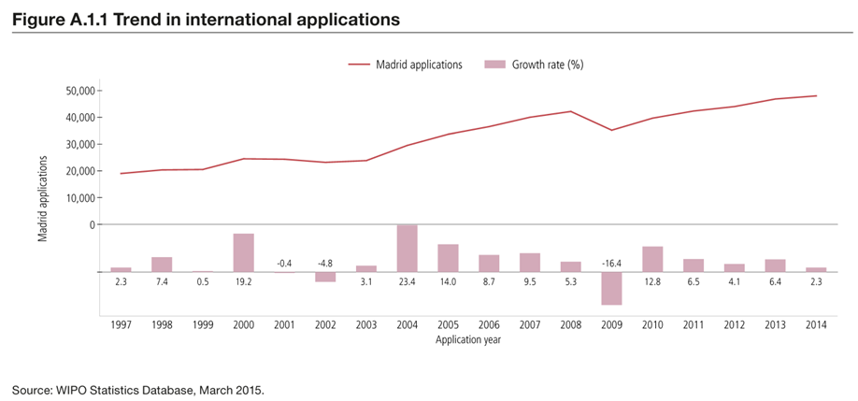
- While the number of international applications has increased, probably thanks to expanded membership of the Madrid Union and a general upward trend in trademark applications filed worldwide, it must be noted that the share of applications filed through the Madrid System has decreased from around 70 per cent of all non-resident trademark filing activity in 2008 to about 60 per cent in 2013.
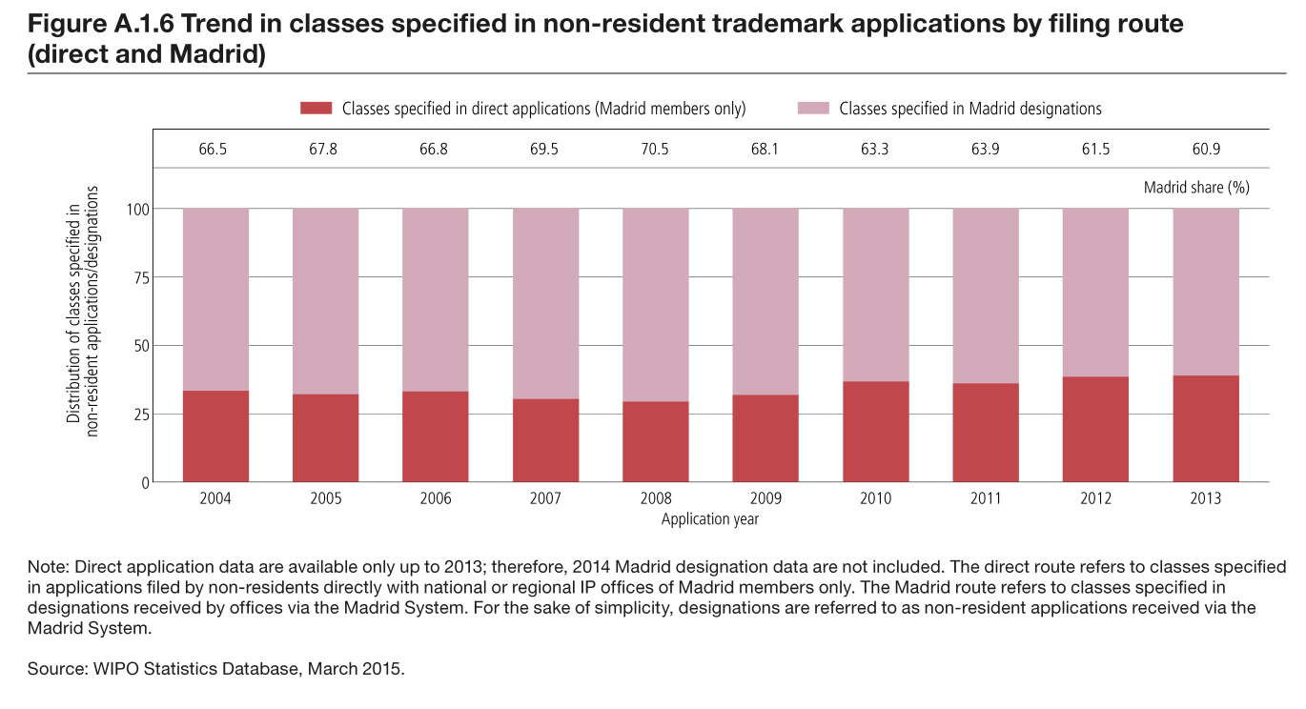

USERS’ NEEDS AND EXPECTATIONS

- Empirical evidence suggests that certain users perceive the Madrid System as not meeting all their needs and expectations in well-defined aspects; more specifically, that the Madrid System:
– provides geographical coverage that is not truly global yet;
– excludes potential users from filing international applications through stringent entitlement requirements;
– constrains users by requiring a basic mark, which is particularly troublesome for companies seeking to protect international or regional versions of their brands that are linguistically different from the brand they use at home;
– limits the goods and services in an international application to those in the basic mark, which affects companies seeking to protect their brands in export markets for goods and services other than those appearing in the basic mark;
– provides insufficient legal certainty due to (i) inadequate implementation in certain Contracting Parties; and, (ii) difficulty enforcing rights acquired in some Contracting Parties;
– is too complex due to (i) requirements by Contracting Parties and increased sophistication by users in specification and classification of goods and services; (ii) inefficient communications between the Offices, the International Bureau and the holders; and, (iii) a complex fee structure; and,
– delivers services, both by the International Bureau and by the Offices of some Contracting Parties, with a quality that should be improved.

NEED FOR EVOLUTION

- Notwithstanding the important revisions brought about by the Madrid Protocol, the Madrid System needs to continue evolving to meet the needs and expectations of all users, including Offices, to maintain its preeminent role in the international trademark landscape.
- The need for the evolution of the Madrid System is fundamentally driven by:
– truly global markets;
– more diverse members covering all continents and many different languages;
– growing expectations of users and Offices alike, for easier-to-use, faster and inexpensive services;
– varying degrees of maturity among Offices, some being more familiar with the Madrid System while others being at earlier stages; and,
– fast-advancing technology.

PURPOSE OF THIS DOCUMENT

- At a very fundamental level, this document sets out a range of options which the International Bureau views as possible responses to the above-mentioned needs and expectations. These options are broad ranging: some concern the design of the Madrid System itself; some concern the practical functioning of the Offices (both as Office of origin and of a designated Contracting Party) and of the International Bureau; and some concern both Offices and the International Bureau.
- The implementation of certain options discussed below would require changes to the Protocol, the Common Regulations under the Madrid Agreement Concerning the International Registration of Marks and the Protocol Relating to that Agreement (hereinafter referred to as “the Common Regulations”), to both, or to the national or regional implementing legislation or regulations. The implementation of other options would require operational changes and increased transparency.
- This document seeks to:
(i) catalogue the options available without elaborating them in detail;
(ii) elicit further discussion to determine whether other options should be included or some of the options presented in this document should be discarded; and
(iii) set out the work to be prioritized by future sessions of the Working Group and/or its Roundtable.
- Guidance provided by the Working Group on which options to discuss would allow the International Bureau to undertake an in-depth analysis and to present its findings for discussion in future sessions of the Working Group or its Roundtable.
- This document is thus intended to serve as a useful framework guiding the possible long-term strategic evolution of the Madrid System.

II. GEOGRAPHICAL COVERAGE OF THE MADRID SYSTEM

- The value of the Madrid System increases as it becomes more global, because it is possible to obtain protection in more countries through a single application and to manage all the rights centrally.
- Progress in the expansion of membership to the Protocol has been very positive in recent years. Based on current planning and information, it is likely that, by the end of 2017, almost all the countries of the Association of Southeast Asian Nations (ASEAN) will have joined the system. In addition, it is anticipated that several more countries will become members by 2018, including Canada and possibly South Africa.
- In other words, within the next two or three years, the Madrid System should have excellent geographical coverage and, therefore, will reach a limit for its further expansion in Africa, Asia, Europe, and North America.
- That being the case, the next strategic focus should be on countries in Latin America and those that are members of the Gulf Cooperation Council (GCC).

III. OPTIONS CONCERNING THE DESIGN OF THE MADRID SYSTEM

ENTITLEMENT TO FILE AN INTERNATIONAL APPLICATION

- To file an international application, an applicant has to be entitled, that is, has to be a national, be domiciled, or have a real and effective industrial or commercial establishment in the Contracting Party where the applicant holds the basic mark.
- An option to explore would be whether and how to relax or eliminate the entitlement requirement, probably, by relaxing the current connectivity requirement for filing an international application.
- A revision of the Protocol and of the Common Regulations might be required to implement this option.

BASIC MARK REQUIREMENT

(a) Mark

- Short of abolishing the need for a basic mark, the question arises as to what standards should be used to determine whether the mark in the international application corresponds to the basic mark.
- The issue of whether marks in different scripts can be determined as the same mark for certification purposes was discussed in the 2015 Madrid Working Group Roundtable. The background for that discussion was that the notion of correspondence, as it appears in Article 3(1) of the Protocol, has been replaced by the more stringent notion of sameness in Rule 9(5)(d)(iv) of the Common Regulations. The discussion revealed that Offices follow different principles of strictness in the certification procedure when they determine whether the marks are the same. It would be useful to analyze the possibility of aligning the Protocol and the Common Regulations, to allow holders to file international applications for marks that, in the opinion of the Office of origin, intrinsically correspond to the basic mark. This analysis could be complemented by a comparative analysis of current practices in the various Offices.
- An agreed understanding of the meaning of correspondence in Article 3(1) of the Protocol, probably as an interpretative statement, and a revision of the Common Regulations might be required to implement this option.

(b) Scope of the list of goods and services

- There is an assumption that the list of goods and services in an international application (the main list) should not be broader in scope than the list of goods and services in the basic mark. The applicant can limit the main list for designated Contracting Parties, but cannot have a broader scope. This affects holders seeking to protect and use their brands in export market for products or services not covered by the basic mark.
- Given the increasing divergence among trademark cultures and practices, resulting from growing membership, and the challenges associated with achieving increased substantive harmonization in this area, it could be useful to investigate possible flexibilities concerning the correspondence of the list of goods and services of the basic mark with that of the international application. Such possible “de-linking” of the lists of goods and services would provide trademark holders with flexibilities in their strategies for protection in the various export markets.
- A revision of the Protocol and of the Common Regulations might be required to implement this option.

NEW TYPES OF MARKS

- The Protocol provides for the international registration of a mark that is the subject of a registration or an application for registration with the Office of a Contracting Party. However, the Protocol does not limit itself to particular types of marks and, accordingly, the Madrid System could accommodate new types of marks.
- Introducing new types of marks could be accomplished by undertaking a comprehensive review of the legal framework under the Protocol and of the practices of the International Bureau. Such review could consider, at least, the new types of marks mentioned in the Regulations under the Singapore Treaty on the Law of Trademarks (STLT).
- The introduction of new types of marks would not impose any obligation on the Contracting Parties to the Protocol; the types of marks they can or cannot protect may follow from their applicable laws. As it is the case today, Contracting Parties would certify and transmit international applications in accordance with the Protocol, and grant protection to marks that are the subject of international registrations in which they are designated, in accordance with the Protocol and with their applicable laws.
- A revision of the Common Regulations, the Administrative Instructions for the Application of the Madrid Agreement Concerning the International Registration of Marks and the Protocol Relating Thereto (hereinafter referred to as “the Administrative Instructions), the forms, as well as changes in practices and infrastructure might be required to implement this option.

FULFILLMENT OF REQUIREMENTS

- The Madrid System gives applicants and holders the option to include information or provide indications, in the international application or in a subsequent designation, which may be required under the law of certain designated Contracting Parties. For instance, an applicant or holder may indicate its nationality or provide a translation of the mark.
- Further flexibilities may be introduced to allow applicants and holders to meet additional requirements under the laws of the designated Contracting Parties.
- A revision of the Common Regulations, the Administrative Instructions, the forms, as well as changes in practices and infrastructure might be required to implement this option.

DEPENDENCY

- Trademark holders who file an application with the Office of origin, with the sole purpose of using it as the basic mark to file an international application, face the threat of cancellation due to non-use of the basic mark. In a number of Contracting Parties that threat may materialize three years from the date of the basic registration, the minimum provided in Article 19 of Agreement on Trade-Related Aspects of Intellectual Property Rights (TRIPS Agreement); meanwhile, dependency lasts five years.
- Short of abolishing or suspending dependency, consideration could be given to a reduction of the dependency period to, for instance, less than three years.
- Furthermore, the cancellation of the international registration could be considered limited to a total ceasing of effect of the basic mark or be limited to certain grounds, such as bad faith.
- A revision of the Protocol and of the Common Regulations might be required to implement this option.

TRANSFORMATION

- Transformation is perceived as a cumbersome and onerous procedure. Moreover, the time limit to file a national or regional application resulting from transformation, three months from the cancellation of the international registration, could be rather short where, in particular, representation to file that application is required. An alternative procedure for the transformation of cancelled international registrations could be considered, with the International Bureau handling all the formalities.
- A revision of the Protocol and the Common Regulations might be required to implement this option.

REPLACEMENT

- Replacement is potentially a very useful feature for right-holders wishing to avail themselves of the centralized management features of the Madrid System, without resorting to centralized filing.
- National or regional registrations obtained through direct filings could be brought into the Madrid System through replacement. However, in practice, replacement has not met its full potential. The matter is currently being discussed by the Working Group.
- A revision of the Common Regulations would be required to implement the option under discussion by the Working Group. A revision of the Protocol might be required to implement further options.

DIVISION AND MERGER OF INTERNATIONAL REGISTRATIONS

- Under Article 4 of the Protocol, an international registration has the same effect as a registration effected by the Office of a designated Contracting Party. Therefore, one of the guiding principles of the Madrid System has been that holders of international registrations should not be placed at a disadvantage with respect to holders of national or regional registrations. This was, for instance, the guiding principle behind the introduction of a mandatory statement of grant of protection.
- The Working Group is currently discussing the possible introduction of division and merger of international registrations for a designated Contracting Party. This would generally occur when the holder has received a partial provisional refusal and wishes to detach the non-refused part to obtain protection and enforce his rights while he continues to litigate the refused portion of the international registration.
- The Working Group could identify other situations in which holders of international registrations might be placed at a disadvantage and propose ways to redress this situation.
- A revision of the Common Regulations might be required to implement this option.

HARMONIZED TIME LIMIT TO REPLY TO A PROVISIONAL REFUSAL

- According to Rule 17(2)(vii) of the Common Regulations, a notification of provisional refusal should indicate the time limit, “reasonable under the circumstances”, to file a request for review or appeal or to respond, as the case may be. The time limit and the way to calculate it varies among the Contracting Parties. The time limit provided could be insufficient where, for instance, local representation is required.
- Discussion in the 2014 Madrid Working Group Roundtable revealed that time limits given by Offices vary from 15 days to 15 months, and that Offices would calculate the time limits differently; (i) from the date the Office sends the notification to the International Bureau; (ii) from the date the International Bureau sends the notification to the holder; or (iii) from the date the holder receives the notification.
- A harmonized time limit to reply to a provisional refusal and of a way to calculate such time limit, for instance, from the date on which the notification was sent by the International Bureau to the holder, would allow holder more time to meet any national or regional requirements for replying to a provisional refusal.
- A revision of the Common Regulations and of the national or regional laws of the Contracting Parties might be required to implement this option.

IV. OPTIONS CONCERNING THE OFFICES

MADRID COMMITMENT CHARTER AND QUALITY ASSURANCE

- The only requirement for a Contracting Party to accede to the Protocol is to be a member of the Paris Convention for the Protection of Industrial Property (hereinafter referred to as “the Paris Convention”). However, when becoming a member of the Madrid System, Contracting Parties could make an explicit commitment to ensure an effective implementation of the Protocol by adhering to a Madrid Commitment Charter.
- This Charter could include specific commitments on, for instance, compliance of the national or regional laws with the Paris Convention, the Protocol, the Common Regulations and any other relevant treaty obligations; implementation of national procedures under the Protocol; adherence to certain classification standards; pendency and processing time of Protocol related transactions not slower than applications or requests filed directly with the Office; capacity building of relevant judicial and customs authorities; and, availability of information.
- Contracting Parties could also submit, on a voluntary basis, to a quality assurance program administered by the International Bureau. The objective of the program would be to inform the Contracting Party of its compliance with the Madrid Commitment Charter. Any interested party would be able to draw attention to any perceived deficiencies, which would be noted and published by the International Bureau.
- A revision of the national or regional laws, regulations and/or practices of the Contracting Parties and an agreement between the Contracting Party concerned and the International Bureau, possibly as a memorandum of understanding, might be required to implement this option.

FAST-TRACKING

- Certain Offices already provide a fast-tracking service to applications that meet certain conditions, for instance, prepaid applications that list goods and services from a database of acceptable indications of goods and services. These applications benefit from faster processing. Offices could also commit to this service for designations through the Madrid System. The International Bureau could make a similar commitment, taking advantage of possible synergies with the Madrid Goods and Services Database.
- A revision of the national or regional laws, regulations and/or practices of the Contracting Parties might be required to implement this option.

V. OPTIONS CONCERNING THE INTERNATIONAL BUREAU

EXAMINATION PRACTICES

- The International Bureau should publish its examination practices regarding all Madrid System related transactions. These practices would be built on the already existing internal Examination Manual.
- Work on this has already started for practices regarding the implementation of Rules 12 and 13 of the Common Regulations. This work will be presented to the 2016 Madrid Working Group Roundtable in June.
- Once the International Bureau’s examination practices are published, any significant changes to them could be preceded by a consultation with users and Offices.
- The introduction of a new practice by the International Bureau would be required to implement this proposal.

PERFORMANCE FRAMEWORK

- Information on the performance of the International Bureau could be published on a regular basis. The International Bureau could publish, for instance, information on pendency rates of all Madrid System transactions, including customer inquiries and formal complaints; error and irregularity rates, with a breakdown of their source (classification, specification, fees and other); and, compliance with its published examination practices.
- The introduction of a new practice by the International Bureau would be required to implement this proposal.

TIME TO PROCESS REGULAR TRANSACTIONS

- The International Bureau could guarantee a maximum processing time for regular transactions, more specifically, for processing of international applications, requests for recording of changes and for recording of decisions.
- The introduction of a new practice by the International Bureau would be required to implement this proposal.

CORRECTIONS

- Rule 28 of the Common Regulations provides for the correction of errors in the International Register, but it does not deliver further guidance as to the types of errors that could be corrected, nor does it provide for a time limit to request their correction in all cases. Only the correction of certain errors attributable to an Office cannot be requested beyond nine months from their publication in the Gazette. The implementation of this rule has resulted in the correction of errors several years after their publication and notification to the Contracting Parties concerned. In some cases, Offices are notified anew of an international registration, with its original date of effect, but with a new refusal period.
- A revision of the Common Regulations might be required to clarify several issues concerning corrections, inter alia, the types of errors that could be corrected and whether errors made by the applicant or holder could be among those.

REVIEW PROCEDURE

- The publication of the examination practices should increase legal certainty. Moreover, the International Bureau has established an internal process to handle complaints. Nevertheless, decisions made by the International Bureau are not subject to a formal review.
- Consideration could be given to whether it would be opportune to introduce a formal review mechanism for decisions made by the International Bureau and how such mechanism could be implemented.
- A revision of the Protocol and/or the Common Regulations, as well as new processes and infrastructure in the International Bureau might be required to implement this option.

UPDATED INTERNATIONAL REGISTRATION CERTIFICATES

- The International Bureau could assess the possibility of producing, upon request, updated international registration certificates reflecting the current status of the mark in each of the designated Contracting Parties.
- Automated translations of these certificates could be made available in a maximum number of languages. More formal and aesthetically pleasing versions of these certificates could also be produced for holders upon request.
- A revision of the Common Regulations and the introduction of a new process by the International Bureau might be required to implement this option.

REVIEW OF THE SCHEDULE OF FEES AND PAYMENT OPTIONS

- On April 1, 1996, the current amounts of the basic fee for an international application, subsequent designation, renewal and changes were established. On September 1, 2008, the supplementary and complementary fees were increased from 73 to 100 Swiss francs. Therefore, it has been more than 20 years since the last comprehensive review of the schedule of fees took place.
- A review should result in a simplified and more transparent Schedule of Fees, with a view to reducing the number of irregularities and providing better information to applicants, holders and Offices.
- A review of the Schedule of Fees would require thorough analysis and careful consideration. Such review should:
– result in a simplified set of fees by, for instance, eliminating or consolidating some items;
– serve as an incentive for adequate applicant and holder behavior by, for instance, discriminating between regular and irregular applications and requests, and rewarding online filing or the use of pre-accepted indications of goods and services;
– be neutral for applicants and holders, with the possible exception of irregular applications and requests; and,
– be neutral on the budget of the Madrid Union.
- Moreover, new payment options, including a broader range of automated payment solutions, should be made available.
- A revision of the Schedule of Fees and of the practices of the International Bureau as well as the allocation of resources by the International Bureau would be required to implement this option.

E-MADRID

- Resources could be allocated to allow applicants and holders to perform all Madrid System related transactions online and, as much as possible, to have these transactions processed automatically and rendered fully transparent to applicants, holders and Offices.

VI. OPTIONS CONCERNING BOTH OFFICES AND THE INTERNATIONAL BUREAU

HARMONIZATION OF CLASSIFICATION PRACTICES

- Inconsistent practices among Offices and the International Bureau regarding the degree of specification and the classification of goods and services are universally regarded as a major challenge facing the Madrid System.
- Offices and the International Bureau should make a collective effort to alleviate the problem. This effort could be based on the following principles:
– a recognition that the problem regarding classification is easier to solve than the problem regarding the degree of specification, in view of the varying requirements in jurisdictions;
– a commitment by the Offices and the International Bureau to seek commonalities for the sake of the smooth functioning of the Madrid System;
– a common acceptance of the alphabetical list of the Nice Classification as the reference in all cases;
– in the absence of a position in the said list, an agreement by the Offices to follow the classification practice of the International Bureau, unless legally prevented to do so;
– an effort by the International Bureau to constantly adjust its practice to align it with the latest international trends and to facilitate, as much as possible, Office’s compliance with its practice;
- Consideration should be given to the possibility that Offices express their commitment to follow the practice of the International Bureau regarding classification in a declaration to this effect, which could also be the subject of specific reservations.
- Moreover, as innovation is constantly introducing new products and services to the market, a mechanism could be envisaged that would allow users and Offices to propose new acceptable indications for their classification and addition to the International Bureau’s databases.
- An agreement between the interested Contracting Parties and the International Bureau, possibly as a memorandum of understanding, might be required to implement this option.

E-MADRID

- Resources could be committed to ensure that data relevant to Madrid System transactions generated by the International Bureau and by the Offices is readily accessible to applicants, holders, Offices and third parties in the most convenient manner possible, based on carefully defined access rights.
- The International Bureau and the Offices could make every possible effort to ensure that data exchange occurs electronically and in a format that could enable automated processing in as many instances as possible. This would ensure faster processing and notification to holders and Offices.
- Finally, resources could be allocated to make sure that electronic filing of international applications is available in all Offices.
- A revision of the practices of the Offices and the International Bureau as well as the sufficient allocation of resources by the parties concerned might be required to implement this option.
- The Working Group is invited to:
(i) consider the options presented in this document;
(ii) indicate whether other options should be considered or some of the options presented in this document should be discarded; and,
(iii) indicate whether it would request that the International Bureau analyze any of those options in documents to be discussed in future sessions of the Working Group, with an indication of the order in or the priority with which these documents should be prepared.

[End of document]

WIPO Publication No. 940E/15, Madrid Yearly Review 2015, page 16, available at: www.wipo.int/publications/en/details.jsp?id=3918.
Bahrain and Oman are already members of the Madrid System.
See document MM/LD/WG/13/RT/PPT3, “Can Marks in Different Scripts be Considered as the Same Mark for Certification Purposes?” available at: www.wipo.int/meetings/en/details.jsp?meeting_id=37742.
See document MM/LD/WG/14/2, “Proposed Amendments to the Common Regulations Under the Madrid Agreement Concerning the International Registration of Marks and the Protocol Relating to that Agreement”.
See document MM/LD/WG/14/3, “Proposal for the Introduction of the Recording of Division and Merger Concerning an International Registration”.
See document MM/LD/WG/12/RT/P2_ROENNING, “Information on Provisional Refusals”, available at: www.wipo.int/meetings/en/details.jsp?meeting_id=33964.
The International Bureau is already publishing information on the average pendency rates of regular transactions under the Madrid System. For instance, the pendency rates, as of February 29, 2016, are available at: www.wipo.int/madrid/en/news/2015/news_0012.html.

