E
WIPO/ECTK/SOF/01/2.5
ORIGINAL: English
DATE: May 2001
 | 
THE PRESIDENT OF THE  REPUBLIC OF BULGARIA | WORLD INTELLECTUAL  PROPERTY ORGANIZATION
international conference on
intellectual property, the internet,
electronic commerce and traditional knowledge
organized
under the auspices of
His Excellency Mr. Petar Stoyanov, President of the Republic of Bulgaria
by
the World Intellectual Property Organization (WIPO)
in cooperation with
the National Intellectual Property Association of Bulgaria
Boyana Government Residence
Sofia, May 29 to 31, 2001

RECENT DEVELOPMENTS AND CHALLENGES IN THE PROTECTION OF INTELLECTUAL PROPERTY RIGHTS
PHARMACEUTICALS AND BIOTECHNOLOGICAL INVENTIONS

Document prepared by Mr. Borislav Borissov, Executive Director, Bulgarian Drug Agency, Sofia

Pharmaceutical Products – Regulatory Overview

1 Pharmaceutical products are not considered ordinary goods. First, because the consumers are not in position to evaluate the quality, efficacy and safety of the drugs and second, because they play a significant social role, being an indispensable part of the realization of the fundamental human right – the right to health.

2 The drug industry is very highly regulated. In the EU the regulation and also the intellectual property protection of the medicinal products are included in the “Acquis communautaire.” Regulatory legislation and practice in the EU is guided by eight “Règlements,” 17 EEC Directives, 180 Regulations and other enactments, and by the case law practice emerging from the decisions of The European Court of Justice. The competent authorities in Europe work in a network that includes both EU member States and the accession States.

3 The introduction on the market of new chemical entities involves increasing research and development (R&D) costs. In 1999, the leading 50 companies invested over $45.38 billion on R&D, or 30% more than in 1998, for half the amount of new compounds marketed. Drug development time is also constantly growing on account of higher efficacy and safety standards.

Intellectual Property in Pharmaceuticals

4 Pharmaceutical inventions are covered by at least one, but often a multitude of patents, which protect the active substance, process, formulation, intermediates, action mechanism, etc. Biotechnological products are protected by the special provisions of Directive 98/44/EEC, and they may be also benefit form the supplementary protection regulated by Règlement 1768/92. Patent protection is essential for medicinal products because of increasing generic exposure in a highly competitive market. By 2002 about 50 drugs will generate sales of over $1 billion each. In the United States alone patent expirations will generate more than the generics, close to $35 billion in sales.

5 Another important mechanism for protecting original products in the pharmaceutical field is data exclusivity. Data exclusivity is a regulatory provision granting the first marketed new chemical entity a guaranteed period of exclusivity, with inaccessibility of the regulatory data. This period is ten years for products authorized by the centralized procedure in the EU and six or ten years for drugs marketed using the national procedure in member States. Data exclusivity is laid down in Directive 65/65/EEC as amended by Directive 87/21/EEC. The same regulation granting exclusivity to the original product is used in the USA and other countries such as Australia and Canada, but for a five-year period.

Intellectual Property in Pharmaceuticals – Trends and Points to Consider

6 There are other particular approaches to strengthening or modifying the status of medicinal products in terms of their protection or the generic exposure alternatives. The main tools applied in various national laws are:

- Bolar-Roche provision. First used in the USA, it allows a period of up to six months for an application for market authorization in respect of a generic product before the patent expires. In Europe this practice is still rarely used and is the subject of controversial approaches.

- A “grace” period for the protection of innovation. Twelve months in the USA, not used in Europe.

- Non-infringement statement. In case of a generic application, the holder of the marketing authorization declares non-infringement of existing patent protection. Adopted in the Bulgarian law on pharmaceuticals, Article 18.4.

- “Swiss claims.” Increasing additional patentability, i.e. a new indication.

7 The development of scientific achievements has given vise to some new “open” issues for intellectual property theory and practice in pharmaceuticals. The most important challenges are:

- gene therapy and human genome mapping;

- cell therapy;

- xenotransplants;

- radiopharmaceuticals;

- medical devices;

- pediatric drugs; in the USA they have bee covered by the Pediatric Rule since 1997; in Europe still there is no consistent regulation and practice;

- orphan drugs; they are specified for a restricted number of consumers, up to five persons per 10,000 population affected. First the concept of orphan drugs was laid down in 1983, in the Orphan Drug Act in the USA. In Europe regulation is relatively recent, starting with Regulation 141/2000, as amended by Regulation 847/2000.

8 In conclusion, the harmonization of intellectual property enforcement is not only an existing obligation under the EU Treaty and many international agreements. It is also mandatory in order to protect R&D, to encourage investment activity without jeopardizing the development carried out by the investors and to provide a reliable basis for strategic alliances in an industry as technology-intensive as pharmaceuticals.

[End of document - Annex follows]

Recent Developments and Challenges in the Protection of Intellectual Property Rights – Pharmaceuticals and Biotechnological Inventions

Borislav Borissov
Bulgarian Drug Agency





Objectives

1. Regulatory overview.

2. IP in pharmaceuticals.

3. Trends and points to consider.

THE PHARMACEUTICAL PRODUCTS CANNOT BE REGARDED AS ORDINARY GOODS OR PRODUCTS

First, because consumers are not in a position to evaluate the quality and efficacy of drugs.

Second, because drugs play a significant social role in that they are an integral part of the realization of the fundamental human right - the right of health.

Policies pursued must aim make drugs available for all who wish to have them, and at affordable prices.
Source WHO

WORLD PHARMA MARKET

1999 sales % change
$ in bill from 1998

USA 116.44 15
EU - total 88.95 5
FRANCE 17.79 4
GERMANY 17.79 7
ITALY 11.32 9
UK 9.70 10
JAPAN 37.20 6
LATIN AMERICA 19.41 -3
ASIA PACIFIC 16.17 3
CANADA 4.85 11

Source: Pharma Business 40/2000

WORLD MARKET BY THERAPEUTIC
CATEGORIES

Category Growth 1999 % change
value ($ in bill) from 1998

Cardiovascular 50.13 8
Central nervous system 42.05 11
Gastrointestinal 40.43 6
Anti-infective 38.81 6
Respiratory 22.64 8

Source: Pharma Business 40/2000

THE PHARMACEUTICAL INDUSTRY IS
HIGHLY REGULATED!

In EU :

Acquis communitaire
8 Reglaments
17 Directives
180 Regulations, resolutions, etc.

Case law practice /ECJ/
Case 120/78 “Cassis de Dijon” – quantitative restrictions; measures having equivalent effect.
Case C-440/93 “Scotia” – abridged procedure.
Case C-181/95 “Biogen”– medicinal product protected by several basic patents.
Case C-368/96”Generics” – essentially similar product.

http://www.cadreac.org

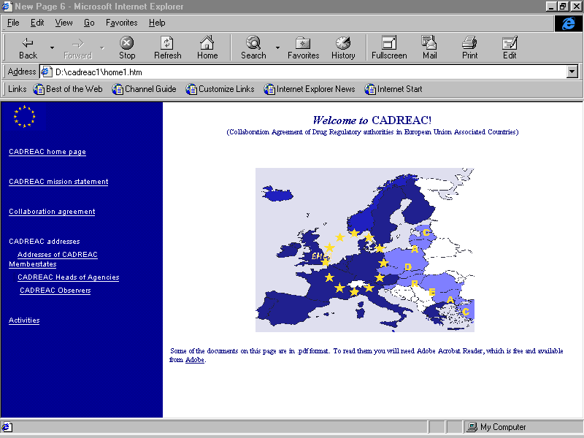

CADREAC countries: Bulgaria, Czech Republic, Cyprus, Estonia, Hungary, Latvia, Lithuania, Poland, Romania, Slovak Republic, Slovenia, Turkey.

To introduce about 30 new compounds on the market in 1999, the top 50 pharmaceutical companies spend more than $45.38 billions on R&D - 30% increase compared with 1998, when with less resources 70 new compounds were marketed.

Along with increasing investment required, due to higher efficacy and safety standards, the drug development time has grown
considerably:

8.1 years - 1960s

11.6 years - 1970s

14.2 years - 1980s

14.9 years - 1990-1996



IP main challenges for
the pharmaceutical industry

By 2002 about 50 drugs will generate sales over $1 bill. each, with 18 brands expected to have sales of more than 2 bill. each.

Only in the United States patent expirations in the coming 5 years will generate in front of the branded drug industry close to $ 35 bill. sales (referred to 1999 results).

PATENTS FOR BIOTECHNOLOGICAL
INVENTIONS IN EUROPE

In EU are laid down by the provisions of Directive 98/44/O.J.L 213 of 30 July 1998/.

- There are products covered by 26 and more patents.
- Usually pharmaceutical inventions are covered by a multitude of patents, i.e. substance, compound, formulation, process /mostly used before/, usage /Swiss claims/, mechanism of action, intermediates /ICE in USA/.

- Reglament 1768/92 introduced SPC for drugs.

DATA EXCLUSIVITY

The data exclusivity provision is laid down by Directive 65/65/EEC, Article 4_{8a i-iii} as amended by Directive 87/21/EEC/.

Data exclusivity is granting the first HoMA of a NCE a guaranteed period of regulatory exclusivity.

The period is 10 years for Centralised Procedure granted /by EMEA/ products.

DATA EXCLUSIVITY - 6 OR 10 YEARS

- EU member states granting 6 years protection:
- Austria, Denmark, Greece, Finland, Ireland, Spain, Portugal.
- EU member states granting 10 years protection:
- Belgium, France, Italy, Germany, The Netherlands, Sweden, UK.

In the USA, data exclusivity provisions consist of the following:

→ 5-year data exclusivity period to the NCE product
→ 3 years data exclusivity period for any new indication
→ 6-month data exclusivity period for paediatric indications
Other countries such as Australia, Canada and New Zealand have 5 years only for NCE.

TRIPS /39.3/ AN DATA EXCLUSIVITY?

- Article 39.3 aims to prevent clinical data from being accessible to third parties.

- 39.3 provides no fixed period for the protection of the information.

- 39.3 makes reference only to NCEs?

- At the present moment, there are no enforceable legal practice /case law/.

“OPEN” IP ISSUES IN EUROPE

• Bolar-Roche provision – “Save harbor” presumption, inconsistent approach in Europe, Article 30 TRIPS?

• “Grace” period – in USA 12 months from the invention in order to effectuate protection.

• Non-infringement statement – Article 18.4, Bulgarian law on pharmaceuticals.

• “Swiss claims” – increasing patentability after the revised text of Article 54/5/ of the European Patent Convention was adopted in Munich Conference, November, 2000.

Medical devices

Geno therapy
- human genome mapping
- top 50 companies aligning with genomic companies

Cell therapy

Xenotransplants

Radio pharmaceuticals

Paediatric drugs

USA The Pediatric Rule, 1997 In EU there are nearly 64 million children aged 0-14years or about 20% of the total population!

Orphan drugs – up to five persons per 10000 population affected.
Orphan Drug Act in USA, 1983.
In EU – Regulation 141/2000, as amended by Regulation 847/2000.

VALUE OF STRONG IP IN PHARMACEUTICALS

In conclusion, equal level of IP in the enlarging Union is not only existing obligation under the Treaty and many international agreements,
but also:

› Protect R&D and development carried out by national and foreign investors.

» Encourage investments and provides basis for strategic alliances.


Thank you!

