E
WIPO/IP/HEL/00/7
ORIGINAL: English
DATE: October 2000
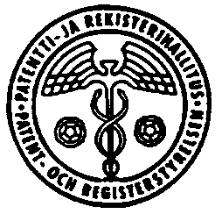 | 
NATIONAL BOARD OF PATENTS AND  REGISTRATION OF FINLAND | WORLD INTELLECTUAL  PROPERTY ORGANIZATION
forum on
creativity and inventions – a better future for humanity in the 21st century
organized by
the World Intellectual Property Organization (WIPO)
and
the National Board of Patents and Registration of Finland
in cooperation with
the Ministry of Trade and Industry of Finland,
the Ministry of Education, Science and Culture of Finland
and
the International Chamber of Commerce (ICC),
the International Federation of Inventors' Associations (IFIA),
the Confederation of Finnish Industry and Employers (TT),
the Finnish Inventors' National Federation (KEKE)
Finlandia Hall
Helsinki, October 5 to 7, 2000

CREATING (ESTABLISHING) A SUPPORTIVE ENVIRONMENT FOR THE USE AND DEVELOPMENT OF INVENTIONS AS A SERVICE TO SOCIETY

Document prepared by Mrs. Vanda Scartezini, National Secretary, Information Technology Policy, Ministry of Science and Technology, Brasilia, Brazil

INNOVATION POLICY IN BRAZIL

1 In this presentation many aspects of the Brazilian Federal Government Policy will be discussed on innovation, including all aspects related to information technology.

2 The nowadays reality will be covered along with the progress and future of Government strategies for human resources, university and research centers, incubators and role players. Our Internet development, investments and the information society program will also be highlighted in order to present an over view of the Brazilian situation relative to improving innovation and consequently our technological and social development.

[Slide presentation follows]

[End of document]

