E
WIPO/INV/MTY/02/18
ORIGINAL: Spanish
DATE: April 2002
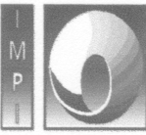 |  | 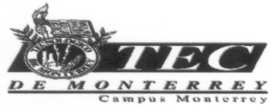
MEXICAN INSTITUTE OF  INDUSTRIAL PROPERTY | WORLD INTELLECTUAL  PROPERTY ORGANIZATION | INSTITUTE OF TECHNOLOGY AND  SUPERIOR STUDIES OF MONTERREY
INTERNATIONAL WORKSHOP ON
MANAGEMENT AND COMMERCIALIZATION OF INVENTIONS
AND TECHNOLOGY
organized by
the World Intellectual Property Organization (WIPO)
in cooperation with
the Mexican Institute of Industrial Property (IMPI)
and
the Institute of Technology and Superior Studies of Monterrey (ITESM)
Monterrey (Mexico), April 17 to 19, 2002
The Patent Cooperation Treaty (PCT) as a Strategy for Filing Foreign Applications
Document prepared by the International Bureau of WIPO

[End of document]

