E
WIPO/INV/BEI/02/23
ORIGINAL: English
DATE: May 2002
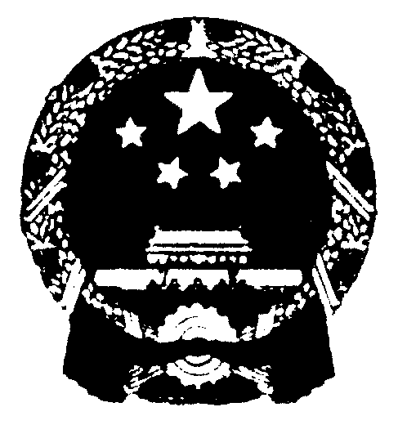 | 
STATE INTELLECTUAL PROPERTY OFFICE  THE PEOPLE’S REPUBLIC OF CHINA | WORLD INTELLECTUAL  PROPERTY ORGANIZATION
SECOND INTERNATIONAL forum on
creativity and invention – a better future for humanity in the 21st century
organized by
the World Intellectual Property Organization (WIPO)
in cooperation with
the State Intellectual Property Office (SIPO) of
the People’s Republic of China
Beijing, May 23 to 25, 2002

INVENTORS, INNOVATORS AND CREATORS – THE INTELLECTUAL
CAPITAL OF NATIONS

Document prepared by Ms. Youyou YU, Academician, China Academy
of Engineers, Beijing

1 Traditional Chinese medicine (TCM), with its unique theory, has been fashioned from the long history of medical practice and the accumulated experience of the Chinese nation. TCM protects the development and growth of the nation, and it is flourishing today as a result of continuous invention and innovation throughout its history. Fire and heat were applied to treat those diseases that our ancestors understood. Alcohol and wine, promoted by the use of fire, were closely related to medicine and medicinal herbs. In the 11th century BC, anatomic terms for the human body and descriptions of a number of diseases were recorded in the form of inscriptions on bones and tortoise shells. The Yellow Emperor’s Internal Classic (Qin dynasty and Han dynasty) and the Treatise on Febrile Diseases (by Zhang Zhongjing, East Han dynasty) established the theoretical basis of TCM and guided the clinical practice of medicine. Medicine and drugs are inseparable, and Chinese herbal medicine has as long a history as TCM. Over a hundred herbal medicines and curative and/or preventive treatments for dozens of diseases are registered in Canon of Mountains and Sea (3rd century BC). The historical record carries the following message: “ Shen Nong (the god of agriculture) tasted hundreds of herbs and initiated medicine.” Shen Nong may well have been a legendary character, but certainly a legend character, but, Shen Nong’s Herbal Classic is a reality. It carries 365 kinds of medicine of herbal, animal and mineral origin. The newly-revised Materia Medica (659 AD) was implemented in the Tang dynasty. In 1578, the well-known Compendium of Materia Medica was completed by Li Shizhen of the Ming dynasty, and the cut blocks were printed in 1593. In 1681, Emperor Kangxi of the Qing dynasty decreed the use of vaccination of human pox for preventing smallpox. The technique spread to Turkey in 1717, and thence to England, Europe and America. I should like to now recall a few recent events that promoted invention and innovation in TCM.

2 In 1955 the Academy of Traditional Chinese Medicine, affiliated to the Ministry of Health, was founded, and in 1983 seven WHO collaborating centers for TCM were established in China.

3 In the 1960’s, malaria was endemic when Viet Nam was engulfed in the flames of war. There has been an urgent need for new antimalarial drugs owing to the problem of chloroquine-resistant strains of P. Falciparum. Globally, hundreds of millions of people contracted the disease every year and mortality increased sharply. A large-scale screening of antimalarial drugs was carried out at home and abroad at that time, but without satisfactory results. Our project to develop new antimalarial drugs was set in place against the background described above in 1969. Malaria is a common disease throughout the world, and was recorded in medical literature in China as long ago as in the 12th century BC. I graduated from the Department of Pharmacy of Beijing Medical College, and systematically studied TCM while I was employed. I firmly believe that TCM, with its long history, is a great treasure-house, and efforts should be made to explore its essence. Following the collection and analysis of traditional prescriptions, over two hundred herbs and three hundred and eighty extracts from them were tested on malarial models in mice or monkeys. The screening produced a positive result for TCM-Qinghao in October 1971. The antimalarial effect of Artemisia annua L was first described in “The handbook of prescriptions for emergencies” compiled by Ge Hong (281-340 AD), the physician and alchemist of the East Jin dynasty. We isolated and purified the active ingredient of the traditional Chinese herb, Artemisia annua L, in 1972. It was named Qinghaosu after the herb’s pronunciation in Chinese. Qinghaosu gave monkeys and mice 100% resistance to malaria parasites, and in 1973, clinical trails verified its efficacy; a new antimalarial drug had appeared. Qinghaosu is a compound of sesquiterpene lactone with a peroxide; it was just what we were looking for: an antimalarial drug with a totally new chemical structure. The invention of Qinghaosu can be credited to TCM, and it is a good illustration of the treasure that is the essence of TCM and its potential for contributing to world medicine. Qinghaosu is a drug with high efficacy, fast-acting and safe. In October 1981 I gave a talk on the chemical research on Qinghaosu at an international Qinghaosu symposium in Beijing; my talk aroused great interest. Qinghaosu was appreciated as “a new antimalarial drug and an important direction indicator for drug synthesis and design.” A new drug certificate was issued for Qinghaosu as a first-category drug in 1986, and another for dihydro-Qinghaosu later on. These achievements gained them the National Invention Award and the Top Ten National Award for Achievement in Science and Technology respectively.

4 If our wish is fulfilled, the 21st century should be a better one, with magnificent prospects. While we can roam the heavens, and all comers of the world are closely connected by the Internet, we still have to face the cruel reality of this local war and life-threatening disease. Malaria is still a dangerous enemy to mankind in this new century. An air crash may kill hundreds, and cause shock and grief to the living for a long time to come, but we do sometimes overlook another significant tragedy. Malaria, a tropical disease, is cruelly killing the poor, in developing countries. Some 500 million infections worldwide are reported, and some 3,000 children die every day in Africa alone. These figures are equivalent to ten airbuses full of children crashing daily; what a nightmare for mankind! We are alerted, and we fight back. In 1998, “control malaria” was made the strategic objective for the new century by the 51st WHO congress; I believe Qinghaosu and its derivatives are the right weapons to deploy. We sincerely hope that the invention of Qinghaosu will daily pull thousands of endangered people back from the brink of death. As one of the inventors of Qinghaosu, I sincerely hope that the drug will contribute more and more to human health in the 21st century and to a brighter future for mankind.

[End of document]

