E
WIPO-IFIA/SEL/02/25 Rev.
ORIGINAL: English
DATE: December 2002
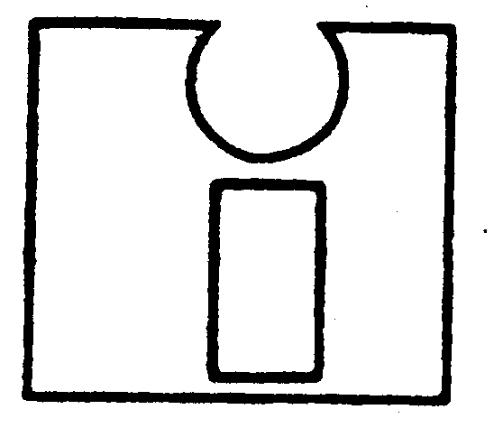 | 
INTERNATIONAL FEDERATION OF  INVENTORS’ ASSOCIATIONS | WORLD INTELLECTUAL  PROPERTY ORGANIZATION
WIPO-IFIA INTERNATIONAL SYMPOSIUM ON
THE commercialization of inventions
in the global market
organized by
the World Intellectual Property Organization (WIPO)
and
the International Federation of Inventors’ Associations (IFIA)
in cooperation with
the Korean Intellectual Property Office (KIPO)
and
the Korea Invention Promotion Association (KIPA)
Seoul, December 4 to 7, 2002
PARTNERING WITH VENTURE CAPITALISTS AND FINANCING THE DEVELOPMENT AND COMMERCIALIZATION OF INVENTIONS

THE national experience of ZIMBABWE

Document prepared by Mr. Ignatius Nyongo, President,
Zimbabwe Association of Inventors, Harare

1 They have a saying in Kenya that talking to one another is loving one another. I am pleased to be here in Korea and talking to you today. I also bring with me best wishes for the Symposium from Zimbabwe’s Minister of Science and Technology Development, Honorable Dr. Olivia Muchena, and the Minister of Small and Medium Enterprises Development, Honorable Mrs. Stembiso Nyoni. Best wishes also come from the Executive Committee and Members of the Zimbabwe Association of Inventors.

2 Today we honor the works of world inventors, I also wish to glorify God for inventing the human machine as well as time and space, which have allowed us to be gathered here today. God also invented friendship, so that we may not only have emotional security but also assist each other in times of need for the development of mankind.

3 Mr. Chairman, the financing of the development and commercialization of inventions in Africa is being hampered by the issue of poverty on a continent in which, of its 600 million people, 300 million live on less than US$1 a day, according to a World Bank report of April 2000. A greater number of inventors in Africa are either unemployed or self-employed in the “informal” sector. They fall into the category of the 300 million poor that I mentioned, and are even failing to pay for the registration and renewal of their patents.

4 Not only are inventors in Africa failing to get financial support from the financial sector, but they are also lacking moral and legislative support from their countries, and this has implications for the development of their economies.

5 Venture capitalists are still few and far between in Africa, and those who are there are not financing the development and commercialization of inventions. In Zimbabwe, for instance, there are only two venture capital companies and no inventor to date has benefited from them, although there are over 32 inventions waiting to be promoted.

6 The failure to assist or finance the development and commercialization of inventions in Zimbabwe stems from the wrong perception that meaningful inventions only come from Europe, the United States and the Far East, while anything coming from Africa cannot reach the world market, let alone the local market itself, yet we have all heard of the Latin saying ex Africa semper aliquid novi - something new always comes out of Africa.

7 Faced with these great problems our Association, immediately on its formation in October 2001, approached the Government for assistance with capital from tax revenue. In fact our request was made after the budget had been announced, but we hoped that an allocation would be made to us from the announced Z$2 billion empowerment fund; nothing happened, however. The only assistance we have received from the Government is the use of office space. We have struggled without a budget for 13 months, and so we have failed to assist any of our members in having their inventions developed and commercialized.

8 We are working full time at the offices, and have reported for duty every day for 13 months without any pay. It has been a very difficult experience, apart from which we walk on average of five days a month to work – a distance of 16 kilometers. In December 2001 we received a donation of eight vehicles from Japan but we have failed to raise the US$11,000 needed to ship them to Africa. These vehicles are for our extension work and other programs.

9 In the past the Ministry of Higher Education and Technology handled technology issues in Zimbabwe, but no national budget has yet made any allocation for invention development. However, in August 2002 a new department styled the Science and Technology Development was created in the Office of the President and Cabinet, headed by a Cabinet Minister. We had the good fortune to have a meeting with the Technology Minister Dr. Olivia Muchena on November 26, 2002, and she invited us to attend a consultative workshop on November 28, 2002. For our part we presented her with our draft Science and Technology Bill, in the hope that she will introduce it in Parliament. Should this Bill become law, it will enable the Government to allocate capital for the commercialization of inventions from the Central Revenue Fund.

10 At the workshop we suggested that Government should introduce a technology levy to be raised on both business and the public so as to generate adequate capital for the development and commercialization of inventions. It was also agreed by the stakeholders present that our Association of Inventors should be recognized as a research organization. This was an important development.

11 In June 2002 Zimbabwe launched its Science and Technology Policy, and President Mugabe announced tax incentives to companies that would donate up to Z$10 million towards research and development; that money would only be distributed to recognized research organizations. On November 14, 2002, in his annual budget, the Minister of Finance announced that the ceiling would be raised to Z$20 million on January 1, 2003. Up to the present all our prototypes, with the exception of just two, have been made from scrap material, and they do not look sufficiently appealing to encourage sponsors.

12 Given this plethora of problems, which continue to impede the development and commercialization of inventions, not only in Zimbabwe but also in the rest of Africa, we respectfully call upon the United Nations and the international community to assist inventors in Africa by supporting our efforts to establish the International Fund for Innovations and Trade Development in Africa (IFITDA) to finance the development and commercialization of inventions.

[End of document]

