E
WIPO-IFIA/SEL/02/22 Rev.
ORIGINAL: English
DATE: December 2002
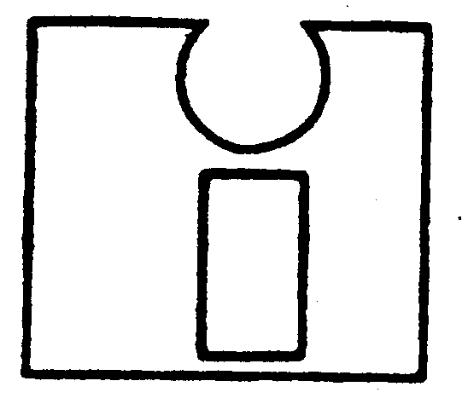 | 
INTERNATIONAL FEDERATION OF  INVENTORS’ ASSOCIATIONS | WORLD INTELLECTUAL  PROPERTY ORGANIZATION
WIPO-IFIA INTERNATIONAL SYMPOSIUM ON
THE commercialization of inventions
in the global market
organized by
the World Intellectual Property Organization (WIPO)
and
the International Federation of Inventors’ Associations (IFIA)
in cooperation with
the Korean Intellectual Property Office (KIPO)
and
the Korea Invention Promotion Association (KIPA)
Seoul, December 4 to 7, 2002
INVENTIVE ACTIVITIES IN THE FRAMEWORK OF UNIVERSITIES AND SMALL AND MEDIUM-SIZED ENTERPRISES (SMES)
Document prepared by Tan Sri Datuk Dr. Augustine S.H. Ong, President and Founder, Malaysian Invention and Design Society (MINDS), Selangor Darul Ehsan (Malaysia)

I. introduction

1 Following a successful intellectual property workshop, which was organized by the Malaysian Scientific Association, in Kuala Lumpur, the Malaysian Invention and Design Society (MINDS) was established in 1986, soon after the Patent Act was passed by the Malaysian Parliament. Subsequently, the vision and mission of MINDS was discussed and accepted as follows.

II. Vision

2 To make Malaysia the center of excellence for inventions and industrial designs through MINDS; to encourage every Malaysian to be inventive and optimize each and every Malaysian invention for the benefit of society.

III. Mission

3 To encourage Malaysians to be creative and inventive, and advise, guide and assist in the utilization of their inventions and designs.

4 The activities of MINDS have been well-supported by the Malaysian Government and Malaysian society as a whole. MINDS is privileged to have the consent of the Rt. Honorable Prime Minister of Malaysia, Dato’ Seri Dr. Mahathir Mohamad and the Honorable Minister of Science, Technology and the Environment, Datuk Law Hieng Ding, and as MINDS’ patrons.

5 The organization of MINDS is illustrated in Fig. 1, and we have attempted to decentralize MINDS’ activities throughout the country as MINDS’ membership has
exceeded 1,500.

6 In promoting awareness and invention-related activities, it is obvious that young people should be targeted. Thus, one of our earliest endeavors was to launch the School Inventors’ Club and now more than 200 schools in Malaysia have formed School Inventors’ Clubs.

7 We recognize that while encouraging young people to be inventive, a number of Malaysians in universities, research institutes, and small and medium-sized enterprises (SMEs) are actively inventing and applying their inventions to society and industry, and for that reason MINDS initiated the Annual Inventors’ Exhibition in 1989. Today (2002), more than 1,000 Malaysian inventions have been showcased (see attachment - winners for
I-TEX 2002) and, since 1993, some of these inventions have subsequently been entered in the Geneva International Exhibition of Inventions. Malaysian inventors have won 45 gold medals.

MINDS CENTRE
Resource

Centre
Professional
Activities
Project
Manager
Industrial
Design

MINDSMART
Foundation &
Exhibition
School Inventors
Club & Ladyminds

Publication

Chapter

Chapter

Chapter

Chapter

Figure 1: Structure and Organization of MINDS

8 In 1994, the inventors’ movement was conceived as shown in Fig. 2. Pilot studies were conducted in the Klang Valley, near Kuala Lumpur, and in Ipoh, adopting the slogan “MINDS FOREVER.” Several chapters were started in different parts of the country. The MINDS song was composed by MINDS’ EXCO members then and thus may need professional input before it is accepted as the final MINDS SONG:

Come and join in the fun of inventing, let your minds be as open and free
You will find many things to create, all you need is to think and use your head

Come and join in the fun of inventing, let your minds be as open and free
Put your left brain and right both together, and get a wild burst of inspiration
Chorus:

Be a member of MINDS, come on get going, together we create even better,
Be a member of MINDS, come on be active, who knows what we can really achieve, be a member of MINDS ( …Be free!),

Repeat verse no. 1:
Come and join in the fun of inventing, let your minds be as open and free
You will find many things to create, all you need is to think and use your head,

Put our minds together and innovate, act together let’s strive to achieve,
Our Nation’s Vision of 2020, new breakthroughs in technology,

WHO ?
3G
Special Group

HOW ?
Structure
Mentoring
Tech Skill

Ideas
Commer-
cialization
Promotion
Challenging Environment

Figure 2: Inventors’ Movement
9 The main achievements of MINDS over the years have been to change the mindset of the Malaysian Government and Malaysian Society in that Malaysians are capable of thinking creatively to solve some local problems and others too. Universities, research institutes and some corporate organizations have shown much interest and enthusiasm in inventive activities.

IV. Future

10 Based on our limited experience, we need to study the successes and failures of bringing our ideas from the laboratory to the market place. Thus, we should focus on the effective commercialization of inventions and research findings. Clinics are to be formed to assist inventors in the early stage of their development of new ideas and to counsel them to take appropriate and timely action at the lowest possible cost, as well as to provide protection for their IPRs. For the future of the nation, we would like to recommend the inculcation of R&D culture in early education.

11 For the benefit of global inventors and for the intellectual wealth of the world, we should all strive for a system which enables a world patent to be granted and hopefully implemented by the WIPO.

[End of document - Attachment follows]

