E
WIPO-IFIA/SEL/02/2
ORIGINAL: English
DATE: December 2002
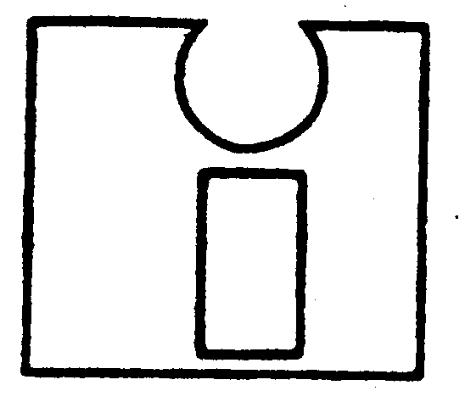 | 
INTERNATIONAL FEDERATION OF  INVENTORS’ ASSOCIATIONS | WORLD INTELLECTUAL  PROPERTY ORGANIZATION
WIPO-IFIA INTERNATIONAL SYMPOSIUM ON
THE commercialization of inventions
in the global market
organized by
the World Intellectual Property Organization (WIPO)
and
the International Federation of Inventors’ Associations (IFIA)
in cooperation with
the Korean Intellectual Property Office (KIPO)
and
the Korea Invention Promotion Association (KIPA)
Seoul, December 4 to 7, 2002

THE COST OF PROTECTING INTELLECTUAL PROPERTY IN THE PROCESS
OF COMMERCIALIZATION

PATENT STRATEGIES FOR BUSINESS SUCCESS

Document prepared by Mr. Gene Scott, President and Chief Executive Officer (CEO), Invention Trader Associates International, Newport Beach, California (USA)

1 Using United States patent law to one's best business advantage takes skill and experience, and can considerably reduce the cost of patent protection. The new (1995)
low-cost Provisional patent application is used as a precursor to the Utility patent application, and provides an extra year of patent pending status. It calls for the filing of a technical brief, which can be easily prepared by the inventor without legal aid, needs no legal language or formalities and is available to inventors worldwide. The filing fee is a mere $80 (small entity). When a Utility patent application for the same invention is filed, anywhere in the world, within one year of the filing date of the U.S. Provisional, the Utility application may claim the earlier filing date of the Provisional as its priority date. This has tremendous advantages as described below in several typical commercial situations. As will be shown, however, it is certainly not applicable to every situation.

2 Design patents have been used to obtain patent pending status for a new product that is thought to be non-patentable otherwise. Entry into the marketplace with “patent pending” announced on the product and package is often used to stave off immediate competitors. The less costly Provisional application now permits such use of the patent pending notice on products for a mere $80, and while the status expires on the first anniversary of the Provisional’s filing date, one has only to file again, maintaining patent pending status indefinitely for $80 a year. Since the text of the Provisional application is not open to the public, competitors cannot know what the nature of the pending patent is.

3 For inventors with few funds to invest in patent pending applications, the Provisional application is ideal to establish an extraordinarily low cost reservation on legal protection during their initial search for venture capital or a licensee.

4 Certain inventions may be mere fads or have a very short commercial life, with technical or commercial obsolescence arriving within months of product launch. It may seem unwise, therefore, to invest in Utility patent protection, which might not be granted before the end of the useful commercial life of the product. For such items, again, the Provisional application is a low-cost way of achieving internationally recognized patent pending status to ward off initial competition, while, should the new product find a continuing market as the first year closes, the Utility patent may be reconsidered as a means of continuing the patent pending status initiated by the Provisional.

5 This same approach is reasonable, also, if it is not sure that there is a viable market for products made using the invention. Should the market prove strong, once again Utility patent protection may be sought in order to continue the patent pending state.

6 When a new product or technology is being developed and it is feared that competitors will file for patent protection first, it may be wise to file a Provisional patent application to secure an early filing (priority) date, and thereafter to file further Provisional patent applications as further technical achievements occur, following them up with a Utility patent application incorporating the several Provisional applications and securing the earliest priority date for legal rights. One could just as easily file Utility patents for each of the innovations, but the Provisional is so inexpensive that it allows for more frequent filings on lesser inventive issues.
7 When wanting to approach a licensee or a venture capital firm with an invention, one needs every advantage possible. In that case it is not desirable to have only a Provisional patent application on file. Rather, to be able to negotiate the best deal, one should have at least one Utility patent application pending with the Patent Office, and preferably strengthening steps such as additional continuations-in-part for improvements, divisional applications for various separate elements of the invention, and possibly a design patent to protect its appearance elements if that is applicable. It is also desirable to accelerate prosecution to obtain patent grant, or at least a partial allowability, before opening negotiations. This ensures a strong negotiating hand.

8 When one knows that competitors are waiting to copy one’s latest innovation when it is brought on to the market, it is wise to file the Utility patent application, petition for the earliest publication and also accelerate patent prosecution. That makes it possible to assert provisional patent rights early on, and also achieve the earliest patent grant so that competitors may be excluded from the marketplace.

9 It is commonly thought that obtaining patent protection by filing and prosecuting a patent application is the only or the best route to take in order to secure ownership rights. That is not true, however. Often one finds a very close patent reference during a preliminary patent search or on receipt of an Office Action from the Patent Office. The patent agent may spend a great deal of time trying to write a set of claims that distinguishes the application subject matter the reference, and may spend expensive time arguing with an examiner, only to obtain a rather narrow patent. Sometimes a better way towards the same objective is to approach the owners of similar prior art to negotiate a licensing deal. This can be less expensive in the long run, and result in instant patent protection.

[End of document]

