E
WIPO-IFIA/SEL/02/18
ORIGINAL: English
DATE: December 2002
 | 
INTERNATIONAL FEDERATION OF  INVENTORS’ ASSOCIATIONS | WORLD INTELLECTUAL  PROPERTY ORGANIZATION
WIPO-IFIA INTERNATIONAL SYMPOSIUM ON
THE commercialization of inventions
in the global market
organized by
the World Intellectual Property Organization (WIPO)
and
the International Federation of Inventors’ Associations (IFIA)
in cooperation with
the Korean Intellectual Property Office (KIPO)
and
the Korea Invention Promotion Association (KIPA)
Seoul, December 4 to 7, 2002

TECHNOLOGY TRANSFER THROUGH ONLINE SERVICES AND DATABASES

THE INSIGHT IPM™ ONLINE COMMERCIALIZATION TOOL

Document prepared by Mr. Andrew Graham, Business Adviser, Technology Commercialisation Group (TCG), Adelaide

I. Background

1 My consulting firm, Technology Commercialisation Group (TCG), works with several Australian universities and Government research organizations to implement practices and programs which support the successful commercialization of new technologies, and in particular very early-stage research results.

2 We supply a number of different information and training products and consulting and mentor services to our research clients to help them on their way to becoming competent technology entrepreneurial organizations.

3 In doing so our aim is to enable the organization concerned to benefit (indeed to benefit greatly) from its own expertise and knowledge. To achieve this aim, our main tool is the fostering of partnerships between our clients and other organizations, whereupon the partnerships return value to our clients’ core business.

4 To do this we need to create a kind of organizational entrepreneurship which until now has been largely lacking. So while our purpose is to help the organization transfer out its inventions, expertise and intellectual property, our activities are in large part about transferring in the basic skills and understanding that surround technology entrepreneurship.

5 One of the tools we are now experimenting with is the Insight IPM™ innovation portfolio management tool which we have developed in partnership with an Australian software house – Research Master.

II. Insight IPM™ Innovation Portfolio Management

6 TCG has always provided its clients with a broad range of support including training and audit programs, mentoring and project development. Together these programs are intended to deliver a shared vision so that our client organization can exhibit the following characteristics:
Aware people: our people are informed and supportive of commercialization;

Strategic management: our managers are able to manage our commercialization activities strategically;

Aligned policies: our management frameworks, policies and systems permit commercialization;

Developed capability: we have the skills and resources with which to foster, support and guide these activities.

7 The overall vision is one where the excellence of a client’s research programs is mirrored by excellence in commercialization with a broad range of strategies being used and a broad range of benefits being returned, all completely aligned with the client’s core business of research.

8 However, in the medium to larger research organizations that are our clients, it soon became clear that whilst the pressure (from Government and funding bodies) to be more successful in commercialization was great, the environment within which the organization operated meant that returns from commercialization were marginal at best.

9 What was required was a greater ability on the part of the client to manage a portfolio of innovations in a manner that was both efficient and highly strategic and which took account of the fact that most members of the organization, at least initially, were not skilled commercializers in their own right.

10 The Insight IPM™ software is delivered via the web or LAN directly to the desktop of every member of the organization. It has no client-end requirements other than a version 3 web browser.

11 It has allowed TCG to both enhance and extend the level of service that it can offer larger numbers of clients, and also has the potential for greatly accelerating the rate at which our clients successfully implement the kinds of awareness, management, policy and ability changes required to meet the vision outlined above.

Aligned Policies
Developed Capability
Aware People
Strategic
Management
Insight IPM™

Figure 1: The Insight IPM™ tool better integrates the other elements of TCG’s
service provision

12 In terms of conception the Insight IPM™ software does not do anything that we are not already doing; it simply allows it to be done more directly and more consistently across a whole organization and (importantly for public-sector organizations) to do so with a high degree of top-level control and transparency and a high degree of focus on risk management and certainty of outcome.

13 As such it is not in the category of online databases of Internet markets for technology transfer, but rather a management tool to assist humans involved in day-to-day or occasional technology transfer activities.

14 The Insight IPM™ innovation portfolio management tool helps guide all levels of the organization in managing commercialization activities.

A. WHAT IT IS

15 The insight IPM™ innovation portfolio management tool:

- is a new tool for project management;

- injects early-stage commercial thinking;

- has a non-linear approach to projects;

- makes commercial activity transparent;

- aligns commercialization on core business;

- offers true innovation portfolio management.

B. HOW IT WORKS – PROJECT LEVEL

16 The starting point for the tool is the project screen, where individual researchers can enter as little or as much information as they consider necessary to get a grip on a new invention, project outcome, commercial opportunity or the like. A project wizard makes “issues” for the user - reconstructing the project into a commercial framework using risk, return, IP, the project and the organization as focus areas. These issue areas in turn link into an education center to provide further support, background information, likely concerns, FAQs and the like.

17 The Insight IPM™ project screen:

- makes the project focus only on critical issues – allowing the team to know what to do next;

- identifies areas that the team has not considered and uses wizards and tools to help them see the issues;

- allows for input from the whole organization;

- makes it easy for the whole team to see at what stage and where the project is;

- helps manage the whole process, not just IP.

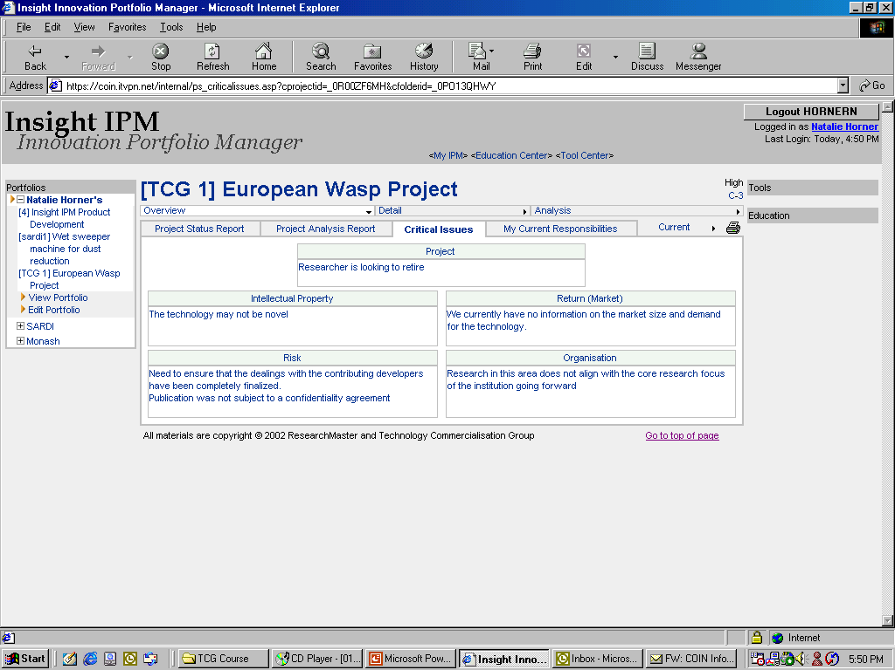

Figure 2: Insight IPM™ Screen – Project Information

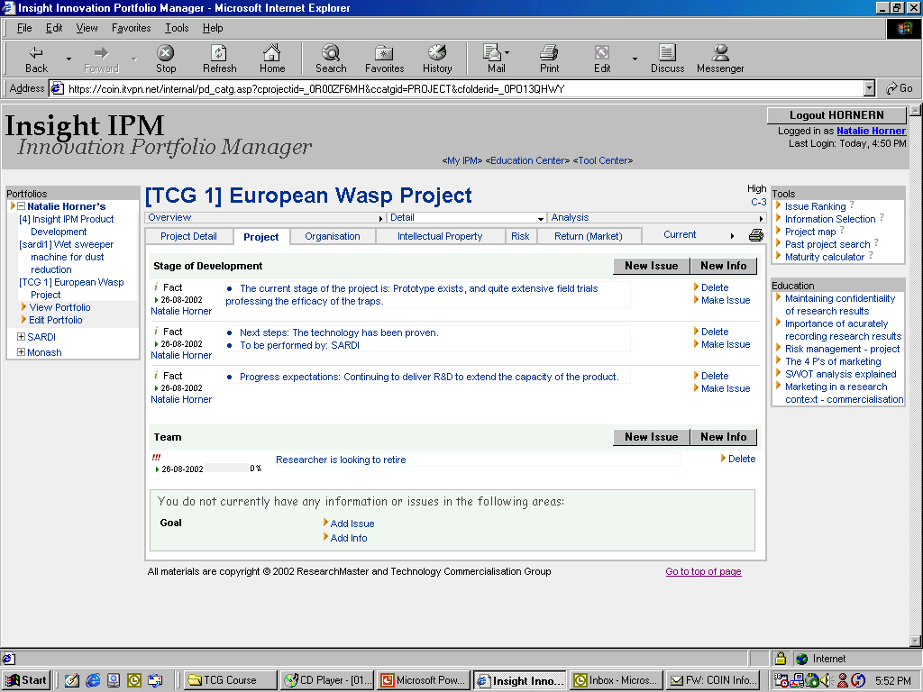

Figure 3: Insight IPM™ - Issues Information

C. HOW IT WORKS – PORTFOLIO LEVEL

18 At the portfolio level the individual projects or aggregate projects grouped by any likely criteria (e.g. by manager, by faculty, by technology area, by commercial partner, etc.) can be interrogated for any specific information. The same information can also be interrogated against any pre-defined or emerging hot issues, grouped in the same manner as for individual projects, i.e. project issues, IP, risk, return or organizational impact.

19 The portfolio-level Insight IPM™:

- amalgamates all the organization’s projects;

- uses tables, graphs and summaries to allow the organization to analyze all activities;

- allows the organization to see at a glance the critical issues and what the implications are for each project;

- allows for risk management across all projects;

- helps planning and alignment with the market and research activities and organizational objectives;

- enables management to identify and facilitate synergy between commercial applications and research opportunities.

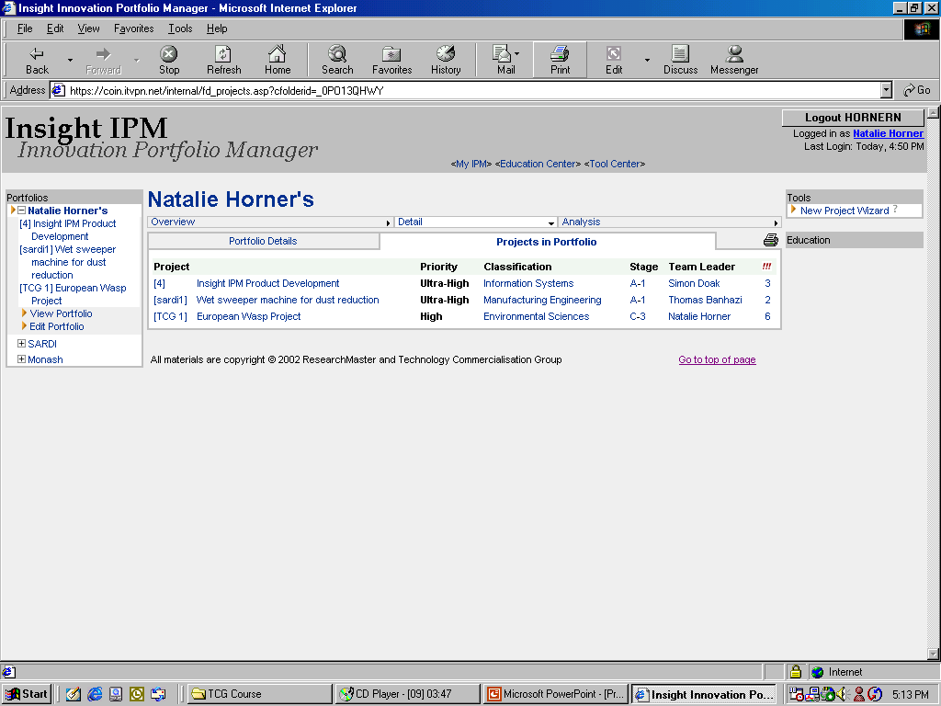
Figure 4: Insight IPM™ - Portfolio Manager
Unique project code
Project title
Priority classification
Department
Project stage of commercial/research development
Project’s team leader
No. of critical issues
Unique project code
Project titles
Entering new projects
Main portfolio/project directory

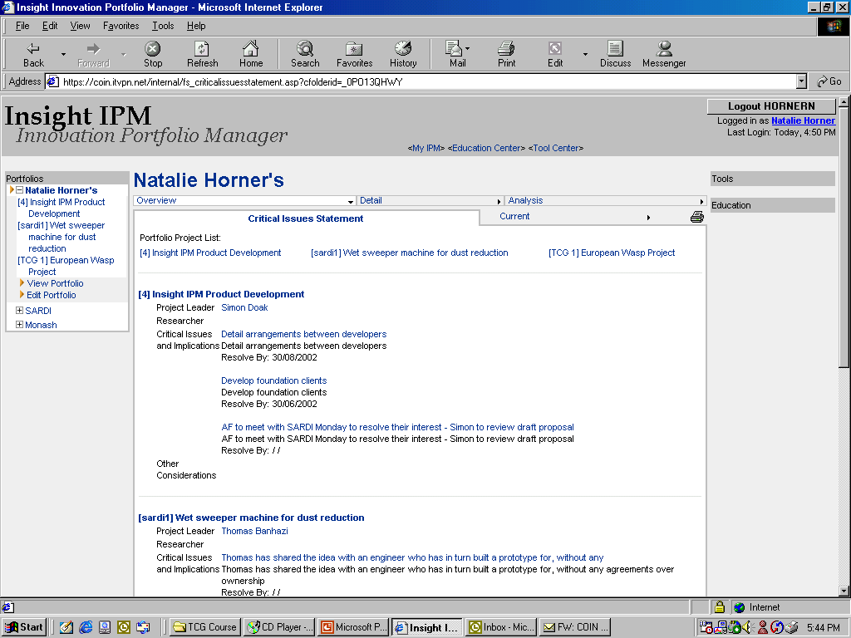

Figure 5: Insight IPM™ – Portfolio of Issues

D. HOW IT WORKS – EDUCATION LEVEL

20 TCG as an organization has a strong profile in the provision of basic and more advanced training for researchers and practitioners in the area of technology commercialization. With Insight IPM™ all these materials are now available online, integrated in the project information area. So for example a researcher considering possible research alliances can call up a wealth of information on organizational and general practice in the formation of such alliances.

21 The Insight IPM™ Education Centre:

- contains integrated information and training resources;

- links FAQs and “points to consider” directly to the issues wizard;

- allows the organization to pinpoint present and future training and support needs.

22 The Education Centre also fully integrates with classroom and online training available from TCG.

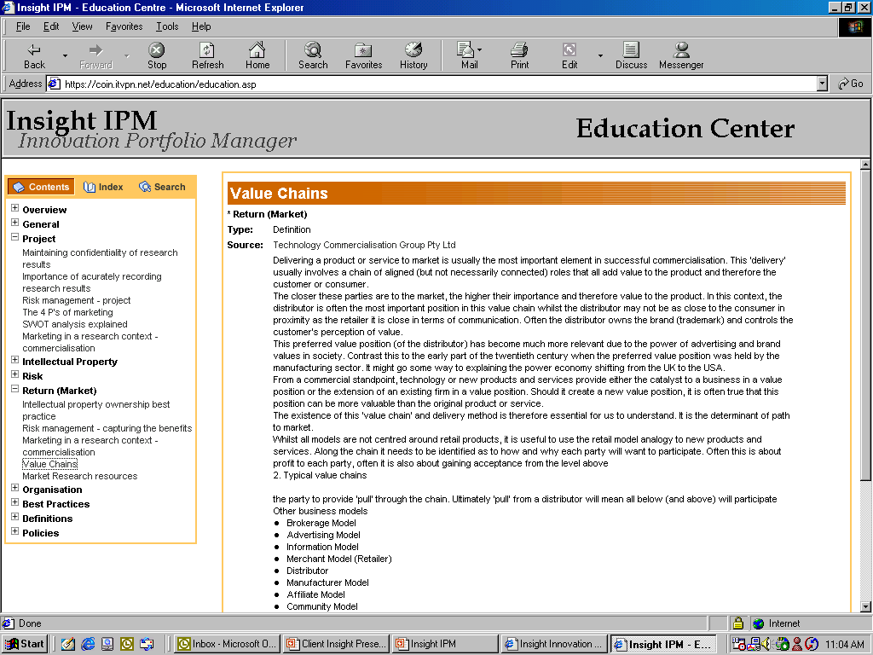

Figure 6: Insight IPM™ – Education Centre

[End of document]

