E
WIPO/IFIA/BUE/00/5
ORIGINAL: English
DATE: September 2000
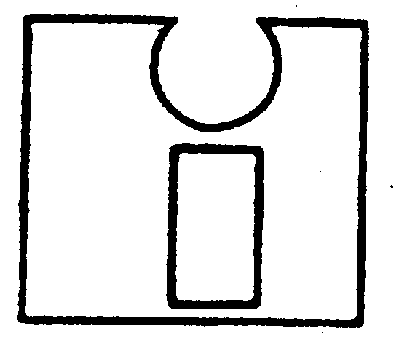 | 
INTERNATIONAL FEDERATION OF  INVENTORS' ASSOCIATIONS  (IFIA) | WORLD INTELLECTUAL  PROPERTY ORGANIZATION
inventors at the dawn of the new millennium:
wipo-ifia international symposium
organized by
the World Intellectual Property Organization (WIPO)
and
the International Federation of Inventors' Associations (IFIA)
in cooperation with
the Government of Argentina
and
the Argentine Association of Inventors (AAI)
Buenos Aires, September 5 to 8, 2000
NETWORKING AND PROMOTION OF NATIONAL INVENTION AND INNOVATIVE ACTIVITIES - PRESENTATION ON PROJETO INVENTIVA

Document prepared by Mrs. Ana Regina de Holanda Cavalcanti, Coordinator,
Ministry of Development, Industry and Foreign Trade,
National Institute of Industrial Property (INPI),
Rio de Janeiro, Brazil

1 During the 1990s, developing countries were faced with the challenge of modernizing their productive infrastructures. The couple “innovation – competitiveness” became a relevant strategy in order to reach the modernization and the participation in international economies and markets.

2 Modernizing the productive structure included creating an appropriate economic environment and improving economic relations in foreign trade, as a means of generating and increasing productivity while stimulating the absorption and disseminating international technology available in the productive sector.

3 It also included the promotion of a better cooperation between the productive activities, which induced a creative interaction between the public and private sectors as a way of strengthening the integrated technical progress and innovation into enterprises, as strategic variables and sources of benefits together with entrepreneurial development practices, which were capable of assuring global competitiveness.

4 On the other hand, intellectual capital became more relevant for an enterprises’ consideration. In this context, the capacity of the organizations in general in creating and in innovating constantly was fundamental. It was really a necessary condition for the survival, where the environment of a lifecycle of products and technology, generally speaking is smaller.

5 Therefore, from the economic and social point of view, a policy concerning the development process for innovation, including an intellectual property policy should be established, besides other incentives. It should also comprise in a global way, the existence of rules and infrastructures at any governmental levels.

6 On the other side, inventions and innovations developed by nationals of any country should be considered of high importance. Generally speaking the inventive capacity exists in any country although the inventive talent needs to be encouraged. Thus, for the great majority of industrialized countries, governmental authorities present a great consciousness about the importance of promoting inventiveness and innovation in the process of endogenous development.

7 A great variety of mechanisms and specific measures have been adopted in different countries having one common objective, namely, to promote and support technological, economic and social progress to benefit society.

8 In Brazil, inventors from institutions as well as individual inventors complain that they are not stimulated and often confronted face to face with difficulties.

9 It should be observed, on the other hand, that the individual inventor is only one of the actors of a complex system of invention and innovation.

10 Considering these setbacks, the Ministry of Industry, Trade and Tourism(MICT), through its Secretariat of Industrial Technology (SIT), decided to identify the real situation and needs of the country and to analyze the reasons why inventions do not transform themselves, in a systematic way, into innovations. In other words, further research needed to be undertaken to find out why inventions did not get to the market.

11 Therefore, the Projeto Inventiva – “Study of Technical and Economic Viability of National Inventiveness” was developed.

12 The main purpose of the Projeto Inventiva was to identify, in cooperation with the private sector, research centers and local governments, existing policies and infrastructures in Brazil. Also, to identify the real difficulties and demands of inventors in the various segments as well as the existing support services concerned with the promotion of inventions, having had in mind, to stimulate creativity and to properly carry out the invention to the market. By improving the conditions of competitiveness of enterprises and, as a result, establishing new small enterprises and generating new jobs.

13 The Projeto Inventiva was carried out by the Secretary of Industrial Technology, supported by the National Institute of Industrial Property, both from the Ministry of Industry, Trade and Tourism, with cooperation with the private sector, namely: the Brazilian Support Service to Small Business – SEBRAE and the São Paulo State Federation of Industries (FIESP) and the São Paulo State Center of Industries (CIESP),this latter as a pilot, since it has already in its Department of Technology, a staff which deals with industrial property matters, besides the fact it is the Industrial Federation located in the highest industrialized state of the country.

14 The methodology used instead of sending questionnaires was a visit to local institutions. Specific questionnaires were designed and the questions were based on 6 main themes:

- Activity in the institution concerning the industrial property field;
- Training in human research;
- Promotion of inventions;
- Support services to commercialization of inventions;
- Support services on national inventiveness;
- General business.

15 Fourteen research centers were interviewed as well as 37 small enterprises, 13 technological-based incubators, 5 large companies, 2 inventor associations and 2 educational centers.

16 The majority of research centers (64%) do not have a formal policy for patenting activities by their researchers.

17 From the 37 enterprises visited it was found that none had an industrial property policy. This situation is the result of a lack of awareness or knowledge about the intellectual industrial system. As a consequence, none of them make use of the intellectual property infrastructure (as weak as it may be) in supporting for business or R&D activities. They even do not pay attention that some of their activities may be infringement of third party’s rights.

18 Concerning the visited technological base incubators, a great majority do not use industrial property criteria for the selection policy of enterprises. A general orientation is offered to enterprises on patenting issues only by 33% of the incubators and 100% do not call the attention on infringement issues.

19 In contrast with the technological institutions, small enterprises and technological base companies and incubators and large companies show their interest in assuring the legal protection for their inventions as part of the development of its inventive capacity. They also use patent documents in their state-of-the-art searches as a base for its developments as well as for monitoring national and international trends.

[End of document]

