 |  | E
h/ld/wg/2/5
ORIGINAL: ENGLISH
DATE: July 19, 2012

Working Group on the Legal Development of the Hague System for the International Registration of Industrial Designs

Second Session
Geneva, November 5 to 7, 2012

SITUATION OF THE 1934 ACT AND THE 1960 ACT
OF THE HAGUE AGREEMENT

Document prepared by the International Bureau

I. INTRODUCTION

- The Hague Agreement Concerning the International Registration of Industrial Designs (hereinafter referred to as “the Hague Agreement”) is constituted by three separate Acts, namely: (i) the London (1934) Act, which was adopted on June 2, 1934 (hereinafter referred to as “the 1934 Act”); (ii) the Hague (1960) Act, which was adopted on November 28, 1960 (hereinafter referred to as “the 1960 Act”); and (iii) the Geneva (1999) Act, which was adopted on July 2, 1999 (hereinafter referred to as “the 1999 Act”). Since the coming into force of the 1999 Act on April 1, 2004, its membership has quickly surpassed and largely overlapped the memberships of the previous Acts.
- It is recalled that the Ad Hoc Working Group on the Legal Development of the Hague System for the International Registration of Industrial Designs, which met from May 30 to June 1, 2011, discussed the situation of the 1934 Act and the 1960 Act based on document H/LD/WG/1/4, entitled “Situation of the 1934 Act and 1960 Act of the Hague Agreement”, provided by the Secretariat, and took note of the information provided therein. The present document is an update of the situation of those Acts and aims at facilitating discussion on the future legal framework of the Hague system.

II. SITUATION OF THE 1934 ACT

A. Freezing of the Application of the 1934 Act, as from January 1, 2010

- It is recalled that, in view of reducing the complexity of the Hague system, the Contracting States to the 1934 Act held an Extraordinary Meeting, on September 24, 2009, to consider and unanimously adopt a decision to freeze the application of the said Act. The Assembly of the Special Union for the International Deposit of Industrial Designs (Hague Union) at its twenty-eighth (17th Ordinary) session took note of the decision.
- Following the said decision, the freezing of the application of the 1934 Act took effect on January 1, 2010, meaning, in particular, that as of that date, it is no longer possible to file international applications governed exclusively by that Act or to make new designations under that Act.
- The Contracting States to the 1934 Act further agreed that the freezing of the application of the 1934 Act merely constituted an intermediary step to reduce the complexity of the Hague system, and that the next – and final – step consisted in terminating the 1934 Act. For the details of the decision, see paragraphs 9 and 10 of document H/A/28/4, entitled “Report”.

B. Termination of the 1934 Act – Current Status

- The Contracting States to the 1934 Act have been invited to express their consent to its termination by Note C.H 74 dated February 22, 2010, Note C.H 76 dated August 3, 2010, and Note C.H 94 dated July 20, 2012, all sent by the Director General of the World Intellectual Property Organization (WIPO). In the meantime, denunciations of the 1934 Act by Indonesia, Switzerland, and the Netherlands (in respect of Aruba, Curaçao, Sint Maarten and the Caribbean part of the Netherlands (the islands of Bonaire, Saint Eustatius and Saba)) have taken effect in June 2010, November 2010 and December 2011, respectively. Furthermore, five Contracting States to the 1934 Act have expressed their consent to the termination of that Act, namely, France, Germany, Liechtenstein, Monaco and Tunisia.
- The last Contracting States to the 1934 Act whose consent remains to be received are Benin, Côte d’Ivoire, Egypt, Morocco, Senegal, Spain and Suriname. The International Bureau of WIPO (hereinafter referred to as “the International Bureau”) will continue to inform each Contracting State to the 1934 Act of any communications of consent received.
- The termination of the 1934 Act will become effective three months after the Director General of WIPO receives the last required consent. Upon receipt of the last required consent, the International Bureau will issue a depositary notification concerning the decision taken to terminate the 1934 Act.

C. Vanishing of a 1934 Act-exclusive Membership in the Hague Union

- Tunisia, the last Contracting State bound only by the 1934 Act, acceded to the 1999 Act on June 13, 2012. As a result, there are no longer any Contracting States bound only by the 1934 Act.
- It is to be noted that out of 12 States party to the 1934 Act, seven States, including Tunisia, are party to the 1999 Act and, therefore, take advantage of the latest international procedures and facilities provided by the 1999 Act, while five States are parties to the 1960 Act.

III. SITUATION OF THE 1960 ACT

A. Stagnation of the 1960 Act versus Geographical Expansion of
the 1999 Act

- At present, 60 States or intergovernmental organizations are members of the Hague Union, 45 of which are bound by the 1999 Act and 34 of which are bound by the 1960 Act. The list of the Hague Union members is given in Annex I to the present document. Two charts providing information on the Hague Union membership are also attached to the present document (see Annexes II and III to the present document).
- Since the entry into force of the 1999 Act on April 1, 2004, its geographical scope has expanded continuously, as reported in detail in document H/WG/1/4. Subsequently to the release of that document, Rwanda, Montenegro, Tajikistan and Tunisia have acceded to the 1999 Act , while no new accession to the 1960 Act occurred. In fact, there has been no new accession to the 1960 Act since 2007.
- It is also to be reminded that, among the 15 States party to the 1960 Act that are not bound by the 1999 Act, 11 are member States of one of the two intergovernmental organizations that are themselves party to the 1999 Act, i.e. the European Union (EU) and the African Intellectual Property Organization (OAPI). In respect of these States, their membership to such an intergovernmental organization leads to a double consequence as to the applicability of the 1999 Act. Firstly, applicants who derive their entitlement to file an international application from any of these States may designate Contracting Parties bound by the 1999 Act. Secondly, protection of industrial designs in the territories of these States can be secured by designating the intergovernmental organization to which they belong. Thus, in practical terms, only four Hague Union members find themselves outside the realm of the 1999 Act which is one of the reasons for the rapid decrease in the use of the 1960 Act, as commented in Chapter B, below.

B. Decrease of Use of the 1960 Act Versus Expansion of the Use of
the 1999 Act

- The registration activity under the 1960 Act has diminished significantly, since the coming into force of the 1999 Act. In 2011, out of a total of 2,363 international registrations entered in the International Register, the number of international registrations governed exclusively by the 1960 Act was 14. In the first semester of 2012, this number dropped to just two out of a total of 1,218 international registrations. The percentage of designations under the 1960 Act has also decreased, passing from 12 per cent in 2011 to 9 per cent in the first semester of 2012.
- Statistics on designations of all the States bound – exclusively or not – by the 1960 Act and recorded over the 2004 – 2011 period are enclosed for reference (see Annex IV to the present document). This is an update of the table attached to document H/WG/1/4, starting from 2004, i.e. the first year of operation of the 1999 Act. In 2010, the 1960 Act only applied in respect of 23.9 per cent of the designations of all States party to the 1960 Act. Moreover, if one is to consider only the States party to both the 1960 Act and the 1999 Act, the application of the 1960 Act drops to less than 1 per cent. In 2011, the application of the 1960 Act continued to decrease and applied to only 14.9 per cent of the designations of all the States party to that Act. This is better illustrated by the graph provided in Annex V showing the respective application of both Acts in respect of all designations of States party to both Acts.
- There are clear reasons for this sharp decrease in the use of the 1960 Act even within its own membership, as explained in detail in document H/WG/1/4. Firstly, protection in the territories of the States party to the 1960 Act, which are also member States of one of the two intergovernmental organizations party to the 1999 Act, can be secured by designating the organization to which they belong, instead of designating each of those States party to the 1960 Act individually. Secondly, Article 31 of the 1999 Act gives precedence to that Act as regards the mutual relations between States party to both the 1999 and 1960 Acts. It follows that, if an applicant originates from a Contracting Party bound by both the 1960 and the 1999 Acts and designates a Contracting Party also bound by both the 1960 and the 1999 Acts, such designation is governed by the 1999 Act. Furthermore, if an applicant originates from Contracting Party A, bound by the 1960 Act, but Contracting Party A is also a State member of an intergovernmental organization bound by the 1999 Act (Contracting Party B), the designation of a Contracting Party C that is bound by both the 1960 and the 1999 Acts is governed by the 1999 Act. As a result, the 1960 Act applies more and more rarely.

C. Complexity Resulting from the Existence of the Two Acts

- Under the current regime of the Hague system, there are three types of international registrations possible, namely, international registrations governed exclusively by the 1999 Act, exclusively by the 1960 Act and by both the 1999 and 1960 Acts.
- It is recalled that there are a number of requirements which have to be fulfilled for international applications which may differ depending on the Act governing each of the designations contained in a given international application. For instance, each of the additional mandatory contents provided for in Rule 7(4) of the Common Regulations Under the 1999 Act and the 1960 Act of the Hague Agreement (hereinafter referred to as “the Common Regulations”) are applicable only to a designation under the 1999 Act. As regards reproductions of the industrial designs, a declaration to require certain specific views is possible only by a Contracting Party to the 1999 Act (Rule 9(3) of the Common Regulations). The possibility and the period of deferment of publication are totally different between the two Acts (Article 11 of the 1999 Act and Article 6(4) of the 1960 Act).
- Furthermore, a different refusal period may apply depending on which Act governs a given designation (Rules 18(1)(a) and (b) of the Common Regulations). Discrepancy is also found in the compliance as to the latest time at which protection must be granted under the national or regional legislation (Article 14(2) of the 1999 Act, Article 8(1) of the 1960 Act and Rule 18(1)(c) of the Common Regulations). These create legal uncertainty for the users of the system. It is also to be noted that, at the time of renewal, an individual designation fee is applicable only if a given designation is governed by the 1999 Act (Article 7(2) of the 1999 Act).
- While the use of the 1960 Act has been decreasing, full account is still taken of the said Act. This, however, not only creates some legal and procedural complexity as described in the foregoing paragraphs, but also increases the management costs. Avoiding those costs by focusing the system around a single Act, the 1999 Act, could possibly allow for better services to be offered to users of the Hague system. For instance, whilst the new version of the E-Filing Interface to be put in place will not take into account the 1934 Act, as its application has been frozen, it will still offer the possibility to use the 1960 Act. Given the disparity between the two Acts, significantly more time is required for the development of this new interface than if it were to support the 1999 Act alone.
- The Working Group is invited to take note of the information provided in the present document in view of its general discussions.

[Annexes follow]

HAGUE UNION MEMBERS*

Bound by the 1999 Act only

African Intellectual Property Organization (OAPI), Armenia, Azerbaijan, Bosnia and Herzegovina, Botswana, Denmark, Egypt, Estonia, European Union, Finland, Ghana, Iceland, Latvia, Lithuania, Namibia, Norway, Oman, Poland, Rwanda, Sao Tome and Principe, Singapore, Spain, Syrian Arab Republic, Tajikistan, Tunisia and Turkey (26)

Bound by the 1999 and the 1960 Acts

Albania, Bulgaria, Croatia, France, Georgia, Germany, Hungary, Kyrgyzstan, Liechtenstein, Monaco, Mongolia, Montenegro, Republic of Moldova, Romania, Serbia, Slovenia, Switzerland, The former Yugoslav Republic of Macedonia and Ukraine (19)

Bound by the 1960 Act only

Belgium, Belize, Benin, Côte d’Ivoire, Democratic People’s Republic of Korea, Gabon, Greece, Italy, Luxembourg, Mali, Morocco, Netherlands, Niger, Senegal and Suriname (15)

[Annex II follows]

HAGUE UNION MEMBERS

GROUPED BY THE LATEST ACT BY WHICH THEY ARE BOUND*

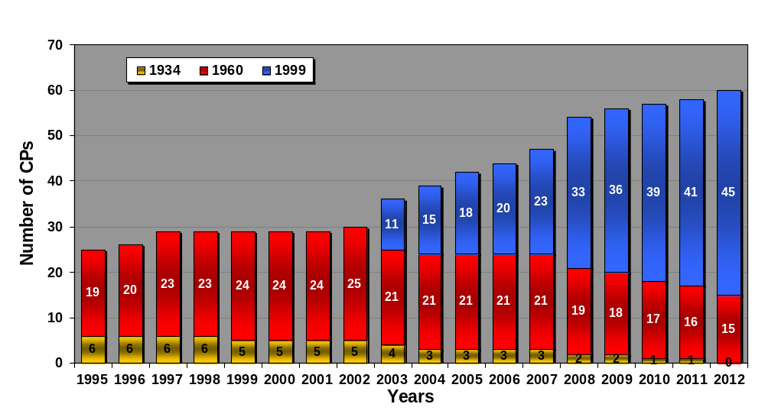

[Annex III follows]

HAGUE UNION MEMBERS

GROUPED ACCORDING TO THE ACTS BY WHICH THEY ARE BOUND

1999 Act: 45 CP

1960 Act : 34 CP
 |  |  | 60 Act |  |  |  |  | 1999 Act
 |  |  | 10 | 60+99 Acts |  |  |  | 23
 |  |  |  | 15
 |  |  | 34+60 Acts |  | 34+60+99 Acts |  | 34 + 99 Acts
 |  |  | 5 |  | 4 |  | 3
1934 Act : 12 CP

[Annex IV follows]

STATISTICS ON DESIGNATIONS RECORDED OVER THE 2004 – 2011 PERIOD

Number of Designations Under Each Act by Contracting Parties to the 1960 Act
Designated CP (which are at least CP to the 1960 Act) | 2004 |  | 2009 |  | 2010 |  | 2011
Designated CP (which are at least CP to the 1960 Act) | 60 | 99 | 60 | 99 | 60 | 99 | 60 | 99
AL |  |  | 0 | 172 | 0 | 176 |  | 180
BG | 472 |  | 0 | 33 | 0 | 23 |  | 18
BJ | 39 |  | 11 |  | 8 |  | 14
BX | 919 |  | 109 |  | 111 |  | 92
BZ | 222 |  | 136 |  | 98 |  | 120
CH | 785 | 416 | 1 | 1,206 | 3 | 1,508 | 5 | 1553
CI | 65 |  | 15 |  | 13 |  | 14
DE¹ | 956 |  | 140 |  | 28 | 116 | 5 | 110
FR | 931 |  | 6 | 135 | 7 | 145 | 6 | 113
GA | 112 |  | 9 |  | 11 |  | 12
GE | 57 | 223 | 0 | 192 | 0 | 203 |  | 200
GR | 582 |  | 52 |  | 55 |  | 46
HR | 111 | 142 | 47 | 365 | 1 | 463 |  | 458
HU | 301 |  | 0 | 40 | 0 | 39 |  | 38
IT | 963 |  | 113 |  | 115 |  | 91
KG | 23 | 214 | 0 | 158 | 0 | 132 |  | 147
KP | 385 |  | 64 |  | 69 |  | 74
LI | 131 | 330 | 0 | 301 | 1 | 303 |  | 298
MA | 443 |  | 332 |  | 323 |  | 374
MC | 476 |  | 335 |  | 317 |  | 1 | 340
MD | 143 | 231 | 0 | 192 | 0 | 184 |  | 205
ME |  |  | 243 |  | 251 |  |  | 231
MK | 440 |  | 0 | 283 | 0 | 325 |  | 332
ML |  |  | 10 |  | 8 |  | 11
MN | 240 |  | 0 | 159 | 1 | 165 |  | 155
NE | 1 |  | 10 |  | 5 |  | 11
RO | 302 | 243 | 0 | 46 | 0 | 25 |  | 17
RS² | 510 |  | 169 | 11 | 0 | 225 |  | 255
SI | 225 | 253 | 0 | 58 | 0 | 69 |  | 64
SN | 59 |  | 14 |  | 11 |  | 14
SR | 50 |  | 20 |  | 14 |  | 28
UA | 208 | 258 | 1 | 446 | 0 | 509 |  | 530
Total | 10,151 | 2,310 | 1,837 | 3,797 | 1,450 | 4,610 | 918 | 5244
Total nb of designations (independant of the Acts) | 12,461 |  | 5,634 |  | 6,060 |  | 6162
Distribution by Act | 81.5% | 18.5% | 32.6% | 67.4% | 23.9% | 76.1% | 14.9% | 85.1%

Germany became a Contracting Party of the 1999 Act on February 13, 2010.
Serbia became a Contracting Party of the 1999 Act on December 9, 2009.

Legend
N/A | Not available at the time.
 | The designated CP is not party to the Act
+% | There is an increase, but it is not a calculable percentage.

[Annex V follows]
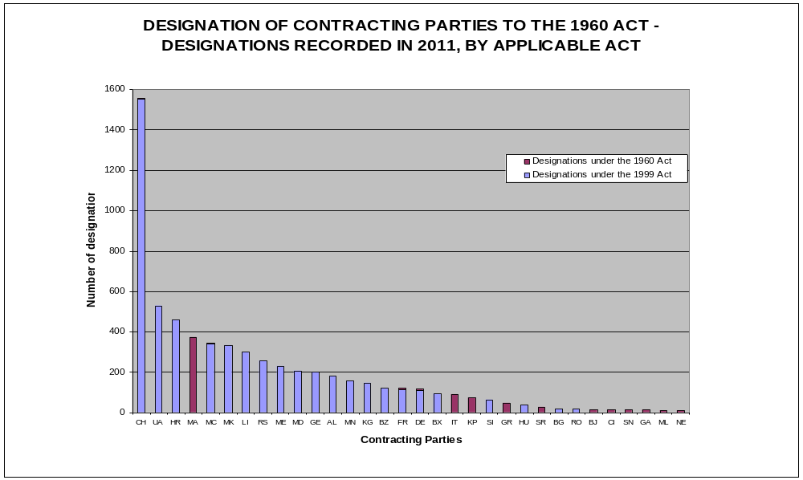

[End of Annex V and of document]

Germany deposited its consent to the termination of the 1934 Act with the Director General of WIPO on August 16, 2010, France on September 20, 2010, Liechtenstein on December 13, 2010, Monaco on March 9, 2011, and Tunisia on June 10, 2011.
Considering the freezing of the application of the 1934 Act, the membership to that Act has not been taken into consideration.
Rwanda (effective as from August 31, 2011), Montenegro (effective as from March 5, 2012), Tajikistan (effective as from March 21, 2012) and Tunisia (effective as from June 13, 2012).
The 1960 Act was last acceded by Albania, but the said country also deposited its instrument of accession to the 1999 Act at the same time.
Belgium, Greece, Italy, Luxembourg and the Netherlands are member States of the EU. Benin, Côte d’Ivoire, Gabon, Mali, Niger and Senegal are member States of OAPI.
Namely, Belize, Democratic People’s Republic of Korea, Morocco and Suriname.
In 2011, out of the 11,708 designations of Contracting Parties made, 10,357 designations were indeed governed by the 1999 Act. In the first semester of 2012, the number of designations of Contracting Parties governed by the 1999 Act was 5,749 out of a total of 6,255.
See Part A, paragraphs 04.13 and 04.14, of the Guide to the International Registration of Industrial Designs, which is available at: http://www.wipo.int/hague/en/guide/.
* List of members as of June 13, 2012. The application of the 1934 Act being frozen since January 1, 2010, the membership to the said Act is not listed in the present Annex.
* List of members as of June 13, 2012.

