E
WO/PBC/24/14
ORIGINAL: ENGLISH
DATE: JULY 10, 2015

Program and Budget Committee

Twenty-Fourth Session
Geneva, September 14 to 18, 2015

PROGRESS REPORT ON THE IMPLEMENTATION OF A COMPREHENSIVE INTEGRATED ENTERPRISE RESOURCE PLANNING (ERP) SYSTEM

prepared by the Secretariat

I. INTRODUCTION

- The forty-eighth session of the Assemblies of the Member States of WIPO in September 2010 approved the Secretariat’s proposal for the Implementation of a Comprehensive Integrated ERP System (documents WO/PBC/15/17 and A/48/14), with a view to: (i) modernize WIPO’s core administrative, management and customer-service functions; (ii) improve efficiency and productivity of WIPO’s administrative and management processes; and (iii) enhance the capability to provide better information to Member States, stakeholders and management.
- This report complements previous progress reports submitted to the Program and Budget Committee (PBC), providing Member States with a view of progress made, milestones reached and budget utilized under the ERP Portfolio of Projects during the period June 2014 to May 2015. The report also provides a summary of the updated portfolio plan and related budget adjustments within the overall portfolio budget as approved by the Member States.

iI. OBJECTIVES, Scope AND APPROACH – BACKGRound

- The ERP system is being implemented through a portfolio of inter-related projects, gradually evolving the Administrative Integrated Management System (AIMS Evolution).
- The first stream of projects will provide WIPO with a comprehensive set of tools to strengthen Human Resource Management (HR), comprising position management, benefits and entitlements, payroll, recruitment, staff performance, learning and development.
- The second stream of projects will provide WIPO with a set of tools, Enterprise Performance Management (EPM) and Business Intelligence (BI), to strengthen and support the implementation of Results-Based Management (RBM), comprising biennial planning, annual work-planning, implementation monitoring and performance assessment, reporting and analytics. Enterprise Risk Management (ERM), a critical function for achieving the Organization’s strategic goals and expected results, performed as an integral part of the Organization’s RBM cycle, will also be strengthened as part of this stream.
- The third stream of projects will enhance the existing PeopleSoft finance, procurement (FSCM) and travel systems through configuration changes and upgrades which will enable the introduction of new functionality, modules and improvements to business processes.
- The fourth stream will lay the foundations for improved Customer Relationship Management (CRM) by supporting business led projects, such as mailing list tools, contact databases, access management, customer analytics and replacing some of the customer focused systems.
- WIPO’s implementation approach is based on incremental phased projects which will help the ERP capabilities to evolve progressively in a coherent and measured manner. The approach is also driven by the capacity of concerned organizational units to absorb and integrate changes.
- Quality, accuracy and completion within the approved budget are the main drivers for the implementation of the ERP portfolio. The revised timeline, proposed later in this report, is based on these criteria and the capacity of the organizational units to absorb and embed the changes being deployed.

III. PORTFOLIO ACHIEVEMENTS

- Overall, the portfolio is well on track to deliver the objectives of modernizing and improving the quality, efficiency and productivity of WIPO’s management, administrative and customer service functions, improving the Organization’s capacity to provide better information to Member States, stakeholders and management. The following diagram shows the progress of the evolution and the future plans:

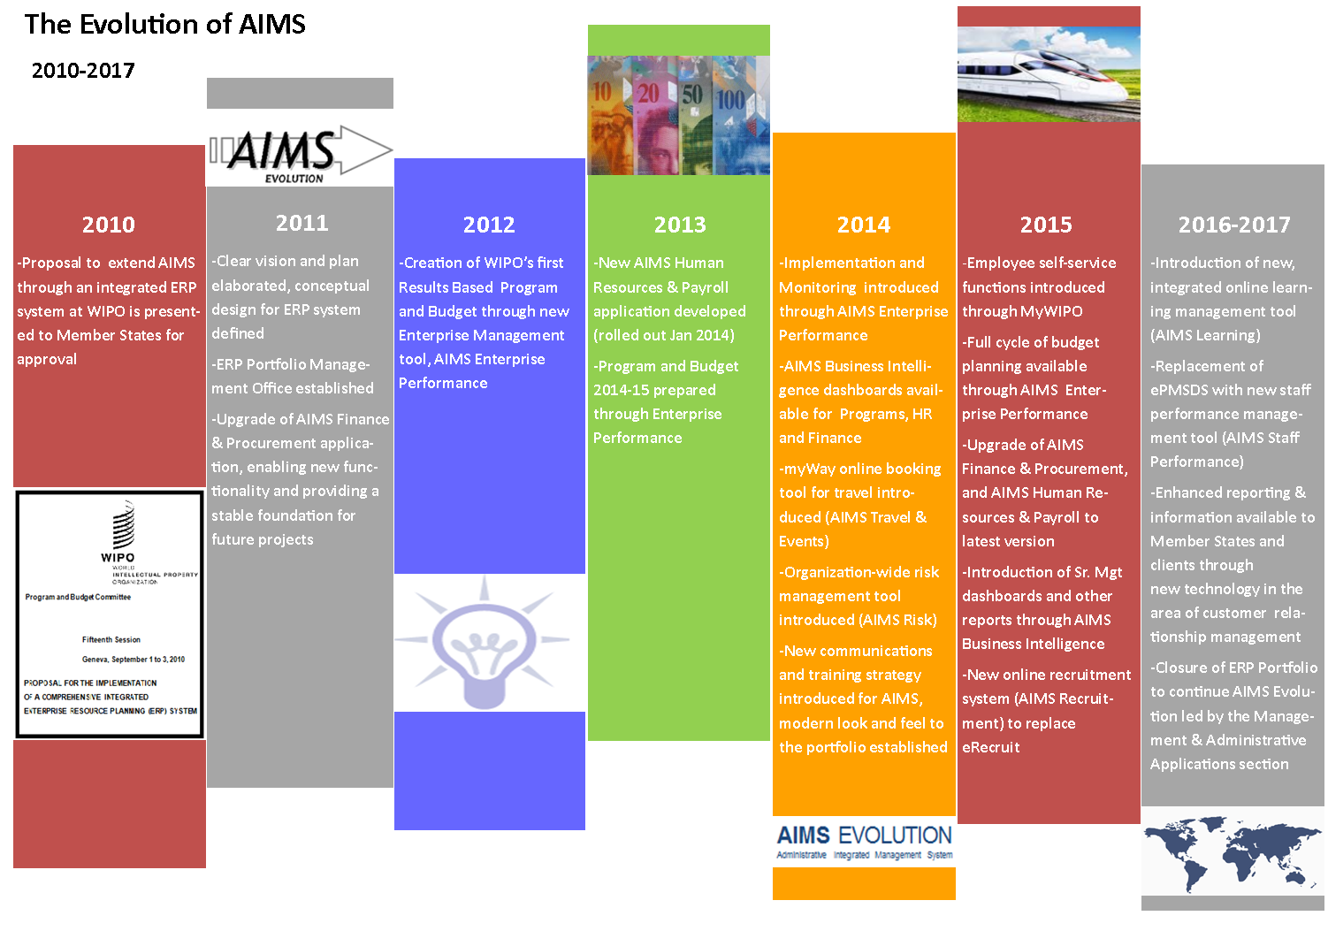

- Section X provides a detailed overview of the progress within each of the portfolio streams. In early 2015, thanks to collaboration between the ERP Portfolio Management Office (EPMO), the Information and Communication Technology Department (ICTD) and the Human Resources Management Department (HRMD), an online training catalogue was launched to provide a single place for WIPO staff to browse all available training courses, with real-time access to online training material and registration information for other training courses.
IV. ERP PERFORMANCE AUDIT
- During the third quarter of 2014 a performance audit of the ERP was conducted by the External Auditors.
- The performance audit in its draft form included nine recommendations. As part of the continuous improvement of the ERP portfolio these recommendations will be considered and appropriately acted upon. Some of the recommendations have been actioned through this report, for example, clarification on the revised timeline, the related impact on the budget for each of the portfolio streams and the inclusion of a performance evaluation section for external implementation partners.

V. EXTERNAL IMPLEMENTATION PARTNER PEFORMANCE EVALUATION
- The performance of ERP implementation partners is constantly monitored during the delivery of each project. Contracts with partners typically consist of a series of deliverables, linked to milestones against which a payment schedule is agreed. The deliverables must be accepted by WIPO in order for a milestone payment to be made. This helps to enforce the required level of control over quality and costs. However, this can impact the implementation timeline, as deliverables may need to be reworked before WIPO is able to accept them.
- The following diagram provides a representation of the performance of external implementation partners with the perfect partner profile represented by the outer green diamond. The actual performance to date of the three key ERP implementation partners are represented by the inner red, orange and blue profiles, i.e. the larger the profile the greater the number of criteria the partner has met.
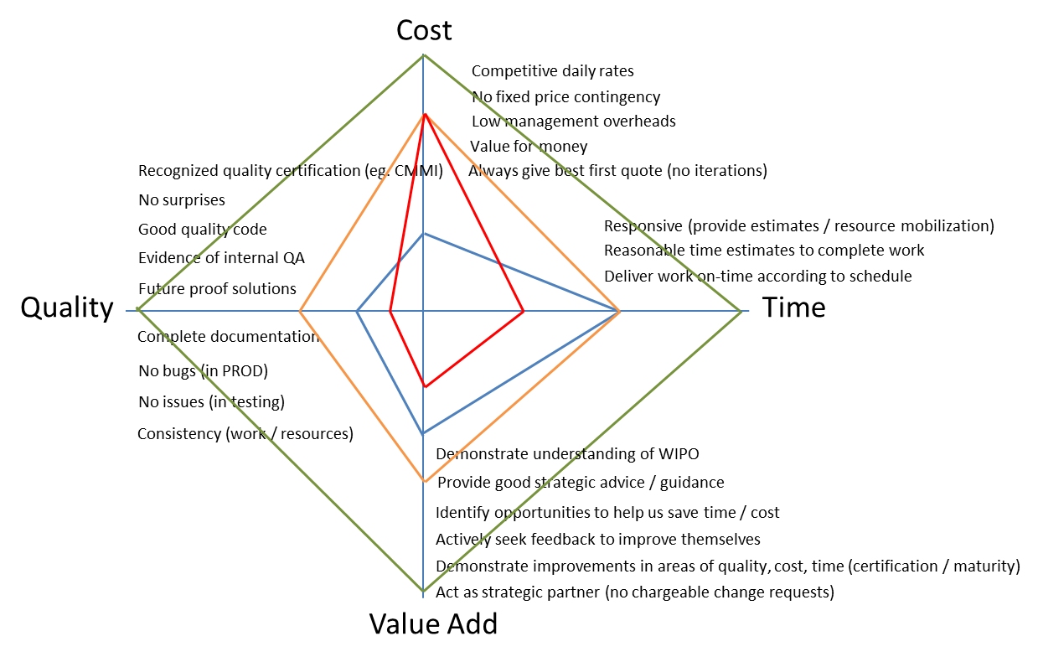
- The above diagram illustrates that each of the key ERP implementation partners has their strengths and weaknesses. As an ongoing continuous improvement process WIPO is introducing the following to help close the gaps between current and perfect performance:
- Ensure partners are certified to a specific quality standard;
- Include key performance indicators in contracts with regular measurement and corrective actions;
- Build agreed performance improvement goals into longer term contracts;
- Ensure all work is competitively tendered for, even smaller pieces of work that could be awarded directly within the framework of an existing umbrella agreement;
- Introduce strong independent gatekeeping, to ensure an acceptable level of quality is achieved before moving to the next stage of a project.

VI. GOVERNANCE STRUCTURE

- The enhanced governance structure, adopted in 2014 as a result of the Independent Verification and Validation (IV&V) review, has helped make the ERP portfolio more responsive, with defined segregation of roles and responsibilities and a clear escalation path for resolution of issues. The Intranet and ERP Wiki are being used as knowledge sharing tools, keeping stakeholders up-to-date on the evolution of projects and the portfolio as a whole.
- The EPMO continues to communicate with staff at all levels. Some of the major initiatives in 2014 included a “Learning @ WIPO” session held in June and a “What’s New @ WIPO” session in October, both of which drew large interest from staff. Summer and Winter 2014 editions of the ERP Newsletter were also published and distributed in order to keep staff informed of new product and service releases across the various projects.
- The portfolio also developed a series of communications in the form of short, informative videos for self-service and BI. Similar videos for other projects are planned for later this year. Additional communication and training activities are underway for the Recruitment project as well as the PeopleSoft Upgrade project, both of which touch a large user base. Some of these activities will include drop-in sessions, training videos, email communication and the upcoming Summer 2015 Newsletter.
- Lastly, an AIMS User Survey will be conducted in the near future to gather feedback from staff on the usability of AIMS so that improvements may be made, where possible, as part of the portfolio. The survey is designed to be performed annually, to obtain regular user feedback and to ensure continuous improvement of the operational ERP systems.

VII. ERP Project Budget Utilization

- The overall estimated cost for the implementation of the ERP portfolio of projects amounts to approximately 25 million Swiss francs over a five-year time frame. The estimated costs include application hosting, software acquisition, project personnel, user back-filling resources, external implementation partner fees, training and communication as well as other project-related costs. As the systems are deployed and become operational, the recurring costs of maintenance and system operation are included in successive Program and Budgets. A judicious mix of external and internal project personnel resources, including the use of low cost off-shore resources and fixed price contracts, has resulted in the delivery of planned functionality within a tightly managed project budget to date.
- A summary of budget utilization to date by major functional area and cost element and estimated budget utilization by the end of 2015, is presented in the tables below.
ERP Portfolio of Projects Budget Utilization (by Major Functional Area)
(In Swiss francs, as at May 31, 2015)

Major Functional Area | Original Project Budget | Updated Budget¹ | Actuals to Date² | Actual Utilization³ | Progress | Estimated budget utilization by end 2015⁴
Program and Change Management | 3,830,200 | 3,797,311 | 2,311,645 | 61% | 53% | 2,645,170
Human Resource Management and Development | 8,945,755 | 6,886,734 | 4,475,183 | 65% | 58% | 5,363,931
Enterprise Performance Management | 6,017,982 | 6,715,538 | 5,383,290 | 80% | 90% | 6,226,353
Customer Relationship Management | 1,955,690 | 1,943,477 | 108,925 | 6% | 0% | 524,945
AIMS Enhancements | 4,591,840 | 4,420,121 | 2,407,021 | 54% | 50% | 3,443,957
Accrued Contingency⁵ | - | 1,578,286 | - | - | - | -
Total | 25,341,467 | 25,341,467 | 14,686,063 | 58% | 59% | 18,204,355

¹ The updated budget is based on actual expenditure as at May 31, 2015 and the estimated budget for planned future projects. The latter includes a 10 per cent contingency, in line with the original planning assumption (document) WO/PBC/15/17
² Actuals to date include actual expenditure as at May 31, 2015.
³ Actual utilization reflects actual expenditure as at May 31, 2015 compared to the updated budget.
⁴ Estimated budget utilization by end 2015 reflects actual expenditure as at May 31, 2015 and expected expenditure until the end of 2015, based on current spending assumptions.
⁵ Accrued contingency refers to unused funds from contingency that was planned for projects already delivered. The overall contingency used will only be known at the end of the Portfolio.

ERP Portfolio of Projects Budget Utilization (by Cost Element)
(In Swiss francs, as at May 31, 2015)

Cost Element | Original Project Budget | Updated Budget¹ | Actuals to Date² | Estimated budget utilization by end 2015³
Application Hosting | 1,383,360 | 576,954 | 175,245 | 356,954
Software Acquisition | 3,989,738 | 2,718,772 | 2,297,353 | 2,312,616
Project Personnel | 5,564,680 | 9,037,623 | 5,446,888 | 6,443,229
User back-filling resources | 2,703,800 | 1,737,022 | 1,094,509 | 1,297,214
External Implementation Partner | 9,896,109 | 9,073,794 | 5,376,986 | 7,340,767
Training | 1,253,780 | 228,828 | 103,558 | 142,588
Communications and other | 550,000 | 390,188 | 191,524 | 310,988
Accrued Contingency⁴ | - | 1,578,286 | - | -
Total | 25,341,467 | 25,341,467 | 14,686,063 | 18,204,355

¹ The updated budget is based on actual expenditure as at May 31, 2015 and the estimated budget for planned future projects. The latter includes a 10 per cent contingency, in line with the original planning assumption (document) WO/PBC/15/17
² Actuals to date include actual expenditure as at May 31, 2015.
³ Estimated budget utilization by end 2015 reflects actual expenditure as at May 31, 2015 and expected expenditure until the end of 2015, based on current spending assumptions.
⁴ Accrued contingency refers to unused funds from projects already delivered.

- Overall, the portfolio budget is on track, and major functional areas are expected to be delivered within the original budget. The final expenditures under the Enterprise Performance Management area are also foreseen to be within the updated budget figures, but slightly (3.5 per cent) above the original budget as estimated in 2010. This is due, as reported in the 2014 ERP Progress Report, to the additional internal effort required to embed the skills and competencies of new EPM technologies, Hyperion and BI, into the Organization, as well as to the inclusion of ERM in the scope.

- Similarly, all cost elements are expected to be delivered below the original budget, except for Project Personnel. This is partly due to the additional internal effort required to embed new technologies, but is also a reflection of choosing the most cost effective delivery method. For example, the original budget for training and communications assumed the engagement of external service providers. However, rather than engaging external providers for these services it was decided to utilize internal project resources, hired directly by WIPO for the duration of the project, at a much lower cost. This also helped ensure that knowledge and skills were better retained internally. In accordance with WIPO’s standard accounting practices, the cost of internal project resources are reported under project personnel rather than under training and communications and hence the updated budget for the latter categories is lower than the original project budget, whereas the updated budget for project personnel is higher.

- Overall, the ERP Portfolio of Projects is expected to be delivered below the original approved budget. The accrued contingency represents funds initially allocated to projects which have not been used for their completion.

- During the lifespan of the portfolio the Organization’s needs have evolved and will continue to evolve and new business requirements and priorities will emerge. Therefore, the portfolio will also need to adapt its scope to remain aligned to these evolving business needs. Two examples of new projects were reported in the 2014 ERP progress report to the Member States, the introduction of an ERM tool and a second PeopleSoft upgrade. The accrued contingency allows the portfolio to remain flexible and able to adapt to unforeseen or emerging business requirements whilst ensuring completion within the original approved budget. At the end of the portfolio any remaining accrued contingency will be returned to the reserves.

- During 2015 a working group was formed by HRMD to review the policies and rules regarding flexible working time. The existing flexi-time system, which is used to electronically enforce the flexible working rules, is old, difficult to maintain and nearing the end of its life. The working group review may highlight new business needs that cannot be met by the existing flexi-time system and which may potentially require it to be replaced with a more modern, flexible and integrated solution. The available contingency could be considered for funding this requirement as the replacement of the flexitime system will contribute to the overall objectives of modernizing the core human resource management functions and their sustainability.

vIII. Portfolio schedule

- The portfolio schedule, originally presented to the Member States in 2010 as a five-year project, has been impacted by a number of delays and subsequently revised, as reported to the Member States in the annual progress reports. Some delays occurred in relation to the delivery of the core HR and Payroll project, which impacted subsequent projects within the HR stream as well as other dependent projects. Other delays have been caused by the Organization’s capacity to absorb the changes that new solutions introduce and the time needed to embed the skills and competences to support the new technologies before starting another implementation.
- Section II emphasized that quality and cost are the primary fixed drivers and therefore the only flexible variable is the timeline. Considering this, the above experience and the scope of the portfolio still to be delivered, the remaining projects have been re-planned and the following diagram provides an overview of the anticipated revised timeline. The projects shown in grey for 2016 and 2017 were pending approval by the AIMS Portfolio Board at the time of preparing this report.
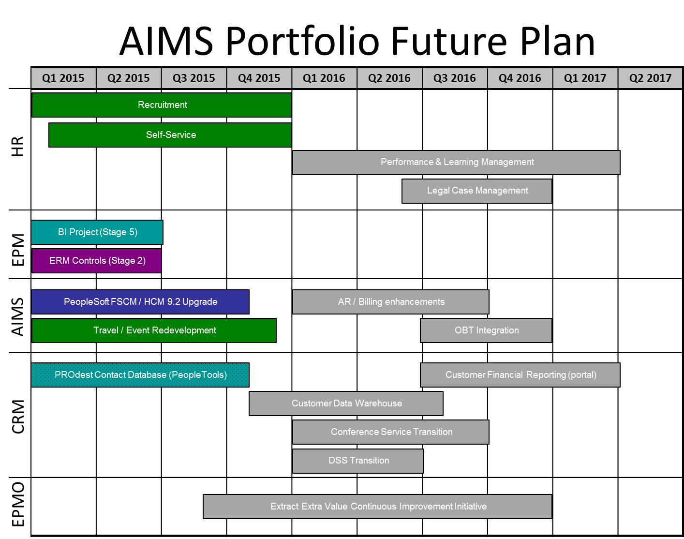
- According to the revised timeline, the remaining projects within the scope of the portfolio are expected to be completed in 2016 and 2017, within the originally approved budget. As projects are completed, the internal project resources will gradually stop being required and charged to the portfolio. Once all of the projects have been completed, a small team will perform the formal portfolio closure procedures during 2017, such as ensuring that post project benefits are delivered, final reports produced, all the necessary documentation archived, accounts are reconciled and closed, etc. The resources to perform these closure activities have been included in the ERP project budget.

IX. PORTFOLIO Risks

- The ERP portfolio of projects continues to comprehensively identify, monitor and manage risks through the implementation of mitigation strategies. The table below highlights the key risks identified for the portfolio of projects as a whole.
Risk | Description | Risk Mitigation
Completion of the portfolio scope within the revised time-frame | The remaining scope of the portfolio still shows a large number of projects that need to be initiated and completed within a relatively short time-frame. The capacity of the Organization to absorb this additional work and to gain the knowledge of the technologies is a concern | Extend the portfolio timeframe into 2017, stagger the projects rather than trying to do too many in parallel. Potentially drop some of the projects if time becomes a fixed constraint. Re-use existing technologies and capabilities to minimize new technologies and the knowledge that needs to be gained
Inability to extract the maximum value from the ERP whilst the portfolio is still present | The portfolio is successfully delivering projects, but the full value of the ERP will only be obtained through changes to processes, behaviors, etc which are not achieved by technology delivery projects | Embed a continuous improvement process into the Organization, through the portfolio, to ensure the maximum value is extracted during the portfolio and in the future
Loss of resources before the portfolio completes | As the portfolio is starting to close resources will start to look for other opportunities and they may leave before their work on the portfolio is complete | Start engaging resources on short term contracts, eg. ICS, which are deliverable based

X. Key Achievements BY STREAM

HUMAN RESOURCE MANAGEMENT (HR)

- Following the implementation of the core HR capabilities and payroll processing based on PeopleSoft HR software, enhanced functionality was deployed to bring new benefits to users as well as to increase systems integration. The enhanced functionality includes system processing of payroll for staff in external offices; automated tools for the processing and payments of education grant benefits; data exchanges with the planning system and a new data exchange with the UN Joint Staff Pension Fund. Targeted training activities were carried out to ensure users were able to use these functions.
- The PeopleSoft HR solution created new opportunities for employee and manager self-service transactions. A project was initiated with the objective to deliver such transactions in a phased manner. The first delivery in January 2015 enabled all employees, via the WIPO Intranet, to update personal information and to access payroll documents via self-service. Additional and more advanced transactions are planned to be introduced after the completion and stabilization of the current PeopleSoft Upgrade project.
- During 2014 key stakeholders analyzed options and concluded that Taleo recruitment would fit the needs of the Organization and provide a modern and efficient solution, allowing the retirement of the existing recruitment solution. The project was initiated in September 2014. Negotiations with the software service provider concluded in January 2015 and the project is currently in the design phase. The scope of the project includes the complete end-to-end recruitment process from the publication of new vacancies to candidate selection. This gives WIPO the opportunity to review the public career pages and to make these more attractive to candidates from all over the world. This project will also deliver new capabilities such as a dedicated site to advertise individual consulting service opportunities.
- The benefits achieved and expected in the future are listed in the table below.
Benefits Delivered 2014-15 | Expected Benefits 2015 | Expected Benefits 2016 | Expected Benefits 2017
Core HR / Payroll  Functionality supported:  Master Data Management  - Integration between HR and EPM for monitoring;  HR Management  - New interface to UNJSPF;  - New tool for processing of education grant claims;  - Additional reports and data control alerts.  Payroll Processing  - Standardized payroll processing across all staff including external offices.  Reporting  - Additional capabilities for HR Dashboard / analytical tools.  System access: HRMD, Payroll, PPBD, Safety and Security Coordination Service, Premises Infrastructure Division, Switchboard  Technology: (PeopleSoft)  Self-Service  Functionality supported:  - Online access to key personal and payroll information for staff.  System access: All staff  Technology: (PeopleSoft) | Self-Service  Functionality supported:  - New transactions for requesting and approving leave and absences;  - New transactions for staff to request specific benefits;  - New tool for managers to manage job descriptions.  System access: All staff  Technology: (PeopleSoft)  Recruitment  Functionality supported:  - Online recruitment of applicants, both internal and external;  - Preparation and publication of job vacancies and service opportunities;  - Evaluation and selection of applicants;  - Analysis of recruiting actions;  - Tracking of competencies and personal profiles.  System access: All staff, Internal and External Candidates  Technology: (Taleo) | Learning Management  Functionality supported:  - Integration with other HR systems;  - Capture training opportunities (from performance evaluations);  - Manage planned training activities;  - Record training outcomes;  Monitoring and analysis of overall organizational staff training needs.  System access: All staff  Technology: (To be selected)  Legal Case Management  Functionality supported:  Tracking lifecycle of staff legal cases and related documents;  System access: HRMD Policy and Law Section  Technology: (To be selected) | Staff Performance  Functionality supported:  - Management of staff performance annual cycle;  - Tracking of individual objectives;  - Ability to support advanced performance evaluations (peer-to-peer, 360, etc);  - Recording of performance ratings;  - Monitoring and analysis of overall organizational staff performance.  System access: All staff  Technology: (To be selected)

- The two HR projects in progress are managed under the portfolio governance structure and supervised by Project Boards made up of key business stakeholders. The following table highlights the key risks for these projects and the mitigation strategies being implemented.
Risk | Description | Risk Mitigation
Delivered solutions for recruitment and employee self-service not intuitive for users. | The delivery of an unintuitive recruitment system for external applicants or unintuitive self-service transactions for internal staff might result in negative situations (staff unable to perform transactions, external resources not applying to vacancies, delays in selection process or many help inquiries to deal with). | Selection of technologies and tools that have reached maturity and are recognized as market leaders.  Intensive and comprehensive testing with many users to ensure usability.
Data integrity and security with data hosted “in the cloud”. | The recruitment solution “Taleo” is a cloud based service. This means that WIPO recruitment data will be stored in the cloud, outside of WIPO. The security of this data, some of which is ‘confidential’, is therefore a risk. | Ensure proper data encryption; work closely with WIPO’s Information Assurance group to apply robust security controls. Ensure that the cloud provider has knowledge for the most effective security measures and has implemented these. Ensure the appropriate cloud solution is used, based on the data sensitivity.

Results-Based Management (through the implementation of epm tools)
- The EPM application strengthens and reinforces WIPO’s core RBM philosophy, enhances the principles enabling consistent results-based planning and resource management and enables Program Managers to develop biennial and annual plans in an integrated, centralized system. The system provides the Organization with a sound audit trail and ensures that all activities are linked to WIPO’s expected results, with the associated human and financial resources.
- During the reporting period, the project delivered an updated version of the Biennial Planning (BP) application. This current version included enhancements to the human resource allocation functionality in order to increase the synergy with the annual work planning (AWP) application. The Organization now has in place refined AWP business processes and has transitioned 2014 and 2015 AWP applications into production, integrated with the 2014/15 BP application.
- Custom integration between the EPM tools and FSCM ensures an accurate comparison of budget and actual expenditure, reconciliations, and eliminates duplicate data entry. Further bespoke integration between the EPM tools and PeopleSoft HR enables all positions to be viewed in EPM for their assignment to activities and facilitates the associated cost calculations.
- The deployment of the EPM applications and business processes has provided Program Managers with a significantly improved mechanism for WIPO’s Program and Budget development and review, reducing the time and effort necessary to verify, consolidate and
analyze the biennial and annual planning information and increasing the accuracy, reliability and traceability of planning data.
- The project has delivered enhanced monitoring capability to programs by developing functionality within the application for measuring a program’s progress over the biennium. Furthermore, an additional module focuses on the performance assessment used as a basis for the annual Program Performance Reports to Member States.
- The benefits associated with annual work planning (AWP) are summarized below.
Benefits Delivered 2012 | Benefits Delivered 2013 | Benefits Delivered 2014 | Expected Benefits  End 2015
AWP 2012/13  Functionality supported:  - Planning and update of activities linked to expected results;  - Allocation and adjustments of non-personnel and personnel resources at program activity level;  - Analysis of several dimensions of workplan information, i.e. results and implementing entity;  - Generation of reports directly from Essbase (e.g. staffing authorization tables, actuals versus workplan budget, etc.);  - Capability to generate budget journals for upload into FSCM;  - Feedback of actual expenditure by FSCM activity to managers in quarterly reports. | AWP 2014/15  Functionality supported:  AWP for 2012/13 with additional functionality:  - Planning / tracking status of workplan activities in 2014/15 linked to performance indicators and expected results;  - Position level planning;  - (Re)assigning positions to program activities;  - First phase integration with PeopleSoft HR and FSCM;  - Generating a large number of reports from EPM for both end-users and central teams. | AWP 2014/15  Functionality supported:  AWP functionality for 2014/15 with additional fine-tuning based on user feedback;  - Full integration with HR and FSCM:  - Actual expenditure from FSCM;  - Budget journals sent to FSCM;  - New Program Activities sent to FSCM;  - Position data received from PeopleSoft HR.  User authentication to corporate active directory  Generating advanced reports for both end-users and central teams. | AWP 2016/17  Functionality supported:  AWP functionality for 2014/15 with additional fine-tuning based on user feedback;  Generating integrated reports for end-users and central teams from BI.
System access: Central Budget and Program Management and Performance Sections  Technology: (Essbase with Excel supported interface) | System access: End-users  Technology: (Essbase; Hyperion Planning) | System access: End-users  Technology: (Essbase; Hyperion Planning) | System access: End-users  Technology: (Essbase; Hyperion Planning, BI)

- During the period under review, the EPM project redeveloped the BP application for 2016/17, which contained a number of technical enhancements. Reporting capability, developed as a core component of the current EPM application, has also provided management with real-time, cross-organizational consolidated analytical information on the 2014/15 Program and Budget. The project benefits in respect of biennial planning are summarized below.
Benefits Delivered 2012 / 2013 | Benefits Delivered 2014 / 2015
Biennial planning 2014/15  Functionality supported:  - Planning of high-level biennial program activities linked to expected results and performance indicators;  - Budgeting of resources (personnel and non-personnel) for high level activities;  - Estimation of development share of the budget;  - Estimation of results-based budget and budget by cost category; and  - Analysis of planning dimensions (expected result, cost category, Development Agenda etc.) by Program, Sector and/or Unit.  System access: End-users  Technology: (Essbase, Hyperion Planning) | Biennial planning 2016/17  Functionality supported:  Biennial planning for 2014/15 with additional functionality to support:  - Publication of the Program and Budget document;  - Process automation through workflows and approval hierarchies.  System access: End-users  Technology: (Essbase, Hyperion Planning)

- In order to track risks as part of the performance cycle, an ERM tool has been implemented during the reporting period. The ERM tool contains the Organization’s program risks and the mitigation actions associated with them. A comprehensive training course has taught managers about managing risks and how to use the tool. The ERM system also stores information about the Organization’s internal controls.
- The benefits in respect of enterprise risk management are summarized below.
Benefits Delivered 2014 / 2015
Enterprise Risk Management

Functionality supported:

- Cost effective management and monitoring of risks
- Effective audits
- Unlocking the potential of the risk data
- Improved integrity of risk data
- More informed planning
- Foundation for Information Security ISO27001:2013 certification
- Conformity with recommendations to put in place robust risk management system

System access: End-users
Technology: (Acuity STREAM)

STRENGTHENED ENTERPRISE REPORTING AND BUSINESS INTELLIGENCE

- The full deployment of the EPM systems has resulted in WIPO being in the lead, among UN agencies, in respect of supporting RBM with a comprehensive set of integrated operational tools and systems. The establishment of such tools is acknowledged as a prerequisite for fully embedding a Results-based culture in the Organization.
- The BI project provides cross-functional analytical capacities to various key internal and external stakeholders to enable them to better understand the key drivers and performance characteristics of their Programs. This capability will progress in a phased manner so that best practice principles are observed and that information meets specific data quality standards.
- During this phase, the BI project has expanded the data feeds to include FSCM, HR and EPM, with work in progress to integrate a number of other WIPO applications. Business resources have been trained and acquired BI development skills. Fifty-six dashboards have been created to date, covering HR, Finance, Procurement and Program Management. Dashboards will continue to be rolled out as they are built and as new data feeds become available.
- Prototypes continue to be used to explore how data feeds from other sources, such as ERM and e-Work, can be included and federated into the BI data warehouse.
- The following table highlights the benefits of Business Intelligence.
Benefits Delivered 2012 / 2013 | Benefits Delivered 2014 / 2015 | Expected Future Benefits
Functionality supported:  - Technology infrastructure established;  - Data feeds from FSCM established;  - Oracle Business Intelligence Applications for Finance and Procurement Departments;  - Prototype customized dashboards for Senior Management;  - User authentication to corporate active directory enabled.  System access: Specific key users  Technology: Oracle Business Intelligence | Functionality supported:  - Data feeds from HR, EPM and risks from ERM established;  - Customized dashboards for Senior Management;  - Oracle Business Intelligence Applications for HR;  - Customized dashboards for HRMD, Program Performance, Procurement and Finance.  System access: Extended stakeholders  Technology: Oracle Business Intelligence | Functionality supported:  - Data feeds from ERM for controls and actions established;  - Data feeds from non-ERP systems established;  - Senior Management dashboards enhanced with further information;  - Dashboards for external stakeholders, such as Member States / customer established.  System access: Extended stakeholders  Technology: Oracle Business Intelligence

- The BI project will conclude in 2015, following the successful deployment of the data feeds from other ERP sources, the release of the first set of dashboards and the establishment of competencies within the Organization to sustain the solutions. Whilst the BI project will conclude it should be noted that BI is a journey and that new requirements, new data sources and enhancements will be required to keep the solutions relevant to the Organization, which also constantly changes and evolves. Therefore, the BI initiative will continue as part of the ongoing operational support activity and some of the expected future benefits, shown above, will be delivered as part of this.
- The following table highlights the key risks for Business Intelligence.
Risk | Description | Risk Mitigation
Maximum value from Business Intelligence is not realized. | The business may not be able to extract the optimal benefit from the Business Intelligence capabilities. | Well-defined requirements with participation from all stakeholders. Consistent view of key-organizational data across WIPO’s applications. Controls over data quality and consistency. Well-managed security regarding confidential information.
Sustainability after project closure | The Organization may not have the capability to sustain BI once the project closes. | Build capabilities within each area across the Organization and within the support function as part of the project to ensure they can continue to evolve the BI solution after the project closes.

ENHANCEMENTS TO the AIMS FSCM AND TRAVEL SYSTEMS

- During the period under review an online booking tool, Traveldoo, has been introduced through a phased deployment, which was completed in the last quarter of 2014. The benefits of this tool, known as myWay, are already being seen with the reduction of transaction and ticketing costs for travel through an improved travel process.
- The ERP integration with the Patent Cooperation Treaty (PCT) translation service systems was successfully completed in the last half of 2014. This allows more granular and accurate information in FSCM without increasing the manual effort to achieve this. The benefits to WIPO include a more responsive streamlined process, removing the need for a year-end budget buffer for translation work and improved traceability, reporting and analysis.
- The PeopleSoft 9.2 Upgrade project was initiated in late 2014 to update the existing PeopleSoft HR and FSCM systems to the latest version. As part of this project the opportunity to introduce new standard functionality and to remove customizations is being undertaken, e.g. moving to the standard payment predictor for the accounts receivable and billing application.
- The Management and Administrative Applications Section (MAAS), which supports AIMS, has funded a project to replace the existing Travel and Event solution with one built using the tools that support PeopleSoft. This will help WIPO to retire the old Metastorm system which will not be supported in the near future. The introduction of a new Travel and Event solution will also provide the opportunity to build a reusable foundation with capabilities that other ERP solutions can utilize, such as the contact database and new conference service system. This will help WIPO to rationalize the number of solutions, improve support, reduce the associated risks of supporting multiple tools / solutions and become more cost efficient.
- The next table highlights the key risks and the mitigation strategies being implemented.
Risk | Description | Risk Mitigation
AIMS users are insufficiently trained in the execution of their work. | Improvements in business processes and the delivery of new ERP modules result in changed roles and responsibilities of AIMS users. If users do not sufficiently understand business processes or tools, the system will be used in a less optimal manner. | Identify training needs early in the project lifecycle. Ensure material is developed and available under the single training catalogue for projects as well as training in the context of on-going operations. Institutionalize training in accordance with the needs.
MAAS provides insufficient support to users | Insufficient understanding of the new ERP modules by the MAAS and inability to cope with the workload required to support the users and the system. | Ensure MAAS participates in the respective projects to acquire a thorough understanding of the new technical and business functions. Develop and execute an agreed plan for each project to effectively transition knowledge to MAAS.

- The following decision paragraph is proposed.
- The Program and Budget Committee took note of the Progress Report on the Implementation of a Comprehensive Integrated Enterprise Resource Planning (ERP) System (document WO/PBC/24/14).

[End of document]

