|  |  |  |
| --- | --- | --- |
|  | WIPO-E | **E** |
| WO/PBC/22/15 | | |
| ORIGINAL: ENGLISH | | |
| DATE: JUNE 27, 2014 | | |

**Program and Budget Committee**

**Twenty-Second Session**

**Geneva, September 1 to 5, 2014**

PROGRESS REPORT ON THE IMPLEMENTATION OF A COMPREHENSIVE INTEGRATED ENTERPRISE RESOURCE PLANNING (ERP) SYSTEM

*prepared by the Secretariat*

**I. INTRODUCTION**

1. The forty-eighth session of the Assemblies of the Member States of WIPO in September 2010 approved the Secretariat’s proposal for the Implementation of a Comprehensive Integrated ERP System (documents WO/PBC/15/17 and A/48/14), with a view to: (i) modernize WIPO’s core administrative, management and customer‑service functions; (ii) improve efficiency and productivity of WIPO’s administrative and management processes; and (iii) enhance the capability to provide better information to Member States, stakeholders and management.
2. This report complements previous progress reports submitted to the Program and Budget Committee (PBC), providing Member States with a view of progress made, milestones reached and budget use under the ERP Portfolio of Projects during the period June 2013 to May 2014.

# iI. OBJECTIVES, Scope AND APPROACH – BACKGRound

1. The ERP system is being implemented through a portfolio of inter-related projects.
2. The first stream of projects will provide WIPO with a comprehensive set of tools to strengthen Human Resource Management (HR), comprising position management, benefits and entitlements, payroll, recruitment, staff performance, learning and development.
3. The second stream of projects will provide WIPO with a set of tools to strengthen the implementation of Results-Based Management (RBM), comprising biennial planning, annual workplanning, implementation monitoring and performance assessment and reporting. The Business Intelligence (BI) analytical tool will be introduced in support of Enterprise Performance Management (EPM). As all streams progress, more data will be available in the ERP system and the BI solution will progressively enable improved reporting to Member States, management and staff on organizational performance, results, and human and financial resources.
4. The third stream of projects will enhance the existing finance, procurement (FSCM) and travel systems through configuration changes and upgrades which will enable the introduction of new functionality and improvements to business processes and the introduction of new modules.
5. The fourth steam will lay the foundations for improved Customer Relationship Management (CRM) by supporting business led projects, such as mailing list tools, contact databases, access management and customer analytics.
6. WIPO’s implementation approach is based on incremental phased projects which will help the ERP capabilities to evolve progressively in a coherent and measured manner. The approach is also driven by the capacity of concerned organizational units to absorb and integrate changes.
7. Quality, accuracy and completion within the approved budget are the main drivers for the ERP portfolio. Timelines will be re-planned, where required, to ensure that the Organizational units concerned have the capacity to absorb and embed the changes being deployed.
8. The overall focus of the ERP Portfolio is to support WIPO’s Results Based Management approach. A representation of this cyclical process is depicted below.

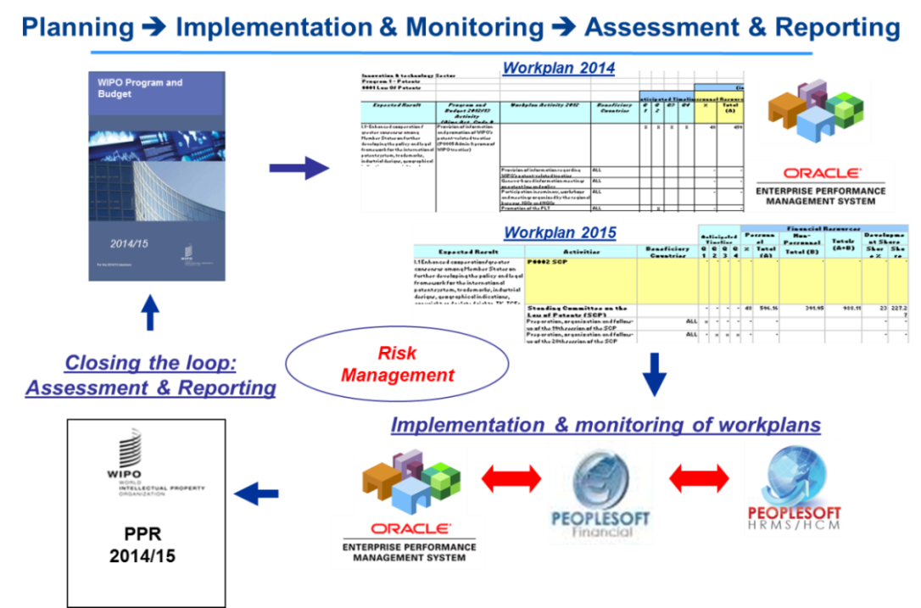

1. The ERP portfolio of projects allow for the gradual evolution of the current Administrative Integrated Management Systems (AIMS Evolution). Historically, AIMS was used to refer to the financial system. In future, the term will refer to the interrelated systems covered by the ERP.

# III. PORTFOLIO ACHIEVEMENTS

1. Overall, the portfolio is well on track to deliver the objectives of modernizing and improving the quality, efficiency and productivity of WIPO’s management, administrative and customer service functions, improving the Organization’s capacity to provide better information to Member States, stakeholders and management. This has been achieved through the following:
   1. Vision/blueprint for the portfolio established. This has enabled the coherent implementation of projects;
   2. Upgrade of PeopleSoft FSCM to version 9.1 successfully completed. This enabled the integration of the HR system with the financial system;
   3. Underlying BI technical architecture and data feeds from PeopleSoft have been established; the first BI dashboard for HR has been delivered. The work done so far lays the foundation for the design and deployment of analytics to help decision making.
   4. Biennial and work planning applications were deployed using the EPM tools, including the capacity to perform implementation, performance assessment and reporting. This ensures that the entire RBM cycle is now well supported by appropriate tools.
   5. Core HR and Payroll on PeopleSoft HR version 9.1 has been deployed. This will result in the retirement of the payroll legacy system and ensures that resource management processes are supported by information from financial and HR systems.
2. Section IX provides a detailed overview on the progress of each of the portfolio streams. The progress achieved on the ERP portfolio during the period under review was good in respect of cross-cutting initiatives aimed at ensuring maximum value from the ERP system, in particular:
   1. The ERP portfolio team continued to collaborate closely with the Information and Communication Technology Department (ICTD) to ensure that the necessary technology management and control mechanisms were in place. An example of this may be seen in the development of an online integrated training platform which will provide users with a single place to request training in IT, ERP applications and other areas;
   2. User authentication for all ERP applications (PeopleSoft FSCM, PeopleSoft HR, EPM and BI) against the WIPO corporate active directory was established. This was an important first step in improving the user experience to allow future single sign-on access across the solutions;
   3. The optimal way to technically integrate an Electronic Document Management System (EDMS) solution to the ERP was agreed on. The actual integration will be implemented through an ICTD led capital master plan initiative.
3. The ERP portfolio has and will continue to support additional projects and work not originally envisaged but which will help achieve the overall goals of the ERP portfolio. Two particular examples are:
   1. Risk management, which is of particular importance to WIPO as an Organization and to the ERP portfolio. A project to introduce an Enterprise Risk Management (ERM) tool will commence in the second half of 2014 as part of the second stream of projects to implement our Results-Based Management. This will enable WIPO to progress in accordance with its Risk Management and Road Map.
   2. A PeopleSoft financials upgrade, which was completed as part of the ERP portfolio in 2012. A second upgrade to a version which has recently been released is now planned for 2015. This will allow the introduction of additional functionality, in particular opportunities to improve and de-customize accounts receivable and billing.

**IV. Independent Verification and Validation (IV&V) review**

1. A tender was completed to hire an external service provider to perform an IV&V review of the ERP portfolio during the second half of 2013. The successful bidder was Gartner Consulting. The review, which included observing meetings, reviewing documents and interviewing over 35 stakeholders, was completed over a six‑week period.
2. Overall, the portfolio evaluation was a medium risk rating, seen by Gartner as good for an ERP portfolio which was mid-way into implementation. The review highlighted many positives, such as the capacity demonstrated by the portfolio to learn and adapt over time and the solid executive support and business involvement shown. The review also mentioned the active involvement and well‑prepared nature of the support team throughout testing which proved successful. The review identified 58 recommendations, all of which were implemented by April 2014, thus allowing the remaining portfolio projects to benefit from the improvements. A summary list of the recommendations may be found in the Annex.

# V. ADAPTED GOVERNANCE STRUCTURE

1. A key recommendation from the IV&V review was the need to enhance the overall governance structure of the ERP portfolio, to make it more responsive in terms of the segregation of roles and responsibilities and to provide a clear escalation path for the resolution of issues.
2. As a result, a board for each project was established, with key roles of Executive, Senior User and Senior Supplier. This has helped more timely decisions to be made for projects.
3. The ERP Project Management Office (EPMO) was strengthened with the appointment of both a Head and a Training and Communications Officer. This has improved co-ordination and sharing of experiences across projects.
4. The AIMS Steering Committee, consisting of the individual project board members, was established to ensure that cross-functional / integration issues could be better addressed.
5. An AIMS Portfolio Board was established to provide overall strategic guidance and leadership. This provided a clear escalation path to address issues that could not be resolved at a project, EPMO or AIMS Steering Committee level. The Information and Communications Technology (ICT) Board, chaired by the Director General, regularly reviews progress made by the ERP portfolio. The membership of the AIMS Portfolio Board is a subset of the ICT Board.
6. The ERP portfolio of projects continues to promote communication with staff at all levels. For instance, a second edition of the ERP communication leaflet is planned for distribution in June 2014. Also, a series of bi-monthly drop-in sessions for staff have been organized throughout 2014. Furthermore, other initiatives such as a “Learning at WIPO workshop”, a “What’s-New” briefing session and an ERP Newsletter, are planned for 2014. Finally, both the intranet and WIPO Wiki space are being used as knowledge sharing tools, and are continuously kept up‑to‑date with new information as each project under the portfolio evolves.

# VI. ERP Project Budget Utilization

1. The overall estimated cost for the implementation of the ERP portfolio of projects amounts to approximately 25 million Swiss francs over a five-year time frame. The estimated costs include application hosting, software acquisition, project personnel, user back-filling resources, external implementation partner fees, training and communication as well as other project‑related costs. As the systems are deployed and become operational, the recurring costs of maintenance and system operation will be included in successive Program and Budget proposals as part of the regular budget. A judicious mix of external and internal project personnel resources, including the use of low cost off-shore resources, has resulted in the delivery of planned functionality within a tightly managed project budget to date.
2. A summary of budget utilization to date by major functional area and cost element, together with the estimated utilization by the end of 2014, is presented in the tables below.

**ERP Portfolio of Projects Budget Utilization (by Major Functional Area)**

*(In Swiss francs, as at May 31, 2014)*

|  |  |  |  |  |  |
| --- | --- | --- | --- | --- | --- |
| **Major Functional Area** | **Project Budget** | **Actuals to Date1** | **Actual Utilization** | **Implementation Progress** | **Estimated budget utilization by end 20142** |
| Program and Change Management | 3,830,200 | 1,883,851 | 48% | 52% | 2,559,318 |
| Human Resource Management and Development | 8,945,755 | 3,899,091 | 49% | 48% | 5,425,220 |
| Enterprise Performance Management | 6,017,982 | 4,031,432 | 63% | 59% | 5,647,611 |
| Customer Relationship Management | 1,955,690 | 108,925 | 7% | 0% | 108,925 |
| AIMS Enhancements | 4,591,840 | 2,197,234 | 44% | 29% | 2,687,912 |
| **Total3** | **25,341,467** | **12,120,533** | **49%** | **44%** | **16,428,986** |

1 Actuals to date includes expenditure as of May 31, 2014.

2 Estimated budget utilization by end 2014, includes actuals to date (May 31, 2014) and expected expenditure until end 2014, based on the current spending assumptions.

3 The original budget estimated actual expenditure to reach 23 million Swiss francs by the end of 2014. The current forecast is significantly lower than the original budget, with the difference expected to be spent in forthcoming project phases.

**ERP Portfolio of Projects Budget Utilization (by Cost Element)**

*(In Swiss francs, as at May 31, 2014)*

|  |  |  |  |
| --- | --- | --- | --- |
| **Cost Element** | **Project Budget** | **Actuals to Date1** | **Estimated budget utilization by end 20142** |
| Application Hosting | 1,383,360 | 144,429 | 569,175 |
| Software Acquisition | 3,989,738 | 2,155,699 | 2,757,420 |
| Project Personnel | 5,564,680 | 4,178,038 | 5,626,233 |
| User back-filling resources | 2,703,800 | 967,868 | 1,140,174 |
| External Implementation Partner | 9,896,109 | 4,554,331 | 5,959,461 |
| Training | 1,253,780 | 99,090 | 266,568 |
| Communications and other | 550,000 | 21,078 | 109,955 |
| **Total3** | **25,341,467** | **12,120,533** | **16,428,986** |

1 Actuals to date includes expenditure as of May 31, 2014.

2 Estimated budget utilization by end 2014, includes actuals to date (May 31, 2014) and expected expenditure until end 2014, based on the current spending assumptions.

3 The original budget estimated actual expenditure to reach 23 million Swiss francs by the end of 2014. The current forecast is significantly lower than the original budget, with the difference expected to be spent in forthcoming project phases.

1. The portfolio now tracks and reports on the progress in project implementation as well as on actual expenditure. Implementation progress is commensurate to actual expenditure, as shown in the budget utilization by major functional area table. Actual expenditure typically runs slightly ahead of progress, due to upfront costs, such as infrastructure, software licenses and maintenance, which are incurred before the implementation of a project can begin.

# vII. Portfolio schedule

1. The delay in the rollout of the core HR and payroll solution has impacted the HR stream and subsequent HR projects, such as recruitment and self-service, starting approximately eight months later than original planned. Similarly, other portfolio‑dependent projects, such as BI

workforce analytics and the integration between HR and EPM, have been delayed by approximately eight months. This means the portfolio is likely to be completed by mid-2016 instead of end‑2015, as originally planned. The EPMO is investigating ways to limit this delay.

1. The following diagram provides an overview of the anticipated revised timeline.

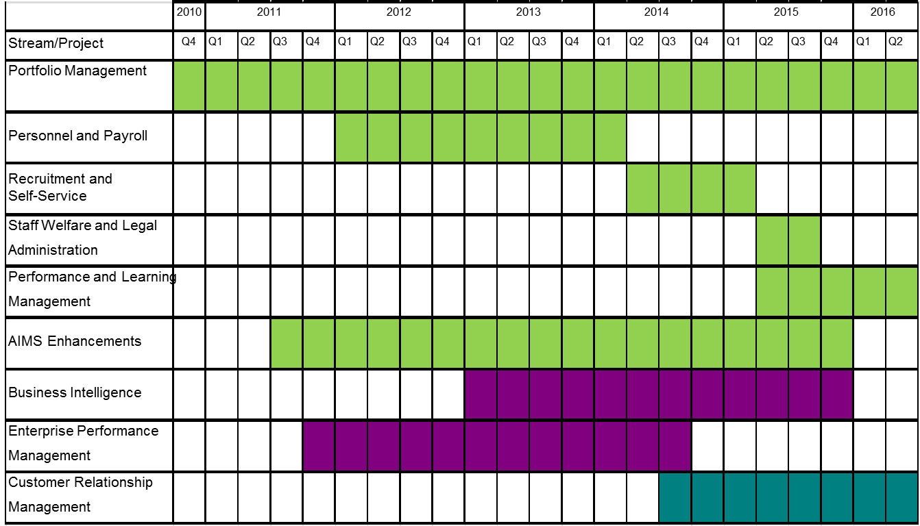

1. Whilst the timeline is anticipated to extend beyond the original five years into 2016, it should be noted that the original approved budget will not be exceeded.

**vIII. PORTFOLIO Risks**

1. The ERP portfolio of projects continues to comprehensively identify, monitor and manage risks through the implementation of mitigation strategies. The table below highlights the key risks identified for the portfolio of projects as a whole.

| **Risk** | **Description** | **Risk Mitigation** |
| --- | --- | --- |
| Late delivery of the portfolio | At the end of 2015, the portfolio did not reach the implementation level communicated to the PBC in 2010 | Keep the PBC informed of progress. Warn the PBC early if this is likely to continue. Ensure any overrun does not impact the agreed budget. |
| Business resists change | Staff do not use the system as planned and do not respond well to change. Services provided by existing systems are disrupted when changes required to support the ERP portfolio requirements are introduced. | Drive the portfolio based on business priorities. Customize the solutions whilst maintaining a prudent balance with out-of-the-box functionality. Ensure users are involved in UAT. Regularly engage with users through Change Management efforts (communication, training, briefings, etc). |

**IX. Key Achievements BY STREAM**

HUMAN RESOURCE MANAGEMENT (HR)

1. The initial project phase that consisted of the implementation of core HR capabilities and payroll processing based on PeopleSoft software is now complete and the system capabilities supporting HR and Payroll’s day-to-day activities have been in place since January 2014.
2. Implementation followed rigorous sequential testing stages to ensure it was complete and that user acceptance of the solution was achieved. These tests highlighted a number of areas for improvement. Accuracy and completion within budget were considered a higher priority as compared to the timeline. As a consequence, the planned rollout for October 2013 was re‑scheduled to January 2014 to provide additional time to improve the final solution, perform additional integration and user acceptance tests and to run a complete series of parallel tests with the legacy system.
3. Testing was completed as planned in early January 2014 and the move to production only intervened once WIPO business stakeholders were satisfied and reassured that the transition would be smooth and successful. As a result of a comprehensive data migration process in January 2014, payroll calculations have been produced from the new system since January, thereby providing the possibility of obtaining a full biennium of data in the new system. The adverse impact of deploying the solution later than expected was consequently minimized and proved beneficial to the Organization.
4. Knowledge transfer activities to regular operations and post-production support by the project team came to an end in May 2014. Remaining functionalities associated with this project are gradually being released in a controlled manner as a part of regular operational support.
5. From December 2013 to May 2014, several training activities were conducted to ensure that users at all levels and across all sectors were prepared to conduct their tasks without any interruptions to WIPO’s business activities. By the end of May, approximately 100 users were active on the system.
6. This initial project aimed at strengthening the integration of data and processes, both within HRMD and in relation to other administration and management functions within WIPO. The successful implementation of the PeopleSoft core HR and payroll solution now provides the foundation for future HR projects to provide enhanced functionality over time. Two new projects have been initiated, namely staff self-service and recruitment. The implementation of the two new projects will be supervised by Project Boards made up of key business stakeholders.
7. The benefits of the first project and those expected to be obtained from future projects are listed in the table below.

| **Benefits Delivered 2014** | **Expected Benefits 2014** | **Expected Benefits 2015** | **Expected Benefits 2016** |
| --- | --- | --- | --- |
| **Core HR / Payroll**  ***Functionality supported:***  ***Master Data Management***   * Integrated HR and FSCM; * Aligned operating structures.   ***HR Planning***   * Standardized concepts for position, job, profiles across all staff; * Integrated planning with the operational HR system.   ***HR Management***   * Comprehensive management of HR information * Automated data entry; * Faster processing of complex transactions; * Enabled HR specialists to easily access information to improve customer service.   ***Payroll Processing***   * More reliable and accurate payroll calculations; * Standardized payroll processing across all staff.   ***Reporting***   * Integrated with BI; * Dashboard / analytical capabilities.   ***Technology***   * Established modern system to allow delivery of future capabilities; * Reduced maintenance and support needs; * Reduced risk of failure; * Establish disaster recovery platform; * Retirements of legacy systems. | **Self-Service**  ***Functionality supported:***   * Implementation of portal technology to view information and initiate administrative tasks; * Online access to key personal and payroll information for staff. | **Self-Service**  ***Functionality supported:***   * Initiate life event related transactions; * Entry and approval of leave and absences; * Requests for specific allowances such as education grant or rental subsidy.   ***System access:*** All staff  ***Technology:*** *(*PeopleSoft)  **Legal Case Management**  ***Functionality supported:***  Tracking lifecycle of staff legal cases;  ***System access:*** HRMD Policy and Law Section  ***Technology:*** *(*PeopleSoft)  **Recruitment**  ***Functionality supported:***   * Online recruitment of applicants, both internal and external; * Preparation and publication of job vacancies and service opportunities; * Evaluation and selection of applicants; * Analysis of recruiting actions; * Definition of organizational competencies and personal profiles; | **Staff Performance**  ***Functionality supported:***   * Management of staff performance annual cycle; * Tracking of individual objectives; * Ability to support advanced performance evaluations (peer-to-peer, 360, etc); * Recording of performance ratings; * Monitoring and analysis of overall organizational staff performance.   ***System access:*** All staff  ***Technology:*** *(*PeopleSoft)  **Learning Management**  ***Functionality supported:***   * Integration with other HR systems; * Capture training opportunities (from performance evaluations); * Manage planned training activities; * Record training outcomes; * Monitoring and analysis of overall organizational staff training needs. |
| ***System access:*** HRMD, Payroll, PPBD, Safety and Security Coordination Service, Premises Infrastructure Division, Switchboard  ***Technology:*** (PeopleSoft) | ***System access:*** All staff  ***Technology:*** *(*PeopleSoft) | ***System access:*** External candidates, HRMD and members of selection boards.  ***Technology:*** *(*To be selected) | ***System access:*** All staff  ***Technology:*** *(*PeopleSoft) |

1. The following table highlights the key risks for the two HR projects that have been initiated and the mitigation strategies currently being implemented.

| **Risk** | **Description** | **Risk Mitigation** |
| --- | --- | --- |
| Increased user base resulting in poor system performance. | An increase of the user base to all staff because of self-service functions may impact the performance of the existing administrative information management systems. Staff efficiency would then be impacted. | Ensure the system is sized accurately for the number of expected users and the volume of transactions.  Carry out perform performance tests before moving the solution to production. |
| Unintuitive recruitment system for external applicants. | The delivery of an unintuitive recruitment system for external applicants might result in resources not applying, delays in selection process or many help inquiries to deal with. | Selection of a recruitment tool that has reached maturity and is recognized as a market leader.  Intensive and comprehensive testing with many users to ensure usability. |

## Results-Based Management (through the implementation of epm tools)

1. The EPM application strengthens and reinforces WIPO’s core RBM philosophy, enhances the principles enabling consistent results-based planning and resource management and enables Program Managers to develop biennial and annual plans in an integrated, centralized system. The system provides the Organization with a sound audit trail and ensures that all activities are linked to WIPO’s expected results, with the associated human and financial resources.
2. During this reporting period, the project has focused on refining annual work planning (WP) end-to-end business processes and delivering an annual WP application for 2014 and 2015. This custom development extends the capabilities of the annual WP solution developed for 2012 and is integrated with the 2014/15 biennial planning application.
3. The annual WP application splits the biennial budgets for human and financial resources into annual budgets, in accordance with the Program and Budget for the biennium approved by the Member States. Program Managers are then guided through the annual WP process, adding workplan activities, assigning budgets and undergoing the approval process. Additional features ensure the accuracy of budget calculations, the assignment of personnel to Program Activities, auditing capabilities and the identification of improved time schedules.
4. The annual WP application also provides additional functionality throughout the performance management cycle and now provides functionalities for the monitoring of annual workplans during implementation and quarterly performance assessments. Integration with the existing FSCM system has enabled actual costs for each Program Activity to be presented in EPM enabling a comparison of budget and actual expenditure. A time-saving functionality has been included to automatically direct internal budget adjustments from EPM to FSCM. This allows time-consuming double data entry to be avoided, facilitates the associated reconciliations and enhances data integrity. Custom integration with PeopleSoft HR enables all positions to be viewed in EPM for their assignment to activities and facilitates the associated cost calculations. The development includes an automated functionality to update the above information as changes are made in the source systems.
5. The deployment of the EPM applications and business processes has provided Program Managers with a significantly improved mechanism for WIPO’s Program and Budget development and review, reducing the time and effort necessary to verify, consolidate and   
     
     
   analyze the biennial and annual planning information and increasing the accuracy, reliability and traceability of the planning data. The project benefits associated with the annual WP and the monitoring of implementation are summarized below.

| **Benefits Delivered 2012** | **Benefits Delivered 2013** | **Benefits Delivered 2014** | **Expected Benefits 2015** |
| --- | --- | --- | --- |
| **Annual WP 2012/13**  ***Functionality supported:***   * Planning and update of activities linked to expected results; * Allocation and adjustments of non‑personnel and personnel resources at program activity level; * Analysis of several dimensions of workplan information, i.e. results and implementing entity; * Generation of reports directly from Essbase (e.g. staffing authorization tables, actuals versus workplan budget, etc.); * Capability to generate budget journals for upload into FSCM; * Feedback of actual expenditure by FSCM activity to managers in quarterly reports. | **Annual WP 2014/15**  ***Functionality supported:***  Annual WP for 2012/13 with additional functionality:   * Planning / tracking status of workplan activities in 2014/15 linked to performance indicators and expected results; * Position level planning; * (Re)assigning positions to program activities; * First phase integration with PeopleSoft HR and FSCM; * Generating a large number of reports from EPM for both end-users and central teams. | **Annual WP 2014/15**  ***Functionality supported:***  Annual WP functionality for 2014/15 with additional fine-tuning based on user feedback;  - Full integration with AIMS HR and AIMS FSCM:   * + Actual expenditure from FSCM;   + Budget journals sent to FSCM;   + New Program Activities sent to FSCM;   + Position data received from PeopleSoft HR.   User authentication to corporate active directory  Generating advanced reports for both end-users and central teams. | **Annual WP 2016/17**  ***Functionality supported:***  Annual WP functionality for 2014/15 with additional fine‑tuning based on user feedback;  Generating integrated reports from both end-users and central teams from BI. |
| ***System access:*** Central Budget and Program Management and Performance Sections  ***Technology:*** (Essbase with Excel supported interface) | ***System access:*** End-users  ***Technology:*** (Essbase; Hyperion Planning) | ***System access:*** End-users  ***Technology:*** (Essbase; Hyperion Planning) | ***System access:*** End‑users  ***Technology:*** (Essbase; Hyperion Planning, BI) |

1. During the period under review, the EPM project continued to support the biennial planning application that was deployed during the prior reporting period. Reporting capability developed as a core component of the current EPM application has also provided management with real‑time, cross-organizational consolidated analytical information on the Program and Budget 2014/15. The project benefits in respect of biennial planning are summarized below.

|  |  |
| --- | --- |
| **Benefits Delivered 2012 / 2013** | **Expected Benefits 2014 / 2015** |
| **Biennial planning 2014/15**  ***Functionality supported:***   * Planning of high-level biennial program activities linked to expected results and performance indicators; * Budgeting of resources (personnel and non-personnel) for high level activities; * Estimation of development share of the budget; * Estimation of results-based budget and budget by cost category; and * Analysis of planning dimensions (expected result, cost category, Development Agenda etc.) by Program, Sector and/or Unit.   ***System access:*** End-users  ***Technology:***  *(Essbase,* Hyperion Planning*)* | **Biennial planning 2016/17**  ***Functionality supported:***  Biennial planning for 2014/15 with additional functionality:   * Publication of the Program and Budget document; * Process automation through workflows and approval hierarchies.   ***System access:*** End-users  ***Technology:*** *(Essbase,* Hyperion Planning) |

1. The following table highlights the key risk on the EPM work stream.

| **Risk** | **Description** | **Risk Mitigation** |
| --- | --- | --- |
| Maximum value from Enterprise Performance Management is not realized. | Whilst an appropriate technology solution may be implemented, the business does not use the system in a way that maximizes the potential value. | Well-defined requirements with participation from the business areas. Ensure close integration with related ERP applications and quality application delivery. Adequate training and change management activities around effective business processes. |

## STRENGTHENED ENTERPRISE REPORTING AND BUSINESS INTELLIGENCE

1. The BI project aims to provide cross-functional analytical capacities to various key internal and external stakeholders to enable them to better understand the key drivers and performance characteristics of their Programs. This capability will progress in a phased manner so that best practice principles are observed and that information meets specific data quality standards.
2. During this phase, the BI project has established the technical infrastructure and data feeds from FSCM. Business resources have been trained and acquired skills with BI development capacities. The creation of BI reports for Finance and Program Management has begun.
3. Proof of concepts have been undertaken to define how data from other sources, such as EPM and e-Works, can be included and federated into the BI data warehouse.
4. Following the PeopleSoft HR go-live, the data feed from HR was established and the release of the first version of an HRMD dashboard was completed in the month of June.
5. The integration of EPM budget and workplan data into BI has commenced. The following table highlights the benefits of this integration process.

| **Benefits Delivered 2012 / 2013** | **Expected Benefits 2014 / 2015** |
| --- | --- |
| ***Functionality supported:***   * Technology infrastructure established with FSCM data feeds; * Oracle Business Intelligence Applications for Finance and Procurement Departments; * Prototype customized dashboards for Senior Management;   User authentication to corporate active directory with single sign‑on enabled.  ***System access:*** Specific key users  ***Technology:***Oracle Business Intelligence | ***Functionality supported:***   * Data feeds from HR, EPM and eWork established; * Customized Dashboards for Senior Management; * Oracle Business Intelligence Applications for HR; * Customized HR Workforce Management Dashboards; and * Customized Member States Dashboards.   ***System access:*** Extended stakeholders  ***Technology:***Oracle Business Intelligence |

1. The following table highlights the key risks for the BI project.

| **Risk** | **Description** | **Risk Mitigation** |
| --- | --- | --- |
| Maximum value from Business Intelligence is not realized. | The business may not be able to extract the optimal benefit from the Business Intelligence capabilities. | Well-defined requirements with participation from all stakeholders. Consistent view of key-organizational data across WIPO’s applications. Controls over data quality and consistency. Well-managed security regarding confidential information. |
| Sustainability after project closure | The organization may not have the capability to sustain BI once the project closes. | Build capabilities within each area across the organization and within the support function as part of the project to ensure they can continue to evolve the BI solution after the project closes. |

## ENHANCEMENTS TO the AIMS FINANCIAL, PROCUREMENT AND TRAVEL SYSTEMS

1. During the period under review an online booking tool, Traveldoo, has been procured. The benefits of this tool will be to reduce the transaction and ticket costs for travel through an improved travel process. The project is in its final stages of implementation and testing and go‑live is now being planned and should take place in a phased manner starting this summer.
2. The ERP integration with the Patent Cooperation Treaty (PCT) translation service systems successfully completed a pilot project. This has allowed a number of business benefits to be identified, including improvements to the management of the budget for translation, improved reporting and monitoring, and reductions in the manual workload required to process translation transactions. The design and build of the interfaces to automate the integration has been completed and the final stages of testing are in progress, with the go-live planned to begin this June, in a phased manner, vendor by vendor.
3. A review of the current customization of WIPO’s existing accounts receivable and billing applications was conducted and enabled the identification of a number of opportunities for improvements to processing and reductions in the level of customization. These findings will be included in the planned upgrade to PeopleSoft Financials in 2015.
4. The redesign of WIPO’s financial chart of accounts was implemented in late 2013, ready for the 2014/15 biennium. The benefits of the new design included the alignment of program activity codes, the introduction of a common set of department codes and reduced maintenance efforts achieved by an increase in the level of integration between systems.
5. The next table highlights the key risks and the mitigation strategies being implemented.

| **Risk** | **Description** | **Risk Mitigation** |
| --- | --- | --- |
| AIMS users are insufficiently trained in the execution of their work. | Improvements in business processes and the delivery of new ERP modules result in changed roles and responsibilities of AIMS users. If users do not sufficiently understand business processes or tools, the system will be used in a less optimal manner. | Develop and implement a training strategy. Address training needs for projects as well as training in the context of on-going operations. Institutionalize training in accordance with the needs. |
| AIMS Support team provides insufficient support to users | Insufficient understanding of the new ERP modules by the AIMS Support team and inability to cope with the work load required to support the users and the system. | Ensure that the AIMS Support team fully participates in the respective projects to acquire a thorough understanding of the new technical and business functions. Ensure involvement in planning and executing User Acceptance Testing to improve quality and lower support requirements. |

1. The following decision paragraph is proposed.

*57. The Program and Budget Committee took note of the Progress Report on the Implementation of a Comprehensive Integrated Enterprise Resource Planning (ERP) System (document WO/PBC/22/15).*

[Annex follows]

INDEPENDENT VERIFICATION AND VALIDATION RECOMMENDATIONS





[End of Annex and of document]