
E
wo/pbc/18/5
OriGINAL: ENGLISH
DATE: JULY 26, 2011
Program and Budget Committee
Eighteenth Session
Geneva, September 12 to 16, 2011
PROPOSED PROGRAM AND BUDGET FOR THE 2012/13 BIENNIUM
presented by the Director General
1. The attached revised version of the Proposed Program and Budget for the 2012/13 Biennium is submitted to the present session of the Program and Budget Committee (PBC) in accordance with Financial Regulations and Rules of WIPO and pursuant to the Mechanism to further involve Member States in the preparation and follow up of the program and budget of the Organization (see documents WO/PBC/13/7 and A/46/12).

2. In accordance with the mechanism, the first draft of the Proposed Program and Budget for the 2012/13 Biennium (document WO/PBC/17/4) was presented to the PBC at its informal session (June 27 to July 1, 2011) for discussion, comments, recommendations and amendments. At that session, the PBC:

- “agreed to the modifications proposed by Member States to program narratives, including the results framework;

- “requested the Secretariat to further strengthen the draft proposed Program and Budget in respect of overarching issues raised by Member States during this informal session of the PBC, including in respect of programmatic information (including program narratives, performance indicators, baselines and targets), the estimated development share (Programs 15 and Program 26), and budgetary information (including explanations for budget transfers and inclusion of approved 2010/11 budget information) and budget levels (staff and non-staff resources) and efficiency measures in accordance with observations and suggestions from Member States;

- “requested the Secretariat to issue a revised version of the draft proposed Program and Budget for the 2012/13 Biennium based on (i) and (ii) above for the upcoming September session of the Program and Budget Committee.

- “took note, inter alia, of the following points for further consideration in the upcoming September session of the Program and Budget Committee:

- Program 1: SMEs (separate program);
- Program 2: narrative text (brands and branding) and target (industrial design treaty);
- Program 11: resource transfer from Program 8;
- Program 20: text on resource mobilization strategy, policy on external offices;
- Program 21: Office of the Legal Counsel (text and indicator);
- Program 24: performance indicator (e-conference, video-conference, webcasting); and
- Program 27: not discussed during the informal PBC session

- “indicated that in addition to the specific issues mentioned in point (iv), other points would be raised by the Member States during the September PBC session for consideration by the PBC.”

3. The attached draft of the Proposed Program and Budget for 2012/13 has been revised in response to the comments and recommendations listed above and is being submitted to the present session of the PBC for its formal recommendation to the forty-ninth session of the Assemblies (September 26 to October 5, 2011).

4. The Program and Budget Committee is invited to recommend to the Assemblies of the Member States of WIPO and of the Unions, each as far as it is concerned, the approval of the attached proposed Program and Budget for the 2012/13 Biennium.

[Proposed Program and Budget
for the 2012/13 Biennium follows]

DRAFT PROPOSED PROGRAM AND BUDGET FOR THE 2012/13 BIENNIUM
TABLE OF CONTENTS

FOREWORD BY THE DIRECTOR GENERAL 4
I. RESULTS OVERVIEW 7
II. FINANCIAL OVERVIEW 11
INCOME 12
EXPENDITURE 15
OVERALL EXPENDITURE 15
PERSONNEL EXPENDITURE 17
NON-PERSONNEL EXPENDITURE 18
DEVELOPMENT ACTIVITIES AND DEVELOPMENT AGENDA RESOURCES 19
III. PROGRAM NARRATIVES BY STRATEGIC GOAL 22
STRATEGIC GOAL I Balanced Evolution of the International Normative Framework for IP 23
Program 1 Patent Law and Innovation 25
Program 2 Trademarks, Industrial Designs and Geographical Indications 31
Program 3 Copyright and Related Rights 35
Program 4 Traditional Knowledge, Traditional Cultural Expressions and Genetic Resources 41
STRATEGIC GOAL II Provision of Premier Global IP Services 45
Program 5 The PCT System 48
Program 6 Madrid and Lisbon Systems 53
Program 31 The Hague System 58
Program 7 Arbitration, Mediation and Domain Names 62
STRATEGIC GOAL III Facilitating the Use of IP for Development 66
Program 8 Development Agenda Coordination 70
Program 9 Africa, Arab, Asia and the Pacific, Latin America and the Caribbean Countries, Least Developed Countries 74
Program 10 Cooperation with Certain Countries in Europe and Asia 82
Program 11 The WIPO Academy 86
STRATEGIC GOAL IV Coordination and Development of Global IP Infrastructure 92
Program 12 International Classifications and Standards 94
Program 13 Global Databases 98
Program 14 Services for Access to Knowledge 102
Program 15 Business Solutions for IP Offices 106
STRATEGIC GOAL V World Reference Source for IP Information and Analysis 110
Program 16 Economics and Statistics 111
STRATEGIC GOAL VI International Cooperation on Building Respect for IP 115
Program 17 Building Respect for IP 116
STRATEGIC GOAL VII Addressing IP in Relation to Global Policy Issues 120
Program 18 IP and Global Challenges 121
STRATEGIC GOAL VIII A Responsive Communications Interface Between WIPO, its Members and all Stakeholders 126
Program 19 Communications 127
Program 20 External Relations, Partnerships and External Offices 131
STRATEGIC GOAL IX Efficient Administrative and Financial Support 136
Program 21 Executive Management 139
Program 22 Program and Resource Management 144
Program 23 Human Resources Management and Development 148
Program 24 General Support Services 152
Program 25 Information and Communication Technology 156
Program 26 Internal Oversight 160
Program 27 Conference and Language Services 163
Program 28 Safety and Security 166
Program 29 Construction Projects 169
IV. ANNEXES 172
ANNEX I 2012/13 BUDGET BY PROGRAM 173
ANNEX II 2012/13 POSTS BY PROGRAM 176
ANNEX III ALLOCATION OF PROJECTED INCOME AND BUDGET BY UNION 177
ANNEX IV EVOLUTION AND DEMAND FOR SERVICES UNDER THE PCT, MADRID AND THE HAGUE SYSTEMS IN THE MEDIUM TERM 182
ANNEX V FUNDS IN TRUST RESOURCES POTENTIALLY AVAILABLE FOR PROGRAMMING 193
ANNEX VI INDICATORS OF PCT OPERATIONS 195
ANNEX VII WIPO ORGANIGRAM 202
ANNEX VIII ANNUAL BUDGET TABLES FOR IPSAS REPORTING 203
ANNEX IX 2012/13 BUDGET BY EXPECTED RESULT AND PROGRAM 204
ANNEX X DEVELOPMENT AGENDA LINKS FOR PROGRAM AND BUDGET 2012/13 207
V. APPENDICES 216
APPENDIX A MEMBER STATES’CONTRIBUTIONS 217
APPENDIX B DEFINITION OF BUDGET HEADINGS 221
APPENDIX C FLEXIBILITY FORMULAS 223
APPENDIX D ACRONYMS AND ABBREVIATIONS USED IN THE PRESENT DOCUMENT 224

FOREWORD BY THE DIRECTOR GENERAL

The external environment has presented significant challenges for WIPO during the last two years. As a consequence of the global economic crisis, the income of the Organization has fallen for the first time. While this fall in income has restricted possibilities for new initiatives, it has also presented an opportunity to introduce needed efficiencies and changes in procedures and processes within the Secretariat and in program delivery.

I believe that we were able to make considerable progress in taking up that opportunity in the current biennium. In particular,
- A series of cost-containment measures were implemented under a Crisis Management Group that was established to monitor the financial performance of the Organization during the crisis. These measures enabled us to avoid reduction in service delivery despite reduced income.
- The Strategic Realignment Program (SRP) moved from a phase of comprehensive design to deployment. It has introduced wide-ranging reforms across the Organization.
- The long-term process of re-profiling the skill sets of staff to correspond to changing external circumstances is well under way. The new Senior Management Team of Deputy Directors General and Assistant Directors General are in place. Key appointments have been made in the areas of Information and Communication Technology (ICT) (Chief Information Officer), Global Challenges, Human Resources, Economics and Statistics, Procurement, Ethics and Ombuds-function. A Voluntary Separation Program has been completed, reducing head count and opening up space for the regularization of long-serving short-termers occupying continuing positions, as well as allowing for the introduction of some critically needed new skills.
- A new performance management system has been fully deployed, with comprehensive staff training, a financial disclosure system adopted for senior managers and those in sensitive positions, an ethics office has been established and an ethics code is under consultation.
- An Information Technology (IT) strategy has been adopted and is being deployed, including the migration to an external provider of commodity services and the introduction of higher levels of security, business continuity and disaster recovery.
- The Organization has become International Public Sector Accounting Standards (IPSAS) compliant.
- The new building has been completed and staff moved from rented premises into that new building.

These developments have created a solid foundation for building the results for the next two years.

The next biennium is expected to see a welcome return to growth, with the Organization’s revenue estimated to grow by 4.7 per cent. This is cause for satisfaction, but two reservations need to be expressed. First, the recovery remains somewhat fragile. We shall continue to monitor the financial performance of the Organization with great vigilance and to publish quarterly financial results on our web site for the benefit of the Member States. A second reservation concerns the cost structure of the Organization. Staff costs account for 64 per cent of expenditure. Step increases, reclassifications and inflation will thus see a significant part of the overall increase in revenue absorbed by staff costs. This result emphasizes the need, in the next several years, to examine judiciously the opportunities presented by out-sourcing in selected areas. The speed of change in the external environment, which calls for the constant renewal of skills, reinforces that need. We already rely heavily on out-sourcing in the areas of PCT translation and IT. Other areas will be carefully and strategically reviewed to identify opportunities to reduce costs through operational efficiency or adjustment of the cost structure where possible. Several of these measures will take root during the course of the next biennium, providing us with the opportunity to monitor and report the results through the annual and biennial program performance reporting process. These improvements would then be baselined into the subsequent program and budget proposals.

In order to balance the 2012/13 budget proposal, no new posts or headcount will be added in the next biennium. Emphasis will instead be on the consolidation of human resources, managing performance and alignment of the existing work force to organizational needs. In line with our commitment to long-serving short-termers, the regularization of continuing short-term positions will be undertaken for 60 posts in the next biennium (out of 156 approved in principle by Member States to be implemented over five years). Sixty-six continuing short-term positions are expected to have been regularized in the current biennium through the filling of posts vacated as a result of the successful execution of the Voluntary Separation Plan.

The proposal also contains within it a number of cost efficiency indicators across the administrative and support areas, as well as in areas of core operations such as PCT operations, where strategic investments in Information and Communication Technology (ICT) and customer facing systems are continuously improving productivity of our core operations. Pursuant to engaging discussions with Member States during the June 2011 informal Program and Budget Committee meeting, we are furthering the work we undertook to review and revise the policy guidelines for staff and third party travel and will be in a position to share with Member States the potential savings and estimated efficiency gains from such measures. Some of the detailed strategies and measures being considered are:

- Further review and tightening of the travel policy and guidelines;
- Stricter and more systematic enforcement of the guidelines by Senior Management Team members;
- Improved planning discipline to ensure delayed booking costs are minimal or limited to exceptions;
- Extension of the staff travel policy to third parties and financed participation of delegates;
- Review and containment of hospitality costs; and
- Increased use of videoconferencing and webcasting and the introduction of e-conferences

The results-based planning approach applied to the preparation of the Program and Budget proposal for the 2012/13 biennium has also yielded many positive results, including the identification of synergies across programs, the clarification of scope and boundaries of work where multiple programs contribute to a single result, greater clarity (and hence accountability) of the results framework and program performance indicators, clear baselines and targets and, consequently, a much stronger basis for reporting to the Member States through the program performance reporting process. The implementation of major parts of the SRP in the next biennium is further expected to assist in containing expenditure through greater efficiency in our business processes and better alignment of our programs, structure and resources to the Organization’s nine Strategic Goals.

Development remains a priority in the 2012/113 biennium, reflected in an overall increase in development expenditure from 19.4 per cent in the present 2010/11 biennium to 21.3 per cent in the next biennium. Consistently with the expressed wishes of Member States, development has been mainstreamed. The Results Framework Chart identifies precisely where resources are devoted to development across the various programs. Mainstreaming has brought about greater coherence in our development activities and greater coordination between the Regional Bureaus and the substantive program sectors. The Regional Bureaus, the Certain Countries in Europe and Asia and the Least Developed Countries Divisions remain the focal points for the least developed and developing countries and for countries with economies in transition. They keep the master plans for the activities proposed and conducted and the results to be achieved by the Organization in each country and are also particularly responsible for national IP strategies and plans and capacity building. The substantive areas are responsible for delivery, within their areas of competence and always in cooperation with the Regional Bureaus, in accordance with the national IP strategies or country plans developed with each country. Increased efforts will be made to move from an ad-hoc request-driven to a strategic demand-driven planning approach.

Other key outcomes that are foreseen for the new biennium include:

- Increased geographical coverage and use of WIPO’s Global IP Systems (PCT, Madrid System, Hague System, Lisbon System and the WIPO Arbitration and Mediation Center), the simplification of those systems and the continuous improvement and attractiveness of the systems through better IT services and tools and the amendment and updating of relevant regulations through the various working groups convened under the Assemblies of the relevant Unions.
- The development of new norms and instruments in the international legal framework. It is always difficult to suggest clear outcomes in the normative area, since they depend entirely on the collective will of the Member States to reach shared positions. But a number of exercises are reaching a degree of technical maturity that now requires only political will for completion. These include audiovisual performances, access to published works on the part of the print disabled, broadcasters’ rights, traditional cultural expressions, traditional knowledge and genetic resources, design formalities and the reform of the Lisbon Agreement on the International Registration of Appellations of Origin.
- The improvement of global IP infrastructure through the expansion of global IP information databases, public-private cooperation in the availability of scientific and technical periodicals and databases for the least developed and developing countries, the continued development of technical standards permitting enhanced inter-office cooperation, the establishment or improvement of digital infrastructure in the offices of the least developed and developing countries, the delivery of knowledge-sharing platforms (such as WIPO CASE for the sharing of search and examination reports) and the establishment of technology and innovation support centers and transfer of technology offices in the least developed and developing countries.
The draft Program and Budget reflects our determination to advance positive strategic change for the Organization and to deliver the results that Member States and stakeholders expect. I would like to thank Member States for their input to and engagement with the process of developing the Program and Budget and for their ongoing contributions to the development of a shared vision of progress.


Francis Gurry
Director General

I. RESULTS OVERVIEW

- This Program and Budget provides the planning for the biennium 2012/13 within the overall strategic context of the Medium Term Strategic Plan (MTSP) and guided by the inputs received from Member States.

- The current proposal ensures that the Organization’s resources are first deployed to the achievement of results that are of highest value to our Member States and stakeholders. In this context, some of the highest priorities in the 2012/13 biennium are:

- Ensuring a more widespread and better use of the services provided by WIPO’s global registration systems, in particular, the PCT, Madrid and The Hague, remains a key priority in 2012/13 as a fundamental part of the services offered by the Organization and a main foundation for its long term financial sustainability. This will require meeting the challenges of the changing geographical composition of demand for such services including the adaption of the required language skills. Operational efficiency of the registration systems will also be enhanced by continuing to improve the electronic environment.

- Facilitating enhanced cooperation and greater consensus among Member States on the further development of a balanced international normative framework for IP will be a key focus in 2012/13:

- WIPO will aim at achieving progress in the development of a balanced international legal framework for trademarks, industrial designs and geographical indications, with outcomes at an appropriate normative level. Special emphasis will be placed on a future international regulatory framework for industrial design procedures, subject to sufficient progress being made at the preparatory level.

- Good progress is being made in the discussions on the protection of audiovisual performances and broadcasting organizations. Limitations and exceptions to copyrights and related rights also continue to be considered in the agenda of the Standing Committee on Copyright and related Rights (SCCR) and recent debate has focused on the needs for access to content in accessible formats by persons with disabilities, particularly visually impaired persons. The Secretariat will continue to facilitate discussions with a view to reaching a consensus result.

- Under the mandate of the Intergovernmental Committee on Intellectual Property and Genetic Resources, Traditional Knowledge and Folklore (IGC), the Committee was requested to submit to the WIPO General Assembly in September 2011 the text (or texts) of an international legal instrument (or instruments) for the General Assembly to decide on the convening of a Diplomatic Conference.

- Provision has been made for the possibility of diplomatic conferences should Member States decide to convene them in the biennium 2012/13.

- Increased efforts will be dedicated in the biennium 2012/13 to enhance access to, and use of IP information and knowledge by IP institutions and the public to promote innovation and to enhance the access to protected creative works and creative works in the public domain. This will be achieved, firstly, by way of creating global IP infrastructure providing IP knowledge content, as public goods. This will be enhanced by global database initiatives such as PATENTSCOPE and GLOBAL BRAND DATABASE and continued exploration of the feasibility of establishing international databases for creative works. Secondly, enhanced access to IP knowledge content will be facilitated through the creation of Technology Innovation Support Centers (TISCs) and University Technology Transfer Offices (TTOs). Thirdly, the strengthening of the technical infrastructure of IP offices, copyright offices and collective management organizations will facilitate an enhanced interaction between those offices/organizations and the provision of more online services to all stakeholders.

- Enhancing human resource capacity in developing countries, LDCs and countries with economies in transition to effectively use IP for development, including by small and medium-sized enterprises (SMEs), remains a substantial and cross-cutting strategy of most of the substantive Programs. Initiatives range from strengthening the human resources capacities of IP institutions to training in innovation commercialization, copyright, patent drafting, TK, TCEs and GRs and enforcement.

- More effective communication to a broad public about IP and WIPO’s role is crucial to enable the Organization to optimize delivery of its mandate. Communication efforts will hence focus on achieving greater visibility and wider recognition of WIPO’s role in encouraging innovation and creativity; in facilitating multilateral dialogue on IP issues; and, as the primary, trusted provider of international IP expertise, information and services.

- Enhancing coordination and coherence within the Secretariat will continue through the Strategic Realignment Plan (SRP) to build a results-oriented, service-delivery and integrated administration, with strengthened management accountability, a productive work environment, which reflects organizational values, and is supported by a fair and equitable regulatory framework, respectful workplace policies and effective channels to address staff concerns.

- Enhanced efforts to provide effective and efficient and customer-oriented services to external stakeholders and internal clients will be pursued. The reform of human resource management policies and processes will contribute to the creation of a well managed, diversified, motivated and appropriately skilled workforce and an improved working environment. Enabling culture change through a focus on performance, both at the individual and organizational level, will build on progress made in the biennium 2010/11. The implementation of the Information and Communication Technology (ICT) strategy and enhanced ICT governance will focus on realizing business benefits from ICT investments that are closely aligned to strategic priorities.

- Development remains a priority in the biennium 2012/13 in line with the MTSP and Member States’ expectations. This is reflected by an increase in development expenditure in the next biennium (Results Framework Chart and Table 9). One of the main objectives of the 2012/13 planning process has been the mainstreaming of development across all substantive Strategic Goals and all relevant Programs of the Organization in line with the Development Agenda (DA) recommendations (Results Framework Chart: see development share budget by result). This has resulted in the mainstreaming of WIPO’s activities related to a) national IP regulatory frameworks that promote creativity and innovation and reflect the level of development of the different WIPO Member States; and b) the strengthening of the institutional and technical infrastructure of IP institutions into the substantive Strategic Goals I and IV, respectively, and the relevant substantive Programs 1, 2, 14 and 15. This mainstreaming is expected to improve the Organization’s delivery of development oriented activities to developing countries, LDCs and countries with economies in transition in terms of effectiveness, efficiency, better coordination and coherence with an ultimate higher development impact. The delivery model is based on substantive sectors providing the substantial and technical expertise for the implementation of development activities. The Regional Bureaus and the Certain Countries in Europe and Asia and LDCs Divisions are to be the custodians of planning and programming at the national level, in close cooperation with all countries concerned, and responsible for the overall coordination of activities at the country level. In addition, the strategy for delivering development activities will shift from a request driven to a more strategic and needs driven approach articulated in country plans.

- The Development Agenda recommendations continue to guide WIPO activities. Program linkages to the DA recommendations have been substantively reflected in each relevant program narrative. DA projects have been mainstreamed, both in terms of substance and resources, in each program. Linkages are provided to the organizational expected results in line with the Budgetary Process for Projects Proposed by the Committee on Development and Intellectual Property (CDIP) for the Implementation of the DA Recommendations approved by the WIPO Assemblies in 2010. Applying a consistent project management and review methodology to DA projects will continue to ensure that lessons from the projects are adequately learned before embarking on subsequent project phases, subject to the approval of the CDIP, or mainstreaming project activities into the regular work of the Organization.

- The mainstreaming of development, including DA projects, is illustrated in the Results Framework Chart, by Strategic Goal III “Facilitating the use of IP for Development” being both a “vertical” and a “horizontal” Goal. The development share of the budget by result (Results Framework Chart) clearly delineates the proportion of each expected result which is development oriented and directly benefits developing countries, LDCs and countries with economies in transition. Expenditure is defined as development expenditure only where the beneficiary is a developing country and the equivalent expenditure is not available for developed countries. The next biennium will see an increase in the overall share of development expenditure (excluding DA projects) from 19.4 per cent in 2010/11 to 21.7 per cent in 2012/13, representing an increase of 17 per cent in development expenditure while overall expenditure increase has been contained at 4.7 per cent.

- WIPO’s support for the Millennium Development Goals (MDGs) is undertaken within the framework of the nine Strategic Goals and involves activities across a wide variety of Programs, Committees and projects, including several DA projects, which are relevant to the achivement of the MDGs. Mainstreaming development into all relevant WIPO Programs helps in WIPO’s efforts to ensure that it contributes to the achievement of internationally agreed development goals and targets, including the MDGs.

- A more structured bottom-up planning exercise and a comprehensive review and enhancement of the biennial results framework as part of the initiative on Strengthening Results-based Management (RBM) in the SRP, has resulted in a sharper focus on the results to be achieved by the Organization in 2012/13 with clear linkages to the nine Strategic Goals. The major improvements in the proposal with respect to the presentation of a results oriented Program and Budget proposal are :

- The expected results, previously embedded within individual programs with a certain degree of duplication, have now been consolidated at the Organizational level linked to Strategic Goals and are represented in the Results Framework Chart which thus provides a strategic overview of the organizational results framework for the biennium 2012/13.

- The consolidation of and planning for results at the organizational rather than program level, reflect their truly cross-cutting nature and helps demonstrate how several programs are contributing to the achievement of a particular expected result measured by separate performance indicators. In other cases, programs share responsibility for contributing to the achievement of an expected result. These cross-functional linkages in achieving the biennial organizational results are illustrated in the results tables in the introduction to each of the Strategic Goals.

- In addition, for the first time, resources have been fully aligned with the results expected to be achieved. The Results Framework Chart also provides the results-based view of the budget for the biennium 2012/13 and the development share of resources for each result. Furthermore, a breakdown of the extra-budgetary resources potentially available under each Program is reflected at the program level and in Annex V.

- In order to establish an improved basis for measuring organizational performance and reporting to Member States through the Program Performance Report (PPR), more measurable performance indicators with baselines and targets have been identified. These are reflected in the program level results frameworks.

- The Program and Budget proposal, with these changes, lays a strong foundation for an enhanced program performance reporting process that would address a number of recommendations made by the independent validation carried out by Internal Audit and Oversight Division (IAOD) and the call for improvements made by Member States in respect of the PPR.

Mainstreaming Strategic Goal III - Facilitating the Use of IP for Development & Development Agenda | Strategic Goal VIII - A Responsive Communications Interface between WIPO, its Member States and All Stakeholders
 |  | More effective communication to a broad public about intellectual property and WIPO’s role  Proposed Budget 12/13: 13,664  Development share: 5,974 | Improved service orientation and responsiveness to inquiries  Proposed Budget 12/13: 2,935  Development share: 1,402 | Effective engagement with Member States  Proposed Budget 12/13: 5,311  Development share : - | Open, transparent and responsive interaction with NGOs  Proposed Budget 12/13: 1,194  Development share: - | WIPO effectively interacts and partners with UN and other IGO processes and negotiations  Proposed Budget 12/13: 3,652  Development share: 65 | Total proposed budget SG VIII: 26,756  Total development share SG VIII: 7,441
 | Strategic Goal I:  Balanced Evolution of the International Normative  Framework for IP | Strategic Goal II:  Provision of Premier  Global IP Services | Strategic Goal III:  Facilitating the Use of  IP for Development | Strategic Goal IV:  Coordination and Development of  Global IP Infrastructure | Strategic Goal V:  World Reference Source for  IP Information and Analysis | Strategic Goal VI:  International Cooperation on  Building Respect for IP | Strategic Goal VII:  Addressing IP in Relation  to Global Policy Issues
 | Enhanced cooperation/greater consensus among Member States on further developing balanced policy and normative frameworks for the international patent system, trademarks, industrial designs, geographical indications, copyright and related rights, TK, TCEs and GRs  Proposed Budget 12/13: 15,256  Development share: 7,263  Evidence-based decision making on copyright issues  Proposed Budget 12/13: 2,754  Development share: 2,754  Tailored and balanced IP legislative, regulatory and policy frameworks  Proposed Budget 12/13: 10,080  Development share: 9,840  Increased protection of State emblems and names and emblems of International Intergovernmental Organizations  Proposed Budget 12/13: 556  Development share: 37 | Informed strategic use of the PCT by all innovators who could benefit from it  Proposed Budget 12/13: 7,041  Development share: -  Stronger relationships with PCT users and Offices  Proposed Budget 12/13: 16,897  Development share: 5,203  Enhancement of overall PCT system  Proposed Budget 12/13: 3,225  Development share: 250  Enhanced IB operations  Proposed Budget 12/13: 152,098  Development share: -  Increased awareness of the Hague system  Proposed Budget 12/13: 2,185  Development share: -  Wider and better use of the Hague system  Proposed Budget 12/13: 2,153  Development share: -  Better administration of the Hague system  Proposed Budget 12/13: 2,633  Development share: -  Better use of the Madrid & Lisbon systems, including by developing countries and LDCs  Proposed Budget 12/13: 7,841  Development share: 2,957  Better operations of the Madrid & Lisbon systems  Proposed Budget 12/13: 43,445  Development share: 730  Increased awareness of the Madrid & Lisbon systems  Proposed Budget 12/13: 1,546  Development share: 1,133  International and domestic intellectual property disputes are increasingly prevented or resolved through mediation, arbitration and other alternative dispute resolution methods  Proposed Budget 12/13: 3,175  Development share: 91  Effective intellectual property protection in the gTLDs and the ccTLDs  Proposed Budget 12/13: 7,409  Development share: 212 | Clearly defined and coherent national innovations and IP policies, strategies and development plans consistent with national development goals and objectives  Proposed Budget 12/13: 10,570  Development share: 10,570  Enhanced human resource capacities able to deal with the broad range of requirements for the effective use of IP for development in developing countries, LDCs and countries with economies in transition  Proposed Budget 12/13: 35,611  Development share: 35,146  Easier access to IP education  Proposed Budget 12/13: 3,903  Development share: 3,903  Upgraded IP Management skills for business  Proposed Budget 12/13: 843  Development share: 843  DA principles further mainstreamed into the Organization’s programs and activities  Proposed Budget 12/13: 4,199  Development share: 4,199  Effective planning, implementation, monitoring, evaluation and reporting on the DA recommendations  Proposed Budget 12/13: 1,220  Development share: 1,220  Enhanced understanding of the DA by Member States, IGOs, civil society and other stakeholders  Proposed Budget 12/13: 1,523  Development share: 1,523  Recognition by Member States, communities, organizations and other stakeholders of the relevance and effectiveness of WIPO’s resources, programs and tools  Proposed Budget 12/13: 825  Development share: 771  New or strengthened cooperation mechanisms, programs and partnerships in LDCs  Proposed Budget 12/13: 1,517  Development share: 1,517  Increased understanding/capacity of SMEs to successfully use IP to support innovation and commercialization  Proposed Budget 12/13: 5,253  Development share: 5,253  Increased extra-budgetary resources available for IP for development, either through direct contributions to WIPO or access to other external funding mechanisms  Proposed Budget 12/13: 1,769  Development share: 1,429 | Updated and globally accepted system of international classifications and WIPO standards to facilitate access, use and dissemination of IP information among stakeholders in the world  Proposed Budget 12/13: 6,932  Development share: 1,213  Enhanced access to, and use of, IP information and knowledge by IP institutions and the public to promote innovation and increased access to protected creative works and creative works in the public domain  Proposed Budget 12/13: 14,974  Development share: 12,478  Increased dissemination of digitized patent collections of national/regional offices of WIPO Member States  Proposed Budget 12/13: 1,210  Development share: 302  Timeliness of PATENTSCOPE updates regarding PCT applications  Proposed Budget 12/13: 2,159  Development share: 540  Enhanced technical and knowledge infrastructure for IP Offices and other IP institutions leading to better services (cheaper, faster, higher quality) to their stakeholders  Proposed Budget 12/13: 16,832  Development share: 13,948 | Increased usage of WIPO statistical information on the performance of the international IP system  Proposed Budget 12/13: 1,569  Development share -  Take-up of WIPO economic analysis as an input into the formulation of IP policy  Proposed Budget 12/13: 2,711  Development share: 1,202  Enhanced access to, and use of, IP-related legal information  Proposed Budget 12/13: 2,244  Development share: 2,102 | Progress in the international policy dialogue among WIPO Member States on building respect for IP, guided by Recommendation 45 of the WIPO Development Agenda  Proposed Budget 12/13 635  Development share: 276  Systematic and effective cooperation and coordination between the work of WIPO and other international organizations in the field of building respect for IP  Proposed Budget 12/13: 785  Development share: 589 | Enhanced understanding among policy makers on the interface between global challenges and innovation and intellectual property as a basis for improved policy decision making  Proposed Budget 12/13: 1,168  Development share: 655  WIPO established as a credible source of support, assistance, and reference for information on innovation and IP in relevant public policy processes  Proposed Budget 12/13: 2,149  Development share: 1,219  IP-based tools are used for technology transfer from developed to developing countries, particularly least developed countries, to address global challenges  Proposed Budget 12/13: 2,596  Development share: 1,887  WIPO established as the relevant Forum for analyzing and debating issues in the field of IP and competition policy  Proposed Budget 12/13: 1,381  Development share: 1,303
 | Total proposed budget SG I: 28,646  Total development share SG I: 19,894 | Total proposed budget SG II: 249,647  Total development share SG II: 10,577 | Total proposed budget SG III: 67,235  Total development share SG III: 66,375 | Total proposed budget SG IV: 42,107  Total development share SG IV: 28,481 | Total proposed budget SG V: 6,524  Total development share SG V: 3,304 | Total proposed budget SG VI: 1,420  Total development share SG VI: 865 | Total proposed budget SG VII: 7,294  Total development share SG VII: 5,063
 | Strategic Goal IX - Efficient Administrative and Financial Support Structure to enable WIPO to Deliver its Programs
 | Effective, efficient, quality and customer-oriented support services both to internal clients and to external stakeholders (human resources, IT, conference, language, procurement, travel, printing and publication, premises management)  Proposed Budget 12/13: 136,604  Development share: - | Efficient and effective results-based programmatic and financial planning, processing, implementation, assessment and reporting  Proposed Budget 12/13: 18,901  Development share: 605  Enhanced coordination and coherence within the Secretariat  Proposed Budget 12/13: 10,255  Development share: - | Well managed, diversified, motivated and appropriately skilled professional workforce  Proposed Budget 12/13: 12,703  Development share: -  Improved working environment supported by enabling regulatory framework and effective channels to address staff concerns  Proposed Budget 12/13: 1,038  Development share: - | WIPO staff, delegates, visitors and information and physical assets are safe and secure  Proposed Budget 12/13: 15,031  Development share: -  ICT investments are closely aligned with strategic priorities and yield business benefits  Proposed Budget 12/13: 2,147  Development share: -  Improved physical access to the WIPO Campus  Proposed Budget 12/13: 439  Development share: - | An effective and professional internal audit function is in place covering all high risk work areas  Proposed Budget 12/13: 1,364  Development share: -  Investigation reports provide a sound basis for decision making by the Director General  Proposed Budget 12/13: 1,364  Development share: - | Evidence-based evaluative information available to senior management, program managers and Member States for decision making  Proposed Budget 12/13: 2,321  Development share: 1,741  Reduced impact of WIPO’s activities on the environment  Proposed Budget 12/13: 299  Development share: - | New conference hall and related facilities available for meetings of Member States  Proposed Budget 12/13: 811  Development share: -  Costs related to the new administrative building are kept to a minimum  Proposed Budget 12/13: 7,020  Development share -  Total proposed budget SG IX: 210,298  Total development share SG IX: 2,346
 | ¹ The proposed budget by results does not include the proposed budget for unallocated: 7,503  ² Development share: Expenditure is qualified as development expenditure only where the beneficiary is a developing country and the equivalent expenditure is not available for developed countries (consistent with past practice, countries with economies in transition are included for the purposes of the Program and Budget)  ³ The figures for Development Share include Development Agenda project resources  ⁴ Expected results which benefit the broader membership, and not exclusively developing countries, do not reflect a development share |  |  |  |  | Total proposed budget 2012/13: 647,430 (of which 7,503 is unallocated)  Total development share: 144,347

II. FINANCIAL OVERVIEW

Table 1. Main Financial Parameters of the Organization
(in millions of Swiss francs)

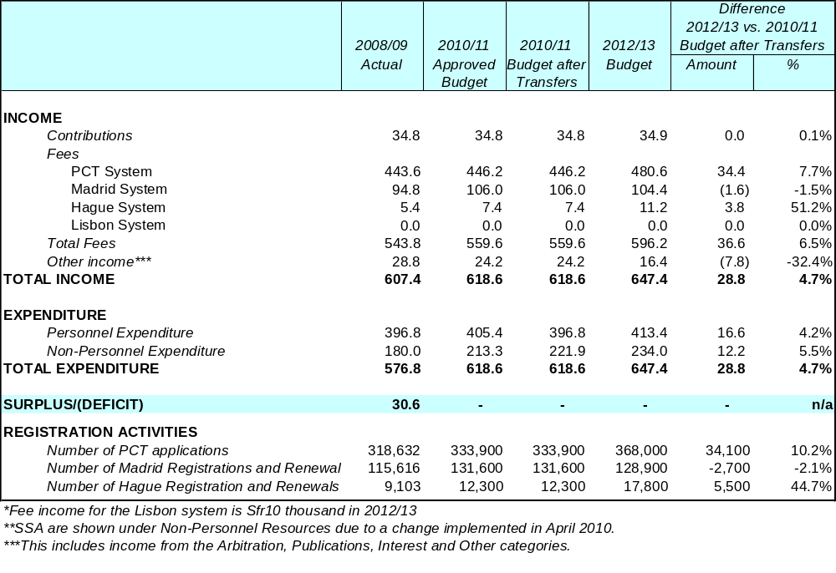

- The proposed Program and Budget for the 2012/13 biennium is submitted to Member States for their consideration in accordance with the Financial Regulations and Rules of the Organization, and the mechanism adopted by Member States in respect of the process for the submission and approval of the Program and Budget of the Organization.

- This section provides an overview of the main financial parameters for the 2012/13 biennium, together with the key changes foreseen and proposed in the Organization’s income and expenditure levels respectively.

- At the forty-third session of the Assemblies from September 24 to October 3, 2007, the Member States agreed in principle to the adoption by WIPO of IPSAS (International Public Sector Accounting Standards) by 2010 (reference document A/43/5). This agreement formed part of a United Nations system-wide initiative endorsed by the General Assembly (A/RES/60/283(IV)I) to replace the existing United Nations Systems Accounting Standards (UNSAS) with IPSAS, which are internationally recognized. Accordingly, WIPO’s financial statements from the year 2010 are prepared in accordance with IPSAS.

- WIPO’s budget continues to be prepared on a modified accrual basis, in accordance with the Organization’s Financial Regulations and Rules. All proposed figures for income and expenditure in the 2012/13 biennium have been set out on a budgetary basis. Differences between the budgetary and IPSAS based actual will be presented and reconciled in the Organization’s financial statements, as required under IPSAS.

- WIPO’s budget continues to be adopted by the Assemblies on a biennial basis. In compliance with IPSAS, the Organization must present financial statements on an annual basis. For this purpose, annual budget figures are provided for both income and expenditure under Annex VIII of this document.

INCOME

- The base case estimate for overall income in 2012/13 is projected at the level of 647.4 million Swiss francs, representing an increase of 4.7 per cent over the base case income foreseen in the Program and Budget for 2010/11. As illustrated in the table below, the base case scenario foresees increases for both the PCT and Hague systems, while a slight downward adjustment is foreseen for the Madrid registration system compared to the income estimates provided in the 2010/11 Budget.

- Income from Arbitration and Mediation activities is expected to increase by 2.6 per cent, while interest income is foreseen to decline significantly as a result of lower interest rates expected to be applied to WIPO’s deposits.

Table 2. Evolution of the Income of the Organization from 2004/05 to 2012/13
(in millions of Swiss francs)

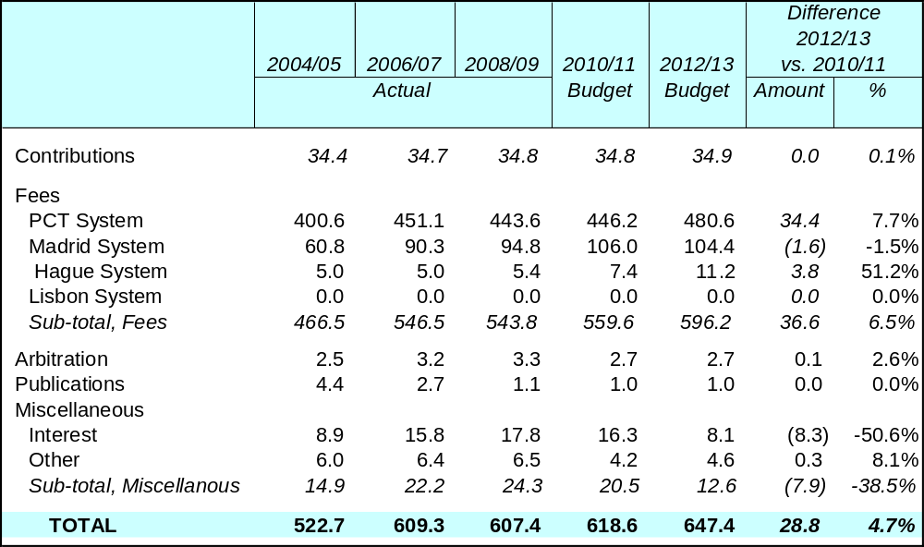

- Income is projected by Union, together with expenditures allocated to the same. While the overall budget for the Organization is based on a balance between income and expenditure, the result by Union on a budgetary basis indicates deficits expected for the Hague and Lisbon Unions. Further details of the allocation of income and expenditure by Union are provided in Annex III.

Table 3. Financial Overview by Union 2012/13
(in thousands of Swiss francs)

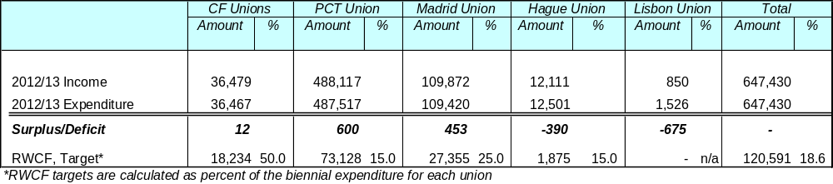

- As in previous biennia, low case and high case scenarios are also presented for the fee income estimates, which drive WIPO’s overall income levels. Table 4 indicates that overall income levels are projected to be in the range of 602 million Swiss francs in the low case, and 686.8 million Swiss francs in the high case.

Table 4. Income Forecast Scenarios for 2012/13
(in millions of Swiss francs)

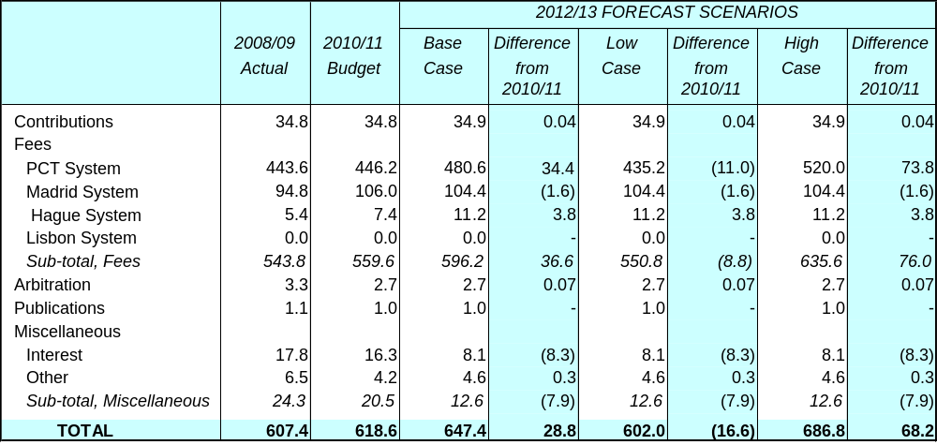

- With the proposed expenditure level of 647.4 million Swiss francs, the financial result for the Organization could vary significantly if income levels were to approach the low or high case scenarios noted below. The Crisis Management Group (CMG), established under the chairmanship of the Director General in 2009, continues to systematically monitor the evolution and potential impact of global financial and economic developments on WIPO’s actual and projected income, alongside the regular monitoring of the Organization’s expenditure levels (the Terms of Reference of the CMG can be found on the Financial Observatory for Member States’ information). The Financial Observatory, via WIPO’s internet site, continues to be updated quarterly with a series of tables illustrating the financial status of the Organization for Member States.

Table 5. Scenarios for Financial Results
(in millions of Swiss francs)

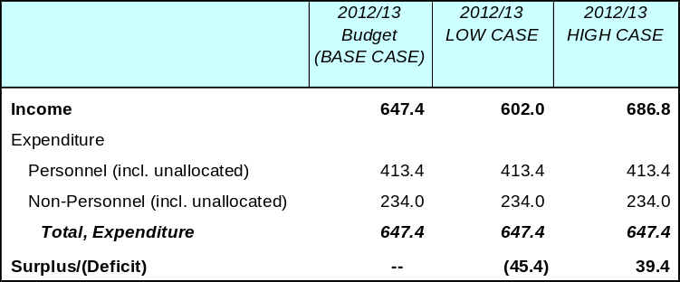

- The main source of income for the Organization remains fees from services provided under the PCT, Madrid and Hague systems. Fee income represented 90 per cent of the Organization’s total income in 2008/09, and is estimated to represent a similar proportion in 2010/11. For the 2012/13 biennium, a slight increase in the share of fee income is foreseen, to 92.1 per cent of total income, as a result of the decline projected in interest income primarily. The following Charts illustrate the share of the various income elements (Chart 1A) and the various registration systems within the fee income (Chart 1B) between 2004 and 2013.

Chart 1A. Evolution of the Share of Income of the Organization from 2004/05 to 2012/13 – by Source of Income

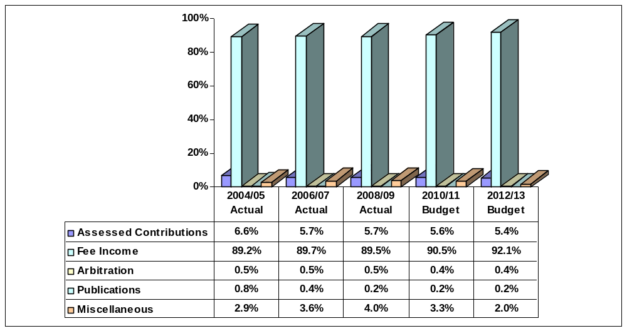

Chart 1B. Evolution of the Share of Income of the Organization from 2004/05 to 2012/13 – PCT and Madrid Systems vs. Other income Components

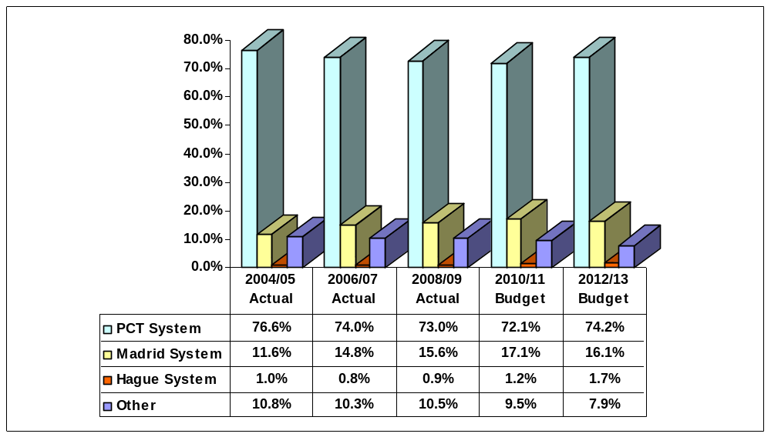

- Estimates for fee income are based on the forecast models developed by the Secretariat. Details of the models and the assumptions underlying the projected income figures are contained in Annex IV of this document. The table below shows the estimates for demand for services (workload) for 2012/13 under the PCT, Madrid and Hague systems, as compared to those included in the 2010/11 Budget, together with actual figures for the 2008/09 biennium.

Table 6. Estimates for Demand for Services (Workload) under the PCT, Madrid and Hague Systems

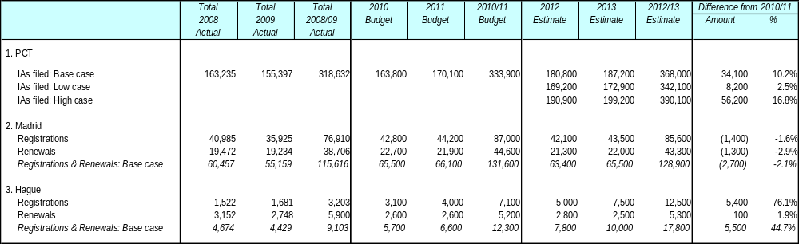

EXPENDITURE

OVERALL EXPENDITURE

- The proposed level of total expenditure for the 2012/13 biennium is 647.4 million Swiss francs, representing an increase of 28.8 million Swiss francs, or 4.7 per cent over the 2010/11 Budget. Personnel costs are proposed to increase by 16.6 million Swiss francs, representing an increase of 4.2 per cent, and non-personnel costs are proposed to increase by 12.2 million Swiss Francs, representing an increase of 5.5 per cent.

Table 7. Budget for 2012/13 - by Object of Expenditure
(in thousands of Swiss francs)

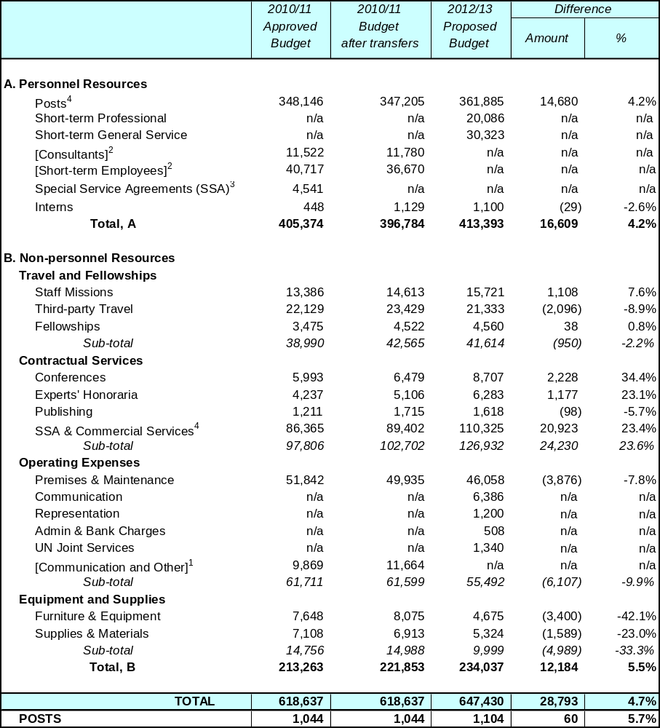

¹ Communication & Other line is applicable for 2010/11, broken down into detailed cost categories in 2012/13. Comparison is therefore provided on the corresponding sub-total level.

² Consultants and Short-term Employees lines are applicable for 2010/11. The budget corresponding to these categories is included under Short-term Professional and Short-term General Service lines in 2012/13.

³ SSA are shown under Non-personnel Resources in 2010/11 Budget after Transfers and 2012/13 Proposed Budget, due to a change implemented in April 2010.

⁴ Unallocated Resources are included under Posts and SSA & Commercial Services cost categories.

- The proposed allocation of expenditure by object of expenditure is shown in the table above, while the proposed allocation of expenditure by Program is shown in Annex I, together with (i) the table illustrating transfers across programs which were made in accordance with Financial Regulation 5.5, and (ii) the table illustrating changes proposed in the program structure from 2010/11 to 2012/13. The proposed allocation of expenditure by Unions is shown in Annex III

- Program narratives are followed by detailed program budget tables, indicating the proposed budget by result, as well as separately by object of expenditure for 2012/13, together with a comparison of the proposed budget against the Budget after transfers for 2010/11 for the Program. All Program budget tables provide an indication of the resources included for the implementation of DA projects, and Table 9 provides a comparative overview of the share of development activities by Program for 2010/11 and 2012/13.

- A number of changes have been introduced to naming and groupings of objects of expenditure, with a view to (i) enabling more granularity in reporting; (ii) preparing for reporting personnel costs in alignment with the contract reform process under way; and (iii) thus providing enhanced transparency and disclosure to both program managers and Member States in reporting on resource utilization. Appendix B provides an overview of the Definition of Budget Headings for further reference. The changes can be summarized as follows:

  - In previous biennia, Special Service Agreements (SSAs) were treated as part of personnel expenditures. SSAs, however, are a contract form designed to hire independent individuals (contractors) in expert capacity to perform specific time-bound and clearly defined tasks; thus they are not a personnel contract type. Accordingly, these types of costs have been moved from personnel to non-personnel costs.

  - The category of “Short-term Employees” was used in previous biennia to cover costs of short-term general service employees, as well as a short term professional contract form known as Special Labor Contract (SLC). Another category, known as “WIPO Consultant”, also covered a short term professional contract form in WIPO. In order to streamline these categories and prepare for the alignment with the contract forms which are expected to be introduced under the contract reform process currently under way, the categories of Short-term Professional and Short-term General Service have been introduced under personnel expenditures. The Short-term Professional category covers the current contract forms of SLC and WIPO Consultant, while the Short-term General Service category covers contracts of general service employees on short-term contracts.

  - The costs covering internships in WIPO have been retained as a personnel cost category. In order to better manage these costs, however, the budget for these has been centralized under HRMD in 2012/13.

  - Under Non-personnel expenditures, changes have been made to names and/or groupings of objects of expenditure under Contractual Services and under Operating Expenses. The line “Other Contractual Services” has been re-named to clearly indicate that expenditures under this category include SSAs and costs of commercial service providers. Under Operating Expenses, the previously used category of “Communication and Other” was broken down into its constituent parts to better illustrate the types of costs covered by the respective lines, which are Communication, Representation, Administrative and Bank Charges, and UN Joint Services.

PERSONNEL EXPENDITURE

- Personnel costs are projected to increase by 16.6 million Swiss francs, representing an increase of 4.2 per cent over the 2010/11 Budget. This increase is due to the following key changes:

- The impact of re-costing approved posts (standard cost review, which takes into account applicable mandatory ICSC adjustments and common staff costs, contribution to the provision for after service employee benefits, including ASHI, step increases and the impact of re-classifications done in the previous biennium, together with an assumption of a certain vacancy rate and part-time work). In addition, the litigation compensation provisions, provisions of accident insurances and closed pension fund contribution changes are also taken into account. The total impact of re-costing amounts to an increase of 9.2 million Swiss francs;

- The impact of re-costing of short-term positions (standard cost review and reflection of
re-classifications in the previous biennium), provision for short term conference staff, and the impact of the changes in the number of short-term positions, amounting to a net increase of 1.7 million Swiss francs;

- Under personnel costs, an amount of 2.0 million Swiss francs has been earmarked for the regularization of 60 long serving temporary employees performing continuing functions. This is in line with the commitment made by the Director General and endorsed by Member States at their Assemblies in 2010 (reference document WO/CC/63/5), and will result in the utilization of 60 of the 156 posts approved in principle for this purpose.

- In line with the strategic realignment process, the review of skills and competencies and the appropriate resource structures is a priority for the Organization. As a result, a further amount of 3.5 million Swiss francs has been earmarked for re-classifications to be implemented in the course of 2012/13.

- It is highlighted that in order to retain overall post costs at a level which is accommodated by the projected income envelope of the Organization, a downward adjustment was made to the percentage applied to post costs for the funding of the provision for after service employee benefits, including ASHI (After Service Health Insurance). The percentage charge against post costs was reduced from 6 per cent in previous biennia to 2 per cent for 2012/13, which has resulted in a budget proposal which is 14 million Swiss francs lower. In view of the fact that this is seen as a short term measure to address the potential risks currently seen in the global economy, which continue to urge the exercise of caution on the base case income envelope projected for 2012/13, the Director General wishes to indicate that a pick-up in the projected income levels would first and foremost be proposed to be utilized to reinstate this provision at the appropriate time.

- As in previous biennia, it is highlighted that the proposed personnel expenditures for the 2012/13 Budget do not include certain costs, which can not be reliably quantified at this point in time, but the impact of which is likely to bring further upward pressure on personnel costs, to be accommodated later in the biennium. These include (i) any decisions which may be taken by the International Civil Service Commission (ICSC) in the course of 2012/13 in respect of mandatory adjustments to salary scales or other elements of the UN system’s compensation and benefits package; and (ii) the potential additional cost of implementing the human resources contract reform proposal which is now expected to be finalized by the end of 2011.

NON-PERSONNEL EXPENDITURE

- Non-personnel resources are proposed to increase from 221.9 million Swiss francs in 2010/11 to 234.0 million Swiss francs in 2012/13, representing an increase of 12.2 million Swiss francs or 5.5 per cent. This overall increase reflects the following key changes:

- With the move of staff from WIPO’s rented buildings to the new building, the premises costs of the Organization will be lower by a net of 5.6 million Swiss francs for the biennium;

- The loan approved for the financing of the new building has now been fully drawn down, and the related interest costs, representing 7 million Swiss francs for the biennium have been included in the budget. The approach utilized in the 2010/11 and in previous budgets to record an expense related to the repayment of loan principal was based upon UNSAS which did not permit for the recording of depreciation of fixed assets as expense. Now that WIPO has moved to IPSAS, depreciation of each component of all of WIPO’s buildings will be recorded as an expense in the IPSAS ledger. Since WIPO’s financial statements will no longer be prepared in accordance with UNSAS, the previous approach of treating loan principal repayment as a budgetary expense will be discontinued from 2012/13, which will help to reduce the adjustments required to be reconciled on the Statement of budget to actual comparison (Statement V) and in the note required by IPSAS-24 to reconcile budgetary and IPSAS results.

In light of part of the savings generated above, it is proposed to set up a building maintenance fund as proposed by some Member States in order to ensure that the buildings owned by WIPO have sufficient funds available at all times for necessary maintenance works. The biennial contribution to the fund is intended at a level of up to 1 per cent of the value of premises owned by WIPO and is estimated to be in the range of 2.5 million Swiss francs.

- Additional resources are required for the outsourced translation work under the PCT system (5 million Swiss francs). This is made up of (i) an increase of around 3 million Swiss francs in the translation costs of Asian languages abstracts and (ii) increase of around 3 million Swiss francs in the translation costs of Asian languages patentability reports, offset by the decrease of 1 million Swiss francs in the translation costs of European languages (abstracts and patentability reports). The increase in the outsourcing costs of the Asian languages is due to an increase in the translation workload in Japanese (above 20 per cent), in Chinese (above 200 per cent) and in Korean (above 50 per cent), itself due to an increase in filings in these languages.

- There has been under-investment in the maintenance and renewal of core information technology. To address this, increases in expenditure are included to bring the WIPO IT infrastructure and operating systems into the 21st century. Funds are included in this biennial proposed budget for business continuity, upgrade of operating systems software and related office applications together with hosting services to be provided by UN International Computing Centre (UNICC). Furthermore, increased levels of IT support would be required for the additional operational activities and initiatives across WIPO’s programs, such as Global Databases, VIP program, operational systems administrated by the international registration systems.

Owing to the age of the current hardware pool as well as new hardware needs related to the Organization’s evolving operational requirements, a capital replacement program is envisaged to be put forward for consideration by the Member States in the form of reserve project proposal in the range of 5 to 6 million Swiss francs.

- Additional resources (1.7 million Swiss francs) have been allocated for safety and security to address the increased safety and security needs due to the completion of the new building.

- Increased expenditure (1.3 million Swiss francs) in relation to the WIPO CASE Project involving the development for a common platform for sharing research and examination reports among different groups of countries, particularly Latin American countries and the Vancouver group countries.

- Increase by 1.9 million Swiss francs is due primarily to the Visually Impaired Persons and other persons with print disabilities (VIP) and the initiative relating to international creative works databases.

- Increase in resources devoted to the Development activities, including the Development Agenda, as illustrated in the section below.

DEVELOPMENT ACTIVITIES AND DEVELOPMENT AGENDA RESOURCES

- The successful implementation of the DA remains a key priority for the Organization. To this end, a total amount of 6.4 million Swiss francs have been set aside within the proposed budget 2012/13 for the implementation of Development Agenda projects as indicated in Table 8. This table contains:

- Five projects approved by the CDIP for implementation in the biennium 2012/13, namely: "Project on Intellectual Property and Product Branding for Business Development in Developing Countries and Least-Developed Countries (LDCs)”; “Project on Intellectual Property and Socio-Economic Development”; “Project on Intellectual Property and Technology Transfer: Common Challenges – Building Solutions”; Project on “Open Collaborative Projects and IP-Based Models” and “Project on Intellectual Property and Brain Drain”.‬
- Two projects presented during the last sessions of the CDIP and still under discussion in the Committee namely: Projects on Patents and the Public Domain and Project on South South cooperation on IP and Development among developing countries and LDC’s.‬ The implementation of the projects is subject to the approval of the CDIP.
- A proposed phase two of three projects: "Pilot Project on the Establishment of “Start Up” National Academies", "Developing Tools for Access to Patent Information and "Specialized Databases’ Access and Support". The second phase of these projects is subject to a final evaluation of the initial projects and approval by the Committee.

Table 8. Development Agenda Projects - Summary Resource Requirements 2012/13
(in thousands of Swiss francs)

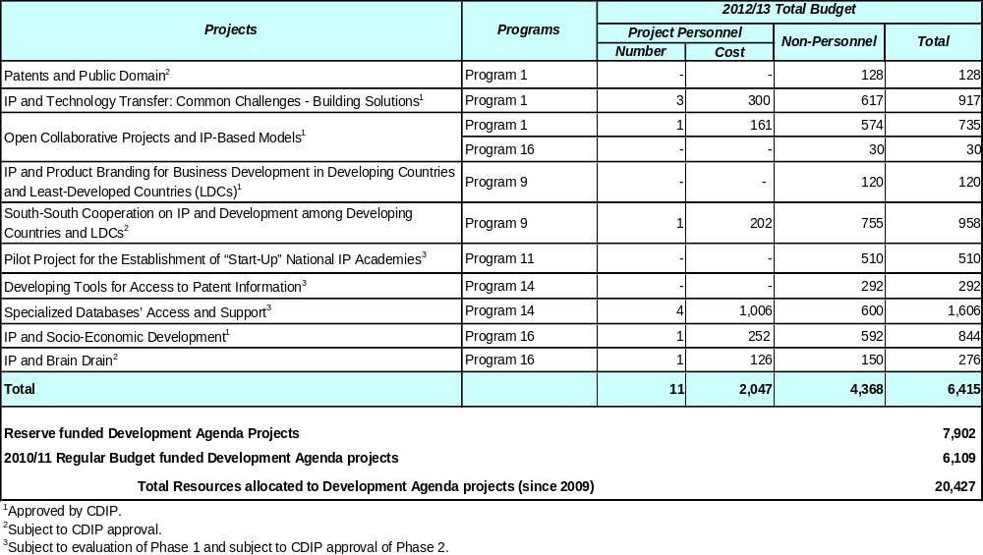

- The table below provides details for proposed development expenditure for 2012/13 by program. Expenditure is qualified as development expenditure, only where the beneficiary is a developing country and the equivalent expenditure is not available for developed countries. These amounts exclude foregone revenues resulting from the fee reductions accorded under the international registration systems for applicants from developing countries. If such expenditure were to be included, the overall figure for development expenditure would be higher.

Table 9. Development Activities in 2012/13
(in thousands of Swiss francs)

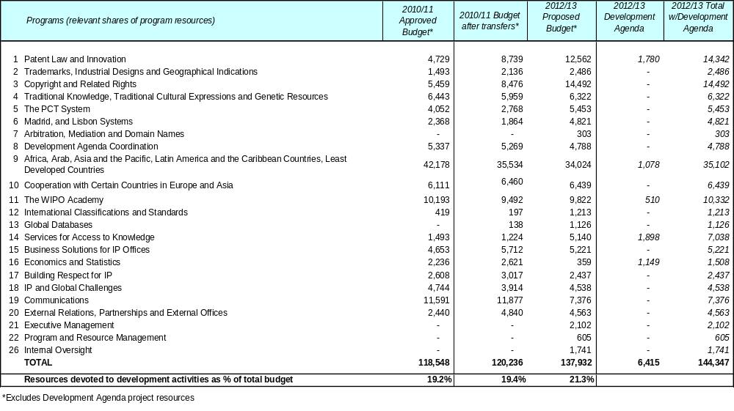

- In line with the Organization’s focused efforts to improve its planning, tracking and reporting on development activities/expenditure, significant improvements have been introduced in the methodology with which the development share of the budget has been estimated for the biennium 2012/13. The development expenditure definition has ensured that a methodology has been consistently applied during the planning phase. The definition also makes possible the consistent tracking and reporting of development expenditure during the implementation phase.

- The estimated budget for development activities in 2012/13 by Program has been compiled by applying the above development expenditure definition to Program activities in close consultation with Program Managers.

- In 2012/13, the Organization will focus on ensuring a more robust tracking of actual development expenditure by expanding the data dimensions in the financial systems. This would result in an improved ability to report to Member States on the actual expenditure against the above estimates for 2012/13. In the long term, with the full implementation of the ERP system, as approved by Member States at their Assemblies in September 2010, both planning, tracking and reporting on the development dimension of WIPO’s activities will become fully integrated into the financial and management systems of the Organization.

III. PROGRAM NARRATIVES BY STRATEGIC GOAL

Strategic Goal I: Balanced Evolution of the International Normative Framework for IP
Program 1. Patent Law and Innovation
Program 2. Trademarks, Industrial Designs and Geographical Indications
Program 3. Copyright and Related Rights
Program 4. Traditional Knowledge, Traditional Cultural Expressions and
Genetic Resources

Strategic Goal II: Provision of Premier Global IP Services
Program 5. The PCT System
Program 6. Madrid, and Lisbon Systems
Program 31 The Hague System
Program 7. Arbitration, Mediation and Domain Names
Strategic Goal III: Facilitating the Use of IP for Development
Program 8. Development Agenda Coordination
Program 9. Africa, Arab, Asia and the Pacific, Latin America and the Caribbean Countries,
Least Developed Countries
Program 10. Cooperation with Certain Countries in Europe and Asia
Program 11. The WIPO Academy
Strategic Goal IV: Coordination and Development of Global IP Infrastructure
Program 12. International Classifications and Standards
Program 13. Global Databases
Program 14. Services for Access to Knowledge
Program 15. Business Solutions for IP Offices
Strategic Goal V: World Reference Source for IP Information and Analysis
Program 16. Economics and Statistics
Strategic Goal VI: International Cooperation on Building Respect for IP
Program 17. Building Respect for IP
Strategic Goal VII: Addressing IP in Relation to Global Policy Issues
Program 18. IP and Global Challenges
Strategic Goal VIII: A Responsive Communications Interface between WIPO, its Member States and All Stakeholders
Program 19. Communications
Program 20. External Relations, Partnerships and External Offices
Strategic Goal IX: Efficient Administrative and Financial Support Structure to Enable WIPO to Deliver its Programs
Program 21. Executive Management
Program 22. Program and Resource Management
Program 23. Human Resources Management and Development
Program 24. General Support Services
Program 25. Information and Communication Technology
Program 26. Internal Oversight
Program 27. Conference and Language Services
Program 28. Safety and Security
Program 29. Construction Projects

STRATEGIC GOAL I
Balanced Evolution of the International Normative Framework for IP

This Strategic Goal aims to ensure that the development of international IP law keeps pace with the rapidly evolving global technological, geo-economic, social and cultural environment, while taking into account implementation of the recommendations of the Development Agenda on norm-setting. A balanced evolution is critical to ensuring that the international intellectual property system continues to serve its fundamental purpose of encouraging innovation and creativity; that it takes into account the needs and interests of countries at different stages of development, including through the flexibilities within international IP agreements; and that it strikes the right balance between (i) the rights of creators and IP owners and the rights of users and the public; and (ii) the encouragement of innovation and creativity and the diffusion of the social benefit of innovation and creative works.

Expected Results | Performance Indicators | Responsible Program(s)
Enhanced cooperation/ greater consensus among Member States on further developing balanced policy and normative frameworks for the international patent system, trademarks, industrial designs, geographical indications, copyright, related rights, TK, TCEs and GRs | Progress on the implementation of SCP agreed steps/plans  International agreement on a normative framework for Industrial Designs  Progress towards agreement on current issues on the SCT Agenda  Conclusions agreed by Member States in each session of the SCCR | Program 1  Program 2  Program 2  Program 3
 | Progress towards agreement on current issues on the SCCR agenda | Program 3
 | Progress in the IGC’s negotiations towards development of an international legal instrument(s) | Program 4
 | Work initiated by the SCT on Geographical Indications (GIs) | Program 2
 | No. of ratifications/accessions to the Singapore Treaty | Program 2
Increased protection of State emblems and names and emblems of International Intergovernmental Organizations | No. of requests for communication under Article 6ter Paris Convention dealt with  No. of signs published in Article 6ter database | Program 2  Program 2
 | Comprehensive guidelines for the application of Article 6ter | Program 2
Evidence-based decision making on copyright issues | No. of follow-up requests for specific studies or guidance on activities contributing to policy decision | Program 3
 | No. of countries using WIPO studies on their creative industries for developing creative industry strategies | Program 3
 | No. of downloads, requests and distribution of WIPO tools for management of copyright in specific creative industries | Program 3
Tailored and balanced IP legislative, regulatory and policy frameworks | No. of countries that have initiated legislative reform in the area of copyright and related rights | Program 3
 | No. of requests for and types of legislative advice related to patents, utility models, trade secrets and integrated circuits including relevant IP flexibilities | Program 1  Program 9  Program 10
 | No. of countries which found WIPO's legislative advice related to patents, utility models, trade secrets and integrated circuits useful | Program 1  Program 9  Program 10
 | % of countries which found the provided information concerning the legal principles and practices of the patent system, including the flexibilities existing in the system and the challenges it faces, useful | Program 1  Program 9  Program 10
 | % of satisfied participants in targeted workshops/seminars held on specific patent-related questions | Program 1  Program 9  Program 10
 | No. of Member States having received legislative advice in the area of trademarks, industrial designs and geographical indications | Program 2  Program 9  Program 10
 | No. of countries providing positive feedback on the usefulness of the provided legislative advice in the area of trademarks, industrial designs and geographical indications | Program 2  Program 9  Program 10
 | No. of countries provided with technical assistance on new or updated legislative frameworks for effective enforcement, taking into account flexibilities in Part III of TRIPS | Program 17  Program 9

Program 1 Patent Law and Innovation

PLANNING CONTEXT

- New technologies are developed at an accelerated rate, with profound effect on world markets and on the ability of individuals and nations to participate effectively in the global information economy. Program 1 seeks to support the efforts of Member States to find common ground for normative development of the international patent system and to shape a national patent system that fits their individual circumstances; it provides advice and support regarding the Paris Convention, the Budapest Treaty, and the Patent Law Treaty; and it attempts to foster indigenous and global capacity for technological innovation. In the next biennium, it faces a number of challenges:

- The slow pace of recent progress in the multilateral normative process, relative to the pace of technological change;
- The existence of alternative approaches to norm-setting, outside of the multilateral context;
- A continuing call for background information about the role and impact of the patent system, including flexibilities, to inform the normative process;
- The differential impact of the patent system according to a country’s stage of development, including its development of domestic innovation capacity;
- The tension inherent in public policy choices relating to the appropriate scope and application of the patent system;
- An increasing need for a systemic and sustained approach to innovation policy and practice, including the effective distribution and commercialization of new technologies;
- The need for better dissemination of technologies through the patent system;
- Increasing requests for legislative and policy assistance to Member States.

IMPLEMENTATION STRATEGIES AND RISKS

- The normative process, being Member States’ driven; the Program will focus its efforts on providing reliable information and supporting an environment conducive to engagement and dialog among Member States regarding areas of common interest. The Program will continue to improve its responsiveness and efficiency in responding to requests for legislative and policy assistance. The Program will also continue to support innovation strategies and capacity building through a variety of initiatives directed at the creation of innovation ecosystems and the development of related resources; in particular, it will focus on small and medium-sized enterprises (SMEs) which represent over 90 per cent of global business activity, but which do not use IP systems as much as they could to extract value from their innovative capacities. Specifically, during the next biennium the Program expects to:

- Organize up to four meetings of the SCP;
- Organize, upon request, informal information meetings for Member State representatives, to provide background on topics related to patent law and policy taking duly into account DA Recommendation 15;
- Continue to provide, upon request, legal advice to Member States relating to patents, utility models, trade secrets, and layout designs of integrated circuits in line with DA Recommendations 17, 20 and 22;
- Continue to inform and assist Member States regarding the Paris Convention, the Budapest Treaty, and the Patent Law Treaty;
- Continue to assist Member States to formulate national IP and innovation strategies and develop institutional IP policies;
- Assist Member States to establish and sustain innovation ecosystems, including through the effective implementation of the DA projects related to IP and Technology Transfer and Open Collaborative Projects;
- Promote effective and efficient use (by individuals, SMEs, research institutions and universities) of IP rights management to achieve dissemination and commercialization, duly taking into account DA recommendations 1 and 4;
- Continue to support the work of the Development Sector relating to patents and technological innovation, including the provision of studies relevant to DA recommendations 4, 10, 12, 13, 14, 19, 25, 26, 28 and 36. Studies related to DA Recommendations 16 and 20 would be provided within the context of the DA project Patents and the Public Domain, subject to the approval of the CDIP; and
- Continue to work with Programs 2, 3, 4, 5, 7, 8, 9, 10, 11, 12, 13, 14, 15, 16, 18, and 20 on issues related to IP law and technological innovation.

- In its work regarding the normative process, the Program needs to facilitate the work of Member States by providing an impartial, professional and inclusive environment for dialog among Member States. Regarding its other services, the Program will focus on achieving efficiencies in service delivery and on better use of internal and external partnerships.

RESULTS FRAMEWORK

Expected Results | Performance Indicators | Baselines | Targets
Enhanced cooperation/ greater consensus among Member States on further developing balanced policy and normative frameworks for the international patent system, trademarks, industrial designs, geographical indications, copyright and related rights, TK, TCEs and GRs | Progress on the implementation of SCP agreed steps/plans | SCP/15 agreed its future work in five areas (October 15, 2010) | Advancement on issues of common interest at the SCP
Tailored and balanced IP legislative, regulatory and policy frameworks | No. and types of legislative advice provided to Member States related to patents, utility models, trade secrets and integrated circuits | In 2010, 12 comments were provided to Member States | 25 comments on drafts prepared by Member States and 10 draft laws prepared by the Secretariat
 | % of countries which found WIPO's legislative advice related to patents, utility models, trade secrets and integrated circuits useful | Not available | 90%
 | % of Member States which found the provided information concerning the legal principles and practices of the patent system, including the flexibilities existing in the system and the challenges it faces, useful | Not available | 90%
 | % of satisfied participants in targeted workshops/ seminars held on specific patent-related questions | Not available | 90%
Enhanced access to, and use of, IP information and knowledge by IP institutions and the public to promote innovation and increased access to protected creative works and creative works in the public domain | No. of Member States that have developed their IP framework and established TTOs | Framework pilot project adopted and funding committed | Eight TTOs
Clearly defined and coherent national innovation and IP policies, strategies and development plans consistent with national development goals and objectives | No. of national IP strategies which includes an innovation and technology component | Contribution on innovation and technology to three national strategic plans | Contribution on innovation and technology to eight national strategic plans
Enhanced human resource capacities able to deal with the broad range of requirements for the effective use of IP for development in developing countries, LDCs and countries with economies in transition | % of participants satisfied with the quality of workshops and seminars on innovation and its commercialization | General feedback available, but no specific data | 90%
 | No. of users from developing countries of WIPO-developed tools, models and materials on innovation and its commercialization | 2,400 users | 3,200 users
Increased understanding/ capacity of SMEs to successfully use IP to support innovation and commercialization | % of assisted SMEs support institutions who provide information, support and advisory/consulting services on IP asset management | Not available | 80% (of 15 support institutions expected to be assisted)

RESOURCES FOR PROGRAM 1

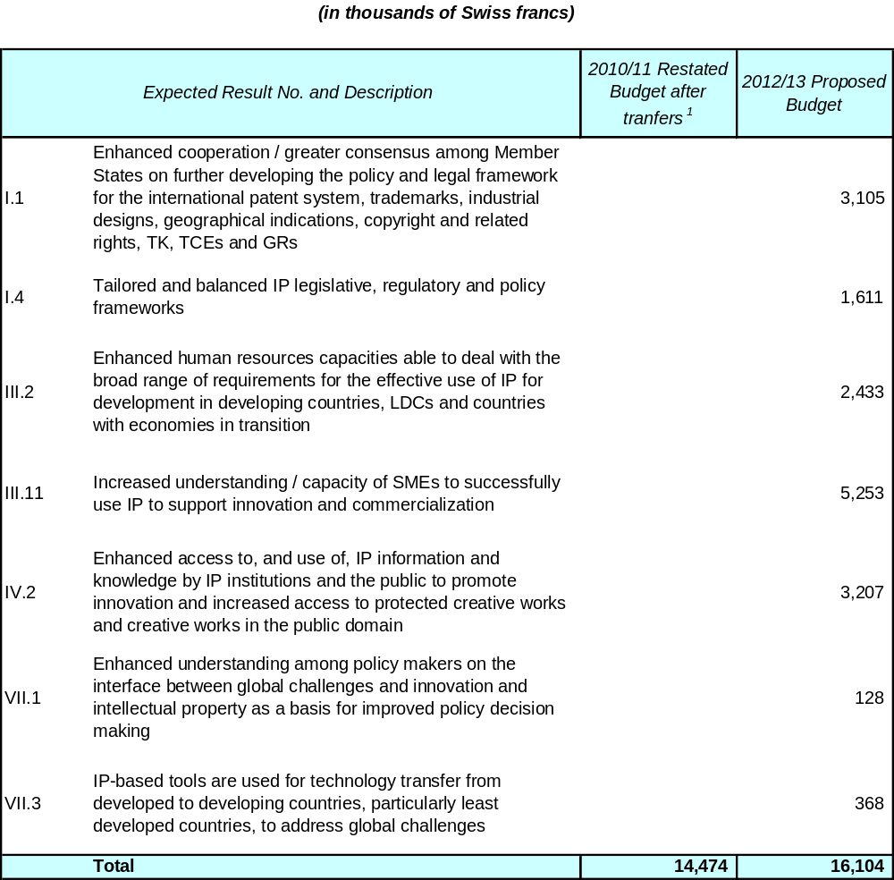

- The figures for 2010/11 Budget under personnel costs represent actual expenditure for 2010 and budgeted amounts based on standard costs for 2011. The budget for 2012/13 is prepared using standard costs for the next biennium. The increase in budgeted amount under Posts for the Program goes beyond the statutory increases incorporated in the standard costs as a result of a lower base in 2010 actual expenditure due to vacancies in the Program.

- The proposed increase under “Staff Missions” is primarily in relation to activities on the Development of Innovation Ecosystems, Legislative and Policy advice and SME’s activities.

- The proposed increase in “Fellowships” is due to the planned advanced regional/sub-regional training programs as part of SME’s activities.

- The proposed increase in “Conferences” is due to the planned Regional Seminars on Patent Related Flexibilities (DA related) as well as various activities related to the area on Innovation and Technology Transfer.

- The proposed increase under “Experts’ Honoraria” is primarily due to (i) studies planned by regional experts on patent related flexibilities as well as the experts working group for the revision of the patent and utility model law for developing countries as part of Patents Legislative and Policy Advice activities, (ii) a number of activities planned as part of Innovation and Technology Transfer, including the DA projects on Open Collaborative Projects and IP-Based Models and IP and Technology Transfer: Common Challenges-Building Solutions, and (iii) experts and lecturers’ assistance for a number of training activities and national and regional forums as part of SME’s activities.

- The proposed increase in “Publishing” is mainly due to activities planned within the Innovation and Technology Transfer area, including the DA projects.

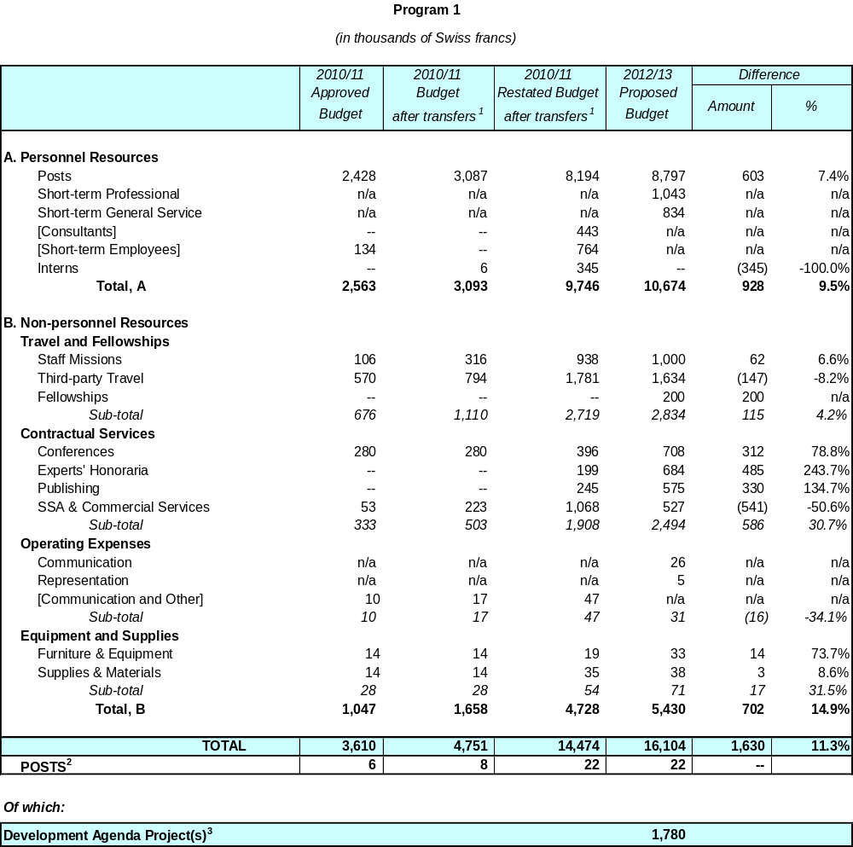

¹ Restated Budget after transfers reflects:

- the adjusted budget of Programs, following transfers during 2010/11 in line with Financial Regulation 5.5. For additional details on the 2010/11 Budget after Transfers, please refer to Table 10 (Annex I) Budget after Transfers by Program of this document and document WO/PBC/18/14 Program Performance Report for 2010;

- restatements of Program budgets for comparison with the 2012/13 proposed Program structure. For those Programs where restatements were not required, the Restated Budget after Transfers is equivalent to the Budget after Transfers, as referred to in document WO/PBC/18/14 Program Performance Report for 2010. For more detailed information on the restatements, please refer to Table 11 (Annex I) of this document.

² For further details on posts for the Program please refer to the Table in Annex II.

³ Includes projects on: (i) "Intellectual Property and Technology Transfer: Common Challenges – Building Solutions” and “Open Collaborative Projects and IP-Based Models”, approved by CDIP; (ii) "Patents and Public Domain", subject to CDIP approval.

Fund-in-Trust Resources Potentially Available for Programming in 2012/13*
(in thousands of Swiss francs)**

Program | Projected Balance end 2011 | Estimated Contributions 2012/13*** | Estimated Available for Programming in 2012/13****
Program 1 | 200 | - | 200

* For information only. This FIT is due to end in 2011. For further details please refer to Annex V.

** The figures do not include interest and exchange rate adjustments. It should also be noted that these funds generally provide for activities spanning a period of time exceeding or overlapping a single biennium, as income is received and expenditure incurred.

*** Annual contributions vary and fluctuations have been observed from one year to another.

**** This figure is purely indicative and is based on previous funding patterns. It does not represent Member States’ commitments except in those cases where the FIT Agreement includes such a commitment.

Program 2 Trademarks, Industrial Designs and Geographical Indications

PLANNING CONTEXT

- The subject matter captured by the well-established intellectual property categories of trademarks, industrial designs and geographical indications continues to exceed the traditional boundaries of those specific rights and merge into the much broader concept of “brand”. Brands are symbols that influence consumer behavior, create customer loyalties and function as vehicles for communication. This development is accentuated by the recent proliferation and acceleration of various means of communication and, in particular, the Internet. Brands are regularly the subject of important investment – be it in respect of individually or collectively owned brands. Increasingly, SMEs are using brands and designs as a means for enhancing their competitiveness in a globalized economy. The role of collectively owned brands, such as nation brands or geographical origin based brands is being more and more valued by policy makers and commercial operators alike. There is a crucial link between successful brand building and the intellectual property rights system. A legal infrastructure that is responsive to the needs of the brand owners while balancing out the interests of competitors and the general public is of paramount importance to a flourishing brand industry. The development and maintenance of this legal infrastructure has to be synchronized with the pace of the general social, economic and cultural developments in all Member States. In that respect, an ongoing challenge is to support the efforts of governments to establish a secure and balanced national legal environment and to design development-oriented IP laws that take into account specific national requirements.

IMPLEMENTATION STRATEGIES AND RISKS

- WIPO will aim at achieving progress in the development of a balanced international legal framework for trademarks, industrial designs and geographical indications, with outcomes at an appropriate normative level. With regard to a future international regulatory framework for industrial design procedures the WIPO Standing Committee on the Law of Trademarks, Industrial Designs and Geographical Indications (SCT) agreed that, as a possible path to move ahead a diplomatic conference for the adoption of a design law treaty could be convened once sufficient progress has been made and the time was ripe for recommending the holding of such a diplomatic conference. Moreover, WIPO will advance work in the area of trademarks and the Internet, in cooperation with Programs 3 (Copyright and Related Rights), 7 (Arbitration, Mediation and Domain Names) and 17 (Building Respect for IP), and of geographical indications, in cooperation with Program 6 (Madrid and Lisbon Systems). Due consideration will be given to cluster B of the DA Recommendations (Recommendations 15-17 and 20-22) ensuring that account is taken of the different levels of development of WIPO Member States; flexibilities of interest to developing countries and LDCs; the views of all Member States and other stakeholders; and development goals agreed within the UN system. In addition, WIPO will facilitate a better appreciation of the role of brands and branding in a modern economy. WIPO will also deliver the appropriate legal and administrative support to Member States and certain international intergovernmental organizations for the protection of certain of their emblems under Article 6ter of the Paris Convention.

- The implementation of Program 2 will be principally based on regular sessions of the SCT. In line with DA Recommendation 15, sessions of the SCT will be open to all Member States and accepted (governmental and non-governmental) observer organizations. The work of the SCT will be supported by working documents prepared by the Secretariat and presented in all six official languages of the UN. The SCT will present the outcome of its work in appropriate cases to the relevant WIPO Assemblies for further action.

- In the area of branding, the SCT will consider, on the basis of one or several expert studies, as appropriate the concepts of “brand” and “branding”, their interface with conventional categories of intellectual property and their economic significance. This study is expected to constitute a future reference for national policy-making as well as for specific WIPO activities in the area of brands and branding. The Secretariat will continue to ensure the efficient administration of Article 6ter Paris Convention communication procedures and, with a view to facilitating the interpretation of this provision of the Paris Convention, initiate work on the establishment of guidelines for the interpretation of Article 6ter of the Paris Convention, to be recommended by the SCT for adoption of the Paris Union Assembly. As regards Strategic Goal III (Facilitating the Use of IP for Development), Program 2 will provide country specific advice to Member States in accordance with the country-level plans being formulated and in response to priorities identified within their national strategies. Where plans and strategies are still under consideration, advice will be provided upon their request – concerning the establishment of a legal framework for trademarks, industrial designs and geographical indications, that is in compliance with the applicable international normative framework while making fully use of the available flexibilities for the achievement of national development objectives. The provision of legal advice will be coordinated with Programs 9 (Africa, Arab, Asia and the Pacific, Latin America and the Caribbean Countries, Least Developed Countries) and 10 (Cooperation with certain countries in Europe and Asia and Some Mediterranean States) taking duly into account DA Recommendations 1, 6, 12, 13 and 14. In addition, the Program will coordinate with Program 9 to ensure an effective implementation of the DA project on IP and Product Branding for Business Development in developing countries and LDCs.

- The Program will continue to represent the Secretariat, at an appropriate level, in topical meetings organized by Member States, relevant IGOs and NGOs, with the aim of communicating a balanced view of all aspects of its work thereby contributing to a better understanding of the underlying issues.

RESULTS FRAMEWORK

Expected Results | Performance Indicators | Baselines | Targets
Enhanced cooperation/ greater consensus among Member States on further developing balanced policy and normative frameworks for the international patent system, trademarks, industrial designs, geographical indications, copyright and related rights, TK, TCEs and GRs | International agreement on a normative framework for Industrial Designs  Progress towards agreement on current issues on the SCT agenda | No existing international agreement  Joint Recommendation Concerning Trademarks on the Internet of 2001 | Convening of a Diplomatic Conference for the adoption of an international treaty on the law of industrial designs subject to sufficient progress in the preparatory work  SCT agreed outcomes
 | No. of ratifications/accessions to the Singapore Treaty | No. of ratifications/ accessions at the end of 2011 | At least 10 ratifications/ accessions to the Singapore Treaty
 | Work initiated by the SCT on Geographical Indications (GIs) | Status of SCT work on GIs by end 2011 | SCT to provide feed-back on an issues paper on GIs
Increased protection of State emblems and names and emblems of International Intergovernmental Organizations | No. of requests for communication under Article 6ter Paris Convention dealt with | No. of requests for communication received in 2010/11 | Response to 160 requests from States/IGOs concerning communications under Article 6ter
 | No. of signs published in  Article 6ter database | No. of signs published in Article 6ter database in 2010/11 | 300 signs published
 | Comprehensive guidelines for the application of Article 6ter | Guidelines for the application of Article 6ter(1)(b) and (3)(b) of 1992 | Adoption of comprehensive guidelines by the Paris Union Assembly
Tailored and balanced IP legislative, regulatory and policy frameworks | No. of Member States having received legislative advice in the area of trademarks, industrial designs and geographical indications | No. of Member States having received legislative advice in 2010/11 | Legislative advice provided to 10 Member States and/or Regional Groups of Member States
 | No. of countries providing positive feedback on the usefulness of the provided legislative advice in the area of trademarks, industrial designs and geographical indications | Data not available | 70%
RESOURCES FOR PROGRAM 2

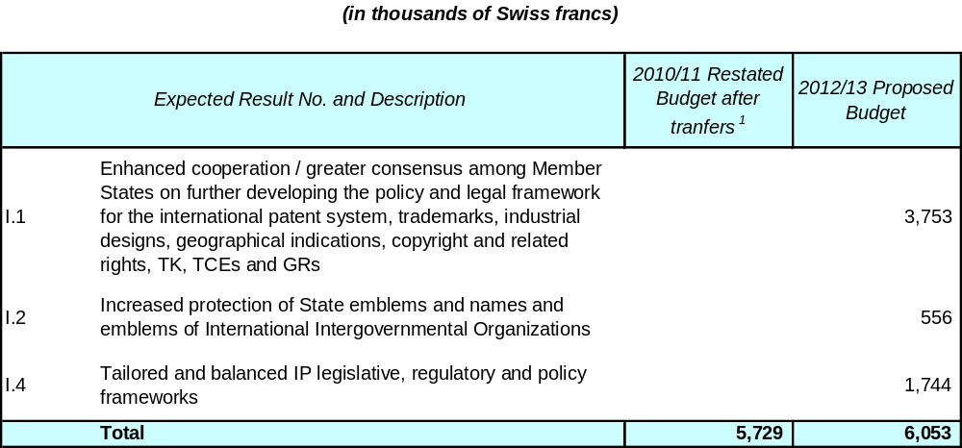

- The figures for 2010/11 Budget under personnel costs represent actual expenditure for 2010 and budgeted amounts based on standard costs for 2011. The budget for 2012/13 is prepared using standard costs for the next biennium.

- The proposed increase under “Third Party Travel” and “Conferences” is related to the possible Diplomatic Conference for the adoption of an international treaty on the law of industrial designs.

- The proposed decrease under “Experts’ Honoraria” is due to the expected completion in 2010/11 of the trademark-related portion of the DA Project on IP and the Public Domain.

- The proposed increases under “SSAs and Commercial Services” are due to (i) the proposed study on “brands” and “branding” and (ii) effective administration of Article 6ter procedures which will require contractual support services.

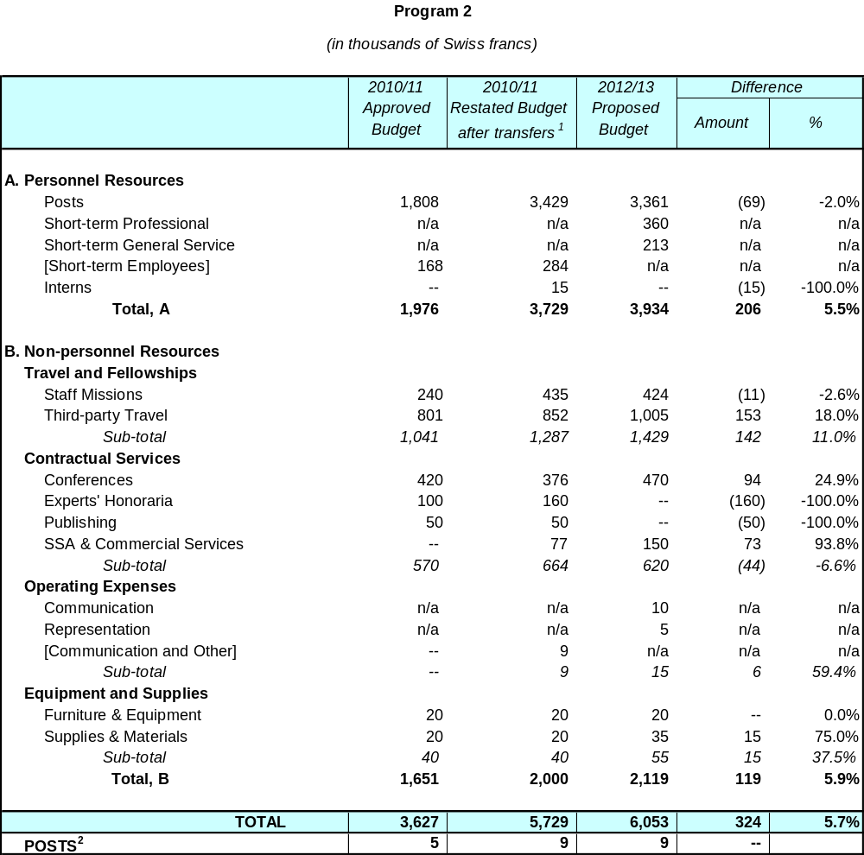

¹ Restated Budget after transfers reflects:

- the adjusted budget of Programs, following transfers during 2010/11 in line with Financial Regulation 5.5. For additional details on the 2010/11 Budget after Transfers, please refer to Table 10 (Annex I) Budget after Transfers by Program of this document and document WO/PBC/18/14 Program Performance Report for 2010;

- restatements of Program budgets for comparison with the 2012/13 proposed Program structure. For those Programs where restatements were not required, the Restated Budget after Transfers is equivalent to the Budget after Transfers, as referred to in document WO/PBC/18/14 Program Performance Report for 2010. For more detailed information on the restatements, please refer to Table 11 (Annex I) of this document.

² For further details on posts for the Program please refer to the Table in Annex II.

Program 3 Copyright and Related Rights

PLANNING CONTEXT

- Challenges are perhaps more evident and difficult in the area of copyright and related rights than in any other area of IP. This places Program 3 in a most challenging context where balance becomes a key consideration in the approach to responding to the mandate of promoting creativity and the protection of copyright and the expectations of the Development Agenda.

- There is growing realization that in order to face the challenges of copyright in the digital environment, copyright needs to evolve to current technological realities. Greater emphasis also needs to be placed on the exercise and management of rights on the one hand while, on the other hand, ensuring greater access to and sharing of creative works globally. This requires a multi-pronged policy response including law, copyright infrastructure, cultural change, institutional collaboration and better business models. Ensuring the full participation of developing countries and LDCs in the future development of copyright is a critical factor for the strategy to succeed.

- Copyright infrastructure includes identifiers of content and rights, databases containing such information and the organizational framework to ensure their broad accessibility. Such infrastructure needs to meet the aspirations of both stakeholders and Member States. It should also be developed in a business-oriented manner, providing services that are appealing to the creative industries and to users. At the same time, copyright infrastructure needs to respond to developmental concerns and enable Member States to attain public interest objectives in the field of creativity and culture. For a solid copyright infrastructure to develop, the Program must ensure that the approach pursued is balanced, taking into account the different and sometimes disparate interests at stake.

IMPLEMENTATION STRATEGIES AND RISKS

- In the 2012/13 biennium, WIPO will seek to address the above challenges on three main fronts:

- Continuation of the well established normative and policy related work;
- Advancing the development of copyright infrastructure;
- Technical assistance to developing countries and LDCs

Normative and policy related work

- In the case of norm setting, a number of studies, seminars and other inputs have already been provided at the request of the Standing Committee on Copyright and Related Rights (SCCR) and good progress is being made in all areas of the agenda.

- With respect to the Protection of Audiovisual Performances, the Committee recommended to the General Assembly to resume the suspended 2000 Diplomatic Conference on the protection of audiovisual performances. Concerning the Protection of Broadcasting Organizations, the Committee agreed to maintain the momentum regarding a draft treaty on the protection of broadcasting organizations and cablecasting organizations in the traditional sense and to continue discussions on a signal-based approach consistent with the 2007 General Assembly mandate. As to limitations and exceptions, recognizing the need to advance the more mature areas, the Committee will undertake text based work with the objective of reaching agreement on appropriate exceptions and limitations for persons with print disabilities and other reading disabilities. In a similar manner, the Committee will undertake text-based work on appropriate exceptions and limitations for libraries, archives, educational, teaching and research institutions, and persons with other disabilities. Moreover, the Committee recommended to the WIPO General Assembly that Members of the Committee continue discussions regarding the Chair’s document SCCR/22/16 on an international instrument on limitations and exceptions for persons with print disabilities with the aim to agree and finalize a proposal on that international instrument in the 23rd session of the SCCR to be held in November 2011, in accordance with the timetable adopted at the 21st session of the SCCR.

- The Secretariat will continue to facilitate progress in the discussions, including the possibility of convening a diplomatic conference for both broadcasting as well as exceptions and limitations. In addition, the Secretariat will continue to promote the benefits of the WIPO Copyright Treaty (WCT) and the WIPO Performances and Phonograms Treaty (WPPT) and will assist countries in updating their national legislation on request.

- The Program will continue to examine key areas where collaboration between Governments and stakeholders would lead to pragmatic solutions. These include the role and responsibility of Internet Intermediaries; the development of licensing models, in line with DA Recommendations 21, 22 and 23, specifically adapted to the requirements of UN agencies in the digital environment; proposals for contractual guidelines in strategic sectors of the creative industries; and, the enhancement of collaborative policies in the music industry, and in IP and sports, that might facilitate the management of copyright and related rights in the digital environment. The measures available for such targeted interventions include platforms for dialogue among stakeholders, and studies and surveys.

- Priority will be given to the provision of balanced information in specific papers on the WIPO web site as well as through the organization of meetings and workshops for decision makers, policy advisers and heads of national copyright offices on issues of particular relevance and importance to them.

Advancing the development of copyright infrastructure

- Copyright infrastructure development, in both its Information Communication Technology (ICT) and organizational contexts, is necessary if developing countries are to share in the growth of creative industries in the online environment where rights management and licensing are critical. Infrastructure development is central to efforts being made by developing countries and LDCs to exploit the economic potential of copyright industries.

- Enhancing the performance and networking of copyright Collective Management Organizations (CMOs) (Recommendation 10) will continue to provide selected CMOs with a series of tools to enable the establishment of a common digital collective management platform. By standardizing and expediting information exchange between the CMOs and the rest of the world for the identification of works and relevant interested parties, the distribution of royalties can be carried out in a fair, equitable and balanced way and in a timely and efficient manner taking into account the economic interest of the countries concerned. This project has the potential to propel a number of developing countries into participating in the growing economic benefits of the global music industry.

- The full potential of these activities will only be realized when they are linked to a repository system that allows for the exchange of repertoire data at the international level, which can become a key tool for facilitating licensing in the digital marketplace. In order to examine these issues more carefully, WIPO is facilitating a stakeholder dialogue comprising a broad spectrum of representatives from the music sector engaged in the discussion related to an International Music Registry (IMR).

- In addition, efforts will continue to be made in the biennium to modernize and automate Copyright Offices.

- Support for the development of the Stakeholders’ Platform for Visually Impaired Persons and other persons with print disabilities (VIP) will continue. The Trusted Intermediary Global Accessible Resources (TIGAR) system network will be fully established. The work being undertaken in the Stakeholders’ Platform VIP Initiative needs to attract the support of relevant interest groups while advancing strong partnership among stakeholders in a pragmatic and cost effective way as technical solutions are developed by WIPO and business models emerge among the Trusted Intermediaries.

- The progress of the VIP activities could be affected by various concerns and priorities of VIP stakeholder platform participants. Regular and focused liaison and consultation should address issues raised by stakeholders at the earliest stage possible.

Technical assistance to developing countries and LDCs

- In providing technical assistance to Member States emphasis will be placed on linking IP to national development strategies; improvement in legal and regulatory systems; enhancement of national infrastructure for the benefit of the creative industries; and, consistent support for building human capacity in the area of copyright and related rights.

- The delivery of technical and infrastructure assistance in the area of copyright and related rights needs to be sharply focused and properly aligned with the necessary training, monitoring and effective follow-up. The focus in the biennium will increasingly be on qualitative rather than quantitative improvements in delivery taking duly into account DA recommendations 1, 6, 12 to 17, 19 and 20. This will require prioritization and improved planning within the Organization (guided by national IP strategies) and close cooperation with Programs 9 and 10 while increasing the level of outsourcing to competent individuals.

RESULTS FRAMEWORK

Expected Results | Performance Indicators | Baselines | Targets
Enhanced cooperation/ greater consensus among Member States on further developing balanced policy and normative frameworks for the international patent system, trademarks, industrial designs, geographical indications, copyright and related rights, TK, TCEs and GRs | Conclusions agreed by Member States in each session of the SCCR  Progress towards agreement on current issues on the SCCR agenda | Conclusions reached in SCCR sessions during 2010-11 biennium (3) (March 2011)  WCT, WPPT (1996), Rome Convention (1961) (March 2011) | Conclusions reached in all SCCR sessions during 2012/13 biennium  International instruments concluded on exceptions and limitations, broadcasting and audiovisual performances
Evidence-based decision making on copyright issues | No. of follow-up requests for specific studies or guidance on activities contributing to policy decision | Six by February 2011 | 15
 | No. of countries using WIPO studies on their creative industries for developing creative industry strategies | Three countries | 10 countries
 | No. of downloads, requests and distribution of WIPO tools for management of copyright in specific creative industries | tbd | Increase in downloads, 10 requests, over 500 copies distributed
Tailored and balanced IP legislative, regulatory and policy frameworks | No. of countries that have initiated legislative reform in the area of copyright and related rights | 19 countries received WIPO legislative advice in 2010/11 (March 2011) | 18 countries
Enhanced human resource capacities able to deal with the broad range of requirements for the effective use of IP for development in developing countries, LDCs and countries with economies in transition | % of participants’ positive rating of the usefulness of copyright related capacity building workshops  % of participants’ rating of usefulness of copyright related workshops and practical use of knowledge 6 months after the workshop | tbd  tbd | 70% agree or strongly agree  70%
 | No. of national copyright and related rights initiatives started directly related to the themes of workshops | tbd | Average 50% of countries participating in workshop
Enhanced access to, and use of, IP information and knowledge by IP institutions and the public to promote innovation and increased access to protected creative works and creative works in the public domain | No. of trusted intermediaries (TIs) and rights holders (RHs) having joined the TIGAR system network, including from developing countries and LDCs  No. of copyright protected works distributed among TIs and made accessible to VIPs across borders through the TIGAR system network | Four TIs and three RHs  Not yet started | 10 new TIs and  four new RHs  The availability of at least 300 books or titles
Enhanced technical and knowledge infrastructure for IP Offices and other IP institutions leading to better services (cheaper, faster, higher quality) to their stakeholders | No. of Institutions using WIPO copyright infrastructure systems (WIPOCOS and GDA) | 20 CMOs equipped with WIPOCOS (end 2011)  Eight Copyright Offices using GDA (end 2011) | 40 CMOs equipped with WIPOCOS  15 Copyright Offices using GDA
 | % of Governments that report positively on the effectiveness and governance of copyright institutions in the country | tdb | 80% of countries that requested and received technical assistance in this area

RESOURCES FOR PROGRAM 3

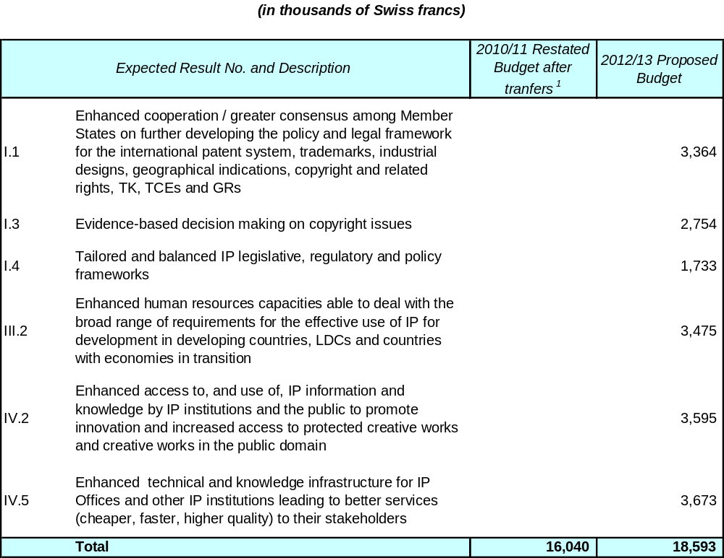

- The figures for 2010/11 Budget under personnel costs represent actual expenditure for 2010 and budgeted amounts based on standard costs for 2011. The budget for 2012/13 is prepared using standard costs for the next biennium. The increase in budgeted amount under Posts for the Program goes beyond the statutory increases incorporated in the standard costs as a result of a lower base in 2010 actual expenditure due to vacancies in the Program.

- The proposed increases in non-personnel resources under “Third-party travel” and “Conferences” are primarily related to the increase in the length of, and interpretation services for the SCCR.

- The proposed increase in “Experts’ Honoraria” relates to the planned increase in the number of expert missions undertaken in respect of the establishment/strengthening of national copyright offices and expansion of WIPOCOS activities.

- The development and provision of updated information materials on copyright and related rights for developing countries and LDCs has led to an increase in the proposed resources for “Publishing”.

- Proposed increases in “SSA and Commercial Services”, as well as in “Equipment and Supplies”, are due primarily to the Visually Impaired Persons and other persons with print disabilities (VIP) initiative and activities related to the international databases for creative works.

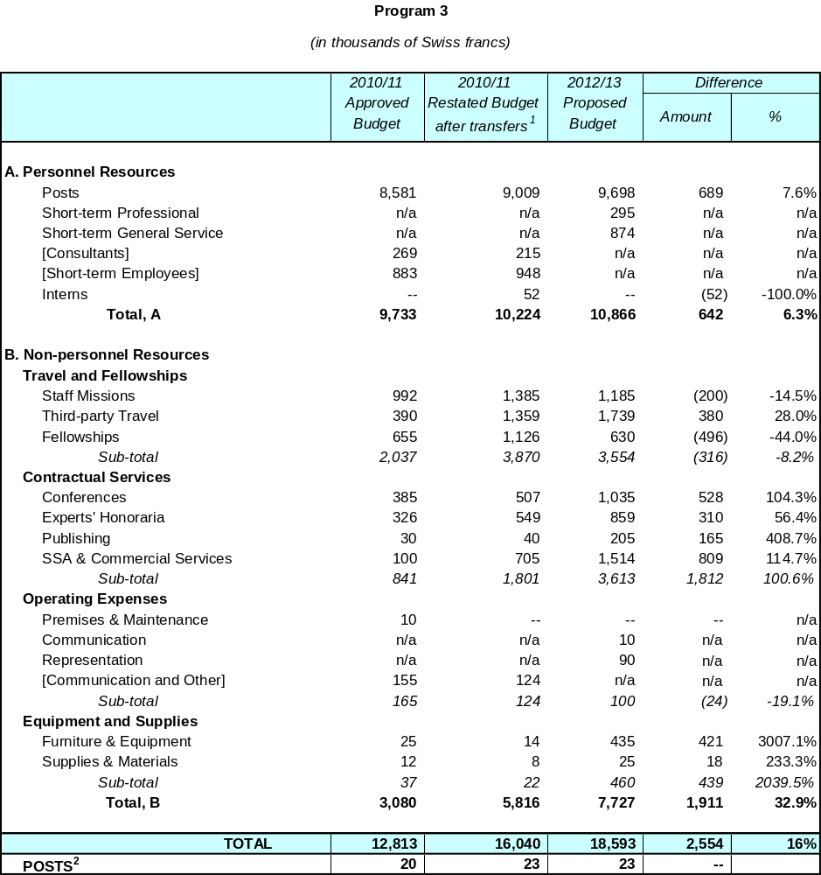

¹ Restated Budget after transfers reflects:

- the adjusted budget of Programs, following transfers during 2010/11 in line with Financial Regulation 5.5. For additional details on the 2010/11 Budget after Transfers, please refer to Table 10 (Annex I) Budget after Transfers by Program of this document and document WO/PBC/18/14 Program Performance Report for 2010;

- restatements of Program budgets for comparison with the 2012/13 proposed Program structure. For those Programs where restatements were not required, the Restated Budget after Transfers is equivalent to the Budget after Transfers, as referred to in document WO/PBC/18/14 Program Performance Report for 2010. For more detailed information on the restatements, please refer to Table 11 (Annex I) of this document.

² For further details on posts for the Program please refer to the Table in Annex II.

Fund-in-Trust Resources Potentially Available for Programming in 2012/13*
(in thousands of Swiss francs)**

Program | Projected Balance end 2011 | Estimated Contributions 2012/13*** | Estimated Available for Programming in 2012/13****
Program 3 | 830 | 2,198 | 3,028

* For information only. For further details please refer to Annex V.

** The figures do not include interest and exchange rate adjustments. It should also be noted that these funds generally provide for activities spanning a period of time exceeding or overlapping a single biennium, as income is received and expenditure incurred.

*** Annual contributions vary and fluctuations have been observed from one year to another.

**** This figure is purely indicative and is based on previous funding patterns. It does not represent Member States’ commitments except in those cases where the FIT Agreement includes such a commitment.

Program 4 Traditional Knowledge, Traditional Cultural Expressions and Genetic Resources

PLANNING CONTEXT

- This Program aims at enhancing effective use of IP principles and systems for the legal protection of traditional knowledge (TK) and traditional cultural expressions (TCEs), and the clarification of the contribution of IP to the conservation, sustainable use and equitable benefit-sharing in genetic resources (GRs). Achieving these objectives would benefit Member States and indigenous and local communities economically, technologically and culturally, and, in line with the DA, enhance the capacity of developing countries and LDCs to benefit from the knowledge economy through the use of IP.

- The Program addresses a complex array of legal, policy, technological and operational issues, amidst high expectations for concrete outcomes from within a wide range of stakeholders with diverse interests. Differences continue on core substantive questions such as the scope of subject matter to be protected and beneficiaries of protection, as well as on the legal status of any such outcomes. International outcomes depend on consensus among Member States and on developments in certain other fora. A further challenge relates to participation and representation, as Indigenous and local communities face major constraints in defining and protecting their IP-related interests.

- Against the backdrop of these objectives and challenges, this Program facilitates text-based negotiations towards reaching consensus on the text of an international legal instrument (or instruments) on TK, TCEs and GRs, and, upon request, supports work on practical mechanisms to contribute towards the protection of TK and TCEs and regulation of the interface between IP and GRs. Practical mechanisms, such as appropriate voluntary databases and registries, can provide a technical infrastructure which complements the legal infrastructure created by legislation. Such practical assistance also encompasses specialized capacity-building, training and legal-technical assistance at local, national and regional levels.

- The international negotiations take place within the Intergovernmental Committee on Intellectual Property and Genetic Resources, Traditional Knowledge and Folklore (the IGC). Under its mandate for the 2010/11 biennium, the IGC was requested to submit to the WIPO General Assembly in September 2011 the text of such an instrument (or instruments) for the General Assembly to decide on the convening of a Diplomatic Conference. In the event that the General Assembly in September 2011 decides to convene a Diplomatic Conference, such a Conference would likely take place in the 2012/13 biennium and be preceded by preparatory negotiations. The 2012/13 biennium is, therefore, likely to see continued international negotiations and an ancillary need for complementary practical support and capacity-building, including for the effective implementation in national and regional systems of any international instruments that may be adopted. The successful conclusion of the IGC’s negotiations will ensure the fulfillment of the aims of DA Recommendation (18).

IMPLEMENTATION STRATEGIES AND RISKS

- As a Member State-driven process, progress towards international outcomes is largely dependent on decisions by Member States and, to a certain extent, developments in other fora. However, the WIPO Secretariat aims to play a supportive and facilitative role. The results of the Program should therefore include, first, an environment conducive to improved communication, understanding and cooperation among Member States, which could lead to the adoption of an international legal instrument(s). A second result would be greater understanding among States and communities of how, in practice, IP can contribute to the effective protection of TK and TCEs and to the conservation, sustainable use and equitable benefit-sharing in GRs, leading to enhanced capacity to use IP principles and systems in these contexts.

- This Program contributes directly and explicitly to development and to the attainment of the Development Agenda’s Recommendations. Generally, the Expected Results will be achieved through continued application of the relevant Recommendations of the DA, notably ensuring that technical assistance is development-oriented and demand-driven (Recommendations 1 and 12) and that normative work in the IGC remains inclusive, member-driven and participatory (Recommendations 15, 21 and 42) and takes into account the public domain (Recommendations 16 and 20). The Expected Results will also be achieved through cooperation and coordination with other WIPO Programs, especially Program 1 (Patent Law and Innovation), Program 3 (Copyright and Related Rights), Program 7 (Arbitration, Mediation and Domain Names), Program 8 (Development Agenda Coordination), Program 9 (Africa, Arab, Asia and the Pacific, Latin America and the Caribbean Countries, and Least Developed Countries), Program 10 (Certain Countries in Europe and Asia), Program 14 (Services for Access to Knowledge) and Program 18 (IP and Global Challenges).

- More specifically, and in addressing the objectives, challenges and issues set out above, the Program will seek to implement the following three inter-related and complementary strategies:

- Creation of an environment conducive to consensus-reaching by Member States through, for example, provision of substantive and administrative support for a possible Diplomatic Conference, negotiations of the IGC and associated inter-sessional working groups and consultations at the international, regional and national levels; consolidation of initiatives aimed at enhancing the effective participation of representatives of indigenous and local communities in WIPO’s work, including logistical management of the WIPO Voluntary Fund for Accredited Indigenous and Local Communities; and, close coordination and cooperation with other intergovernmental organizations and forums;
- Enhancing understanding among States and communities of how, in practice, IP can contribute to the effective protection of TK and TCEs and to the conservation, sustainable use and equitable benefit-sharing in GRs through, for example, development and application, on request, of a streamlined and integrated suite of relevant and effective practical resources, programs, and tools; and,
- Establishment of ICT and other infrastructure at the national, regional and international levels, such as databases, traditional knowledge digital libraries (TKDLs), inventories, registers and other platforms, to complement legal and policy frameworks that States and communities may develop.

- The main risk that the IGC’s negotiations face is the uncertainty over progress resulting from Member States’ efforts to reach agreement on the content and/or legal status of international legal instrument(s). Developments in other fora may also impact progress towards concrete outcomes in the IGC. While these factors are external to the sphere of influence of the WIPO Secretariat, the Secretariat will do all it can within the scope of its resources to facilitate and support the negotiations.

RESULTS FRAMEWORK

Expected Results | Performance Indicators | Baselines | Targets
Enhanced cooperation/ greater consensus among Member States on further developing balanced policy and normative frameworks for the international patent system, trademarks, industrial designs, geographical indications, copyright and related rights, TK, TCEs and GRs | Progress in the IGC’s negotiations towards development of an international legal instrument(s) | Negotiations underway under IGC mandate for 2010/11 | Adoption of an international legal instrument(s)
Enhanced human resource capacities able to deal with the broad range of requirements for the effective use of IP for development in developing countries, LDCs and countries with economies in transition | % of participants in WIPO capacity-building activities which report enhanced capacity to understand and use IP principles, systems and tools or the protection of TK and TCEs, and for management of the relationship between IP and GRs | First time this Performance Indicator has been used in this Program | 75%
Recognition by Member States, communities, organizations and other stakeholders of the relevance and effectiveness of WIPO’s resources, programs and tools | No. of requests received for WIPO’s assistance | 60 (2010/11) | 60

RESOURCES FOR PROGRAM 4

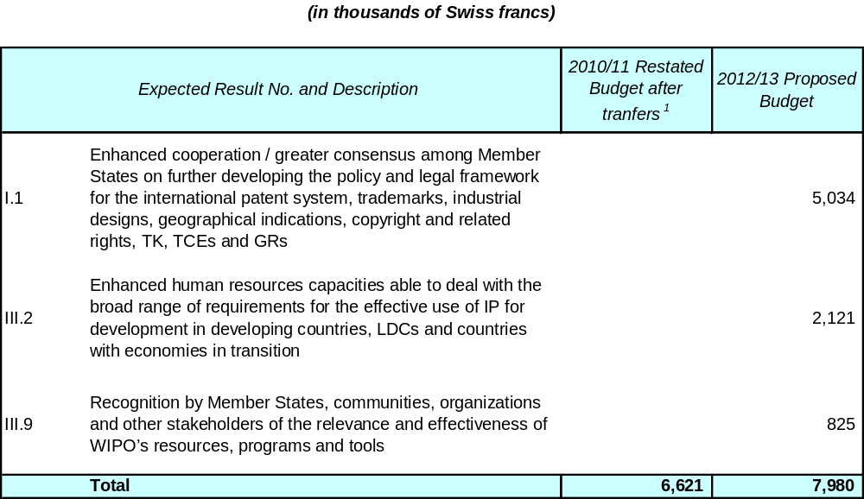

- The figures for 2010/11 Budget under personnel costs represent actual expenditure for 2010 and budgeted amounts based on standard costs for 2011. The budget for 2012/13 is prepared using standard costs for the next biennium. The increase in budgeted amount under Posts for Program goes beyond the statutory increases incorporated in the standard costs due to the transfers during the course of 2010/11.

- The proposed increases in non personnel resources under the Program, mainly under “Staff Missions” and “Conferences” are primarily linked to the provisions made for a possible Diplomatic Conference during the 2012/13 biennium. The increased resources requirement related to “Equipment and Supplies” relate to the possible traditional knowledge digital libraries (TKDLs) project. Reductions have been made across several other budget cost categories to align with the expenditure patterns of the current biennium.

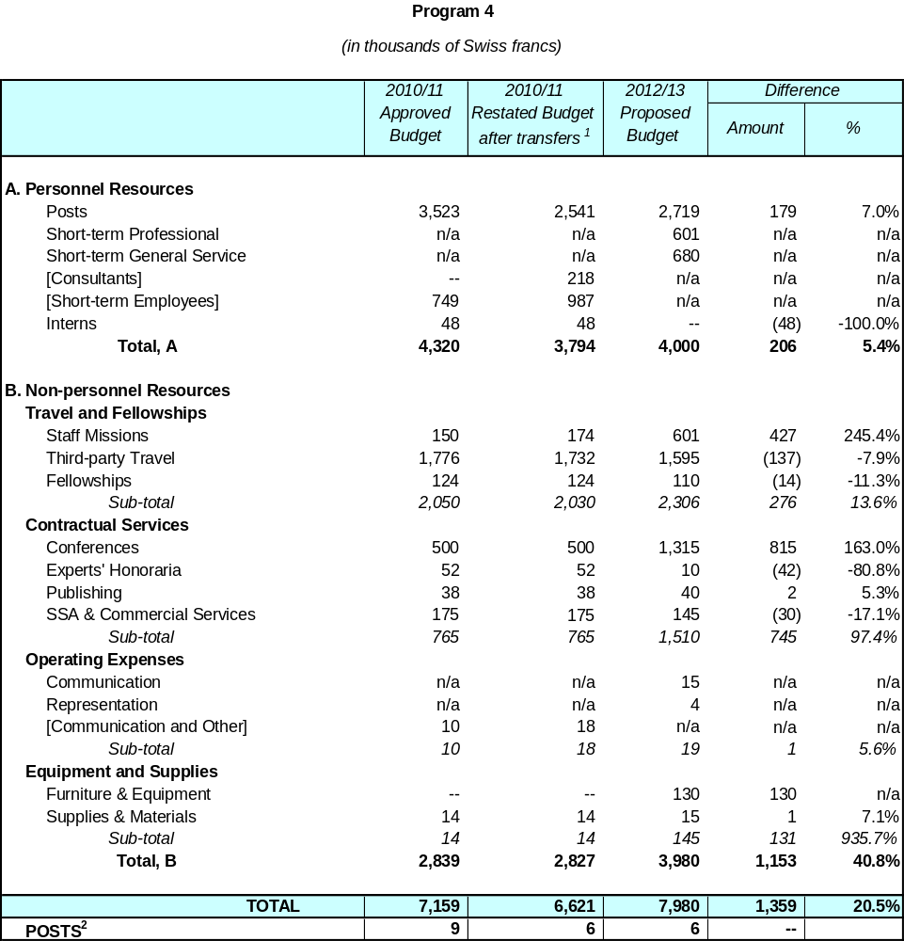

¹ Restated Budget after transfers reflects:

- the adjusted budget of Programs, following transfers during 2010/11 in line with Financial Regulation 5.5. For additional details on the 2010/11 Budget after Transfers, please refer to Table 10 (Annex I) Budget after Transfers by Program of this document and document WO/PBC/18/14 Program Performance Report for 2010;

- restatements of Program budgets for comparison with the 2012/13 proposed Program structure. For those Programs where restatements were not required, the Restated Budget after Transfers is equivalent to the Budget after Transfers, as referred to in document WO/PBC/18/14 Program Performance Report for 2010. For more detailed information on the restatements, please refer to Table 11 (Annex I) of this document.

² For further details on posts for the Program please refer to the Table in Annex II.

STRATEGIC GOAL II
Provision of Premier Global IP Services

This Strategic Goal addresses the core services of WIPO, which are also the income-generating businesses of the Organization. The aim is to make WIPO’s global systems and alternative dispute resolution services the systems of first choice for users through attractive, cost-effective services which provide added value for users.

Expected Results | Performance Indicators | Responsible Program(s)
Informed strategic use of the PCT by all innovators who could benefit from it | PCT filings  Share of PCT national phase entries in total international patent filings | Program 5  Program 5
Stronger relationships with PCT users and Offices | Satisfaction of Offices and International Authorities with PCT cooperative activities | Program 5
 | Meaningful contact with PCT users | Program 5
 | Increased feedback from PCT users on overall system performance | Program 5
Enhancement of overall PCT system | Further progress towards implementation of the recommendations endorsed by the PCT Working Group in 2010 on how to improve the functioning of the PCT, relating to the following six groups of issues: (i) backlogs; improving quality of granted patents; (ii) timeliness in the international phase; (iii) quality of international search and preliminary examination; (iv) incentives for applicants to use the system efficiently; skills and manpower shortages; (v) cost and other accessibility issues; consistency and availability of safeguards; (vi) technical assistance; PCT information and technology transfer. | Program 5
Enhanced IB operations (see Annex VI) | Unit cost of processing an application | Program 5
 | Productivity of formality examination | Program 5
 | Quality of formality examination | Program 5
 | Timeliness of formality examination (% accomplished within 3 weeks from receipt) | Program 5
 | Timeliness of publication (% published within 18 months + three weeks from priority date) | Program 5
 | Quality of translation (% that pass quality check) | Program 5
 | Filings at the IB as Receiving Office | Program 5
Better use of the Madrid and Lisbon systems, including by developing countries and LDCs | No of new registrations (Madrid system) | Program 6
 | No of renewals (Madrid system) | Program 6
 | % of irregularity letters compared to total number of applications received (Madrid system) | Program 6
 | % of international applications from developing countries and LDCs (Madrid system) | Program 6
 | No. of Contracting Parties to the Madrid Protocol | Program 6
 | No. of Contracting Parties to the Lisbon Agreement | Program 6
 | No. of international registrations in force under the Lisbon system concerning appellations of origin from developing countries and LDCs | Program 6
Better operations of the Madrid and Lisbon systems | Average processing time of new applications without irregularities (Madrid system) | Program 6
 | No. of Offices sending applications in XLM format and receiving designations in XLM format (Madrid system) | Program 6
 | % of documents received electronically (Madrid system) | Program 6
 | No. of clients receiving email notifications (Madrid system) | Program 6
 | No. of clients using Portfolio manager (Madrid system) | Program 6
 | No. of fully automated processes (Madrid system) | Program 6
 | % of corrections inscribed compared to the total of operations inscribed (with the exception of refusals and final decisions) (Madrid system) | Program 6
 | Establishment of an automated International Register (Lisbon system) | Program 6
 | Increased number of competent authorities using electronic means of communication under Lisbon procedures | Program 6
 | Adoption of provisions streamlining or modernizing the Lisbon system legal framework | Program 6
Increased awareness of the Madrid and Lisbon systems | % of participants in Madrid system related events who are satisfied and report enhanced awareness post training event | Program 6
 | % of participants in Lisbon system related events who are satisfied and report enhanced awareness post seminars/workshops | Program 6
Increased awareness of the Hague system | No. of first-time applicants | Program 31
 | No. of languages in which general information is available | Program 31
 | No. of national or regional offices providing adequate information on the Hague system | Program 31
Wider and better use of the Hague system | No. of registrations, designs contained in registrations, renewals and other recordings | Program 31
 | No. of applications from, and designations of, developing countries and LDCs | Program 31
 | % of irregular applications | Program 31
Better administration of the Hague system | Predominance of the Geneva Act in the system as a whole system | Program 31
 | Pendency for a regular non-deferred application, until publication | Program 31
 | No. of fully automated processes | Program 31
 | % of requests filed through electronic interfaces | Program 31
 | % of users satisfied with the services provided by the International Bureau | Program 31
International and domestic intellectual property disputes are increasingly prevented or resolved through mediation, arbitration and other alternative dispute resolution methods | Increased consideration of the use of alternative dispute resolution services in intellectual property transactions, including through the use of WIPO procedures | Program 7
 | Alternative dispute resolution policies to the development and implementation of which policies the Center has contributed | Program 7
Effective intellectual property protection in the gTLDs and the ccTLDs | No. of gTLD UDRP cases administered | Program 7
 | No. of ccTLD UDRP-based cases administered | Program 7
 | Dispute resolution policies in the Domain Name System to the development and implementation of which policies the Center has contributed | Program 7
 | No. of ccTLD administrators with WIPO-assisted design or administration of intellectual property protection mechanisms in accordance with international standards | Program 7

Program 5 The PCT System

PLANNING CONTEXT

- The PCT system accounts for over 70 per cent of WIPO’s income. Necessarily, the vast majority of program expenditures are allocated to operating it. However, to maintain and reinforce the PCT as the preferred route for users of the international patent system in the next biennium, it will be necessary to ensure that Program 5 meets the challenges of an increasingly dynamic global market for patent services, characterized by:

- Concerns over quality and timeliness of international reports;
- Financial stresses of applicants and national Offices;
- Continuing or growing backlogs of unexamined applications in national Offices;
- Increasingly diverse geographical composition of patent protection;
- Increasing linguistic diversity of prior art;
- Limited participation in the PCT by most developing and least developed countries;
- The need to promote technological innovation and the transfer and dissemination of technology , particularly in least developed and developing countries;
- Increasing need for PCT technical assistance and capacity building for developing and least developed countries;
- Growing demands from existing and new PCT users for training;
- Variation in how, and the extent to which, customers use the PCT over other methods;
- Availability of new information and communication technologies

IMPLEMENTATION STRATEGIES AND RISKS

- The participation of all contracting parties and stakeholders – such as Member states, Offices and International Authorities, applicants and third parties, intergovernmental and nongovernmental organizations – is crucial for the optimum functioning of the PCT system. Therefore, the Program will focus on communication and cooperation among stakeholders. The following implementation strategies will be pursued:

- Support efforts by the International Authorities to improve the quality and timeliness of their work products, including the development of quality metrics and investigation of collaborative search and examination of PCT applications;
- Continue to study ways to improve the PCT system, while implementing the specific measures approved by the Member States in 2010;
- Study existing PCT fee structures to inform specific proposals;
- Increase coordination with Programs 9, 10, 12, 13 and 14, concerning PCT technical assistance and capacity building for developing countries and LDCs taking duly into account DA Recommendations 1, 6 and 10;
- Increase focus on marketing the PCT to under-utilizing actual and potential customers;
- Enhance communications with all PCT stakeholders, through surveys and other outreach to identify needs and to improve effectiveness of PCT service;
- Deliver training to more PCT users, employing technological methods such as webinars and video conferencing;
- Streamline preparation and dissemination of PCT information;
- Introduce technologies to improve PCT user experience, including a centralized interactive “ePCT system” and computer-assisted translation tools;
- Continue adjustments to staff composition and overall resource allocation to align with changing geographical patterns in PCT demand;
- Continue to study and implement cost control and efficiency measures within PCT operations, including outsourcing arrangements to improve the quality and cost of translations.

- The success of much of this work will depend on the circumstances, input and decisions of the Member States and other stakeholders; therefore, the ability of the International Bureau to influence outcomes is necessarily limited. The International Bureau will attempt to mitigate those risks through careful attention to dynamic market conditions, close formal and informal consultations with stakeholders, and responsive actions as appropriate. Another risk lies in not having sufficient human resource capacity to respond to the emerging, aggregate needs of PCT users and other stakeholders and at the same time achieve the remaining expected results. The International Bureau attempt to mitigate that risk through close communication with stakeholders and a cooperative internal planning environment.

RESULTS FRAMEWORK

Expected Results | Performance Indicators | Baselines | Targets
Informed strategic use of the PCT by all innovators who could benefit from it | PCT filings | PCT filings (2011) | PCT filings for the current year as forecast
 | Share of PCT national phase entries in total international patent filings | Share of PCT national phase entries in international patent filings (end 2011) | Increased share of PCT national phase entries in international patent filings
Stronger relationships with PCT users and Offices | Satisfaction of Offices and International Authorities with PCT cooperative activities | 30 Offices and International Authorities expressed satisfaction with PCT cooperative activities (2010) (i.e. 91% out of 33 who benefitted from PCT cooperative activities and 46% out of the total 65 respondents) | Maintain the 2010 level of satisfaction of Offices and International Authorities
 | Meaningful contact with PCT users | Tbd by the end of 2011 | Regular contacts with high-volume PCT users
 | Increased feedback from PCT users on overall system performance | Tbd by the end of 2011 | Informal requests for feedback in every user contact
Enhancement of overall PCT system | Further progress towards implementation of the recommendations endorsed by the PCT Working Group in 2010 on how to improve the functioning of the PCT, relating to the following six groups of issues: (i) backlogs; improving quality of granted patents; (ii) timeliness in the international phase; (iii) quality of international search and preliminary examination; (iv) incentives for applicants to use the system efficiently; skills and manpower shortages; (v) cost and other accessibility issues; consistency and availability of safeguards; (vi) technical assistance; PCT information and technology transfer. | Decisions by appropriate PCT bodies in 2011 | Decisions by appropriate PCT bodies in 2013
Enhanced IB operations  (see Annex VI) | Unit cost of processing an application | Unit cost in 2011 | Improvement over the biennium
 | Productivity of formality examination | Productivity in 2011 | Improvement over the biennium
 | Quality of formality examination | Average of last three years | 90% (average of last three years)
 | Timeliness of formality examination (% accomplished within 3 weeks from receipt) | Average of last three years | 80% (average over last three years)
 | Timeliness of publication (% published within 18 months + three weeks from priority date) | Average of last three years | 96% (average over last three years)
 | Quality of translation (% that pass quality check) | Quality level in 2011 | 87%
 | Filings at the IB as Receiving Office | Filings in 2011 | 9,700 (2012)  10,100 (2013)

RESOURCES FOR PROGRAM 5

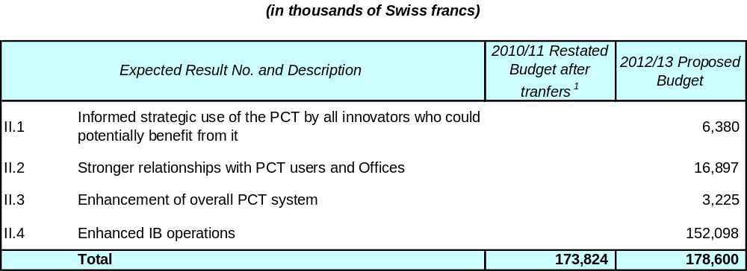

- The figures for 2010/11 Budget under personnel costs represent actual expenditure for 2010 and budgeted amounts based on standard costs for 2011. The budget for 2012/13 is prepared using standard costs for the next biennium. While the statutory increases have been taken into account, the combination of the reduction of number of posts and the lower base in 2010 actual expenditure due to vacancies in the Program resulted in a slight increase in budgeted amount under Posts.

- The proposed increases under “SSA and Commercial Services” are primarily for PCT translation services, where additional resources are required for the outsourced translation work, in particular, as regards Asian languages. The translation workload, in particular, for the Japanese, Chinese and Korean languages is estimated to increase.

- The proposed decreases under “Furniture and Equipment” reflect the fact that during the 2010/11 biennium, servers, databases, licenses and disk space were purchased and PCT applications and external and internal systems were moved to the new servers.

- The proposed increases under “Supplies and Materials” are primarily due to activities in the processing and IT areas of PCT. PCT processing area dispatches on average 4000 mail items (covering all sorts of media) to PCT applicants and IP offices per day. PCT’s IT costs cover the cost of existing and new software licenses and services that would enable additional functionality in the ePCT system, improved disaster recovery capabilities, and improvements in business intelligence and application testing capabilities.

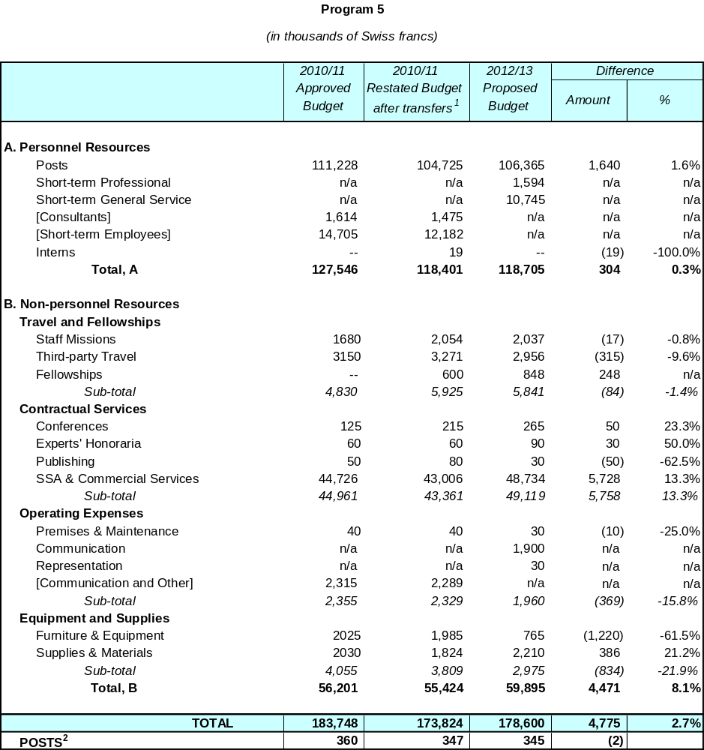

¹ Restated Budget after transfers reflects:

- the adjusted budget of Programs, following transfers during 2010/11 in line with Financial Regulation 5.5. For additional details on the 2010/11 Budget after Transfers, please refer to Table 10 (Annex I) Budget after Transfers by Program of this document and document WO/PBC/18/14 Program Performance Report for 2010;

- restatements of Program budgets for comparison with the 2012/13 proposed Program structure. For those Programs where restatements were not required, the Restated Budget after Transfers is equivalent to the Budget after Transfers, as referred to in document WO/PBC/18/14 Program Performance Report for 2010. For more detailed information on the restatements, please refer to Table 11 (Annex I) of this document.

² For further details on posts for the Program please refer to the Table in Annex II.

Program 6 Madrid and Lisbon Systems

A. MADRID SYSTEM

PLANNING CONTEXT

- Since 2011 there is an expectancy of continuous growth and increased use of the Madrid system, both in terms of increased number of international applications filed through the system as well as an expansion of its geographical scope. While a worldwide economic recovery seems to be underway, the strength and pace of this recovery, and its sustainability, are still uncertain.

- The Program aims to achieve an increase in the geographical coverage of the Madrid system, an increase in its use by existing members of the Madrid Union, and an increase in the participation of developing and least-developed countries and emerging economies. WIPO also aims at ensuring that the system will continue to be the main filing system offering international trademark protection in a simple, efficient, flexible, user-friendly and time and cost-effective manner. Improvements on the operational and legal side will continue to be implemented to ensure that the Madrid system meets the evolving needs of right holders and Member States.

IMPLEMENTATION STRATEGIES AND RISKS

- A further increase in the efficiency and cost-effectiveness of the administration of the international registration service has been identified as a priority for the 2012/13 biennium. To this end, IT tools will be developed to eliminate duplication of work and to reduce the number of functions which are currently performed manually. In addition, a comprehensive process re-engineering exercise will be carried out to streamline processes and practices making them more efficient, targeting the automation of low value added or repetitive tasks. There will be further expansion of electronic communication facilities between the International Registries and the users and Offices. The use of related databases through the Internet (Madrid Database Goods and Services Manager) will also continue to be encouraged.

- The Examiners Exchange Program funded through the IT Modernization Reserve Project will continue. Countries that actively participate in the Madrid system at the level of filings and designations, and in which the national language is not one of the working languages of the system, have been part of this exchange program. The Program will prove its benefits for the International Bureau and the national offices when the staff carry out more comprehensive promotional activities upon return to their offices.

- The Working Group on the Legal Development of the Madrid System will meet on a biannual basis. One focus area in the Working Group will be possible simplifications of the Madrid system, which will improve the system so as to be more efficient, flexible, reliable, user-friendly and time-and cost-effective for all its users. Upon the recommendation of the Working Group, proposed amendments to the Common Regulations will be submitted for adoption by the Assemblies during the 2012/13 biennium. Another focus area will be to determine whether under-utilization in specific countries is due to a lack of familiarity with, or confidence in, the Madrid system or to some technical or non-technical barrier at the national, regional or even international levels that may require changes in policy or law. While each problem may have its own solution within its own timeframe, the immediate elimination of perceived, as opposed to real, weaknesses may significantly increase satisfaction and intensify use of the system within the timeframe of this special challenge. Following the accession of all Members of the Madrid Union to the Madrid Protocol, consideration will be given to the transformation of the dual treaty structure of the Madrid system into a one-treaty system.

- For the Madrid system to be used to its full potential and be a truly global system, both an increase in international applications as well as an expansion of the geographical coverage will be necessary. There will be a stronger focus on promoting a better use of the Madrid system in countries where there is a potential for such use. Local consultants in specific countries (big users of the system) will be important in the promotion activities to take place in these countries. This also represents the most cost-efficient approach with the additional benefit of carrying out promotion activities in national languages. Such activities will involve the competent authorities of Contracting Parties, competent intergovernmental organizations, non-governmental organizations, and interested circles, including IP attorneys and agents, as well as the business community. Another special focus will be placed on the development of training initiatives and capacity building activities, in consultation with other key Programs of the Organization.

- Increasing the Madrid membership of countries that play important roles in international trade will boost the use of the Madrid system. As such, accession of those countries not yet party to the Protocol should render the system more attractive to current and potential users in both developing and developed countries. Regarding accession of developing countries and LDCs, special attention will be given to strengthening the institutional capabilities of the national offices, in cooperation with Programs 9, 10 and 15, to ensure that the users, the nationals, take full advantage of the benefits of the Madrid system. Identifying the factors that might be hindering further accessions to the Protocol will be a focus area. Specifically tailored outreach programs will be developed to more effectively communicate the impact an accession to the Protocol might have in a particular national context. This will be done in accordance with DA Recommendations 1 and 6 taking into account the priorities and special needs of each country and the different levels of development between developing countries and LDCs.

- If the expected economic growth does not materialize in the 2012/13 biennium, or if it is unsustainable, the level of use of the Madrid system will be negatively affected, as happened in 2009. Another risk is that factors preventing geographical expansion and greater use of the system are more complex and diverse than currently understood thus taking longer to be addressed.

- Risks may be mitigated by intensive promotion activities to maximize the potential use of the system by countries - and thereby reducing any under-utilization - to take advantage of the increased efficiency and cost-effectiveness of the system.

B. LISBON SYSTEM

PLANNING CONTEXT

- The main focus in the biennium as regards the Lisbon system will be the on-going review exercise in the Working Group on the Development of the Lisbon System, which is taking place in view of the need to make the system more attractive for governments to accede and for right holders to use, while preserving the principles and objectives of the Lisbon Agreement. Moreover, there is a need to take into account the increasing number of requests from developing countries and LDCs for technical assistance for the establishment of appropriate systems for the protection of their geographical indications and appellations of origin. In addition, maximizing the use of electronic tools under the procedures of the Lisbon system will be further pursued.

IMPLEMENTATION STRATEGIES AND RISKS

- The on-going review of the Lisbon system in the Working Group on the Development of the Lisbon system is currently focusing on the elaboration of an international registration system that would be available for the international registration of geographical indications, in addition to appellations of origin, and in which not only States, but also intergovernmental organizations could participate. This work may result, in the 2012/13 biennium, in a decision to convene a diplomatic conference for the consideration of amendments or a revision of the Lisbon Agreement and/or the conclusion of a new treaty supplementing the Lisbon Agreement. In addition, to the extent that the review may generate, within the same period, recommendations from the Working Group for amendment of the Lisbon Regulations under the current regime of the Lisbon Agreement, proposals for such amendments to the Lisbon Regulations will be submitted for adoption by the Lisbon Union Assembly during the 2012/13 biennium. The difficulty of transforming the Lisbon system into a system that enjoys wide international participation should, as also mentioned in the MTSP, not be under-estimated, as the negotiations in the World Trade Organization (WTO) on the establishment of a multilateral notification and registration system for geographical indications show.

- The information and promotion activities of the International Bureau concerning the protection of geographical indications and appellations of origin will incorporate, as an important component, questions concerning the international registration of geographical indications of origin and appellations of origin.

- As regards the use of electronic tools, the aim is to complete the on-going automation of the notification and registration procedures by engaging all competent authorities of Lisbon Member States in the establishment of electronic means of communication under the Lisbon procedures.

- The average number of international applications and other requests for recording in the International Register under the Lisbon system since 1967 has amounted to approximately 25 such transactions per year, with large variations, however, between years (for example, seven transactions were received in 2009 and 596 in 2007). The work on transactions includes the receipt, examination and recording of international applications, statements of grant of protection, refusal declarations, withdrawals of refusals and requests for the modification of international registrations as well their notification to Member States and publication in the Lisbon Bulletin. In addition, in the case of the accession of a new Member State, all existing international registrations are notified to the newly acceding State. Since 1997, the membership of the Lisbon system increased from 17 to 27 States.

RESULTS FRAMEWORK

Expected Results | Performance Indicators | Baselines | Targets
Better use of the Madrid and Lisbon systems, including by developing countries and LDCs | No. of new registrations (Madrid system)  No. of renewals (Madrid system) | 37,533 (2010);  40,900 (2011)  21,949 (2010);  21,900 (2011) | 42,100 (2012);  43,500 (2013)  21,300 (2012);  22,000 (2013)
 | % of irregularity letters compared to total number of applications received (Madrid system) | 19.3% (end 2010) | 15%
 | % of international applications from developing countries and LDCs (Madrid system) | 7% international applications | at least 10% international applications
 | No. of Contracting Parties to the Madrid Protocol | 85 | 93
 | No. of Contracting Parties to the Lisbon Agreement | 27 (March 2011) | 30
 | No. of international registrations in force under the Lisbon system concerning appellations of origin from developing countries and LDCs | 57 (out of 792)  (March 2011) | 75
Better operations of the Madrid and Lisbon systems | Average processing time of new applications without irregularities (Madrid system) | 24 days (end 2010) | 20 days
 | No. of Offices sending applications in XLM format and receiving designations in XLM format (Madrid system) | Five Offices | Eight Offices
 | % of documents received electronically (Madrid system) | 46% | 60%
 | No. of clients receiving email notifications (Madrid system) | 23,800 | 26,000
 | No. of clients using Portfolio manager (Madrid system) | nil | 400
 | No. of fully automated processes (Madrid system) | Provisional refusals, renewals,  Automatic translation (Final Decision, Grant of protection) | Provisional refusals, renewals,  Automatic translation (Final Decision, Grant of Protection), limitations, subsequent designations
 | % of corrections inscribed compared to the total of operations inscribed (with the exception of refusals and final decisions) (Madrid system) | 5.30% | less than 4%
 | Establishment of an automated International Register (Lisbon system) | Status of the automation exercise at the end of 2011 | Fully automated notification and registration procedures
Better operations of the Madrid and Lisbon systems (cont.) | Increased number of competent authorities using electronic means of communication under Lisbon procedures | 14 (March 2011) | All
 | Adoption of provisions streamlining or modernizing the Lisbon system legal framework | The procedures of the Lisbon system end 2011 | Recommendations for modifications of the procedures under the Lisbon Agreement and/or the Lisbon regulations
Increased awareness of the Madrid and Lisbon systems | % of participants in Madrid system related events who are satisfied and report enhanced awareness post training event | data not available | At least 85%
 | % of participants in Lisbon system related events who are satisfied and report enhanced awareness post seminars/workshops | data not available | At least 85%

RESOURCES FOR PROGRAM 6

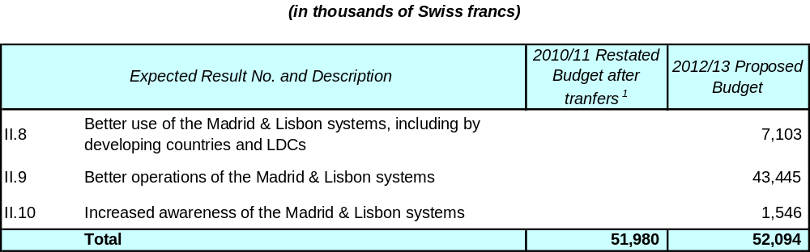

- A slight decrease in Posts budget for 2012/13 under the Program is due to the fact that the 2010/11 restated budget after transfers includes actual expenditures of staff on posts for the Hague System for parts of 2010 before the Hague System was separated as independent Program unit within Program 6.

- The proposed changes in the non-personnel cost categories are due primarily to the re-allocation of funds to better accommodate the extra needs for the promotion of the better use of the Madrid and Lisbon systems and new accessions as well as for the review of the Lisbon system.

- The proposed decreases in a number of budget cost categories under the Program also represent a shift of funds from Program 6 to Program 31, following the creation of a separate Program for the Hague System. To reach the target of doubling Madrid filings, the Program would need to accelerate and reinforce the path of awareness and promotion of the system.

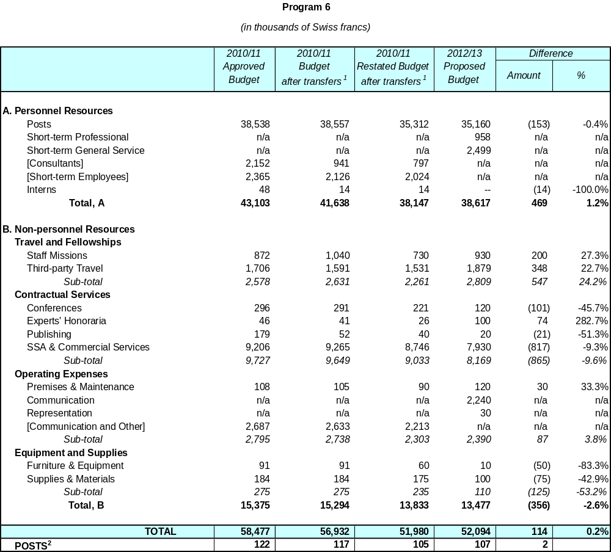

¹ Restated Budget after transfers reflects:

- the adjusted budget of Programs, following transfers during 2010/11 in line with Financial Regulation 5.5. For additional details on the 2010/11 Budget after Transfers, please refer to Table 10 (Annex I) Budget after Transfers by Program of this document and document WO/PBC/18/14 Program Performance Report for 2010;

- restatements of Program budgets for comparison with the 2012/13 proposed Program structure. For those Programs where restatements were not required, the Restated Budget after Transfers is equivalent to the Budget after Transfers, as referred to in document WO/PBC/18/14 Program Performance Report for 2010. For more detailed information on the restatements, please refer to Table 11 (Annex I) of this document.

² For further details on posts for the Program please refer to the Table in Annex II.

Program 31 The Hague System

PLANNING CONTEXT

- Despite a 32 per cent increase in filings in 2010, the untapped potential of the Hague system remains very large and, following continued promotion in 2011, the planning context for this biennium is assumed to be that of continued growth. In addition, as indicated in the MTSP, the Hague system fails to enjoy global membership (56 Contracting Parties by the end of 2010) but its Geneva Act of 1999, which was introduced to remedy this failing, is gathering momentum. Efforts to capitalize on this momentum and expand the system into a truly global system should start bearing fruit during the 2012/13 period. As some of the expected newcomers into the system count amongst the world’s largest sources of design filings and are likely to stimulate further accessions, filings are expected to increase many fold and in a more sudden manner than forecasted in the MTSP. Furthermore, some of these newcomers are those for which a number of features of the Geneva Act of the Agreement have been developed. These features, which are but a reflection of the divergences in national/regional laws, are among the more complex and have yet to be tested in practice. Consequently, their implementation will lead to the international procedure becoming more heterogeneous and cumbersome. In view of the above, the challenges for the 2012/13 period will be: (i) to cope with the expected growth; (ii) to successfully implement the features of the Geneva Act not yet put in practice; and (iii) to ensure, amidst all this, that the system remains attractive to users.

IMPLEMENTATION STRATEGIES AND RISKS

- WIPO aims at making the Hague system a first choice system for design registrations through new applicants and Contracting Parties. To achieve this, WIPO will aim at enhancing awareness of the Hague system, promoting a wider and better use of it, while ensuring a better administration of the system.

- Coordinated actions will take place on three fronts: visibility, geographical scope and system development.

(i) Visibility: promotion will continue in the existing membership where there is significant untapped potential so as to overcome the obvious knowledge gap about the system and its advantages. Conducting regular analysis of the statistics on the use of the Hague system compared to national/regional systems will allow targeted promotional activities to win back former right holders and attract new users. Making general information available in all official languages and then assisting national or regional offices to relay that information to users will also help make the system better known. All this should lead to a continued increase in the use of the system.
(ii) Geographical scope: promotion and assistance to foster expansion of the Hague system through new accessions to the Geneva Act will continue in cooperation with Programs 9 and 10, with a priority on prospective Contracting Parties whose accession is likely to make the system more attractive to users or to prompt further accessions.
(iii) System development: as the system grows, the sophistication of the IT support services will need to increase in order to achieve higher levels of productivity through efficiency gains. In particular, the user interface of the system and the availability of e-business tools will need to be enhanced. Also, further development of the legal framework will be required in order to ensure that it remains in step with new Contracting Parties’ and users’ needs. This would require coordination with Program 2 in relation to the potential developments on the normative framework for designs. Finally, focusing the system around the Geneva Act appears essential in view of simplification, starting with continued efforts to terminate the antiquated London (1934) Act.

- Events outside the control of the International Bureau such as economic and political uncertainties may remain a risk to the actual rate of filings or new accessions. In addition, the following more specific risks associated with the implementation strategies will need attention:

(i) Coping with the increase in filings: if the aim of increasing the use of the system is successfully accomplished, the human resources deployed in all aspects of the administration of the system will need to be correspondingly built up.
(ii) Increase in users’ expectations: promoting the system energetically means raising its visibility. Therefore, there is a need to build capacity to follow up on comments or suggestions that would unavoidably ensue, otherwise the system’s new visibility could have adverse effects on its popularity.
(iii) Growing complexity of the system: as the geographic scope of the Hague system broadens, a number of the features of the Geneva Act that were introduced to accommodate divergent national practices will be implemented for the first time. The international procedure will consequently become more complex, which risks making the system less attractive.

RESULTS FRAMEWORK

Expected Results | Performance Indicators | Baselines | Targets
Increased awareness of the Hague system | No. of first-time applicants | Not available | Tbd in the course of 2011
 | No. of languages in which general information is available | The three working languages of the system | All official languages
 | No. of national or regional offices providing adequate information on the Hague system | About 2/3 of the offices concerned | All offices concerned
Wider and better use of the Hague system | No. of registrations, designs contained in registrations, renewals and other recordings | 2010 2011  New Registrations  2,216 2,900 | 2012 2013  New Registrations  5,000 7,500
 |  | Designs contained | Designs contained
 |  | 11,238 15,000 | 20,000 25,000
 |  | Renewals | Renewals
 |  | 2,783 2,700 | 2,800 2,500
 |  | Other recordings | Other recordings
 |  | 4,244 5,100 | 8,000 12,000
 | No. of applications from, and designations of, developing countries and LDCs | 12 applications from and 2,065 designations of developing countries and LDCs (2010) | 80 applications from and 7,500 designations of developing countries and LDCs
 | % of irregular applications | 57% (in 2010) | 40% (in 2013)
Better administration of the Hague system | Predominance of the Geneva Act in the system as a whole system | 39 Contracting Parties to the Geneva Act and 18 Contracting Parties bound by other Acts only in 2010 | 55 Contracting Parties to the Geneva Act , 1934 Act terminated and no countries bound only by the 1960 outside the EU or OAPI
 | Pendency for a regular non-deferred application, until publication | Nine weeks | Three weeks
 | No. of fully automated processes | 0 | 2
 | % of requests filed through electronic interfaces | 64% of international applications filed through electronic interfaces in 2010, no other requests going through electronic processes | 80% of applications and renewal requests filed electronically
 | % of users satisfied with the services provided by the International Bureau | Tbd end 2011 | Tbd end 2011

RESOURCES FOR PROGRAM 31

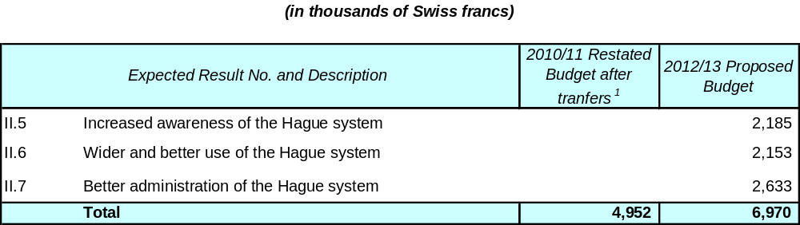

- The increase in personnel budget under the Program is due to the transfer of posts from Program 6, related to the Hague System.

- The proposed increases in the budget cost categories for non-personnel resources under the Program represent a shift of funds from Program 6 to Program 31, following the creation of a separate Program for the Hague System. In addition, the proposed increases under “Staff Missions”, “Third-party Travel” and “Contractual Services” are related to improving the administration of the Hague system, as well as promoting the better use of the system and its geographical expansion.

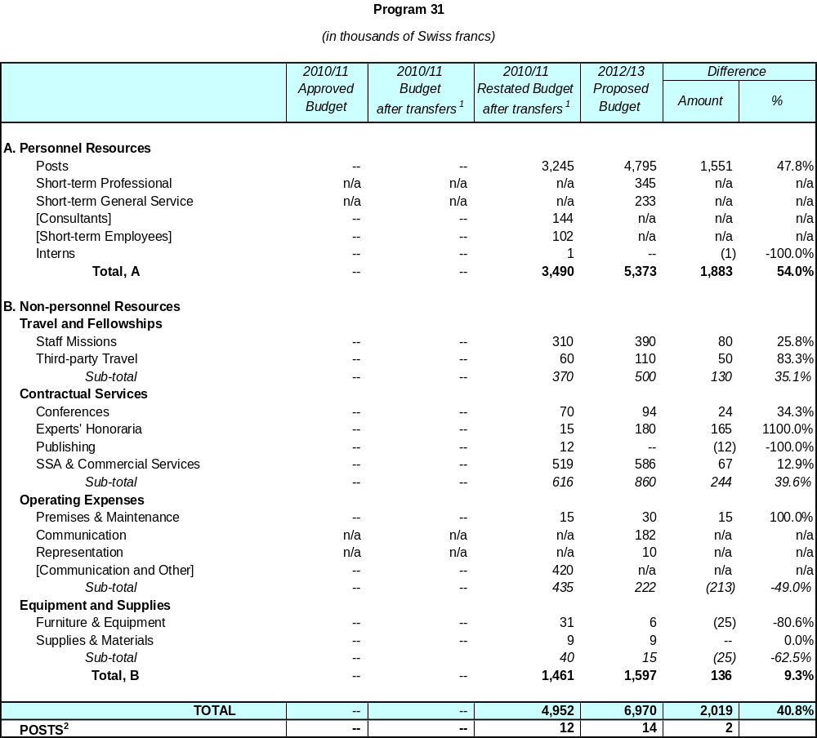

¹ Restated Budget after transfers reflects:

- the adjusted budget of Programs, following transfers during 2010/11 in line with Financial Regulation 5.5. For additional details on the 2010/11 Budget after Transfers, please refer to Table 10 (Annex I) Budget after Transfers by Program of this document and document WO/PBC/18/14 Program Performance Report for 2010;

- restatements of Program budgets for comparison with the 2012/13 proposed Program structure. For those Programs where restatements were not required, the Restated Budget after Transfers is equivalent to the Budget after Transfers, as referred to in document WO/PBC/18/14 Program Performance Report for 2010. For more detailed information on the restatements, please refer to Table 11 (Annex I) of this document.

² For further details on posts for the Program please refer to the Table in Annex II.
Program 7 Arbitration, Mediation and Domain Names

PLANNING CONTEXT

- To preserve and enhance the role of IP in the economy, it is vital to minimize the disruption which legal disputes can cause in the exploitation of such rights. For IP stakeholders, this translates into a need to integrate conflict management into business processes (for example, the development of new technologies), contracting practices, and broader enforcement policies, all of which require awareness of dispute resolution risks and opportunities.

- The public court system offers formal territorial solutions resulting from generally applicable rights-based procedures, but as the evolution of the conditions for the creation and use of IP is highlighting the need for streamlining the framework for obtaining IP titles, similar motives are challenging rights holders and users to explore further cross-border solutions to their disputes. The WIPO Arbitration and Mediation Center assists these efforts as a global resource center, working to enhance party awareness, and as a service provider, offering dispute management tools on the basis of WIPO-facilitated clauses and rules.

- Factors that may impact the possibilities for the implementation of effective dispute resolution mechanisms include the evolution of technology and the diversity of contractual frameworks for its development and use. At the same time, as they require efficient international solutions, these new networks present opportunities for the introduction of adapted alternative dispute resolution processes. As a result of its policy experience, the WIPO Arbitration and Mediation Center is well-placed to contribute to the creation of such alternative dispute resolution (ADR) frameworks as they relate to IP. On the other hand, for commercial and political reasons, numerous ADR service providers compete in the actual operation of these and other mechanisms. Recognition in that market will depend upon the efficient provision of the right services.

- An example of the potential of ADR for IP is the WIPO-initiated Uniform Domain Name Dispute Resolution Policy (UDRP). Under this effective global online alternative to court litigation for addressing trademark abuse in the Domain Name System (DNS), the WIPO Arbitration and Mediation Center has processed almost 20,000 cases through 2010. The DNS landscape appears set to undergo considerable change, in the form of a broad expansion of the number of generic top level Domains (gTLDs) and the introduction of internationalized (non-Latin script) gTLDs and domain names. A further development of note is the increasing prominence of country code top level Domains (ccTLDs) within the DNS.

- The impact of these changes on both IP and the UDRP is uncertain. The WIPO Arbitration and Mediation Center needs to continue to play a proactive role in proposing solutions to the Internet Corporation for Assigned Names and Numbers (ICANN) to reduce any adverse impact of the changes on IP or on the effectiveness of the UDRP as an instrument for combating cyber-squatting. Also, any substantial increase in demand under the UDRP (which grew by some 30 per cent in 2010) and other rights-protection mechanisms resulting from DNS expansion would require consideration of the resource impact.

- The WIPO Arbitration and Mediation Center organizes training programs for intellectual property officials and practitioners, including online programs. The WIPO Arbitration and Mediation Center also assists national domain name authorities in the establishment of best registry practices and domain name dispute resolution mechanisms. Furthermore, national IP offices call on the WIPO Arbitration and Mediation Center for desired input on the development of alternative dispute resolution mechanisms tailored to their processing needs. These training and capacity building activities conducted in line with DA Recommendations 1 and 6 will contribute to the implementation of DA Recommendation 10 by ensuring that developing countries and LDCs have enhanced institutional capacity to efficiently, fairly and cost-effectively resolve IP disputes.

IMPLEMENTATION STRATEGIES AND RISKS

- Against this background, the WIPO Arbitration and Mediation Center will pursue the following strategies:

- Enhance awareness of IP ADR options. This Program will cooperate with other Programs, including Program 1 (Patents), Program 3 (Copyright and Related Rights), Program 4 (Traditional Knowledge, Traditional Cultural Expressions and Genetic Resources), Program 5 (The PCT System), Program 6 (Madrid, Hague and Lisbon Systems), Program 9 (Africa, Arab, Asia and the Pacific, Latin America and the Caribbean Countries, Least Developed Countries), Program 10 (Cooperation with Certain Countries in Europe and Asia), Program 11 (The WIPO Academy), Program 19 (Communications), Program 20 (External Offices and Relations), Program 27 (Conference and Language Services) and Program 30 (Small and Medium-sized Enterprises).
- Increase market research into the expectations and experience of IP stakeholders in the use of ADR. This Program will cooperate with other Programs, in particular Program 16 (Economics and Statistics).
- Increase the attractiveness of dispute resolution services offered by the WIPO Arbitration and Mediation Center by adapting its procedures and case infrastructure to the evolving needs of users, including through IT-based solutions. This Program will cooperate with other Programs, in particular Program 25 (Information and Communication Technology).
- Working with IP owners, users and institutions to establish tailored procedures specifically adapted to the particular features of recurrent disputes in their areas of activity. The availability of such procedures may for example contribute to the successful functioning of international platforms facilitating technology transfer agreements, or the appropriate use of web-based services. This Program will cooperate with other Programs, including Program 1 (Patent Law and Innovation), Program 2 (Trademarks, Industrial Designs and Geographical Indications), Program 3 (Copyright and Related Rights), Program 4 (Traditional Knowledge, Traditional Cultural Expressions and Genetic Resources), Program 6 (Madrid and Lisbon Systems), Program 17 (Building Respect for IP), Program 18 (IP and Global Challenges), and Program 31 (The Hague System)

RESULTS FRAMEWORK

Expected Results | Performance Indicators | Baselines | Targets
International and domestic intellectual property disputes are increasingly prevented or resolved through mediation, arbitration and other alternative dispute resolution methods | Increased consideration of the use of alternative dispute resolution services in intellectual property transactions, including through the use of WIPO procedures | 225 disputes and 50 bons offices (end 2010)  Center Survey Results  2,000 incoming queries (2010)  Web visits 15 million (2010)  125 participants at Center annual events (2010);  3,000 participants at Center external events (2010) | 20 additional disputes and bons offices  Center Survey Results  4,000 additional queries  30 million  250 participants at Center annual events;  6,000 participants at Center external events
 | Alternative dispute resolution policies to the development and implementation of which policies the Center has contributed | Schemes adopted (AGICOA, Film and Media, EGEDA) | One to three additional schemes
Effective intellectual property protection in the gTLDs and the ccTLDs | Number of gTLD UDRP cases administered | 17,772 gTLD cases (end 2010) | 3,500 additional cases
 | Number of ccTLD UDRP-based cases administered | 1,694 ccTLD-only cases administered by the Center (end 2010) | 350 additional cases
 | Dispute resolution policies in the Domain Name System to the development and implementation of which policies the Center has contributed | UDRP (at the end of 2010, only the UDRP had been adopted, for a number of years already) | Implementation in the Domain Name System of WIPO policy and process recommendations
 | Number of ccTLD administrators with WIPO-assisted design or administration of intellectual property protection mechanisms in accordance with international standards | 65 ccTLD administrators (end 2010) | Six additional administrators

RESOURCES FOR PROGRAM 7

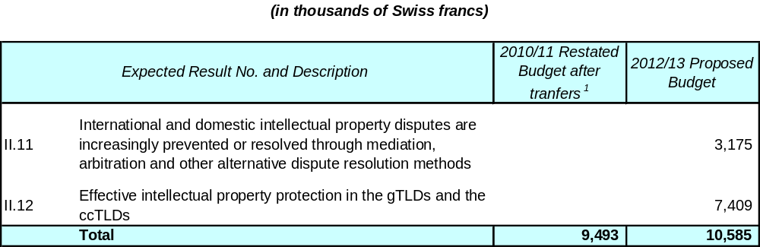

- The figures for 2010/11 Budget under personnel costs represent actual expenditure for 2010 and budgeted amounts based on standard costs for 2011. The budget for 2012/13 is prepared using standard costs for the next biennium.

- The proposed increases under “Staff Missions” would enable the Program to carry out a number of outreach activities to more fully meet its expected results. Certain activities which the Center must follow (e.g., ICANN developments) have also intensified the schedules and scope of related meetings, impacting on the required frequency and duration of travel. As regards the increases under “SSA and Commercial Services”, these resources primarily concern IT expenditure previously budgeted under Program 25 as well as transfers from “Experts’ Honoraria” to better reflect the nature of services to be utilized.

- The Program does not envisage holding a larger conference during the next biennium and has reduced its resources under this category. By relying on its web pages for information purposes, offering fast and real time updating, the Program makes less use of formal publications and have therefore reduced its resource requirement under “Publications”. The investment in communication equipment in the present biennium has resulted in a lower budget requirement for the next biennium and the introduction of electronic case filing and training tools have also allowed for a reduction in physical supplies needs.

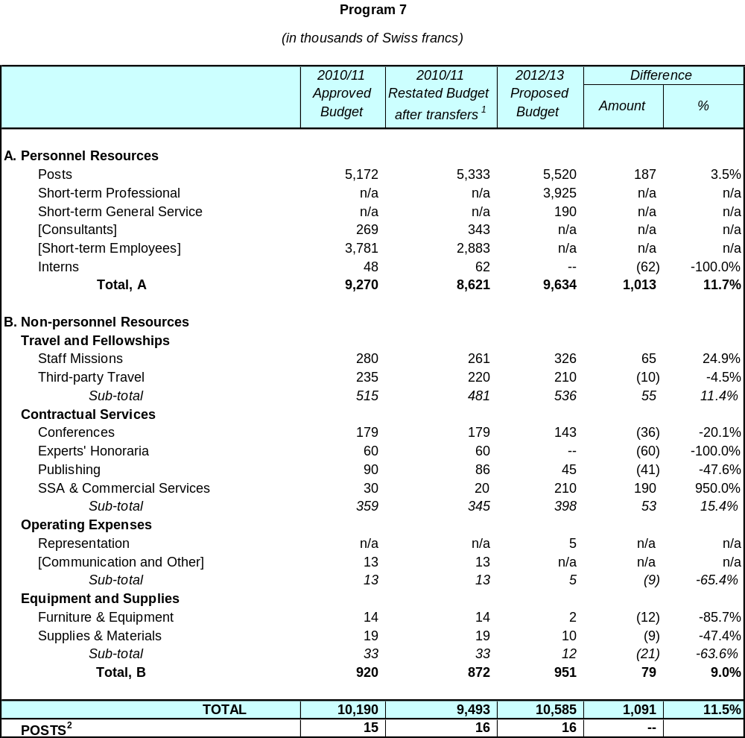

¹ Restated Budget after transfers reflects:

- the adjusted budget of Programs, following transfers during 2010/11 in line with Financial Regulation 5.5. For additional details on the 2010/11 Budget after Transfers, please refer to Table 10 (Annex I) Budget after Transfers by Program of this document and document WO/PBC/18/14 Program Performance Report for 2010;

- restatements of Program budgets for comparison with the 2012/13 proposed Program structure. For those Programs where restatements were not required, the Restated Budget after Transfers is equivalent to the Budget after Transfers, as referred to in document WO/PBC/18/14 Program Performance Report for 2010. For more detailed information on the restatements, please refer to Table 11 (Annex I) of this document.

² For further details on posts for the Program please refer to the Table in Annex II.

STRATEGIC GOAL III
Facilitating the Use of IP for Development

The goal of facilitating the use of IP for social, cultural and economic development drives WIPO’s multiple technical assistance and capacity building activities, which are delivered through programs in every sector of the Organization. Covering all these activities, the medium term focus of this cross-cutting Strategic Goal is to assist developing countries, least developed countries and countries with economies in transition to make effective use of the IP system in their specific context.

The WIPO Development Agenda plays a central role in ensuring that all areas of WIPO’s activities contribute to this Strategic Goal.

Expected Results | Performance Indicators | Responsible Program(s)
Clearly defined and coherent national innovation and IP policies, strategies and development plans consistent with national development goals and objectives | No. of countries that have formulated and/or are engaged in implementation of their IP Policies, Strategies and/or Plans each year (Africa) | Program 9
 | No. of countries with appropriate mechanisms for the development and implementation of IP strategies (Arab region) | Program 9
 | No. of countries with initiatives linked to the national IP plans  (Arab region) | Program 9
 | No. of countries with IP policies and strategies in their national approval processes  (Asia and the Pacific) | Program 9
 | No. of countries having adopted IP policies and strategies  (Asia and the Pacific) | Program 9
 | No. of countries in which activities/projects have been carried out that contribute to the formulation of IP strategies/policies  (Latin America and the Caribbean) | Program 9
 | No. of countries in which activities/projects have been carried out that contribute to the implementation of IP strategies/policies  (Latin America and the Caribbean) | Program 9
 | No. of LDCs that have included LDC-specific IP considerations in their national IP strategies and/or policies (LDCs) | Program 9
 | No of countries having developed national IP strategies or plans, dovetailed with national development goals | Program 10
Enhanced human resource capacities able to deal with the broad range of requirements for the effective use of IP for development in developing countries, LDCs and countries with economies in transition | No. of specialized training (patent drafting, technology management, enforcement, etc.) and/or awareness-raising events (Africa) | Program 9
 | No. of graduates from the master in IP (MIP) program (Africa) | Program 9
 | No. of countries with available IP training programs and IP related career opportunities (Arab region) | Program 9
 | % of trained examiners using upgraded skills in their professional work (Asia and the Pacific) | Program 9
 | % of policy makers, government officials, and IP practitioners with enhanced understanding of IP issues, including how to effectively use IP for development (Asia and the Pacific) | Program 9
 | No. of national IP trainers/national experts (Latin America and the Caribbean) | Program 9
 | No. of structured national training programs (Latin America and the Caribbean) | Program 9
 | No. of countries in which the needs for technical assistance and capacity building have been assessed (LDCs) | Program 9
 | No. of trainees/participants per year and geographical distribution (LDCs) | Program 9
 | % of participants in WIPO capacity-building activities which report enhanced capacity to understand and use IP principles, systems and tools or the protection of TK and TCEs, and for management of the relationship between IP and GRs | Program 9  Program 4
 | % of trained IP office officials using upgraded skills in their work  % IP professionals attesting to an enhanced understanding of IP issues | Program 10
 | % of trained enforcement officials that report satisfaction with the training provided, and its usefulness for their professional life | Program 9  Program 10  Program 17
 | % of participants satisfied with the quality of workshops and seminars on innovation and its commercialization | Program 9  Program 10  Program 1
 | % of participants’ positive rating of the usefulness of copyright related capacity building workshops | Program 3
 | % of participants’ rating of usefulness of copyright related workshops and practical use of knowledge 6 months after the workshop | Program 3
 | No. of national copyright and related rights initiatives started directly related to the themes of workshops | Program 3
New or strengthened cooperation mechanisms, programs and partnerships in LDCs | No. of partnerships established in LDCs among governmental organizations, private sector, NGOs, and other development partners (LDCs) | Program 9
 | No. of IP programs implemented jointly with other UN bodies and other IGOs (LDCs) | Program 9
 | % of IP office trainees that report satisfaction with the training provided | Program 11
 | % of trainees that report actual use of the acquired skills in their job | Program 11
 | % of supervisors attesting to satisfactory application of acquired skills after one year of training | Program 11
 | No. of graduates from WIPO academy and partner academic institutions (joint offering) | Program 11
 | No. of participants trained under the WIPO Summer Schools annually | Program 11
 | No. of IP teachers trained by the Academy | Program 11
 | No. of start up academies established | Program 11
 | No. of new inter-institutional cooperation agreements | Program 11
Easier access to IP education | No. of online registrations to DL courses | Program 11
 | Completion rate of DL courses | Program 11
 | % of DL course participants having passed the exam | Program 11
 | No. of Academy courses incorporated in educational institutions curricula | Program 11
 | No. of new online courses / at different levels of specialization | Program 11
 | No. of languages used | Program 11
 | No. of scolarships provided to participants to developing countries, LDCs and countries with economies in transition | Program 11
Upgraded IP Management skills for business | % of participants that report satisfaction with the training provided | Program 11
 | % of trainees that report actual use of the acquired skills in their job | Program 11
 | No. of requests for courses | Program 11
Increased understanding/ capacity of SMEs to successfully use IP to support innovation and commercialization | % of assisted support institutions who provide information, support and advisory/consulting services on IP asset management | Program 1
Development Agenda principles further mainstreamed into the Organization’s programs and activities | No. of DA recommendations linked to Expected Results in the 2010/11 P&B | Program 8
 | No. of DA recommendations that are linked to Performance Indicators in the 2010/11 P&B | Program 8
 | Implementation of the coordination mechanism as approved by Member States | Program 8
Effective planning, implementation, monitoring, evaluation and reporting on the DA recommendations | No. of DA recommendations that have been addressed by the CDIP through projects, activities and studies | Program 8
 | No. of projects approved by the CDIP | Program 8
 | No. of projects proposed by Member States that are tabled for consideration by the CDIP | Program 8
 | % of projects which are monitored on a systematic basis | Program 8
 | % of projects which have been evaluated during the biennium | Program 8
 | Feedback on the quality of the reports presented to the CDIP on the implementation of the DA recommendations | Program 8
Enhanced understanding of the Development Agenda by Member States, IGOs, civil society and other stakeholders | No. of countries requesting technical assistance through DA projects and expressing interest in DA related activities | Program 8
Recognition by Member States, communities, organizations and other stakeholders of the relevance and effectiveness of WIPO’s resources, programs and tools | No. of requests received for WIPO’s assistance | Program 4
Increased extrabudgetary resources available for IP for development, either through direct contributions to WIPO or access to other external funding mechanisms | An increase in fund available through Funds-in Trust arrangements | Program 20
 | Number and financial value of WIPO implemented projects funded by existing external donor funded mechanisms | Program 20
 | Establishment of WIPO Guidelines for Partnership with the Private Sector | Program 20

Program 8 Development Agenda Coordination

PLANNING CONTEXT

- An effective implementation of the WIPO Development Agenda (DA) remains a high priority for the Organization. The challenges during the biennium will be to: further mainstream the DA recommendations into the Organization’s work; continue to define further work for the implementation of the 45 Recommendations; ensure effective monitoring and evaluation; and, assist Member States in reaping the benefits of the DA implementation.

- During the previous biennium, tangible achievements were made notably: an enhanced integration of DA recommendations in the Program and Budget of the Organization and its MTSP; consolidation of the project based methodology; adoption by the Committee on Development and Intellectual Property (CDIP) of a number of projects and other activities and substantial reporting on progress made in their implementation; adoption by the WIPO General Assembly of the Coordination Mechanism and the Budgetary Process applied to Projects Proposed by the CDIP; and, a number of activities aimed at fostering a better understanding of the DA and participation by the various stakeholders in its implementation.

IMPLEMENTATION STRATEGIES AND RISKS

- During the current biennium, the Program will continue to play its critical role in the mainstreaming and cross-cutting implementation of the DA. The Program will facilitate the implementation of the decisions adopted by the WIPO General Assembly and the CDIP and, for this purpose, will work closely together with Member States and various sectors within WIPO and other stakeholders including bodies in the UN system, intergovernmental organizations (IGOs), non-governmental organizations (NGOs) and civil society at large.

- The Program will facilitate the work of the CDIP and, in particular, will: develop the work plans for implementation of the various DA recommendations; coordinate and ensure that projects are properly implemented, monitored, evaluated and reported upon; facilitate the implementation of the Coordination Mechanisms and Monitoring, Assessing and Reporting Modalities (in collaboration with Program 22); and, undertake internal coordination within WIPO to include financial requirements for the projects proposed by the CDIP in the Organizational budgetary process (in collaboration with Program 22). In line with the DA recommendations, the Program will also facilitate the integration of the DA considerations into national IP strategies of WIPO Member States (in collaboration with Program 9 and 10). The Program will also organize a conference on IP and development.

- The Program will continue to implement the communication strategy developed during the previous biennium. In close collaboration with other sectors within WIPO, it will organize events to create awareness with regard to the benefits arising from DA implementation (in particular in collaboration with Programs 1, 2, 3, 4, 9, 10, 11, 16, 17,18, 19 and 20). This will include organizing and participating in meetings, symposia and interactive sessions with Member States and engaging with other agencies and stakeholders to coordinate action that contribute to an effective implementation of the Development Agenda. Finally, in line with the mandate of the CDIP, the Program will also facilitate activities on IP and Development related issues as requested by the Committee, as well as those decided by the General Assembly.

- An effective implementation of the DA continues to be dependant upon an active role and cooperation of the Member States. Their guidance will thus be of immense value for the Program to achieve the above stated objectives.

RESULTS FRAMEWORK

Expected Results | Performance Indicators | Baselines | Targets
Development Agenda principles further mainstreamed into the Organization’s programs and activities | No. of DA recommendations linked to Expected Results in the 2010/11 Program and Budget (P&B) | 26 DA recommendations are linked to at least one Expected Result | 45 DA recommendations to be linked to at least one expected results in the 2014/15 P&B
 | No of DA recommendations that are linked to Performance Indicators in the 2010/11 P&B | 16 DA recommendations | 45 DA recommendations linked to Performance Indicators in the 2014/15 P&B
 | Implementation of the coordination mechanism as approved by Member States | Coordination Mechanisms and Monitoring, Assessing and Reporting Modalities approved by the CDIP in April 2010 | Coordination Mechanisms implemented in accordance with the decision of Member States
Effective planning, implementation, monitoring, evaluation and reporting on the DA recommendations | No. of DA recommendations that have been addressed by the CDIP through projects, activities and studies | 42 recommendations (Dec 2010) | 45 recommendations
 | No. of projects approved by the CDIP | 19 projects (end 2010) | n/a
 | No. of projects proposed, by Member States, that are tabled for consideration by the CDIP | tbd | At least one project/region
 | % of projects which are monitored on a systematic basis | 100% (17 projects) | 100%
 | % of projects which have been evaluated during the biennium | 100% (14 projects) | 100%
 | Feedback on the quality of the reports presented to the CDIP on the implementation of the DA recommendations | Positive feedback received from the CDIP. Specific request for more analytical information in the reports | Positive feedback from the CDIP
Enhanced understanding of the Development Agenda by Member States, IGOs, civil society and other stakeholders | No. of countries requesting technical assistance through DA projects and expressing interest in DA related activities | Projects and DA related activities in 50 countries | Projects and DA related activities in 50 countries

RESOURCES FOR PROGRAM 8

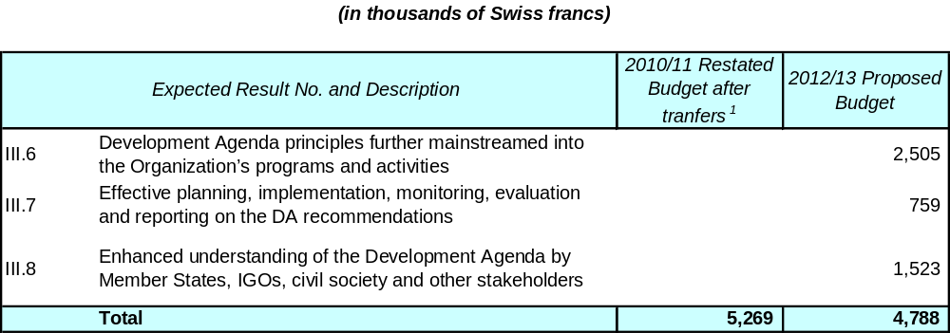

- The figures for 2010/11 Budget under personnel costs represent actual expenditure for 2010 and budgeted amounts based on standard costs for 2011. The budget for 2012/13 is prepared using standard costs for the next biennium. While there is a reduction of one post, the increase in costs is due to the allocation of a D post to the Program.

- The proposed reduction in the non-personnel resources for the Program is mainly linked to the re-allocation of some resources to Program 11, primarily to accommodate the re-designed Executive Program (for further details please refer to Program 11).

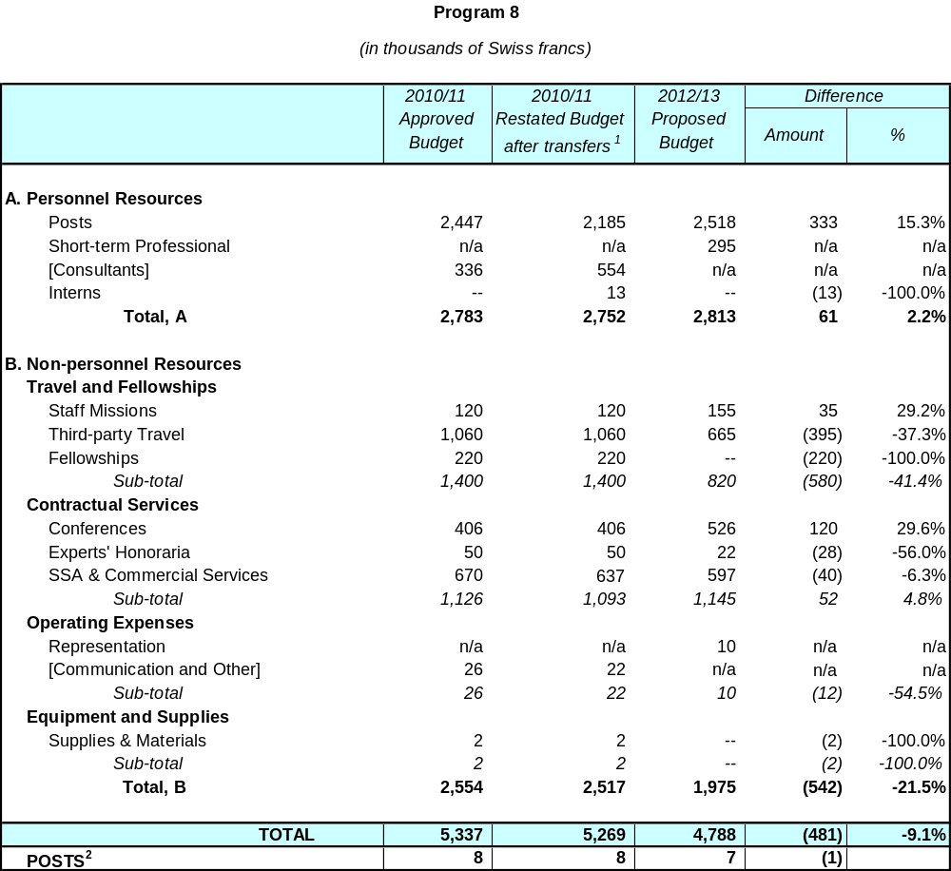

¹ Restated Budget after transfers reflects:

- the adjusted budget of Programs, following transfers during 2010/11 in line with Financial Regulation 5.5. For additional details on the 2010/11 Budget after Transfers, please refer to Table 10 (Annex I) Budget after Transfers by Program of this document and document WO/PBC/18/14 Program Performance Report for 2010;

- restatements of Program budgets for comparison with the 2012/13 proposed Program structure. For those Programs where restatements were not required, the Restated Budget after Transfers is equivalent to the Budget after Transfers, as referred to in document WO/PBC/18/14 Program Performance Report for 2010. For more detailed information on the restatements, please refer to Table 11 (Annex I) of this document.

² For further details on posts for the Program please refer to the Table in Annex II.
Program 9 Africa, Arab, Asia and the Pacific, Latin America and the Caribbean Countries, Least Developed Countries

PLANNING CONTEXT

- Strategic Goal III, Facilitating the Use of IP for Development, drives WIPO’s multiple technical assistance and capacity building activities and serves as the high level framework for Program 9. The main challenge is to address the diversity and growing needs of developing countries and least developed countries (LDCs) in the African, Arab, Asia and the Pacific and Latin America and the Caribbean regions as they endeavor to unleash the full potential of IP for the advancement of social, cultural and economic development. In order to meet this challenge, the Program will strengthen its focus on the four critical pillars identified in the MTSP 2010-2015, namely, national IP strategies and policies, legislative and regulatory frameworks, institutional and technical infrastructure and human resource capacity building.

- This Program is at the forefront of WIPO’s cooperation and engagement with Member States, particularly from the developing and least developed countries, and brings to the Organization the depth and breadth of its accumulated knowledge and understanding of the various regions. As such, it serves as the primary interface between the said Member States and the various programs of WIPO. Given the cross-cutting nature of Strategic Goal III, the Program will fully take into account its planning, coordinating and support role to other Programs and enhance synergies with them to ensure coherence in the design and implementation of national IP strategies and country plans.

- The DA principles and recommendations will continue to guide the Program in its technical assistance activities, in particular, recommendations 1 to 14, 17, 19, 23, 25, 30, 31, 33 and 38 to 43.

- The diversity of socio-economic situations among the countries is another challenge that requires careful and thorough country-based review, consideration and approach. Assistance relating to regulatory frameworks and institutional infrastructure will take these differences into account. As regards human capital, the requirements for training and capacity building reflect the diversity of stakeholders, from policy makers and administrators, to legal practitioners and experts and eventually the generators and users of IP. The challenge is to design programs that suit the requirements of different target groups while accommodating the interdisciplinary nature of IP, i.e., law and public policy, economics, business and technology.

IMPLEMENTATION STRATEGIES AND RISKS

- The overall objective of the Program is to empower developing countries and LDCs to use IP for economic growth and development and to take full advantage of the potential of IP as a major contributing factor in achieving national development objectives.

- To this end, technical cooperation in the field of human, institutional and technical capacity building and the adaptation of legislative and regulatory frameworks will be consolidated with the aim of achieving the following results:

- Clearly defined and coherent national IP strategies and policies consistent with existing national development goals and objectives and international IP flexibilities;
- Tailored and balanced legislative and regulatory frameworks, taking into account specific national requirements;
- Strengthened, efficient and responsive institutional and technical infrastructure; and
- Enhanced human resources able to deal with the broad range of requirements for the effective use of IP for development.

- The target is to increase significantly the number of countries with customized IP strategies, the number of strengthened and equipped IP and IP related institutions and the number of countries receiving WIPO’s assistance related to legislative and regulatory frameworks.

- WIPO will assist developing countries and LDCs in the design, development and implementation of national IP strategies that are both consistent with overall development plans and able to: foster innovation and creativity; leverage the potential of IP in all areas, including agriculture, health, trade and research; and, improve living conditions in general. These strategies will be prepared on the basis of systematic identification and assessment of needs and an inclusive process of national government-led consultation involving relevant government sectors, the private sector as generators, and users of IP, academia and civil society.

- Raising the level of awareness of policy-makers is central to the successful formulation and implementation of national IP strategies and the integration of IP in national, institutional and sectoral development policies and plans.

- Implementation will take place through country plans, a blueprint to guide the development of IP over a short- to medium-term period. These country plans, developed in
government-led consultation with Member States, will: build on existing or newly adopted IP strategies or action plans; demonstrate complementarities of various programs; and, illustrate how resources will be or are being utilized in order to achieve a coherent set of objectives and results.

- Program 9 will cooperate closely with the development-specific programs listed under Strategic Goal III as well as with Programs listed under other Goals, to the extent that specific national/sub-regional/regional plans and programs require. The mainstreaming of the infrastructure and legislative and regulatory framework pillars of development will be facilitated by this Program which will ensure that these services are delivered in accordance with country plans and priorities identified in the IP strategies. Cooperation arrangements and partnerships between and among countries and regions will be promoted as a means of facilitating the development of mechanisms, tools and solutions which could be applied horizontally across regional/sub-regional lines, while taking into account the different levels of development, and recognizing the special needs of developing and least-developed countries, and the need to avoid the universal applicability of one-size-fits-all models. This will include promotion of cooperation and partnerships with regional economic communities, groupings and institutions, particularly among countries with similar needs and priorities. Efficient use of funds-in-trust and extra-budgetary resources will be ensured along with enhanced coordination with other donor agencies and organizations, including developing country organizations, in delivering assistance to countries. These strategies are, in general, intended to improve the quality and effectiveness of technical assistance, focusing on results, and ensuring sustainability and continuity of actions.

- Following DA principles, technical assistance delivery will be demand-driven, based on country needs, strengths and requirements and will be undertaken in close consultation with national authorities and relevant stakeholders, including the private sector and consumer rights and other civil society organizations. Where appropriate, the strategy will be to design and implement the most appropriate projects that will facilitate the inclusion of IP and in congruence with public policy priorities. On-line databases provided via the Internet containing detailed information on WIPO’s technical assistance activities (IP-TAD) and the organization’s Roster of Consultants (IP-ROC) will provide Member States and the Secretariat with full access to information on all technical assistance activities undertaken by the Organization, including access to a global pool of IP experts that can be used in IP development-related activities. WIPO will work closely with Member States and the relevant IP stakeholders for the implementation of the DA project on capacity-building in the use of appropriate technology for LDCs which aims at contributing to the strengthening of national capacities in the management, administration and utilization of technical and scientific information with a view to building their appropriate technology base. In addition, the Program will ensure an effective implementation of the DA project on IP and Branding for Business Development for developing countries and LDCs in close cooperation with Program 2. The project on South South cooperation is subject to the approval of CDIP.

- Regional specificities will be taken into account in the determination of performance indicators and targets based on regional baselines. These are reflected in the tables which follow.

- The implementation of planned activities could be affected by external factors such as the international environment, the absorptive capacity of recipient institutions and economic and political uncertainties. WIPO will endeavor, when needed, to minimize the impact of such risks, and will spare no effort to ensure the effective implementation, on time, of defined objectives. It will maintain an appropriate level of engagement and dialogue with Member States and other stakeholders.

RESULTS FRAMEWORK

Expected Results | Performance Indicators | Baselines | Targets
Clearly defined and coherent national innovation and IP policies, strategies and development plans consistent with national development goals and objectives | No. of countries that have formulated and/or are engaged in implementation of their IP Policies, Strategies and/or Plans each year (Africa) | Two countries have adopted IP policies  Four countries have adopted national IP development plans  Three countries have completed formulation of national IP policies and strategies | At least four countries have adopted IP policies  At least eight countries have adopted national IP development plans  At least six countries have completed formulation of national IP policies and strategies
 | No. of countries with appropriate mechanisms for the development and implementation of IP strategies (Arab region) | Five countries | Five countries
 | No. of countries with initiatives linked to the national IP plans  (Arab region) | Two countries | Four countries
 | No. of countries with IP policies and strategies in their national approval processes  (Asia and the Pacific) | - nil | Six countries
 | No. of countries having adopted IP policies and strategies  (Asia and the Pacific) | - nil | Three countries
 | No. of countries in which activities/projects have been carried out that contribute to the formulation of IP strategies/policies  (Latin America and the Caribbean) | Seven countries | Eight countries
 | No. of countries in which activities/projects have been carried out that contribute to the implementation of IP strategies/policies  (Latin America and the Caribbean) | Seven countries | 16 countries
 | No. of LDCs that have included LDC-specific IP considerations in their national IP strategies and/or policies (LDCs) | Four LDCs | At least eight LDCs
Enhanced human resource capacities able to deal with the broad range of requirements for the effective use of IP for development in developing countries, LDCs and countries with economies in transition | No. of specialized training (patent drafting, technology management, enforcement, etc.) and/or awareness-raising events (Africa) | Eight training programs; two IP awareness raising events | Six training programs; two awareness raising events
 | No. of countries with available IP training programs and IP related career opportunities (Arab region) | Five countries | Three countries
 | % of trained examiners using upgraded skills in their professional work (Asia and the Pacific) | Data not available | 70%
 | % of policy makers, government officials, and IP practitioners with enhanced understanding of IP issues, including how to effectively use IP for development (Asia and the Pacific) | Data not available | 60%
 | No. of national IP trainers/national experts (Latin America and the Caribbean) | 151 national experts/trainers | 230 national experts/trainers
 | No. of structured national training programs (Latin America and the Caribbean) | 31 national programs | 59 national programs
 | No. of countries in which the needs for technical assistance and capacity building have been assessed (LDCs) | Needs assessment of 5 LDCs | Needs assessment for al least 15 LDCs
 | No. of trainees/participants per year and geographical distribution (LDCs) | Total of 502 trainees/participants across all regions | Increase in numbers of trainees/ participants
 | % of participants in WIPO capacity-building activities which report enhanced capacity to understand and use IP principles, systems and tools or the protection of TK and TCEs, and for management of the relationship between IP and GRs | First time this Performance Indicator has been used in this Program | 75%
 | % of trained enforcement officials that report satisfaction with the training provided, and its usefulness for their professional life | No current data available | 75%
 | % of participants satisfied with the quality of workshops and seminars on innovation and its commercialization | General feedback available, but no specific data | 90%
Enhanced access to, and use of, IP information and knowledge by IP institutions and the public to promote innovation and increased access to protected creative works and creative works in the public domain | No. of national TISC networks launched | Nine national TISC networks launched  (1 quarter 2011):  Africa (3)  Arab region (3)  Asia and Pacific (1)  Latin America and the Caribbean (2) | 18 additional national  TISC networks launched:  Africa (9), all in LDCs  Arab region (2)  Asia and Pacific (3), all in LDCs  Latin America and the Caribbean (4)
 | No. of users serviced by TISCs per quarter and country | Tbd by end 2011 | Tbd by end 2011
 | No. of Member States that have developed their IP framework and established TTOs | Framework pilot project adopted and funding committed | Regional targets tbd
Enhanced technical and knowledge infrastructure for IP Offices and other IP institutions leading to better services (cheaper, faster, higher quality) to their stakeholders | No. of Offices with fully automated vs partially automated IP administration systems provided by WIPO  No. of Offices with IP data online in WIPO databases | Africa (14)  Arab (13)  Asian and Pacific (7)  Latin America and the Caribbean (12)  Total 20  (Regional breakdown tbd) | Africa (4)  Arab (4)  Asian and Pacific (4)  Latin America and the Caribbean (7)  Total 40  (Regional breakdowns tbd)
 | No. of Groups of Offices participating in a common platform | One | Three
 | No. of Offices processing PCT and Madrid data with the support of WIPO supplied systems | Total five  (regional breakdown tbd) | Total 20  (regional breakdown tbd)
Tailored and balanced IP legislative, regulatory and policy frameworks | No. of requests for and types of legislative advice related to patents, utility models, trade secrets and integrated circuits, including relevant IP flexibilities | In 2010, 12 comments were provided to Member States | 25 comments on drafts prepared by Member States and 10 draft laws prepared by the Secretariat (regional breakdown tbd)
 | No. of countries which found WIPO's legislative advice related to patents, utility models, trade secrets and integrated circuits useful | Not available | 90%
 | % of countries which found the provided information concerning the legal principles and practices of the patent system, including the flexibilities existing in the system and the challenges it faces, useful | Not available | 90%
 | % of satisfied participants in targeted workshops/ seminars held on specific patent-related questions | Not available | 90%
 | No. of Member States having received legislative advice in the area of trademarks, industrial designs and geographical indications | No. of Member States having received legislative advice in 2010/11 | Legislative advice provided to 10 Member States and/or Regional Groups of Member States (regional breakdown tbd)
 | No. of countries providing positive feedback on the usefulness of the provided legislative advice in the area of trademarks, industrial designs and geographical indications | Data not available | 70%
 | No. of countries provided with technical assistance on new or updated legislative frameworks for effective enforcement, taking into account flexibilities in Part III of TRIPS | One regional group (Africa)  One country  (Asia) | Four countries
New or strengthened cooperation mechanisms, programs and partnerships in LDCs | No. of partnerships established in LDCs among governmental organizations, private sector, NGOs, and other development partners (LDCs) | Nil | Establishment of partnerships in at least five LDCs
 | No. of IP programs implemented jointly with other UN bodies and other IGOs (LDCs) | Cooperation with the UN and other Organizations:  (i) UN LDC IV Conference, Istanbul, Turkey  (ii) WTO organized TRIPS meetings in Senegal, Uganda and Bangladesh | Two regional fora in cooperation with the UN and two regional fora in cooperation with WTO

RESOURCES FOR PROGRAM 9

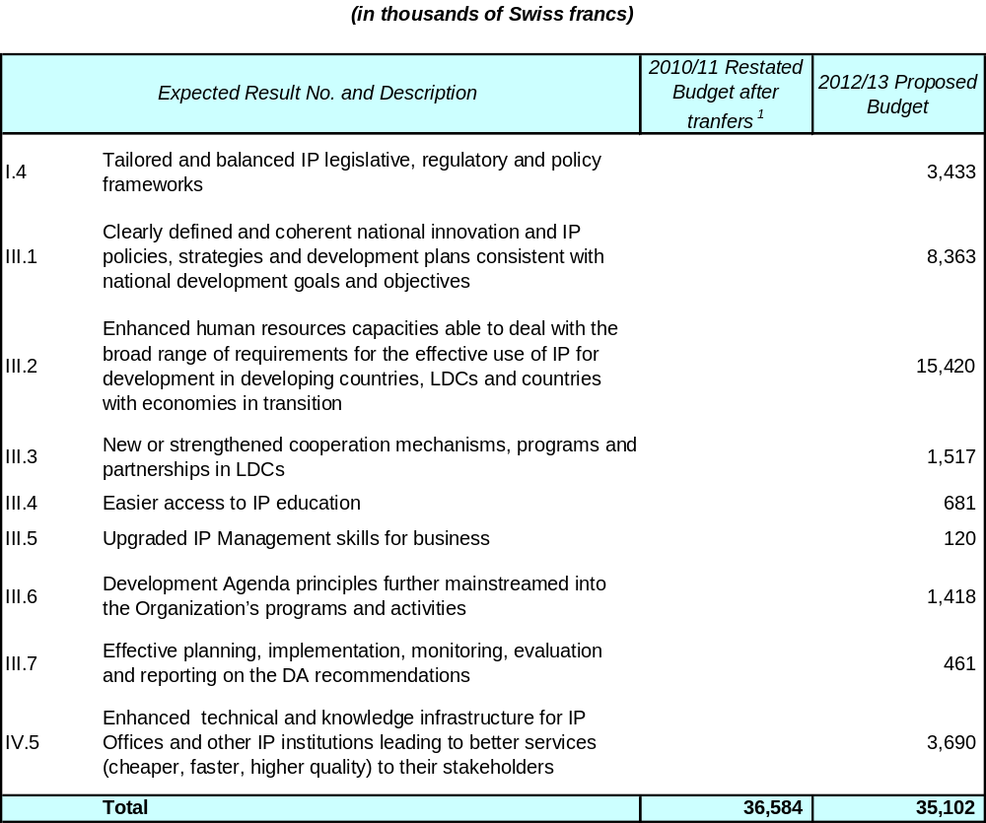

- The figures for 2010/11 Budget under personnel costs represent actual expenditure for 2010 and budgeted amounts based on standard costs for 2011. The budget for 2012/13 is prepared using standard costs for the next biennium. The increase in budgeted amount under Posts for the Program goes beyond the statutory increases incorporated in the standard costs mainly due to the transfer of two posts from other Programs.

- The proposed reductions under the non-personnel resources for the Program are primarily due to the mainstreaming of activities related to legislative and policy advice as well as IP office modernization to Programs 1, 2 and 15 respectively.

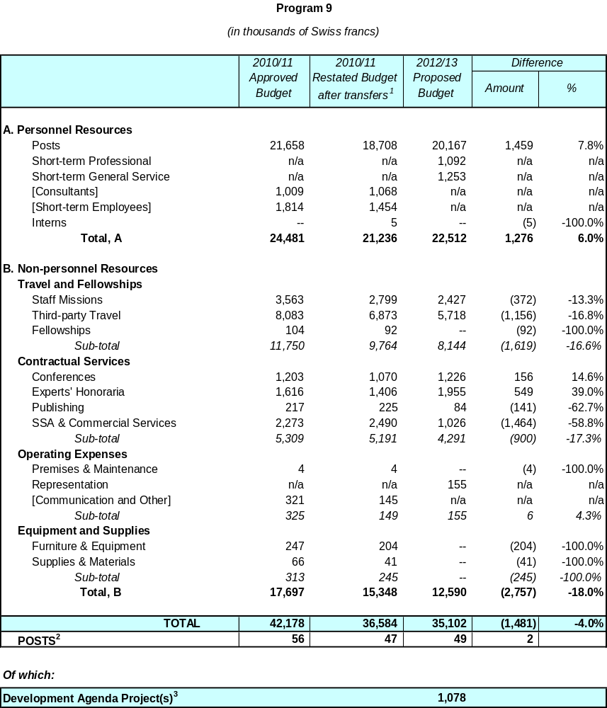

¹ Restated Budget after transfers reflects:

- the adjusted budget of Programs, following transfers during 2010/11 in line with Financial Regulation 5.5. For additional details on the 2010/11 Budget after Transfers, please refer to Table 10 (Annex I) Budget after Transfers by Program of this document and document WO/PBC/18/14 Program Performance Report for 2010;

- restatements of Program budgets for comparison with the 2012/13 proposed Program structure. For those Programs where restatements were not required, the Restated Budget after Transfers is equivalent to the Budget after Transfers, as referred to in document WO/PBC/18/14 Program Performance Report for 2010. For more detailed information on the restatements, please refer to Table 11 (Annex I) of this document.

² For further details on posts for the Program please refer to the Table in Annex II.

³ Includes projects on: (i) "Intellectual Property and Product Branding for Business Development in Developing Countries and Least-Developed Countries (LDCs)”, approved by CDIP; (ii) "South South cooperation on IP and Development among developing countries and LDC’s", subject to CDIP approval.

Fund-in-Trust Resources Potentially Available for Programming in 2012/13*
(in thousands of Swiss francs)**

Program | Projected Balance end 2011 | Estimated Contributions 2012/13*** | Estimated Available for Programming in 2012/13****
Program 9
Africa | 688 | 2,651 | 3,339
Asia and Pacific | 2,772 | 5,998 | 8,770
Latin America | 100 | 475 | 575
Total |  |  | 12,684

* For information only. It should be noted that some FIT Agreements provide resources for activities which extend beyond the region/program. For further details please refer to Annex V.

** The figures do not include interest and exchange rate adjustments. It should also be noted that these funds generally provide for activities spanning a period of time exceeding or overlapping a single biennium, as income is received and expenditure incurred.

*** Annual contributions vary and fluctuations have been observed from one year to another.

**** This figure is purely indicative and is based on previous funding patterns. It does not represent Member States’ commitments except in those cases where the FIT Agreement includes such a commitment.

Program 10 Cooperation with Certain Countries in Europe and Asia

PLANNING CONTEXT

- The key challenge for capacity-building activities in the regions covering Certain Countries in Europe and Asia, namely Central European and Baltic States, Central Asian, Eastern European and Caucasian countries, as well as some Mediterranean countries will be to provide effective, efficient, targeted and coordinated assistance to a broad range of countries at different levels of economic development and with widely different IP needs. For several of these countries, meeting even the more basic IP requirements of a market economy is still a challenge. On the other end of the spectrum, the 12 Central European and Baltic States that are members of the European Union (EU) as well as the Mediterranean countries are facing the challenge of using IP for economic development in a more competitive environment. Other countries in the region are preparing for membership in the EU and the European Patent Organization (EPO) and need to adapt their IP systems accordingly. With regard to such countries with a more sophisticated IP infrastructure, the challenge for WIPO is to provide more specialized assistance to meet their particular needs. Throughout the region, the recent international economic and financial crisis has increased the awareness of the role of IP and innovation in the process of economic recovery and economic development. This has led to a growing demand and higher expectations with regard to WIPO’s capacity to deliver systematic and focused support for the elaboration and implementation of these countries’ national IP and innovation strategies.

IMPLEMENTATION STRATEGIES AND RISKS

- The Program acts as WIPO’s primary interface with the countries in the region, focusing in particular on the four pillars identified in the MTSP 2010-2015, namely, national IP strategies and policies, legislative and regulatory frameworks, institutional and technical infrastructure, and human resource capacity building. The program will support and coordinate the input from all relevant programs within WIPO in this regard. The DA recommendations will continue to guide the Program in its technical assistance activities, in particular, recommendations 1-14, 17, 33, 38 and 40-43.

- Meeting the diverse IP needs and expectations of these countries will require a differentiated approach, country by country, that takes into consideration their different levels of economic and social development as well as their different IP infrastructures. This requires country-specific needs assessment activities which form the basis for the development of targeted national IP and innovation strategies. One of the Program’s key objectives is to significantly increase the number of countries with customized IP strategies. In this context, particular attention will be given to the need to involve all relevant national stakeholders and to obtain the commitment of the countries’ political leadership. The need to expand cooperation with the private sector remains a particular challenge in many of these countries.

- At the same time, the Program will take account of certain commonalities and shared features of the economic and IP systems of the countries in the region. In this regard, the Program will facilitate the sharing of experiences, best practices, and methodologies at sub-regional and inter-regional levels in order to enable countries to learn from their respective experiences.

- Some of the shared features and requirements of certain countries in Europe and Asia stem from the close relationship of a number of these countries with the EU. Cooperation with these countries will, where relevant, take into account requirements arising from EU membership, as well as the specific needs of acceding countries, candidate countries and countries benefiting from the EU’s New Neighborhood Policy and Eastern Partnership Policy. Synergies will be aimed for IP programs which these countries may be undertaking within an EU context or in the framework of the European Patent Organization (EPO). In addition, cooperation activities in member states of the Commonwealth of Independent States (CIS), in particular in cooperation with the Inter-State Council on the Protection of Industrial Property (ICPIP) and the Interparliamentary Assembly of the CIS Member States (IPACIS) will be duly taken into consideration with the aim to build synergies with these efforts. Cooperation with the regional Eurasian Patent Organization will continue to be given particular attention and will be further strengthened to promote links with the PCT system as well as to join efforts to facilitate the use of IP systems and assets for the sustainable development in the region.

- The implementation of a WIPO strategy in the Region is a large undertaking and will achieve its intended outcome only if properly resourced and managed. To avoid a major imbalance between an increasing demand for assistance on the one hand and limited resources on the other, the Program will strive to ensure that its activities are properly targeted, that they achieve the desired impact, and that they are delivered as efficiently as possible. The program will also aim for synergies with other international and regional partners.

RESULTS FRAMEWORK

Expected Results | Performance Indicators | Baselines | Targets
Clearly defined and coherent national innovation and IP policies, strategies and development plans consistent with national development goals and objectives | No of countries having developed national IP strategies or plans, dovetailed with national development goals | Six countries (2008/09) | Eight additional countries
Enhanced human resource capacities able to deal with the broad range of requirements for the effective use of IP for development in developing countries, LDCs and countries with economies in transition | % of trained IP office officials using upgraded skills in their work  % IP professionals attesting to an enhanced understanding of IP issues | Data not available  Data not available | 40%  30%
 | % of participants satisfied with the quality of workshops and seminars on innovation and its commercialization | General feedback available, but no specific data | 90%
Enhanced access to, and use of, IP information and knowledge by IP institutions and the public to promote innovation and increased access to protected creative works and creative works in the public domain | No. of national TISC networks launched  No of users serviced by TISCs per quarter and country | One national TISC network launched  (1 quarter 2011)  Tbd by end 2011 | Four additional national  TISC networks launched  Tbd by end 2011
 | No. of Member States that have developed their IP framework and established TTOs | Framework pilot project adopted and funding committed | Eight TTOs
Enhanced technical and knowledge infrastructure for IP Offices and other IP institutions leading to better services (cheaper, faster, higher quality) to their stakeholders | No. of Offices with fully automated vs partially automated IP administration systems provided by WIPO  No. of Offices with IP data online in WIPO databases | Four  Total 20  (regional breakdown tbd) | Four  Total 40  (regional breakdown tbd)
 | No. of Offices processing PCT and Madrid data with the support of WIPO supplied systems | Five | 20
Tailored and balanced IP legislative, regulatory and policy frameworks | No. of countries with updated national IP laws and/or regulations | Eight countries (2008/09) | 10 additional countries
 | No. of requests for and types of legislative advice related to patents, utility models, trade secrets and integrated circuits | In 2010, 12 comments were provided to Member States | 25 comments on drafts prepared by Member States and 10 draft laws prepared by the Secretariat
 | No. of countries which found WIPO's legislative advice related to patents, utility models, trade secrets and integrated circuits useful | Not available | 90%
 | % of countries which found the provided information concerning the legal principles and practices of the patent system, including the flexibilities existing in the system and the challenges it faces, useful | Not available | 90%
 | % of satisfied participants in targeted workshops/ seminars held on specific patent-related questions | Not available | 90%
 | No. of Member States having received legislative advice in the area of trademarks, industrial designs and geographical indications | No of Member States having received legislative advice in 2010/11 | Legislative advice provided to 10 Member States and/or Regional Groups of Member States
 | No. of countries providing positive feedback on the usefulness of the provided legislative advice in the area of trademarks, industrial designs and geographical indications | Data not available | 70%

RESOURCES FOR PROGRAM 10

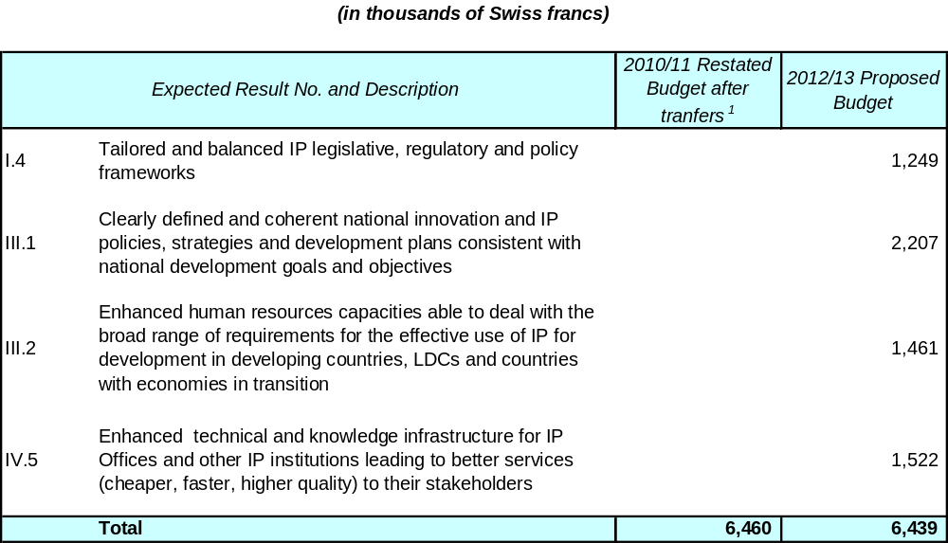

- The figures for 2010/11 Budget under personnel costs represent actual expenditure for 2010 and budgeted amounts based on standard costs for 2011. The budget for 2012/13 is prepared using standard costs for the next biennium. The increase in budgeted amount under Posts goes beyond the statutory increases incorporated in the standard costs due to the transfers during the course of 2010/11.

- The non personnel resources have been proposed at the same level as 2010/11, however, the budget allocation to cost category have been revised to reflect the intended utilization of resources for the Program delivery in the 2012/13 biennium. The increases under “Contractual Services”, including “Publishing”, primarily relates to development of specific tools and guidance materials for the overall use of IP assets for economic, social and cultural development in the countries covered. Furthermore, resources under “Third-party Travel” have been reduced to better reflect current expenditure patterns for the Program.

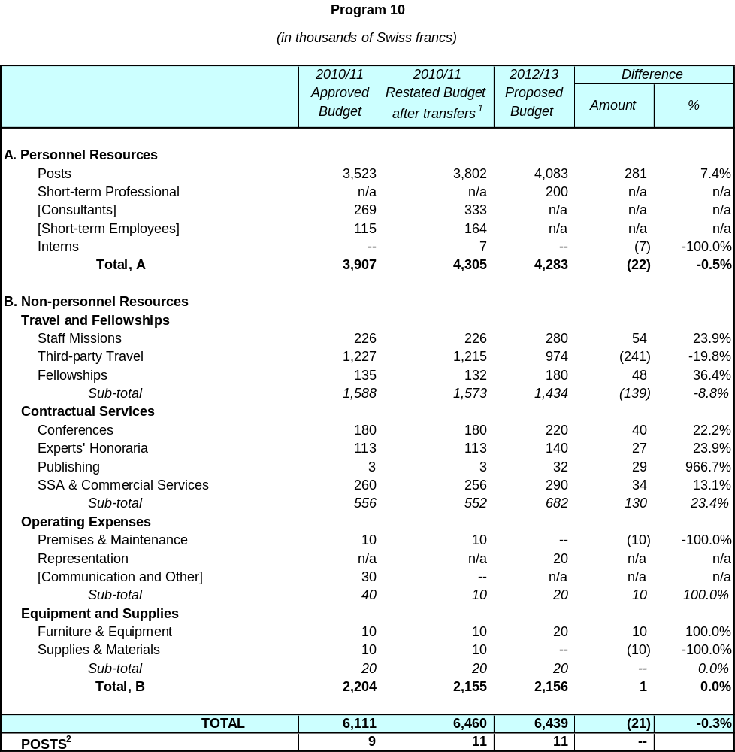

¹ Restated Budget after transfers reflects:

- the adjusted budget of Programs, following transfers during 2010/11 in line with Financial Regulation 5.5. For additional details on the 2010/11 Budget after Transfers, please refer to Table 10 (Annex I) Budget after Transfers by Program of this document and document WO/PBC/18/14 Program Performance Report for 2010;

- restatements of Program budgets for comparison with the 2012/13 proposed Program structure. For those Programs where restatements were not required, the Restated Budget after Transfers is equivalent to the Budget after Transfers, as referred to in document WO/PBC/18/14 Program Performance Report for 2010. For more detailed information on the restatements, please refer to Table 11 (Annex I) of this document.

² For further details on posts for the Program please refer to the Table in Annex II.

Program 11 The WIPO Academy

PLANNING CONTEXT

- The WIPO Academy (“The Academy”) offers educational, research and training programs for government officials, policy makers, academics, professionals and various stakeholders in the field of intellectual property (IP) and the management of IP rights (IPRs). The main challenge facing the Academy is to respond to the increasing number of requests from Member States in the context of human resource development and capacity building.

- At a time when information has never been more prolific, the need for ‘added value’ is critical. This is why the Academy focuses not just on information, but also on knowledge-generation. In all the Academy programs, participants complement their own experiences with guidance from professionals who know IP and how it works to stimulate innovation, creativity and development. Through high levels of interaction and a dynamic and empirical approach, the Academy packages specialized knowledge and, most importantly, helps build the capacity to apply that knowledge to add value in today’s networked, technology-driven world.

- The demand for growth by Member States pertains to significant areas of the Academy’s portfolio of programs by increasing: training of professionals from IP offices, collective management organizations, diplomats, academics, students, and young professionals; the offering of joint Masters Degrees and the introduction of IP in the curriculum of universities and other institutions; specialized and tailor-made distance learning courses in various languages; and, training of senior students and juniors professionals in the framework of the Summer Schools program. The Academy also continues to receive requests from developing countries for the introduction of customized and tailor-made Executive Programs to enhance the skills of local business communities.

- As set out in the MTSP, a further challenge of developing human resources is the need for expertise in cross-cutting issues at the intersection of law, technology and economics. A final challenge pertains to the effective translation of the objectives of the DA into the Academy’s undertakings and courses.

IMPLEMENTATION STRATEGIES AND RISKS

- To respond to the challenges faced by the Academy and to meet its core expected results, the Academy will continue to play a central role in delivering training and capacity building, in particular in accordance with DA Recommendations 1, 3 to 6, 12, 33, 38 and 41 including through customized programs and new approaches and methodologies, which will be continuously evaluated for quality. To this end, the Academy will continue to work closely with Programs 1 to 7, 14, 16 to 18 for the development of the substantive content of its training courses. Programs 8 to 10 will continue to assist the Academy in the delivery phase.

- By adopting an interdisciplinary approach to IP education, the Academy will continue to provide IP courses to a broad audience during the 2012/13 biennium. Traditional face-to-face and distance learning methodologies will continue to be used and enhanced in the design of training programs to expand the reach of the Academy to an increasing number of recipients. Partnerships with 30 national and four regional IP offices will be strengthened and joint programs will be offered for the benefit of the Member States. In the same vein, cooperation with universities and higher educational institutions for joint offering of Masters Degree and diploma programs, on the one hand, and, on the other, cooperation with partner institutions in the field of on-line courses in various languages, will continue to be reinforced. Collaboration with business associations and higher academic institutions from developing and least-developed countries, as well as countries with economies in transition, will be strengthened to enable business communities from these countries to benefit from the specifically targeted Executive Program. Partnerships with academic institutions and IP offices will enable the Academy to continue to offer Summer Schools in different locations to equip students and young professionals with cross-cutting IP knowledge. The Development Agenda Start-Up National Academy project will provide means to developing countries and LDCs to increase skills of a wide range of stakeholders, including professionals and academics. The Global Network of IP Academies established in 2008 will continue to be hosted by the Academy to allow Member States to share experience, reference materials and resources for training, with a view to promoting efficient and coherent approaches to capacity building in the field of IP.

- To achieve its expected results, the Academy’s portfolio of activities and tailor-made programs in the next biennium will comprise:

- The Professional Development Program which will continue to offer courses in industrial property and copyright and related rights at the intermediate and advanced levels. Specialized courses in IP for specific target audiences in cooperation with its long-standing partner institutions will continue to be delivered. To respond to the requests for more training on management and innovation, in cooperation with the Technology and Innovation Sector and external partners, the Academy will offer these specialized courses for the benefit of senior officials from research and development institutions (R&D) and transfer of technology centers from developing countries and countries with economies in transition. New courses targeting copyright collective management organizations have been developed and offered to empower the stakeholders in this field. Cooperation with the WTO will be strengthened for the training of government officials.
- The Distance Learning Program which will offer: the Primer on IP course (DL-001); the General Course on IP (DL-101); Primer on the PCT (DLPCT- 101) in seven languages; and, 11 advanced and specialized courses, namely Copyright and Related Rights (DL-201), IP and Electronic Commerce (DL-202), IP and Biotechnology (DL-204), Patents (DL-301), Trademarks (DL302), WIPO Arbitration and Mediation Rules (DL-317), Patent Information Search (DL-318), Basics of Patent Drafting (DL-320), IP Management in the Publishing Industry (DL-401), IP Management (DL-405), and the joint WIPO-University of South Africa Certificate Program on Specialization on IP. Three new specialized courses will be developed on traditional knowledge (DL-330), IP and economics (DL-420), and IP and public health (DL-430). The WIPO DA will be incorporated in the DL-101, DL-301, and DL-302 courses. The on-line courses will continue to serve as a prerequisite for professional training courses and as a complement to academic teaching programs in a number of universities. Efforts will also be made to translate the DL courses in additional languages as requested by Member States.
- The Academic Institutions Program which will offer with a number of academic institutions, joint Masters Degree courses for the benefit of developing countries and countries with economies in transition. As of 2012, the Academy will jointly offer regional Master Degrees in IP with universities in Latin America, Asia and Eastern Europe. The Academy will assist academic institutions by providing them with tailor-made technical and expert advice on the design of new programs or updating of existing programs. The Colloquium for IP Teachers will be organized jointly with the WTO for the benefit from IP Professors from developing countries.
- The redesigned Executive Program will be organized for the benefit of IP managers, executives, entrepreneurs, senior general and technical executives, managers of legal departments and other stakeholders from developing countries, LDCs and countries with economies in transition. The Program will target business executives from countries where IP executive education is unavailable. Quality of service will be ensured by engaging well-experienced and qualified resource persons. Specially designed pedagogy will be applied for interactive discussion based learning in intense three-day training sessions.
- The WIPO Summer Schools Program which will be offered in different localities to provide opportunities to students and young professionals to appreciate the importance of IP for development and the role played by WIPO, adopting the interdisciplinary dimension of IP as a key approach of teaching. During the 2012/13 biennium, two pilot Specialized Summer School Courses on Copyright and Related Rights and on Industrial Property will be organized. In total, at least six courses will be held and a rotational approach will be applied.
- A phase 2 of the Development Agenda National Start-Up Academy Project will be subject to the evaluation of phase 1 and approval of phase 2 by the CDIP.
- The Global Network of IP Academies which has created synergies among the specialized IP academies and training institutions of Member States. To increase membership, the Global Network is now open to any academic institution being public or private.
- Managing the balance between available resources and the increasing demands on both the quantity and quality of the Academy’s activities is the single major risk that could jeopardize the successful achievement of the expected results. In addition, as most of the programs of the Academy are in partnerships with cooperating institutions. Non-participation of some in the joint activities, due to financial constraints, could have an impact on the delivery of services.

RESULTS FRAMEWORK

Expected Results | Performance Indicators | Baselines | Targets
Enhanced human resource capacities able to deal with the broad range of requirements for the effective use of IP for development in developing countries, LDCs and countries with economies in transition | % of IP office trainees that report satisfaction with the training provided  % of trainees that report actual use of the acquired skills in their job | 80%  60% | 90%  80%
 | % of supervisors attesting to satisfactory application of acquired skills after one year of training | 60% | 70%
 | No. of graduates from WIPO academy and partner academic institutions (joint offering) | 60 | 75
 | No. of participants trained under the WIPO Summer Schools annually | 600 | 500
 | No. of IP teachers trained | 30 | 36
 | No. of start up academies established (DA project) | 2 | 4
 | No. of new inter-institutional cooperation agreements | 2 | 3
Easier access to IP education | No. of online registrations to DL courses | 100,000 | 100,000
 | Completion rate of DL courses | 60% | 75%
 | % of DL course participants having passed the exam | 65% | 75%
 | No. of Academy courses incorporated in educational institutions curricula | 8 (2010/11) | 8
 | No. of new online courses / at different levels of specialization | 2 (2010/11) | 3
 | No. of languages in which courses are offered | 11 | 11
 | No. of scholarships for developing countries, LDCs and countries with economies in transition | 1,000 (2010/11) | 1,400
Upgraded IP Management skills for business | % of participants that report satisfaction with the training provided | 80% | 90%
 | % of trainees that report actual use of the acquired skills in their job | 60% | 70%
 | No. of requests for courses | Two courses per year | Three courses per year

RESOURCES FOR PROGRAM 11

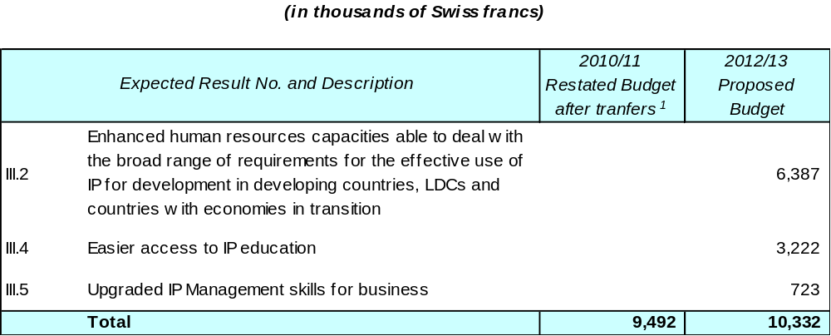

- The figures for 2010/11 Budget under personnel costs represent actual expenditure for 2010 and budgeted amounts based on standard costs for 2011. The budget for 2012/13 is prepared using standard costs for the next biennium. The increase in budgeted amount under Posts for Program goes beyond the statutory increases incorporated in the standard costs as a result of a lower base in 2010 actual expenditure due to vacancies in the Program.

- The proposed increases under non-personnel resources are mainly linked to the eventual Phase 2 of the “Pilot Project on the Establishment of “Start-up” National Academies”, subject to evaluation of Phase 1 and subject to CDIP approval of Phase 2. The project will contribute to providing easier access to IP education.

- The proposed increases under the Program also reflect the re-allocation of some resources from Program 8, mainly under the “Contractual Services” in order to accommodate the re-designed Executive Program. This program will be tailored for IP managers, executives, entrepreneurs, senior general and technical executives and managers of legal departments from developing countries, LDCs and countries with economies in transition, with particular focus on those countries where IP executive education is unavailable.

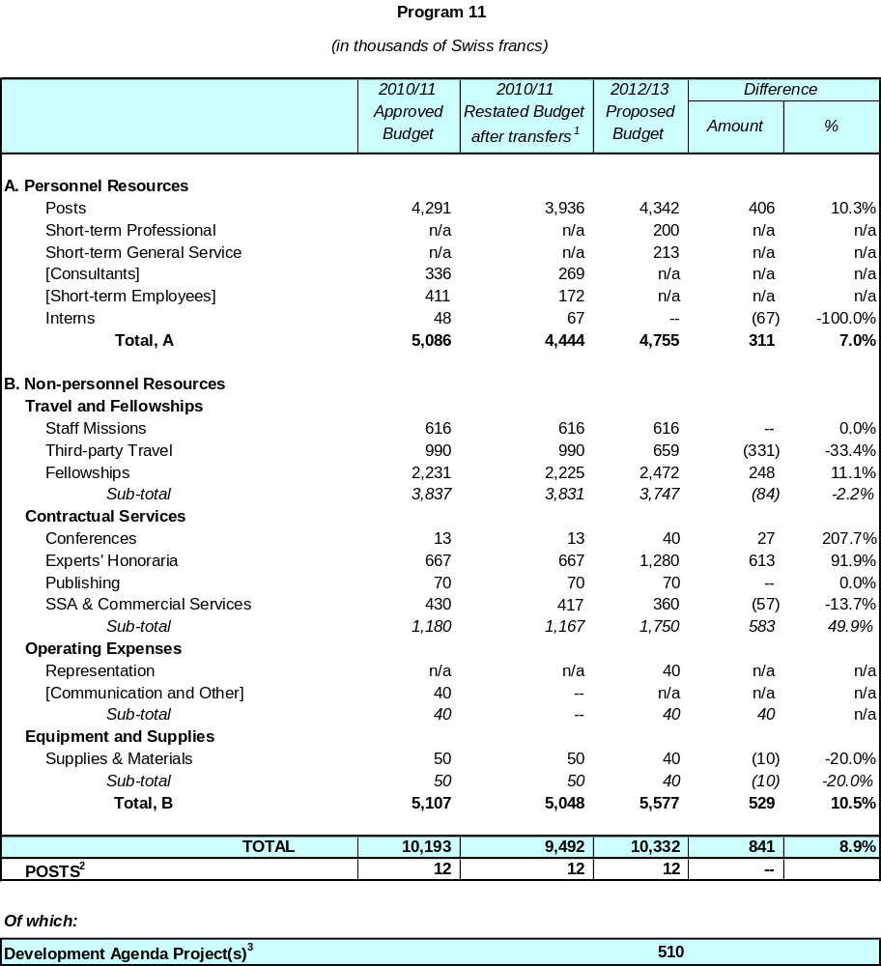

¹ Restated Budget after transfers reflects:

- the adjusted budget of Programs, following transfers during 2010/11 in line with Financial Regulation 5.5. For additional details on the 2010/11 Budget after Transfers, please refer to Table 10 (Annex I) Budget after Transfers by Program of this document and document WO/PBC/18/14 Program Performance Report for 2010;

- restatements of Program budgets for comparison with the 2012/13 proposed Program structure. For those Programs where restatements were not required, the Restated Budget after Transfers is equivalent to the Budget after Transfers, as referred to in document WO/PBC/18/14 Program Performance Report for 2010. For more detailed information on the restatements, please refer to Table 11 (Annex I) of this document.

² For further details on posts for the Program please refer to the Table in Annex II.

³ Includes "Pilot Project on the Establishment of “Start Up” National Academies", subject to evaluation of Phase 1 and subject to CDIP approval of Phase 2.

Fund-in-Trust Resources Potentially Available for Programming in 2012/13*
(in thousands of Swiss francs)* *

Program | Projected Balance end 2011 | Estimated Contributions 2012/13*** | Estimated Available for Programming in 2012/13****
Program 11 | 649 | 500 | 1,149

* For information only. It should be noted that some FIT Agreements provide resources for activities which extend beyond the region/program. For further details please refer to Annex V.

** The figures do not include interest and exchange rate adjustments. It should also be noted that these funds generally provide for activities spanning a period of time exceeding or overlapping a single biennium, as income is received and expenditure incurred.

*** Annual contributions vary and fluctuations have been observed from one year to another.

**** This figure is purely indicative and is based on previous funding patterns. It does not represent Member States’ commitments except in those cases where the FIT Agreement includes such a commitment.

STRATEGIC GOAL IV
Coordination and Development of Global IP Infrastructure

Information and Communication Technology (ICT) has created opportunities for greater efficiencies in the international IP system, more effective access to the output of the system, and increased participation in the system by least developed, developing and transition countries. The aim of this Strategic Goal is to strengthen the infrastructure of least developed, developing and transition countries, to enhance international cooperation in infrastructure and data flows throughout the system, and to develop global IP databases and voluntary platforms for increased technical cooperation.
The coordination and development of global IP infrastructure also contributes to Strategic Goal III (Use of IP for Development), Strategic Goal II (Provision of Premier Global IP Services) and Strategic Goal V (World Reference Source for IP Information). It includes the implementation of a number of Development Agenda Recommendations.

Expected Results | Performance Indicators | Responsible Program(s)
Updated and globally accepted system of international classifications and WIPO standards to facilitate access, use and dissemination of IP information among stakeholders in the world | No. of Offices using WIPO standards  No. of amendments to the Nice Classification  Unified ECLA and FI in the IPC | Program 12  Program 12  Program 12
 | Integration in Locarno Classification of a tool for searching visual features of design applications | Program 12
 | No. of amended and new standards adopted | Program 12
 | No. of Offices indicating satisfaction following training to improve their skills in the use of classifications | Program 12
 | No. of users accessing the internet publications of international classifications and standards, in particular from developing countries | Program 12
Enhanced access to, and use of, IP information and knowledge by IP institutions and the public to promote innovation and increased access to protected creative works and creative works in the public domain | No. of different users per quarter/system (PATENTSCOPE/Global Brand Database)  No. of languages in which cross-lingual search is available | Program 13  Program 13
 | No. of national TISC networks launched | Program 14  Program 9  Program 10
 | No. of users serviced by TISCs per quarter and country | Program 14  Program 9  Program 10
 | No. of users of the value-added information services (technology search service, Patent Landscape Reports and ICE) | Program 14
 | % of recipients satisfied with the value-added information services (technology search service, Patent Landscape Reports and ICE) | Program 14
 | No. of Member States that have developed their IP framework and established TTOs | Program 1  Program 9  Program 10
 | No. of trusted intermediaries (TIs) and rights holders (RHs) having joined the TIGAR system network, including from developing countries and LDCs | Program 3
 | No. of copyright protected works distributed among TIs and made accessible to VIPs across borders through the TIGAR system network | Program 3
 | No. of entities making data available to the IMR | Program 3
 | No. of commercial users of IMR | Program 3
Increased dissemination of digitized patent collections of national/regional offices of WIPO Member States | No of records in PATENTSCOPE/Global Brand Database which are not produced by the IB | Program 13
 | No. of national collections in PATENTSCOPE | Program 13
 | No. of national collections in Global Brand Database | Program 13
Timeliness of PATENTSCOPE updates regarding PCT applications | Delay (in months) in implementation of PCT rule changes concerning PATENTSCOPE | Program 13
 | No. of weeks per year where publication is not available at 20:00 Geneva time on publication day | Program 13
Enhanced technical and knowledge infrastructure for IP Offices and other IP institutions leading to better services (cheaper, faster, higher quality) to their stakeholders | No. of Offices with fully automated versus partially automated IP administration systems provided by WIPO | Program 15  Program 9  Program 10
 | No. of Offices with IP data online in WIPO databases | Program 15  Program 9  Program 10
 | No. of Groups of Offices participating in a common platform | Program 15  Program 9  Program 10
 | No. of Offices processing PCT and Madrid data with the support of WIPO supplied systems | Program 15  Program 9  Program 10
 | No. of Institutions using WIPO copyright infrastructure systems (WIPOCOS and GDA) | Program 3
 | % of Governments that report positively on the effectiveness and governance of copyright institutions in the country | Program 3

Program 12 International Classifications and Standards

PLANNING CONTEXT

- Global infrastructure of IP systems increasingly need interlinked and interoperable platforms and databases. International classifications and standards are crucial tools and instruments to bridge various IP offices working in different systems and languages, and to enable data to flow on a common platform and databases. With technologies, business solutions and collaborative arrangements of IP offices constantly evolving, international classifications and standards also need to be dynamically updated and refined.

- Against this background, WIPO aims at providing Member States with the most updated and globally accepted system of international classifications and WIPO standards to facilitate access, use and dissemination of IP information among various stakeholders worldwide. In that respect, the activities of this Program have a direct link to Recommendations 30 and 31 of the DA.

IMPLEMENTATION STRATEGIES AND RISKS

- Strategies in the 2012/13 biennium will focus on further improving and developing the International Classifications and Standards through extensive use of e-fora and physical meetings of the respective Committees. In addition, demand-driven training will be provided for the use of the Classifications and Standards, in particular in developing countries.

IPC (International Patent Classification)

- Enhancement of the IPC will continue within the auspices of the IPC Committee of Experts through simplification (an initial stage was successfully implemented and became operational in 2011) and possible convergence or integration of the three classification systems (the European Classification System (ECLA) of EPO, the File Index (FI) of JPO and the US Classifications (USCLA) of USPTO) into the IPC, taking into account the Common Hybrid Classification of the Foundation project of IP5 (EPO, Korean Intellectual Property Office, JPO, China State Intellectual Property Office and US{TO). Subject to general agreement on a new structure of the IPC, WIPO will make necessary changes in the ICT system to support the new IPC and coordinate with Member States of the IPC Union during a transitional period which could start in 2013 and end in 2016.

Nice Classification (list of goods and services for registration of trademarks)

- The reform of the Nice Classification started in 2010. A decision was taken to integrate a taxonomy in the new structure which will allow, firstly, easier navigation between Nice classes and the list of individual goods and services and, secondly, rapid integration of goods and services coming from databases developed separately by various offices, including WIPO (the Madrid system), OHIM (Community Trademarks), USPTO and JPO. This will require close cooperation with Program 6 (Madrid and Lisbon Systems). The new publication platform will be in production by 2012, as approved by the Nice Committee of Experts (paragraphs 20 to 26 of document CLIM/CE/21/3), allowing the integration of new features such as synonyms, links to similar goods or services across Classes, links to definitions of some goods, classification reports, and links to WIPO Brand Database (in coordination with Program 13 (Global Databases). The Nice Committee of Experts will start meeting annually instead of every five years and, by extensive use of e-fora, new goods and services will be introduced into the Classification every year, allowing a swift and timely integration of elements from existing databases.

Locarno Classification (Industrial Design)

- Improvement of the Locarno Classification by integrating indexing of visual aspects has started and is expected to be approved by the Locarno Committee of Experts during the biennium. A new structure of the Locarno Classification, in line with the new Nice structure and integrating the above indexing, will be introduced before the end of 2013.

Standards

- Further development of new WIPO Standards or the revision of existing Standards should provide a basis for the transmission, exchange, dissemination and sharing of IP information and documentation. Important tasks include the enhancement of existing XML Standards (for a better structured digital data format) and, in particular, the development and adoption of ST.96, the common XML standard for the three IP modalities, namely patents, trademarks and industrial designs. This will require close cooperation with Programs 5 (PCT system) and 6 (Madrid, Hague and Lisbon systems). The use of the recently developed new database and publication platform, WIPO STAD (accessible through WIPO GOLD), will contribute to the further enhancement of the work for the development and revision of WIPO IP Standards, recommendations and guidelines, and for sharing the current practices of IP offices in the domain of IP information.

ICT systems for International Classifications and Standards

- ICT systems managing these tools will be upgraded and consolidated. The IPC management system needs a system development to accommodate the new structure of the IPC which will increase the number of IPC groups three-fold. A new database will be developed for the Nice Classification in order to allow complete control by the International Bureau of the revision and publication of the Nice Classification given its more frequent revision and introduction of new features. Synergy with the IPC revision and publication infrastructure will be maximized in order to foster cost and time-efficient development. The electronic fora, which have been used with considerable success for more than 10 years, initially in the IPC environment and recently extended to the other Classifications, will be further enhanced in order to facilitate decision-making on routine issues and global data input by Offices to be introduced in the databases, thus reducing the need for additional capture.

- The principal risk faced by the Program is related to the major changes and developments of the IT infrastructure which could result in delaying the implementation of the new structures of the Classifications. This risk will be offset by the use of common elements across areas of Program 12 based on proven technologies. Furthermore, separate applications will be developed sharing data in common XML format in such a manner that problems in development of an application would have less impact on the complete infrastructure. In that respect, the e-fora, the publication platforms, the web services for creating amendments to the Classifications, the core databases and the handling of the Committee decisions would be developed separately, despite sharing common data-files.

RESULTS FRAMEWORK

Expected Results | Performance Indicators | Baselines | Targets
Updated and globally accepted system of international classifications and WIPO standards to facilitate access, use and dissemination of IP information among stakeholders in the world | No. of Offices using WIPO standards  No. of amendments to the Nice Classification | Tbd end 2011  300 modifications per year in the two languages (average of 2006-2010) | Tbd end 2011  Additional 2,000 terms from trilateral list and correction of 4,000 terms from linguistic improvement
 | Unified ECLA and FI in the IPC | Separate publications of ECLA and FI in national databases | ECLA and FI included in official IPC publications
 | Integration in Locarno Classification of a tool for searching visual features of design applications | Absence of tool | Development of an indexing scheme for Locarno
 | No. of amended and new standards adopted | Average 2010/11: tbd end 2011 | Tbd end 2011
 | No. of Offices indicating satisfaction following training to improve their skills in the use of classifications | Tbd end 2011 | Tbd end 2011
 | No. of users accessing the internet publications of international classifications and standards, in particular from developing countries | Tbd end 2011 | 5% increase compared to baseline

RESOURCES FOR PROGRAM 12

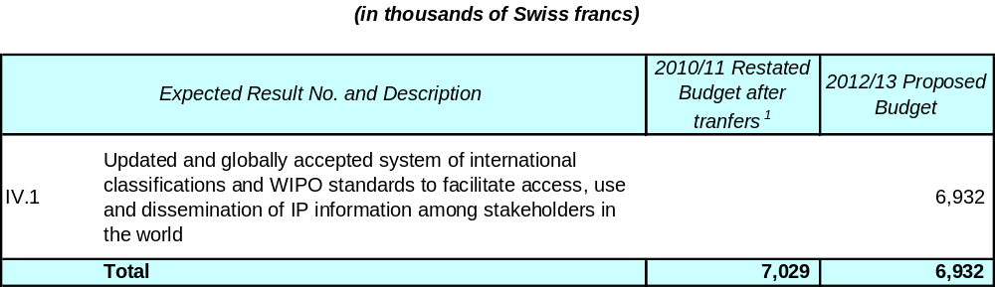

- The figures for 2010/11 Budget under personnel costs represent actual expenditure for 2010 and budgeted amounts based on standard costs for 2011. The budget for 2012/13 is prepared using standard costs for the next biennium.

- The proposed increase in “Staff Missions” relates primarily to training activities in the field of international classifications of trademarks and designs, for which the demand from developing countries is high.

- The proposed resources under “Expert’s Honoraria” relates to the update and maintenance of the database of the International Patent Classification (RIPCIS); participation in the publication of official versions of the Nice, Vienna and Locarno Classifications as well as support to the Committee of WIPO Standards (CWS) and its Task Forces.

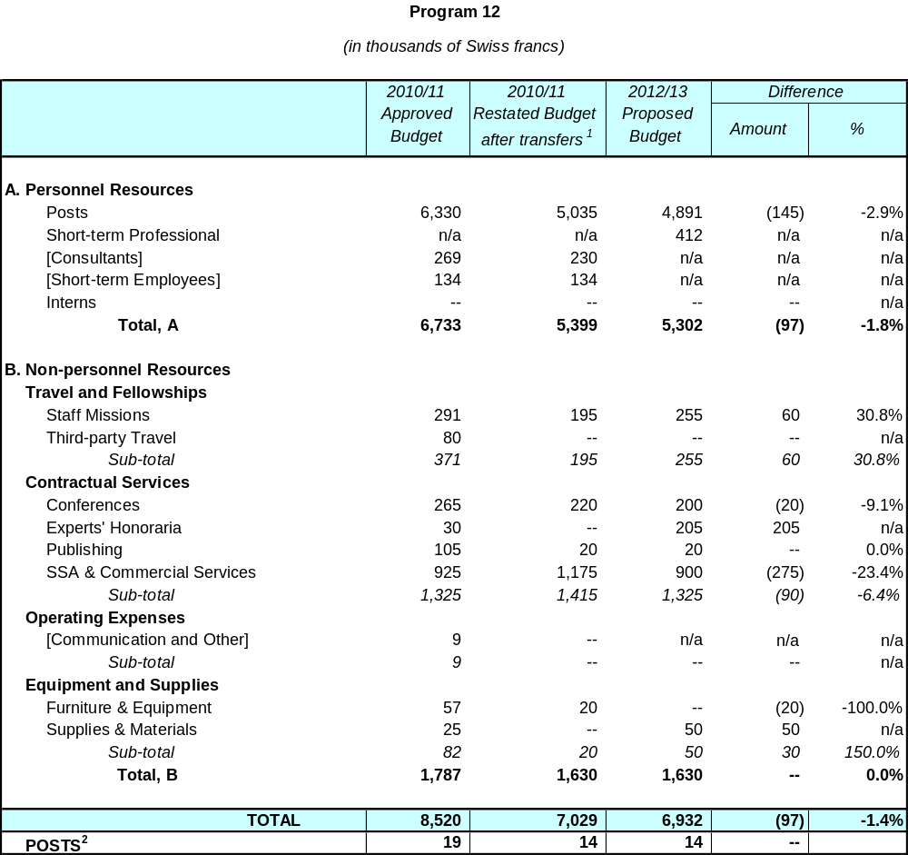

¹ Restated Budget after transfers reflects:

- the adjusted budget of Programs, following transfers during 2010/11 in line with Financial Regulation 5.5. For additional details on the 2010/11 Budget after Transfers, please refer to Table 10 (Annex I) Budget after Transfers by Program of this document and document WO/PBC/18/14 Program Performance Report for 2010;

- restatements of Program budgets for comparison with the 2012/13 proposed Program structure. For those Programs where restatements were not required, the Restated Budget after Transfers is equivalent to the Budget after Transfers, as referred to in document WO/PBC/18/14 Program Performance Report for 2010. For more detailed information on the restatements, please refer to Table 11 (Annex I) of this document.

² For further details on posts for the Program please refer to the Table in Annex II.

Program 13 Global Databases

PLANNING CONTEXT

- Through this Program, WIPO contributes to the creation of global IP infrastructure by providing IP knowledge content, as public goods, available through global databases. The digitization of patent data and the rise of web-based technologies opened up the possibility of developing global databases of IP data as well as effective and powerful search tools. WIPO global databases such as PATENTSCOPE and GLOBAL BRAND DATABASE, accessible through WIPO GOLD services, include data from the collections of PCT, Madrid, Lisbon and Paris 6ter emblems. The databases also include data related to national and regional applications/registrations contributed by interested IP Offices which have agreed to develop the WIPO global databases as world reference resources for a ”one-stop search” strategy. Two key challenges relate to the processing of original data sources, which often exist in different formats and are of poor quality, for uploading, and the development of intelligent search tools for multi-language and image search. The Program provides support, in particular, for the implementation of DA Recommendations 24 and 31 with opportunities for knowledge transfer and for bridging the digital divide, by increasing multilingual access to documentation and by increasing the range and scope of searchable documents.

- Global public information goods in the form of databases with worldwide coverage and effective search tools will assist Member States in making their data available for wider dissemination and in performing the most effective searches. The databases are thus expected to narrow the knowledge gap by increasing the number of users of IP information, including in developing countries and LDCs, and provide data to promote innovation. The Program will also ensure the publication of the PCT international applications in accordance with the relevant legal obligations and provide WIPO Global Databases assets as foundation and support for the implementation of Programs 14 (Services for Access to Knowledge) and 15 (Business Solutions for IP Offices).

IMPLEMENTATION STRATEGIES AND RISKS

- In the biennium, WIPO will expand the following global databases in terms of their geographical coverage of data collections and the quality of data in collaboration with interested IP offices which agree on standardized data formats and coordinated policies on the exchange and usage of data. New national patent collections will be made searchable in full text using WIPO’s in-house Optical Character Recognition (OCR) conversion processes. New functionalities will broaden the appeal of the services provided in a cost-effective manner by outsourcing quality control and creating awareness of the services through seminars and promotional materials/activities.

- WIPO PATENTSCOPE: PATENTSCOPE is the legal mechanism for publication of the international PCT applications and a patent database covering PCT and national and regional patent collections. The system will be further developed to cover some 30 million patent documents by the end of the biennium. Main challenges include the processing of the high volume of data and improving the quality of the data received, ensuring timeliness and completeness of the disseminated data, overcoming linguistic barriers and maximizing the number of national collections.

- WIPO BRAND DATABASE: The database covering international registrations under the Madrid and Lisbon systems, national and regional trademark data collections, and emblems protected under the Paris Convention Article 6^{ter}, will be further developed to cover some 10 countries during the biennium. Possible extension to industrial designs will be explored. Main challenges include the uploading of more data in different data formats and the implementing of an efficient image similarity search system for trademarks.

- Multi-Languages Search Support: The search functions of all databases will be enhanced by multiple languages tools such as Cross Lingual Information Retrieval (CLIR) and machine translation for abstracts. Other functions such as citation extraction, patent landscape visualization/analysis, image similarity searching, patent family grouping, chemical and gene information extraction will also be explored.

- Coordination with Program 15 should assist more Member States in using their business solutions including digitization projects for participating in global databases projects. Data cleaning and uploading will be rationalized by systemic approaches based on standards (in cooperation with Program 12). Coordination with Program 14 should enhance the usability of global databases.

- The development of global databases depends largely on effective and close collaboration with participating IP offices, involved industrial partners and outsourcing agencies with regard to ensuring acceptable quality of supplied data and completeness of data collections. New search functions will also involve some risk in that no viable technological solutions exist at present. These risks will be mitigated by sharing responsibilities between participating IP offices and WIPO, using international standards and best practices to the greatest extent possible, as well as practical and realistic planning of development of new technologies, where necessary, with qualified partners.

RESULTS FRAMEWORK

Expected Results | Performance Indicators | Baselines | Targets
Enhanced access to, and use of, IP information and knowledge by IP institutions and the public to promote innovation and increased access to protected creative works and creative works in the public domain | No. of different users per quarter/system (PATENTSCOPE/Global Brand Database)  No. of languages in which cross-lingual search is available | Tbd end 2011  5 | Tbd end 2011  9
Increased dissemination of digitized patent collections of national/regional offices of WIPO Member States | No. of records in PATENTSCOPE/Global Brand Database which are not produced by the IB | PATENTSCOPE: seven million documents (Feb 2011)  Global Brand Database: 0 | PATENTSCOPE: 30 million documents  Global Brand Database: two million
 | No. of national collections in PATENTSCOPE | 18 | 40
 | No. of national collections in Global Brand Database | n/a | 10
Timeliness of PATENSCOPE updates regarding PCT applications | Delay (in months) in implementation of PCT rule changes concerning PATENTSCOPE | 0 | 0
 | No. of weeks per year where publication is not available at 20:00 Geneva time on publication day | 0 | 0

RESOURCES FOR PROGRAM 13

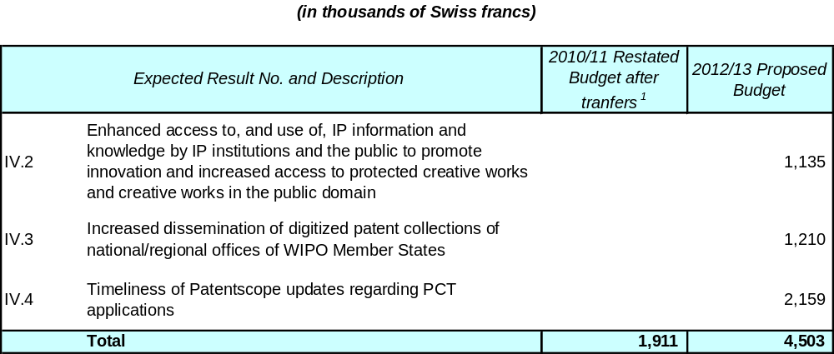

- The overall proposed increase for Program 13 is mainly due to the split of Global Databases related activities from the Services for Access to Knowledge (Program 14) during the 2010/11 biennium. As a result, the 2010/11 restated budget after transfers for Program 13 shows the cost of Global Database for only one year (2011).

- The proposed increase in “SSA and Commercial Services” is also due to the significant increase in the number of collections and documents to be included in the PATENTSCOPE platform, which will represent an increase in loading, OCR and proof-reading activities.

- The proposed increase under “Equipment and Supplies” relates mainly to an increase in hardware maintenance costs due to increased levels of multilingual searching and larger data amounts.

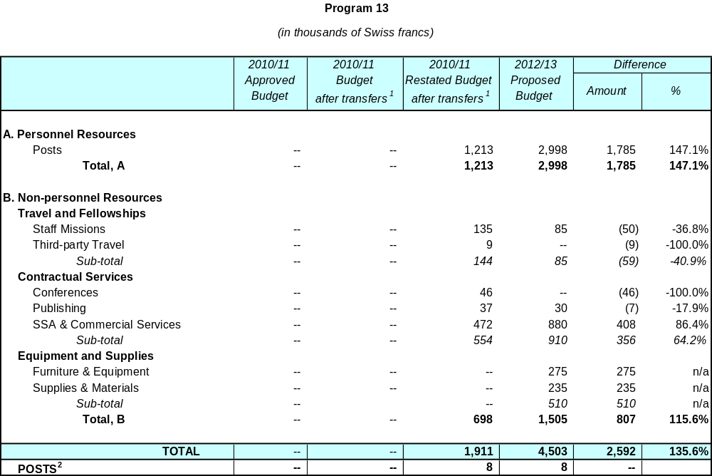

¹ Restated Budget after transfers reflects:

- the adjusted budget of Programs, following transfers during 2010/11 in line with Financial Regulation 5.5. For additional details on the 2010/11 Budget after Transfers, please refer to Table 10 (Annex I) Budget after Transfers by Program of this document and document WO/PBC/18/14 Program Performance Report for 2010;

- restatements of Program budgets for comparison with the 2012/13 proposed Program structure. For those Programs where restatements were not required, the Restated Budget after Transfers is equivalent to the Budget after Transfers, as referred to in document WO/PBC/18/14 Program Performance Report for 2010. For more detailed information on the restatements, please refer to Table 11 (Annex I) of this document.

² For further details on posts for the Program please refer to the Table in Annex II.

Program 14 Services for Access to Knowledge

PLANNING CONTEXT

- This Program is designed to support the last segment of a value chain from creation to use of Global IP Infrastructure. It aims at providing a variety of services which would make knowledge created by global infrastructure more accessible to IP institutions including IP offices and Technology Innovation Support Centers (TISCs), and to a broad public, particularly in developing countries, LDCs and countries with economies in transition.

- Despite more availability of searchable digital content in databases on the Internet and access to specialized databases, the use of tools and content has not reached the level of expectation in many developing countries and LDCs. In addition to insufficient awareness, this is mainly due to the lack of users’ capacity. In this biennium, WIPO will focus on services for capacity building to facilitate the use of a wide array of tools, to better understand search results of content in databases, and to utilize effectively knowledge from IP systems for promoting innovation. The DA included several projects in the last biennium in pursuit of improved access to information and knowledge, in particular in the public domain. The main difference from the previous Program 14 is that this re-focused Program 14 will concentrate on the provision of value-added high quality technology information services as key resources for strengthening innovation, particularly in developing countries and LDCs.

- Through this Program, therefore, knowledge created by IP systems will be made more accessible to IP institutions and the public. This will in turn narrow the knowledge gap and promote innovation. The Program is expected to make a significant contribution towards implementing DA Recommendations 8, 16, 19, 20, 30, and 31.

IMPLEMENTATION STRATEGIES AND RISKS

- The main services provided by WIPO under Program 14 are grouped in three areas as follows:

Creating TISCs

- The DA project “Specialized Databases’ Access and Support” received requests from some 40 countries for assistance in creating TISCs. TISCs were established in several countries in the biennium 2010/11. The remaining requests which have not been met would be dealt with in the biennium, subject to the CDIP’s approval of an extension of the project based on the evaluation of the initial results. WIPO would continue to lay the foundation for providing locally available technology information services to individual inventors, small and medium-sized enterprises, and other stakeholders in developing countries and LDCs. While assisting in creating more TISCs, in line with DA Recommendations 1, 6 and 10 and in close cooperation with Programs 9 and 15, Program 14 will also reinforce the capacities of TISCs through the provision of a variety of services including a structured training program for TISC staff with e-learning modules.

- To support TISCs and other relevant institutions, services will be upgraded by the provision of access to specialized content as follows:

- Access to major science and technical journals databases through the Access to Research for Development and Innovation (aRDi) project for free or at extremely low cost; and,
- Access to commercial patent databases through the Access to Specialized Patent Information (ASPI) project, for free or at extremely low cost.

- Both projects are initial successful results from WIPO partnerships with electronic publishers and private patent database vendors in 2009 and 2010, respectively, to promote access to knowledge in developing countries and LDCs. In order to further promote the projects, while expanding the content, priority will be given to cooperation with existing partners, and specialized agencies of the United Nations implementing sister programs, in the planning and implementation of joint training and awareness-raising activities.

- The sustainability and self-supporting operation of TISCs depend on shared responsibilities between the host government and WIPO. Availability of financial and human resources among potential TISC host institutions may be limited. To mitigate this risk, WIPO encourages institutions interested in hosting TISCs to use existing human resources as available (e.g., on a part-time basis) and takes into account the need to train a greater number of potential TISC staff in order to ensure that a sufficient number of trained individuals are available to staff TISCs.

- The promotion of TISCs services and active use of aRDi and ASPI also need greater efforts made by all stakeholder groups. WIPO will develop interactions and cooperation within national networks and across different networks through joint events and an e-platform designed to enable TISCs to exchange experiences and best practices.

Value-added information and coordination for IP offices and IGOs

- Since the 1980s, WIPO has provided developing countries and LDCs with two services of patent information, namely, Patent Information Services (WPIS) and International Cooperation for the Search and Examination of Inventions (ICSEI). In 2012/13, these services will be remodeled, integrated and upgraded to fit the objectives of the Program in support of access to knowledge and capacity building. Services will include:

- Technology search service which provides simple search reports of patent information to be provided by donor IP offices that volunteer to respond to requests from IP offices with insufficient capacity in developing countries and LDCs;

- Patent Landscape Reports (PLR) service which provides reports containing more value-added information analyzing and contextualizing search results of patent information, introduced during the implementation of the thematic DA project on “Developing Tools for Access to Patent Information”. Subject to the extension of the thematic project by the CDIP after the evaluation of the project, more PLRs would be produced in response to demands from developing countries. The PLR service will be coordinated with Program 1 and 18;

- Following the completion of WIPO feasibility study on the support for national patent legal status databases which was requested under the DA thematic project on ”Intellectual Property and the Public Domain”, and subject to the approval of further activities for greater access to national patent legal status data, WIPO will explore new services such as patent legal status inquiry service for Member States and IGOs, and possible inclusion of national legal status data of interested IP Offices in PATENTSCOPE. The project will be implemented in coordination with Programs 1, 2, 3, 4, 8 and 9; and,

- A remodeled service of ICSEI, to be launched as ICE (International Cooperation on Examination), within which WIPO will explore the provision of coordination services and make arrangements between donor IP and requesting IP offices for delivery of search and examination reports on patent applications and for organizing training and other capacity building programs to develop skills in utilizing such reports.

- The delivery of value-added information services and international coordination services often suffers from: a mismatch between the expected and delivered quality of services under constraints of available resources; an inappropriate balance between costs, quality and benefits; a lack of synergy between the private sector and public organizations like WIPO and governments of Member States; and, non-reflection of all the different interests of participating institutions. WIPO will mitigate the risks by international coordination among all the stakeholder groups, and by taking a solid approach in which a pilot project should be followed by a smaller scale operation which, in turn, should lead to the full operation for services.

Organizing annual global symposium of IP authorities

- Since 2009, the WIPO Global Symposium of IP Authorities, held immediately before the WIPO General Assembly, has provided authorities responsible for IP rights registration, including IP offices, with the unique opportunity to exchange views and share experience to address a number of practical questions regarding global infrastructure, tools, databases and common platforms. The symposium will continue to be organized in the same format with greater coverage of all the recent topics in relation to all types of IP rights.

RESULTS FRAMEWORK

Expected Results | Performance Indicators | Baselines | Targets
Enhanced access to, and use of, IP information and knowledge by IP institutions and the public to promote innovation and increased access to protected creative works and creative works in the public domain | No. of national TISC networks launched | 10 national TISC networks launched  (1 quarter 2011):  Africa (3)  Arab region (3)  Asia and Pacific (1)  Latin America and the Caribbean (2)  Certain Countries in Europe and Asia (1) | 22 additional national  TISC networks launched:  Africa (9)  Arab region (2)  Asia and Pacific (3)  Latin America and the Caribbean (4)  Certain Countries in Europe and Asia (4)
 | No. of users serviced by TISCs per quarter and country | Tbd by end 2011 | Tbd by end 2011
 | No. of users of the value-added information services (technology search service, Patent Landscape Reports and ICE) | Tbd by end 2011 | Tbd by end 2011
 | % of recipients satisfied with the value-added information services (technology search service, Patent Landscape Reports and ICE) | n/a | 70%

RESOURCES FOR PROGRAM 14

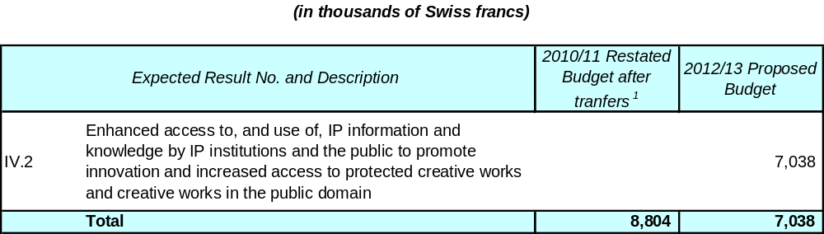

- The figures for 2010/11 Budget under personnel costs represent actual expenditure for 2010 and budgeted amounts based on standard costs for 2011. The budget for 2012/13 is prepared using standard costs for the next biennium.

- The main reason for the overall reduction in 2012/13 proposed budget as compared to the 2010/11 restated budget after transfers under Program 14 is the fact that the 2010/11 restated budget after transfers includes the 2010 expenditure of Global Databases (new Program 13), which was split from this Program during 2010/11. This concerns in particular the personnel resources and non-personnel budget cost categories on “SSA and Commercial Services” and “Furniture and Equipment”.

- In addition, the proposed decreases under various budget cost categories are also due to the expected completion of the Phase 1 of the DA project on Developing Tools for Access to Patent Information by the end of 2011.

- The proposed reduction in “Publishing” is due to higher reliance on documentation produced in-house.

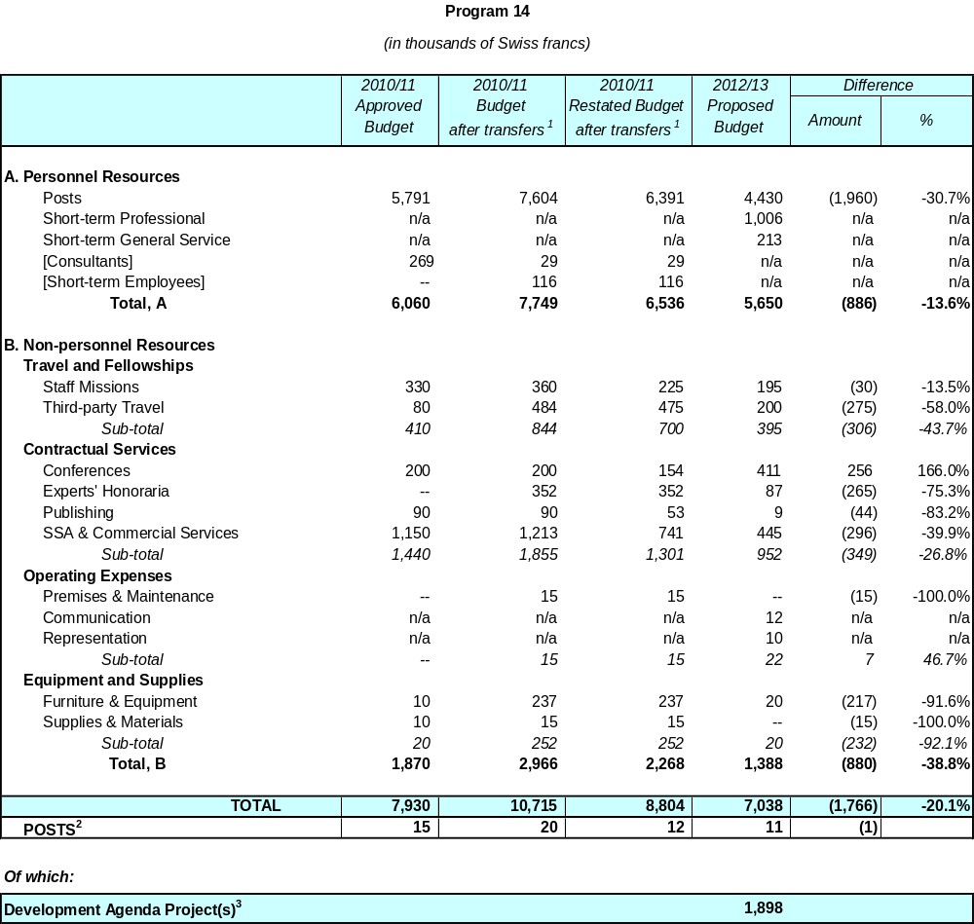

¹ Restated Budget after transfers reflects:

- the adjusted budget of Programs, following transfers during 2010/11 in line with Financial Regulation 5.5. For additional details on the 2010/11 Budget after Transfers, please refer to Table 10 (Annex I) Budget after Transfers by Program of this document and document WO/PBC/18/14 Program Performance Report for 2010;

- restatements of Program budgets for comparison with the 2012/13 proposed Program structure. For those Programs where restatements were not required, the Restated Budget after Transfers is equivalent to the Budget after Transfers, as referred to in document WO/PBC/18/14 Program Performance Report for 2010. For more detailed information on the restatements, please refer to Table 11 (Annex I) of this document.

² For further details on posts for the Program please refer to the Table in Annex II.

³ Includes projects on: "Developing Tools for Access to Patent Information" and "Specialized Databases’ Access and Support", subject to evaluation of Phase 1 and subject to CDIP approval of Phase 2.

Program 15 Business Solutions for IP Offices

PLANNING CONTEXT

- This Program forms the basis of global infrastructure as the technical architecture of the IP system to complement the legal architecture of the system. The introduction of ICT, and the generation of digitized IP data at each IP (industrial property) Office, creates the possibility of greatly enhancing the interaction between such Offices throughout the world and between those Offices and WIPO, and of providing more online services to stakeholders.

- Around 50 Offices are now using IP Office Automation software (IPAS) provided and supported by WIPO. The number of IP Offices requesting modernization of their business systems is expected to increase from the current 50 to 80 or more in 2012/13.

- A key challenge consists of integrating DA principles into the Program, in particular DA Recommendations 1 and 6. This will be addressed by significantly increasing activities aimed at capacity-building and knowledge transfer, so that IP Offices in developing countries are equipped to manage and continually upgrade their IP business systems in a sustainable fashion.

IMPLEMENTATION STRATEGIES AND RISKS

- Activities under this Program will result in more national and regional IP Offices enhancing their business solutions and technical infrastructure so as to provide more cost-effective and higher-quality services to their stakeholders. Most of the beneficiaries of this Program are IP Offices in developing and least developed countries. Common platforms such as WIPO DAS (Digital Access Service for Priority Documents) and WIPO CASE (Centralized Access to Search and Examination results) will be provided and upgraded as global business solutions that can enable IP Offices and stakeholders to participate to a greater extent in global networks.

- Program services include: technical consultancy; business needs assessment; project scoping and planning; business process analysis; ongoing development and deployment of customized business system solutions for the administration of IP rights and for the exchange of priority documents and of search and examination results; establishment of IP databases; digitization of IP records and preparation of data for online publication and electronic data exchange with WIPO global IP systems (including PCT and Madrid); e-communication with WIPO databases such as PATENTSCOPE; provision of WIPO IP statistics; upgrading of technical infrastructure; training and knowledge transfer; and, business system support.

- For the 2012/13 biennium, the aim is to move beyond assisting Offices to automate their internal IP administration processes so as to help Offices meet the demand for online services such as search systems, online registries and online filing systems, as well as to participate in multilateral arrangements for sharing of information and documents. WIPO DAS will be extended from patent priority documents to trademark and industrial design priority documents. WIPO CASE will be upgraded, taking into account business needs of different groups of countries, in particular Latin American countries and the Vancouver group countries. WIPO CASE technology will be made available to other groups of IP Offices (such as Latin American countries under a project called “PROSUR”) which wish to share search and examination results for international work share programs.

- The Program contributes to several DA recommendations aimed at strengthening institutional and technical infrastructure of IP Offices and institutions (in particular, Recommendations 1, 2, 3 and 10).

- For the 2012/13 biennium, implementation strategies will focus on:

- A significantly increased emphasis on transferring knowledge and building capacity in IP Offices through on-site training, mentoring and regional training workshops, including training of trainers in the regions.
- Implementing a project management methodology that emphasizes the collaborative nature of business system modernization projects between WIPO and IP Offices.
- Seeking closer coordination and partnerships with IP Offices which develop infrastructure and tools for international collaboration in providing services of IP Offices.
- Enhancement and further development of the software tools provided by WIPO to support the demands of IP Offices for more sophisticated tools and services. Enhancements should support the full range of IP business systems required by Offices, including filing systems, internal administration systems, search and examination systems and publication or data dissemination systems.
- Consolidating new infrastructure platforms for the exchange of IP information and documents and making common platforms available to a wider range of offices.

- Internally, the Program will continue to work closely with Program 8 (Development Agenda Coordination), Program 9 (Africa, Arab, Asia and the Pacific, Latin America and the Caribbean Countries, Least Developed Countries), Program 10 (Cooperation with Certain Countries in Europe and Asia), Program 14 (Services for Access to Knowledge), Program 6 (Madrid and Lisbon Systems), Program 5 (the PCT system) and Program 25 (Information and Communication Technology) and Program 31 (The Hague System). Externally, the Program will cooperate, as appropriate, with relevant regional and national IP organizations for the purposes of coordinating and sharing information on related activities, for joint organization of activities, and for possible funding arrangements. Collaboration with other relevant organizations and potential partners will be explored.

- The main risks concern the sustainability of projects, the ability to provide adequate support and knowledge transfer to IP Offices, and the need to support a large number of Offices with limited resources. The implementation strategies above are designed to mitigate these risks by creating a business model where IP Offices own their projects to the extent possible, and WIPO provides knowledge transfer, capacity building and ongoing support at local, regional and international levels. Partnerships with other IP Offices and agencies will help to use WIPO’s limited resources more effectively.

RESULTS FRAMEWORK

Expected Results | Performance Indicators | Baselines | Targets
Enhanced technical and knowledge infrastructure for IP Offices and other IP institutions leading to better services (cheaper, faster, higher quality) to their stakeholders | No. of Offices with fully automated vs partially automated IP administration systems provided by WIPO  No. of Offices with IP data online in WIPO databases | 38/55  20 | 50/80  40
 | No. of Groups of Offices participating in a common platform | 1 | 3
 | No. of Offices processing PCT and Madrid data with the support of WIPO supplied systems | 5 | 20

RESOURCES FOR PROGRAM 15

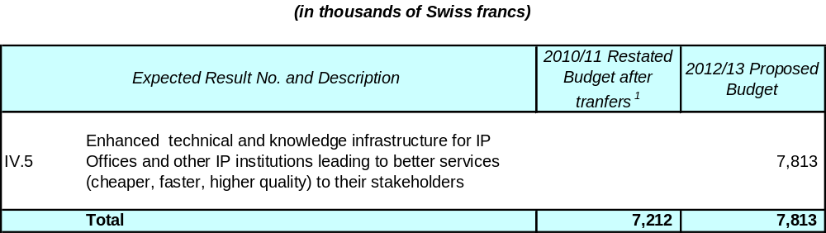

- The figures for 2010/11 Budget under personnel costs represent actual expenditure for 2010 and budgeted amounts based on standard costs for 2011. The budget for 2012/13 is prepared using standard costs for the next biennium. The increase in budgeted amount under Posts for the Program goes beyond the statutory increases incorporated in the standard costs mainly due to the transfer of one post from another Program.

- The proposed increase under “Staff Missions” corresponds to a planned increase in the number of projects in IP Offices following increased demands from Member States.

- The proposed increases under “Contractual Services” are related to the planned developments under the WIPO CASE project, the DAS project and enhancements in the Industrial Property Automation System (mainly due to Member States’ requests for new features such as EDMS and e-filing in IP Offices).

- The proposed decreases under “Equipment and Supplies” are due to a shift in Program strategies with an enhanced focus on the on-site deployment, transfer of knowledge and training in IP Offices in order to ensure the Offices’ capacity to take ownership of their modernization projects.

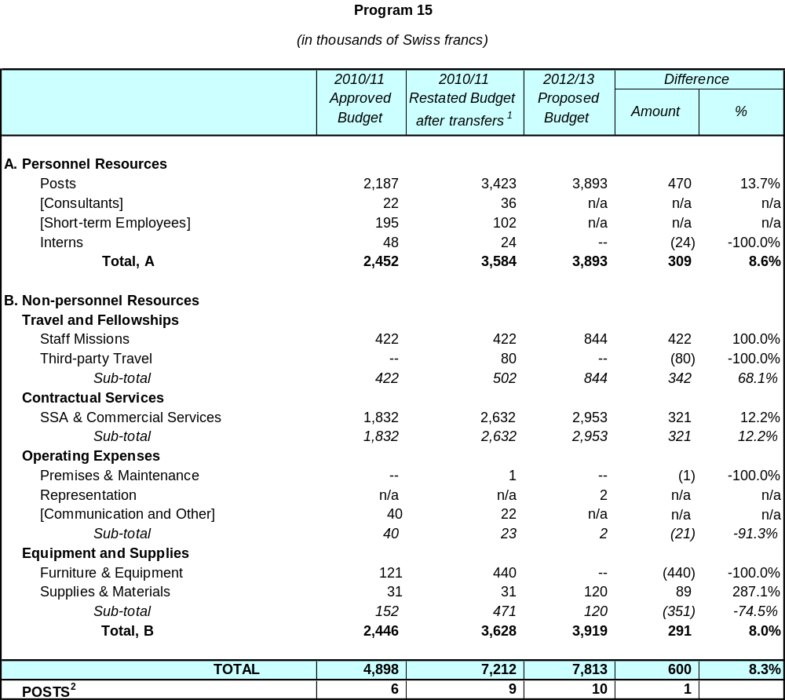

¹ Restated Budget after transfers reflects:

- the adjusted budget of Programs, following transfers during 2010/11 in line with Financial Regulation 5.5. For additional details on the 2010/11 Budget after Transfers, please refer to Table 10 (Annex I) Budget after Transfers by Program of this document and document WO/PBC/18/14 Program Performance Report for 2010;

- restatements of Program budgets for comparison with the 2012/13 proposed Program structure. For those Programs where restatements were not required, the Restated Budget after Transfers is equivalent to the Budget after Transfers, as referred to in document WO/PBC/18/14 Program Performance Report for 2010. For more detailed information on the restatements, please refer to Table 11 (Annex I) of this document.

² For further details on posts for the Program please refer to the Table in Annex II.

STRATEGIC GOAL V
World Reference Source for IP Information and Analysis

WIPO is the generator and repository of outstanding collections of technology disclosures, brand data, and technical and legal IP information. These collections provide a window onto what is happening in important sectors of the economy and in the IP system. They are of immense value to policy-makers; industry, business and other users of the IP system; and the interested public. That value has also been recognized in the Development Agenda, where there is strong demand for the Organization to provide empirical economic analysis and studies.
The value of WIPO’s data reference collections, however, depends upon the collections being accurate, up-to-date and responsive to the needs of stakeholders, as well as freely and universally accessible. WIPO is in a unique position to serve as a host and portal to the world’s most comprehensive and valuable collections of IP information. Under this strategic goal, WIPO would strive to realize the potential of that unique position.

Expected Results | Performance Indicators | Responsible Program(s)
Increased usage of WIPO statistical information on the performance of the international IP system | No. of downloads of two main statistical reports  No. of data downloads | Program 16  Program 16
Take-up of WIPO economic analysis as an input into the formulation of IP policy | No. of downloads of main economic publications  No. of developing countries which find WIPO economic studies useful and degree of usefulness | Program 16  Program 16
Enhanced access to, and use of, IP related legal information | Enhanced coverage in WIPO Lex database of IP related legal information | Program 21

Program 16 Economics and Statistics

PLANNING CONTEXT

- As the world economy recovers from the global financial crisis, innovation will remain essential in sustaining long-term economic growth and improving human development. Over the past decade, the innovation landscape has continuously changed: driven by fast economic growth, new sources of innovation have emerged – especially in Asia – and innovation models are becoming increasingly open, international, and reliant on markets for knowledge. Despite the fast growth of certain developing economies, a significant share of the world’s population continues to live in poverty and has not been able to harness knowledge for economic prosperity.

- Against this background, the global intellectual property (IP) system faces significant challenges. Notwithstanding the crisis-induced drop in patent, trademark, and design filings in many countries, the continuously increasing reliance on knowledge inputs into production and the greater diversity of the world economy are prompting a steady increase in the demand for IP rights. The capacity of IP offices to cope with this rising demand is stretched, placing strains on the system. Policymakers also need to respond to new technological and business developments, such as the emergence of knowledge markets, ensuring that the IP system best serves the needs of societies. Similarly, policymakers in developing countries face the challenge to tailor IP policy to the needs of their economies, taking into account different resource endowments and different industrial structures.

- For policymakers, firms and the public at large to better understand these challenges, a sound knowledge base is required. On the one hand, this knowledge base consists of accurate and timely statistical information on the performance of the international IP system. IP statistics are an important input into operational planning at patent offices. They also capture emerging technology and business trends and, in the case of patents, remain one the most frequently used indicators of innovative activities of firms, industries, and countries.

- On the other hand, the knowledge base consists of analytical studies that explain how economic, technology, and business trends impact on the IP system and that evaluate the economic effects of different IP policy choices. Studies that support evidence-based decision-making are especially needed in developing countries, where fewer academic institution and research institutes conduct economic analysis on the IP system.

IMPLEMENTATION STRATEGIES AND RISKS

- Against this background, Program 16 will provide accurate, comprehensive, and timely statistical information on the performance of the IP system worldwide. The collection and publication of IP statistics is a longstanding WIPO activity, dating back to the Paris Convention of 1883. WIPO’s data and statistical publications are widely used by policymakers, businesses and the public at large to better understand patterns of IP use around the world, the latest filings trends, and other aspects of IP performance.

- WIPO works with national and regional IP offices in collecting data on IP activity worldwide through its annual statistics survey. The statistics on the WIPO-administered filing treaties are generated in-house. The annual World Intellectual Property Indicators report summarizes the main statistical trends in the area of patents, utility models, trademarks, and industrial designs. WIPO participates in relevant international task forces for the development of IP statistics. Continuous efforts will be made to expand data coverage, improve the timeliness of statistical reporting, link data on different forms of IP by applicants, combine IP data with relevant economic data and enhance the user-friendliness of statistical products. These efforts will contribute to enhanced usage of WIPO statistical information by stakeholders from around the world.

- Ensuring comprehensiveness and timeliness in the collection of statistical data relies on the voluntary cooperation of national IP offices in compiling and submitting the required data. Cooperation has generally been excellent, but many national IP offices have limited resources for statistical work, especially in developing countries. Appropriate planning, use of information and communication technologies, and special outreach efforts in the implementation of the statistical survey should help solicit wider participation.

- Program 16 will also provide high quality economic analysis on the functioning of the international IP system and assessing the economic effects of IP policy choices in developing countries. The provision of economic analysis is still a young WIPO activity with limited capacity. WIPO economic analysis seeks to offer an objective and empirical input into the public policy discourse on IP.

- The economic analysis program has two pillars. One pillar focuses on economic challenges as they pertain to the global IP system. In part, analysis conducted under this pillar occurs in collaboration with other WIPO programs (especially, Programs 1, 2, 3, 5, 9, 10, 17, 18, and 30), contributing to the achievements of other WIPO Strategic Goals. Economic analysis projects are implemented drawing on a wide international network of academic economists. WIPO also coordinates a network of IP office economists, through which economic research work is coordinated and/or collaboratively conducted. One key expected output of the global analysis work is a WIPO economic flagship report.

- The second pillar focuses on assessing the economic effects of IP policy choices in developing countries and specifically takes the form of implementing DA project CDIP/5/7 (related to DA Recommendations 35 and 37). The project consists of a series of studies on the relationship between IP protection and various aspects of economic performance in developing countries. Studies are tailored to the analytical needs of national policymakers, but generally focus on three themes: domestic innovation, the national and international diffusion of knowledge, and institutional features of the IP system and their economic effects. Studies are implemented by research teams involving WIPO economists, leading international academic economists, and local researchers in the concerned countries. A second CDIP project on IP and Brain Drain (submitted to the Seventh Session of the CDIP) would complement the economic analysis work on developing countries. In addition, the Program will advise Program 1 in its effective implementation of the project on Open Collaborative Projects and IP Based Models.

- High quality economic analysis relies on access to data, not only on IP activity but also on different measures of performance by firms, households, industries, and economies as a whole. Such data are not always available, especially in developing countries, or may not be publicly accessible. Original survey work can be resource-intensive and, if done only once, may not yield sufficient insights. Collaborating with specialized research institutes may help address data problems. More generally, it is important to realistically assess the likely outcome of an economic investigation from the outset and manage expectations accordingly.

RESULTS FRAMEWORK

Expected Results | Performance Indicators | Baselines | Targets
Increased usage of WIPO statistical information on the performance of the international IP system | No. of downloads of two main statistical reports  No. of data downloads | Tbd  Tbd | 10% increase in usage  10% increase in usage
Take-up of WIPO economic analysis as an input into the formulation of IP policy | No. of citations in economic publications and government policy reports | Given novelty of program, baseline not available | Given novelty of program, not possible to establish meaningful targets
 | No. of developing countries which find WIPO economic studies useful and degree of usefulness |  | Given novelty of program, not possible to establish meaningful targets

RESOURCES FOR PROGRAM 16

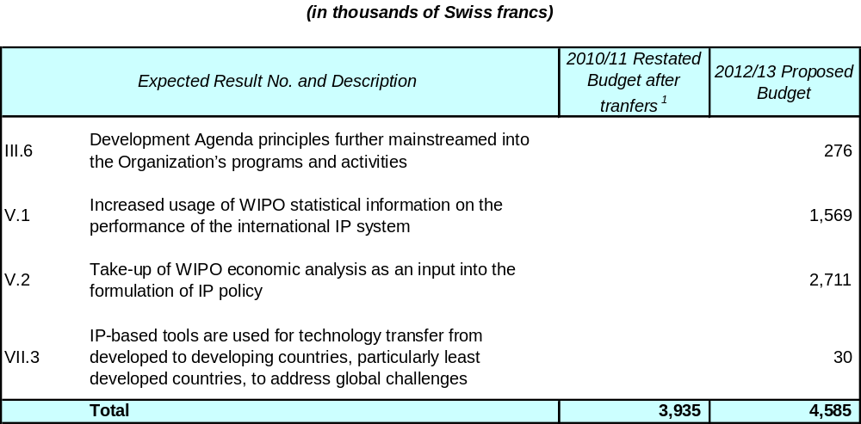

- The figures for 2010/11 Budget under personnel costs represent actual expenditure for 2010 and budgeted amounts based on standard costs for 2011. The budget for 2012/13 is prepared using standard costs for the next biennium. The increase in the budgeted amount under Posts for Program goes beyond the statutory increases incorporated in the standard costs due to the growth in personnel during the course of 2010/11.

- The proposed increases in non-personnel resources under the program are mainly related to the DA projects implemented under the Program. These include increases in costs, especially
“Third-party Travel”. While there is an overall decrease in “Contractual Services”, this is primarily due to a shift of resources from “Experts’ Honoraria” to “SSA and Commercial Services” to better reflect the nature of services envisaged to be utilized.

- A budget provision of 60 thousand Swiss francs had been allocated to “Publishing” under Program 16 for the 2010/11 budget; however, there has been no expenditure under this cost category to date because the publishing of WIPO statistical reports is not borne by Program 16. For 2012/13 the proposed budget of 15 thousand Swiss francs is planned to cover the cost of external publishing in respect of a book project envisaged to be undertaken in the period.

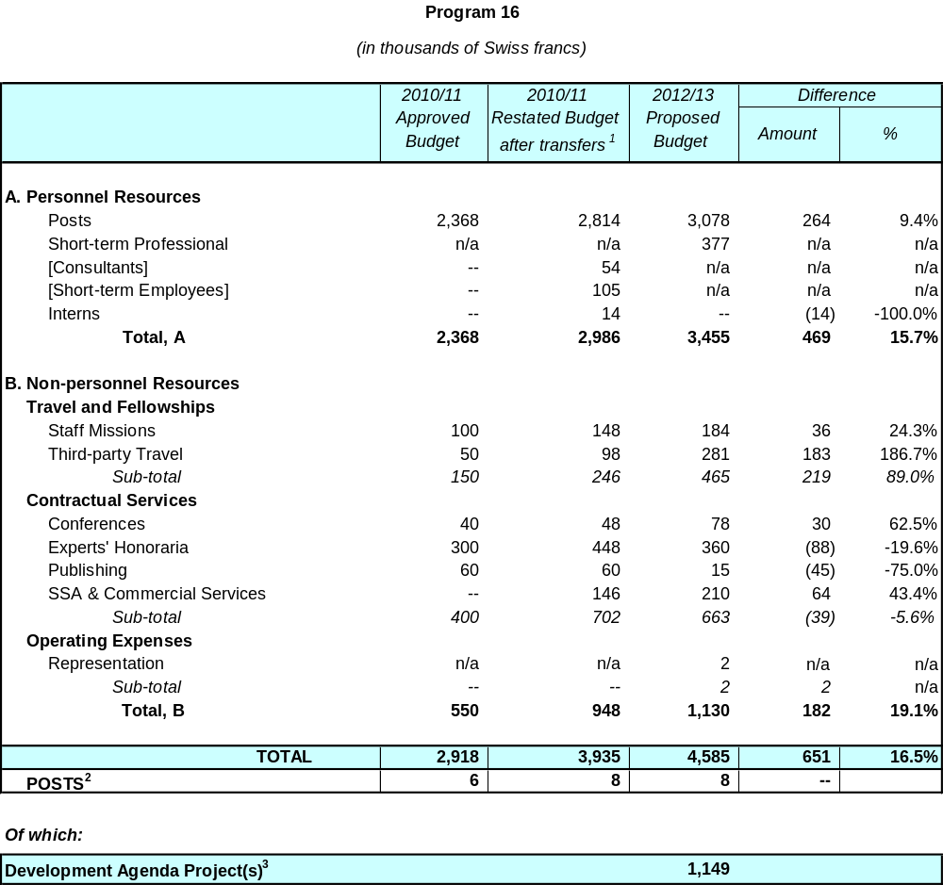

¹ Restated Budget after transfers reflects:

- the adjusted budget of Programs, following transfers during 2010/11 in line with Financial Regulation 5.5. For additional details on the 2010/11 Budget after Transfers, please refer to Table 10 (Annex I) Budget after Transfers by Program of this document and document WO/PBC/18/14 Program Performance Report for 2010;

- restatements of Program budgets for comparison with the 2012/13 proposed Program structure. For those Programs where restatements were not required, the Restated Budget after Transfers is equivalent to the Budget after Transfers, as referred to in document WO/PBC/18/14 Program Performance Report for 2010. For more detailed information on the restatements, please refer to Table 11 (Annex I) of this document.

² For further details on posts for the Program please refer to the Table in Annex II.

³ Includes projects on: (i) “Intellectual Property and Socio-Economic Development”; “Open Collaborative Projects and IP-Based Models” , approved by CDIP; (ii) “Intellectual Property and Brain Drain”, subject to CDIP approval.

STRATEGIC GOAL VI
International Cooperation on Building Respect for IP

Building respect for IP embodies a broader approach than that covered by the enforcement of IP rights alone. It calls for a focus on international cooperation where WIPO can make a difference. This is a broad, cross-cutting goal, supported by many different areas of WIPO’s activities. The WIPO Advisory Committee on Enforcement (ACE) serves as a mechanism for Member States to coordinate work towards this goal. Work under this Strategic Goal is guided by Development Agenda Recommendation 45.

Expected Results | Performance Indicators | Responsible Program(s)
Progress in the international policy dialogue among WIPO Member States on building respect for IP, guided by Recommendation 45 of the WIPO Development Agenda | Continued agreement by Member States on the substantive work of the WIPO Advisory Committee on Enforcement (ACE) in the biennium, incorporating development-oriented elements | Program 17
Systematic and effective cooperation and coordination between the work of WIPO and other international organizations in the field of building respect for IP | No. of formal cooperation mechanisms in place  No. of joint activities | Program 17  Program 17

Program 17 Building Respect for IP

PLANNING CONTEXT

- The work of WIPO in the field of Building Respect for IP is guided by Strategic Goal VI as well as Recommendation 45 of the WIPO DA. It is a broad, cross-cutting approach, supported by various WIPO Programs. It goes beyond the enforcement of IP rights as such, and aims at the creation of an enabling environment that promotes respect for IP in a sustainable manner and strengthened capacity in Member States for the effective enforcement of IP rights in the interest of social and economic development and consumer protection.

- Risks associated with infringement of IP laws and regulations remain a global concern. In spite of intensive efforts by governments and right holders over the past years, more industries are targeted and new distribution patterns are emerging. The great demand for assistance by Member States mirrors the multi-facetted dimension of counterfeiting and piracy, including with a view to socio-economic and development-oriented concerns. While there is rich experience available in many countries and the global understanding of the relevant issues has been constantly evolving, evidence-based responses and mechanisms for sharing experiences need to be further developed. Especially in times of economic downturn, governments and right holders alike seek to focus resources on cost-effective remedies. Moreover, alternative models are explored that adequately balance rights, interests and obligations in the context of IP enforcement. At the same time, effective IP enforcement remains at the heart of a number of international initiatives. In this regard, it will be a major challenge to ensure and further build systematic cooperation and coordination among partner organizations, as appropriate, in the interest of quality, efficacy and transparency of services.

- Against this background, the main results sought to be achieved in the biennium consist of:

- Further progress in the international policy dialogue among WIPO Member States on building respect for IP, guided by Recommendation 45 of the WIPO Development Agenda;
- Enhanced capacity at the national level to develop and give effect to IP enforcement policies and measures, taking into account socio-economic and development-oriented concerns; and
- Systematic and effective cooperation and coordination between the work of WIPO and other international organizations in the field of building respect for IP, in consultation with WIPO Member States.

IMPLEMENTATION STRATEGIES AND RISKS

- Within the framework of the WIPO Advisory Committee on Enforcement (ACE), WIPO will continue to support an effective implementation of the work program agreed by Member States for the individual sessions of this body. In close cooperation with Programs 16 and 19, research will be conducted to assist Member States in further deepening the understanding of the socio-economic context and impact of counterfeiting and piracy, including with a view to the demand-side of the problem. This work will take into account development-oriented concerns, in line with Recommendation 45 of the WIPO DA. The emerging understanding within the ACE may form the basis for exploring strategies that adequately respond to IP infringement in all its complexities.

- WIPO will continue to offer and further develop its services to effectively respond to Member States’ requests for assistance, taking duly into account DA Recommendations 1, 6, 12 to 14 and 17. This work will be carried out in close cooperation with Programs 9, 10, 11 and 19, and coordinated with partner organizations, as appropriate, including the private sector. The findings of the work of the ACE will support and guide the Program’s technical assistance. A certain priority will be given to requests by LDCs in the biennium. This will embrace advising on the implementation of obligations under the TRIPS Agreement in light of the expiring transition period for LDCs, including with a view to flexibilities permitted under the Agreement, and corresponding capacity building.

- Assuming responsibility to further build international cooperation in the area of building respect for IP will remain a key feature of the work in the biennium. Program 17 will closely follow relevant processes in other international forums and increase cooperation, where appropriate, including with a view to ensuring further integration of development-oriented concerns in joint initiatives.

- A range of issues that are relevant in the context of IP infringements in the digital environment touch on the areas of work of different WIPO Programs and Standing Committees. Program 17 will continue to closely cooperate with and support the work of those other Programs, in particular Programs 2, 3 and 7.

RESULTS FRAMEWORK

Expected Results | Performance Indicators | Baselines | Targets
Progress in the international policy dialogue among WIPO Member States on building respect for IP, guided by Recommendation 45 of the WIPO Development Agenda | Continued agreement by Member States on the substantive work of the WIPO Advisory Committee on Enforcement (ACE) in the biennium, incorporating development-oriented elements | Current work program | Agreement on specific work programs for the 8th and the 9th session of the ACE
Enhanced human resource capacities able to deal with the broad range of requirements for the effective use of IP for development in developing countries, LDCs and countries with economies in transition | Inclusion of development-related issues in WIPO enforcement training programs  % of Member States that report satisfaction with strategic and legal assistance provided | No current data available  No current data available | 100%  75%
 | % of trained enforcement officials that report satisfaction with the training provided, and its usefulness for their professional life | No current data available | 75%
Systematic and effective cooperation and coordination between the work of WIPO and other international organizations in the field of building respect for IP | No. of formal cooperation mechanisms in place  No. of joint activities | Three  30 | Four  30
Tailored and balanced IP legislative, regulatory and policy frameworks | No. of countries provided with technical assistance on new or updated legislative frameworks for effective enforcement, taking into account flexibilities in Part III of TRIPS | One regional group (Africa)  One country  (Asia) | Four countries

RESOURCES FOR PROGRAM 17

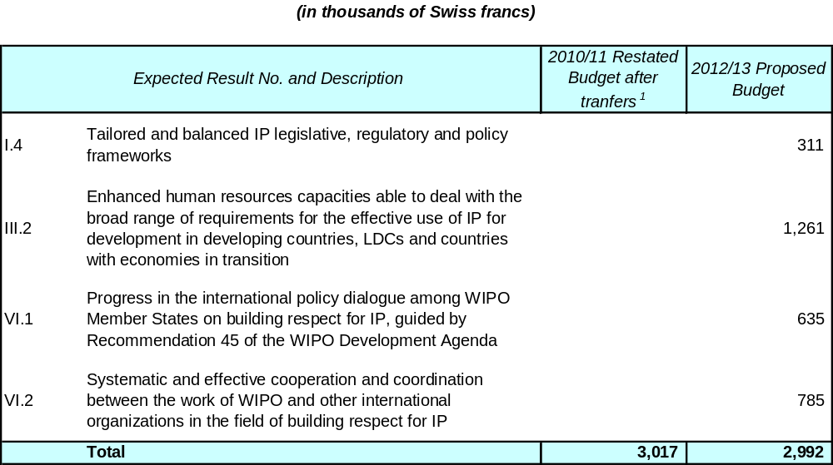

- The figures for 2010/11 Budget under personnel costs represent actual expenditure for 2010 and budgeted amounts based on standard costs for 2011. The budget for 2012/13 is prepared using standard costs for the next biennium.

- The proposed increases under “Staff Missions” are the result of WIPO having to bear the travel costs to regional workshops, which were previously funded by FITs. The resource requirement for “Conferences” has reduced as WIPO will not be hosting the next two Global Congress cycles. Since no work on casebooks is anticipated in the 2012/13 biennium, the amount under “SSA and Commercial Services” has also been reduced.

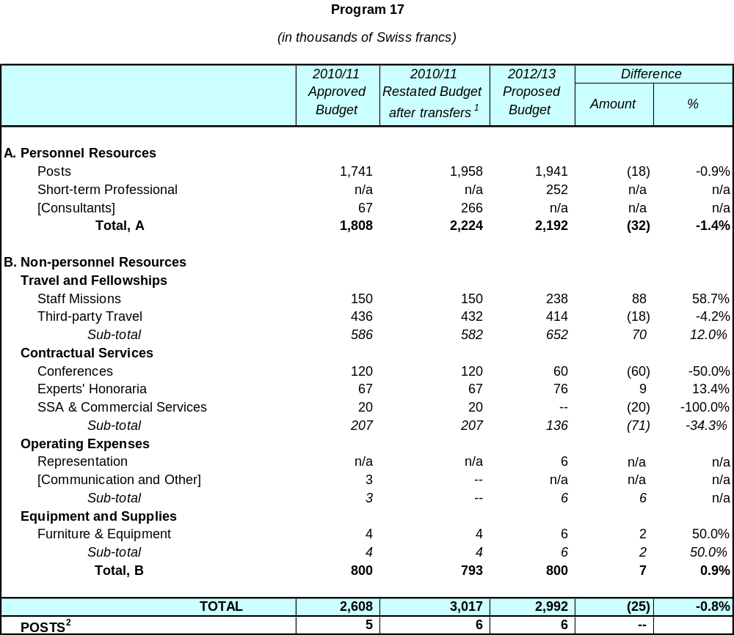

¹ Restated Budget after transfers reflects:

- the adjusted budget of Programs, following transfers during 2010/11 in line with Financial Regulation 5.5. For additional details on the 2010/11 Budget after Transfers, please refer to Table 10 (Annex I) Budget after Transfers by Program of this document and document WO/PBC/18/14 Program Performance Report for 2010;

- restatements of Program budgets for comparison with the 2012/13 proposed Program structure. For those Programs where restatements were not required, the Restated Budget after Transfers is equivalent to the Budget after Transfers, as referred to in document WO/PBC/18/14 Program Performance Report for 2010. For more detailed information on the restatements, please refer to Table 11 (Annex I) of this document.

² For further details on posts for the Program please refer to the Table in Annex II.

Fund-in-Trust Resources Potentially Available for Programming in 2012/13*
(in thousands of Swiss francs)* *

Program | Projected Balance end 2011 | Estimated Contributions 2012/13*** | Estimated Available for Programming in 2012/13****
Program 17 | 20 | 92 | 112

* For information only. The figure indicated for programming is at present only for 2012 as the existing FIT Agreement is due to conclude in 2012. For further details please refer to Annex V.

** The figures do not include interest and exchange rate adjustments. It should also be noted that these funds generally provide for activities spanning a period of time exceeding or overlapping a single biennium, as income is received and expenditure incurred.

*** Annual contributions vary and fluctuations have been observed from one year to another.

**** This figure is purely indicative and is based on previous funding patterns. It does not represent Member States’ commitments except in those cases where the FIT Agreement includes such a commitment.
STRATEGIC GOAL VII
Addressing IP in Relation to Global Policy Issues

This Strategic Goal reflects WIPO’s potential to serve as the leading intergovernmental forum for addressing the intersection between IP, innovation and global public policy issues. It implies proactive and substantive engagement with other UN, intergovernmental, and non-governmental organizations in order to contribute to the search for shared solutions to the major challenges facing humanity, including climate change, food security, public health, the protection of biodiversity and meeting the Millennium Development Goals (MDGs). The most immediate impact of many of these global problems is borne by developing and least developed countries, and the programs under this Strategic Goal will be closely involved in the realization of development objectives and Development Agenda recommendations.

Expected Results | Performance Indicators | Responsible Program(s)
Enhanced understanding among policy makers on the interface between global challenges and innovation and intellectual property as a basis for improved policy decision making | References to WIPO's work in the area of global challenges in other policy processes  Increased use of material from the Global Challenges website | Program 18  Program 18
 | Feedback from participants in policy fora | Program 18
WIPO established as a credible source of support, assistance, and reference for information on innovation and IP in relevant public policy processes | No. and diversity of specific requests from Member States and international organizations for WIPO contributions on IP in relation to global public policy issues | Program 18
IP-based tools are used for knowledge transfer from developed to developing countries, particularly least developed countries, to address global challenges | No. of participants in IP-based platforms  No. of transactions concluded using the platform(s) | Program 18
WIPO established as the relevant Forum for analyzing and debating issues in the field of IP and competition policy | No. of countries requesting WIPO’s specific contributions on IP in relation to competition law-related issues | Program 18
 | No. and diversity of stakeholders (IP offices, competition authorities, relevant IGOs and NGOs) engaged in dialogue with WIPO | Program 18
 | Report and recommendations by the WIPO Group of Experts considered by Member States | Program 18

Program 18 IP and Global Challenges

PLANNING CONTEXT

- This Program addresses innovation and IP at the intersection of pressing global and interconnected issues, in particular Global Health, Climate Change, and Food Security. The focus on the three subject areas is guided largely by Member States as noted, inter alia, in the DA because the most immediate impact of these is borne by developing countries.

- As the specialized UN agency for IP, WIPO endeavors to facilitate international policy dialogue on the intersection between innovation, IP, and global public policy issues, recognizing that IP is not an end in itself but a tool to achieve socio-economic and development objectives. WIPO therefore cooperates actively with diverse international partners, both within and outside the UN system, in order to contribute to shared solutions to major challenges by: unlocking the potential of innovation and IP for a more equitable world; analyzing the relationship between innovation, IP and technology transfer (to include, as appropriate, various forms of knowledge sharing, the transfer of R&D and productive capacity, including collaborations, capacity building, licensing and technology adaptation and diffusion); and, developing practical tools.

- During the biennium, the Program will continue to engage in policy dialogues on IP and global challenges with the aim of becoming a world-wide recognized source of fact-based information and analysis, a forum for international discussion, and a catalyst of tangible, results-oriented projects that leverage innovation for development. Work is guided by the Development Agenda and Millennium Development Goals.

IMPLEMENTATION STRATEGIES AND RISKS

- Effective and constructive contribution to the global policy dialogue will be pursued through a three-pronged implementation strategy:

- Developing objective and balanced information on the relationship between global challenges and innovation and technology transfer;
- Providing support to Member States, IGOs, civil society, and other stakeholders and assisting them in the identification of feasible approaches; and,
- Developing and maintaining practical IP-based mechanisms and tools for addressing global challenges

Developing objective and balanced information on the relationship between global challenges and innovation and technology transfer

- Under this strategy, the Program will bring together constituencies to explore ideas and options. Both internal and external policy studies will be pursued on topics such as the role of IP and IP management in technology transfer in addressing global challenges. The studies will constitute the basis for further discussions at conferences and symposia to allow for a wide input of ideas and a concurrent broad sharing of outcomes.

- In addition, substantive analyses, in the form of reports and briefs, should: lead to a better understanding of the policy and strategic drivers of innovation; demonstrate proactively the use of IP tools; and, support Member States’ understanding of technology transfer.

- In order for WIPO to realize the full potential of addressing the interface between IP and global policy issues, it must ensure the trust of potential partners by providing significant contributions that not only move debates forward in terms of better understanding of the issues, but also generate confidence as to the impartiality of its contributions.

- This part of the strategy will be implemented in close cooperation with, in particular, Program 1 (Patent Law and Innovation), Program 14 (Services for Access to Knowledge), Program 19 (Communications) and Program 20 (External Relations, Partnerships and Offices).

Providing support to Member States, IGOs, civil society, and other stakeholders and assisting them in the identification of feasible approaches

- The activities above will provide the substantive foundation for assistance related activities. To this end, information tools on important issues in the context of IP, health, environment and food security will be developed that provide a neutral and objective analysis for the benefit of Member States and other interested stakeholders. Also, in response to requests from Member States, IGOs, civil society, and other stakeholders, the Program will provide input, as appropriate, in fora where innovation and IP are discussed in the context of health, climate change, and food security. Ensuring WIPO’s constructive engagement in relevant public policy processes provides support to other actors and helps establish WIPO as the forum and reference point on IP as it touches on global public policy issues.

- This work will be implemented in close cooperation with Program 20 (External Relations, Partnerships and Offices) to ensure systematic engagement with the full range of IP issues currently debated in international and national fora and, in particular, a reinforced cooperation with other UN agencies, in line with Recommendation 40 of the DA. Cooperation with Program 9 (Africa, Arab, Asia and the Pacific, Latin America and the Caribbean Countries, Least Developed Countries) and Program 10 (Cooperation with Certain Countries in Europe and Asia) will ensure that activities are targeted to the needs of developing countries, LDCs and countries with economies in transition.

Developing and maintaining practical IP-based mechanisms and tools for addressing global challenges

- The core element of this part of the strategy will be to facilitate the technology transfer relevant to health, climate change and food security. Initiatives will build on partnerships and collaborations and explore the use of open innovation structures, networked innovation, and other forms of partnerships to accelerate their impact in developing countries.

- Together with external partners, technology sharing tools to facilitate the diffusion and transfer of both climate and health related technologies from developed to developing and least developed countries will be explored, consistent with the goals of the DA, in particular Recommendations 19 (access to knowledge and technology), 25 (transfer of technology) and 30 and 42 (cooperation with other IGOs and NGOs). Program 1 (Patent Law and Innovation) will be a partner in this endeavor.

IP AND COMPETITION POLICY

PLANNING CONTEXT

- Two additional areas covered by Program 18 include IP and Competition Law and Unfair Competition, including the protection of test data.

- WIPO’s activities concerning Intellectual Property and Competition Policy (IP&CP) are guided by the relevant DA Recommendations, in particular Recommendations 7, 23 and 32. A number of activities, namely those concerning the exchange of experiences and assistance to Member States in addressing the interface between IP and CP, which started in the previous biennium, will be continued and further expanded in 2012/13. The main objective is to generate information and raise awareness about the interface of IP and CP and to identify international trends that Member States can use in devising development-oriented national policies.

- Work on IP&CP is linked to Strategic Goal VII since ensuring the operation of a pro-competitive IP regime is a “global” issue which, in globalized markets, transcends national borders. However, because of its specific reference in Recommendations 7, 23 and 32, work on IP&CP is also connected with Strategic Goal III. Ensuring the freedom of markets is a strong catalyst for development, and IP is an important component in that endeavor. Moreover, competition law is increasingly being perceived as an important component in a balanced IP system but there is currently no international forum to explore this interface. Accordingly, efforts will aim at raising the profile of WIPO as the relevant forum for debating issues at the interface between IP and CP.

- Article 39 of the TRIPS Agreement refers to protection of test data as an element of protection against unfair competition as provided by Article 10bis of the Paris Convention. The impact of test data on access to pharmaceuticals and food security requires a deep understanding of the nature, rationale and legal regimes available for test data protection. WIPO’s work in this area would be oriented towards the collection of national practices and the identification of different (flexible) manners of implementing protection of test data, thus providing a menu of available options from which Member States could draw the legal design in accordance with their national public policies.

IMPLEMENTATION STRATEGIES AND RISKS

- The achievement of results in both fields will depend on obtaining reliable data by means of studies and surveys. Activities will be oriented towards acquiring a better factual understanding of the issues. Moreover, an intensive dialogue with authorities and stakeholders in Member States will be initiated by means of conferences, seminars, workshops. These activities will engage the whole of Program 18 and will be carried out in close cooperation with Programs 1, 9 and 10.

- The major risk for both areas of activities involving IP and Competition is the eventual failure to obtain reliable data. Without reliable data, the achievement of expected results would be greatly jeopardized. The strategy to mitigate that risk is to maintain close interaction with the broadest spectrum possible of stakeholders, including national and regional IP and competition authorities, as well as relevant IGOs and NGOs. At the same time, this strategy will generate a perception that the Secretariat, in engaging in these complex and sensitive issues, is capable of maintaining its neutrality.

RESULTS FRAMEWORK

Expected Results | Performance Indicators | Baselines | Targets
Enhanced understanding among policy makers on the interface between global challenges and innovation and intellectual property as a basis for improved policy decision making | References to WIPO's work in the area of global challenges in other policy processes  Increased use of material from the Global Challenges website | Tbd  No. of downloads (tbd end 2011) | References in all processes  50% increase
 | Feedback from participants in policy fora | Positive feedback from key participants | Sustained positive feedback from key participants
WIPO established as a credible source of support, assistance, and reference for information on innovation and IP in relevant public policy processes | No. and diversity of specific requests from Member States and international organizations for WIPO contributions on IP in relation to global public policy issues | One formal request (WHO) | One-two requests per year
IP-based tools are used for technology transfer from developed to developing countries, particularly least developed countries, to address global challenges | No. of participants in IP-based platforms  No. of transactions concluded using the platform(s) | 0  0 | 8-10 participants  10 transactions concluded
WIPO established as the relevant Forum for analyzing and debating issues in the field of IP and competition policy | No. of countries requesting WIPO’s specific contributions on IP in relation to competition law-related issues | Two requests (as of December 2010) | Six requests.
 | No. and diversity of stakeholders (IP offices, competition authorities, relevant IGOs and NGOs) engaged in dialogue with WIPO | Engagement with five national competition authorities (from three Member States) and three IGOs | Stakeholders engaged in WIPO’s Global Forum: 15 national authorities and 5 NGO’s

RESOURCES FOR PROGRAM 18

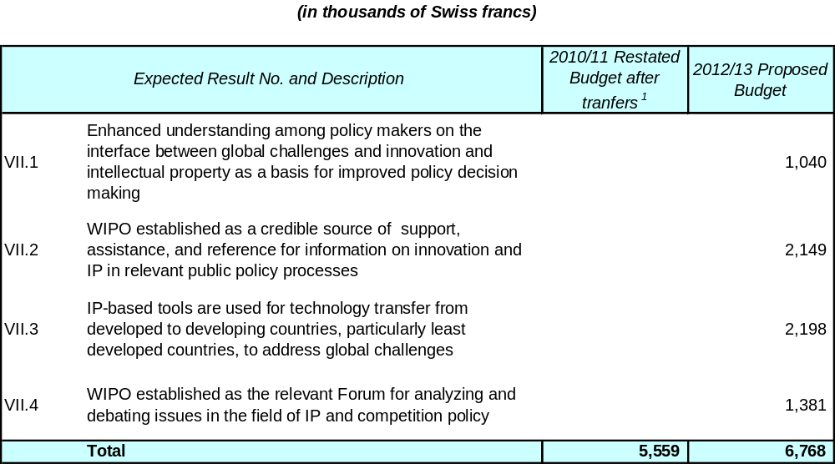

- The figures for 2010/11 Budget under personnel costs represent actual expenditure for 2010 and budgeted amounts based on standard costs for 2011. The budget for 2012/13 is prepared using standard costs for the next biennium. The increase in budgeted amount under Posts for Program goes beyond the statutory increases incorporated in the standard costs as a result of a lower base in 2010 actual expenditure due to vacancies in the Program.

- Increases in non-personnel resources are mainly related to the proposed allocation of resources for IP and Competition Policy (350 thousand Swiss francs) under the Program, which were covered under the related DA project in 2010/11. The remaining non personnel increases in other Program activities are primarily aimed at developing, maintaining, improving and operationalizing the two “technology innovation and transfer tools”, or platforms, in climate change (WIPO Green) and health (WIPO Re: Search). An amount of about 100 thousand Swiss francs each is foreseen for the further development and maintenance of the two databases as well as addition of new features and improvements respectively. An additional 125 thousand Swiss francs is foreseen for the strengthening of support services. All of these increases are directly related to making solutions, technologies and intellectual property, in the broad sense, more readily available to address specific needs of developing countries, most notably LDCs. Each of the projects to be carried out under the Program has impact on various cost categories, the major increases relate to “Contractual Services” as well as travel expenses which are due to the projected advancement in the development of these platforms.

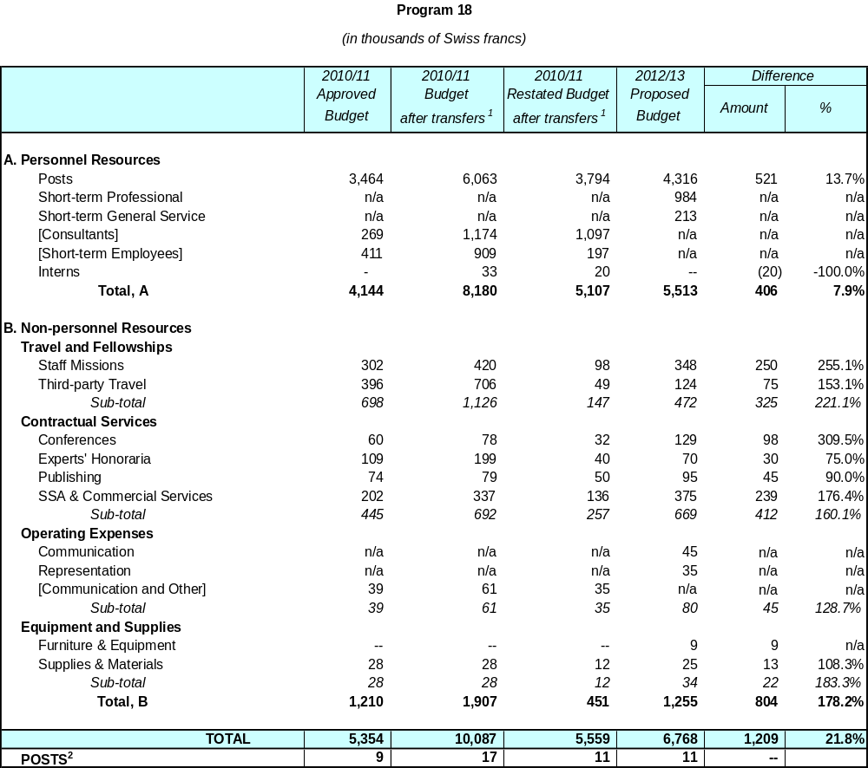

¹ Restated Budget after transfers reflects:

- the adjusted budget of Programs, following transfers during 2010/11 in line with Financial Regulation 5.5. For additional details on the 2010/11 Budget after Transfers, please refer to Table 10 (Annex I) Budget after Transfers by Program of this document and document WO/PBC/18/14 Program Performance Report for 2010;

- restatements of Program budgets for comparison with the 2012/13 proposed Program structure. For those Programs where restatements were not required, the Restated Budget after Transfers is equivalent to the Budget after Transfers, as referred to in document WO/PBC/18/14 Program Performance Report for 2010. For more detailed information on the restatements, please refer to Table 11 (Annex I) of this document.

² For further details on posts for the Program please refer to the Table in Annex II.

STRATEGIC GOAL VIII
A Responsive Communications Interface Between WIPO, its Members and all Stakeholders

This Strategic Goal signals the high priority which the WIPO Secretariat attaches to effective communication as an essential enabler of success in every aspect of its work, and to service as a core, corporate value. WIPO provides diverse services to a wide range of stakeholders – first and foremost, as a United Nations Specialized Agency, to its Member States. Such services include support to the Committees in their normative activities, capacity building services to developing countries, information and technical services, as well as the global IP registration, filing and dispute resolution services.

Expected Results | Performance Indicators | Responsible Program(s)
More effective communication to a broad public about intellectual property and WIPO’s role | No. of press articles on WIPO's work  Availability rate of WIPO core publications in all official UN languages | Program 19  Program 19
 | Number of views (on average) per WIPO video on YouTube | Program 19
 | No. of downloads (on average) per WIPO publication | Program 19
 | No. of countries with reported World IP Day events and activities | Program 19
 | No. of external information requests serviced by the WIPO Library | Program 19
 | % of stakeholders with a positive recognition of WIPO’s mission, activities and organizational image | Program 19
Improved service orientation and responsiveness to inquiries | Customer/stakeholder satisfaction rate  Processing time of information inquiries handled through ticketing system | Program 19  Program 19
WIPO effectively interacts and partners with UN and other IGO processes and negotiations | Use of WIPO’s contributions in reports, resolutions and documents from targeted processes. | Program 20
 | Feedback on WIPO’s contribution/participation in UN and other IGO processes and fora. | Program 20
 | % of responses to external requests for contributions from the UN, IGOs, etc, submitted on time | Program 20
 | No. of joint activities/workplans implemented and reviewed in line with agreements with partner organizations (new and existing MoU’s with IGOs) | Program 20
 | New joint initiatives with other UN agencies | Program 21
Open, transparent and responsive interaction with NGOs | No. of briefing sessions and meetings/activities organized for NGOs | Program 20
 | No. of briefing sessions/activities organized for developing country and LDC NGOs | Program 20
Effective engagement with Member States | % of Committee Meetings for which pre-Committee information meetings for MS are held | Program 21
 | % of letters to the DG from Member States are responded to within 2 weeks | Program 21
 | Member States satisfaction levels with the preparation and functioning of the Assemblies | Program 21
 | Timeliness of publication of Assembly documents | Program 21
Program 19 Communications

PLANNING CONTEXT

- The increased value of knowledge in the global economy has placed IP in the limelight, bringing a sharper focus on the workings of the IP system and its role with respect to innovation, culture, development, and access to knowledge. High policy interest, a public debate in which views are often polarized, and the need for reliable, objective information to increase understanding about IP, present an on-going communications challenge for WIPO. The Organization must continue to improve the clarity and consistency of the messages it delivers, the value of the content it produces for a diverse public, and the effectiveness of its dissemination.

- Awareness of WIPO’s own role and organizational identity remains relatively low. To optimize delivery of its mandate, there is a need for greater visibility, coupled with wider recognition of WIPO’s role in encouraging innovation and creativity; in facilitating multilateral dialogue on IP issues; and, as the primary, trusted provider of international IP expertise, information and services.

- Improving both quality and timeliness of WIPO’s communications output will remain a challenge in 2012/13. Internal coordination procedures and editorial policies, introduced for this purpose during the previous biennium, will require consolidation. In order to respond effectively in today’s fast moving global media environment, and to exploit the opportunities presented by the exponential growth of new communications platforms, the Secretariat will need to build up a multilingual communications skills base, particularly in flexible content creation, web and new media management, media production, and marketing.

- Program 19 makes a significant, on-going contribution to development goals by providing technical assistance “for promoting a, inter alia, development-oriented IP culture, with an emphasis on introducing IP at different academic levels and on generation of greater public awareness on IP” (DA Recommendation 3). This includes servicing the strong demand from developing countries and LDCs for public outreach and educational materials, as well as for advice in conducting national IP awareness-raising campaigns. The challenge is to enhance the impact of this assistance and ensure consistency with national policy objectives through a more coordinated approach.
- Communication is also an essential element of service delivery. WIPO must improve its understanding of the needs and expectations of its diverse stakeholders. During 2012/13, the Organization must build on foundations laid in the previous biennium to foster a culture of service orientation supported by improved technical infrastructure.

IMPLEMENTATION STRATEGIES AND RISKS

- Within the wider Strategic Goal VIII results framework of the MTSP, the work of Program 19 in 2012/13 should result in more effective communication about IP and about WIPO’s own role. (Program 19 has primarily responsibility for broad public communication, whereas enhanced communication between the Secretariat and Member States’ delegates on WIPO’s work program is led by Program 21, Executive Management). The success of the Program’s contribution will be measured through increased numbers of consumers of WIPO public information materials, including publications, videos, press communications and web-based resources, as well as through the number of Member States which conduct World IP Day activities and use WIPO’s outreach products and services in their national strategies. Successful communication will also result in increased visibility in international media, and in positive recognition by stakeholders of WIPO’s “brand” image. The WIPO Secretariat’s improved responsiveness in handling external enquiries will result in an increased stakeholder satisfaction rate.

- Strategies led by Program 19 to achieve these results will include the following:

  - Internal coordination. A more strategic approach to communications will be fostered across the Organization, supported by a cross-sectoral Communications Group. Organization-wide policy guidelines, procedures and standards, covering publications, web publishing, and other communications, will help ensure that WIPO information materials meet standards of quality, impact and need.
  - Enhanced delivery. Content will be delivered through diverse communications channels and platforms in order to reach new and bigger audiences. The content, presentation and usability of the WIPO website will be reviewed and significantly developed. The potential offered by new media will be further leveraged. An expanded, text-searchable electronic platform for publications will be developed by the WIPO Library and delivered to an international audience of interested IP researchers. WIPO video footage will be disseminated via DVD, television networks and multiple social media platforms.

  - Quality content. In order to ensure the provision of high quality content in all official languages and which respond to identified needs, existing publications will be reviewed and gaps identified in the product range. The pattern of demand for WIPO publications will be monitored to establish a logical order of priority for production. A reinstated editorial board will contribute to the objective of producing fewer publications but of higher quality and utility. The look and content of the WIPO Magazine will continue to be enhanced, taking account of reader feedback. The IP Advantage database of IP case studies, developed under the DA framework, will be expanded as an online resource. The Film and Multimedia Section will evolve into a video-centered production studio, which will produce targeted, informative and engaging content, including interviews, news content, documentaries, IP success stories and promotional spots.

  - Increasing visibility. The network of journalists around the world who produce well informed reporting on WIPO and IP issues will be expanded, and the Program will reach out proactively to influential press, blogs and online media, with the aim of positioning WIPO in the media as the world reference source of reliable information on all IP issues. The strategic communications value of major WIPO events and projects, and of the Director General’s speaking engagements, will be exploited systematically. The Organization will also engage the local community in Open Day and other outreach events.

  - Integrating IP outreach into national strategies. In order to increase public understanding of IP in relation to innovation and creativity, Program 19 will work closely with the Regional Bureaus to assist Member States and stakeholder groups, particularly in developing and least developed countries, wishing to conduct outreach campaigns and activities. Program 19 will provide access, inter alia, to expert advice, outreach guides, educational materials for young people, the WIPO Awards, the WIPO Depository Library program, and online tools, such as the database of outreach campaigns. In order to increase impact and to ensure alignment with national development goals, importance will be given to integrating outreach assistance within the broader framework of National IP and Innovation Strategies.

  - Organizational Identity. WIPO’s organizational identity, in line with its mission, mandate and values, will be projected more consistently in order to achieve increased positive recognition by stakeholders. The core skills and expertise needed to promote recognition of WIPO’s “brand” identity will be acquired through consultancy services, as well as through training, redeployment and recruitment of personnel. This will be conducted within the SRP project framework.

  - Service-oriented Culture. The service orientation of staff will be improved through training and awareness activities adapted to the individuals’ responsibilities. Responsiveness to enquiries will be improved through the provision of new call tracking and customer management tools, the redefinition of operational procedures and the establishment of quality standard policies.

- Principal risks which could prevent achievement of the expected results within the biennium include: insufficient human resources with the required skills sets and resistance to change. Mitigation strategies would include ensuring that new team members are multi-skilled; seeking public or private sector partnerships; and strengthening internal communication and consultation to leverage cross-sectoral engagement.

RESULTS FRAMEWORK

Expected Results | Performance Indicators | Baselines | Targets
More effective communication to a broad public about intellectual property and WIPO’s role | No. of press articles on WIPO's work | 6,226  (2008/09) | 5% increase
 | Availability rate of WIPO core publications in all official UN languages | 63.8% | ≥ 70%
 | Number of views (on average) per WIPO video on YouTube | 414 per video (April 26 to December 31, 2010) | 10% increase
 | No. of downloads (on average) per WIPO publication | Tbd | 5% increase
 | No. of countries with reported World IP Day events and activities | Tbd | ≥ 75 countries
 | No. of external information requests serviced by the WIPO Library | 270  (2008/09) | 10% increase
 | % of stakeholders with a positive recognition of WIPO’s mission, activities and organizational image | Tbd | ≥ 70%
Improved service orientation and responsiveness to inquiries | Customer/stakeholder satisfaction rate | Tbd | ≥ 70% satisfied or highly satisfied
 | Processing time of information inquiries handled through ticketing system | Data from Sep to Dec 2011 | ≥ 90% within 3 working days

RESOURCES FOR PROGRAM 19

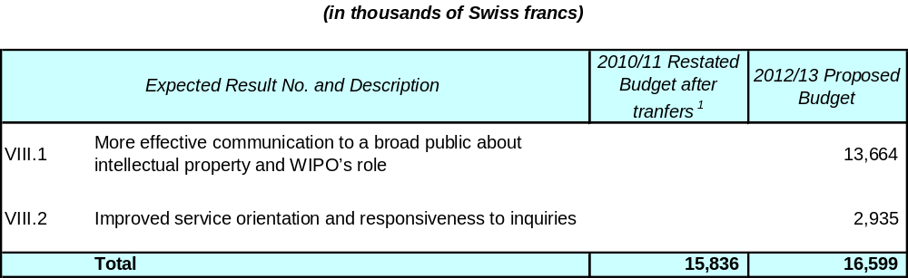

- The figures for 2010/11 Budget under personnel costs represent actual expenditure for 2010 and budgeted amounts based on standard costs for 2011. The budget for 2012/13 is prepared using standard costs for the next biennium. The increase in budgeted amount under Posts for Program goes beyond the statutory increases incorporated in the standard costs as a result of a lower base in 2010 actual expenditure due to vacancies in the Program. In addition, one post was transferred from another Program.

- The Program covers a broad range of communication and outreach related activities. The overall proposed decrease (1.5% compared with the 2010/11 budget after transfer) in the non-personnel resources is a combination of increases and decreases across various costs categories. On the decreases, the reduction under “Conferences” reflects the adjustment of the budget to better reflect actual expenditure patterns. The decreases under “Equipment and Supplies” reflect one-off expenses related to the creation of the Customer Service Section, the launch of the Customer Service Center and the equipment for the new video studio in 2010/11. As regard the reduction under the “Operating Expenses”, this relates to a transfer of such resources to the “Contractual Services” category, to better reflect the nature of the services required.

- As regards increases, those under “Staff Mission” mainly cover the provision for media support to the Director General. The increase under “Third-party Travel” relates to the organization of a seminar for journalists from developing countries previously budgeted under Program 9. The increase under “Publishing” is related to the digitization program of WIPO publications conducted by the WIPO Library. The increase under “SSA and Commercial Services” relates respectively to graphist and designers services required to increase the availability of WIPO core publications in the six official languages, to expenses related to the customer interface/experience SRP initiative, and expenses linked to the further development of the WIPO organizational image.

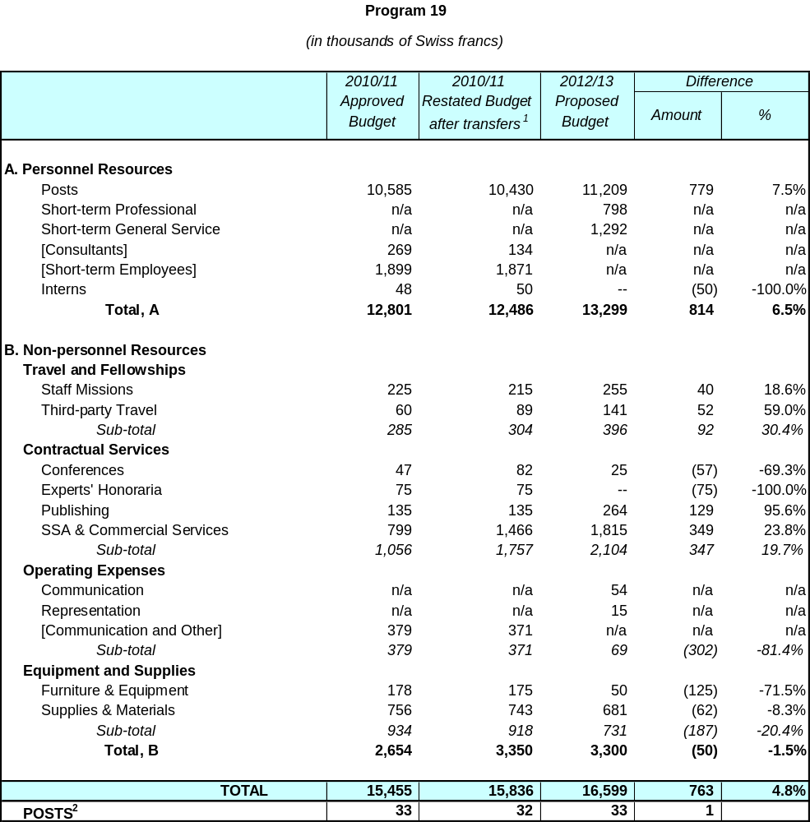

¹ Restated Budget after transfers reflects:

- the adjusted budget of Programs, following transfers during 2010/11 in line with Financial Regulation 5.5. For additional details on the 2010/11 Budget after Transfers, please refer to Table 10 (Annex I) Budget after Transfers by Program of this document and document WO/PBC/18/14 Program Performance Report for 2010;

- restatements of Program budgets for comparison with the 2012/13 proposed Program structure. For those Programs where restatements were not required, the Restated Budget after Transfers is equivalent to the Budget after Transfers, as referred to in document WO/PBC/18/14 Program Performance Report for 2010. For more detailed information on the restatements, please refer to Table 11 (Annex I) of this document.

² For further details on posts for the Program please refer to the Table in Annex II.

Program 20 External Relations, Partnerships and
External Offices

PLANNING CONTEXT

- This Program focuses on maintaining and strengthening WIPO’s relations with the United Nations (UN), other intergovernmental organizations, non-governmental organizations and associations and WIPO’s partnership building activities in particular the coordination and implementation of WIPO’s resource mobilization strategy.

- IP rights continues to be an increasingly critical factor in a wide range of international public policy discussions that take place in UN and other intergovernmental negotiations and processes. Within these processes, there is a strong demand for evidence based information on the IP system. Understanding this external environment and engaging with it based on a well-informed, strategic and results-based approach is a key priority for the successful achievement of WIPO’s strategic goals, in particular VII and VIII. It also helps ensure that WIPO meets its obligations as a member of the UN system, to serve the broad needs of the international community, especially in terms of meeting the needs of developing countries and least developed countries and contributing to a balanced and better informed international policy making process as it relates to IP, in line with the relevant WIPO Development Agenda Recommendations.

- As the specialized UN agency leading on IP, WIPO is increasingly called upon to make such a contribution. The challenge for Program 20 is to ensure that this contribution responds effectively to the needs of UN and other intergovernmental processes and partners; that it reflects a clear understanding of the global public policy issues discussed in other fora; that it is well-targeted; that it takes account of the perspectives of all stakeholders engaged in these processes; that it responds to the needs of developing countries and LDCs and reflects the principles and recommendations of the WIPO Development Agenda. Through the identification, development and implementation of strategic external partnerships WIPO can make a valued and positive difference, particularly in terms of meeting the needs of developing countries, especially LDCs, in ensuring broader development benefits from the IP system.

- Ensuring that developing countries and LDCs have the resources to maximize their use of IP for development is a central message of the WIPO Development Agenda. Development Agenda Recommendation 2 expressly calls for “providing additional assistance to WIPO through donor funding, and establish Funds-in-Trust or other voluntary funds within WIPO specifically for LDCs, while continuing to accord high priority to finance activities in Africa through budgetary and extra-budgetary resources, to promote, inter alia, the legal, commercial, cultural, and economic exploitation of IP in these countries.” Following the WIPO Conference on Building Partnerships for Mobilizing Resources for Development (November, 2009), organized in direct response to DA Recommendation 2, implementation of the identified “Next Steps” began in the 2010/11 biennium, including the development of an organizational resource mobilization strategy. The challenge in 2012/13 will be to deliver additional resources to developing countries and LDCs as a complimentary source of support, not as a substitute for regular budget funding of development activities, but as an additional and complementary source of support to help meet the demand for this work, to accelerate the use of IP for development within the context of WIPO’s programs and priorities. To this end, WIPO will leverage its engagement with intergovernmental organizations, bilateral and multilateral donor institutions and charitable foundations to support and coordinate resource mobilization efforts within the Secretariat, as well as supporting WIPO’s developing country Member States to mobilize and access such resources.

IMPLEMENTATION STRATEGIES AND RISKS

- Achieving WIPO’s goal of securing its role as the lead UN agency on IP and recognition of WIPO as a trusted and valued partner, depends upon the quality and relevance of the substantive contribution it makes, its responsiveness to the needs of the UN, IGOs, NGOs and associations, and the successful delivery of partnerships which achieve tangible results, in line with DA Recommendations 30, 40 and 42.

- To achieve this goal, WIPO will develop strategies of engagement and partnership which ensure the quality and relevance of WIPO’s contribution and which follow the overall guidance of WIPO’s Member States and take account of the views of a wide range of WIPO stakeholders. On this basis the strategic approaches in the biennium include:

- Strengthening relations with key partners such as the United Nations Department of Social and Economic Affaires (UN-DESA), United Nations Development Programme (UNDP), World Trade Organization WTO, World Health Organization (WHO), United Nations Conference on Trade and Development (UNCTAD), United Nations Environmental Programme (UNEP), United Nations Framework Convention on Climate Change (UNFCCC), United Nations Industrial Development Organization (UNIDO), Food and Agricultural Organization (FAO), International Telecommunications Union (ITU) and United Nations Educational, Scientific and Cultural Organization (UNESCO), and coordinating the implementation of joint projects and activities agreed with those organizations.

- Coordinating timely and high quality WIPO contributions in response to requests from UN organizations and other IGOs and NGOs.

- Monitoring and reporting on negotiations, processes and discussions in UN and other intergovernmental fora of major relevance and priority to WIPO, identifying opportunities where WIPO can make a valued contribution and coordinating the substantive input and participation from relevant WIPO Programs.

- Developing institutional arrangements and practical partnerships focused on concrete joint activities with NGOs and the creation of mechanisms which improve the way WIPO engages and interacts with the positions and views of civil society.

- Developing and coordinating the implementation of a resource mobilization and partnership strategy which is aimed at increasing the availability of resources to WIPO Member States for IP projects for development building on the “Next Steps” of the Conference on Building Partnerships for Mobilizing Resources for Development (November 2009) as reported to the CDIP. This work will include partnerships with the private sector based on guidelines to be approved by Member States, prepared according to the best practices in the UN system as well as the promotion and use of the WIPO Matchmaking Database which has been developed as a CDIP project.

EXTERNAL OFFICES

- Each of WIPO's external offices will, within its respective host country and in the surrounding region operating in a similar time zone, provide services in support of WIPO's Global IP Services (Strategic Goal II), as well as capacity-building services in coordination with the respective regional bureau (Strategic Goal III). In addition the following specific strategies for the external offices will be implemented. The future role of external offices is subject to ongoing consultation process with Member States.

WIPO New York Office (NYO)
- The Office will support, in particular, engagement with the United Nations and its programs.

WIPO Brazil Office (WBO)

- The WIPO Brazil Office (WBO) is supporting the implementation of activities contributing to Strategic Goal III with a special focus on: strengthening the use of the IP system in general and of WIPO services in particular in Brazil and in other developing countries having cooperation programs with Brazil;

- The WBO manages the Funds-in-Trust Agreement between the Government of Brazil and WIPO, which, inter alia, aims at promoting an IP culture among national and international institutions and users through initiatives involving collaboration among developing countries within and outside the Latin American region, while making use of Brazilian expertise in the field of IP.

WIPO Singapore Office (WSO)
- The WIPO Singapore Office (WSO) acts as a service center in the Asia Pacific region, particularly focusing on the sub-region of the Association of South East Asian Nations (ASEAN).

WIPO Japan Office

- The WIPO Japan Office, established in 2006, supports activities under the funds-in-trust established at WIPO by Japan (FIT/JP). WIPO will continue its close cooperation with Japan in using resources and expertise made available by FIT/Japan for the implementation of activities contributing to Strategic Goal III (Facilitating the Use of IP for Development).

RESULTS FRAMEWORK

Expected Results | Performance Indicators | Baselines | Targets
WIPO effectively interacts and partners with UN and other IGO processes and negotiations | Use of WIPO’s contributions in reports, resolutions and documents from targeted processes | Data not available | 100%
 | Feedback on WIPO’s contribution/participation in UN and other IGO processes and fora | Data not available | Positive ratings of WIPO’s contribution/ participation
 | Percentage of responses to external requests for contributions from the UN, IGOs etc, submitted on time | Data not available | 100%
 | No. of joint activities/workplans implemented and reviewed in line with agreements with partner organizations (new and existing MoU’s with IGOs) | Data not available | Activities: 8 Workplans: 4
Open, transparent and responsive interaction with NGOs | No. of briefing sessions and meetings/activities organized for NGOs | Data not available | 4
 | No. of briefing sessions and meeting/activities organized for developing country and LDC NGOs | Data not available | 4
Increased extra-budgetary resources available for IP for development, either through direct contributions to WIPO or access to other external funding mechanisms | An increase in funds available through Fund in Trust arrangements | See FMR 2010/11 | 10%
 | No. and financial value of WIPO implemented projects funded by existing external donor funded mechanisms | No data | Five projects Total Value: Sfr 2 million
 | Establishment of WIPO Guidelines for Partnership with the Private Sector | Draft under preparation for consultations | Approval by Member States of WIPO Guidelines

RESOURCES FOR PROGRAM 20

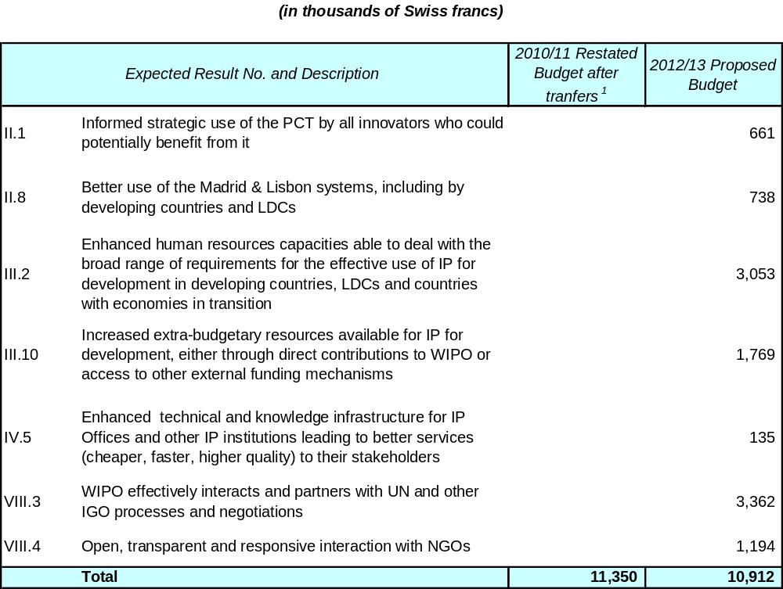

- The figures for 2010/11 budget under personnel costs represent actual expenditure for 2010 and budgeted amounts based on standard costs for 2011. The budget for 2012/13 is prepared using standard costs for the next biennium.

- The reductions in non-personnel resources are primarily due to the transfer of charges related to UN common services (e.g. JIU, CEB) from Program 20 to other responsible programs
in 2012/13.

- The increase under “Staff Missions” relates to increased engagement by WIPO in UN system processes and negotiations. The increase under “Conferences” relates primarily to resource mobilization and partnerships activities such as the organization of regional donor events, in follow up to the WIPO Conference on Building Partnerships for Mobilizing Resources for Development.

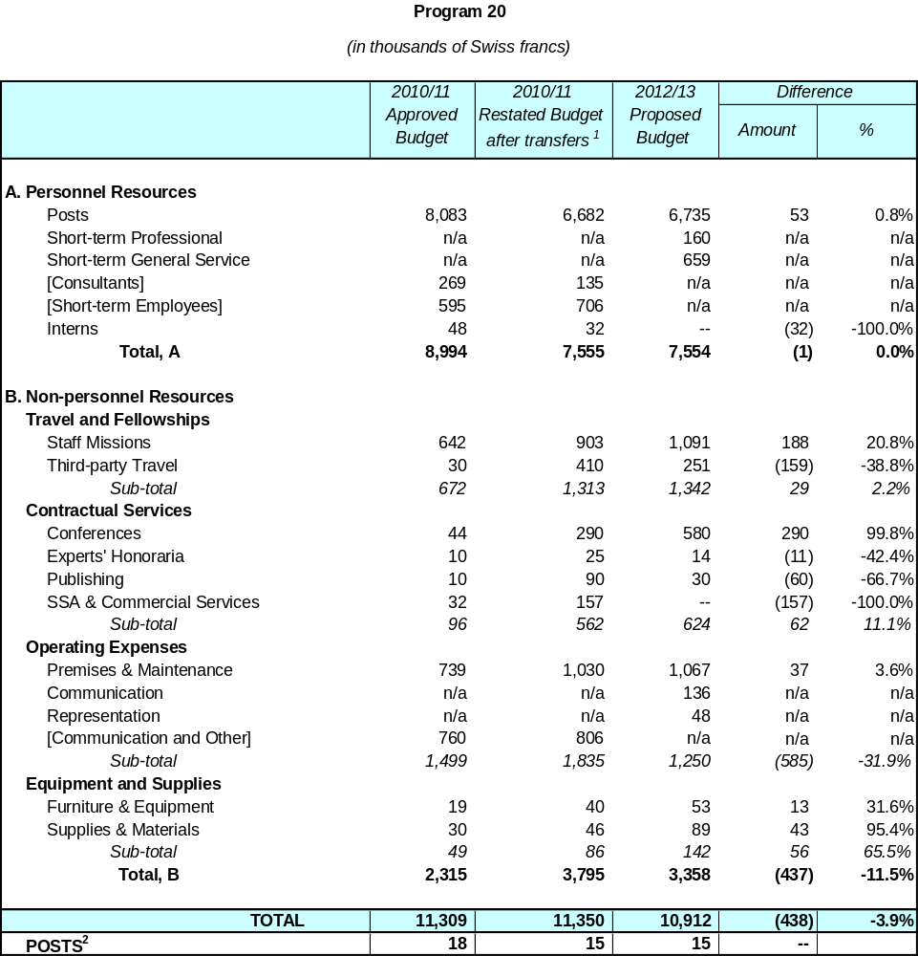

¹ Restated Budget after transfers reflects:

- the adjusted budget of Programs, following transfers during 2010/11 in line with Financial Regulation 5.5. For additional details on the 2010/11 Budget after Transfers, please refer to Table 10 (Annex I) Budget after Transfers by Program of this document and document WO/PBC/18/14 Program Performance Report for 2010;

- restatements of Program budgets for comparison with the 2012/13 proposed Program structure. For those Programs where restatements were not required, the Restated Budget after Transfers is equivalent to the Budget after Transfers, as referred to in document WO/PBC/18/14 Program Performance Report for 2010. For more detailed information on the restatements, please refer to Table 11 (Annex I) of this document.

² For further details on posts for the Program please refer to the Table in Annex II.

STRATEGIC GOAL IX
Efficient Administrative and Financial Support

Strategic Goal IX is the second of two enabling goals. It reflects and responds to the needs of the Organization as a whole for an administrative, financial and management support structure focused on enabling program delivery, with efficiency and transparency as guiding principles. This strategic goal also covers the broad institutional reform (the Strategic Realignment Program) that will enable WIPO to provide better, more efficient and cost-effective support and to achieve enhanced performance.

Expected Results | Performance Indicators | Responsible Program(s)
Effective, efficient, quality and customer-oriented support services both to internal clients and to external stakeholders (human resources, IT, conference, language, procurement, travel, printing and publication, premises management) | Cost savings for goods and services procured by WIPO  (derived from RFPs, negotiations, or UN globalization actions)  % of internal clients satisfied with procurement services  % of spend subject to UN leverage or benchmark | Program 24  Program 24  Program 24
 | Processing time of e-Travel Authorization (TA) and e-Event Request (subject to respected deadline) | Program 24
 | Processing time for 3rd party visas | Program 24
 | Reduction in travel costs as a result of e-conferences and video conferences | Program 24
 | Ratio of employees (full time equivalent) to human resources staff | Program 23
 | % of staff satisfied with HR services | Program 23
 | Productivity rate for calculations, data input and collection and provision of statistics (mail delivery) | Program 27
 | % of PCT Media batch in paper and electronic format on time | Program 27
 | % of Madrid Notifications in paper format on time | Program 27
 | % of Madrid Romarin in electronic format on time | Program 27
 | % of internal and external users satisfied with WIPO's conference services | Program 27
 | Translation productivity standards and cost per page of translation | Program 27
 | A comprehensive language policy adopted by Member States together with related resource allocation requirements | Program 27
 | Outsourcing in operation and provision of IT technical infrastructure | Program 25
 | WIPO meetings are accessible real-time over the Internet or after the event | Program 25
 | No. of communication channels seamlessly integrated | Program 25
 | Rental of additional workplaces and related facilities (assuming same headcount as end 2011) | Program 24
 | No. of main technical installations (electrical, sanitary, heating and cooling) improved in line with applicable standards (to be defined) | Program 24
ICT investments are closely aligned with strategic priorities and yield business benefits | % of projects having benefit realization assessed post project implementation | Program 25
 | Maturity level of ITIL implementation based upon the official self-assessment on scale 5 | Program 25
Efficient and effective results-based programmatic and financial planning, processing, implementation, assessment and reporting | % of WIPO Programs using performance data for managing Program performance | Program 22
 | % of (WIPO) respondents who perceive that WIPO is accountable for its results | Program 22
 | Financial operations and budget management conform to the provisions of the applicable WIPO conventions and treaties, the WIPO Financial Rules and regulations and applicable accounting standards | Program 22
 | Satisfactory financial report from the External Auditors confirms the conformity of accounting operations with applicable regulations, rules and standards | Program 22
Well managed, diversified, motivated and appropriately skilled professional workforce | % of staff whose performance is evaluated against their individual objectives and competencies | Program 23
 | Recruitment lead time | Program 23
 | % of total mass salary invested in staff development | Program 23
 | Geographical diversity - % of Member States represented | Program 23
 | % of women in professional and higher positions | Program 23
 | Decreased absenteeism | Program 23
 | Decreased appeals | Program 23
WIPO staff, delegates, visitors and information and physical assets are safe and secure | % of WIPO staff, delegates and visitors reporting a work related injury or incident | Program 28
 | % of timely requests for safety & security assistance at conferences or events held in or outside of Geneva | Program 28
 | Comprehensiveness and relevance of the set of information security policies, procedures and standards | Program 25
 | Up-to-date information security risk registry | Program 25
Costs related to the new administrative building are kept to a minimum | Use of remaining funds available under the approved consolidated budget and provisions during the construction guarantee period | Program 29
New conference hall and related facilities available for meetings of Member States | Construction of new conference hall and related facilities in compliance with the approved quality, budget and time framework | Program 29
Enhanced coordination and coherence within the Secretariat | Completion of the SRP | Program 21
 | Achievement of SRP Value Level Outcomes | Program 21
 | % of queries for legal advice which receive a response from the Office of the Legal Counsel | Program 21
 | % of adherence notifications processed in a timely manner | Program 21
Improved working environment supported by enabling regulatory framework and effective channels to address staff concerns | % of users satisfied with standard of service obtained from Ombuds-Office | Program 21
 | No. of staff aware of WIPO ethical principles and policies | Program 21
Reduced impact of WIPO’s activities on the environment | No. of Programs with environmental improvement indicators, baselines and targets. | Program 24
 | % of reduction in carbon emissions in respect of energy consumption (in relation to WIPO buildings) | Program 24
Improved physical access to the WIPO Campus | No. of relevant Programs with physical accessibility indicators, baselines and targets | Program 24
An effective and professional internal audit function is in place covering all high risk work areas | No. of audits performed in high risk areas  The professional standards, code of ethics, and practice advisories of the Institute of Internal Auditors (IIA) are applied | Program 26  Program 26
 | Complete and accurate tracking of the implementation of oversight recommendations, showing all historical recommendations made, new ones added and their status | Program 26
Investigation reports provide a sound basis for decision making by the Director General. | Investigation activity is carried out in accordance with the Internal Oversight Charter, UN Uniform Guidelines for Investigation, the Investigation Procedures Manual and the Investigation Policy (currently in draft). | Program 26
Evidence-based evaluative information is available to senior management, program managers and Member States for decision making | Evaluations are produced in line with the Evaluation Policy and Evaluation Section Procedures Manual. | Program 26
Program 21 Executive Management

PLANNING CONTEXT

- The principal challenge for WIPO’s Executive Management is to provide strategic direction and to lead the change which will enable the Organization to perform efficiently, and deliver its mandate effectively while continuing to observe the concept of neutrality of the Secretariat and upholding the rule of law in the rapidly evolving external environment.

- The overarching framework for organizational improvement will continue to be provided by the Strategic Realignment Program (SRP). During the previous biennium, the definition and planning phase of the SRP was completed and the implementation phase began. In 2012/13, the Senior Management Team (SMT) will aim to build momentum and broad-based ownership to ensure timely completion of the nineteen major initiatives of the SRP, and to achieve the expected results in terms of the Organization’s core values.

- The Program must also continue to lead efforts to strengthen trusted, transparent communication with Member States and other stakeholders in order to facilitate progress towards the nine, shared Strategic Goals. The tight resource constraints and uncertain global economic outlook will heighten the challenge of ensuring an equitable and effective response to the constantly increasing demands which result from growing recognition of the importance of intellectual property to developed and developing economies, while at the same time ensuring that the income-generating services of the Organization are adequately resourced.

IMPLEMENTATION STRATEGIES AND RISKS

- The Program will champion and support the implementation of strategies and initiatives that aim at building a delivery-oriented and integrated administration, strengthening management accountability, enhancing ethical conduct and governance responsibility, improving performance in line with WIPO’s Results-based Management (RBM) framework, the MTSP and mainstreaming of the DA. Work within the program will aim to achieve a productive work environment, which reflects organizational values, and is supported by a fair and equitable rules framework, respectful workplace policies and effective channels to address staff concerns.

- The following strategies will be pursued in 2012/13:

- Strengthening communication with Member States: Regular, quality communication, consultation and dialogue with Member States will increase the flow of information at all levels, and enhance transparency with respect to program activities.
- Improving internal coherence and efficiency: This will continue to be strengthened through SMT-level coordination processes, management reporting processes, and through implementation of the SRP. The nineteen SRP projects each comprise a set of implementation strategies which will strengthen the Organization’s management culture and its core values. These include the following:
  - Service orientation: improving the external interface with all stakeholders; strengthening external communications and organizational identity
  - Working as one: strengthening internal communication and organizational culture; ERP implementation to streamline administrative processes; revising the Human Resources regulatory framework.
  - Accountability for results: reinforcing results-based management at all levels.
  - Environmental, social and governance responsibility: raising understanding of ethics principles and functions; reducing WIPO’s carbon footprint.
- Enhancing the functioning of the WIPO Assemblies: The form and content of the High Level Segment (HLS), which was introduced in 2009 with the objective of elevating the level of political engagement, will be improved for future HLSs, which are expected to be held once every two years. Streamlined internal coordination and planning will contribute to thorough, timely preparation of the Assemblies, and so facilitate the work of Member States in WIPO’s most important governing body.
- Building WIPO’s contribution to the Chief Executives Board (CEB): WIPO will continue to participate as an active player within the UN system, including at the CEB. Its role in providing global leadership on IP issues will be promoted.
- Providing prompt independent and reliable legal advice and services: In harmony with statutory requirements and applicable law to facilitate the orderly conduct of business by the Secretariat and the constituent organs of the Organization. Continued development of the WIPO Lex database which is a collection of IP laws and treaties, based on an informed understanding of demand and use.
- Improving the handling of grievances and conflict: The rules and procedures of WIPO’s formal grievance processes will be streamlined. Alternative mechanisms for conflict management will be actively promoted in pursuit of conflict prevention as well as informal conflict resolution.
- Establishing a comprehensive ethics and integrity system: The strategic plan for the recently established WIPO Ethics office will be rolled out, including a draft Code of Ethics, development of the financial disclosure program, introduction of an anti-retaliation policy, and staff training.

- Many of these initiatives are complex, broad in scope and at early stages of implementation. Risks to success include natural resistance to change, initiative fatigue, and competing demands on resources. Particular risks for the timely implementation of the SRP are associated with managing the scale and complexity of the program, requiring intense cross-collaboration between initiatives. The risks will be mitigated through the robust SRP governance and management structure, championed collectively by the Senior Management; as well as through initiatives to specifically address cultural change and internal communication which engage wide staff participation.

RESULTS FRAMEWORK

Expected Results | Performance Indicators | Baselines | Targets
Effective engagement with Member States | % of Committee Meetings for which pre-Committee information meetings for Member States are held | Tbd: No. of information meetings before committee meetings in 2010/11 | 90% of Committee Meetings
 | % of letters to the DG from Member States are responded to within 2 weeks | Tbd | Average 80%
 | Member States satisfaction levels with the preparation and functioning of the Assemblies | Data currently not available | 85% satisfied with arrangements
 | Timeliness of publication of Assembly documents | 90% published at least two months before Assemblies | All documents published two months before Assemblies
Enhanced coordination and coherence within the Secretariat | Completion of the SRP | One out of 19 initiatives completed in 2010 | All initiatives completed
 | Achievement of SRP Value Level Outcomes | See Annex on SRP Baseline Report  (URL) | 75% of Outcomes achieved (ref: SRP Results Framework Dashboard)
 | % of queries for legal advice which receive a response from the Office of the Legal Counsel | 100% | 95%
 | % of adherence notifications processed in a timely manner | 100% processed within three days | 95% processed within three days
 | % of users satisfied with standard of service obtained from Ombuds-Office | Data not available | 70%
Improved working environment supported by enabling regulatory framework and effective channels to address staff concerns | % of staff aware of WIPO ethical principles and policies | 64% | +10%
WIPO effectively interacts and partners with UN and other IGO processes and negotiations | New joint initiatives with other UN agencies | n/a | Two
Enhanced access to, and use of, IP-related legal information | Enhanced coverage in WIPO Lex database of IP-related legal information | Limited coverage of regional economic integration treaties (23 of which 13 have been notified to WTO and of bilateral treaties with IP-related provisions (currently 90 of which 40 have been notified to WTO) | Substantial coverage of over 200 regional economic integration treaties and bilateral treaties in the WTO database. Some coverage those outside the database

RESOURCES FOR PROGRAM 21

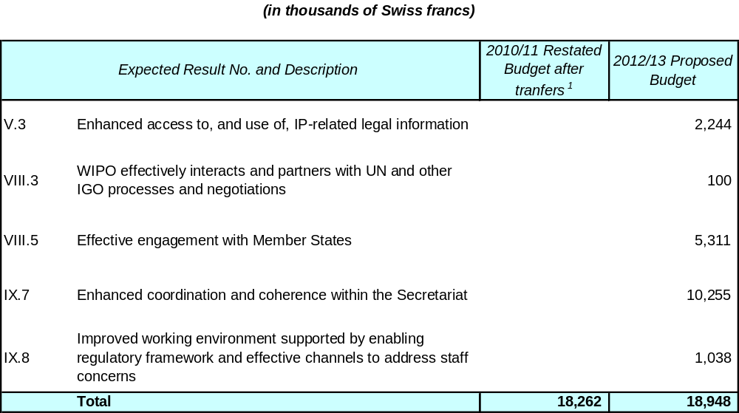

- The figures for 2010/11 Budget under personnel costs represent actual expenditure for 2010 and budgeted amounts based on standard costs for 2011. The budget for 2012/13 is prepared using standard costs for the next biennium. It should be noted that several units within Program 21 (Assemblies Affairs and Documentation Division, Ethics Office, Ombudsman) were established during the 2010/11 biennium and consequently, their full costs were not incorporated. The costs have been fully accounted for in the 2012/13 resulting in the increases in the 2012/13. A new post has also been transferred to the Program.

- The bulk of the reduction in “Contractual Services” is represented by a reduction in the budget for “Special Service Agreements”. The reduction in SSAs is primarily linked to the implementation schedule of the Strategic Realignment Program (SRP). Phase one of the SRP involved considerable resources for “Contractual Services” for strategic human resource advice, planning of SRP initiatives, development of the SRP roadmap and reformulation of core values. Phase Two of the SRP which commenced in 2010/11 will be far less dependent in 2012/13 on the use of external expert services due to the establishment of the SRP Program Management Office.

- The resource requirements presented in respect of Result - Enhanced access to, and use of, IP-related legal information - include the continuing need for attracting junior to mid-level lawyers (through non-staff contract types) who are desirous of devoting time to studying and becoming thoroughly familiar with the IP legal systems of countries in their geographical region. Through their work they will contribute to ensuring that the IP legal system of a country, as reflected on WIPO Lex, is entirely updated and includes the latest principal or subsidiary IP legislation. This in turn will contribute to WIPO’s ability to provide authoritative, updated and complete legal information concerning IP through this on-line database.

- This increase in “Operating Expenses” relates to WIPO’s engagement with the UN Chief Executives’ Board (CEB) and the promotion of WIPO’s global leadership role on IP issues. In addition, the increase is observed in the allocation for “Representation” in the Office of the Director General acknowledging the enhanced efforts of the Director General to improve engagement and communication with Member States.

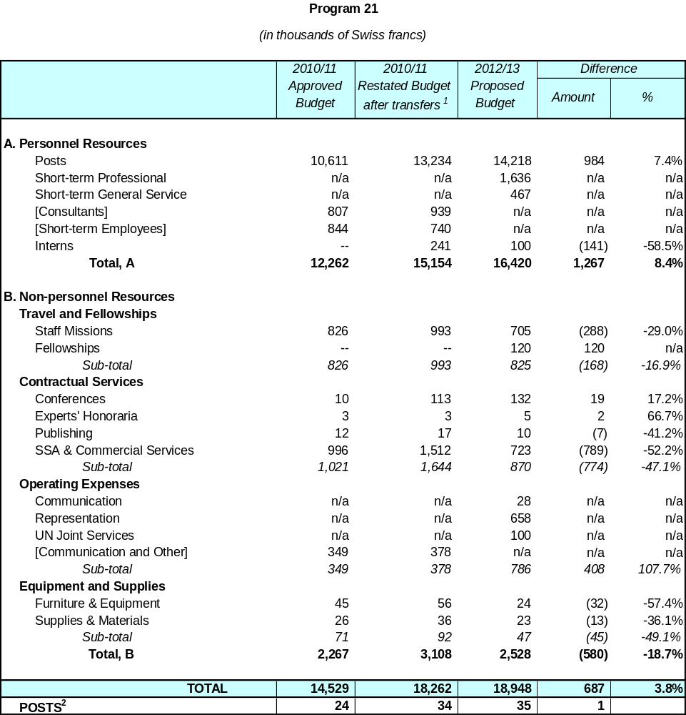

¹ Restated Budget after transfers reflects:

- the adjusted budget of Programs, following transfers during 2010/11 in line with Financial Regulation 5.5. For additional details on the 2010/11 Budget after Transfers, please refer to Table 10 (Annex I) Budget after Transfers by Program of this document and document WO/PBC/18/14 Program Performance Report for 2010;

- restatements of Program budgets for comparison with the 2012/13 proposed Program structure. For those Programs where restatements were not required, the Restated Budget after Transfers is equivalent to the Budget after Transfers, as referred to in document WO/PBC/18/14 Program Performance Report for 2010. For more detailed information on the restatements, please refer to Table 11 (Annex I) of this document.

² For further details on posts for the Program please refer to the Table in Annex II.

Program 22 Program and Resource Management

PLANNING CONTEXT

- The uncertainty in the global economy, the modest recovery in income growth and the increasing demand for WIPO’s services set the context for this program. The current biennium has seen energetic efforts within the context of the Strategic Realignment Program (SRP) in strengthening: (a) the results-based approach to the management of the Organization’s activities; (b) the management of financial resources; and, (c) internal controls.

- The implementation in 2010/11 of the Strategic Realignment Program’s (SRP) “Strengthening RBM Initiative” and the CDIP RBM Project have been successful in further moving RBM from a conceptual to a more practical level. Advances in Results-Based Management (RBM) have included the development of a Medium Term Strategic Plan for 2010-2015 as well as improvements in operational planning within the context of the Program and Budget 2012/13 and the annual workplans in the 2010/11 biennium. The work done in 2010/11 on establishing a sound planning framework for the 2012/13 biennium is a pre-requisite for establishing appropriate systems and tools to support the effective implementation of RBM within the Organization, including monitoring and performance assessment.

- Initiatives were commenced in 2010/11 to ensure more effective and efficient management of the Organization’s financial resources, the strengthening of internal controls and external oversight, and the compliance with the new accounting standards – the International Public Sector Accounting Standards (IPSAS). They focus on the management of investments and reserves following the adoption by Member States of the new investment and reserve policies, and on establishing the required financial elements of WIPO’s policy and regulatory framework, including in preparation for the Enterprise Resource Planning (ERP) implementation.

IMPLEMENTATION STRATEGIES AND RISKS

- A main focus in the biennium will be to ensure that financial and results-based management is fully supported by adequate systems and tools in the ERP. The full integration of WIPO’s financial and RBM systems is essential to ensure that coherent and mutually supportive systems are developed to integrate programmatic and financial planning, monitoring and reporting. This will require, as a first step, that the foundations for the ERP are in place in terms of streamlined, clear and consistent policies, regulations and processes as regards both resource management and organizational performance planning, monitoring and performance assessment. There will be a need to define the delegation of responsibility, authority and accountability that is aligned with the Program/Budget Structure. Additional priorities will include: improved processes to manage and forecast WIPO’s income; institutionalizing a responsible spending culture; enhancing the tracking of development-related expenditure; and, putting in place a stronger system of controls in areas where weaknesses have been identified.

- On the programmatic side, the design and implementation of a monitoring and performance assessment system will proceed with the full participation of managers at all levels to ensure its future usefulness for both internal management and reporting purposes. It will also be guided by DA Recommendation 12, 33 and 38 to ensure that the assessment of development-oriented activities is fully supported. This will require a close cooperation both within Program 22 and between Program 22 and the ERP project. Although the ERP system will not be fully implemented in WIPO by the end of the biennium, the design stage is expected to be completed and implementation underway. Program 22 will also continue to liaise closely with Program 26 (Internal Oversight) to ensure that: (a) external, independent evaluations complement and inform organizational performance assessment mechanisms; (b) gaps in internal controls are identified and addressed in a timely manner; and, (c) there is adequate servicing of oversight bodies.

- Efforts will also continue to be made to improve financial, management and performance reporting both internally and to Member States. The mid-term review of the MTSP which is scheduled for 2013 will further help to strengthen the linkages and coherence between the strategic and operational levels of planning and performance assessment.

- A practical approach will be taken to strengthen the organization’s results culture by providing targeted support to managers at times when they are already having to concentrate on organizational deliverables, such as annual workplans, the Program and Budget, Program Performance Reports and reports of progress at a more strategic level, for example in preparation for the MTSP mid-term review. To this end, a close cooperation with the SRP in Program 21, in particular in relation to the ‘Accountability for Results’ Core Value, will be essential. Within this overall context, specific emphasis will also be given to strengthening the capacities for performance assessment, including of development results in line with DA Recommendation 38. Capacity building efforts in both the financial and programmatic areas will continue during the biennium.

- An eventual continuation of the global economic recession would put a strain on the effective and efficient management of financial resources. It therefore remains critical for WIPO to closely monitor income and expenditure through the internally established Crisis Management Group and the Financial Observatory reporting mechanism to Member States. Additionally, the continuously evolving standards within IPSAS continue to be a risk for IPSAS non-compliance. The biennial budget for the Independent Advisory Oversight Committee (IAOC) is also included in the amount of 737,000 Swiss francs for the 2012/13 budget under Program 22.

RESULTS FRAMEWORK

Expected Results | Performance Indicators | Baselines | Targets
Efficient and effective results-based programmatic and financial planning, processing, implementation, assessment and reporting | % of WIPO Programs using performance data for managing Program performance | 20% | 50%
 | % of (WIPO) respondents who perceive that WIPO is accountable for its results | 59% | 75%
 | Financial operations and budget management conform to the provisions of the applicable WIPO conventions and treaties, the WIPO Financial Rules and regulations and applicable accounting standards | Existing set of documented policies, rles and procedures | Gaps identified through ERP visioning exercise are filled
 | Satisfactory financial report from the External Auditors confirms the conformity of accounting operations with applicable regulations, rules and standards | Unqualified report from the External Auditor | Unqualified report from the External Auditor

RESOURCES FOR PROGRAM 22

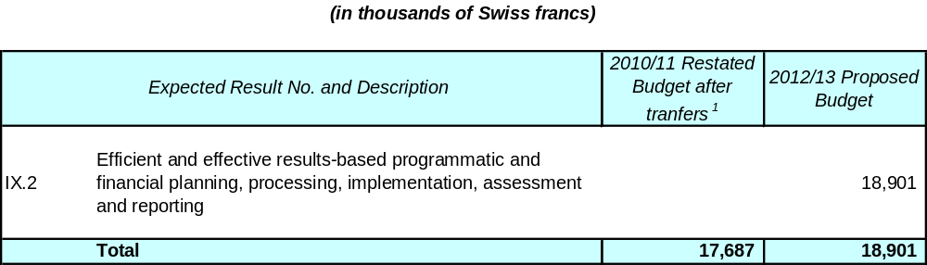

- The figures for 2010/11 Budget under personnel costs represent actual expenditure for 2010 and budgeted amounts based on standard costs for 2011. The budget for 2012/13 is prepared using standard costs for the next biennium. The increase in budgeted amount under Posts for Program goes beyond the statutory increases incorporated in the standard costs as a result of a lower base in 2010 actual expenditure due to vacancies in the Program.

- The proposed decreases in non-personnel resources are mainly due to the completion of several components of the CDIP approved RBM project. This has affected the proposed allocation of resources under in 2012/13 as compared to the 2010/11 under “Staff Missions”, “Third-party Travel”, “Conferences”, “Experts’ Honoraria” and “Publishing”. The proposed increase of 705 thousand Swiss francs under “SSA and Commercial Services” is mainly related to the need for actuarial valuation under IPSAS, mid-term review of the MTSP and Staff training activities to strengthen the implementation of RBM. Furthermore, some expenditure previously shown under “Conferences” (e.g. costs of interpretation for PBC, IAOC meetings) are now included under “SSA and Commercial Services”. The proposed increases under “Operating Expenses” mainly include the rental and maintenance cost of small equipment/machines used by the Income Section to process envelopes and UN charges for IPSAS. The amount of 508 thousand Swiss francs under “Administrative and Bank Charges” includes a provision of 388 thousand Swiss francs for the External Auditors fees.

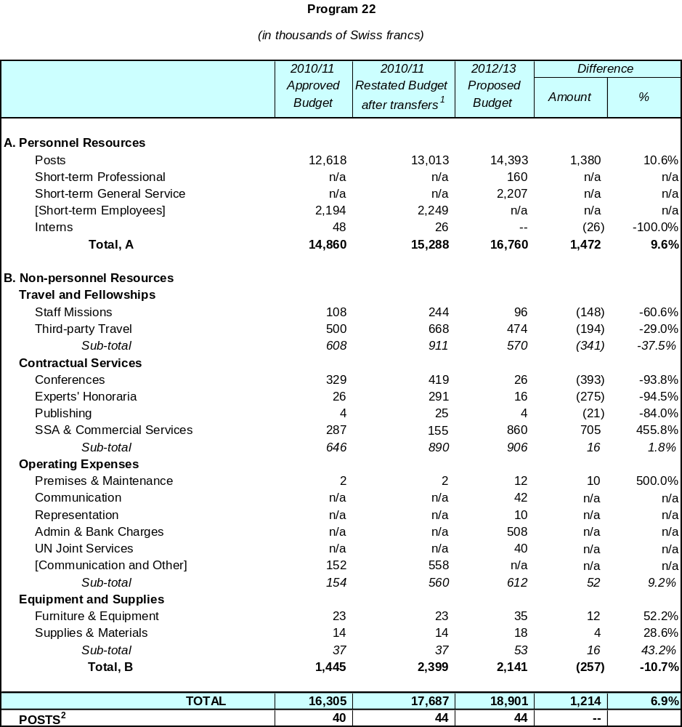

¹ Restated Budget after transfers reflects:

- the adjusted budget of Programs, following transfers during 2010/11 in line with Financial Regulation 5.5. For additional details on the 2010/11 Budget after Transfers, please refer to Table 10 (Annex I) Budget after Transfers by Program of this document and document WO/PBC/18/14 Program Performance Report for 2010;

- restatements of Program budgets for comparison with the 2012/13 proposed Program structure. For those Programs where restatements were not required, the Restated Budget after Transfers is equivalent to the Budget after Transfers, as referred to in document WO/PBC/18/14 Program Performance Report for 2010. For more detailed information on the restatements, please refer to Table 11 (Annex I) of this document.

² For further details on posts for the Program please refer to the Table in Annex II.

Program 23 Human Resources Management and Development

PLANNING CONTEXT

- In order to achieve its substantive goals, the Organization must have a well managed and appropriately skilled staff which is working within a robust and enabling regulatory framework supported by clear policies, efficient procedures and modern systems. In this context, many challenges would need to be addressed, in particular: the gap between the current competencies and skills and the competencies required in order to meet the Organization’s future needs, also affected by delays in the current recruitment processes of the Organization; the gender and geographical balance of staff; a regulatory framework in need of updating, including the Staff Regulations and Staff Rules and policies; the need for staff contracts to be aligned with the best practices within the UN Common System; and the need to enhance the efficiency and effectiveness of human resources processes.

- The absence of an integrated technology platform has proven to affect the efficiency and effectiveness of human resources processes. In particular, the current Administrative and Payroll Systems would need replacement and other paper-based processes would require automation.

IMPLEMENTATION STRATEGIES AND RISKS

- The priority in the 2012/13 biennium will be to ensure the implementation and continuation of major initiatives, many of which have been initiated in the current biennium, including through the Strategic realignment Program (SRP). These include the further development of the Performance Management and Staff Development System (PMSDS), encompassing staff development activities through training, revision and implementation of Staff Regulations and Staff Rules as well as development of complementary, supporting policies and procedures as appropriate. In addition, processes will be streamlined, including the classification and recruitment processes. Human resource operational services to all stakeholders will continue to be provided and improved, including the processing of benefits and entitlements of staff members and the provision of adequate insurance coverage and medical and welfare services.

- Recruitment will continue to focus on ensuring that the skills gap within the Organization is reduced, while paying due attention to gender balance and geographical distribution. Reducing the length of the recruitment process will be a top priority during the biennium to ensure that WIPO is in a position to attract the best applicants.

- The ERP project is a high priority initiative of this Program. The focus in the biennium will be on ensuring that the design and implementation of the system effectively meets the needs of human resource management as well as senior management to support decision-making, consistent policy application and reporting to Member States.

- Due to interdependencies, several of the human resources improvement initiatives related to the SRP (e.g. to policies, process and systems ERP) depend critically on the revised Staff Regulations and Staff Rules. Delays in approval could significantly impact progress on these initiatives. Senior Management and Staff Council commitment and engagement will play a key role in this process. Regular communication and engagement with staff will ensure good and consistent understanding of the provisions of the revised Staff Regulations and Staff Rules. Transparent and coherent policies and procedures and their consistent application will reduce the risk of staff appeals and grievances. Accessibility to up to date information on regulations, rules, policies and procedures will be enhanced through an online staff manual. Particular attention will be paid to the support needed by newly recruited staff/employees.

- The ability and capacity of the Program to cope with the changes and initiatives while continuing effectively and efficiently to deliver services could be a risk. This will be addressed through the empowerment of human resources leadership, providing Senior Management support, team building, improving internal communications, better definition of roles and responsibilities and delegation of authority and careful planning of activities including those related to the ERP implementation. A comprehensive medium-term human resources plan will developed for this purpose.

RESULTS FRAMEWORK

Expected Results | Performance Indicators | Baselines | Targets
Effective, efficient, quality and customer-oriented support services both to internal clients and to external stakeholders (human resources, IT, conference, language, procurement, travel, printing and publication, premises management) | Reduced time from submission to completion of standard human resources transactions (education grant, dependency allowances)  Ratio of employees (full time equivalent) to human resources staff | Three days  One HR employee for 31 Organization’s employees (Jan 2011) | Two days  One HR employee for 50 Organization’s employees
 | % of staff satisfied with HR services | Highly satisfied: 30.8%,  Satisfied: 48.2 %, Dissatisfied: 17.9%, Highly dissatisfied: 3.1% | 50% highly satisfied
Well managed, diversified, motivated and appropriately skilled professional workforce | % of staff whose performance is evaluated against their individual objectives and competencies | 62% | 90%
 | Recruitment lead time | 24 weeks | 21 weeks
 | % of total mass salary invested in staff development | 0.44% (Jan 2011) | 1%
 | Geographical diversity - % of Member States represented | 56.70% | 60%
 | % of women in professional and higher positions | P4 – 44.2%  P5 - 30.9 %  D1 - 12.1 %  D2 – 9.1% | 50% (as approved by the UNGA following ICSC recommendation)
 | Decreased absenteeism | Average number of sick leave days per employees: 9.6 | Average of 5.5 days/employee
 | Decreased appeals | 27 cases | 22 cases

RESOURCES FOR PROGRAM 23

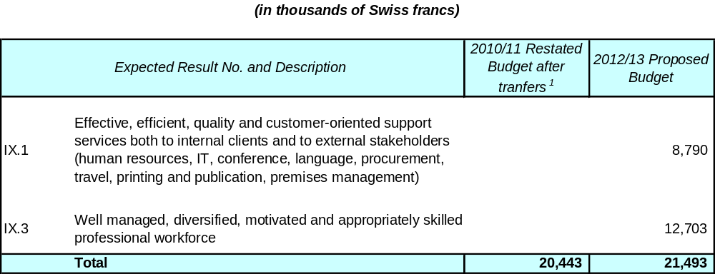

- The figures for 2010/11 Budget under personnel costs represent actual expenditure for 2010 and budgeted amounts based on standard costs for 2011. The budget for 2012/13 is prepared using standard costs for the next biennium. The proposed increases under the Program include the provision of approximately 3.0 million Swiss francs for some of the central items such as Internship, Professional Insurance and Closed Pension Fund Contribution.

- The proposed increase in non-personnel resources under “Staff Mission” is mainly related to increased participation of staff in various UN related human resources fora and travel for training related activities. The increase of “Third-party Travel” mainly relates to Interview travels (large number of vacancies, with recruitment still ongoing and expected to continue in 2012/13). Increases in “Operating Expenses” are mainly due to the transfer of HR related UN common services costs under the responsibility of Program 23.

- A provision has for the first time been included under “SSA and Commercial Services” for maternity and sickness cover, which will be in the form of an outside contract with a temporary employment agency (this increase has been offset by various other reductions under “SSA and Commercial Services”).

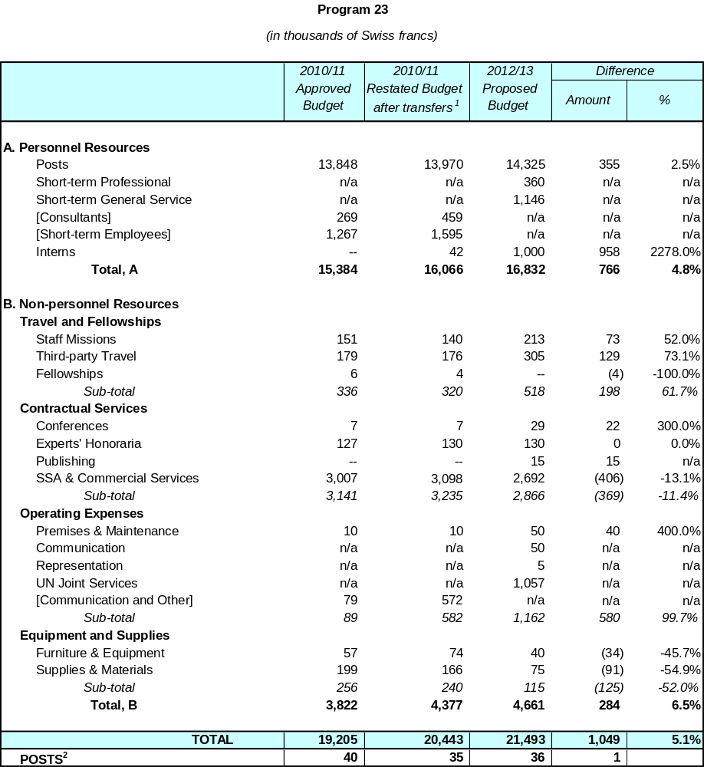

¹ Restated Budget after transfers reflects:

- the adjusted budget of Programs, following transfers during 2010/11 in line with Financial Regulation 5.5. For additional details on the 2010/11 Budget after Transfers, please refer to Table 10 (Annex I) Budget after Transfers by Program of this document and document WO/PBC/18/14 Program Performance Report for 2010;

- restatements of Program budgets for comparison with the 2012/13 proposed Program structure. For those Programs where restatements were not required, the Restated Budget after Transfers is equivalent to the Budget after Transfers, as referred to in document WO/PBC/18/14 Program Performance Report for 2010. For more detailed information on the restatements, please refer to Table 11 (Annex I) of this document.

² For further details on posts for the Program please refer to the Table in Annex II.

Program 24 General Support Services

PLANNING CONTEXT

- Procured goods and services, as well as travel, constitute one of WIPO’s most important
non-personnel costs and is therefore an area with potentially high efficiency and cost gains for the Organization as a whole. Procurement and travel services will therefore focus on driving value through strategic sourcing and enhancing the efficiency of its activities while ensuring a continuous high quality and customer-oriented support to users across the Organization.

- The biggest challenge as regards the management of existing premises will be the integration of the new building, with the largest building capacity ever, into the WIPO campus. Enhanced functioning of technical installations and compliance with standards will continue to be a priority. Furthermore, construction work on the new conference hall, the AB Building, and the UN HMOSS security perimeter will continue until 2013, bringing with it the challenge of minimizing the effects of the major worksites on the daily operations of the Organization.

- The internal mail distribution and mail delivery and/or pick-up, both internally and externally, are important parts of the work and communication flows within the Organization. This service will face the particular challenge of adapting and streamlining its work during the biennium due to the unprecedented number of staff movements following the completion of the new building in 2011.

- In his SRP, the Director General has made a strong commitment to strengthening environmental and social governance across all WIPO activities. In the biennium, the main challenge will be to further reduce the adverse impact that WIPO’s activities have on the environment, including that of premises and travel, and to improve the physical access to the WIPO Campus.

IMPLEMENTATION STRATEGIES AND RISKS

- In order to further optimize the cost of WIPO procured goods and services, strategic sourcing policies will be established to leverage spending across the Organization, over time, and in collaboration with other UN system organizations. Better procurement planning for the Organization as a whole will be developed, as well as an emphasis on delivering satisfactory services to internal clients, through a professional, timely and pro-active approach, in line with the SRP core value of ‘service orientation’. Local sourcing will be fostered for any development related procurement activity. Lastly, efficiency and compliance of procurement processes and services will be enhanced by streamlining different initiatives and projects, whose results will be closely monitored in a Key Performance Indicator dashboard.

- As regards travel services, the optimization of travel costs will be pursued by continuing stand alone or global negotiations of corporate fares. Further efficiency gains in the travel services are expected by reducing processing time, automating statistical reports, implementing user-friendly IT tools that also ensure better data consistency, and by closely monitoring the performance of the WIPO travel agency.

- The main risks faced by the procurement and travel services are those linked to global inflation trends that may arise from market consolidation, tighter regulations, and raw material contingency situations. These risks will be mitigated by maintaining a forward-looking market analysis of its critical providers.

- For the management of premises, the optimal allocation of work space to host all WIPO staff will necessitate continued alignment of the space allocation policy to the available facilities. To ensure a continuous and uniform upgrading of technical facilities in WIPO premises, an overall plan for renovation and enhancement of technical installations throughout the WIPO Campus will be established based on a set of definitions and criteria for technical installations standards. Efforts to minimize disruptions due to the ongoing construction work will be pursued through a close coordination with Programs 25 (IT), 27 (Conference and Language Services), 28 (Safety and Security) and 29 (Construction Projects) in particular.

- The main risk associated with the management of premises is a potential expansion of the actual number of WIPO staff beyond the capacity of the buildings even with a stricter office space allocation policy. This will be mitigated through a close coordination between programs. Major technical breakdowns, requiring vacating a building or a significant part of a building and relocating staff temporarily off-site for a longer period of time, would also significantly affect the achievement of results. This will be mitigated by putting in place an adequate and continuous monitoring of the facilities, with a particular emphasis on the oldest buildings.

- A high-level service of internal mail distribution and mail delivery and/or pick-up both internally and externally will necessitate close monitoring of staff moves and continuous coordination within this Program.

- Efforts to reduce the impact of WIPO’s activities on the environment will focus on defining, for each program, a set of environmental improvement indicators, baselines and targets which will be monitored on a continuous basis. This will be pursued hand-in-hand with awareness raising initiatives contributing to the mainstreaming of the SRP environmental and social governance core value throughout the Organization. This Program will, in particular, target a reduction in the impact on the environment through reducing energy consumption in WIPO premises, including by replacing obsolete technical installations with greener alternatives, gradually moving to a greener electricity tariff bracket for all WIPO buildings, thereby contributing to local investments in renewable energies, and the gradual replacement of existing WIPO vehicles with hybrid models. Investments in greener technology and utilities might risk increasing the overall cost of maintenance of the WIPO premises in the short term. This should be off-set in the longer term by a reduction in the overall energy consumption. Environmental considerations will also gradually become, whenever relevant, a selection criteria in sourcing activities.

- Similar strategies will be adopted to enhance the accessibility to WIPO premises. In addition to Program 24, such efforts will in particular be relevant in Program 25 (IT), Program 28 (Safety and Security) and Program 29 (Construction Projects). The cost implications of improving accessibility could, for some measures, be significant. It will therefore be examined which measures could be introduced as an addendum to the ongoing construction projects (new conference hall, security perimeter) thereby avoiding additional subsequent worksites. A plan will also be developed during the biennium to phase a series of improvements over this and future biennia.

RESULTS FRAMEWORK

Expected Results | Performance Indicators | Baselines | Targets
Effective, efficient, quality and customer-oriented support services both to internal clients and to external stakeholders (human resources, IT, conference, language, procurement, travel, printing and publication, premises management) | Cost savings for goods and services procured by WIPO  (derived from RFPs, negotiations, or UN globalization actions)  % of internal clients satisfied with procurement services  % of spend subject to UN leverage or benchmark | CHF500,000 (P&B 10/11 value)  Tbd (end 2011)  Tbd (end 2011) | At least CHF500,000 (P&B 10/11 value)  Tbd (end 2011)  Tbd (end 2011)
 | Processing time of e-Travel Authorization (TA) and e-Event Request (subject to respected deadline) | e-TA - 1 day  e-ER = 2 hours | e-TA - 1 day  e-ER = 2 hours
 | Processing time for 3rd party visas | 4-5 days | 2-3 days
 | Reduction in travel costs as a result of e-conferences and video conferences | Tbd | tbd
 | Rental of additional workplaces and related facilities (assuming same headcount as end 2011) | 80 workplaces | 80 workplaces
 | No. of main technical installations (electrical, sanitary, heating and cooling) improved in line with applicable standards (to be defined) | n/a | n/a
Reduced impact of WIPO’s activities on the environment | No. of Programs with environmental improvement indicators, baselines and targets | Tbd end 2011 | All Programs
 | % of reduction in carbon emissions in respect of energy consumption | Tbd end 2011 | Tbd end 2011
Improved physical access to the WIPO Campus | No. of relevant Programs with physical accessibility indicators, baselines and targets | Tbd end 2011 | All related Programs

RESOURCES FOR PROGRAM 24

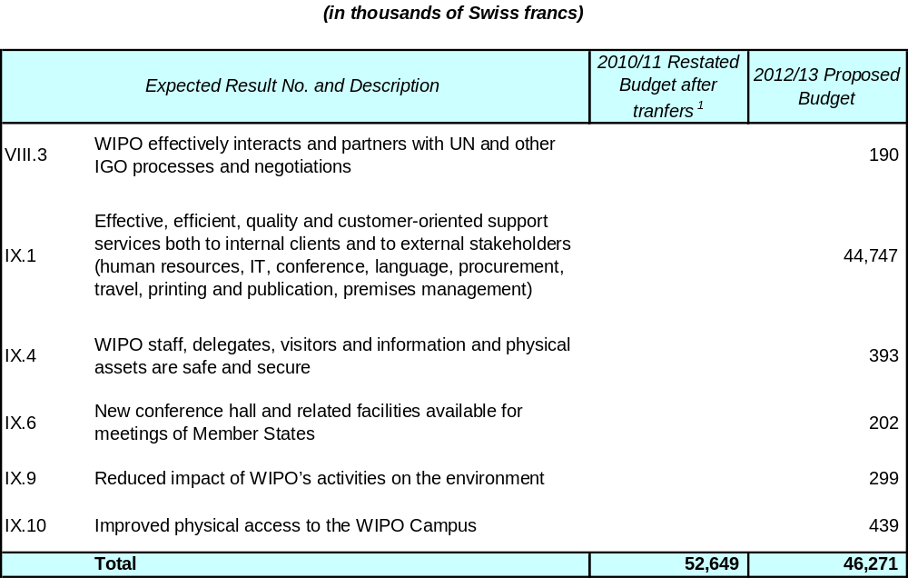

- The figures for 2010/11 Budget under personnel costs represent actual expenditure for 2010 and budgeted amounts based on standard costs for 2011. The budget for 2012/13 is prepared using standard costs for the next biennium. The increase in budgeted amount under Posts for Program goes beyond the statutory increases incorporated in the standard costs due to the transfers during the course of 2010/11.

- The proposed reduction in non-personnel resources is mainly related to the end of the lease of the rented P&G building. This reduction has been partly offset by an increase in the charges and maintenance related costs for the new building, the New Conference Hall (starting second half of 2013) and the modernization/renovation/projects for the older buildings, such as lake-water cooling systems and other upgrades or replacements of technical installations. In addition, increases are foreseen for the implementation of physical accessibility measures and related equipment costs. A budget provision of 2.5 million Swiss francs is also proposed as an initial contribution to the Building Maintenance and Renovation Fund to be established.

- The increases under “Staff Missions” are mainly related to UN inter-agency activities and meetings and staff training and development. The increases under “SSA and Commercial Services” are primarily related to an audit by the Institute of Safety and Security (Neuchatel) for the implementation of premises-related safety measures, commercial maintenance service contracts (renovation, transformation and modernization of premises) and commercial services for the management of WIPO assets.

- The increase under “Furniture and Equipment” primarily relates to the equipment costs required for the implementation of physical accessibility measures.

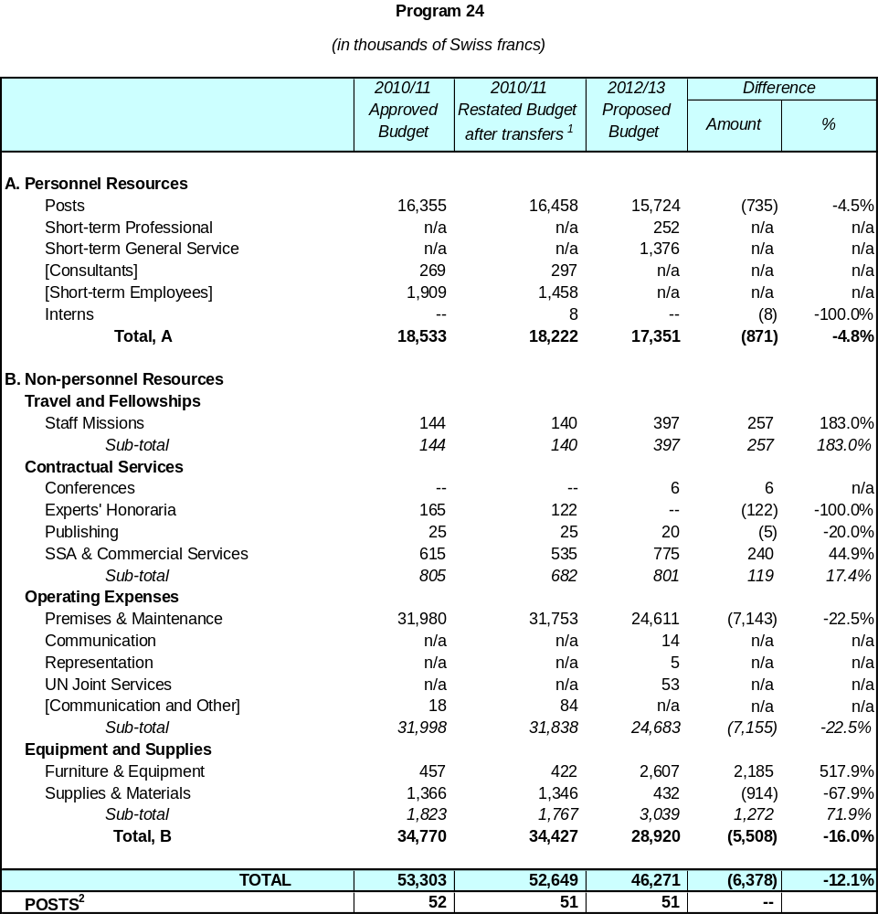

¹ Restated Budget after transfers reflects:

- the adjusted budget of Programs, following transfers during 2010/11 in line with Financial Regulation 5.5. For additional details on the 2010/11 Budget after Transfers, please refer to Table 10 (Annex I) Budget after Transfers by Program of this document and document WO/PBC/18/14 Program Performance Report for 2010;

- restatements of Program budgets for comparison with the 2012/13 proposed Program structure. For those Programs where restatements were not required, the Restated Budget after Transfers is equivalent to the Budget after Transfers, as referred to in document WO/PBC/18/14 Program Performance Report for 2010. For more detailed information on the restatements, please refer to Table 11 (Annex I) of this document.

² For further details on posts for the Program please refer to the Table in Annex II.

Program 25 Information and Communication Technology

PLANNING CONTEXT

- In today’s connected world, advanced, reliable and secure Information and Communications Technology (ICT) is operationally vital and strategically imperative to WIPO in fulfilling its mandates and obligations. ICT at WIPO is far more than just an administrative tool. Unlike many other United Nations organizations, a significant number of WIPO’s mission critical services are delivered to its users and stakeholders through the processing of time-critical online transactions.

- ICT is a key enabler for WIPO to achieve its nine Strategic Goals, in particular the following:

- Provision of premier global IP services
- Coordination and development of global IP infrastructure
- World reference source for IP information and analysis
- Addressing IP in relation to global policy issues
- A responsive communications interface between WIPO, its Member States and all stakeholders
- Efficient administrative and financial support structure to enable WIPO to deliver its programs.

- Over the past few years, significant efforts have been made to introduce good management practices and to consolidate technology standards. The key challenge for 2012/13 is to transform the ICT services by mainstreaming good practices and by ensuring that the Organization builds capabilities to effectively and efficiently benefit from the technology advancement. This is a race against time with limited resources, as many past ICT initiatives must first be consolidated to ensure sustainability, reliability and security. The Organization is also expected to continue to innovate to better serve its Member States and all stakeholders by exploiting opportunities provided by emerging technologies.

- As this transformation unfolds, it is a major challenge to manage the risks associated with the significant changes in technologies, desired staff competency, and processes. Past under-investment in core technologies and services has made this transformation exigent.

- WIPO’s ICT vision is described in the ICT strategy approved by the ICT Board in 2010: “We strive to provide responsive, secure, client-centric ICT services that are well coordinated and dedicated to cost-effectively meet the needs of its clients”.

IMPLEMENTATION STRATEGIES AND RISKS

- This vision calls for the establishment of a set of key enabling capabilities, some of which are particularly relevant to and driven by this Program:

- Effective and efficient ICT governance framework and operational practices that ensure alignment between ICT investments and WIPO strategic priorities, and increased accountability for ICT investment.
- Elastic, up-to-date and reliable ICT hardware and software common services to meet the growing ICT demands in a timely and cost-effective manner, while ensuring business continuity.
- Well understood information security risks, accountabilities and enforceable corresponding policies and internal controls.
- A client-centric ICT environment that is capable of providing a consolidated user experience to our clients and one that is more accessible, interoperable and compatible both within WIPO and with its external clients.
- Advanced business intelligence and process management capabilities which utilize modern modeling technologies and tools that provide value-added reference information for optimizing business processes.
- Strategically focused adoption of enterprise collaboration, conferencing and web technologies to sustain effective communication and promote access to knowledge among the workforce, Member States and other stakeholders.
- Improved enterprise content management (ECM) to enable proper management of unstructured information regardless where that information exists.

- This Program provides vital support to other programs in establishing enabling capabilities including: modern and advanced multilingual platforms and tools for language services; well established strategic information repository and secured exchange mechanism to position WIPO as a comprehensive and trusted source or channel for IP information; and, extended ERP environment to efficiently streamline and integrate management and administrative processes to support result-based management.

- The expected results in the biennium are to be achieved through several strategies. Firstly, the ICT Board will play a key role in determining the ICT related priorities and the effectiveness of the Technical Advisory Group will be improved. Also, business ownership over ICT initiatives will be promoted while improving project management discipline. Improving governance and business ownership over ICT initiatives needs time to cultivate, while pressing ICT demands continue. Flexibility, result orientation, and the spirit of “working as one” will go a long way to smooth the path of this transformation.

- Secondly, infrastructure provision and operations will be strategically outsourced to ensure high levels of service and cost effectiveness. Switching the Infrastructure and Service Management to outsourcing is resource intensive and puts additional load on the existing staff during the transitional period. Gradual implementation of outsourcing will be essential to address this issue.

- Thirdly, a new domain of Enterprise Architecture and Information Assurance will be established to holistically manage information security risks and technology directions. Outsourcing introduces different set of challenges for information security. Management attention needs to be intensified to validate outsourcing partners’ internal controls and security management, while staff focus also needs to be redirected from operational monitoring to performance and contractual management.

- Uncoordinated technological changes introduce additional complexity and integration challenges, even potential for service interruptions. Process maturity must improve. This must be complemented, in parallel, with intensified staff development and training.

RESULTS FRAMEWORK

Expected Results | Performance Indicators | Baselines | Targets
ICT investments are closely aligned with strategic priorities and yield business benefits | % of projects having benefit realization assessed post project implementation | 0 | 20%
 | Maturity level of ITIL implementation based upon the official self-assessment on scale 5 | In average two of the service support | Increase by one step
Effective, efficient, quality and customer-oriented support services both to internal clients and to external stakeholders (human resources, IT, conference, language, procurement, travel, printing and publication, premises management) | Outsourcing in operation and provision of IT technical infrastructure  WIPO meetings are accessible real-time over the Internet or after the event  No of communication channels seamlessly integrated | Two hosted applications  Assemblies broadcasted  e-mail, phone separated | 30% of the server park hosted at ICC  At least 20 meeting days broadcasted  e-mail, phone, web conferencing, web meetings, webinars integrated
WIPO staff, delegates, visitors and information and physical assets are safe and secure | Comprehensiveness and relevance of the set of information security policies, procedures and standards | Eight policies, under revision | 12 up-to-date policies
 | Up-to-date information security risk registry | Risk registry has been created | Risk registry revised twice a year

RESOURCES FOR PROGRAM 25

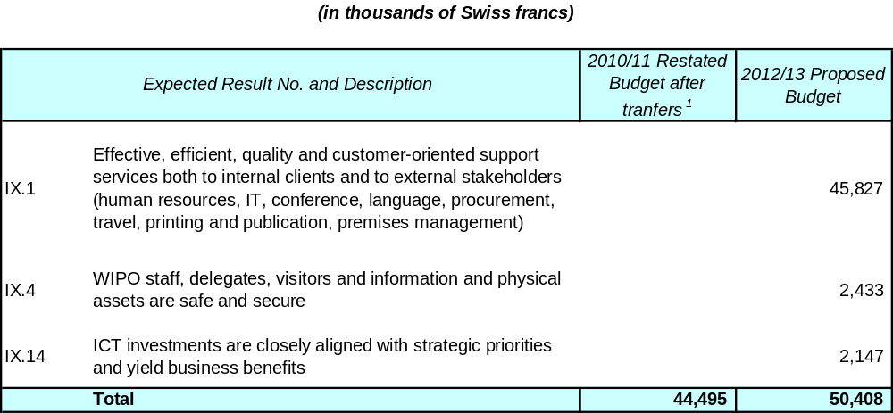

- The figures for 2010/11 Budget under personnel costs represent actual expenditure for 2010 and budgeted amounts based on standard costs for 2011. The budget for 2012/13 is prepared using standard costs for the next biennium.

- The reduction in post costs for the Program is the result of the decision to delay recruitment into certain posts, where the content of these is expected to be significantly influenced by the evolution and needs of the Organization’s IT systems and infrastructure, post ERP implementation.

- The proposed 6.9 million Swiss francs increase in non-personnel resources for the next biennium primarily comes from the 12.5 million Swiss francs increase under “SSA and commercial services”, which relates to outside contracts (strategic partnership with UNICC and regular suppliers for Licensing, software, and support specific to the IT support systems such as Helpdesk services). In parallel, staff costs and operational costs and provisions for investments in hardware and infrastructure from the regular budget were significantly decreased. This reflects the measured strategy that infrastructure provisioning and operations be strategically outsourced to meet increased demands while ensuring high quality services in a cost effective manner. The proposed budget also includes provisions for the implementation of various Business Continuity initiatives.

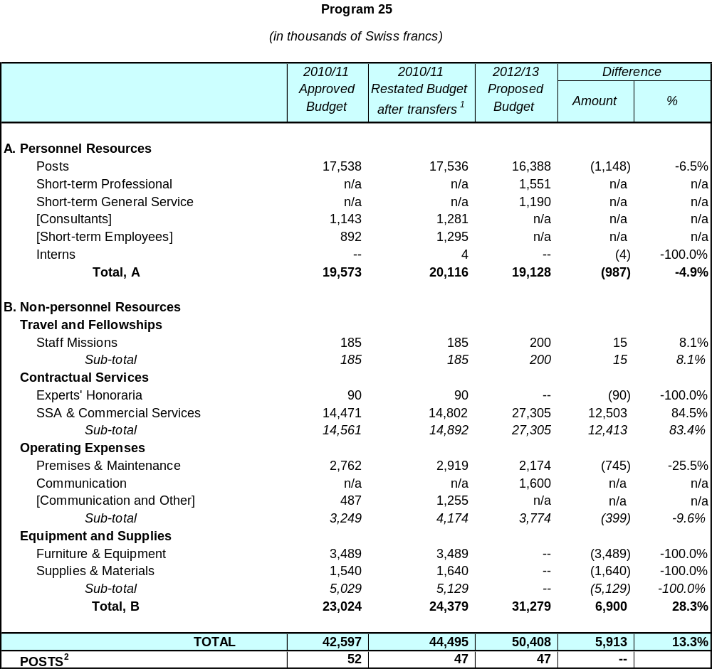

¹ Restated Budget after transfers reflects:

- the adjusted budget of Programs, following transfers during 2010/11 in line with Financial Regulation 5.5. For additional details on the 2010/11 Budget after Transfers, please refer to Table 10 (Annex I) Budget after Transfers by Program of this document and document WO/PBC/18/14 Program Performance Report for 2010;

- restatements of Program budgets for comparison with the 2012/13 proposed Program structure. For those Programs where restatements were not required, the Restated Budget after Transfers is equivalent to the Budget after Transfers, as referred to in document WO/PBC/18/14 Program Performance Report for 2010. For more detailed information on the restatements, please refer to Table 11 (Annex I) of this document.

² For further details on posts for the Program please refer to the Table in Annex II.

Program 26 Internal Oversight

PLANNING CONTEXT

- The strengthening of the Internal Oversight services has continued during the biennium 2010/11 to ensure the progressive implementation of the Internal Oversight Charter and the Evaluation Policy. The implementation of both the Charter and the Policy is based on a risk and needs based planning approach reflected in detailed annual work plans for internal audit, evaluation and investigation services. In addition, longer term strategic frameworks have been developed for Internal Audit and Evaluation. Plans for evaluation are based on extensive consultation with management.

IMPLEMENTATION STRATEGIES AND RISKS

- Internal Audit will continue to focus on high-risk audits and provide advice for the improvements of internal controls, information security and risk management. Progress in implementing oversight recommendations will be regularly monitored and reported to the Director General, the Independent Advisory and Oversight Committee (IAOC) and the WIPO Assemblies. Several software applications will be fully in use by 2012 to enhance the efficiency of the audit process. The strengthening of the Internal Audit Section in 2011 will help ensure the good quality and added value of audit reports through implementation of a two stage review process of reports.

- The generation of quality and real-time evaluation reports and other evaluative information will be further developed. The wide dissemination of information generated by evaluations, including lessons learned, and the timely follow-up to recommendations contained in evaluation reports will be important. Independent evaluations (program level, thematic, strategic goal level) will be conducted based on priorities established with major stakeholders. The DA will become an important focus for evaluation work. The Evaluation Policy will continue to be implemented and institutionalized.

- Internal Oversight will continue to support management in the development and implementation of an efficient and effective Ethics and Integrity framework within which all WIPO staff have clear duties, roles, responsibilities and rights. This will be accomplished through the provision of professional and timely investigation reports conducted in line with accepted norms and good practices for investigation in UN organizations. Formalized whistle-blowing procedures and a “hot line” will be put in place. Active support for the development of ethics and conduct codes, and a system of financial disclosures based on UN good practice will continue to be provided. Also, a risk assessment framework will be developed, to mitigate against the occurrence of wrongdoing, misbehavior and fraud. A program to counter misbehavior, wrongdoing and fraud will be developed with other interested parties.

- Support and advice will be provided, as appropriate, in connection with WIPO’s SRP (in particular aspects covering internal control, risk management, ethics and information security), and the DA.

- Cooperation and coordination with the External Auditor, Ombudsman and Ethics Office will remain a high priority, as will the active follow up of management implementation of all oversight recommendations. In addition, appropriate oversight tools, such as manuals, policies and guidelines will continue to be developed and will incorporate professional and UN good practices.

- Cooperation with the UN internal oversight community and relevant international and professional associations will continue during the biennium to ensure that internal oversight at WIPO is being conducted in line with international developments and good UN practices.

RESULTS FRAMEWORK

Expected Results | Performance Indicators | Baselines | Targets
An effective and professional internal audit function is in place covering all high risk work areas | Number of audits performed in high risk areas | Six audits completed (2010) | 12 audits
 | The professional standards, code of ethics, and practice advisories of the Institute of Internal Auditors (IIA) are applied. | Internal audit section received "general conformance with the IIA standards" rating (External Auditor's quality assurance review of the Internal Audit Section, 2009) | Maintain the "meets general conformity with the IIA standards" rating in subsequent external quality assurance reviews.
 | Complete and accurate tracking of the implementation of oversight recommendations, showing all historical recommendations made, new ones added and their status | IAOD reviewed the implementation status of oversight recommendations twice in 2010 | The implementation of all IAOD recommendations is followed up every six months
Investigation reports provide a sound basis for decision making by the Director General | Investigation activity is carried out in accordance with the Internal Oversight Charter, UN Uniform Guidelines for Investigation, the Investigation Procedures Manual and the Investigation Policy (currently in draft). | Investigations are carried out in accordance with the Internal Oversight Charter, the UN Uniform Guidelines for Investigation and the Investigation Procedures Manual | Average elapsed time to complete investigations below 6 months.
Evidence-based evaluative information is available to senior management, program managers and Member States for decision making | Evaluations are produced in line with the Evaluation Policy and Evaluation Section Procedures Manual. | The Evaluation Policy will be progressively implemented through 2012 and 2013 | At least six evaluations completed in the biennium.

RESOURCES FOR PROGRAM 26

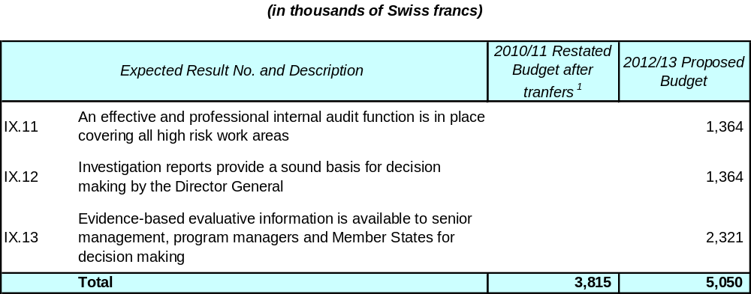

- The figures for 2010/11 Budget under personnel costs represent actual expenditure for 2010 and budgeted amounts based on standard costs for 2011. The budget for 2012/13 is prepared using standard costs for the next biennium. The increase in budgeted amount under Posts for Program goes beyond the statutory increases incorporated in the standard costs as a result of a lower base in 2010 actual expenditure due to vacancies in the Program that were filled only recently.

- The proposed increases are mainly related to “SSA and Commercial Services”, for hiring of experts for various audits, investigation and evaluation related activities planned for 2012/13 biennium. Other changes across cost categories have been proposed to align the budget to the 2010/11 expenditure pattern of the Program.

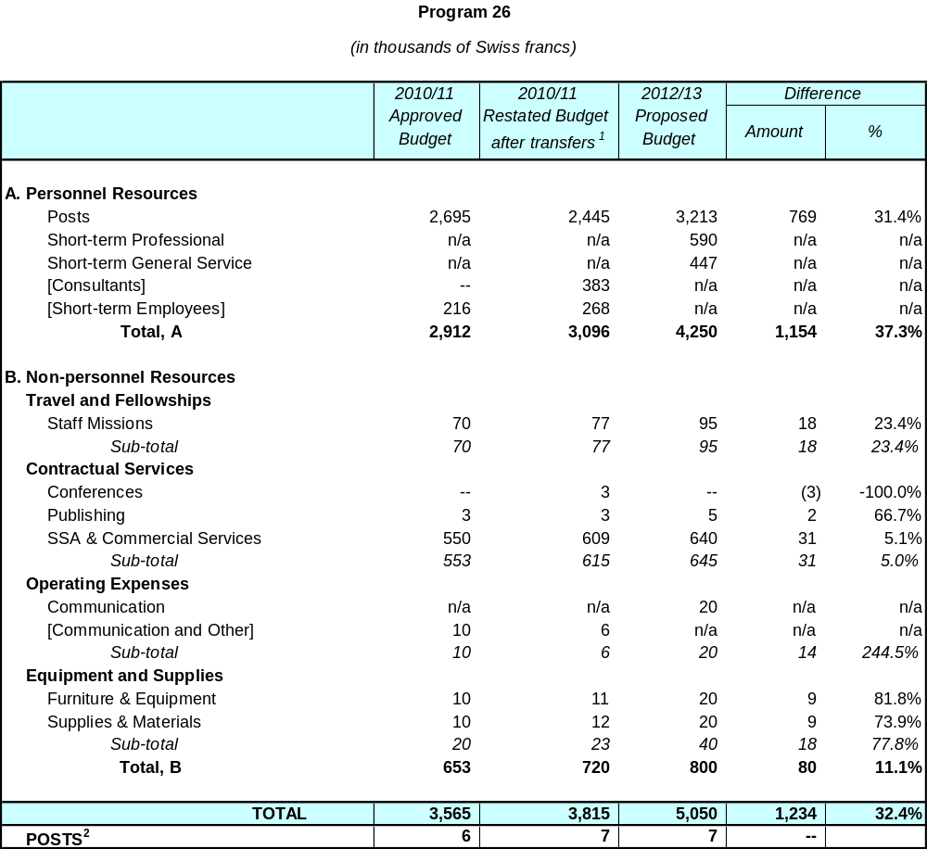

¹ Restated Budget after transfers reflects:

- the adjusted budget of Programs, following transfers during 2010/11 in line with Financial Regulation 5.5. For additional details on the 2010/11 Budget after Transfers, please refer to Table 10 (Annex I) Budget after Transfers by Program of this document and document WO/PBC/18/14 Program Performance Report for 2010;

- restatements of Program budgets for comparison with the 2012/13 proposed Program structure. For those Programs where restatements were not required, the Restated Budget after Transfers is equivalent to the Budget after Transfers, as referred to in document WO/PBC/18/14 Program Performance Report for 2010. For more detailed information on the restatements, please refer to Table 11 (Annex I) of this document.

² For further details on posts for the Program please refer to the Table in Annex II.

Program 27 Conference and Language Services

PLANNING CONTEXT

- Program 27 covers conference, language, printing, records management and archives, and mail expedition services. Language Services include translation work for WIPO meeting documentation, publications, laws and certain parts of the website but exclude translations under the PCT, Madrid and The Hague System. This Program also provides interpretation services for the meetings of the WIPO Assemblies and the WIPO Coordination Committee as well as other meetings organized by various Programs.

- The main challenge for Language Services is the continued development and phased implementation of a comprehensive language policy for the Organization and the further extension of language coverage of WIPO meeting documentation, WIPO publications and certain aspects of the WIPO website in a cost-effective manner, while maintaining the highest standards of quality. Other challenges for Language Services include increased use of technology and the development of multilingual terminology databases.

- The main challenge for Conference Services will consist of providing high quality services to Member States and other stakeholders. Special preparations will be required to effectively service the WIPO new conference hall which is expected to become operational towards the end of the biennium.

- A further challenge will be to contribute to a paper-free environment by progressively introducing electronic distribution of meeting documentation, electronic registration of conference participants and optical archiving of records.

IMPLEMENTATION STRATEGIES AND RISKS

- In the language area, the Program aims at delivering high quality translation and interpretation services and continuing to develop, in consultation with Member States, a comprehensive language policy for the Organization. To ensure that quality language services continue to be provided in a cost effective manner within this context, particular attention will be devoted to streamlining work processes and the development of computer assisted translation tools. Further efforts will also be deployed to improve internal productivity. The share of outsourced translation work will be increased with specific regard to available competencies in developing countries in accordance with WIPO procurement rules. These objectives are based on the decisions adopted by the WIPO Assemblies in September 2010 (A/48/26 para. 250).

- In the conference, printing, mail expedition and records management areas, the Program aims at continuing to deliver efficient and cost-effective services that maximize the use of modern technology. New IT based services, such as webcasting and electronic recording of conference proceedings, will continue to be developed.

- Implementation strategies for the Program will continue, in general, to focus on enhanced utilization of IT tools and systems for increased cost-effectiveness, and, in the language area, exploring all available means to reduce the average cost per page of translation while maintaining high quality standards. Revision of internal policies and procedures (in the context of planning for the ERP project) will also be pursued as a means of increasing efficiency of work flows in all areas.

- The volume of services to be delivered by the Program is determined by users within and outside the Secretariat. The main risk facing the Program is an increase in demand for services which can not be satisfied with available resources. This risk will be mitigated by close cooperation with substantive Programs to improve the planning and prioritization of activities.

RESULTS FRAMEWORK

Expected Results | Performance Indicators | Baselines | Targets
Effective, efficient, quality and customer-oriented support services both to internal clients and to external stakeholders (human resources, IT, conference, language, procurement, travel, printing and publication, premises management) | % of internal and external users satisfied with WIPO's conference services  Translation productivity standards and cost per page of translation  A comprehensive language policy adopted by Member States together with related resource allocation requirements | Rate at end 2011  Productivity and cost levels at end 2011  Language Policy elaborated in 2010 only for documentation of WIPO Standing Committees | 10% increase in rate by end 2013  10% increase over baseline  Language policy covers documentation of all WIPO meetings, as well as language coverage of WIPO publications and website
 | Productivity rate for calculations, data input and collection and provision of statistics (mail delivery) | Rate of productivity at end 2011. | 10% increase over baselines.
 | % of PCT Media batch in paper and electronic format on time | Rates at end 2011 | 10% improvement over baseline.
 | % of Madrid Notifications in paper format on time | Rates at end 2011 | 10% improvement over baseline.
 | % of Madrid Romarin in electronic format on time | Rates at end 2011 | 10% improvement over baseline.

RESOURCES FOR PROGRAM 27

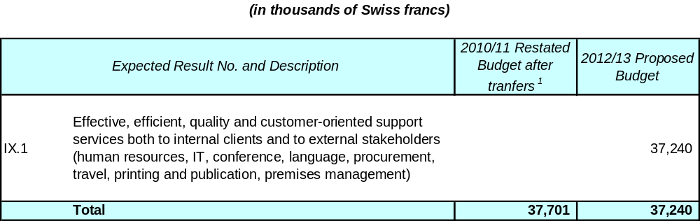

- The figures for 2010/11 Budget under personnel costs represent actual expenditure for 2010 and budgeted amounts based on standard costs for 2011. The budget for 2012/13 is prepared using standard costs for the next biennium.

- The proposed increases in non-personnel resources especially under “SSA and Commercial services” are related to Language Services, to deal with the increased workload and for the implementation of the proposed new language policy. Reductions in other cost categories were possible following elimination of overlaps of activities with other Program areas, mainly on IT related items, software trainings etc. Cost efficiency gains have been realized in printing services and mail expedition contracts.

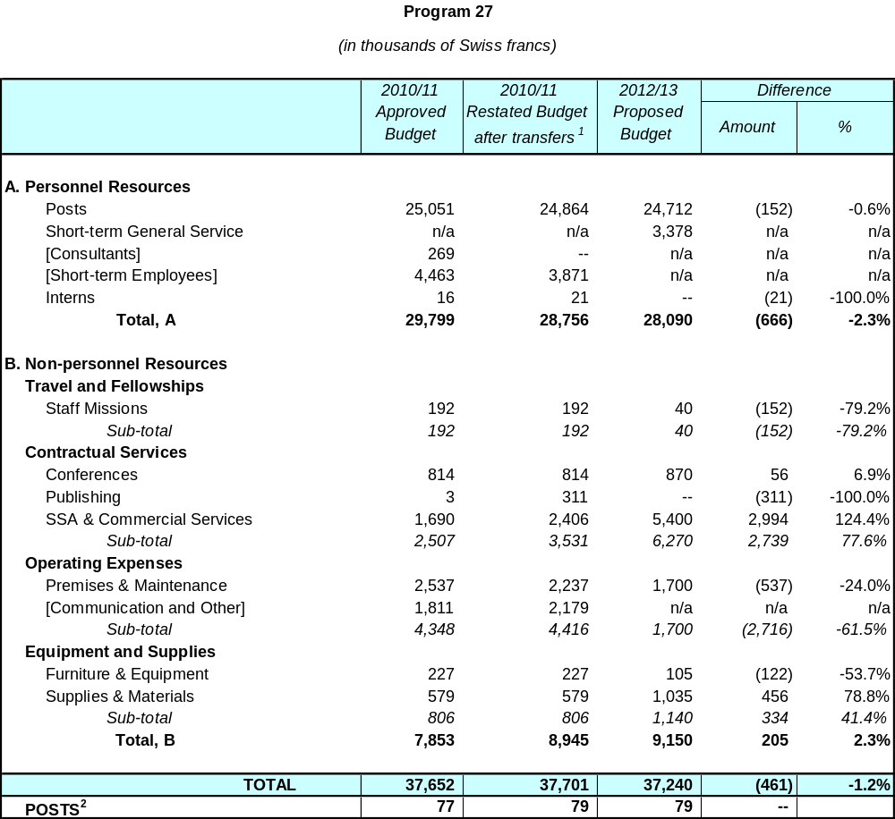

¹ Restated Budget after transfers reflects:

- the adjusted budget of Programs, following transfers during 2010/11 in line with Financial Regulation 5.5. For additional details on the 2010/11 Budget after Transfers, please refer to Table 10 (Annex I) Budget after Transfers by Program of this document and document WO/PBC/18/14 Program Performance Report for 2010;

- restatements of Program budgets for comparison with the 2012/13 proposed Program structure. For those Programs where restatements were not required, the Restated Budget after Transfers is equivalent to the Budget after Transfers, as referred to in document WO/PBC/18/14 Program Performance Report for 2010. For more detailed information on the restatements, please refer to Table 11 (Annex I) of this document.

² For further details on posts for the Program please refer to the Table in Annex II.

Program 28 Safety and Security

PLANNING CONTEXT

- An increase in the level of actual and perceived global threats targeting the United Nations system poses a key on-going challenge for the Organization. The focus of the Program is to ensure the safety and security of its stakeholders/clients (staff, visitors, and delegates) at the WIPO premises and outside sponsored events, and the overall protection of WIPO assets in a way that is commensurate with the threats to WIPO, and through the effective and efficient use of its resources.

- An overall safety and security concept and strategy for the Organization that are independent but in line with the UN Security Management System standards and guidelines will continue to provide the basis for the safety and security services at WIPO.

IMPLEMENTATION STRATEGIES AND RISKS

- The main focus in the biennium will continue to consist of providing for and maintaining an environment that is safe and secure for WIPO’s stakeholders/clients. This will be achieved through continued security risk management of direct or indirect threats based on Annual Risk Assessments in order to reduce the likelihood that they may occur against staff or the Organization’s assets. This will include implementation and/or monitoring of procedures, policies, and the provision of training to enhance staff’s awareness about safety and security issues. Furthermore, the new or upgraded systems, equipment and services at the WIPO premises will significantly contribute to enhance the safety and security in the longer term.

- The project to upgrade safety and security of existing WIPO premises will continue in this biennium with the enhancements being extended to the new building projects. It is expected that in 2012/13 the implementation of many of the required systems, equipment and services will be completed. The implementation of the safety and security upgrade project will need to be dovetailed with the timelines and permits of the new construction projects. Any eventual delays in the new constructions could lead to possible delays in the implementation of the safety and security upgrade project. The risk of such delay will be mitigated by working in close collaboration with Program 24 (General Support Services) and Program 29 (Construction Projects) and with other external stakeholders.

RESULTS FRAMEWORK

Expected Results | Performance Indicators | Baselines | Targets
WIPO staff, delegates, visitors and information and physical assets are safe and secure | % of WIPO staff, delegates and visitors reporting a work related injury or incident | 2% | 2% or less
 | % of timely requests for safety and security assistance at conferences or events held in or outside of Geneva | 65% | 80%

RESOURCES FOR PROGRAM 28

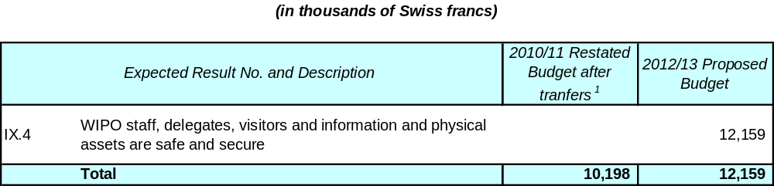

- The figures for 2010/11 Budget under personnel costs represent actual expenditure for 2010 and budgeted amounts based on standard costs for 2011. The budget for 2012/13 is prepared using standard costs for the next biennium. The increase in budgeted amount under Posts for Program goes beyond the statutory increases incorporated in the standard costs as a result of a lower base in 2010 actual expenditure due to vacancies in the Program.

- The increases in non-personnel resources are mainly due to: (i) the transfer of safety and security related maintenance contracts from Premises to Program 28 as of 2011, (ii) increase in costs of several security related services contracts for events and meetings, (iii) security related to the new building starting 2011, (iv) installations of HMOSS upgrade project equipment in 2012 and 2013, and the safety and security related maintenance contracts.

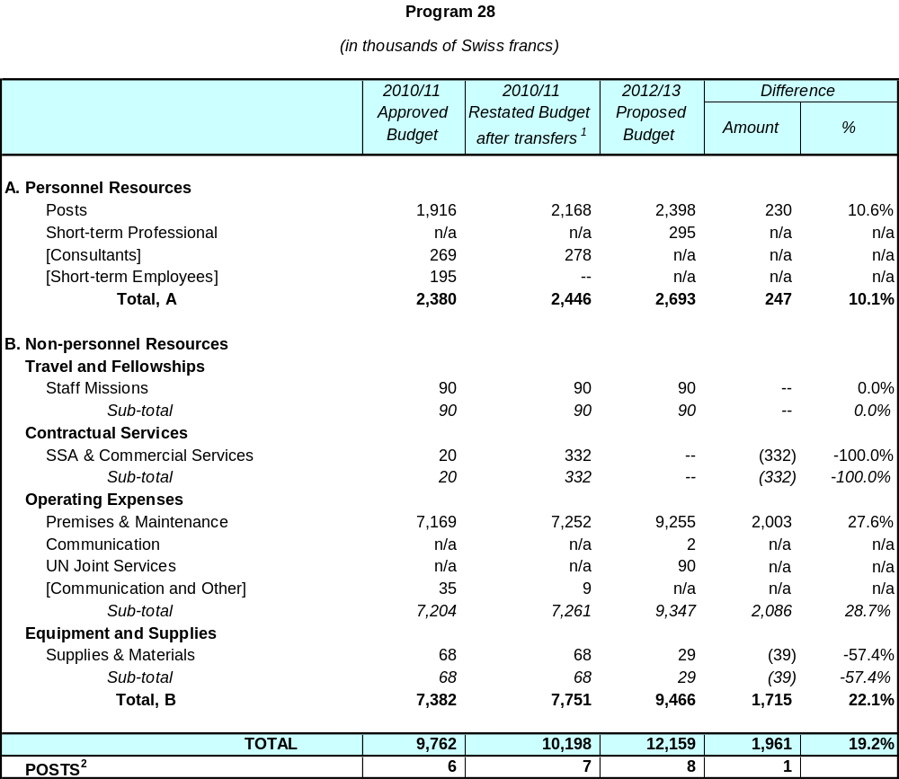

¹ Restated Budget after transfers reflects:

- the adjusted budget of Programs, following transfers during 2010/11 in line with Financial Regulation 5.5. For additional details on the 2010/11 Budget after Transfers, please refer to Table 10 (Annex I) Budget after Transfers by Program of this document and document WO/PBC/18/14 Program Performance Report for 2010;

- restatements of Program budgets for comparison with the 2012/13 proposed Program structure. For those Programs where restatements were not required, the Restated Budget after Transfers is equivalent to the Budget after Transfers, as referred to in document WO/PBC/18/14 Program Performance Report for 2010. For more detailed information on the restatements, please refer to Table 11 (Annex I) of this document.

² For further details on posts for the Program please refer to the Table in Annex II.

Program 29 Construction Projects

PLANNING CONTEXT

- In December 2008, Member States approved the launch of the preparation of the architectural and technical dossier (“Phase One”) for the new conference hall. This was followed by the Member States’ approval, in October 2009, of the execution (“Phase Two”) of the Project.

- The application for the complementary building permit was deposited with the local authorities in October 2009; the permit was granted in June 2010. The general contractor was selected by a Board, composed of representatives of Member States, in February 2011.

- The financing of Phase Two of the Project was approved by the WIPO Assemblies through an appropriation of 24 million Swiss francs from the WIPO reserves and a commercial loan for an amount of 40 million Swiss francs. An addendum for the extension of the existing loan contract (for the New Construction Project) to cover the latter amount was signed with the banks in October 2010.

- Against this background, the main key challenges in the biennium 2012/13 will be the completion of the new conference hall, which promises to be a unique and highly visible architectural object. In addition, major renovations to several lower floors of the AB Building, necessary in view of its proximity to the new hall, will be executed along with the conference hall construction.

- As regards the new administrative building, completed during the biennium 2010/11, the main challenge will consist of ensuring that the cost of the bank loan amortization is maintained to a minimum and that the remaining funds available under the approved consolidated budget and provisions are minimally utilized during the construction guarantee period.

IMPLEMENTATION STRATEGIES AND RISKS

- For the construction of the new conference hall, the project management and governance structure based on best practice and the model established for the construction of the new administrative building, which was adopted from the start of the Project, will continue to be used. This will apply, in particular, to the monitoring and risk management processes in respect of quality, budget and timelines for the project, based on those established and used, with good results, for the construction of the new administrative building. Emphasis will be placed on ensuring that lessons learnt from the previous construction project are fully incorporated into the new project approach. In addition, a prudent approach for the utilization of approved funds for the new construction project will continue to be a priority.

- The potential adverse impact of the new conference hall project worksite on the daily operations of the Organization and inevitable disruption in daily work and meetings of Member States during the biennium will be mitigated by improved coordination between Program 29 and all other programs. Such impact as well as possible technical breakdowns due to the new worksite could require vacating parts of the AB Building and relocating staff temporarily off-site as well as holding a number of meetings off-site. This risk can be partly mitigated through a thorough monitoring of the construction project by the Program in collaboration with the external parties (Architect, General Contractor, Pilot, etc.) as part of the established monitoring process. In addition, alternatives for office and meeting spaces will have to be integrated in the risk management.

RESULTS FRAMEWORK

Expected Results | Performance Indicators | Baselines | Targets
New conference hall and related facilities available for meetings of Member States | Construction of new conference hall and related facilities in compliance with the approved quality, budget and time framework | n/a | n/a
Costs related to the new administrative building are kept to a minimum | Use of remaining funds available under the approved consolidated budget and provisions during the construction guarantee period | n/a | n/a

RESOURCES FOR PROGRAM 29

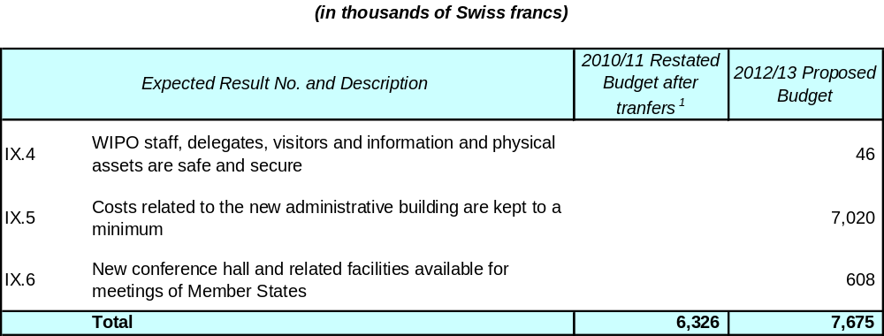

- The increases under the Program, which is mainly under Premises and Maintenance are related to the interest payment of the loan (6.9 million vs. 5.3 million in 2010/11) for the new building following the full draw down of the loan amount (130 million Swiss francs).

- The decreases in “SSA and Commercial Services” and “Experts’ Honoraria” are due to the fact that the honoraria and other initial costs for the Pilot and other experts were covered under the regular budget in 2010/11 for the New Construction Project whereas honoraria for the Pilot for the New Conference Hall Project are covered from the WIPO reserves and loan. The reduction under “Equipment and Supplies” is due to the fact that the construction costs for the relocation of the AB building parking ramp was a one-time occurrence and will not be required in the 2012/13 biennium.

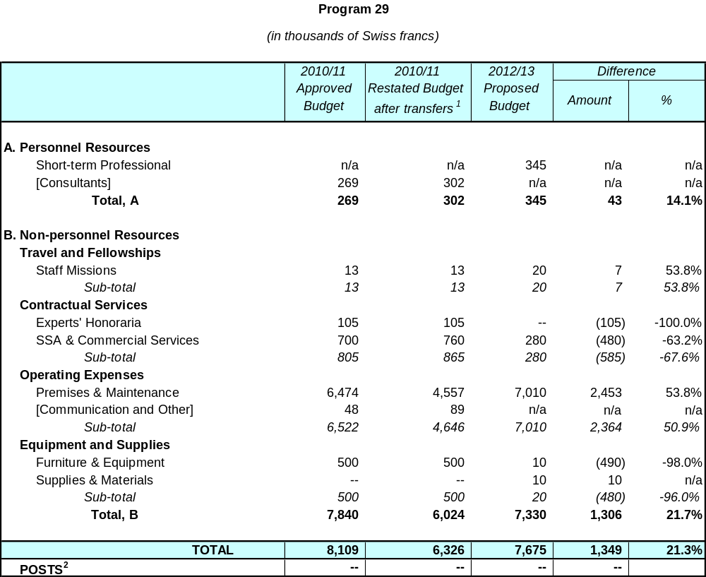

¹ Restated Budget after transfers reflects:

- the adjusted budget of Programs, following transfers during 2010/11 in line with Financial Regulation 5.5. For additional details on the 2010/11 Budget after Transfers, please refer to Table 10 (Annex I) Budget after Transfers by Program of this document and document WO/PBC/18/14 Program Performance Report for 2010;

- restatements of Program budgets for comparison with the 2012/13 proposed Program structure. For those Programs where restatements were not required, the Restated Budget after Transfers is equivalent to the Budget after Transfers, as referred to in document WO/PBC/18/14 Program Performance Report for 2010. For more detailed information on the restatements, please refer to Table 11 (Annex I) of this document.

² For further details on posts for the Program please refer to the Table in Annex II.

IV. ANNEXES

Annex I. 2012/13 Budget by Program

Annex II. 2012/13 Posts by Program

Annex III. Allocation of Projected Income and Budget by Union

Annex IV Evolution of Demand for Services Under the PCT, Madrid and
The Hague Systems in the Medium Term

Annex V Funds-in-Trust Resources Potentially Available for Programming
in 2012/13

Annex VI Indicators for PCT Operations

Annex VII WIPO Organigram

Annex VIII Implications of IPSAS Adoption on Budgeting Practices

Annex X Development Agenda Links for Program and Budget 2012/13

ANNEX I 2012/13 BUDGET BY PROGRAM

Table 10. Budget after Transfers by Program
(in thousands of Swiss francs)

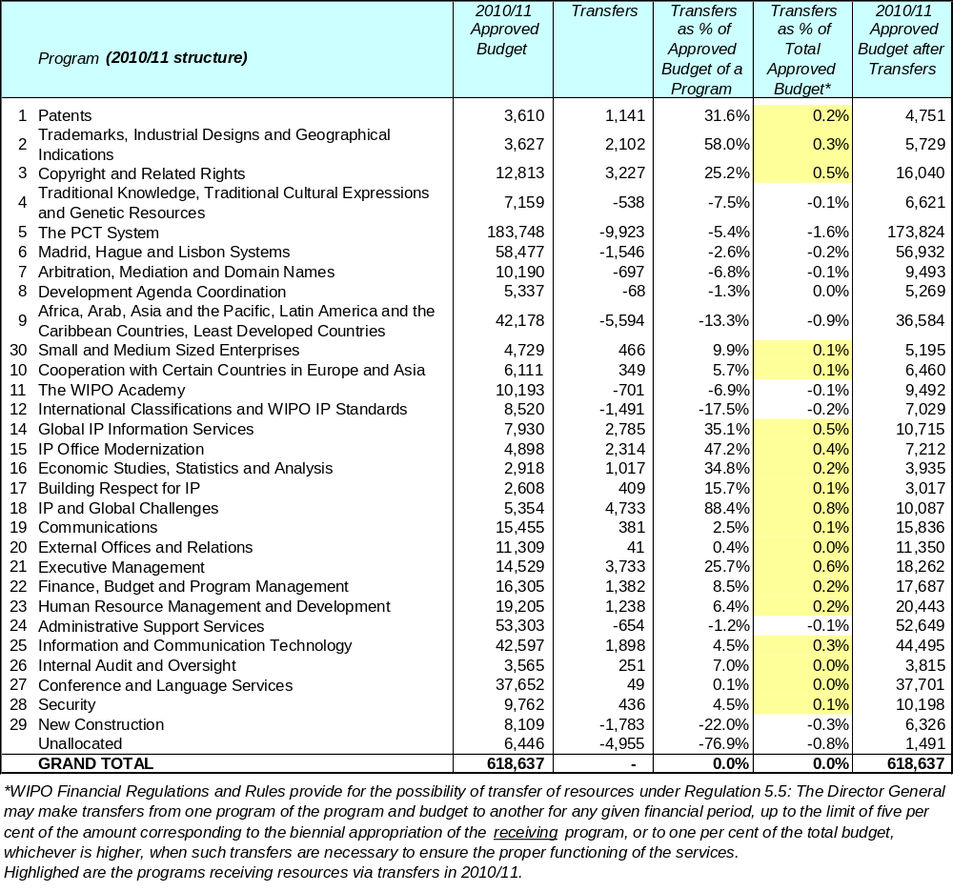

Table 11. Restated 2010/11 Budget after Transfers by Program
(in thousands of Swiss francs)

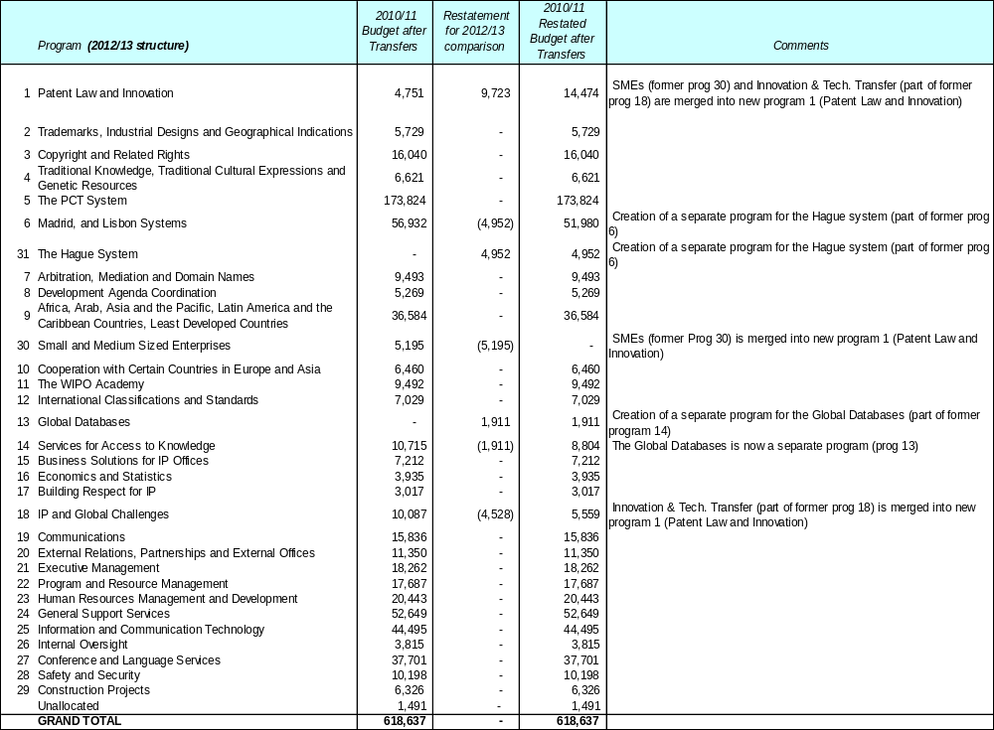

Table 12. 2012/13 Budget by Program
(in thousands of Swiss francs)

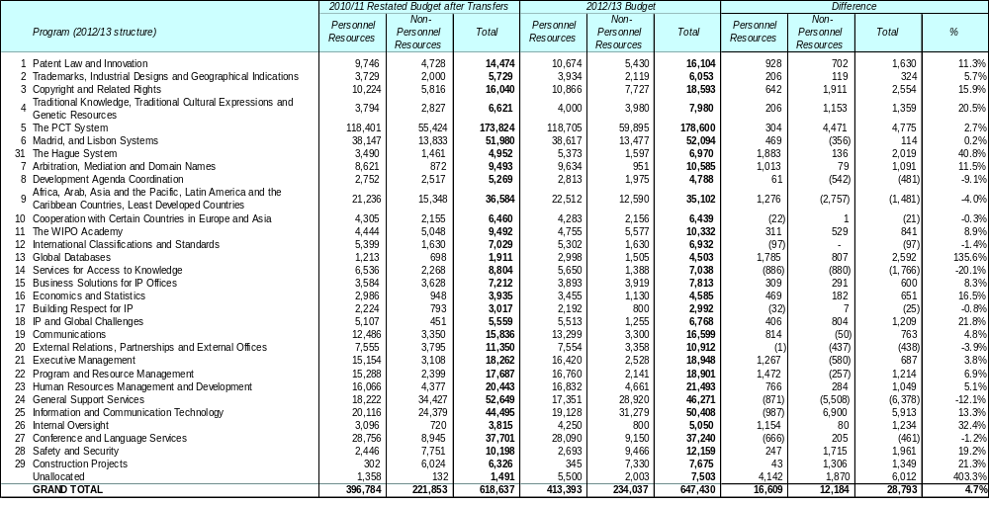

[Annex II follows]
ANNEX II 2012/13 POSTS BY PROGRAM
Table 13. 2012/13 Posts by Program

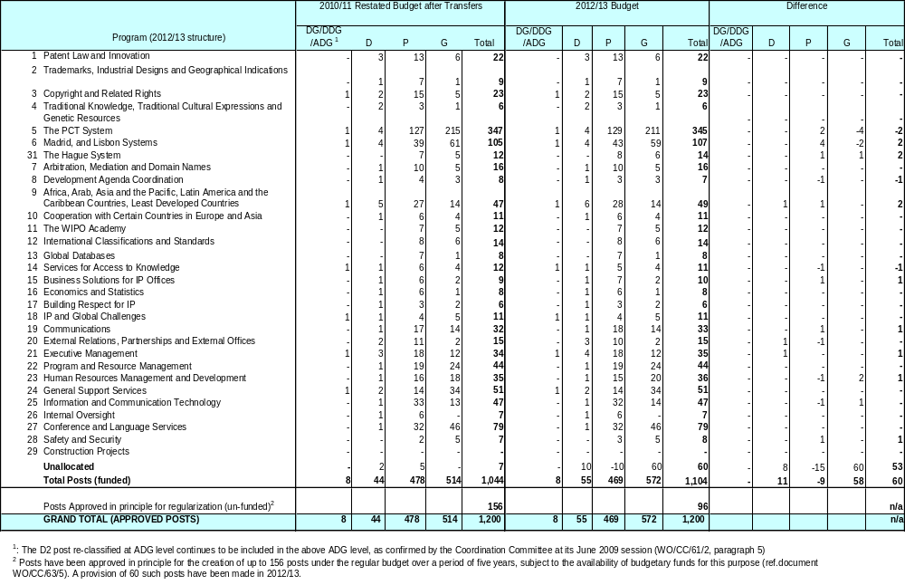
[Annex III follows]
ANNEX III ALLOCATION OF PROJECTED INCOME AND BUDGET BY UNION

INTRODUCTION

- Under the WIPO Financial Regulations and Rules (Rule 102.2), the proposed Program and Budget is required to present the biennial budget for the Organization as well as separately for each Union.

ALLOCATION OF BUDGETED EXPENDITURE BY UNION

- It is recalled that the approved methodology on the allocation of the expenditure by Unions is based on the identification of Union direct and Union indirect expenses. Programs are categorized as Union Direct and Union Indirect activities as described below.

- UNION DIRECT EXPENSES are the expenses incurred under Union specific activities and the attributable share of related administrative and other budgeted expenses.

3.1 Union specific activities: The following Program activities and budgeted expenditures are considered under this heading. Where expenditures of a program are only partly allocated to a Union, the basis for allocation is the respective Union’s share of this expense as estimated by the Program Managers of the respective programs. Where the allocation of a Program is to a single Union, the full cost of that Program is allocated to that Union.

3.1.1 Contribution-financed Unions: Programs 1 (Patent Law and Innovation) (partly), 2 (Trademarks, Industrial Designs and Geographical Indications) (partly), 3 (Copyright and Related Rights) (partly), 4 (Traditional Knowledge, Traditional Cultural Expressions and Genetic Resources), 7 (Arbitration, Mediation and Domain Names) (partly), 12 (International Classifications and Standards) (partly) and 14 (Services for Access to Knowledge) (partly).
3.1.2 PCT Union: Programs 1 (Patent Law and Innovation) (partly), 5 (The PCT System), 7 (Arbitration, Mediation and Domain Names) (partly), 12 (International Classifications and Standards) (partly), 13 (Global Databases) (partly) and 14 (Services for Access to Knowledge) (partly).
3.1.3 Madrid Union: Programs 2 (Trademarks, Industrial Designs and Geographical Indications) (partly), 6 (Madrid and Lisbon Systems) (partly), 7 (Arbitration, Mediation and Domain Names) (partly), 12 (International Classifications and Standards) (partly), 13 (Global Databases) (partly), 14 (Services for Access to Knowledge) (partly) and 25 (Information and Communication Technology).
3.1.4 Hague Union: Programs 2 (Trademarks, Industrial Designs and Geographical Indications) (partly), 7 (Arbitration, Mediation and Domain Names) (partly), 12 (International Classifications and Standards) (partly) and 14 (Services for Access to Knowledge) (partly) and 31 (The Hague System).
3.1.5 Lisbon Union: Programs 2 (Trademarks, Industrial Designs and Geographical Indications) (partly), 6 (Madrid and Lisbon Systems) (partly), 7 (Arbitration, Mediation and Domain Names) (partly) and 14 (Services for Access to Knowledge) (partly).

3.2 Union Direct Administrative Expenses: A share of all programs under Strategic Goal IX (Programs 21 to 29) and “Unallocated” is considered to belong under this category. The allocation of budgeted expenditures is determined in a two-step process. In the first step, the total share of direct administrative costs for all Unions is determined on the basis of the total headcount of the direct union-related programs relative to the total headcount of all programs other than those under Strategic Goal IX. As a second step, this Union Direct administrative expense was allocated to the respective Unions on the basis of the relative share of each Union’s headcount to the total headcount of direct union-related programs.

- UNION INDIRECT EXPENSES are each Union’s allocated share of budgeted expenses for Programs not directly related to the activities of the respective Union, together with the share of related administrative and other budgeted expenses.

4.1 Indirect Union expenses: The following Program activities and budgeted expenditures are considered under this heading: Programs 1 (Patent Law and Innovation) (partly), Programs 2 (Trademarks, Industrial Designs and Geographical Indications) (partly), 3 (Copyright and Related Rights) (partly), 8 (Development Agenda Coordination), 9 (Africa, Arab, Asia and the Pacific, Latin America and the Caribbean Countries, Least Developed Countries), 10 (Cooperation with Certain Countries in Europe and Asia and Some Mediterranean States), 11 (The WIPO Academy), 15 (Business Solutions for IP Offices), 16 (Economics and Statistics), 17 (Building Respect for IP), 18 (IP and Global Challenges), 19 (Communications) and 20 (External Relations, Partnerships and External Offices). The share of budgeted expenditures from each of these is allocated to Unions on the basis of their respective biennial capacity to pay. This is calculated as the difference between the respective Union’s projected income to be earned in the biennium and the Union’s other allocated expenses and minimum reserve requirements (“reserve target floor”). The reserve target floor’s calculation is based on the reserve requirements of the prior biennium’s expenditures. The methodology applied ensures a proportionate allocation of indirect expenditure to Unions on the basis of resources (surplus) earned in the current biennium, and only if the biennial surplus income is not sufficient, would excess reserves be used to cover the remaining part of indirect expenditure, on the basis of their relative share by Unions.

4.2 Indirect Administrative Expenses: These relate to budgeted expenditures under Programs 21 to 29) which have not been allocated to Direct Union expenses, as well as the amount budgeted under “Unallocated” in the proposed budget. The allocation of these budgeted expenditures is done on the basis of their respective capacity to pay (i.e., along the same principles as for Indirect Union expenses).

- In accordance with the above methodology, tables indicating the following are presented below:

- Table 14. 2012/13 Financial Overview by Union
- Table 15. 2012/13 Income Estimates by Union
- Table 16. 2012/13 Budget by Program and Union
- Table 17. 2012/13 Overall Scenario by Union

Table 14. 2012/13 Financial Overview by Union
(in thousands of Swiss francs)

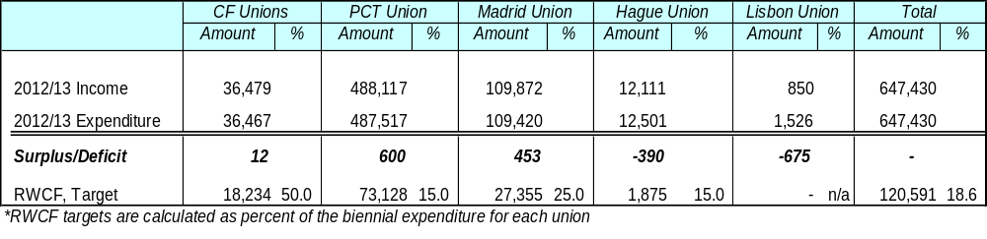

Table 15. 2012/13 Income Estimates by Union
(in thousands of Swiss francs)

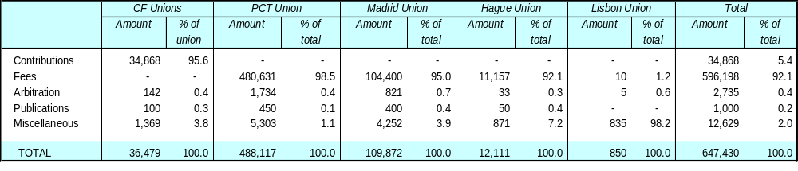

Table 16. 2012/13 Budget by Program and Union
(in thousands of Swiss francs)

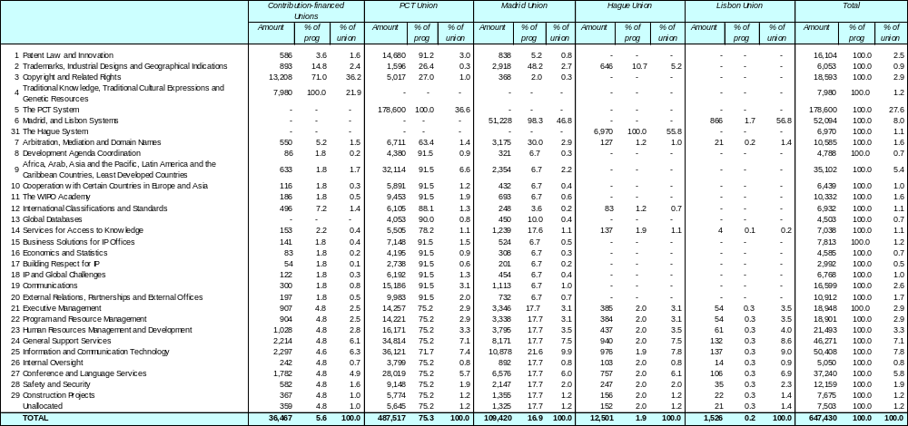

Table 17. 2012/13 Overall Scenario by Union
(in thousands of Swiss francs)

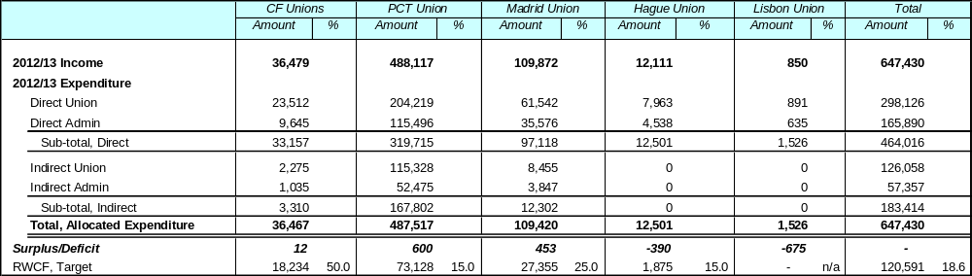

[Annex IV follows]

ANNEX IV EVOLUTION AND DEMAND FOR SERVICES UNDER THE PCT, MADRID
AND THE HAGUE SYSTEMS IN THE MEDIUM TERM

PCT

1 The level of PCT income is influenced by a variety of factors, including demand for PCT services and applicants’ filing behavior. Demand for PCT services is in turn influenced by a number of factors that may be internal or external to the patent system. External factors include: performance of the economy globally, and in countries of the highest and fastest growing demand; research and development (R&D) investment levels; technological confidence levels; and exchange rate fluctuations. Internal factors include: the level of PCT fees as compared to other filing routes; the attractiveness and value of PCT services as compared to other filing routes; the overall credibility of performance of the patent system; and individual corporate patent strategies.

2 Applicants’ behavior influences PCT income as follows:

(i) Page Fee: The International Bureau receives 15 Swiss francs for every page over 30 pages in a given application.

(ii) International Preliminary Examination: Applicants making use of international preliminary examination under Chapter II of the PCT must pay an additional fee (a “handling fee”).

(iii) Electronic Filing: When applicants use electronic (instead of paper) filing they benefit from discounts.

(iv ) International Bureau as Receiving Office: Applicants who choose to file their application with the International Bureau acting as Receiving Office (IB/RO) must pay a special fee (the “transmittal fee”).

3 The following paragraphs elaborate on current forecasts as regards: the level of demand; the expected level of Chapter II demands; the expected level of electronic filings; and the expected use of IB/RO.

PCT Filing Forecast (Demand)

4 After falling in 2009 by close to 5 per cent year-to-year, PCT filings grew by 5.3 per cent in 2010, thanks to strong filings by applicants from China (+56 per cent), the Republic of Korea
(+21 per cent) and Japan (+8 per cent), and a moderate recovery observed at the EPO (+3 per cent). They fully recovered to pre-crisis levels, as the continued drop in US PCT filings was offset by strong performance in other major PCT filing countries.

5 Chart 1 shows the forecasted number of PCT applications for the years 2011 to 2015 (based on data at the end of March 2011). The following assumption serves as the basis of the forecast: PCT filings will return to their original trends after the period when financial crisis had an impact on them.

Chart 1. PCT Applications 2009 to 2015

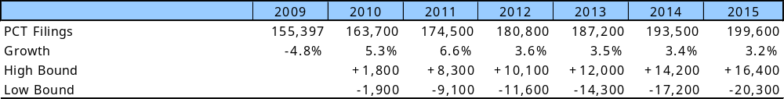

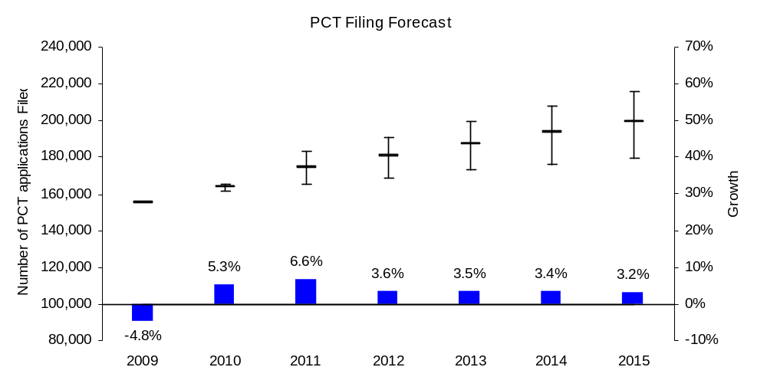

6. Chart 2 below shows the forecasted numbers of files by the country of origin.

Chart 2. PCT Filings from Selected Countries 2010 to 2015

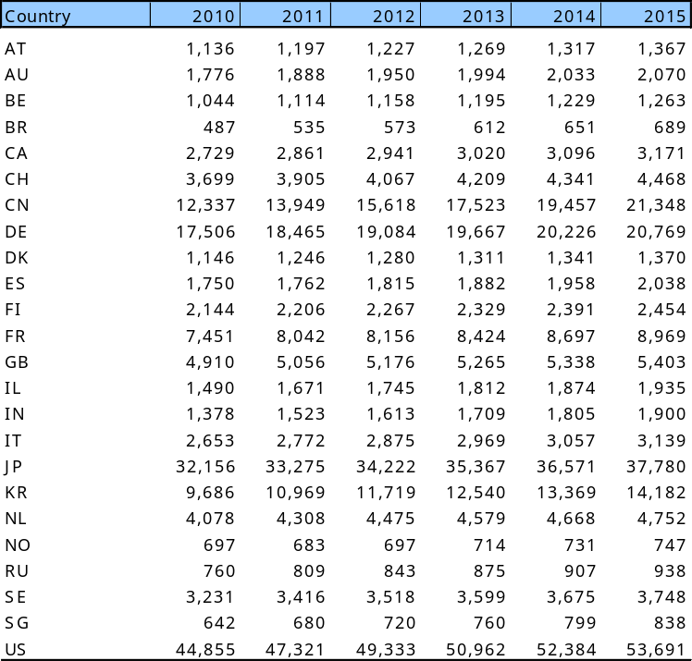

- Chart 3 shows the evolution and forecast of the demand for the international preliminary examination procedure, under Chapter II of the PCT in the period up to 2015. As this chart shows, the demand for the Chapter II procedure is expected to stabilize at around 13,000 per year during the period 2010-2015. The long-term decline in the use of the Chapter II procedure is due to changes in the PCT regulations that came into effect in 2002 and in 2004. Since PCT applicants became less interested in requesting preliminary examination, the final results are likely to change towards lower bound.

Chart 3. Chapter II Demands 2007 to 2015

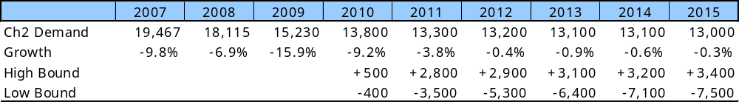
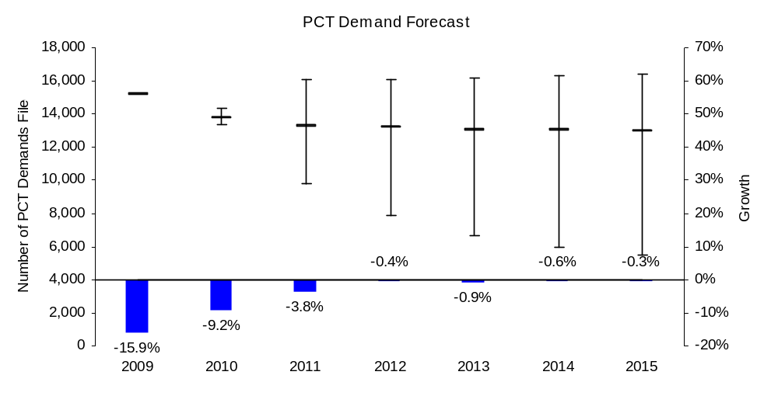

Use of Electronic Filing Methods

- The estimated use of electronic filing methods (EASY, PDF or XML), as a percentage of total filings, is illustrated in Chart 4 below. As this chart shows, utilization of electronic filings has steadily increased in the period from 2000 to 2008. In the year 2010 electronic filing was close to 81 per cent of total filings and is expected to continue to grow.

Chart 4. Use of Electronic Filing Methods (EASY, PDF or XML)
as a Percentage of Total Filings 2000 to 2015
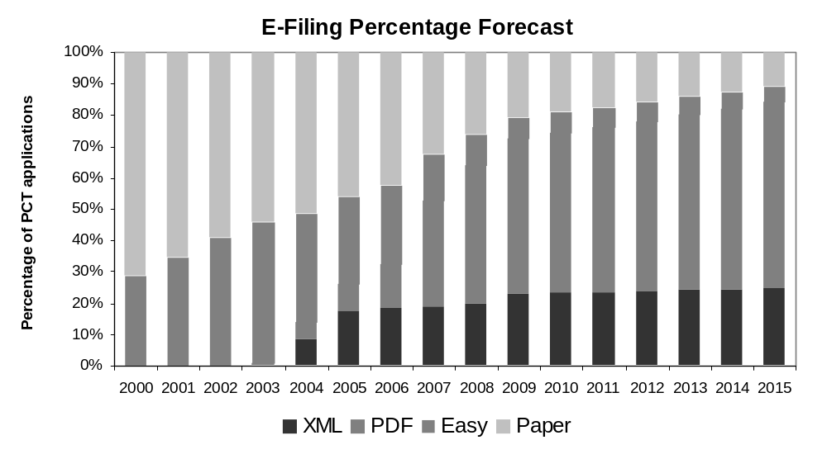

- The estimated number of PCT international applications filed with the Receiving Office of the International Bureau (RO/IB) is shown in Chart 5 below. As this chart shows, this number is expected to increase gradually in the next few years.

Chart 5. PCT International Applications Filed with the RO/IB 2000 to 2015

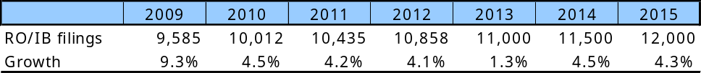

Expected Level of PCT Income

- Charts 6 and 7 show calculated PCT income in the period 2009 to 2010, and forecasted PCT income in the period from 2011 to 2015, by type of income. The charts are based on the expected level of applications (Chart 1), an estimate of the expected level of page fees, the expected level of Chapter II demands (Chart 3), the expected level of electronic filings (Chart 4) and the expected level of RO/IB filings (Chart 5). The current PCT schedule of fees is reproduced in Chart 9.

- Chart 6 shows provides the hypothetical PCT income forecast which is based on the assumptions that (1) all fees are paid within the same of year of filing and (2) all fees are converted to Swiss francs according to WIPO official exchange rates. Hypothetical PCT income indicates the possible revenue generated by the filings, without considering when the money is paid and how it is converted to Swiss francs. Since most applicants eventually pay their fees, the hypothetical income forecast reflects the long-term revenue expectation. The calculation takes into account all the major elements of the PCT fee structure: withdrawals, e-filing reductions and fee reductions for low-income countries.

Chart 6. Hypothetical PCT Income Forecast until 2015

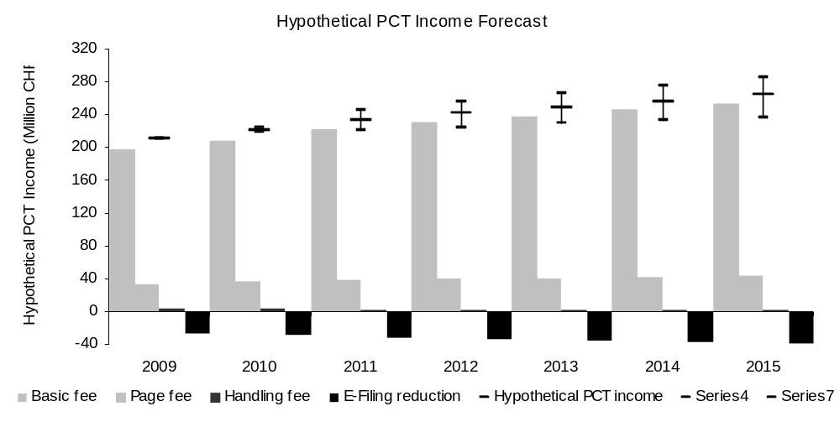

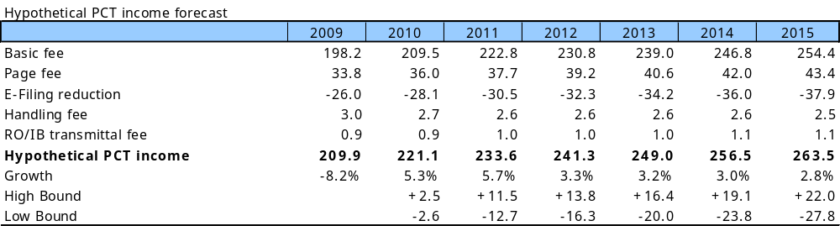

Impact of Payment Delay on PCT Income

- The hypothetical income forecast assumes that fees are paid within the same year of filing. However, WIPO receives payments with a delay ranging from one to six months. Some applicants – especially those who file at the beginning of the year – pay within the same year of filing (usually around 85 per cent), while others pay in the following year (usually around 15 per cent). Therefore, actual PCT income in any given year consists of a portion of payments for filings in the previous year plus a portion of payments for those in the same year. As a result, the money received in a year does not equal to that generated by the filings in the same year. Annual differences between hypothetical and real income do not alter the long-term overall income. Any income shortfall due to payment delays will likely be compensated in the following year. If a large portion of the payment is delayed to next year, this year’s actual income will fall, but next year’s will be higher. On the other hand, if a smaller portion of the payment is shifted to next year, this year’s actual income will rise and next year’s will fall. In 2009, a relatively small portion of payment – around 13.3 per cent – was delayed to 2010, leading to a gain of eight million for 2009 actual income and a loss of six million for 2010. The adjusted PCT income forecasts until 2015 taking into account the impact of the payment delay is presented below in Chart 7.

Chart 7. Adjusted PCT Income Forecast until 2015

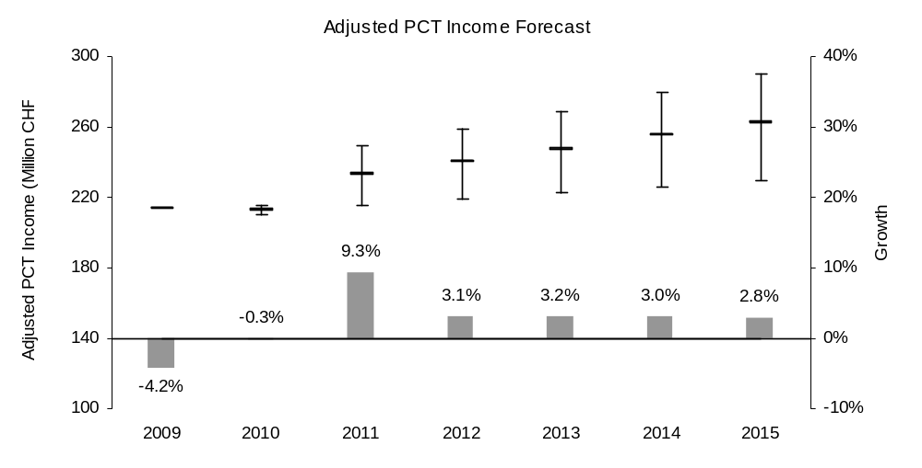
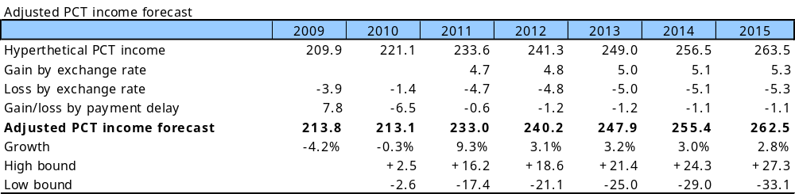

- For budgeting purposes, the figures appearing in Chart 7 have been adjusted downward by 1.5% as a risk aversion adjustment, which primarily relates to the possible negative impact of exchange rate fluctuations to the base case. It is recalled however that the effect of exchange rate fluctuations between the time applications are filed with a receiving office and the time their corresponding fees reach the International Bureau may be positive or negative. Therefore, this adjustment represents a prudent approach to the financial forecast.

Chart 8. PCT Fee Schedule
(as of January 1, 2004)
(in Swiss francs)

Basic Fee | 1,400
Fee for pages over 30 | 15
E-filing Fee Reduction | -100 (Easy)
 | -200 (PDF)
 | -300 (XML)
RO/IB transmittal fee | 100
Handling Fee | 200

Chart 9. Revised PCT Fee Schedule
(as of July 1, 2008)
(in Swiss francs)
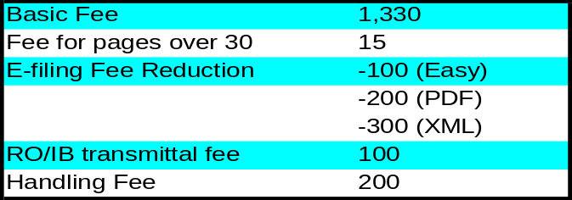

Madrid

Madrid - Forecast of Demand for International Registration
- Chart 10 shows the actual number of Madrid applications filed in the period from 2006 to 2010, and the five-year forecast for the years 2010 to 2015.

Chart 10. Madrid Demand for International Registration

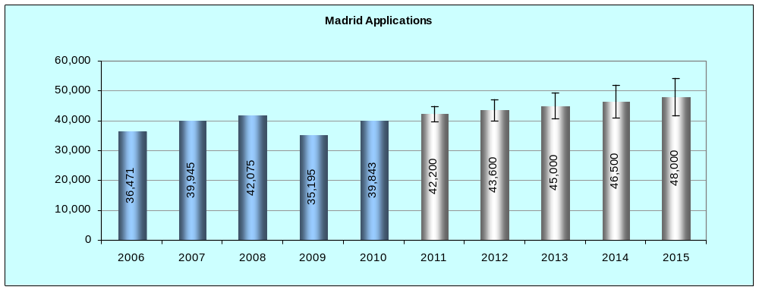

- Estimates for the period 2011 to 2015 are based on a forecast model that takes into account the evolution of demand over the last 15 years, the analysis of the short term trend and a gradual increase in membership in the Madrid system expected for the years to come. This and other exogenous factors, such as a sudden significant increase in membership, may lead to revised results. Thus, a growth of around 5.9 per cent is forecast for the year 2011. Thereafter, following the historical average, the figures indicated in Chart 10 for 2012 to 2015 are in the range of some 3.3 per cent annual growth.

Madrid - Forecast of Demand for Renewals
- Chart 11 shows the actual number of renewals recorded in the period from 2001 to 2010, and the five-year forecast for the years 2011 to 2015.

Chart 11. Madrid Demand for Renewals

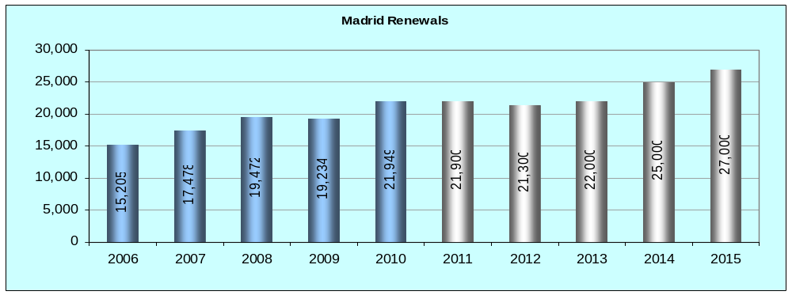

- In the last ten years, the number of renewals varied according to the number of registrations and renewals expiring in each given year, representing a renewal rate of 47 per cent on average.
- The forecast for the period 2011 to 2015 is based on the renewal trends observed in the last 15 years, and on the actual number of registrations due to expire (unless they are renewed) in the next six years. Estimated figures have been calculated on the basis of a 47 per cent renewal rate on the number of registrations and renewals expiring in each given year.

Expected Level of Madrid Fee Income
- Madrid fee income derives from three categories of services offered by WIPO under the Madrid System, namely: (a) the recording of international registrations; (b) the recording of renewals; (c) other services, including the recording of subsequent designations and other modifications and the issuance of extracts. The percentage of fee income attributable to each of these categories of services has varied over time, but has been stable from 2008 to 2010. In 2010, the services falling under these three categories accounted for 54.7 per cent, 29.6 per cent and 15.7 per cent of the Madrid total fee income, respectively.

- Chart 12 below shows actual figures of Madrid fee income for the period 2006 to 2010, and estimated figures of Madrid fee income for the period 2011 to 2015, attributable to each of the above-mentioned three categories of services. Income estimates are based on the numbers of international registrations and renewals that are expected to get recorded from 2011 to 2015, as indicated in Table 1 below (which are, in turn, based on the forecast for applications and renewals given in Charts 10 and 11, above).

Chart 12. Expected Level of Madrid Fee Income, by Source

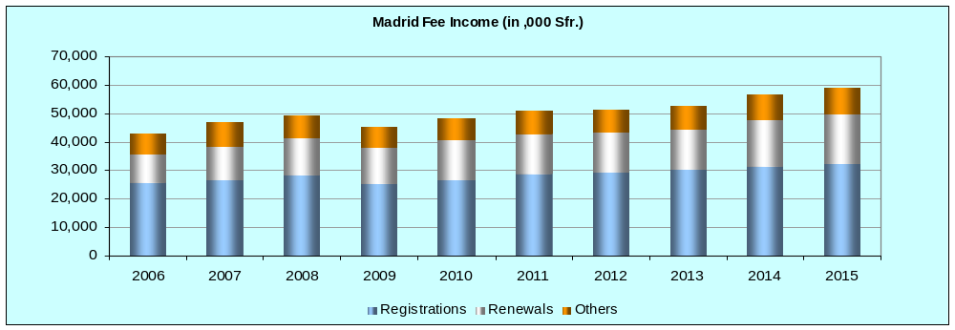

- For the years 2008 to 2010, the ratio between income from international registrations and renewals, on the one hand, and income from other services, on the other hand, was stable at 84/16, on average. For the years to come, the ratio may be estimated to be 84/16 as well.

- Table 18 below, provides information on the actual and expected numbers of registrations and renewals for the period 2006 to 2015 and on the actual and expected evolution of the average fee during that period. The average fee is calculated as the total Madrid fee income divided by the total number of registrations and renewals in any given year.

Table 18. Madrid Total Fee Income and Average Fee

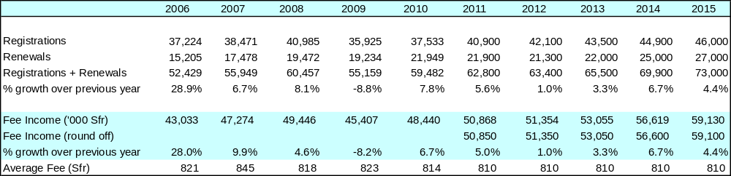

- As can be seen from Table 18, above, the average fee was 814 Swiss francs in 2010, 823 Swiss francs in 2009 and 818 Swiss francs in 2008. In 2007, the average fee amounted to 845. However, this figure is distorted due to the one-off fee income – 936 thousand Swiss francs – resulting from the special procedure that applied in 2007 in connection with the accession of Montenegro. Not counting the resulting additional revenue, the average fee was 828 in 2007. For the years to come, the average fee is being estimated at 810 Swiss francs, following a conservative approach.

- It should be noted that the income estimates given above are based on the assumption that no changes to the schedule of fees payable to the International Bureau under the Madrid system will take place in the forthcoming years.

Hague

The Hague - Forecast of Demand for International Registration
- Chart 13 shows the actual number of Hague registrations recorded by the International Bureau in the period from 2006 to 2010, and the five-year forecast for the years 2011 to 2015.

Chart 13. Hague Registrations and Renewals

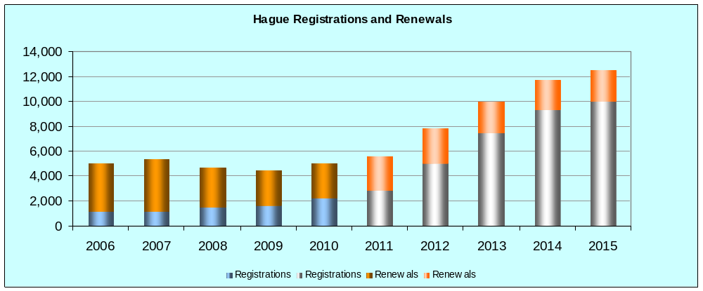
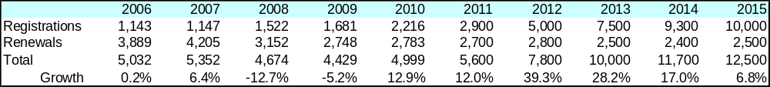

- The growth in registrations from 2008 to 2010 as compared to previous years was the result of the accession of the European Union (EM) to the Geneva Act that took effect on January 1, 2008 combined to tailored promotional activity undertaken throughout 2010. Estimates for the period 2011 to 2015 take into account a gradual increase in membership in the Hague system expected for the years to come, including some of the world’s largest sources of design filings and countries whose national regimes are likely to encourage users to file single-design applications as opposed to multiple ones.

- The expected growth is important, with an estimated 39.3 per cent in 2012 and 28.2 per cent in 2013, but the margin of error of the forecast of Hague registrations for the period 2011 to 2015 is larger then usual, due to a higher exposure of the Hague system to exogenous factors, such as the possible accession of new members with a large potential for international industrial design registration activity.

Hague - Forecast of Demand for Renewals
- Chart 14 also shows the actual number of renewals recorded in the Hague International Register in the period from 2006 to 2010, and the five-year forecast for the years 2011 to 2015.

- For any given year, the number of renewals that can be expected depends on the number of registrations and renewals recorded five years earlier. The average renewal rate has been 51.9 per cent for the last 15 years, 53.5 per cent for the last ten years and 54.4 per cent for the last five years.

- Estimates for the period 2011 to 2015 have been calculated on the basis of a rather conservative 53 per cent renewal rate.

Expected Level of Hague Income
- Fee income under the Hague system results from three categories of services offered by WIPO, for which fees are charged, namely: (a) the recording and publication of international registrations; (b) the recording of renewals; (c) other services, including the recording of modifications and the issuance of extracts. In 2010, the services falling under those three categories accounted for 69 per cent, 24 per cent and 7 per cent of the total Hague fee income. This ratio is expected to gradually change in the years to come, as shown in chart 2, below.

- Chart 14 below shows actual Hague total fee income in the period from 2006 to 2010, and estimated Hague total fee income for the period from 2011 to 2015.

Chart 14. Expected Level of Hague Fee Income, by Source

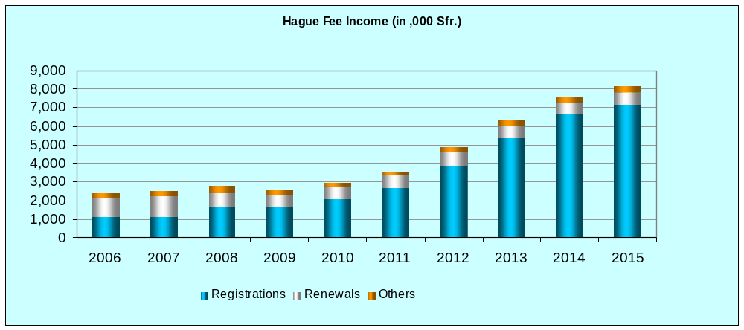
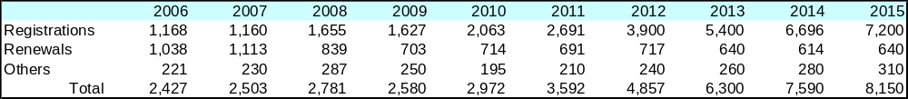

- Income estimates for 2011 to 2015 are based on the expected numbers of international registrations and renewals (Chart 13), and an estimated average fee that would evolve from 623 in 2012 to 652 in 2015. The increase in the number of international registrations had an upward effect on the level of the average fee from 2008 to 2010 as compared to 2006 and 2007. This trend is expected to continue in 2011. From 2012, the average fee will be influenced by the number of designs per registration that is expected to slightly decrease (see paragraph 32, above).

Table 19. Hague Total Fee Income and Average Fee

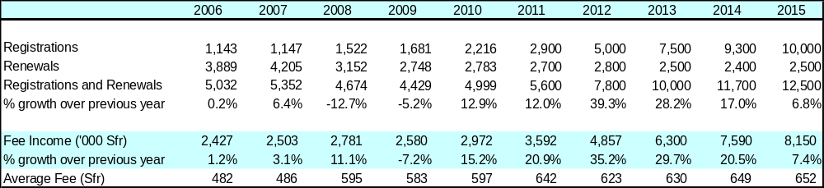

- It should be noted that the income estimates given above are based on the assumption that no changes to the schedule of fees payable to the International Bureau under the Hague system will take place in the forthcoming years.

[Annex V follows]

ANNEX V FUNDS IN TRUST RESOURCES POTENTIALLY AVAILABLE FOR PROGRAMMING

Table 20. Funds in Trust Potentially Available for Programming in 2012/13 (by donor)
(in thousands of Swiss francs) ¹

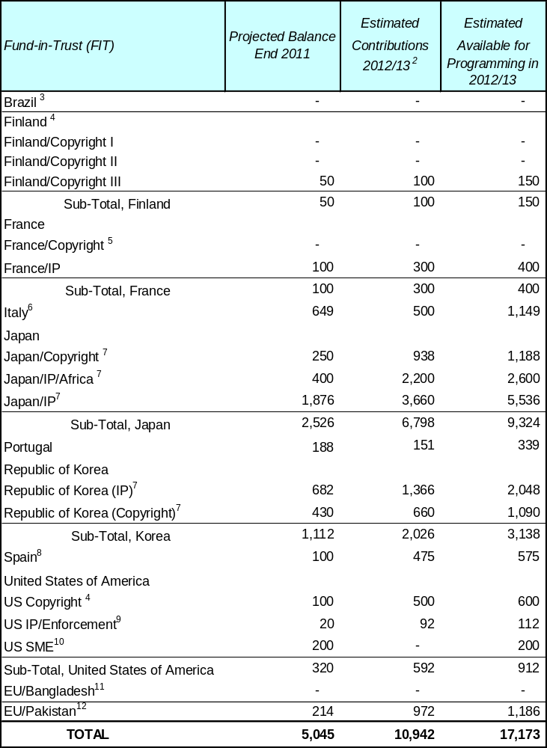

____________________________

¹ The figures do not include interest and exchange rate adjustments. It should also be noted that these funds generally provide for activities spanning a period of time exceeding or overlapping a single biennium, as income is received and expenditure incurred.

² This column is purely indicative and is based on previous funding patterns. It does not represent Member States' commitments except in those cases where the FIT Agreement includes such a commitment.

³ Discussions are currently underway with the Government of Brazil with respect to a Bilateral Agreement to establish a new FIT Brazil. Discussions envisage that such a fund would be dedicated to support for South-South cooperation activities. Should these discussions be successfully concluded, it is intended that this table would be updated for the final version of the Program and Budget 2012/13.

⁴ Information is not available at this time on possible future contributions

⁵ Discussions are currently underway with the Government of France with respect to the France FIT (Copyright). It is intended that this table will be updated for the final version of Program and Budget 2012/13 to reflect the outcome of these discussions.

[continued on the next page]

Table 21. Fund-in-Trust Resources Potentially Available for Programming in 2012/13 (by program)
(in thousands of Swiss francs)

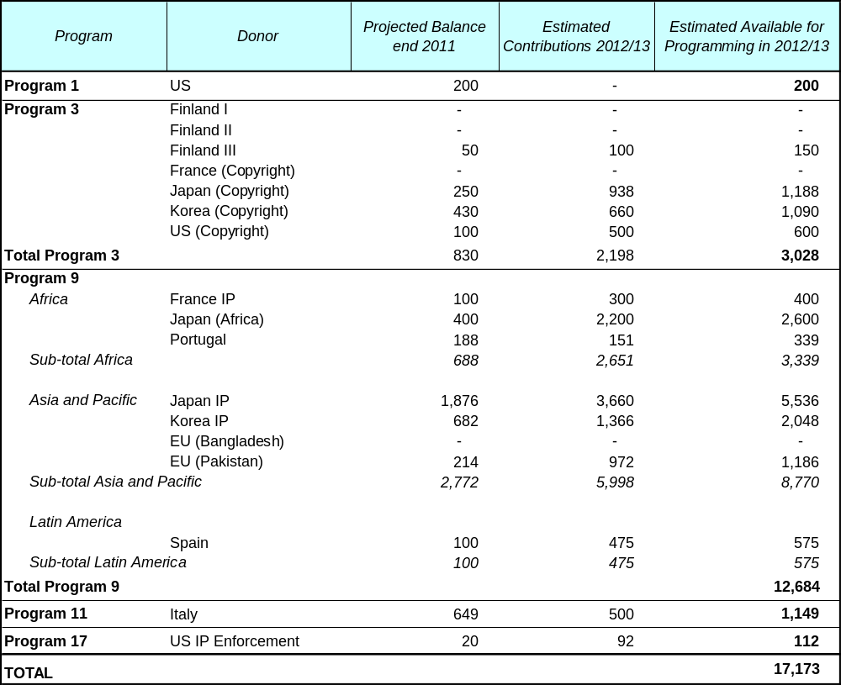

Please refer to the footnotes in Table 1. It should also be noted that some of the FIT Agreements (EG Korea IP, Italy) provide resources for activities which extend beyond the region/program indicated in Table 2 above.

_____________________________
[continued from the previous page]

⁶ Discussions are foreseen to take place with the Government of Italy with respect to the renewal of the estimated contribution. It is intended that this table will be updated for the final version of Program and Budget 2013/13 to reflect the outcome of these discussions.

⁷ Annual contributions vary and fluctuations have been observed from one year to another.

⁸ The figure provided for possible contributions in 2012/13 is provisional and the resources are specifically for activities in the LAC Region.

⁹ The figure indicated for planning is at present only for 2012 as the existing FIT Agreement is due to conclude in 2012.

¹⁰ Current understanding is that this FIT will finish at the end of 2011.

¹¹ This FIT is due to end in 2011.

¹² This is a new FIT established in connection with a joint project with UNIDO and the ITC which is to be funded by the EU.

[Annex VI follows]
ANNEX VI INDICATORS OF PCT OPERATIONS

PERFORMANCE INDICATORS FOR THE EXPECTED RESULT
“ENHANCED IB OPERATIONS”

Background

- As background for the performance indicators for the expected result “Enhanced IB Operations”, it is useful to consider the evolution of:

- The PCT workloads;
- The language distribution of those workloads; and
- The number of staff assigned to process those workloads.

Workloads

- The workloads are tracked on the basis of the yearly number of record copies received by
the IB.

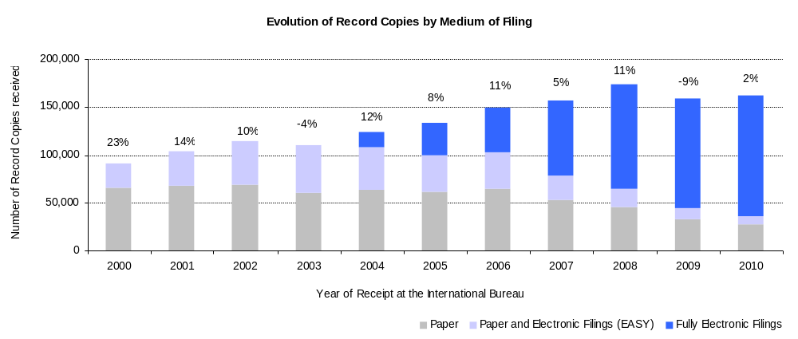

- The IB received over 162,000 record copies in 2010, representing an increase of 2 per cent compared to 2009. Whereas filings in 2010 are estimated to have increased by 5.7 per cent, this increase was not fully reflected in the IB’s 2010 workloads, because of the time lags between the date on which an international application is filed and the date of the receipt of the record copy by the IB.

- The share of fully electronic filing methods kept increasing in 2010 and now represents 78 per cent of total filings.

Language distribution

- One fundamental development driving change in the IB is the increasing language diversity of filings, resulting, in particular, from increased usage of the PCT System in East Asian countries.

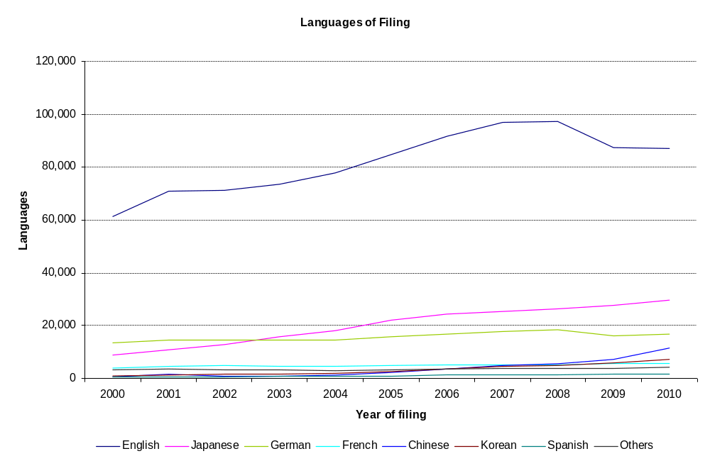
- As can be observed, while English remains by far the most important language of filing, its importance has diminished relative to Japanese, Chinese and Korean. The following graph zooms in on the evolution of languages of filing other than English:

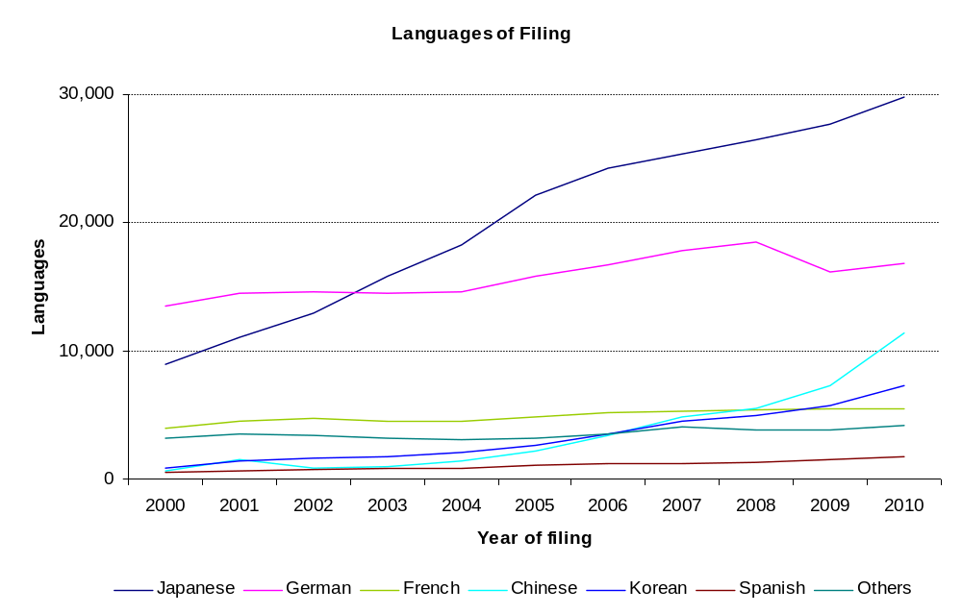
- These evolutions put a considerable strain on the IB because it takes many years to adjust the language composition of the PCT Operations staff to ensure that it is more in line with these recent filing patterns.

Staff
- The chart below shows the number of PCT Operations staff since 2000, in Full Time Staff Equivalent (FTSE - total number of full-time staff plus the full-time equivalent of the part-time staff).
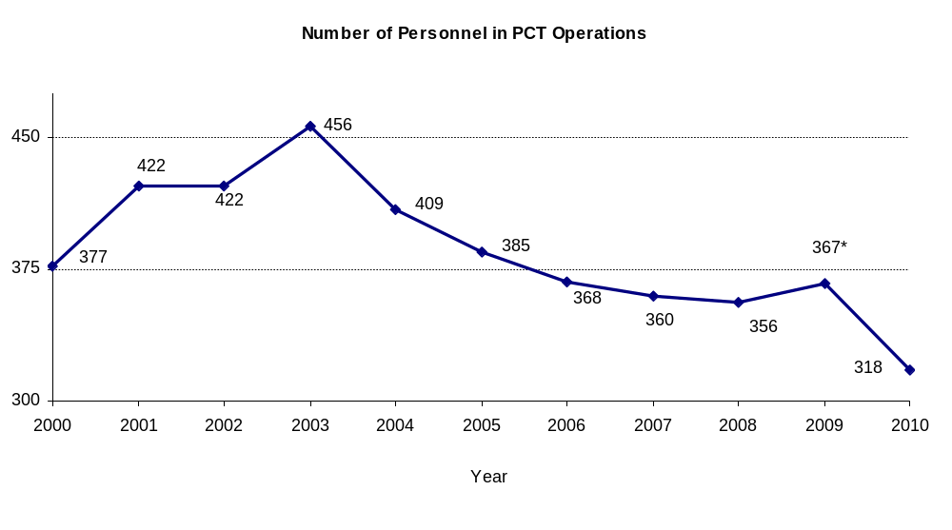
* Note that the increase in personnel in 2009 is due to the integration into the PCT Operations Division of two units which were not part of the Division prior to 2009 (and therefore were not counted as part of its personnel at that time). The units in question are the PCT Information Systems Service (30 persons) and the PCT fee handling team (2 persons). Without the integration of these two units, the number of personnel in the Division would have decreased from 356 in 2008 to 335 in 2009.

- The PCT Operations Division’s personnel was reduced by 13 per cent in 2010 (49 staff less than in 2009). This reduction was mainly due to departures in the formality examination group following the Voluntary Separation Program. As a number of these now vacant positions will need to be filled, a moderate increase in the personnel count may be expected in the next few years.

Unit cost of processing an application

- The definition of the unit cost used in this methodology is the average total cost of producing one unit of output, namely a PCT publication. Average total cost is determined by the total of the PCT expenditures plus a proportion of the expenditures of supporting and management activities. The unit cost is therefore an average total cost per publication and includes the cost of all PCT activities including translation, communication, management, etc.

- The cost of production has been divided into two parts, the direct and the indirect cost. The direct cost corresponds to the expenditures of the units of the PCT system (the Administration of the PCT system and programs). The indirect cost includes the expenditures of the organization units that support the PCT system (e.g. Building, IT). These expenditures must be weighted in order to take into account only their share attributable to the PCT system. The cost of storage of published applications has been added to the formula since the PCT system must store applications for 30 years.

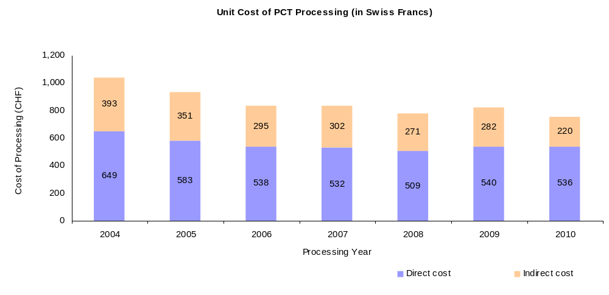
- Although the number of applications published was 2 per cent lower in 2010 than it was in 2009, cost reductions in 2010 were such that the unit cost per application was reduced by 8 per cent to reach 756 Swiss francs. The principal causes of this decrease in the unit cost are reductions in the indirect costs associated with the processing of applications and staff reductions in the PCT Operations Division, resulting from, inter alia, the Voluntary Separation Program.

Productivity of formality examination

- The definition of staff productivity is output (i.e., number of PCT publications) divided by the number of available staff for formality examination.

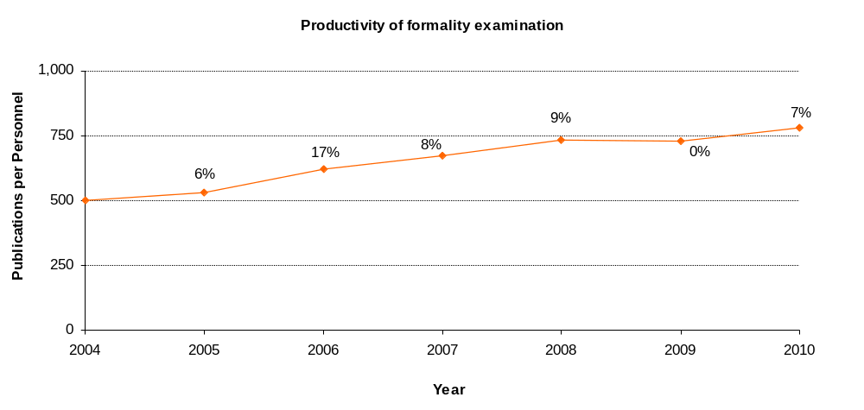

- Historically, productivity of formality examination has increased, mainly due to automation which has permitted the processing of much larger workloads with less staff.

Aggregate quality of formality examination

- In order to capture quality in a simple and comprehensive way, a single aggregate quality indicator has been developed, constructed from a set of four lead quality indicators.
- The quality indicator is the simple average of four lead indicators, three of which are based on the timeliness of key transactions in the PCT system – issuance of Form 301, publication and republication. The fourth indicator shows the number of quality defects resulting in republication code R5 (errors in bibliographical data, mostly due to manual data entry errors).

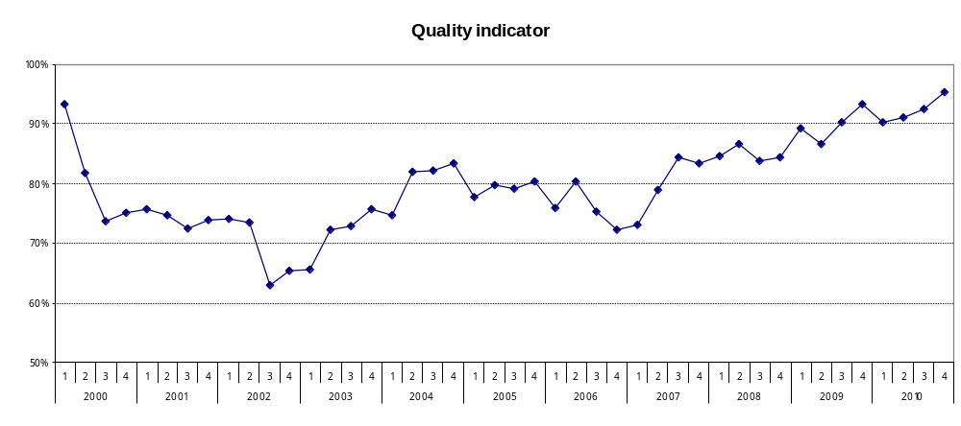

- Quality as measured by the aggregate index has markedly improved, reaching 95.3 per cent in the final quarter of 2010, which is the highest it has been in a decade.

Timeliness of formality examination

- This indicator reflects in more detail one of the components of the aggregate quality indicator, namely the time required by the IB to issue Form 301. This form is issued after the formality examination of the application has been completed. Applicants appreciate receiving this Form as soon as possible because it allows them to know whether their application has any formal defects.

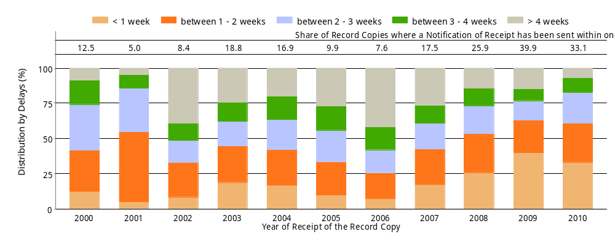

Timeliness of publication

- This indicator reflects in more detail one of the components of the aggregate quality indicator, namely the time required by the IB to publish the application. Article 21 (2) (a) of the PCT states that the “… international publication of the international application shall be effected promptly after the expiration of 18 months from the priority date of that application.”

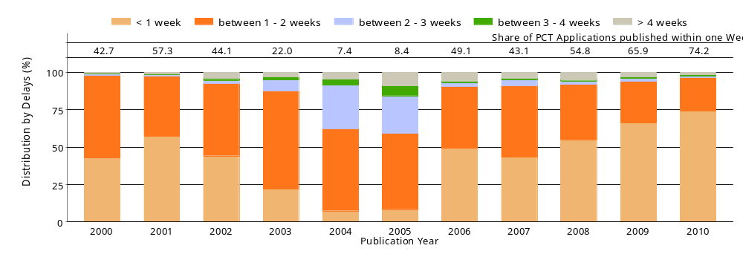

Quality of translation

- Translations of abstracts and reports prepared under the responsibility of the IB are subjected to a quality control process based on a sample. The results are classified in two categories: translations that are deemed acceptable and those that are deemed not acceptable. This performance indicator tracks the quality of the translations as reflected in the samples.

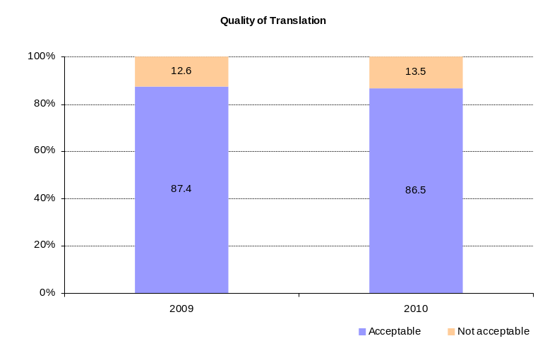

Filings at the IB as Receiving Office (RO/IB)

- This table presents PCT filings by the top ten receiving offices over the past five years to 2010. In principle, a PCT application is filed at the national patent office of the applicant’s home country or at a regional patent office acting for the applicant’s home jurisdiction. The IB is a competent receiving office for applicants from all PCT contracting states. The evolution of the filings at the RO/IB, its ranking among other receiving offices, as well as its market share are also reflected in this table.

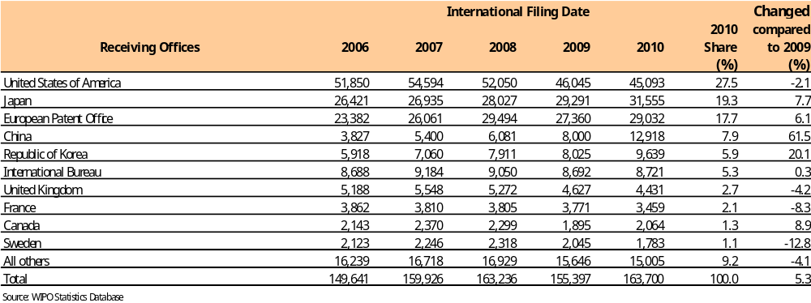

[Annex VII follows]

ANNEX VII WIPO ORGANIGRAM

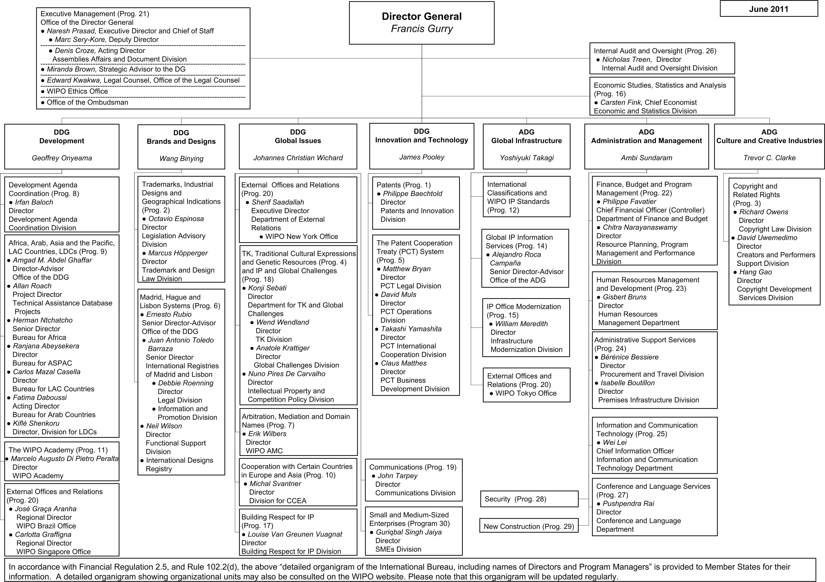
[Annex VIII follows]

ANNEX VIII ANNUAL BUDGET TABLES FOR IPSAS REPORTING

- At the forty-third session of the Assemblies from September 24 to October 3, 2007, the Member States agreed in principle to the adoption by WIPO of IPSAS by 2010 (reference document A/43/5). This agreement formed part of a United Nations system-wide initiative endorsed by the General Assembly (A/RES/60/283(IV)I) to replace the existing United Nations Systems Accounting Standards (UNSAS) with IPSAS, which are internationally recognized. Accordingly, WIPO’s financial statements from the year 2010 are prepared in accordance with IPSAS.

- WIPO’s budget continues to be adopted by the Assemblies on a biennial basis. In compliance with IPSAS, the Organization must present financial statements on an annual basis. For this purpose, annual budget figures are provided for both income and expenditure.

- Within the context of the approval of the 2010/11 Program and Budget, the Member States approved the methodology for the annual presentation for WIPO’s biennial approved budget. Table 22 below provides the annual income amounts in accordance with this methodology.

Table 22. Annual Income 2004-2013
(in millions of Swiss francs)
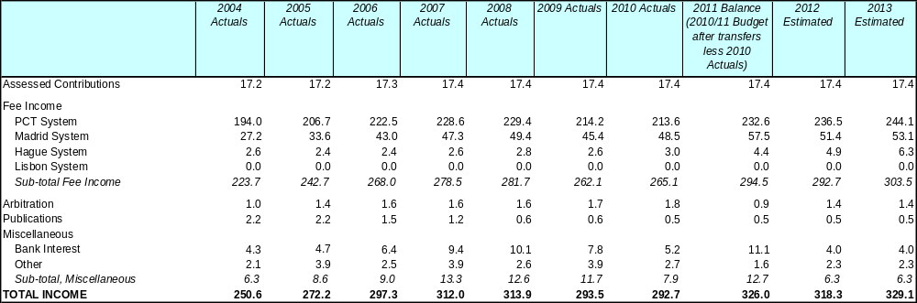

- In respect of WIPO’s expenditure budget, a 50/50 split is applied to the biennial budget figures in order to establish the annual budget view. It is noted that for 2010/11 personnel costs were presented on the basis of annual standard costs and therefore did not represent an exact 50/50 split. However, this was due to the differences in costing resulting from the implementation of the Voluntary Separation Program. In the absence of such a program in 2012/13, the personnel budget has been prepared on the basis of the biennial standard costs. Table 23 below provides the annual expenditure amounts accordingly.
Table 23. Annual Expenditure 2004-2013
(in millions of Swiss francs) 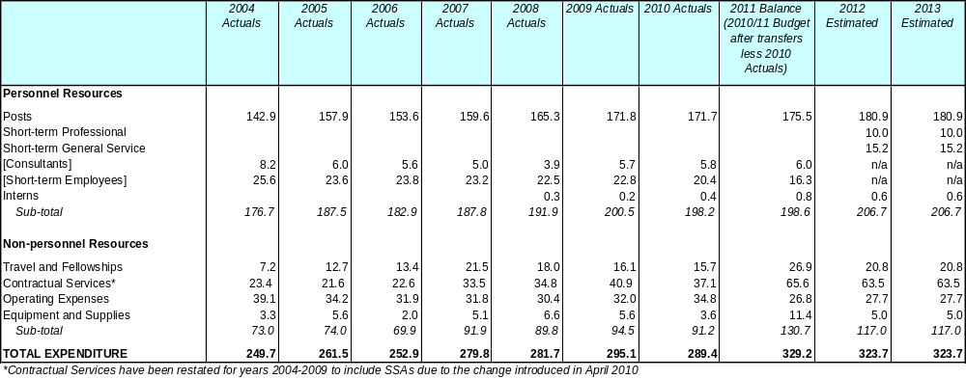

[Annex IX follows]

ANNEX IX 2012/13 BUDGET BY EXPECTED RESULT AND PROGRAM

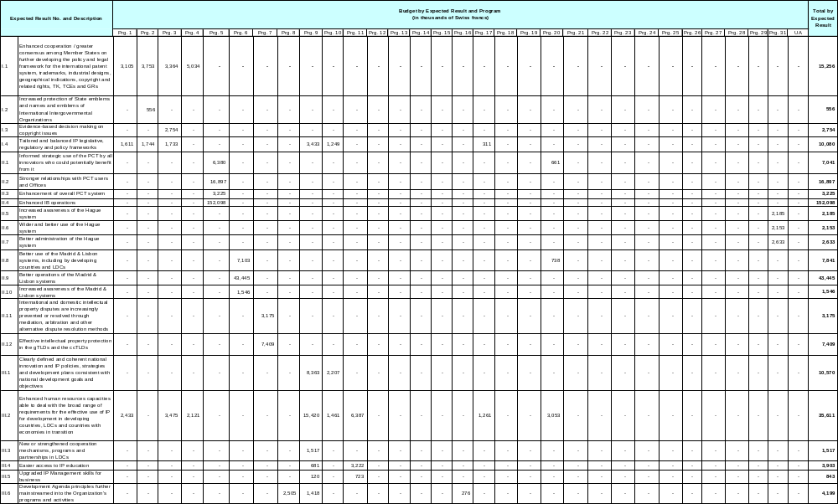
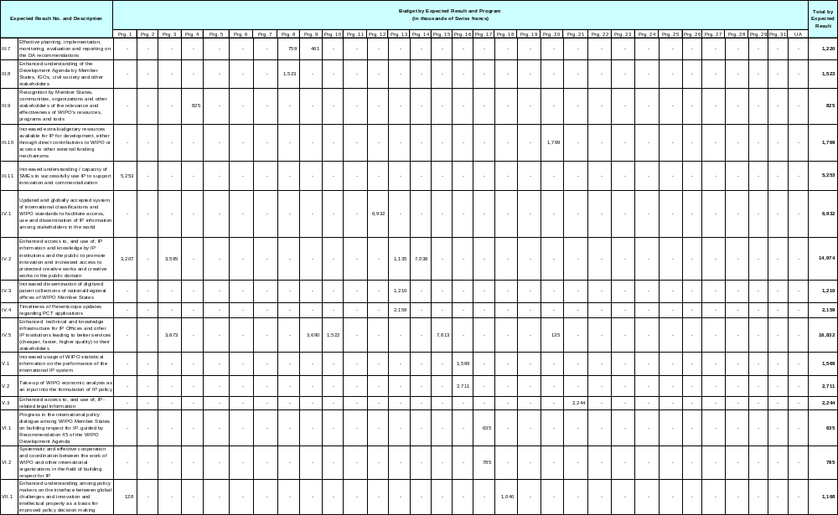

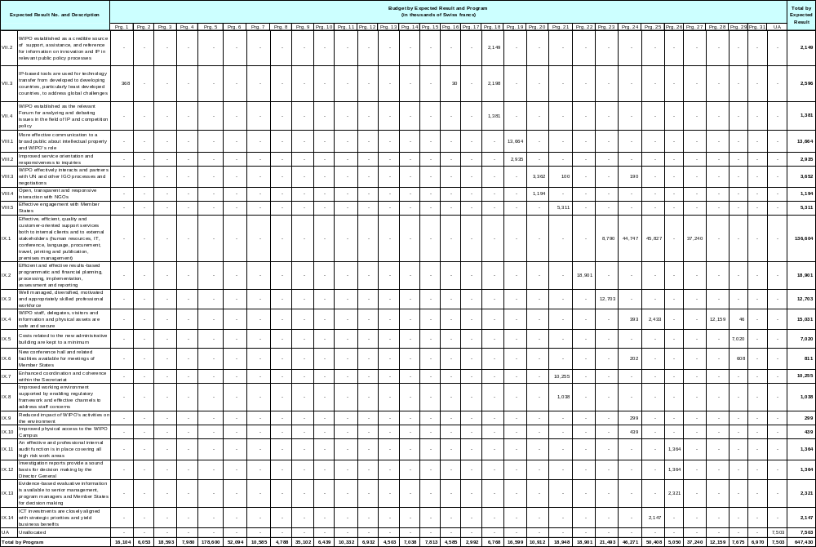
[Annex X follows]
[Annex X follows]
ANNEX X DEVELOPMENT AGENDA LINKS FOR PROGRAM AND BUDGET 2012/13

DEVELOPMENT AGENDA  RECOMMENDATION | PROGRAM LINKS
1. WIPO technical assistance shall be, inter alia, development-oriented, demand-driven and transparent, taking into account the priorities and the special needs of developing countries, especially LDCs, as well as the different levels of development of Member States and activities should include time frames for completion. In this regard, design, delivery mechanisms and evaluation processes of technical assistance programs should be country specific. | Program 1: Patent Law and Innovation  Program 2: Trademarks, Industrial Designs and Geographical Indications  Program 3: Copyright and Related Rights  Program 4: Traditional Knowledge, Traditional Cultural Expressions and Genetic Resources  Program 5: The PCT System  Program 6: Madrid and Lisbon Systems  Program 7: Arbitration, Mediation and Domain Names  Program 8: Development Agenda Coordination  Program 9: Africa, Arab, Asia and the Pacific, Latin America and the Caribbean Countries, Least Developed Countries  Program 10: Cooperation with Certain Countries in Europe and Asia  Program 11: The WIPO Academy  Program 14: Services for Access to Knowledge  Program 15: Business Solutions for IP Offices  Program 16: Economics and Statistics  Program 17: Building Respect for IP  Program 21: Executive Management
2. Provide additional assistance to WIPO through donor funding, and establish Trust-in-Funds or other voluntary funds within WIPO specifically for LDCs, while continuing to accord high priority to finance activities in Africa through budgetary and extra-budgetary resources, to promote, inter alia, the legal, commercial, cultural, and economic exploitation of intellectual property in these countries. | Program 8: Development Agenda Coordination  Program 9: Africa, Arab, Asia and the Pacific, Latin America and the Caribbean Countries, Least Developed Countries  Program 10: Cooperation with Certain Countries in Europe and Asia  Program 15: Business Solutions for IP Offices  Program 20. External Relations, Partnerships and External Offices  Program 21: Executive Management
3. Increase human and financial allocation for technical assistance programs in WIPO for promoting a, inter alia, development-oriented intellectual property culture, with an emphasis on introducing intellectual property at different academic levels and on generating greater public awareness on intellectual property. | Program 8: Development Agenda Coordination  Program 9: Africa, Arab, Asia and the Pacific, Latin America and the Caribbean Countries, Least Developed Countries  Program 10: Cooperation with Certain Countries in Europe and Asia  Program 11: The WIPO Academy  Program 15: Business Solutions for IP Offices  Program 19. Communications  Program 21: Executive Management
4. Place particular emphasis on the needs of small and medium-sized enterprises (SMEs) and institutions dealing with scientific research and cultural industries and assist Member States, at their request, in setting-up appropriate national strategies in the field of intellectual property. | Program 1: Patent Law and Innovation  Program 3: Copyright and Related Rights  Program 8: Development Agenda Coordination  Program 9: Africa, Arab, Asia and the Pacific, Latin America and the Caribbean Countries, Least Developed Countries  Program 10: Cooperation with Certain Countries in Europe and Asia  Program 11: The WIPO Academy  Program 21: Executive Management
5. WIPO shall display general information on all technical assistance activities on its website, and shall provide, on request from Member States, details of specific activities, with the consent of the Member State(s) and other recipients concerned, for which the activity was implemented. | Program 8: Development Agenda Coordination  Program 9: Africa, Arab, Asia and the Pacific, Latin America and the Caribbean Countries, Least Developed Countries  Program 10: Cooperation with Certain Countries in Europe and Asia  Program 11: The WIPO Academy  Program 21: Executive Management
6. WIPO’s technical assistance staff and consultants shall continue to be neutral and accountable, by paying particular attention to the existing Code of Ethics, and by avoiding potential conflicts of interest. WIPO shall draw up and make widely known to the Member States a roster of consultants for technical assistance available with WIPO. | Program 1: Patent Law and Innovation  Program 2: Trademarks, Industrial Designs and Geographical Indications  Program 3: Copyright and Related Rights  Program 4: Traditional Knowledge, Traditional Cultural Expressions and Genetic Resources  Program 5: The PCT System  Program 6: Madrid and Lisbon Systems  Program 7: Arbitration, Mediation and Domain Names  Program 8: Development Agenda Coordination  Program 9: Africa, Arab, Asia and the Pacific, Latin America and the Caribbean Countries, Least Developed Countries  Program 10: Cooperation with Certain Countries in Europe and Asia  Program 11: The WIPO Academy  Program 14: Services for Access to Knowledge  Program 15: Business Solutions for IP Offices  Program 16: Economics and Statistics  Program 17: Building Respect for IP  Program 21: Executive Management
7. Promote measures that will help countries deal with intellectual property-related anti-competitive practices, by providing technical cooperation to developing countries, especially LDCs, at their request, in order to better understand the interface between IPRs and competition policies. | Program 8: Development Agenda Coordination  Program 9: Africa, Arab, Asia and the Pacific, Latin America and the Caribbean Countries, Least Developed Countries  Program 10: Cooperation with Certain Countries in Europe and Asia  Program 18: IP and Global Challenges  Program 21: Executive Management
8. Request WIPO to develop agreements with research institutions and with private enterprises with a view to facilitating the national offices of developing countries, especially LDCs, as well as their regional and sub-regional intellectual property organizations to access specialized databases for the purposes of patent searches. | Program 8: Development Agenda Coordination  Program 9: Africa, Arab, Asia and the Pacific, Latin America and the Caribbean Countries, Least Developed Countries  Program 10: Cooperation with Certain Countries in Europe and Asia  Program 14: Services for Access to Knowledge  Program 21: Executive Management
9. Request WIPO to create, in coordination with Member States, a database to match specific intellectual property -related development needs with available resources, thereby expanding the scope of its technical assistance programs, aimed at bridging the digital divide. | Program 8: Development Agenda Coordination  Program 9: Africa, Arab, Asia and the Pacific, Latin America and the Caribbean Countries, Least Developed Countries  Program 10: Cooperation with Certain Countries in Europe and Asia  Program 21: Executive Management
10. To assist Member States to develop and improve national intellectual property institutional capacity through further development of infrastructure and other facilities with a view to making national intellectual property institutions more efficient and promote fair balance between intellectual property protection and the public interest. This technical assistance should also be extended to sub-regional and regional organizations dealing with intellectual property. | Program 1: Patent Law and Innovation  Program 3: Copyright and Related Rights  Program 5: The PCT System  Program 7: Arbitration, Mediation and Domain Names  Program 8: Development Agenda Coordination  Program 9: Africa, Arab, Asia and the Pacific, Latin America and the Caribbean Countries, Least Developed Countries  Program 10: Cooperation with Certain Countries in Europe and Asia  Program 14: Services for Access to Knowledge  Program 15: Business Solutions for IP Offices  Program 21: Executive Management
11. To assist Member States to strengthen national capacity for protection of domestic creations, innovations and inventions and to support development of national scientific and technological infrastructure, where appropriate, in accordance with WIPO’s mandate. | Program 8: Development Agenda Coordination  Program 9: Africa, Arab, Asia and the Pacific, Latin America and the Caribbean Countries, Least Developed Countries  Program 10: Cooperation with Certain Countries in Europe and Asia  Program 21: Executive Management
12. To further mainstream development considerations into WIPO’s substantive and technical assistance activities and debates, in accordance with its mandate. | Program 1: Patent Law and Innovation  Program 2: Trademarks, Industrial Designs and Geographical Indications  Program 3: Copyright and Related Rights  Program 4: Traditional Knowledge, Traditional Cultural Expressions and Genetic Resources  Program 8: Development Agenda Coordination  Program 9: Africa, Arab, Asia and the Pacific, Latin America and the Caribbean Countries, Least Developed Countries  Program 10: Cooperation with Certain Countries in Europe and Asia  Program 11: The WIPO Academy  Program 17: Building Respect for IP  Program 21: Executive Management  Program 22: Program and Resource Management
13. WIPO’s legislative assistance shall be, inter alia, development-oriented and demand-driven, taking into account the priorities and the special needs of developing countries, especially LDCs, as well as the different levels of development of Member States and activities should include time frames for completion. | Program 1: Patent Law and Innovation  Program 2: Trademarks, Industrial Designs and Geographical Indications  Program 3: Copyright and Related Rights  Program 8: Development Agenda Coordination  Program 9: Africa, Arab, Asia and the Pacific, Latin America and the Caribbean Countries, Least Developed Countries  Program 10: Cooperation with Certain Countries in Europe and Asia  Program 17: Building Respect for IP  Program 21: Executive Management
14. Within the framework of the agreement between WIPO and the WTO, WIPO shall make available advice to developing countries and LDCs, on the implementation and operation of the rights and obligations and the understanding and use of flexibilities contained in the TRIPS Agreement. | Program 1: Patent Law and Innovation  Program 2: Trademarks, Industrial Designs and Geographical Indications  Program 3: Copyright and Related Rights  Program 8: Development Agenda Coordination  Program 9: Africa, Arab, Asia and the Pacific, Latin America and the Caribbean Countries, Least Developed Countries  Program 10: Cooperation with Certain Countries in Europe and Asia  Program 17: Building Respect for IP  Program 21: Executive Management
15. Norm-setting activities shall:  - be inclusive and member-driven;  - take into account different levels of development;  - take into consideration a balance between costs and benefits;  - be a participatory process, which takes into consideration the interests and priorities of all WIPO Member States and the viewpoints of other stakeholders, including accredited inter-governmental organizations (IGOs) and NGOs; and  - be in line with the principle of neutrality of the WIPO Secretariat. | Program 1: Patent Law and Innovation  Program 2: Trademarks, Industrial Designs and Geographical Indications  Program 3: Copyright and Related Rights  Program 4: Traditional Knowledge, Traditional Cultural Expressions and Genetic Resources  Program 8: Development Agenda Coordination  Program 21: Executive Management
16. Consider the preservation of the public domain within WIPO’s normative processes and deepen the analysis of the implications and benefits of a rich and accessible public domain. | Program 1: Patent Law and Innovation  Program 2: Trademarks, Industrial Designs and Geographical Indications  Program 3: Copyright and Related Rights  Program 4: Traditional Knowledge, Traditional Cultural Expressions and Genetic Resources  Program 8: Development Agenda Coordination  Program 14: Services for Access to Knowledge  Program 21: Executive Management
17. In its activities, including norm-setting, WIPO should take into account the flexibilities in international intellectual property agreements, especially those which are of interest to developing countries and LDCs. | Program 1: Patent Law and Innovation  Program 2: Trademarks, Industrial Designs and Geographical Indications  Program 3: Copyright and Related Rights  Program 8: Development Agenda Coordination  Program 9: Africa, Arab, Asia and the Pacific, Latin America and the Caribbean Countries, Least Developed Countries  Program 10: Cooperation with Certain Countries in Europe and Asia  Program 21: Executive Management
18. To urge the IGC to accelerate the process on the protection of genetic resources, traditional knowledge and folklore, without prejudice to any outcome, including the possible development of an international instrument or instruments. | Program 4: Traditional Knowledge, Traditional Cultural Expressions and Genetic Resources  Program 8: Development Agenda Coordination  Program 21: Executive Management
19. To initiate discussions on how, within WIPO’s mandate, to further facilitate access to knowledge and technology for developing countries and LDCs to foster creativity and innovation and to strengthen such existing activities within WIPO. | Program 1: Patent Law and Innovation  Program 3: Copyright and Related Rights  Program 8: Development Agenda Coordination  Program 9: Africa, Arab, Asia and the Pacific, Latin America and the Caribbean Countries, Least Developed Countries  Program 14: Services for Access to Knowledge  Program 15: Business Solutions for IP Offices  Program 18: IP and Global Challenges  Program 21: Executive Management
20. To promote norm-setting activities related to IP that support a robust public domain in WIPO’s Member States, including the possibility of preparing guidelines which could assist interested Member States in identifying subject matters that have fallen into the public domain within their respective jurisdictions. | Program 1: Patent Law and Innovation  Program 2: Trademarks, Industrial Designs and Geographical Indications  Program 3: Copyright and Related Rights  Program 4: Traditional Knowledge, Traditional Cultural Expressions and Genetic Resources  Program 8: Development Agenda Coordination  Program 14: Services for Access to Knowledge  Program 21: Executive Management
21. WIPO shall conduct informal, open and balanced consultations, as appropriate, prior to any new norm-setting activities, through a member-driven process, promoting the participation of experts from Member States, particularly developing countries and LDCs. | Program 1: Patent Law and Innovation  Program 2: Trademarks, Industrial Designs and Geographical Indications  Program 3: Copyright and Related Rights  Program 4: Traditional Knowledge, Traditional Cultural Expressions and Genetic Resources  Program 8: Development Agenda Coordination  Program 21: Executive Management
22. WIPO’s norm-setting activities should be supportive of the development goals agreed within the United Nations system, including those contained in the Millennium Declaration.  The WIPO Secretariat, without prejudice to the outcome of Member States considerations, should address in its working documents for norm-setting activities, as appropriate and as directed by Member States, issues such as: (a) safeguarding national implementation of intellectual property rules (b) links between intellectual property and competition (c) intellectual property -related transfer of technology (d) potential flexibilities, exceptions and limitations for Member States and (e) the possibility of additional special provisions for developing countries and LDCs. | Program 1: Patent Law and Innovation  Program 2: Trademarks, Industrial Designs and Geographical Indications  Program 3: Copyright and Related Rights  Program 8: Development Agenda Coordination  Program 21: Executive Management
23. To consider how to better promote pro-competitive intellectual property licensing practices, particularly with a view to fostering creativity, innovation and the transfer and dissemination of technology to interested countries, in particular developing countries and LDCs. | Program 3: Copyright and Related Rights  Program 8: Development Agenda Coordination  Program 9: Africa, Arab, Asia and the Pacific, Latin America and the Caribbean Countries, Least Developed Countries  Program 18: IP and Global Challenges  Program 21: Executive Management
24. To request WIPO, within its mandate, to expand the scope of its activities aimed at bridging the digital divide, in accordance with the outcomes of the World Summit on the Information Society (WSIS) also taking into account the significance of the Digital Solidarity Fund (DSF). | Program 3: Copyright and Related Rights  Program 8: Development Agenda Coordination  Program 13: Global Databases  Program 15: Business Solutions for IP Offices  Program 21: Executive Management
25. o explore intellectual property -related policies and initiatives necessary to promote the transfer and dissemination of technology, to the benefit of developing countries and to take appropriate measures to enable developing countries to fully understand and benefit from different provisions, pertaining to flexibilities provided for in international agreements, as appropriate. | Program 1: Patent Law and Innovation  Program 8: Development Agenda Coordination  Program 9: Africa, Arab, Asia and the Pacific, Latin America and the Caribbean Countries, Least Developed Countries  Program 18: IP and Global Challenges  Program 21: Executive Management
26. To encourage Member States, especially developed countries, to urge their research and scientific institutions to enhance cooperation and exchange with research and development institutions in developing countries, especially LDCs. | Program 1: Patent Law and Innovation  Program 8: Development Agenda Coordination  Program 21: Executive Management
27. Facilitating intellectual property -related aspects of ICT for growth and development: Provide for, in an appropriate WIPO body, discussions focused on the importance of intellectual property -related aspects of ICT, and its role in economic and cultural development, with specific attention focused on assisting Member States to identify practical intellectual property -related strategies to use ICT for economic, social and cultural development. | Program 3: Copyright and Related Rights  Program 8: Development Agenda Coordination  Program 15: Business Solutions for IP Offices  Program 21: Executive Management
28. To explore supportive intellectual property -related policies and measures Member States, especially developed countries, could adopt for promoting transfer and dissemination of technology to developing countries. | Program 1: Patent Law and Innovation  Program 8: Development Agenda Coordination  Program 21: Executive Management
29. To include discussions on intellectual property -related technology transfer issues within the mandate of an appropriate WIPO body. | Program 8: Development Agenda Coordination  Program 21: Executive Management
30. WIPO should cooperate with other IGOs to provide to developing countries, including LDCs, upon request, advice on how to gain access to and make use of intellectual property-related information on technology, particularly in areas of special interest to the requesting parties. | Program 8: Development Agenda Coordination  Program 9: Africa, Arab, Asia and the Pacific, Latin America and the Caribbean Countries, Least Developed Countries  Program 12: International Classifications and Standards  Program 14: Services for Access to Knowledge  Program 18: IP and Global Challenges  Program 20. External Relations, Partnerships and External Offices  Program 21: Executive Management
31. To undertake initiatives agreed by Member States, which contribute to transfer of technology to developing countries, such as requesting WIPO to facilitate better access to publicly available patent information. | Program 8: Development Agenda Coordination  Program 9: Africa, Arab, Asia and the Pacific, Latin America and the Caribbean Countries, Least Developed Countries  Program 12: International Classifications and Standards  Program 13: Global Databases  Program 14: Services for Access to Knowledge  Program 21: Executive Management
32. To have within WIPO opportunity for exchange of national and regional experiences and information on the links between IPRs and competition policies. | Program 8: Development Agenda Coordination  Program 18: IP and Global Challenges  Program 21: Executive Management
33. To request WIPO to develop an effective yearly review and evaluation mechanism for the assessment of all its development-oriented activities, including those related to technical assistance, establishing for that purpose specific indicators and benchmarks, where appropriate. | Program 8: Development Agenda Coordination  Program 9: Africa, Arab, Asia and the Pacific, Latin America and the Caribbean Countries, Least Developed Countries  Program 10: Cooperation with Certain Countries in Europe and Asia  Program 11: The WIPO Academy  Program 21: Executive Management  Program 22: Program and Resource Management
34. With a view to assisting Member States in creating substantial national programs, to request WIPO to conduct a study on constraints to intellectual property protection in the informal economy, including the tangible costs and benefits of intellectual property protection in particular in relation to generation of employment. | Program 8: Development Agenda Coordination  Program 16: Economics and Statistics  Program 21: Executive Management
35. To request WIPO to undertake, upon request of Member States, new studies to assess the economic, social and cultural impact of the use of intellectual property systems in these States. | Program 8: Development Agenda Coordination  Program 16: Economics and Statistics  Program 21: Executive Management
36. To exchange experiences on open collaborative projects such as the Human Genome Project as well as on intellectual property models. | Program 1: Patent Law and Innovation  Program 8: Development Agenda Coordination  Program 21: Executive Management
37. Upon request and as directed by Member States, WIPO may conduct studies on the protection of intellectual property, to identify the possible links and impacts between intellectual property and development. | Program 8: Development Agenda Coordination  Program 16: Economics and Statistics  Program 21: Executive Management
38. To strengthen WIPO’s capacity to perform objective assessments of the impact of the organization’s activities on development. | Program 8: Development Agenda Coordination  Program 9: Africa, Arab, Asia and the Pacific, Latin America and the Caribbean Countries, Least Developed Countries  Program 10: Cooperation with Certain Countries in Europe and Asia  Program 11: The WIPO Academy  Program 21: Executive Management  Program 22: Program and Resource Management
39. To request WIPO, within its core competence and mission, to assist developing countries, especially African countries, in cooperation with relevant international organizations, by conducting studies on brain drain and make recommendations accordingly. | Program 8: Development Agenda Coordination  Program 9: Africa, Arab, Asia and the Pacific, Latin America and the Caribbean Countries, Least Developed Countries  Program 16: Economics and Statistics  Program 21: Executive Management
40. To request WIPO to intensify its cooperation on IP related issues with United Nations agencies, according to Member States’ orientation, in particular UNCTAD, UNEP, WHO, UNIDO, UNESCO and other relevant international organizations, especially the WTO in order to strengthen the coordination for maximum efficiency in undertaking development programs. | Program 8: Development Agenda Coordination  Program 9: Africa, Arab, Asia and the Pacific, Latin America and the Caribbean Countries, Least Developed Countries  Program 10: Cooperation with Certain Countries in Europe and Asia  Program 18: IP and Global Challenges  Program 20. External Relations, Partnerships and External Offices  Program 21: Executive Management
41. To conduct a review of current WIPO technical assistance activities in the area of cooperation and development. | Program 8: Development Agenda Coordination  Program 9: Africa, Arab, Asia and the Pacific, Latin America and the Caribbean Countries, Least Developed Countries  Program 10: Cooperation with Certain Countries in Europe and Asia  Program 11: The WIPO Academy  Program 21: Executive Management  Program 22: Program and Resource Management
42. To enhance measures that ensure wide participation of civil society at large in WIPO activities in accordance with its criteria regarding NGO acceptance and accreditation, keeping the issue under review. | Program 4: Traditional Knowledge, Traditional Cultural Expressions and Genetic Resources  Program 8: Development Agenda Coordination  Program 9: Africa, Arab, Asia and the Pacific, Latin America and the Caribbean Countries, Least Developed Countries  Program 10: Cooperation with Certain Countries in Europe and Asia  Program 18: IP and Global Challenges  Program 20. External Relations, Partnerships and External Offices  Program 21: Executive Management
43. To consider how to improve WIPO’s role in finding partners to fund and execute projects for intellectual property -related assistance in a transparent and member-driven process and without prejudice to ongoing WIPO activities. | Program 8: Development Agenda Coordination  Program 9: Africa, Arab, Asia and the Pacific, Latin America and the Caribbean Countries, Least Developed Countries  Program 10: Cooperation with Certain Countries in Europe and Asia  Program 21: Executive Management
44. I n accordance with WIPO’s member-driven nature as a United Nations Specialized Agency, formal and informal meetings or consultations relating to norm-setting activities in WIPO, organized by the Secretariat, upon request of the Member States, should be held primarily in Geneva, in a manner open and transparent to all Members. Where such meetings are to take place outside of Geneva, Member States shall be informed through official channels, well in advance, and consulted on the draft agenda and program. | Program 8: Development Agenda Coordination  Program 21: Executive Management
45. To approach intellectual property enforcement in the context of broader societal interests and especially development-oriented concerns, with a view that “the protection and enforcement of intellectual property rights should contribute to the promotion of technological innovation and to the transfer and dissemination of technology, to the mutual advantage of producers and users of technological knowledge and in a manner conducive to social and economic welfare, and to a balance of rights and obligations”, in accordance with Article 7 of the TRIPS Agreement. | Program 8: Development Agenda Coordination  Program 17: Building Respect for IP  Program 21: Executive Management

[Appendices follow]

V. APPENDICES

Appendix A Member States’ Contributions

Appendix B Definition of Budget Headings

Appendix C Flexibility Formulas

Appendix D Acronyms and Abbreviations Used in the Present Document

APPENDIX A
MEMBER STATES’CONTRIBUTIONS
(in Swiss francs)

States Members of  One or More | Contribution | Contribution Units | Contribution¹ | Contribution¹ | Contributions
Contribution-Financed Unions | Class | 2012/13 | 2012 | 2013 | 2012/13
Afghanistan² | Ster | 0.03125 | 1,424 | 1,424 | 2,848
Albania | IX | 0.25 | 11,395 | 11,395 | 22,790
Algeria | IX | 0.25 | 11,395 | 11,395 | 22,790
Andorra | IX | 0.25 | 11,395 | 11,395 | 22,790
Angola | Ster | 0.03125 | 1,424 | 1,424 | 2,848
Antigua and Barbuda | Sbis | 0.0625 | 2,849 | 2,849 | 5,698
Argentina | VIbis | 2 | 91,158 | 91,158 | 182,316
Armenia | IX | 0.25 | 11,395 | 11,395 | 22,790
Australia | III | 15 | 683,685 | 683,685 | 1,367,370
Austria | IVbis | 7.5 | 341,842 | 341,842 | 683,684
Azerbaijan | IX | 0.25 | 11,395 | 11,395 | 22,790
Bahamas | Sbis | 0.0625 | 2,849 | 2,849 | 5,698
Bahrain | S | 0.125 | 5,697 | 5,697 | 11,394
Bangladesh | Ster | 0.03125 | 1,424 | 1,424 | 2,848
Barbados | Sbis | 0.0625 | 2,849 | 2,849 | 5,698
Belarus | IX | 0.25 | 11,395 | 11,395 | 22,790
Belgium | III | 15 | 683,685 | 683,685 | 1,367,370
Belize | Sbis | 0.0625 | 2,849 | 2,849 | 5,698
Benin | Ster | 0.03125 | 1,424 | 1,424 | 2,848
Bhutan | Ster | 0.03125 | 1,424 | 1,424 | 2,848
Bolivia (Plurinational State of) | Sbis | 0.0625 | 2,849 | 2,849 | 5,698
Bosnia and Herzegovina | Sbis | 0.0625 | 2,849 | 2,849 | 5,698
Botswana | Sbis | 0.0625 | 2,849 | 2,849 | 5,698
Brazil | VIbis | 2 | 91,158 | 91,158 | 182,316
Brunei Darussalam | S | 0.125 | 5,697 | 5,697 | 11,394
Bulgaria | VIbis | 2 | 91,158 | 91,158 | 182,316
Burkina Faso | Ster | 0.03125 | 1,424 | 1,424 | 2,848
Burundi | Ster | 0.03125 | 1,424 | 1,424 | 2,848
Cambodia | Ster | 0.03125 | 1,424 | 1,424 | 2,848
Cameroon | Sbis | 0.0625 | 2,849 | 2,849 | 5,698
Canada | IV | 10 | 455,790 | 455,790 | 911,580
Cape Verde | Sbis | 0.0625 | 2,849 | 2,849 | 5,698
Central African Republic | Ster | 0.03125 | 1,424 | 1,424 | 2,848
Chad | Ster | 0.03125 | 1,424 | 1,424 | 2,848
Chile | IX | 0.25 | 11,395 | 11,395 | 22,790
China | IVbis | 7.5 | 341,842 | 341,842 | 683,684
Colombia | IX | 0.25 | 11,395 | 11,395 | 22,790
Comoros | Ster | 0.03125 | 1,424 | 1,424 | 2,848
Congo | Sbis | 0.0625 | 2,849 | 2,849 | 5,698
Costa Rica | S | 0.125 | 5,697 | 5,697 | 11,394
Côte d'Ivoire | Sbis | 0.0625 | 2,849 | 2,849 | 5,698
Croatia | VIII | 0.5 | 22,789 | 22,789 | 45,578
Cuba | S | 0.125 | 5,697 | 5,697 | 11,394
Cyprus | S | 0.125 | 5,697 | 5,697 | 11,394
Czech Republic | VI | 3 | 136,737 | 136,737 | 273,474
Democratic People's Republic of Korea | Sbis | 0.0625 | 2,849 | 2,849 | 5,698
Democratic Republic of the Congo | Ster | 0.03125 | 1,424 | 1,424 | 2,848
Denmark | IV | 10 | 455,790 | 455,790 | 911,580
Djibouti | Ster | 0.03125 | 1,424 | 1,424 | 2,848
Dominica | Sbis | 0.0625 | 2,849 | 2,849 | 5,698
Dominican Republic | S | 0.125 | 5,697 | 5,697 | 11,394
Ecuador | S | 0.125 | 5,697 | 5,697 | 11,394
Egypt | S | 0.125 | 5,697 | 5,697 | 11,394
El Salvador | Sbis | 0.0625 | 2,849 | 2,849 | 5,698
Equatorial Guinea | Ster | 0.03125 | 1,424 | 1,424 | 2,848
Eritrea ² | Ster | 0.03125 | 1,424 | 1,424 | 2,848
Estonia | IX | 0.25 | 11,395 | 11,395 | 22,790
Ethiopia ² | Ster | 0.03125 | 1,424 | 1,424 | 2,848
Fiji | Sbis | 0.0625 | 2,849 | 2,849 | 5,698
Finland | IV | 10 | 455,790 | 455,790 | 911,580
France | I | 25 | 1,139,475 | 1,139,475 | 2,278,950
Gabon | Sbis | 0.0625 | 2,849 | 2,849 | 5,698
Gambia | Ster | 0.03125 | 1,424 | 1,424 | 2,848
Georgia | IX | 0.25 | 11,395 | 11,395 | 22,790
Germany | I | 25 | 1,139,475 | 1,139,475 | 2,278,950
Ghana | Sbis | 0.0625 | 2,849 | 2,849 | 5,698
Greece | VI | 3 | 136,737 | 136,737 | 273,474
Grenada | Sbis | 0.0625 | 2,849 | 2,849 | 5,698
Guatemala | S | 0.125 | 5,697 | 5,697 | 11,394
Guinea | Ster | 0.03125 | 1,424 | 1,424 | 2,848
Guinea-Bissau | Ster | 0.03125 | 1,424 | 1,424 | 2,848
Guyana | Sbis | 0.0625 | 2,849 | 2,849 | 5,698
Haiti | Ster | 0.03125 | 1,424 | 1,424 | 2,848
Holy See | IX | 0.25 | 11,395 | 11,395 | 22,790
Honduras | Sbis | 0.0625 | 2,849 | 2,849 | 5,698
Hungary | VI | 3 | 136,737 | 136,737 | 273,474
Iceland | VIII | 0.5 | 22,789 | 22,789 | 45,578
India | VIbis | 2 | 91,158 | 91,158 | 182,316
Indonesia | VII | 1 | 45,579 | 45,579 | 91,158
Iran (Islamic Republic of) | VII | 1 | 45,579 | 45,579 | 91,158
Iraq | S | 0.125 | 5,697 | 5,697 | 11,394
Ireland | IV | 10 | 455,790 | 455,790 | 911,580
Israel | VIbis | 2 | 91,158 | 91,158 | 182,316
Italy | III | 15 | 683,685 | 683,685 | 1,367,370
Jamaica | Sbis | 0.0625 | 2,849 | 2,849 | 5,698
Japan | I | 25 | 1,139,475 | 1,139,475 | 2,278,950
Jordan | Sbis | 0.0625 | 2,849 | 2,849 | 5,698
Kazakhstan | IX | 0.25 | 11,395 | 11,395 | 22,790
Kenya | Sbis | 0.0625 | 2,849 | 2,849 | 5,698
Kuwait ² | IX | 0.25 | 11,395 | 11,395 | 22,790
Kyrgyzstan | IX | 0.25 | 11,395 | 11,395 | 22,790
Lao People's Democratic Republic | Ster | 0.03125 | 1,424 | 1,424 | 2,848
Latvia | IX | 0.25 | 11,395 | 11,395 | 22,790
Lebanon | S | 0.125 | 5,697 | 5,697 | 11,394
Lesotho | Ster | 0.03125 | 1,424 | 1,424 | 2,848
Liberia | Ster | 0.03125 | 1,424 | 1,424 | 2,848
Libyan Arab Jamahiriya | IX | 0.25 | 11,395 | 11,395 | 22,790
Liechtenstein | VIII | 0.5 | 22,789 | 22,789 | 45,578
Lithuania | IX | 0.25 | 11,395 | 11,395 | 22,790
Luxembourg | VII | 1 | 45,579 | 45,579 | 91,158
Madagascar | Ster | 0.03125 | 1,424 | 1,424 | 2,848
Malawi | Ster | 0.03125 | 1,424 | 1,424 | 2,848
Malaysia | VIII | 0.5 | 22,789 | 22,789 | 45,578
Maldives ² | Ster | 0.03125 | 1,424 | 1,424 | 2,848
Mali | Ster | 0.03125 | 1,424 | 1,424 | 2,848
Malta | Sbis | 0.0625 | 2,849 | 2,849 | 5,698
Mauritania | Ster | 0.03125 | 1,424 | 1,424 | 2,848
Mauritius | Sbis | 0.0625 | 2,849 | 2,849 | 5,698
Mexico | IVbis | 7.5 | 341,842 | 341,842 | 683,684
Micronesia (Federates States of) | Sbis | 0.0625 | 2,849 | 2,849 | 5,698
Monaco | VII | 1 | 45,579 | 45,579 | 91,158
Mongolia | Sbis | 0.0625 | 2,849 | 2,849 | 5,698
Montenegro | IX | 0.25 | 11,395 | 11,395 | 22,790
Morocco | S | 0.125 | 5,697 | 5,697 | 11,394
Mozambique | Ster | 0.03125 | 1,424 | 1,424 | 2,848
Myanmar ² | Ster | 0.03125 | 1,424 | 1,424 | 2,848
Namibia | Sbis | 0.0625 | 2,849 | 2,849 | 5,698
Nepal | Ster | 0.03125 | 1,424 | 1,424 | 2,848
Netherlands | III | 15 | 683,685 | 683,685 | 1,367,370
New Zealand | VI | 3 | 136,737 | 136,737 | 273,474
Nicaragua | Sbis | 0.0625 | 2,849 | 2,849 | 5,698
Niger | Ster | 0.03125 | 1,424 | 1,424 | 2,848
Nigeria | S | 0.125 | 5,697 | 5,697 | 11,394
Norway | IV | 10 | 455,790 | 455,790 | 911,580
Oman | S | 0.125 | 5,697 | 5,697 | 11,394
Pakistan | S | 0.125 | 5,697 | 5,697 | 11,394
Panama | S | 0.125 | 5,697 | 5,697 | 11,394
Papua New Guinea | Sbis | 0.0625 | 2,849 | 2,849 | 5,698
Paraguay | Sbis | 0.0625 | 2,849 | 2,849 | 5,698
Peru | S | 0.125 | 5,697 | 5,697 | 11,394
Philippines | S | 0.125 | 5,697 | 5,697 | 11,394
Poland | VI | 3 | 136,737 | 136,737 | 273,474
Portugal | IVbis | 7.5 | 341,842 | 341,842 | 683,684
Qatar | IX | 0.25 | 11,395 | 11,395 | 22,790
Republic of Korea | V | 5 | 227,895 | 227,895 | 455,790
Republic of Moldova | IX | 0.25 | 11,395 | 11,395 | 22,790
Romania | VIbis | 2 | 91,158 | 91,158 | 182,316
Russian Federation | IV | 10 | 455,790 | 455,790 | 911,580
Rwanda | Ster | 0.03125 | 1,424 | 1,424 | 2,848
Saint Kitts and Nevis | Sbis | 0.0625 | 2,849 | 2,849 | 5,698
Saint Lucia | Sbis | 0.0625 | 2,849 | 2,849 | 5,698
Saint Vincent and the Grenadines | Sbis | 0.0625 | 2,849 | 2,849 | 5,698
Samoa | Ster | 0.03125 | 1,424 | 1,424 | 2,848
San Marino | IX | 0.25 | 11,395 | 11,395 | 22,790
Sao Tome and Principe | Ster | 0.03125 | 1,424 | 1,424 | 2,848
Saudi Arabia | VII | 1 | 45,579 | 45,579 | 91,158
Senegal | Ster | 0.03125 | 1,424 | 1,424 | 2,848
Serbia | VIII | 0.5 | 22,789 | 22,789 | 45,578
Seychelles | Sbis | 0.0625 | 2,849 | 2,849 | 5,698
Sierra Leone | Ster | 0.03125 | 1,424 | 1,424 | 2,848
Singapore | IX | 0.25 | 11,395 | 11,395 | 22,790
Slovakia | VI | 3 | 136,737 | 136,737 | 273,474
Slovenia | VII | 1 | 45,579 | 45,579 | 91,158
Somalia ² | Ster | 0.03125 | 1,424 | 1,424 | 2,848
South Africa | IVbis | 7.5 | 341,842 | 341,842 | 683,684
Spain | IV | 10 | 455,790 | 455,790 | 911,580
Sri Lanka | Sbis | 0.0625 | 2,849 | 2,849 | 5,698
Sudan | Ster | 0.03125 | 1,424 | 1,424 | 2,848
Suriname | Sbis | 0.0625 | 2,849 | 2,849 | 5,698
Swaziland | Sbis | 0.0625 | 2,849 | 2,849 | 5,698
Sweden | III | 15 | 683,685 | 683,685 | 1,367,370
Switzerland | III | 15 | 683,685 | 683,685 | 1,367,370
Syrian Arab Republic | S | 0.125 | 5,697 | 5,697 | 11,394
Tajikistan | IX | 0.25 | 11,395 | 11,395 | 22,790
Thailand | IX | 0.25 | 11,395 | 11,395 | 22,790
The former Yugoslav Republic of Macedonia | VIII | 0.5 | 22,789 | 22,789 | 45,578
Togo | Ster | 0.03125 | 1,424 | 1,424 | 2,848
Tonga | Sbis | 0.0625 | 2,849 | 2,849 | 5,698
Trinidad and Tobago | S | 0.125 | 5,697 | 5,697 | 11,394
Tunisia | S | 0.125 | 5,697 | 5,697 | 11,394
Turkey | VIbis | 2 | 91,158 | 91,158 | 182,316
Turkmenistan | IX | 0.25 | 11,395 | 11,395 | 22,790
Uganda | Ster | 0.03125 | 1,424 | 1,424 | 2,848
Ukraine | IX | 0.25 | 11,395 | 11,395 | 22,790
United Arab Emirates | IX | 0.25 | 11,395 | 11,395 | 22,790
United Kingdom | I | 25 | 1,139,475 | 1,139,475 | 2,278,950
United Republic of Tanzania | Ster | 0.03125 | 1,424 | 1,424 | 2,848
United States of America | I | 25 | 1,139,475 | 1,139,475 | 2,278,950
Uruguay | S | 0.125 | 5,697 | 5,697 | 11,394
Uzbekistan | IX | 0.25 | 11,395 | 11,395 | 22,790
Venezuela (Bolivarian Republic of) | IX | 0.25 | 11,395 | 11,395 | 22,790
Viet Nam | S | 0.125 | 5,697 | 5,697 | 11,394
Yemen | Ster | 0.03125 | 1,424 | 1,424 | 2,848
Zambia | Ster | 0.03125 | 1,424 | 1,424 | 2,848
Zimbabwe | Sbis | 0.0625 | 2,849 | 2,849 | 5,698
Total Contributions |  |  | 17,433,958 | 17,433,958 | 34,867,916

¹ The value of one unit for the years 2012 and 2013 is 45,579 Swiss francs.
² States members of WIPO which are not members of any of the Unions.

[Appendix B follows]

APPENDIX B
DEFINITION OF BUDGET HEADINGS

SOURCES OF INCOME

Contributions: Contributions of Member States to the Organization under the unitary contribution system.

Fees: Fees for the International Bureau under the PCT, Madrid, Hague and Lisbon Systems.

Interest: Revenues from interest on capital deposits.

Publications: Revenues from the sale of publications and from subscriptions to periodicals published by the Secretariat, in paper, CD-ROM or any other format.

Other income: fees for the arbitration of domain names, registration fees for conferences and training courses, support charges in respect of extra-budgetary activities executed by WIPO and financed by UNDP and trust funds, accounting adjustments (credits) in respect of prior years and currency adjustments (credits), rental of WIPO premises, UPOV’s payments to WIPO for administrative support services.

OBJECTS OF EXPENDITURE

PERSONNEL RESOURCES

Posts: remuneration received by staff members, in particular salaries, post adjustment, dependency allowances, language allowances and overtime, non-resident allowances, assignment grant and representation allowances.

Short-term Professional: remuneration and allowances paid to professional employees on short-term contracts.

Short-term General Service: remuneration and allowances paid to general service employees on short-term contracts.

Internships: remuneration and allowances paid to headquarters-based interns.

NON-PERSONNEL RESOURCES

Travel and Fellowships

Staff missions: travel expenses and daily subsistence allowances for the staff and short-term employees of the Secretariat on official travel.

Third party travel: travel expenses and daily subsistence allowances for Government officials, participants and lecturers attending WIPO sponsored meetings.

Fellowships: travel expenses, daily subsistence allowances and training and other fees in connection with trainees attending courses, seminars, fellowships.

Contractual Services

Conferences: remuneration, travel expenses and daily subsistence allowances for interpreters; renting of conference facilities, and interpretation equipment; refreshments and receptions; and the cost of any other service directly linked to the organization of a conference.

Experts’ Honoraria: remuneration, travel expenses and daily subsistence allowances for experts, and honoraria paid to lecturers.

Publishing: outside printing and binding; reviews; paper and printing; other printing: reprints of articles published in reviews; brochures; treaties; collections of texts; manuals; working forms and other miscellaneous printed material; production of CD-ROMs, videos, magnetic tapes and other forms of electronic publishing.

Special Service Agreements and Commercial Service Providers: remuneration paid to holders of special service agreements (SSAs) and to commercial service providers.

Operating Expenses

Premises and maintenance: acquiring, renting, improving and maintaining office space and renting or maintaining equipment and furniture, loan reimbursement for new construction, external management consultants related to new construction.

Communication: communication expenses such as telephone, internet, facsimile and mail, postage and carriage of documents. Mobile telecommunication, long distance calls on landlines, internet and facsimile costs are centralized and will be reflected under ICT's budget. Please ensure that you liaise with the ICT for changes in such communication costs.

Representation: official hospitality expenses, excluding reception for conferences / events.

Administrative and bank charges: bank charges; currency adjustments; loan interest and audit expenses.

UN Joint Services: medical assistance, contributions to joint administrative activities within the UN system, Administrative Tribunal.

Equipment and Supplies

Furniture and equipment: purchase of office furniture, office machines, computer equipment (desktop, laptops, printers, servers, etc), conference servicing equipment, reproduction equipment and transportation equipment.

Supplies and materials: stationery and office supplies; internal reproduction supplies (offset, microfilms, etc.); library books and subscriptions to reviews and periodicals; uniforms; computer supplies, software and licenses.

[Appendix C follows]

APPENDIX C
FLEXIBILITY FORMULAS

General

The flexibility formulas are the mechanism which enables the levels of financial resources allocated to the global protection systems (PCT, Madrid, Hague) to be varied to reflect unbudgeted variations in the total volume of registration activities. The flexibility formulas for the PCT, Madrid and Hague systems were revised and approved by their respective Assemblies, which convened from September 24 to October 3, 2007.

PCT System

The revised flexibility formula for the PCT system is described in document PCT/A/36/5, and it was approved by the PCT Assembly as indicated in document PCT/A/36/13. As noted in these documents, the flexibility formula for PCT was revised to reflect a budget variation of 341,870 Swiss francs per 1,000 unbudgeted PCT international applications. The revised formula no longer linked the variations in the number of applications to variations in the number of staff posts as it was done before. Rather, the formula proposed to vary the total resources allocated to programs involved, allowing to use both personnel resources (such as posts, short-term employees, SSAs, etc.) and non-personnel resources (such as outsourcing contracts). The adjustments are allocated to the administration of the PCT system and support services at a 87.5:12.5 ratio.

Madrid System

The revised flexibility formula for the Madrid system is described in document MM/A/38/5, and it was approved by the Madrid Assembly as reflected in document MM/A/38/6. The new formula allows for adjustments in the Madrid Union budget by 197,060 Swiss francs for each variation of 500 registrations and/or renewals recorded as compared to the approved initial estimates. The formula no longer links the adjustments to staff posts only, but rather allows for adjustments in overall financial resources allocated to the programs directly involved in the processing of the resulting workload. These resources may be of personnel (posts, short-term employees, etc.) and non-personnel nature (e.g., outsourcing contracts). The adjustments are allocated to the administration of the International Trademark Registry and support services at a 87.5:12.5 ratio.

Hague System

The revised flexibility formula for the Hague system is described in document H/A/24/3, and it was approved by the Hague Assembly as reflected in document H/A/24/4. The new formula provides for adjustments of the Hague Union budget by an amount of 99,024 Swiss francs for each variation of 300 registrations and/or renewals recorded in the Hague Union Registry as compared to the approved initial estimates. The resources may be of personnel and non-personnel nature, and they are allocated to the administration of the Hague Union Registry and support services at a 87.5:12.5 ratio.

[Appendix D follows]
APPENDIX D
ACRONYMS AND ABBREVIATIONS USED IN THE PRESENT DOCUMENT

ACE Advisory Committee on Enforcement
ADR Alternative Dispute Resolution
AGICOA Association of International Collective Management of Audiovisual Works
aRDi Access to Research for Development and Innovation
ASEAN Association of South East Asian Nations
ASHI After Service Health Insurance
ASPI Access to Specialized Patent Information

CASE Centralized Access to Search and Examination Results
ccTLDs country code Top-Level Domain
CDIP Conference on Development and Intellectual Property
CIS Commonwealth of Independent States
CLIR Cross Lingual Information Retrieval
CMG Crisis Management Group
CMOs collective management organizations

DA Development Agenda
DAS Digital Access Service for Priority Documents
DNS Domain Name System

ECDL (test) European Computer Driving Licence (global computer literacy certification)
ECLA patent classification assigned by the European Patent office
ECM Enterprise Content management
EDMS Electronic Document Management System
EGEDA Entidad de Gestión de Derechos de los Productores Audiovisuales
EPO European Patent Office
ERP enterprise resource planning
EU European Union

FAO Food and Agricultural Organization
FI patent classification assigned by the Japanese Patent office
FIT Fund-in-Trust

GR genetic resources
gTLDs generic Top-Level Domains

HLS High Level Segment (of the Assemblies)
HR Human Resources
HRMD Human Resources Management Department

IAOC Independent Advisory and Oversight Committee
IAOD Internal Audit and Oversight Division
ICANN Internet Corporation for Assigned Names and Numbers
ICE International Cooperation on Examination
ICSEI International Cooperation for the Search and Examination of Inventions
ICPIP Inter-State Council on the Protection of Industrial Property
ICSC International Civil Service Commission
ICT Information and Communication Technology
IGC Intergovernmental Committee on Intellectual Property and Genetic Resources, Traditional Knowledge and Folklore
IGOs inter-governmental organizations
IIA Institute of Internal Auditors
IMR International Music Registry
IP Intellectual Property
IPAS IP Office Automation software
IPACIS Assembly of the CIS Member States
IPC International Patent Classification
IPO Intellectual Property Office
IPRs Intellectual Property Rights
IPSAS International Public Sector Accounting Standards
IT Information Technology
ITIL Information Technology Infrastructure Library
ITU International Telecommunications Union

LDCs Least Developed Countries

MDGs Millenium Development Goals
MTSP Medium Term Strategic Plan

NGOs non-governmental organizations

OAPI l’Organisation Africaine de la Propriété Intellectuelle (African Intellectual Property Organization)
OHIM Office for Harmonization in the Internal Market (Community Trademarks)

PCD Procurement Services Division
PCT Patent Cooperation Treaty
PLR Patent Landscape Reports
PLT Patent Law Treaty
PMSDS Performance Management and Staff Development System
PPR Program Performance Report

RBM Results-based Management
R&D research and development
RFPs Requests for Proposals
RO Receiving Office

SCCR Standing Committee on Copyright and Related Rights
SCP Standing Committee on the Law of Patents
SCT Standing Committee on the Law of Trademarks, Industrial Designs and Geographical Indications
SLC Special Labor Contract
SMEs small and medium size enterprises
SSA Special Service Agreements
SRP Strategic Realignment Program

TA Travel Authorization
TCEs Traditional Cultural Expressions/Folklore
TIGAR Trusted Intermediary Global Accessible Resources
TISCs Technology Innovation Support Centers
TK Traditional Knowledge
TTO Technology Transfer Office

UDRP Uniform Domain Name Dispute Resolution Policy
UN United Nations
UNCTAD United Nations Conference on Trade and Development
UN CEB United Nations Chief Executives Board
UN-DESA United Nations Department of Social and Economic Affaires
UNEP United Nations Environmental Programme

UNESCO United Nations Educational, Scientific and Cultural Organization
UNFCCC Framework Convention on Climate Change
UN-H-MOSS UN Headquarters Minimum Operating Security Standards
UNICC UN International Computing Centre
UNIDO United Nations Industrial Development Organization
UNSAS United Nations System Accounting Standards
UPOV International Union for the Protection of New Varieties of Plants
USCLA US Classifications
USPTO United States Patent and Trademark Office

VIP Visually Impaired Persons and other persons with print disabilities

WCO World Customs Organization
WCT WIPO Copyright Treaty
WHO World Health Organization
WIPOCOS software for collective management of copyright and neighboring rights
WPPT WIPO Performances and Phonograms Treaty
WTO World Trade Organization

[End of Appendix D and of document]

There was no consensus among Member States on zero nominal growth.
Review of Budgetary Process Applied to Projects Proposed by the Committee on Development and Intellectual Property (CDIP) for the Implementation of the Development Agenda Recommendations (A/48/5 REV.)
Consistent with past practice, countries with economies in transition are included for the purpose of the Program and Budget.
All statistics are based on the date of filing of PCT applications or Chapter II demands.
A record copy is a PCT application transmitted to the International Bureau by a receiving Office after its filing at, and its processing by, that Office. Because record copies are only received at the International Bureau after processing at a receiving Office, the figures are strongly influenced by processing times at these Offices. For this reason, trends in the receipt of record copies, while valid indicators of International Bureau workloads do no accurately match trends in the filing of PCT applications.
Republications and other forms of rework or additional work are not considered outputs.

