
E

wo/pbc/15/20
OriGINAL: English
DATE: May 28, 2010
Program and Budget Committee
Fifteenth Session
Geneva, September 1 to 3, 2010
progress report on the new conference hall project
Prepared by the Secretariat
- The purpose of this document is to present to the Program and Budget Committee (“the PBC”) a progress report on the New Conference Hall Project (“the Project”) covering the period since approval of the execution (“Phase Two”) of the Project by the Assemblies of the Member States of WIPO on October 1, 2009 (documents A/47/12, A/47/13 and A/47/16 (report, paragraph 347)). It is recalled that the Assemblies had approved in December 2008 the launching of the preparation of the architectural and technical dossier (“Phase One”) (documents A/46/6(c) and A/47/12 (report, paragraph 46)).

PHASE TWO OF THE NEW CONFERENCE HALL PROJECT
- The various documents and plans constituting the application for complementary building permit were deposited on September 29 and October 6, 2009, with the local authorities. The application has been moving through the various services involved at the city and county levels, but, as at the date of drafting this document, the building permit has not yet been delivered. The matter is being closely followed-up by the architect, the pilot, the Construction Committee and the Internal Project Monitoring Team representatives with the local authorities.
- A major step in the pre-construction phase was the launch, on October 22, 2009, of the international Call for Expressions of Interest for the mandate of general contractor. The closing date was December 14, 2009.
- The Selection Board, composed of representatives of Member States, held its first session on March 30, 2010, and proceeded with the preselection of eligible general contractors that had replied to that international call. It is expected that the tender documents will be sent to those preselected companies in June 2010. The selection of the future general contractor by the same Board is expected to take place at the end of 2010.
- The tender documentation, including technical specifications and draft contract, is being prepared under the supervision of the Project Pilot and the Internal Project Monitoring Team. The Pilot has been coordinating with the WIPO architect and specialized engineers the preparation of the technical specifications. The Internal Team has been coordinating with the Swiss and International Construction Law Institute (Institut pour le droit suisse et international de la construction, Fribourg, Switzerland) the preparation of the draft contract. The essential character of the wood structure of the future hall, as well as the scope and nature of such a construction project, are the subject of particular attention at the management and operational levels, with close assistance by the various specialists and the Institute, in order to be adequately reflected in all relevant tender documents. The approach taken is based on that which had been put in place for the New Construction Project and on the experience gained from that Project (see document WO/PBC/14/10, paragraphs 42 to 45).
- The Indicative Pre-Construction Phase Timetable is enclosed in the Annex.

Loan and effect of the project on the WIPO regular budget
- It is recalled that financing of Phase Two of the Project was approved by the Assemblies through an appropriation of 24 million Swiss francs from the WIPO reserves and a commercial loan for an amount of 40 million Swiss francs. Discussions with the banks for the extension of the existing loan contract to cover the latter amount have been ongoing. The addendum to that existing contract is expected to be signed in the near future, well in time before the signature of the contract with the future General Contractor for the new hall.
- The Secretariat does not expect to have to make a first drawdown from the loan before 2012. Furthermore, proceeding this way would reduce the amount of interest to be paid from the regular budget in the next biennium (as had been the rationale for waiting to make the first drawdown on the loan for the New Construction Project).

WIPO Construction Projects Charter and Risk Registers
- The WIPO Construction Projects Charter, which was originally drafted for the purpose of the New Construction Project only, has been expanded to cover the New Conference Hall Project.
- The revised version of the Charter, version v.09 (2010), dated March 26, 2010, which was presented to the Audit Committee at its April 2010 meeting, is available upon request.
- The WIPO Risk Register and the Pilot Risk Register, both of which reflect the New Conference Hall Project, continue to be updated on a monthly basis.

IMPLEMENTATION OF UN H-MOSS SECURITY MEASURES RELATING TO THE NEW CONFERENCE HALL PROJECT
- UN H-MOSS security measures relating to the Project were included from the beginning in the architectural and technical specifications. Their implementation will be carried out in that overall context and will be reported on in that context also.
- Reference is made to the separate Progress Report dedicated to UN H-MOSS security measures implementation as it relates to the WIPO existing buildings.

14. The Program and Budget Committee is invited to take note of this Progress Report.

[Annex follows]

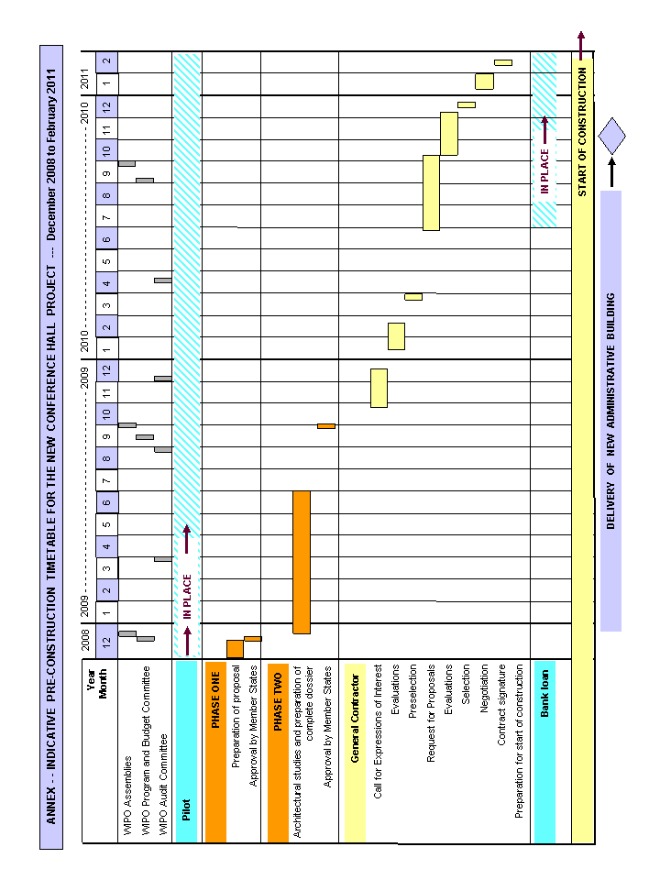
[End of Annex and of Document]

