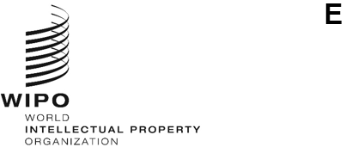
WO/GA/55/3 CORR.
ORIGINAL: English
DATE: July 8, 2022
WIPO General Assembly
Fifty-Fifth (30th Extraordinary) Session
Geneva, July 14 to 22, 2022

Report ON THE STANDING COMMITTEE ON THE LAW OF TRADEMARKS, INDUSTRIAL DESIGNS AND GEOGRAPHICAL INDICATIONS (sct)
Corrigendum
Paragraph 6 of document WO/GA/55/3 should read as follows:
“The SCT also considered a proposal by the Delegations of Colombia, Ecuador and Peru for a program for an information session on nation brands (document SCT/45/6 Rev. 2) and decided to continue the discussion on that proposal at the next session.”
[End of document]

