 |  | E
WO/GA/47/3
ORIGINAL: ENGLISH
DATE: September 4, 2015

WIPO General Assembly

Forty-Seventh (22nd Ordinary) Session
Geneva, October 5 to 14, 2015

MATTERS CONCERNING THE ADMINISTRATION OF THE GENEVA ACT OF THE LISBON AGREEMENT: PROPOSAL OF THE UNITED STATES OF AMERICA TO THE WIPO GENERAL ASSEMBLY

Document prepared by the Secretariat

1 In a communication dated September 3, 2015, a copy of which is set out in the Annex, the Delegation of the United States of America requested, amongst other, that its submission entitled “Matters Concerning the Administration of the Geneva Act of the Lisbon Agreement” be made available as a working document for discussion at the Forty-Seventh (22nd Ordinary) Session of the WIPO General Assembly.

2 The WIPO General Assembly is invited to consider the communication in the Annex to this document.

[Annex follows]

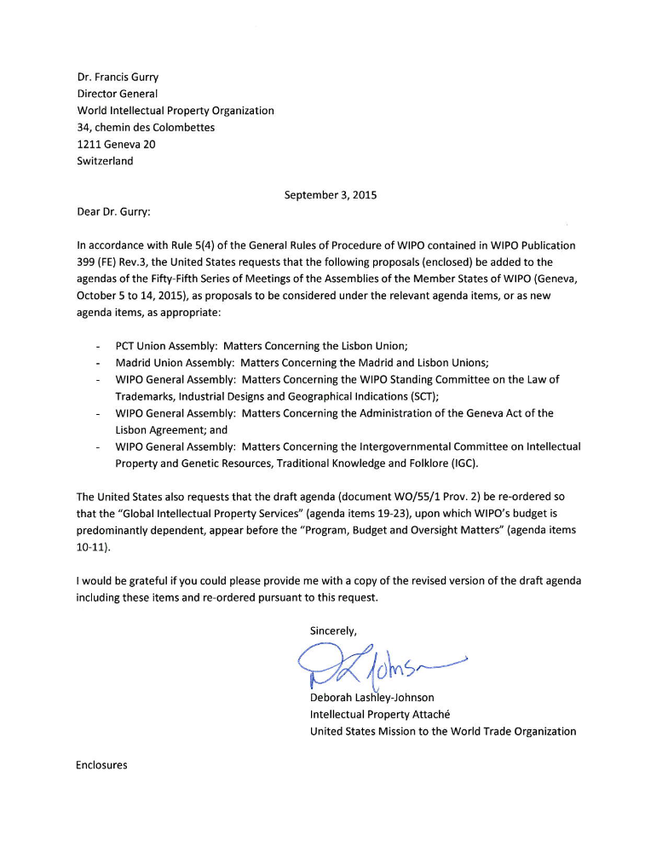

Matters Concerning the Administration of the Geneva Act of the Lisbon Agreement

Proposal of the United States of America to the WIPO General Assembly

The Contracting Parties to the Lisbon Agreement for the Protection of Appellations of Origin and their International Registration (Lisbon Agreement and the 1967 Act) concluded a new international agreement for the protection of geographical indications in May 2015. In this new agreement, the Geneva Act of the Lisbon Agreement on Appellations of Origin and Geographical Indications (Geneva
Act), Lisbon Members decided that the Lisbon Union would serve as the Union for the Geneva Act and that the World Intellectual Property Organization (WIPO or Organization) would perform its administrative functions.
The Convention Establishing the World Intellectual Property Organization (WIPO Convention) provides that the WIPO membership has the authority to decide whether to administer new international agreements. Although prior new agreements concluded under WIPO’s auspices have been
administered by the Organization without any specific decision by the relevant assemblies, the negotiations of such agreements were open to participation by all WIPO members. In contrast, the Geneva Act was open for negotiation to less than one-sixth of WIPO members (as well as two non-WIPO members) and the vast majority of WIPO members were relegated to observer status with virtually no ability to influence the final outcome.
We request that, consistent with Articles 4(iii), 6(2)(v) and 6(3)(g) of the WIPO Convention, the Director General propose measures for the implementation of the Geneva Act, so that these measures can be
fully considered by the WIPO General Assembly, the Paris Union Assembly and the Berne Union Assembly, and these bodies can decide whether to approve them.
As outlined below, the new Union that may be established by the new Geneva Act should not be considered a “Special Union” for which WIPO performs administrative tasks under Article 4(ii) of the WIPO Convention. It would be, rather, a union established under an “other international agreement” under Article 4(iii) of the WIPO Convention whose administration requires the consideration and
decision of the appropriate WIPO organs under Articles 6(2)(v) and 6(3)(g) of the WIPO Convention.
Even if any Contracting Parties to the Geneva Act may somehow affiliate themselves with the existing Lisbon “Special Union,” any WIPO administration of the Geneva Act of Lisbon, including registration services, must be approved by the broader WIPO membership.

The New Lisbon Union is not a “Special Union” Established in Relation to the Paris Union
Source identifiers such as Geographical Indications are of interest to most, if not all, members of WIPO
to identify goods or services originating in their country or region. In May of this year, a Diplomatic Conference was held at WIPO where only members of the Lisbon Union--representing a small fraction of WIPO membership--agreed upon a new international agreement for the protection of geographical indications, the Geneva Act. In a controversial decision and despite the interest of all WIPO members in the subject matter, a majority of the Lisbon Union decided to adopt rules of procedure for the
Diplomatic Conference that limited participation to Lisbon members (as well as two non-WIPO (and non-Paris Union) members). In so doing, they refused to accept a proposal to amend the rules of procedure to allow the Diplomatic Conference to be open to equal participation by all 188 WIPO members instead
of only the 28 Lisbon Members.
Following several days of negotiation, the Lisbon Union concluded negotiation and adopted the Geneva Act, without a consensus decision of the full WIPO membership. While the Diplomatic Conference has concluded and the Geneva Act adopted by the Lisbon Agreement Contracting Parties, it does not automatically follow that the Geneva Act must be administered by WIPO.
Article 4 of the WIPO Convention provides that the Organization 1) shall perform the “administrative tasks” of the established Unions (Article 4(ii)), 2) “may agree to assume…the administration of any other international agreement” (Article 4(iii)), and 3) “shall . . . , where appropriate, provide for registration in this field and the publication of data concerning the registrations” (Article 4(vii)). The WIPO Convention does not mandate that the Organization take on these functions, but leaves the decision to the
discretion of the WIPO membership. A small subset of WIPO members cannot obligate WIPO’s
resources to perform such functions without review and approval by the Organization as a whole. The Director General must propose measures for implementation that the relevant Assemblies must approve.
Article 4(ii) refers to the administrative tasks of the “Special Unions established in relation” to the Paris Union, meaning those in existence at the time of the WIPO Convention. The Union created by the Geneva Act of the Lisbon Agreement has not yet been established. Because all WIPO members were invited to negotiate the WIPO Convention, the WIPO membership as a whole was party to the decision that the already-established unions should be administered by WIPO. Any agreement concluded after the WIPO Convention does not enjoy that presumptive status, particularly one that has been negotiated by less than the entire membership of the Paris or Berne Unions where appropriate, or the entire WIPO membership, and that invited entities other than such members to join. Even if the Lisbon Union members may grant any Contracting Parties to the new Geneva Act the right to join their union (as
Article 21 of the Geneva Act purports to do), Article 4(ii) of the WIPO Convention cannot be read to override the remainder of the WIPO Convention, which gives the WIPO membership the power to
decide its administrative tasks, measures concerning the administration of international agreements, programs and budgets of the Organization, etc..
Article 4(iii) provides that the Organization may agree to take on the administration of any new agreement, but that is not mandatory either. Article 4(vii) provides that the Organization can provide registration services, “where appropriate.” Again, the language of the WIPO Convention clearly provides that these functions are not automatic and cannot be assumed by the Organization merely because one Union wishes it. Although WIPO has assumed the administration of numerous international
agreements, including “special agreements” under Article 19 of the Paris Convention and Article 20 of
the Berne Convention concluded after the 1967 WIPO Convention, no members of the WIPO membership or its competent bodies have challenged the Organization’s role in assuming their administration because, unlike the Geneva Act of the Lisbon Agreement, their negotiation was open to
all interested members of the Paris, Berne and/or WIPO Conventions.

Two Different Legal Entities With Different Members
The new Lisbon Union as established by the Geneva Act cannot be assumed to be a Special Union established in relation to the Paris Union within the meaning of WIPO Convention Article 4(ii); merely assuming the same name as the original Lisbon Union does not render it the same legal entity. First, the new Lisbon Union is expected to have different members (as new Contracting Parties may join and all existing Lisbon Agreement Contracting Parties may not) and is established by a different agreement. According to Articles 21 and 22(1)(a) of the Geneva Act, the future Contracting Parties to the Geneva Act will purportedly be part of the same Union and Assembly as the Contracting Parties to the Lisbon Agreement (i.e., the Lisbon Union and the Lisbon Assembly). However, despite sharing the same Union
and Assembly, under Article 22(4)(c), when decisions are taken on matters that only concern the Geneva Act, only the Contracting parties to the Geneva Act may take part in the decision. As a result, it is
illusory to describe them as a single Union, given that there are two different legal entities for decision making.
In addition to being two different unions as a legal matter, the Lisbon Union for the Geneva Act may include members that are not members of WIPO, such as intergovernmental organizations, and may
even include as members only members that are not Contracting Parties to the original Lisbon Agreement. The Union for the Geneva Act is not the same as the Lisbon Union for voting purposes, and could include members that are not Paris Convention members or even Lisbon Agreement Contracting Parties, demonstrating that it is not a “Special Union” established in relation to the Paris Convention.

Different Budget Structures
Further demonstrating the existence of two separate Unions are their budgets. The budgets of the
Lisbon Unions have different potential funding sources and different entities entitled to make decisions
as to the use of those sources. Article 24 of the Geneva Act provides that its Union shall have a budget derived from specific sources including registration fees, special contributions and “any alternative
source derived from the Contracting Parties or beneficiaries.” The Lisbon Agreement provides for a budget derived from these same sources, but does not provide for alternative funding sources.
During the Diplomatic Conference there was considerable discussion over the need for the Contracting Parties to the Geneva Act to create a system that will be financially self-sufficient. The point was raised that the Lisbon Agreement is not financially self-sufficient and despite a funding deficit, fees have not been raised in over twenty years. Under the terms of the Geneva Act and the Lisbon Agreement, the Contracting Parties to each — despite purportedly sharing one Union and one Assembly — could choose to take different financing routes. For example, the Geneva Act Contracting Parties could, in light of the emphasis on financial sustainability at the Diplomatic Conference, decide to set fees to help recover
costs going forward, or to collect contributions. At the same time, the Lisbon Agreement’s past deficit could be covered, as provided in the Agreement, by the Host Government of Switzerland. These disparate funding source scenarios demonstrate that for practical purposes the Lisbon Union for the Geneva Act is a different Union than the Lisbon Union for the Lisbon Agreement and 1967 Act.
Even if the Contracting Parties to the Geneva Act can be considered members of the existing Lisbon Special Union, it is illogical and legally unsupported to read the WIPO Convention as allowing a Special Union, especially one composed of a small subset of WIPO members, to unilaterally dictate the administrative tasks, including the administration of a new international agreement, that the Organization must perform. Not only does such a reading ignore the discretion granted to the Organization under Articles 4 and 6, it could result in two Unions dictating conflicting tasks, and no
Union assuming financial responsibility. Of course, Article 19 of the Paris Convention acknowledges that the countries of the Paris Union may make separate agreements for the protection of intellectual property, and there is nothing that prevents the Geneva Act from being considered such an agreement.
But WIPO cannot not be forced to administer an agreement that was concluded by a small fraction of its membership, that cannot be utilized by many members due to its inconsistency with their existing systems of protection for geographical indications, and whose administration the full membership of WIPO, the Paris Union and Berne Union may not wish to financially support.

Implementation Measures with Respect to Administration of the Agreement
Pursuant to Article 4(iii) of the WIPO Convention, the Organization “may agree to assume, or participate in, the administration of any other international agreement designed to promote the protection of intellectual property” after measures proposed by the Director General are approved by the WIPO General Assembly, the Paris Union Assembly and the Berne Union Assembly. We request that the Director General consider the nature of the Geneva Act and the financial situation of the Lisbon Agreement (as reflected in the Lisbon Union’s budget and as discussed in WO/PBC/24/16), and propose measures to allow consideration by the appropriate Assemblies as to whether the Geneva Act should be administered by the Organization.
The Lisbon Union has been operating at a financial deficit for many years, if not from its inception. In addition to accumulating a deficit regarding its own direct expenses, the Lisbon Union has not been contributing, or has been contributing very little, to expenses common to the unions or to the work of
the Organization, unrelated to the registration systems (such as to support the Committee on Development and Intellectual Property). Unlike the Patent Cooperation Treaty (PCT) Union, Contracting Parties to the Lisbon Agreement have neither been assessed nor paid contributions to fund the Lisbon system, nor contributed toward the Organization’s indirect “common expenses.” In deciding to forgo
the advice of the Coordination Committee in 2014, Members of the Lisbon Assembly specifically argued that its actions were of no interest to other unions. But the financial self-sufficiency of the registration systems is of interest to the other Unions and the Organization as a whole, and therefore it is important
for the General Assembly to provide oversight as to any potential future administration of the Geneva
Act by the Organization.
Finally, regardless of the decision as to administration of the Geneva Act generally, the Organization is
not required to perform registration services for the Act. Even assuming that the Lisbon Union established by the Geneva Act is a Special Union, Article 4 of the WIPO Convention and its negotiating history make clear that there is a difference between Article 4(ii)’s “administrative tasks” and Article 4(vii)’s provision of registration services. Article 4(vii) is modified by the phrase “where appropriate,” which demonstrates that the Organization need not always provide the relevant registration services; instead, a decision must be made as to whether such services are appropriate. The inability of the Organization to recover the costs of operating the system should be considered as a basis for
determining that they are not appropriate. We believe, however, that this is a decision to be made by
the General Assembly, Paris Union Assembly and Berne Union Assembly as part of any decision about
the Organization’s administration of the Geneva Act.

Conclusion
We suggest, pursuant to his authority under the WIPO Convention, that the Director General propose measures for the implementation of the Geneva Act, so that these measures can be fully considered by the WIPO General Assembly, the Paris Union Assembly and the Berne Union Assembly and these bodies can decide whether to approve them. Pursuant to the WIPO Convention, the Organization is under no obligation to perform administrative tasks or to provide registration services for the new Lisbon Union. Instead, because the Geneva Act is an “other international agreement” under the terms of the WIPO Convention, WIPO’s administration of the new Act requires consideration of and approval by the appropriate WIPO organs.

The General Assembly is invited to request that the Director General propose appropriate measures concerning the administration of the international agreement referred to above for full consideration by the WIPO General Assembly and the Assemblies of the Paris and Berne Unions so that they may
decide whether to approve them.

[End of Annex and of document]

Article 4 of the WIPO Convention reads, in part: “In order to attain the objectives described in Article 3, the Organization, through its appropriate organs, and subject to the competence of each of the Unions… (ii) shall perform the administrative tasks of the Paris Union, the Special Unions established in relation with that Union, and the Berne Union; (iii) may agree to assume, or participate in, the administration of any other international agreement designed to promote the protection of intellectual property;…(vii) shall . . . , where appropriate, provide for registration in this field and the publication of data concerning the registrations . . . .” Article 6(2)(v) directs that the General Assembly shall “approve the measures proposed by the Director General concerning the administration of the international agreements referred to in Article 4(iii).” Article 6(3)(e) provides that such approval “shall require a majority of three-fourths of the votes cast.” Finally, Article 6(3)(g) provides that “the required majority must be attained not only in the General Assembly but also in the Assembly of the Paris Union and the Assembly of the Berne Union.”
LI/DC/2.
LI/DC/9.
LI/DC/2, Rules 1, 2 and 34 provide that adoption of the New Act and the Regulations shall be by the Conference (which includes the observers) normally by consensus. At the beginning of the Diplomatic Conference, observer delegations were given an opportunity to voice their concerns regarding the Rules of Procedure and, in Main Committee 2, certain articles, and to block consensus, but the process at the end of the Diplomatic Conference was significantly less inclusive.
WIPO does not automatically administer all “special agreements” established by members of the Paris Convention under the terms of Paris Convention Article 19. See Guide to the Application of the Paris Convention for the Protection of Industrial Property as Revised at Stockholm in 1967, George H.C. Bodenhausen, page 170-72.
WIPO Convention Article 6(2)(v).
Records of the Intellectual Property Conference of Stockholm (1967), Volume II, p. 1225, para 20 states in part: “Furthermore, the Organization is to carry out various administrative tasks. It performs the administrative tasks of the existing Unions (Article 4(ii)) and, if so requested by competent bodies, it may agree to assume, either alone or in cooperation with other international organizations, the administration required for the implementation of any other treaty, convention or agreement in the field of intellectual property (Article 4(iii)).” (emphasis added)
See full list of 26 WIPO-Administered Treaties at: www.wipo.int/treaties/en/.
WIPO Coordination Committee, Seventieth (45th Ordinary) Session, Geneva, September 22 to 30, 2014, REPORT, (WO/CC/70/5), see paragraphs 42-65, including the intervention from the delegation of the Czech Republic on behalf of CEBS group: “The members of the Lisbon Union Assembly considered Article 9(2)(b) of the Lisbon Agreement as not applicable, since the decision was not a matter of interest to other Unions administered by the Organization.” (para 58) and “The Delegation of Hungary supported the statements made by the Delegations of France and Italy and took note of the proposal by the Delegation of the United States of America for a supplementary agenda item. Nevertheless, the Delegation clarified that the inclusion of such agenda item did not in any way imply that the Delegation of Hungary could agree with the necessity for the Coordination Committee to provide advice on the matter, as its view was quite the opposite. The Delegation recalled that the Lisbon Union Assembly had taken a valid decision to convene a diplomatic conference in 2015. At the time of the adoption of such decision the members of the Lisbon Union, including the Delegation of Hungary, had taken the view that the interests of the other Unions administered by WIPO would not be affected and that by way of consequence Article 9(2)(b) of the Lisbon Agreement would not be applicable and that the advice of the Coordination Committee would not be required.” (para 46). Accessed at http://www.wipo.int/edocs/mdocs/govbody/en/wo_cc_70/wo_cc_70_5.pdf
See Intellectual Property conference of Stockholm, 1967, Convention Establishing the International Intellectual Property Organization, Proposals for Establishing the Organization, (S/10, September 16, 1966), Commentary on Article 3: Objective and Functions, paragraph 42.

