 |  | E
WO/GA/41/9
ORIGINAL: ENGLISH
DATE: August 1, 2012

Assemblies of the Member States of WIPO

Fiftieth Series of Meetings
Geneva, October 1 to 9, 2012

Summary Annual Report of the Director of the Internal Audit and Oversight Division

prepared by the Secretariat

- This document presents the Summary Annual Report of the Director of the Internal Audit and Oversight Division (IAOD).
- The WIPO General Assembly is invited to take note of the Summary Annual Report of the Director of the Internal Audit and Oversight Division.

[Summary Annual Report by Director, IAOD follows]

TABLE OF CONTENT

ACRONYMS 2

SUMMARY ANNUAL REPORT OF THE DIRECTOR OF THE INTERNAL AUDIT AND OVERSIGHT DIVISION 3

1. BACKGROUND 3

2. PLANNING, STANDARDS AND NORMS 3

3. SIGNIFICANT INTERNAL OVERSIGHT FINDINGS AND RECOMMENDATIONS 4

A. Programme and Project Management 4
B. Human Resources Management 5
C. IT Management 6

4. INVESTIGATIONS IN THE REPORTING PERIOD/INVESTIGATION ISSUES 6

5. STATUS OF IMPLEMENTATION OF PREVIOUS RECOMMENDATIONS 8

6. OTHER OVERSIGHT WORK 10

A. Audit and Control Advice 10
B. The Independent Advisory and Oversight Committee 10
C. Client Satisfaction Survey 11
D. The External Auditor 11
E. The Ombudsman and the Ethics Office 11
F. UN Networking 11
G. Oversight Document Management 12
H. Evaluation Seminar 12

7. OVERSIGHT RESOURCES 12

A. Budget and Staff 12
B. Training 13

ANNEXES

ANNEX I – List of IAOD Reports
ANNEX II – Investigation Statistics
ANNEX III – List of IAOD Recommendations Closed without Implementation

ACRONYMS
CPE Country Portfolio Evaluation
ERM Enterprise Risk Management
ERP Enterprise Resource Planning
FAFA Financial Administrative Framework Agreement with the European Union
FAO Food and Agricultural Organization
HR Human Resources
HRMD Human Resources Management Department
IAOC Independent Advisory Oversight Committee
IAOD Internal Audit and Oversight Division
ICTD Information and Communication Technology Department
IFAD International Fund for Agriculture and Development
IIA Institute of Internal Auditors
ILO International Labor Organization
ILOAT ILO Administrative Tribunal
IOC Internal Oversight Charter
IPSAS International Public Sector Accounting Standards
IT Information Technology
JIU UN Joint Inspection Unit
MIS Management Information System
OIOS Office of Internal Oversight Services
OLC Office of the Legal Counsel
PCT Patent Cooperation Treaty
PMSDS Performance Management and Staff Development System
PTD Procurement and Travel Division
RF Results Framework
RIAS Representatives of Internal Audit Services
SMT Senior Management Team
UN United Nations
UNEG UN Evaluation Group
WFP World Food Programme

SUMMARY ANNUAL REPORT OF THE DIRECTOR
OF THE INTERNAL AUDIT AND OVERSIGHT DIVISION

July 1, 2011 to June 30, 2012

BACKGROUND

- The purpose of WIPO’s Internal Audit and Oversight Division (IAOD) is to provide independent and effective internal oversight for WIPO, in accordance with the provisions set out by the Member States in the Internal Oversight Charter (IOC).
- The WIPO IOC, paragraph 25, requires the Director of IAOD to present a Summary Annual Report to the Director General, with a copy to the External Auditor and the Independent Advisory Oversight Committee (IAOC), of activities undertaken, including orientation and scope of such activities, the schedule of work undertaken and the progress on the implementation of prioritized recommendations. This Summary Report is also presented to the General Assembly and enables our major stakeholders and WIPO staff generally to be informed of IAOD reports, activities, and the challenges faced by IAOD in fulfilling its mandate. IAOD also makes a presentation on its activities (IOC, paragraph 24) to formal sessions of the Program and Budget Committee (PBC).

PLANNING, STANDARDS AND NORMS
- The activities of IAOD include internal audit and evaluation, as well as monitoring and assessing the adequacy and effectiveness of WIPO’s control environment, and effective and efficient use of resources. IAOD also investigates allegations involving waste, fraud and mismanagement, or other breaches in WIPO rules and regulations.
- IAOD adheres to the International Professional Practices Framework (IPPF) promulgated by the Institute of Internal Auditors (IIA). The IPPF includes the Code of Ethics, the International Standards for the Professional Practice of Internal Auditing, Practice Advisories, Position Papers and Practice Guides. The IIA Standards provide principle-focused, mandatory requirements for the conduct of internal auditing at both the organizational and individual auditor levels. Other guidelines, such as those promulgated by the Information Systems Audit and Control Association (ISACA), are utilized in connection with Information Technology (IT) audits. Similarly, in conducting investigatory work, IAOD is guided by the Uniform Guidelines for Investigations endorsed by the Conference of International Investigators in 2009. Evaluation is guided by international standards in evaluation practice as set out by the United Nations Evaluation Group (UNEG).
- In accordance with the WIPO IOC, IAOD developed its work plan in line with current best practices, using a multi-dimensional planning process involving a risk assessment exercise that encompasses WIPO’s operational entities and relevant cross-cutting focus areas. The risk assessment has been used to determine the level of risk-based audit coverage necessary for the 2012/2013 biennium and matched the audit needs with available internal audit resources
with a view to providing reasonable assurance on the effectiveness, efficiency and integrity of WIPO’s governance, risk management and control processes and systems. IAOD also based its work plan on consultations with key stakeholders.
- IAOD planned for a series of country, thematic and program evaluations based on various criteria, such as the WIPO activity level, result of the WIPO investment as well as the number of duty travel to each country or training events organized; the “International Context”, using Economic Development level, Security, number of Treaties signed and the presence of a national IP strategy as criteria; the “National IP Relevance”, identified by numbers of applications for patents/utility models, trademarks and industrial designs; and “WIPO administered Treaties”, where PCT, Madrid and The Hague System Applications were used. In addition to this, focus was given to countries in which Development Agenda (DA) projects are being implemented.
- The criteria for selecting thematic Evaluations were to select those cross-cutting themes which were relevant to the greatest number of programs and for which the largest number of activities and largest budgets were recorded. In selecting which programs to evaluate, IAOD assessed the different “operational” programs (1-18), in particular their mentioning by Member States, their potentials for generating lessons, ownership, replication, innovation, and their evaluability in terms of quality of the performance framework/indicators.
- Finally, IAOD makes all efforts for investigations to be completed in a timely manner to a high level of quality. The priority has been to deal with the backlog from the past – see below. Once new incoming cases are dealt with as well, IAOD will try to act in more proactive areas and implement fraud prevention work.

SIGNIFICANT INTERNAL OVERSIGHT FINDINGS AND RECOMMENDATIONS
- IAOD reported findings in the following major areas: Program and Project Management, Results-Based Management (RBM), Human Resources (HR) Management and Information, Communications and Technology (ICT) Management. In accordance with paragraph 26(a) and (b) of the IOC, the following comments reflect the results of the oversight work done during the period. IAOD acknowledges that management has already taken action on the issues identified.

Programme and Project Management
- Through its review of WIPO activities in one country, two DA projects and the validation of the Program Performance Report (PPR), IAOD could identify good practices and make some recommendations for improvement in program and project management.
- From its evaluations, IAOD could conclude that WIPO’s support was relevant to the need of its beneficiaries and effective in achieving the expected results. WIPO could make more use of specific, measurable, achievable, relevant and time-bound (SMART) performance and outcome indicators to measure the effects of projects including at the level of beneficiaries. When it was possible to measure, IAOD found that sustainability could be enhanced by developing government-supported strategies (including for exit). More attention should be given on strengthening synergies within and outside WIPO. This should include strengthening the role of the Regional Bureaus in the projects and coordinating better with the UN Agencies in the
host countries. WIPO could put more efforts on monitoring, evaluating, and reporting on the results of funded activities. Generally, the project delivery strategies would need to be modified to make project implementation more efficient and needs or demand driven.
- Through its independent validation of the PPR for the 2010/2011 biennium, IAOD identified significant strengths such as timeliness of reporting on the individual PPRs and efficiently collected and easily accessible Performance Data (PD). Some limitations observed were partial relevance and lack of sufficiency and comprehensiveness of PD and the results framework was primarily used for reporting on performance rather than for management and learning. The changes in the 2010/2011 PPR with regard to the previous biennium have led to improved expected results, Performance Indicators (PI) and sensible baselines and targets. Although, ownership levels for PIs have improved, information used for reporting during the 2010/2011 biennium was not being produced on a regular basis, such as quarterly, to track progress.
- A comparison between two biennia has been established (see graphic below).
Chart 1 – Performance indicators meeting criteria (2010/11 vs. 2008/09)
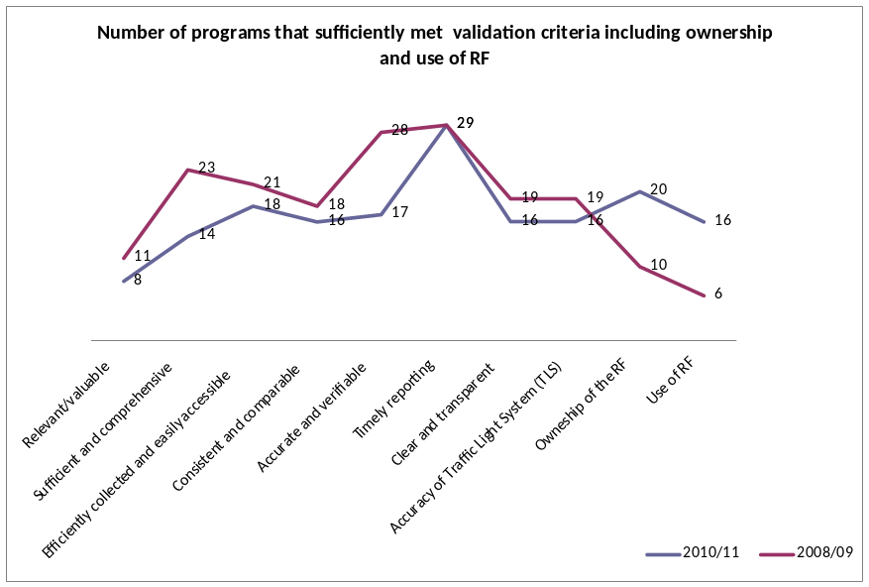

Human Resources Management
- The audit of HR management identified opportunities to strengthen the control environment and better align WIPO HR practices with UN best practices. Implementation of recommendations will help WIPO to have a well-managed and appropriately skilled staff, working within a robust and enabling regulatory framework, supported by clear policies, efficient procedures and modern systems. In this regard, a formal HR Management Strategy, fully aligned with WIPO’s strategic goals, objectives and plans, needs to be developed expeditiously to ensure that human resources at WIPO serve the Organization to achieve its mandate.
- Well defined policies in post and talent management will enable WIPO to acquire and retain competence within the Organization and ensure that staff skills and expertise best match the needs of the Organizational units where they are most required. This will also help mitigate the impact of engaging a high number of employees on short term contracts.
- The review of statistics of the internal justice system and of the International Labour Organization Administrative Tribunal (ILOAT) showed that a cause-effect analysis of all internal litigation cases and ILOAT decisions should be undertaken with a view to improving the internal justice system. This will also necessitate the revision, as necessary, and the consistent implementation of HR policy and procedures especially in the areas of recruitment, reclassification, career development and resolution of disagreements.
- The Organization should also do a root cause analysis of staff absenteeism. The estimated costs of absenteeism increased, from CHF 20 million in 2008/2009 biennium to CHF 22 million in 2010/2011 biennium.
- Also, supervisory and technical controls to the FlexiTime system and keeping proper documentary records of staff separation will further enhance the control environment and improve the efficiency of operations.
- The Performance Management and Staff Development System (PMSDS) and its refinement needs to be closely monitored to ensure that this crucial change management project achieves its objectives by improving accountability at all levels, staff motivation and overall performance within the Organization. In this regard, the training budget which has been provided additional resources subsequent to the audit report needs to be further enhanced to meet Organization-wide training needs identified through the PMSDS.

IT Management
- In line with the formal request of the WIPO IAOC, a follow up of recommendations IAOD had made in previous audits on Information Technology Security and Access Controls was carried out. The audit identified very high residual risks relating to lack of encryption of unpublished PCT information prior to copying the information to backup tapes and storage of the backup tapes in an off-site location. Controls over physical computer room access and related logging and monitoring of users with administrator privileges were also identified as areas requiring significant improvements.
- Further, IAOD identified high residual risks in the areas of governance of information risk management, business continuity planning, information system strategy, security policy and procedures, IT governance and Configuration Management.
- The audit of Software Management found that controls require further strengthening in the area of software license management and security over WIPO’s software license keys.

INVESTIGATIONS IN THE REPORTING PERIOD/INVESTIGATION ISSUES
- Eighteen new cases were received or initiated in the reporting period (as compared with 14 received in the previous period). Sixteen cases were closed in the period (as compared to 27 cases previously). Fifteen cases are currently being processed by IAOD, of which five are active investigations (of which two are “closure pending”) and ten are complaints received undergoing preliminary review.
Table 1 – Investigation cases summary
Active cases and complaints  on July 1, 2011 | New complaints registered | Investigation actions completed | Active cases and complaints  as at June 30, 2012
13 | 18 | 16 | 15

- Tables and charts in Annex II provide statistical information on complaint and investigation cases. Since 2008, IAOD registered a total of 85 investigation complaints, with 70 of these cases now closed. On average since 2008, harassment, IT security violations, defamation and recruitment represent 60 per cent of all complaints received. During the recent reporting period, there were three cases of harassment, three cases of information leak, two cases related to medical claim and one case in each of the following categories: misconduct by having two jobs, recruitment, travel claim, defamation and change of date birth and nationality. Most complaints were filed by staff members (52 per cent) or management representatives (26 per cent).
- The investigations undertaken during the period had led to some satisfactory outcomes and also to some general lessons to be learnt. It is noted that although a number of significant investigations remained, it was likely that the outcome of these would have a positive impact upon a number of areas where abuse appeared to be prevalent.
- The outcome of the closed cases in the reporting period is as follows in Table 2 below:
Table 2 – Outcome of closed cases in 2011-2012
Outcome | Count
Allegation not substantiated | 6
Allegation substantiated | 6
Allegation substantiated but staff member retired | 1
Preliminary Evaluation determined no investigation required | 3
Total | 16

- Of the seven cases during the reporting period where allegations were substantiated through investigation, four staff members received charge letters approved by the Director General, one staff member had retired and therefore was not charged, one staff member resigned and one case is currently under consideration for charging. Of the four staff members who received charge letters, all have been subject to disciplinary action. Their cases currently remain to proceed fully through the internal administration of justice system.
- For cases registered in 2011-2012, the average elapsed time for completion of an investigation case from recording to reporting was some seven months.
- An Investigation Policy has been pending since August 2010 for review and comments. The Policy was considered by the IAOC at their 24th meeting in March 2012. Following completion of future internal consultations, the Policy together with an update of the Investigation Procedure Manual will be provided for consultation to the Member States, as required by paragraph 13(b) of the IOC.
- In accordance with paragraph 26(g) of the IOC, I report that no staff member has refused to assist in an ongoing investigation during the reporting period.

STATUS OF IMPLEMENTATION OF PREVIOUS RECOMMENDATIONS
- The Director General is responsible for ensuring that all recommendations made by the Director, IAOD and other oversight entities are responded to promptly, indicating actions taken regarding specific report findings and recommendations. The Director General discharges this responsibility through his Program Managers responsible for the specific operational areas within the Organization. The implementation of all oversight recommendations by WIPO Managers is subject to regular follow-up by IAOD.
Table 3 – Open recommendation by source
Source | July 1, 2011 |  |  | June 30, 2012
Oversight Recommendations from: | Open Recommendations | Recommendations added in the period | Recommendations Recorded as Implemented in the period | Recommendations in-progress
External audit | 7 | 13 | 8 | 12
Joint Inspection Unit | 2 | 0 | 1 | 1
Internal Audit and Evaluation | 128 | 72 | 82 | 118
Ernst & Young | 1 | 0 | 1 | 0
Audit Committee | 25 | 0 | 16 | 9
Totals | 163 | 85 | 108 | 140

- IAOD also follows up on its own recommendations in three ways:
  - At the start of each new audit, a review of the implementation of related earlier recommendations is undertaken;
  - Through the updating, with information from the responsible Managers, of the listing of Implementation of Oversight Recommendations spreadsheet and its submission to the Director General and the IAOC for review; and
  - As a specific annual exercise to keep the Director General informed on the progress of implementation activities by WIPO Managers. In respect to this, the Director General has requested the Senior Management Team (SMT) to take more effort in implementing accepted oversight recommendations as quickly and expediently as practical.
- The IAOC reviews the list of oversight recommendations at every other of their regular meetings. During the reporting period, IAOD conducted at the request of the IAOC, two verification audits of IAOC High Risk Recommendations and of Information Technology and Security Related Recommendations made in previous IAOD reports.
- At the date of the present report, there are 140 recommendations now recorded as open by Program Managers which include 90 that address very high-risk (six) and high-risk (84) issues. The six very high risk recommendations relate primarily to information technology issues identified in audits of Flexitime System and Employee Access Controls to WIPO’s Premises (2011) and Verification of IAOD’s Information Technology and Security Related Audit Recommendations (2011). Nineteen (or 22 per cent) of the high risk recommendations have been open for more than two years.
Chart 2 - Oversight Recommendations Implementation progress - July 1, 2011, to June 30, 2012
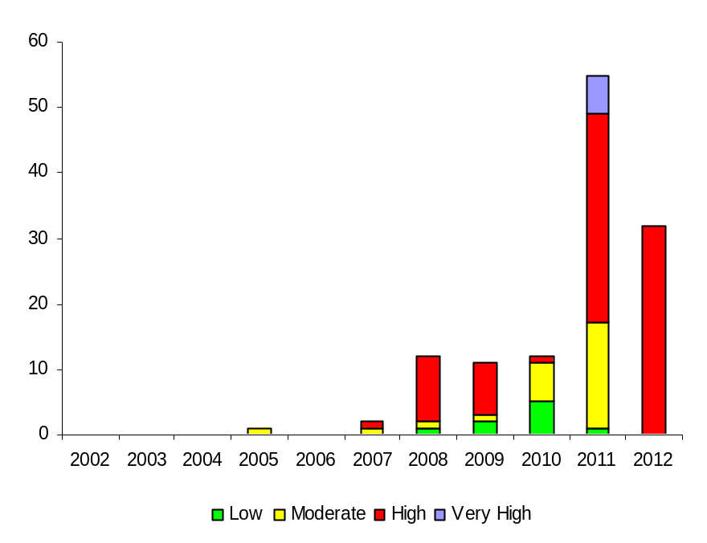

- Of the 84 high risk recommendations, 31 relate to HR, 17 relate to IT, 11 relate to the WIPO Academy, nine are DA related, six relate to Procurement, five relate to Finance, and the remaining five relate to Ethics, Legal, Performance Measurement and Segregating PCT Duties.
Chart 3 - Open recommendations by category
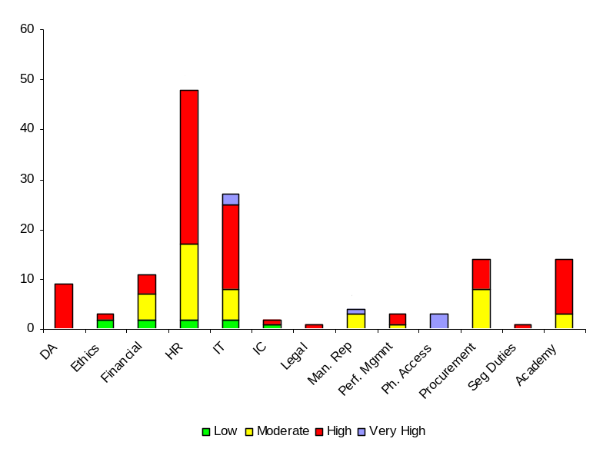

- The recommendations of the External Auditor have continued to be progressively implemented during the period, and only 12 remain outstanding. As required by the IOC paragraph 23, a report was provided to the Director General regarding the implementation of recommendations made by the External Auditor and this has been copied to the External Auditor and the IAOC.
- In accordance with paragraph 26(c) of the IOC this summary annual report must provide “a description of all recommendations which were not approved by the Director General, together with his reasons for not doing so”. Annex III provides a list of six recommendations closed during the reporting period without implementation together with the reasons for not implementing them.

OTHER OVERSIGHT WORK

Audit and Control Advice
- In addition to its normal oversight work, IAOD provides advice in two forms. First, by participating as observer in various committees (the Investment Committee, the implementation of IPSAS and of an integrated Enterprise Resource Planning (ERP) System project team and the Procurement evaluation Panel for the training on ethics). Second, by providing advice as requested on policy documents or the regulatory framework. This happened in the following cases:
  - SMT discussions on the consequences of the financial administrative framework agreement (FAFA) with the European Union;
  - Business process flowcharts and risk registers prepared by Finance Services;
  - Document for the PBC on Long-Term Financing of After-Service Health Insurance in WIPO;
  - Draft Code of Conduct for Managing Supplier Relationships;
  - Draft Whistleblower protection policy;
  - Draft Financial disclosure policy;
  - Draft policy on preventing and deterring corruption, fraud, corruption, collusion, coercion, money laundering and the financing of terrorism; and
  - The Memorandum of Understanding (MoU) between WIPO and the United States Patent and Trademark Office (USPTO).

The Independent Advisory and Oversight Committee
- IAOD has been regularly invited by the IAOC to attend its quarterly meetings in order to answer detailed questions concerning the work and functioning of the Division. The 22nd through 25th meetings of the IAOC took place in the period covered by this report.
- All recommendations made by the IAOC concerning IAOD, as described in Annex VI of last year’s IAOD report (document WO/GA/40/4), have been implemented.

Client Satisfaction Survey
- To better understand expectations from colleagues and get their feedback on oversight work, IAOD began using client satisfaction surveys. Such surveys should allow IAOD to better identify areas for improvement of its own work.
- Since the beginning of 2012, four surveys were sent after the audit on Software Management and HR, the evaluation of the start-up Academies project, the evaluation of Technology and Innovation Support Centers (TISCs) and the pilot country portfolio evaluation. On average the work was rated as 76 per cent satisfactory. The best average score was in assessing if “an adequate level of communication was maintained throughout the audit/evaluation, significant issues were promptly brought to management attention in briefings, debriefings and/or validation events.” The worst average mark was obtained while assessing if “the complete audit/evaluation took a reasonable length of time, from notification of audit/evaluation to issuance of final report.”
- The additional comments sent by the audited/evaluated units show there is room for IAOD to improve on consultant selection and management, report writing and strict adherence to the scope of the assignment. IAOD will work to correct these identified shortcomings.

The External Auditor
- The excellent professional and working cooperation and coordination established with the External Auditor has continued with regular information sharing meetings on audit, internal control and risk management issues. The External Auditor is sent all Oversight reports and a copy of IAOD’s oversight work plan and strategy with a view to ensuring efficient oversight coverage and avoiding any potential unnecessary duplication.

The Ombudsman and the Ethics Office
- During the reporting period, the Director, IAOD met regularly with the Ombudsman and the Ethics Office, as required by the IOC paragraph 8, to ensure good liaison and avoid any unnecessary duplication of activities. The exchange of views and discussions has been very helpful and useful in ensuring that the separate and independent mandates of IAOD, the Ombudsman and the Ethics Office are carried out effectively.

UN Networking
- The IOC (paragraph 13(f)) makes specific provision for the need for participation in various formal networks of the UN for oversight functions. During the period under review, IAOD continued its active and useful collaboration and networking with other UN organizations and entities. In particular IAOD actively participated in:
  - The 41st Annual Meeting of Representatives of Internal Audit Services (RIAS) of the UN, in September 2011. IAOD is member of the RIAS Working Group on performance audit and evaluation;
  - The annual meeting of Head of internal audit services of European based international organizations (HOIA) hosted by the International Committee of the Red Cross in May 2012 at Versoix;
  - The annual United Nations Evaluation Group (UNEG) meeting in May 2012, co-hosted by the Food and Agriculture Organization (FAO), the World Food Programme (WFP) and the International Fund for Agricultural Development (IFAD) in Rome. IAOD is a member of the UNEG Task Forces on Standards and Norms and on the Evaluation of Normative Work;
  - The inter-agency forum for UN investigators – the Conference for Internal Investigators; and
  - Joint training activities with other UN organizations based in Geneva.

Oversight Document Management
- In September 2011, IAOD acquired the state-of-the-art audit software package, TeamMate. The software has now been deployed and it will provide IAOD staff members with comprehensive working instruments to assist them in the conduct of their oversight responsibilities. This tool will also facilitate full compliance with standards in preparation for IAOD’s next quality assurance review in 2014.

Evaluation Seminar
- In order to strike the balance between the two evaluation aims of learning and accountability, IAOD successfully organized in November 2011 an Evaluation Seminar on “Learning from Existing Evaluation Practices on the Impacts and Effects of Intellectual Property on Development”. The main objectives were to share good practices in evaluation of the impacts of Intellectual Property on development which still is a very specialized field of work. The aim of the workshop was to allow for some focused learning about the successes and weaknesses of this type of evaluation. An additional objective of the seminar was also to allow exchanges between IP and evaluation experts with the view to broaden the expertise in that particular field of work. The seminar met its objectives as confirmed by participants through the returned evaluation sheets.
- In November 2012, IAOD will organize a seminar to further raise awareness of the WIPO Evaluation Function and advocate for good evaluation practices and their usefulness for management and decision-making.

OVERSIGHT RESOURCES
- The IOC (paragraph 27) specifically requires the Director, IAOD to comment on the adequacy of resources allocated to internal oversight within the Organization.

Budget and Staff
- Compared with the previous biennium IAOD staff numbers remain stable and non-staff resources increased by 11 per cent. Staffing issues had challenged the proper and effective introduction of internal oversight at WIPO for a considerable period of time. IAOD now has 11 staff for 2012 and 2013. While IAOD budget and staff represent only 1.6 per cent and
0.9 per cent of WIPO budget and staff, this puts WIPO ostensibly in the average of other UN organizations. Reallocation of staff from one function to another can allow managing between different priorities.
- The major concern should now be to move from a structure with short-term consultants serving on the workforce to a structure with a majority of fixed term posts. This will help move IAOD closer to UN norms for internal oversight activities. IAOD has not yet reached a level of sufficient staffing through creation of approved budget posts to ensure the effective and independent functioning of any of the internal oversight functions which would enable IAOD to successfully and fully carry out its mandate.

Table 4- 2010/11 IAOD Budget after transfers
Approved Budget |  |  | Expenditure | Expenditure and Commitment |  | Balance as percentage of budget
Personnel Resources | Non-Personnel Resources | Total | Personnel Resources | Non-Personnel Resources | Total | Personnel Resources | Non-Personnel Resources | Total
2,586 | 778 | 3,364 | 2,586 | 746 | 3,332 | 0% | 4% | 0.99%

- During the reporting period, use was made of contracted experts for various oversight activities. This was particularly valuable for work related to evaluations and investigations. It is planned to continue to engage experts and contractors in the next years in order for IAOD to be able to compensate somewhat for the lack of staffing resources and broaden the expertise in the fields of evaluation and investigation.

Training
- Essential for the continued professional development, and in accordance with its training policy, IAOD ensures that each IAOD staff member possesses and improves knowledge, skills and other competencies needed to perform their individual responsibilities, with a view to continuously improving the quality of oversight work undertaken. IAOD staff members were trained during the reporting period on time management, DL 101, Performance Audit organized by ILO, Principles of Fraud Examination and Advanced Fraud Examination Techniques. New staff attended WIPO’s induction training and language classes. IAOD supports continuous professional development and encourages its staff to obtain recognized professional qualifications (certified internal auditor (CIA), certified information system auditor (CISA), certified fraud examiner (CFE) etc.), in line with the strategy of the Division.
- Arrangements have been made for a teambuilding exercise in October 2012. With the assistance of the HRMD, this exercise should increase open communication and cooperation within the team, enhance sharing of information and tools and methods, build relationships within the group, develop greater understanding of self and others and develop understanding of the roles, expertise and responsibilities between team members.

[Annexes follow]

List of IAOD Reports
July 1, 2011 to June 30, 2012

- Review of HR Management – IA/06/2011
- Review of Software Asset Management IA/07/2011
- Verification of Implementation of Independent
Advisory Oversight Committee High Risk Recommendations IA/08/2011
- Verification of IAOD’s Information Technology
and Security Related Audit Recommendations IA/09/2011
- Pilot Country Portfolio Evaluation: WIPO Kenya EVAL 2011-01
- Technology and Innovation Support Centers (TISCs) EVAL 2012-01
- Startup National Intellectual Property Academies EVAL 2012-02
- Validation of Programme Performance Report 2010-2011 IA/EVAL 2012-01
- 18 investigation cases evaluated or formally opened.

[Annex II follows]
INVESTIGATION STATISTICS

- As at the end of the reporting period and from March 2008 (when the Investigation Section was established) to date, IAOD registered a total of 85 investigation complaints, with 70 of these cases now closed.
Chart 4 – Investigation cases per year up to June 30, 2012
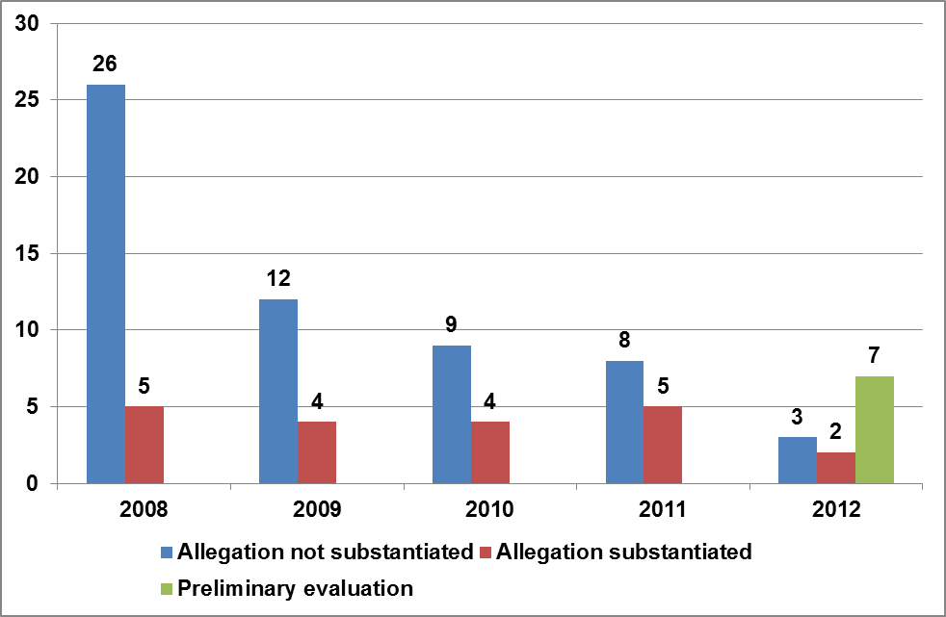
- The table below gives an indication of the type of complaints per year.
Table 5 – Investigation type per year
Complaint type | 2008 | 2009 | 2010 | 2011 | 2012 | Grand Total
Asset loss | 0% | 6% | 0% | 0% | 0% | 1%
Confidential information Leak | 0% | 6% | 0% | 8% | 25% | 6%
Defamation | 10% | 19% | 15% | 15% | 8% | 13%
Fraud - Cell abuse | 0% | 0% | 0% | 8% | 0% | 1%
Fraud - Change of date of birth | 0% | 0% | 0% | 8% | 0% | 1%
Fraud - Change of date of birth - change of nationality | 0% | 0% | 0% | 0% | 8% | 1%
Fraud - Education Grants | 0% | 6% | 0% | 0% | 0% | 1%
Fraud - Extortion | 0% | 0% | 0% | 23% | 0% | 4%
Fraud - medical | 0% | 0% | 0% | 8% | 8% | 2%
Fraud - medical & education grant | 0% | 0% | 8% | 0% | 0% | 1%
Fraud - Travel | 0% | 6% | 0% | 8% | 8% | 4%
Harassment | 32% | 0% | 15% | 0% | 25% | 18%
IT Content Irregularities | 0% | 0% | 15% | 0% | 0% | 2%
IT Security Violations | 29% | 31% | 8% | 0% | 0% | 18%
Misc - Civil Debt | 3% | 0% | 0% | 0% | 0% | 1%
Misc - Contract Fraud | 3% | 0% | 0% | 8% | 0% | 2%
Misc - money exchanges on WIPO premises | 3% | 0% | 0% | 0% | 0% | 1%
Misconduct - Having two jobs | 0% | 0% | 0% | 0% | 8% | 1%
Recruitment | 10% | 13% | 15% | 15% | 8% | 12%
Violation of SRSR | 6% | 0% | 8% | 0% | 0% | 4%
Fraud - Flexitime | 3% | 13% | 15% | 0% | 0% | 6%
Grand Total | 100% | 100% | 100% | 100% | 100% | 100%

- As can be seen below, the largest group to initiate investigations dealt with by IAOD is WIPO staff members. Most complaints from staff have not been substantiated. However, several complaints from whistleblowers have led to full investigations and recommendations to the Director General for consideration of disciplinary actions.
Chart 4 – Source of complaints up to June 30, 2012
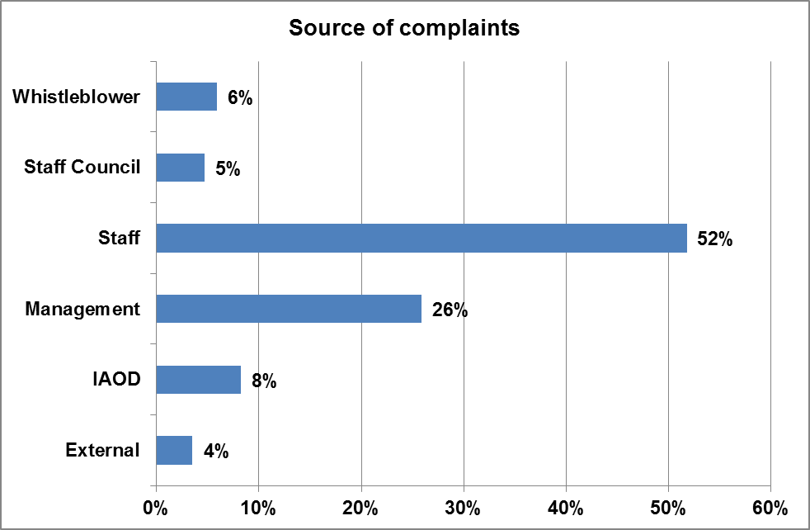

- In terms of the 70 cases which have been closed overall out of the 85 registered, the outcome of the closed cases can be seen in the table below:
Table 6 - Outcome of closed investigations
Outcome | Count
Administrative resolution | 2
Allegation not substantiated | 35
Allegation substantiated | 17
Complaint falls outside IAOD mandate | 1
Complaint withdrawn | 2
Non compliance with good practice but no misconduct | 1
Preliminary Evaluation determined no investigation required | 12
Total | 70

Chart 6 Evolution throughout years of types of fraud
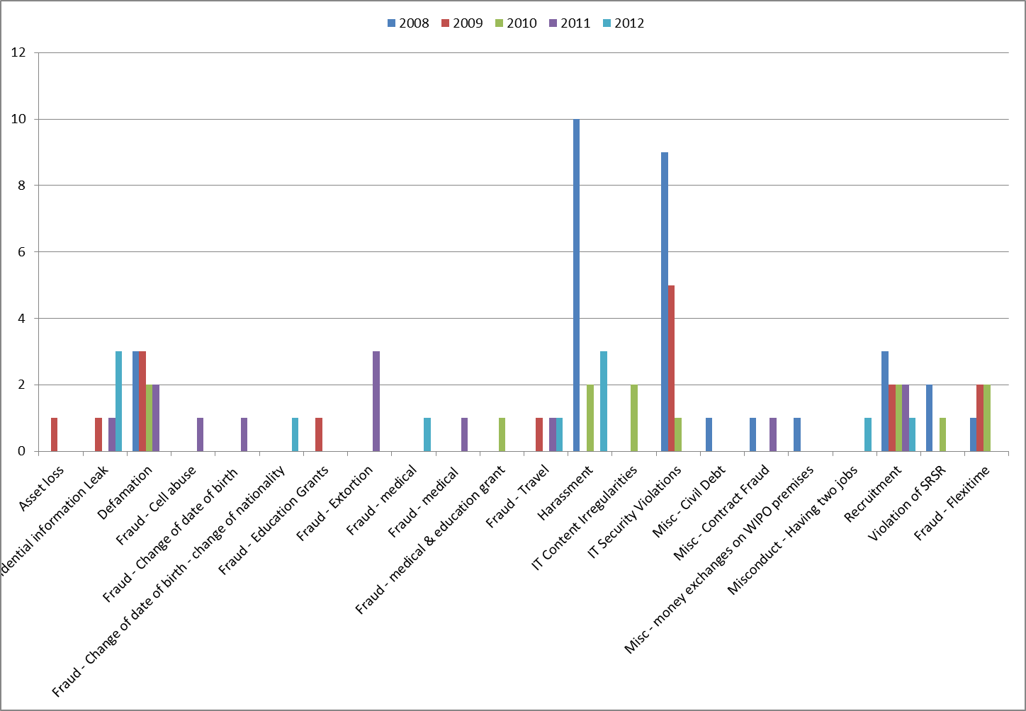

[Annex III follows]
LIST OF IAOD RECOMMENDATIONS CLOSED WITHOUT IMPLEMENTATION

No. | Reference | Recommendation Description | Residual Risk Appreciation  (Secretariat)
1. | 11355BE_OMPI_audit final 2010 (External Audit report) | I recommend WIPO to find a permanent solution for PCT pricing in three or four currencies (CHF, EUR, USD, and JPY for example). I am convinced that such a solution will simplify the administrative workload of the PCT finance service and will reduce exchange rate risks. (High risk) | This recommendation will not be implemented; the external auditors have been informed and agree with this. It is acknowledged that foreign currency exchange rates represent an area of risk with regard to PCT revenue. The majority of payments received currently are made in the four principal currencies mentioned in the recommendation (CHF, EUR, JPY and USD) and so further concentration on these currencies will not reduce the risk to any significant degree. In addition, provisions already exist within the PCT Treaty which are designated to mitigate the exchange risks associated with tariffs and the currencies in which they are expressed. It is very important to note that a key advantage of the PCT system for users is that of being able to pay in their local currency and this is the principal argument for retaining all currencies. This recommendation is not, therefore, appropriate in terms of a system which aims to be readily accessible to all. However, the situation will continue to be monitored to see if there are ways of mitigating the remaining exchange rate risk.
2. | IA/01/2008 | It is vital that the role of information security carries the necessary authority within IT and WIPO. The decision to maintain the grade of the role of Head of Information Security as a P4 does not reflect this need. (High risk) | Item 2 concerns the grade of the head of information security section. It is felt that the function has sufficient authority within IT as it reports to the CIO directly (taking this function outside IT will only reduce its authority within IT – see item 4) and it also has sufficient authority at the organizational level as such authority is embedded into the ICT Board based on its Terms of Reference.
3. | IA/04/2009 | WIPO Management should ensure that the impact of exchange rates over PCT income is analyzed and necessary corrective actions for any unexpected revenue variances which could have adverse impact on the biennium budget are taken on time to ensure smooth cash flow and enable more precise and accurate budget preparation. (High risk) | Until now, PCT/IB has borne the impact arising from exchange rate fluctuations between pairs of currencies, mainly USD against EUR.  The exchange rate applied by the bank of the International Searching Authority (ISA) receiving the search fee from a national Receiving Office in a currency other than the one prescribed, lies outside the control of PCT/IB and Finance. Various ways of hedging the inherent currency risk in Rule 16.1(e) have been explored with WIPO’s banks but no satisfactory hedge has been found. As it is impossible to quantify the number of search fees and their timing, it is consequently not possible to gauge the size or timing of the underlying risk. The only hedging choice available would therefore be to put a hedging instrument in place (such as an option) which has no link to the risk which WIPO is endeavoring to mitigate. This is not advisable as it could increase WIPO’s risk still further depending on the movement of exchange rates. Given the considerable impact of Rule 16.1 upon the International Bureau (IB), Finance will propose to the relevant authority adding a new clause to the rule which would give the IB full control over the cash management of the search fee funds upon notification by the ISA concerned. This would allow the IB to decide when to convert, at what rate and how much.  The IB would no longer be subject to the impact of conversions being made by the most important ISA organizations which have little incentive to watch exchange rate movements and time their conversions accordingly. Finance will also analyze whether IPSAS are or not compliant with such in-house regulations in order to harmonize IB’s practice, mainly for forecast/projection purpose. An analysis carried out by WIPO's Finance Services and the PCT Sector in December 2010 revealed that there are only a few International Searching Authorities in respect of which the procedure under Rule 16.1(e) may be applicable. Of these, only a small number have requested reimbursement under Rule 16.1(e) of losses incurred due to substantive exchange rate fluctuations between the currency in which the search fee has been paid to the Receiving Office and the currency in which the International Searching Authority has fixed that fee.  Rather than proposing an amendment to the PCT Regulations which would affect the payment of all search fees and thus would affect all Receiving Offices and ISAs irrespective of whether the Rule 16.1(e) procedure may be applicable to them or not, it would appear preferable to find informal arrangements with only those ISAs and Receiving Offices actually concerned by the Rule 16.1(e) procedure with a view to ensure that, with the active involvement of the IB, the currency exchange process is better managed. By the end of 2011, the USPTO, as one of the main Receiving Offices, and the European Patent Office (EPO), as one of the main ISAs, had been informally approached by the IB in order to discuss the effect of Rule 16.1(e) and to propose a new channel for monthly transfers of ISA fees from USPTO to EPO by transiting through IB. This gives to IB full responsibility for managing more closely the exchange rate impact via negotiation with the banks and by using existing funds in Euros in IB's books, thus minimizing the exchange rate exposure for that currency. This project pilot should start mid 2012 by common agreement, based on a simple exchange of letters between the three entities, without any modification of Rule 16.1(e). The project will be reviewed after one year.
4. | IA/09/2011 | The Information Security Section should, as is current recognized good practice, not report to the Chief Information Officer. (High risk) | Item 4 concerns the reporting line of the information security. It was decided that the current arrangement is adequate, based on the independent advice from Gartner which showed that in the large majority of organizations (56 % + 7 %) this function reports to the CIO or middle level IT manager and that there is no clear trend on where this function should report to outside IT.
5. | IA/01/2009 | WIPO Management should follow the set procedures and pay staff members 80 % of full economic fare if the lump sum is applied. (Moderate risk) | Due consideration has been given to this recommendation, but WIPO management has elected to maintain the home leave lump sum as is for the time being. Considering that this has been the practice for many years in WIPO, this does not constitute a financial risk since it is integrated in the WIPO budget provisions.
6. | IA/06/2010 | The Finance Services Section should ensure that any payment instruction corrections are always effected from within the PeopleSoft/AIMS system, and not while temporarily stored on WIPO’s network. (Moderate risk) | Finance volunteered the information that such corrections have been made in the past but that these instances were very rare (two cases during the past four years). On both occasions the corrections were made in order to avert operational risk and were performed in the presence of a Finance staff-member. Technical issues with line items in the files had put the two entire (large) files at risk and a business decision was made to correct the two files, as reversing them in their entirety would have led to considerable workload issues and the possibility of payment duplication. Given the stability of Office Wings now, we do not envisage such instances arising again in the future. However, Finance Services needs to retain the ability to execute this procedure in the event of unforeseen or exceptional circumstances. Access rights would only be granted to AIMS support for a minimal time period and on an exceptional basis to allow such corrections to be made. All such exceptions will be documented and reported.

[End of Annex III and of document]

Annex I to WIPO’s Financial Regulations and Rules
List of reports in Annex I refers
It is important to note that the methodology for sampling PIs was modified for the validation of the 2010/2011 PPR. For this validation a random sampling exercise of PIs was undertaken which enabled a better representation of the quality of PD, PIs and monitoring tools within the Organization instead of selecting only the PIs and PD that fulfill SMART criteria as done during the validations of the previous PPR. As a result, the 2010/2011 PPR validation presents a slightly higher number of programs not sufficiently meeting the validation criteria while positive improvements have been recorded in terms of ownership and use of the Results Framework (RF) and PD for internal monitoring compared to the 2008/2009 biennium.
Review of recruitment statistics for the period 2007 to 2011 revealed that about half (49 per cent) of WIPO employees have been engaged on short term contracts
IOC paragraph 22.
Office Instruction (OI) 16/2010, paragraph 7.
OI 16/2010 paragraph 3.
DA: Development Agenda; IC: Internal Controls; Man. Rep: Management Reporting; Perf. Mgmnt: Performance Measurement; Ph. Access: Physical Access.
Document WO/GA/39/6 and document WO/AC/18/2 paragraph 27.
For the 2012/2013 Budget, IAOD proposed to be allocated a headcount of 12 – 10 posts and two consultants. The draft budget proposes a headcount of 11 – 7 posts and 4 consultants.
JIU reports refer (JIU/REP/2010/5-The Audit function in the United Nations System and JIU/REP/2011/7 The Investigation function in the United Nations System)
As at June 30, 2012 - In thousands of Swiss francs. Staff commitments are allocated annually.
On-line distance learning course provided by WIPO Academy on IP basics

