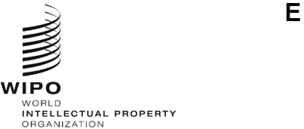
WO/CC/85/2
ORIGINAL: ENGLISH
DATE: October 27, 2025
WIPO Coordination Committee
Eighty-Fifth (29th Extraordinary) Session
Geneva, February 12 and 13, 2026
PROPOSED CANDIDATES FOR NOMINATION TO THE POST OF DIRECTOR GENERAL OF WIPO
Memorandum of the Chair of the Coordination Committee
The Chair of the Coordination Committee sent, on July 24, 2025, Circular Note 4222 to all Member States of WIPO inviting them to propose one of their nationals as a candidate for the post of Director General of WIPO.
The proposed nominations of the following persons, listed in alphabetical order, were received by the Chair of the Coordination Committee and each was communicated, following its receipt, to the Member States of WIPO:
Mr. Johanny Stanley Joseph (Haiti)
Mr. Daren Tang (Singapore)
The Annex to this document sets out the text of the correspondence transmitting each of the above-mentioned candidatures, together with the curriculum vitae of the corresponding candidate.
[Annex follows]
Permanent Mission of Haiti to the Office of the United Nations
and other international organizations at Geneva
Ref. No.: MPH-ONUG/KJ/0716-2025
The Permanent Mission of Haiti to the Office of the United Nations and other international organizations at Geneva presents its compliments to the World Intellectual Property Organization (WIPO) and has the honor to transmit a letter from His Excellency Mr. Jean-Victor Jean-Baptiste, Minister of Foreign Affairs and Worship, to his Excellency Mr. James Baxter, Chair of the WIPO Coordination Committee, in which His Excellency Mr. Jean-Baptiste presents the official nomination by Haiti of Mr. Johanny Stanley Joseph as a candidate for the position of Director General of WIPO at the elections to be held at the extraordinary session of the WIPO General Assembly, on April 21, 2026, in accordance with Circular Note 4222, dated July 24, 2025.
The Permanent Mission would like to highlight that Mr. Joseph is a Doctor of Laws (private law), with a specialization in intellectual property and a sub-specialization in geographical indications and appellations of origin. Furthermore, he has extensive experience in business law and sustainable economic development, particularly in the public administration of Haiti.
Please find attached Mr. Joseph’s curriculum vitae.
The Permanent Mission of Haiti to the Office of the United Nations and other international organizations at Geneva avails itself of this opportunity to renew to WIPO the assurances of its highest consideration.
Geneva, October 16, 2025
World Intellectual Property Organization

Ministry of Foreign Affairs and Worship of Haiti
Ref. No.: IIC/1590
Port-au-Prince, October 14, 2025
Chair,
I am pleased to present, in accordance with Circular Note 4222, dated July 24, 2025, the candidacy of Dr. Johanny Stanley Joseph for the position of Director General of the World Intellectual Property Organization (WIPO), to be nominated by the WIPO Coordination Committee at its extraordinary session on February 12 and 13, 2026, and appointed by the WIPO General Assembly at its extraordinary session on April 21, 2026.
Mr. Joseph is a Haitian lawyer who holds a doctorate in private law with a specialization in intellectual property (IP). His career is distinguished by strong technical expertise, developed over many years of experience, particularly in the public administration of Haiti.
In submitting this nomination, my country remains convinced of the transformative potential of IP as an essential driver of sustainable development and wishes to make a significant contribution to the global governance of IP.
You will find attached Mr. Joseph’s curriculum vitae.
Please accept, Chair, the assurances of my highest consideration.
(Signed) Jean-Victor Harvel Jean-Baptiste
Minister
His Excellency Mr. James Baxter
Chair of the Coordination Committee of the World Intellectual Property Organization (WIPO)

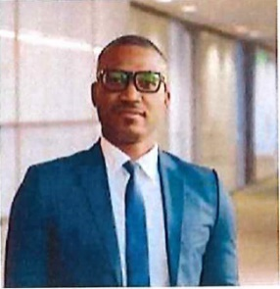
Dr. Johanny Stanley JOSEPH
Year of birth: 1987
Nationality: Haitian
Tel: (509) 3173- 7861
Emails: johannystanley1987@gmail.com jsjoseph@cabinetsales.com
PROFESSIONAL SUMMARY
Doctor of Laws (private law) with a specialization in Intellectual property and a sub-specialization in geographical indications/appellations of origin. With expertise in interdisciplinary research, I combine a solid understanding of legal and economic frameworks with strategic analytical skills oriented toward sustainable economic development.
PROFESSIONAL EXPERIENCE
2025 Attorney, Cabinet Salès, Haiti
- Field: Business Law, Intellectual Property Law
2025 Director, OPEN ECONOMIC LAW (REVIEW), Haiti
- Field: Academic Journal in Economic Law
2020 - 2022 Director of Industrial Property and Legal Affairs, Ministry of Commerce and Industry (MCI), Port-au-Prince-Haiti
- Field: Industrial Property Law (trademarks, patents, trade names, opposition and), corporate law (public limited companies, partnerships companies, partnerships limited by shares, general partnerships, limited partnerships).
- Field: Administrative conflict management in trademark law: opposition
- Field: Study and analysis of international conventions and agreements.
- Field: Study and analysis of contracts and protocols.
2021 - 2022 Special Advisor to the Minister, Ministry of Commerce and Industry (MCI), Port- au-Prince-Haiti
- Advice: Industrial property management.
- Advice: Drafting of administrative instructions.
2020 - 2021 Coordinator, Project for the Modernization of the Business Law Framework, Ministry of Commerce and Industry (MCI), Port-au-Prince-Haiti
- Field: Project management, drafting legislative calendar, awareness-raising and dissemination of industrial property law and business formalization.
2017 - 2020 Deputy Director of Industrial property and Legal Affairs, Ministry of Commerce and Industry (MCI), Port-au-Prince-Haiti.
- Field: Industrial property law (trademarks, patents, trade names, opposition and invalidity proceedings), corporate law.
2012 - 2017 Head of the Commercial Companies Section, Directorate of Industrial Property and Legal Affairs, Ministry of Commerce and Industry (MCI), Port-au-Prince-Haiti.
- Field: Corporate law (public limited companies, partnerships limited by shares, general partnerships, limited partnerships).
June-Sept 2012 Intern, Directorate of Industrial Property and Legal Affairs, Ministry of Commerce and Industry (MCI), Port-au-Prince-Haiti
- Field: Corporate law
TEACHING ACTIVITIES
2025 Professor, Master's Program in Business Law, State University of Haiti (UEH)
- Field: Intellectual property law
Jan-July 2022 Lecturer, Port-au-Prince Bar School (ECB)
- Field: Industrial property law
AFFILIATIONS
2025 Arbitrator, Haitian Chamber of Conciliation and Arbitration (CCAH)
2017 Attorney, Port-au-Prince Bar Association
ACADEMIC BACKGROUND
2022 - 2024 Doctorate in Private Law, University of Bordeaux (France)
- Field: Private law/intellectual property law
- Thesis: The Legal Protection of Geographical Indications and Its Advantage for Haiti's Development.
Auq 2024 - Jan 2025 Specialization in Patent Law and Public Health, Harvard University
- Field: Intellectual property law
2019 - 2020 Master II in Intellectual Property Law, University of Yaoundé 2 SOA (Cameroon)
- Field: Intellectual property law
- Dissertation: Intellectual Property Litigation under Haitian Law

2008 - 2012 Bachelor of Legal Sciences, Quisqueya University (Haiti)
- Field: Law
- Dissertation: Opposition Proceeding in Haitian Trademark Law.
OTHER TRAINING
2025 WIPO Academy
- Field: Arbitration and Mediation Procedures under WIPO Rules.
2020 WIPO Academy
- Field: Advanced Course on Collective Management of Copyright and Related Rights for Collective Management Organizations.
2020 WIPO Academy
- Field: Introduction to the UPOV System of plant variety protection under the UPOV Convention.
2019 WIPO Academy
- Field: Introduction to the Patent Cooperation Treaty (PCT).
2019 WIPO Academy
- Field: Intellectual property management.
2018 Moroccan Office of Industrial and Commercial Property (OMPIC), Morocco
- Field: Trademarks and industrial designs.
2016 WIPO Academy
- Field: General introduction to intellectual property.
PUBLICATIONS
- Top 10 Images of Strong and Positive Brands in Haiti, The Light Magazine, Ad Justitiam Intellectual Property, April 26, 2022.
- Private Copying "Lawful": The Three-Step Test in the Digital Age in Haiti, Le Nouvelliste, April 26, 2023.
- The Potential of Protecting Haitian Rum as a Geographical Indication, Open Economic Law, October 2, 2025 (forthcoming).
- The Economic Importance of the Legal Protection of Cayes Vetiver as an Appellation of Origin, Open Economic Law, October 2, 2025 (forthcoming).
- The Challenges at the Intersection of Artificial Intelligence, Ethics and Intellectual Property Law, Open Economic Law, October 2, 2025 (forthcoming).
SKILLS
- Expertise in geographical indications/appellations of origin: development of public policies and strategies to enhance local products.
- Research and strategic analysis: ability to analyze legal and economic frameworks for in-depth studies.
- Languages: French (fluent), English (professional).
INTERESTS
- Enhancing local resources through intellectual property tools.
- Research on intersections between law, economics and finance.

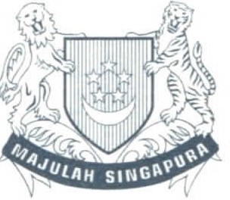
MINISTRY OF FOREIGN AFFAIRS
SINGAPORE
MINISTER
24 July 2025
His Excellency Mr James Baxter
Chair, WIPO Coordination Committee
34 Chemin des Colombettes
CH 1211 Geneva 20 SWITZERLAND
Your Excellency,
I am writing to formally nominate Mr Daren Tang as Singapore's candidate for the position of Director General (DG) of the World Intellectual Property Organization (WIPO) at the elections to be held in February 2026.
The Singapore Government fully supports Mr Tang's candidature for a second term (2026 - 2032). Since his appointment as WIPO DG in 2020, Mr Tang has transformed WIPO and strengthened the global IP ecosystem by leveraging IP as a catalyst for innovation, creativity, economic growth, and social development for every Member State.
Under his leadership, WIPO also successfully organised two Diplomatic Conferences in 2024, which concluded the WIPO Treaty on IP, Genetic Resources and Associated Traditional Knowledge (GRATK), and the Riyadh Design Law Treaty (RDLT). This is an unprecedented achievement as it marked the first time in more than a decade that WIPO has been able to conclude a multilateral treaty.
Tanglin, Singapore 248163 IT +65 6379 8000 F +65 6473 5159 I mfa@mfa.gov.sg I mfa.gov.sg

Singapore is confident that Mr Tang will continue to deliver on his transformative agenda if he is entrusted with a second term as WIPO DG.
In line with WIPO Note C. N 4222 of 24 July 2025, we enclose Mr Tang's curriculum vitae. On behalf of the Singapore Government, I sincerely commend his candidature to all WIPO Member States.
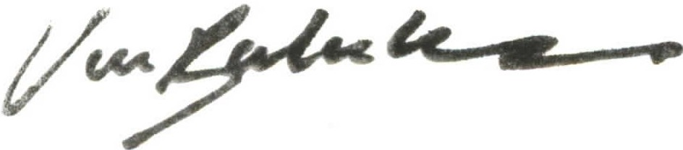
Yours sincerely,
DR VIVIAN BALAKRISHNAN
Enc

Curriculum Vitae of Mr Daren Tang
Director General, World Intellectual Property Organization
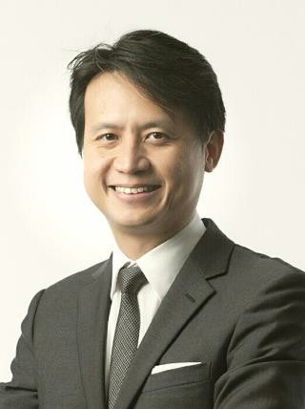
Year of Birth: 1972 Nationality: Singaporean

ACADEMIC QUALIFICATIONS
2013 Advanced Management Program
Harvard Business School, USA
2006 Master of Laws (LL.M) with Distinction Georgetown University Law Centre, USA Fellow, Institute of International Economic Law
1997 Bachelor of Laws (LL.B) with Honours
National University of Singapore

PROFESSIONAL EXPERIENCE
2020 – Director General
present World Intellectual Property Organization (WIPO)
Secretary-General
International Union for the Protection of New Varieties of Plants (UPOV)
Board Member
UN System Chief Executives Board for Coordination
2015 – Chief Executive
2020 Intellectual Property Office of Singapore (IPOS) Ministry of Law, Singapore

2012 – 2015 Deputy Chief Executive and Chief Legal Counsel
Intellectual Property Office of Singapore Ministry of Law, Singapore
2003 – 2012 Senior State Counsel
International Affairs Division
Attorney-General’s Chambers, Singapore
2001 – 2003 Legal Consultant
Ministry of Trade and Industry, Singapore
1997 – 2001 State Counsel/Deputy Public Prosecutor

PAST APPOINTMENTS
Chairperson, Standing Committee on Copyright and Related Rights (SCCR), WIPO, 2017 – 2020
Member, Singapore-Guangdong Collaboration Council (SGCC)
Member, Manufacturing Sub-Committee of the Future Economy Council, Singapore
Member, Modern Services Sub-Committee of the Future Economy Council, Singapore
Member, Research, Innovation and Enterprise Strategy Committee (RIE SC), Prime Minister’s Office, Singapore
Member, Research, Innovation and Enterprise Executive Committee (RIE Exco), Prime Minister’s Office, Singapore
Co-Chair, National IP Working Group, Prime Minister’s Office, Singapore

Advisory Board Member, Saudi Authority for Intellectual Property (SAIP)
Member, Group of Experts on IP Office of the Future Project, International Trademark Association (INTA)
Board Chairman, IPOS International
Board Member, EW Barker Centre for Law & Business, National University of
Singapore
Board Director, Fraunhofer Singapore
Coordinator and Principal Examiner, Intellectual Property Law Course for the Singapore Bar Exam run by the Singapore Institute of Legal Education

HONOURS
2016 Public Administration Medal (Silver)
Prime Minister’s Office, Singapore
2006 Fellow
Institute of International Economic Law, Georgetown University, USA

LANGUAGES
English, Mandarin Chinese, understanding of French, Cantonese

PUBLICATIONS
The Tea Bone Zen Mind Manual of Tea
[End of Annex and of document]

