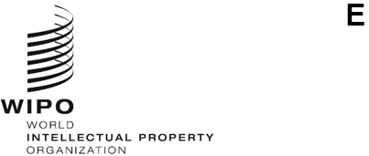
WO/CC/84/inf/2
ORIGINAL: English
DATE: April 7, 2025
WIPO Coordination Committee
Eighty-Fourth (56th Ordinary) Session
Geneva, July 8 to 17, 2025
Annual Report by the Ethics Office
prepared by the Secretariat

Introduction
- This report is submitted to the WIPO General Assembly, through the Director General, in accordance with paragraph 4 of Office Instruction No. 16/2020. It describes the key activities undertaken by the Ethics Office in 2024.
- Since its establishment in 2010, the Ethics Office has been supporting the Director General to ensure that all WIPO personnel maintain the highest standards of ethics and integrity, as required by WIPO’s regulatory framework, including the WIPO Convention, the WIPO Staff Regulations and Rules, the WIPO Code of Ethics, and the Standards of Conduct for the International Civil Service.
- The objective of the Ethics Office is to promote an organizational culture of ethics based on shared values of independence, loyalty, impartiality, integrity, accountability, and respect for human rights. The Ethics Office fulfills this mission by providing services to all WIPO personnel, including senior management, in the following broad areas of responsibility:
  - Confidential advice and guidance;
  - Awareness-raising, training and outreach;
  - Monitoring and standard-setting;
  - Review of retaliation complaints in accordance with WIPO’s Policy to Protect against Retaliation; and
  - Administration of WIPO’s Policy on Financial Disclosure and Declaration of Interests (FDDI).
- The Office is headed by a Chief Ethics Officer, who is functionally and operationally independent from WIPO management. Following the departure of the previous incumbent, Mr. David Mitchels served as Chief Ethics Officer ad interim until July 31, 2024. A newly appointed Chief Ethics Officer, Ms. Fanny Martin, began her duties on August 1, 2024.
- Throughout 2024, the Office also included an external reviewer (contracted under a long-term agreement and in charge of reviewing disclosure statements filed by staff members under the FDDI Policy), an intern, as well as an agency worker in charge of providing management, administrative and technical support. In the first half of 2024, the Office further included an individual contractor.

II. REPORT ON 2024 ACTIVITIES
- The Director General and the Independent Advisory Oversight Committee (IAOC) were kept apprised of the performance of the ethics function, through monthly and quarterly meetings, respectively, over the course of 2024.

A. CONFIDENTIAL ADVICE AND GUIDANCE
- In providing confidential guidance to WIPO personnel on situations raising ethical dilemmas, the Ethics Office plays a key role with a view to: (i) supporting the consistent interpretation of, and compliance with, rules, standards of conduct as well as ethics-related policies; and (ii) identifying, monitoring, and mitigating risks that could cause reputational damage to WIPO.
- Figure 1 provides an overview of the number of requests received and addressed by the Ethics Office in the last four years.
Figure 1. Comparison of requests per reporting year, 2020 to 2024
9 staff members
- In total, in 2024, the Ethics Office responded to 188 individual requests, through in-person and virtual meetings or in writing. A comparison of this number with the number of requests received and addressed in 2023 (see Figure 1) shows a steady upward trend in requests, which in turn reflects a continued trust in the Ethics Office through a period of change in leadership.
- Requests for ethics advice received in 2024 covered various categories (see Figure 2). As in previous years, the vast majority of them concerned participation in outside activities and occupations (71, or approximately 37.8 per cent) such as teaching assignments, membership in executive or advisory boards, and publishing activities. About half of these requests (33) were referred by the Human Resources Management Department (HRMD) and the other requests (38) were received directly from members of personnel, who were seeking clarifications prior to submitting their request for authorization to the Director of HRMD.
- The other major categories of requests related to standards of conduct (23, or 12.2 per cent), reprisals and retaliation (18, or 9.6 per cent) and “other ethics advice”, which essentially related to the reporting of misconduct and other workplace concerns (48, or 25.5 per cent).
- The Ethics Office also recorded requests in the following categories: gifts (11, or 5.9 per cent), disclosure of financial and other interests (seven, or 3.7 per cent), conflicts of interest arising from political activity (one, or 0.5 per cent) or from family and close relationships (two, or 1.1 per cent) or other circumstances (seven, or 3.7 per cent).
Figure 2. Breakdown of advice by category

- As shown in Figure 3, the majority of requests were submitted by staff members (163), three from individual contractors or agency workers, 16 from fellows or young experts and six from other WIPO external stakeholders (e.g., individuals from other UN entities or having used services provided by WIPO).
Figure 3. Origin of requests

B. Awareness-raising, training and outreach
- The awareness-raising, training and outreach activities of the Ethics Office aim to improve knowledge and understanding of and reinforce accountability for WIPO’s ethical values and principles, across the Organization.
- As Figure 4 shows, throughout 2024, the Ethics Office undertook several outreach initiatives, including three induction training sessions (in April, June and November, attended by 65 newly recruited members of personnel), one presentation to the Directors in charge of WIPO’s External Offices (in July) and one town hall meeting (in November) aimed at presenting its mandate and encouraging personnel to reach out to it for support (attended by approximately 300 members of personnel). In addition, between August and December, the Ethics Office met with all eight Sector Leads (both individually and collectively) and senior managers (reaching 188 members of personnel).
- The Intranet pages of the Ethics Office were further redesigned to provide concrete guidance on ethical issues such as conflicts of interest (including those arising from intimate relationships and private and/or financial interests) and outside activities, as well as easy access to applicable provisions and key contacts within WIPO. The new Intranet Pages were made available to WIPO personnel in September 2024.
- In addition, in October 2024, on the occasion of Global Ethics Day, the Ethics Office launched a survey with a view to improving awareness of, and bringing personnel closer to, WIPO’s ethical values.
- In December 2024, the Ethics Office sent an all-staff communication reminding WIPO personnel of their obligations under WIPO’s Policy on Honors and Gifts.
- Also in December 2024, the Ethics Office provided all Sector Leads with an overview of the number and nature of requests for ethics advice received in 2024 from members of personnel in their area (while preserving confidentiality and anonymity of those raising queries). This was intended to ensure greater accountability for ethical standards, by identifying where more could be done (notably in terms of guidance or communication) to make sure that such standards are clearly understood, and complied with, across WIPO.
Figure 4. Outreach initiatives by the Ethics Office and number of members of personnel reached
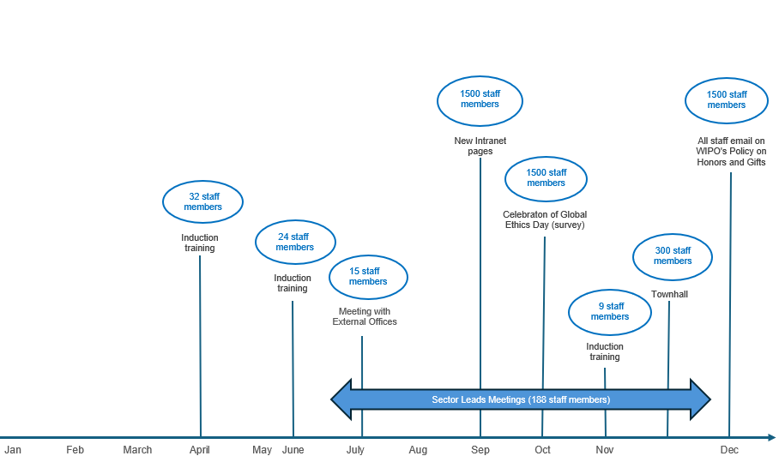

Mandatory Ethics and Integrity training
- The Ethics and Integrity training gives an overview of available ethics resources. It includes a message from the Director General on the importance of ethics at WIPO and infographics, interactive exercises, a closing quiz and videos to convey important ethical concepts in an engaging way, such as what ethics means at WIPO, ethical risks or dilemmas personnel may face, the expectation for managers and supervisors to act as role models, the role of the Ethics Office, and protection against retaliation.
- In 2024, the Ethics Office continued to monitor completion of this mandatory training, with the support of the WIPO Academy. Regular reminders were sent to newly recruited personnel after their first thirty days within the Organization. In total, up until December 31, 2024, 1279 out of 1330 staff members successfully completed the e-learning course, with a 96 per cent completion rate.

C. Monitoring and standard-setting
- The Ethics Office provides standard-setting and policy support for the development and interpretation of ethics-related policies, and input to management to ensure that other policies and practices reflect, reinforce, and promote ethical standards and integrity within WIPO.
- In the second half of 2024, in anticipation of the review of WIPO’s Policy on Outside Activities, the Ethics Office engaged in discussions with HRMD and subsequently undertook a comparative review of the provisions of other UN Common System entities.
- Working closely with the relevant Sector Leads, the Office of the Controller and the Office of the Legal Counsel, the Ethics Office further reviewed the FDDI Policy, with a view to expanding its scope to cover IP-related conflicts of interest, in line with two recommendations from the (former) External Auditor.
- The Ethics Office also provided input on several policies or guidance documents developed by other internal stakeholders​.

D. Review of retaliation complaints in accordance with WIPO’s Policy to Protect against Retaliation
- The Ethics Office administers WIPO’s Policy to Protect against Retaliation, which aims at protecting from retaliation those who, in good faith, make a report of misconduct or cooperate in an oversight activity. Upon receipt of a formal complaint of retaliation, the Ethics Office undertakes a preliminary review of the request, and if a prima facie case of retaliation is established, the matter is referred to IOD for investigation. Following completion of the investigation, the Ethics Office reviews the investigative findings, seeks clarification if needed, and determines whether retaliation occurred.

Formal retaliation complaints
- As may be seen in Figure 5, in 2024 the Ethics Office received two formal complaints of retaliation. Having undertaken a preliminary review of the complaints, as required under WIPO’s Policy to Protect against Retaliation, the Ethics Office determined that there was no prima facie case of retaliation in either case.
Figure 5. Number of formal complaints received from 2020 to 2024

- The three formal complaints which had been submitted in 2022 and remained pending in 2024 were dismissed after (i) the Internal Oversight Division (IOD) investigated the matters; (ii) the Ethics Office determined that retaliation had not occurred, and (iii) the Director General decided to endorse the Ethics Office’s determinations.
- Out of the four formal complaints submitted in 2023, only one remained pending with IOD in 2024 (following the determination by the Ethics Office that there was a prima facie case of retaliation). Figure 6 shows the status of the requests that were received by the Ethics Office in 2024, and/or pending with IOD at the end of 2024.
Figure 6. Status of formal complaints at the end of 2024

Confidential advice on allegations of retaliation
- The Ethics Office responded to eight separate requests for advice relating to retaliation, where colleagues sought further clarifications on the applicable procedure, or advice or reassurance about protection either before going on to report misconduct or when feeling exposed, having engaged in a protected activity.

E. Administration of the FDDI policy
- The purpose of the FDDI program administered by the Ethics Office is threefold:
(i) promoting transparency and personal accountability, (ii) enhancing internal and external public trust in WIPO’s integrity, and (iii) assisting the Organization to manage the risk of actual, potential and perceived conflicts of interest through disclosure, mitigation and prevention, by requiring selected members of personnel to report annually on their financial and other interests.
- In 2024, a total of 110 staff members – at the level of D1 and above, as well as other staff working in specifically designated categories – were invited to participate in the annual FDDI exercise, which covered the 2023 calendar year.
Figure 7. Staff members invited to participate in the annual FDDI exercise, 2020 to 2024

- Having assessed the completeness of, and analyzed, the FDDI statements, the external reviewer did not identify any actual, perceived or potential conflicts of interest. Subsequently, nine participants were randomly selected to participate in the verification process contemplated in the applicable guidelines (this verification process allows the Ethics Office to ensure that staff are completing their FDDI statements accurately). They were all found to be compliant.
- At the end of October 2024, the external reviewer transmitted an anonymized report to the Director General, following which the FDDI exercise was closed without there being any actual, perceived or potential conflict of interest identified.
- Consistent with its mandate, the Ethics Office also launched, administered and managed the annual 2024 disclosure exercise under the International Public Sector Accounting Standards (IPSAS). All staff members at the D2 level and above were required to disclose transactions of their close family members with the Organization, as well as transactions between the Organization and entities in which they or their close family members hold a substantial ownership interest or over which they are able to exercise significant influence. All participants responded and the IPSAS exercise was closed without there being any issues identified.
- The year 2024 was also marked by the successful launch of the IPSAS exercise within the new in house FDDI IT platform, which now provides for a central and confidential repository for both the FDDI and the IPSAS disclosure exercises.
- In collaboration with HRMD, the Ethics Office further designed a process allowing it to be informed of upcoming separations, enabling it to invite departing staff members to complete their IPSAS disclosure statements prior to their separation from service.

Policy review
- As mentioned earlier, the Ethics Office reviewed the FDDI Policy, with a view to expanding its scope to cover IP-related conflicts of interest, in line with two pending recommendations from the (former) External Auditor. A new section of the FDDI questionnaire was designed accordingly and will be implemented in 2025.

III. OTHER ACTIVITIES OF THE ETHICS OFFICE
- Throughout 2024, the Ethics Office continued to engage regularly with the IAOC and submitted timely updates and reports, in particular on the implementation of the Office’s workplan. Drawing on its extensive organizational experience, the IAOC provided useful guidance to the Chief Ethics Officer, including on the Office’s proposed annual and biennial workplans.
- The Ethics Office further responded to several enquiries in the context of internal and/or external audit, control and other oversight processes, and it attended the Risk Management Group meeting in November 2024.

IV. COLLABORATION ON ETHICS-RELATED ISSUES WITHIN THE UN SYSTEM

Ethics Network of Multilateral Organizations (ENMO)
- The Ethics Office pursued its engagement with the ENMO, which serves as a broad forum of ethics functions from UN system entities, affiliated international organizations, and international financial institutions, and aims to promote system-wide collaboration on ethics-related issues for participating bodies. In August 2024, the Ethics Office took an active part in the discussions on proposed standards of practice.

V. OBSERVATIONS AND Looking Forward
- Having noted the steady increase in requests for ethics advice, the Ethics Office has already improved and intends to further refine its case-tracking capabilities, with a view to reporting more efficiently and accurately on ethical maturity within WIPO.
- The Ethics Office has also made substantial strides in diversifying its outreach activities, to further increase awareness of ethical standards among WIPO staff.
- The Ethics Office has further initiated two policy reviews in relation to FDDI and outside activities, respectively. It further encourages other organizational units to draw on its expertise in future discussions regarding WIPO’s policies, to make sure that ethical considerations are always incorporated into organizational policies and guidelines, as appropriate.

- The FDDI IT platform was enhanced regularly throughout 2024 to improve the overall functionality, efficiency, accuracy, user experience and security of the system.
- Lastly, the Ethics Office has actively sought to further enhance exchanges with key internal stakeholders, including the Director of HRMD (through monthly meetings), the Ombudsperson and the Director of IOD (through bi-weekly meetings), the Senior Medical Adviser and the Staff Council. Through various meetings with Sector Leads and senior managers, the Ethics Office has sought to promote accountability in decision-making and strengthened ethical leadership at all levels of the Organization. The Ethics Office is grateful for the support it received from all these stakeholders, and plans to maintain continuous dialogue with them.

vI. CONCLUSION
- In 2024, the Ethics Office made significant efforts to provide consistent ethics advice, high-quality training, and meaningful outreach to strengthen capacity and further increase understanding of and compliance with WIPO’s ethical standards. The Office is encouraged by its increased interactions with WIPO personnel on ethics issues and looks forward to continuing this work in the next year.
- As was done last year, the Ethics Office will issue an illustrated summary report to provide WIPO personnel with an overview of its work. A one-page snapshot of this report is available in the Annex.
[Annex follows]
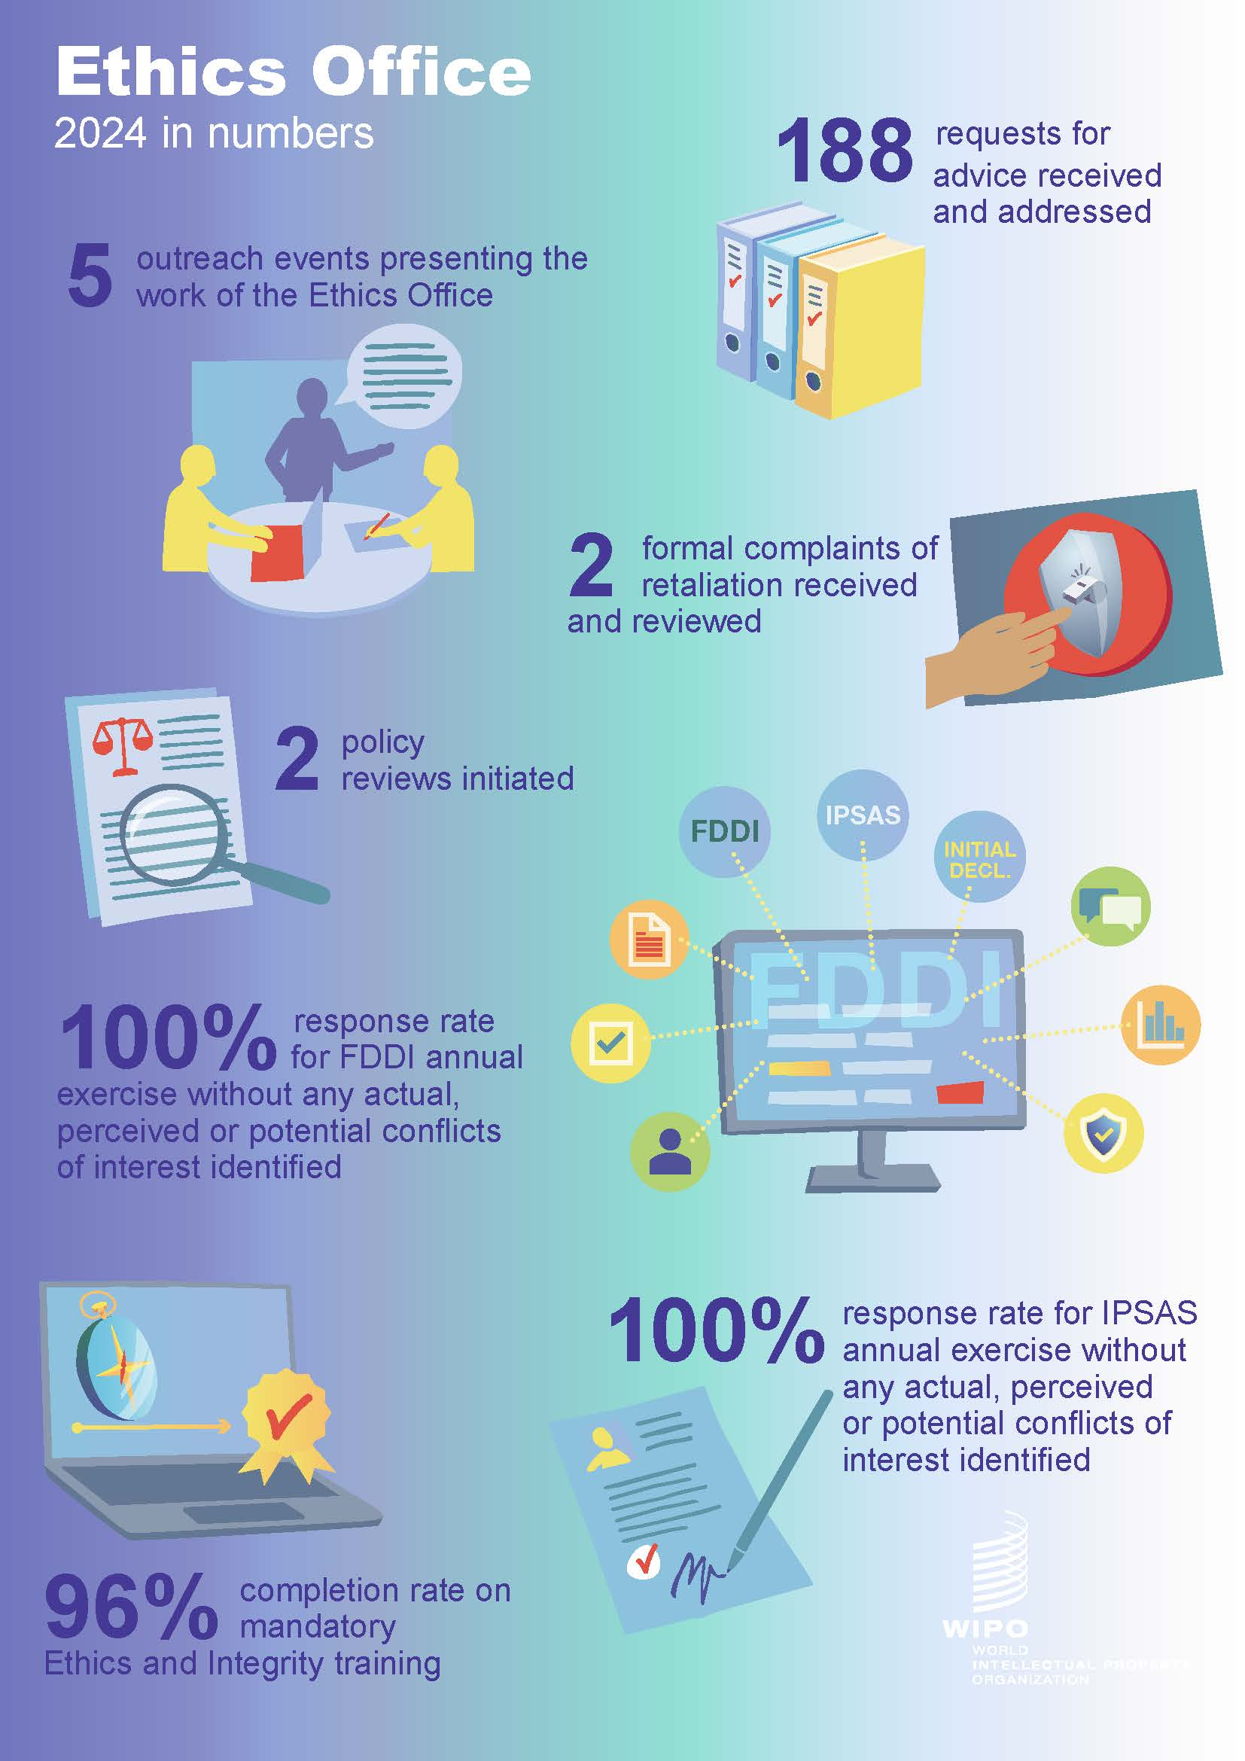

[End of Annex and of document]

This includes all staff and non-staff personnel of WIPO and the International Union for the Protection of New Varieties of Plants (UPOV) based in WIPO/UPOV headquarters and elsewhere.
Up until mid-October 2024, Mr. Mitchels remained as an Individual Service Contractor on a part-time basis, to ensure proper handing over of all pending requests, cases, policy reviews and files.
The Ethics Office counts as one request any request for confidential advice made individually by one, or jointly by several, member(s) of personnel, in relation to a set of facts.
This category includes requests relating to retaliation as defined in WIPO’s Policy to Protect against Retaliation (that is, retaliation for having reported misconduct or cooperated in an oversight activity), as well as those relating to reprisals within the ordinary meaning of this term (that is, adverse action against someone in reaction to, or intended to punish for, a prior action).
For the purposes of WIPO’s Policy on Honors and Gifts, “gift” also includes any favor, remuneration, benefit or other compensation of a financial value in excess of a nominal value of (i) 200 Swiss francs for staff based in Geneva, New York, Japan and Singapore, as well as staff on mission to these locations, and (ii) 100 Swiss francs for staff based in any other location.
The UPOV Secretary-General and Vice Secretary-General were also provided with an overview of the requests for ethics advice received in 2024 from members of UPOV personnel.
All new recruits since the launch of the new Ethics and Integrity training in 2022 have been required to complete the training.
The review of WIPO’s Policy on Outside Activities will be completed once the International Civil Service Commission will have issued its revised Standards of Conduct for the International Civil Service.
Out of the 110 staff members invited to participate in the program, three could not complete the exercise it as they either retired from WIPO or were on extended sick leave.
See paragraph 24 above.

